Student: Elitsa Ivanova
Student ID number: 2123375
Module: Project Management
Module code: LCBB5005
Assignment 2
Lecturer: Md Sadeque Imam Shaikh

Table of Contents
Introduction 3
Main body 3
Scope 3
Budget 4
Time 5
Risk 5
Quality 7
Stakeholders 8
Communication 10
HR 10
Integration 11
Procurement 11
Conclusion 11
References 14

Introduction
This essay considers the specific case of the new headquarters of Google in London, UK. This is a large-scale project with many innovative features and a popular nickname of “Landscraper” (Construction UK, 2022). The interest in the project is also motivated by the fact that it is the only Google-designed building outside of the US (Construction UK, 2022).
The essay expands the discussion of the project by including a total of ten key performance features. The latter are essential in project management and include scope, budget, time, risk, stakeholder management, quality, integration, human resources (HR), communication and procurement. The discussion aims to be critical by identifying the performance of the company in all the above-mentioned key performance areas. The results from the discussion are expected to deliver evidence-based recommendations for improvement; thereby, supporting the successful project execution.

Main body

Scope
The scope of the construction project is a key feature worth discussing in more detail. The key characteristics of the project suggest that it is a large-scale and complex project.
The structure is intended to be a length of 330 metres and consist of 11 floors, resembling the form of a landscaper. The anticipated overall space would encompass 92,000 square metres, accommodating around 4,500 Google employees (Construction UK, 2022). The Landscraper embraces the notion of 'multi-use' by integrating diverse amenities, including cafés and indoor recreational areas that contain a basketball court, a 25-meter swimming pool, and a fitness centre - key amenities which expand the scope and complexity of the project (Construction UK, 2022). Furthermore, the facility boasts a precisely crafted rooftop garden that has been continuously maintained, containing a practical jogging track (Wilde, 2023). In addition to all, the building is expected to have the largest facade in the world, expanding to a total of 23,300 square meters (HTL, 2023).
Considering all, the large scope makes the construction project quite ambitious.

Budget
The building project has a beginning budget of £1 billion as of the year 2018 (Office Reality, 2022). Cost assessment is not fully transparent given the lack of cost breakdown information regarding each activity.
Considering the cost analysis, the primary issue at hand pertains to the significant inflationary pressures experienced in the UK following the pandemic, culminating in annual inflation of 11% in October 2022. This has resulted in a substantial cost-of-living problem (Francis-Devine et al., 2023). The building costs have been impacted by price hikes as well (Cost Modelling, 2023). The provided figure displays the enduring fluctuations in the tender and building cost indices, as documented in the Cost Modelling (2023). Overall, the building cost index has risen by 31% since Google announced that their construction project will cost £1 billion in 2018 (Cost Modelling, 2023). This growth is significantly more than the typical increase seen in the past.
Figure 1 – Changes in construction cost indices (2000 – 2023)
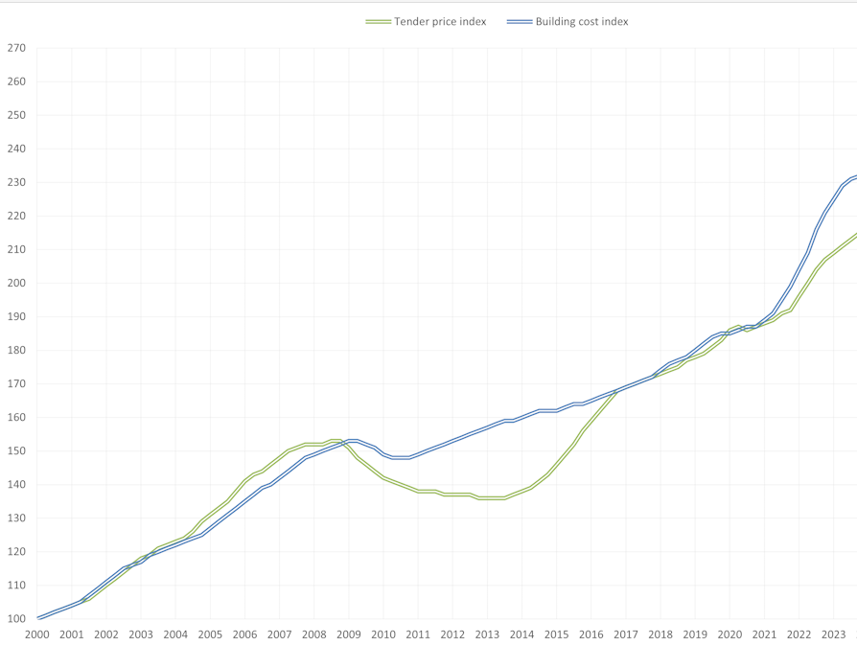
Source: Cost Modelling (2023)
Based on these crucial factors, it is quite probable that the ongoing building project would encounter a significant budget overrun. Precise figures are not accessible since Google is not obligated to provide such data to the public. The current inflationary environment serves as a clear demonstration of the dangers involved in cost management of large-scale and time-consuming construction projects where cost planning may be quite inaccurate.

Time
Time is a crucial factor for successful project management (Pinto, 2016). Given the scarce available data, it can be inferred that Google is experiencing delays because of many issues.
Initially, the project started at a quite delayed stage. According to Shead (2023), the project was initially announced more than ten years ago in 2013. Per the original blueprints, the construction of the new headquarters was scheduled to be finished by 2016 (Shead, 2023). The commencement of the construction phase occurred in 2018 following many modifications to the building's design and other crucial aspects (Wilde, 2022). The second significant concern refers to the negative impact of the pandemic. More specifically, the project development was significantly hindered by the mandated lockdowns and other interruptions caused by the pandemic (Office Reality, 2022). Furthermore, an official termination date has not been established. As proposed by Wilde (2022), the project is likely to be finished in 2024.
Based on the available facts, the project's time management is far from being efficient. The commencement date of the building process was rescheduled, and the unanticipated ramifications of the pandemic further exacerbated the observed delays. If the project is finally completed in the year 2024, there will be an interval of 11 years to complete the project after its initial announcement. Taken together, the mentioned facts suggest a generally inefficient time management process.

Risk
Risk management is the systematic approach of identifying, planning, and minimising any risks that may hinder the proper execution of a project according to the initial plan (Guo, 2015). Guo (2015) states that project managers may utilise a risk matrix to classify various risks and then develop strategies and actions to efficiently control and mitigate their consequences. Risks are categorised based on two primary factors - probability and consequence (Guo, 2015). The following risk matrix evaluates the current construction project under consideration.
Figure 2 – Risk assessment matrix
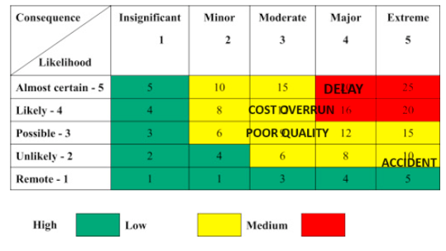
Source: Guo (2015)
The primary risk arises from time delays, which are already mentioned as quite problematic in the current case. Omoregie and Radford (2006) indicate that large construction projects are prone to experiencing delays. Delays frequently extend over a significant duration, as indicated by the examination of prior extensive building efforts (Omoregie and Radford, 2006). Delays not only occur often but also have a detrimental effect on the timely completion of building projects and can result in additional expenses (Omoregie and Radford, 2006; Olawale and Sun, 2015).
Cost overruns are a frequent issue in building project management. As previously mentioned, the current construction project has been negatively affected by the high inflation, despite the lack of precise data. Hence, Google should implement rigorous monitoring and control methods in cost management to minimise the negative effects.
Although infrequent, construction accidents can have significant adverse consequences. Accidents inflict harm onto individuals and have a detrimental effect on the reputation of a company. Hence, although being categorised as having a moderate risk level on the risk matrix, it is imperative to handle the risk of accidents with utmost caution. Google must ensure strict adherence to the highest health and safety requirements at the building site. Utilising cutting-edge materials, techniques, and safety protocols is vital for enhancing the standard of health and safety.
The final significant danger pertains to substandard quality. To ensure the building process's high quality, a variety of actions must be considered. When making decisions about supplies, subcontractors, and labour, it is recommended to be cautious and choose based on finding the best balance between price and quality. Furthermore, it is crucial for Google to regularly oversee and exert authority over performance. The quality performance of the company is quite important in the field of project management; hence, it is discussed in more detail below.

Quality
Considering the level of quality, several key aspects which differentiate the building, are discussed. To begin with, the applied architectural style is suitable for a wide variety of creative work environments, as more than 50% of the available areas have been specifically allocated to promote communication landscapes (E-architecture, 2023). This allocation offers employees several opportunities to participate in flexible cooperation and communication with their colleagues at Google, within a diversified and dynamic environment (E-architecture, 2023).
Second, the exceptional craftsmanship of the materials used must be acknowledged, alongside the creative design. The materials chosen for the new headquarters are specifically steel, glass, and timber (PG, 2023). The building is distinctive because of its facade. The cutting-edge outside is projected to encompass over 23,300 square metres upon completion - an unparalleled building advancement in the UK (HTL, 2023).
Third, the project's exceptional quality is evidenced by the wide array of amenities. The premises offer a range of amenities tailored for athletic activities, such as football fields, a swimming pool, conference facilities, dining establishments, a retail complex, a rooftop garden, a dedicated meeting room with seating for 210 people, and more (PG, 2023).
Fourth, the building is also designed with the intention of providing ample open spaces, efficient areas, and seamless connectivity between stores (PG, 2023). Last, but not the least, the enormous rooftop garden is worth discussing (Gillespies, 2023). The expansive lawn, spanning an impressive one million square feet, sets the structure apart and adds to its distinctiveness. The garden not only enhances the project's quality, but also exemplifies the optimal methods of integrating urban and environmental design elements (Gillespies, 2023).
Figure 3 – The intended rooftop garden of the new building

Source: Gillespies (2023)
Findings demonstrate the project's capacity to provide superior design characteristics which boost its quality.

Stakeholders
Ensuring the success of large-scale initiatives relies heavily on proficient stakeholder management. As stated by Karlsen (2002), stakeholders consist of any groups that can exert influence on or be affected by the project. Stakeholders can be classified into two categories - internal or external - depending on whether they are directly or indirectly involved in a project (Karlsen, 2002). In the case of Google, there are different internal and external stakeholders, as positioned below (see fig. 4). Respectively, stakeholders demonstrate different levels of interest and influence; thereby explaining the need for diversified management.

Figure 4 – Stakeholder mapping
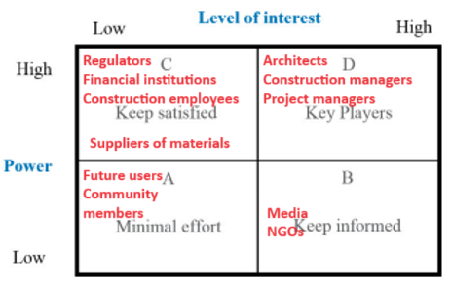
Source: Moreno-Marimbaldo and Manso-Callejo (2020)
Based on the stakeholder map, it is advisable to allocate minimal resources towards future users and community members, as these stakeholder groups have a low influence and interest profile. Google is obligated to distribute information to the media and NGOs to satisfy their significant interest in the construction project.
Most stakeholders possess significant influence, necessitating the corporation to allocate additional resources towards fulfilling their requirements. Stakeholders, such as regulators, financial institutions, suppliers of materials, and construction staff, may not have a strong stake in the project, but their actions might nevertheless have an impact on its execution. Hence, Google is obligated to ensure the contentment of its employees and creditors by performing their financial responsibilities, including salary payments and debt settlements, while also complying with legal standards.
Maximum efforts must be directed to architects, project and construction managers, who are stakeholders with significant influence and vested interest in the project. To meet the demands of these crucial stakeholder groups, Google must address their requirements and even involve them in the decision-making process.

Communication
The success of the stakeholder management process requires effective communication and diverse communication means (Moreno-Marimbaldo and Manso-Callejo, 2020). Given the private nature of the construction project, most of the communication, especially in relation to the groups of internal stakeholders, remains private and difficult to access. Thus, the public can understand only some general announcements about the project, accessible via the mass media (Shead, 2022).
The scarcity of external communication prevents the full understanding of the project and its impact on the affected stakeholders. Hence, only some general pieces of information regarding the are available, as discussed in the previous sections of the essay. In general, it is concluded that Google could have been more pro-active in communicating the project and its impact, especially on external stakeholders, such as affected communities, media, NGOs and others.

HR
The management of all employees, who participate in a project, is a challenging process given the different areas of specialisation, goals and tasks (Pinto, 2016). There is no specific information regarding the number of employees participating in the current project. As discussed in the stakeholder management section of the essay, they are different groups, such as architects, construction and project managers, regular employees, suppliers and others. It is worth noting that there are no major accidents or strikes associated with the project which is evidence for good HR management.
In addition, some of the key tasks related to the design of the project and its actual implementation is outsourced to experienced and reputable firms, such as HESS TIMBER, Bjarke Ingels (BIG Group) and Thomas Heatherwick (Heatherwick Studio) (HTL, 2023). The outsourcing process minimises the requirements to actively manage some of the key tasks of the project, such as the interior design development, façade creation and others (HTL, 2023). Moreover, Google has already successfully cooperated with Bjarke Ingels (BIG Group) and Thomas Heatherwick (Heatherwick Studio) before and this can be a sign for the existence of an effective partnership.

Integration
Integration must be accomplished at many levels. First, the design of the building is integrated to facilitate collaboration and communication among employees, as discussed in the quality section of the essay (E-architecture, 2023).
Second, integration is also manifested by the development of a large garden at the roof (see fig. 3). This aims to foster the integration of the building with the environment; thereby, strengthening the sustainability performance of the project.
Third, project integration is also necessary in terms of stakeholder management, so that the project is successfully completed based on mutual efforts. This largely depends on Google’s ability to apply effective stakeholder management policies and practices, as explained by the stakeholder mapping process (see fig. 4).

Procurement
In the field of construction, procurement pertains to the essential process of accessing the necessary physical inputs and services to effectively complete a project (Massay, 2023). Therefore, it is important to have the necessary financial resources and suppliers. Google is a large-scale company with annual revenue of $282 billion and a net profit of almost $60 billion (Reuters, 2023). Therefore, the company has enough financial resources to exercise effective procurement of the current project.
The procurement process is also considered successful due to the inclusion of strategic suppliers. The building is expected to have the largest façade in the world, reaching 23,300 square meters (HTL, 2023). The procurement relies on the supplies by Josef Gartner GmbH – a leading global manufacturer of custom-made facades (HTL, 2023). In addition, the façade development is supported by HESS TIMBER, a popular company specialised in façade building (HTL, 2023). The actual design of the headquarters is conducted by the specialists in the field and previous partners of Google – Bjarke Ingels (BIG Group) and Thomas Heatherwick (Heatherwick Studio) (HTL, 2023). The cooperation with the above-mentioned strategic partners and suppliers is of essential importance for effective procurement.

Conclusion
The detailed project evaluation revealed a mixed performance. The following map provides a summary of the key strengths and weaknesses of the construction project. In general, cost and time are identified as weak performance areas due to the experiences cost overruns and delays in comparison to the initial plans. In contrast, the quality of the project, its scope, integration, HR and procurement are essential strengths. To sum up, the project is expected to be successfully completed, despite its weaknesses which is possible due to the considerable resource of Google and previous experience with similar projects – key resources and competences in project management.
Figure 5 – Performance evaluation
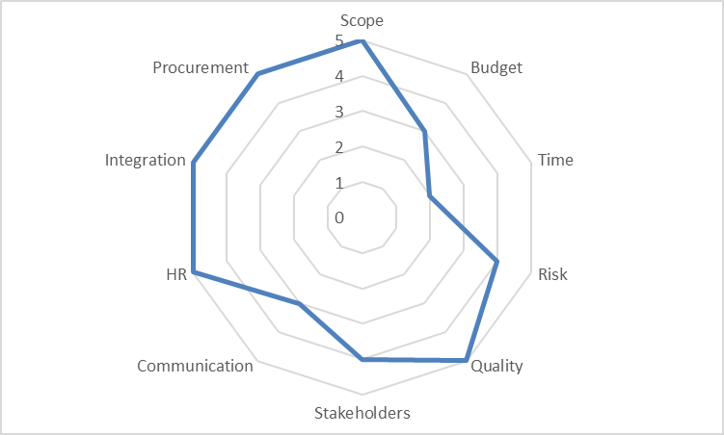
The main lessons, which stem from the current analysis, are related to the complexity of accurately managing large-scale projects with long durations. The inability to precisely forecast the changes in the external environment is a main challenge requiring conservative projections, buffers and other risk management tools to cope with emerging problems.
As a large and public company, Google must also emphasise the importance of sustainability in all business areas, including construction. The choice of eco-friendly materials and processes, waste minimisation, recycling, carbon-neutral technologies, efficient lighting, better conservation practices and other innovative approaches is of critical importance for the achievement of a more sustainable performance (Jackson, 2021). It is also worth mentioning that sustainability is a key performance area of Google since the company aims to achieve net zero by the tear 2030 (Panettieri, 2023). Moreover, sustainable development is not only an area of growing importance from a legal point of view, as indicated in the stricter environmental regulations, but also a key ethical and philanthropic activity. Thus, project management should be considered an element of Google’s corporate social responsibility (CSR) policies and practices, as well. In the context of CSR, the role of the triple P, which is also known as the triple bottom line, is also relevant (Kenton, 2023). This means that the project must fulfil not only economic goals, but also environmental and societal ones; thereby, simultaneously addressing the profit, people and planet requirements (Kenton, 2023). Thus, the success of the project is evaluated by its ability to combine economic, environmental and social objectives (Kenton, 2023).

References
Construction UK (2022) Google HQ: Bearing the weight of a grand vision, [online] Available: https://constructionmaguk.co.uk/google-hq-bearing-the-weight-of-a-grand-vision/ [Accessed: 23 December 2023]
Cost Modelling (2023) UK tender price and building cost indices, [online] Available: https://costmodelling.com/construction-indices [Accessed: 28 December 2023]
E-architecture (2023) Google Buildings: New Office Architecture, [online] Available: https://www.e-architect.com/articles/google-buildings [Accessed: 28 December 2023]
Francis-Devine, B., Harari, D., Keep, M., Bolton, P., Barton, C. and Carthew, H. (2023) Rising cost of living in the UK, [online] Available: https://commonslibrary.parliament.uk/research-briefings/cbp-9428/ [Accessed: 21 December 2023]
Gillespies (2023) Goggle headquarters, [online] Available: https://www.gillespies.co.uk/projects/google-headquarters [Accessed: 23 December 2023]
Guo, L., (2015) Implementation of a Risk Management Plan, International Journal of Nursing Sciences, Vol. 2(4), pp. 348-354.
Hess Timber Limitless (HTL) (2023) Google KGX1 London Headquarters, [online] Available: https://www.hess-timber.com/en/references/detail/google-kgx1-london-headquarters/ [Accessed: 30 December 2023]
Jackson, C. (2021) The Methods and Benefits of Sustainable Construction, [online] Available: https://www.construction21.org/articles/h/the-methods-and-benefits-of-sustainable-construction.html [Accessed: 31 December 2023]
Karlsen, J. (2002) Project Stakeholder Management, Engineering Management Journal, Vol. 14(4), pp. 19-24.
Kenton, W. (2023) Triple Bottom Line, [online] Available: https://www.investopedia.com/terms/t/triple-bottom-line.asp [Accessed: 31 December 2023]
Massay, C. (2023) What is Procurement in Construction? (And What Are The Best Methods?) [online] Available: https://www.theaccessgroup.com/en-gb/construction/software/procurement/what-is-procurement-construction/ [Accessed: 30 December 2023]
Moreno-Marimbaldo, F. and Manso-Callejo, M. (2020) Methodological Approach to Incorporate the Involve of Stakeholders in the Geodesign Workflow of Transmission Line Projects, International Journal of Geo-Information, Vol. 9(1), pp. 178-204.
Office Reality (2022) Googles new HQ costs 1 billion pounds but is it enough to tempt people back in to the office? [online] Available: https://www.officereality.co.uk/blog/googles-new-landscaper-hq-at-kings-cross-london-costs-1-billion-pounds-but-is-it-enough-to-tempt-people-back-in-to-the-office#:~:text=%C2%AB%20Design-,Googles%20new%20HQ%20costs%201%20billion%20pounds%20but%20is%20it,back%20in%20to%20the%20office%3F&text=If%20you%20have%20been%20anywhere,gauntlet%20alongside%20the%20railway%20lines [Accessed: 23 December 2023]
Olawale, Y. and Sun, M. (2015) Construction project control in the UK: current practice, existing problems and recommendations for future improvement, International journal of project management, Vol. 33(3), pp. 623-637.
Omoregie, D. and Radford, D. (2006) Infrastructure delays and cost escalation: Causes and effects in Nigeria, [online] Available: https://core.ac.uk/download/pdf/78911604.pdf [Accessed: 23 December 2023]
Panettieri, J. (2023) Google Sustainability Strategy: Mike Werner's New Role and Responsibilities, [online] Available: https://sustainabletechpartner.com/topics/talent/google-sustainability-strategy-mike-werners-new-post/#:~:text=Google%2C%20owned%20by%20Alphabet%2C%20is,includes%20cloud%2Dcentric%20sustainability%20partnerships [Accessed: 31 December 2023]
Permasteelisa Group (PG) (2023) Google KGX1, [online] Available: https://www.permasteelisagroup.com/project-detail?project=1797 [Accessed: 28 December 2023]
Pinto, J. (2016) Project Management, 4th edition, Boston: Pearson Education Limited
Reuters (2023) Alphabet Inc., [online] Available: https://www.reuters.com/markets/companies/GOOGL.O/ [Accessed: 30 December 2023]
Shead, S. (2022) Google expands London property empire with $1 billion office purchase, [online] Available: https://www.cnbc.com/2022/01/14/google-expands-london-property-empire-with-1-billion-office-purchase.html [Accessed: 30 December 2023]
Shead, S. (2023) An Inside Look at the Plans for Google's Massive New London Headquarters, [online] Available: https://www.inc.com/business-insider/google-headquarters-uk-offices-london-landscraper-pool-basketball-court.html [Accessed: 30 December 2023]
Wilde, D. (2022) Google wants to turn its King Cross HQ into a destination for tourists, community projects, and more, [online] Available: https://9to5google.com/2022/04/14/google-wants-to-turn-its-king-cross-hq-into-a-destination-for-tourists-community-projects-and-more/ [Accessed: 30 December 2023]

