
The infection rate of Covid – 19 varies between white people and BAME in the U.K.

Student name: Dzhuliano Alenov Stefanov (2027630)
Module name: Data Analysis & Visualisation
Module code ACCB4002
Lecturer: Koushik Modak
Submission Date: 10/01/2022

Table of Content
Introduction …...................................................3
T-test .............................................................................3
Explaining the T-TEST..........................................................................3
Hypothesis.........................................................................................................3
How to develop Null hypothesis and Alternative Hypothesis 3
Description of Dataset 4
A numerical measure of Central Tendency...............................................................................4
The measure of central tendency 4
Mean 4
Median 4
Mode 5
Using the Mean and Standard Deviation to Describe Data 5
Numerical Measures of Relative Standing 5
Visualization of Dataset.......................................................................................................7
Analysis 6
Outliers of the Dataset 6
Factors Affecting the Hypothesis Testing..............................................................................7
Sample Size 7
Variance...................................................................................................................7
Experimental Design 7
Result 7
Conclusion…………………………………………………………………………………11
References...................................................................................................................12

[1]Introduction
A t-test is a form of inferential statistics used to determine whether two mean values differ significantly and are associated with specific characteristics. The t-test is used to test hypotheses, which allows a population to test its assumptions when the data sets follow a normal distribution or might have no variances, as the data sets are the result of spinning a coin 100 times. In the case of testing three or more means, variance analysis is necessary to determine the significance levels of the t-statistic, t-distribution, and free levels.

[1]Explaining the T-test
The t-test allows for comparing the mean of two data sets to see if they are from the same group. In the example above, if we take a sample of Class A students and another class B student, we should not expect them to have the same mean and standard deviation. Additionally, the mean values and standard deviations of samples from the placebo-control group and prescription-drug group should be slightly different. Assuming that the null hypothesis is that the two devices are equal, the t-test constructs a solution using a sample from each set.
Following this, a few values are calculated and compared to average values, and the null hypothesis is accepted or rejected based on the results of the calculation. In this case, the null hypothesis meets the rejection criteria, and the readable data cannot be random. The T-test is one of many tests used for this purpose. To check for more variables and larger samples, statisticians should use tests other than t-tests.
The T-test is used by statisticians for large samples. The chi-square test and f-test are other options for testing.

[2]Hypothesis
(Plural) The hypothesis is the explicit, testable statement of the investigation results that the researchers expect. In general, that includes the possibility of a connection between the independent variable (what changes the researcher) and the dependent variable (what the research measures). In research, it is standard to have two versions of a hypothesis: the null hypothesis and the alternative hypothesis (known as the experimental hypothesis if the method of investigation is an experiment).

[3]How to develop Null hypothesis and Alternative Hypothesis
[3]Null hypothesis: there is no relationship between the measured phenomenon (dependent variable) and the independent variable. You do not have to believe that the null hypothesis is true to prove it. However, you may suspect a relationship between the set of variables. One way to prove this is to reject the null hypothesis. Rejecting the hypothesis does not mean that the experience was "bad" or did not work. This is usually the first step in a thorough investigation.
To filter it from other assumptions, the initial hypothesis is written as H0 (pronounced "H-something", "H-null", or "H-null"). The semantic test determines the possibility that the result supporting the null hypothesis is not random. A 95% or 99% confidence level is normal. Keep in mind that although confidence is high, the chance that the null hypothesis is not true is minimal, perhaps because the experimenter had not considered vital factors or the accident. This is one of the reasons why a repeat experience is essential.
If you test the two-tail hypothesis, the second hypothesis states that the parameter population is not equal to the value of the null hypothesis. For example, if the second hypothesis is H.A.: μ ≠ 0, the test may detect a difference greater than or less than zero. A one-sided hypothesis can test only one difference in one direction. For example, H.A.: μ> 0 can only test a difference greater than zero.

Description of Dataset
When we talk about a data set, we refer to one sample or population. If the statistical inference is our objective, we will want to make conclusions about the appropriate measurements for the population using samples of descriptive numerical measures. The central tendency of the measuring package: Cluster or the central tendency of data concerning numerical values the variability of the measuring set: Data Distribution
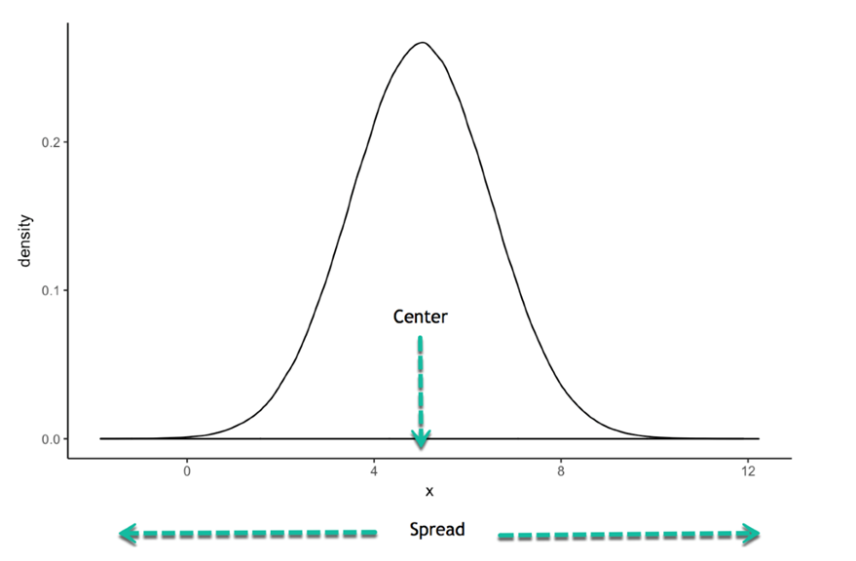

[4]The measure of central tendency

Mean
Measures divided by the number of measurements in the data set are the mean of a quantitative dataset. The mean sample, ̄xx, is crucial to inferencing people based on sample information. Therefore, we must use a different sign to use the mean of a population.

Median
When measures are organized in the up (or downward) order, the median of a quantitative dataset is in the middle numbers. In some instances, the median can be a better indicator of the central tendency than the mean. The median is less susceptible to exceptionally large or tiny values than the mean. A data set will be shifted if more severe observations are on one tail than the other.
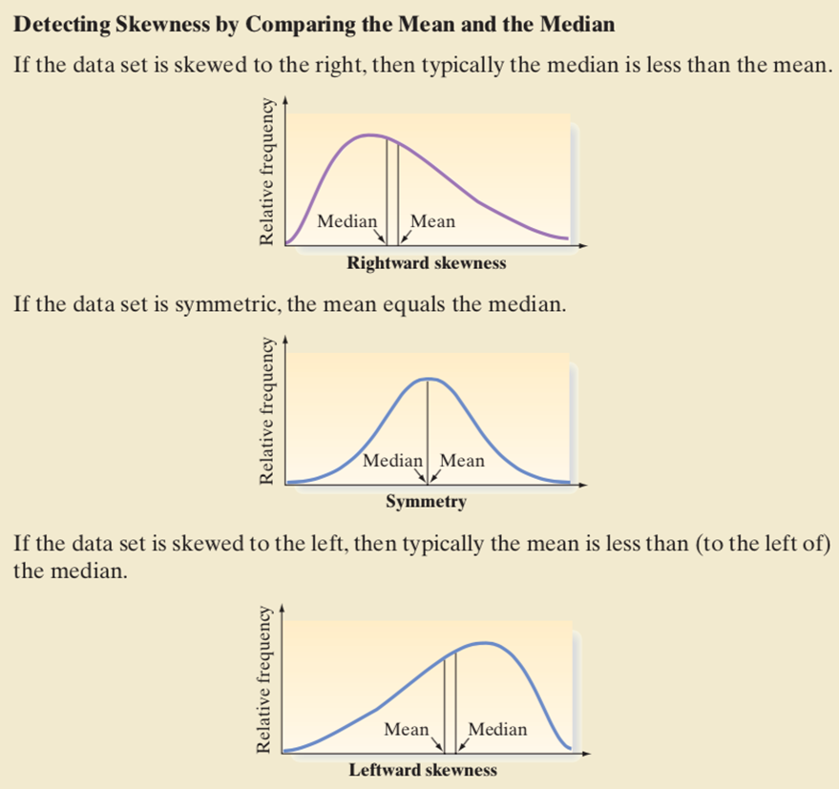

Mode
The mode is the measurement that occurs in the data set.

Using the Mean and Standard Deviation to Describe Data
The sample with the bigger standard deviation is more varied if anybody compares the variability of two samples chosen from a population. We know thus how the standard deviation may be disrupted on a relative or comparative basis. However, we have never described how the deviation is measured for a single specimen.

Numerical Measures of Relative Standing
The t-score is another indicator of relative widespread use. The t-score uses the mean and standard deviations of the data set to describe the relative position of the measurement, as you will see in the definition of t-score below. Note that z-score is derived from ̄xx ̄ measurement, then ss. (or Ś ̄) is subtracted. The measurement is then divided by ss. The result, t-point, reflects the distance from the standard deviation between a particular measurement XX and the mean.
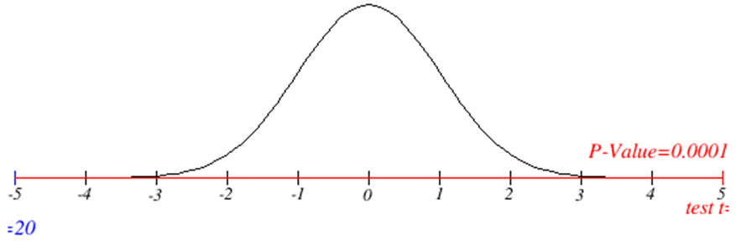
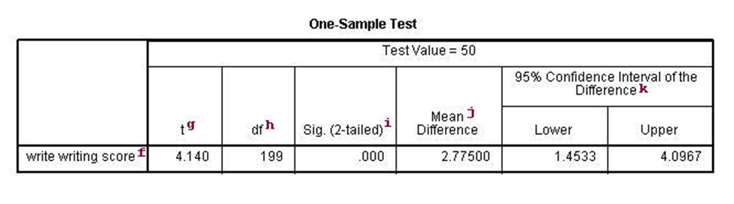
F. - This decides the variable. Every factor recorded in the variable sentence has its line in this piece of the result. If the variable = proclamation is not determined, the t-test plays out a t-test for all data set numbers.
G. t-This is understudy t measurements. The proportion of the contrast between the mean example and the number allocated to the standard blunder of the standard is: (52,775 - 50)/0,6702372 = 4,1403. Since the standard mistake of the mean estimates the changeability of the mean of the example, the more modest the standard blunder of the mean, the nearer the mean of our example is to the genuine mean. The accompanying three pictures show this thing.

[5]Outliers of the Dataset
External observation is exceptionally huge or tiny. Outliers can disproportionately impact statistical outcomes, such as the average, which can lead to erroneous interpretations. However, in this supplied dataset, there are no outliers.

Identify the T-test.
Upon analysing the dataset, I chose to compare the two free examples because each of them meets three fundamental conditions: they are contrasting; they are free (there is no association between the request for information passage for subjects in one gathering and the request for information section in the other gathering), and the variable (reliance) is dependent upon correlation is communicated mathematically (as indicated by the span scale or size of extents).

Express the Null and Alternative theories.
Invalid theory: Is no huge distinction in contamination paces of disease among (white) and B-A-M-E individuals in Great Britain.
Elective theory: There are fundamentally different disease rates of Covid-19 among white and BAME individuals in the United Kingdom.
Ascertain the level of opportunity (df) after the recipe df=N-2=n1+n2-2=50+50-2=98.
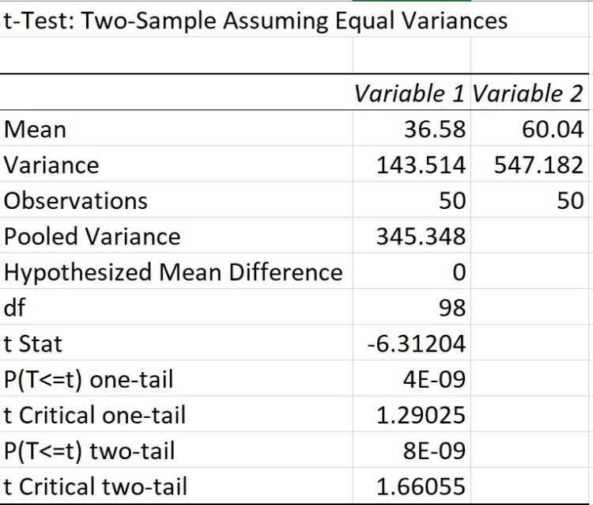
Ascertain t-out Below are examples of the t-Test calculations in Excel at these degrees of importance.

For a significance level of p=0.10, Excel performs the T-test.

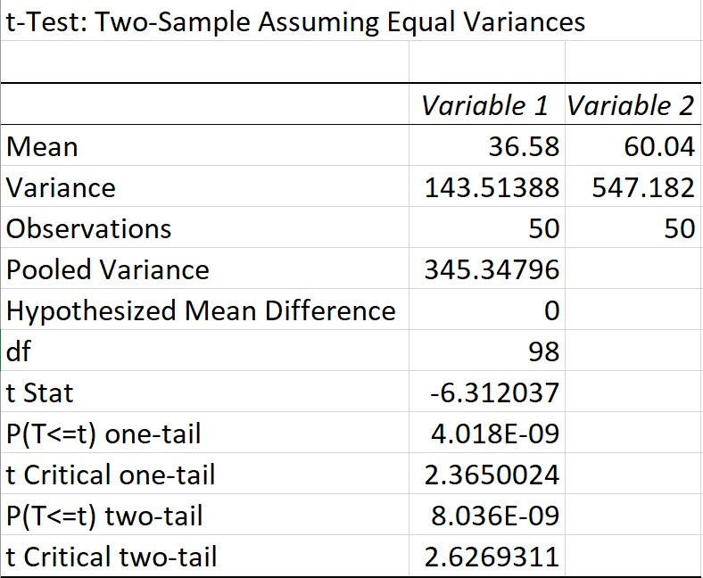
4. Excel T-test for a significance level of p=0.01.
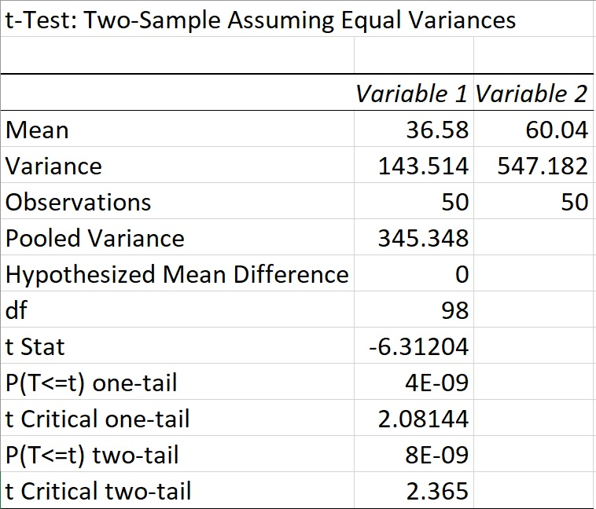
5. Using Excel, the T-test for a p-value of 0.02.
Decide whether to discard the speculation if it is invalid., The study analysed the T-esteem acquired (outright worth, paying little attention to the worth sign) with the classified qualities for either the one-followed or two-followed tests. the t esteem was analysed (outright worth, ignoring the worth sign) with the classified characteristics Based on the dataset provided, the value of t is -6.31, at 98 levels of opportunity (df = 50+50 - 2 = 98). The inquiry is: 'What is the probability of presenting a sort I screw up with a value of t of - 6.31, at 98 degrees of given an open door? ‘To address this request, we need to direct the probability table of t regards (Table 4). Not really set in stone t regard is higher than the fundamental worth (contrasting with 98 degrees of chance), the significance level p will be under 0.05 for undirected hypothesis and a short time later 0.025for an organized hypothesis, so the invalid theory will be excused. In our dataset, the t regard is quantifiably tremendous, both for a test with two-followed hypothesis and for a one-followed test, since promote = 6.31 is more vital than t crit = 1.66/2.62/2.36. Taking everything into account, we can excuse the invalid hypothesis since promote > t crit and we can concede that there is a basic distinction in the infection paces of Covid-19 among light coloured and BAMEs in the Great Britain
The outcomes are measurably huge at the 01, 02, .10 levels separate in almost 100%, 98%, 90% levels. Not exclusively is tout huge, yet the upsides of the means are essentially unique. Based on the review, we conclude that the contrast between the disease paces of BAME and white individuals in the UK is essentially larger. The difference in contamination rates between BAME and white patients implies an extremely large impact size.
. It analyzed the t esteem acquired (outright worth, paying little heed to the worth sign) with the classified qualities for either the one-followed or two-followed test. In the dataset given, the worth of t is - 6.31, at 98 levels of opportunity (df = 50+50 - 2 = 98). The inquiry is: 'The thing that is the likelihood of submitting a sort I blunder with a worth of t of - 6.31, at 98 levels of given opportunity?' To address this inquiry, we want to counsel the likelihood table of t esteems (Table 4). Assuming the determined t esteem is higher than the basic worth (comparing to 98 levels of opportunity), the importance level p will be under 0.05 for undirected speculation and afterward 0.025for a coordinated theory, so the invalid speculation will be dismissed. In our dataset, the t esteem is measurably huge, both for a test with two-followed speculation and for a one-followed test, since tout = 6.31 is more noteworthy than t crit = 1.66/2.62/2.36. Taking everything into account, we can dismiss the invalid speculation since tout > t crit and we can concede that there is a critical contrast in disease paces of Covid-19 among white and BAME individuals in the United Kingdom.
The outcomes are measurably huge at the .01, .02, and .10 levels separate at almost 100%, 98%, 90% levels. Not exclusively is tout huge, yet the upsides of the means are essentially unique. We close dependent on our review that the contrast between the disease pace of Covid-19 of BAME is essentially bigger than that of white individuals in the UK. It is an enormous impact of the distinction between the mean contamination pace of the BAME and white patients, inferring that impact size is huge in extent.

Outliers in the dataset
The lower and upper limits in our data set are 20 and 100, respectively. White and BAME patients under the age of 20 and over the age of 100 are considered abnormal. Next, I'll look at whether we're given a dataset and, if we include these outliers, what type of tout and t crit we get, and what happens when we remove the outliers. The first table shows the t-Test calculation in Excel with outliers included, and the second table shows the t-Test without outliers.
Table number 1
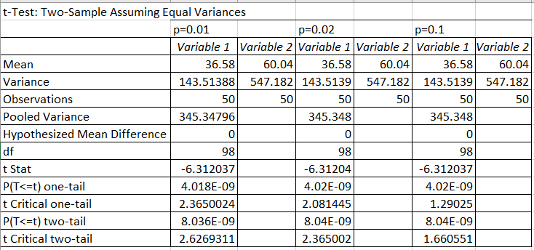
Table number 2

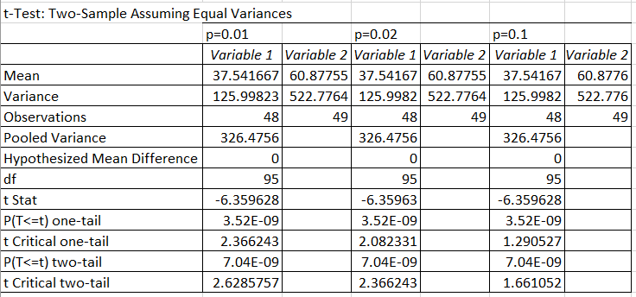
At the point when we think about Tables 1 and 2, we can see that eliminating the exceptions impacts the example size and the engaging insights created from white and BAME individuals. The mean and difference are essentially unique for every p esteem. Meanwhile, the t obt values are exceptionally close, and the t crit one-tail or two-tail is something very similar.
At long last, we should consistently look out for anomaly esteems. They are now and then the consequence of a mistake. Oddities in qualities can periodically show the presence of a formerly obscure peculiarity [8]. Numerous spellbinding measurements are touchy to anomalies, which is another explanation we should be industrious in confirming exceptions. For the related information, these insights incorporate the mean, standard deviation, and relationship coefficient.

Conclusion
The subsequent theory is one of two unrelated speculations when testing theories. The subsequent speculation expresses that the worldwide boundary is not equivalent to not set-in-stone qualities. This is normally the invalid theory esteem related to the impact, like zero. Assuming the example contains sufficient proof, you can dismiss the invalid theory and back the subsequent speculation. The subsequent speculation is normally introduced utilizing H1 or H.A.
Coronavirus in the U.K. is two times as high as among whites. Likewise, individuals with a BAME foundation are bound to play the lead. The over-cooperation of the British Covid-19 in the BAME people group shows long-standing imbalances in the public arena and reaffirms the fundamental connection between race, identity, financial status, and wellbeing results. Potential explanations behind the distinction incorporate the high extent of BAME staff at the front line, the imbalance of social and financial assets, the exorbitant danger of BAME staff in the NHS, and the high racial vulnerability to specific Covid-19-related illnesses. In the U.K., racial disparities in the wellbeing impacts of Covid-19 should be tended to direly. We offer strategies for settling complex ethnic contrasts. Albeit these distinctions are not altogether new in themselves, they are regularly methodically overlooked.

References

[1] | “https://www.investopedia.com,” [Online]. Available: https://www.investopedia.com/terms/t/t-test.asp.
[2] | “https://thewordcounter.com,” [Online]. Available: https://thewordcounter.com/plural-of-hypothesis/.
[3] | C. Zaiontz, “https://www.real-statistics.com,” [Online]. Available: https://www.real-statistics.com/hypothesis-testing/null-hypothesis/.
[4] | “https://corporatefinanceinstitute.com,” [Online]. Available: https://corporatefinanceinstitute.com/resources/knowledge/other/central-tendency/.
[5] | J. Frost, “https://statisticsbyjim.com,” [Online]. Available: https://statisticsbyjim.com/basics/outliers/.

