



Marketing Planning for Innovative Customer Care Report
Assignment 2 (Module Code BMMB7012)
Submitted to Davina Evans & Jayne Williams

Executive Summary Contents
This report will focus on the current marketing strategies of ASOS and how they plan to improve overall customer care and performance of the organisation, it will also look at definitions of Marketing and future strategies that can be implemented into ASOS to make them more successful for the future and will also consider what innovative customer care really is and what it means within ASOS as a brand and how they have made these into a vision of the organisation to focus on the consumers who make their business what it is today and why customer service is so important to ASOS.
Also, it will focus on how and why ASOS bought part of the Arcadia Group and why they chose the specific stores which included Miss Selfridges, Topman and Topshop.
Included in this report is a STEEPLE analysis and SWOT analysis of ASOS and a marketing plan which includes the objectives of the organisation and strategies and key tactics to create new customer innovation and customer care and the Ansoff marketing matrix which will determine how to implement these strategies into ASOS for the future.
As well as the included in this report are strategic recommendations and key strategies for implementing the various objectives that have been chosen for ASOS.

Contents
- Introduction 4
  - Background Information
  - What is Innovative Customer Service 5
- Innovative Customer Care Recommendations 7
  - Unique Customer Service Ideas 7
  - Why Customer Service Matters 8
  - Comparison of ASOS and Debenhams 8
- How and Why ASOS bought Topman, Topshop, and Miss Selfridges 10
- STEEPLE Analysis 12
  - SWOT Analysis 14
- Marketing Objectives and Strategic Review 16
- Marketing Growth Strategies 17
  - Marketing Strategies for the Objectives 18
  - ASOS Digital Marketing Strategies 18
  - Mission to be the world’s number one destination for fashion 19
- Recommendations for resources 21
- Recommendations on how performance will be monitored 22
- Conclusion 23
- References 24

1.0 Introduction
This report focusses on creating innovative customer care for ASOS. This will be done using reviews online of ASOS formally known AsSeenOnScreen and looking at strategic ways to improve the overall customer care experience for clients who shop with ASOS on a regular basis. Also, it will critically discuss the definitions of innovative customer experience and a comparison with Debenhams customer service experience and how these compare with ASOS current customer service experience plan that is already in place.

1.1 Background Information on ASOS
In 1999, two men had the idea to start a fashion industry business which copied the trending styles and designs worn by popular celebrities in the 1990's. Robertson and Griffiths did not know at the time that their small idea would grow into something as huge as ASOS is today (AsosPlc, 2021). By 2001, their website was officially www.ASOS.co.uk, and the AsSeenOnScreen name had well and truly gone. However, the reason behind the business was never forgotten, and Robertson and Griffiths still worked tirelessly to provide the elegant and stylish fashion items which had been seen on TV. Around the same time, the business was admitted to the AIM (Alternative Investment Market) on the London Stock Exchange, meaning that shares could now be floated. This enabled ASOS to benefit from shareholders and investors, helping to add more products and clothing lines. Not long after, ASOS expanded and began to sell products which were not necessarily seen on the screen. This prompted the owners and managers to think more seriously about officially changing the registered name to ASOS Limited (ASOSPlc, 2021).

1.2 What is Innovative customer service within ASOS
Innovative customer service is an experience where the customer feels that every interaction with the organisation is seamless, natural, and easy and a totally enjoyable experience (Babbar, 2008). ASOS base their customer experience on listening to customers and what they want and need from ASOS as a brand and meeting the consumers’ needs in ways they cannot yet conceive, ASOS would rather avoid conflicts, disruption and bad reputation and provide that level of drive differentiation, value, and loyalty to their consumers (Shannon, 2020).
According to what the Journalist Mikhail Dubov (2017) had to say “The secret is ASOS’ laser-like focus on all aspects of Customer Experience including Sign Up, Navigation, Payment, Returns and Customer Care. In this ASOS follows another great fashion retailer, Zappos, who, in the words of their customer-obsessed founder are a “service company that just happens to sell shoes” (ASOSPlc, 2021).

2.0 Innovative Customer Care Recommendations for the future of ASOS
For ASOS to be successful for the future a new way of Customer Care needs to be designed and implemented within the organisation. It would be helpful for ASOS to think about ways they can innovate the customer experience, this can be done by looking at companies that have done it. Here are four organisations that have created innovate your customer experience learning from these companies which would help ASOS in the long term. Lemonade, McDonalds, Amazon, Walmart (Dubov, 2017).
2.1 Unique Customer Service Ideas on how to Improve Customer Care and Customer Service.
Often organisations want to differentiate themselves from competitors by doing something unique for consumers (Knowledge, 2018). When brands do something unique that surprises customers, it makes customers come back for an even better experiences from that brand, Innovative ideas are therefore effective, and they work, which is why they are so powerful (Ameyo, 2017).
Here is a list of keyways customer care for ASOS can be improved:
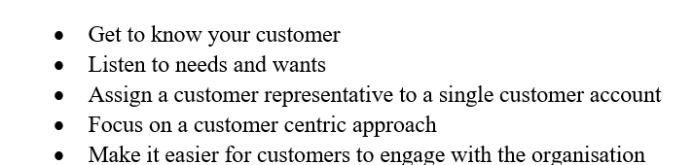
These recommendations have been made for ASOS from researching the innovative strategies that other organisations have created their customer care experience policies, this has been done by reviewing online journals and websites. By looking at the various strategies that other organisations have developed over time with customer care and innovation made it possible to create the list of recommendations for ASOS to improve customer care.
2.2 Why Customer Service Matters: Importance of Innovation in Customer Service.
The important reason for improving customer service is reputation. ASOS companies brand image and reputation depend on the way the customer service agents deal with customers on a regular basis. For example, 89% of consumers stop doing business with a company after experiencing poor customer service, according to the RightNow Customer Experience Impact Report (Ameyo, 2017).
Consumer expectations have increased dramatically in the modern digital era with the widespread adoption of innovative technologies. If companies do not adapt to changes within the organisation, the organisation may lose focus of the customer, the organisation could be losing out on a really great opportunity to make their customers even happier and make the business even more successful (Lauer, 2021).
2.3 Comparison of ASOS and Debenhams
It has been announced by Michael Sharp, the veteran chief executive of the department store chain Debenhams, that his company Debenhams was a little slow off the mark when it came to creating an internet offering worthy of the 200-yearold retailer (Simon Neville, 2013). They had various offers for consumers such as male customers would receive email offers for mens clothing and accessories and female customers would receive email offers for dresses and lingerie, However, click and-collect was unheard of and the website was slow and clunky (Mark Duell, 2020). By comparison, online fashion retailer ASOS has masses of data on every single customer, knows each item they have bought and has screens dotted throughout its head office showing real-time sales data, including the customer's location, gender and items bought (ASOSPlc, 2021).
This has left ASOS with a market value of £4.4bn while Debenhams was worth just £1.4bn the same year, in arguably one of the clearest examples of traditional bricks-and-mortar retailers losing out to their younger online upstarts (Mark
Duell, 2020).
Online sales this year are up 46 per cent at £366.3m and now account for about
15 per cent of sales, which were up 2.5 per cent at £2.28bn and way ahead of
ASOS’s £769m. But perhaps the most interesting aspect of Debenhams' online growth has been as a direct result of the new stores it has opened (ASOSPlc, 2021) (Mark Duell, 2020).

3.0 How and Why ASOS bought Topman, Topshop, and Miss Selfridge
February 2021 has seen unprecedented times for many retailers and unfortunately for Sir Philip Green and the Arcadia Group, they could not survive during the pandemic, and ended up selling Topshop, Topman and Miss Selfridges and the active brand HITT to ASOS in a £330 million deal that secured the purchases of the brands from Arcadia Group aftr the Arcadia Group went into administration in 2020 (Makortoff, 2021). ASOS paid £330m in total, including £265m for the brands and £65m for current and future stock (ASOSPlc, 2021).

This deal does not include any of Arcadia Groups warehouses or its distribution centre in Daventry. The ASOS chief executive, Nick Beighton, explained how the company already had its own “well-funded and built out warehouse strategy” and the Daventry site was not purpose-built to handle online shopping orders (Makortoff, 2021). Although ASOS bought Arcadia Group, they did not invest in buying any of the high street stores which were used for the brands Topman, Topshop, Miss Selfridges or HITT active wear, Since ASOS decided not to do this over 7000 jobs have been cut around the UK from various stores and Head Office locations (ASOSPlc, 2021) (Makortoff, 2021).

ASOS is believed to have secured the deal from other potential bidders including the Chinese fashion retailer Shein, Authentic Brands, the US owner of the Barneys department store – which was linked to a joint bid with JD Sports – and the billionaire Issa brothers, who in October announced they were buying Asda for £6.8bn (ASOSPlc, 2021).

Online group Boohoo confirmed last week it had entered exclusive talks to buy the final three Arcadia brands: Wallis, Dorothy Perkins, and Burton. Evans, its plus-size clothing brand, was sold to the Australian retailer City Chic Collective for £23m in December (Makortoff, 2021).

4.0 STEEPLE Analysis
•
Behaviour
•
Values
S
•
Supply Chain
•
Digital Marketing
T
•
Global Economy
•
Impact of Covid
-
19
E
•
Suppliers, Distribution, Customers, Competitors, Government
E
•
Impacts of Brexit
•
Sales Taxes
P
•
Security and Cyber Threats
L
•
Working Standards and Conditions, Diversity, Equal Opportunities,
Integrity, Human Rights
E

Figure 1 STEEPLE Analysis
By examining the information contained within the STEEPLE Analysis of ASOS, there are many different factors surrounding the analysis of the organisation as there are many factors that can affect the overall business and its performance within the retail sector. Some of these factors are very important for the successful running and sustainability of ASOS (ASOSPlc, 2021).
By looking at the Socio-cultural factors this would include the company values and beliefs and behaviour of staff within the organisation as these are key to the success of any organisation and play a huge role on how consumers view the brand ASOS. Unfortunately, if the organisation does not meet standards for values and beliefs and behaviour, they will find that the consumer will not rely on information posted from the organisation (ASOSPlc, 2021).
Notably, ASOS have a good supply chain network within the UK, America, and Australia to be able to deliver supply and demand to its stores around the globe and online consumers, this is essential to any business and vital for the overall success of the organisation (ASOSPlc, 2021).
From the Ecological factors surrounding the organisation these could be seen as long-term problems if they are not managed correctly by directors, senior management, and staff. The Ecological factors such as distribution, suppliers, and the government all play a crucial role within ASOS, this may not seem obvious to the everyday person but for management they need to work closely with all of these to ensure the overall business success. Although ASOS has many high-street competitors, it would be hard to compete with ASOS due to their upcoming fashion lines from a basic range all the way to brands such as Tommy Hilfiger for the fashion aware consumers.
Whilst there are many ethical issues that could affect the overall running of ASOS, these factors do not cause much issue within the organisation, ASOS are known for excellent working standards for staff, diversity, and equal opportunities for staff, these are all vital to the organisation and the company would not be as successful as they are now if they treated staff unfairly.

4.1 SWOT Analysis
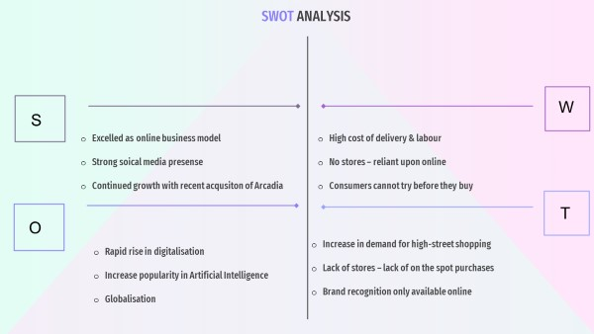
Figure 2 SWOT Analysis

Strengths
ASOS have excelled in recent years, and with the pandemic it has forced high street retailers to shut, However ASOS could still operate, with more demand and thriving through their tried and tested model, while other organisations faced having to vastly improve their online presence (Bhasin, 2019). The use of social influencers to help promote the brand, ASOS have a presence on all social media platforms which means that consumers can access the ASOS site and purchase in just a few clicks (Bhasin, 2019).
Continued growth with recent acquisition of Arcadia brands Topman, Topshop and Miss Selfridge which was an astute business move to bring their brands customer base to ASOS online and the emphasis on ethical practice through warehouses and distribution has ensured staff are paid the living wage and have good working conditions (Bhasin, 2019).
|However, the high cost of delivery and labour, and with Brexit makes it more of a challenge with higher export /import fees (Bhasin, 2019). Now there are no stores meaning that they rely heavily on the internet and consumers may initially want to go shopping on the high street as restrictions are lifted and people feel safer to shop in the big cities (Bhasin, 2019). Additionally, consumers cannot try on products and must order then send back which can be inconvenient for some and cost more shipping fees for ASOS (Bhasin, 2019).
Nonetheless, with the rapid rise in digitalisation ASOS remain front runners in the retail fashion and cosmetics industry in the UK and are well equipped and have the years’ worth experience as more and more brands move online (Bhasin, 2019). The tactic of using artificial intelligence tools to help develop the customer experience on the site to feel as if they are physically their which will enhance the experience (ASOSPlc, 2021).
However, it could go the other way when the consumer demands change and shift back to shopping on the high street as consumers can try items on in store and get to shop with friends that they have not seen for a while due to the pandemic (Bhasin, 2019).Having stores sometimes pushes people into making on the spot purchases and as there are no stores the lack of footfall is something that competitors do not do (Bhasin, 2019). Brand recognition can be hindered by not having stores, and this is where ASOS are missing out on for those that prefer not to online shop (Bhasin, 2019).

5.0 Marketing Objectives and Strategic Review
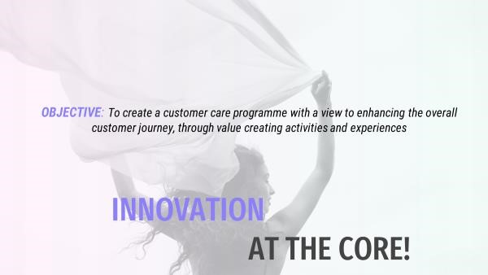Figure 3 Current Objectives

Mission aim to be
‘world’s number
-
one
destination for fashion
-
loving
-
20
-
somethings
2.7
bn digital platform
visits in 2020
Digital Strategy including
‘ASOS Insiders’

6.0 Marketing growth strategies for products with the help of Ansoff matrix
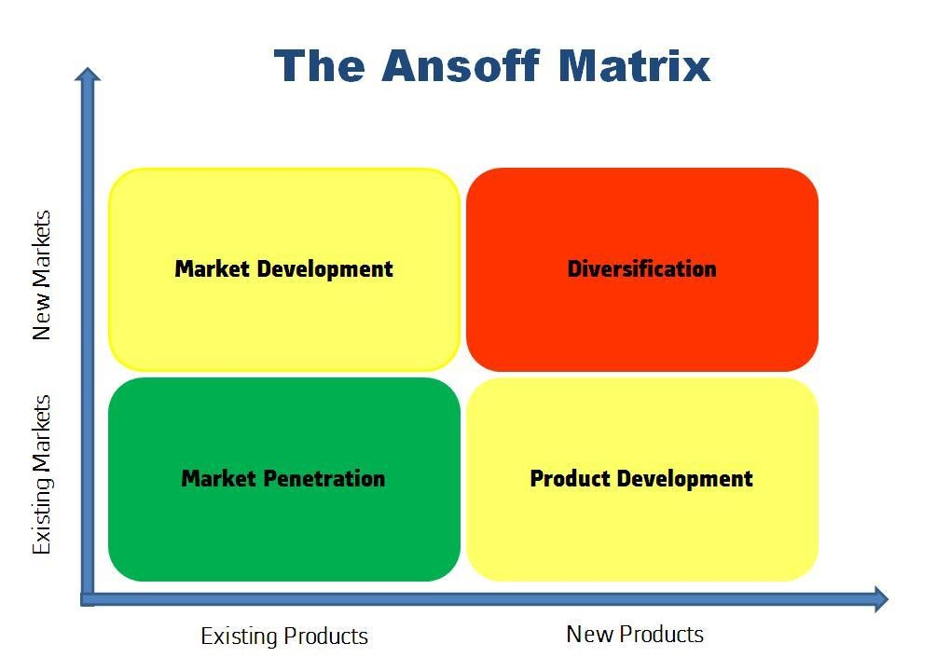

Figure 4 Ansoff Marketing Matrix (Google, 2021)
Definition declares that market growth is an increase in the demand for a particular product or service over time within an organisation (Patrick M. Wright, 2019). Market growth can be small if the buyers do not approve the product or big if they discover the beneficial view of the product for money that corresponds to it. The primary wish that every organisation makes when they create a company is to grow their business and boost sales and earnings (Babbar, 2008). But in today's world it is difficult for a company to maintain in the market let alone to expand its business. Research suggests that only one-tenth of 1 percent of companies will ever reach $250 million in annual revenue (Shannon, 2020).

By Applying the Ansoff Matrix diagram to the ASOS marketing objectives could be very helpful to the issue of expanding the organisation or not via incorporating digitalisation into their current strategies.

6.1 Marketing Strategies for the Objectives
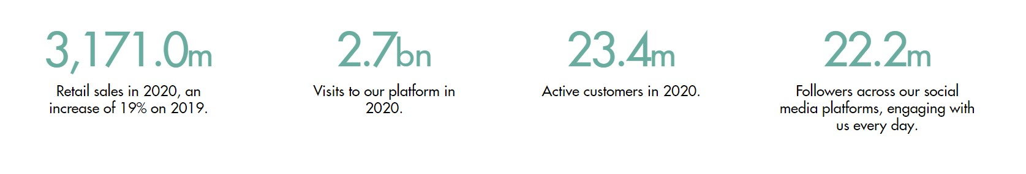

Figure 5 Asos Marketing Objectives (Google, 2021)
6.2 ASOS Digital Marketing Strategies.
It is therefore evident that the current marketing strategies used by ASOS are directed toward reaching the wider target audience. The use of social platforms and digital channels is an efficient method of promotion and distribution that ensures communication and personalization as well as the possibility to determine the audience’s demands and fulfil expectations (Dave Chaffey, 2019).

ASOS has adopted a cross-channel approach by using some paid and organic channels to promote the brand and product range (ASOSPlc, 2021). This approach is consistent with the increasing demand for fashion stores’ presence in social media and the popularity of e-commerce platforms (Dave Chaffey, 2019). This apparently, ensures the balance between mass reach and targeting as such campaign helps analyse the areas where customers’ demand is the largest and where they consume the most while giving them something valuable in exchange for this opportunity (ASOSPlc, 2021) (Kingsnorth, 2019).
Therefore, by implementing a digital marketing strategy into ASOS will boost their use of digital-channels and social media in general for representing their offerings and promoting the brand to the wider target audience as well as for attaining data for the further analysis of consumer tendencies (J Singh, 2020) (Dave Chaffey, 2019).
6.3Mission aim to be ‘world’s number-one destination for fashion-loving20-somethings.
ASOS is a unique business that runs multiple fashion lines from one online store, it is an experience that can truly resonate with consumers from start to end because it is designed and built by the employees of ASOS themselves, it is classified as a place to develop your own unique style and be inspired by the fashion that is available online (ASOSPlc, 2021).

ASOS have stated that they want to become the world's number one destination for fashion loving 20-somethings by the end of 2021, this is a truly inspiring goal from the management of ASOS, but by them having this vision and objective is creating a way forward for the organisation within the fashion industry (ASOS,
2021) (Nick Beighton, 2021).

For ASOS to do this they need to create a strategy to make this happen within the next 6 months and they need to create a brand ambassador strategy that will focus on putting the brand out there for potential consumers. The strategy could include but is not limited to the following:
- Recruitment of brand ambassadors for the organisation, these could be current consumers who are totally in love with the products that ASOS sell online and this could be done via their own website and even by using social media platforms where ASOS could advertise that they are looking for brand ambassadors to represent the organisation and give the company a good ‘vibe’ and reputation among potential consumers that have not quite heard about ASOS.
- Run Facebook and Instagram adverts. Client’s brand probably already has a social media presence, but they have trouble growing their followings and engagement metrics.
- Run ads on Twitter. On Twitter, launch brand-awareness campaigns by promoting your tweets and paying for impressions instead of engagements.
- Partner with influencers to review your brand. If having trouble connecting with your target audience, you may want to try reaching them through their favorite creators and influencers.
By implementing these strategies within the organisation this would potentially boost ASOS chance of becoming the world’s number one for fashion loving 20somethings, these strategies have been created using online strategic tools and
Ansoff’s marketing model.

7.0 Recommendations of resources required
The resources required to implement the chosen objectives into ASOS would be the following
- Funding
- Computers
- Staff
- Brand Ambassadors
- Celebrities
- Backing from Stakeholders

8.0 Recommendations of how performance will be monitored

The performance can be monitored using data collection via statistics from the ASOS website and social media platforms used to implement these objectives. By using the data collected this gives a more accurate guide of how the statistics have improved or stayed the same since starting the process of implementation of ASOS objectives (Martin, 2010). The following are also effective ways of data collection that are used widely among various organisations to gain a sense of the organisation’s performance.
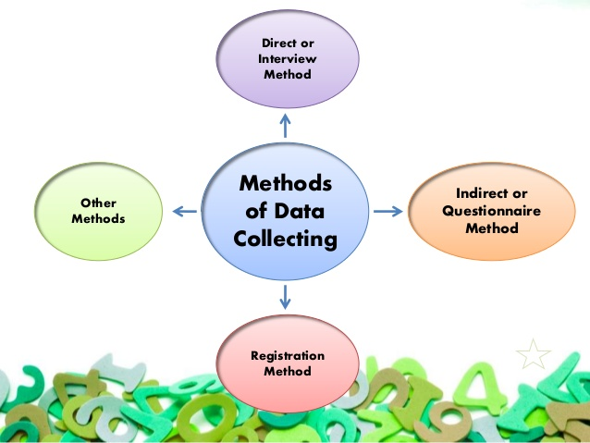
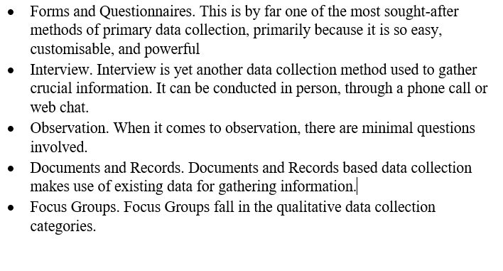

9.0 Conclusion
Following the research, it shows that ASOS has managed to reach their target objectives.
- Since ASOS bought part of the Arcadia Group, ASOS has significantly improved in revenue

- Evidence has shown that without ASOS intervention the brands known as Miss Selfridges, Topman and Topshop would have closed permanently.

- Statistics have shown that ASOS have significantly improved with digitalisation of the organisation since 2019

- Evidence has also proven that ASOS have become the world's number one fashion retailer for consumers ages 20 plus.

10.0 References
Ameyo, T., 2017. The Big List of Innovative Customer Service Ideas to Create Happier Customers. [Online]
Available at: https://www.ameyo.com/blog/innovative-customer-service-ideas
[Accessed 18TH June 2021].
Asos, 2021. LEADERSHIP & CORP GOV. [Online]
Available at: https://www.asosplc.com/investors/leadership-corporate-governance?source=content_type%3Areact%7Cfirst_level_url%3Aarticle%7Csection%3Amain_content%7Cbutton%3Abody_link
[Accessed 21st June 2021].
AsosPlc, 2021. ASOS Company Information. [Online]
Available at: www.asosplc.com/companyoverview
[Accessed 11Th June 2021].
Babbar, S., 2008. Improving Customer Service. Innovation within customer care, 2(1), pp. 79-106.
BasuMallik, C., 2018. HR Technology Trends to Track in 2019. [Online]
Available at: https://www.hrtechnologist.com/articles/digital-transformation/5-new-hr-tech-trends-to-track-in-2019/
[Accessed 16th February 2021].
Bhasin, H., 2019. ASOS Swot Analysis. [Online]
Available at: https://www.marketing91.com/swot-analysis-of-asos/#:~:text=%20Swot%20Analysis%20of%20ASOS%20%201%20Strengths,products%20in%20terms%20of%20positioning%20and...%20More%20
[Accessed 14TH June 2021].
Britannica, T. E. o. E., 2017. Change Management. [Online]
Available at: https://www.britannica.com/biography/Kurt-Lewin
[Accessed 24 May 2021].
Dave Chaffey, F. E.-C., 2019. Digital Marketing. 7th ed. London: Pearson.
Dubov, M., 2017. We Analysed ASOS’s Customer Experience and Here’s What We Found. [Online]
Available at: https://blog.chattermill.io/we-analysed-asoss-customer-experience-and-here-s-what-we-found-6a203d685a91
[Accessed 13TH June 2021].
Fahri Karakaya, N. G. B., 2010. Impact of online reviews of customer care experience on brand or company selection. [Online]
Available at: https://www.emerald.com/insight/content/doi/10.1108/07363761011063349/full/html
[Accessed 18TH June 2021].
Google, 2021. Google Images. [Online]
Available at: www.googleimages.com
[Accessed 11th June 2021].
HA, H., 2014. Change Managment for Sustainability, New York: Business Expert Press.
J Singh, G. B., 2020. One-Voice Strategy for Customer Engagement. [Online]
Available at: https://journals.sagepub.com/page/jsr/customer-exp-collection
[Accessed 18TH June 2021].
Jackson, R., 2020. Modernizing Portals and Data with AI. [Online]
Available at: https://www.govwebworks.com/2020/06/23/modernizing-portals-and-data-with-ai/
[Accessed 27th March 2021].
James, W., 1978. Consumer Needs, Denmark: Triberg University.
John E. Barbuto, J., 2016. How is Strategy Formed in Organizations? A Multi-Disciplinary Taxonomy of StrategyMaking Approaches, Nebraska: University of Nebraska-Lincoln .
Kingsnorth, S., 2019. Digital Marketing Strategy. 2nd ed. London: Kogan Page Limited.
Kinnie, J. P. a. N., 2008. HRM and Business Performance. 1st ed. London: Oxford.
Knowladge, M., 2018. The Concept Of Strategy. [Online]
Available at: ttps://www.mbaknol.com/strategic-management/the-concept-of-strategy/#:~:text=According%20to%20Johnson%20%26%20Scholes%20strategy%20is%20“the,or%20clients%20so%20as%20to%20meet%20stakeholder’s%20expectations”.
[Accessed 11th November 2020].
Lauer, T., 2021. Change Management. 1 ed. Springer-Verlag GmbH Germany: Springer, Berlin, Heidelberg.
Luckman, N., 2019. Strategy and why it is important. 1st ed. Chicago: s.n.
Makortoff, K., 2021. Asos buys Topshop and Miss Selfridge brands for £330m. [Online]
Available at: https://www.theguardian.com/business/2021/feb/01/asos-buys-topshop-topman-miss-selfridge-arcadia
[Accessed 18th June 2021].
Mark Duell, 2020. Debenhams History. [Online]
Available at: https://www.dailymail.co.uk/news/article-9005503/Debenhams-Looking-doors-close-final-time-242-year-history.html
[Accessed 13th June 2021].
Martin, L. A., 2010. Effective Data Collection. [Online]
Available at: https://www.tandfonline.com/doi/abs/10.1080/0954412006856
[Accessed 27th March 2021].
Mullins, L. J., 2007. Management and organisational behaviour, London: Pearson education.
Myers, A. M. A. M. W. B. S., 2019. Engaging customer care employees in internal collaborative crowdsourcing: Managing the inherent tensions and associated challenges. 1st ed. London: John wiley & Sons.
Nick Beighton, C., 2021. Asos Personal Vision Statement. [Online]
Available at: https://www.asosplc.com/~/media/Files/A/Asos-V2/reports-and-presentations/2021/interim-results-statement.pdf
[Accessed 21st June 2021].
Nickolas, F., 2012. Strategy: Definitions and Meanings. [Online]
Available at: https://nickols.us/strategy_definition.htm#:~:text=In%20short%2C%20Porter%20argues%20that%20strategy%20is%20about,of%20activities%20different%20from%20those%20used%20by%20competitors.#:~:text=In%20short%2C%20Porter%20argues%20that%20strategy%20is%20about,
[Accessed 11th november 2020].
Omer Cloutier, L. F. C. H., 2015. The Importance of Developing Strategies for Employee Retention. Business Management, pp. 1-11.
QuestionPro, 2021. Data Collection: Definition, Methods, Example and Design. [Online]
Available at: https://www.questionpro.com/blog/data-collection/
[Accessed 27th March 2021].
Research, T. A. f. C., 1978. Motivation-Need Theories and Conumer Behaviou.. [Online]
Available at: www.acrwebsite.org
[Accessed 13th November 2020].
Simon Neville, 2013. Asos v Debenhams: The battle lines are drawn. [Online]
Available at: https://www.independent.co.uk/news/business/analysis-and-features/asos-v-debenhams-battle-lines-are-drawn-8902766.html
[Accessed 13th June 2021].
Theo Leggett, 2020. Brexit. [Online]
Available at: https://www.bbc.co.uk/news/business-52462660
[Accessed 27th October 2020].

