Problem
Analysis and Solution
Development

Module Name: Analysing and Solving Problems
Module Code: ACCA 4019
Student Name: Maksym Berkyta
Student ID: 2518672
Group:1
Lecturer’s Name: Fahad Ahmed

Table of Contents
Table of Contents 1
1. Introduction 2
2. Deconstruct the Problem 2
2.1 MoSCoW Technique Requirement 2
2.2 Variables Identification 2
3. Proposed Solution 2
3.1 Flowchart 2
3.2 Flowchart Explanation 2
4. Reflection and Justification 2
4.1 Abstract thinking 2
4.2 Sub-dividing 2
4.3 Justification of solution 2
4.4 Limitation 2
4.5 Assumption 2
5. Conclusion 2
References 2

Introduction
Group projects help students develop teamwork and communication skills. However, many students have different class timetables, part-time jobs, and personal commitments, making it difficult to arrange meetings. Thos can lead to missed meeting, unequal workloads, and late project submissions. This report analyses the problem, identifies the main requirements, and proposes a simple solution to help groups schedule meetings before project deadline.

Deconstreruct the Problem
The main problem Is finding a meeting time that suits every member of a project group. Every student has different commitments, meaning there may be limited time when everyone is available. The problem can be divided into smaller tasks: Collect each student’s timetable, collect information about work and personal commitments, compare all schedules, find common available time slots, check whether the meeting is before the project deadline, confirm the meeting with all members. By breaking the problems into smaller parts, it becomes easier an effective scheduling process.

MoSCoW Technique Requirement
Must have: Collect all students availability, identify a meeting time suitable for every group member, ensure meetings take place before the weekly project deadline.
Should have: Minimise timetable conflicts, allow meeting times to be changed if necessary, notify all members about the confirmed meeting.
Could have: Recommend the best meeting time automatically, suggest online meetings when face-to0face meetings are impossible, rank meeting options based on student preferences.
Won’t have: Automatic marking of projects, attendance monitoring outside project meeting, management of other college activities.

Variables Identification
Variables: | Description:
Student availability | Times when students are free
Class timetable | Schedule lectures and labs
Work schedule | Part time working hours
Personal commitments | Family or personal activities
Project deadline | Weekly submission date
Meeting duration | Length of each meeting
Group size | Number of students
Meeting location | Classroom or online meeting
Preferred time | Students peered meting period

Proposed Solution
The proposed solution is a scheduling system that compare every group member’s timetable to identify common free time before the weekly deadline. The process begins by collecting each student’s availability. The system compares all schedules and searches for overlapping free periods. If a common time exist before the deadline, the meeting is confirmed and notification are sent all members. If no suitable time exists, students update their availability or choose an online meeting. The system repeats the comparison util a suitable meeting time is found. This approach ensures meetings are organised efficiently while reducing scheduling conflicts.

Flowchart
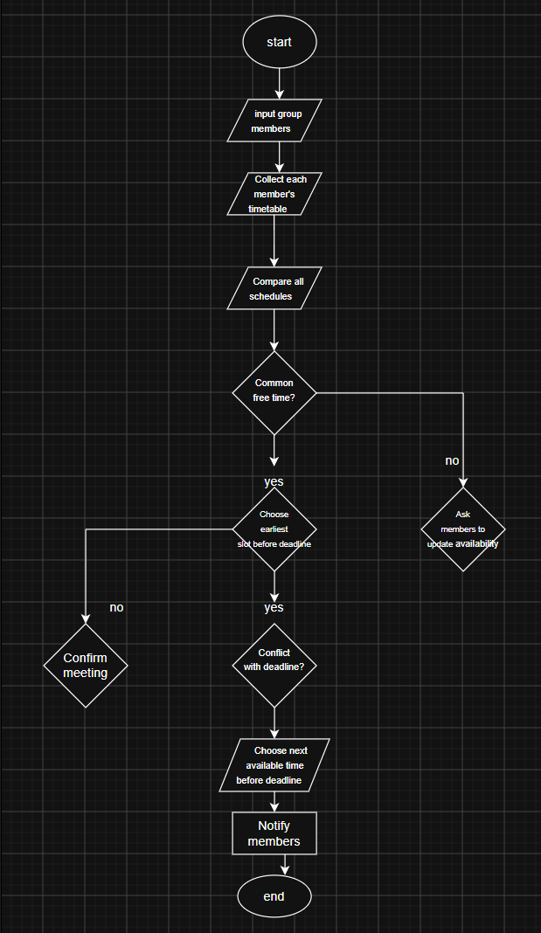

Flowchart Explanation
The flowchart begins when the group enters all member details. Each student’s timetable, work schedule, impersonal commitments are collected. The system compares every timetable to identify overlapping free periods. If a common time exist, the system checks whether there meeting occurs before the weekly deadline. If the meeting is before the deadline, it is confirmed immediately and notification are sent. If the meeting would occur after the deadline, the system searches for the next available time before the deadline. If no common availability exists, students update their schedules or select an online meeting option before repeating the scheduling process. This logical process minimizes timetable conflicts while ensuring every support successful project completion.

Reflection and Justification

Abstract thinking
Abstract thinking was used by focusing only on information necessary for scheduling. Details unrelated to meeting organisation, such as student’s personal preferences unrelated to availability, were ignored. This simplified the problem and the solution easier to design.

Sub-dividing
The problem was divided into several smaller tasks: Collect schedules, compare availability, check deadline confirm meeting, notify members. Breaking the problem into smaller components improved organisation and reduced complexity.

Justification of solution
The proposed solution ensures group member has an opportunity to attend meeting. By comparing all schedules before confirming meetings also improves the likelihood of completing project work on time. The flowchart provides a clear and logical process that is simple to understand and could easily be implemented as software.

Limitation
Several limitations exist.
Students may provide incorrect availability.
Unexpected events may require meeting to be rescheduled.
Some groups may never have a time when everyone is available, requiring compromises.

Assumption
The solution assumes that: Students provide accurate schedules, students regular check meeting notification, internet access is available for online meetings, weekly project deadlines remain fixed.

Conclusion
Scheduling group meeting is a common challenge for computing students because of different timetables, employment, and personal commitments. The proposed scheduling process provides a practical solution by identifying common free time, reducing conflicts, and ensuring meetings occur before project deadlines. Using abstract thinking, subdivision, and MoSCoW prioritisation made it possible an organised and effective solution.

References
1. I. Sommerville, Software Engineering, 10th ed. Harlow, UK: Pearson, 2016.
2. K. Wiegers and J. Beatty, Software Requirements, 3rd ed. Redmond, WA: Microsoft Press, 2013.
3. R. S. Pressman and B. R. Maxim, Software Engineering: A Practitioner's Approach, 9th ed. New York, NY: McGraw-Hill, 2019.
4. Project Management Institute, A Guide to the Project Management Body of Knowledge (PMBOK® Guide), 7th ed. Newtown Square, PA: PMI, 2021.
5. P. Checkland, Systems Thinking, Systems Practice. Chichester, UK: Wiley, 1999.
6. A. Dennis, B. Wixom, and D. Tegarden, Systems Analysis and Design, 7th ed. Hoboken, NJ: Wiley, 2020.

