Introduction
Civil emergencies are high-impact events that pose significant risks to life, property, and the environment. In Wales, these emergencies include natural hazards such as flooding, public health crises like pandemics, and man-made incidents including industrial accidents and terrorism. The framework for emergency management in Wales is shaped both by devolved governance and the wider UK legislative environment, primarily underpinned by the CCA [2004]. This provides a statutory duty for Category 1 and Category 2 responders to prepare for, respond to and recover from emergencies. The CCA [2004] provides the statutory foundation for emergency planning and response in the UK, mandating that Category 1 responders, including Public Health Wales, maintain effective emergency response plans. Category 1 responders “must maintain plans for the purpose of ensuring that if an emergency occurs… they are able to perform their functions so far as necessary or desirable for the purpose of responding.” (Civil Contingencies Act, 2004, Section 2(1) (c)).
Successful emergency management depends on the seamless coordination of multiple agencies, operating at strategic, tactical, and operational levels. As demonstrated by major incidents such as the Grenfell Tower fire and Manchester Arena attack, any breakdown in communication or command structure can have devastating consequences. Structures such as the Welsh Government Resilience Forum and the involvement of the Local Resilience Forums (LRFs), ensure that regional risks are identified and addressed collaboratively.
The UK’s approach to emergency management is guided by the Integrated Emergency Management (IEM) Framework, which promotes a holistic, multi-phase cycle of anticipation, assessment, prevention, preparedness, response and recovery. IEM is supported by eight core principles outlined in the Cabinet Office’s Emergency and Response and Recovery guidance: anticipation, preparedness, subsidiarity, direction, information, integration, co-operation, and continuity. These principles underpin multi-agency coordination and are embedded in planning structures across Wales, aligning closely with JESIP and supporting the CCA [2004] duty to cooperate and maintain risk-informed plans.
This assignment explores the comprehensive emergency response and recovery arrangements in Wales, exploring multi-agency cooperation, command structures, and best practices that promote effective joint working. It will discuss key considerations throughout the recovery phase and potential legal implications that follow a civil emergency, drawing on real world inquiries such as Manchester Arena attack and Grenfell Tower Inquiry along with guidance documents, used to illustrate how an effective response can address operational challenges.
Emergency Management Framework and Multi-Agency Coordination in Wales
Emergency response in Wales is shaped by a comprehensive framework that integrates local, devolved, and national structures. Due to its geographical location, the presence of major transportation hubs, and the vulnerability to flooding, as well as other factors, Wales faces distinct challenges in emergency planning, response and recovery. Effective multi-agency planning and exercising ensures that appropriate measures are taken to mitigate these risks and protect communities. “The Act requires Category 1 responders to maintain plans for preventing emergencies: reducing, controlling or mitigating the effects of emergencies in both the response and recovery phases” (Cabinet Office 2011, p. 2). In Wales, the planning, response, and recovery phases are distinct due to the involvement of unique structures such as the Welsh Government Resilience Forum and the Local Resilience Forums (LRFs), which facilitate regional collaboration and ensure local risks are identified and addressed effectively. This assignment will explore how these phases are managed in Wales, highlighting the collaborative efforts and tailored approaches that differentiate it from other regions.
The Wales Resilience Partnership (WRP) coordinates multi-agency efforts, including contributions from LRFs, which align with Category 1 responders such as emergency services and public health agencies. “The Wales Resilience Partnership Team supports the Wales Resilience Forum. It does this through sub-groups to develop resilience across Wales in such arears as risk assessment and mass fatalities.” (Welsh Government, 2022)
Agencies involved in civil emergency response include Category 1 responders such as Public Health Wales, Welsh Ambulance Service, Police, Fire Service, and local authorities, and Category 2 responders include Utility Companies, Harbour Authorities, Network Rail, Telephone service providers. Each plays a vital role in mitigating immediate risks, providing relief, and restoring community functions post-emergency.
Emergencies in Wales span natural hazards such as flooding and severe weather events, to complex public health emergencies like the COVID 19 pandemic. The risk landscape in Wales is diverse encompassing both environmental and human-induced threats. Natural hazards, including extreme weather conditions pose significant risks to communities and infrastructure. Additionally, Wales faces challenges related to cyber threats, health crises and industrial accidents, which require comprehensive preparedness and response strategies.
To effectively manage these risks, the Welsh Government and LRFs utilise risk registers. The National Risk Register (NRR) feeds into Community Risk Registers, which are created by the LRF’s to systematically identify, assess and prioritise potential threats in their areas. These registers are integral to the strategic planning and operational readiness of emergency response agencies. For instance, Public Health Wales maintains a Strategic Risk Register that outlines key risks, action plans, and controls to mitigate impacts. Plans may be hazard-specific or adopt an all-hazards approach. This broad scope requires flexibility and readiness from all response agencies.
The response phase focuses on immediate actions to save lives, protect property, and restore order, while the recovery phase is aimed at returning to normality and rebuilding after the immediate incident has passed. “Recovery is defined as the process of rebuilding, restoring and rehabilitating the community following an emergency”. (Cabinet Office 2013, P10)
Multi-agency cooperation is essential for effective emergency management, requiring clear command structures and interoperable systems. The use of strategic, tactical, operational command structures ensures coordinated responses, while frameworks like JESIP provide clear operational protocols for collaboration.
During the recovery phase, leadership from both local and national authorities, ensures that recovery efforts are effective. This phase involves not only restoring physical infrastructure but addressing the psychological and social needs of affected communities.
The adoption of best practice guidelines, such as those outlined in the JESIP framework and National Occupations Standards (NOS) for civil contingencies, ensures agencies are well-equipped to manage emergencies effectively. The JESIP framework provides essential guidelines to enhance coordination among emergency services during major incidents, while the NOS delineates the requisite skills and knowledge for proficient emergency management. Additionally, the lessons identified from inquiry reports of past incidents such The Kerslake Report and the Grenfell Tower Inquiry provide invaluable insights and recommendation for change informed by evidence improving coordination and response strategies “Public Inquiries are official investigations, established by a UK or Devolved government minister, but conducted by an independent body, to examine matters of “public concern” about a particular event or set of events.” (Institute for Government, 2025). These reports help agencies refine their approaches, leading to continuous improvement in emergency management.
Having established the wide scope of emergencies facing Wales, it is crucial to explore how structured command hierarchies enable agencies to respond efficiently. The strategic, tactical and operational command levels provide a clear framework for responsibility and decision-making, ensuring that multi-agency operations are coordinated even under intense pressure.

Stating the different command levels used by responder agencies to respond to an emergency.
In Wales, as across the UK, emergency response operations are structured using the UK-wide strategic, tactical & operational command framework to ensure clarity of roles, shared decision-making, and effective resource allocation.
In any civil emergency, a well-defined command structure is essential to ensure decisions are made efficiently and effectively, and agencies work together in a coordinated manner. Clear and effective command structures are the backbone of any emergency response, ensuring decisions are made swiftly, and responsibilities are unambiguous. The commonly used command structure (see table 1) within the UK ensures that each level can focus on its responsibilities while supporting others and enables an effective and coordinated multi-agency response.
Table 1: Command Structures for Emergency Response
Command Level | Description | Multi-Agency Representation | Single Agency Representation
Strategic (Gold) Level | Gold Commanders are responsible for the overall strategic direction of the emergency response.  In Wales, strategic coordination is led through a Strategic Coordination Group (SCG), typically chaired by a senior police officer. | Public Health Wales, health boards, emergency services, local authorities, military liaisons, and government agencies may be represented. | Each agency will appoint own Strategic (Gold) Commanders to manage its strategic response.
Tactical (Silver) Level | Silver Commanders coordinate resources and response across agencies to achieve the strategic objectives set at Gold Level.  In Wales, Silver coordination often takes place through a Tactical Coordination Group (TCG).  They play a crucial role in forming shared situational awareness and ensuring that operational activity aligns with wider priorities. | Public Health Wales, health boards, emergency services, local authorities, may be represented. | Each agency will appoint own Tactical (Silver) Commanders to manage its tactical response.
Operational (Bronze) Level | The Bronze Commanders are responsible for delivery of the tactical plan on the ground.  Each agency appoints its own Bronze-level lead to manage its response at the scene.  Their role is to implement actions decided by tactical and coordinate frontline resources. | Public Health Wales, health boards, emergency services, local authorities, may be represented. | Each agency will appoint its own Operational (Bronze) lead to manage its operational response.

The emergency response phase is defined by immediate actions taken to mitigate the impact of the emergency, save lives and reduce harm. As stated by the Cabinet Office (2013, P.10), the primary goals are “to protect life, contain, and mitigate the impacts of the emergency”. In Wales, the response to a civil emergency is guided by the principles outlined in the CCA [2004], which, mandates the establishment of Local Resilience Forums (LRFs). These forums bring together representatives from emergency services, local authorities, health services, and other relevant organisations to coordinate their efforts. “The Act necessitated a restructuring of joint agency planning in Wales resulting in the creation of LRFs in South Wales, Gwent, North Wales and Dyfed-Powys Police Force areas.” (Cabinet Office, 2011, p.9)
Effective multi-agency collaboration is the cornerstone of successful emergency response and recovery. In Wales, this collaboration is facilitated through various mechanisms, including multi-agency training exercises and regular communication channels. Challenges such as conflicting priorities and communication barriers are addressed through continuous improvement and lessons Identified from past emergencies. It is vital to have command structures in place as highlighted in the Grenfell Tower Inquiry (2019) significant breakdowns in command and coordination, noting that the absence of a clearly established single point of incident command contributed to confusion and duplicated efforts during the response phase. The report specifically stated that “too often firefighters or junior officers acted on their own initiative, resulting in confusion and duplication of effort.” (Grenfell Tower Inquiry, Phase 1 Report [2019] – Executive Summary, p.16)
LRFs play an important role in emergency preparedness and response, established under the CCA [2004] they are multi-agency partnerships that bring together Category 1 and 2 responders within a police area. The primary purpose of an LRF is to facilitate coordination and cooperation among the responders. “These forums are the principal mechanisms for multi-agency co-operations between local responders and help to facilitate better co-ordination and communication.” (Cabinet Office, 2013, p206).
Briefly describing command structures at a local and Pan Wales (and UK level) and any relevant guidance/best practice that promotes effective joint work arrangements.
In Wales, emergency planning and response are supported by framework that integrates local, devolved, and national structures. At the local level, planning, primarily co-ordinated through LRFs, which bring together Category 1 and Category 2 responders to assess risks and develop plans. These LRFs ensure that local risks are identified and addressed collaboratively, facilitating effective multi-agency planning. At Pan Wales level, the Wales Resilience Forum (WRF), chaired by the First Minister, provides strategic oversight and policy direction for civil contingencies. The WRF plays are crucial role in shaping strategic priorities and multi-agency policy alignment, although it is not operational during incidents. Additionally, the National Risk Register (NRR) identifies and assesses potential threats which feed into local Community Risk Registers to support strategic planning and operational readiness.
When an emergency occurs, response structures are activated to manage the immediate situation. At the local level, Strategic Coordination Groups (SCGs) are established to provide strategic direction and ensure coordinated response efforts between local agencies. Above the local level, the Wales Civil Contingencies Committee (WCCC) is the principal Welsh Government coordination body during major incidents, supporting communication and decision-making between the Welsh Government, SCGs, and UK Government departments. It ensures policy coherence and co-ordinated action across multiple SCGs when an incident affects more than one area or sector.
To support this command architecture, the Emergency Coordination Centre (Wales) or ECCW acts as the logistical and information hub during a crisis. Located in Cardiff and operated by Welsh Government officials, the ECCW facilitates real-time information flow, situation reporting, resource tracking and liaison with the Cabinet Office Briefing Rooms (COBR) at the UK level when required. It is central to enabling effective Pan-Wales situational awareness and strategic communication across responder agencies.
Together, the WRF, WCCC and ECCW ensure that Wales has both the policy infrastructure and operational mechanisms to manage civil emergencies in alignment with UK frameworks, while reflecting the devolved responsibilities of the Welsh Government.
At the UK level, the overarching strategic command structure for major civil emergencies is coordinated through the Cabinet Office Briefing Rooms (COBR). COBR’s role includes setting national strategic objectives, coordinating policy responses, allocating resources, and ensuring unified public communications across the UK. COBR is activated in response to significant national or international incidents, providing a central forum for cross-government coordination and strategic decision-making.” The Government maintains dedicated crisis management facilities (COBR) and supporting arrangements which are only activated in the event of a major national emergency.” (Cabinet Office, 2013, p. 192). COBR is the mechanism through which ministers and senior officials from across government coordinate the central government response to emergencies. It brings together senior officials and ministers from UK government departments, devolved administrations (including the Welsh Government), emergency services, and other relevant bodies. The devolved administrations are fully involved in the UK-level emergency response structures where appropriate and will attend COBR meetings as necessary.” The Welsh Government will usually be represented at COBR by the First Minister.” (Cabinet Office, 2013 p. 171.)
When an incident affects Wales, either directly or as part of a UK-wide emergency, the Welsh Government plays a full and active role in COBR. Wales is represented by senior ministers or officials, often supported by briefings from the Wales Civil Contingencies Committee (WCCC) and operational updates from the Emergency Coordination Centres Wales (ECCW). This ensures that the unique legal, cultural, and devolved governance context of Wales is factored into national decision-making. For instance, while terrorism is a reserved matter managed by the UK Government, health is a devolved matter, allowing Wales to tailor its public health responses to its specific needs and circumstances.
At the same time, the Welsh Government provides strategic direction to local SCGs via WCCC and ECCW, while feeding key operational intelligence up to COBR. This two-way flow enables coherence between local response, Welsh policy, and UK-level strategy. The Wales Resilience Forum (WRF), though not operational, also plays a long-term role in aligning national resilience priorities between Wales and the UK. This integrated model allows for flexibility within devolution, ensuring Wales maintains autonomy over devolved matters such as health & social services, education, fire & rescue services while still contributing to and benefiting from UK-level coordination. This approach aligns with the principle of subsidiarity, ensuring that decisions are made at the most appropriate level, allowing Wales to maintain autonomy over devolved matters while effectively participating in the UK-wide strategies.
While command structures define ‘who does what,’ interoperability frameworks such as JESIP Joint Doctrine detail ‘how agencies work together.’ “The purpose of the Joint Doctrine is to provide a framework of common models and principles, which when applied consistently will improve interoperability between organisations across all levels of command.” (JESIP, 2023, p.6). Without effective interoperability, command decisions can become isolated, leading to fragmented or delayed responses, as demonstrated in high profile incident inquiries. The creation of Shared Situational Awareness across command levels is fundamental to effective multi-agency operations, enabling timely and coherent strategic and tactical responses. “Sharing information in a way that can be understood by the intended recipient aids the development of shared situational awareness which underpins the best possible outcomes of an incident.” (JESIP, 2023, p.14)
Interoperability in emergency response refers to the interaction between partner agencies, allowing them to work together efficiently and respond to emergencies in a coordinated manner. Effective interoperability ensures critical resources, such as personnel, equipment and information, are shared in a timely and accurate way, thus improving the overall effectiveness of the response. The JESIP framework is essential in ensuring that all responders work together during an emergency. By establishing common protocols, JESIP ensures interoperability and enhances overall response efficiently. The inability to share accurate information about internal conditions of the Grenfell Tower severely hindered the ability of commanders to make informed decisions. “Emergency services failed to coordinate with each other and share information as intended” (Grenfell Tower Inquiry, Phase 1 Report [2019] – Executive Summary, p.16)
The JESIP principles of co-locate, communicate, co-ordinate, jointly understand risk, and shared situational awareness (see figure 1) are key to achieving effective interoperability. These principles guide responders to work together, share information, and coordinate their actions to develop a common understanding of risks and maintain a shared situational awareness. This approach ensures that decisions are made collaboratively and consistently, enhancing the effectiveness of the emergency response.
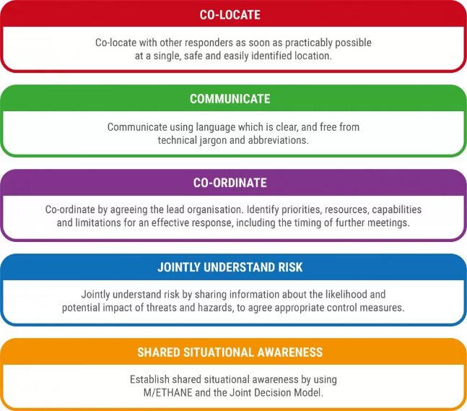
Figure 1 JESIP Principles for Joint Working (Jesip 2023, p12)

Between 1986 and 2013, a series of major incidents and emergencies in the UK revealed persistent challenges in multi-agency emergency response. The Pollock Report [2013] conducted a comprehensive review of these events, identifying recurring issues such as poor communication, lack of coordination, and the failure to learn from past incidents. A key concern was the lack of interoperability – the ability of emergency services to work together effectively during incidents.
In response to these systemic issues, the Joint Emergency Services Interoperability Programme (JESIP) was launched in 2012. JESIP aimed to improve the way the emergency services work together during major incidents. It introduced a set of principles and tools designed to foster shared situational awareness, joint decision-making, and coordinated action. Central to JESIP were the Joint Decision Model (JDM) (see figure 2 and the METHANE reporting framework (see figure 3), both provide structured approaches to communication and decision-making in high-pressure environments.
Despite these efforts, the Manchester Arena bombing in 2017 exposed significant shortcomings in the practical application of JESIP principles. The Kerslake Report [2018] found that while JESIP was understood in theory, it was not fully embedded in practice. Agencies failed to establish a shared situational awareness, and communication between control rooms was fragmented. The report emphasised that “The JESIP principle of Shared Situational Awareness is also founded on the importance of responders using a consistent reporting framework.” (Kerslake, 2018, p.26)
The Pollock Review [2022] revisited these issues and confirmed that many of the same interoperability failures persisted. It noted “Control room displays did not adequately communicate what was happening; poor design and layout hampered response” (Pollock Report, 2013, p.46). These findings underscored that JESIP, while conceptually sound, had not consistently been implemented in all agencies.
Both the Kerslake and Pollock reviews recommended renewed emphasis on multi-agency exercising, training and shared understanding to ensure JESIP principles are not only taught but practiced. These improvements are essential for enabling agencies to respond quickly and cohesively, guided by clearly defined roles and joint operating procedures.
In summary, JESIP was born out of years of lessons not learned. While it introduced frameworks like the JDM and METHANE, its effectiveness depends on consistent use and adoption across all agencies. The failures seen in 2017 and again in 2022 highlighted the need for ongoing commitment to interoperability as constant practice, not just a policy.

Figure 2 Joint Decision Model (JDM) (Jesip 2023, p23)
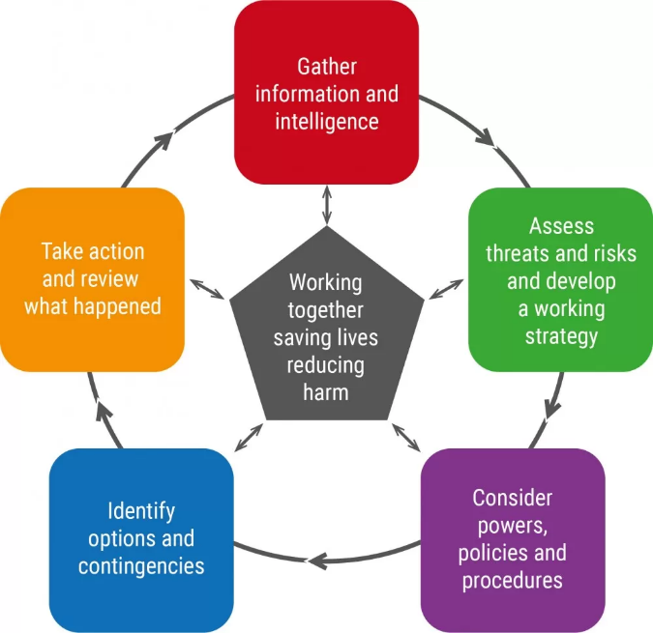

Figure 3: METHANE (Jesip 2023, p21)
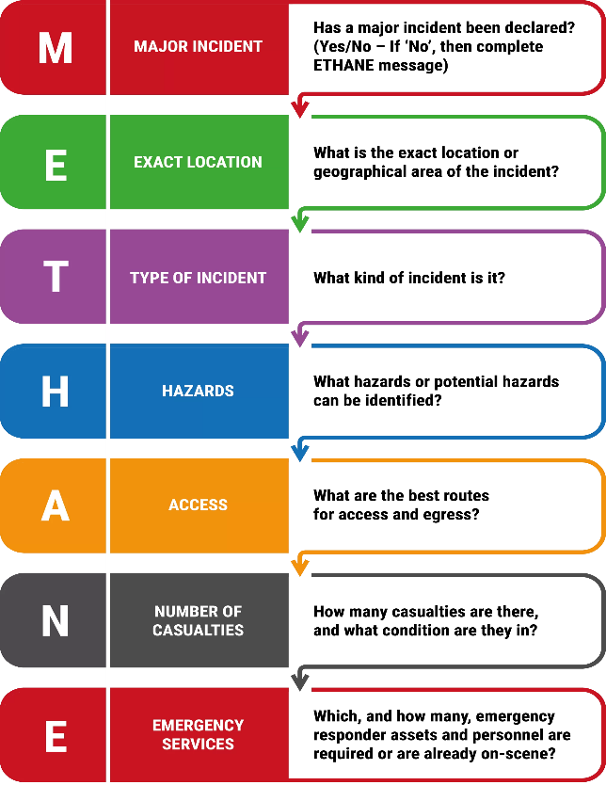

Agencies should operate in line with established guidance and recognised best practices such as the JDM which supports shared situational awareness and helps align decisions across agencies. The Kerslake Report [2018] highlighted the consequences of weak joint decision-making during the Manchester Arena response, reinforcing the need for wider training and consistent application of the JDM. As JESIP (2023, p.23) states, “The JDM is designed to help make effective decisions together. As they establish shared situational awareness.”
The importance of interoperability has also been underscored in legal proceedings and inquiries. The Kerslake Report [2018] highlighted the lack of shared communications picture during the Manchester Arena attack, while the Pollock Review [2022] noted that strategic groups performed best when guided by timely legal and public health advice. Similarly, the Grenfell Tower Inquiry [2019] identified a lack of effective communication and coordination between the emergency services. “The principal flaw, common to all, was poor communication.” (The Grenfell Inquiry, Phase 1 Report 2019, p. 697).
These findings converge on the necessity of clear command structures, shared situational awareness, and interoperability protocols. Joint working and interoperability are essential for cohesive action across agencies, preventing fragmented responses during high pressure situations. Consistent terminology and structured communication models, as outlined in JESIP, are essential to reducing operational delays and confusion. Effective interoperability depends on joint training and exercising, compatible communication systems, and a shared understanding of roles and responsibilities. As the Cabinet Office (2013, p.20) states “There is an agreed national framework for managing multi-agency response to, and recovery from. Emergencies.”
The National Occupational Standards (NOS) for Civil Contingencies establish a framework for the competencies required from those involved in emergency response. These standards cover a wide range of roles and responsibilities across different agencies, providing a benchmark for best practice and ensuring that all responders possess the necessary expertise to handle complex emergency situations.
The National Occupational Standards outlines key competencies for responders, such as effective communication, strategic leadership, and the ability to collaborate in multi-agency teams. These competencies ensure that individuals are not only capable of performing their specific roles but also able to work within a broader, coordinated emergency response framework. “Collaboration is essential resilience, requiring a clear understanding of roles, responsibilities, governance, and risk content. The standard supports individuals in fostering engagement, developing integrated approaches, and ensuring continuous improvement through shared knowledge and collaborative decision-making across all phases, risk assessment, prevention, preparedness, response and recovery.” (Skills for Justice, NOS SFJCCAAA1)
Continuous review and improvement of interoperability frameworks are essential for ensuring that emergency response practices remain effective in the face of evolving risks. This includes conducting debriefs, updating training programs, and incorporating emerging technologies to enhance future response efforts.
In conclusion, interoperability is at the heart of effective emergency response, ensuring that agencies can work together efficiently to save lives and restore normality. By adhering to frameworks such as JESIP, the National Occupational Standards (NOS), and lessons identified from past incidents, agencies can continuously improve their coordination and readiness for future emergencies. “An essential element of resilience is learning from crisis. A learning organisation will ensure that the lessons learned will result in changes to the organisational culture, norms and operating practices.” (Pollock Report, [2013], p.13).
Briefly describe potential legal ramifications that may follow the response and recovery from a civil emergency and how these can be mitigated through an effective joint response.
The response and recovery from a civil emergency can entail significant legal ramifications for the organisations and individuals involved. These ramifications can arise from various aspects of the emergency response, including negligence, failing to comply with regulations or legislative responsibilities such as the Health & Safety at Work Act [1974] or under regulation 28 of the Prevention of Future Deaths (PFD) report. When investigating a death, a coroner must issue a PFD report if they identify circumstances that could lead to future deaths and believe that action should be taken to prevent these risks. The report will be sent to an individual or organisation that have the power to implement the recommended changes. Understanding these potential legal issues and implementing strategies to mitigate them through an effective joint response is crucial for ensuring a coordinated and legally sound approach. The CCA [2004] provides the cornerstone of legal duties for Category 1 and 2 responders, mandating risk assessments, emergency planning, and multi-agency cooperation. Under the CCA [2004], responders have a duty to cooperate and share information with other Category 1 and 2 responders. “Co-operate with other local responders to enhance co-ordination and efficiency.” (Cabinet Office, 2015, p.2)
One of the primary legal risks in emergency response is liability for negligence. Emergency responders and organisations may face legal action if their actions or omissions during the response and recovery phase are deemed negligent. This can include failure to follow established protocols, inadequate training, or improper use of resources. For instance, following investigations by the Independent Police Complaints Commission (IPCC) the matchday commander at the Hillsborough Disaster was charged with gross negligence manslaughter by the Crown Prosecution Service (CPS) for the deaths of 95 of the 96 victims who died in April 1989. He was responsible for ordering the opening of a gate, which led to a fatal crush in the overcrowded pens at the Sheffield Wednesday stadium. David Duckenfield was found not guilty of gross negligence manslaughter in a retrial that took place 30 years after the tragedy. “It is important to remember that criminal proceedings have a very different purpose to an inquest. The not guilty verdict today does not affect or alter the inquest jury’s findings of unlawful killing.” (Crown Prosecuting Service, 2019)
The legal landscape underpinning emergency response and recovery is complex and multifaceted, demanding adherence to statutory obligations, regulatory frameworks, and common law duties. To mitigate such risks, it is essential to adhere to agreed protocols, standards of good practice and ensure compliance by adhering to relevant laws and regulations.
Post incident inquiries and potential legal proceedings place additional scrutiny on emergency response, making proactive legal risk mitigation an essential part of planning. By maintaining detailed records of all actions taken during the response and recovery phases to provide evidence of compliance and due diligence. Agencies should follow established best practices and guidelines to minimise legal risks and enhance the effectiveness of the response and recovery efforts.
There is a legal risk if all decisions, actions and rationale are not documented in a timely manner there is always a need for good record-keeping and for a full audit trail.
In conclusion, the legal ramifications following response and recovery from a civil emergency can be extensive, encompassing civil rights violations, regulatory non-compliance, and contractual disputes. However, these risks significantly mitigated through an effective joint response that emphasises adherence to established protocols, comprehensive documentation, robust communications, and regular training. By following best practices and learning from past inquiries, such as Grenfell Tower Inquiry and the Kerslake Report, organisations can ensure a coordinated and legally sound approach to emergency management. This not only enhances the effectiveness of the response but also upholds accountability and public trust, ultimately contributing to a more resilient and prepared society.

The key considerations before, during and after the recovery phase.
Recovery should be prioritised from the beginning of the incident. As noted by the Health Protection Agency, “Recovery begins at the incident start and runs alongside the response; the response should inform the recovery and form the basis for the recovery process.” (Health Protection Agency, 2008 p.127). While response and recovery phases can operate concurrently, primacy will eventually shift from response to recovery. Once the immediate response phase stabilises, the focus transitions to long-term recovery. Multi-agency cooperation remains critical during this stage, as the needs of affected communities change from emergency relief to long term rehabilitation and resilience building.
The recovery phase focuses on rebuilding, restoring and rehabilitating the affected community. “Recovery is defined as the process of rebuilding, restoring and rehabilitating the community following an emergency.” (HM Government, 2018, p101). This phase is equally important as it aims to return the community to normality and address the long-term impacts of the emergency. In Wales the recovery arrangements are designed to be flexible and tailored to the specific needs of the affected area. “Recovery should be an integral part of the response from the beginning, with key personnel and structures identified early and working alongside the response phase.” (Cabinet Office, 2013, p.10).
Recovery is a complex and often prolonged phase of emergency management that requires careful planning before an incident, strong coordination during response, and sustained leadership in the aftermath. “Recovery is a complex and potentially long-running process that will involve many more agencies and participants that the response phase.” (Cabinet Office, 2013 p.83).
Recovery necessitates a structured, evidence-informed approach that integrates preparedness, resilience, and long-term sustainability. Before the recovery phase, it is vital to establish robust emergency planning frameworks, community engagement strategies, and data surveillance systems to identify vulnerabilities and strengthen local capacity. During the recovery phase, coordination across health and social care sectors, transparent communication, and support for affected populations – particularly marginalised groups – are essential to mitigate health inequalities and promote wellbeing. After recovery, it is crucial to evaluate the response through debriefs, integrate lessons identified into future planning, and invest in workforce development and public health infrastructure to enhance resilience. This cyclical approach ensures that recovery is not only reactive but also a foundation for future preparedness and community health improvement.
Pre-recovery planning should be embedded within emergency response plans and frameworks and include clear recovery objectives, stakeholder roles, and mechanisms for community engagement. The recovery strategy should include clear aims and objectives, criteria for standing down, and details of how the community will be involved. “It is therefore essential for the process to be based on well thought out and tested structures and procedures for it to work in an efficient and orderly manner.” (Cabinet Office, 2013 p.83)
The establishment of a Recovery Coordinating Group (RCG) ideally identified early in the response ensures that recovery activities can commence alongside response operations, promoting continuity and minimising delays. During the recovery phase, priorities include, although not exhaustive, restoring critical infrastructure, health and social care services, psychosocial support, and rebuilding community confidence. Maintaining robust information-sharing across agencies and with the public is crucial to sustain trust and manage expectations. Effective communication and information sharing between responders and with the public is vital to support recovery and rebuild confidence.
After recovery, formal debriefs, lessons identified processes – often aligned to JESIP’s Joint Organisational Learning (JOL) platform help identify strengths and gaps. These findings should inform future planning and training to enhance long-term resilience. As observed in both the COVID-19 pandemic and the Manchester Arena incident, early recovery planning, inclusive leadership, and public health integrations were key to restoring normality and trust. In my opinion recovery is always strongest where there are established and trusted relationships between public and responders enabling better decision-making and hopefully a quicker recovery.
Conclusion
In conclusion, the response to and recovery from civil emergencies in Wales demands an unwavering commitment to multi-agency collaborations, underpinned by clear command structures and a culture of continual learning. The examination of operational frameworks such as JESIP and adherence to National Occupational Standards for Civil Contingencies has illuminated how interoperability, joint situational awareness, and aligned objectives are critical to the success of emergency operations. Incidents as the Manchester Arena attack and the COVID-19 pandemic have highlighted the profound consequences of fragmented communications and decision-making processes, both operationally and legally. Inquiry findings, notably the Kerslake Report [2018] and Pollock Review [2022], have reinforced the necessity for integrated frameworks, robust record-keeping, and the strategic inclusion of legal oversight within command groups to mitigate risks of future legal scrutiny and enhance public accountability.
Importantly, the recovery phase must be recognised not as a secondary consideration but as a continuum of the response effort, requiring sustained, coordinated action that addresses both the immediate and longer -term needs of affected communities. The role of Category 1 and 2 responders is central in restoring essential services and supporting community resilience. To achieve this, ongoing investment in shared communication platforms, comprehensive training exercises, and community engagement strategies remains vital.
Looking forward, as Wales continues to strengthen its emergency preparedness, there is an opportunity to embed lessons identified from past incidents into future resilience planning, embracing innovation, fostering strong multi-agency relationships, and maintaining legal and ethical accountability will ensure that future responses are not only operationally effective but also inspire public trust. In doing so, we safeguard not only the health and well-being of our communities but also the integrity of our collective emergency response.

Bibliography
Civil Contingencies Act [2004], c. 36. Available at: Legislation.gov.uk (Available At: Civil Contingencies Act 2004 (Accessed: 1 April 2025)
Cabinet Office [2011], Revision to Emergency Preparedness. Available At: Emergency_Preparedness_chapter5_amends_21112011.pdf (Accessed 1 April 2025).
Welsh Government [2022] What we do: Resilience Forum Available at: What we do: Wales Resilience Forum | GOV.WALES (Accessed 25 April 2025).
Institute for Government (2025) Public inquiries. Available at: Public inquiries | Institute for Government (Accessed: 1 May 2025).
Cabinet Office [2013], Emergency Response and Recovery. Available At: Emergency_Response_and_Recovery_5th_edition_October_2013.pdf. (Accessed 13 May 2025)
Cabinet Office [2013], Emergency Response and Recovery. Available At: Emergency_Response_and_Recovery_5th_edition_October_2013.pdf. (Accessed 1 April 2025)
Cabinet Office [2011], Revision to Emergency Preparedness. Available At: Chapter-11-Wales-amends-10112011.pdf (Accessed 1 April 2025).
Grenfell Tower Inquiry [2019]: Phase 1 Report: Report of the Public Inquiry into the Fire at Grenfell Tower on 14 June 2017 Available At: GRENFELL TOWER INQUIRY: PHASE 1 REPORT OVERVIEW (Accessed 1 April 2025)
Cabinet Office [2013], Emergency Response and Recovery. Available At: Emergency_Response_and_Recovery_5th_edition_October_2013.pdf. (Accessed 1 April 2025)
Cabinet Office [2013], Emergency Response and Recovery. Available At: Emergency_Response_and_Recovery_5th_edition_October_2013.pdf. (Accessed 24 April 2025)
Cabinet Office [2013], Emergency Response and Recovery. Available At: Emergency_Response_and_Recovery_5th_edition_October_2013.pdf. (Accessed 1 April 2025)
JESIP Joint Doctrine version 3.1 [2024]. Available at: Download the Joint Doctrine - JESIP Website. (Accessed 13 May 2025)
JESIP Joint Doctrine version 3.1 [2024]. Available at: Download the Joint Doctrine - JESIP Website. (Accessed 1 April 2025)
Grenfell Tower Inquiry [2019]: Phase 1 Report: Report of the Public Inquiry into the Fire at Grenfell Tower on 14 June 2017 Available At: GRENFELL TOWER INQUIRY: PHASE 1 REPORT OVERVIEW (Accessed 1 April 2025)
Pollock Report [2013]. Available At: The Pollock Report - JESIP Website (Accessed 8 April 2025)
Kerslake Review [2018]. Available At: Microsoft Word - Kerslake_Arena_Review_PROOFED.docx (Accessed 1 April 2025)
JESIP Joint Doctrine version 3.1 [2024]. Available at: Download the Joint Doctrine - JESIP Website. (Accessed 1 April 2025)
Grenfell Tower Inquiry [2019]: Phase 1 Report: Report of the Public Inquiry into the Fire at Grenfell Tower on 14 June 2017 Available At: GRENFELL TOWER INQUIRY: PHASE 1 REPORT OVERVIEW (Accessed 1 April 2025)
Cabinet Office [2013], Emergency Response and Recovery. Available At:Emergency_Response_and_Recovery_5th_edition_October_2013.pdf (Accessed 1 April 2025)
Skills for Justice, National Occupational Standards. Available At: NOS Finder - National Occupational Standards Accessed At: 1 April 2025)
Pollock Report [2013]. Available At: The Pollock Report - JESIP Website (Accessed 8 April 2025)
Cabinet Office (2015), Civil Contingencies, Secretariat, Civil Contingencies Act 2004 (a short guide revised) Available at: Microsoft Word - 06 05 15 Short guide _final_.doc (merseysideprepared.org.uk) (Accessed 1 April 2025)
Crown Prosecution Service. (2019, November 28) Available at: CPS statement on Hillsborough verdict | The Crown Prosecution Service (Accessed 15 May 2025)
Health Protection Agency (2008) Health Emergency Planning: A Handbook for Practitioners. 2nd edn. Edited by S. Stuart-Black, J. Stuart-Black and E. Coles. London: The Stationery Office.
Cabinet Office [2013], Emergency Response and Recovery. Available At: Emergency_Response_and_Recovery_5th_edition_October_2013.pdf. (Accessed 24 April 2025)
Cabinet Office [2013], Emergency Response and Recovery. Available At: Emergency_Response_and_Recovery_5th_edition_October_2013.pdf. (Accessed 24 April 2025
Cabinet Office [2013], Emergency Response and Recovery. Available At: Emergency_Response_and_Recovery_5th_edition_October_2013.pdf. (Accessed 24 April 2025
Cabinet Office [2013], Emergency Response and Recovery. Available At: Emergency_Response_and_Recovery_5th_edition_October_2013.pdf. (Accessed 24 April 2025

Picture Credits
JESIP Joint Doctrine version 3.1 [2024]. Download the Joint Doctrine - JESIP Website Available online
JESIP Joint Doctrine version 3.1 [2024]. Download the Joint Doctrine - JESIP Website Available online
JESIP Joint Doctrine version 3.1 [2024]. Download the Joint Doctrine - JESIP Website Available online

