
Designing a Human Capital Architecture for Strategic Renewal
Helios Urban Mobility (HUM) - Strategic Human Capital Advisory Report
Student name: | Harshil Ghanshyambhai Beladiya | Student ID number: | 2543506
Programme: | Master of Business Administration
Module: | Human Capital Management
Module code: | LCMB7023 | Contribution to Overall Module Assessment (%): | 50%
Lecturer: | Alireza Nazarian | Internal Verifier: | Vasilios Tavlaridis  Hoang Nguyen
Assignment Title: | Assessment component 1: Individual report | Word count (or equivalent): | 2,500
Submission Date : | Friday 17th July 2026 | Return date of provisional marks & written feedback: | 14th August 2026

Table of Contents
TASK A: Socialisation, Identity and Business Activism 3
A.1 Traditional Onboarding versus Strategic Organisational Socialisation 3
A.2 A Structured Socialisation Framework for Helios Urban Mobility 3
A.3 Mechanisms for Identification, Ethical Professionalism, and Business Activism 5
TASK B: Job Design Strategy 6
B.1 Innovative Job Design Using the Job Characteristics Model 6
B.2 Job Crafting as an Engine of Innovation 8
B.3 Skills-Based Architecture and Internal Talent Marketplaces 8
B.4 Stimulating Intrinsic Motivation and Supporting Innovation 9
TASK C: Reflective Report 10
C.1 AI as a Decision-Support Tool Without Eroding Human Judgement 10
C.2 Personal Capability Development Plan 11
References 13

TASK A: Socialisation, Identity and Business Activism

A.1 Traditional Onboarding versus Strategic Organisational Socialisation
Helios Urban Mobility (HUM) faces a critical people management challenge. An eight-months ramp-up time is indicative of a socialisation failure in a structural sense. The traditional approach to onboarding simply involves administrative and logistical orientation (Bauer and Erdogan, 2011). Standard Policy Handbooks, IT credentials and introductions are provided to employees. These inputs do not develop belonging or shared purpose. Strategic organisational socialisation, on the other hand, is intentional behavioural and cognitive change (Van Maanen and Schein, 1977). Over time it deliberately forms values, role clarity and group membership in a systematic manner.
The socialisation tactics of Van Maanen and Schein are still basic. Collective, formal, sequential institutionalised tactics generate custodial orientations of roles. Tactics that are customized encourage innovative and entrepreneurially oriented employees (Cable et al., 2012). The latter is necessary by the innovation-driven mandate of HUM. The psychological contract theory also sheds light on this issue. Rousseau (1989) differentiates between relational and transactional contracts. Upon graduation, HUM alumni look forward to growing, learning, and doing something impactful. These expectations go unmet, and the disengagement takes off quickly. This breach is substantiated by HUM's 54% engagement score.
There is one more framing tool: identity construction theory. Ashforth and Mael (1989) maintain that people get their self-concept from group membership. Instead, new entrants at HUM need to be led to the identification with the organisation's mission of AI-mobility. Without an intentional identity anchor, high-potential graduates go astray. In line with this, Wrzesniewski et al. (2023) found a strong link between purpose aligned identity formation and low voluntary turnover. Thus the change from administration onboarding to strategic socialisation is imperative for HUM.

A.2 A Structured Socialisation Framework for Helios Urban Mobility
Pre-Boarding Phase (Weeks −4 to 0)
HUM should contact the Hire 4 weeks prior to their first day of employment. AI enabled content curation (Morrison, 1993) tailors the experience on digital pre-boarding portals, personalising the experience. New players get mission stories tailored for them, team introductions, and live project snapshots. This should eventually lead to a virtual "Mission Immersion Day". New employees are introduced to senior leaders and current groups of graduates online. Studies show time-to-productivity (TTP) and first-week anxiety are reduced with pre-boarding (Korte, 2007). Here is the start of the psychological contract formation, clarity of expectations is key.
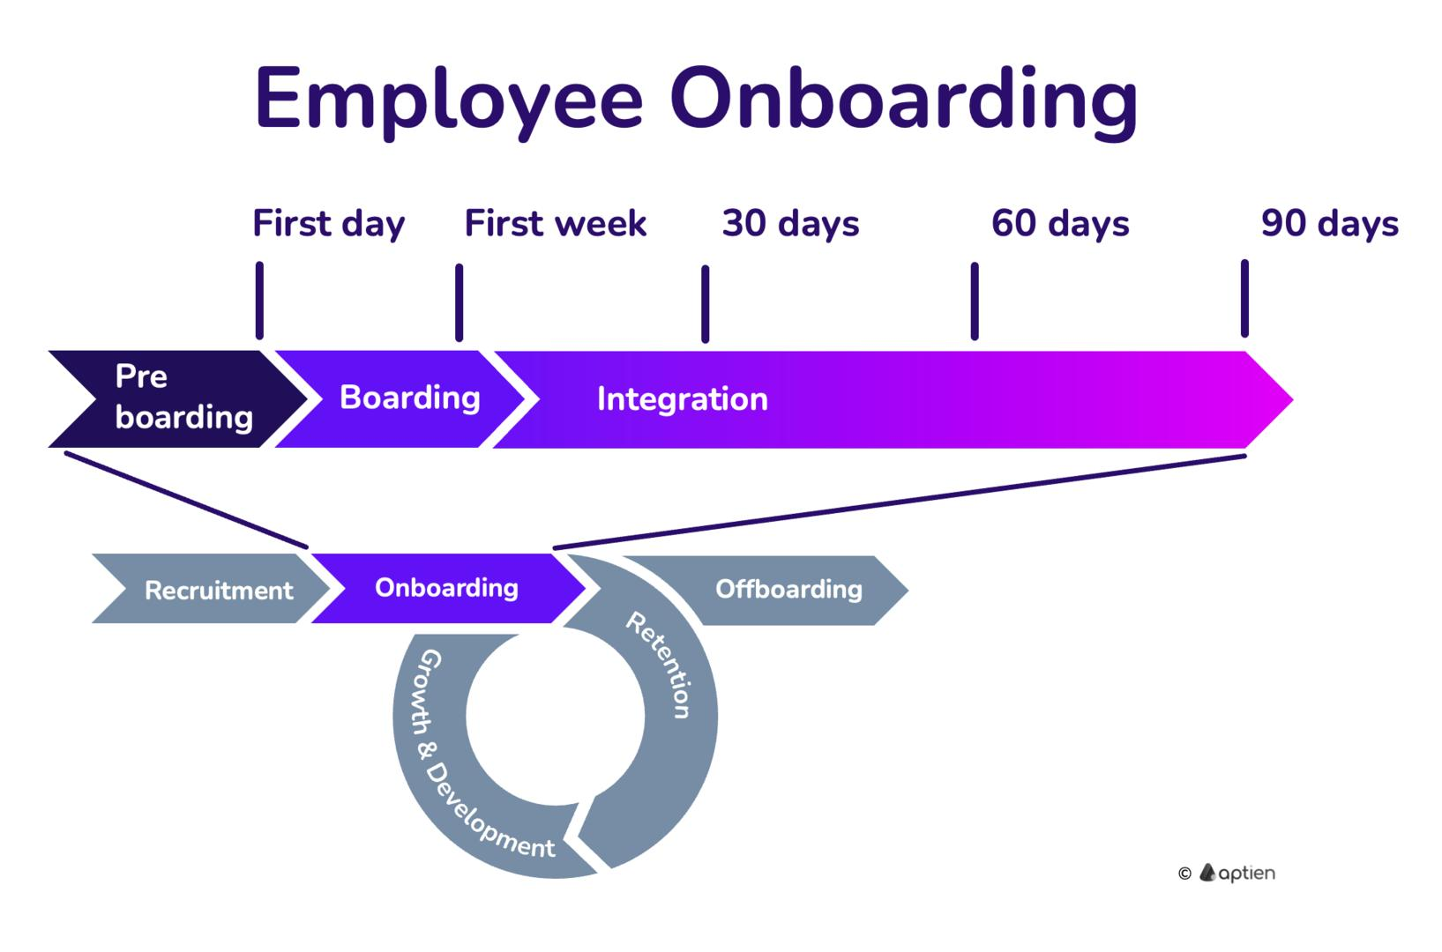
Figure 1: Employee onboarding
(Source: self created)
The image exemplifies the change from pre-boarding to identity alliance and makes the framework easier to comprehend.
Structured Integration
The first 90 days are the socialisation "critical window" (Bauer et al., 2007). HUM needs to implement a tri-city buddy system between new staff members in London, Berlin and Singapore. This makes cross cultural knowledge transfer happen on the spot. Structured line management meetings weekly to discuss role clarity. Longitudinal survey data reveals that support from a manager, in the 30-60 period, is the greatest predictor of engagement (CIPD, 2025). HUM should also create “Mobility Innovation Squads” which are small, multi-disciplinary teams to address concrete city-government challenges. This results in real-life task-based identity development. At day thirty, the learning goal is signed collaboratively in learning contracts.
Year 1: Identity Consolidation and Activation
Career identity and business activism develop in the second year (months 4-12). Performance appraisals are replaced with quarterly "Impact Reviews. These reviews are specifically linked to the mission of HUM and measure the impact of the contributions. The peer nominated 'Urban Mobility Champion' awards strengthen organisational identification. A dedicated alumni mentoring platform is in place to link alumni with seasoned employees around the world. According to McKinsey & Company, (2023), structured mentoring results in a 28% lower rate of graduate attrition in technology companies. Year-one socialisation is completed in a "HUM Leadership Lab" cross-city immersion programme, which speeds up strategic thinking.

A.3 Mechanisms for Identification, Ethical Professionalism, and Business Activism
Organisational Identification
There is a need to embed symbolic artefacts that communicate mission into HUM. Urban-mobility impact figures in real-time dashboards do engender tangible purpose (Cable et al., 2012). Regular "City Impact Stories" featuring stories from government partners reinforce employees' identities in terms of social good. The higher their sense of distinctiveness and prestige in their organisation, the stronger their identification will be (Ashforth and Mael, 1989). Thus, this is imbibed with the unique HUM AI-mobility positioning and needs to be made vivid and personal through socialisation.
Ethical Professionalism
Ethical responsibilities are a major consideration for AI-powered transport systems. An "Ethics by Design" module shall be incorporated into HUM within the first ninety days. The material in this module is based on case-based learning, inspired by real algorithmic bias incidents in public transport (Whittlestone et al., 2019). Ethical professionalism is developed not assumed. Employees have the opportunity to question decisions openly through monthly cross functional Ethics Forums. Psychological safety is essential for professional integrity development (Edmondson, 2018).
Relationality and the Business Activist Mindset
Finally, HR business partner has been updated to include “business activist,” a role for an HR professional who influences the external societal conversation (Ulrich and Dulebohn, 2015). HUM staff should have the authority to speak on behalf of the organisation at advocacy forums of the city government. The stakeholder capitalism views (Freeman et al., 2020) require employees to recognise the accountability of HUM to cities, citizens and ecosystems, not shareholders. A “Mobility Policy Fellow” cycle is organised by rotation between high-quality graduates and public sector partner organisations. This simultaneously makes workers credible urban mobility advocates and increases the commitment of the organisation.

TASK B: Job Design Strategy

B.1 Innovative Job Design Using the Job Characteristics Model
Hackman and Oldham's Job Characteristics Model (JCM) lists five components that are associated with intrinsic motivation (Oldham and Hackman, 2010). The elements of these are skill variety, task identity, task significance, autonomy, and feedback. The present HUM engagement score of 54% indicates that these are systematically under delivered. All 5 characteristics need to be included in a re-designed job architecture in an intentional manner. The impact of JCM aligned roles has been shown in the research to be 34% higher engagement in knowledge intensive organizations (Grant and Parker, 2009). HUM's AI-mobility context is an abundance of raw material for such redesign.
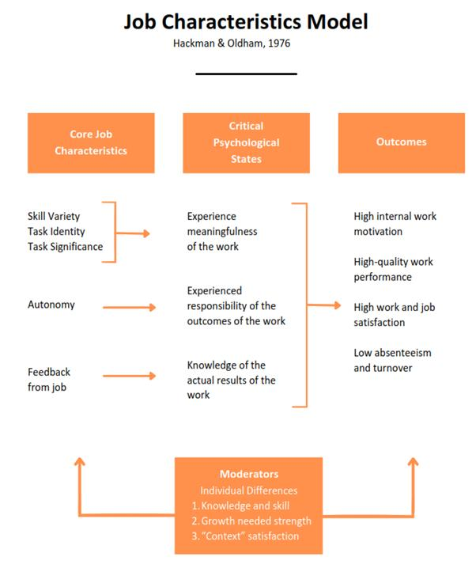
Figure 2: Job characteristics model
(Source: self created)
The image demonstrates and supports the clarification of the five core job features. Skill variety is achieved by swapping engineers from hardware to software and from software to data analytics sub-units. To enhance task identity, project ownership is strengthened by assigning a group of people a single project, end-to-end, which is the entire city-government brief. Task significance is brought to life when employees see how it affects the lives of urban commuters. Micro-management is eliminated and therefore autonomy is maintained, using outcomes-based performance measures. Feedback is fast with real-time data dashboards that provide project impact data every day. These five improvements combined result in a high level of increase for the Motivating Potential Score of HUM roles (Oldham and Hackman, 2010).

B.2 Job Crafting as an Engine of Innovation
According to the job crafting theory of Wrzesniewski and Dutton, employees engage in tasks, people, and thoughts (Tims et al., 2016). HUM should institutionalize job crafting not as an incidental. A formal "Crafting Sprint" should take place twice a year. Through these sprints, staff identifies their strengths and passion with their current position. The role adjustments are then co-designed by the managers within the boundaries. Job crafting can boost innovative work behaviour by 31% in technology companies (Lichtenthaler and Fischbach, 2019). This investment is directly commercially relevant due to HUM's innovation mandate.
In HUM there are three dimensions of crafting that are salient. Task crafting: Engineers can be asked to take part in briefs outside their specific domain, but which are relevant to the other discipline. Relational crafting invites data scientists to work directly with urban planners and government stakeholders to co-create. Individual tasks are reimagined as opportunities to contribute to sustainable city futures in cognitive crafting. The reframing has an extra strong impact on those in HUM's graduate cohort who tend to value purpose driven work (Deloitte, 2024) to a higher degree. HUM managers need training in facilitative leadership to be able to craft without compromising their operational coherence.

B.3 Skills-Based Architecture and Internal Talent Marketplaces
A traditional job-title based organization structure limits talent deployment, and they demoralize talented employees. Skills-based organisations (SBOs) divide work into task groups aligned with capability packages, or portfolios, (Deloitte, 2024). The three campuses of HUM need to be designed in a skills-based architecture. This starts with a detailed skills taxonomy of some 200 fundamental skills. These can include AI engineering, stakeholder engagement, and regulatory intelligence. According to Mercer (2023), companies that use skills-based models are 40% faster than companies with title-based approaches hiring internal candidates.
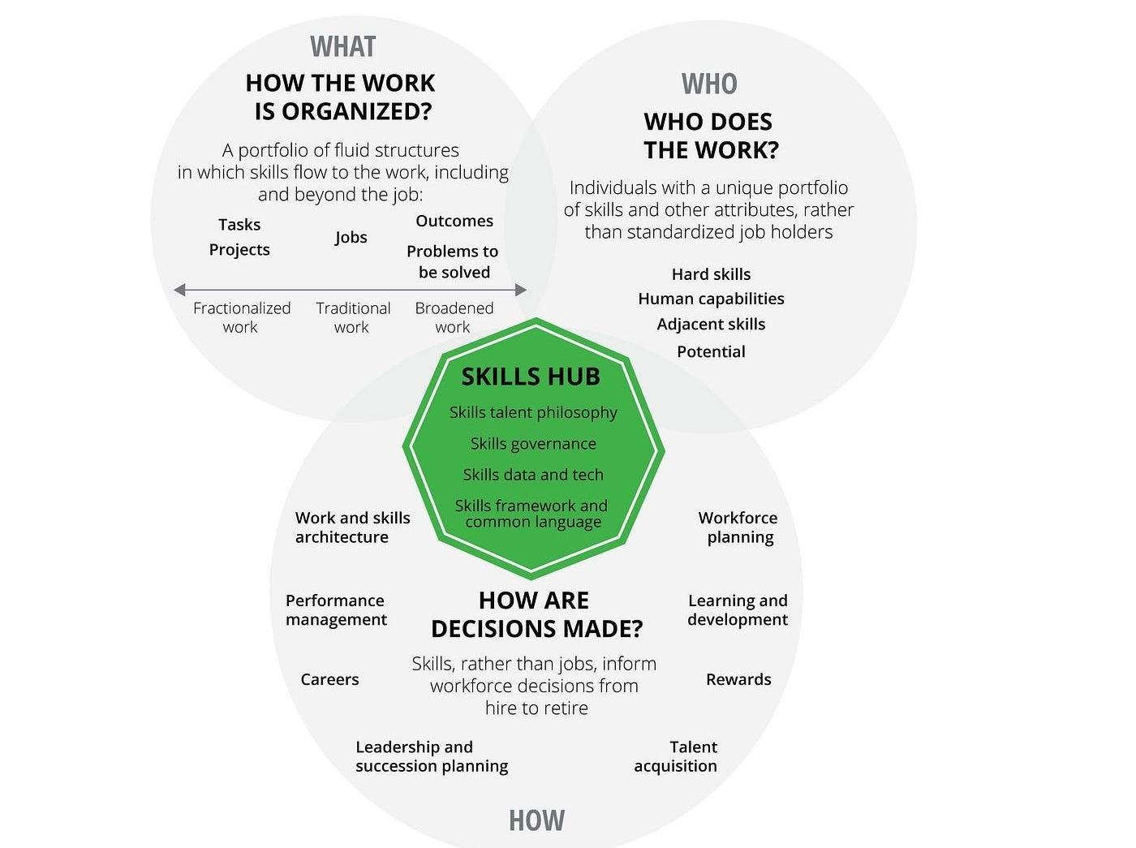
Figure 3: Skills-Based Organisation or Internal Talent Marketplace framework
(Source: self created)
This architecture is dynamically realised by an internal talent marketplace. HUM should implement an AI-based platform similar to Gloat or Fuel50, to bring together employees, projects and mentors and learning resources based on skill data (Levit, 2018). The skill profiles are posted by employees and the project needs are posted by the managers. Algorithmic matching reveals high-potential candidates who are hidden in hierarchical systems in a way that is not visually apparent. According to LinkedIn Talent Solutions 2024, workers who have access to internal mobility are 3.5 times more likely to stay with their organisation. This directly impacts the problem of graduate attrition for HUM.

B.4 Stimulating Intrinsic Motivation and Supporting Innovation
According to Self-Determination Theory (SDT) by Deci et al., (2017), there are three universal intrinsic motivation factors: autonomy, competence, and relatedness. HUM's new building design needs to explicitly cater for all three. Project ownership and the designing of rights are safeguards for autonomy. Competence is developed through skills marketplace and learning sprints. Relatedness is built through activities of collaboration across cities and shared mission stories. Creative performance is much higher in R&D-intensive firms in SDT-aligned environments (Amar, 2004).
Innovation is also encouraged by using designated "10% Exploration Time" - time during the day when employees are encouraged to explore ideas related to mobility that go beyond their core brief. This approach has been proven effective by Google's 20% time model, and by 3M's innovation sabbaticals (Edmondson, 2018). HUM will match this with an internal “Urban Mobility Innovation Fund” that distributes seed capital to staff initiated projects throughout the quarter. This is indicative of a true commitment to bottom-up innovation within the organisation. Together with the skills marketplace and building sprints, it creates HUM's job architecture as a long-term competitive advantage in retaining talent and generating innovation output. Job Design should not work alone, above all. It requires leadership behaviors, norms, and performance structures that “encourage people to try new things rather than just getting things done” (Grant and Parker, 2009). HUM's Board should create an annual "Job Quality Audit" and compare it to the JCM standards. This guarantees that design interventions are responsive to changing expectations of the workforce. Taking the synthesis of JCM, Job Crafting and Skills Based Architecture together, a coherent and evidence based framework is created. This approach tackles recruitment and retention challenges of HUM at the same time as the issue of graduate attrition in a structural manner.

TASK C: Reflective Report

C.1 AI as a Decision-Support Tool Without Eroding Human Judgement
AI has advanced to a point where it can be a strategic asset in the HR landscape and a potential danger at the same time. AI is ultimately a tool for practitioners, not a decision-maker, so one needs to use it as such, not as the decision-maker (Tambe et al., 2019). AI can analyze the data of the workforce at speed, uncovering patterns of attrition and drivers of engagement without anyone knowing. But algorithmic output can be riddled with historical biases and lack of contextual empathy. According to IBM (2026), AI-driven HR decisions have a 23% bias risk when not managed by humans. Human judgment is an essential element.
The practitioner's job is to question the recommendations of AI thoroughly. If an attrition prediction algorithm reports that a student is a “flight risk,” it is important to understand what factors underlay the prediction. These kinds of models can be tainted by age, gender, and network distance from managers. Interpretable AI frameworks include explainability tools like SHAP values and give practitioners the chance to audit the algorithmic logic transparently (Whittlestone et al., 2019). One agrees to demand that any HR-tech vendor be explainable, before using their system. This epistemic discipline maintains professional integrity.
Moreover, do not replace relational intelligence with AI when it comes to people's decisions. Human judgment is needed for decisions about promotion, disciplinary review, and wellbeing interventions, and this judgment is not a pattern of data (Edmondson, 2018). Therefore, the practitioner's effect is: AI brings evidence to the surface, humans interpret the evidence within ethical and contextual perspectives. This blended approach ensures close analytical rigour and prevents dehumanisation of the employment relationship.

C.2 Personal Capability Development Plan
Data Literacy
One recognises a need to further develop quantitative HR analytics functions. A learning roadmap is designed for 12 months that covers R for People Analytics and Power BI dashboards. The People Analytics Certificate from CIPD will be formally accredited. This competency is fundamental as all the strategic interventions suggested in this report (CIPD, 2025) rely on data literacy.
AI Augmentation in HR
One will finish SHRM's AI in HR Specialisation course in 6-months. Further, collaboration with practitioner communities, such as the Josh Bersin Academy's AI community, will also offer peer learning. It is crucial to understand the limitations of the algorithms as well as their capabilities. This helps to avoid adopting technology without critical reflection, leading to an imbalance in workforce status (Tambe et al., 2023).
Strategic Influencing Skills
Good, credible communication in the boardroom is essential to evidence-based HR recommendations. One will undertake Executive Communication coaching with the Chartered Management Institute. There will be applied exposure through shadowing with a Chief People Officer in three quarterly Board presentations. The authors of 'Strategic influencing skills for HR professionals' (Ulrich and Dulebohn, 2015) agree that strategic influencing is a key skill for HR practitioners to be a true business partner at the higher levels.
Global Mobility Awareness
HUM is a tri-city organization that requires cross-cultural intelligence. One is in the process of finishing the CQ Certification at the Cultural Intelligence Centre in 9 months. Further, a development priority is identified for a short term project secondment to a HUM campus in Singapore. Regulatory differences in immigration, labour law, tax equalisation etc. in HUM's geographies will significantly improve the credibility of the advisory (Deloitte, 2024). Of course mobility awareness is not an ancillary issue; it is a core element of the work for delivering coherent human capital strategies in multinational organisations.

References
Amar, A.D., 2004. Motivating knowledge workers to innovate: a model integrating motivation dynamics and antecedents. European Journal of Innovation Management, 7(2), pp.89-101. https://www.emerald.com/ejim/article/7/2/89/41962
Ashforth, B.E. and Mael, F., 1989. Social identity theory and the organization. Academy of management review, 14(1), pp.20-39. https://journals.aom.org/doi/abs/10.5465/amr.1989.4278999
Bauer, T.N. and Erdogan, B., 2011. Organizational socialization: The effective onboarding of new employees. https://psycnet.apa.org/record/2010-06019-002?doi=1
Bauer, T.N., Bodner, T., Erdogan, B., Truxillo, D.M. and Tucker, J.S., 2007. Newcomer adjustment during organizational socialization: a meta-analytic review of antecedents, outcomes, and methods. Journal of applied psychology, 92(3), p.707. https://psycnet.apa.org/fulltext/2007-06438-009.html
Cable, D., Gino, F. and Staats, B.R., 2012, July. Breaking them in or revealing their best? Reframing socialization around newcomer self expression. In Academy of Management Proceedings (Vol. 2012, No. 1, p. 15051). Briarcliff Manor, NY 10510: Academy of Management. https://journals.aom.org/doi/abs/10.5465/AMBPP.2012.15051abstract
CIPD (2025). Employee engagement and motivation. [online] CIPD. Available at: https://www.cipd.org/en/knowledge/factsheets/engagement-factsheet/ [Accessed 17 July 2026].
Deci, E.L., Olafsen, A.H. and Ryan, R.M., 2017. Self-determination theory in work organizations: The state of a science. Annual review of organizational psychology and organizational behavior, 4, pp.19-43. https://www.annualreviews.org/content/journals/10.1146/annurev-orgpsych-032516-113108
Deloitte. (2024). Deloitte’s ‘2024 Global Human Capital Trends’ Report Identifies Trust and Human Sustainability as Top Issues. [online] Available at: https://www.deloitte.com/ua/en/about/press-room/human-capital-trends.html [Accessed 17 July 2026].
Edmondson, A.C., 2018. The fearless organization: Creating psychological safety in the workplace for learning, innovation, and growth. John Wiley & Sons. https://books.google.com/books?hl=en&lr=&id=aZZxDwAAQBAJ&oi=fnd&pg=PR13&dq=Edmondson,+A.C.+(2023)+The+fearless+organisation:+Creating+psychological+safety+in+the+workplace+for+learning,+innovation+and+growth.+2nd+ed.+New+York:+Wiley.&ots=AlaK494idJ&sig=2oUGEKudmpdx5D5sUCeNNYp5B-o
Freeman, R.E., Phillips, R. and Sisodia, R., 2020. Tensions in stakeholder theory. Business & society, 59(2), pp.213-231. https://journals.sagepub.com/doi/abs/10.1177/0007650318773750
Grant, A.M. and Parker, S.K., 2009. 7 redesigning work design theories: the rise of relational and proactive perspectives. Academy of Management annals, 3(1), pp.317-375. https://journals.aom.org/doi/abs/10.5465/19416520903047327
Ibm.com. (2026). AI Agents Solutions | IBM. [online] Available at: https://www.ibm.com/solutions/ai-agents?utm_content=SRCWW&p1=Search&p4=957696076757&p5=p&p9=181410761691&gclsrc=aw.ds&gad_source=1&gad_campaignid=22297710955&gbraid=0AAAAAD-_QsTf6gxb-srjjQ2wqHdfpEIaB&gclid=Cj0KCQjwguLSBhDLARIsAH-yPrFgG-bb4TuD47JQloeqK97pYtDU87at0nw1gjBjrGsXDFRjdcjwWpgaAgvEEALw_wcB [Accessed 17 July 2026].
Korte, R.F., 2007. A review of social identity theory with implications for training and development. Journal of European industrial training, 31(3), pp.166-180. https://www.emerald.com/ejtd/article/31/3/166/215031
Levit, A., 2018. Humanity works: Merging technologies and people for the workforce of the future. Kogan Page Publishers. https://books.google.com/books?hl=en&lr=&id=MrlwDwAAQBAJ&oi=fnd&pg=PP1&dq=Workforce+2030:+Managing+talent+in+an+age+of+AI+and+internal+marketplaces.+London:+Kogan+Page.&ots=Q_PSy7cfh3&sig=mJSmPU8-qQqGE4dNlpaVhgJZYQ4
Lichtenthaler, P.W. and Fischbach, A., 2019. A meta-analysis on promotion-and prevention-focused job crafting. European Journal of Work and Organizational Psychology, 28(1), pp.30-50. https://www.tandfonline.com/doi/abs/10.1080/1359432X.2018.1527767
LinkedIn Talent Solutions (2024) 2024 Workplace Learning Report: The skills advantage. Sunnyvale: LinkedIn.https://delivery-p143253-e1476319.adobeaemcloud.com/adobe/assets/urn:aaid:aem:4b1cb4da-9126-4583-8916-b2525f5411ef/original/as/original.pdf [Accessed 17 July 2026].
McKinsey & Company. (2023). Closing the tech talent gap: Adopting the right mindset. [online] Available at: https://www.mckinsey.com/capabilities/tech-and-ai/our-insights/tech-forward/closing-the-tech-talent-gap-adopting-the-right-mindset [Accessed 17 July 2026].
Mercer (2023) Global Talent Trends 2023: The rise of the skills-based organisation. New York: Mercer.
Morrison, E.W., 1993. Longitudinal study of the effects of information seeking on newcomer socialization. Journal of applied psychology, 78(2), p.173. https://psycnet.apa.org/fulltext/1993-31588-001.html
Oldham, G.R. and Hackman, J.R., 2010. Not what it was and not what it will be: The future of job design research. Journal of organizational behavior, 31(2‐3), pp.463-479. https://onlinelibrary.wiley.com/doi/abs/10.1002/job.678
Rousseau, D.M., 1989. Psychological and implied contracts in organizations. Employee responsibilities and rights journal, 2(2), pp.121-139. https://link.springer.com/article/10.1007/BF01384942
Tambe, P., Cappelli, P. and Yakubovich, V., 2019. Artificial intelligence in human resources management: Challenges and a path forward. California management review, 61(4), pp.15-42. https://journals.sagepub.com/doi/abs/10.1177/0008125619867910
Tims, M., Derks, D. and Bakker, A.B., 2016. Job crafting and its relationships with person–job fit and meaningfulness: A three-wave study. Journal of vocational behavior, 92, pp.44-53. https://www.sciencedirect.com/science/article/pii/S0001879115300129
Ulrich, D. and Dulebohn, J.H., 2015. Are we there yet? What's next for HR?. Human resource management review, 25(2), pp.188-204. https://www.sciencedirect.com/science/article/pii/S1053482215000054
Van Maanen, J.E. and Schein, E.H., 1977. Toward a theory of organizational socialization. https://dspace.mit.edu/bitstream/handle/1721.1/1934/?sequence=1
Whittlestone, J., Nyrup, R., Alexandrova, A. and Cave, S., 2019, January. The role and limits of principles in AI ethics: Towards a focus on tensions. In Proceedings of the 2019 AAAI/ACM Conference on AI, Ethics, and Society (pp. 195-200). https://dl.acm.org/doi/abs/10.1145/3306618.3314289
Wrzesniewski, A., LoBuglio, N., Dutton, J.E. and Berg, J.M., 2013. Job crafting and cultivating positive meaning and identity in work. https://www.emerald.com/books/edited-volume/15962/chapter/87623796

