Contents
I. Introduction 1
II. Peer-to-Peer Networks 2
III. Client/Server networks 2
IV. Cloud Computing 2
V. Effects of Cloud Computing 4
VI. How Challenges are overcome ? 6
VII. Restful Services and Cloud Computing 6
VIII. Software Defined Networking 9
IX. 6.1 SDN Benefits 10
X. Usability of JSON and REST 11
References 12

Introduction
As mentioned in [1], The interchanging and movement of data between nodes of an information system through a common media. The computer networks fields include network development, design and use as well as infrastructure, software and policy upkeep. The first computer network was developed in 1960 by US department of defense. They were used to share information on large computers which were even difficult to move. Now after the evolution of such networks we got internet Which is used by different organizations to share resources and devices. Computer networking provides easy access and sharing of resources and data there are different types of computer networks or we can say that the way in which different computer devices are connected to each other. Personal computers, servers, networking equipment, and other specialized or general-purpose hosts can all function as nodes in a computer network. They can have hostnames and are identifiable by network addresses. After being assigned, hostnames act as recognizable labels for the nodes and are rarely updated. Network addresses are used by communication protocols like the Internet Protocol to locate and identify the nodes. There are mainly two types network configuration which are as follow.

Peer-to-Peer Networks
P 2: “Peer-to-peer networks are more commonly used in situations involving less than ten devices and when stringent security is not required. Since they all have the same status and interact with one another on an equal basis, computers are known to as peers.” [2]

Client/Server networks
Larger networks are more suitable for client/server networks. Files and applications shared over a network are stored on a central computer, or "server." The server typically outperforms a machine with ordinary performance. The other computers, also referred to as "client computers," have their network access controlled by the server. The server will only be accessible to the network administrator, and nobody else.
A detail discussion of computer network impact on the software and all the aspects with the main focus on the cloud computing technology.

Cloud Computing
P1 : “Cloud computing, a mechanism for easy and convenient network access to a shared pool of devices. Storage devices, application and other computing devices. Cloud computing provides an important feature of applying minimum efforts which gives rapid services.” Information is the process data and mechanism are the way or the standard for the collection, selection and organization of contents and data is possible through scientific procedure. The usage, advantages and disadvantages of cloud computing are as follow.
As mentioned in [19],
Virtualization is a technique that makes cloud computing possible. By using virtualization, it is possible to create a simulated, digital-only "virtual" computer that functions just like a real one with its own hardware. Virtual machine is the technical word for such a computer. The files and apps from one virtual machine are not accessible to the other virtual machines, despite the fact that they are on the same physical computer, when virtual machines on the same host machine are properly configured, they are sandboxed from one another and do not communicate at all.
- P 3: Advantages of cloud computing
- Reliable and user convenient.
- Creates platform for services and technology.
- New experiences to users.
- Provides maximum flexibility and efficiency.

- Disadvantages of cloud computing
- Loss of data or theft.
- Account or service hacking.
- Insecure API’s and interfaces.
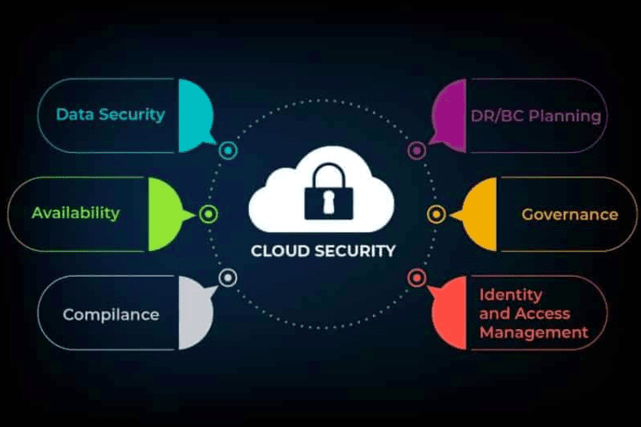

As illustrated in [9,fig 1]

Effects of Cloud Computing
As mentioned in [5], The usage of cloud computing is overtaking the world. According to Cisco research, 94% of workloads and compute instances will really be processed through datacenters by 2021, compared to only 6% by traditional data centers. Cloud networks are something different from the traditional computer networks. Communications and design are simplified by the cloud. Environment level isolation for each application will operate better with central routing; as a result, there will be less of a need to maintain large routing tables and track route. As a result, having many experts on the same team is no longer necessary.
- Cloud Computing Effect on Business
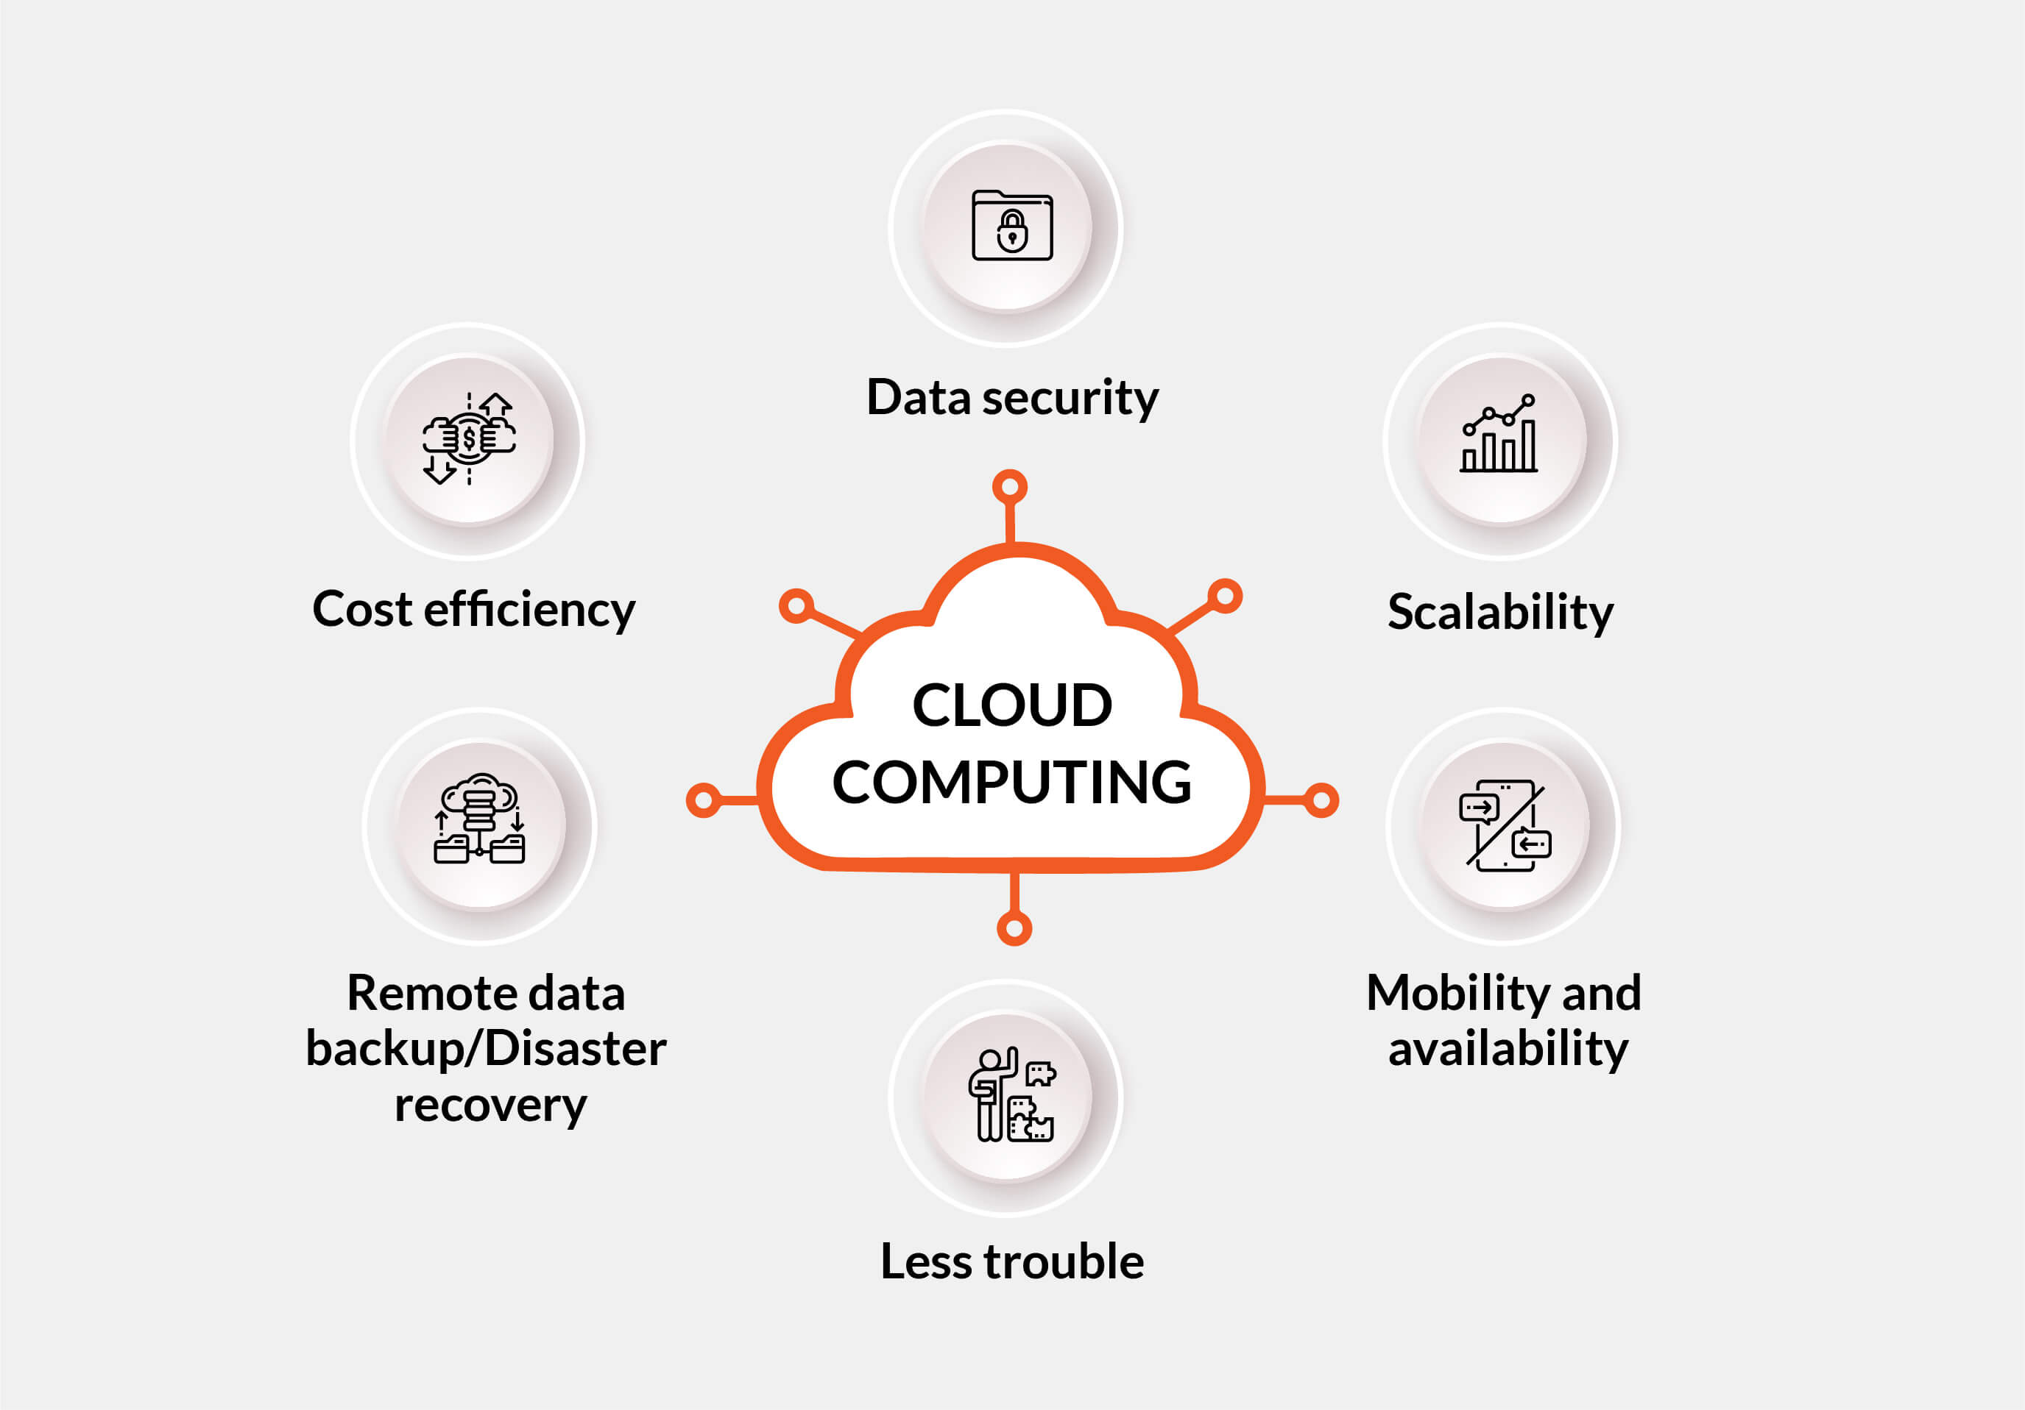
As mentioned in[10, fig 1]
As mentioned in [6], Bigger and scalable business are shifting towards cloud computing technology instead of traditional computer networks. Businesses can use cloud computing to run their operations online. It enables business entities to electronically access their information, making data accessible from anywhere at any time. The cost reduction is the main focus of business to gain and earn maximum profits. Because the business is not needed to buy or maintain the infrastructure, cloud computing can result in a significant reduction in labor and maintenance expenses. There is less need for internal staff because the vendor owns the computer gear and keeps it at off-site facilities. The storage of employees and client's data is one of the biggest obstacles faced by the organizations to handle this issue and manage the bulking of data Companies can ask for an upgrade in the storage space and use the services as the company growth and requires more storage space.
- Cloud Computing and Society
Cloud computing impacted the different aspects of society like social media, entertainment, shopping and healthcare. The pictures upload on Facebook or different social apps like Instagram are stored in cloud. A revolution in the entertainment industry has been brought on by cloud. A few examples of cloud-based apps are Netflix, Amazon Prime, Spotify, Watcho, and Disney Hotstar. They deliver the stuff to us via the cloud. With these apps, we can access the internet from anywhere and watch movies, tv programs, and listen to our favorite song.

How Challenges are overcome ?
- Shared Responsibility Models
As mentioned in [7], In the private data centers enterprises are responsible for management of security concern but the public cloud demands some responsibility from the cloud professionals. Enterprises must review their policies about shared responsibility to ensure the cloud security under them.
- Cloud Cost
As mentioned in [8], The technical networks people evolve and learn new skills to reduce the cost of cloud by automating different policies for governance, financial analytics. The team also prepares an estimate budget right from the beginning.
- Cloud Migration
As mentioned in [8], The cloud migration process in which the movement of applications and data to storage of cloud takes place. The networking team takes detailed pre migration testing for accessing the situation better knowing the budget and deadline limits.

Restful Services and Cloud Computing
Abbreviated as Representational State Transfer, Restful web services is a kind of software architecture for the development of web applications that provides the interaction of computer systems. The Restful webservices works on four common and basic principles which are GET, POST, PUT, DELETE.
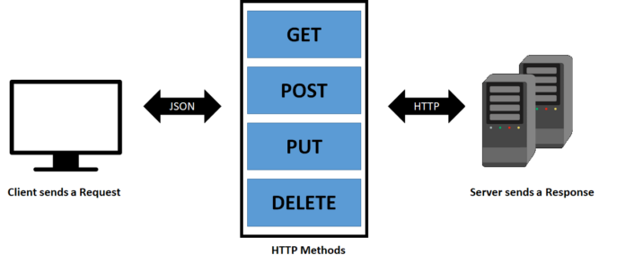
As mentioned in [11, fig 1]
The illustrative explanation about the four principles or stages of sending or receiving data over the web servers.
REST APIs are challenging to develop because they are frequently based merely on an architectural style, rather than on precise and written specifications. As a result, we are now going to give a list of REST API best practices for readability and reuse that we have organized and pulled from the literature to complement our examination of cloud REST APIs.
The webservices helps cloud computing in a way that the Application programming interfaces (APIs) are used in cloud computing to define how various software components should communicate with one another. APIs serve as messengers between apps, sending your request to the providers and then returning with the provider's response. There are some of the characteristics of rest in cloud computing.
As mentioned in [12]
- Client and server are separated by uniform interface.
- All information required for completing a client request is included in every request.
- To enhance the speed of cloud services, responses may be cached on the client computer.
- The connection of client to the final server is possible through a middle layer that provides flexibility.
Restful API’s allow easier implementation of cloud apps and services which are possible by using two services Software as Service (SaaS) and Platform as a Service (PaaS).
As mentioned in [13]
- SaaS
It is a model of software that is deployed as a hosting service and is accessed over the internet, or software delivery model, in which software and its associated data are hosted centrally and accessed using their client, typically an online browser, over the web. Software as a Service facilitates users to run existing online applications. Modern apps are created and delivered via SAAS services.
- PaaS
For applications made up of services managed by a third party, Platform as a Service is a cloud delivery approach. It offers elastic scaling for your application, enabling developers to create online services and applications with public, private, and hybrid deployment methods.
- IaaS
Technology as a Service enables the provision of computing infrastructure as on-demand services. It is one of the three essential models for cloud services. In a fully outsourced, on-demand service model, the user purchases servers, software data centers, or network equipment and rents those resources. The resources are distributed as services, and it supports dynamic scalability. On a single piece of hardware, numerous users are typically supported.
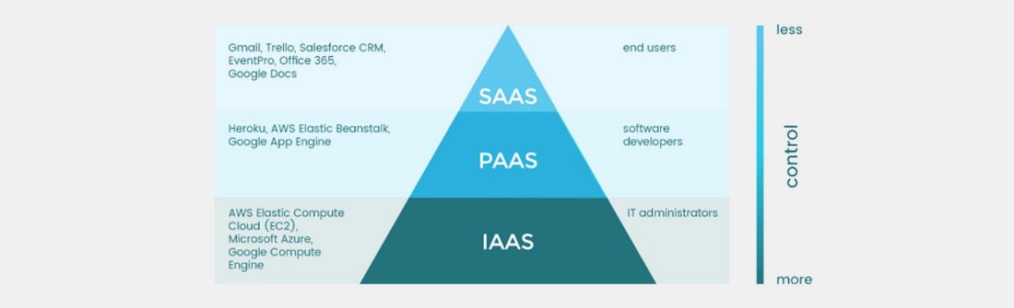
Figure explains the area of usage of these technologies and how different area are used by these software services types.

Software Defined Networking
As mentioned in [14]
A network design strategy called Software-Defined Networking (SDN) enables the network to be intelligently and centrally controlled, or "programmed," using software programs. Without respect to the underlying network technology, this aids operators in managing the entire network consistently and comprehensively.
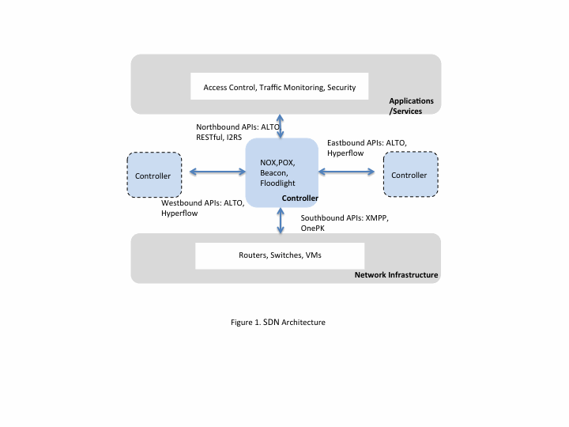
The figure illustrates the flow control of different applications and programs using the cloud services. It explains the data and information security flow in the network infrastructure.
As mentioned in [20],
Furthermore, SDN facilitates swift network-wide movement of workloads. For instance, telecom service providers can shift client services to less expensive servers or even the customers' own servers by segmenting a virtual network using a technique called network functions virtualization (NFV). A virtual network architecture can be used by service providers to immediately launch new client services and move workloads from private to public cloud infrastructures as needed. As network operators add or delete virtual machines, whether they are on-premises or in the cloud, SDN also makes it simpler for any network to flex and scale.
As mentioned in [15]
Software defined networking make it convenient to program network behavior in centrally in a manageable environment using software programs that make usage of open API’s. The complexity of underlying network technology is not considered in this case. Operators manage the entire network and devices connected by consistently opening the closed networks platforms and implementing a standard SDN control layer. By developing new kinds of apps, services, and business models in record speed and with less fuss than before, organizations can empower innovation using SDN. With dynamic apps and a more effective workflow, businesses can develop new services and avenues for revenue. The capex can be decreased by running network functions on less expensive off-the-shelf hardware. In order to make network design, deployment, management, and scaling easy, businesses can promote automation and algorithm control through greater programmability of network parts. In order to quickly fulfil their changing requirements, enterprises can quickly deploy new, fluid, and adaptable applications, services, and infrastructure with the aid of SDN.

SDN Benefits
As mentioned in [16]
Transition to SDN is a journey. Before enterprises integrate virtualization and automate it into their data architecture, it will take time, resources, and planning. Having said that, the initial step is too contextual the ensuing advantages.
- Automation
This helps business and companies to create more consistent and environment for scalability.
- Central Networking Control
The centralized networking control manage the distribution of traffic efficiently. This remove stopping points enhancing and boosting the application performance. Organization can control the storage and server more easily in a centralized environment.
- Security
The virtualization complicates the management but the centralized system makes it possible to control and manage the security.
- Expense Control
The central system makes it easy for management to better use of hardware. The lifespan of hardware can be extended as there is more relying on SDN controller.
As mentioned in [19]
The adaptation of SDN in an organization can change the dynamics of network engineer's role this might be a challenging for them to change the existing network type of an organization. For seasoned engineers who still frequently think in hardware terms and have spent the most of their careers learning how to automate legacy devices and setups, it could be challenging. We can build more scalable networks, react to demand peaks or changes without touching cables or going to the data center by viewing the network as useful virtualized software resources.

Usability of JSON and REST
As mentioned in [18]
Data representation uses a format called JSON, or JavaScript Object Notation. It was first introduced as a component of JavaScript in the early 2000s and over time developed into the predominant method for expressing and transferring text-based data. The current global standard for data communication is JSON. It can be found in every field of programming, including systems, middleware, databases, and server- and client-side development.
The Cloud Storage JSON API is a straightforward, JSON-supported interface for programmatically accessing and modifying Cloud Storage projects. With the Cloud Storage Client Libraries, everything works flawlessly. The JSON API is for software developers. The usage is only possible when there is a familiarity with the web programming.

References
[1] AARON_K, “Career Opportunities in Computer Networking” embibe.com. https://www.embibe.com/exams/career-in-computer-networking/#:~:text=Computer%20Networking%20is%20the%20practice,infrastructure%2C%20software%2C%20and%20policies (Accessed 12/11/2022)
[2] M.Benaiah Deva Kumar and B Deepa, Computer Networking: A Survey. India: Deepa,2015.
[3] Prantosh Kumar Paul and Mrinal K ghose, Cloud Computing: possibilities, challenges and opportunities with special reference to its emerging needs in the academic and working area of information science. India: 2012.
[4] Rui Wang, Application and Development of Cloud Computing Technology in Computer Data Processing. China :2021
[5] Mohit Bhardwaj, “Network to cloud engineer, do you need to make this Transition” LinkedIn.com. https://www.linkedin.com/pulse/network-cloud-engineer-do-you-need-make-transition-mohit-bhardwaj (Accessed 12/11/2022)

[6] Ajay Ohri, “Impact of cloud computing: A simple overview in 4 points” jigsawacademy.com. https://www.jigsawacademy.com/blogs/cloud-computing/impact-of-cloud-computing (Accessed 12/11/2022)

[7] Debasish Pramanik,” Best Practices to Overcome Cloud Security Challenges” cloudcodes.com. https://www.cloudcodes.com/blog/cloud-security-challenges.html (Accessed 13/11/2022)

[8] “Top 5 Cloud Management challenges and tips to overcome them”. Hurix.com. https://www.hurix.com/cloud-management-challenges/ (Accessed 13/11/2022)
[9] Hitesh Jethva,” Cloud Security vs Cyber Security – What's the difference?” cloudinfrastructureservice.co.uk. https://cloudinfrastructureservices.co.uk/cloud-security-vs-cyber-security-whats-the-difference-explained/ (Accessed 13/11/2022)

[10] “Cloud Computing – Step up your business opportunities with cloud service”. Quintagroup.com. https://quintagroup.com/blog/cloud-computing-step-up-your-business-opportunities-with-cloud-services (Accessed 13/11/2022)

[11] Shibi Kamalakannan,” RESTFUL web service and its methods.” mechomotive.com. https://mechomotive.com/restful-web-service-and-its-methods/ (Accessed 13/11/2022)

[12] Edward Kuhn, “REST in Cloud Computing”. Cloudivity.com. https://www.cloudivity.com/cloud-architecture/rest-in-cloud-computing/ (Accessed 13/11/2022)
[13] “Difference between IAAS, PAAS and SAAS”. GeeksforGeeks.org. https://www.geeksforgeeks.org/difference-between-iaas-paas-and-saas/ (Accessed 13/11/2022)
[14] “What is SDN”. Ciena.com. https://www.ciena.com/insights/what-is/What-Is-SDN.html (Accessed 13/11/2022)
[15] “Why is software defined networking important”. Sdxcentral.com. https://www.sdxcentral.com/networking/sdn/definitions/what-the-definition-of-software-defined-networking-sdn/why-sdn-important/#:~:text=SDN%20allows%20organizations%20to%20use,%2C%20services%2C%20and%20business%20models. (Accessed 13/11/2022)

[16] Habeeb Ehtesham, “What Is SDN? Why Business Prepare Need to for SDN Transition.” extnoc.com. https://www.extnoc.com/blog/businesses-prepare-for-sdn-transition/ (Accessed 13/11/2022)

[17] Joachim Bauernberger,” How SDN is going to affect your job as a network engineer.” LinkedIn.com. https://www.linkedin.com/pulse/20140527163943-7082046-how-sdn-is-going-to-affect-your-job-as-a-network-engineer (Accessed 13/11/2022)
[18] “Cloud Storage JSON API overview.” cloud.google.com. https://cloud.google.com/storage/docs/json_api#:~:text=The%20Cloud%20Storage%20JSON%20API,is%20intended%20for%20software%20developers. (Accessed 13/11/2021)
[19] “What is the cloud? “. cloudfare.com. https://www.cloudflare.com/learning/cloud/what-is-the-cloud/ (Accessed 13/11/2022)
[20] “What is software defined networking “. vmware.com. https://www.vmware.com/topics/glossary/content/software-defined-networking.html (Accessed 13/11/2022)

