The Thomas Picton Monument: Contesting Legacy, Memory, and Reinterpretation

- INTRODUCTION
Historian and anthropologist Sharon Macdonald introduced the term ‘difficult heritage’ to describe how societies engage with aspects of their past that are morally troubling, politically contentious, or challenge national identity. Macdonald defines difficult heritage as a past ‘recognised as meaningful in the present but contested and awkward for public reconciliation with a positive, self-affirming contemporary identity’ (Macdonald, 2009, p. 1). The concept has shaped views on Britain's colonial history and commemorations, influencing everyday street names and trauma sites recognised as heritage (Copley and Carter, 2024). Public monuments from the era of British slavery are central to ongoing discussions about heritage, memory, and racial justice (Grindon et al., 2024). The June 2020 toppling of slave trader Edward Colston's statue in Bristol by the Black Lives Matter (BLM) movement increased awareness of the problematic histories of many statues and artefacts, which often reinforce socio-economic disparities (Branscome, 2021).
The Picton Monument in Carmarthen, West Wales, is a significant yet contentious symbol of Welsh heritage. It illustrates the complexities of commemorating historical figures with colonial legacies, highlighting the tensions between historical preservation, modern ethical considerations, and future heritage concerns. This report examines this monument honouring Sir Thomas Picton, a controversial British military figure from the Napoleonic Wars, known for his oppressive rule in Trinidad, which included torture and slavery. Often referred to as the ‘Tyrant of Trinidad’ or the ‘Blood-Stained Governor’, Picton's legacy has sparked debate and protests, raising questions about the monument's relevance today (Amgueddfa Cymru, n.d.; Youle, 2021). This report critically examines the historical context and significance of the Picton Monument and discusses the public debates and controversies related to its commemoration. Additionally, the report evaluates the actions taken by the local authority, which, while representing progress, are considered inadequate and require further review to address Picton’s legacy accurately. In conclusion, the report provides options for reassessing the monument’s commemoration, ensuring it aligns with principles of historical justice and better reflects its complex heritage implications.
- LOCATION AND DESCRIPTION OF THE MONUMENT
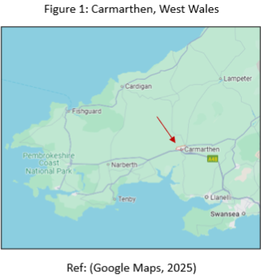
The monument is a prominent landmark in the county town of Carmarthen (See Figure 1) (grid reference of SN4026919950). The corresponding ‘what3words’ address is parts.spill.shrimp, and the nearest postal code is SA313BU (Grid reference finder, 2025). The site is located on an island in the middle of the B4312 road, at the apex of Picton Terrace and Monument Hill (See Figures 2 and 3).

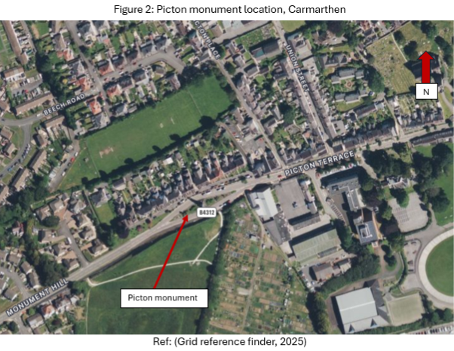

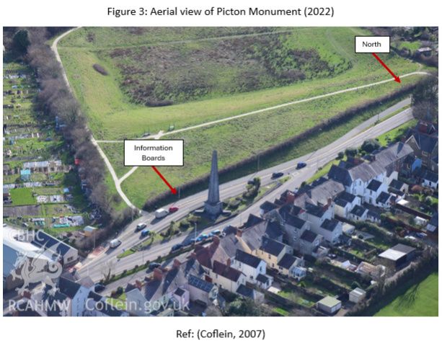
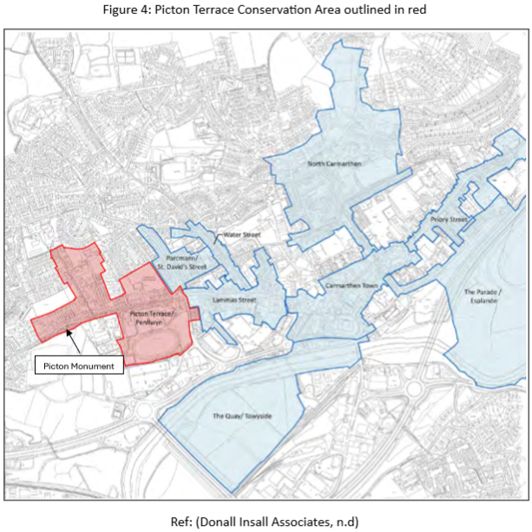
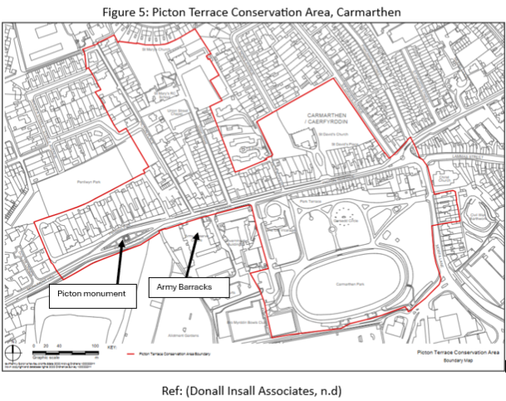
This site is in the Picton Terrace Conservation Area (See Figures 4 and 5), which was established in 1971, and it serves as a significant landmark visible from various locations both within and outside the area. The responsibility for the site lies with Carmarthenshire County Council (Legall, 2021; Donall Insall Associates, n.d.).
Picton Terrace likely follows an ancient Roman road through the town and was agricultural land until development began as the town expanded. Research shows the area's development from open land to residential housing during the 19th century (See Appendix 1, 2 and 3). The Conservation Area maintains a historical layout with various residential styles, including 19th-century workers' cottages and townhouses. Most homes are terraced, with their grandeur increasing as you travel up Picton Terrace and approach the monument (Donall Insall Associates, n.d.). The Picton Monument is about 30 meters above sea level (Topographic Map, 2025). Its location on Picton Terrace, a major thoroughfare and the western entrance to the town, ensures that it is a prominent feature of the landscape. The monument's height symbolises the historical significance of Picton in society, as elevated positions for monuments convey authority, permanence, and public recognition, allowing them to stand out in the surroundings (Simko et al., 2022).
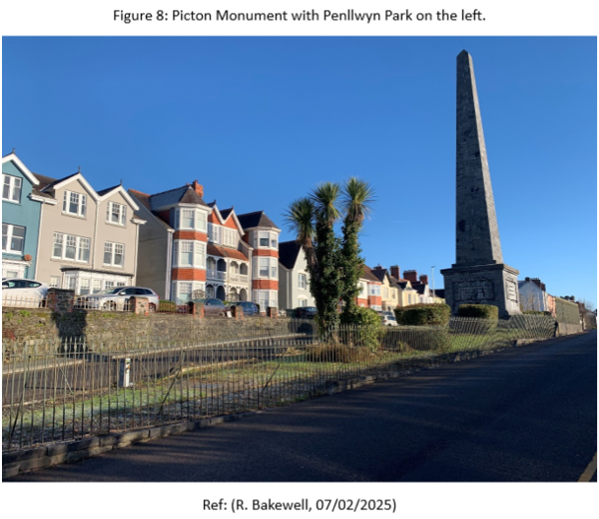
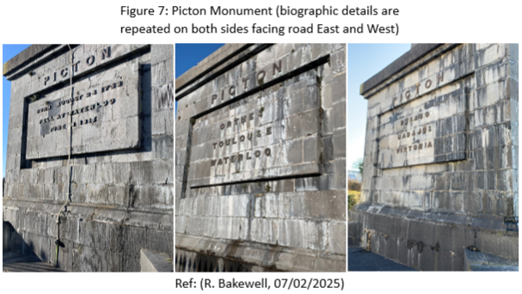
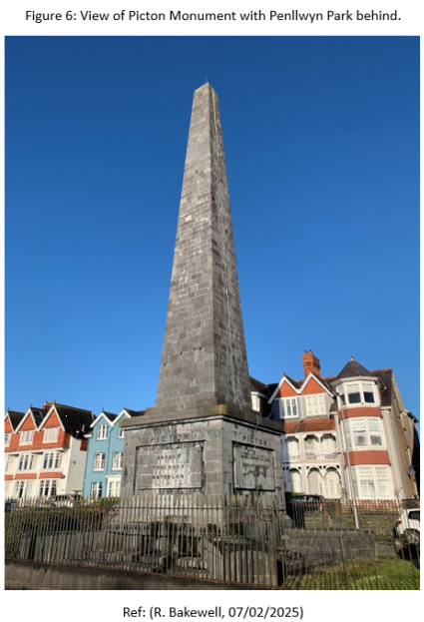
The Picton Monument is a Grade II listed structure, designated in 1981 (See Figure 6). It stands 24 meters tall and is designed in the neoclassical style. The monument is constructed from finely worked grey limestone, featuring diagonal plain plinths extending from the corners of the obelisk. On two sides, it has raised capital letters: ‘Picton, born August 24, 1758; fell at Waterloo, June 18, 1815’. The other two sides list the battles he participated in: Busaco, Badajoz, Vittoria, Orthes, Toulouse, and Waterloo (See Figure 7). The monument is in a garden surrounded by iron fencing, with an access gate on the west side (CADW, 2023). Palm trees on site may symbolise Picton's time as the British Governor of Trinidad (See Figure 8).

- THOMAS PICTON: LEGACY AND CONTROVERSY
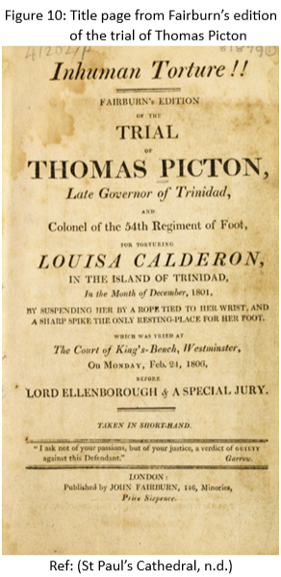
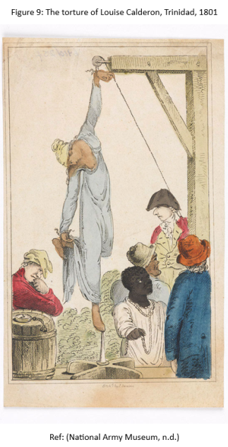
Lieutenant-General Sir Thomas Picton (1758–1815) is a significant yet controversial figure in Welsh history, commemorated through various monuments and place names across Wales. Born in Haverfordwest, Pembrokeshire, he spent his childhood at Poyston Hall in Rudbaxton before joining the British Army. Picton's legacy is complex, primarily due to his tenure as military governor of Trinidad from 1797 to 1803. During this time, he owned plantations and enforced oppressive practices, resulting in 36 court charges against him, including torture and wrongful imprisonment. Notably, Picton was put on trial in 1806 for allowing the torture of a 14-year-old girl named Louisa Calderon (See Figures 9 and 10). The media coverage of this case highlighted the horrors of Caribbean slavery and aided the abolitionist movement. His conviction was annulled in 1808 due to a legal technicality. In 1813, Picton was elected as a Member of Parliament for Pembrokeshire and established a home in Ferryside, near Carmarthen. He was later recalled to military service after Napoleon's escape and, in 1815, became the highest-ranking officer to die at the Battle of Waterloo. Picton is remembered for his heroic death, which earned him a tomb in St. Paul’s Cathedral and is recognised as the only Welshman buried there (See Appendix 4). Additionally, he is commemorated with streets named after him in Trinidad, and towns called ‘Picton’ exist in Canada, Australia, and New Zealand (Legall, 2021; Hoskins and James, 2024; Pantheons, 2025). The ‘Ode on the Death of Sir Thomas Picton’ poem, written shortly after his death, glorifies Picton as a heroic military figure, emphasising his bravery, sacrifice, and patriotism while ignoring his brutal colonial rule in Trinidad. It reflects the imperial values of the time, portraying him as a national martyr and reinforcing a one-sided narrative that celebrated British military leaders while overlooking their involvement in slavery and oppression (Rowlands, 1819).
- MATERIAL SIGNIFICANCE AND ARCHITECTURAL FEATURES
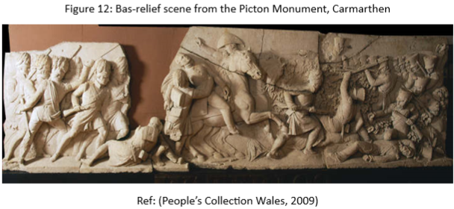
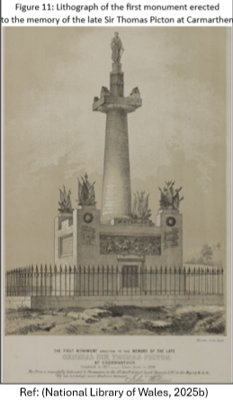
The original monument was created to honour Picton and was funded by a public campaign (See Appendix 5) that raised £3,000 in 1815 (Legall, 2021). This initiative was part of broader efforts to establish national memorials to celebrate British heroes from the Revolutionary and Napoleonic Wars, highlighting themes of patriotism and masculinity. Plans for a monument in Carmarthen progressed slowly, led by Lord Dynevor’s fundraising committee and Captain Gwynne, Picton's relative. The foundation stone was laid on 16th August 1825, during a ceremony about ten thousand people attended, including speeches and festivities (Hoskins and James, 2024). Sir Christopher Cole, M.P., defended Picton's Trinidad governorship against criticism during the event (The Cambrian, 1825). The monument (See Figure 11), dedicated on 16th August 1828, featured a statue of Picton over nine and a half feet tall, with carvings of his military achievements by E.H. Bailey, a section of which is now held at Carmarthen Museum (See Figure 12). Local stone mason Daniel Mainwaring completed the structure, which stood 75 feet tall and included an internal staircase and cannons at each corner. Although initially praised, the monument began to deteriorate by the late 1830s due to its Roman cement construction, with The Welshman later describing it as a ‘monument of poverty or something worse’ (Hoskins and James, 2024; War Memorials Online, 2020; Coflein, 2007).

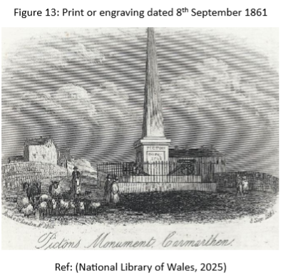
In 1844, a committee was formed to fund the restoration, and the monument was demolished in 1846 (Hoskins and James, 2024). A new obelisk was designed by Francis Fowler and completed between 1847 and 1849 (See Figure 13). Initially surrounded by lions, these were omitted due to budget cuts and replaced by cannons. The obelisk showcases 19th-century fascination with antiquities as British tourists explored Europe and the Near East after the Battle of the Nile and the Battle of Waterloo and often commemorated military honours, like those for Picton (CWGC, 2022). The monument was truncated in 1984 (See Appendix 6 and 7) due to safety concerns and rebuilt in 1988 on firmer foundations (CADW, 2023; War Memorials Online, 2020). At that time, there were concerns over the costs of repairs, and Picton's connections to slavery led to calls for a new monument honouring a different Welsh hero. Many people saw Picton as an agent of the English state, which fuelled Welsh nationalism and a desire to separate from that historical legacy (Hoskins and James, 2024).
Notable sites in Wales commemorating Picton include his statue, previously located in Cardiff City Hall's Marble Hall (See Appendix 8), unveiled by Lloyd George in 1916 but removed in 2020 due to its links to slavery (Legall, 2021). The National Museum Cardiff also removed his portrait (See Appendix 9) in November 2021 as part of the 'Reframing Picton' initiative (Amgueddfa Cymru, 2022). A painting of Picton in the Guildhall courtroom (See Appendix 10) in Carmarthen faced calls for removal in 2011 but resulted in an information board being added instead (Youle, 2020; The Guardian, 2011). The building is no longer a court. The Wellington Monument in Brecon (See Appendix 11) also honours him with panels from the Battle of Waterloo (Legall, 2021). Finally, a blue plaque marking his birthplace in Haverfordwest was removed in 2020 (Sinclair, 2020).
Research on memorials in Carmarthen identified one more with slavery links: a blue plaque for Richard Steele linked to slave ownership in Barbados. The plaque remains unchanged, with research showing no challenges (Grindon et al., 2023). During research, the author discovered the University of Wales Trinity Saint David's historical links to slavery, particularly its connections to St Vincent. Andy Bevan (2023) highlights Thomas Phillips (1760-1851), a Welsh entrepreneur who contributed to the university's growth while owning a plantation in St Vincent that used enslaved labour. This reflects the impact of the region's involvement with colonial histories and slavery.
- PUBLIC DEBATE AND CONTROVERSY
Since the BLM movement began in 2015, monuments related to slavery have become central to anti-racist activism (Grindon et al., 2024). Discussions about removing statues and renaming places raise important questions about free speech, historical memory, and changing moral values (The Economist, 2022). Some see monuments as painful reminders of outdated values, while others argue that their removal erases significant history. This debate highlights the complexities of understanding our past (Pickles, 2020). Dresser (2007) explores the connection between public monuments and the transatlantic slave trade, pointing out that many statues honour figures associated with slavery. She advocates for a nuanced view of these monuments, emphasising the ongoing debates about their removal versus historical context. Dr Simon John emphasises the need to acknowledge both the positive and negative aspects of controversial figures in public memory. Each memorial must be assessed individually due to unique challenges in recontextualising them (Sayed et al., 2021). This controversy highlights the challenge of balancing Picton’s achievements with his violence against enslaved people. Monuments like this both celebrate colonialism and perpetuate narratives that justify exploitation.
The Picton Monument requires heritage authority approval for modifications, highlighting the challenges of reevaluating colonial monuments amid changing public perspectives (Epstein and Palmer, 2025). The UK government's 'retain and explain' policy offers limited guidance on addressing past injustices, potentially alienating communities by advocating for context rather than removal. Additionally, the Police, Crime, Sentencing and Courts Act (2021) imposes heightened penalties for damage to memorials, indicating a reluctance to engage in deeper discussions (Peacock, 2021). As the House of Commons Library (2021) notes, planning permission is needed to demolish unlisted public statues, reflecting the ongoing tension between preserving heritage and ensuring inclusive historical representation (Grimwood, 2021).
The Welsh Government's 2020 audit, ‘The Slave Trade and the British Empire: An Audit of Commemoration in Wales’, identified 209 commemorating the slave trade, many of which lack context and may be misinterpreted. Picton is the second most commemorated figure, with 39 dedicated to him (Legall, 2021). A 2021 Welsh Parliament report, ‘Set in Stone?’, called for community engagement in monument decisions and a national dialogue about their historical context (Sayed et al., 2021). The Welsh Government's 2024 guidance, ‘Public Commemoration in Wales,’ encourages decolonising public spaces by reassessing colonial monuments. It suggests adding historical context through plaques or art instead of removal, promotes inclusive representation of marginalised voices, and advocates for community engagement in decision-making for ethical historical representation.
In 2020, a petition with around 20,000 signatures called for removing the Picton Monument, sparking protests and debates over cultural identity and government spending. (Welsh Government, 2024). Neil Hamilton, then leader of UKIP Wales, defended the monument as a tribute to Picton's military achievements, criticising ‘Cultural Marxists’ for attempting to erase history (YouTube, 2021). Far-right groups like Voice of Wales and Patriotic Alternative also opposed the removal, viewing it as an attack on national heritage (Hoskins and James, 2024).
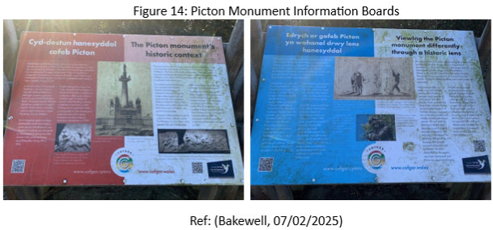
In 2020, Carmarthenshire County Council held an online consultation about the Picton Monument, receiving 2,470 responses. Notably, 23% came from outside the county, and only 30% were from Carmarthen town. Of the respondents, 32% supported action regarding the monument, while 68% opposed it. Supporters of change generally favoured relocating the monument for a more inclusive replacement or renaming it for context, with a small group calling for demolition. Those against change highlighted its historical significance and suggested adding educational materials. The results indicated a stronger sentiment for preservation, with younger individuals and those from Black, Asian, and Minority Ethnic backgrounds more likely to support action. In response to these findings, information boards, including QR codes (See Figure 14), were added in 2021 to highlight Picton’s military service and connections to slavery (Carmarthenshire County Council, 2020). During a 2025 visit, the author found the QR codes on the boards inadequate, with limited links and information. These boards, placed across from the monument and obscured by parked cars, challenge traditional narratives of Picton's heroism but do not significantly alter the environment or meet counter-memorial criteria, serving as reinterpretation tools. In June 2023, CADW rejected calls to delist the monument, adjusting the designation reasons to acknowledge Picton's crimes, prioritising architectural merit over ethical concerns and maintaining existing commemorative narratives (CADW, 2023).
In Trinidad, the remembrance of slavery's impact is an important national discussion, yet there is a lack of substantial government initiatives addressing this history (Hoskins and James, 2024). The Trinidad Express (2021) criticises the nation’s superficial efforts to acknowledge its colonial past, arguing that current memorials do not adequately reflect the brutal realities of slavery. It calls for more authentic memorials and educational programs for accurate remembrance and healing.
- RE-NEGOTIATION AND RECONSIDERATION
The monument is an imposing and uninviting site to visit, somewhat sterile, being enclosed by black iron fencing, with its location making access challenging. Installing information boards was a positive initial step, but their poor location disconnects them from the monument (see Figure 3). Although cost-effective for the council, they have minimal impact and fail to address the complexities of Picton's legacy.
There are several options for reinterpreting the monument to better reflect the complexities of Picton's legacy. Relocating it might be seen as erasing history, and disassembling and moving it could be costly and unpopular. Another option is to replace it with a memorial for victims of colonial oppression, though this would likely face local opposition.
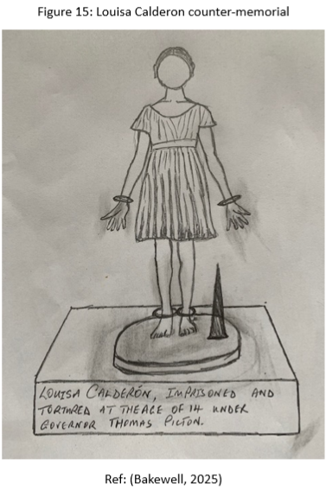
Retaining the existing monument while adding a counter-memorial to Louisa Calderon would contrast Picton’s legacy and encourage viewers to reconsider his historical significance. The sketch shown in Figure 15 outlines a life-size bronze statue of Louisa standing upright, eyes unflinching and hands open to showcase strength. Dressed simply, with bare feet, she stands beside the wooden torture device (pick) and wears wrist and leg irons. Instead of lengthy text, a single engraved sentence at the base states, ‘Louisa Calderon, imprisoned and tortured at the age of 14 under Governor Thomas Picton’. There is no embellishment, just the stark truth. The memorial is positioned in the garden of Picton Monument, forcing visitors to engage with both at once. There is no unnecessary dramatisation. The minimalist design is heavy with meaning, requiring viewers to fill in the horror themselves. The contrast with the grandiosity of Picton’s monument enhances its impact. The statue sits on a low slab, inviting visitors to engage with the etched text, seamlessly integrating into the memorial’s stark design. Counter-monuments foster public engagement, social justice, and inclusivity (Stevens et al., 2018).
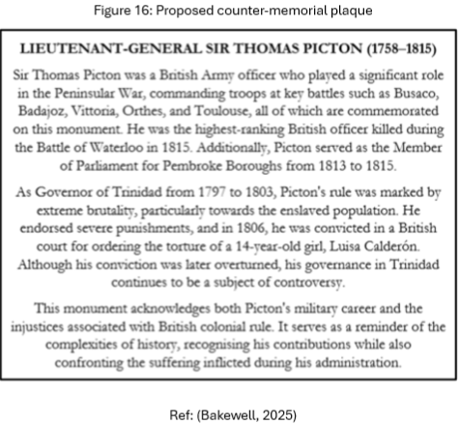
Frayne’s (2023) concept of contextualisation suggests reimagining the Picton monument by transforming it from a celebration of his military achievements to an ‘ambiguous’ artefact that encourages critical engagement with his colonial violence and slavery. Dresser (2007) supports this by proposing that adding plaques to such monuments can provide context and enhance public education. This could be achieved by removing the existing inscriptions and adding a counter-memorial plaque acknowledging Picton’s military achievements and explicitly acknowledging Picton’s role in slavery, thereby introducing conflict and forcing viewers to confront multiple narratives rather than a singular glorification (See Figure 16). This was done with the Henry Dundas Memorial in Edinburgh, although there were challenges to the narrative, so this should be borne in mind (BBC, 2024).
The ‘Reframing Picton’ exhibition concluded in January 2025. If feasible, the exhibition could be temporarily relocated to Carmarthen Museum or another appropriate venue in the town. This would allow the local community to engage with a more comprehensive and nuanced understanding of Picton's legacy. It would aim to foster ongoing dialogue and reflection on the historical and social implications of his commemoration. Additionally, the exhibition could serve as a platform for education and public discussion, encouraging critical thinking and a deeper connection to local history.
In addition, the information boards would remain in place but be updated to ensure the QR codes work. Seating for visitors within the monument grounds could also be provided. Removing the palm trees would weaken the symbolic connection between Picton and his colonial legacy in Trinidad. However, if the Calderon memorial was implemented, retaining the palm trees would be appropriate, as they are native to her.
Decisions would be based on public and stakeholder engagement, including consultation with the Republic of Trinidad and Tobago.
- CONCLUSION
The Picton Monument highlights the difficulties of commemorating figures with complex legacies. Although it was significant when first established, the monument became irrelevant to the community within a generation and fell into disrepair. By the 1980s, as restoration became necessary, critiques of its relevance and Picton's status as a national hero increased. Originally intended to honour his military achievements, Picton's association with colonial violence has led to significant controversy.
The local authority's efforts to address concerns about the Picton Monument, while in alignment with Welsh Government guidance, have proven inadequate. This underscores the need to comprehensively re-evaluate the proposed options, situating the monument's controversies within the broader discourse on public memory and decolonisation. Engaging with difficult heritage reflects shifting attitudes toward justice and inclusivity in public spaces. Ultimately, these discussions highlight the importance of critically examining the individuals commemorated and the motivations underlying these public tributes.
Future heritage policies should focus on open dialogue and community-driven initiatives to reflect diverse histories and perspectives in public spaces. As heritage management evolves, it is essential to create long-term strategies for historical commemoration that recognise multiple viewpoints and address colonial legacies. This can include adaptive frameworks for reassessing contested monuments to align with contemporary values. Encouraging public engagement and fostering educational partnerships will be crucial for shaping a dynamic heritage landscape that reflects Wales’s ongoing relationship with its history.

REFERENCES
Amgueddfa Cymru (2022) Reframing Picton. Available at: https://museum.wales/cardiff/whatson/11568/Reframing-Picton/ (Accessed: 10 February 2025).
Amgueddfa Cymru (n.d.) Lieutenant-General Sir Thomas Picton (1758-1815). Available at: https://museum.wales/collections/online/object/4adfdd41-6370-36bf-a907-c74f5ad7d4a5/Lieutenant-General-Sir-Thomas-Picton-1758-1815/#:~:text=Thomas%20Picton%20%E2%80%93%20also%20known%20as,as%20a%20particularly%20cruel%20leader (Accessed: 16 February 2025).
Bakewell, R. (2025) Louisa Calderon counter-memorial (Pencil sketch). Unpublished.
Bakewell, R. (2025) Picton Monument, Carmarthen. (Photographs). Unpublished.
Bakewell, R. (2025) Proposed counter-memorial plaque. Unpublished.
BBC (2024) Council installs new slavery plaque at Edinburgh’s Melville Monument. Available at: https://www.bbc.co.uk/news/uk-scotland-edinburgh-east-fife-68597359 (Accessed: 26 February 2025).
Bevan, A. (2023) Wales’ oldest university – and its slavery links with St Vincent, in the Caribbean. Available at: https://www.iwa.wales/agenda/2023/03/wales-oldest-university-and-its-slavery-links-with-st-vincent-in-the-caribbean/#:~:text=In%20Lampeter%2C%20however%2C%20decolonisation%20is,Caribbean%20island%20of%20St%20Vincent (Accessed: 13 February 2025).
Branscome, E. (2021) ‘Colston’s Travels, or Should We Talk About Statues?’, ARENA Journal of Architectural Research, 6(1). Available at: https://doi.org/10.5334/ajar.261
CADW (2023) The Picton Monument. Available at: https://cadwpublic-api.azurewebsites.net/reports/listedbuilding/FullReport?lang=&id=9503 (Accessed: 14 February 2025).
Carmarthenshire County Council (2020) Equality and Diversity Task and Finish Group: Interim Report November 2020. Available at: https://democracy.carmarthenshire.gov.wales/documents/s47238/Report.pdf (Accessed: 19 February 2025).
Coflein (2007) Picton Monument. Available at: https://coflein.gov.uk/en/site/32669/ (Accessed: 14 February 2025).
Copley, C. and Carter, N. (2024) ‘The Difficult Heritage of Dictatorship in Europe’, Journal of Contemporary History, 59(1), pp. 3–10. Available at: https://doi.org/10.1177/00220094231218572
CWGC (2022) War memorial design through the ages. Available at: https://www.cwgc.org/our-work/blog/war-memorial-design-through-the-ages/ (Accessed: 16 February 2025).
Donall Insall Associates (n.d) Conservation Area Character Appraisal and Management Plan: Picton Terrace Conservation Area. Available at: https://www.carmarthenshire.gov.wales/media/1229142/picton-terrace-ca-appraisal.pdf (Accessed: 13 February 2025).
Dresser, M. (2007) ‘Set in Stone? Statues and Slavery in London’, History Workshop Journal, 64(1), pp. 162–199. Available at: https://doi.org/10.1093/hwj/dbm032
Epstein, J. and Palmer, L. (2025) ‘Representing colonial legacies: some legal and historical perspectives on Reframing Picton’, Law and Humanities, pp. 1-12. Available at: https://doi.org/10.1080/17521483.2025.2465076 (Accessed: 19 February 2025).
Frayne, N.F. (2023) ‘Absolutes and Ambiguity: Transforming Artefacts Towards Non-violence’, The British Journal of Aesthetics, 63(1), pp. 91–107. Available at: https://doi.org/10.1093/aesthj/ayac017
Gibbs, W. (n.d.) The Wellington and Picton Memorial, Brecon. Available at: https://static1.squarespace.com/static/649d4579168838251e67aa8c/t/64de0c4477782e6703515697/1692273733305/The-Wellington-and-Picton-Memorial.pdf (Accessed: 13 February 2025).
Google Maps (2025) Carmarthen. Available at: https://www.google.com/maps/@52.0309792,-3.606463,8.5z?entry=ttu&g_ep=EgoyMDI1MDIxOS4xIKXMDSoASAFQAw%3D%3D (Accessed: 23 February 2025).
Grid reference finder (2025) Picton monument, Carmarthen. Available at: https://gridreferencefinder.com/#gr=SN4026919950|Point_s_C|1 (Accessed: 21 February 2025).
Grimwood, G. (2021) Contested heritage: Controversy surrounding public monuments. Available at: https://commonslibrary.parliament.uk/research-briefings/cbp-9405/ (Accessed: 14 February 2025).
Grindon, G. et al. (2023) British Public Monuments related to Slavery. Available at: https://www.britishmonumentsrelatedtoslavery.net/public/ (Accessed: 15 February 2025).
Grindon, G. et al. (2024) ‘Mapping British Public Monuments related to Slavery’, 45(2), pp. 384-407. Available at: https://doi.org/10.1080/0144039X.2023.2264837
Gwyn, M. (2012) Wales and the memorialisation of slavery in 2007. Available at: https://www-tandfonline-com.ezproxy.uwtsd.ac.uk/doi/pdf/10.1080/14788810.2012.688629?needAccess=true& (Accessed: 13 February 2025).
Harries, R. (2020) Monuments to brutal slave owner Thomas Picton in Carmarthen and Cardiff ‘should be removed’. Available at: https://www.walesonline.co.uk/news/wales-news/picton-carmarthen-cardiff-black-lives-18382570 (Accessed: 13 February 2025).
Hoskins, G. and James, L. (2024) ‘Commemorating Picton in Wales and Trinidad: Colonial legacies and the production of memorial publics’, Journal of Historical Geography, 83, pp. 68–79. Available at: https://doi.org/10.1016/j.jhg.2023.11.010
Independent (2020) Sir Thomas Picton: Statue of ‘sadistic slave owner’ to be removed in Cardiff. Available at: https://www.independent.co.uk/news/uk/home-news/thomas-picton-statue-cardiff-removed-slave-owner-a9636046.html (Accessed: 15 February 2025).
Legall, G. (2021) The Slave Trade and the British Empire: An Audit of Commemoration in Wales. Available at: https://www.gov.wales/sites/default/files/publications/2021-12/the-slave-trade-and-the-british-empire-an-audit-of-commemoration-in-wales.pdf (Accessed: 13 February 2025).
Macdonald, S. (2009) Difficult heritage : negotiating the Nazi past in Nuremberg and beyond. Abingdon: Routledge. Available at: https://doi.org/10.4324/9780203888667
Macdonald, S. (2015) ‘Is ‘Difficult Heritage’ Still ‘Difficult’? Why Public Acknowledgment of Past Perpetration May No Longer Be So Unsettling to Collective Identities’, Museum International, 67(1–4), pp. 6–22. Available at: https://doi.org/10.1111/muse.12078
Murphy, A. (2021) National Museum Cardiff removes portrait of slave-owner Thomas Picton. Available at: https://www.museumnext.com/article/national-museum-cardiff-removes-portrait-of-slave-owner-thomas-picton/ (Accessed: 14 February 2025).
National Army Museum (n.d.) The torture of Louise Calderon, Trinidad, 1801. Available at: https://collection.nam.ac.uk/detail.php?acc=1969-10-254-1 (Accessed: 13 February 2025).
National Library of Scotland (2025) OS Map 1877 to 1888. Available at: http://maps.nls.uk/view/101168435 (Accessed: 14 February 2025).
National Library of Wales (2025) Picton’s Monument, Carmarthen. Available at: https://viewer.library.wales/1131609#?xywh=-981%2C-56%2C3456%2C1254 (Accessed: 14 February 2025).
National Library of Wales (2025b) Lithograph of the first monument erected to the memory of the late Sir Thomas Picton at Carmarthen. Available at: https://viewer.library.wales/1133701#?xywh=-7707%2C264%2C20637%2C7489 (Accessed: 14 February 2025).

National Library of Wales (n.d.) Thomas Picton: Hero or villain? Available at: https://www.library.wales/discover-learn/education/learning-resources/thomas-picton-hero-or-villain#:~:text=Thomas%20Picton%20is%20widely%20regarded,ordered%20the%20torturing%20of%20people (Accessed: 13 February 2025).
Oxford DNB (2004) Picton, Sir Thomas. Available at: https://www.oxforddnb.com/display/10.1093/ref:odnb/9780198614128.001.0001/odnb-9780198614128-e-22219?rskey=JQyMlk&result=1 (Accessed: 13 February 2025).
Pantheons (2025) Monument to Lieutenant-General Sir Thomas Picton (1816–1821) by Sebastian Gahagan. Available at: https://pantheons-st-pauls.york.ac.uk/monument/lieutenant-general-thomas-picton/ (Accessed: 14 February 2025).
Peacock, C. (2021) A meaningful debate about statues is happening – the government just doesn’t seem to be taking part. Available at: https://theconversation.com/a-meaningful-debate-about-statues-is-happening-the-government-just-doesnt-seem-to-be-taking-part-162806 (Accessed: 13 February 2025).
Peoples Collection Wales (2009) Bas-relief scene from the Picton Monument, Carmarthen. Available at: https://www.peoplescollection.wales/items/1900#?xywh=-7%2C-97%2C721%2C494 (Accessed: 14 February 2025).
Pickles, K. (2020) Removing monuments to an imperial past is not the same for former colonies as it is for former empires. Available at: https://theconversation.com/removing-monuments-to-an-imperial-past-is-not-the-same-for-former-colonies-as-it-is-for-former-empires-140546 (Accessed: 13 February 2025).
Rowlands, D. (1819) Ode on the Death of Sir Thomas Picton. Available at: https://www.jstor.org/stable/30068909?workspaceFolderId=dae6e96e-f545-4457-afd2-4b74a17ede06&orderBy=updatedOn&orderType=desc&index=1&seq=2 (Accessed: 13 February 2025).
Sayed, B. et al. (2021) Set in Stone? A report on who gets remembered in public spaces. Available at: https://senedd.wales/media/3jbnhs2d/cr-ld14301-e.pdf (Accessed: 13 February 2025).
Simko, C., Cunningham, D. and Fox, N. (2022) ‘Contesting Commemorative Landscapes: Confederate Monuments and Trajectories of Change’, Social Problems, 69(3), pp. 591–611. Available at: https://doi.org/10.1093/socpro/spaa067
Sinclair, T. (2020) Sir Thomas Picton’s plaque will be placed on display in museum. Available at: https://pembrokeshire-herald.com/59504/sir-thomas-pictons-plaque-will-be-placed-on-display-in-museum/ (Accessed: 13 February 2025).
St Paul’s Cathedral (n.d.) Title page from Fairburn’s edition of the trial of Thomas Picton. Available at: https://www.stpauls.co.uk/thomas-picton (Accessed: 14 February 2025).
Stevens, Q. et al. (2018) ‘Counter-monuments: the anti-monumental and the dialogic’, The Journal of Architecture, 23(5), pp. 718–739. Available at: https://doi.org/10.1080/13602365.2018.1495914
The Cambrian (1825) Sir Thomas Picton’s Monument. Available at: https://newspapers.library.wales/view/3326005/3326009/19/sir%2BOR%2Bthomas%2BOR%2Bpicton (Accessed: 16 February 2025).
The Economist (2022) Cancel culture: Iconoclasm past and present. Available at: https://www.proquest.com/docview/2617702482/4BBC2EFCE62B4CB0PQ/1?accountid=130472&sourcetype=Magazines (Accessed: 13 February 2025).
The Guardian (2011) Sir Thomas Picton? Let him hang. Available at: https://www.theguardian.com/artanddesign/jonathanjonesblog/2011/nov/25/sir-thomas-picton-portrait (Accessed: 19 February 2025).
Topographic Map (2025) Map showing elevation of Picton monument. Available at: https://en-gb.topographic-map.com/map-gdftp/Carmarthen/?center=51.85809%2C-4.32101&zoom=18 (Accessed: 16 February 2025).
Trinidad Express (2021) A national shame. Available at: https://trinidadexpress.com/opinion/editorials/a-national-shame/article_95fbc2d4-4675-11ec-95a0-235824935301.html (Accessed: 24 February 2025).
War Memorials Online (2020) Sir Thomas Picton Obelisk. Available at: https://www.warmemorialsonline.org.uk/memorial/270440 (Accessed: 14 February 2025).
Welsh Government (2024) Public Commemoration in Wales: Guidance for Public Bodies. Available at: https://www.gov.wales/sites/default/files/publications/2024-03/public-commemoration-in-wales-guidance.pdf (Accessed: 19 February 2025).
Youle, R. (2020) Information boards ‘referring to slavery links’ to be placed by Thomas Picton monument. Available at: https://nation.cymru/news/information-boards-to-be-placed-by-thomas-picton-monument/ (Accessed: 13 February 2025).
YouTube (2021) The Picton Monument Must Stand! Available at: https://www.youtube.com/watch?app=desktop&v=SyIdKRdbQno (Accessed: 15 February 2025).

APPENDIX

CONTENTS | PAGE
APPENDIX 1: Ordnance Survey Map 1877 to 1888 | 20
APPENDIX 2: Picton Terrace Historic Boundary Overlay 1886 | 20
APPENDIX 3: Picton Terrace Historic Boundary Overlay 1906 | 21
APPENDIX 4: Monument to Lieutenant-General Sir Thomas Picton (1816–1821)  St Paul’s Cathedral | 21
APPENDIX 5: Photograph in the National Library of Wales Collection entitled ‘Subscriptions towards the Erection of a Monument to Perpetuate the Glorious Memory of the late Sir Thomas Picton’ | 22
APPENDIX 6: Drawing of damage to the second monument by  structural engineers Mander, Raikes & Marshal in January 1984 | 22
APPENDIX 7: Drawing of alternative cost estimates Mander, Raikes & Marshal survey 1984 | 23
APPENDIX 8: Picton Statue, Heroes of Wales Collection, City Hall, Cardiff | 23
APPENDIX 9: Picton Portrait National Museum Cardiff | 24
APPENDIX 10: Portrait of Picton hanging in the Guildhall in Carmarthen, formerly a Crown Court | 24
APPENDIX 11: Wellington Statue, Brecon showing Wellington saluting Picton, and the death of Picton | 25

APPENDIX 1
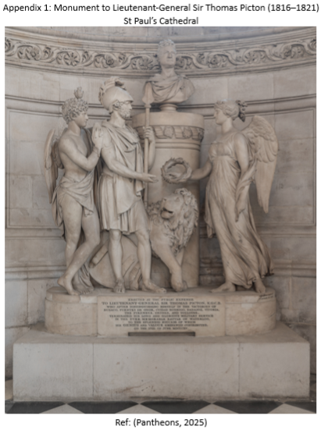

APPENDIX 2
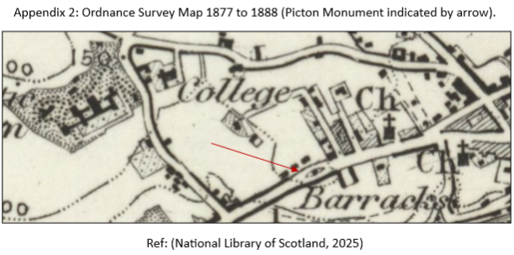
APPENDIX 3
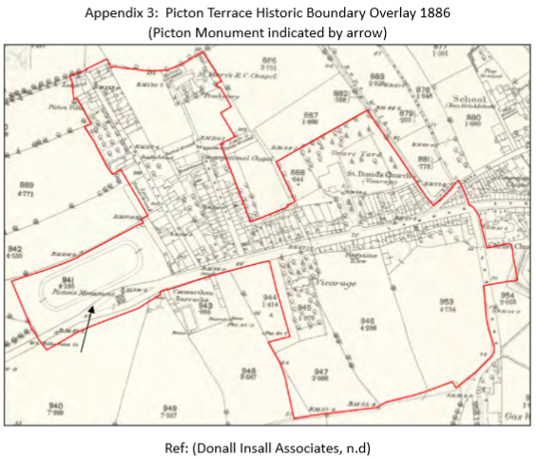

APPENDIX 4
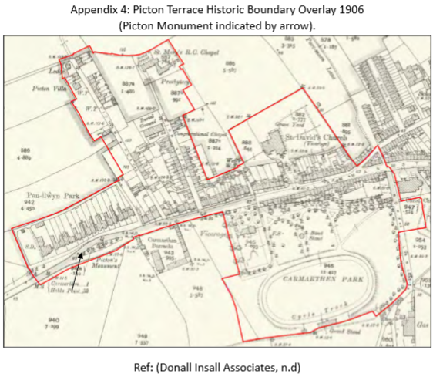
APPENDIX 5
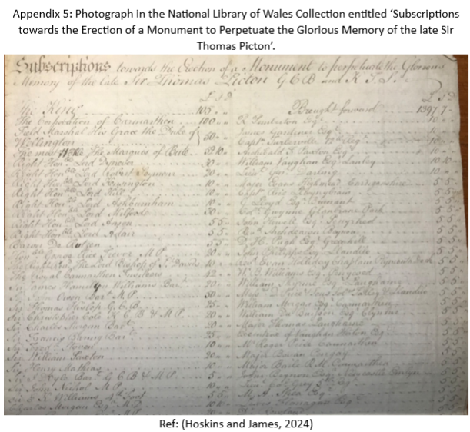

APPENDIX 6

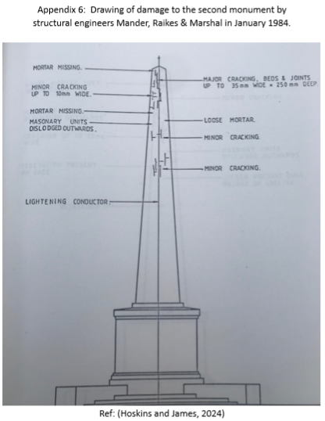

APPENDIX 7
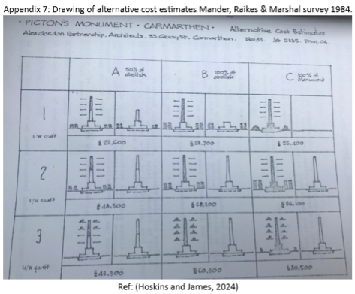

APPENDIX 8
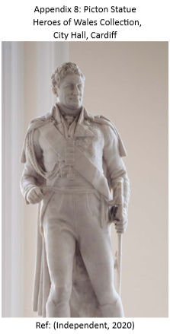

APPENDIX 9
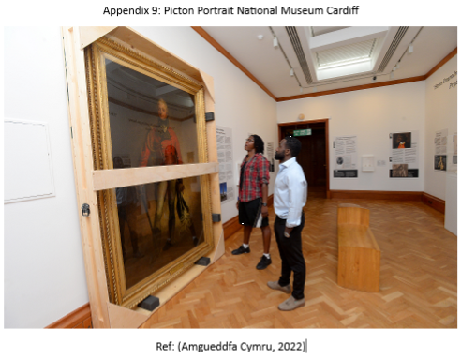

APPENDIX 10
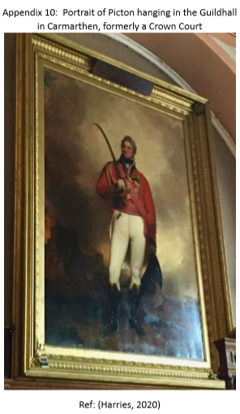

APPENDIX 11


