
.
Student name : Romana Begum Chowdury
Student ID : 2229137
Program : BSc Health and Social Care
Module name : Introduction to Psychology
Module code : BMHP5023
Lecturer name : Dr. Soban Sadiq
Assessment Title : Component 1, Written Assignment Case Study 1 Report
Submission deadline : 9th April 2026

1. Introduction
Diabetes mellitus is a persistent metabolic disease that is associated with a constantly high level of glucose in the blood due to the impairment of insulin secretion, insulin activity, or both (Care, 2024). It is a significant worldwide issue in terms of healthcare because of its increasing incidence and its relationship with severe chronic conditions, such as cardiovascular disease, neuropathy, nephropathy and retinopathy (Zheng et al., 2018). Three primary categories of diabetes exist: Type 1 diabetes, in which pancreatic beta cells are destroyed by the autoimmune reaction and cause absolute insulin deficiency; Type 2 diabetes, in which pancreatic insulin resistance and relative insulin deficiency take place; and gestational diabetes that occurs during pregnancy (Chatterjee et al., 2017).
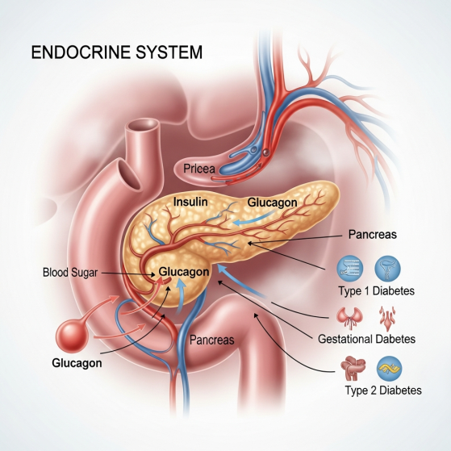
The most widespread one is Type 2 diabetes, which has an estimated prevalence of 90% in the global population (DeFronzo et al., 2015). The major risk factors are obesity, lack of physical activity, unhealthy diets, old age, family history and some ethnicities (Zheng et al., 2018). Insulin resistance and glycaemic instability have also been reported to be aggravated by smoking and chronic stress (Care, 2024).
The endocrine system is inextricably connected with diabetes because the amount of glucose in the blood is regulated mainly due to the hormonal activities of the insulin and glucagon manufactured by the pancreas. The pancreas is an endocrine gland that secretes these hormones directly into the blood to ensure homeostasis of glucose (Chatterjee et al., 2017). The disturbance of this regulatory system leads to the disturbed glucose metabolism and the inability of the cells to produce energy.
The report will discuss the process of maintaining normal level of blood sugar in the body, explain the use of glucose and oxygen in producing energy by cellular metabolism, discuss the significance of recording and monitoring blood glucose in Type 2 diabetes and give evidence-based lifestyle changes to help in effective self-management and better health outcomes.

2. Blood Sugar Regulation
The amount of glucose in the blood is closely monitored so that the body cells get a constant supply of energy without the occurrence of dangerous fluctuations that may destroy tissues. This is regulated in normal persons by a negative feedback mechanism that entails the secretion of the hormones insulin and glucagon both of which are produced by the pancreas under the endocrine system (DeFronzo et al., 2015).
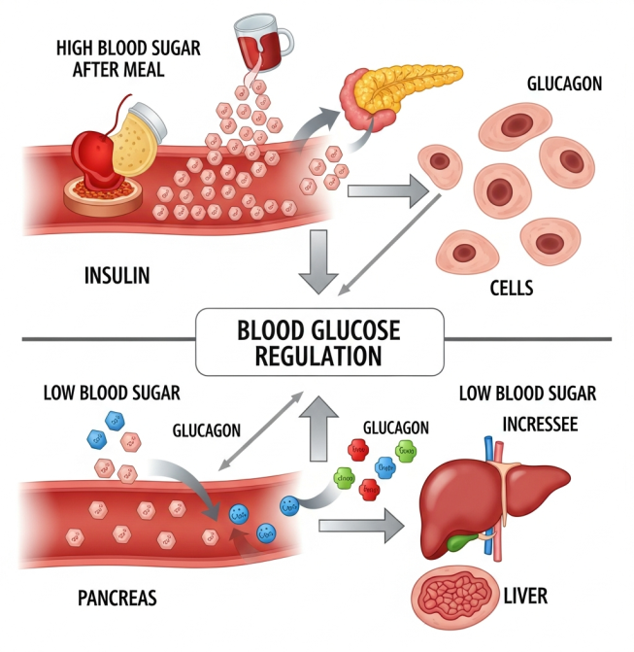
Once a meal is consumed, the carbohydrates are broken down into glucose and absorbed into the blood and the level of glucose in the blood increases. The pancreas responds by secretion of insulin by beta cells. Insulin facilitates muscle and adipose tissue uptake of glucose and activates liver to transform surplus glucose into glycogen to be stored, which is referred to as glycogenesis (Chatterjee et al., 2017). Insulin also suppresses gluconeogenesis and degradation of glycogen, and does not allow further rises in blood glucose (Care, 2024). This keeps glucose within normal physiological levels of 4–7mmol/L.
Blood glucose level decreases during fasting or between meals. Its reaction is a response by the alpha cells of the pancreas to secrete glucagon that stimulates the liver to break down glycogen into glucose (glycogenolysis) and into the bloodstream (DeFronzo et al., 2015). The glucagon also enhances gluconeogenesis by which glucose can be produced out of non-carbohydrates like amino acids (Nelson et al., 2008).
This regulatory mechanism is lost in Type 2 diabetes because of the insulin resistance of peripheral tissues and the decreased insulin secretion with age. Consequently, the uptake of glucose by the cell is reduced and the hepatic glucose production is still high, resulting in chronic hyperglycaemia (Chatterjee et al., 2017). The continued dysregulation of blood glucose is associated with the risk of developing vascular and metabolic complications, which is why it is necessary to keep glucose levels within safe ranges by making lifestyle changes and monitoring (Care, 2024).

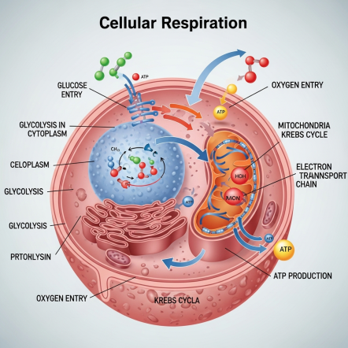
3. Cellular Metabolism
Cellular metabolism is a set of biochemical reactions in which cells store nutrients into usable energy. Most of the body cells use glucose as the major energy source and it is metabolised in the presence of oxygen to generate adenosine triphosphate (ATP), which forms the major energy currency of the cell (Nelson et al., 2008). This is done by a series of metabolic reactions, which include glycolysis, Krebs cycle and oxidative phosphorylation.
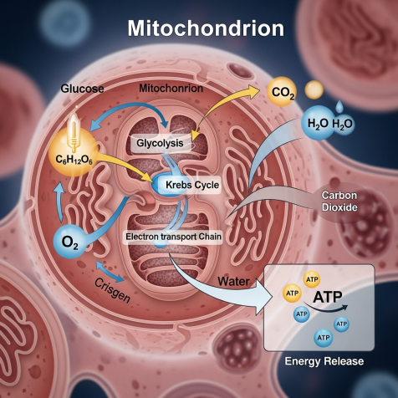
Glycolysis is a process that occurs in the cytoplasm and involves the degradation of glucose into pyruvate, with the generation of a low concentration of ATP and reduced nicotinamide adenine dinucleotide (NADH) (Kerr, 2019). Pyruvate is transported to the mitochondria when there is adequate oxygen and further oxidised in the Krebs cycle producing electron carriers like NADH and flavin adenine dinucleotide (FADH 2 ) (Nelson et al., 2008). These electron carriers proceed to donate electrons into the electron transport chain whose end electron is oxygen. This allows oxidative phosphorylation which results in the production of large quantities of ATP that is utilized to carry out cellular activities such as muscle contraction, nerve signalling and biosynthesis (Tao et al., 2006).
In diabetics, the insulin action is impaired, which abates the uptake of glucose in to cells especially skeletal muscle and adipose tissue. This leads to the fact that even with elevated glucose in the bloodstream, the supply of glucose to cells is lessened, which prevents the synthesis of ATP and interferes with the normal metabolism (DeFronzo et al., 2015). Such an imbalance of metabolism causes fatigue, poor tissue regeneration and reliance on alternative sources of energy like fatty acids, which can result in ketones body accumulation in severe cases (Chatterjee et al., 2017).
The level of blood glucose should thus be effectively controlled to maintain sufficient cellular oxygenation and energy synthesis. The body is unable to support normal physiological functioning, and this is because it is unable to transport glucose into cells and use oxygen efficiently, the relationship between glucose metabolism, oxygen supply and general health (Nelson et al., 2008).

4. Recording and tracking blood sugar levels for type 2 diabetes
Self-management of the Type 2 diabetes disease is the key aspect of the safe and effective management of the disease, including recording and monitoring of the level of the blood glucose. Frequent monitoring helps patients and medical workers to evaluate the level of glycaemic control, the effectiveness of treatment, and identify hyperglycaemia or hypoglycaemia patterns (Polonsky et al., 2011). The use of structured self-monitoring has proven to be very effective in lowering the HbA1c levels of people with Type 2 diabetes that is not well managed, which proves to be of great importance in enhancing the long-term outcome (Polonsky et al., 2011).
Blood glucose records are a necessary feedback on the effect of lifestyle factors, including diet, physical activity, and medication on glucose levels. As an example, monitoring of the readings before and after meals may assist in determining the type of food that leads to excessive glucose spikes, whereas monitoring during exercise may assist in determining the safe activity levels (Farmer et al., 2012). This data helps to empower the patients and facilitate informed choice-making and allow a person to become an active participant in their care plans (Care, 2024).
Unless the level of blood glucose is measured or tracked, people might be unaware of the long-term hyperglycaemia, which puts them at risk of developing complications, including cardiovascular disease, neuropathy, and kidney damage (Zheng et al., 2018). Furthermore, unnoticed hypoglycaemia can lead to dizziness, loss of consciousness and confusion, which is dangerous to the person (Chatterjee et al., 2017). The lack of valid data also imposes restrictions on the possibility to modify the treatment regimens by healthcare professionals effectively, which may result in the inappropriate control and disease progression (DeFronzo et al., 2015).
Thus, regular monitoring of blood glucose is a key factor in ensuring metabolic stability, complications prevention and behavioural change. It serves as an intermediary between physiological response and everyday self-care behaviour, and increases the efficacy of monitoring as a component of holistic diabetes management (Care, 2024).

5. Recommendations
Treatment of Type 2 diabetes is achieved through a combination of medical treatment, lifestyle changes and constant education. Health and social care should focus on evidence-based strategies aimed at promoting health, empowering patients and reducing risks to enhance their overall health and avoiding complications in the long run (Care, 2024).
One of the most important elements of diabetes management is dietary modification. The combination of whole grains, vegetables, lean protein, and unsaturated fats can be used to enhance the glycaemic control and decrease insulin resistance (Uusitupa et al., 2019). Limiting the consumption of refined carbohydrates and sweetened food stuffs can reduce the sudden increase of blood glucose level, and portion control assists in maintaining weight, which is closely linked to better insulin sensitivity (Tuomilehto et al., 2001). Adherence can be increased with referral to a dietitian or structured nutrition education programme that will promote sustainable behaviour change (Care, 2024).
It is also highly suggested that regular physical activity is taken. Resistance training with aerobic exercise, like walking or cycling, enhances the intake of glucose by skeletal muscle and decreases the level of glucose in the bloodstream (Chatterjee et al., 2017). Research has revealed that lifestyle intervention which involves physical activity can greatly slow down the development of Type 2 diabetes and enhance the metabolic results (Tuomilehto et al., 2001). The healthcare personnel must promote slow increments of the activity based on the ability and comorbid conditions.
Smoking cessation is another urgent intervention since smoking is a primary cause of insulin resistance and cardiovascular risk (Zheng et al., 2018). The quit rates and complications associated with diabetes could be better supported with the help of smoking cessation services, counselling and pharmacotherapy (Care, 2024). Psychological support and stress management are also vital as chronic stress and depression are linked to poor glycaemic control and lack of adherence to treatment (DeFronzo et al., 2015).
Lifestyle change and medication adherence should be encouraged by means of structured self-monitoring of blood glucose. Monitoring helps people to discover the trends of glucose changes and learn how the diet and physical activity affect their state (Polonsky et al., 2011). Nurse-led health education is crucial in enhancing knowledge and confidence and self-care behaviour (Farmer et al., 2012). All these measures are designed to cover physiological control and social determinants of health to promote comprehensive disease management of diabetes.

6. Conclusion
This report has discussed diabetes as a metabolic disorder which is associated with dysfunction of the endocrine system and poor regulation of the blood glucose levels. It has defined the processes of glucose and oxygen use in cellular metabolism to produce energy and emphasised the effects of impaired insulin activity in Type 2 diabetes. Recording and monitoring blood glucose levels have been highlighted as a major measure towards glycaemic control and avoidance of complications. Lifestyle interventions such as dietary modification, physical activity, smoking cessation and health education have been considered as some of the key elements of good management. These strategies combined ensure metabolic stability, patient engagement, and long-term health and well-being in Type 2 diabetes patients (Care, 2024; Chatterjee et al., 2017).

References
Care, D. (2024). Standards of Care in Diabetes—2024. Diabetes Care, 47, S77.
Chatterjee, S., Khunti, K., & Davies, M. J. (2017). Type 2 diabetes. The lancet, 389(10085), 2239-2251.
DeFronzo, R. A., Ferrannini, E., Groop, L., Henry, R. R., Herman, W. H., Holst, J. J., ... & Weiss, R. (2015). Type 2 diabetes mellitus. Nature reviews Disease primers, 1(1), 15019.
Farmer, Andrew J., Rafael Perera, Alison Ward, Carl Heneghan, Jason Oke, Anthony H. Barnett, Mayer B. Davidson et al. "Meta-analysis of individual patient data in randomised trials of self monitoring of blood glucose in people with non-insulin treated type 2 diabetes." Bmj 344 (2012).
Kerr III, E. L. (2019). An investigation of glycolysis, metabolic acidosis, and lactate’s role in cellular respiration.
Nelson, D. L., Lehninger, A. L., & Cox, M. M. (2008). Lehninger principles of biochemistry. Macmillan.
Polonsky, W. H., Fisher, L., Schikman, C. H., Hinnen, D. A., Parkin, C. G., Jelsovsky, Z., ... & Wagner, R. S. (2011). Structured self-monitoring of blood glucose significantly reduces A1C levels in poorly controlled, noninsulin-treated type 2 diabetes: results from the Structured Testing Program study. Diabetes care, 34(2), 262-267.
Tao, Zhimin, Syed S. Ahmad, Harvey S. Penefsky, Jerry Goodisman, and Abdul-Kader Souid. "Dactinomycin impairs cellular respiration and reduces accompanying ATP formation." Molecular Pharmaceutics 3, no. 6 (2006): 762-772.
Tuomilehto, Jaakko, Jaana Lindström, Johan G. Eriksson, Timo T. Valle, Helena Hämäläinen, Pirjo Ilanne-Parikka, Sirkka Keinänen-Kiukaanniemi et al. "Prevention of type 2 diabetes mellitus by changes in lifestyle among subjects with impaired glucose tolerance." New England journal of medicine 344, no. 18 (2001): 1343-1350.
Uusitupa, Matti, Tauseef A. Khan, Effie Viguiliouk, Hana Kahleova, Angela A. Rivellese, Kjeld Hermansen, Andreas Pfeiffer et al. "Prevention of type 2 diabetes by lifestyle changes: a systematic review and meta-analysis." Nutrients 11, no. 11 (2019): 2611.
Zheng, Y., Ley, S. H., & Hu, F. B. (2018). Global aetiology and epidemiology of type 2 diabetes mellitus and its complications. Nature reviews endocrinology, 14(2), 88-98.

