
The event experience
THE LONDON MOONWALK
13th MAY, 2017

name: melissa duffy
student p no: 1708486
Module: the events industry
level/code: 4/m4x02104
lecturer: suzanne wells

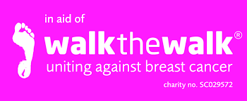

Table of Contents…………………………………………………………….1
1. Introduction 2
2. A brief Overview of the London Moonwalk 3
3. Purpose of this report………………………………………………….. 3
4. Size and Scale of the Event……………………………………..……. 3
Organizational Chart (Fig 4.1)..…….……..…….……….……..………….……….. 4
5. Motivational Factors 5
5.1 Motivators.……..…………..…………..……………………………………………....5
i. Social Motives 5
ii. Organisational Motives 5
iii. Physiological Motives 5
iv. Personal Motives……………………….……………….…………………...…....5
5.2 Determiniants.………………………………………………………………………….6
6. Motivational Behaviour…………………………………….…………………………..6
Maslows Hierarchy of Needs Diagram (Fig 6.1)…………………………………….6
i. Physiological Needs……………………………………………………………….7
ii. Safety Needs……………………………………………………………………….7
iii. Love & Belonging………………………………………………………………….7
iv. Self-Esteem………………………………………………………………………..7
v. Self-Actualization………………………………………………………………….7
7. Conclusion……………………………………………………………………………….8
8. Appendices…………………………………………………………….…………9,10,11
9. References………………………………………………………………………...…...12

1. Introduction
Each year, thousands of people come together to take part in one of London’s most successful charity events – The London Moonwalk. What originally started out as a small scale fundraiser, has now become a multi-million pound charity event that continues to attract (predominantly) woman to participate year after year. So what is the big attraction? Is it the fact that you are fundraising for a worthy cause? Or is it the social camaraderie of being with friends and the wider community? Or is it being part of a spectacular and unique experience with thousands of other likeminded people, that keeps everyone coming back? Whatever the reason, it continues to capture the attention of individuals, groups and organisations every year. In this report we take a look at some of the key elements that have contributed to its continued success. It will look in more detail at some of the motivators and determinants that have influenced people to attend and whether Maslow’s (1943) hierarchy theory in relation to human needs was evident at this particular event. It will also explore Richards (1992) five basic areas of analysing and monitoring an event which identifies the five key elements that contribute to an events success (or failure). Firstly, here is a short overview of the event.

2. A brief Overview of the London Moonwalk

The event evolved back in 1996, when 13 friends power walked in their bras at the New York City marathon and successfully raised £25,000 for Breast cancer research. Since then, it has become a multi-million pound charity event that attracts thousands to take part each year. According to the Evening Standard (15 May, 2017), 15,000 participated in this years walk and the amount raised was in excess of £7.2m. The idea behind the event is for participants to walk around the streets of London at night, wearing brightly decorated bras in aid of Breast Cancer research. The charity organisation is called Walk the Walk. Participants choose to walk either 26.2miles (full-moon) or 13miles (half-moon). This years Event took place on the 13th May, 2017 and commenced at its usual location of Clapham Commons. The event also takes place in Edinburgh and Iceland on an annual basis and the charity organisers are planning to take it further afield on a more global scale.

3. Purpose of the Report

The event was viewed from an observational perspective and investigates some of the reasons behind its success. It also identifies the typical event consumer and their main motivations for attending the event. To do this, we need to get an understanding of an individuals motivational behaviour and will take a closer look at Maslows Hierarchy theory to see how it correlates with this event. According to Bagraim et al (2007), the concept motivation refers to “the force within us that arouses, directs and sustains our behaviour”. It is very clear that this event is very well organised and is no doubt the reason behind its continued success.

4. Size and Scale of the Event
The success of any event can generally be measured by the amount of people that are in attendance. Each year, it is evident that more and more people want to be part of this spectacular charity event. There are, however, many other factors that can contribute towards its success. The way it is managed and organised is also vital. Figure 4.1 is a simplified version of an Organizational Chart that can be used to organise an event (Anderson 2010) and shows some of the key components that need to be considered.
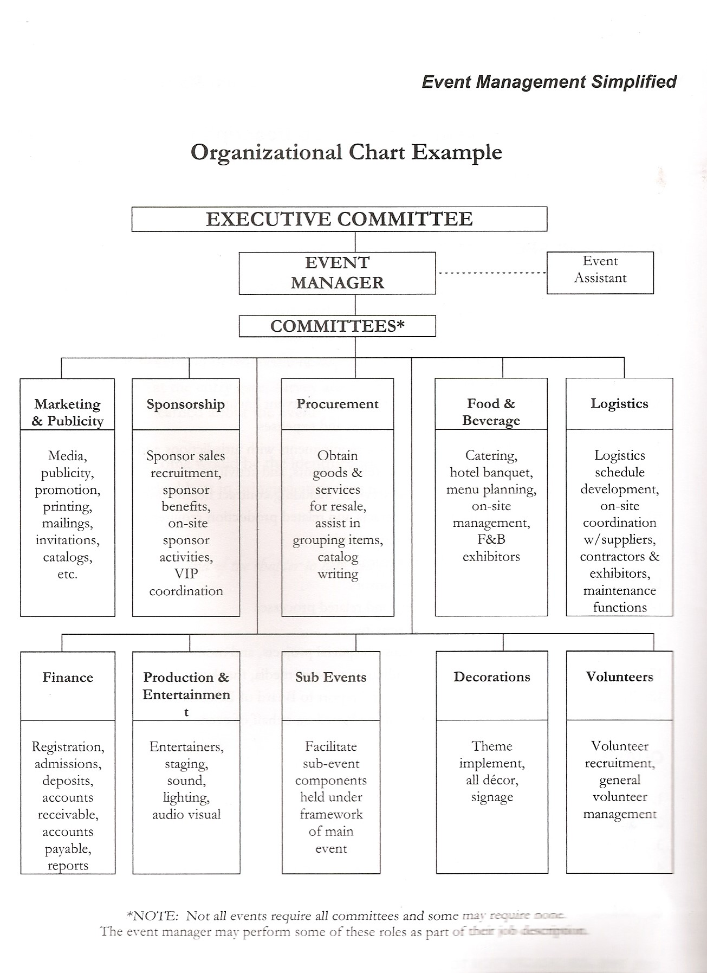
(Figure 4.1)
It is clear that a similar organizational structure was used to plan this event as ALL sub-catergories in this chart were evident at The London Moonwalk. Volunteers played a major role at this event and tended to be generally, middle-aged. However, in a journal article by Leigh et al (2013), it states “Volunteer workforces at events are becoming relentlessly younger”. It goes on to say that “with the limited duration of events, it makes the induction and training of volunteers challenging for event managers.

5. Motivational Factors (Motivators/Determinants)
To realise the effect an event is having on an individual and the wider community, we need to understand the motivational and determining factors that encourage people to participate in the first place.
5.1 Motivators
This is simply to do with “What motivates an individual or group of people to attend and event in the first place?”. Shone & Parry (2011) grouped these motivators into four main areas: social, organisational, physiological and personal motives.
i. Social Motives – The social objectives were definitely present throughout the evening and there was an overwhelming sense of community spirit.
ii. Organisational Motives – The aim of the event is to promote a healthy and fit lifestyle and at the same time raise funds for a much needed cause. As a result, it has inspired an ongoing passion for healthy eating and exercise. As a charity event, the organisation is always looking for extra sponsorship to help increase the profile of the event
iii. Physiological Motives – It is obvious that the physical and mental demands on your body can be very challenging. In fact, some of the participants had never power walked or even been part of a fitness programme before, yet the adrenaline and the atmosphere that can be felt on the night is what seems to get people through it. There is an overwhelming feeling of pride and achievement once you complete the walk. This in itself can be very rewarding and many have described it as a life-changing event.
iv. Personal Motives – One of the goals of the Charity is to encourage its participants to maintain good health and wellbeing. It was also a way of acknowledging those who may have lost the fight against breast cancer and to do something in their honour. This challenge certainly is about seeking a new experience or fulfilling a life long ambition and the London Moonwalk offered these opportunities.

5.2 Determinants
Shone and Parry, (2011, p.150) relate this part to the buying process and look at the factors that would “determine” whether we attend an event (or not). It could include things such as the price, quality of the event or access factors. The London Moonwalk showed a great deal of prospensity whether it be as a group or an individual motivator. Everyone has their own personal reason for taking part in the event so to them, crossing that finish line was all that mattered.
6. Motivational Behaviour
According to the theorist, Maslow (1943/54), he believes that humans have five basic needs (see fig. 6.1). We will now take a closer look at these five needs and demonstrate how it correlates with this event and if it was in fact present on the night.
Maslows Hierarcy of Needs
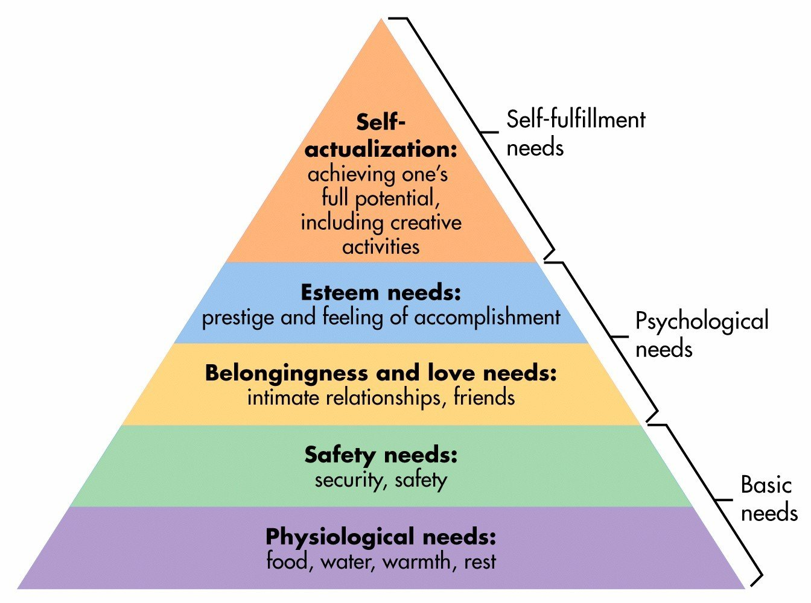

(Figure 6.1)

i. Physiological Needs: This relates to the basic requirements for human survival and includes things such as air, food and water. This event definitely met the majority of these basic needs. Food and drink was provided prior to starting the walk and several water stations were available on route. Portable toilets were also available at various points along the route but at times had long queues.
ii. Safety Needs: This area relates to things such as protection, security, law and freedom. When people attend an event, they like to feel safe and secure and know that there is help and support available if needed. Volunteers played a big part at this event; whether it was handing out water or giving directions they all played a vital role. First aid officers and police security was available throughout the night.
Iii. Love & Belonging: This level refers to our feelings of social belonging. According to Maslow, “humans need to feel a sense of belonging and acceptance among their social groups, regardless of whether these groups are large or small”. It is evident that this event unites people of all ages for a common cause and the social camaraderie that is created before, during and after the event, is definitely felt throughout the whole challenge.
iv. Self-Esteem: Maslow’s theory states “All humans have a need to feel respected as well as accepted and valued by others”. Everyone likes to be recognized for something they’ve achieved. Apart from the enthusiasm shown by all the supporters cheering you on throughout the race and at the finish line, all those who complete the challenge are awarded a medal for their achievement.
v. Self-Actualization: Maslow describes this level as “the desire to accomplish everything that one can, to become the most that one can be”. It looks at realizing personal potential, self-fulfillment and personal growth. When people go to an event, they want to feel inspired, more knowledgeable and transformed. In respect to this event, people came away with a sense of pride and achievement by completing the challenge

7. Conclusion
The London Moonwalk is an event that everyone needs to experience at least once in their lifetime. It is a well organised event and is a charity organisation that raises millions of pounds. If is becoming more and more popular as more people find out about it. Not only is the participant supporting a great cause, but they are also doing something for their own physical heatlh and wellbeing. Although the walk is London based, it is an event that still captures the attention of people from outside of the local area. Radio stations, printed posters, social media platforms and word of mouth, were used to promote and advertise this event. Anderson (2010) says “Marketing provides exposure, gets the word out, creates excitement, and helps to generate attendance and dollars to support the event.” Maybe because the emphasis has been placed on the marketing it continues to be successful year after year.
In conclusion, whatever your reason is for participating or going to an event, comes down to our own personal choice. However, there are a lot of other factors that influence the decision making process and how well these factors are managed could be the difference between whether we would choose to attend or not.
The London Moonwalk is definitely an example of a well run event that earns a fantastic amount of money for a good cause. Detailed information is readily available online and is also included in the information pack that is sent to you once you are registered
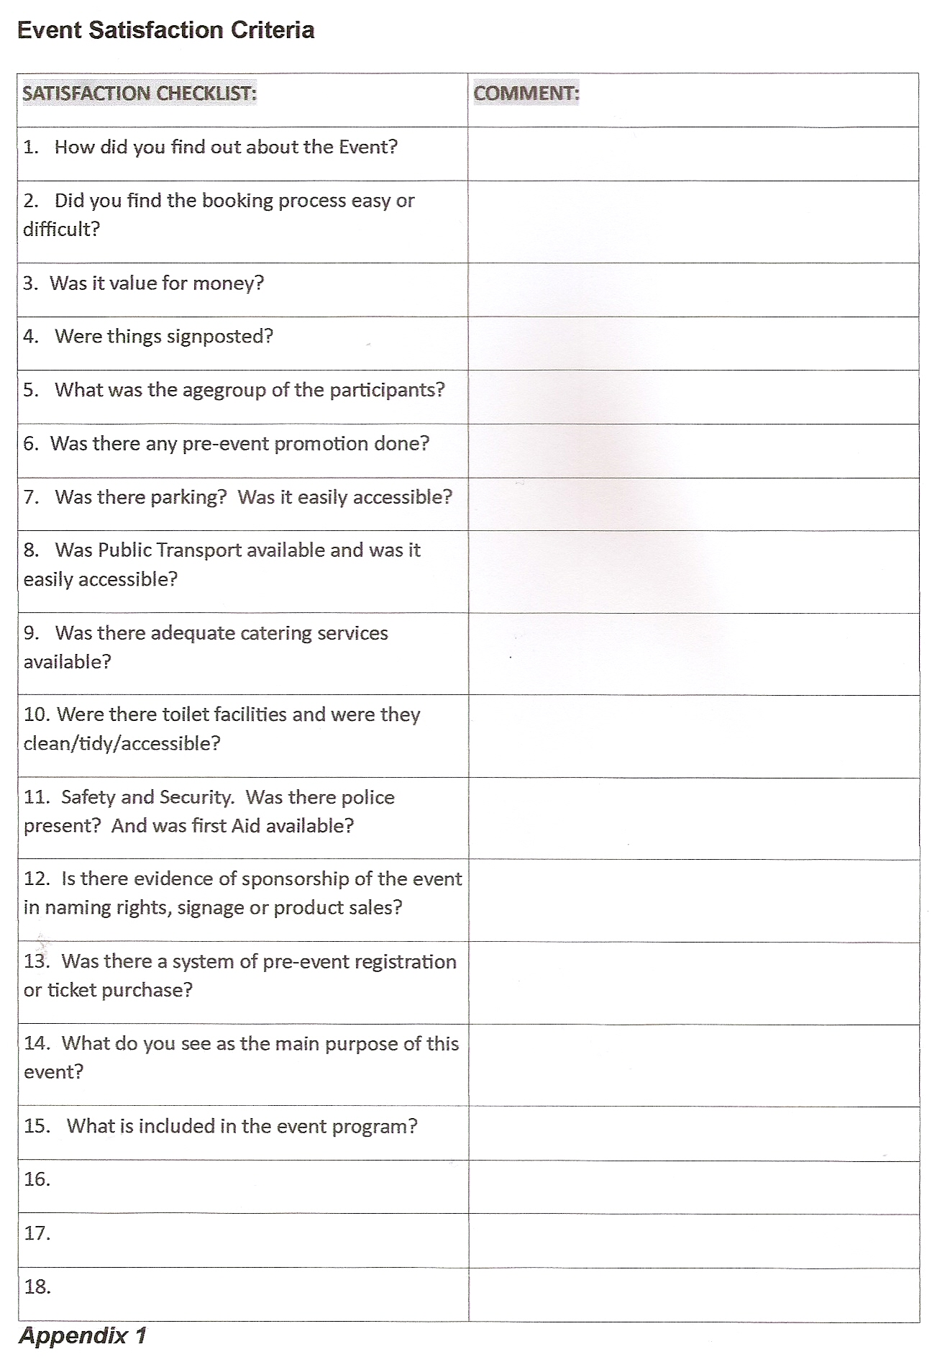
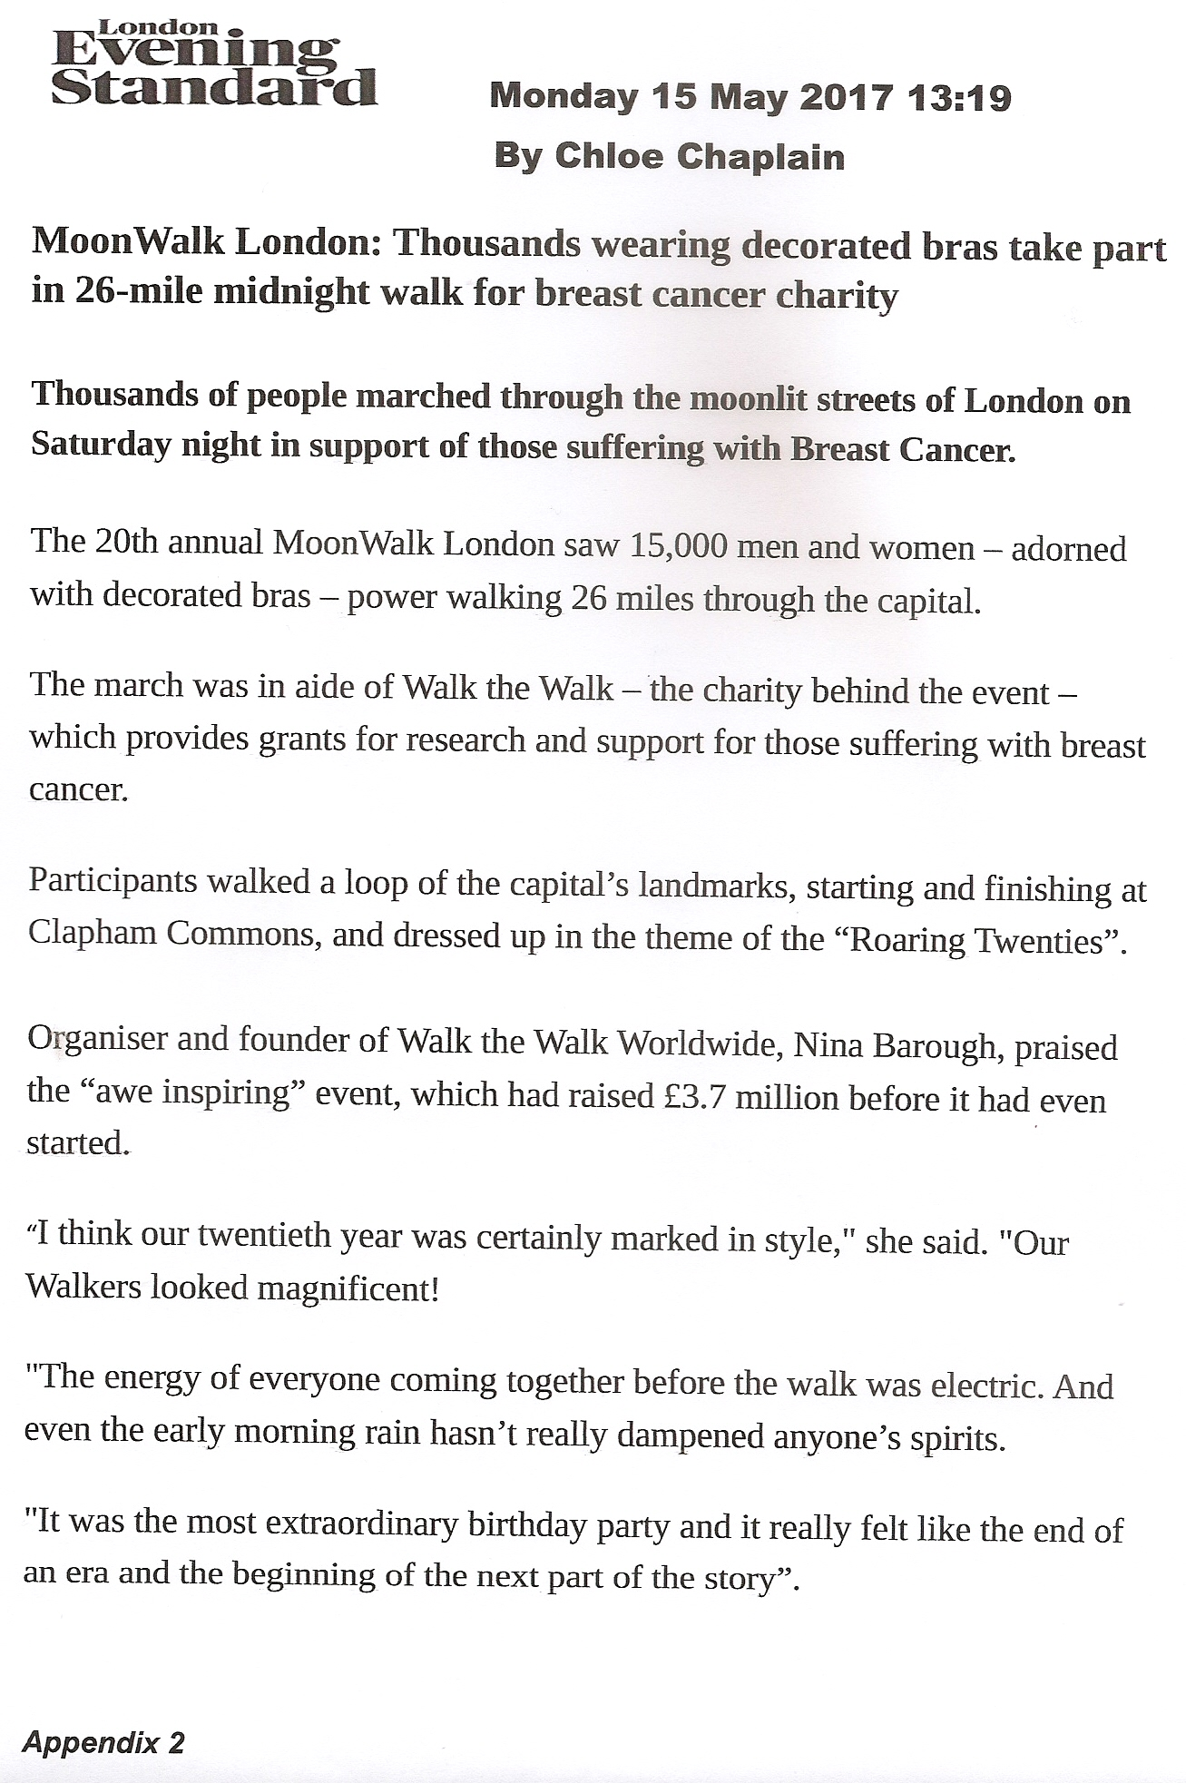

London Moonwalk pictures (images courtesy of the Evening Standard, 15/5/17)
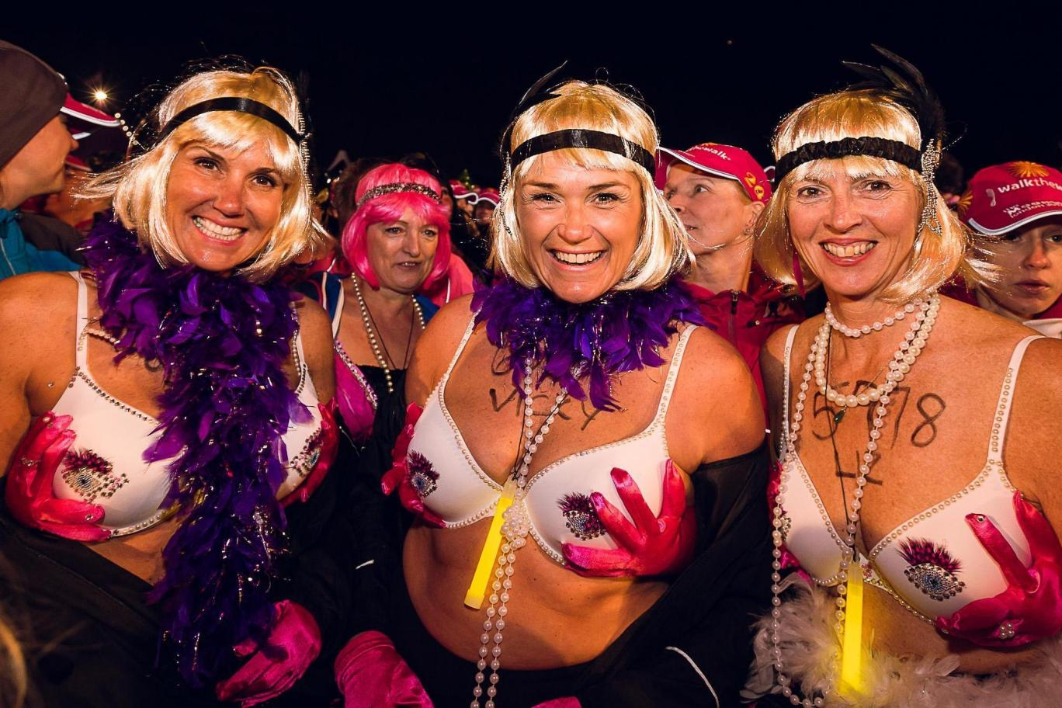
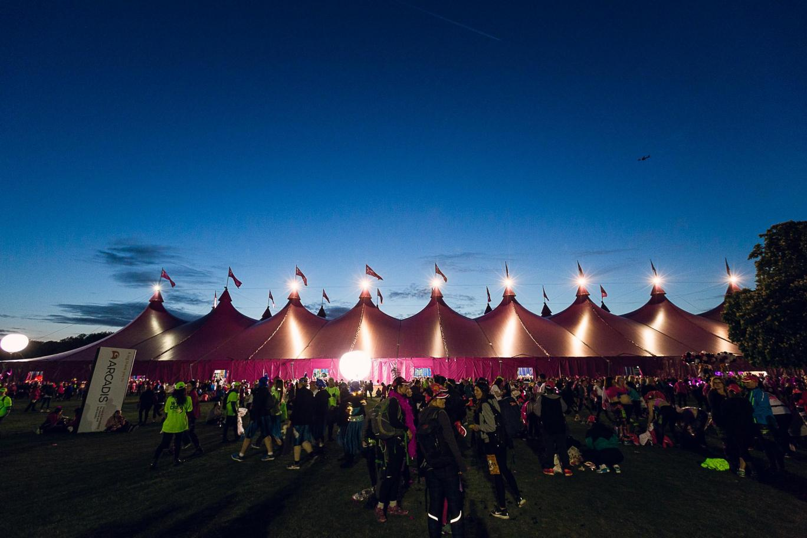

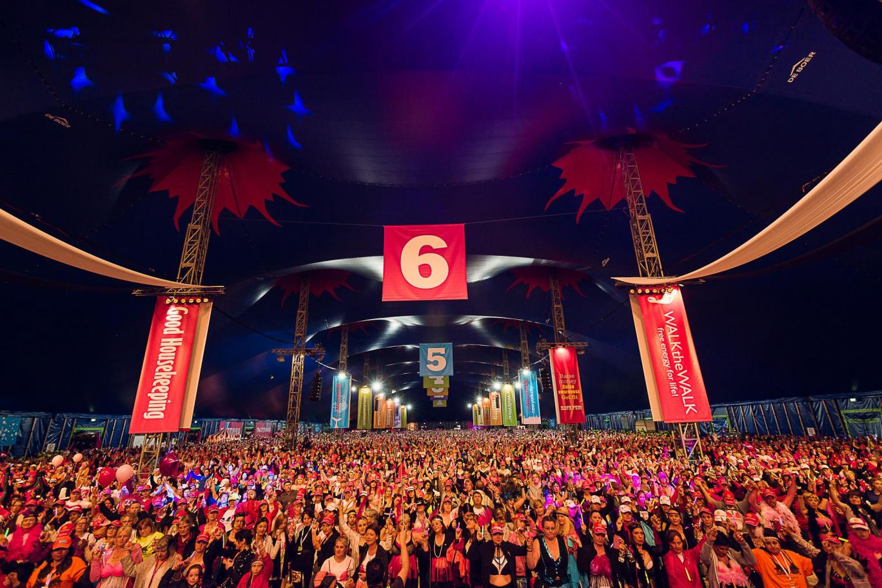
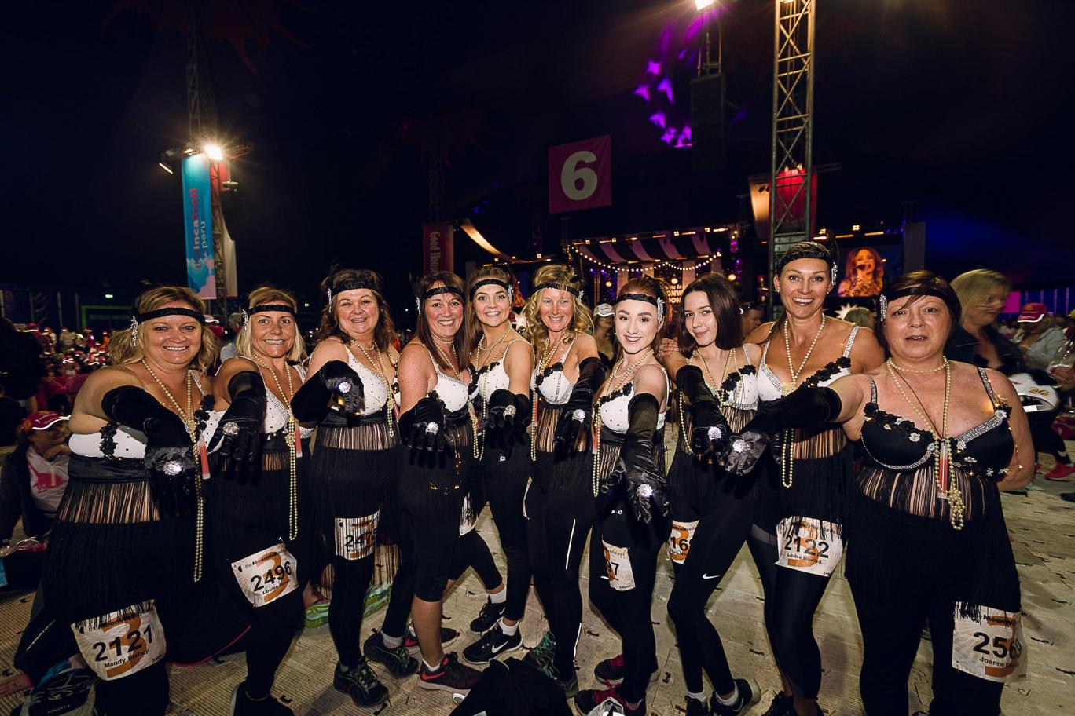

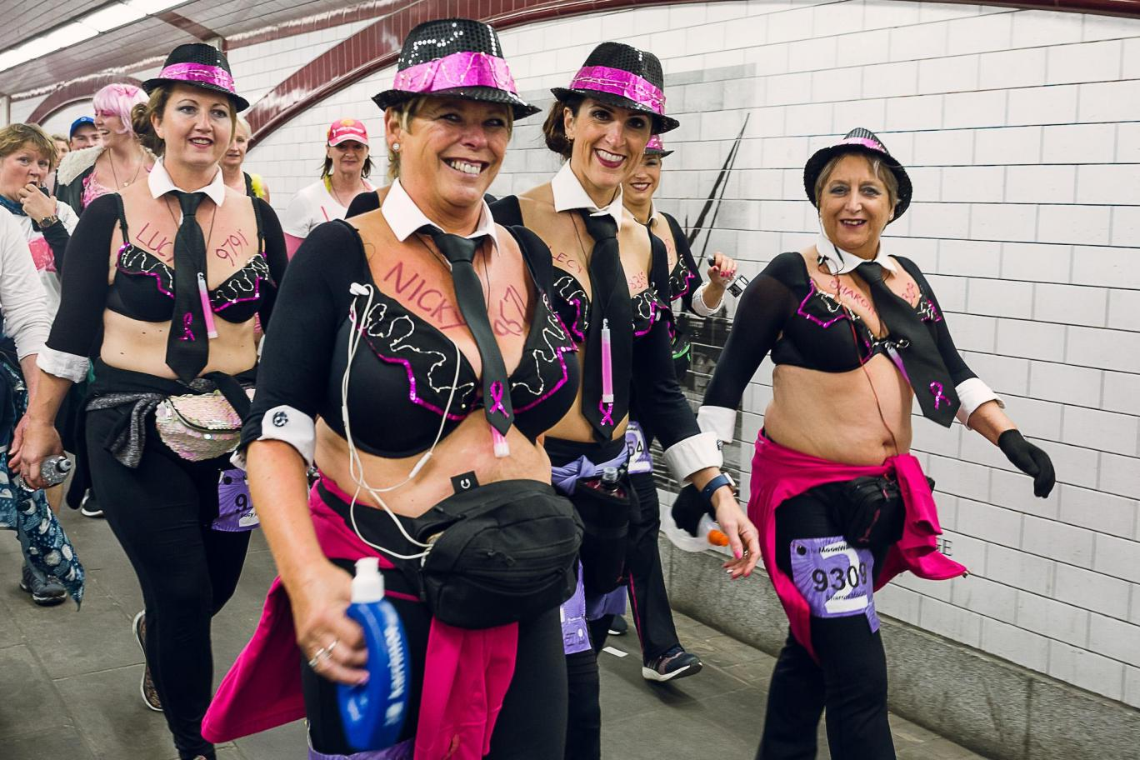
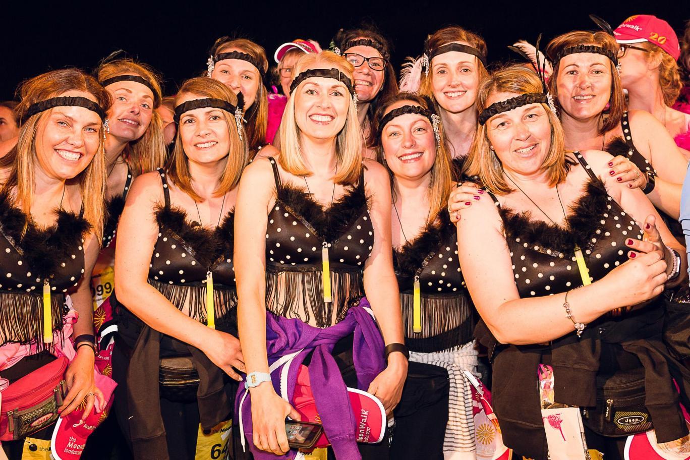

REFERENCES

Anderson, J.L (2010), Events Management Simplified, Bloomington: Author House

Bagraim, J., Cunningham, P., Potgieter, T. & Viedge, C. (2007), Organizational behavior -A contemporary South African perspective. (2nd Ed), Pretoria: Van Schaik

Leigh, J., Lamont, M., Cairncross, G., (2013) ‘Towards a process Model of Induction and training for young event volunteers’ International Journal of Event Management Research, 8:1 [Online]. Available: www.ijemr.org [2017, November, 3]

Maslow, A.H, (2012), What’s your motivation – Maslows Heirarchy of Needs

McLeod, S. (2017), ‘Simply Psychology – Maslows Hierarchy of Needs, [Online]. Available: , [2017, November, 6]

Shone, A., Parry, B., (2011), Successful Event Management: A practical handbook, (3rd Edition), Andover:Cengage Learning EMEA

Chaplain, C. (2017), 'Moon Walk London: Thousands wearing decorated bras…..for breast cancer charity, The Evening Standard,
Employee Motivation Measurement -A Descriptive Analysis (PDF Download Available). Available from: [accessed Nov 11, 2017].

