Name: Rustic Romanian Hotel
Business Plan for: Entrepreneurship (BMIH5001)

Lecturer: | Chris Wilkin
Date: | 04.03.2024
Team members: | Constantin Nanu (2206483)  Alina Cristina Pruteanu (2209886)  Alina Maria Cimpian (2207461)
Business plan contents
Executive Summary…………………………………………………………………………………………………………….3
1 Executive summary 3
2 Business details 4
3 Key personnel 5
Vision 6
4 The business idea 6
5 Business goals 6
6 What the business does 7
7 What makes the business different 7
8 Legal requirements 7
Marketing 8
9 Market research 8
10 Profiling customers 8
11 Profiling competitors 9
12 Managing market risks 9
13 Pricing 9
14 Promotion and advertising 10
Running the business 11
15 Staff 11
16 Premises 11
17 Suppliers 11
18 Equipment 12
19 Managing operational risks 12
Finance 13
20 Start-up costs 13
21 Profit and loss forecast 15
22 Sourcing finance 16
23 Managing financial risks 16
24 Cash flow forecast 17

1 Executive summary (We suggest you complete this section after you have completed the other sections of the Business Plan).

The Romanian Rustic Hotel is envisioned to be a premier boutique hotel experience that encapsulates the cultural and ecological ethos of Romania. The business plan outlines the creation of a unique destination for travelers seeking authenticity and sustainability, offering an immersive experience in Romanian heritage, cuisine, and artistry.
The term "rustic" refers to a design and style that is natural, rough, aged, and casual, often embodying rural or country living. In the context of a hotel or accommodation, "rustic" can imply a setting or ambiance that is simple, charming, and unpretentious, often incorporating elements like raw wood, stone, and natural fibers. It's a style that emphasizes coziness and comfort, with a nod to traditional craftsmanship and materials. Rustic design often seeks to bring the outdoors inside, creating a warm, welcoming atmosphere that encourages relaxation and a sense of connection with nature.
Key components of the hotel's offerings include accommodations that blend traditional Romanian design with modern amenities, a dining experience featuring farm-to-table Romanian cuisine, and a commitment to eco-friendly practices. The hotel will not only serve as a retreat for leisure but also cater to business travelers and event planners looking for a distinctive venue.
Strategic partnerships with local artisans, farmers, and businesses will be essential to the hotel's operations, ensuring that guests receive an authentic experience while also contributing to the local economy. The hotel intends to collaborate with travel and airline companies to streamline the travel experience and create tailored packages for diverse customer segments.
The business plan projects growth through direct and referral channels, capitalizing on the burgeoning trend of eco-tourism and cultural travel. Marketing efforts will leverage digital platforms to tell the Romanian Rustic Hotel's story, connecting with potential guests globally.
In summary, the Romanian Rustic Hotel aims to become synonymous with the rich tapestry of Romanian culture, offering guests an escape that is both luxurious and environmentally conscious, and a true reflection of Romania's welcoming spirit.

2 Business details

Company name:

Rustic Romanian Hotel
Hope Road, Bamford, Hope Valley

Primary contact method

+441612447709

The business will:

The Romanian Rustic Hotel will be established as a full-service boutique hotel that delivers an authentic Romanian experience to its guests. Situated in the tranquil and picturesque landscape of Romania, the hotel's design and operation will be deeply rooted in showcasing the rich cultural heritage of the region.
The hotel's design will incorporate traditional Romanian motifs and textiles, reflecting the country's history and cultural artistry. Artifacts and artworks, sourced directly from local artisans, will adorn the public spaces and guest rooms, providing an environment that is both culturally rich and inviting.
The dining experience at the hotel will be centered around a Romanian restaurant that prides itself on traditional recipes. The ingredients for the restaurant will be sourced from local farms, ensuring that guests have access to fresh, organic, and sustainable meals, thereby promoting the local agrarian community.
In line with sustainable tourism practices, the hotel will be constructed using eco-friendly materials. Operations will follow environmentally sustainable principles to ensure a reduced ecological footprint. This commitment will extend to the day-to-day running of the hotel, where energy conservation measures and waste reduction practices will be integral to the hotel's operations.
The hotel will also engage in various activities, such as:
- Establishing partnerships with local suppliers for construction materials and operational supplies to support the local economy.
- Offering packages that cater to different market segments including cultural enthusiasts, adventure seekers, and those looking for relaxation and wellness.
- Collaborating with local tour operators to provide guests with immersive experiences, from historical tours to nature explorations.
- Forming strategic alliances with airlines and travel companies to facilitate ease of travel for international guests.
The Romanian Rustic Hotel will aim to be a premier destination for travelers seeking a genuine Romanian experience, combining the comfort of modern amenities with the charm of Romanian tradition. Its commitment to cultural authenticity, sustainability, and local partnership will position it as a leader in the boutique hotel market in Romania.

3 Key personnel

Details of owner(s):
Name: Constantin Nanu
Position/main responsibilities: Owner
Experience and knowledge of our industry:
- Barista (hospitality industry)
- Waitress (hospitality industry)
Previous employment:
- Warehouse operative – Maintenance (05.2019-current)
Employer: Amazon, Doncaster
- Assistant Manager (02.2017 – 05.2019)
Employer: Costa - Tilbury
- Barista (09.2015– 02.2017)
Employer: Costa - Tilbury
- Team Leader (06.2017 – 08.2018)
Employer: Poncho 8 – London
- Commercial and Sales (02.2013 – 07.2017)

Key skills brought to the business: leadership, hospitality management, communication, marketing and sales
Business experience and any training undertaken:
Hotel Placement Premier Inn-Tilbury
Academic/professional qualifications:
High School MATEI BASARAB, Craiova, Romania
Salary expectations £ 36000

Name: Alina Maria Cimpian
Position/main responsibilities: Manager
Experience and knowledge of our industry:
- Barista and Supervisor (hospitality environment)
- Hotel Placement- Rossington Hall (Doncaster)
Previous employment:
- Amazon Associate – Problem Solver (11.2020-current)
Employer: Amazon, Doncaster
- Warehouse operative- Picker (10.2018 – 11.2020)
Employer: Lidl, Doncaster
- Warehouse operative-Picker, packer (05.2016 – 02.2018)
Employer: B & Q, Doncaster
- Retail -Sales assistant (06.2014 – 02.2018)
Employer: Deichmann, Romania

Key skills brought to the business: problem-solving, adaptability, sensitivity and understanding
Business experience and any training undertaken:
- Hotel placement – Rossington Hall, Doncaster

Academic/professional qualifications:
Hight school NICOLAE BALCESCU, Cluj- Napoca, Romania

Salary expectations £28000

Name: Alina Cristina Pruteanu
Position/main responsibilities: Assistant Manager
Experience and knowledge of our industry:
- Hotel Placement- Premier Inn, Portsmouth
- Hotel Receptionist- Premier Inn, Portsmouth
Previous employment:
- Driver – delivery station (07.2021-current)
Employer: Amazon, Doncaster
- Sales Assistant (02.2018 – 07.2021)
Employer: Krispy Kream, Portsmouth
- Barista (09.2017 – 06.2018)
Employer: Costa, Portsmouth
- Waitress (06.2015 – 08.2017)
Employer: Miorita Restaurant,Bacau

Key skills brought to the business: communication, interpersonal skills, tenacity
Business experience and any training undertaken:
Hotel placement-Premier Inn, Portsmouth
Academic/professional qualifications:
Hight School ION GHICA – Bacau, Romania
Salary expectations £ 28.000
Name: Alina Maria Cimpian
Position/main responsibilities: Operational Coordinator
Experience and knowledge of our industry: Restaurant Coordinator at Hotel Bucuresti
Experience and knowledge of our industry: Experience in hotels and restaurants
Previous employment: Hotel Bucuresti
Key skills brought to the business: Teamwork, Good Comunication/Coordinating Skills
Business experience and any training undertaken: 7 years at Hotel Bucuresti
Academic/professional qualifications: University of Wales Trinity Saint David
Salary expectations £ 25000

Vision

4 The business idea

Sum up your business idea:

The Romanian Rustic Hotel Ltd aims to distinguish itself in the global hospitality market by offering an authentic Romanian experience, focusing on the country's rich culture, arts, and crafts. Embracing the "rustic" aesthetic, the hotel will feature natural, earthy designs and decorations that reflect rural Romanian life, providing guests with a serene yet sophisticated escape. Unlike its competitors, this hotel will deeply immerse its guests in local traditions through decor, food, and cultural activities, making it a unique cultural haven. Structured as a limited company, the Romanian Rustic Hotel Ltd emphasizes professional management and sustainable growth. Strategic partnerships with local artisans, builders, and suppliers will be key to delivering authentic experiences, while online platforms and content marketing will drive its promotion. Ultimately, the Romanian Rustic Hotel Ltd represents a commitment to celebrating and sharing Romanian heritage on a global scale, offering a distinctive blend of rustic charm and cultural immersion.

5 Business goals
- What do you want to achieve in your first year of business? (for example, turnover of £100,000 or trading at breakeven)
- Brand Establishment: Position the hotel as a key player in the UK's cultural hospitality sector, emphasizing unique Romanian cultural offerings.
- Profitability: Target a 25% profit margin through strategic pricing, efficient cost management, and exceptional service and a turnover of 300.000.
- Customer Base Growth: Aim to grow the customer base by 35%, focusing on cultural enthusiasts, business travelers, and local staycationers.
- Market Share Acquisition: Achieve a 2% market share in the UK's cultural hospitality sector by offering authentic Romanian experiences.
- Workforce Development: Create a skilled and creative team to deliver high-quality service and drive innovation.

- Where do you see your business in 3-5 years?
For the Romanian Rustic Hotel's 3-5 year vision, key points include: establishing a strong brand within the UK hospitality market, achieving a 5% market share increase, expanding into two additional European countries, developing a diverse and loyal customer base, enhancing service quality for greater satisfaction, integrating innovative and technological advancements for improved customer convenience, and increasing foreign travelers' awareness of Romanian culture.

6 What the business does

Product/service | Features | Benefits
Accommodation | - Different capacity  - Multiple features  - Cleanliness and hygiene | - Attract diverse customer groups  - Greater service satisfaction
Food | - Authentic Romanian Food  - Diverse menu items | - New and unique customer experience  - Competitive advantage
Leisure Activities | - Gym  - Pool  - Gaming Zone | - Positive impact on mental well-being.  - Contribute to guest relaxation and enjoyment.  - Strong brand name
Cultural Activities | - Romanian music  - Crafts  - Local Festivals | - Greater customer engagement, understanding and appreciation for different traditions and customs  - Unique experience

7 What makes the business different (Value Proposition)
Your product/service is unique or different compared with the competition because:
- The décor and ambience of the hotel are going to represent authentic Romanian art and culture, such as wooden beams, stone walls and clay tile roofs, creating a cosy and rustic atmosphere reminiscent of rural Romania.
- The authentic Romanian food will offer a unique dining experience to guests with dishes prepared with locally sourced ingredients.
- Romanian festivals and cultural activities will be a unique element of the portfolio, such as traditional music and dance performances, storytelling sessions or craft workshops, providing guests with immersive experiences that celebrate Romanian heritage.
- Drawing inspiration from the simplicity and sustainability of rural Romanian life, the hotel could implement eco-friendly practices such as using renewable energy sources, reducing waste, and promoting conservation efforts in the Peak District.
- Guests could participate in outdoor activities inspired by the Romanian countryside, such as guided hikes through the peak district’s scenic trails, picnics in picturesque locations or horseback riding excursions.

8 Legal requirements (including regulations and licences particular to your business)
The legal and insurance requirements that apply to your business are:

Employment Act 1996 - This regulation will be required to manage employment contracts and work relationships (legislation.gov.uk, 2023).
Food Safety Act 1990 – This regulation will ensure that food quality and hygiene standards are adequately maintained in the hotel (food.gov.uk, 2023).
Equality Act 2010 – This regulation will ensure equal and fair treatment of all staff and guests at the hotel (legislation.gov.uk, 2023).
Health and Safety Act 1974 – It will be complied with to manage the health and safety of staff and guests on hotel premises (hse.gov.uk, 2023).
Data Protection 2018 – This will ensure the safety of online information related to guests and other stakeholders (legislation.gov.uk, 2023).

Licensing Act 2003- Regulates the sale and supply of alcohol, the provision of entertainment and the sale of late-night refreshments (alcohol.gov.uk,2023)

You will meet your legal and insurance requirements by:

- Complying with legal and insurance requirements related to the business
- Disclosing all necessary information related to business activities and performance
- Documenting finances, staff and guest records
- Taking insurance for liabilities, health and safety, fire and theft.

Marketing

9 Market research (appendix 3, 4 5, 6)

Trends in your chosen market are:

- Changing customer behaviours
- Personalised experience
- Sustainability
- Technology innovation

How you know this:

Customer needs are changing constantly in the UK hospitality industry. More comprehensive options are available to choose from. Customers prefer personalised and unique experiences to meet their needs (modernhospitality.co.uk, 2023). Businesses are personalising experiences to gain a competitive advantage in the market. Sustainability is also a significant trend in the hospitality industry with growing environmental concerns. Customers are looking for safe and clean hotels and accommodations. Technology is used by hotels and restaurants to enhance customer experience. AI-powered chatbots are used for automated 24/7 customer services (hopsy.co.uk, 2022).

10 Profiling customers (appendix 8)

The customer groups you will be selling to are: (3 x Customer profiles minimum)

Profile | Demographics | Interests/Attitudes | Behavioral Tendencies | Preferred Content
Discerning Traveler | Mostly females, 25-34 | High-quality accommodation and travel | Direct methods and referrals | Premium and luxury services
Social Savvy Urbanite | Balanced genders, 25-34 | Social media engagement, current events | Direct channels and referrals | Urban experiences, business travel
Cultural Connoisseur | Balanced genders, 25-34 | Cultural experiences, authentic travel | Referral sites, direct searches | Travel, luxury accommodations

Your customer research has shown what your customers want is:
Secondary customer research has been conducted to identify customer requirements in the UK hospitality industry. News articles and company websites have been explored to collect data. Customer expectations from the business are shown below:
- Good service
- Sustainability
- Good food
- Personalisation
Unique experience

How you know this:

One of the key and common expectations of customers from the hospitality business is good service quality. Slow service, unhelpful staff and poor food quality are major disappointments for customers (modernhospitality.co.uk, 2022). Customers also prefer sustainable and personalised experiences. The Romanian Rustic Hotel would consider these requirements in designing products and services.

Number of customers you expect to win in each group and what they might pay:
Group | Number of customers | The price they might pay per unit
Solo Travellers | 100 | £70 per unit
Families | 200 | £120 per unit
Couples | 100 | £130 per unit
Professionals | 50 | £80 per unit

11 Profiling competitors (appendix 13)
Competitor name | Strengths | Weaknesses
Royal China Group | - Stylish design  - Traditional décor  - Luxury appeal | - Expensive  - Lacks modern facilities
Ikoyi London | - Budget Friendly  - Unique décor | - Lacks cultural charm  - No authentic menu
Mandarin Oriental | - Beautiful ambience  - Spacious rooms  - Location | - Expensive menu  - Lacks cultural charm

How you can improve on their offer and/or price(s) unique offerings. (appendix 9)

Competitive Strategy Plan:
Objective: To establish a competitive edge in the UK hospitality market by offering high-class services and value-oriented pricing, drawing inspiration from successful Turkish restaurant models.
Pricing Strategy
- Value for Money: Introduce a competitively priced daily menu that includes a selection of starters, main courses, and a complimentary coffee, ensuring guests perceive high value in our offerings.
- Dynamic Pricing: Implement a dynamic pricing strategy for peak and off-peak hours to attract more customers during slow times without compromising on service quality.
Service Enhancements
- Complimentary Tea or Coffee: Offer a complimentary tea or coffee with every meal order, enhancing the dining experience and encouraging repeat business.
- Daily Sweet Treats: Introduce a small, complimentary daily dessert post-meal, adding an unexpected delight for guests and fostering positive word-of-mouth.
- High-Class Service: Train staff extensively in hospitality best practices to ensure service is attentive, personal, and reflective of a high-class establishment. Emphasize cultural authenticity in service delivery.
Menu Innovation
- Daily Menu Specials: Curate a daily menu that offers a few select starters and main courses, rotating to showcase the variety and richness of Romanian cuisine. This approach keeps the offering fresh and encourages regular patronage.
- Seasonal and Local Ingredients: Emphasize the use of seasonal and local ingredients to ensure freshness and support local suppliers, which can also be a unique selling point.
Marketing and Promotion
- Highlight Unique Offerings: Use social media, email newsletters, and local advertising to highlight the unique selling propositions, such as the complimentary tea or coffee, daily sweet treats, and value-packed daily menu.
- Customer Feedback Loop: Implement a system for gathering and acting on customer feedback to continually refine the menu, pricing, and service offerings based on actual customer preferences.
Execution Timeline
- Short Term (1-3 months): Launch the complimentary tea or coffee offering and daily sweet treats. Begin staff training for enhanced service delivery.
- Medium Term (4-6 months): Introduce and promote the daily menu. Adjust pricing strategy based on initial customer feedback and dining patterns.
- Long Term (6-12 months): Evaluate the effectiveness of the competitive strategy through sales analysis, customer feedback, and market positioning. Refine offerings and expand marketing efforts based on successful outcomes.
This plan is designed to position the business as a premier destination for those seeking high-quality Romanian culinary experiences in the UK, offering exceptional value and service that sets it apart from competitors.

12 Managing market risks

Write down the risks you have identified:
- Operational risks – Staff skills engagement, motivation and skill set can affect daily operations and service quality of the proposed hotel (Xie et al., 2020).
- Environmental risks – Negative impacts of hotel operations on the natural environment can affect the sustainable image of the business (Legrand et al., 2022).
- Financial risks – Inflation can result in higher operational costs and low profits.
- Market risks – High competition in the UK hospitality industry can affect the demand for new business (Williams et al., 2021).

How will you manage these risks so that they become less of a threat:
- Operational risks will be managed by hiring the right people for jobs and training staff to stay updated with changes (Ghani et al., 2022).
- Environmental risks can be addressed by using sustainable practices such as renewable energy, water conservation and recycling of waste.
- Financial risks can be addressed by keeping track of economic fluctuations and controlling costs (Motta and Sharma, 2020).
- The risk of competition can be minimised by using effective marketing strategies.

13 Pricing

How you can calculate your prices:
- The price will be calculated considering the income of target customer groups.
- The total cost of services, and economic conditions such as market inflation and competition. The aim is to keep prices affordable for target customers.

How your prices compare with the competition:
Product/service | Your price(s) | Range of competitor prices (per unit)
Single rooms | £70-80 | £100-120
Family rooms | £120-180 | £150-180
Deluxe rooms | £160-200 | £200-300
Luxury rooms | £200-250 | £200-300
Cultural events | £30-40 | £40-50
Banquet services | £140-150 | £160-200
Dining services | £40-£50 | £50-70

Reasons for the difference between your price(s) and your competitors’ price(s):

- The first reason for our lower prices is weak brand identity and new market. New business can attract customers by offering discounted prices for quality services.
- The second reason is high competition in the UK market. Lower prices can help in gaining cost leadership in the UK market.
- The third reason is to focus on cost control and efficient use of available resources.

14 Promotion and advertising (appendix 10, 11)

How and where will you promote your product/service?
The Romanian Rustic Hotel will be promoted using both traditional and online marketing channels. Global distribution channels have been selected for marketing. For traditional marketing, discounts, offers, newspaper ads and billboards will be used (Caliskan et al., 2021). Combo offers and packages for different income groups will be designed. It will help in attracting customers from the local market. For online marketing, videos, photos, and influencer marketing will be used. Instagram, Facebook, TikTok and Twitter will be used to reach potential customers from global markets (Kingsnorth, 2021). Keywords will be used in the website name to optimise search. Regular updates about packages, events and amenities will be posted on social media platforms.

Running the business

15 Staff

Role | Total cost  Per hr | Necessary experience | Specialist skills and/or qualifications
Manager/Owner | £25 | 5 years | Leadership skills and master's degree in hotel management
Assistant Manager | £15 | 3 years | Management skills and graduation in hotel management
Operational Coordinator | £14 | 3 years
Housekeeping staff | £12 | 1 year | Time management skills and high school pass
Front desk staff | £14 | 2 years | Communication skills and graduation
Chef x2 | £20 | 2 years | Creativity and school graduate

16 Premises

 | Cost £
Premises required at start-up: A property for rent in Peak District | £20,000
Premises required in the future (if different): Kitchen appliances and tools | £10,000

17 Suppliers

Your key suppliers and their credit terms (appendix 8)

Supplier | What you’ll buy from them | Number of days’ credit
Hitchcock & King | For building material supplies | 30 days
Ultimate Craft | Arts and crafts for décor | 30 days
Brakes  Butcher and Edmonds | Fresh ingredients for menu items  Different fresh meats | 15 days
Aviko and Costco | For catering items | 25 days
Justerini& brooks | Variety of wines | 30 days

18 Equipment
Resource | When | How funded | Cost £ per unit
Computers & laptops | All stages | Loan | £1624,25
Internet | All stages | Loan | £500
Light fixtures | Initial stage | Loan | £2000
Business License | Initial stage | Loan | £1000
Insurance+activity taxes | Initial stage | Loan | £34500
Safety equipment | All stages | Loan | £3000
Kitchen equipment | Initial Stage | Loan | £7000
Cleaning equipment | All stages | Loan | £1500
Furniture | Initial Stage | Loan | £20000
Garden equipment | Initial Stage | Loan | £30000

19 Managing operational risks

Risk | Solution
Staff  Lack of skills and motivation | This risk can be addressed by hiring staff with effective skill sets. Regular training and guidance can also help in keeping staff motivated to work (Girdwichai and Sriviboon, 2020). Leadership can also play an important role in overcoming operational risks.
Suppliers  Poor quality materials and delays in supply | This risk can be eliminated by defining clear quality and sustainability standards in the supply chain. Suppliers can be trained about sustainability and quality (Benton et al., 2020). Suppliers’ manual can be introduced to guide suppliers about business requirements.

Finance
Please double click in the table below to access the embedded Microsoft Excel sheets to input your figures, Microsoft Excel will automatically update the total for you. If you do not have access to Microsoft Excel you can use the link below this table and save the file onto your PC. You can then use Open Source Software such as Google Docs or OpenOffice to access the information by uploading the file into this software. Please note that all tables can be customised and additional rows and categories can be added.

20 Start-up costs

Calculate how much money you need before you start trading

* Total from here should be used in 22 Sourcing finance below

21 Profit and loss forecast

22 Sourcing finance (appendix 12)

Total borrowing requirement for the business

23 Managing financial risks (such as, sales are less than forecasted or start-up finance takes three months longer to obtain)

The risks that you have identified for your financial forecast are:
- The first risk is inflation in the prices of materials and equipment due to economic changes. It can increase the cost requirement to start the business (Machlup, 2020).
- The second risk is a delay in obtaining a loan for business operations due to weak brand identity (Wahyuni et al., 2023). It can result in a loss of opportunities.
- The third risk is sales being less than forecasted due to market competition or trend changes. Wrong estimates can affect budget and other financial estimates.

How you will minimise their impact:

- The risk of inflation will be minimised by keeping the budget flexible and considering small fluctuations in price (Beck et al., 2020).
- Delay in managing funds for new business can be minimised by exploring multiple sources of funds such as sponsorships, angel investors and personal savings. Mortgages can also be used for quick loans.
- The risk of low sales can be addressed by keeping sales projections realistic and using effective marketing strategies to attract target customers.

24 Cash flow forecast (Click on the tabs within the Microsoft Excel sheet to view the second 6 months and summary)

24 Cash flow forecast (Click on the tabs within the Microsoft Excel sheet to view the second 6 months and summary)

25 Conclusion.
As a new Romanian Rustic Hotel in Peak district with a projected profit margin of 1% presents significant challenges in achieving financial sustainability. While we offering a distinct cultural experiences in a picturesque location may attract customers, the narrow profit margin underscores the importance of stringent cost control measures and operational efficiency’s navigate these challenges successfully the business must prioritise strategies as optimizing prices, minimising overhead costs and enhancing revenue streams through additional services or amenities. Moreover, maintaining a strong focus on customers satisfaction and using a innovative marketing techniques can help generate repeat business and drive revenue growth. Despite the low profit margin with dedication, innovation and a customer-centric approach Rustic Romanian Hotel has the potential to thrive in the Peak District hospitality industry.

31 References
Alexandrov, A., Lilly, B., & Babakus, E. (2013). The effects of social- and self-motives on the intentions to share positive and negative word of mouth. Journal of the Academy of Marketing Science, 41(5), 531-546. http://dx.doi.org/10.1007/s11747-012-0323-4
Aviko.2024,Catering. Available at: https://www.aviko.co.uk/ (Accessed:20 February 2024)
Beck, F., Mucci, D.M. and Frezatti, F., (2020). Which are the Roles of the Flexible Budget Practices?. Anais.
Benton Jr, W.C., Prahinski, C. and Fan, Y., (2020). The influence of supplier development programs on supplier performance. International Journal of Production Economics, 230, p.107793.
Brakes.2024.Fresh food suppliers.Available at https://www.brake.co.uk/inspirational-food/category (Accesed: 20 February 2024)
Business Model Canvas 2024. Available at: Romanian Rustic Hotel ‒ Conceptboard (Accessed: 20 February 2024).
Caliskan, A., Özkan Özen, Y.D. and Ozturkoglu, Y., (2021). Digital transformation of traditional marketing business model in new industry era. Journal of Enterprise Information Management, 34(4), pp.1252-1273.
food.gov.uk. (2023). Key regulations Food Standards Agency. Available at: https://www.food.gov.uk/about-us/key-regulations (Accessed: 18 February 2024).
Ghani, B., Zada, M., Memon, K.R., Ullah, R., Khattak, A., Han, H., Ariza-Montes, A. and Araya-Castillo, L., 2022. Challenges and strategies for employee retention in the hospitality industry: A review. Sustainability, 14(5), p.2885.
Girdwichai, L. and Sriviboon, C., (2020). Employee motivation and performance: do the work environment and the training matter?. Journal of Security & Sustainability Issues, 9.
Guizzardi, A., Pons, F.M.E., Angelini, G. and Ranieri, E., 2021. Big data from dynamic pricing: A smart approach to tourism demand forecasting. International Journal of Forecasting, 37(3), pp.1049-1060. https://doi.org/10.1016/j.ijforecast.2020.11.006
Hall, C. M., & Gössling, S. (2013). Sustainable Culinary Systems: Local Foods, Innovation, Tourism, and Hospitality. Routledge.
Health and Safety Suppliers 2024 Available at : https://www.thesafetysupplycompany.co.uk/?gad_source=1&gclid=EAIaIQobChMIsMCBpfXDhAMV_5VQBh2W3Q_JEAAYASAAEgJMy_D_BwE (Accesed :20 February 2024 )
Hitchcock & King.2024 Building Material Suppliers. Available at : https://www.hitchcockandking.co.uk/branches/ashford/ (Accessed: 20 February 2024)
hopsy.co.uk. (2022). The All-In-One App For Hospitality. Available at: https://www.hopsy.co.uk/post/the-impact-of-ai-on-the-uks-hospitality-industry (Accessed: 17 February 2024).
hse.gov.uk (2023). Health and Safety at Work etc Act 1974 – legislation explained. Available at: https://www.hse.gov.uk/legislation/hswa.htm (Accessed: 18 February 2024).
Kimes, S. E., & Wirtz, J. (2015). Revenue Management: Advanced Strategies and Tools to Enhance Firm Profitability. Foundations and Trends in Marketing, 8(1), 1-68. https://www.nowpublishers.com/article/DownloadSummary/MKT-037
Kingsnorth, S., (2022). Digital marketing strategy: an integrated approach to online marketing. Kogan Page Publishers.
legislation.gov.uk. (2023). Employment Act 1996. Available at: https://www.legislation.gov.uk/ukpga/1996/18/pdfs/ukpga_19960018_en.pdf (Accessed: 18 February 2024).
legislation.gov.uk. (2023). Equality Act 2010, Legislation.gov.uk. Statute Law Database. Available at: https://www.legislation.gov.uk/ukpga/2010/15/contents (Accessed: 18 February 2024).
legislation.gov.uk. (2023). Legislation.gov.uk. King’s Printer of Acts of Parliament. Available at: https://www.legislation.gov.uk/ukpga/2018/12/contents/enacted (Accessed: 18 February 2024).
Legrand, W., Chen, J.S. and Laeis, G.C., (2022). Sustainability in the hospitality industry: Principles of sustainable operations. Taylor & Francis.
Machlup, F., (2020). Another view of cost-push and demand-pull inflation. In Economic Semantics (pp. 241-268). Routledge.
Mindmap 2024 Available at: https://www.mindmaps.app/ (Accessed: 15 February 2024)
modernhospitality.co.uk. (2022). What Do Customers Value Most?, Modern Hospitality. Available at: https://modernhospitality.co.uk/what-do-customers-value-most/ (Accessed: 17 February 2024).
modernhospitality.co.uk. (2023). Hospitality Industry Trends 2024, Modern Hospitality. Available at: https://modernhospitality.co.uk/hospitality-industry-trends-2024/ (Accessed: 17 February 2024).
Motta, V. and Sharma, A., 2020. Lending technologies and access to finance for SMEs in the hospitality industry. International Journal of Hospitality Management, 86, p.102371.
Rental Plus 2024 .Kitchen equipment Available at :https://rental-plus.co.uk/product-category/production-equipment/ (accesed:20 February 2024 )
Similar web 2024.Similar Hotels.com.Available at: https://www.similarweb.com/ (Accessed 15 February 2024)
Ultimate Craft.2024. Art and craft décor.Available at: https://www.ultimatecraft.co.uk/ (Accessed:20 February 2024)
Vargo, S. L., & Lusch, R. F. (2016). Institutions and axioms: an extension and update of service-dominant logic. Journal of the Academy of Marketing Science, 44(1), 5-23. https://www.researchgate.net/profile/Stephen-Vargo-2/publication/282540931_Institutions_and_axioms_an_extension_and_update_of_service-dominant_logic/links/5bab1e4b299bf13e604c9e49/Institutions-and-axioms-an-extension-and-update-of-service-dominant-logic.pdf
Wahyuni, E.S., Aspan, H. and Mauliza, P., (2023). Financial Analysis Of Entrepreneurship Education. International Journal of Economics and Management Research, 2(3), pp.10-18.
Williams, A.M., Rodriguez Sanchez, I. and Škokić, V., (2021). Innovation, risk, and uncertainty: A study of tourism entrepreneurs. Journal of Travel Research, 60(2), pp.293-311.
Xie, C., Zhang, J., Chen, Y., Morrison, A.M. and Lin, Z., (2020). Measuring hotel employee perceived job risk: dimensions and scale development. International Journal of Contemporary Hospitality Management, 32(2), pp.730-748.

27 Appendix
(An appendix comes at the end (after the reference list) of a report, research project, or dissertation and contains any additional information such as raw data, tables, and supporting information such as screenshots, and additional evidence. The information in the appendices is relevant but is too long or too detailed to include in the main body of your work.)

Business Canvas Model (BMC) of Rustic Romanian Hotel

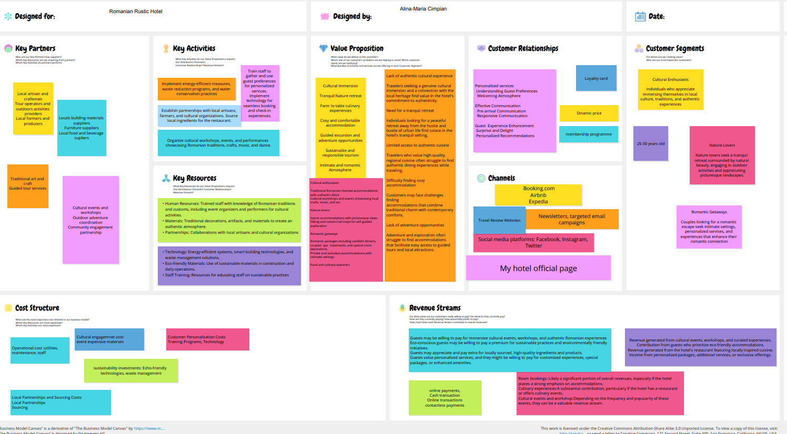

Figure 1: BMC
(Source: Romanian Rustic Hotel ‒ Conceptboard)

Appendix 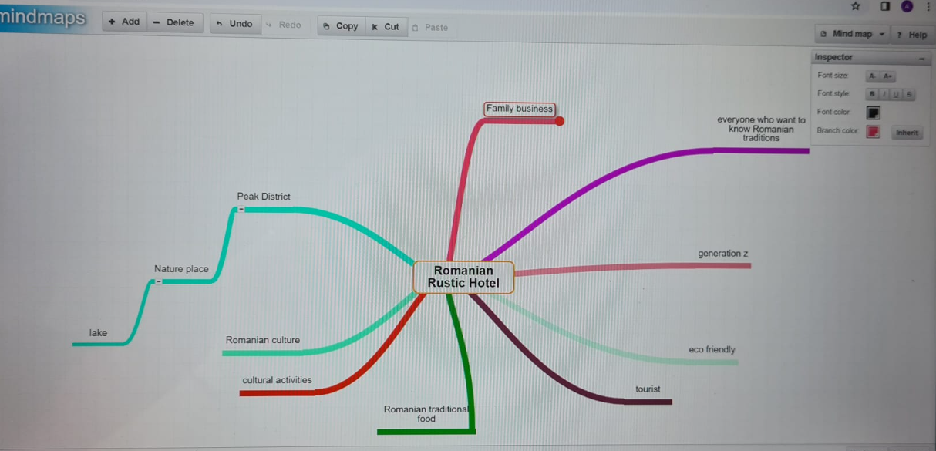

Fig No 1: Mindmap for Rustic Romanian Hotel
(Source: https://www.mindmaps.app/)

PESTLE Analysis of Rustic Romanian Hotel
Elements | Factors
Political | - A stable government in the UK is favourable for starting operations othe f new Rustic Romanian Hotel, as there is less risk of changes in regulations and policies related to the hospitality industry.  - The has a low corruption ranking in the global corruption index (transparency.org, 2023). It means the new hotel does not require additional funds and time for legal works related to licensing and registration.
Economic | - Inflation rate was 5.2% in December 2023 (Beckett, 2024). Increasing inflation can increase the operational cost of hotels.  - Increasing the GDP the of UK is a favourable condition for the business (Clark, 2024). New market opportunities can be utilised to expand hotel operations.
Social | - UK society is highly diverse and people from different parts of world come to explore English heritage. Hence, international tourists can be attracted to create demand for the hotel.  - Growing awareness about new cultures is also an opportunity for Romanian Hotel to attract potential customers from global markets.
Technological | - Smart check-ins and checkouts using artificial intelligence and internet is a popular trend in the UK hotels.  - Technology can also be used for offering personalised experience by using data analytics and online reviews and posts.
Legal | - Rustic Romanian Hotel would comply with employment Act 1996 to ensure safe and fair work environment for employee (legislation.gov.uk, 2023).  - The hotel will also adhere to Health and Safety Act 1974 to mitigate risk of accidents and injuries of staff at the workplace (hse.gov.uk, 2023)  - Compliance with Data Protection 2018 is crucial to protect online information of guests and staff from manipulation and misuse (legislation.gov.uk, 2023)
Environmental | - Emission from hotel operations such as logistics and kitchen work can create environmental challenges for the new hotel.  - Waste generated from daily operations can be recycled and reused to mitigate pollution and landfill.

Appendix 4
Swot Analysis of Rustic Romanian Hotel
Strengths  - Cultural theme of Rustic Romanian Hotel would offer a unique experience to guests.  - Sustainable services would create a green and positive public image of the hotel.  - Affordable prices would attract customers from different income groups. | Weaknesses  - Weak brand identity of new hotel can create challenges in attracting customers initially.  - Only one operational unit can limit the reach of new hotel to specific location.  - The cultural theme might be appealing to only specific customer group.
Opportunities  - Technology and innovation can create new opportunity to personalise experience and reach potential customers.  - Expansion in new locations can help in increasing market share and customer base. | Threats  - Higher competition can be challenge for new hotel, as target customers have multiple choices.  - Increasing inflation can be a threat for financial condition of the hotel.  - Changing trends can create instability in managing product portfolio.

Appendix 5
SMART analysis

Specific | Measurable | Achievable | Realistic | Time
To enhance occupancy rates of Rustic Romanian Hotel | An occupancy rate of 70% will show the success of the new business plan. | It will be achieved by effective marketing and quality services. | It is relevant for maintaining consistent demand. | 6 months
To create profits in UK market | A profit margin of 30% in the first six months will show financial success. | It will be achieved by making efficient use of resources. | It is relevant for the long-term growth of the business. | 6 months

5. Business goals
To establish a clear and actionable set of business goals for the Romanian Rustic Hotel in its first year, we'll focus on measurable objectives that align with the vision and strategy outlined in the business plan and canvas documents. These goals are designed to position the hotel as a significant player in the UK's cultural hospitality sector, with a strong emphasis on delivering quality and culturally rich experiences to its guests. Here's a refined statement of the business goals:
- Brand Establishment: Solidify the Romanian Rustic Hotel as a recognized name within the UK hospitality industry, emphasizing its unique Romanian cultural offerings.
- Profitability: Aim for a 25% profit margin by efficiently managing costs and maximizing revenue through strategic pricing, marketing, and exceptional service delivery and a turnover of 300.000.
- Customer Base Growth: Expand the customer base by 35%, targeting cultural enthusiasts, business travelers, and local staycationers through personalized marketing campaigns and partnerships.
- Market Share Acquisition: Secure a 2% share of the UK's cultural hospitality sector by differentiating the hotel's offerings, focusing on authentic Romanian experiences, and exceptional customer service.
- Workforce Development: Build a team of skilled, creative, and experienced professionals dedicated to delivering high-quality service and innovating the guest experience.
These goals serve as a roadmap for the Romanian Rustic Hotel's initial year, laying a foundation for future growth and expansion. Achieving these objectives will require a focused approach to marketing, operations, and service excellence, ensuring the hotel not only meets but exceeds the expectations of its guests.

Where do you see your business in 3-5 years?
For the Romanian Rustic Hotel, the vision includes establishing a firm brand name, expanding market share, geographical expansion, cultivating a diverse and loyal customer base, enhancing service quality, leveraging innovation and technology, and promoting Romanian culture.
- Market (M): The goal to increase market share by 5% in the UK and expand into at least two more European countries aligns with identifying and targeting new market segments and geographical areas where there is demand for unique hospitality experiences emphasizing Romanian culture.
- Product (P): The focus on quality services and leveraging innovation and technology for customer convenience and satisfaction aligns with the development of differentiated and high-quality offerings that meet or exceed customer expectations, leveraging technological advances for enhanced customer experience.
- Organization (O): The plan implies building a strong brand and expanding operations, necessitating a well-structured organization capable of managing increased scale, cross-border operations, and maintaining high standards of service quality.
- Profitability (P): The vision encompasses not just growth in terms of market share and geographical footprint but also implies a focus on profitability through effective service delivery, operational efficiency, and leveraging technology for marketing and customer engagement to drive revenue growth.
By focusing on these dimensions also discussed in the study by Yencken and Gillin (2006), the Romanian Rustic Hotel aims to achieve a sustainable and profitable business model that leverages its unique value proposition of offering a glimpse into Romanian culture and hospitality.
Reference: Yencken, J., Gillin, M., 2006. The Klofsten Business Platform as a self-diagnostic tool for new technology-based small firms. Paper for HTSF Conference 2006. https://proceedings.utwente.nl/140/1/Yencken,J._c.s._paper.pdf

Table:
Year | Market Goals | Product Development | Organizational Growth | Profitability and Revenue | Customer Base Expansion
Year 1 | Establish brand presence in the UK. | Launch initial services focusing on quality and Romanian cultural experiences. | Form the core team and define organizational structure. | Aim for a profit margin of 25%. | Begin cultivating a diverse and loyal customer base.
Year 2-3 | Increase market share by 5% in the UK. | Integrate innovative solutions for customer convenience. | Strengthen operational capabilities to manage scale. | Focus on operational efficiency to sustain profitability. | Achieve a growth of 35% in customer base.
Year 4-5 | Expand into at least two more European countries. | Further enhance service offerings with advanced technology. | Ensure organization can support cross-border operations. | Drive revenue growth through marketing and customer engagement. | Solidify customer loyalty and satisfaction.

Appendix 7
7.1 Premises
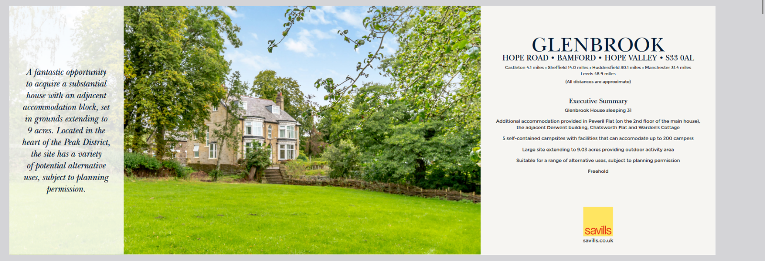
Fig Hotel to Buy-1750000£
(Source: https://search.savills.com/ie/en/property-detail/c1387746-132d-4da9-bc4e-996966b022ae)
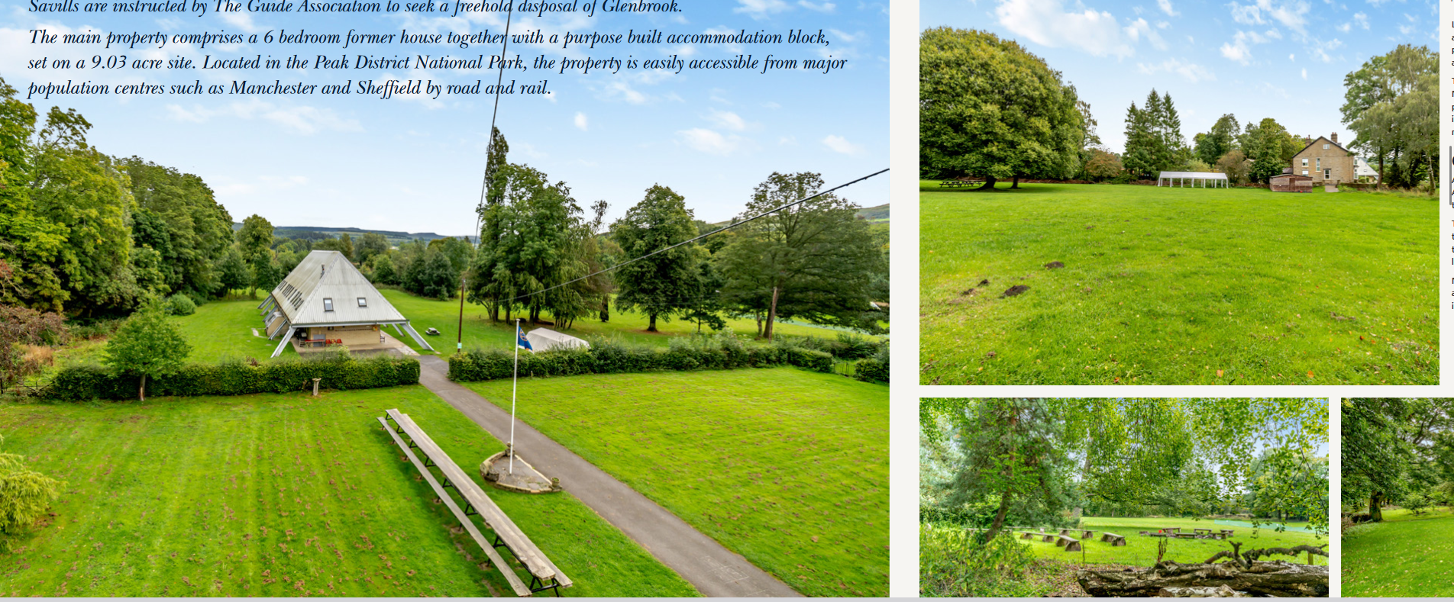
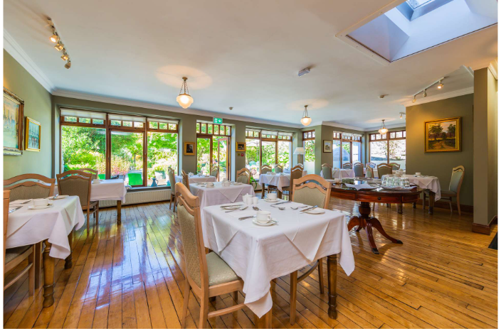
Dining area

7.2 Equipment
Computer & Laptop : https://www.amazon.co.uk/Apple-MacBook-laptop-8%E2%80%91core-10%E2%80%91core/dp/B0CM5VRKKM/ref=sr_1_5?crid=2LH3RMTDG4E62&dib=eyJ2IjoiMSJ9.BKn63Ri_KxSfB3xZq_s6ScCxPNRF_oNmsEWNCx-C0XXDh_7TD-DcjbmKh8qvMlo8-4H7w1eBvotYDCe2jzJnFcfs6T1SakDwxdzPm1fdiVh5AnTCQ6gg3vn-PXZ49fuuSG9H3DTPr2fOWG0uQ5Vlgkwqh0hdtRjnFCQoRADf-QvxEnTWg0k5FpoJSu3bwJZiBACnegankyLDMA9zjWYHtadULuRbHuwY-TeP7o106S0.uwIWocXch03moTHs4lMbf71_QymhW420xxvDQVhyTc0&dib_tag=se&keywords=Laptop+apple&qid=1709594453&sprefix=laptop+apple%2Caps%2C105&sr=8-5
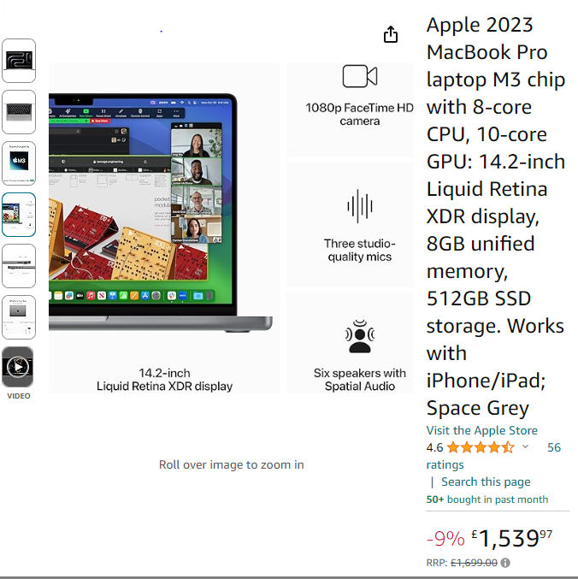

7.3 Health and safety equipment
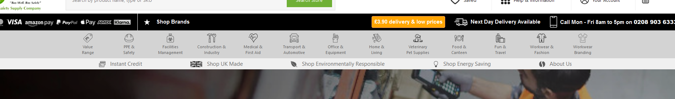
(Source : https://www.thesafetysupplycompany.co.uk )

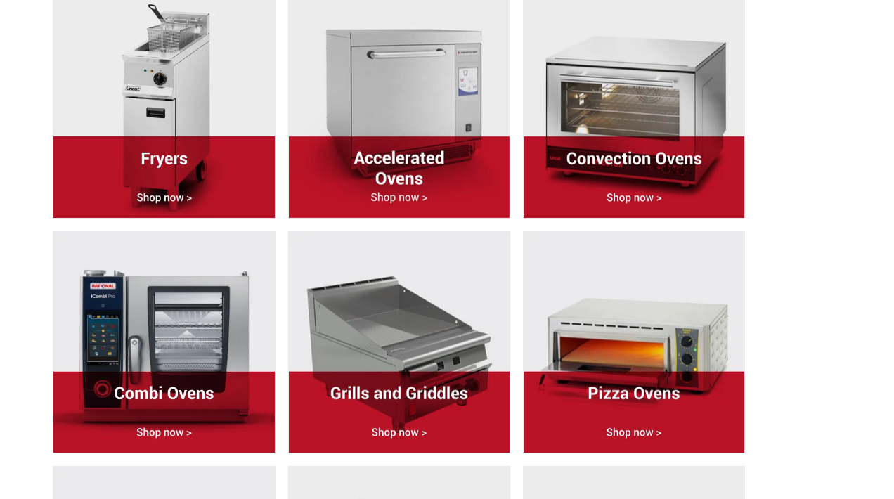
Kitchen appliance
(Source : https://rental-plus.co.uk/product-category/production-equipment/ )
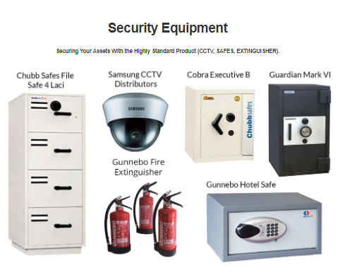

Appendix 8 Suppliers
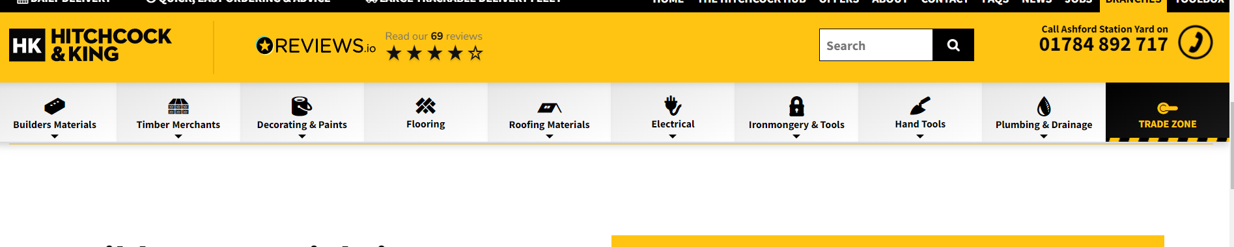

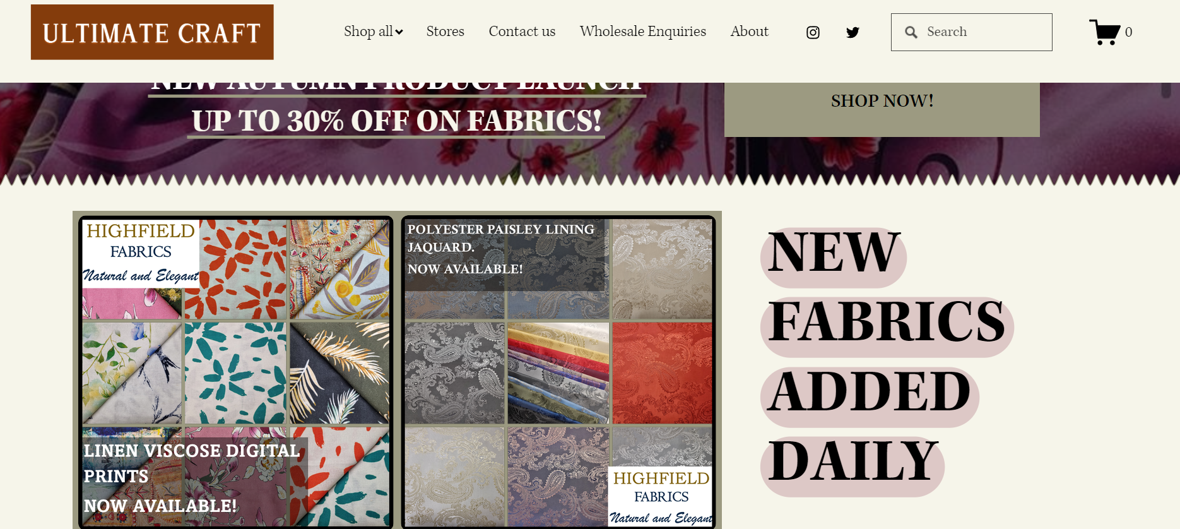
Craft Supplier

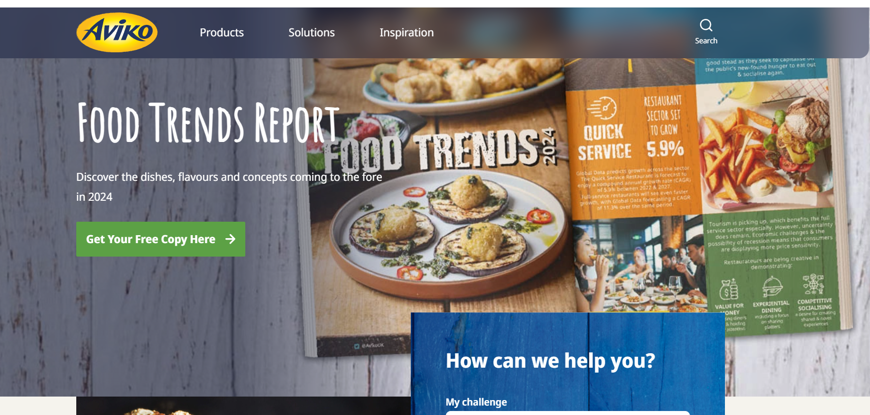
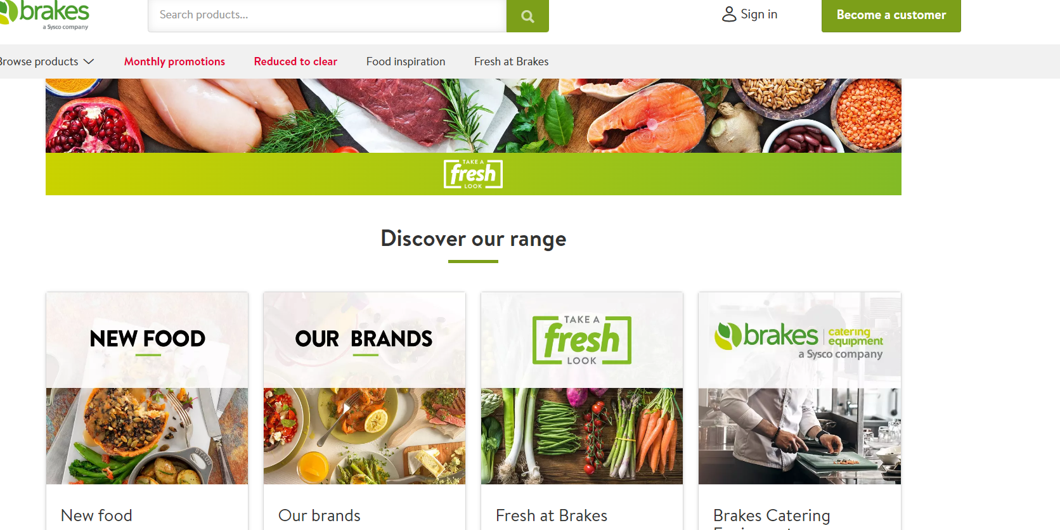
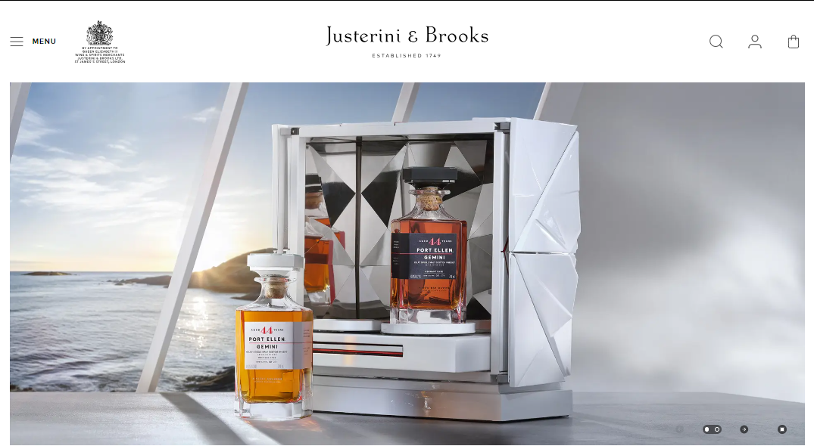
Appendix 8
Customers demographic
Mandarin hotel
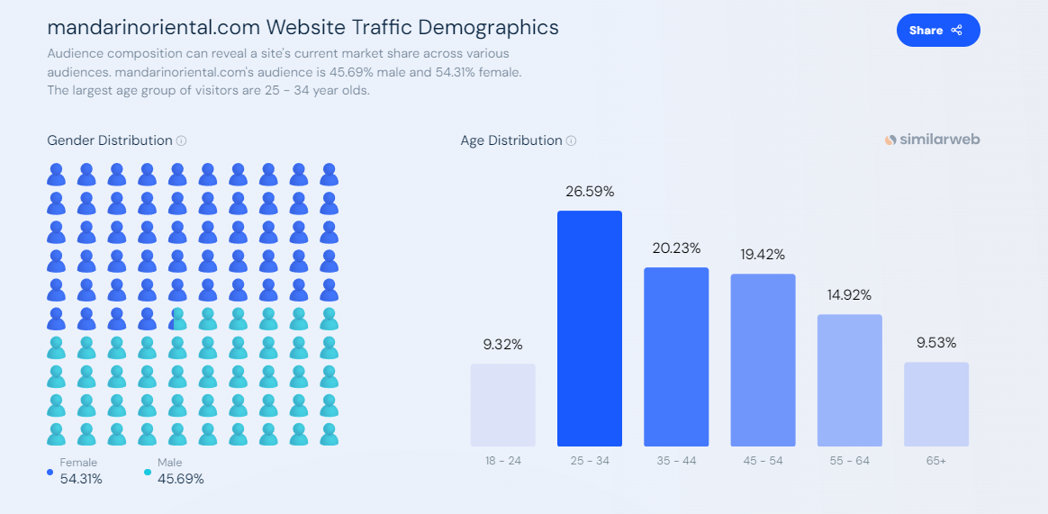
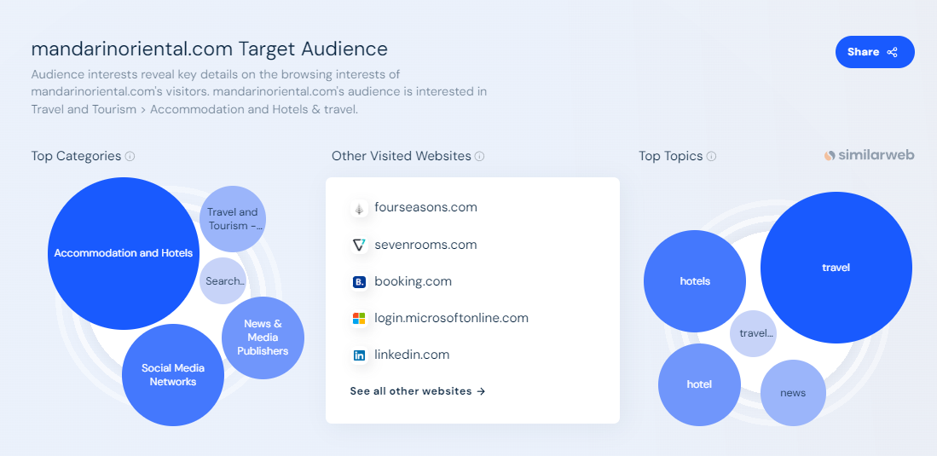
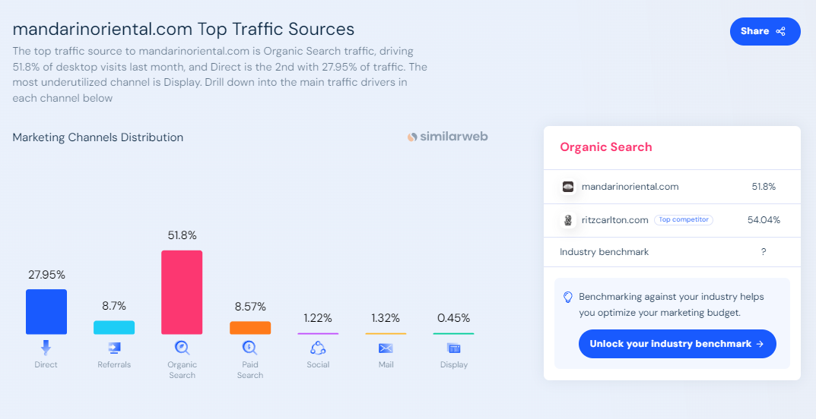
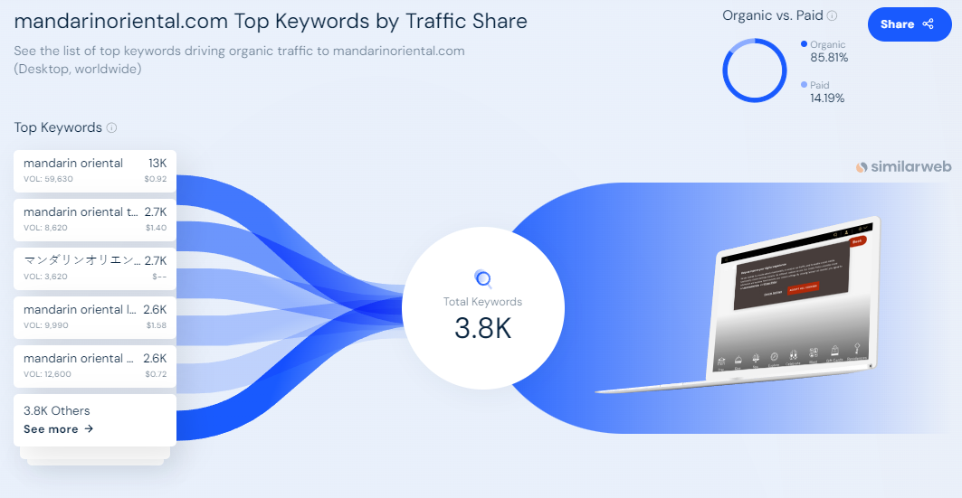
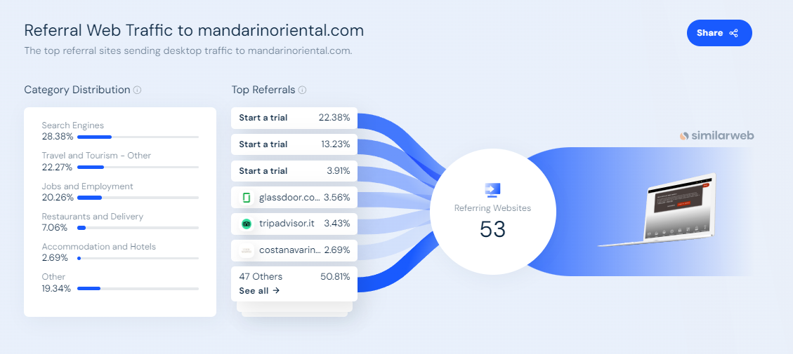
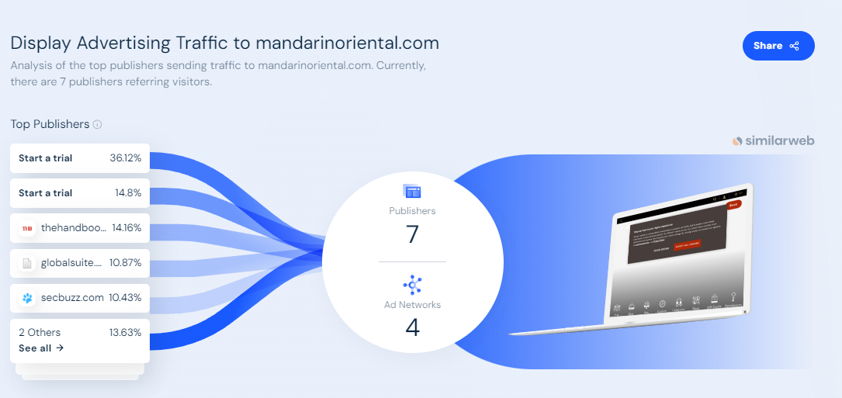
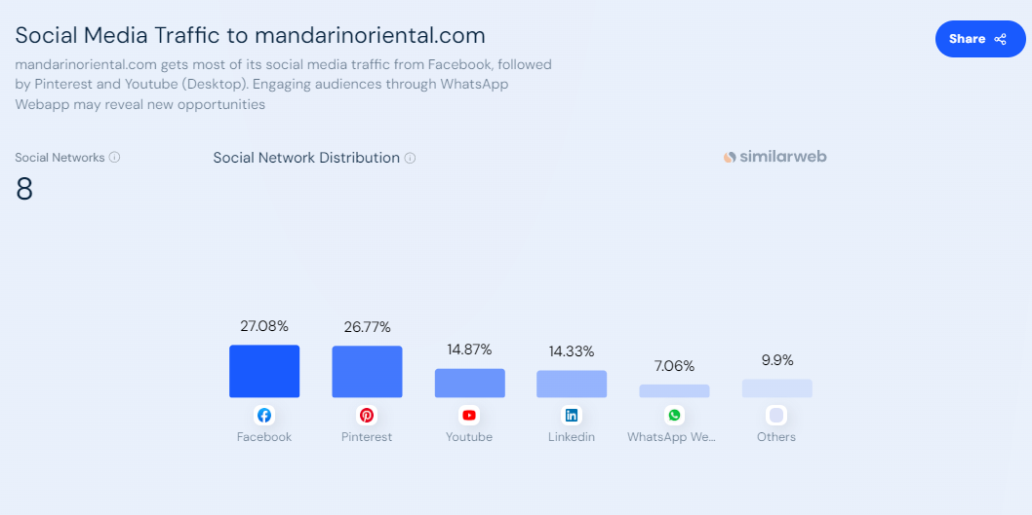
Ikoylondon
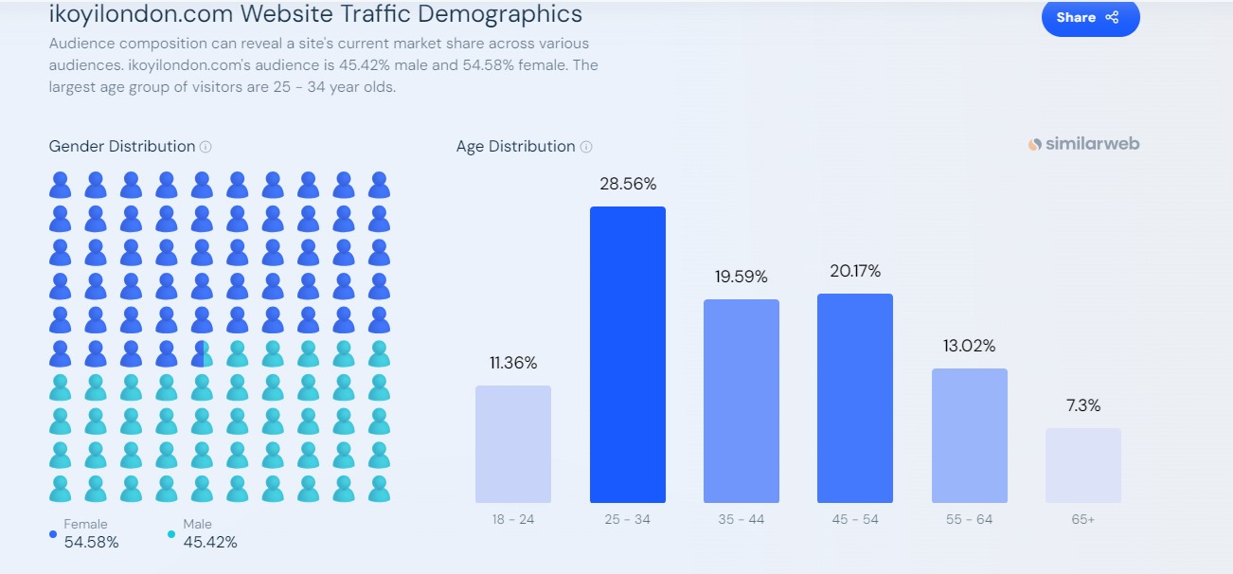
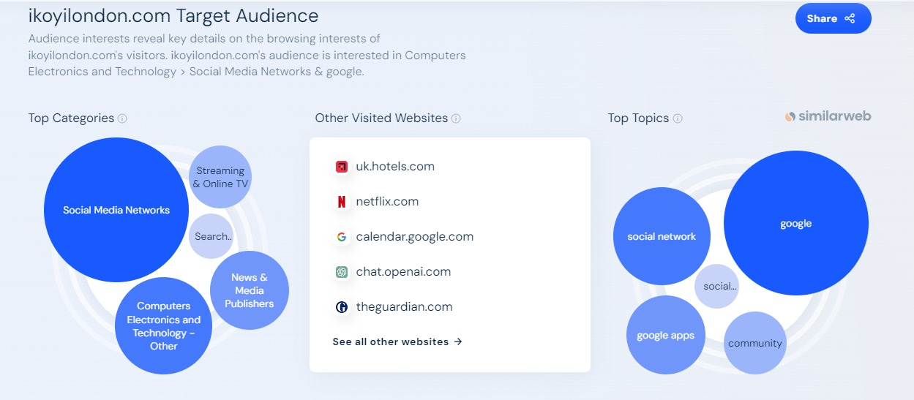
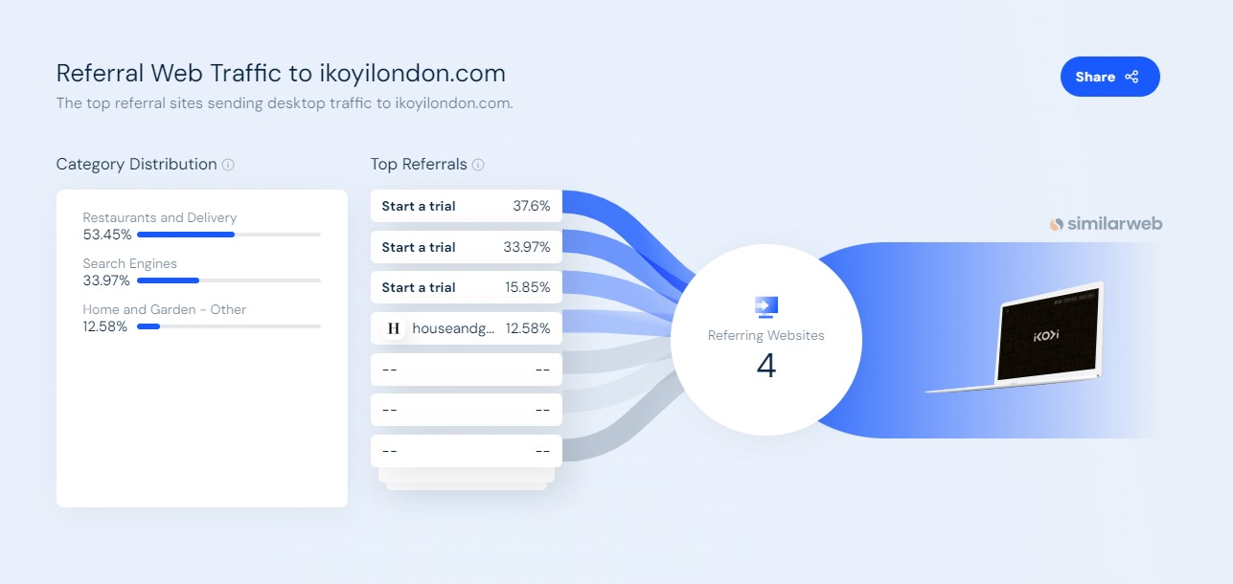
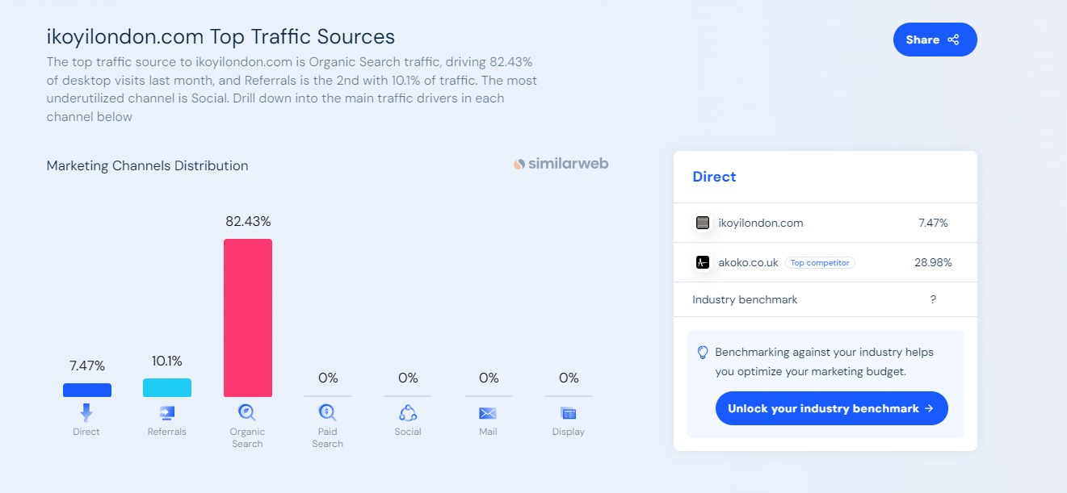
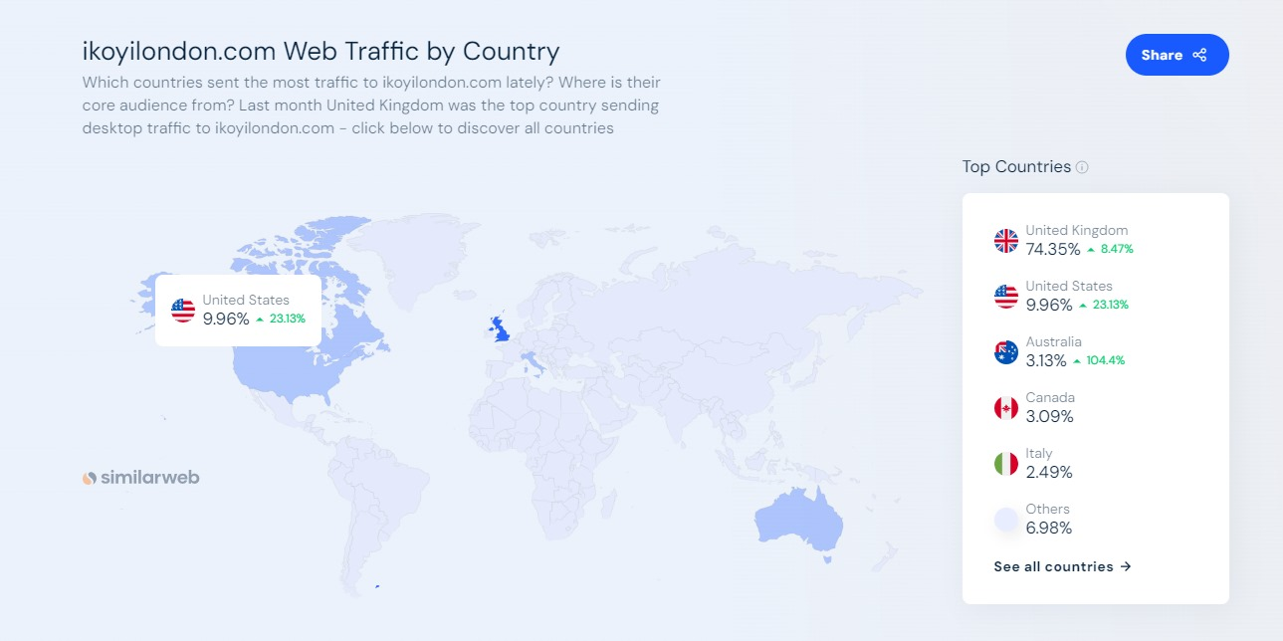
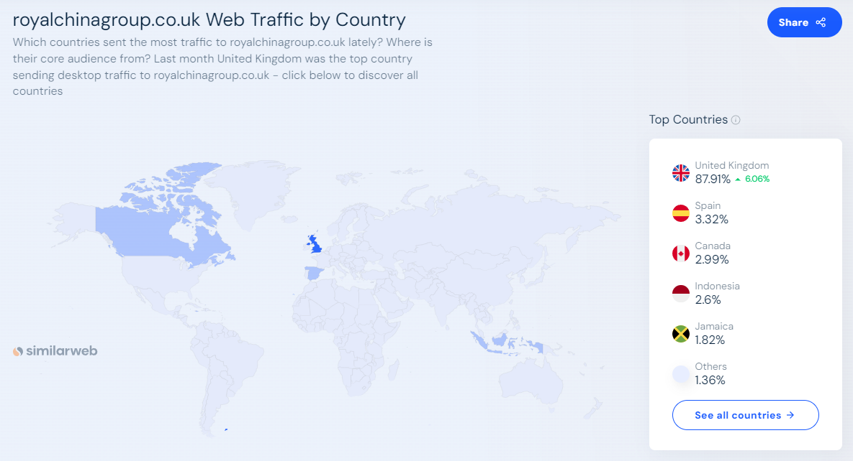
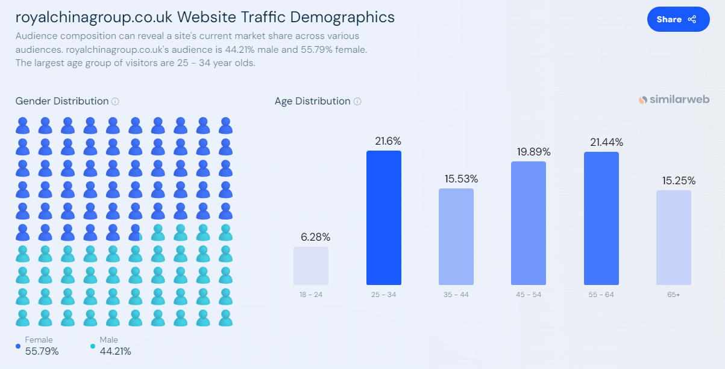
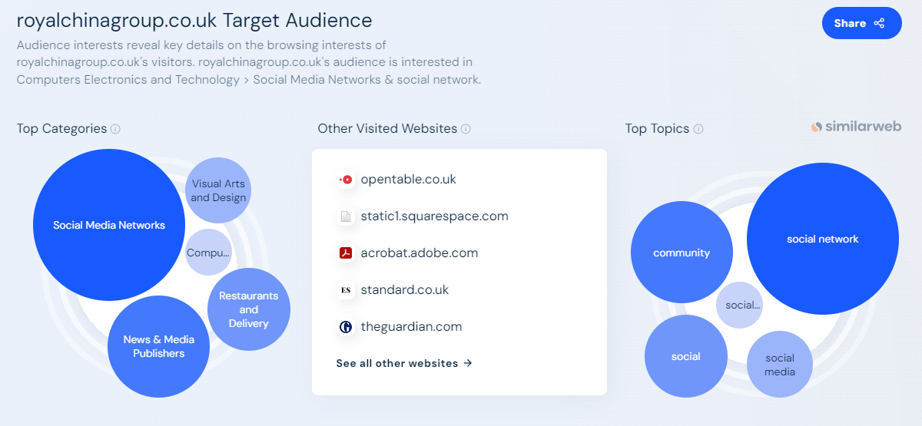
Appendix 9

- Pricing and Value for Money:
Kimes, S. E., & Wirtz, J. (2015). Revenue Management: Advanced Strategies and Tools to Enhance Firm Profitability. Foundations and Trends in Marketing, 8(1), 1-68. https://www.nowpublishers.com/article/DownloadSummary/MKT-037
This publication delves into revenue management and pricing strategies that can enhance profitability while maintaining a perception of value among customers.
- Enhancing Service Quality:
Alexandrov, A., Lilly, B., & Babakus, E. (2013). The effects of social- and self-motives on the intentions to share positive and negative word of mouth. Journal of the Academy of Marketing Science, 41(5), 531-546. http://dx.doi.org/10.1007/s11747-012-0323-4
This study highlights the impact of service quality on customer behavior, including the propensity to share positive word of mouth, which is crucial for service differentiation.
- Menu Innovation and Use of Local Ingredients:
Hall, C. M., & Gössling, S. (2013). Sustainable Culinary Systems: Local Foods, Innovation, Tourism, and Hospitality. Routledge.
This book discusses the role of local foods and culinary innovation in creating sustainable and appealing hospitality experiences, emphasizing the importance of integrating local ingredients into menus.
- Customer Feedback Systems:
Vargo, S. L., & Lusch, R. F. (2016). Institutions and axioms: an extension and update of service-dominant logic. Journal of the Academy of Marketing Science, 44(1), 5-23. https://www.researchgate.net/profile/Stephen-Vargo-2/publication/282540931_Institutions_and_axioms_an_extension_and_update_of_service-dominant_logic/links/5bab1e4b299bf13e604c9e49/Institutions-and-axioms-an-extension-and-update-of-service-dominant-logic.pdf
This paper extends the service-dominant logic framework, proposing that customer feedback is integral to co-creating value in service-based businesses, including hospitality.
- Dynamic Pricing:
Guizzardi, A., Pons, F.M.E., Angelini, G. and Ranieri, E., 2021. Big data from dynamic pricing: A smart approach to tourism demand forecasting. International Journal of Forecasting, 37(3), pp.1049-1060. https://doi.org/10.1016/j.ijforecast.2020.11.006
This article explores dynamic pricing models for tourism products, offering insights into adjusting prices in real-time based on demand to maximize revenue and maintain customer satisfaction.

Competitors
https://www.royalchinagroup.co.uk/
https://ikoyilondon.com/
https://www.mandarinoriental.com/en/london/hyde-park/dine

Appendix 10
Marketing channels
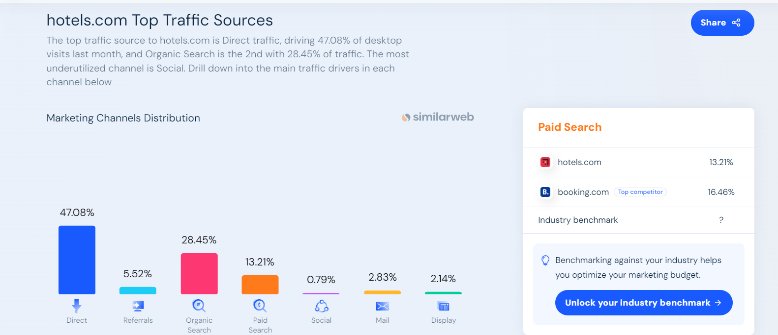

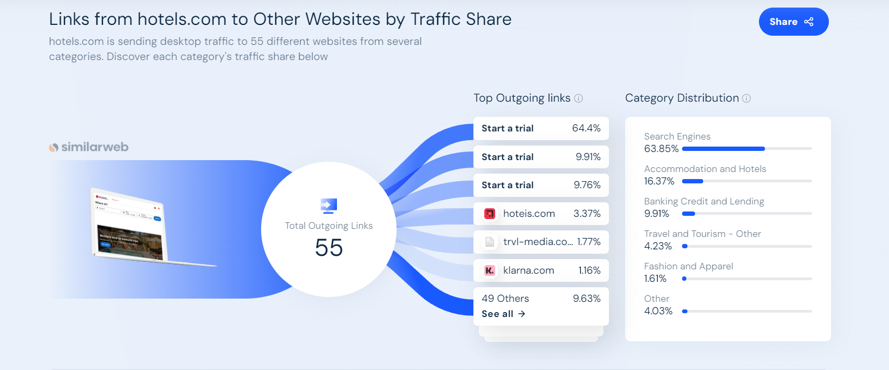 (Source: https://www.similarweb.com/)
Appendix 11
- Marketing strategies

1. Website: Create an appealing and user-friendly website for the hotel. Include high-quality photographs that capture the hotel's rustic character, as well as information on amenities, room kinds, pricing, and booking choices. Make sure the website is mobile-responsive for users browsing on smartphones and tablets.
2. social media: Utilise social media sites such as Facebook, Instagram, and Pinterest to highlight the Romanian Rustic Hotel's distinctive qualities. Share photographs, videos, and anecdotes about the rustic design, traditional Romanian cuisine, and neighbouring attractions in the Peak District. Engage your audience by reacting to comments, sharing user-generated content, and executing targeted ad campaigns.
3. Online travel agencies :Partner with big OTAs like Booking.com, Expedia, and Airbnb to boost hotel visibility and attract a wider audience.

4. Email Marketing: Create an email list of previous guests and subscribers interested in travel and cultural adventures. Send out regular mailings that include promotions, special discounts, upcoming events, and local suggestions. Personalise your emails so that recipients feel valued and engaged.
5. Influencer partnership: Collaborate with travel influencers, bloggers, and vloggers who focus on cultural tourism or distinctive accommodations. Invite them to stay at the Romanian Rustic Hotel and then share their experiences with their audience via sponsored posts, reviews, and social media material.
6. Local turist partnership: Develop ties with local tourism boards, visitor centres, and tour companies in the Peak District. Provide exclusive packages or discounts to customers who book through these partners, and cross-promote each other's offers to bring additional people to the area
7. Content Marketing: Create entertaining and useful content on Romani culture, tourism tips, and experiences in the Peak District. Publish blog pieces, articles, and videos on your website and social media channels to establish the hotel as a reliable source for travellers looking for real experiences.
8. Optimise your Google My Business listing to increase your hotel's visibility in local search results. To attract potential visitors looking for Peak District accommodations, keep your listing up to date with correct information, images, and reviews.

Appendix 12
Funds calculator
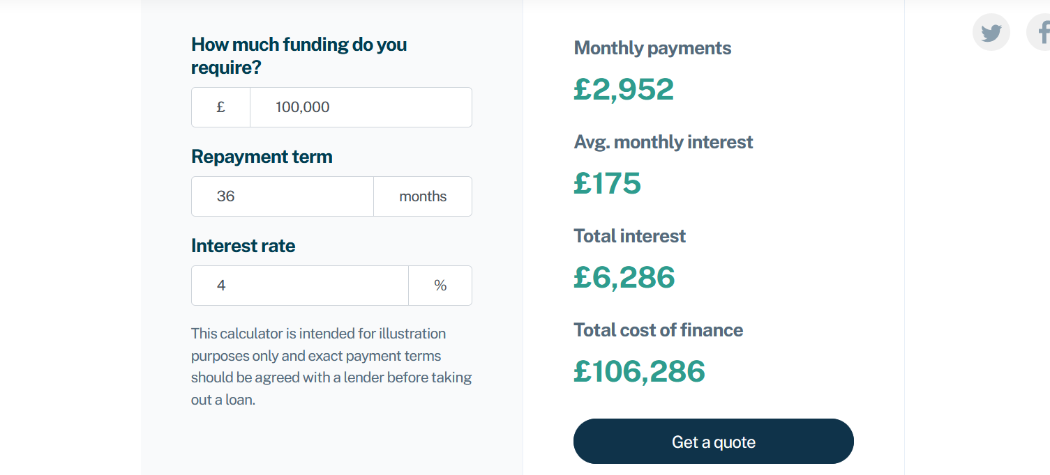

(Source: swoopfunding.com/uk/ )
Appendix 13
Competitors
https://www.royalchinagroup.co.uk/
https://ikoyilondon.com/
https://www.mandarinoriental.com/en/london/hyde-park/dine

