Solving problems by making effective decisions in the workplace

Student Name: Bogdan Ioan Sigheti
Student Number:1817824
Lecturer Name: Suneth Fernando
Module Name: Problem Solving and Decision Making
Module Code: BMSW4004_LON

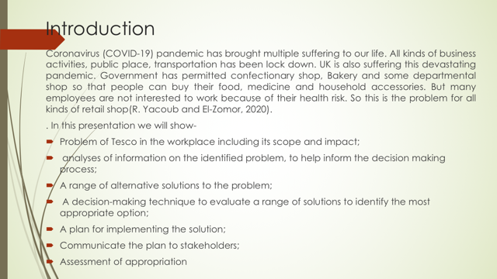

Introduction: Coronavirus (COVID-19) pandemic has brought multiple suffering to our life. All kinds of business activities, public place, transportation has been lock down. UK is also suffering this devastating pandemic. Government has permitted confectionary shop, Bakery and some departmental shop so that people can buy their food, medicine and household accessories. But many employees are not interested to work because of their health risk. So this is the problem for all kinds of retail shop (R. Yacoub and El-Zomor, 2020). Tesco is most familiar departmental super shop in UK which retails all kinds of products like baby food, confectionary, clothing, electronics, sanitary and all kinds of accessories. Government has permitted to open these departmental shop. But employees are not fond of working in Tesco due to Covid-19. They are afraid of their health security. So this is the serious problem for Tesco to continue their business without the support of employees. This problem is needed to solve by effective decision making.

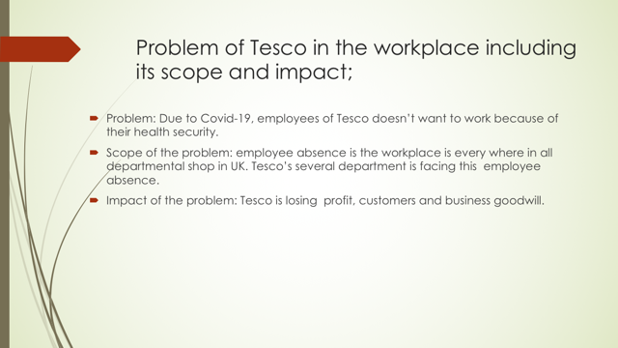

Problem of Tesco in the workplace including its scope and impact: This problem is available in all kinds of departmental shop. At this time, employee absence in Tesco can destroy business good will. So this is serious problem of employee absence in the workplace. The scope of the problem is that sales assistant, accountant and marketing employees are not attending in the workplace. But product manager and his group, operation department is still joining to Tesco. At the essence, employee whose has to work with customers are not attending in the work place and employees whose has to work in isolation are attending in Tesco. More or less, this problem is occurring all departmental shop in UK. Somehow other department shop like John Lewis, Harrods, Wait Rose, Morrison are giving incentives to the employees to work. If Tesco doesn’t retail these products and service, then it will lose heavy revenue. At this pandemic, Tesco must supply these services to the fix customers or they will not come again. So at a time, Tesco will lose the fix customers as well as its business goodwill (Allwood and Selart, 2010).

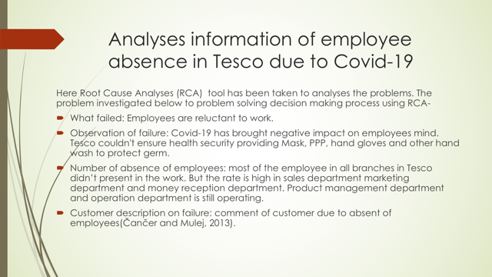
Analyses information of employee absence in Tesco due to Covid-19: Here Root Cause Analyses (RCA) tool has been taken to analyses the problems. The problem investigated below to problem solving decision making process using RCA-
- What failed: Employees are reluctant to work.
- Observation of failure: Covid-19 has brought negative impact on employee’s mind. Tesco couldn't ensure health security providing Mask, PPP, hand gloves and other hand wash to protect germ.
- Number of absence of employees: most of the employee in all branches in Tesco didn’t present in the work. But the rate is high in sales department marketing department and money reception department. Product management department and operation department is still operating.
- Customer description on failure: comment of customer due to absent of employees (Čančer and Mulej, 2013).

RCA is the tool that has been used for Tesco’s Problem. Before effective decision making, we have to know what failed, what is the reason of failure, number of failure units and customer description. Employees are absent in work due to Covind-19. Employees get afraid of their health security because every day hundreds of people are dying in UK, Spain, and France. So employee want to keep themselves secured from this pandemic. Except product and operation department, all employees have left the workplace. Now customer is reviewing negatively in online and the fix customers of Tesco is shifting other departmental shop. They think, Tesco has no business ethics.

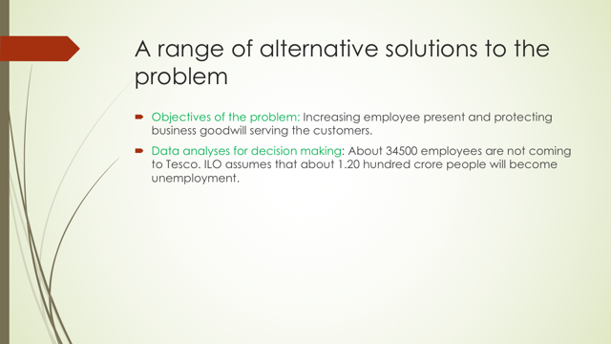 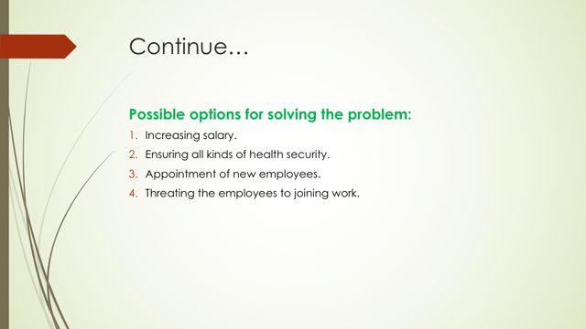A range of alternative solutions to the problem: Absence of employees in Tesco has brought negative review in market. Tesco us famous as a retailer. But Covid-19 is decreasing employees present in the workplace. This is the challenging task to get back employee presence in the workplace. Now the objectives from the problems is that
- Increasing employee present.
- Protecting business goodwill serving the customers.
- About 75000 employee work in Tesco and most of them are sales representatives. About 34500 employees are not attending in the workplace. Rest of the employee can’t serve the customers. ILO has predicted about 1.2 hundred crore people will lose the workplace (Coronavirus: Tesco to take hit of up to £925m due to COVID-19, 2020).

Salary increasing can be the best motivator for working. The sales assistant will get more salary than other department. When Tesco will sell products in this pandemic, they will be benefited than before because of products scarcity.

Another alternative solution may become ensuring health security to the employees. Tesco can provide PPP, surgical mask, hand wash and maintaining a proper distance. Infected employee will get medical facility and risk profit. When employee is infected, they lose their motivation to work. So these facilities can motivate them to attend in the workplace.

Appointment new employees may become another solution but honestly this will not work.
Threating the employees can be another solution because due to Brexit, EU employs can’t enter in labor market quickly. For this reason, threating the employee of fair from job can be another options for solution.

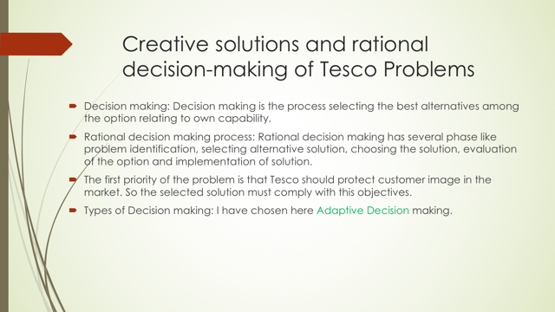
Creative solutions and rational decision-making of Tesco Problems: Decision making means choosing an alternative among the options. Rational decision making means choosing the best alternative. Tesco authority will take the solution which is reliable and will protect customer image in market. This is the adaptive decision making process because Covid-19 is a current pandemic. So Tesco should adjust with this pandemic to operating business smoothly. So a rational decision making can get back the employees in the workplace (Szymaniec-Mlicka, 2017). Creative solutions and rational decision-making of Tesco Problems are follows:

- Decision making: Decision making is the process selecting the best alternatives among the option relating to own capability.
- Rational decision making process: Rational decision making has several phase like problem identification, selecting alternative solution, choosing the solution, evaluation of the option and implementation of solution.
- The first priority of the problem is that Tesco should protect customer image in the market. So the selected solution must comply with this objective.
- Types of Decision making: I have chosen here Adaptive Decision making.

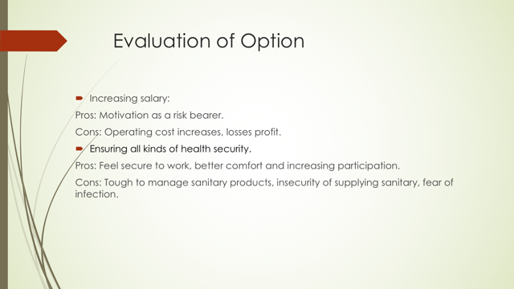
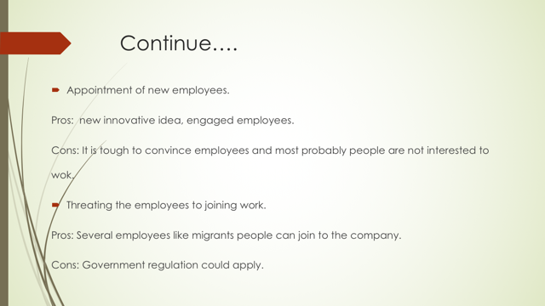
Evaluation of Option: Increasing salary can be the best motivation to work in Tesco at this pandemic. But the cons are that it increases operating cost and Tesco have to pay the revenue to employees. Health facility option is the most applicable for this current situation. When employees gate PPP, surgical mask, hand sanitizer and money reception will become secure, then employee will be attracted to join in work. In addition to, Tesco can provide free food and other opportunity fro employee’s family. But the cons are, it is tough to manage these sanitary and other germ protector liquid and dress because of heavy demand (When rational decision-making becomes irrational: 2020).

New employees could have energy to work and they will become innovative. But at this time, new employee will not join to the work because of unavailable health security. Threating employees can be useful but only several employees will join in the work place. In addition to, government regulator body can interfere in this action.

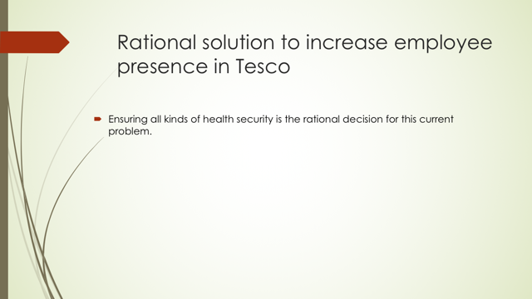Rational solution to increase employee presence in Tesco: This option evaluation has presented the pros and cons of every alternative option. But I prefer ensuring all kinds of health security. People are getting fear of death and infection. If Tesco can supply these PPP, masks, hand gloves, liquid hand wash and proper money transaction, then employee will join in the company. Though it is tough to manage because of heavy demand but Tesco has a connection with several producers. So Tesco can manage these products for the customers. Thus employees will attend in the working place and employees will feel comfortable to work in Tesco.

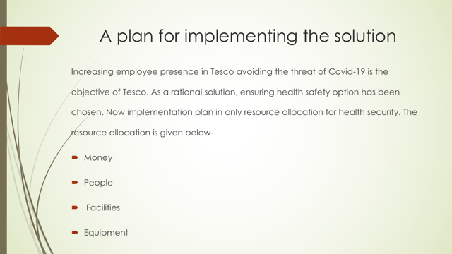A plan for implementing the solution: The resources are financial assistant and its operation in Tesco Business Environment. The resource allocation is money, people, facilities and equipment.
Money will be provided by Tesco to purchase the equipment of Covid-19. some employees (People) will be recruited for ensuring managing crowed customers, wearing PPP and put of clothing from the employees. facilities include ensuring freedom of work, health security or insurance, money or other products supply for employee’s family. Equipment is PPP, mask, hand wash, liquid germ protector etc. (Vickers, 2016).

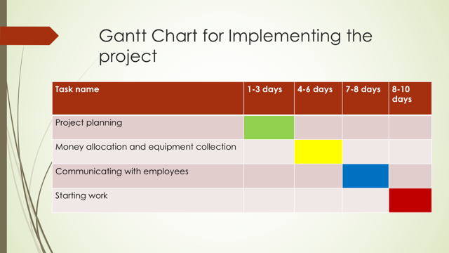Gantt Chart for Implementing the project: Taking rational decision, Tesco will make a Gantt chart for implementing the project. The project planning takes 1-3 days, money allocation and equipment collection takes 4-6 days. Informing the employees about Tesco new initiatives take one day and securing health facilities employees presents their join within 8-10 days. Thus within 10 days, this decision will be implemented properly.
The communication plan is completely online because it is tough to reach the employee to their home physically. Email, social media a d video conference can be the communication way.

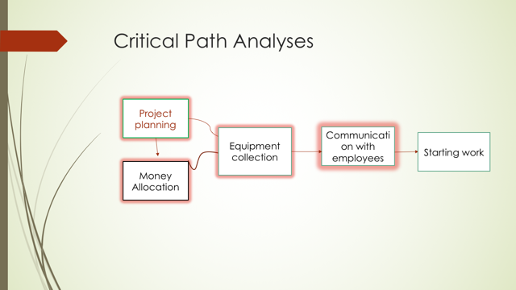Critical Path Analyses: Critical path analyses finds out the most versatile way of implementing plan (The ABCs of the Critical Path Method - Ideas and Advice, 2020). Communication with employees is the critical path in this project implementation plan. Tesco is always concerns to return back the employees to the work. Again, Tesco wants to allocate money to purchase products. Equipment collection is hard but not impossible because Tesco has a business conduct with several companies. But communication is the critical path because it is hard to convince the employees to work in this pandemic. Employees are not interested and so convincing them through email or video cheating is really tough. If Tesco can communicate and convince them to work, then Tesco will operate business smoothly in this pandemic.

Now Tesco as well as other business organization is facing the lack of employees. only departmental shop is permitted by government to open but threat of Covid-19 is decreasing employee’s presence. From this presentation, we can understand problem identification, scope and its impact. We have seen how rational decision is taken evaluating the options. If Tesco can overcome the challenges of communication, then it can protect customer goodwill, potential customers and benefit.

Conclusion: Now Tesco as well as other business organization is facing the lack of employees. only departmental shop is permitted by government to open but threat of Covid-19 is decreasing employee’s presence. From this presentation, we can understand problem identification, scope and its impact. We have seen how rational decision is taken evaluating the options. If Tesco can overcome the challenges of communication, then it can protect customer goodwill, potential customers and benefit.

Reference
- Allwood, C. and Selart, M., 2010. Decision Making. Dordrecht: Springer Netherlands.
- Čančer, V. and Mulej, M., 2013. Multi‐criteria decision making in creative problem solving. Kybernetes, 42(1), pp.67-81.
- n.d. The Abcs Of The Critical Path Method - Ideas And Advice .... [online] Available at: <https://hbr.org/1963/09/the-abcs-of-the-critical-path-method> [Accessed 2 May 2020].
- n.d. When Rational Decision-Making Becomes Irrational: A .... [online] Available at: <https://link.springer.com/article/10.1007/s40685-019-0096-4> [Accessed 2 May 2020].
- R. Yacoub, A. and El-Zomor, M., 2020. Would COVID-19 Be the Turning Point in History for the Globalization Era? The Short-Term and Long-Term Impact of COVID-19 on Globalization. SSRN Electronic Journal,.
- Sky News. 2020. Coronavirus: Tesco To Take Hit Of Up To £925M Due To COVID-19. [online] Available at: <https://news.sky.com/story/coronavirus-tesco-to-take-hit-of-up-to-925m-due-to-covid-19-11970276> [Accessed 2 May 2020].
- Szymaniec-Mlicka, K., 2017. The decision-making process in public healthcare entities – identification of the decision-making process type. Management, 21(1), pp.191-204.
- Vickers, A., 2016. Decisional Conflict, Regret, and the Burden of Rational Decision Making. Medical Decision Making, 37(1), pp.3-5.

