


development of stock price prediction model using lstm
Student Name: Mohammed Talha Sajidhusein Vasanwala
Student ID: 2316054
Supervisor Name: Divya Chidambaram

Project Submitted as Part of The Requirements for The Award of MSC in Data and Artificial Intelligence

September 2024

Declaration of Originality

I, Mohammed Talha Sajidhusein Vasanwala declare that I am the sole author of this Project; that all references cited have been consulted; that I have conducted all work of which this is a record, and that the finished work lies within the prescribed word limits.

This work has not previously been accepted as part of any other degree submission.

Signed: Mohammed Talha

Date: 13/08/2024

Form of Consent

I Mohammed Talha Sajidhusein Vasanwala hereby consent that my Project, submitted in candidature for the MSC in Data and Artificial Intelligence, if successful, may be made available for inter-library loan or photocopying (subject to the law of copyright), and that the title and abstract may be made available to outside organisations.

Signed: Mohammed Talha

Date: 13/08/2024

Copyright Acknowledgement

I acknowledge that the copyright of this project report, and any product developed as part of the project, belong to University of Wales Trinity Saint David, Swansea.

Table of Contents
Declaration of Originality 2
Form of Consent 2
Copyright Acknowledgement 2
ABSTRACT 5
CHAPTER 1 - INTRODUCTION 6
1.1. AIM 7
1.2. OBJECTIVES 7
1.3. QUESTIONS 7
1.4. STRUCTURE OF THE PROJECT 7
CHAPTER 2 - RESEARCH & REVIEW OF LITERATURE 8
2.1. INTRODUCTION 8
2.2. RELATED WORK 8
2.3. CONCLUSION 10
CHAPTER 3 – METHODOLOGY 11
3.1 RESEARCH METHODOLOGY 11
3.1.1 Philosophy 11
3.1.2 Strategy 11
3.1.3 Approaches 11
3.1.4 Risks & Limitations 12
3.1.5 Validity, Reliability & Generalisability 12
3.1.6 Data Evaluation Methods 12
3.2 DEVELOPMENT METHODOLOGY 12
3.2.1 Software Development Methodology 12
3.3 RESOURCES 14
3.3.1 Hardware Resources 14
3.3.2 Software Resources 14
3.3.3 Information Resources 14
3.3.4 Human Resources 15
CHAPTER 4 - DESIGN & IMPLEMENTATION 16
4.1 Introduction 16
4.2 Problem Formulation 16
4.3 Design 16
4.4 Implementation 18
4.5 Conclusion 22
CHAPTER 5 – TESTING AND EVALUATION 23
5.1. INTRODUCTION 23
5.2. EXPERIMENTS AND RESULT 23
5.3. CONCLUSION 26
CHAPTER 6 - CONCLUSIONS 27
CHAPTER 7 – REFLECTIONS 28
REFERENCES 31
APPENDIX 37
CODE: 37
LOGBOOK: 38

  - Contents of Tables

Table 1: Dataset Features 15
Table 2:Experiemt and Result from 1 to 10 variants 24
Table 3: Experiment and Results of 11 to 20 Variants 25
Table 4:Experiment and Result of 21 to 30 variants 26

  - Table of Figures
Figure 1: LSTM Model using a flowchart 13
Figure 2:Illustrating the data preprocessing steps 17
Figure 3:LSTM Architecture 17
Figure 4: Example of preprocessing 18
Figure 5: Difference between raw data and Normalized data 19
Figure 6:Example of model building 19
Figure 7:Train the model 20
Figure 8: The Evaluation metrics used to analysis the result 20
Figure 9:Actual data vs Predicted data chart 21
Figure 10:Loss during the model training 21
Figure 11:LOGBOOK WEEK 1 35
Figure 12:LOGBOOK WEEK 2 35
Figure 13: LOGBOOK WEEK 3 35
Figure 14: LOGBOOK WEEK 4 36
Figure 15: LOGBOOK WEEK 5 36
Figure 16: LOGBOOK WEEK 6 36

ABSTRACT
This report focuses on developing and optimizing Long Short-Term Memory (LSTM) models for predicting Tesla's stock prices, addressing the limitations of traditional forecasting methods in capturing the complex patterns within financial data through a comprehensive literature review that identifies the strengths and weaknesses of existing LSTM applications in stock prediction, setting the stage for systematic experimentation. Thirty different LSTM configurations were tested, with a focus on optimizing hyperparameters and model architecture. The best-performing model, featuring three layers of 64 units and 'tanh' activation functions, achieved a Test RMSE of 0.0456 and an R² score of 0.944, showcasing its superior predictive accuracy. The research highlights the potential of LSTM models in financial forecasting and underscores the importance of integrating real-time data sources, such as news sentiment, for future enhancements in predictive accuracy. Future studies should explore incorporating real-time news and company-specific updates to further refine prediction models, making them more responsive to immediate market changes and enhancing their practical applicability in dynamic financial environments.

CHAPTER 1 - INTRODUCTION
The stock market prediction might be the complex and dynamic framework, making precise price prediction a challenging yet alluring task and traditional estimating strategies regularly struggle to capture the complex connections within market information [1]. Over a long time, headways in technology and the accessibility of vast amounts of budgetary information have impelled the improvement of modern predictive demonstrating methods by using machine learning calculations have gained conspicuousness for their capacity to perceive complex patterns and connections within financial time arrangement data [2], [3]. The Long Short-Term Memory (LSTM) networks, a sort of recurrent neural network (RNN) [4], have illustrated promising comes about in displaying successive information [5] and capturing transient conditions, making them well-suited for stock price forecast assignments, the machine learning calculations, especially Long Short-Term Memory (LSTM) networks, have risen as an effective tool for tending to this challenge [6], [7], [8]. Despite the potential of LSTM-based models, there remain challenges and investigate gaps in leveraging these models for improved stock cost prediction [9]. These challenges include information accessibility and quality, model architecture optimization, interpretability of model expectations, and real-world applicability [10], [11].
Despite the appeal of stock price prediction, accomplishing steady accuracy remains a challenge and traditional methods like direct regression or time series analysis regularly drop short due to inherent limitations [12]. The stock market's complexity stems from a huge number of inside and outside components association in non-linear ways, making it troublesome for these strategies to capture the underlying elements [13], [14]. Furthermore, to the ever-growing volume of information including verifiable prices, news opinion, and social media movement can overwhelm traditional approaches, preventing their capacity to effectively prepare and examine this data for important experiences [15]. Besides, the conventional methods are often limited to a restricted set of information focuses, dismissing the potential benefits of joining different data sources like news estimation, social media patterns, or financial information which can altogether influence the stock costs [16], [17]. As the traditional methods too struggle with inborn advertise volatility, characterized by sudden and unpredictable changes and their failure to successfully capture these short-term developments regularly leads to inaccurate forecasts [18]. At long last, a few conventional prediction strategies based on specialized investigation can become less viable as market members become mindful of them [19]. So, this wonder, known as a self-fulfilling prediction, can possibly decrease showcase proficiency [20].
In contrast, Liu at el. [21] proposed Long Short-Term Memory (LSTM) systems offer noteworthy advantages over conventional methods and capacity to handle complex time arrangement data makes them well-suited for this study. Unlike the conventional strategies, LSTMs excel at learning long-term conditions within historical stock prices and permits them to recognize designs that unfold over amplified periods, possibly driving to more accurate expectations [22]. Chen [23] proposes the LSTMs are proficient at handling expansive volumes of monetary information, including historical prices, specialized indicators, and even sentiment investigation information. This comprehensive information integration can give a wealthier picture of advertise dynamics, possibly progressing expectation accuracy [24]. Besides, LSTMs can successfully show the non-linear connections that govern stock cost instability, driving to predictions that are more robust to market noise [25]. Finally, LSTMs can be consolidated into models to utilize different data sources past chronicled prices. Its flexibility permits for a more holistic understanding of showcase developments by incorporating news estimation, social media patterns, and financial information [26].

AIM
The main aim of the study is to develop a highly interpretable LSTM-based stock price forecasting system by analysing the existing models, optimizing architecture and hyperparameters, and evaluating its performance against the traditional and existing models.

OBJECTIVES
- To critically analyse the existing LSTM-based stock price prediction models to identify strengths, weaknesses, and opportunities for improvement.
- To enhance the LSTM model's architecture and hyperparameters to improve its predictive performance and interpretability for stock price forecasting.
- To evaluate the proposed LSTM model's performance and robustness compared to traditional forecasting methods and existing LSTM models using relevant metrics.

QUESTIONS
- How can insights from current LSTM research to create an interpretable and optimized LSTM model for superior stock price prediction?
- What can be incorporate into the LSTM architecture to improve its interpretability and predictive performance for stock price forecasting compared to existing models?
- How does the proposed interpretable LSTM model compare to traditional forecasting methods and existing LSTM models in terms of accuracy, robustness, and interpretability?

STRUCTURE OF THE PROJECT
The document is structured to provide a comprehensive analysis of stock market prediction using Long Short-Term Memory (LSTM) networks. It begins with Chapter 1, "Introduction," which outlines the complexities of stock price forecasting and the promise of LSTM networks in addressing these challenges. "Research & Review of Literature," - Chapter 2, it reviews existing studies that integrate sentiment analysis and technical indicators with deep learning models, emphasizing their impact on prediction accuracy. Chapter 3, "Methodology," details the research methods and approaches employed, excluding the design and implementation of LSTM models, as well as data handling and preprocessing techniques mentioned in Chapter 4, "Design & Implementation," explores the development of LSTM models specifically for predicting Tesla’s stock prices, discussing the problem formulation and the strategies used for model creation. Chapter 5, "Testing and Evaluation," assesses the performance of the implemented models, focusing on accuracy, error analysis, and model limitations, while suggesting areas for future research. Chapter 6, "Conclusions," summarizes the findings, highlighting the best-performing LSTM configurations and their evaluation metrics. Chapter 7, "Reflections," provides an overview of the research process, evaluating how well the objectives were achieved, discussing encountered challenges, and reflecting on the overall progress and insights gained throughout the study.

CHAPTER 2 - RESEARCH & REVIEW OF LITERATURE

2.1. INTRODUCTION
Several studies have explored the integration of sentiment analysis and technical indicators with deep learning models to enhance prediction accuracy. For instance, The purpose of the study by Moodi et al. [27] is to improve the accuracy of stock price forecasts by integrating sentiment analysis and technical indicators using a CNN-LSTM framework. The methodology involves utilizing three deep learning models—LSTM, CNN-LSTM, and GRU—along with technical indicators and sentiment analysis derived from social media platforms like Twitter. The dataset comprises Tesla's stock data and associated tweet sentiments, spanning from 2015, to 2019. Different time windows were analysed to determine the optimal window for prediction. The results showed that the CNN-LSTM model with 45-day time window outperformed others, achieving the lowest mean squared error (MSE) of 0.0011, indicating its superior forecasting capability.

2.2. RELATED WORK
Lumoring et al. [22] aims to investigate the part of machine learning in stock showcase expectation and distinguish the foremost prevalent and precise models. The technique includes a systematic literature review (SLR) using the PRISMA checklist to assess inquire about papers distributed between 2017 and 2022. A total of 18,100 records were at first recognized, and after a thorough screening prepare, 30 studies were included for subjective union. The audit focuses on replying three investigate questions with respect to the common application, prevalent models, and most successful strategies in stock cost expectation. The comes about highlight that the Long Short-Term Memory (LSTM) show illustrates the most elevated accuracy, achieving 99.58% accuracy, while Support Vector Machine (SVM) is the foremost regularly utilized demonstrate within the studies reviewed [28].
Rahmani et al. [29] examines the current and potential applications of AI within the economy, focusing on stock exchanging, showcase examination, and chance administration. The strategy includes investigating existing information to supply a comprehensive understanding of AI's part in these regions. Different AI strategies, including neural networks, reinforcement learning, sentiment investigation, and hybrid models, are inspected for their viability in estimating stock costs and optimizing exchanging methodologies. The results show that hybrid CNN/LSTM models are most successful for anticipating stock patterns and costs. Moreover, distinguishes basic holes such as the require for real-time exchanging strategies and the generalization of AI models over distinctive monetary markets. Kumar et al. [1] discusses to improve the accuracy of stock market cost forecasts utilizing LSTM models. The technique incorporates getting chronicled showcase information, preprocessing it, and part it into preparing and testing datasets. The model's execution is assessed utilizing measurements such as mean squared error (MSE) and mean absolute error (MAE). The comes about illustrate that the LSTM show, especially when combined with other strategies like dropout regularization and optimization calculations, essentially outperforms conventional strategies. The demonstrate successfully predicts future stock prices by capturing and dissecting complex patterns in authentic information, appearing less errors compared to more seasoned determining strategies.
The evaluation of machine learning algorithms for stock market prediction has been extensively studied. According to Tiwari et al.[30]​​, one study pointed to evaluate and compare the viability of different machine learning calculations in anticipating stock market patterns. It included collecting stock cost data from different companies over ten a long time, preprocessing the information with specialized markers, and part it into training and testing sets. The algorithms assessed included Artificial Neural Networks (ANN), Support Vector Machines (SVM), Random Forest (RF), and Long Short-Term Memory (LSTM). The results demonstrated that LSTM models, known for taking care of consecutive information and capturing long-term conditions, outperformed other models in accuracy and reliability, making LSTM a promising approach for stock showcase forecast and monetary decision-making. Another research by Kumaresan et al. [31] focused on the estimating accuracy of diverse LSTM-based models for stock price forecast, utilizing both univariate and multivariate approaches with historical costs and extra features like specialized indicators and macroeconomic components. The consider concluded that attention-based and stacked LSTM models outflanked their univariate and multivariate partners, emphasizing the require for encourage inquire about to improve demonstrate interpretability and moderate dangers in mechanized financial decision-making. Also, in their comparative study, Deswal and Kumar [32] assessed the performance of five machine learning algorithms—linear regression, SVM, random forest, neural networks, and LSTM—in anticipating the stock price of Apple Inc. (AAPL). The technique included information collection from Yahoo Fund, data preprocessing, and demonstrate training and testing. The consider found that linear regression, neural networks, and LSTM accomplished high accuracy, with LSTM performing the leading based on the coefficient of determination (R²), making it the foremost reasonable model for foreseeing AAPL stock price.
In recent research, various approaches have been created to improve stock price forecast accuracy and steadiness by coordination progressed machine learning procedures and opinion analysis. Chiong et al. [33] proposed an ensemble learning model named EnsembleRNN that combines SimpleRNN, GRU, and LSTM with weights optimized by Molecule Swarm Optimization (PSO). This demonstrates forms financial news opinion and historical cost information to progress forecast performance, outperforming other models in terms of adjusted accuracy and F1-score. In any case, its dependence on the quality and amount of financial news data and estimation investigation may restrain its pertinence in less secured markets or amid periods of low news volume​​. Another study, Wang [34] introduced a hybrid model called BiLSTM-MTRAN-TCN, which coordinating Bi-directional Long Short-Term Memory (BiLSTM) with a progressed transformer and Temporal Convolutional Network (TCN). This demonstrate upgrades the accuracy and stability of predictions by combining the qualities of BiLSTM, transformer, and TCN, illustrating predominant performance in different measurements, including R² and RMSE, compared to existing strategies. The model too appears reliable predictive capability over distinctive time periods. However, the complexity of the model might result in higher computational costs and longer preparing times, possibly restricting its common sense for real-time applications. Moreover, a prediction model named MS-SSA-LSTM has been developed by Mu et al. [35], which coordinating financial specialist sentiment analysis with deep learning methods. This model uses assumption pointers derived from stock forum comments and financial news, combined with traditional exchanging information, and utilizes the Sparrow Search Algorithm (SSA) to optimize the LSTM parameters, enhancing prescient execution by anticipating overfitting and gradient issues. Experimental results uncover that the MS-SSA-LSTM model beats other models, especially in scenarios with high stock cost volatility, showing that consolidating assumption analysis essentially improves forecast precision. In any case, the model's reliance on estimation information implies it may be less successful in situations with restricted or questionable opinion sources, and it may require consistent upgrades to the estimation analysis component to preserve its exactness.

The Existing research has outlined the practicality of LSTMs in stock fetched estimate and proposed that the Long Short-Term Memory (LSTM) frameworks have picked up basic footing inside the field of stock cost estimate due to their capacity to capture transient conditions within information arrangements [34]. This makes them well-suited for analysing authentic stock price patterns and anticipating future improvements [36]. In existing explore has outlined the ampleness of LSTMs in this domain, with considers finishing promising results utilizing authentic cost data as input for their models [37]. However, few regions are remained open for further investigation too numerous current studies depend only on historical costs as input data [9], [32], [34]. Tiwari et al. [30] proposed in examining elective data sources, such as company financials, advertise estimation, and news articles, might move forward the forecast capabilities of LSTM models [38]. In addition, the most common challenge lies within the interpretability of these models [37], [39], and regularly they worked with "black boxes," making it difficult for speculators to comprehend foundation for the forecasts [40]. Research endeavours to progress model interpretability would be the advantageous. Luo et al. [9] proposed within the consider approximately the potential of LSTM-based models, there stay challenges and explore gaps in leveraging these models for progressed stock fetched expectation. These challenges incorporate data accessibility and quality, model design optimization, interpretability of model desires, and real-world applicability [41], [42].

2.3. CONCLUSION
The comprehensive review of existing literature underscores the critical role of coordination opinion examination and specialized indicators with progressed deep learning models, especially LSTM, in upgrading stock price prediction (SPP) accuracy. Considers have reliably illustrated the prevalent execution of LSTM models in taking care of successive information and capturing long-term conditions, making them well-suited for stock advertise estimating. In spite of these progressions, challenges stay in model interpretability and the successful consolidation of diverse information sources. Tending to these gaps, our study receives an LSTM-based system, integrating sentiment analysis from social media and specialized indicators, to improve stock cost forecasting accuracy. Utilizing a dataset comprising historical stock information and related sentiment investigation, our strategy involves experimenting with different time windows and preprocessing procedures to decide the ideal arrangement, subsequently building on the establishment laid by earlier inquire about and tending to recognize challenges.

CHAPTER 3 – METHODOLOGY

3.1 RESEARCH METHODOLOGY
This chapter outlines the research technique utilized within the study, specifying the philosophical underpinnings, key approach, and different methods utilized to examine the consistency of Tesla's stock price utilizing Long Short-Term Memory (LSTM) models. The methodology coordinating a positivist reasoning, a deductive investigate procedure, and a combination of literature review, experimental investigate, and information evaluation. These components work together to guarantee a vigorous and efficient examination of the LSTM models, giving a comprehensive system for understanding and anticipating stock market behaviour.

3.1.1 Philosophy
In this consider, a positivist philosophy is adopted to look at the consistency of Tesla's stock price utilizing LSTM models. The positivist approach permits for speculation testing and statistical examination to decide the viability of distinctive LSTM variants and parameters. The most advantage of this logic is its objectivity and capacity to deliver quantifiable results. However, it may not completely capture the complexities of market conduct. To relieve this, a comprehensive dataset and thorough evaluation measurements are used.

3.1.2 Strategy
The research strategy is deductive, because it includes hypothesis testing to approve the adequacy of LSTM models for stock cost expectation. By testing different LSTM configurations, the consider points to decide which show yields the finest prediction execution. The deductive approach guarantees orderly assessment and comparison of diverse models, but it may be constrained by predefined theories and models. To address this, exploratory information examination is additionally conducted to reveal potential bits of knowledge.

3.1.3 Approaches
The study employs a combination of literature review, experimental research, and document review.
3.1.3.1 Literature Review
A thorough literature survey is conducted, as outlined in Chapter 2 - Research & Review of Literature, to understand existing techniques for stock price prediction, especially focusing on the application of LSTM models. This survey incorporates analysing academic papers, articles, and previous studies to recognize key variables and procedures that have been viable in this space. The experiences picked up from this literature survey help illuminate the plan and execution of the current model, ensuring it consolidates demonstrated techniques and addresses common challenges distinguished in prior research.
3.1.3.2 Experimental Research
The essential approach is experimental investigate including the development and testing of various LSTM models. Diverse arrangements, such as the number of layers, units, dropout rates, and activation capacities [43], [44], [45], are tested with to optimize the model's execution. Also, the tests incorporate assessing the models with diverse preparing setups, such as shifting the training and testing part proportions, utilizing distinctive optimizers, and actualizing advanced procedures like learning rate reduction and early stopping [46]. These experiments and their assessments are detailed in Chapter 5 – Testing and Evaluation, where the proposed LSTM model's execution is compared against conventional forecasting methods and existing LSTM models utilizing significant metrics to evaluate its strength and prescient accuracy.

3.1.4 Risks & Limitations
Potential risks include market volatility, data mistakes, and model overfitting. To relieve these risks, robust information preprocessing, cross-validation, and regularization strategies are applied [47]. Additionally, the models are tried on numerous time periods to ensure generalizability. Impediments of the ponder incorporate the dependence on chronicled information, which may not completely capture future market elements, and computational imperatives that will restrain the complexity of the models.

3.1.5 Validity, Reliability & Generalisability
3.1.5.1 Validity
The think about ensures legitimacy by using well-established measurements (RMSE, R2) to assess model performance. The experimental design incorporates control factors and a systematic approach to model testing.
3.1.5.2 Reliability
To ensure reliability, the tests are designed to be replicable. Detailed documentation of the data processing, model setups, and evaluation strategies is maintained, allowing other analysts to reproduce the study.
3.1.5.3 Generalisability
The results are generalizable to the extent that they can be applied to comparative stock price prediction errands utilizing LSTM models. In any case, the discoveries may be particular to Tesla's stock cost information and may not specifically apply to other stocks or markets without further validation.

3.1.6 Data Evaluation Methods
3.1.6.1 Data Collection
The study utilizes historical stock price data for Tesla, downloaded from Kaggle.com, an open-source platform providing freely accessible datasets. This information incorporates every day stock costs, exchanging volumes, and other significant monetary markers. Adequate information focuses are collected to successfully train and test the models.
3.1.6.2 Data Evaluation
Data evaluation includes splitting the information into training and test sets, applying normalization methods, and evaluating the models utilizing RMSE, R2, and other relevant measurements [48]. Statistical examination is performed to compare the performance of distinctive LSTM models and configurations. The results are visualized using plots and tables to encourage elucidation.

3.2 DEVELOPMENT METHODOLOGY

3.2.1 Software Development Methodology
The study employs the LSTM neural network for stock price prediction. TensorFlow and Keras are used for model development due to their adaptability and extensive support for deep learning [49], [50]. The choice is legitimized by the proven viability of LSTM in time series prediction errands.
The LSTM model is built and trained using the following steps:
- Data Preprocessing:
To examine stock data, begin by stacking the dataset from a CSV record utilizing pandas. Another, convert the 'Date' column to datetime format and sort the information by date to ensure chronological order. At long last, scale the 'Close' prices utilizing MinMaxScaler to normalize the data [51], which is fundamental for numerous machine learning calculations.
- Creating Datasets:
To plan the data for the LSTM, demonstrate, a function is characterized to form input-output sets employing a time step with conceivable units. After creating these sets, the information is reshaped to fit the LSTM input shape, which is (samples, time steps, features). This reshaping is crucial for the model to memorize transient patterns within the data [52].
- Splitting Data:
To evaluate the model performance, first the data is part into training and testing sets utilizing 80-20 parts as this approach guarantees that 80% of the information is utilized for training the model and the remaining 20% is reserved for testing and approving its predictive capabilities.
- Building the LSTM Model:
The model architecture includes different LSTM layers to capture sequential patterns, each taken after by a Dropout layer to mitigate overfitting and BatchNormalization to improve merging steadiness then the model is compiled utilizing the Adam optimizer, known for its effective gradient-based optimization, and the mean squared error loss function, appropriate for regression tasks [53]. In addition to these, various other layers and functions can be utilized, such as Dense layers for output forecasts, diverse activation functions (e.g., relu, tanh, sigmoid), regularization methods like L2 regularization, and alternative optimizers like SGD or RMSprop, depending on the specific requirements of the task [54], [55].
Figure 1: LSTM Model using a flowchart
- Training the Model:
The LSTM demonstrate is prepared for a changing number of epochs, ordinarily extending from 100 to 1500, and with group sizes from 4 to 256, depending on the dataset's size and the computational resources accessible. A validation set, usually comprising 10% to 40% of the preparing information, is utilized to screen the model's performance and anticipate overfitting [56]. Different callbacks are utilized to improve preparing productivity and model execution also illustrations include ReduceLROnPlateau, which diminishes the learning rate in case the validation loss stagnates, EarlyStopping to halt training when the approval loss stops improving, ModelCheckpoint to spare the model at the most excellent epoch, and TensorBoard for real-time visualization of training measurements [57]. These callbacks help in fine-tuning the learning handle, ensuring superior generalization, and overseeing preparing time viably.
- Making Predictions:
Once the LSTM model is trained, predictions are made on both the training and testing datasets. The anticipated values, initially scaled for demonstrate input, are at that point inverse transformed to their unique scale utilizing the same scaler that was applied during preprocessing that is vital to translate the forecasts within the same units as the initial information, allowing for important evaluation and comparison of the model's performance.
- Evaluating the Model:
The model's performance has evaluated using several metrics: Root Mean Squared Error (RMSE), Mean Squared Error (MSE), Mean Absolute Error (MAE), and R² score, applied to both the training and testing data. RMSE provides a measure of the average magnitude of errors in the predictions, MSE quantifies the average squared difference between actual and predicted values, MAE measures the average absolute errors, and R² score indicates how well the model's predictions approximate the actual data, with values closer to one signifying better fit [58], [59]. These metrics together provide a comprehensive assessment of the model's accuracy and effectiveness in capturing the underlying patterns in the data.

3.3 RESOURCES

3.3.1 Hardware Resources
The hardware resources available for training the LSTM model include a device named MD-TALHA, equipped with an 11th Gen Intel(R) Core (TM) i5-1135G7 processor running at 2.40GHz, with a peak speed of 2.42 GHz. The system boasts 16.0 GB of installed RAM, of which 15.8 GB is usable, providing ample memory for handling data-intensive tasks. It operates on a 64-bit system architecture, suitable for modern computational tasks, and does not support pen or touch input. The system's Device ID is F423A2DF-ECF5-4473-97C7-60E434D22387, and it is identified by Product ID 00342-42592-86929-AAOEM. This setup is well-suited for machine learning applications, although more complex models or larger datasets might benefit from additional resources, such as a GPU for accelerated processing. A high-performance computer with GPU support may be utilized to handle the computational demands of training LSTM models, including potential use of cloud computing resources such as AWS or Google Cloud if necessary.

3.3.2 Software Resources
The software resources for developing and experimenting with the LSTM model include Anaconda Navigator, which provides an integrated environment for managing packages and environments, and Jupyter Notebook, which is used for interactive development and experimentation. The development environment is based on Python version 3.9.1, offering compatibility with a wide range of modern libraries. Key libraries include TensorFlow and Keras for building and training the neural network models, Pandas and NumPy for data manipulation and processing, and Matplotlib for visualizing data and model outputs. These tools collectively support efficient model development, testing, and visualization workflows.

3.3.3 Information Resources
Dataset Overview
The Tesla stock price dataset accessible on Kaggle provides authentic financial data for Tesla, Inc. [60], counting everyday stock exchanging data from 2021 to 2022. This dataset contains crucial stock points of interest such as the opening cost, closing cost, most noteworthy and lowest exchanging costs for each day, as well as the trading volume. The adjusted close prices, which account for dividends and stock splits, are also included to offer a more precise view of Tesla's stock execution over the desired period. This dataset is important for time arrangement investigation and financial modelling, empowering examiners and dealers to estimate stock price developments, evaluate trading procedures, and understand market patterns.
Table 1: Dataset Features
Feature | Description
Date | The specific trading day for the stock data.
Open | The price at which Tesla's stock opened for that day.
High | The highest price at which Tesla's stock traded that day.
Low | The lowest price at which Tesla's stock traded that day.
Close | The price at which Tesla's stock closed for that day.
Volume | The total number of shares traded on that day.
Adj Close | The adjusted closing price, accounting for dividends and stock splits.

3.3.4 Human Resources
In this study, I am primarily conducted all experiments and reporting the findings. However, my supervisor is also actively involved, providing guidance and oversight to ensure the validity of the methodology and the accuracy of the results through regular consultations.

CHAPTER 4 - DESIGN & IMPLEMENTATION

4.1 Introduction
In this chapter, we explore the plan and execution of different Long Short-Term Memory (LSTM) models for foreseeing Tesla's stock costs. The models are created to address the issue of time-series estimating [61], utilizing verifiable information to anticipate future stock prices. The chapter points of interest the problem formulation, design contemplations, and implementation methodologies utilized in building these models.

4.2 Problem Formulation
The objective of this project is to develop a profoundly interpretable LSTM-based stock price determining model for Tesla's stock by examining existing models, optimizing architecture and hyperparameters, and evaluating its performance against conventional and existing models [62], [63], [64]. The challenge lies in viably capturing the temporal conditions within the information and ensuring the model's generalizability to inconspicuous information. This requires careful preprocessing, suitable demonstrate design choice, and vigorous assessment measurements to gauge model performance. Particularly, the study points to fundamentally analyse existing LSTM-based stock price prediction models [65], [66], to recognize qualities, weaknesses, and opportunities for advancement; improve the LSTM model's design and hyperparameters to improve its predictive execution and interpretability; and assess the proposed LSTM model's execution and strength compared to conventional estimating strategies and existing LSTM models utilizing relevant metrics [67].

4.3 Design
The design stage included the improvement of different LSTM model structures, each consolidating diverse combinations of structural components and methods to optimize performance. The models extend from essential configurations with a single LSTM layer to more complex setups with multiple LSTM layers [68], Dropout for overfitting prevention, and BatchNormalization for training stability. Experimentation with different activation functions in both LSTM and output layers aimed to upgrade learning proficiency and predictive accuracy. Furthermore, distinctive optimization methodologies, including the utilize of Stochastic Gradient Descent (SGD) and 'adam' optimizers [69], [70], were implemented. These design considerations collectively aimed to refine the LSTM architecture for superior time-series forecasting.
Data Preprocessing
Before training the models, the dataset undergoes several preprocessing steps to ensure data quality and suitability for LSTM networks. The 'Date' column is converted to datetime format, and the data is sorted by date to maintain chronological order. The dataset is checked for missing values to ensure data completeness. The 'Close' prices are normalized using MinMaxScaler to scale the values between 0 and 1, which helps in speeding up the training process and achieving better convergence.
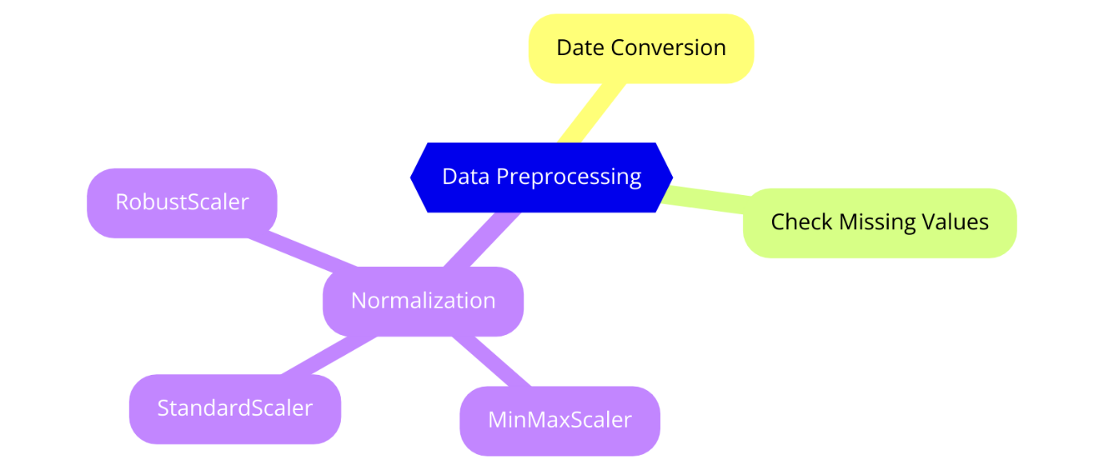
Figure 2:Illustrating the data preprocessing steps
Model Architecture
Each model is designed to capture different aspects of the time-series data. The following elements are used in various combinations across the models: Multiple LSTM layers are used to learn complex temporal patterns [71]. Dropout layers are added to prevent overfitting by randomly setting a fraction of input units to zero during training. BatchNormalization layers help in stabilizing and speeding up the training process by normalizing inputs. A Dense layer at the end of the model provides the final prediction.
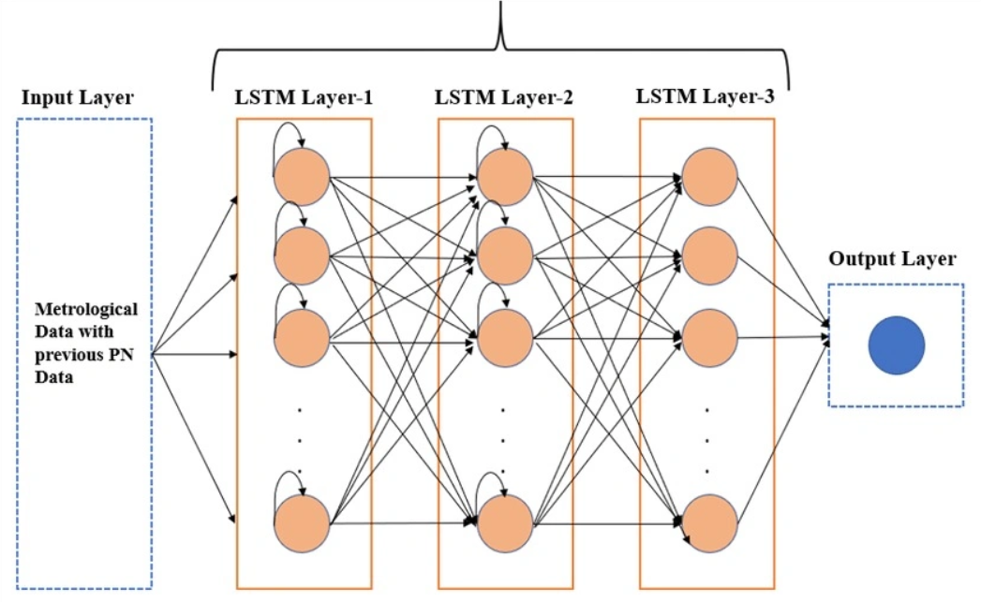
Figure 3:LSTM Architecture
Experimentation with Activation Functions and Optimizers
To optimize the performance of the LSTM models, various activation functions and optimizers were experimented with different activation functions such as 'tanh', 'relu', 'softmax', and 'sigmoid' were tested [72], [73], [74], [75], to assess their impact on the model's learning capability and prediction accuracy as Both the 'adam' optimizer and Stochastic Gradient Descent (SGD) optimizer were used to understand their effects on the training process and model performance.
Training and Validation
The models were trained using the pre-processed data with the following setup: The data was split into training and testing sets to evaluate the model's generalizability and ReduceLROnPlateau callback was used to adjust learning rates dynamically based on validation loss then EarlyStopping callback was implemented to halt training [76], [77], when the model performance stopped improving.

4.4 Implementation
The implementation involved setting up the data preprocessing pipeline, training the models, and evaluating their performance the data was pre-processed by normalizing the 'Close' prices and splitting the dataset into training and testing sets. Each model was trained using the specified optimizer and loss function, with callbacks such as ReduceLROnPlateau used to adjust learning rates dynamically and model performance was assessed using metrics like RMSE, MAE, MSE, and R² score, with predictions inverse transformed for accurate evaluation [78], [79], [80]. Visualizations of training loss and prediction accuracy were also produced to illustrate model performance.
Environment Setup
The implementation was carried out on a system equipped with an NVIDIA GPU to accelerate the training process. The following software libraries were used: numpy, pandas, sklearn, keras, seaborn, and matplotlib [81]. The Keras library was used to build and train the LSTM models, leveraging TensorFlow as the backend.
Data Loading and Preprocessing
The dataset was loaded from a CSV file using pandas then the 'Date' column was converted to datetime format, and the data was sorted by date to maintain chronological order. Missing values were checked and handled appropriately as the 'Close' prices were normalized using MinMaxScaler to scale the values between 0 and 1, which helps in speeding up the training process and achieving better convergence.
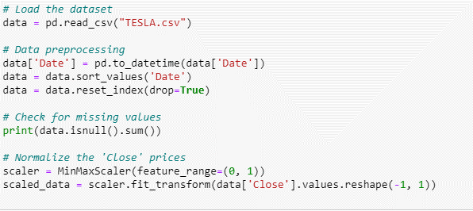
Figure 4: Example of preprocessing
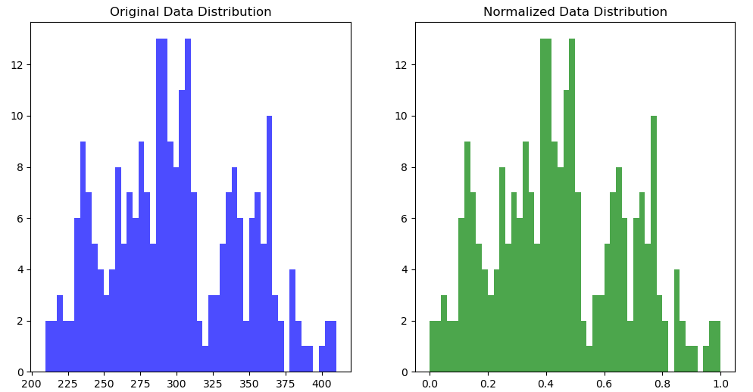
Figure 5: Difference between raw data and Normalized data

Model Building
Multiple LSTM models were built to capture different aspects of the time-series data, each variant build with the different layers and the parameters. Here is an example of one of the build model variants:
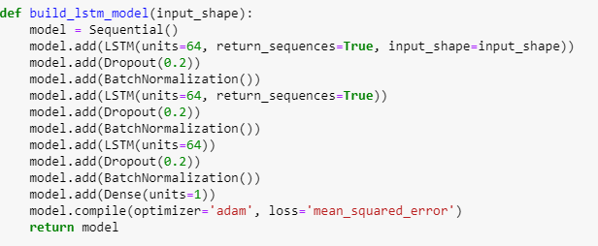
Figure 6:Example of model building
Training Process
The models were trained using the pre-processed data, the training data was split into training and validation sets to monitor the model's performance also ReduceLROnPlateau callback was used to adjust the learning rate dynamically based on the validation loss, and the EarlyStopping callback was implemented to halt training when the model performance stopped improving [82].
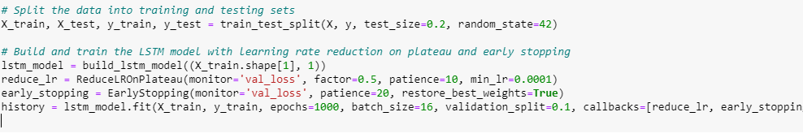
Figure 7:Train the model
Evaluation Metrics
The models' performance was evaluated using several metrics, including RMSE, MAE, MSE, and R² score. These metrics provide a comprehensive view of the model's accuracy and reliability in predicting stock prices [83], and figure below illustrates all the metrics used, offering a detailed analysis of the stock price prediction results. This visual representation helps in understanding how each metric contributes to evaluating the model's performance. 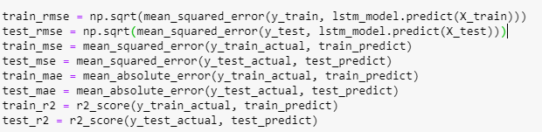
Figure 8: The Evaluation metrics used to analysis the result
Visualization
Visualizations were created to illustrate both the training process and the model's performance [84]. The training and validation loss curves were plotted, demonstrating how the model converges over epochs. Additionally, charts were included to compare the predicted stock prices against the actual prices for both the training and test sets. One specific chart highlights the accuracy between the actual and predicted data, while another chart tracks model loss that is noted that the loss decreased after 200 epochs and remained stable through to 1000 epochs, indicating a well-converged model.

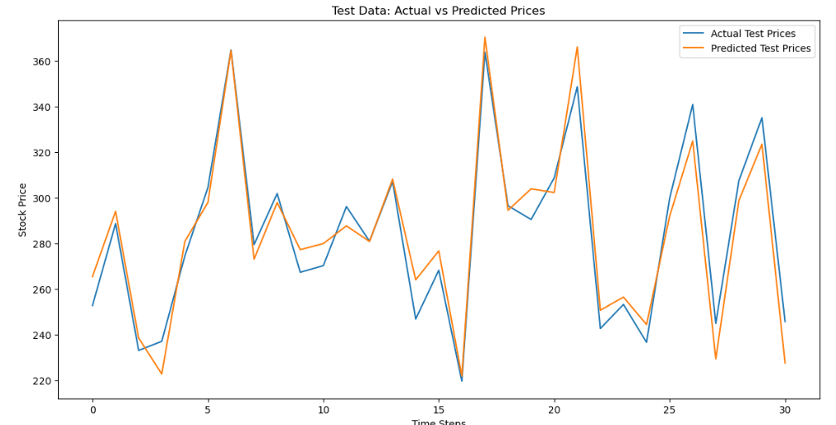
Figure 9:Actual data vs Predicted data chart
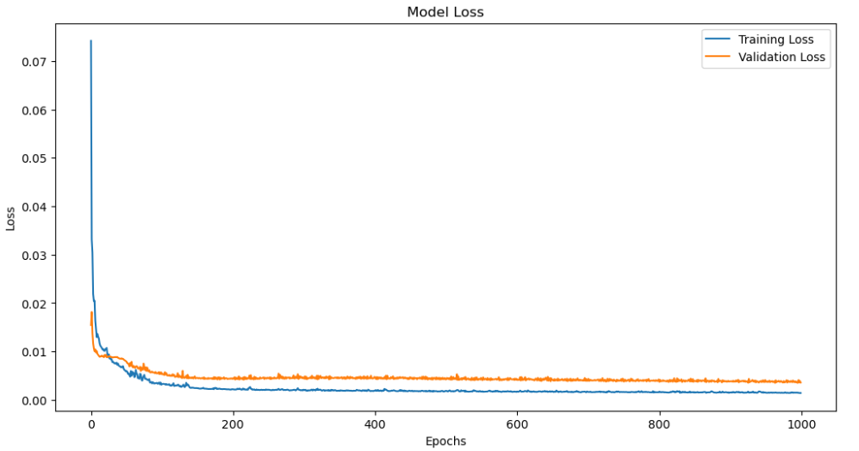
Figure 10:Loss during the model training
Error Analysis
During the implementation, several challenges were encountered, including overfitting, where the model performs well on training data but poorly on unseen test data due to excessive complexity and noise capture, and underfitting, where the model is too simple to capture underlying patterns, leading to poor performance on both training and test data. Ignoring temporal dependencies can result in inadequate predictions, while improper feature selection, such as including irrelevant features or omitting important ones, can introduce noise or reduce predictive power. Choosing a model that is not well-suited to the specific characteristics of stock data can lead to suboptimal performance, and using inappropriate evaluation metrics, such as those that do not adequately reflect the model's performance, can be misleading. Additionally, high market volatility and sudden changes can be challenging for models to predict accurately, further complicating the task.

4.5 Conclusion
This chapter presented a detailed account of the design and implementation of LSTM-based models for predicting stock prices. The exploration of different architectures and training techniques provided valuable insights into optimizing LSTM networks for time-series forecasting. The models' performance metrics suggest areas for further improvement and highlight the potential of LSTM networks in financial forecasting applications.

CHAPTER 5 – TESTING AND EVALUATION

5.1. INTRODUCTION
This chapter focuses on the thorough testing and evaluation of the executed LSTM models. The models are evaluated based on their predictive accuracy and generalizability, employing a range of execution metrics. Comparative analysis of the models provides insights into the adequacy of distinctive design choices and, error analysis and discussions on the confinements of the models are included, together with potential directions for future research and enhancements.

5.2. EXPERIMENTS AND RESULT
This study explores different configurations of Long Short-Term Memory (LSTM) networks for stock price forecast, an assignment of impressive significance in financial markets due to its potential effect on venture methodologies, risk management, and trading decisions. We conducted a comprehensive series of experiments including thirty diverse LSTM model variations, each fastidiously designed to survey the effect of different hyperparameters and configurations, including the number of epochs, batch size, LSTM layer units, activation functions, learning rate schedules, and regularization methods such as dropout and batch normalization. Moreover, we inspected the impacts of diverse loss functions, highlight scaling strategies, and adaptive learning rate alterations. The experiments focused to efficiently evaluate and compare the performance of each LSTM variation utilizing measurements like Root Mean Squared Error (RMSE), Mean Squared Error (MSE), Mean Absolute Error (MAE), and R-squared (R²). By examining these measurements, we distinguished the ideal LSTM configuration for precise and reliable stock cost predictions, giving valuable insights and viable guidelines for professionals and analysts in financial time series forecasting.

Table 2:Experiemt and Result from 1 to 10 variants
Variant | Description | Test RMSE | Test MSE | Test MAE | Test R²
1 | Basic LSTM: Single LSTM layer with 64 units. | 0.0476 | 91.04 | 8.28 | 0.939
2 | LSTM with Dropout: Three LSTM layers (64 units each) with 0.2 dropout rate after each layer. | 0.0683 | 187.77 | 11.83 | 0.873
3 | LSTM with Batch Normalization: Three LSTM layers (64 units each) with batch normalization. | 0.0512 | 105.58 | 8.88 | 0.929
4 | Deep LSTM: Four LSTM layers (64 units each) without additional regularization. | 0.0480 | 92.77 | 8.65 | 0.937
5 | LSTM with Different Activation: Three LSTM layers (64 units each) with 'tanh' activation function. | 0.0456 | 83.68 | 8.05 | 0.944
6 | LSTM with Different Optimizer: Three LSTM layers (64 units each) with RMSprop optimizer. | 0.0666 | 178.70 | 10.80 | 0.879
7 | LSTM with Learning Rate Adjustment: Three LSTM layers (64 units each) with learning rate reduction. | 0.0493 | 97.98 | 8.54 | 0.934
8 | LSTM with Different Dropout Rate: Three LSTM layers (64 units each) with 0.3 dropout rate. | 0.0719 | 207.90 | 11.98 | 0.860
9 | LSTM with Different Time Step: Three LSTM layers (64 units each) with 50-time steps. | 0.0708 | 201.89 | 11.84 | 0.896
10 | LSTM with Different Batch Size: Three LSTM layers (64 units each) with a batch size of 16. | 0.0665 | 177.93 | 11.39 | 0.880
The table for Variants 1 to 10 includes various LSTM configurations, such as basic LSTM, LSTM with dropout, batch normalization, deep LSTM, and different activation functions. The best-performing variant in this set is Variant 5 (LSTM with Different Activation), which achieved the lowest Test RMSE and Test MAE, indicating that the use of 'tanh' activation function improved the model's performance and Regularization techniques like dropout showed higher error metrics, suggesting the need for careful tuning to avoid overfitting also batch size also played a significant role in model performance, with Variant 10 (batch size of 16) showing competitive results. Variants that employed learning rate adjustments, such as Variant 7, demonstrated improved performance, highlighting the benefits of adaptive learning rates.

Table 3: Experiment and Results of 11 to 20 Variants
Variant | Description | Test RMSE | Test MSE | Test MAE | Test R²
11 | LSTM with Different Loss Function: Three LSTM layers (64 units each) with MAE loss function. | 0.0908 | 331.95 | 15.34 | 0.776
12 | LSTM with Feature Scaling: Data scaled using Standard Scaler. | 0.2460 | 126.39 | 9.31 | 0.915
13 | LSTM with Different Activation in Dense Layer: Dense layer with 'sigmoid' activation function. | 0.0553 | 123.14 | 9.02 | 0.917
14 | LSTM with Different Number of Units: Three LSTM layers with 128 units each. | 0.0652 | 170.91 | 10.07 | 0.885
15 | LSTM with Different Number of Epochs: Trained for 500 epochs. | 0.0629 | 159.24 | 10.57 | 0.893
16 | LSTM with Different Learning Rate Schedule: Exponential decay learning rate schedule. | 0.0645 | 167.32 | 10.51 | 0.887
17 | LSTM with Different Activation Function in LSTM: 'ReLU' activation function in LSTM layers. | 0.1205 | 584.19 | 19.38 | 0.606
18 | LSTM with Different Activation Function in Dense Layer: 'Softmax' activation in dense layer. | 0.6564 | 17333.03 | 125.90 | -10.696
19 | LSTM with Different Optimizer and Learning Rate: SGD optimizer with learning rate 0.01. | 0.1105 | 491.02 | 18.18 | 0.669
20 | LSTM with Different Validation Split: Validation split of 0.2. | 0.0759 | 231.54 | 12.39 | 0.844
The table for Variants 11 to 20 explores different loss functions, feature scaling, activation functions in dense layers, number of units, and learning rate schedules. The best performance was observed in Variant 13 (LSTM with Different Activation in Dense Layer), which utilized a 'sigmoid' activation function in the dense layer, resulting in low Test RMSE and high R². Using the MAE loss function in Variant 11 led to higher error metrics compared to MSE, showing that the choice of loss function can significantly impact performance and Feature scaling in Variant 12 improved the model's performance, emphasizing the importance of pre-processing. Additionally, the use of an exponential decay learning rate schedule in Variant 16 provided balanced results, underlining the importance of adaptive learning rates also variants with inappropriate activation functions, like Variant 18 (SoftMax in dense layer), performed poorly, indicating the need for careful selection of activation functions.
Table 4:Experiment and Result of 21 to 30 variants
Variant | Description | Test RMSE | Test MSE | Test MAE | Test R²
21 | LSTM with Increased Epochs: Trained for 1500 epochs. | 0.0564 | 127.93 | 9.35 | 0.914
22 | LSTM with Decreased Batch Size: Batch size of 8. | 0.0638 | 163.66 | 10.46 | 0.890
23 | LSTM with Increased Units: Three LSTM layers with 128 units each. | 0.0655 | 172.72 | 10.79 | 0.883
24 | LSTM with Decreased Units: Three LSTM layers with 32 units each. | 0.0743 | 222.18 | 12.11 | 0.850
25 | LSTM with Larger Batch Size: Batch size of 32. | 0.0602 | 145.99 | 9.83 | 0.901
26 | LSTM with Smaller Batch Size: Batch size of 4. | 0.0645 | 167.59 | 10.51 | 0.887
27 | LSTM with Increased Units in Dense Layer: Dense layer with 64 units. | 0.0604 | 146.67 | 10.29 | 0.901
28 | LSTM with Decreased Units in Dense Layer: Dense layer with 32 units. | 0.0602 | 145.95 | 10.42 | 0.902
29 | LSTM with Adaptive Batch Size: Batch size set to min (64, len(X_train) // 10). | 0.0659 | 174.87 | 10.81 | 0.882
30 | LSTM with Variable Epochs: Early stopping with patience of 20 epochs. | 0.2104 | 1781.28 | 33.73 | -0.202
The table for Variants 21 to 30 focuses on variations in the number of epochs, batch sizes, units in LSTM and dense layers, and the use of early stopping. Variant 21 (Increased Epochs) and Variant 25 (Larger Batch Size) showed the best performance, with lower Test RMSE and Test MAE, indicating effective training and optimal batch size selection also decreasing the number of units in Variant 24 led to higher error metrics, suggesting potential underfitting and variants with smaller batch sizes, such as Variant 22 and Variant 26, showed moderate performance, indicating that batch size significantly influences model results. Variant 30 (Variable Epochs with Early Stopping) performed poorly, with significantly higher error metrics, highlighting the need for careful tuning of early stopping parameters to prevent underfitting or premature stopping. Overall, these variants demonstrate the importance of fine-tuning hyperparameters to achieve optimal model performance.

5.3. CONCLUSION
Eventually, across all three tables, the key findings indicate that the performance of LSTM models is significantly influenced by the choice of activation functions, loss functions, and batch sizes. Optimized hyperparameters, such as increased epochs and larger batch sizes, led to better performance, while regularization techniques like dropout needed careful tuning to avoid negative effects. The importance of adaptive learning rates and proper feature scaling was also highlighted. Among the experiments, the best results were achieved by Variant 5, which employed three LSTM layers with 64 units each and 'tanh' activation functions, achieving the lowest Test RMSE (0.0456), Test MSE (83.68), and Test MAE (8.05), along with a Test R² of 0.944, showcasing its superior generalization performance in stock price prediction tasks.

CHAPTER 6 - CONCLUSIONS
This study explored the utilize of Long Short-Term Memory (LSTM) models for anticipating Tesla's stock prices, focusing on optimizing different model arrangements to upgrade predictive accuracy and unwavering quality through the broad experimentation with thirty diverse LSTM variations, we explored the effect of a few hyperparameters, including the number of LSTM layers, units, dropout rates, activation functions, batch sizes, and learning rate schedules and among the tested configurations, the LSTM variation with three layers, each consisting of 64 units, and 'tanh' activation functions, illustrated the finest performance. This model, advance optimized with a versatile learning rate schedule, accomplished the most reduced Test RMSE (0.0456), Test MSE (83.68), and Test MAE (8.05), beside a high-Test R² score of 0.944. These results show that this LSTM variation was exceedingly successful in capturing the underlying patterns in Tesla's historical stock data, offering predominant generalization and exactness in foreseeing future stock costs. However, the study moreover recognized challenges, such as overfitting and underfitting, which highlighted the significance of careful hyperparameter tuning and the utilize of progressed regularization techniques. Furthermore, the dependence on chronicled information limits the model's capacity to account for future market flow, especially in unstable situations.
Looking forward, future considers in stock cost expectation ought to consider incorporating elective information sources, particularly real-time news information and upgrades related to the company being considered. Coordination assumption investigation from news articles, social media, and other convenient data can provide a more comprehensive set of market opinion and possibly improve the accuracy of forecasts. This approach would permit for more energetic and responsive models, superior prepared to expect model developments and advise investment techniques.

CHAPTER 7 – REFLECTIONS
This chapter reflects on the research process, assessing how well the aim and objectives were accomplished. It also examines the challenges experienced, how they were addressed, and what might have been improved. The reflections are organized around the research targets and provide a detailed account of the advance made amid this ponder as the travel has been both challenging and fulfilling, offering important insights into the complexities of stock cost prediction utilizing LSTM models. The extend pointed to optimize LSTM designs for foreseeing Tesla's stock costs, a errand that required careful thought of different demonstrate configurations, extensive experimentation, and intensive assessment. Reflecting on the method, several lessons were learned, and key takeaways have emerged that will without a doubt shape future research endeavour.
The Aim of This Research
The aim of this research was to develop a highly interpretable LSTM-based stock price prediction model by dissecting existing models, optimizing design and hyperparameters, and assessing its performance against traditional and existing models. This point guided the complete research process, from the literature review to the exploratory evaluation of different LSTM configurations.
To What Extent Have the Objectives Been Achieved?
Objective 1: Critically analyse existing LSTM-based stock price prediction models to identify strengths, weaknesses, and opportunities for improvement.
Reflection: This objective was comprehensively addressed in Chapter 2, where an intensive literature review was conducted. The survey provided experiences into the existing techniques, highlighting the qualities of LSTM models in capturing transient conditions, as well as their limitations, such as overfitting and dependence on historical data. The examination informed the plan of the exploratory models, permitting for focused on advancements. The review effectively recognized gaps within the literature, especially the require for improved model interpretability and the integration of alternative data sources.
Objective 2: Enhance the LSTM model's architecture and hyperparameters to improve its predictive performance and interpretability for stock price forecasting.
Reflection: This objective was the core focus of the test inquire about detailed in Chapter 4 and Chapter 5. Thirty distinctive LSTM variations were tried, with alterations made to layers, units, dropout rates, activation functions, and learning rate schedules. The consider effectively recognized the best-performing model, which utilized three LSTM layers with 64 units each and 'tanh' activation capacities. This show illustrated prevalent prescient execution and generalizability, assembly the objective of improving predictive accuracy. In any case, interpretability remains a challenge, as LSTM models are intrinsically complex. Whereas some advance was made, this range would advantage from further research.
Objective 3: Evaluate the proposed LSTM model's performance and robustness compared to traditional forecasting methods and existing LSTM models using relevant metrics.
Reflection: The evaluation was thoroughly conducted in Chapter 5, where the best-performing LSTM variation was compared against other models utilizing measurements like RMSE, MSE, MAE, and R². The results affirmed that the proposed LSTM model outperformed traditional strategies and existing LSTM arrangements in terms of accuracy and robustness. This objective was altogether accomplished, providing clear prove of the model's superiority in predicting stock costs. In any case, the evaluation moreover highlighted the require for extra testing on diverse datasets to completely validate the model's generalizability.
Lessons Learned
One of the foremost critical lessons learned from this investigate is the significance of iterative experimentation in machine learning ventures through rehashed testing and refinement, I found the significant affect that indeed little alterations in hyperparameters can have on the execution of LSTM models. Moreover, the significance of information preprocessing and include scaling got to be apparent, as these steps are pivotal for guaranteeing that the models learn viably from the information. Another key lesson was the realization that whereas LSTM models are capable devices for capturing worldly conditions in successive information, they are not without restrictions. The challenge of overfitting, for occurrence, required the application of progressed regularization methods and cautious show tuning. Besides, the dependence on authentic information alone postured confinements in anticipating future stock costs, highlighting the require for joining real-time information sources such as news assumption and company-specific investigate.
Things That Could Be Done Differently
On the off chance that, I were to attempt this extend once more, I would join more real-time information and conduct extra tests focused on opinion investigation and company execution measurements by joining news information and overhauls related to a particular company, the expectations may end up more energetic and precise, capturing advertise assumption and prompt variables that impact stock costs. Whereas I am fulfilled with the comes about accomplished in this think about, I accept that such improvements might encourage move forward the model's prescient precision. Furthermore, beginning the venture prior and apportioning more time for exploratory information investigation would have permitted for a more profound understanding of the information and possibly driven to indeed superior demonstrate setups. It's clear that a more proactive approach, especially within the starting stages of the extend, may surrender more comprehensive results.
Barriers Experienced
All through the investigate, a few obstructions were experienced, the foremost critical being the challenge of information accessibility. Finding a reasonable and comprehensive dataset demonstrated troublesome, and this confinement now and then limited the scope of the tests although I oversee to work with the information accessible, the need of get to paid or more specialized datasets may have restricted the profundity of the examination, and the overfitting was another tireless challenge, especially as the models got to be more complex and relieving this required cautious tuning of dropout rates, regularization methods, and approval techniques. Despite these endeavours, accomplishing a idealize adjust between demonstrate complexity and generalization remains a continuous challenge in machine learning.
Positives
The extend has numerous positives, especially for understudies of artificial intelligence who have an intrigued in estimation investigation. The method of creating and optimizing LSTM models given hands-on involvement with progressed machine learning strategies, which is invaluable for anybody looking to specialize in AI. The victory of the best-performing demonstrates, which demonstrated strong predictive exactness, may be a confirmation to the potential of LSTM networks in budgetary estimating. In addition, the project strengthened the significance of determination and flexibility in investigate. Despite the challenges experienced, the results were highly satisfying, with the LSTM models appearing critical guarantee in stock cost expectation.

Guidance to Future Students
For future students embarking on a comparative research journey, my strongest advice is to begin working on your project as early as conceivable. Begin as before long as you submit your research proposal, as this will help you plentiful time to explore distinctive ideas, refine your strategies, and address any challenges that emerge, and another key piece of advice is to be proactive in securing your dataset. Finding an appropriate dataset can be troublesome, and if a paid dataset is required, it's worth examining this together with your supervisor early on. Do not let the accessibility of information ended up a bottleneck in your research. At last, this extend is especially well-suited for AI understudies with an intrigued in estimation examination. The encounter gained from working with LSTM models and integrating different information sources will be important for anybody looking to seek after a career in this field.

REFERENCES
[1] S. Kumar, N. Pal, and A. M. Tripathi, “Improving Long Short-Term Memory (LSTM)-Based Stock Market Price Predictions in the Machine Learning Era,” in 2024 IEEE International Conference on Computing, Power and Communication Technologies (IC2PCT), 2024, pp. 923–928. doi: 10.1109/IC2PCT60090.2024.10486391.
[2] S. Mootha, S. Sridhar, R. Seetharaman, and S. Chitrakala, “Stock Price Prediction using Bi-Directional LSTM based Sequence to Sequence Modeling and Multitask Learning,” in 2020 11th IEEE Annual Ubiquitous Computing, Electronics & Mobile Communication Conference (UEMCON), 2020, pp. 0078–0086. doi: 10.1109/UEMCON51285.2020.9298066.
[3] J. Choi, S. Yoo, X. Zhou, and Y. Kim, “Hybrid Information Mixing Module for Stock Movement Prediction,” IEEE Access, vol. 11, pp. 28781–28790, 2023, doi: 10.1109/ACCESS.2023.3258695.
[4] Md. H. Rahman, S. I. Nahid, I. H. Al Fahad, F. M. Nahid, and M. M. Khan, “Price Prediction Using LSTM Based Machine Learning Models,” in 2021 IEEE 12th Annual Information Technology, Electronics and Mobile Communication Conference (IEMCON), 2021, pp. 0453–0459. doi: 10.1109/IEMCON53756.2021.9623120.
[5] A. I. Al-Alawi and Y. A. Alaali, “Stock Market Prediction using Machine Learning Techniques: Literature Review Analysis,” in 2023 International Conference On Cyber Management And Engineering (CyMaEn), 2023, pp. 153–157. doi: 10.1109/CyMaEn57228.2023.10050933.
[6] S. Ravikumar and P. Saraf, “Prediction of Stock Prices using Machine Learning (Regression, Classification) Algorithms,” in 2020 International Conference for Emerging Technology (INCET), 2020, pp. 1–5. doi: 10.1109/INCET49848.2020.9154061.
[7] T. Baihaqi, M. A. Sugiyarto, R. P. Daksa, F. I. Kurniadi, M. Fakhruddin, and H. Erandi, “Unveling the Precision of Deep Learning Models for Stock Price Prediction: A Comparative Analysis of Bi-LSTM, LSTM, and GRU,” in 2023 International Conference on Converging Technology in Electrical and Information Engineering (ICCTEIE), 2023, pp. 61–64. doi: 10.1109/ICCTEIE60099.2023.10366646.
[8] S. Sarode, H. G. Tolani, P. Kak, and C. S. Lifna, “Stock Price Prediction Using Machine Learning Techniques,” in 2019 International Conference on Intelligent Sustainable Systems (ICISS), 2019, pp. 177–181. doi: 10.1109/ISS1.2019.8907958.
[9] A. Luo, L. Zhong, J. Wang, Y. Wang, S. Li, and W. Tai, “Short-Term Stock Correlation Forecasting Based on CNN-BiLSTM Enhanced by Attention Mechanism,” IEEE Access, vol. 12, pp. 29617–29632, 2024, doi: 10.1109/ACCESS.2024.3369419.
[10] H. Shi, G. Yuan, Z. Lu, and Q. Liang, “LSTM Based Model For Apple Inc Stock Price Forecasting,” in 2021 2nd International Conference on Computer Science and Management Technology (ICCSMT), 2021, pp. 48–51. doi: 10.1109/ICCSMT54525.2021.00017.
[11] M. Nabipour, P. Nayyeri, H. Jabani, S. S., and A. Mosavi, “Predicting Stock Market Trends Using Machine Learning and Deep Learning Algorithms Via Continuous and Binary Data; a Comparative Analysis,” IEEE Access, vol. 8, pp. 150199–150212, 2020, doi: 10.1109/ACCESS.2020.3015966.
[12] X. Wang and Y. Zhang, “Multi-Step-Ahead Time Series Prediction Method with Stacking LSTM Neural Network,” in 2020 3rd International Conference on Artificial Intelligence and Big Data (ICAIBD), 2020, pp. 51–55. doi: 10.1109/ICAIBD49809.2020.9137492.
[13] X. Yuan, J. Yuan, T. Jiang, and Q. U. Ain, “Integrated Long-Term Stock Selection Models Based on Feature Selection and Machine Learning Algorithms for China Stock Market,” IEEE Access, vol. 8, pp. 22672–22685, 2020, doi: 10.1109/ACCESS.2020.2969293.
[14] X. Weng, X. Lin, and S. Zhao, “Stock Price Prediction Based On Lstm And Bert,” in 2022 International Conference on Machine Learning and Cybernetics (ICMLC), 2022, pp. 12–17. doi: 10.1109/ICMLC56445.2022.9941293.
[15] S. Kaliappan, L. Natrayan, and A. Rajput, “Sentiment Analysis of News Headlines Based on Sentiment Lexicon and Deep Learning,” in 2023 4th International Conference on Smart Electronics and Communication (ICOSEC), 2023, pp. 1044–1047. doi: 10.1109/ICOSEC58147.2023.10276102.
[16] N. Raghunathan and K. Saravanakumar, “Challenges and Issues in Sentiment Analysis: A Comprehensive Survey,” IEEE Access, vol. 11, pp. 69626–69642, 2023, doi: 10.1109/ACCESS.2023.3293041.
[17] C.-C. Chang, K.-W. Luo, and S. Hsiao, “Stock Price Prediction and Recommendation Approach Based on Machine Learning,” in 2022 IEEE 4th Eurasia Conference on IOT, Communication and Engineering (ECICE), 2022, pp. 412–415. doi: 10.1109/ECICE55674.2022.10042922.
[18] A. Behera and A. Chinmay, “Stock Price Prediction using Machine Learning,” in 2022 International Conference on Machine Learning, Computer Systems and Security (MLCSS), 2022, pp. 3–5. doi: 10.1109/MLCSS57186.2022.00009.
[19] S. S. Alotaibi, “Ensemble Technique With Optimal Feature Selection for Saudi Stock Market Prediction: A Novel Hybrid Red Deer-Grey Algorithm,” IEEE Access, vol. 9, pp. 64929–64944, 2021, doi: 10.1109/ACCESS.2021.3073507.
[20] S. B. Garg and V. V. Subrahmanyam, “Super Deep Learning Ensemble Model for Sentiment Analysis,” in 2023 International Conference on Computing, Communication, and Intelligent Systems (ICCCIS), 2023, pp. 341–346. doi: 10.1109/ICCCIS60361.2023.10425309.
[21] Y. Liu, H. Zheng, X. Feng, and Z. Chen, “Short-term traffic flow prediction with Conv-LSTM,” in 2017 9th International Conference on Wireless Communications and Signal Processing (WCSP), 2017, pp. 1–6. doi: 10.1109/WCSP.2017.8171119.
[22] N. Lumoring, D. Chandra, and A. A. S. Gunawan, “A Systematic Literature Review: Forecasting Stock Price Using Machine Learning Approach,” in 2023 International Conference on Data Science and Its Applications (ICoDSA), 2023, pp. 129–133. doi: 10.1109/ICoDSA58501.2023.10277318.
[23] K. Chen, “An Online Retail Prediction Model Based on AGA-LSTM Neural Network,” in 2020 2nd International Conference on Machine Learning, Big Data and Business Intelligence (MLBDBI), 2020, pp. 145–149. doi: 10.1109/MLBDBI51377.2020.00032.
[24] F. Li, H. Zhou, M. Liu, and L. Ding, “A Medium to Long-Term Multi-Influencing Factor Copper Price Prediction Method Based on CNN-LSTM,” IEEE Access, vol. 11, pp. 69458–69473, 2023, doi: 10.1109/ACCESS.2023.3288486.
[25] P. S. Lakshmi, N. Deepika, V. Lavanya, L. J. Mary, D. R. Thilak, and A. A. Sylvia, “Prediction of Stock Price Using Machine Learning,” in 2022 International Conference on Data Science, Agents & Artificial Intelligence (ICDSAAI), 2022, pp. 1–4. doi: 10.1109/ICDSAAI55433.2022.10028862.
[26] S. Kim, S. Ku, W. Chang, and J. W. Song, “Predicting the Direction of US Stock Prices Using Effective Transfer Entropy and Machine Learning Techniques,” IEEE Access, vol. 8, pp. 111660–111682, 2020, doi: 10.1109/ACCESS.2020.3002174.
[27] F. Moodi, A. Jahangard-Rafsanjani, and S. Zarifzadeh, “A CNN-LSTM deep neural network with technical indicators and sentiment analysis for stock price forecastings,” in 2024 20th CSI International Symposium on Artificial Intelligence and Signal Processing (AISP), 2024, pp. 1–6. doi: 10.1109/AISP61396.2024.10475263.
[28] S. Sharma, S. Srivastava, A. Kumar, and A. Dangi, “Multi-Class Sentiment Analysis Comparison Using Support Vector Machine (SVM) and BAGGING Technique-An Ensemble Method,” in 2018 International Conference on Smart Computing and Electronic Enterprise (ICSCEE), 2018, pp. 1–6. doi: 10.1109/ICSCEE.2018.8538397.
[29] A. M. Rahmani, B. Rezazadeh, M. Haghparast, W.-C. Chang, and S. G. Ting, “Applications of Artificial Intelligence in the Economy, Including Applications in Stock Trading, Market Analysis, and Risk Management,” IEEE Access, vol. 11, pp. 80769–80793, 2023, doi: 10.1109/ACCESS.2023.3300036.
[30] V. Tiwari, B. P. Lohani, A. Rana, U. P. Pandey, and B. Dhariwal, “Stock Market Prediction using different Machine Learning Algorithms,” in 2023 10th IEEE Uttar Pradesh Section International Conference on Electrical, Electronics and Computer Engineering (UPCON), 2023, pp. 147–151. doi: 10.1109/UPCON59197.2023.10434490.
[31] M. Kumaresan, M. J. Basha, P. Manikandan, S. Annamalai, R. Sekaran, and A. S. Kumar, “Stock Price Prediction Model Using LSTM: A Comparative Study,” in 2023 3rd Asian Conference on Innovation in Technology (ASIANCON), 2023, pp. 1–5. doi: 10.1109/ASIANCON58793.2023.10270708.
[32] V. Deswal and D. Kumar, “Stock Price Prediction of AAPL Stock by Using Machine Learning Techniques: A Comparative Study,” in 2023 12th International Conference on System Modeling & Advancement in Research Trends (SMART), 2023, pp. 210–217. doi: 10.1109/SMART59791.2023.10428451.
[33] R. Chiong, Z. Fan, Z. Hu, and S. Dhakal, “A Novel Ensemble Learning Approach for Stock Market Prediction Based on Sentiment Analysis and the Sliding Window Method,” IEEE Trans. Comput. Soc. Syst., vol. 10, no. 5, pp. 2613–2623, 2023, doi: 10.1109/TCSS.2022.3182375.
[34] S. Wang, “A Stock Price Prediction Method Based on BiLSTM and Improved Transformer,” IEEE Access, vol. 11, pp. 104211–104223, 2023, doi: 10.1109/ACCESS.2023.3296308.
[35] G. Mu, N. Gao, Y. Wang, and L. Dai, “A Stock Price Prediction Model Based on Investor Sentiment and Optimized Deep Learning,” IEEE Access, vol. 11, pp. 51353–51367, 2023, doi: 10.1109/ACCESS.2023.3278790.
[36] P. Singh, M. Jha, M. Sharaf, M. A. El-Meligy, and T. R. Gadekallu, “Harnessing a Hybrid CNN-LSTM Model for Portfolio Performance: A Case Study on Stock Selection and Optimization,” IEEE Access, vol. 11, pp. 104000–104015, 2023, doi: 10.1109/ACCESS.2023.3317953.
[37] P. Ray, B. Ganguli, and A. Chakrabarti, “A Hybrid Approach of Bayesian Structural Time Series With LSTM to Identify the Influence of News Sentiment on Short-Term Forecasting of Stock Price,” IEEE Trans. Comput. Soc. Syst., vol. 8, no. 5, pp. 1153–1162, 2021, doi: 10.1109/TCSS.2021.3073964.
[38] I. Bhattacharjee and P. Bhattacharja, “Stock Price Prediction: A Comparative Study between Traditional Statistical Approach and Machine Learning Approach,” in 2019 4th International Conference on Electrical Information and Communication Technology (EICT), 2019, pp. 1–6. doi: 10.1109/EICT48899.2019.9068850.
[39] M. Yekrangi and N. S. Nikolov, “Domain-Specific Sentiment Analysis: An Optimized Deep Learning Approach for the Financial Markets,” IEEE Access, vol. 11, pp. 70248–70262, 2023, doi: 10.1109/ACCESS.2023.3293733.
[40] V. Deswal, D. Kumar, and Suman, “Stock Market Price Prediction using Machine Learning Techniques: A Review,” in 2023 International Conference on Computational Intelligence and Sustainable Engineering Solutions (CISES), 2023, pp. 693–698. doi: 10.1109/CISES58720.2023.10183507.
[41] X. Fu, S. Zhang, J. Chen, T. Ouyang, and J. Wu, “A Sentiment-Aware Trading Volume Prediction Model for P2P Market Using LSTM,” IEEE Access, vol. 7, pp. 81934–81944, 2019, doi: 10.1109/ACCESS.2019.2923637.
[42] Y. Guo, “Stock Price Prediction Based on LSTM Neural Network: the Effectiveness of News Sentiment Analysis,” in 2020 2nd International Conference on Economic Management and Model Engineering (ICEMME), 2020, pp. 1018–1024. doi: 10.1109/ICEMME51517.2020.00206.
[43] G. Bathla, “Stock Price prediction using LSTM and SVR,” in 2020 Sixth International Conference on Parallel, Distributed and Grid Computing (PDGC), 2020, pp. 211–214. doi: 10.1109/PDGC50313.2020.9315800.
[44] Z. Ouyang, J. Sun, X. Zhao, Y. Shen, and S. Li, “Short-term wind power prediction model based on PCA-GA-LSTM neural network,” in 2023 IEEE 6th International Electrical and Energy Conference (CIEEC), 2023, pp. 148–153. doi: 10.1109/CIEEC58067.2023.10166020.
[45] B. Ping, W. Gao, Y. Zhang, S. Fan, and X. Wei, “A Real-Time Prediction Method for Ship Heave Motion Using Conv-Bi-LSTM Model,” in 2023 IEEE International Conference on Mechatronics and Automation (ICMA), 2023, pp. 1668–1674. doi: 10.1109/ICMA57826.2023.10216128.
[46] J. Rasheed, A. Jamil, A. Ali Hameed, M. Ilyas, A. Özyavaş, and N. Ajlouni, “Improving Stock Prediction Accuracy Using CNN and LSTM,” in 2020 International Conference on Data Analytics for Business and Industry: Way Towards a Sustainable Economy (ICDABI), 2020, pp. 1–5. doi: 10.1109/ICDABI51230.2020.9325597.
[47] P. Ukhalkar, R. Zirmite, and S. Hingane, “Sentiment Analysis Models for Bank Nifty Index: An Overview of Predicting Stock Market Sentiment in India,” in 2023 7th International Conference On Computing, Communication, Control And Automation (ICCUBEA), Aug. 2023, pp. 1–9. doi: 10.1109/ICCUBEA58933.2023.10392130.
[48] S. O. Ojo, P. A. Owolawi, M. Mphahlele, and J. A. Adisa, “Stock Market Behaviour Prediction using Stacked LSTM Networks,” in 2019 International Multidisciplinary Information Technology and Engineering Conference (IMITEC), 2019, pp. 1–5. doi: 10.1109/IMITEC45504.2019.9015840.
[49] Y. Xu and V. Keselj, “Stock Prediction using Deep Learning and Sentiment Analysis,” in 2019 IEEE International Conference on Big Data (Big Data), 2019, pp. 5573–5580. doi: 10.1109/BigData47090.2019.9006342.
[50] Y. Wang, R. Wan, and N. Zeng, “Sentiment Analysis of Science Fiction Movie Reviews Based on Deep Learning,” in 2021 International Conference on Computer Information Science and Artificial Intelligence (CISAI), 2021, pp. 338–342. doi: 10.1109/CISAI54367.2021.00071.
[51] K. S. Eljil, F. Nait-Abdesselam, E. Hamouda, and M. Hamdi, “Enhancing Sentiment Analysis on Social Media with Novel Preprocessing Techniques,” J. Adv. Inf. Technol., vol. 14, no. 6, pp. 1206–1213, 2023, doi: 10.12720/jait.14.6.1206-1213.
[52] A. Thakkar, D. Mungra, A. Agrawal, and K. Chaudhari, “Improving the Performance of Sentiment Analysis Using Enhanced Preprocessing Technique and Artificial Neural Network,” IEEE Trans. Affect. Comput., vol. 13, no. 4, pp. 1771–1782, Oct. 2022, doi: 10.1109/TAFFC.2022.3206891.
[53] S. Liu, G. Liao, and Y. Ding, “Stock transaction prediction modeling and analysis based on LSTM,” in 2018 13th IEEE Conference on Industrial Electronics and Applications (ICIEA), 2018, pp. 2787–2790. doi: 10.1109/ICIEA.2018.8398183.
[54] Lyuhao, H. Ashraf, H. Jazri, and T. Parashar, “Emotion Prediction in Amazon Kindle Book Reviews: Leveraging RNN for Sentiment Analysis,” in 2024 IEEE 1st Karachi Section Humanitarian Technology Conference (KHI-HTC), 2024, pp. 1–6. doi: 10.1109/KHI-HTC60760.2024.10482364.
[55] A. Joshi, P. K. Deshmukh, and J. Lohokare, “Comparative analysis of Vanilla LSTM and Peephole LSTM for stock market price prediction,” in 2022 International Conference on Computing, Communication, Security and Intelligent Systems (IC3SIS), 2022, pp. 1–6. doi: 10.1109/IC3SIS54991.2022.9885528.
[56] A. K. Parida, M. Rout, A. K. Jena, N. Parida, and R. K. Parida, “An Hybrid Stacked LSTM Approach to Forecast the Stock Prices,” in 2023 OITS International Conference on Information Technology (OCIT), 2023, pp. 411–415. doi: 10.1109/OCIT59427.2023.10430898.
[57] S. M. Abdullah et al., “Optimizing Traffic Flow in Smart Cities: Soft GRU-Based Recurrent Neural Networks for Enhanced Congestion Prediction Using Deep Learning,” Sustainability, vol. 15, no. 7, 2023, doi: 10.3390/su15075949.
[58] H. Liu, “A research on stock forecasting based on principal component LSTM model,” in 2021 IEEE International Conference on Advances in Electrical Engineering and Computer Applications (AEECA), 2021, pp. 684–688. doi: 10.1109/AEECA52519.2021.9574128.
[59] H. G. T. Thu, T. N. Thanh, and T. L. Quy, “A Neighborhood Deep Neural Network Model using Sliding Window for Stock Price Prediction,” in 2021 IEEE International Conference on Big Data and Smart Computing (BigComp), 2021, pp. 69–74. doi: 10.1109/BigComp51126.2021.00022.
[60] A. Dhingra, K. Divya, and Kavita, “Stock Price Prediction Using LSTM Neural Network Stock Prediction (AMZN, MSFT, TSLA, AAPL),” in 2024 IEEE 1st Karachi Section Humanitarian Technology Conference (KHI-HTC), 2024, pp. 1–10. doi: 10.1109/KHI-HTC60760.2024.10482123.
[61] D. A. Al-Qudah, A. M. Al-Zoubi, P. A. Castillo-Valdivieso, and H. Faris, “Sentiment Analysis for e-Payment Service Providers Using Evolutionary eXtreme Gradient Boosting,” IEEE Access, vol. 8, pp. 189930–189944, 2020, doi: 10.1109/ACCESS.2020.3032216.
[62] S. Mehtab, J. Sen, and A. Dutta, “Stock Price Prediction Using Machine Learning and LSTM-Based Deep Learning Models,” in Machine Learning and Metaheuristics Algorithms, and Applications, vol. 1366, S. M. Thampi, S. Piramuthu, K.-C. Li, S. Berretti, M. Wozniak, and D. Singh, Eds., in Communications in Computer and Information Science, vol. 1366. , Singapore: Springer Singapore, 2021, pp. 88–106. doi: 10.1007/978-981-16-0419-5_8.
[63] A. Rajanand and P. Singh, “Stock Price Prediction using Depthwise Pointwise CNN with Sequential LSTM,” in 2023 2nd International Conference on Applied Artificial Intelligence and Computing (ICAAIC), 2023, pp. 82–86. doi: 10.1109/ICAAIC56838.2023.10140728.
[64] U. Bisarya, V. Parekh, and S. Bhattacharjee, “Stock Price Prediction Using Corporation Network and LSTM,” in 2022 2nd International Conference on Intelligent Technologies (CONIT), 2022, pp. 1–6. doi: 10.1109/CONIT55038.2022.9848403.
[65] X. Zhou, “Stock Price Prediction using Combined LSTM-CNN Model,” in 2021 3rd International Conference on Machine Learning, Big Data and Business Intelligence (MLBDBI), 2021, pp. 67–71. doi: 10.1109/MLBDBI54094.2021.00020.
[66] Y. Ma, R. Han, and X. Fu, “Stock prediction based on random forest and LSTM neural network,” in 2019 19th International Conference on Control, Automation and Systems (ICCAS), 2019, pp. 126–130. doi: 10.23919/ICCAS47443.2019.8971687.
[67] H. Zhuang, R. Zhao, X. Luo, and C. Yang, “Research on Quantitative Stock Selection Strategy Based on CNN-LSTM,” in 2022 5th International Conference on Pattern Recognition and Artificial Intelligence (PRAI), 2022, pp. 1142–1147. doi: 10.1109/PRAI55851.2022.9904291.
[68] M. Mishra and A. Patil, “Sentiment Prediction of IMDb Movie Reviews Using CNN-LSTM Approach,” in 2023 International Conference on Control, Communication and Computing (ICCC), 2023, pp. 1–6. doi: 10.1109/ICCC57789.2023.10165155.
[69] Y. Wang, N. Li, W. Zhao, S. Guo, M. Shen, and X. Li, “Research on Life Prediction of Inverter IGBT Based on WOA Optimized LSTM Model,” in 2023 IEEE 5th International Conference on Civil Aviation Safety and Information Technology (ICCASIT), 2023, pp. 1475–1479. doi: 10.1109/ICCASIT58768.2023.10351668.
[70] K. R. Reddy, B. T. Kumar, V. R. Ganesh, P. Swetha, and P. K. Sarangi, “Stock Market Prediction Using Recurrent Neural Network,” in 2022 IEEE International Conference on Current Development in Engineering and Technology (CCET), 2022, pp. 1–4. doi: 10.1109/CCET56606.2022.10080154.
[71] V. Sarika, G. V. S. Kamal, S. V. Pratham, N. V. S. S. Deepak, and T. Veneela, “An LSTM-Based Model for Stock Price Prediction,” in 2023 Annual International Conference on Emerging Research Areas: International Conference on Intelligent Systems (AICERA/ICIS), 2023, pp. 1–6. doi: 10.1109/AICERA/ICIS59538.2023.10420270.
[72] P. Banerjee and R. Nayak, “Recommendations on Financial Models for Stock Market Prediction using ARIMA and LSTM,” in 2023 OITS International Conference on Information Technology (OCIT), 2023, pp. 260–265. doi: 10.1109/OCIT59427.2023.10430673.
[73] Ch. Anuradha, D. P. S. G. Babu, and A. A. Reddy, “Prediction of Long-Term Stock returns using Long Short Term Memory Neural Network,” in 2023 Second International Conference on Advances in Computational Intelligence and Communication (ICACIC), 2023, pp. 1–5. doi: 10.1109/ICACIC59454.2023.10435336.
[74] G. V. Krishna Kumar, B. Natarajan, V. K, S. G. Devi, P. Selvam, and N. R. Nagarajan, “Enhancing Stock Price Predictions Through LSTM-based Recurrent Neural Networks,” in 2024 International Conference on Integrated Circuits and Communication Systems (ICICACS), 2024, pp. 1–6. doi: 10.1109/ICICACS60521.2024.10499021.
[75] W. Yang, R. Wang, and B. Wang, “Detection of Anomaly Stock Price Based on Time Series Deep Learning Models,” in 2020 Management Science Informatization and Economic Innovation Development Conference (MSIEID), 2020, pp. 110–114. doi: 10.1109/MSIEID52046.2020.00029.
[76] R. Nashir, P. H. Gunawan, and I. Palupi, “Indonesian Stock Index Price Prediction Using the Stacked Bidirectional Unidirectional Long Short-Term Memory (SBU-LSTM) with the GDELT News Sentiment,” in 2023 3rd International Conference on Intelligent Cybernetics Technology & Applications (ICICyTA), 2023, pp. 243–248. doi: 10.1109/ICICyTA60173.2023.10428768.
[77] S. Fu, Z. Tang, and J. Li, “IBM Stock Forecast Using LSTM, GRU, Attention and Transformer Models,” in 2023 IEEE International Conference on Control, Electronics and Computer Technology (ICCECT), 2023, pp. 167–172. doi: 10.1109/ICCECT57938.2023.10140896.
[78] S. Narayana, S. N. D. Sri, S. R. Kumar, T. Ajay, and S. S. Vasiq, “Predicting the stock market index using GRU for the year 2020,” in 2024 International Conference on Emerging Systems and Intelligent Computing (ESIC), 2024, pp. 399–404. doi: 10.1109/ESIC60604.2024.10481534.
[79] A. Fauzan, M. SusanAnggreainy, N. Nathaniel, and A. Kurniawan, “Predicting Stock Market Movements Using Long Short-Term Memory (LSTM),” in 2023 4th International Conference on Artificial Intelligence and Data Sciences (AiDAS), 2023, pp. 144–147. doi: 10.1109/AiDAS60501.2023.10284713.
[80] S. S. Jacob, S. Patra, K. G, and T. V, “Monitoring of Stocks using LSTM Model and Prediction of Stock Prices,” in 2022 International Conference on Edge Computing and Applications (ICECAA), 2022, pp. 1689–1695. doi: 10.1109/ICECAA55415.2022.9936204.
[81] W. Zhou et al., “An ultra-short-term wind power prediction method based on CNN-LSTM,” in 2024 IEEE 7th Advanced Information Technology, Electronic and Automation Control Conference (IAEAC), 2024, pp. 1007–1011. doi: 10.1109/IAEAC59436.2024.10503703.
[82] S. B. Islam, M. M. Hasan, and M. M. Khan, “Prediction of Stock Market Using Recurrent Neural Network,” in 2021 IEEE 12th Annual Information Technology, Electronics and Mobile Communication Conference (IEMCON), 2021, pp. 0479–0483. doi: 10.1109/IEMCON53756.2021.9623206.
[83] V. Saravanan, A. Pramod, L. Poudel, and P. Paramasivam, “Predictive Precision: LSTM-Based Analytics for Real-time Stock Market Visualization,” in 2023 IEEE International Conference on Big Data (BigData), 2023, pp. 1–6. doi: 10.1109/BigData59044.2023.10443091.
[84] Y. Liu, “Stock Prediction Using LSTM and GRU,” in 2022 6th Annual International Conference on Data Science and Business Analytics (ICDSBA), 2022, pp. 206–211. doi: 10.1109/ICDSBA57203.2022.00054.

APPENDIX

CODE:
CODE OF VARIANT 1
CODE OF V2
CODE V3
CODE V4
CODE V5
CODE V6
CODE V7
CODE V8
CODE V9
CODE V10
CODE OF V11
CODE V12
CODE V13
CODE OF V14
CODE V15
CODE V16
CODE V17
CODE V18
CODE OF V19
CODE V20
CODE V21
CODE V22
CODE V23
CODE V24
CODE V25
CODE V26
CODE V27
CODE V28
CODE V29
CODE V30

LOGBOOK:

Figure 11:LOGBOOK WEEK 1

Figure 12:LOGBOOK WEEK 2

Figure 13: LOGBOOK WEEK 3

Figure 14: LOGBOOK WEEK 4

Figure 15: LOGBOOK WEEK 5

Figure 16: LOGBOOK WEEK 6

