Daniel Ward (1504426)
[Email address]
Advanced processes and manufacturing project.
Advanced Processes and materials M6X00414

Executive summery
This report will discuss CNC Machining, Additive Manufacturing and Laser Cutting, it will highlight the advantages and disadvantages of each process as well as giving some indication of where these processes are being used in manufacturing today.
It’ll show the reader that although additive manufacturing doesn’t stem well according to tolerances or speed, it does give companies the edge when producing prototypes, performance enhancing and customised parts

Table of Contents
1. Executive summery 1
2. Introduction 3
3. Findings 4
3.1 Sub headings 4
3.1.1 Further subheadings 4
4. Conclusion 5
5. Recommendations 6
6. Reference list 7
7. Appendix 8

Introduction
Investing in nonconventional technology may seem exciting but risky, but not doing so will leave your business in the dark ages, especially in our days, where technology is moving so fast, according to an article in The Telegraph (Lombard, 2016). They say “Investment in new technology and equipment can also have a positive impact on productivity, helping to secure significant growth for your business.”
Understanding which technology is important and can make the difference to whether or not the investment pays dividends or not.
This report will discuss recent laser technologies, more specifically Laser melting/sintering a member of the Additive Manufacturing (AM) and laser cutting. It will also look to make a clear decision on which of these two technologies are most suitable for future investment.
The new technology will aim to be accurate to at least 0.127mm, produce parts 50.8 x33 x 2.5cm, increase surface quality while ensuring mechanical properties aren’t compromised, produce aluminium parts and facilitate in the expansion of the company.

Findings

CNC Machining
Computer Numerical Control (CNC) Machining is a computer run subtractive machining process that removes martial from a block or sheet by cutting or drilling using an array of tools called bits to do so, this is usually facilitated by a cooling fluid to remove the heat caused by friction.
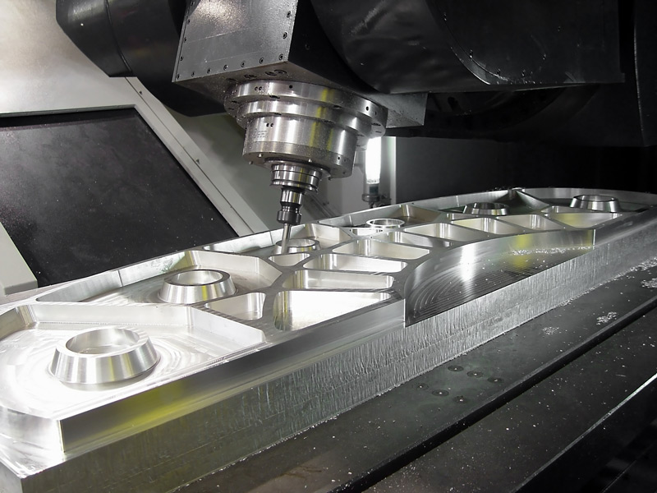
Figure 1: 5 Axis CNC machine in operation (ProCim, 2018).
It is one of the most diverse pieces of equipment that industry have to offer and there are many books that illustrate their operational capabilities, much like Advanced Machining Processes of Metallic Materials (Grzesik, 2017). It gives the reader a clear understanding of the array of various cutting methods, tooling and tool materials.
Test pieces are often needed to refine coding for materials with different mechanical properties (Dashchenko, 2006).
Amy Reyes, a blog writer and community manager at Siemens.com lists five main advantages of CNC. She says that:
- Prototypes aren’t needed, as the “Digital twin”, a phrase used at Siemens to describe the 3D CAD model of the component can be used in the analysis,
- One off and low production parts are more cost effective to manufacture as tooling costs are minimised and labour costs are also very low (Pabla & Adithan, 1994),
- CNC Machining produces consistent, precise parts as there is very little human intervention,
- The production and topology of parts can be complex and various textures can be accomplished easily (Pabla & Adithan, 1994) (Koening, 1994).
- Safety is increased in comparison to traditional machining. (Reyes, 2018)
Another advantage of CNC is that coding can be manually input or altered to be more efficient (Smid, 2003)
The only real disadvantages that can be found with CNC machining are high costs incurred due to maintenance down time and trained labour (Koening, 1994), coding errors can cause clashing which can damage the machinery and tooling (Grzesik, 2017).
Discussing the capabilities of a CNC heavily depend on which machine one has to compare to. CNC machines can cut sheet materials up to

Additive manufacturing
Additive Manufacturing (A.M.) or otherwise known as 3D printing, is a process in which material is joined together layer by layer to achieve a desired three-dimensional model (Bhavar, et al., 2014). Additive manufacturing must be post processed if the surface an engineered surface is required. It is excellent for making geometrically complex parts, light weight parts and tool free production parts (Wohlers, 2017) (Kamrani & Nasr, 2008).
Using additive manufacturing to produce low quantity parts can be very cost effective as they are produced directly from raw materials and very little secondary processes are needed. The only machining that would be essential are those in which increase surface finishes or to tap a thread for connections to other components much like you would in a casting process.
Additive manufacturing is being used many companied for small scale production parts and rapid prototyping. Some of the Aerospace giant’s use additive manufacturing to produce an array of components. In October 2018, GE celebrated that they had mass produced its 30,000th Fuel injection nozzles for their LEAP engine which has only been in service since 2015 (GE Additive, 2018). This isn’t the only part of that engine that’s being produced that way either they boast that they have managed to consolidate 854 components in their new business class plain down to just 11 parts, they say that this will speed up production, reduce complexity, help save fuel due to weight reduction and while making the aircraft lighter and more powerful (GE, 2017).
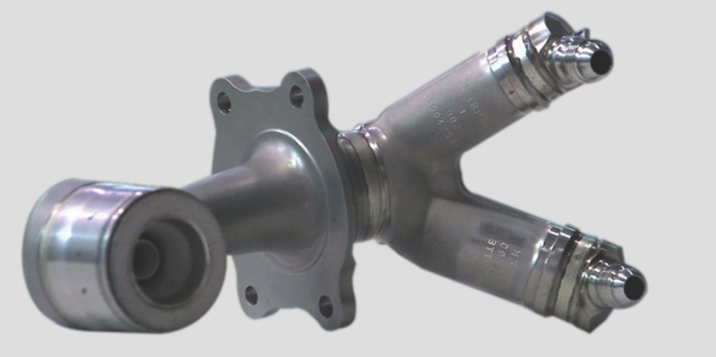
Figure 2: Image of GE’s Fuel nozzle from the LEAP engine.
They aren’t the only company out there using the technology either, in 2015 Sheffield University and Rolls Royce worked together to develop a 1.5m bearing housing for Rolls Royce’s Trent XWB-97 engine (Sheffield University, 2015)
The process of producing AM parts is simple, an engineer produces a CAD drawing on the preferred CAD software such as Inventor or SolidWorks it is than saved as an .stl file, which is uploaded onto the AM machines computer (Gibson, et al., 2015).
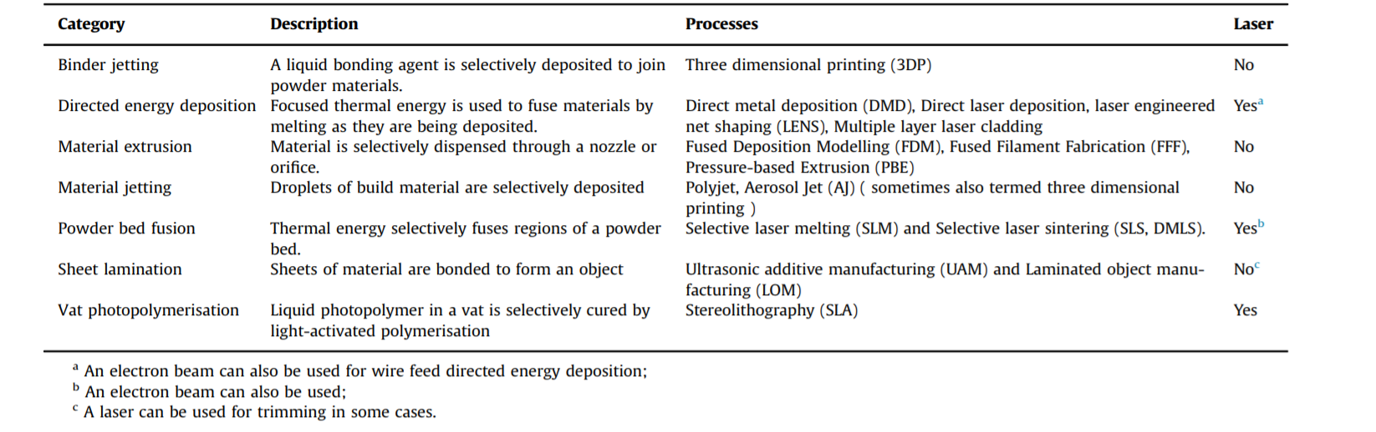Figure 3. A.J. Pinkerton produced this table which categorise the different processes of additive manufacturing, classified according to ASTM Standard F2792 (Pinkerton, 2016).
This means that the information can be stored on an external hard drive and reused at a later date if necessary.

Design for Additive Manufacturing
One of the main considerations to take into account when contemplating adopting any AM process is Design for Additive Manufacturing (DfAM). It allows engineers to produce complex components that are not manufacturable using CNC or any other engineering process with little to no waste (GE Additive, 2018). Good DfAM can reduces parts, labour costs, processing time, component weight and materials used.
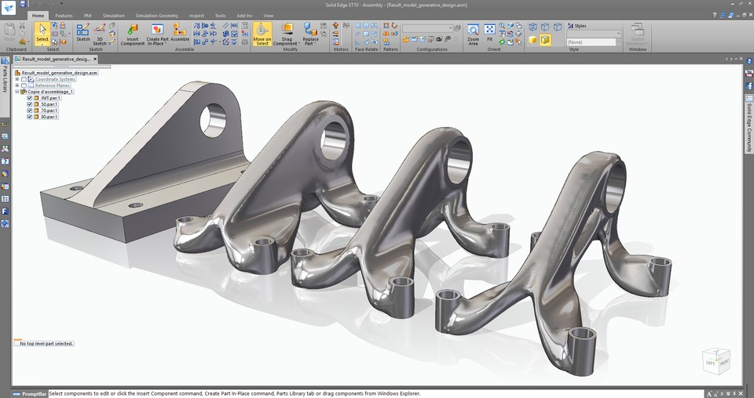
Figure 4: An example of how DfAM can reduce material and weight as well as improving appearance without affecting the components mechanical properties.
Getting it wrong can come at a cost, when designing any components that are due to be manufactured using AM the topology of the component is vital to reduce printing time, minimise support structures and limit post processing. This can drastically affect the overall machining and labour costs of the components. A misprint will mean that the part will need to scrapped as the material can’t always be reused as it is often very difficult and expensive to manufacture the material for AM.
As additive manufacturing has a range of processes and each have their own set of pros and cons, we’ll need to set our sights at one of these processes. An article by Mark Crawford published by the American Society of Mechanical Engineers, called ‘Four key advanced manufacturing technologies used in aerospace’ outlines Additive manufacturing, composite materials, robotics and laser beam welding to be the top advances in aerospace technology. He highlights powder-bed laser printing as the AM processes that “are preferred for most components”.

Powder-bed laser printing
  - (Also known as Powder Bed Fusion-PBF)
  - The university of Texas brought PBF to the commercial market during the 1980’s in the form of SLS or selective laser sintering (Gibson, et al., 2015). Since then a number of other techniques have been developed, such as Selective laser melting (SLM), Electron Beam Melting (EBM) and Direct melting Laser Sintering (DMLS), which allow for a more diverse array of materials such as polymers, ceramics metals. Glass, polymers and ceramics are generally sintered with SLS or DMLS but metal alloys are mostly melted using SLM and EBM.
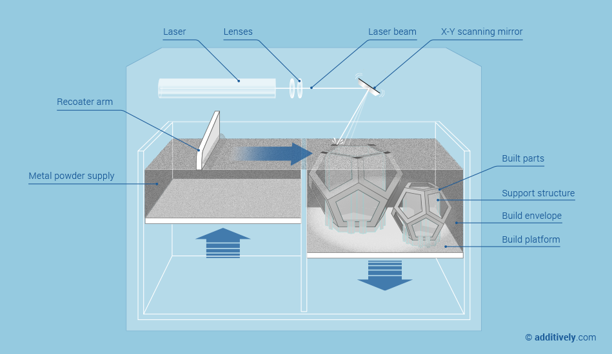Figure 5 – This image is from additivly.com, it illustrates how the Laser melting process such as SLM works (Additivly, 2017)
A powder layer is layered up using the recoater arm. A laser beam is then intensified through a series of lenses then reflected off an X-Y scanning mirror onto a bed of material. The material heats up to its melting point in a melt pool then solidifies to a form one layer of the object. the process repeats itself until the object is complete.
The materials that are most commonly used for this process are polymers such as Nylon and metals alloys like aluminium which is used to produce the helicopter floor pan in the specification. Renishaw, a global leader in AM, use a range of metals such as titanium, nickel, cobalt chromium, and aluminium alloys (Renishaw, 2018). The reason these metal alloys are most popular is due to the slow oxidation rates, the powdered material needs to be atomised so that they can be reduced to the smallest size, as small 17µm (0.000017m or 0.0017mm) (Renishaw, 2018).
When comparing it to CNC it’s very difficult to hide the fact that companies are promoting speeds of 48mm/h for commercial SLS printers which is very slow by any standard.
Other drawbacks include their maximum build size, which is typically 250x150x150mm according to The 3D Printing Handbook (Redwood, et al., 2017) this is slightly misleading as printers can have very large bed sizes, the largest found during this research was the Sciak EBAM 300 Series are it has a whooping 5791x1219x1291mm. And this isn’t cheap commercial SLS/SLM/DSLM Printers rand from $10,000 up to over $700,000.

CO² Laser cutting
CO² Laser cutting is a subtractive machining method which is a type of CNC machine, they are able to cut sheet materials in either 2D or 3D, but instead of using a cutting bit or tool it uses a high-powered laser which is intensified onto the cutting surface using lens to melt a sheet material, it then uses pressurised CO² gas to expel the melted material away leaving a kerf.
This allows the user to cut a range of materials including ceramic, wood, metal, polymers and glass, without changing or consuming the cutting tool thus reducing machine downtime compared to a traditional CNC machine. Materials such as Carbon Fibre Reinforced polymers (CFRP), which are notoriously difficult to cut due to their hard carbon fibres and softer polymer resin.
Figure 6. & Figure 7. These images show how CO² laser cutters work.
However, some materials are exempt from this process, such as poly-carbonate which absorbs some of the infra-red light, this means that the material around the cutting point heats up and can discolour or melt (Caristan, 2004).
According to some manufactures like WEC in Lancaster, say that the precision and surface finish are far better than those of traditional cutting machines.
Another big advantage to laser technology is that the channel which is cut out, known as the kerf, is much more narrow than traditional CNC cutting tools which means that parts can be more intricate and more parts can be cut out of one piece if material which reduces waste materials. The kerf of a Laser cutting machine is as narrow as 0.08mm whereas the kerf of a CNC is limited to the width of the cutting tool(s).
There’s little to say in terms of disadvantages when talking about laser cutting other than it only cutes sheet materials which can be done on most CNC machines.
One of the main drawbacks of CO² laser cutting is that the sheet material that has been cut usually needs to be formed if the desired shape is more complex than a 2D shape.

Conclusion
In terms of processes these 3 are very different, CNC is fantastic at producing many complex shapes, its fairly cheap to produce one off and low production parts as well as machining hard materials such as stainless steel etc but comes with a few drawbacks. For one it is a subtractive machining method which means, that there is a lot of waste, the hardened tool bits come at a premium, which need replacing regularly and it’s very difficult to add material to the finished part if it’s too small or doesn’t meet specifications. This could be overcome by using an AM machine to the collection of hardware, the 3D printer could produce parts quickly with a lower surface finish which could then be machined using the CNC as a finishing tool when necessary, this would also allow the company to help customers develop personalised, performance enhancing or one off parts, increasing the companies market potential and facilitating its expansion. It would also allow for prototyping of new, injection moulded parts.
Inventory can be minimised, the 3D CAD Drawing or STL file can be saved onto a driver for the parts that are required less often and printed when a customer requires. The main drawback being that it does not improve surface finish and can be slow to print at just 48mm per min.
Laser cutting is more precise at 0.01mm compared to 0.1mm precision seen in Additive manufacturing, although, CNC Machines can match this and the most precise machines can outperform the laser cutting machines. Laser cutting is a much faster process but is limited in its uses and doesn’t present much in terms of versatility, outside of experimenting with new materials such as carbon fibre as mentioned in this report.
Therefore, it is the opinion of this report that a decision will need between speed and precision or versatility. For the growth and sustainability.

Recommendations

The report concludes that additive manufacturing would be the more desirable option, although it isn’t as precise and a much slower process, it opens the door to producing high performance parts and customisation for customers which is a very lucrative market.

Reference list

References
Additivly, 2017. additivly.com. [Online]
Available at: https://www.additively.com/en/learn-about/laser-melting
[Accessed 07 04 2019].
Anon., n.d. [Online].
Bhavar, V. et al., 2014. A review on powder bed fusion technology of metal additive manufacturing. Pune, India, Kalyani Centre for Technology and Innovation (KCTI).
Caristan, C., 2004. Laser cutting guide for manufactures. first edition ed. Michigan: Society of manufacturing engineers.
Dashchenko, A. I., 2006. Reconfigurable Manufacturing Systems and Transformable Factoies. First Edition ed. Berlin: Springer.
GE Additive, 2018. New Manufacturing Milestone. [Online]
Available at: https://www.ge.com/additive/blog/new-manufacturing-milestone-30000-additive-fuel-nozzles
[Accessed 07 04 2019].
GE, 2017. ge.com/additive. [Online]
Available at: https://www.ge.com/additive/case-study/ges-new-aviation-plant-heart-europe-will-build-engines-3d-printed-parts-next-gen-cessna
[Accessed 2019 04 08].
Gibson, I., Rosen, D. & Stucker, B., 2015. Additive Manufacturing Technologies. Second Edition ed. New York: Springer.
Grzesik, W., 2017. Advanced Machining Processes of Metallic Materials: Theory, Modelling, and Applications. Second Edition ed. London: Elsevier.
Kamrani, A. K. & Nasr, E. A., 2008. Collaborative Engineering: Theory and Practice. First Edition ed. New York: Springer.
Koening, D. T., 1994. Manufacturing Engineering: Principles For Optimisation:. Second Edition ed. Long Island City, New York: Taylor & Francis.
Lombard, 2016. Why investment in your business is important, s.l.: The Telegraph.
Pabla, B. S. & Adithan, M., 1994. CNC Machines. First Edition ed. New Delhi: New Age International (P) Ltd.
Pinkerton, A. J., 2016. [INVITED] Lasers in additive manufacturing. Elsevier, optics & Laser Technology(78), pp. 25-32.
ProCim, 2018. CNC Machine/Tool Making Sercives. [Online]
Available at: http://www.prociminc.com/cnc-machining-tool-making-services.html
[Accessed 07 04 2019].
Redwood, B., Schoffer, F. & Garret, B., 2017. The 3D Printing Handbook. First Edition ed. New York: 3D Hubs BV.
Renishaw, 2018. Metal Powders for AM. [Online]
Available at: https://www.renishaw.com/en/metal-powders-for-am--31457
[Accessed 08 04 2019].
Reyes, A., 2018. 5 Benifits of CNC Machining for Manufactures. [Online]
Available at: https://community.plm.automation.siemens.com/t5/Solid-Edge-Blog/5-Benefits-of-CNC-Machining-for-Manufacturers/ba-p/516015
[Accessed 17 04 2019].
Sheffield University, 2015. Department research supports Rolls Royce largest ever 3D printed Component. [Online]
Available at: https://www.sheffield.ac.uk/materials/news/3dprinting-1.445852
[Accessed 08 04 2019].
Smid, P., 2003. CNC Programming Hanbook: A Comprehensive Guide to Practical CNC Programming. Second Edition ed. New York: Industrial Press Inc..
Wohlers, D., 2017. Frontiers of Additive manufacturning. Gothenburg: Chalmers University Of Technology.

Appendix

