Increasing the Awareness of the Glynn Vivian Art Gallery as a Corporate Events Venue
Thomas Fowler (P150535)
Glynn Vivian Art Gallery

Client:
Laura Gill: Marketing Officer - Audience Development
Charlotte Thomas: Exhibitions Assistant
Contact Details:
 01792 516900
Address: Alexandra Rd, Swansea SA1 5DZ
laura.gill@swansea.gov.uk
charlotte.thomas@swansea.gov.uk
Acknowledgments
A great thank you and appreciation to Laura Gill for providing me with the opportunity of acting as a consultant for the Glynn Vivian Art Gallery but also for the continuous support and advice throughout the process of the project alongside exhibitions assistant Charlotte Thomas. Another special thank you to everyone who participated and completed the online survey; without the responses the market research for this project would have been limited and would have resulted in a disappointing report.
Thank you also to Michael Davies & Suzanne Wells both Lecturers for the consultancy module at Swansea Business School (UWTSD), for ongoing support, feedback and encouragement to do this project.

Executive Summary
This report is a consultancy project designed to support the Glynn Vivian Art Gallery to solve the issue of low visitation and low economic income. To overcome these issues the consultant and the client suggested ways in which this could be accomplished, and the main points to come out of the meeting was a possible corporate events business plan.
The main aim of this project was to research ways in which the Glynn Vivian Art Gallery could grow their corporate event business. And to achieve this aim the consultant had the role to identify possible corporate event packages by assessing competitors approach to corporate business, general online survey to the public for their thoughts on this possibility and after the research, to propose a marketing strategy.
The competitors that were considered to be the most successful in the corporate events business were looked at and they included hotels in Swansea; Morgan’s and the Marriot, the Oldwalls in Gower, National Waterfront Museum, Brangwyn Hall, Liberty Stadium and for a similar attraction the Hepworth Wakefield. After researching all of these businesses they helped the consultant identify resources that the Glynn Vivian already have and what resources they needed to gather.
After the discussions of competitors, 58 participants got involved in the online survey designed for the purpose of market research for the Glynn Vivian in terms of a visitor attraction and as a corporate events venue. 72.41% of the respondents said they had heard of the Art Gallery before, the majority by word of mouth which showed that a marketing strategy is vital when moving forward with this business plan. However even though respondents said they had heard of the Glynn Vivian only 29.31% said they actually visited, which showed the consultant that marketing may not be the problem here, but getting people through the door is. Many respondents throughout the survey commented saying that it is a nightmare to park and maybe a reason why it puts people off from visiting.
For the Glynn Vivian Art Gallery becoming a corporate events venue, there were mixed receptions with 26 respondents saying yes to the idea and 25 saying no. Yes, commented saying the venue is close to transport hubs, has a perfect setting and would be a change from your usual corporate event venue, however some said no and commented about the parking and that they could not envisage an art gallery holding such events. The most popular days of the week for respondents to book a corporate event was Friday and Saturday and between the hours of 5pm to 9pm.
An online website was proposed for the marketing strategy which all of the competitors had access too. The website allows a platform for the Glynn Vivian to sell corporate packages, advertise brochures and create links through social media.
Contents Page
- Terms of Reference………………………………………………………………………….5

- Background information of the Glynn Vivian Art Gallery.….………………………….....5

- Project Aim and Objectives…………………………………………………………………6
  - Project Aim……………………………………………………………………………….6
  - Project Objectives……………………………………………………………………….6

- Research Methodology.……………………………………………………………………..6
4.1 Deviations from the PID………………………………………………………………...7

- Research Findings….……………………………………………………..….....................7
  - Content analysis of Competitors…………………………………………………...7-18
  - Resources Needed to Run a Corporate event………………………………….19-23
  - Data Collected through Online Survey…………………………..………………24-39
  - Marketing Strategy……………………………………………………………………..40

- Conclusions…………………………….…………………………………………………...41

- Strategic Recommendations…..……………………….…………………………………42

- References……………………………………………………………………………….…43

- Appendices……………………………………………………………………………........44
  - Appendix 1 – Online Survey Blank Copy………………………………………..44-48
  - Appendix 2 – Meetings & Discussions with Client………………………………….49

1. Terms of Reference
This report is written for Laura Gill and Charlotte Thomas at the Glynn Vivian Art Gallery as well as for the University of Wales Trinity Saint David by Tourism Management student Thomas Fowler. The report will research ways in which the Glynn Vivian Art Gallery could grow their corporate event business and will be valuable market research, both in terms of their visitors and competitors.

2. Background information of the Glynn Vivian Art Gallery
In 1905, Richard Glynn Vivian offered to leave his art collection to the city and county of Swansea, and wanted to build a gallery to house it. The offer was not immediately accepted as there were concerns about the costs of maintenance, but the plan was giving the go ahead in 1908, with the gallery eventually opening 3 years later in July 1911 where Richard Glynn Vivian sadly did not live to take part in the opening ceremony (Swansea Council, 2019).
100 years on from the opening of the art gallery, there was a £6m restoration and redevelopment project put in place to make the attraction more of a 21st century visitor experience. Today, the Glynn Vivian Art Gallery is a free entry and fully accessible visitor attraction providing a place for historical, modern and contemporary art exhibitions, lectures and conferences, live music and monthly events (Visit Swansea Bay, 2019).
The issue identified by both the consultant and the client was that although the Gallery has great facilities and services; they are no good unless they are utilised on a more regular basis, and with the café currently without catering business, the main concerns for the client at this moment in time are low visitation and low economic income.

3. Project Aim and Objectives
3.1 Project Aim
To research ways in which the Glynn Vivian Art Gallery could grow their corporate event business.
3.2 Project Objectives
- To identify corporate event packages that would be of interest to potential clients for the future.
- To undertake a content website analysis of competitors.
- To gather market research through the use of an online survey.
- To recommend a marketing strategy for corporate event business at the Glynn Vivian.

4. Research Methodology
This project report will consist of both primary and secondary research methods. Primary research will be undertaken through the use of online survey’s which could prove to be an important one for the market research of corporate events to analyse what most respondents are interested in and what they would like to see hosted at the Glynn Vivian.
Secondary research will include a content website analysis of the Glynn Vivian’s competitors whom are used to marketing, organising and hosting corporate events. This data collecting method is important for the Glynn Vivian as it will provide them with the information regarding other venues hosting corporate events, and to help identify the resources needed to run each event.

4.1 Deviations from the PID
In the Project Initiation Document it was discussed that structured interviews would be conducted with Glynn Vivian’s close competitors, however due to feedback from the PID and consideration from the consultant; the fact is that access to these interviews as well as them providing another competitor with information is both no guarantee and very unlikely.
Another adjustment to the PID is the survey, where it was mentioned that the survey will be conducted both online and within the gallery, however it was more appropriate to gather analysis all in one place and to have respondents that have and have not been to the Gallery before

5. Research Findings
This section of the report will provide a content website analysis of Glynn Vivian Art Gallery’s competitors, data collected through the online survey where the results will allow the consultant to identify new corporate packages that would best suit the business and also to put forward a proposed and recommended marketing strategy based upon the results and research gained.

5.1 Content analysis of Competitors
This secondary data research method has been chosen because it will allow the opportunity to address the Glynn Vivian Art Gallery’s corporate competitors to see what type of packages they offer, what resources they use and also to analyse their marketing strategies to see if they work and whether or not the Glynn Vivian Art Gallery should consider a similar approach moving forward.
Within this section the content analysis will take a look at a number of current corporate event business competitors. There are so many businesses in and around Swansea that offer corporate events and the following have been selected to see what they offer in regards to packages, facilities and costs:
- Morgan’s Hotel
- Marriot Hotel
- Oldwalls Gower
- Hepworth Wakefield
- National Waterfront Museum
- Brangwyn Hall
- Liberty Stadium
Morgan’s Hotel
Morgan’s is a luxury boutique hotel, restaurant and bar situated in the heart of Swansea’s city centre. The hotel is also a venue for hosting corporate events such as weddings and conference meetings and offers a range of packages for clients to choose from.
Morgan’s provide clients with a choice of three Wedding packages.
Exclusive Wedding Package
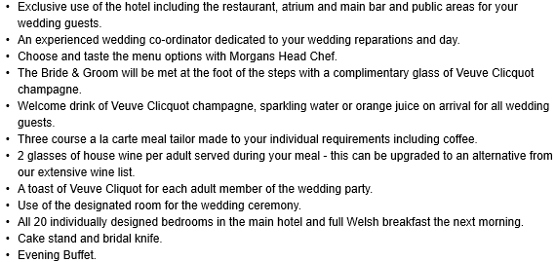
Tailor Made Wedding Package
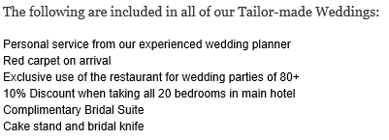
Evening Only Package
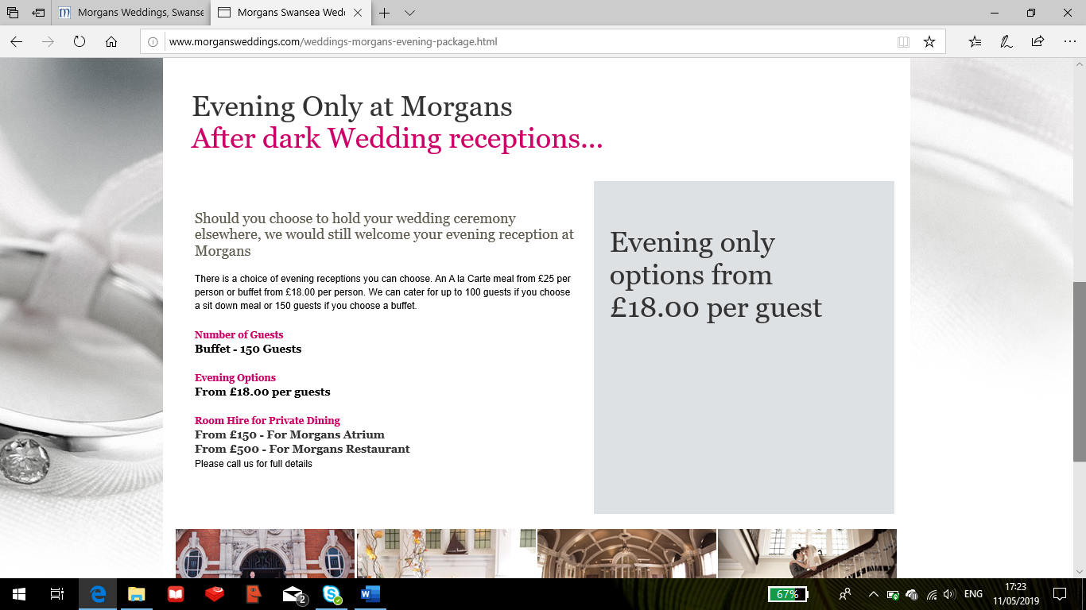

Meeting Room hire costs
Morgan’s meeting room is available for business and social functions and has facilities including DVD Video and large screen projector making it suitable for most meetings and presentations.
Meeting Room – Full Day Rate
- 9am to 5pm £175
Meeting Room – Half Day Rate
- 9am to1pm £100
- 2pm to 6pm £100
- 6pm to 10pm £100
Day Delegate Rate - £32 per person, price based on minimum 24 delegates (9am to 5pm).
Overnight Delegate Rate - £150 per person, price based on minimum 24 delegates (9am to 5pm), evening meal and overnight accommodation.

Marriot Hotel
Another hotel in Swansea that hosts corporate events is the Marriot by the Marina. The hotel provides clients with the facilities to run both weddings and conference meetings.
Weddings
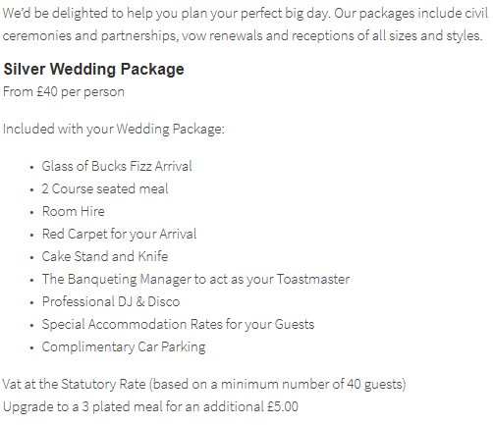
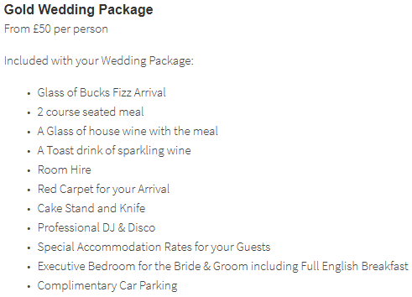
Conferences
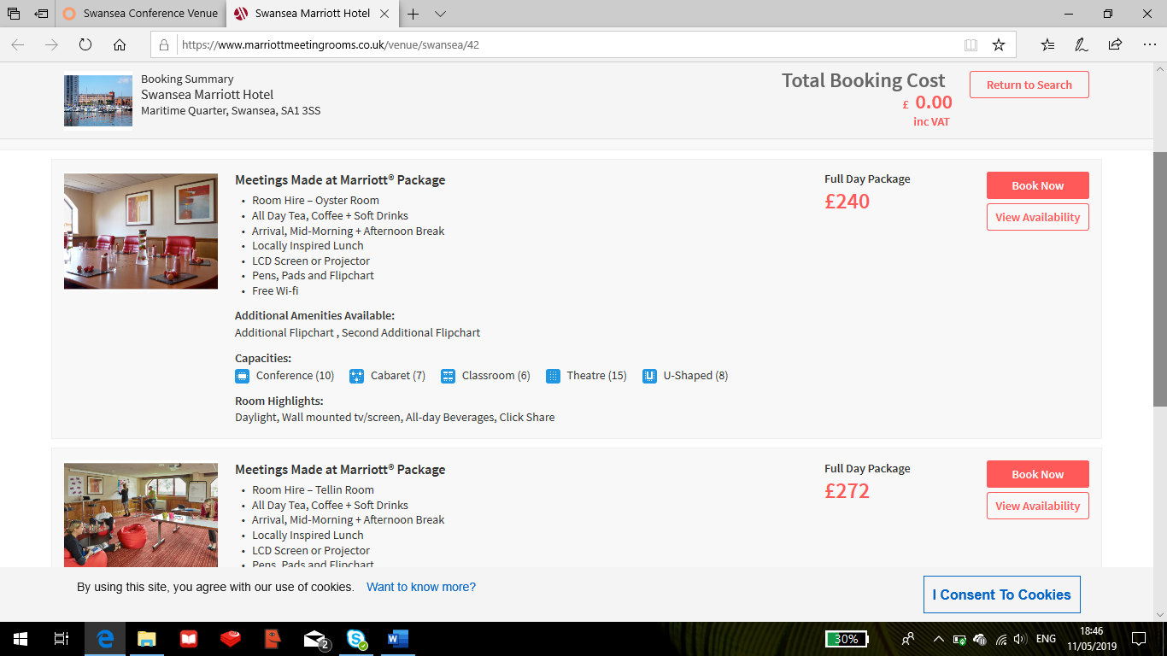
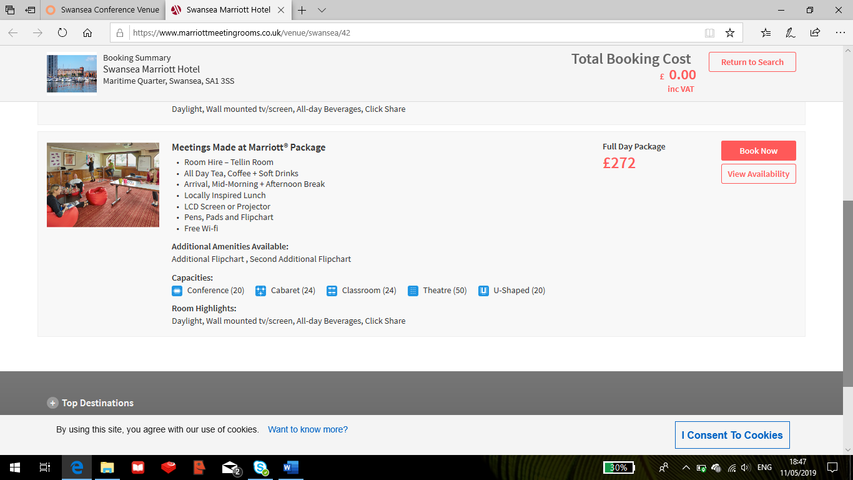

Oldwalls Gower
The Oldwalls in Gower has been recognised as the most luxurious wedding venue in South Wales and offer five wedding packages for clients to choose from.
- The Ultimate Wedding Package (Fri/Sat)
- Mid-Week Wedding Package (Sun/Thurs)
- Autumn / Winter Wedding Package (Nov/Feb)
- Whirlwind Wedding Package
- Mid-season Wedding Package (Mar/Apr/Oct)
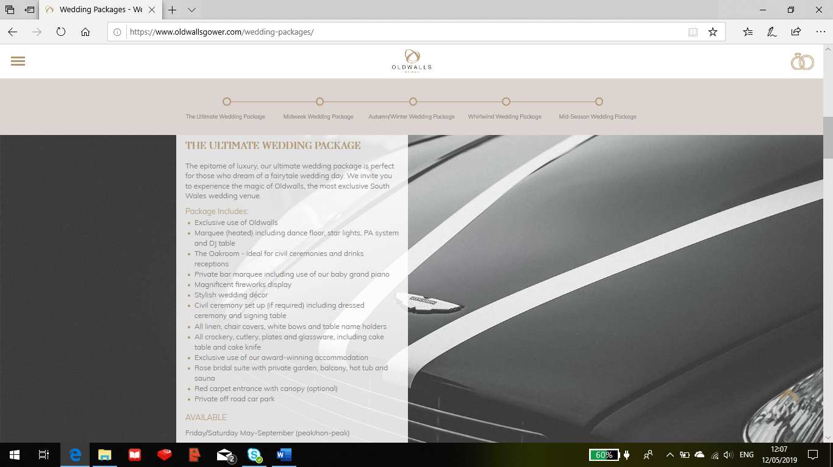

Oldwalls also provides a variety of different accommodations:
- Honeymoon Suite
- Luxury rooms and Suites
- Glamping
- Mulberry House
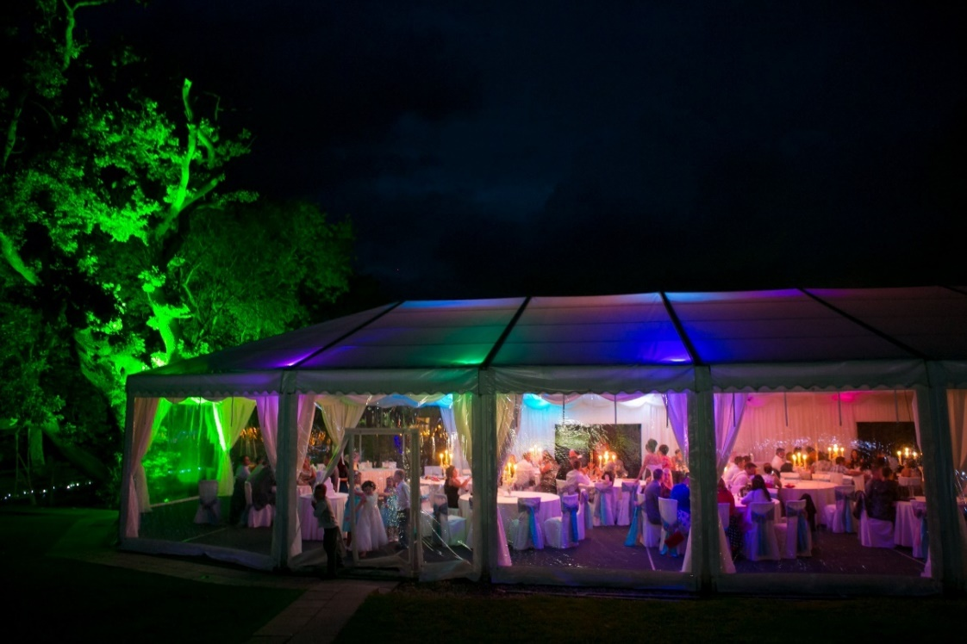
Oldwalls has a fully heated marquee that can hold between 55 to 185 guests for wedding receptions. At night, a hidden dancefloor and lighting system are revealed to welcome evening guests of up to 250 people.

Hepworth Wakefield
The Hepworth Wakefield is one of the UK’s leading art galleries, located on Wakefield’s historic waterfront in the heart of Yorkshire. This corporate business will provide a clearer on the price range that the Glynn Vivian should go for. In regards to weddings the gallery runs on average 10 a year and provide clients with a choice from five packages:
Package 1 – Ceremony in a gallery and evening reception in the auditorium. (£3,900) For one hour additional hire to close the event at 1:00am an additional charge of £300 will apply.
Package 2 – Ceremony and evening reception in Auditorium. (£3,300). For one hour additional hire to close the event at 1:00am an additional charge of £300 will apply.
Package 3 – Ceremony only in gallery. 2 hour hire (£2,400). Champagne and Canapés served in adjacent gallery.
Package 4 – Ceremony only in Auditorium. 2 hour hire (£1,200) Champagne and Canapés served in the café bar.
Package 5 – Evening reception only in the Auditorium. (£3,000). For one hour additional hire to close the event at 1:00am an additional charge of £300 will apply.
National Waterfront Museum
The National Waterfront Museum located in Swansea offer a wide range of packages designed for special occasions and corporate events that can be seen below.
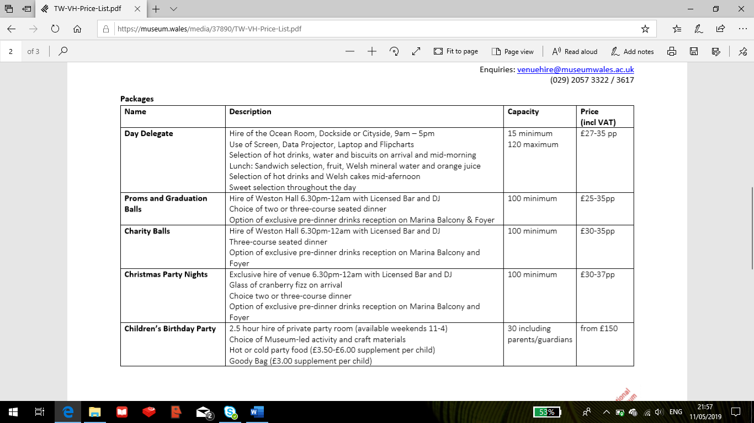
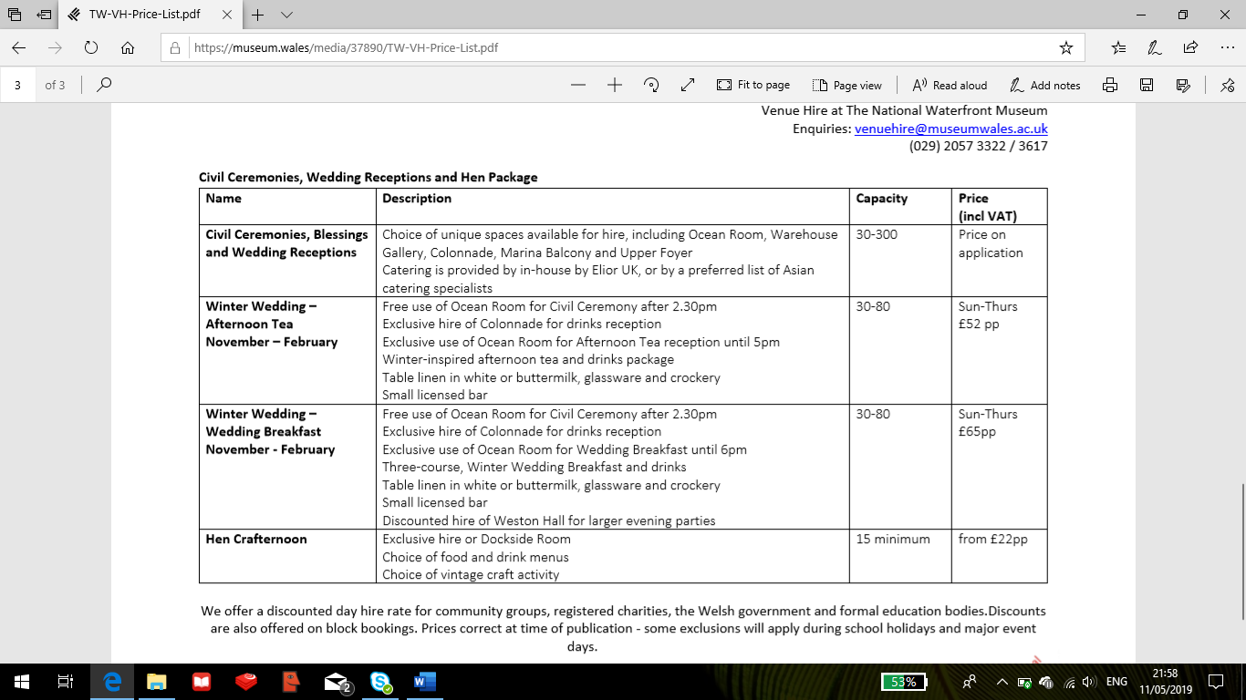
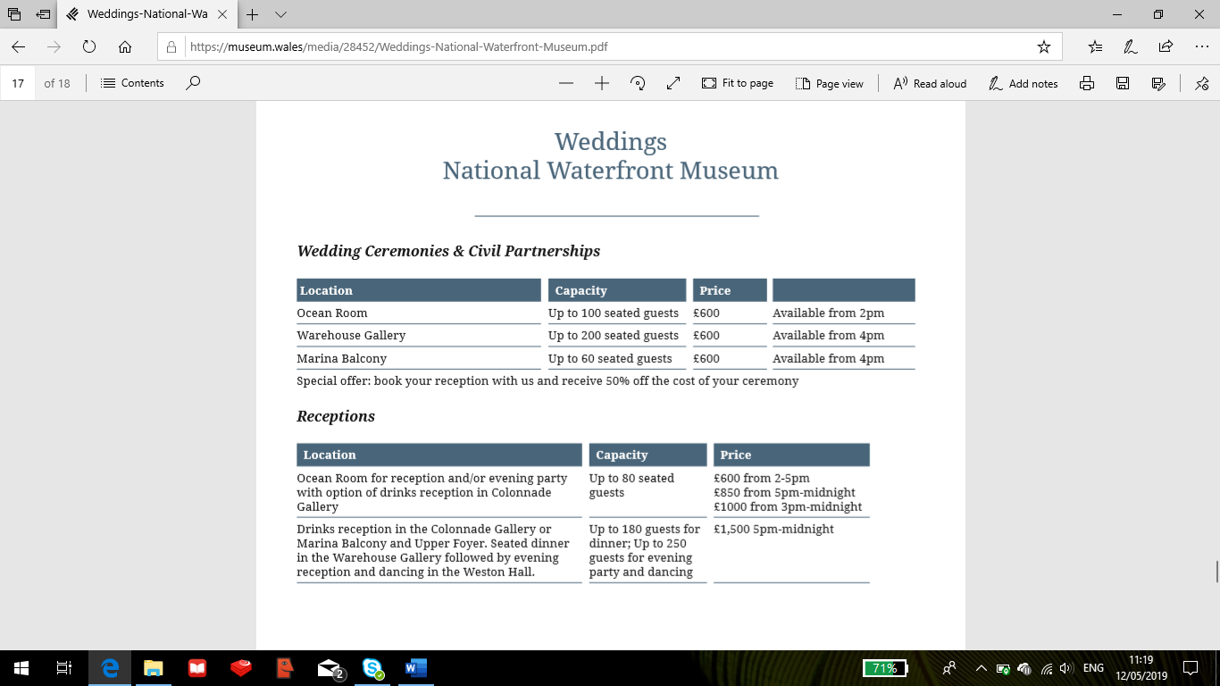

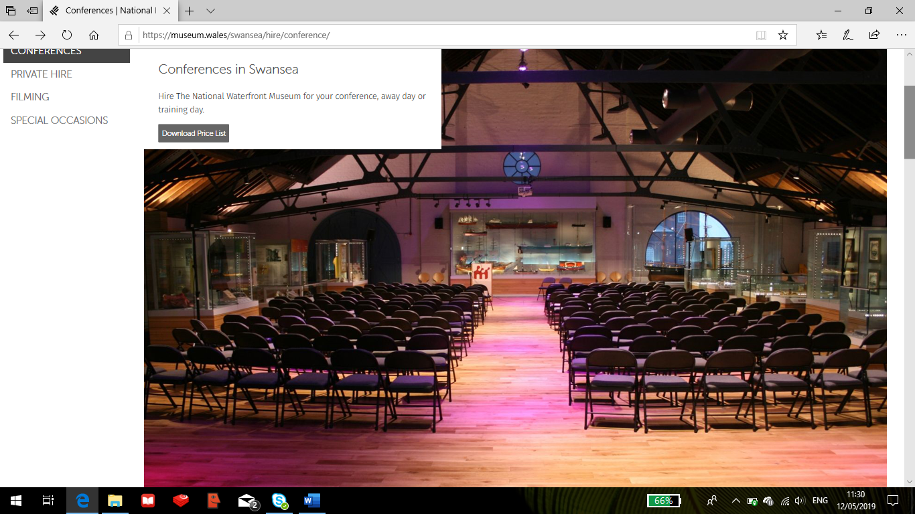
The National Waterfront alongside their offerings also have two other venues that are both fully licensed for civil ceremonies and receptions and they are the National Museum in Cardiff and St.Fagans: National History Museum.

Brangwyn Hall
The Brangwyn Hall is the ideal venue for events, conferences, weddings, dinners and functions, and regularly hosts internationally acclaimed orchestras and some of the biggest names in contemporary music.
Brangwyn Hall have rooms that can cater for both small and large weddings with capacity ranging from 20 to 500 guests. The venue also can accommodate events including conferences, training days, team-building activities, exhibitions or corporate entertainment.
There are fourteen rooms available in total, from small committee rooms which hold up to 16 delegates boardroom style, to the Brangwyn Hall itself which can seat up to 1070 people theatre style.

Liberty Stadium
Liberty Stadium, Swansea is the premier venue for conference and events in South West Wales as shown on their website. The stadium is also the home of Swansea City Football Club and the Ospreys regional rugby team. The stadium boasts over 700 complimentary car parking spaces and Wi-Fi.
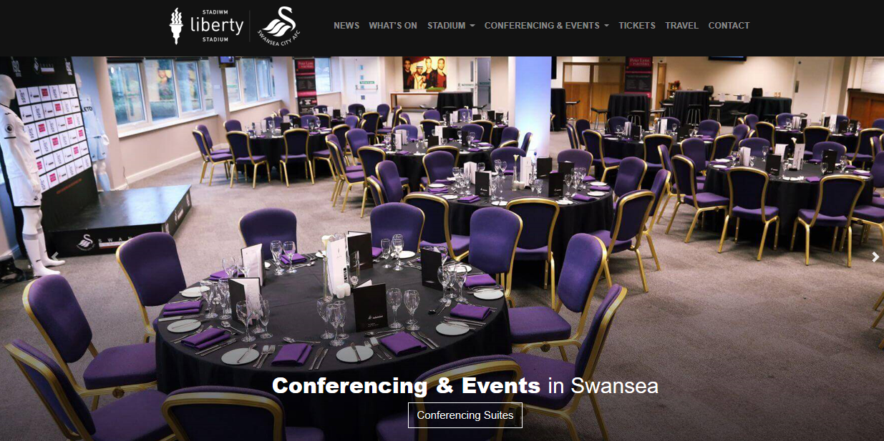
Conference
The stadium has a variety of suites that can accommodate a full complement of events including meetings, lunches, dinners, product launches, exhibitions, private celebrations and much more. With 15 suites and 22 executive suites to hold between 8 and 600 there is the flexibility to suit any event.

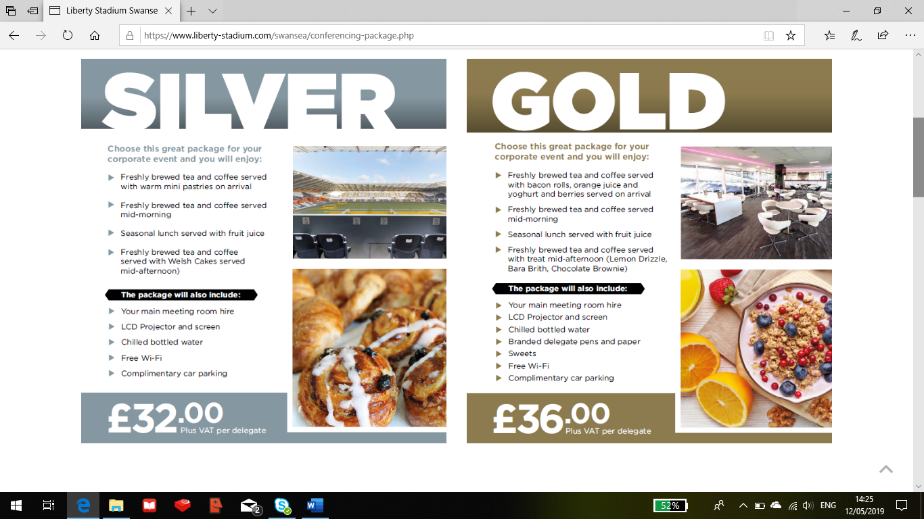
Events
Liberty Stadium is suitable for many special events such as private parties, engagements, award ceremonies, proms, birthday parties and weddings.
The Liberty Stadium is licensed to provide rooms for civil ceremonies and civil partnerships. There is a range of facilities available with rooms that can hold up to 330 guests.
Security Costs
Required for all events with a bar facility:
- Up to 100 guests - £308.00 plus VAT
- Up to 200 guests - £404.00 plus VAT
- Up to 300 guests - £500.00 plus VAT

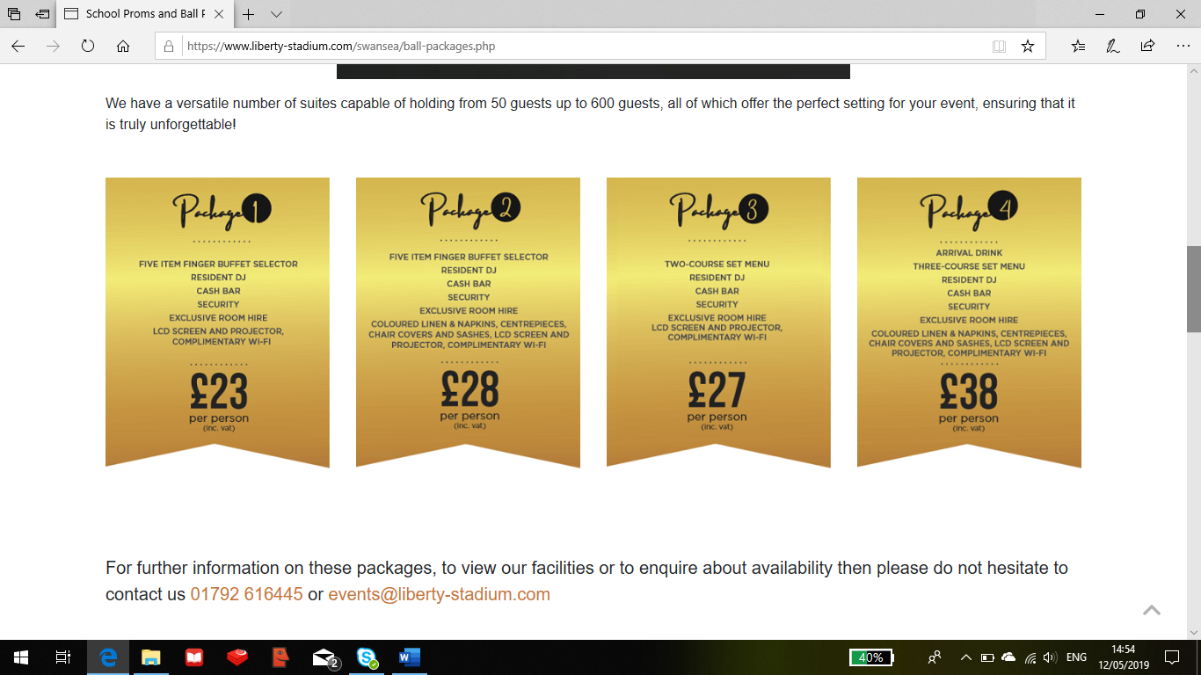
School Proms and Ball Packages
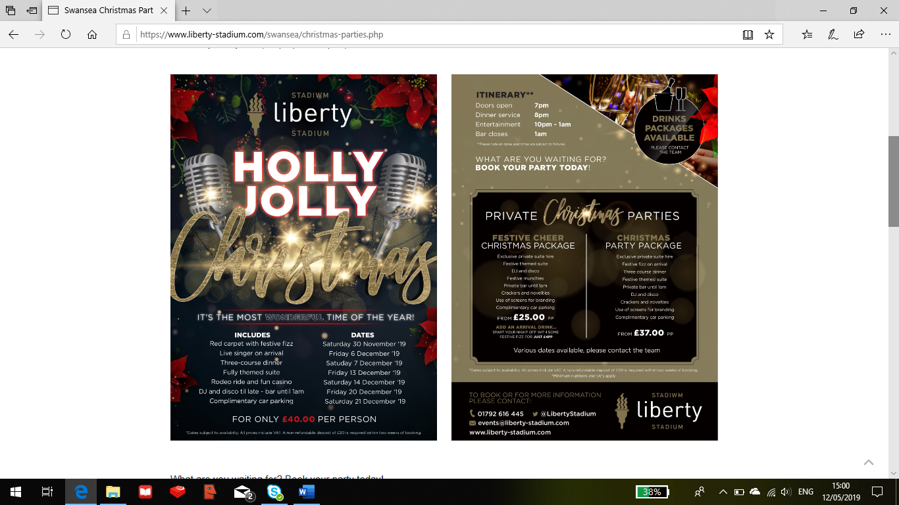
Swansea Christmas Parties
5.2 Resources Needed to Run a Corporate event
Through looking at a number of businesses that operate corporate events within their venues, in this section will be a reflection of what resources the Glynn Vivian Art Gallery would need to consider when planning and running a corporate event, and also looking at the type of packages that business competitors have offered, and to propose packages that could be implemented into the Glynn Vivian Art Gallery.
Resources needed for Weddings / Evening Reception
- Red Carpet on Arrival
- Professional photographers
- Staff (Waiters, Bartender, Chefs, Security)
- Seating and Tables
- Personalised napkins for clients
- Flowers and Decorations (Helium Balloons)
- Evening Entertainment (DJ, Disco, Band).
- Catering (Menu, Drinks (Licensed Cash Bar), Buffet / Canapes, Cake Stand) All crockery, cutlery, plates and glassware.
- Car Parking Access for guests
- Marquee (heated) Utilise the Garden
- PA System, Star lights
Resources needed for Conferences
- Room Hire
- Catering (Teas / Coffees, Soft Drinks, Snacks – Welsh cakes)
- Bottled water per guest
- Laptop
- Screen,
- Projector
- Pens & Flip Chart
- Seating and Tables
- Free Wi-Fi

Discussions
After identifying the resources needed for the Glynn Vivian to host Weddings and Conferences it is now time to mention the resources that the Art Gallery already have and what they do not have.
Weddings
For weddings the Glynn Vivian Art Gallery have Room 1 that can host up to 80 guests in a lecture theatre style or alternatively the ceremony could be held in the Garden weather permitting. The Garden if not used for the ceremony could be used as a marquee as a place for the evening dance, however heating may be required due to cold temperatures so the Atrium could be a better option.
To run a wedding the Glynn Vivian will need to consider recruitment for employees such as waiters, bartender (if selling alcohol), chefs, security and photographers which will all be at a cost. There would be the need for rounded tables for the dining for the evening reception where this would most likely be held in the atrium of the Gallery. The tables and even chairs could be borrowed from the Brangwyn Hall; even though the venue could be seen as a corporate event business competitor, both the Glynn Vivian and Brangwyn are owned by the Swansea council, so if they approve the Art Galleries corporate business plans then access to these resources may be possible.
There are catering facilities at the Glynn Vivian Art Gallery, however there is no catering business operating from there. As an Art Gallery there is also no accommodation available, however it could be suggested that the Glynn Vivian could host the wedding ceremony then work in conjunction with a hotel in Swansea whom could provide the dining, entertainment and catering services and accommodation for the evening reception.
One of the packages run by the National Waterfront Museum is named Hen Crafternoon. This idea of mixing Art with an event is a clever one even though the Waterfront is not an Art museum but the Glynn Vivian is which could give them an advantage when attracting clients however the setting and location of the Waterfront is an advantageous one right by Swansea Bay.
Conferences
Alongside weddings, conferences is already a used corporate event at the Glynn Vivian Art Gallery but maybe not as much as they would like it to be. Room 1 is where the conferences are held with a capacity of up to 80 people and the resources that are already in place include a digital projector, screen, microphones, laptop cables & connectors, MacBook, speakers, Blue ray player, flipchart & pens, chairs and free Wi-Fi access.
The only things that the Glynn Vivian Art Gallery need to consider is creating conference packages that include some sort of hospitality (Teas / Coffees, Soft Drinks, Snacks), and as a gesture of thanks to the client for choosing your venue a bottle of water per guest invited to the conference would be welcoming and has been used by many of the competitors.
Proposing a Wedding package
Package 1 – Ceremony & Evening Reception
(2pm to 9pm) (£562 for room hire) Minimum guests of 20 - £600 for dining, £440 for buffet minimum. Additional costs to be considered to cover staffing costs & ceremony.
Includes:
Welcome drink of Champagne, orange juice or water and Canapés upon arrival to the venue
Wedding Ceremony to take place in Room 1
Photography included
Wedding reception to take place in the Atrium, including a three course meal or choice of buffet (£30 pp for 3 course meal, £22 pp for Buffet).
Cake stand and Bridal knife
Drinks package to be included where guests can choose from a range of soft to Alcoholic drinks on the day
Marquee in the Garden area, incl. Disco and DJ. (Heated area)
Complimentary Car Parking
Please note: Busy learning and educational programme schedule is in place at the Glynn Vivian Art Gallery so dates and times for booking will need to be discussed. Please contact the Glynn Vivian Art Gallery for more information.

Package 2 – Only Wedding Ceremony in Atrium
(2pm to 4pm) £108 room hire, (5pm to 7pm) £200 room hire, plus additional costs
Includes:
Welcome drink of Champagne, orange juice or water and Canapés upon arrival to the venue
Wedding Ceremony to take place in the Atrium
Photography included
Complimentary Car Parking
Busy learning and educational programme schedule is in place at the Glynn Vivian Art Gallery so dates and times for booking will need to be discussed. Please contact the Glynn Vivian Art Gallery for more information.
Proposing a Conference package
Package 1 – Full Day Package (10am to 5pm) £378 + £25pp Includes:
Room Hire – Room 1 Boardroom Style (Max; 30 guests), lecture style (Max; 80 guests).
Large Screen Projector
Catering served throughout (Hot Drinks, Soft Drinks, Lunch – choice of Sandwiches, Snacks – Welsh cakes, biscuits)
Bottled water per guest
Pens & Flip Chart
Seating and Tables
Free Wi-Fi
Complimentary Car Parking
Busy learning and educational programme schedule is in place at the Glynn Vivian Art Gallery so dates and times for booking will need to be discussed. Please contact the Glynn Vivian Art Gallery for more information.

Package 2 – Half Day Package (10am to 1pm) £162 Room + £25pp. Includes:
Room Hire – Room 1 Boardroom Style (Max; 30 guests), lecture style (Max; 80 guests).
Large Screen Projector
Catering served throughout (Teas / Coffees, Soft Drinks, Snacks – Welsh cakes)
Bottled water per guest
Pens & Flip Chart
Seating and Tables
Free Wi-Fi
Complimentary Car Parking
Busy learning and educational programme schedule is in place at the Glynn Vivian Art Gallery so dates and times for booking will need to be discussed. Please contact the Glynn Vivian Art Gallery for more information.
Proposing a Birthday Party Package
Although the competitors looked at above did not advertise birthday parties as a main event in their business the consultant believes that the Glynn Vivian Art Gallery have the potential to run one.
Package 1 - Arts and Crafts Birthday Party at the Glynn Vivian (£312 minimum price for Package)
Room Hire – Arts Room and Room 1 (11am till 2pm) (£162 for 3 hours)
Minimum 10 children (£15 per child, Adults minding their children are free)
Arts and Crafts facilities
Professional Artist (Idea)
Tour of the Art Gallery
Balloons only to be used in Room 1
Disco & Music in Room 1
Personalised seats at the table for the birthday child
Buffet
Glynn Vivian styled Birthday Cake (candles)
Party Bags

Package 2 - Arts and Crafts Birthday Party at the Glynn Vivian (£242 minimum price for Package)
Room Hire – Arts Room and Room 1 (11am till 2pm) (£162 for 3 hours)
Minimum 10 children (£8 per child, Adults minding their children are free)
Arts and Crafts facilities
Professional Artist (Idea)
Tour of the Art Gallery
Disco & Music & Balloons in Room 1
Personalised seats at the table for the birthday child
5.3 Data Collected through Online Survey
The online survey was created on Survey Monkey with a total of 16 questions for respondents to fill out. The survey was distributed on social media sites including Facebook and Linkedin where people from the South Wales region had the opportunity to support the Glynn Vivian Art Gallery in the market research and generated a total of 58 responses. The analysis of these responses was also conducted through Survey Monkey via a one month upgrade plan where the consultant in this section will discuss the analysis and answers that respondents have generated. See Appendix 1 for Online Survey Blank Copy.

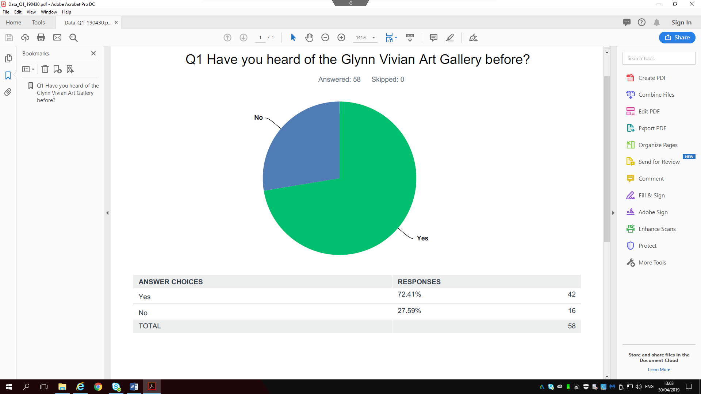
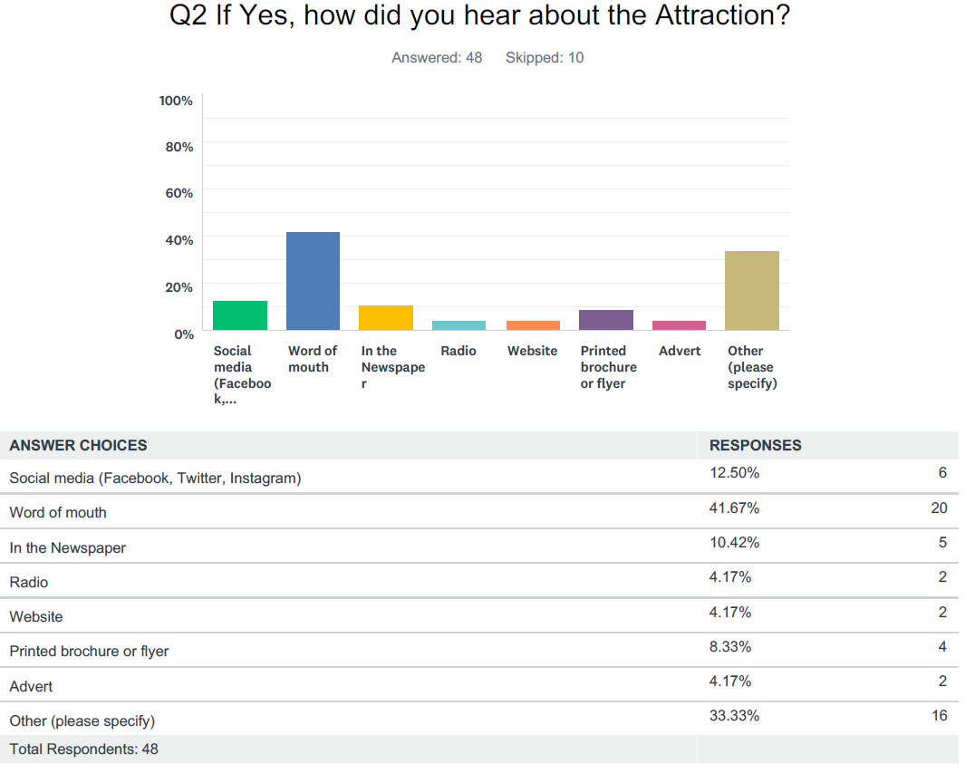
The first question saw 42 (72.41%) out of the 58 respondents saying that they have heard of the Glynn Vivian Art Gallery before; which indicates that the attraction has been well marketed across the South West Wales region. And to move on from that question it was important to ask where the respondents had heard about the Glynn Vivian.
The majority of respondents (41.67%) said they had heard via word of mouth. 12.50% said they heard via social media, 10.42% by reading the newspaper and 8.33% from a printed brochure or flyer. The radio, website and advertisement saw the least respondents whilst 33.33% specified other in which they left a comment saying how they heard of the gallery.
The comments included people in Swansea saying that it is a well-known attraction and that they have walked passed it many times; with other respondents mentioning that they have visited with school and university groups.

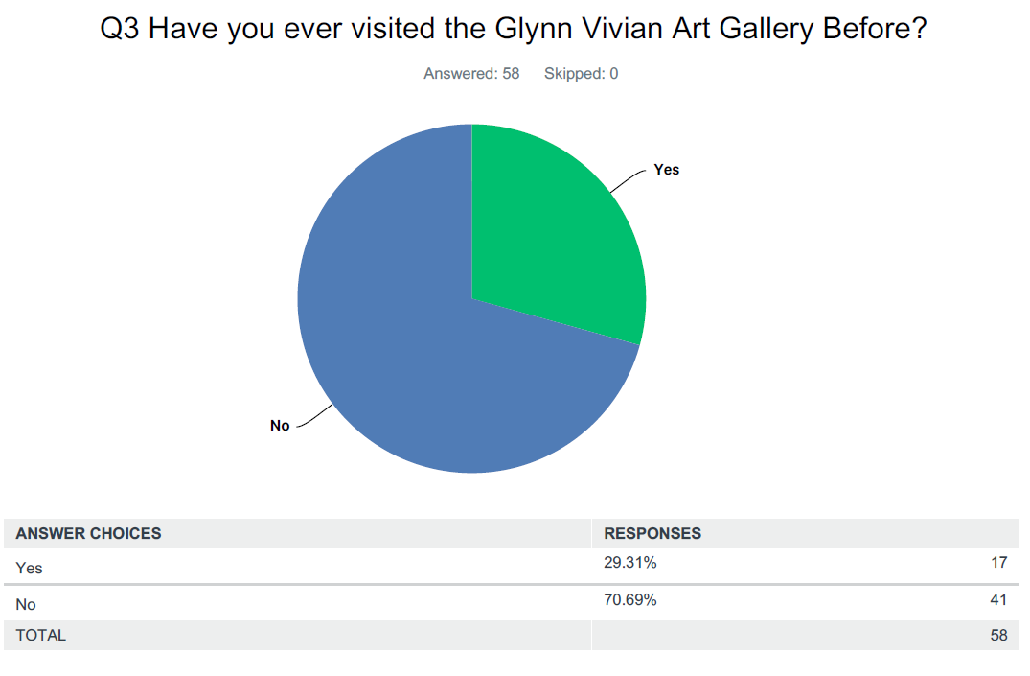
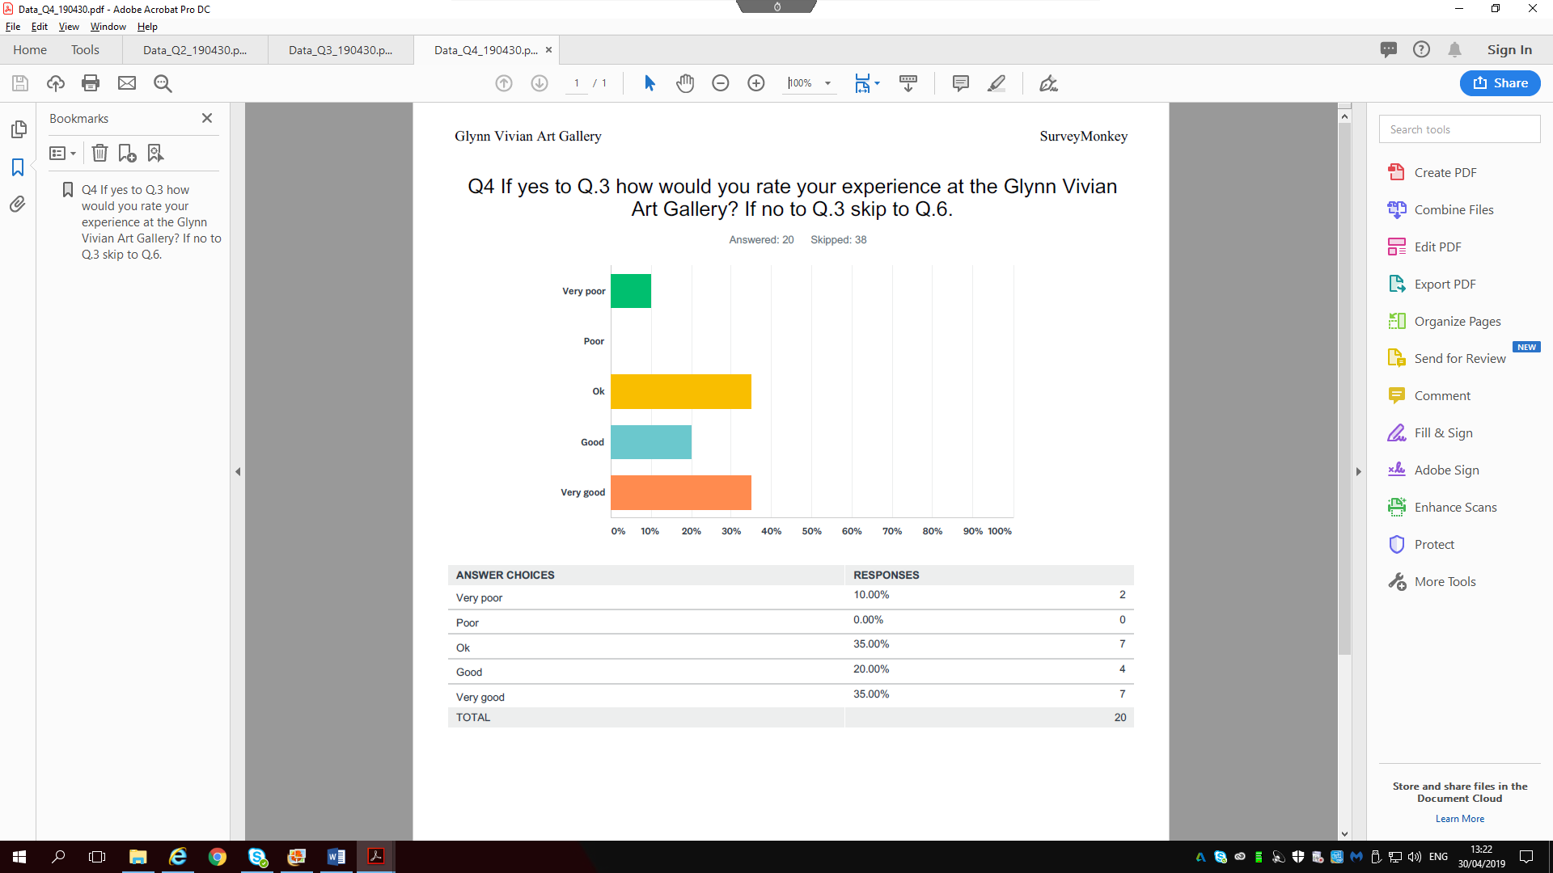
After asking the participants if they have heard of the Glynn Vivian Art Gallery it was important to ask if after hearing about it, whether or not they visited afterwards. 72.41% said they had heard about the Glynn Vivian before, however results show that only 29.31% (17 respondents) actually visited, which shows a discrepancy of 25 people who did not visit the attraction. Evidence from this survey shows that marketing the Art Gallery is not the problem, however getting people through the door is.
From the respondents who said they have visited; it was important to have some reflection from their experiences at the Art Gallery and to see how they would rate their overall visit, with the opportunity to comment. Results show mixed perceptions with 35% of the respondents saying it was Ok and Very Good, 20% saying it was good and 10% saying it was very poor. After rating their experiences at the Glynn Vivian there were three respondents who elaborated on their choice of answer.
Respondent #55 rated the experience as good and stated in the comments that is was a nightmare to park, and is a reason why it might put people off. This shows a concern of accessibility of parking near the entrance, however, to argue with this comment the attraction is located not too far away from the city centre where there are many parking locations for visitors to use.
Respondent #39 rated the experience as very good and stated that the Glynn Vivian Art Gallery provided given knowledge about artists methods and styles of painting that I did not realise before. Which shows a very positive comment for the quality of Art on show at the attraction.
Respondent #5 rated the experience as ok and stated that the Glynn Vivian Art Gallery is a nice place with so much potential but very empty. This response elaborates on results from question 3 where getting more and more people through the door is an issue at this moment for the attraction, and needs to have the ambition to improve this predicament.

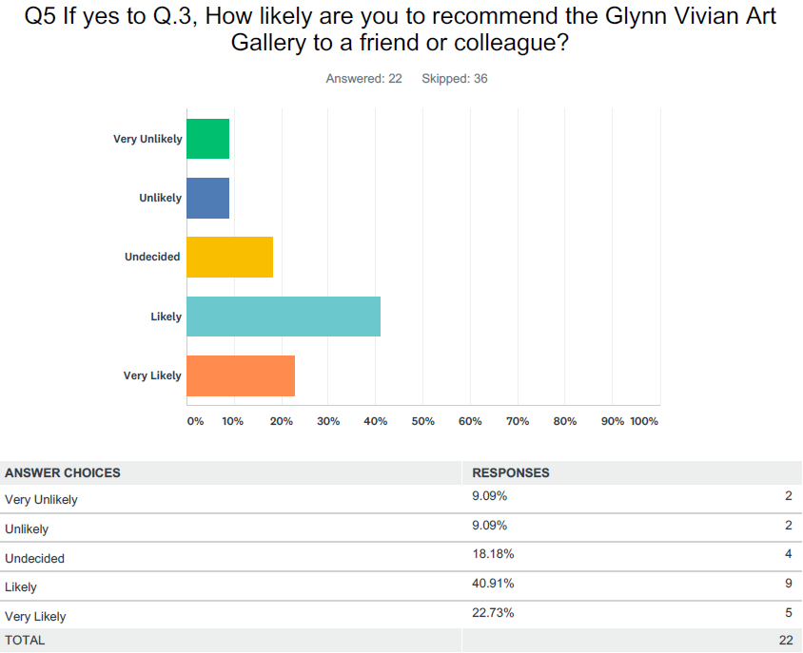
After responding to question 3 on whether or not the participant has visited the Glynn Vivian Art Gallery before with 29.31% saying they did it was important to see whether or not they would recommend this attraction to friends or a work colleague. The results show mixed feelings from respondents towards this question however 40.91% are likely and 22.73% are very likely to recommend the Glynn Vivian to people they know. There was 18.18% that were undecided if they would recommend the attraction and 9.09% saying they are unlikely and 9.09% very unlikely to recommend.
This shows some disappointment that respondents have decided not to recommend the Glynn Vivian. And as the Consultant there was a missed opportunity here to add a comment field where the respondents could have expressed their decision for this question.
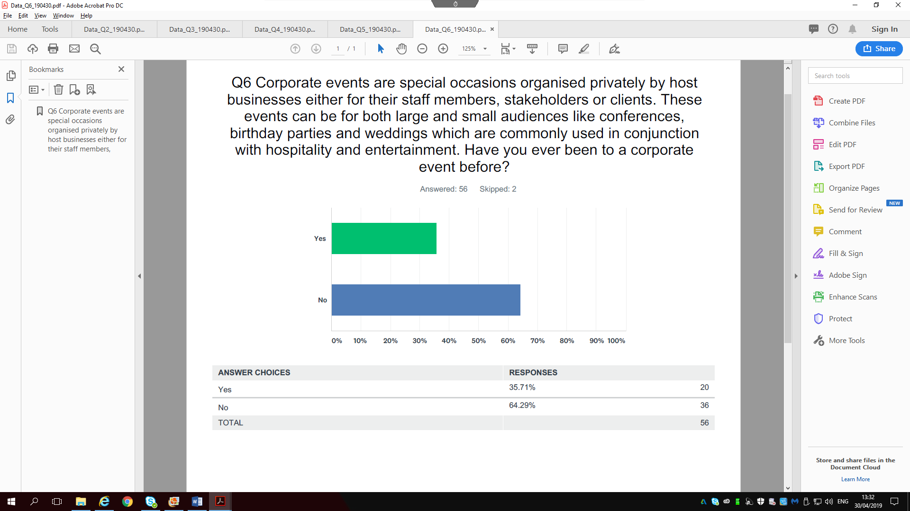
The first part of the survey was gathering data about the Glynn Vivian Art Gallery in general from a visitor’s perspective and now the next part of the survey will concentrate more on the Glynn Vivian Art Gallery as a corporate events venue. The first question to be asked was whether or not the respondents have been to a corporate event before, a definition of what a corporate event is was first explained at the start of the question and 56/58 respondents participated in this question with 35.71% saying they have attended a corporate event before and 64.29% saying they have not.

The question allowed the respondents to share what type of event they attended and where it was held in the comment box with 17 comments in total. One respondent #9 named only the venue which was the Vale resort in Cardiff and not the type of event although it is a venue for weddings and business. And another respondent #6 named the Princess Royal Theatre in Port Talbot as a venue which is known for shows and performances as well as trade shows and recruitment days.
Staff Parties
Respondent #55 Works do, Respondent #20 Staff parties (Marriott & National Waterfront Museum), Respondent #7 Work awards event,
Birthday Parties
Respondent #54 Birthday party LC2, Respondent #13 Birthday party,
Conferences
Respondent #52 Conference, Respondent #46 Conference in USW Trefforest campus, Respondent #44 Teaching conference in a Cardiff hotel, Respondent #42 At The Louvre Paris for members of an international conference, Respondent #20 Conference (V&A),
Gala Dinner
Respondent #34 Avon presidents dinner at the towers hotel in Swansea, Respondent #12 Networking dinner with my previous workplace at The Angel Hotel in Abergavenny. It was a fairly large event with very monied people, included chats with Warren Gatland and Eddie Butler and people like Bryn Terfel were also attending.
Trade Show
Respondent #28 Car dealership launch in Margam Orangery
Charity event
Respondent #38 Fund raiser
Sporting Events
Respondent #18 Horse racing, Rugby, Football
Weddings
Respondent #11 Several weddings variety of venues,
These responses have provided the consultant with a lot of detailed answers about the different types of events and venues that people have attended.
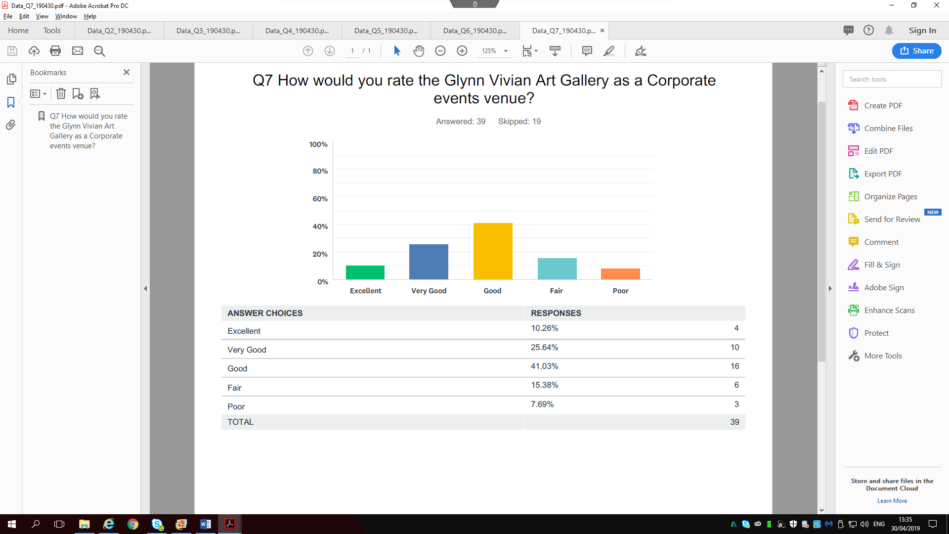
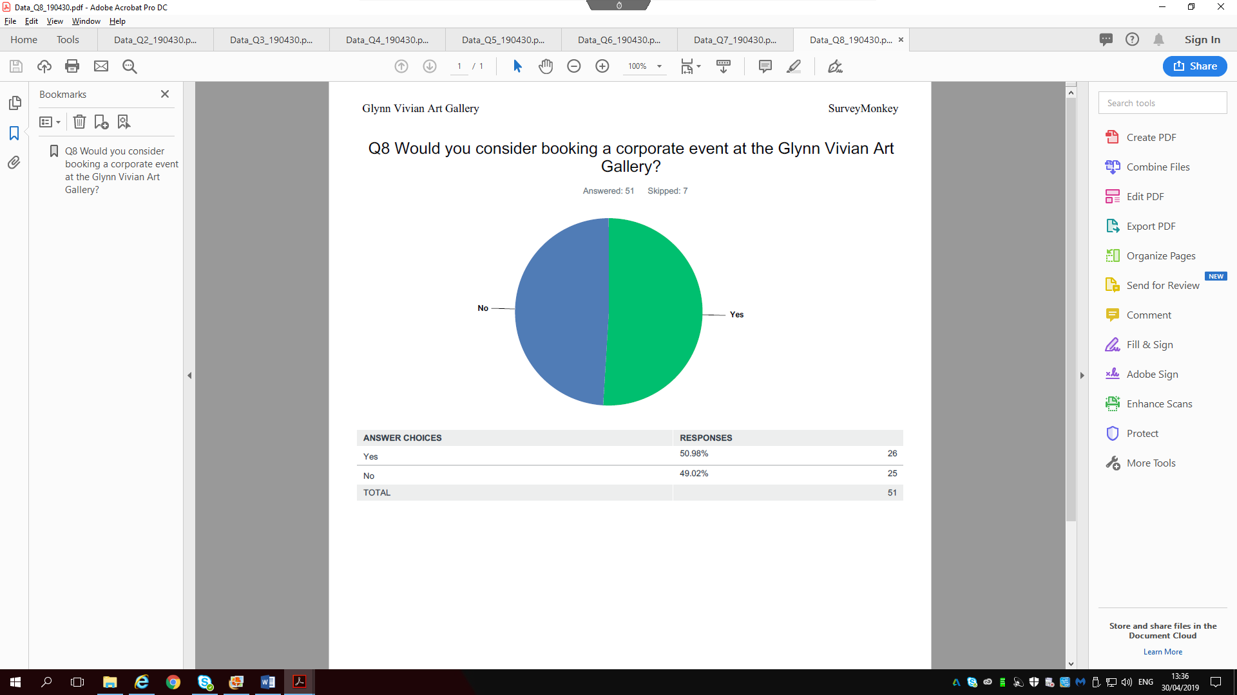
After identifying what type of corporate events respondents have attended it was time to move onto how people perceived the Glynn Vivian as a corporate events venue, this question was designed for people who have heard of or visited the attraction before. 39/58 answered this question with results showing that 41.03% respondents said it is good, 25.64% saying very good and 10.26% saying excellent which shows the majority of respondents rated the Glynn Vivian Art Gallery as a viable corporate events venue that has great potential. However there were 15.38% saying it is fair and only 7.69% saying it is poor.
After rating the Glynn Vivian Art Gallery as a corporate events venue it was important to ask the respondents whether or not they would consider booking an event at the Art Gallery. 51/58 answered the question with 26 respondents saying Yes to the idea and 25 respondents saying No, which shows a very close result. The question produced several comments for and against the idea of the Glynn Vivian as a corporate events venue which will now be discussed.
Q8 – Yes – Comments
Four comments were on the same lines stating that the Glynn Vivian Art Gallery is a perfect setting for corporate events; saying the venue has the sufficient space and friendly staff to run and organise everything efficiently.
Respondent #27 stated that the Glynn Vivian Art Gallery is near to transport hubs and local hotels thus making it easy to get to; with respondent #28 backing up the previous comment by saying the attraction is in a central location and is a well-known venue.
Respondent #47 said It would be a change from the regular corporate events venues, and respondent #18 said depending on the event type it would have to be arts related to satisfy the right crowd.

Q8 – No – Comments
The majority of respondents of commented No stated that the Glynn Vivian Art Gallery do not have the adequate facilities needed and are in no position to organise and run corporate events. Respondent #55 stated No because the parking is dreadful when visiting the Gallery and respondent #52 cannot envisage an Art Gallery forming as a corporate events venue.

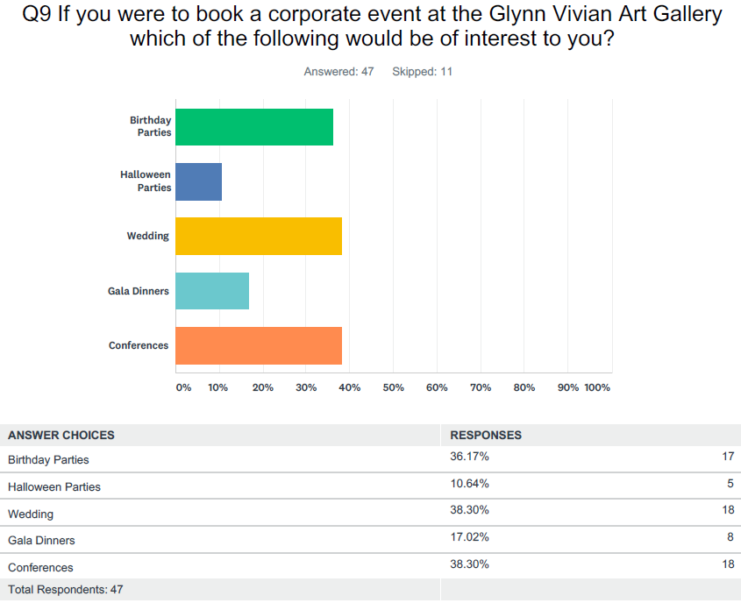
After asking respondents what types of corporate events they have been before and whether or not respondents would be interested in booking a corporate event at the Glynn Vivian it was important to ask which events they would like to see organised by the Glynn Vivian. The question allowed respondents to tick more than one type of event and resulted in almost a three way tie between Birthday parties, Conferences and a Wedding. There was only 10.64% interested in Halloween parties and 17.02% in Gala Dinners. There was the option to provide any other events respondents would be interested in and comments included University balls and a Wedding Anniversary.
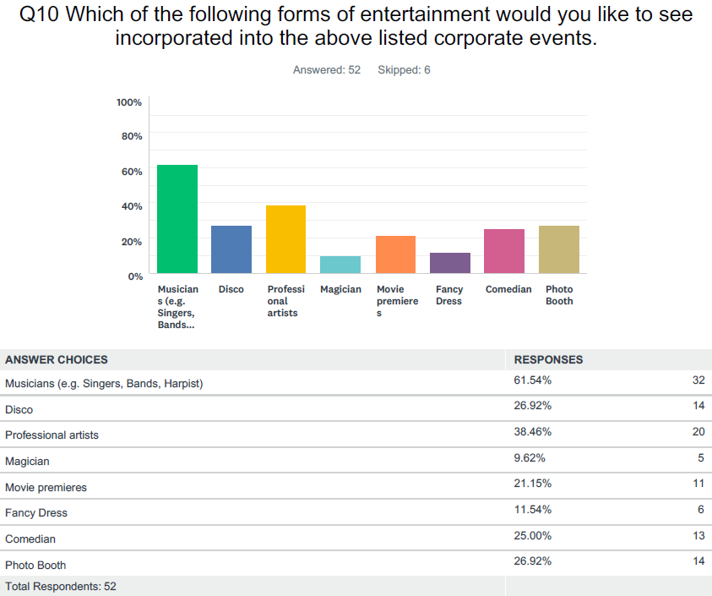
After asking what corporate events the respondents would be interested in booking at the Glynn Vivian Art Gallery it was important to ask what forms of entertainment the respondents would like to see incorporated into the events listed previously. The question allowed respondents to tick more than one form of entertainment if they wanted to, and results showed that Musicians were the most popular choice of entertainment with 61.54% with professional artists coming second with 38.46%. The least popular forms of entertainment were a magician 9.62% and fancy dress 11.54%. This question offered respondents to add extra types of entertainment that they would like to see at the Glynn Vivian, however respondent #55 commented that the Glynn Vivian is not really the type of place for social events after previously commenting throughout the survey that the parking is dreadful and the visitor experience was poor.

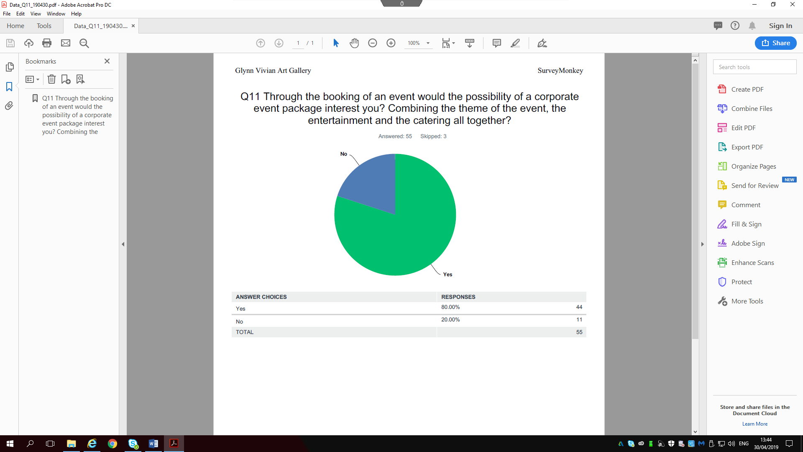
Through asking questions about what types of events and entertainment respondents would like to see, it was important to ask whether or not they would be interested in booking a corporate event package where everything was included for one price and 80% of respondents said Yes to this question.

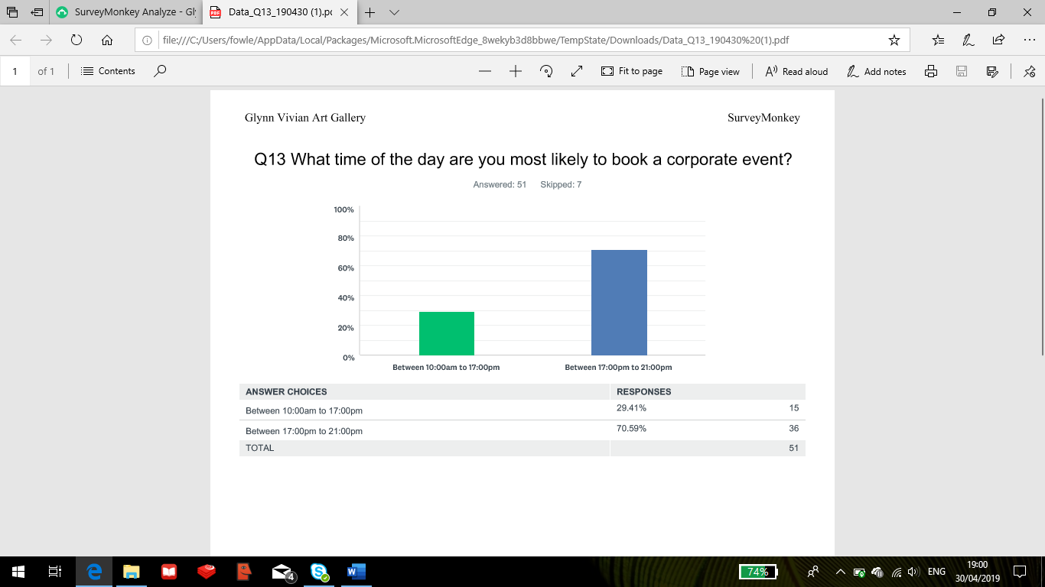
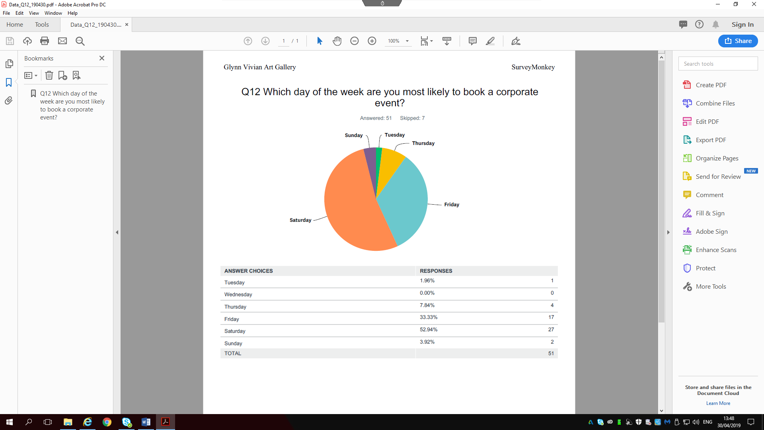
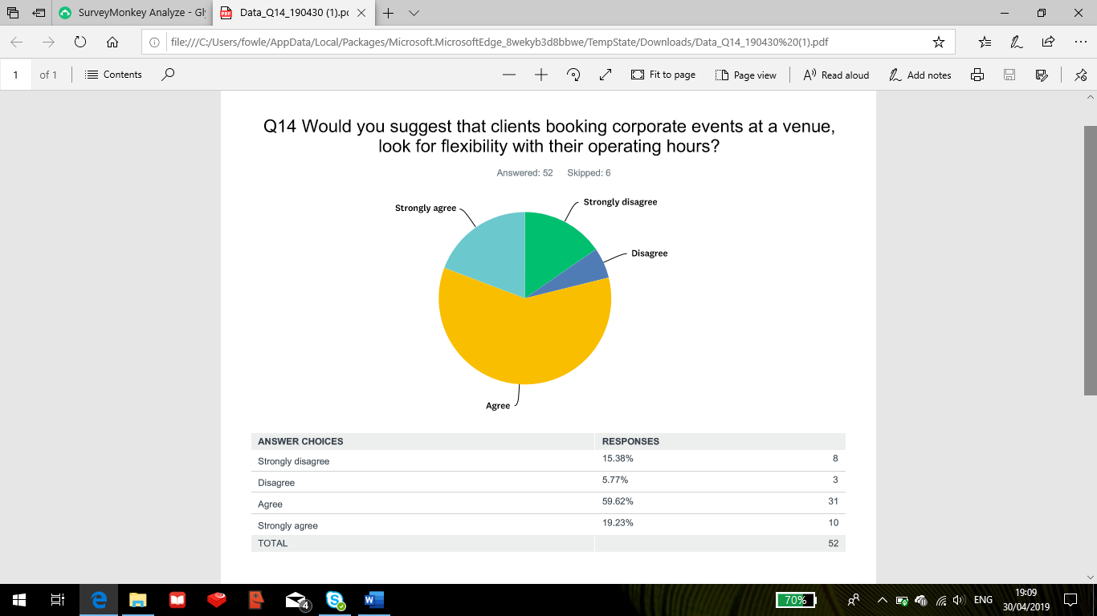
The Glynn Vivian Art Gallery is open 10am to 5pm Tuesday to Sunday every week and on Friday run an event called Glynn Vivian at Night which keeps the Gallery open until 8pm. This question asked respondents which day of the week they are most likely to go for when looking to book a corporate event at the Glynn Vivian Art Gallery and 52.94% of the votes went for Saturday and 33.33% went for Friday.
The results shows a massive difference between those two days and the rest of the week proving that the Glynn Vivian may want to choose one of the days to focus on, as running the Glynn Vivian at Night event is a priority as it offers visitors after hours workshops, films, poetry, live music and performances
After identifying the respondents are most likely to book a corporate event on Saturday or Friday it was important to ask what time of the day would be preferred. Results show 70.59% would book a corporate event between the hours of 17:00pm to 21:00pm, in comparison to 29.41% wanting to book between the hours of 10:00am to 17:00pm. To be critical the hours are restricted at the Glynn Vivian from 17:00pm to 21:00pm and the next question asked whether or not clients look for flexibility with a venue’s operating hours. Results show that 59.62% agree and 19.23% strongly agree that they do look for flexibility. On the other hand 5.77% disagree and 15.38% strongly disagree and they book an event according to the details of the package and not the operating hours of a venue.
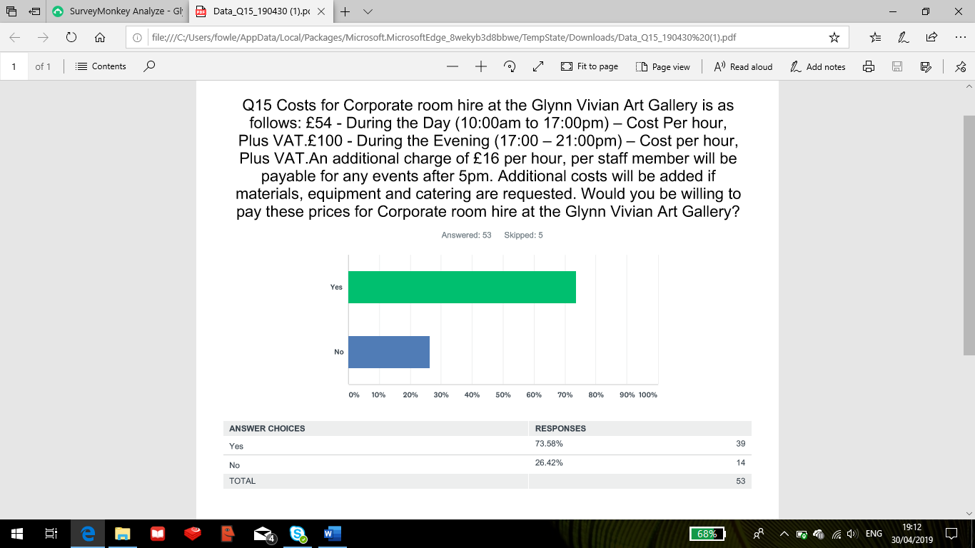

The costs for corporate room hire during the day and night at the Glynn Vivian Art Gallery have been stated in Q15 where the respondents have been asked whether or not they would be willing to pay these prices. Results show that 73.58% would be willing to pay these prices compared to 26.42% who would not be willing. This question allowed the respondents to voice their opinions and seven of them who said they are not willing to pay these prices stated that it is too expensive. Respondent #6 gave a more detailed reason for it being too expensive by saying “I book a number of rooms £20 per hour and it is more the going rate”. This shows that there are competitors out there with cheaper services and prices in comparison to the Glynn Vivian Art Gallery.
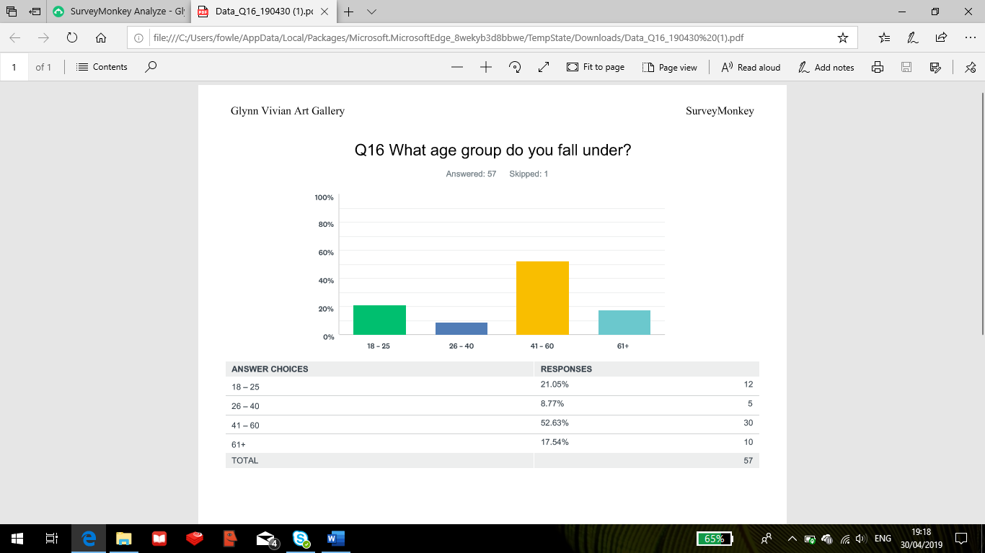
At the end of the survey the participants were asked what age group they fall under for market research purposes for the Glynn Vivian Art Gallery. The results show that 30/57 (52.63%) respondents were aged 41-60 and 10/57 (17.54%) were aged 61+.

5.4 Marketing Strategy
To get the corporate business up and running for the Glynn Vivian Art Gallery it is important that the business has a marketing strategy in place to advertise and market the packages to gather future business and clients.
There are a number of ways to market a product and they include:
- Brochures
- Official Website
- Social Media
- Advertisements
- Newspapers
The consultant after taking on board the questionnaire results of how people heard about the Glynn Vivian Art Gallery and how competitors have marketed corporate packages it will be suggested that an Official website is the most important way to provide yourself a platform in a corporate event business plan.
Website
With a website the Glynn Vivian have the opportunity to actually implement tools that can take users to different platforms such as social media links at the bottom of the page, links to corporate event brochures, packages and prices like the Morgan’s Hotel have done.
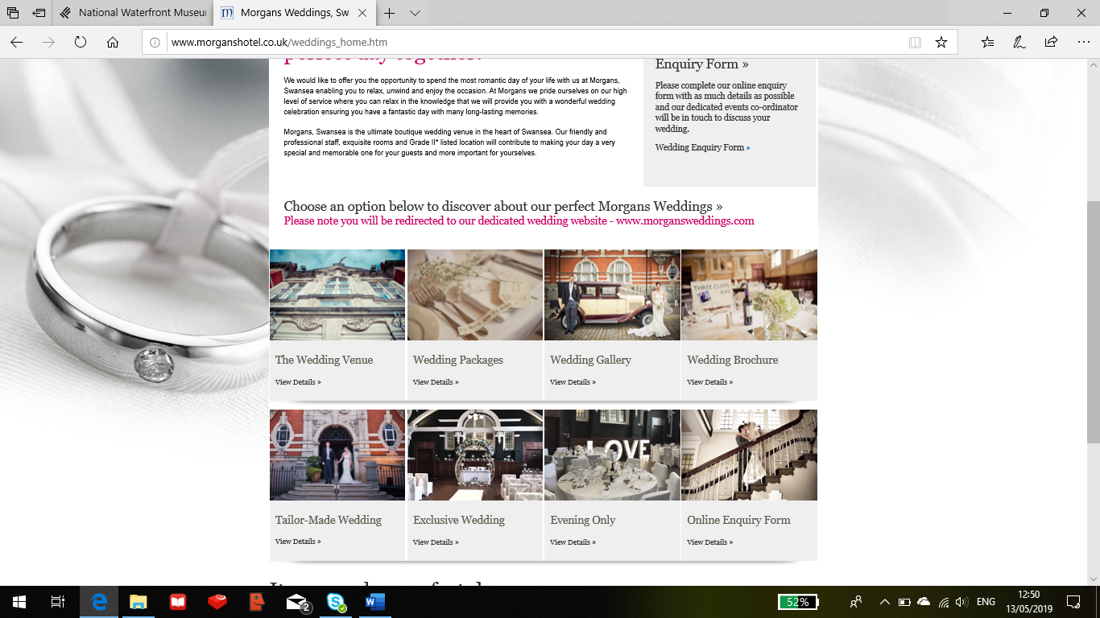
Furthermore it would be recommended to share photos of the Art Gallery and the spaces that will be utilised for corporate events to encourage and attract clients to choose the Glynn Vivian over competitors.
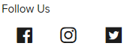

6. Conclusions
To conclude, this consultancy project report for the Glynn Vivian Art Gallery has researched ways in which the attraction can overcome the issue of low visitation and low economic income and that is by looking into starting a corporate event business within the Gallery. The objectives set to achieve this aim was to undertake a content analysis of competitors to identify the resources needed to be placed into a corporate event package, to undertake an online survey to produce valuable market research moving forward and also to propose a marketing strategy to advertise the potential business.
The competitors that were considered to be the most successful in the corporate event business were looked at and they included hotels in Swansea; Morgan’s and the Marriot, the Oldwalls in Gower, National Waterfront Museum, Brangwyn Hall, Liberty Stadium and for a similar attraction the Hepworth Wakefield.
Throughout the research, packages, prices and resources were identified on these companies websites so that the Glynn Vivian Art gallery can have an idea on what they require moving forward and as part of this the consultant came up with a few proposals for potential packages in weddings, conferences and birthday prices.
The online survey was designed and taking through survey Monkey with the purpose of asking the public what they thought of the Glynn Vivian as a corporate events venue. The survey suggested the issue that has led to this project being undergone and that was marketing the Gallery was not the issue it was encouraging more visitors through the door.
Analysis showed that respondents who had visited the Glynn Vivian before suggested that the parking is a nightmare and that it might be one of the main reasons that it puts people off from going. The first part of the survey was gathering data about the Glynn Vivian Art Gallery in general from a visitor’s perspective and the next part concentrated on the Glynn Vivian as a corporate events venue. Respondents suggested that they would most likely be interested in a wedding, conference or birthday party compared to the other options with entertainment choice going for musicians and professional artists. 73.58% of respondents said they would be willing to pay the room hire prices at the Glynn Vivian with the most popular days of the week for respondents to book a corporate event was Friday and Saturday and between the hours of 5pm to 9pm.
As one of the objectives, the marketing strategy recommended for the Glynn Vivian to use would be to have an official website where they would be able to post about the Gallery in general to increase visitor awareness and then for the corporate event business to have packages, prices, brochures, social media links and any promotions to gather and increase numbers at the attraction.
7. Strategic Recommendations
- To create a website that will benefit the plan of a corporate event business, whilst utilising current social media networks as well.

- To continuously check the competition to see what new incentives or promotions they are offering their clients.

- To build relationships with hotels within Swansea in the scenario of having no catering business for the foreseeable future, although still have the capabilities to organise and offer ceremonies (weddings), conferences & other events.

- To counteract any negative comments received throughout the online survey either by proving respondents wrong or by solving issues identified by the respondents such as parking.

8. References
Swansea Council (2019), Glynn Vivian Art Gallery, available [online] at - https://www.swansea.gov.uk/glynnvivian - accessed 10/03/19

Saunders, M. et al, (2016). Research methods for business students, 7th Ed, New York, Pearson Education.
Visit Swansea Bay (2019), Glynn Vivian Art Gallery, available [online] at - https://www.visitswanseabay.com/listings/glynn-vivian-art-gallery/ - accessed 10/03/19

9. Appendices
9.1 Appendix 1 – Online Survey Blank Copy
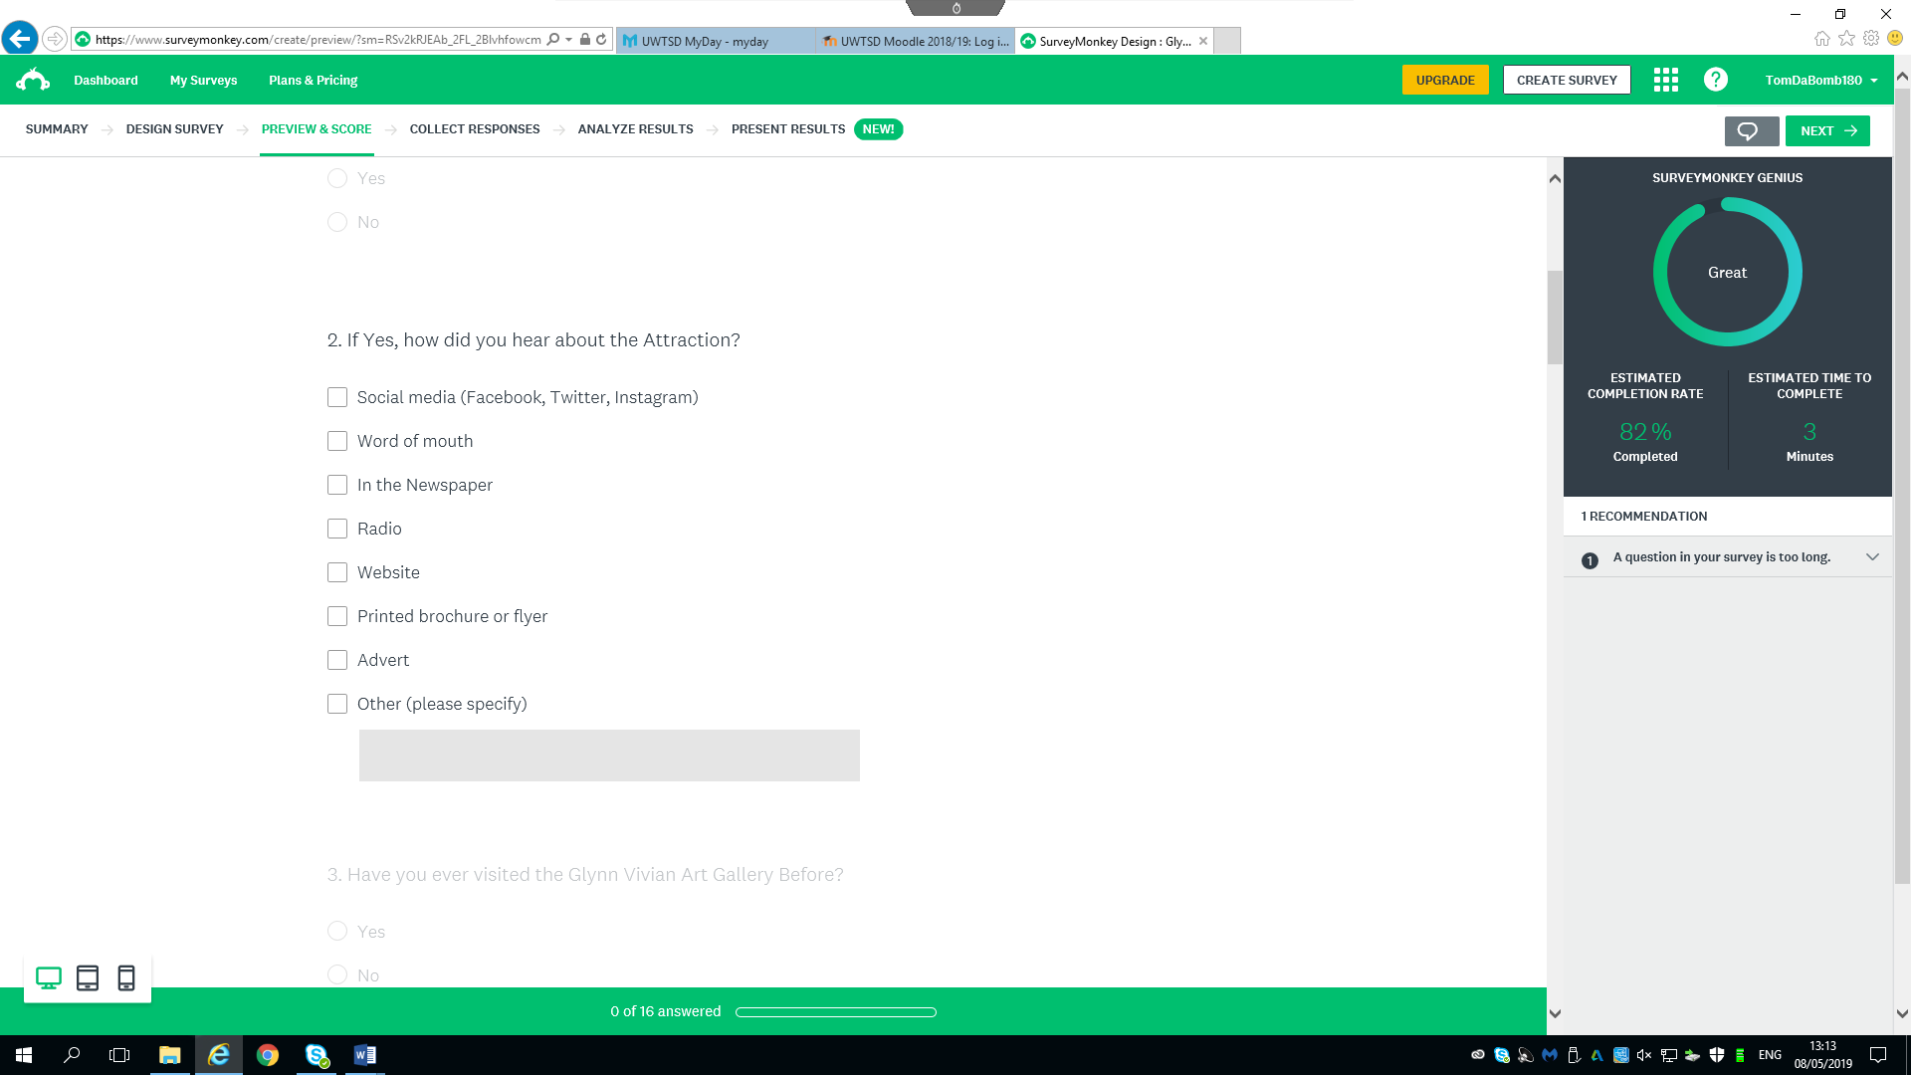
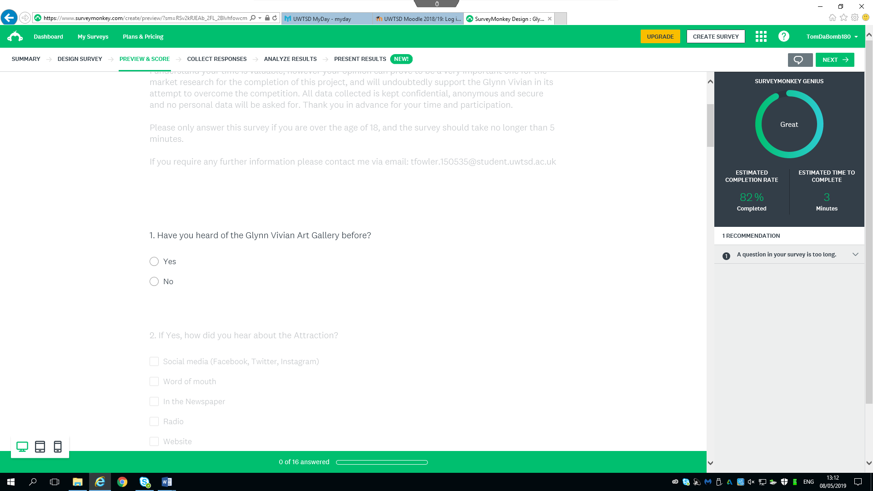
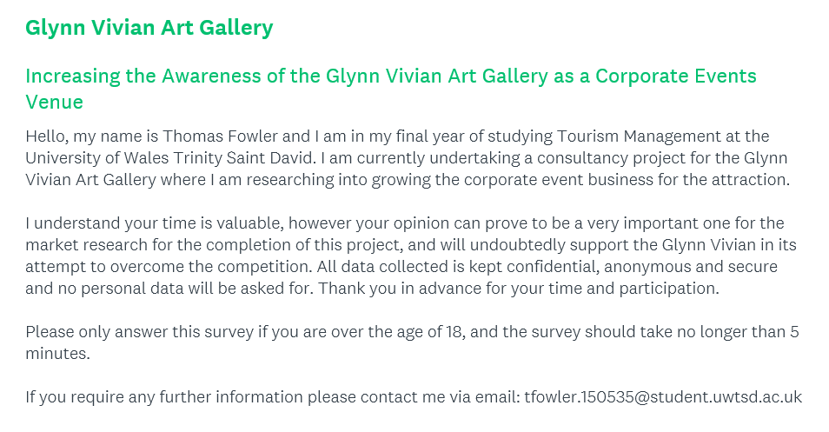

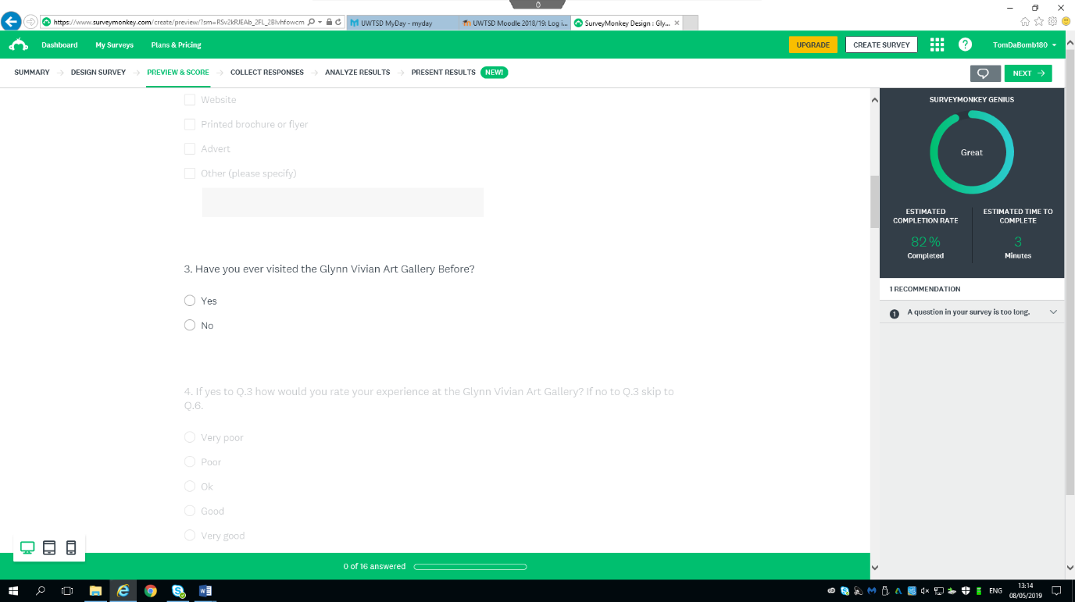
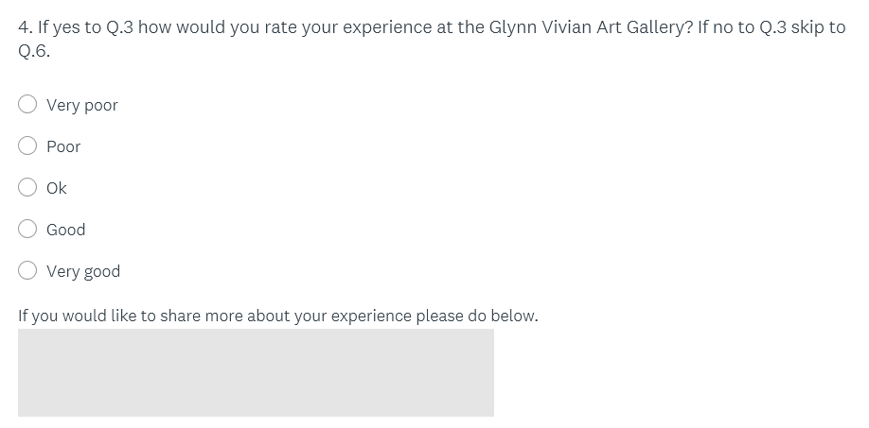

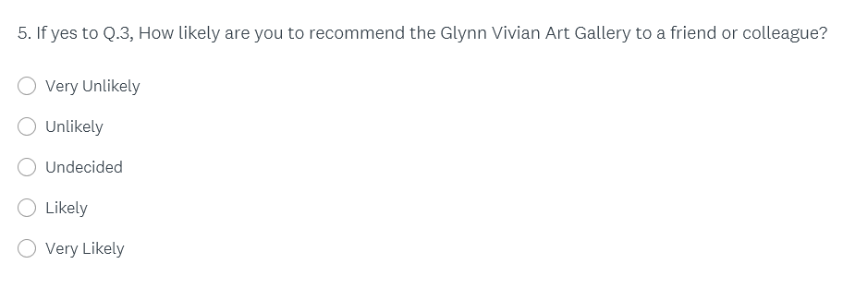
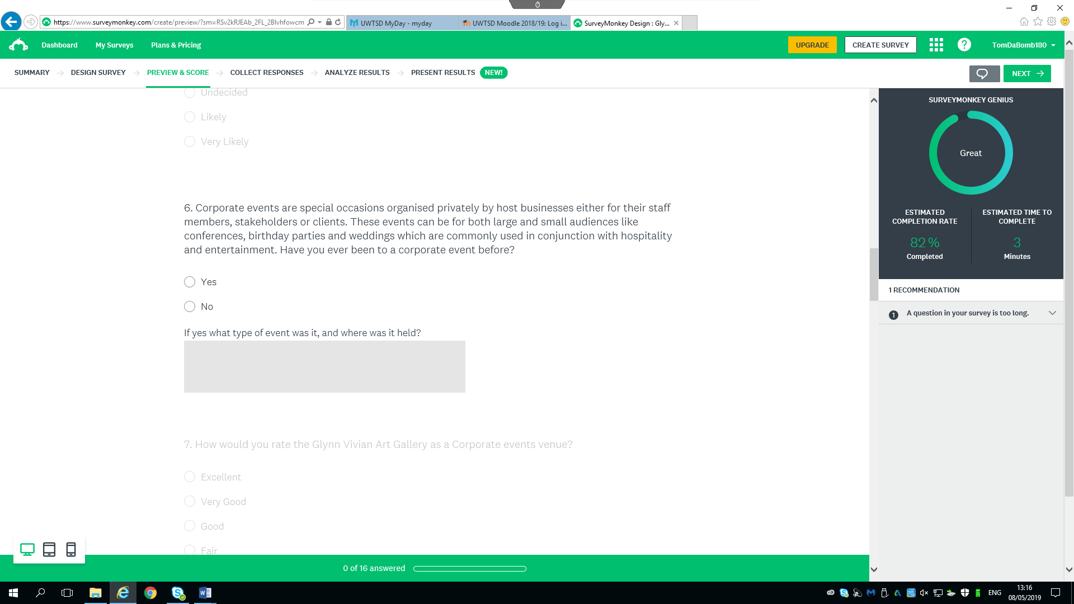
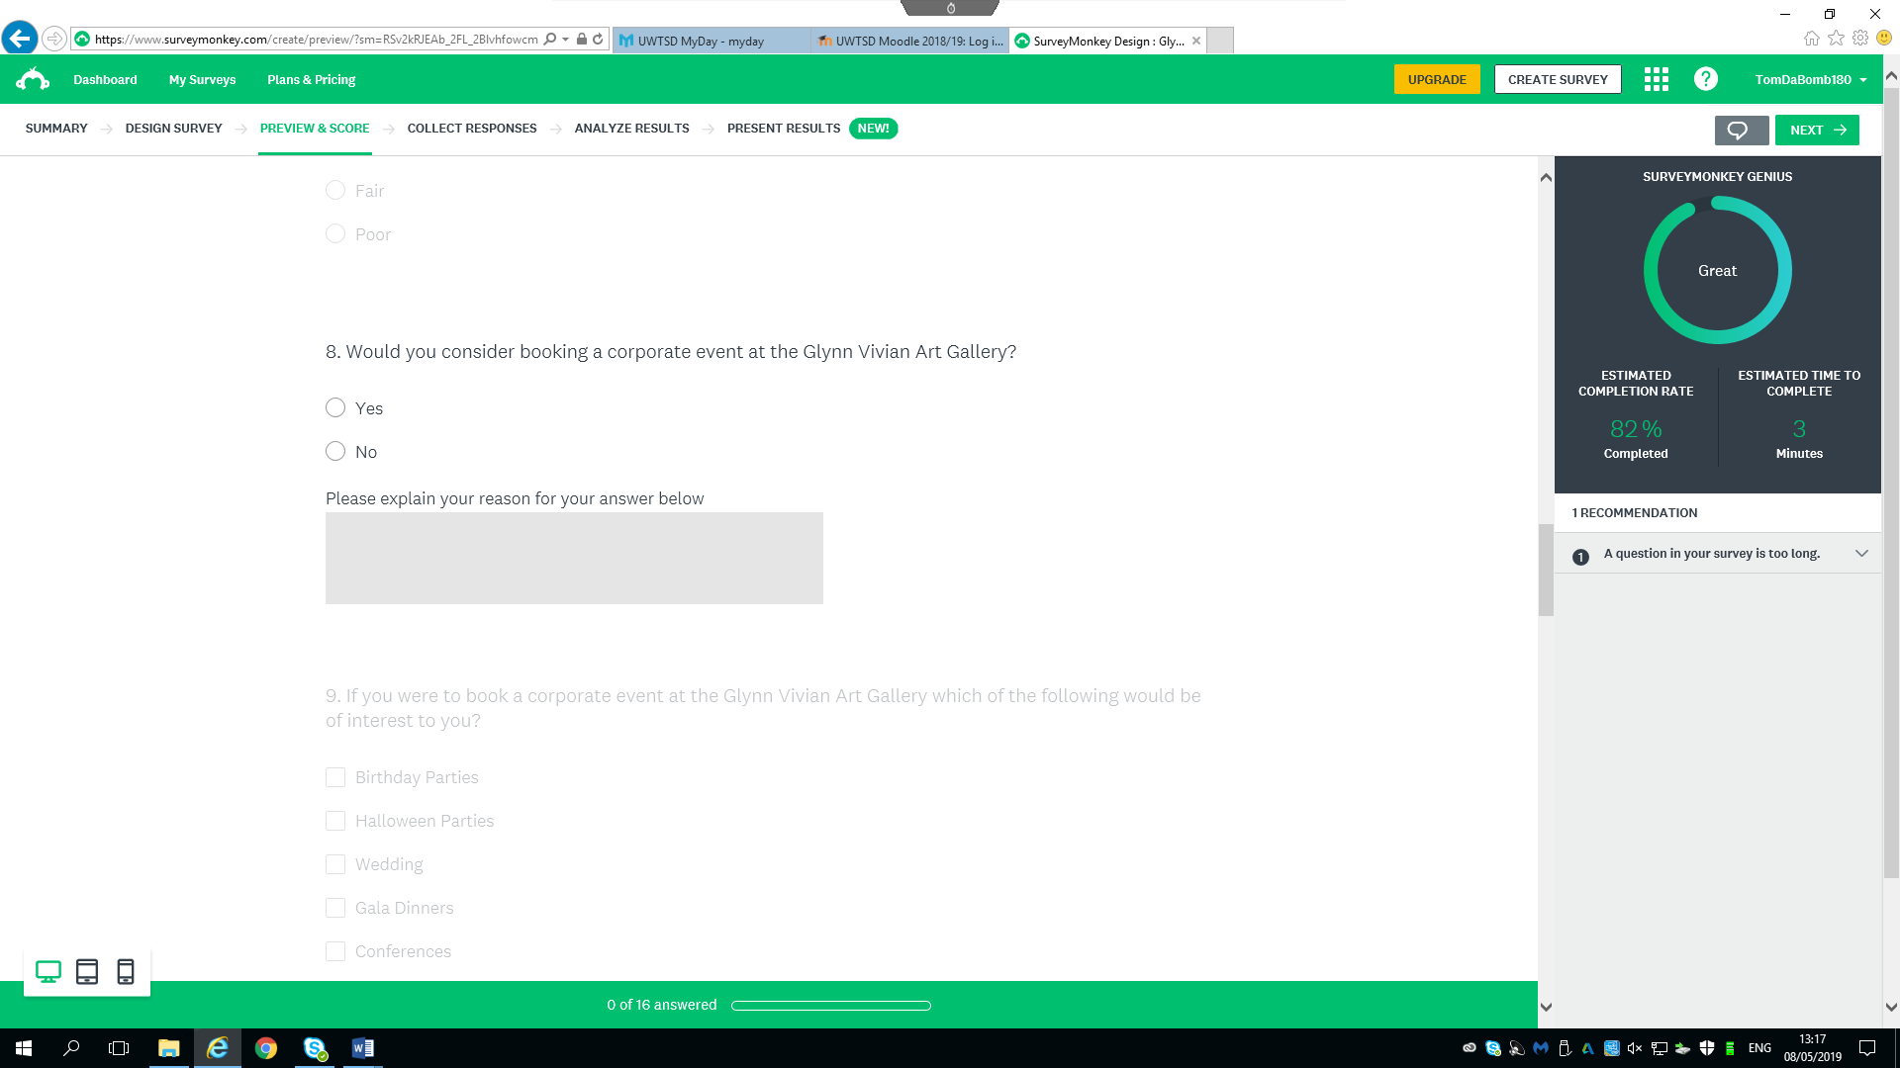
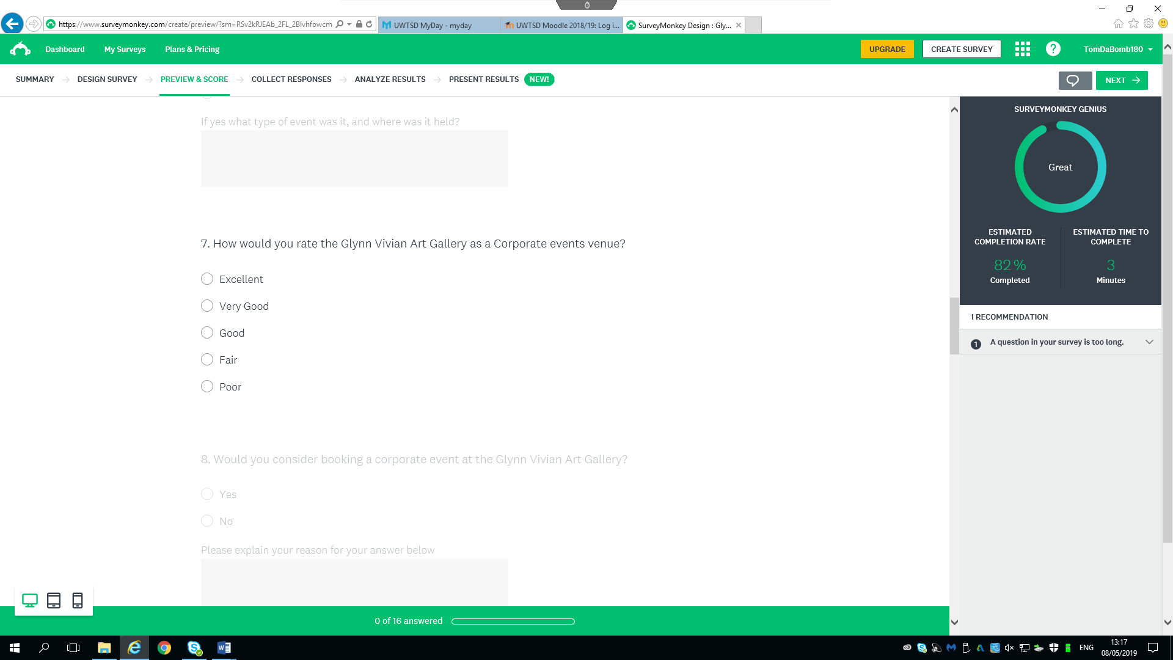
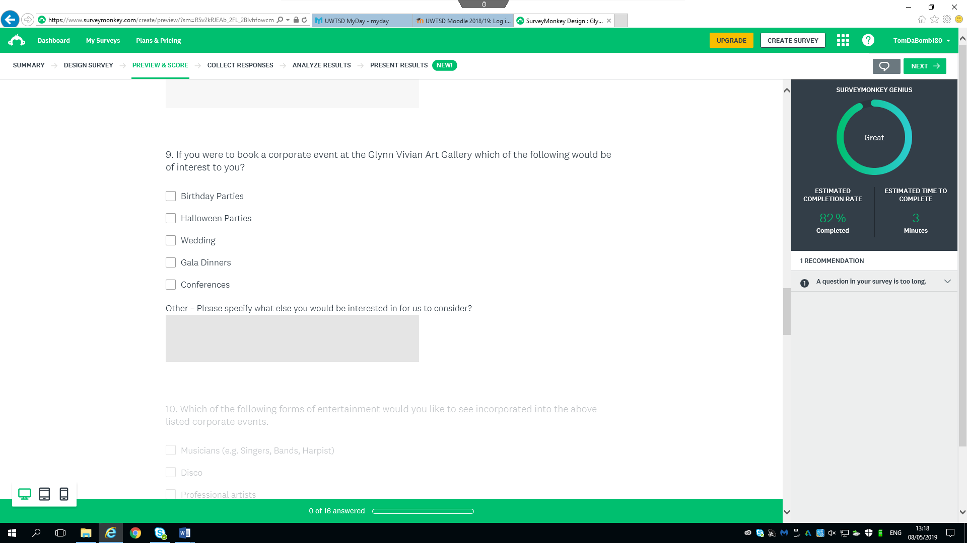

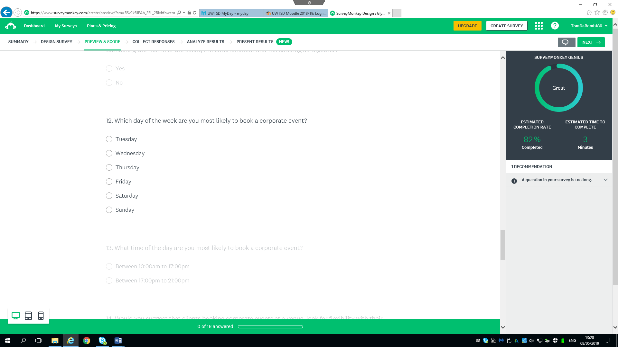
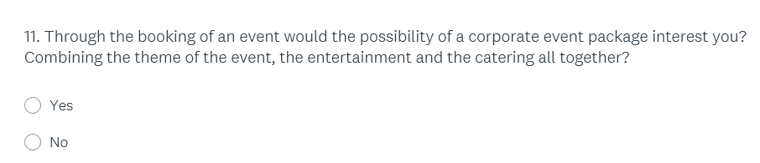
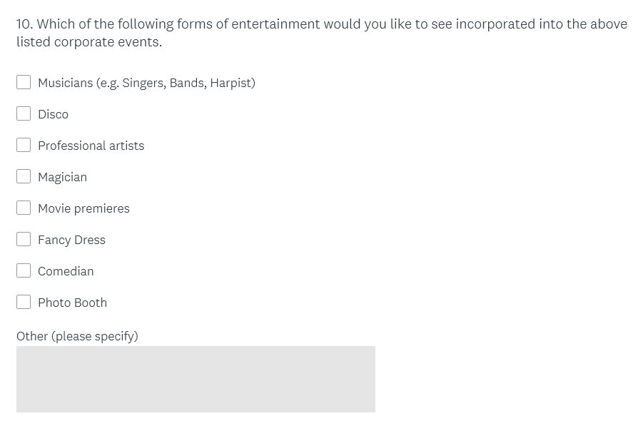
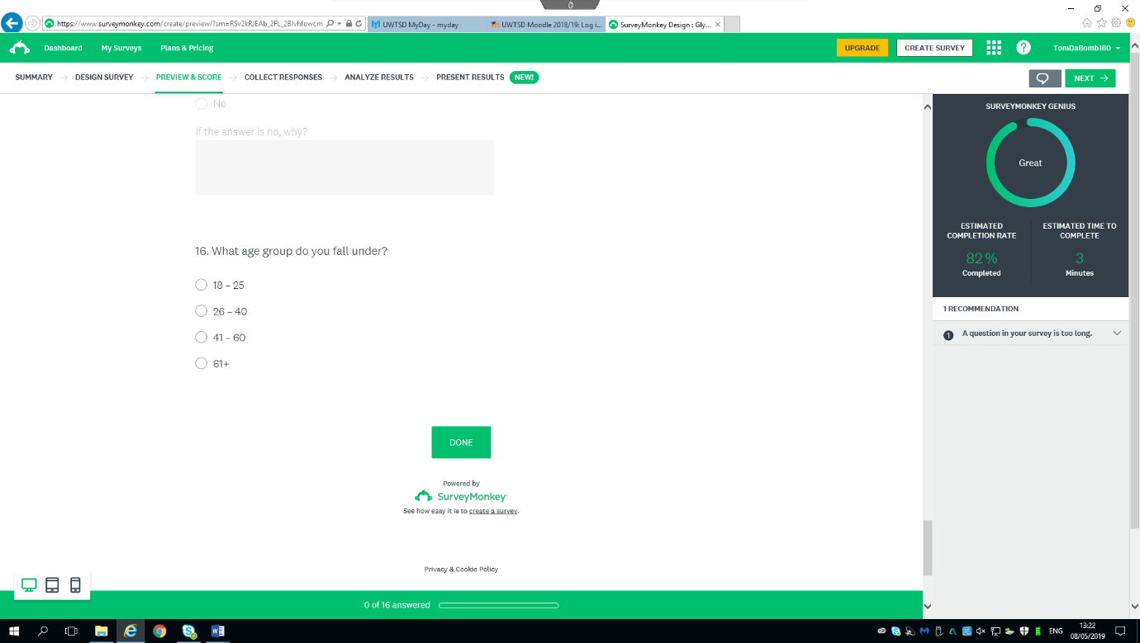
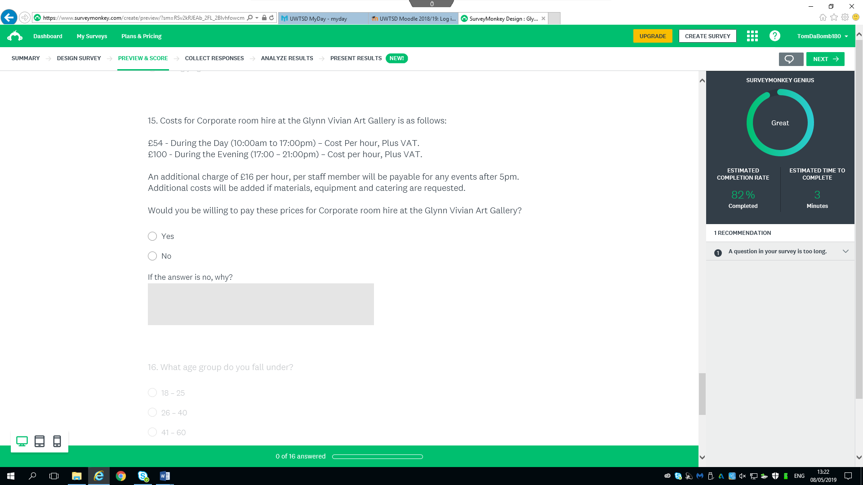
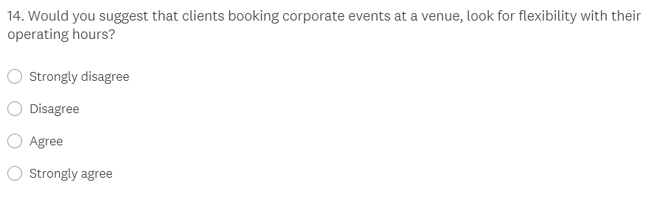
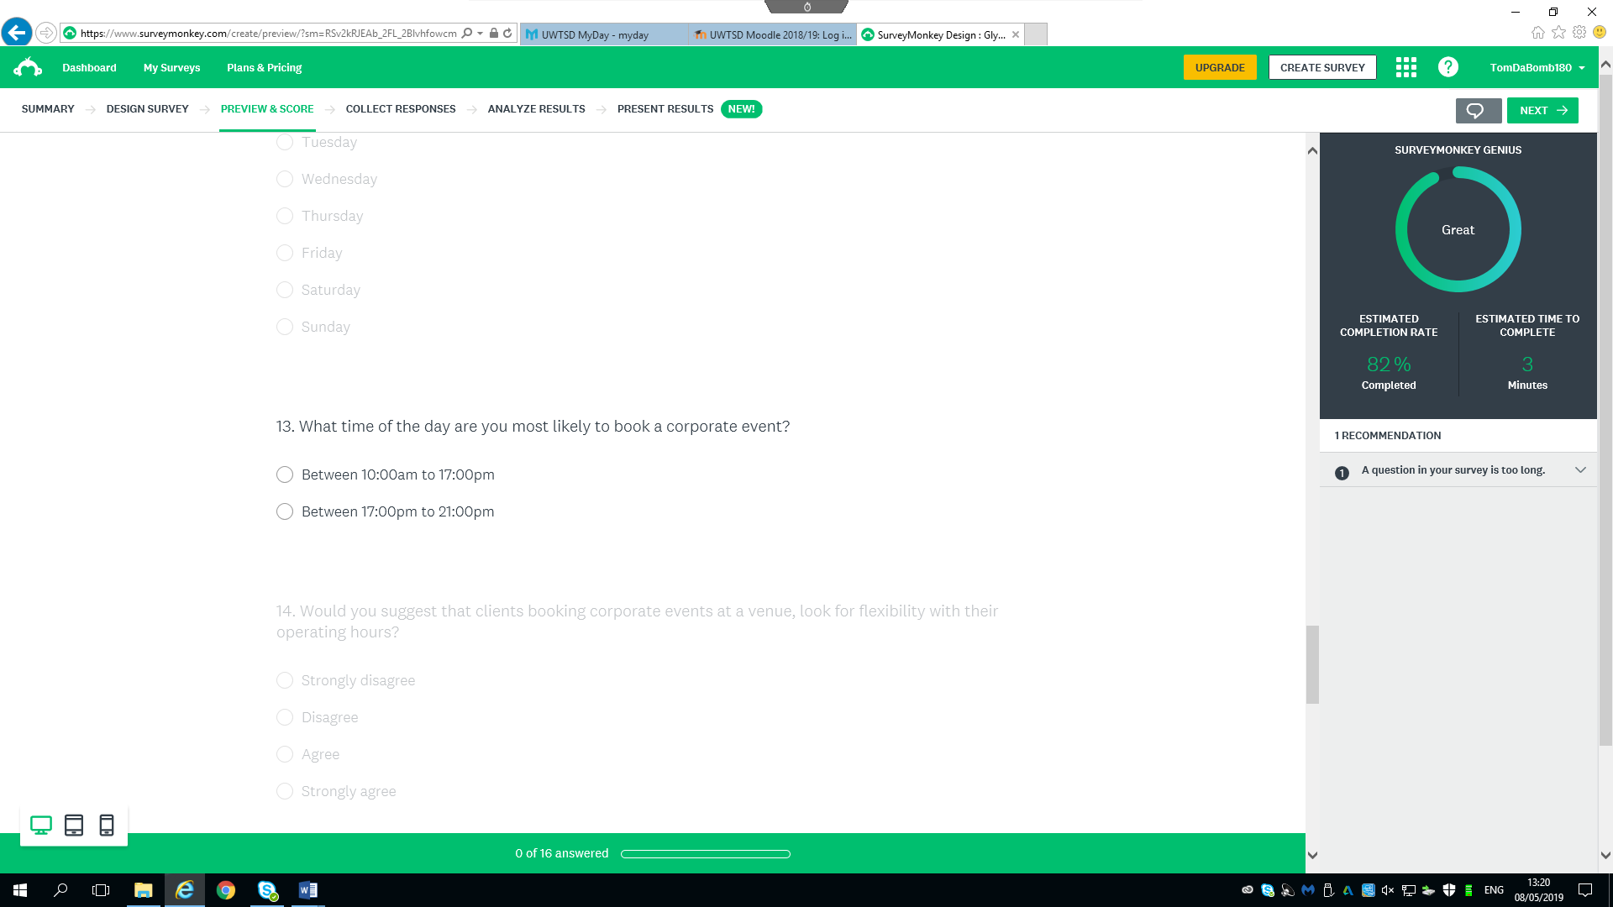

9.2 Appendix 2 – Meetings & Discussions with Client
Date | Discussion
21st February | First meeting with the client discussing possible project to move forward with.
27th February | Bid Presentation initial ideas about the project moving forward.
7th March | Second meeting with client, refining the aim and objectives was the first discussion then establishing the right research methods moving forward and for the second stage of the process.
13th March | Email, the client emailed the consultant sharing news about the gallery being asked to look into the costs of hiring the Gallery for a wedding in 2020, and the client stated that this proposed project is a timely one and will support the business for their market research.
18th March | Project Initiation Document (PID)
21st March | Next meeting with client to discuss details about hiring the venue for corporate events.
3rd April | Finalising questions for Online Survey before distributing to the public
13th May | Final Consultancy report

