BA (Hons) Leadership and Management Skills for the Workplace

Developing Emotional Intelligence Skills
Module Code: LCLM5006

Student name: Halima Hussein

Student ID: 2409649
Table of Contents
1. Introduction 4
2. Task 1: Emotional Intelligence in the Workplace 5
2.1 Defining Emotional Intelligence 5
2.2 Goleman’s Emotional Intelligence Framework 6
2.3 Mayer and Salovey Ability Model 7
2.4 Bar-On Emotional-Social Intelligence Model 8
2.5 Application of Emotional Intelligence in the workplace 10
2.6 Critical Discussion 10
3. Task 2: Managing a Multigenerational Workforce 12
3.1 Overview of Generations 12
3.2 Comparison of Generational Differences 13
3.3 Impact on Organisational Effectiveness 15
3.4 Using Emotional Intelligence and Mindfulness to Manage Generational Diversity 16
4. Recommendations 18
4.1 Implement Emotional Intelligence Training 18
4.2 Introduce Mindfulness Workshops 18
4.3 Establish Cross-Generational Mentoring 18
4.4 Develop Inclusive Leadership Practices 18
4.5 Integrate EI into Recruitment Processes 18
5. Conclusion 19
References 20

LIST OF FIGURES
Figure 1: Emotional Intelligence 5
Figure 2: Key components of emotional intelligence in leadership 6
Figure 3: Mayer and Salovey Ability Model 8
Figure 4: Bar-On Emotional Quotient Inventory (EQ-i) framework 9
Figure 5: Managing a Multigenerational Workforce 12
Figure 6: Generational differences in the workplace 14

LIST OF TABLES
Table 1: Three emotional intelligence models 10

1. Introduction
Emotional intelligence (EI) has emerged as a skill that employees and managers should have in this current workplace (Alaql et al., 2023). Emotional intelligence is a concept that suggests that someone can comprehend and know how to handle emotions and react to them. Employers are naturally seeking employees with high emotional intelligence as they tend to have better communication skills, work well in a team, solve problems, and manage problems at work. Mindfulness, along with emotional intelligence, has become an issue of great concern in contemporary organisations. Mindfulness is the complete awareness of what is happening now without making judgments (Abdullah Alaql et al., 2023). Meanwhile, organisations are finding themselves employing representatives of various generations, such as Generation X, Millennials (Generation Y), and Generation Z. The values, communication preferences, and demands of work are not the same in each generation.
This report will critically look at the contribution of emotional intelligence and mindfulness to modern organisations. It will review key models of emotional intelligence and ways that emotional intelligence can enhance performance in the workplace, communication, leadership and decision making. The report will also explain the nature of various generations within the workforce and explain how emotional intelligence and mindfulness can help managers to develop an inclusive, productive and supportive workplace.

2. Task 1: Emotional Intelligence in the Workplace

2.1 Defining Emotional Intelligence
Emotional Intelligence (EI) can be defined as employing emotions in others and ourselves to manage, comprehend, and identify emotions. EI is applicable in the workplace and assists employees in the workplace to be clear in their communications, work as a team and respond well to situations (Ayele and Barchard, 2024). Emotional intelligence has turned out to be a significant variable in the success of organisations, as organisations are inclining more towards paying attention to teamwork and the well-being of their employees.
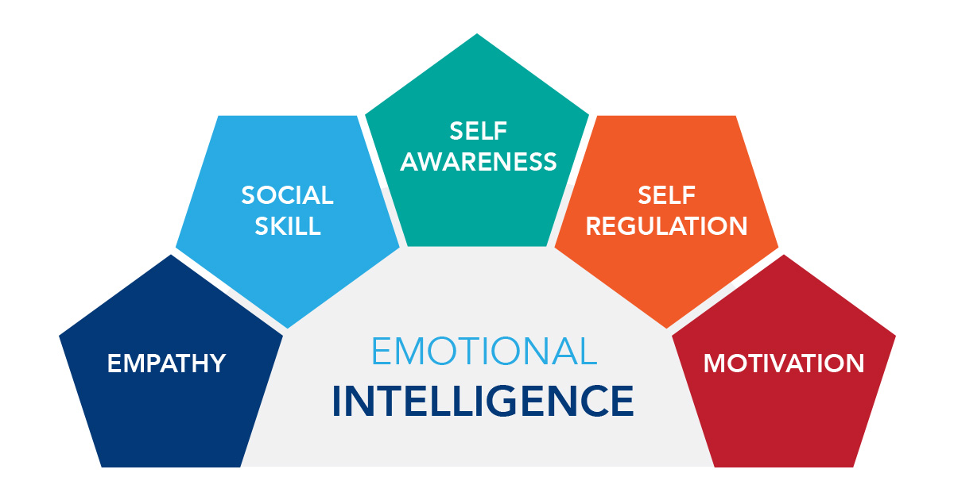
Figure 1: Emotional Intelligence
(Source: Uluç, 2026)
Various researchers have come up with the definition of emotional intelligence. Goleman defined EI as a combination of emotional and social skills that determine performance in the workplace and as a leader. EI is the capacity to perceive, comprehend, utilise and manipulate emotions (Bonde et al., 2024). They are defined based on emotional skills, but not personality traits. On the same note, EI is considered to be a mixture of both emotional and social skills, which enable a person to deal with environmental pressures and demands. The differences differ as much as the similarities of the elements in these definitions. The fact that EI is a quantifiable skill makes the model designed by Mayer and Salovey more scientific. The framework by Goleman is more comprehensive and applicable in the workplace, whereas the model developed by Bar-On has more personality-related traits like optimism and adaptability.

2.2 Goleman’s Emotional Intelligence Framework
The most popular framework of Emotional Intelligence in organisations is that of Goleman. It comprises five main parts: self-awareness, self-regulation, motivation, empathy and social skills.
Self-awareness means the ability to be aware of one's feelings and how this impacts one's behaviour. Having high self-awareness, employees can understand their strengths and weaknesses and make more informed decisions (Buasuwan, 2023). Self-regulation entails the ability to control emotional responses and be calm in stressful events.
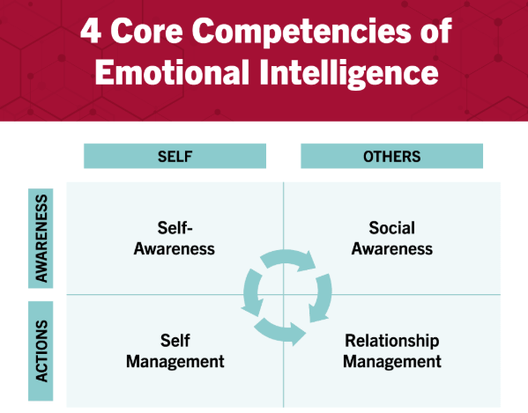
Figure 2: Key components of emotional intelligence in leadership
(Source: Harvard Business School Online, 2026)
Motivation is the internal force behind every goal attainment and good performance. Well-motivated employees have a tendency to be loyal, strong and energetic. Empathy is the skill to comprehend the emotions and viewpoints of others (Johar et al., 2023). Social skills include effective communication, resolution of conflicts, and working together with others.
The simplicity and practicality of the Goleman framework are key strengths. The model can be applied to leadership development and training of the employees directly, and it is simple to understand. It has been utilised in most organisations to enhance teamwork, communication and effectiveness in leadership.
Nevertheless, there are flaws in the model. There is an overlapping number of elements with personality traits, and it is hard to tell emotional intelligence and general behaviour. Moreover, comprising these competencies can prove to be difficult to quantify scientifically since tests usually are based on self-report. Irrespective of these shortcomings, the framework by Goleman is very relevant since it gives realistic directions guiding the enhancement of relationships and performance at the workplace.

2.3 Mayer and Salovey Ability Model
The Mayer/Salovey Ability Model considers emotional intelligence to be a collection of emotion-related cognitive abilities. The model is made up of four arms: perceiving emotions, using emotions, understanding emotions, and managing emotions.
Perceiving emotions entails identifying emotions in people and the self by comparing the faces of people and their body language. Using emotions is the use of emotions to think and resolve problems (Ke et al., 2024). The perception of emotions entails the realisation of the dynamics and interaction of emotion with time.
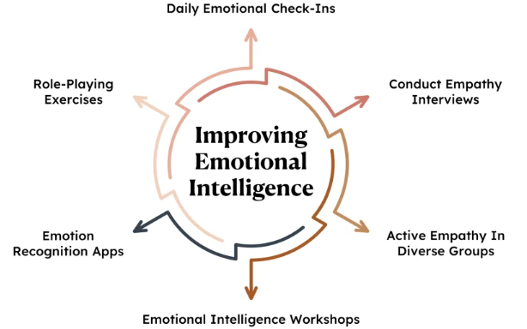
Figure 3: Mayer and Salovey Ability Model
(Source: Kapable, 2026)

The scientific basis of the model presents a significant strength of the model. As opposed to other models, it does not assume emotional intelligence is a collection of personality traits but is a measurable ability. This renders it more objective and accommodates academic studies. The model also describes that emotional abilities can enhance communication and decision-making. In fact, one can use the example of a manager who comprehends employee emotions accurately and adjusts communication strategies to bring about more knowledge and collaboration. Yet, the model puts more emphasis on emotional skills and is less concerned with broader social skills and behaviours at the workplace.

2.4 Bar-On Emotional-Social Intelligence Model
The model of emotional intelligence is a broader approach to intelligence that is taken by Bar-On in his Emotional-Social Intelligence Model. The model consists of five dimensions: intrapersonal skills, interpersonal skills, stress management, adaptability and general mood.
The skills of intrapersonal are self-confidence, self-awareness, and emotional expression. The interpersonal skills emphasise empathy, social responsibility and relationship building. Stress management can be defined as the skill of responding to pressure and managing emotional responses (Petrou et al., 2024). Adaptability means to adapt to change and be able to resolve problems. General mood encompasses optimism and positive thinking.
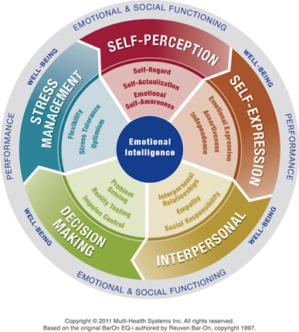
Figure 4: Bar-On Emotional Quotient Inventory (EQ-i) framework
(Source: LEADx, 2025)
The widespread applicability of its model in the workplace is a strength of the Bar-On model. This fact is enhanced by the fact that it has adaptability and stress management, which are especially useful in contemporary organisations where employees encounter perpetual change and uncertainty. Those employees who display high emotional-social competencies tend to be more competent in dealing with challenges as well as have a good relationship in the workplace. Although the model is strong, it has been criticised for overlapping with personality traits. Personality traits like optimism and happiness could be a result of personality and not emotional intelligence (Petrou et al., 2024).

2.5 Application of Emotional Intelligence in the workplace
EI is very important in enhancing performance in the workplace as well as organisational performance. Communication is one of such areas. Highly emotionally intelligent employees and managers are more capable of identifying the cues of feelings and conveying them in a much better way. As an illustration, managers who are aware of the issues of their employees may give them the necessary support and feedback, which will result in a good relationship at the workplace. Emotional intelligence helps in effective conflict management too. Conflicts at the workplace are analogous, yet the ability to empathise and control certain emotional factors can give people the necessary intelligence to comprehend opposing views and resolve conflicts productively.
Employee engagement and motivation are closely related to emotional intelligence in the context of leadership. Empathy, self-awareness and social skills in a leader have been known to make the leader more effective in working with their team, inspiring their support. Leaders who can comprehend the needs and emotions of employees tend to be trusted and followed more by the employees (Schutte and Meynadier, 2024). Another aspect where emotional intelligence comes in handy is in decision-making. Making effective decisions involves a balance between logic and emotions. Highly emotionally intelligent employees are able to take into account the emotional factors without letting emotions take the centre of the stage, leading to decisions being made in a more balanced and learned manner.

2.6 Critical Discussion
The three emotional intelligence models offer various insights into comprehending emotions at the workplace.
Table 1: Three emotional intelligence models
(Source: Self-generated)
Model | Strengths | Weaknesses
Goleman | Practical and easy to apply in leadership | Less scientific and difficult to measure
Mayer & Salovey | Research-based and scientifically grounded | Focuses mainly on emotional abilities
Bar-On | Holistic and workplace-oriented | Overlaps with personality traits
The models provide useful information on emotional intelligence. However, the framework by Goleman seems to be the most helpful in an organisational context as it deals directly with leadership, communication, teamwork and performance in the workplace. Although Mayer and Salovey offer a more scientifically based model and Bar-On offers a wider angle of view, the model suggested by Goleman can be most efficiently used in the workplace environment (Tiwari, 2023).

3. Task 2: Managing a Multigenerational Workforce

3.1 Overview of Generations
The current organisations hire individuals of various generations who bring with them some different experiences, values and expectations in their workplace.
Generation X
Generation X consists of those who were born between circa 1965 and 1980. This generation is said to be mostly independent, loyal, and keen on ensuring a healthy work-life balance (Piispanen and Rousi, 2024). After undergoing tremendous economic and technological transformation, members of Generation X are likely to enshrine job security, autonomy and pragmatic solutions. They mostly like to have straight organisational systems and like the chances of working on their own.
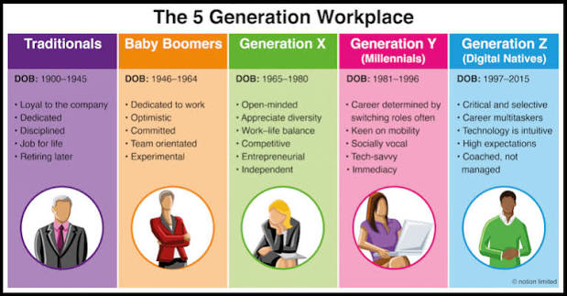
Figure 5: Managing a Multigenerational Workforce
(Source: Alauddin, Islam and Rahman, 2024)
Millennials (Generation Y)
Millennials are development-oriented, technologically friendly and cooperative, born around 1981-1996. They appreciate collaborating in teams, lifelong learning and professional development. Millennials would like to do meaningful work and have managers regularly assess them. Being a generation that has been nurtured in a fast-changing technology, they are at ease with the use of digital tools and also adjust to changing technologies in the workplace.
Generation Z
Generation Z is a term that is used to denote people who were born around the middle of 1997 to 2012. They are regarded as digital natives since they have been exposed to technology and the use of the internet at a tender age. In this generation, the areas of flexibility, diversity, inclusion, and working with life integration are highly valued (Li et al., 2024). Gen Z workers tend to be attracted to new work environments where they can work creatively, develop, and be socially responsible.

3.2 Comparison of Generational Differences
Values and Communication Preferences
There may be differences in value and communication styles of different generations in the workplace. The Generation X employees normally appreciate permanence, autonomy, and work experience. In most cases, they also like face-to-face communication as this enables one to interact directly and build relationships. Millennials tend to appreciate collaboration, teamwork and personal growth. They would love to communicate openly and get feedback regularly from the managers. Common team meetings and group discussions are some of the forms of collaborative communication that can be effective for this generation.
On the contrary, Generation Z would enjoy instant and electronic communication. They are not afraid to use messaging applications, social media and virtual communication tools. Their mode of communication is normally very rapid and technological. These variations can be a source of misunderstanding at times (Kycia et al., 2021). To illustrate, Generation X workers might interpret digital communication as depersonalised, whereas Generation Z might regard the old-fashioned way of communication as being efficient. As such, managers need to embrace adaptive communication strategies that can support the needs of all employees.
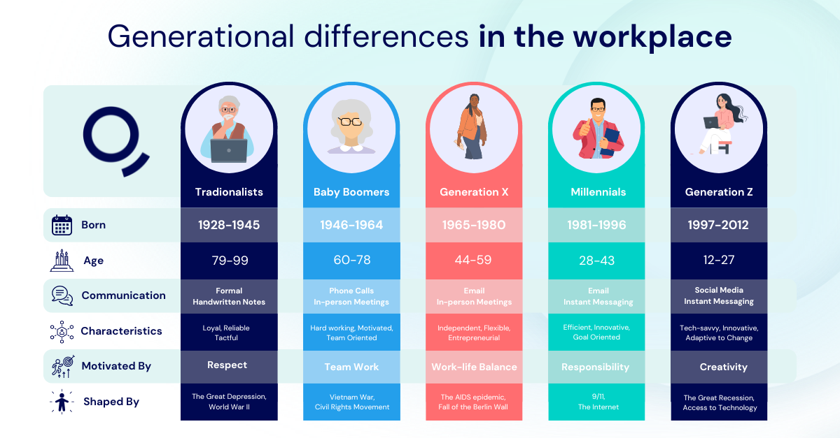
Figure 6: Generational differences in the workplace
(Source: Qualee, 2026)
Motivation
Other generations also differ in the motivation of the employees. Financial incentives, job security and work-life balance are some of the motivators most likely to attract Generation X employees. They like predictability and being appreciated due to their experience. The motivators among the millennials are those that provide prospects in career advancement, learning and professional development (Niemczynowicz, 2021). They usually want to join organisations that place emphasis on employee development and offer career progression. Most employees belonging to Generation Z are often driven by purposeful work. They desire to be employed in organisations that are socially responsible, diverse and ethical. They also enjoy flexibility and having a chance to make a significant contribution.
Technology Adaptability
There is a significant role of technology in contemporary workplaces. The use of digital tools by Generation Z and Millennials has made them fast learners of new technologies as a result of their upbringing. This is able to enhance productivity, innovation and efficiency in organisations.
Nevertheless, adoption of technology can pose challenges, as well. The new systems might need further support to sustain some Generation X employees as they learn new systems; several have been able to cope with change in technology throughout their careers. It is the role of organisations to offer the right training and resources so that every employee can take advantage of technological advancements.

3.3 Impact on Organisational Effectiveness
A multigenerational workforce may both positively and negatively impact organisational effectiveness.
Positive Impacts
Innovation is one of the key benefits. The presence of diverse employees based on different generations introduces a variety of experiences, worldviews, and ideas, which can enhance the level of creativity and problem-solving. When the old knowledge combined with the new ones is implemented, more novel solutions can be formulated. The other important advantage is knowledge sharing (Alaql et al., 2023). The Generation X employees who are still experienced can also impart some knowledge on the industry and give professional advice to the young employees. Simultaneously, Millennials and Generation Z have the capability to bring on new technologies and ways of working. Also, different points of view enhance decision-making. Intergenerational teams are also likely to take into consideration various perspectives when making decisions and therefore achieve a better and more balanced result.
Negative Impacts
Although this has brought about these advantages, the differences in age may also pose problems. Communication conflicts can arise when employees differ in their preferences for communication techniques and interactions in the workplace. Stereotyping is another issue. Staff can create stereotypes concerning others in relation to age, as opposed to personal skills. Stereotypes may decrease cooperation and cause divisions in the workplace. Organisational effectiveness can also be impacted by resistance to change (Abdullah Alaql et al., 2023). Older staff can be considered reluctant to the new technologies, and young employees can be considered inexperienced. These impressions are potentially a source of tension, and they may affect cooperation when not handled properly. Thus, organisations need to understand the strengths and limitations of generational diversity so as to get the most out of their workforce.

3.4 Using Emotional Intelligence and Mindfulness to Manage Generational Diversity
Mindfulness and emotional intelligence can be helpful in dealing with a multigenerational workforce. With good emotional intelligence, managers are able to comprehend the needs of their employees and establish good relationships and inclusivity in the workplace.
Self-Awareness
Self-awareness helps managers to see what they believe, assume and are likely biased towards various generations (Ayele and Barchard, 2024). Through this awareness, managers are now better placed to make more justifiable decisions when it comes to their hiring activities, performance and even promotions.
Empathy
Empathy helps managers to comprehend the views and expectations of employees of other generations. To illustrate, a manager who realises that Generation Z prefers flexibility as opposed to stability in Generation X can change management methods. This can assist in enhancing employee engagement and satisfaction.
Emotional Regulation
Emotional regulation enables managers to be in control during conflict situations at work, being calm and professional. Intergenerational differences can, in some cases, cause conflict, but as long as they are managed through emotional intelligence skills, the managers can effectively handle such tensions and can foster positive communication between people instead of emotional responses.
Mindfulness
Mindfulness makes managers be present, attentive and non-judgmental when relating with employees (Bonde et al., 2024). Mindful leadership reinforces inclusion, active listening, respect and psychological safety. When employees feel valued and respected, they will be more likely to volunteer freely and work in harmony with others.
Mindfulness and emotional intelligence in the recruitment process assist managers in eliminating unconscious bias and paying attention to unique skills and capabilities, as opposed to generation-related stereotypes. These skills are useful in employee management in terms of proper communication and the establishment of relationships. To maintain, when organisations promote emotionally intelligent and mindful leadership, there are high levels of employee satisfaction, high levels of engagement and low levels of turnover. Thus, emotional intelligence and mindfulness are important to develop a productive and inclusive multigenerational workforce.

4. Recommendations
The findings of this report suggest that organisations need to incorporate some strategies to enhance emotional intelligence, mindfulness, and generational inclusion at the workplace.

4.1 Implement Emotional Intelligence Training
Regular emotional intelligence (EI) training programs should be conducted for employees and managers in their organisations (Ke et al., 2024). Such programmes must also aim at instilling self-awareness, empathy, communication, and conflict management skills. Employees will have better decision-making, work in a team, and work better because of improved emotional intelligence.

4.2 Introduce Mindfulness Workshops
The level of stress, focus and emotional health of the employees should be addressed through mindfulness workshops. From this, regular mindfulness can help to establish a healthier workplace and diminish the threat of burnout.

4.3 Establish Cross-Generational Mentoring
Organisations are supposed to promote the idea of mentoring relationships amongst employees of various generations. It may facilitate the exchange of knowledge, foster a better working relationship, and enhance understanding between the Generation X, Millennials and Generation Z employees.

4.4 Develop Inclusive Leadership Practices
They should provide training to managers on inclusive leadership as a way of ensuring that they are aware of the generational differences and handling diverse teams. Inclusive leaders have the ability to foster a respectful culture, cooperation and equal opportunities for all employees.

4.5 Integrate EI into Recruitment Processes
The emotional intelligence should be measured during recruitment and selection procedures as well as at the level of technical abilities (Petrou et al., 2024). Companies should hire emotionally intelligent people as they can enhance communication, teamwork, adaptability and success of the organisation in the long run.

5. Conclusion
To sum up, emotional intelligence is a crucial skill in contemporary organisations since it facilitates efficient communication, collaboration, leadership, and decision-making. Highly emotionally intelligent employees and managers are more likely to comprehend and handle emotions, which plays a role in better performance at the workplace and better workplace relationships. Mindfulness is also critical since it can assist individuals to stay attentive, overcome stress, and balance emotions.

References
Abdullah Alaql, A., Alqurashi, F. and Mehmood, R. (2023) ‘Multigenerational labour markets: data-driven discovery of multi-perspective system parameters using machine learning’, arXiv e-prints. Available at: https://ui.adsabs.harvard.edu/abs/2023arXiv230210146A/abstract (Accessed: 25 June 2026).
Alaql, A.A., Alqurashi, F. and Mehmood, R. (2023) ‘Multigenerational labour markets: Data-driven discovery of multi-perspective system parameters using machine learning’, Science Progress, 106(4), p. 00368504231213788. Available at: https://journals.sagepub.com/doi/abs/10.1177/00368504231213788 (Accessed: 25 June 2026).
Alauddin, M., Islam, M.A. and Rahman, M.S. (2024) ‘The impact of emotional intelligence on employee performance and organisational effectiveness’, Educational Administration: Theory and Practice, 30(5), pp. 1–15. Available at: https://kuey.net/index.php/kuey/article/download/4438/2985/9833 (Accessed: 25 June 2026).
Ayele, F.A. and Barchard, K.A. (2024) 'Positive reappraisal and catastrophising mediate the relationship between mindfulness and job burnout', Discover Psychology, 4(1), p. 188. Available at: https://link.springer.com/article/10.1007/s44202-024-00229-z (Accessed: 25 June 2026).
Bonde, E.H., Mikkelsen, E.G., Fjorback, L.O. and Juul, L. (2024) 'Exploring an organisational-level mindfulness-based intervention in private workplace settings', mindfulness, 15(6), pp. 1453–1471. Available at: https://link.springer.com/article/10.1007/s12671-024-02375-w (Accessed: 25 June 2026).
Buasuwan, N. (2023) ‘Managing the multigenerational workforce and the future workplace’, Proceedings of the NIC-NIDA International Conference 2023. Available at: https://www.researchgate.net/profile/Napalai-Buasuwan/publication/377114624_Managing_the_multigenerational_workforce_and_the_future_workplace/links/65962f142468df72d3f96034/Managing-the-multigenerational-workforce-and-the-future-workplace.pdf (Accessed: 25 June 2026).
Harvard Business School Online, (2026). Emotional Intelligence in Leadership: Why It's Important. Available at: https://online.hbs.edu/blog/post/emotional-intelligence-in-leadership (Accessed: 25 June 2026).
Johar, E.R., Rosli, N. and Mohd Hamirudin, S.N.S. (2023) ‘Ageless collaboration: From Boomers to Gen Z, thriving in the era of multigenerational workforces’, International Journal of Academic Research in Business and Social Sciences, 13(12), pp. 2240–2242. Available at: http://dx.doi.org/10.46886/IJARBSS/v13-i12/7849 (Accessed: 25 June 2026).
Kapable (2026) Emotional Quotient vs Intelligence Quotient. Kapable. Available at:https://kapable.club/blog/emotional-intelligence/emotional-quotient-vs-intelligence-quotient/ (Accessed: 25 June 2026)
Ke, S.W., Tsai, C.F. and Chen, Y.J. (2024) ‘Managing emotion in the workplace: an empirical study with enterprise instant messaging’, Applied Artificial Intelligence, 38(1), p. 2297518. Available at: https://www.tandfonline.com/doi/abs/10.1080/08839514.2023.2297518 (Accessed: 25 June 2026).
Kycia, R.A., Niemczynowicz, A. and Nieżurawska-Zając, J. (2021) 'Towards the global vision of engagement of Generation Z at the workplace: Mathematical modelling', arXiv Preprint. Available at: https://arxiv.org/abs/2112.15401 (Accessed: 25 June 2026).
LEADx (2025) The Reuven Bar-On Emotional Quotient Inventory (EQ-i): What It Is, Why It Matters, How To Use It. Available at: https://leadx.org/articles/bar-on-emotional-quotient-inventory-eq-i/ (Accessed: 25 June 2026).
Li, J., Cochrane, K.A. and Leshed, G. (2024) ‘Beyond meditation: understanding everyday mindfulness practices and technology use among experienced practitioners’, Proceedings of the ACM on Human-Computer Interaction, 8(CSCW2), pp. 1–29. Available at: https://dl.acm.org/doi/abs/10.1145/3687023 (Accessed: 25 June 2026).
Lima, D., Spahi, J. and Shala, V. (2022) ‘The management of emotional intelligence in the workplace impact on improving employee performance’, Calitatea, 23(188), pp. 297–301. Available at: https://www.researchgate.net/profile/Jyxhel-Spahi/publication/361152081_The_management_of_emotional_intelligence_in_the_workplace_impact_on_improving_employee_performance/links/629fc1e8a3fe3e3df86529b3/The-management-of-emotional-intelligence-in-the-workplace-impact-on-improving-employee-performance.pdf (Accessed: 25 June 2026).
Niemczynowicz, A. (2021) Towards the global vision of engagement of Generation Z at the workplace: Mathematical modeling. Available at: https://ideas.repec.org/p/arx/papers/2112.15401.html (Accessed: 25 June 2026).
Ömer Saltukalp Uluç (2026) A Milestone of Intelligent Development: Daniel Goleman's Emotional Intelligence Theory. Experianta. Available at: https://experianta.com/directory/concepts/a-milestone-of-intelligent-development-daniel-golemans-emotional-intelligence-theory/ (Accessed: 25 June 2026)
Petrou, P., Xanthopoulou, D. and Mäkikangas, A. (2024) 'Mindfulness and proactivity: friends or enemies? Latent profiles and relationships with task performance and creativity, Current Psychology, 43(34), pp. 27664–27679. Available at: https://link.springer.com/article/10.1007/s12144-024-06336-3 (Accessed: 25 June 2026).
Piispanen, J.R. and Rousi, R. (2024) ‘Emotion AI in workplace environments: A case study’, in International Conference on Software Business. Cham: Springer Nature Switzerland, pp. 142–148. Available at: https://link.springer.com/chapter/10.1007/978-3-031-85849-9_12 (Accessed: 25 June 2026).
Qualee (2026) Harnessing the Strengths of Each Generation in the Workplace. Available at: https://www.qualee.com/blog/harnessing-the-strengths-of-each-generation-in-the-workplace (Accessed: 25 June 2026).
Schutte, N.S. and Meynadier, J. (2024) ‘A model of connections between positive characteristics: Emotional intelligence links mindfulness to positive characteristics with emotion elements’, Trends in Psychology, pp. 1–11. Available at: https://link.springer.com/article/10.1007/s43076-024-00371-6 (Accessed: 25 June 2026).
Tiwari, A. (2023) ‘A Study on Emotional Intelligence at Workplace’, Revista Internacional de Investigación Multidisciplinaria, 1. Available at: https://pdfs.semanticscholar.org/83e3/7048eaacbf0ce584f6dddc2b022293ce4c4a.pdf (Accessed: 25 June 2026).

