Student Name: Poamaneagra Bianca-Mihaela
Student number: 1809876
Module lecturer’s Name: Joy Botu
Module code: LCBB5005
Module name: Project Management

Table of Contents
Project Background 2
Project aim 3
Project objectives 3
Project deliverables 4
Strategic alignment 4
Project schedule 4
Project Scope 6
Project Requirements 6
Project Cost 7
Timeline 8
Human Resources 9
Risk management 10
Quality Control 12
Communication plan 12
References 16

Project Background
The use of the Prince2 methodology is deemed as one of the popular choices among the developers when it comes to software development (Matos and Lopes, 2013). It is attributed to the fact that it is vested with the proficiencies of thorough planning. The task of developing appropriately functioning software is arduous one and requires intensive planning in order to create the application module that instantiates on the smooth operation of the API request. The requirements of such adequate planning make the project methodology of Prince2 methodology to be proper integration within the software development project. It has been realised that the implications of the Prince 2 methodology is extremely necessary to the development of the well managed program (Vaníčková, 2017).
The development of software application involves the integration of the front end and backend services. Each of the services is developed separately and is prepared in sequential process. it mandates the use of proper timeline and milestone that helps in accomplishing the integration of both the services at the stipulated deadline. Thus it makes a necessity that the tasks are planned in stages in order to make seamless of the front end services to the database structures. It has been realised that the prospect of the proper software development is associated with the efficiency of the Work Breakdown Structure. The accomplishment of such requirements is met if the project follows the principle of the Prince2 methodology, which states that the work should, planned in stages. The principle lays down the platform where the PRINCE2 projects are fragmented into individual work phases by monitoring the project with the implementation of the periodic reviews that record observations and assures the project is on course to accomplish requirements (Tomanek and Juricek, 2015).
The graphical user interface is developed by the frontend software developers whereas the development of the database structure falls under the responsibilities of the backend developers. The integration of the frontend and the backend services is done through the help of the Application Interface Programming (API). The development of the API requires a collaborative approach of the backend developers and frontend developers in order to create the proper algorithm and the POST requests. Thus the perplexing nature of responsibilities beckons the implementation of segmentation of the roles and the responsibilities with transparency and clarity. The provision of such segmentation is synonymous with the principle of Prince2 methodology which implies that the Roles and responsibilities are clearly defined and can be achieved only if the software development project follows this project methodology (Mousaei and Javdani, 2015).
In the competitive IT sector, one of the major facets that are asserted by the software development project; is its ability to amplify the business profits and its capacity of delivering on the domains of the business justification. The software development project is associated with cost intensive ventures and is required to reflect on an increased Return of Investment (ROI) in order to elevate the indexes of the project feasibility. The aspects could be actuated if the project is in alignment with the principles of the Prince2 methodology that sheds importance on the fact, which implies the projects must have business justification. It states that the project must be endowed with the realistic benefits, comprehensive cost assessment and customer requirement accomplishment. It has been understood the procurement of the backend services is associated with high amount of capital investment. Thus the selection of the appropriate database services is critical to the project’s feasibility in the financial terms as well as imparts a positive reflection on the cost benefit analysis.
Project aim
The aim of this project is to develop a project management plan with Prince 2 methodology in order to develop a software program by the company within six months with the help of a new and innovative software.
Project objectives
The major objectives of this project are as follows:
- To understand the importance of Prince 2 methodology in the development of prject management plan
- To analyse the requirements and deliverables of the project of software development
- To determine the time and cost for the successful completion of the project of software development
- To discuss the risks and communication plan regarding the software development project along with quality control strategy
Project deliverables
In this project of software development, the major project deliverables is to line up the project to different objectives and strategies of the company with the software development. The project deliverables for this project is to determine the milestones and schedule the entire project as per the requirements of the project. Moreover, the deliverables include determination of costs and timeline along with human resource management and risk management for the software development project of a company (Niazi et al., 2016). Apart from these, there are two more deliverables of this, which include quality controlling and planning a communication strategy for the project.
Strategic alignment
The strategic alignment of this software development project is associated with the determination of financial goals and improving the market share by the enhancing the services of software development with their innovative tools. For the development of strategic alignment regarding the software development project, the most important thing is understanding the rationale behind different challenges (Tomanek and Juricek, 2015). With the strategic alignment, the project manager will be able to develop various policies related to this project and take serious decisions for the risks or challenges. The strategic alignment of this project is depended on three major aspects of the society, which includes political, social as well as economic aspects.
Project schedule
WBS | Task Name | Duration | Start | Finish | Predecessors
1 | Software development | 96 days | Mon 12/2/19 | Mon 4/13/20
1.1 | Initiation of the project | 9 days | Mon 12/2/19 | Thu 12/12/19
1.1.1 | Hiring the developers | 3 days | Mon 12/2/19 | Wed 12/4/19
1.1.2 | Board of directors meeting | 2 days | Mon 12/2/19 | Tue 12/3/19
1.1.3 | AS-IS documenting | 1 day | Wed 12/4/19 | Wed 12/4/19 | 4
1.1.4 | TO-BE documenting for the software development | 2 days | Thu 12/5/19 | Fri 12/6/19 | 5
1.1.5 | Functioning as per specifications | 1 day | Mon 12/9/19 | Mon 12/9/19 | 6
1.1.6 | Project Charter approval | 3 days | Tue 12/10/19 | Thu 12/12/19 | 7
1.2 | Project Planning | 11 days | Fri 12/13/19 | Fri 12/27/19 | 2
1.2.1 | Identification of the project objectives | 2 days | Fri 12/13/19 | Mon 12/16/19
1.2.2 | Setting of the project goals | 3 days | Tue 12/17/19 | Thu 12/19/19 | 10
1.2.3 | Scope determination | 2 days | Fri 12/20/19 | Mon 12/23/19 | 11
1.2.4 | Preparation of the research checklist | 1 day | Tue 12/24/19 | Tue 12/24/19 | 12
1.2.5 | Development of the timeline | 1 day | Wed 12/25/19 | Wed 12/25/19 | 13
1.2.6 | Allocation of the Project Budget | 2 days | Thu 12/26/19 | Fri 12/27/19 | 14
1.3 | Data Analysis | 9 days | Mon 12/30/19 | Thu 1/9/20 | 9
1.3.1 | Software requirement analysis | 3 days | Mon 12/30/19 | Wed 1/1/20
1.3.2 | Gap analysis | 2 days | Thu 1/2/20 | Fri 1/3/20 | 17
1.3.3 | Vulnerability analysis for the software | 4 days | Mon 1/6/20 | Thu 1/9/20 | 18
1.4 | Budget analysis | 44 days | Fri 1/10/20 | Wed 3/11/20 | 16
1.4.1 | Cost of tools | 4 days | Fri 1/10/20 | Wed 1/15/20
1.4.2 | Cost of model analysis | 1 day | Thu 1/16/20 | Thu 1/16/20 | 21
1.4.3 | Allocation of Resource time | 7 days | Fri 1/17/20 | Mon 1/27/20 | 22
1.4.4 | Analysis of the Budget limitations | 5 days | Tue 1/28/20 | Mon 2/3/20 | 23
1.4.5 | Collection of budget data | 5 days | Tue 2/4/20 | Mon 2/10/20 | 24
1.4.6 | Analysis as per the software requirements | 7 days | Tue 2/11/20 | Wed 2/19/20 | 25
1.4.7 | Cost model analysis before and after | 5 days | Thu 2/20/20 | Wed 2/26/20 | 26
1.4.8 | Analysis of the Budget feedback | 8 days | Thu 2/27/20 | Mon 3/9/20 | 27
1.4.9 | Modifications according to feedback | 2 days | Tue 3/10/20 | Wed 3/11/20 | 28
1.5 | Challenge analysis | 12 days | Thu 3/12/20 | Fri 3/27/20 | 20
1.5.1 | Sustainability analysis | 2 days | Thu 3/12/20 | Fri 3/13/20
1.5.2 | Assessment of external factors | 2 days | Mon 3/16/20 | Tue 3/17/20 | 31
1.5.3 | Changes required for the software development | 1 day | Wed 3/18/20 | Wed 3/18/20 | 32
1.5.4 | Analysis of the feedback | 4 days | Thu 3/19/20 | Tue 3/24/20 | 33
1.5.5 | Feedback alterations | 2 days | Wed 3/25/20 | Thu 3/26/20 | 34
1.5.6 | Project validation | 1 day | Fri 3/27/20 | Fri 3/27/20 | 35
1.6 | Project closure | 4 days | Mon 3/30/20 | Thu 4/2/20 | 30
1.6.1 | Project submission | 4 days | Mon 3/30/20 | Thu 4/2/20
Table 1: Work Breakdown structure for project of software development
Project Requirements
Particulars | Quantity
Firebase Database Services Subscription | 1 year
LAN card | 4 pieces
Server | 3 pieces
Modem | 2 pieces
Frontend developer | 3 candidates
Table 2: Project Requirements
Project Cost
Project Budget for the software development project
Analysis Variables:
Discount Rate Used | 5.00%  £ 62,000.00  £ 9,560.00  £ 93,000.00
Annual Benefits
Annual Maintenance Cost
One-Time Development Cost
 |  |  |  | Year of Software development
 |  | 0 | 1 | 2 | 3 | TOTALS
Economic Benefit |  | £72,556.00 | £ 21,670.00 | £ 20,450.00 | £ 15,400.00
Discount Rate |  | 1.000 | 0.914 | 0.847 | 0.772
PV of Benefits |  | £82,5560.00 | £16,546.62 | £16,453.60 | £11,340.75
NPV of all BENEFITS |  | £92,556.00 | £ 106,768.62 | £ 126,223.22 | £ 135,568.98 | £461,115.82
One-Time COSTS |  | £ (126,000.00)
Recurring Costs |  | £0.00 | £ (9,760.00) | £ (9,760.00) | £ (9,760.00)
Discount Rate |  | 1.0000 | 0.9174 | 0.8417 | 0.7722
PV of Recurring Costs |  | £0.00 | £ (8,235.88) | £ (7,443.12) | £ (6,920.65)
NPV of all COSTS |  | £ (126,000.00) | £ (132,432.88) | £ (141,332.00) | £ (145,781.65) | £ (545,546.53)
Overall NPV |  |  |  |  |  | £ (503,331.71)
Overall ROI
 |  |  |  |  |  | -21453.677
Break-even Analysis
Yearly NPV Cash FLOW |  | £ (35,000.00) | £ 10,561.74 | £ 9,342.48 | £ 4,576.10
Overall NPV Cash FLOW |  | £ (35,000.00) | £ (24,756.26) | £ (15,752.78) | £ (11,324.68)
Table 3: Budget analysis for the software development project
Timeline
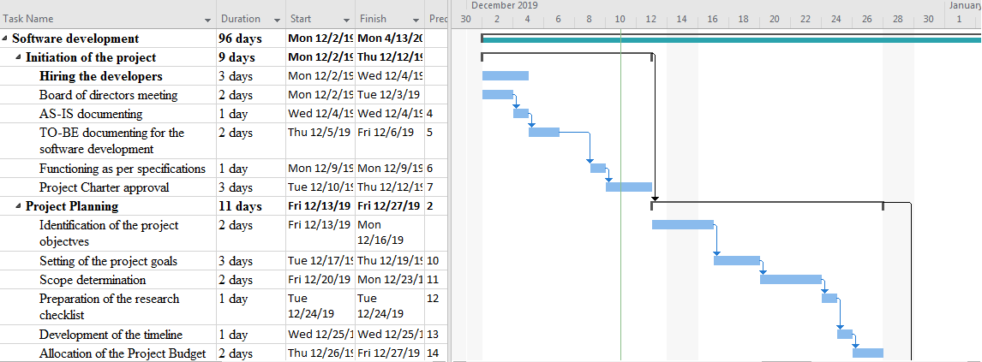
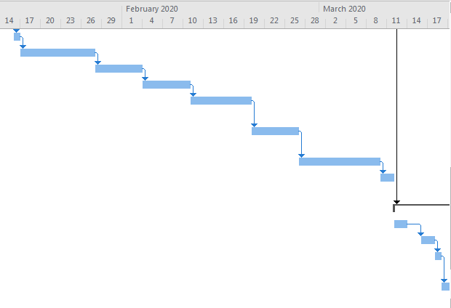
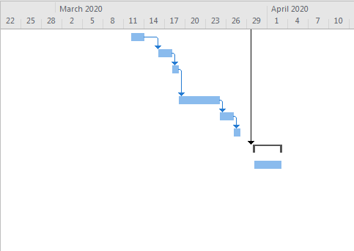
Figure 1: Timeline and Gantt chart for the software development project
Human Resources
The proper allocation of the human resource plays an important part for the software project development. In order to accomplish the task, the project manager, the project team and team manager and the administrator are required.
Roles | Responsibilities
project manager | Planning, overseeing and organising the project tasks  Manage and select the employees who accomplishes the project tasks  Responsible for ensuring the work is done appropriately and on time.  Monitors the project with the help of the KPI evaluation
project team | Performs the project tasks and finishes them on time
team manager | Review the overall facets of software development and report directly to the project manager
Administrator | Keeping the employees updated  Setting up of meetings  Documentation tracking
Table 4: Human resource responsibilities
Risk management
Risks | Frequency of Occurrence | Impact | Consequence | Mitigation strategy
Improper integration of the Firebase database services | Low | High | It will hinder the automation process of data entry and thus will decrease the performance of the software. It will leave the database vulnerable to the cyber crimes of potential act of phishing which eventually lead to the data theft of sensitive information | Implementation of the offline database through the use of the ASP.NET
Inappropriate functioning of the API requests | Low | High | It could lead to the increase of reloading time as the number of requests within a particular time period could not be capped. It will delay the retrieval process of the information as the GET request will not perform properly. | Reviewing of the API functionality
Improper means of resource allocation | High | Medium | It could loss to the financial capitals as the departments which requires intensive amount of labour and technical incorporations is not able to reflect on such acquisitions. Thus the project is not able to milestone and additional funding is required to accomplish the project on a postponed timeline. | Monitoring the resource allocation plan in the pre-planning stages
Inadequate allocation of capital finances to the project budget | High | Medium | The procurement process suffers the most as it had to do with the constrained amount of financial provisions and runs the risk of missing out on important technical acquisitions. | Over viewing the project budget on a weekly basis
Table 5: Risk Management Plan
Quality Control
The following KPI’s are to be used in order to monitor the progress and efficiency of the software development project:
Derivative metrics: It helps in the identification of the modules that have problems with the software testing process and provides the developers team with the opportunity of taking effective steps that improves the accuracy of the beta testing. It has been implemented within the project as it is going to identify the accuracy of the API requests.
Defect Density: It is one of the important software testing metrics that helps the team to account for the overall number of defects that has been observed within the software for a stipulated operational time window (Mandhan et al., 2015). The results that are obtained are divided by the particular module size, which allows the team to take a decision on possible software launch or postponing its release. It is calculated per thousand lines of the code and is termed as the KLOC. It has been implemented within the project as an elevated amount of capital finances has been invested in the project and thus it is an absolute necessity that the software solution has no faulty codes that could malign the performance. The best of way ensuring such efficiency is the implementation of the Defect Density
Communication plan
The software development project will give approximately 180 days for a proper outcome after the implementation of aforementioned objectives. Hence, in order to successfully complete the project there is a requirement of effective communication plan for entire team and stakeholders (Akhmetshin et al., 2019). Without proper communication plan, the team will not be able to be on the same page and can lead to misunderstanding affecting the overall productivity and duration of the project.
Communication strategy purpose
For internal stakeholders
- Board of directors
- Supervisor of the development team
- Project manager
- Team members
- Reference groups
For external stakeholders
- Clients
- Commercial customers
Strategy
Information management of all the external and internal stakeholders:
Stakeholders: Each internal and external partner should follow the similar guidelines that are mentioned below:
Medium | Responsibility | Reason | Duty | Recurrence
- SharePoint | Project manager | Managing the internal groups, team members and other reference group  Document sharing via internal network (Marchewka, 2016) | Documentation and management for the project | Revising the document after development
- Application for the team | Project manager and team lead | For the management of effective communication among the team members | Information sharing between the individuals for required activities associated with software development (Alvarez-Dionisi et al., 2016) | As per the requirement
- Memorandum creation | Supervisor | Important documentation needs a sharing between the team members and other stakeholders | Proposition of the accomplishment required for the growth of the project | Based on the project meetings and requirements
- Frequently Asked Questions or FAQs | Team leader | For collecting different feedbacks, which are given by the client and stakeholders (Murillo Gomez and Jiménez, 2018) | Providing essential solutions by the collected data | Based on the needs of the project of software development
Table 6: Communication plan

References
Akhmetshin, E.M., Romanov, P.Y., Zakieva, R.R., Zhminko, A.E., Aleshko, R.A. and Makarov, A.L., 2019. Modern Approaches to Innovative Project Management in Entrepreneurship Education: A Review of Methods and Applications in Education. Journal of Entrepreneurship Education, 22, pp.1-15.
Alvarez-Dionisi, L.E., Turner, R. and Mittra, M., 2016. Global project management trends. International Journal of Information Technology Project Management (IJITPM), 7(3), pp.54-73.
Marchewka, J.T., 2016. Information technology project management: Providing measurable organizational value. John Wiley & Sons.
Murillo Gomez, D.M. and Jiménez, L.A.T., 2018, December. Use of PRINCE2 as a Project Management Approach for Spatial Audio Developments. In INTER-NOISE and NOISE-CON Congress and Conference Proceedings (Vol. 258, No. 3, pp. 4558-4568). Institute of Noise Control Engineering.
Niazi, M., Mahmood, S., Alshayeb, M., Riaz, M.R., Faisal, K., Cerpa, N., Khan, S.U. and Richardson, I., 2016. Challenges of project management in global software development: A client-vendor analysis. Information and Software Technology, 80, pp.1-19.
Tomanek, M. and Juricek, J., 2015. Project risk management model based on PRINCE2 and SCRUM frameworks. arXiv preprint arXiv:1502.03595.
Matos, S. and Lopes, E., 2013. Prince2 or PMBOK–a question of choice. Procedia Technology, 9, pp.787-794.
Tomanek, M. and Juricek, J., 2015. Project risk management model based on PRINCE2 and SCRUM frameworks. arXiv preprint arXiv:1502.03595.
Mousaei, M. and Javdani, T., 2018. A new project risk management model based on scrum framework and Prince2 methodology. International Journal of Advanced Computer Science and Applications, 9.
Jamali, G. and Oveisi, M., 2016. A study on project management based on PMBOK and PRINCE2. Modern Applied Science, 10(6), p.142.
Vaníčková, R., 2017. Application of PRINCE2 project management methodology. Studia Commercialia Bratislavensia, 10(38), pp.227-238.
SIMION, M., 2012. Management Methodology for Research and Development Projects. ICAMS.
Mandhan, N., Verma, D.K. and Kumar, S., 2015, May. Analysis of approach for predicting software defect density using static metrics. In International Conference on Computing, Communication & Automation (pp. 880-886). IEEE.

