

Module Code: M4X01160

Module: L4 - Engineering Design

BEng Mechanical & Manufacturing Engineering
Engineering Design Project Drill Press Main Sliding Unit

Name: Joseph Samuel Law

Student Number: 1704471

Table of Contents
Scope 4
Evaluation of the current concept design 4
Functional Requirement of the DPMSU: 4
Crucial Design 4
Concept Designs 5
Drill Press Concept # 1 5
Drill Press Concept # 2 5
Drill Press Concept Improvements 5
Manufacturing Process Selection 6
Quantity of the product 6
Cost of Manufacturing 6
Time Required for Manufacturing 6
Design Tolerance 6
Surface Finishing 6
Suitable Manufacturing Methods 6
Material Selection Process 7
Cost 7
Weight 7
Flexibility 7
Hardness 8
Redesign Comparisons 8
Current Design 8
New Design 8
Volumetric Properties 8
Spring Connection Point 9
Drill Clamp Clip 9
Radii 9
Stress Analysis 10
Loads & Fixtures 10
Draft Angles 11
Appendix. 12
Original Design Drawing 12
New Design 13
Bibliography 14

Scope
This report is to look into a redesign of a Drill-Press Main Sliding Unit (DPMSU) and produce a digital model with justifications to change throughout the design stage.

Evaluation of the current concept design
- Large/bulky block of material
  - Aesthetically poor
  - Costly for the amount of material needed.
- Cross piece within the DPMSU to connect the spring, would be expensive to manufacture and a difficult design to produce.

Functional Requirement of the DPMSU:
- The Sliding unit must only move in the y-axis (Vertical), this ensures a square and true drill hole.
- Must be compatible to hold and function with a wide variety of drills.
- Drill clamping/fixing function must hold the drill solid in place to ensure precision.
- Sliding unit should have a fixing for the spring which allows the press to bring the DPMSU back up to its original resting area.
- It must have an area in which the handle can be fixed to, to preform the vertical movement and allow leverage for the user.

Crucial Design
- The manufacturer has requested the DPMSU is made from a polymeric material to reduce costs.
- Hole for Main Shaft must remain the same dimension and location*
- Hole for Guide Shaft must remain the same dimension and location*
- Clamp that holds the drill must remain in the same location, as this is central to the base of the Drill Press*

*All statements are relative to each other.

Concept Designs
A couple concept designs have been sketched up to start the design idea process, this has highlighted certain element which need attention when deciding on a final design.

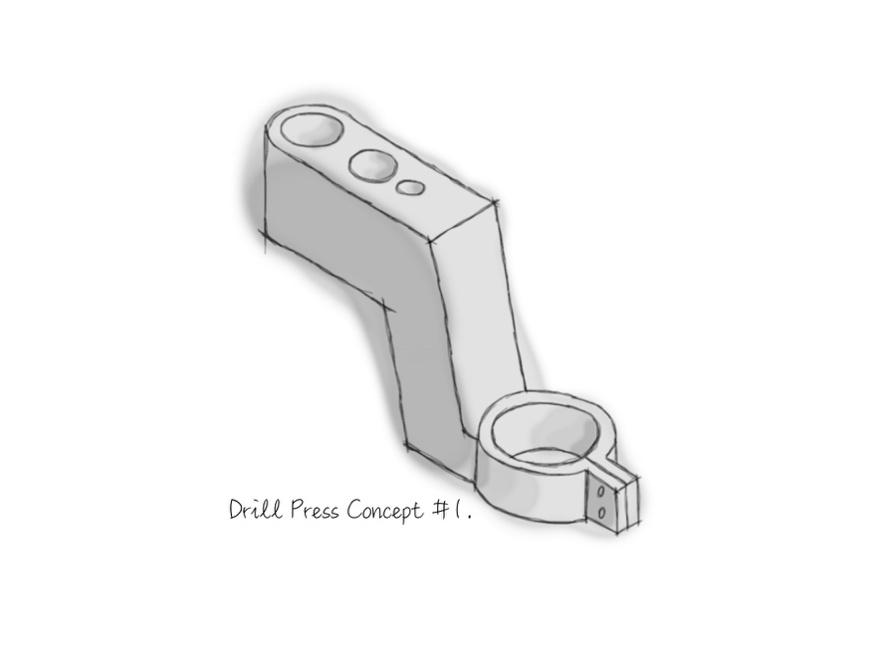 | Drill Press Concept # 1  A main priority of this redesign is to reduce as much material as possible. This concept cuts a large bottom section out from the current design.  All alignment holes remain in the same location. The arm may not be able to take the strain of the press without ribs for support. There are also large blocks of material with uneven wall thickness which is not ideal for injection moulding.
Drill Press Concept # 2  The design has reduced a lot of material and catered for uniform wall thickness. The majority of the material that has been removed does not contribute to the strength of the DPMSU. The design is ideal for injection moulding but screw fixing holes with either require slider or could be drills post operation. | 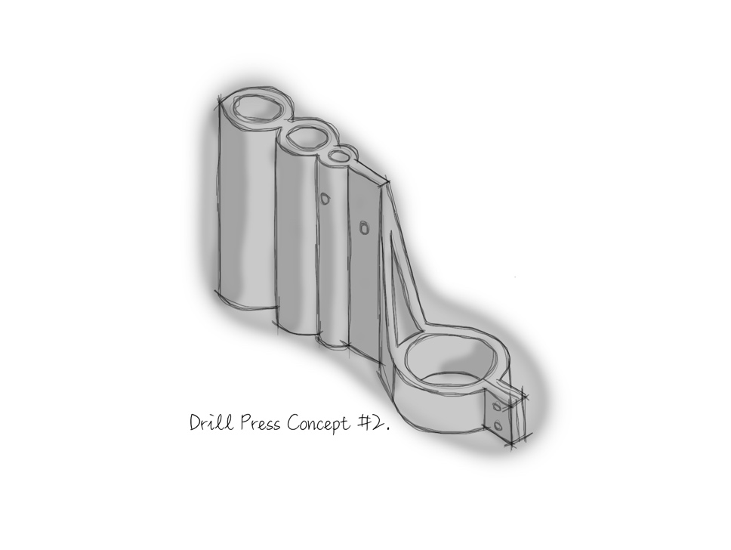
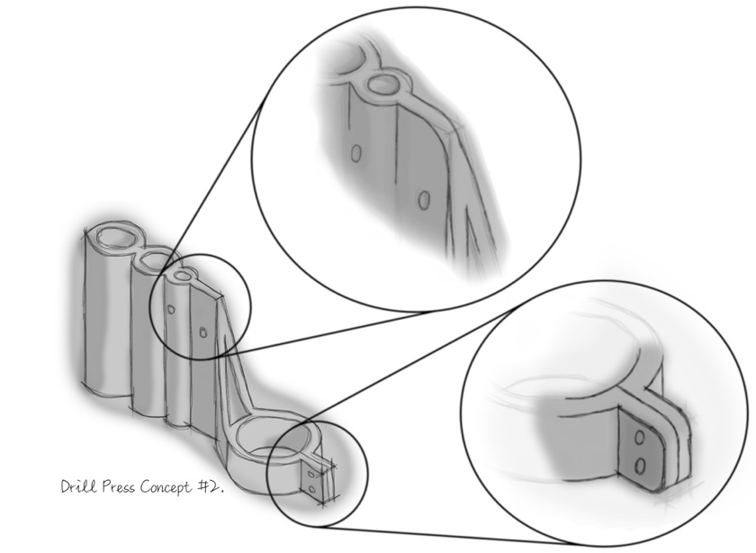 | Drill Press Concept Improvements  Working on the previous concept design, it is not ideal to have sharp corners when injection moulding due to the possibility of cold shots and air trapped in these corners.  So rads have been designed into the concept, Radii will also reduce stress concentration zones on the part.

Manufacturing Process Selection

Quantity of the product
The company states that a quantity of 1000 unit per week are required to fulfill orders. This can be considered a high production volume.

Cost of Manufacturing
Home drill presses can be purchased at a ranged price. £20 – £40, this needs to be factored into the manufacturing process as the entire assembly needs to stay within or very near the average price for a drill press to stay competitive and appealing.

Time Required for Manufacturing
1000 unit a week are required, this boils down to an approximately 200 units per working day. This is all dependent on the manufacturing hours.

Design Tolerance
There are features of the DPMSU which potentially require a high tolerance due to the mating parts. The hole which slides up and down the main shaft is extremely crucial, if it’s too large it will cause the drill press precision to be poor and if its too tight it will bind and not slide.

Surface Finishing
Due to the nature of the product, it is not generally designed to be aesthetically pleasing, although features on the DPMSU may need smooth finishes due to its friction & sliding action.

Suitable Manufacturing Methods

- Die Casting – NOTE: - Only produces metal parts, does not meet requirement.
  - Expensive startup cost.
  - Lot of energy required to hit aluminum melting point.
  - Cheap parts when mass producing.
  - Only relates to metal parts.
- CNC Machining
  - No startup cost
  - Very expensive parts, even when mass produced.
- Injection Moulding
  - Plastic parts are lightweight
  - Low energy consumption
  - Cheap parts when mass produce
  - Expensive startup cost

Injection moulding would be the best suited method of manufacture due to the requirements. Tooling is important when manufacturing, a hard tool will be required to produce this part as the quantities are very high.

Material Selection Process
The injection mounding process can be used with many different types of materials, I will look at the main overall polymers used in this process. All the polymers will be thermoplastics as opposed to thermosets, thermoplastics are very good with heat and this is needed in the injection moulding process.
- High Density Polyethylene (HDPE)
- Polyamide (Nylon)
- Polypropylene (PP)
- Acrylonitrile Butadiene Styrene (ABS)
- Polycarbonate (PC)
- ABS & PC blend (Generally used for electronic housing)

Cost
The cost of the item is an important factor. If we can limit the material quantity, we could benefit from a better-quality material
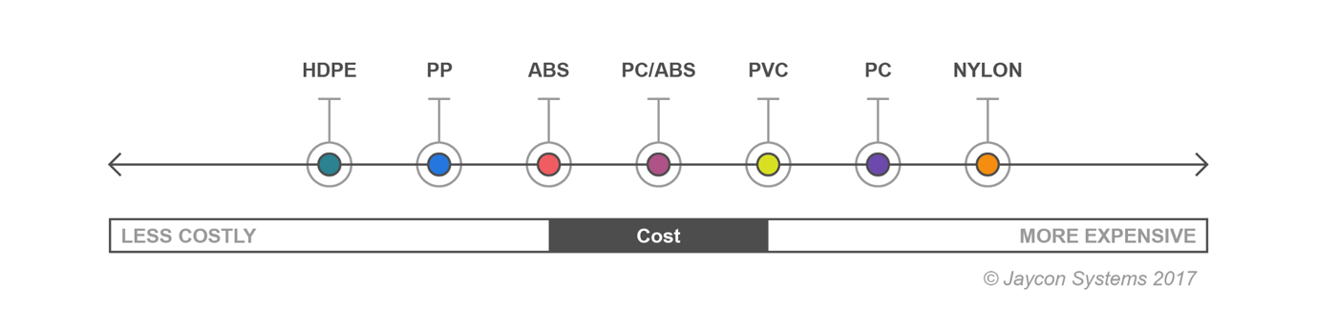

Weight
Due to the request of the part being made from a polymeric material as opposed to metal, weight is not an issue, especially as the product is not handheld.
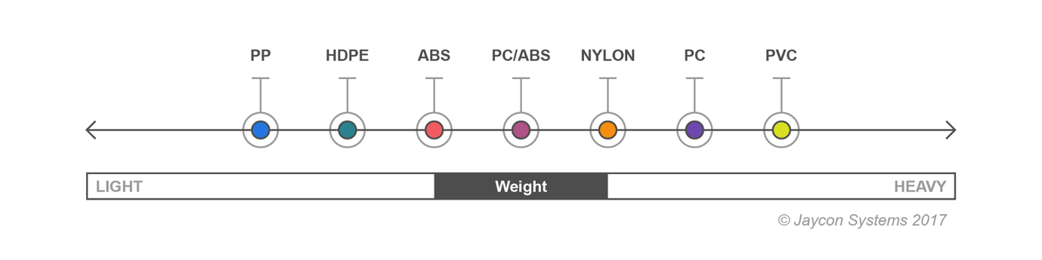

Flexibility
The design ideally would not be flexible as tolerance and precision is vital. You want your drill press to be consistence and accurate with your machining.
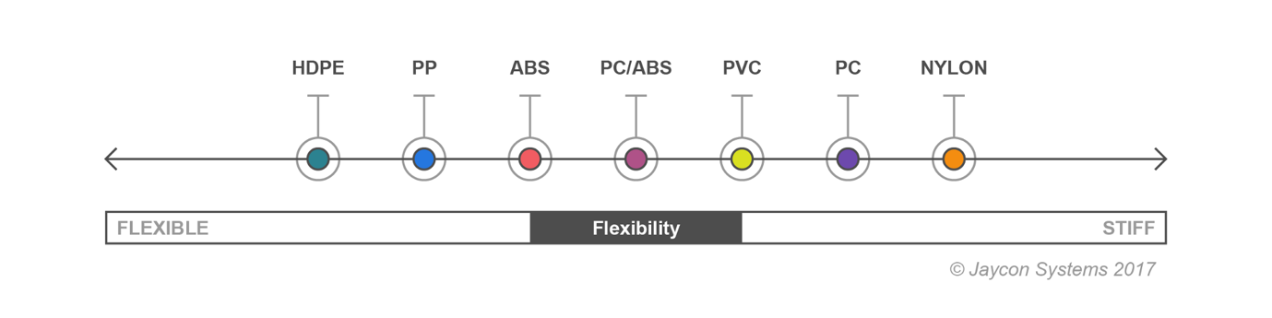

Hardness
As one of the DPMSU main function is to follow the z-axis of the main shaft, it must slide in both direction, a hard material is far more likely to perform better.
(Systems, 2017) (Unknown, 2019)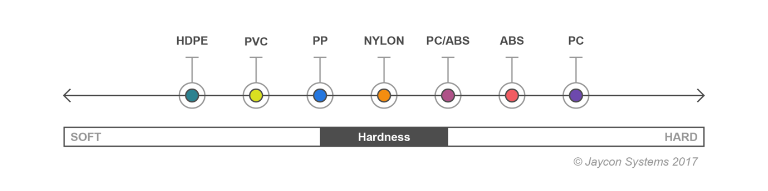
After reviewing all aspects of the material characteristics, Polycarbonate and ABS mix would be a suitable choice for the DPMSU

Redesign Comparisons
Current Design | New Design
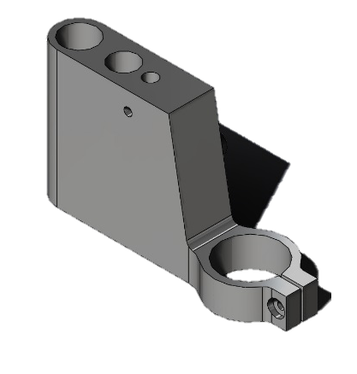 | 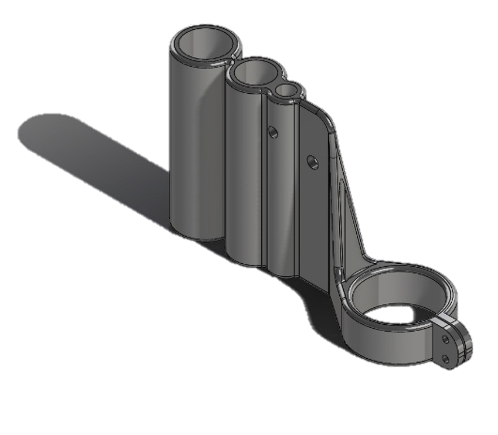

Volumetric Properties
Mass: 0.317866 kg  Volume: 0.000283809 m³  Density: 1120 kg/m³  Weight: 3.11509 N | Mass:0.132803 kg  Volume:0.000118574 m³  Density:1120 kg/m³  Weight:1.30147 N
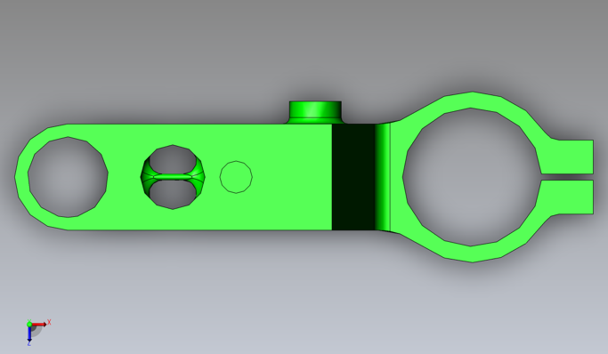 | 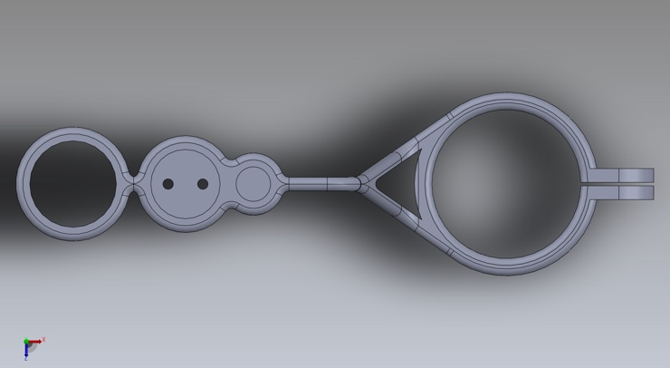
By creating uniform wall thickness throughout the design, the volume of the part has been decreased by well over half and also reducing its weight by the same. Doing this will make the part cheaper by reducing material cost.
Uniform wall thickness is essential when injection moulding as any areas with large sections of material will endure shrinkage and defects. The new design has no sections of large material and shrinkage will not be an issue.

Spring Connection Point
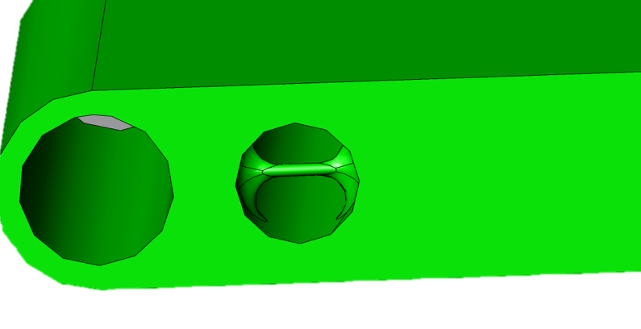 | 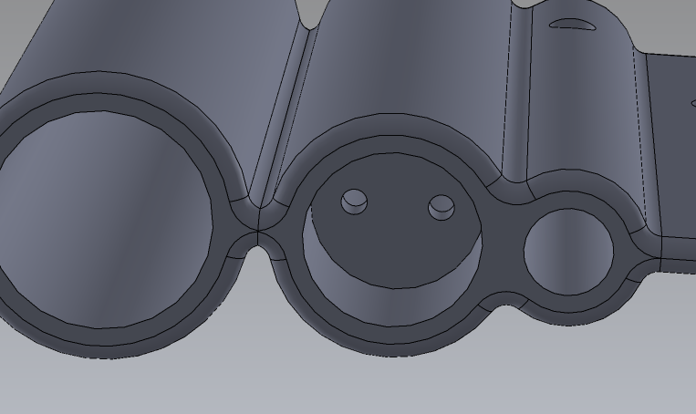
The current design of the spring connection point is a difficult design and expensive to manufacture. It also may not provide the most strength needed. | The removal of a thin shaft replaced with a 4mm thick diaphragm, makes it easier to manufacture and give more strength to the feature.

Drill Clamp Clip
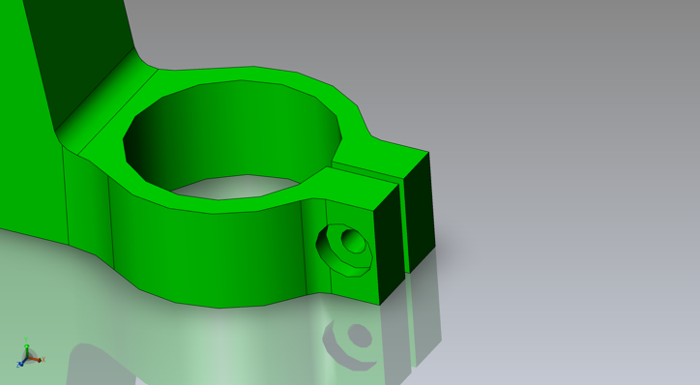 | 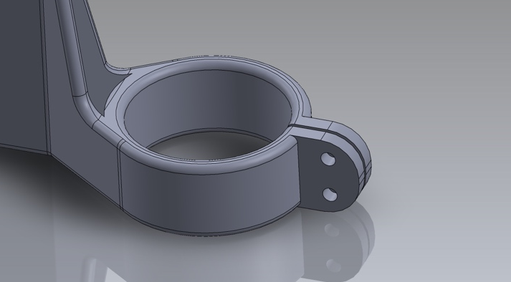
The original drill clip would have been specified for a certain sized drill, due to this the new design has remained the same dimension. The clip that hold the drill tight, has been redesigned to consist of two clearance holes to accommodate fixings to give more strength to hold the drill.

Radii
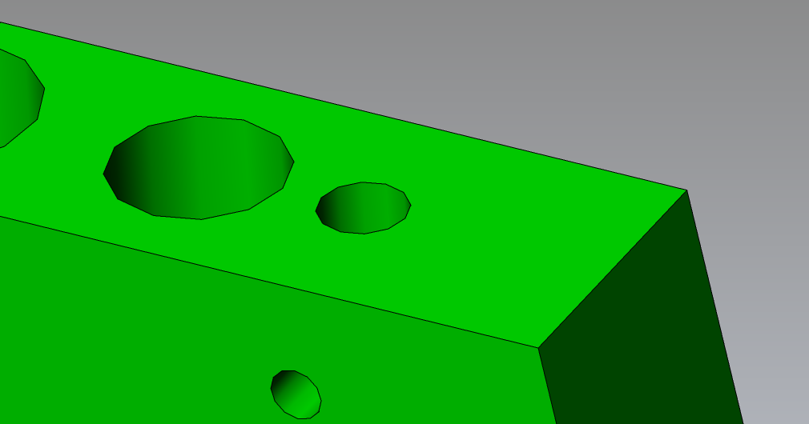 | 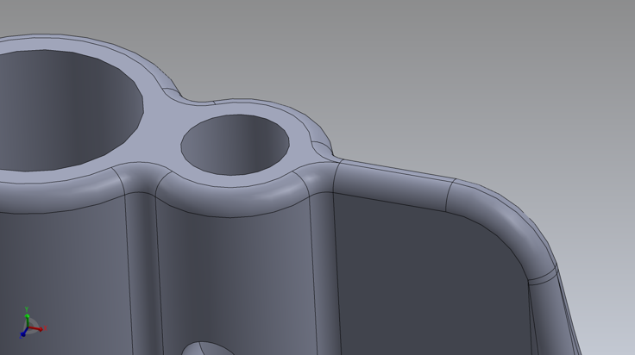
No Radii were present in the original design. This could be an issue if the part was injection moulded as the sharp corners may cause the material to cold shot or trap air. | The redesign has incorporated Radii in the majority of the part. This is to help in the manufacturing process. This well help greatly in the injection moulding process, it will allow the material to flow smooth around the tool. This will ensure good shots with minimal defects which will help costs.

Stress Analysis
Name: | PA Type 6/Nylon
Model type: | Linear Elastic Isotropic
Default failure criterion: | Max von Mises Stress
Yield strength: | 1.03649e+08 N/m^2
Tensile strength: | 9e+07 N/m^2
Force: | 2N
NOTE: All tests were performed with the same specifications to compare designs.

Loads & Fixtures

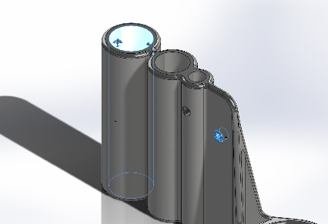  Fixtures | 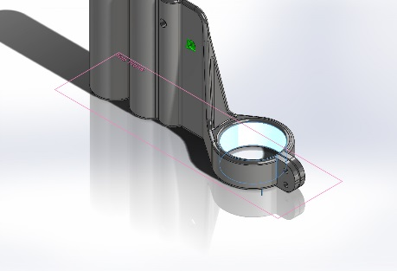  Load
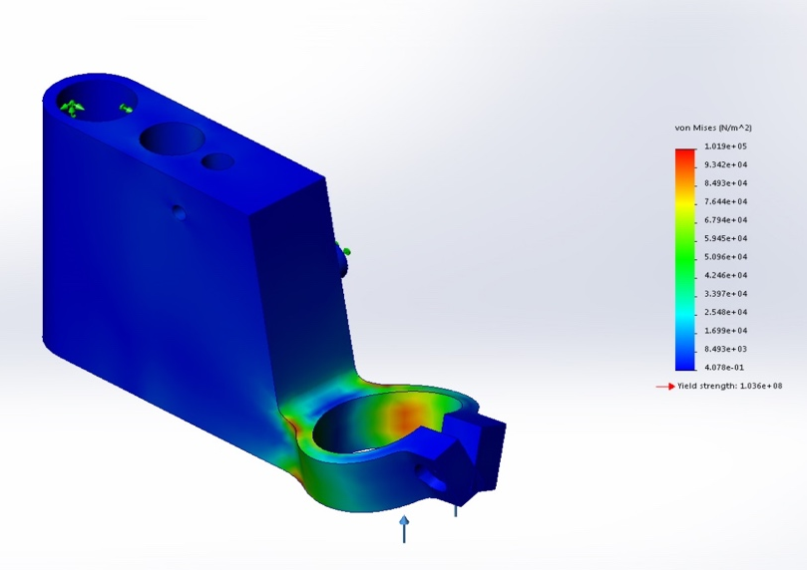 | 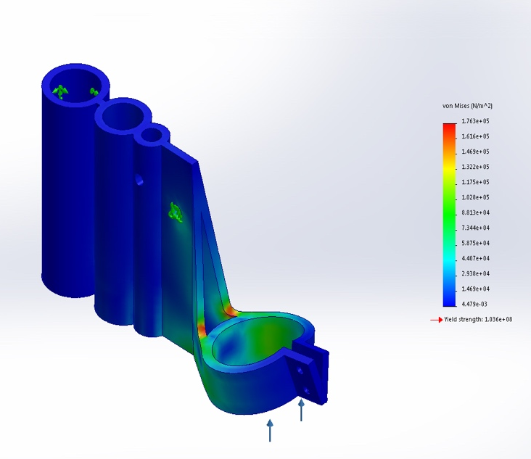
Stress  Type: VON: von Mises Stress  Minimum: 4.078e-01 N/m^2  Maximum: 1.019e+05 N/m^2 | Stress  Type: von Mises Stress  Minimum: 4.479e-03 N/m^2  Maximum: 1.763e+05 N/m^2

Draft Angles
 | 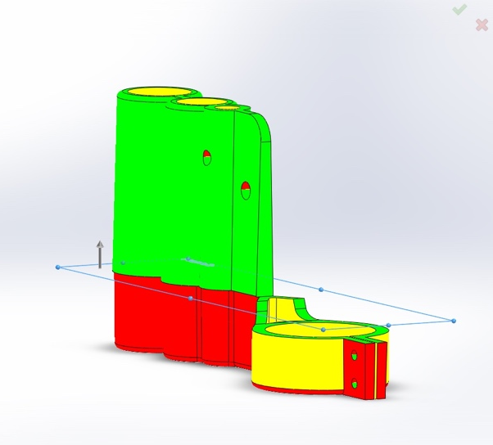
Previous design did not possess any draft angles, this would make it very difficult to remove from any moulding tool. | The improved design has two draft angles the meet at the middles (Where the tool meets). This allows the part to be removed from the tool.
 | NOTE: Draft angle was designed at 2 degrees

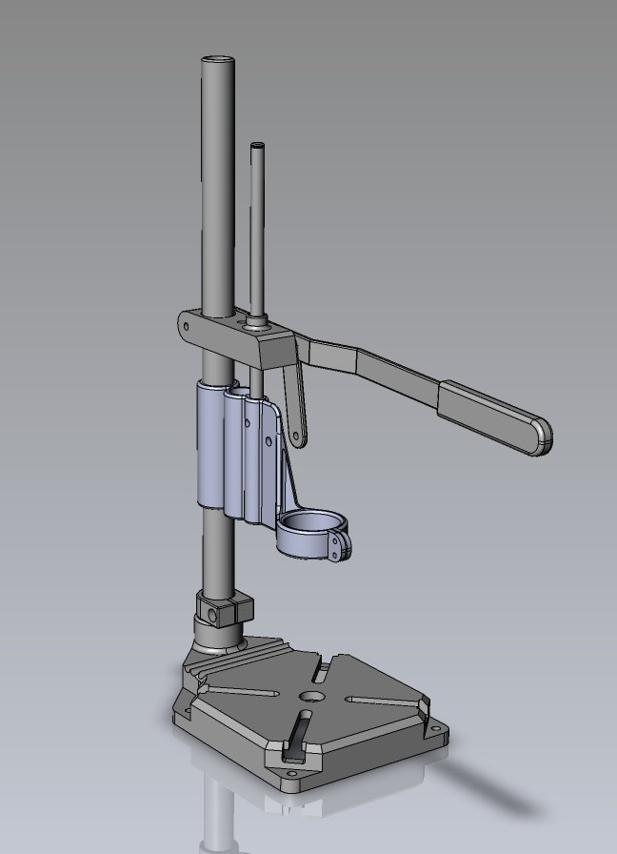
Final Redesign Assembly

Appendix.

Original Design Drawing

New Design

Bibliography
Systems, J., 2017. Platsics 101: Selecting the right material for injection molding. [Online]
Available at: https://medium.com/jaycon-systems/plastics-101-selecting-the-right-material-for-injection-molding-10edb3a8baba
[Accessed 02 2019].
Unknown, 2019. Selecting the right plastics for your parts. [Online]
Available at: https://www.protolabs.co.uk/resources/design-tips/selecting-the-right-plastic-for-your-parts/

