

Build IT framework and model to solve information security problems based on Caribbean coffee

By
Yuxuan Zhao

January 2022

Abstract
In the modern times with the rapid development of the Internet, more and more companies are combining their services with online platforms, and the widespread use of modern electronic office technology will become an inevitable trend in the development of companies. However, in a network environment, companies and users on an open platform are bound to face many risks such as hacker attacks and virus infections. If information security cannot be guaranteed, information leakage will certainly cause very serious losses to enterprises and customers. With the innovation of computer technology, the Internet has facilitated the development of the information society and has also put forward higher requirements for information security. This paper focuses on the analysis and comparison of three network security models, P2DR2, IAFT and Information Technology Infrastructure Library (ITIL), and uses the Caribbean Coffee as an example of a network application to address information security and management issues.

Keywords: Data Security, Governance and Compliance, P2DR2, IAFT, Information Technology Infrastructure Library, ITIL

1.Introduction
With the evolution of internet technology, more and more people are using it and more and more companies and businesses are implementing cloud operations via the internet. For example, many companies are using internet platforms for commodity trading, file transfers, financial operations, etc. The openness and anonymity of computer networks has led to increasing problems with the security of information. Virus infections, hacker attacks and data theft are serious threats to information security, and information is very important for the development of companies and people's lives. If a company's systems are attacked by external hackers or operational errors, these attacks can lead to data leakage and theft of company secrets, which can cost the company a great deal of money. For individuals, hackers may sell customer information to other organizations or companies and the safety of people's lives and property is likely to be at risk. In order to protect information security, measures must be taken to prevent information leakage. Companies need to develop a complete information management system, including how it is protected and the measures that need to be taken in the event of an attack. In the next section, this paper describes and examines three cyber security frameworks and models.

2.Security Frameworks and Models
This chapter mainly introduces three kinds of network framework [1] and model: P2DR2, Information Assurance Technical Framework (IAFT), and Information Technology Infrastructure Library (ITIL). The following will focus on their advantages and disadvantages, requirements for specific aspects, and the aspects that can give full play to their greatest advantages.

2.1 Policy Protection Detection Response Recovery(P2DR2)
The P2DR2 dynamic security model is a dynamic security model structure based on enterprise network objects, time and policy characteristics (policy, protection, detection, response, recovery) [2]. It is a model of dynamic security based on closed-loop control and active defense. P2DR2 builds an all-round, three-dimensional regional network security environment through the analysis and formulation of regional network routing and security policies, the establishment of real-time detection and monitoring at multiple levels within the network and at the border, and the use of multiple system disaster backup and recovery and redundancy design for critical systems.

2.1.1 Elements and core ideas of P2DR2 theoretical model
P2D R2 model is a new security protection model based on the characteristics of traditional models such as P2D R model and P D R model.[3] It includes five links: strategy, protection, response, detection and recovery, as shown in Figure. Among them, strategy is the part of technology management in enterprise management system, which specifies the main goal of security management of scientific and technological secrets. The elements of protection, detection, response and recovery need to be implemented around the strategy. Through comprehensive security technical means, we should establish defense against the system, timely monitor and detect loopholes, intrusion behavior and other problems, and take corresponding measures to prevent attacks and record them, so as to recover the system or even launch counterattack in the shortest time after being attacked.
Figure 1 P2DR2 model
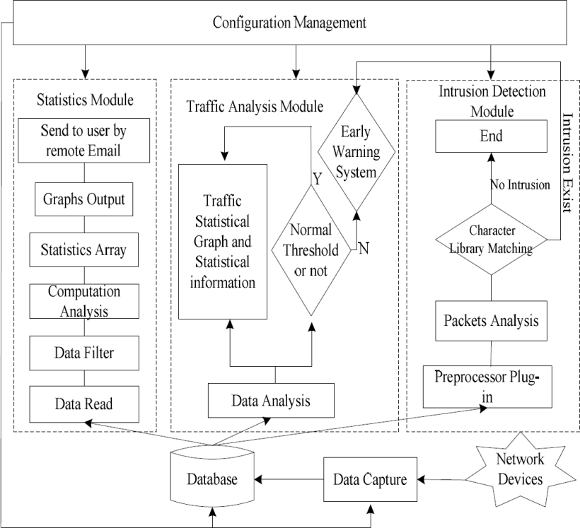
Figure 2 basic elements of P2DR2 theoretical model

2.1.2 Analysis of the proportion of each factor resource in P2DR2 theoretical model
In the implementation process of P2DR2 model, the resource allocation ratio of each element can be dynamically adjusted according to the actual application scenarios of different enterprises. Let security policy be policy, protection, inspection be detection, response be reaction and recovery be recovery. The proportion of resource input of each element in the specific implementation is expressed as α, β, γ and δ respectively. Then the proportion of each element resource in the enterprise dynamic security protection model is shown in formula (1)
Policy =α*Protection +β*Detection +γ* Reaction +δ*Recovery (1)

2.1.3 Security analysis of P2DR2 theoretical model
On the other hand, the security of P2DR2 model can be improved and extended according to PDR theory and time theory. Suppose that the enterprise security policy is policy, the system time is T, the system protection time is PT, the system detection time is DT, the system response time is rest, and the system recovery time is CT, then the system exposure time ET can reflect the enterprise security policy validity of YT.

2.1.4 Architecture design of enterprise technology security protection system based on P2DR2 theoretical model
Compared with the traditional PDR and P2DR models, P2DR2 model has more complete elements and better security protection effect. At the same time, it is easier to deploy and implement than the most complex security protection system models such as PDR, p2otpd2 and po2p, which is more in line with the actual needs of enterprises.

2.1.5 Management layer based on P2DR2
The management layer belongs to the top layer of the system architecture. In the deployment, it first needs to determine the organizational structure and personnel composition of the science and technology security protection system according to the overall strategy of enterprise security protection, then formulate the relevant science and technology security protection system, and finally form the specific management process of the science and technology security system, so as to improve the management ability of enterprise science and technology security. In this layer, strategy making (the strategy element of P2D R2 model corresponding to the strategy link module) is the core content of this layer, and provides management and strategy support for the lower layer.

2.1.6 Element layer based on P2DR2
The element layer belongs to the middle layer of the architecture, which includes the protection link, detection link, response link and recovery link. By adjusting the resource composition proportion of each dynamic protection element, it forms the security technology prevention ability, confidentiality inspection ability and emergency recovery ability of the enterprise's scientific and technological secrets. In this layer, how to dynamically coordinate the resource proportion and relationship among technical protection, confidentiality inspection and emergency recovery according to the needs of different enterprises, and meet the strategic objectives of the management layer in the upper architecture is the core content of this layer, and provides support for the implementation layer at the bottom. The key elements of enterprise technology secret protection are not completely isolated, but interrelated and coordinated. Technical protection includes security protection technology of classified places, host and carrier protection technology, communication and network protection technology, which is the embodiment of protection elements. Security check is the embodiment of detection elements, which can be implemented with the help of security check at all levels to detect possible attacks in the process of system operation. The emergency remedy corresponds to the response elements and recovery elements, which will minimize the loss when and after the security incident. The element layer takes management strategy as the center, and on the basis of the basic defense ability constructed by the three elements of technical protection, confidentiality inspection and emergency remedy, it finds problems through timely detection ability and improves the remedial ability to deal with problems, so as to form a closed-loop control of finding problems and solving problems.

2.1.7 Application and Implementation Suggestions of management
The planning and design of enterprise technology security protection system architecture is important, but the effective operation of the system is also inseparable from the perfect guarantee and operation and maintenance. If there is no targeted operation and maintenance, the long-term stable operation of the protection system is difficult to guarantee, and the advantages of the system are difficult to play. Therefore, when building the management layer in the system architecture proposed in this paper, we need to accurately grasp the enterprise protection management strategy, formulate corresponding system guarantee, organization guarantee and resource guarantee measures, pay attention to the organic combination of technical protection and management system, constantly improve the management process, and standardize the scientific and technological confidentiality behavior of relevant personnel.

2.1.8 Application and Implementation Suggestions of implementation layer
When building the implementation layer of the architecture proposed in this paper, enterprises need to make full use of the existing technology security protection means, and constantly combine with the latest technology means to achieve, such as big data, cloud computing, artificial intelligence and blockchain, so as to constantly meet the changing needs of enterprises in physics secure, host security, Internet secure and data security besides then comply with latest international development trend of science and technology confidentiality.

2.1.9 Application and Implementation Suggestions of element layer
When constructing the element layer of the system architecture proposed in this paper, based on the existing enterprise confidentiality management system, organizational structure and information security system, according to the needs of enterprise management strategy, the resource allocation proportion of each basic element should be reasonably planned, and the resource proportion between each element should be dynamically adjusted according to the actual needs of the enterprise, so as to ensure the coordination between each element We should work in a unified way and stress the key points. At the same time, it is necessary to analyze the security of enterprise science and technology system in real time according to the dynamic factors such as time according to the enterprise security strategy, and make timely prevention and response, so as to realize the dynamic adjustment of security protection strategy.

2.2 About the Information Assurance Technical Framework (IAFT)
The IATF is a comprehensive framework for describing information security systems, written by experts from the US National Security Agency, which sets out the full range of security requirements for information infrastructures in the information assurance era. Its predecessor is the network security framework (NSF). The IATF has developed the idea that information assurance relies on people, operations and technology to jointly deliver organized functions and business operations, and that the management of technology and information infrastructures is dependent on these three elements. The core concept of IATF is that people, supported by technology, carry out a series of operational processes to achieve information assurance goals. The IATF defines the engineering processes and security requirements for all aspects of information systems to achieve information assurance objectives. On this basis, multiple layers of protection can be achieved for information infrastructures, which are referred to as "deep protection strategies". The IATF core idea is shown in Figure.
Figure 3 IATF theoretical model

2.2.1 Four technical framework focus areas in IATF
The IATF divides the scientific aspects of information assurance for messaging systems into four technical focus areas: local computing environment, enclave boundary, network and infrastructure, and supporting infrastructure. Local computing environment includes servers, clients and their installed applications, operating systems, etc. The enclave boundary is the collection of local computing devices connected through the LAN. The network and infrastructure provide regional interconnection, including OAN, metropolitan area network (MAN) and campus area network (CAN) can and local area network (LANS), and the supporting infrastructure provides the foundation to support the information assurance mechanisms of the network, regional and computing environments [4].
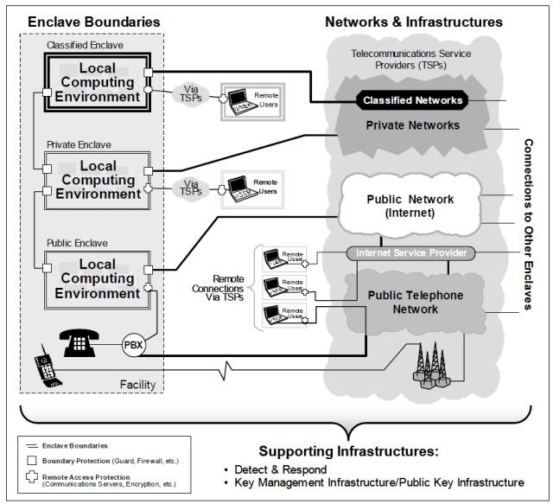
Figure 4 Four technical framework focus areas in IATF

2.2.2The core of IATF Information Assurance
The main parts of IATF message assurance are in depth part, which gives an all-round, multilevel guiding ideology for the information assurance system. By adopting multilevel and implementing the assurance mechanism in each technical framework area, it can minimize risks, prevent attacks, and ensure the security of user information and its information system. The defense in depth strategy of IATF is shown in Figure 4.
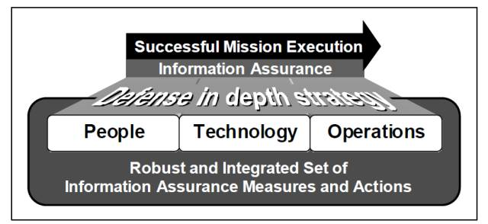
Figure 5 defense in depth strategy of IATF
Protect local computing environment

2.2.3 Protect local computing environment on IATF
Users need to protect the internal system applications and servers, including a variety of existing and emerging applications in the high-end environment of the system authentication access control, confidentiality, data integrity and non-repudiation and other security. In order to meet the above requirements, the following security objectives should be achieved: to ensure that the client, server and application are re divided to prevent whether the client, server or application is located in or outside a certain area, it must ensure that the data processed by it has integrity; to prevent unauthorized use of the client, unauthorized disclosure and data change It is necessary to ensure that the client and server comply with the security correctly install all patches, maintain the Configuration management, track the patch and system configuration change information, and have sufficient ability to prevent internal and external trusted personnel from engaging in violations and attacks on the system.

2.2.4 Boundary of protected area
In order to obtain information and services from professional or public networks, many organizations connect with these networks through their information infrastructure. Once, these organizations must protect their information infrastructure, such as protecting their local computer environment from intrusion. A successful intrusion may result in damage to usability, integrity or confidentiality.

2.2.5 Protect network and infrastructure on IATF
In order to maintain information services, protect public, private or confidential information, and avoid inadvertent disclosure or change of such information, institutions must protect their networks and infrastructure. The target protection in line with the requirements: ensure that the data exchanged in the whole Wan will not be leaked transmission and non-transmission of protected information in the process of sending; protect the network infrastructure control information; ensure the protection mechanism It is not interfered by various seamless operations existing between other authorized hubs or regional networks.

2.2.6 Protecting supporting infrastructure on IATF
The supporting infrastructure is another technical aspect of defense in depth, providing key management, detection and response capabilities for a defense in depth strategy. The required supporting infrastructure components for detection and response include intrusion detection system and audit configuration system. The objectives of meeting this requirement are as follows: to provide infrastructure supporting key, priority and certificate management, and to be able to identify individuals using network services; to be able to quickly detect and respond to intrusion and other violations; to implement plans and report requirements for continuity and reconstruction.

2.3 Information Technology Infrastructure Library (ITIL)
Information Technology Infrastructure Library (ITIL) is a globally recognized series of best practices for information technology (IT) service management. It was created by the British Central Computer and Telecommunications Agency (CCTA) to meet the development needs of the application of information technology in the commercial field. ITIL introduces a systematic methodology in managing IT services in organizations [1]. Information Technology Infrastructure Library (ITIL) is a globally recognized series of best practices for information technology (IT) service management. It was created by the British Central Computer and Telecommunications Agency (CCTA) to meet the development needs of the application of information technology in the commercial field. ITIL introduces a systematic methodology in managing IT services in organizations [5].

In recent years, ITIL has developed rapidly all over the world. For example, in the United States, when the it SMF annual meeting was held for the first time in 2001, only 200 people attended, 800 people attended in the second year, and more than 1600 people attended the third annual meeting in 2003!
ITIL in foreign countries, especially in Europe and the United States, can be said to present a "hot" scene, then how is its development in China?
ITIL was first introduced into China in 1999. In the first three years of its introduction, due to the fact that there are not many units to know about it and the successful cases in this respect are quite limited, it is in a state of not sulking in China. But since 2002, ITIL has attracted more and more attention in China. Especially in 2003, ITIL appeared several firsts in the development process of China: Han Wei IT management research and consulting center published the first Chinese ITIL monograph, China computer users weekly founded the first it service management column in China, the first ITIL Oriented Portal "ITSM information network", which is also in Han Wei IT management research and consulting center and ITSM portal It was officially founded in cooperation with international.
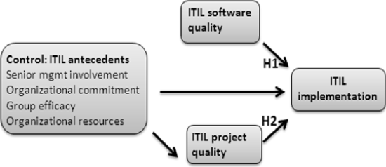
Figure 6 research model

3.Discussion and Comparison
P2DR2 is a model of dynamic security based on closed-loop control and active defense. P2DR2 builds an all-round, three-dimensional regional network security environment through the analysis and formulation of regional network routing and security policies, the establishment of real-time detection and monitoring at multiple levels within the network and at the border, and the use of multiple system disaster backup and recovery and redundancy design for critical systems.
The IATF, on the other hand, focuses more on the security management of information infrastructures.
ITIL deals with 10 core service management processes and is mainly applicable to IT service management. Its application is more focused on the individual or manager side and its height is also based on the IT industry.
A good network security model should fully understand architecture through the security model, which usually has the following properties: accurate and unambiguous; simple and abstract; general; fully embodies the security policy.

4.Applying security frameworks to solve the information security problem of Caribbean coffee shops
Caribbean Coffee sells mainly Blue Mountain Peak coffee from Jamaica, one of the most popular coffees in the world. Caribbean Coffee is available in all regions of the world. With the development of internet technology, the company is now also using cloud services to provide IT services to its employees and customers. According to statistics, the company now does nearly 95% of its business online. The company also has a large online and social media presence to promote its activities to stimulate user spending. The company has recently faced significant online pressure due to its large employee and international customer base. Employees and customers have to frequently access the company's web pages via the internet to complete transactions. The security of employee data and customer data is a major concern for the company. At the same time, the company also owns billions of intellectual property rights, the protection of which is also an important task. Information security is a top priority for the company, but so far everything is confusing and there is no established strategy to meet their security needs. Designing a stable cyber security framework is therefore essential for the company's future growth.
As for how to protect the network information security of thousands of customers and employees of Caribbean coffee, I plan to build a network information security system based on ITIL framework to protect the network information of customers and employees from being used by illegal elements. At the same time, I will also establish a mature protection system to maintain the network security of the whole company.
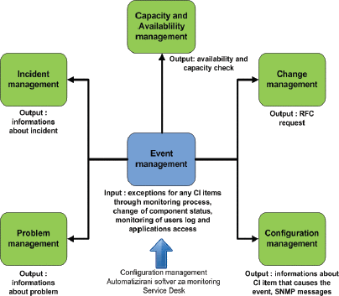
figure 7 The security framework for Caribbean coffee

4.1 The key role of risk management
Senior management provides effective resource guarantee for risk management projects and applies the results of risk analysis to management decisions; Chief Information Officer (CIO), who applies risk management principles and methods to it planning, budgeting and execution activities; System and information owners support risk management projects and apply risk management principles and methods to the protection of IT systems and data; Business and functional managers apply risk management principles and methods to business operations and it procurement decisions, so that it systems can support business activities more safely and effectively; Information system security officer (ISSO), the specific person in charge of it risk management project, formulates a comprehensive plan for it system risk identification, assessment and mitigation, and provides suggestions to support and participate in risk management of relevant IT systems, including identifying risks in the system and deploying appropriate preventive measures to provide appropriate security protection for the system.
Security awareness trainers, who understand risk management methods and develop training materials related to risk management, provide training evaluation education for users in training projects.

4.2 IT Security
IT security refers to a range of measures taken to protect information security, including asset security, human resource security, system development and maintenance. Specific operations, for example, set up a special information security protection agency within the company. When the company is attacked by foreign hackers or peers, effective measures must be taken in a timely manner to protect the security of the company's property and the private information of employees and customers. Maintain and update the online trading platform in a timely manner to prevent similar attacks from happening again and to achieve system sustainability.

4.3 Service Management
Project management refers to the online sale of coffee. Service management refers to a series of service operations guided by the ITIL framework, including service level management, service financial management, service continuity management, etc. It applies to specific practical situations, such as setting different service levels for different customers, while the service funds corresponding to different service levels will naturally vary. Staff competencies must be monitored and staff must be replaced in a timely manner to ensure that service needs are met. Finally, services need to be monitored to achieve sustainable service management.

4.4 Quality System
The company needs to plan for future developments, such as launching new products or implementing certain promotions to stimulate consumption. A number of measures are needed to ensure the efficient and stable operation of the entire IT operation, requiring the company to have clear management responsibilities and to strictly implement business continuity management. Control over IT services can be provided to the company by auditing various functions, allocating various resources and attributes appropriately and protecting information security in a reasonable manner. Sustainable development of the company.

5.Conclusions
Preventive measures and suggestions of Caribbean coffee enterprise network information security. Installations of protection software at the technical level: at the technical level, the installation of network information security protection software can meet the requirements of all aspects. As Caribbean coffee enterprises are not professional network practitioners, it is necessary to cooperate with advanced network information enterprises in the society. Security protection is gradually upgraded: first of all, the network security equipment, firewall, anti-virus and other measures of Caribbean coffee enterprise foundation can filter a lot of viruses. Second, hacker attacks will leave traces of operation on the network either through database triggers or through network bypass. Caribbean It is the top priority for coffee enterprises to refine the login account, detection and authority, and improve the user operation behavior chain. Finally, through the processing of the login account big data, we can continuously develop the value of access information, analyze the user's behavior, detect and alarm the unreasonable behavior, and take special protection measures. Strengthen the "management requirements": Caribbean coffee enterprises set up a network information security department, strengthen the network security education for the Department staff and even all staff, popularize relevant knowledge, improve the awareness of network security and confidentiality, and formulate the network information security system, which is required to be strictly observed. File encryption: all files including encryption, re-use needs to use password, password technology, biotechnology two or more kinds of authentication technology to obtain use. Data backup and recovery: backup the network information data, store the backup data in other security areas, implement the highest authority protection, ensure that the system, and avoid the paralysis of Caribbean coffee enterprise due to system attack.
Through the examines and compares multiple cybersecurity framework models, integrating multiple frameworks to secure information in the Caribbean Coffee and protect company property and information. We can continue to improve the system in the future by learning from other cyber security architectures to help the company better protect information and manage the company to continue to serve customers consistently and sustainably.

References
1.Risk analysis and Countermeasures of enterprises applying vie mode to list [J]. Yang Xiaowei, Han Jinhong. Finance and finance. 2019 (06).
2.Bo, Luo Pingping, Wang GAOMENG, et al. A new method for detecting covert data attack in power system based on grey relational analysis (J). New technology of electric energy, 2019, 38 (1): 17-23. Yuan Kai。
3.Wu Wen Chuan, Zhang Bo Ming, Sun Hong bin. Power system dispatching automation [M]. Beijing: Tsinghua University Press, 2011:117-123。
4. Chen Bo, Zhu Hong. Research on the status of information security architecture[J]. Computer Knowledge and Technology,2011,7(12):2818-2819+2823.
5.H. Gunawan, "Strategic Management for IT Services Using the Information Technology Infrastructure Library (ITIL) Framework," 2019 International Conference on Information Management and Technology (ICIM Tech). Jakarta/Bali, Indonesia, 2019, pp. 362-366, doi: 10.1109/ICIMTech.2019 8843711.
6.Wang Shouxiang, Wang Chengshan. Analysis of modern distribution system (m). 2nd Edition. Beijing: Higher Education Press, 2014:245-247

