Title Page
Name of report: La Maison Champs Elysées.
Your name and your student number
Name of your company: LuxeHorizon Consulting
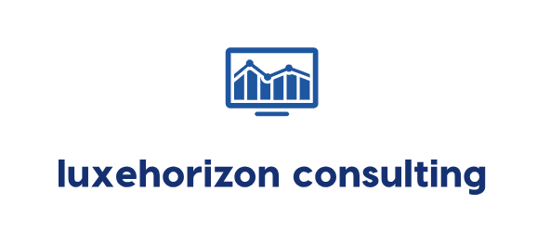

Declaration
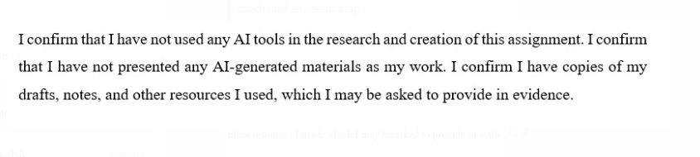

Table of Contents
1 Introduction 6
2 Analysis 7
3 SWOT Analysis 8
4 STEEPLED Analysis 9
5 TOWS Analysis 13
4 Recommendations and Change Management 14
4.1 Working with Recruitment Companies 14
4.2 Techniques for Flexible Staffing 15
4.3 Programs for Staff Development 15
4.4 Guest services being provided via technology 16
4.5 Handling Risks and Ways to Minimise Them 16
4.6 Implementation Plan for Each Recommendation 17
4.7 Change Management Strategy 18
4.8 Staff Engagement and Communication Plans 19
4.9 Success Metrics and KPIs 19
4.10 Cost-Benefit Analysis 21
5 Action Plan 22
6 Conclusion 24
7 Reference 26

Executive summary
A detailed analysis and strategic plan are given in this report for La Maison Champs Elysées, a luxury hotel in Paris. The hotel belongs to Marriott's Autograph Collection and brings together ancient features and contemporary charm. Still, the hotel is meeting several problems that are interfering with how well it provides service, how employees are satisfied, and how efficiently it works. These problems matter since they can negatively affect the hotel's image and how guests feel in a crowded market for luxury services. There is a key issue concerning rising internal management issues, specifically in the fields of staff and how activities are performed. Some travelers have complained about check-in and check-out which takes too much time, not enough housekeeping staff, and poor communication among teams. As a result, customers are not happy and the staff is discouraged. Because Paris's hospitality industry faces greater competition, it is vital to resolve these issues quickly and in a smart way. The report explains the hotel's background and covers the principal problems facing it. It also makes clear that consultancy work aims to learn about the company's problems, analyze them with strategic methods, and give solutions that are suitable to Marriott's international standards.
To analyze its internal and external conditions, a STEEPLED analysis was applied to La Maison Champs Elysées. These covers looking at factors related to Social, Technological, Economic, Environmental, Political, Legal, Ethical, and Demographic aspects. The report found that labor is getting more expensive in France, guests now prefer individualized experiences and hotels are now using digital tools more. It has also become clear from the analysis that travelers expect to complete more things such as checking in, online and paying with their mobile devices. Likewise, the hotel must manage labor laws that are tough and must work towards high sustainability standards. The analysis of SWOT was conducted to learn about what strengths, weaknesses, opportunities, and threats the hotel faced. The hotel's key strengths are being situated in the best part of town, having an exclusive luxury vibe, and being connected to Marriott. Difficulties include days when the lines are slow and shortages among the employees. Ways to improve include forming collaborations with hospitality schools and applying smart gadgets for efficient work. Some of the threats are the presence of many other luxury hotels in Paris and the desire for more from guests.
Then, the TOWS matrix helped create strategic options by joining the benefits of the organization with possible opportunities and risks in the environment. This allowed the team to determine four important steps. First, hotels can form alliances with hospitality schools and hiring agencies to find capable and talented new employees. In the same way, introducing part-time or seasonal jobs can help the company manage when there is high demand. In addition, investing in employee training and growth helps make services better and improves how happy team members feel. In addition, using systems such as digital check-in and scheduling for housekeeping will make operations more efficient. In order to make sure these strategies were executed well, a change management plan was put in place. This plan depends on good communication, employee participation, training, and constant review. Instead of making them change, employees should understand the reasons behind the change and how it helps them. This way of working encourages cooperation and confidence. In this way, staff could join training sessions and group meetings where they can express their concerns and offer ideas. Celebrating and rewarding those who adjust to changes encourages others and helps motivate them.
According to the model, I set up Key Performance Indicators (KPIs). It separates performance into four categories: financial, focused on customers, involving internal processes, and regarding people. Financial KPIs involve cutting expenses by doing effective staff scheduling and raising the amount of money earned per room. Some important KPIs for customers in hospitality are improving how guests rate their stay and cutting down their check-in time. Examples of internal process KPIs include how much time is needed to clean a room and the speed at which staff reply to requests. Employee retention rates and levels of training completion are among the people-related KPIs. With KPIs, the hotel can notice when things are not going as planned and make improvements. A SMART objectives table was built to check that all the goals are Specific, Measurable, Achievable, Relevant, and Time-bound. One target could involve cutting the average time for cleaning rooms by 15% over the next six months. You can also try to increase employee satisfaction scores by 20% in one year by focusing on training and engagement.
It is expected that introducing these changes will first require money for technology and for staff to receive training. It is expected that, over the next 12–18 months, the hotel will notice better satisfaction among guests, improved employee work, and a more efficient way of operating. With these benefits, the company can make more profits and spend less which makes the decision to invest valuable for the long term. The report states in its conclusion that these strategic tips are easy to put into practice and match the hotel’s identity as well as the standards set by Marriott worldwide. If La Maison Champs Elysées concentrates on recruiting, training, flexible staffing, and digital changes, it can solve its present challenges and enhance experiences for guests and employees alike. Being able to manage these changes well is essential for lasting results. It is important that staff feel valued and helped throughout the process. By using KPIs, everyone can easily track progress and make necessary changes when needed. If leadership and improvement efforts continue, the hotel can hold its place as one of the top luxury hotels in the city.

Introduction
La Maison Champs Elysées is a 5-star hotel, located in the city center and just a walk away from the famous Champs-Elysées Avenue. The hotel has 57 personality-filled rooms, offers delicious meals, and has been designed with style by Martin Margiela. As part of the Autograph Collection by Marriott International, the hotel gets strong brand awareness, crowded rooms, and is involved in Marriott's reward programs around the world (Horozhankina et al., 2024) While La Maison Champs Elysées is known for its excellence, it is currently struggling with difficulties due to a significant lack of workers in France. The trouble was made far worse by recent immigration measures that reduced the supply of labor from outside the EU, a leading group of workers in the hospitality industry (Brochmann, 2020). Not having enough workers is affecting the hotel's performance, employee happiness, and visitor experience. Many user reviews posted on TripAdvisor suggest that the hotel experiences late cleaning and some inconsistencies in service, negatively affecting its image (TripAdvisor, 2025). Nova Vista Hospitality Solutions is a Paris-based boutique firm that helps with the transformation of luxury and lifestyle hotels. It offers aged-for-you services in human resources, service development, digital adaptation, and staying strong during operations. The goal is to equip hotels with data that leads to sustainable and effective strategies and actions.
The report uses a mixture of frameworks to help analyze what challenges and opportunities La Maison Champs Elysées currently faces, both within the company and in the external environment. Initially, a STEEPLED analysis helps to look at the impact of social, technological, economic, environmental, political, legal, ethical, and demographic factors on the hotel's performance. The concept helps determine key factors, including updates in customer desires, innovations in technology, and legislative changes in immigration, that have an impact on how a business works. Furthermore, a SWOT analysis examines a company's positives, negatives, potential benefits from the outside, and negative pressures from the outside world (Hossain, 2025). As a result of this approach, it is easier to highlight advantages such as partnering with the brand and its location, alongside weaknesses such as lack of enough staff and delayed services (Thais et al., 2022). To benefit from the SWOT analysis, the TOWS method is used to come up with useful strategies (Saleh and Zohry, 2022). This outline guides businesses to suitable planning for problems such as keeping a solid workforce and dealing with the quality of their services. All in all, these approaches enable a thorough analysis of the problem and guide decisions supported by research for lasting positive results. The consultancy report will dig deeper into the factors causing workplace problems in the hotel, also studying the main results (Chela-Alvarez et al., 2022). After this, it will offer custom solutions for finding and keeping talent, along with suggestions for improving services. To guide the process, the change management strategy uses a roadmap with KPIs, estimated costs, and set schedules. Overall, the report focuses on making the hotel more efficient, offering top-quality service, and increasing its standing against other luxury hotels.

Analysis
The La Maison Champs Elysées is part of Marriott Design Hotels and is found in the very heart of Paris. Despite its unique environment and intriguing design, the hotel is struggling with several issues that are lowering guest satisfaction, profit, and the hotel's performance. They are because of service flaws, a lack of staff, and issues with maintaining the hospital. The examiner factors that lead to these problems, assesses their impact on the business, and suggests ways to improve. This also requires conducting a STEEPLED, SWOT, and TOWS analysis. Several people have noted that staff are not always welcoming, friendly, or able to help. For a luxury hotel, this kind of issue brings disappointment and results in angry guests (Lee and Kim, 2020). The result of this inadequate service upsets the guests. If there are poor reviews on a site, it may affect the number of bookings in the coming months.
Many hotels in France and Europe are also affected by a staff shortage, including La Maison Champs-Élysées. A recent report from Travel and Tour World states that hiring hospitality staff is a major issue for France (Morrison, 2022). The consequence of serving customers will be that they won’t be fast enough, wait times will increase, and the employees will be forced to carry more work. As a result, the guests may feel overlooked and enjoy their stay less. Many guests have complained about making reservations, not receiving clear information, and having difficulties reaching the hotel for answers. A few noted that things didn’t look the same online as they did at check-in time. The consequence of the miscommunication leads to confusion and stress.
Facility maintenance and irregularity of service delivery is also key issues hampering La Maison Champs-Elysees. There have also been symptoms of wear and tear in some parts of the hotel, which include broken lighting systems, old-fashioned decor or slow drainage systems, which are not positive contributions to the luxurious experience the guests anticipate. Physical appearance is relevant in influencing customer perception and satisfaction in the hospitality industry (Ali et al., 2021). The failure of the hotel to deliver as per the expectations, particularly in a luxury destination as Paris, results in dissatisfaction, which may manifest in negative reviews, lack of brand loyalty, and repeat. Besides, online platforms like TripAdvisor or Google Reviews have a significant impact on the travelling choices of potential guests. Word of mouth travels fast and bad comments about dirty conditions, broken furniture, or defective amenities put a dent on the image of the hotel.
Moreover, technological problems are identified to make the guests dissatisfied as well. At a time when the digital experience of the customer, online booking, check-in kiosks, and quick Wi-Fi is expected to be smooth, La Maison Champs-Elysees has been getting reports of unstable internet connectivity and archaic reservation platforms. Technology is imperative in the hospitality business to streamline services and make them convenient to customers. Inability to deal with them may put the hotel in an unfavourable competitive position. The current luxury hospitality industry, particularly in central Paris, is already very competitive and sustaining high standards and adaptation to technological change is not a luxury but a necessary condition of continued success (Equenot, 2024). Thus, organisational enhancements on training, communication and maintenance are of great strategy to restore the competitive advantage.

SWOT Analysis
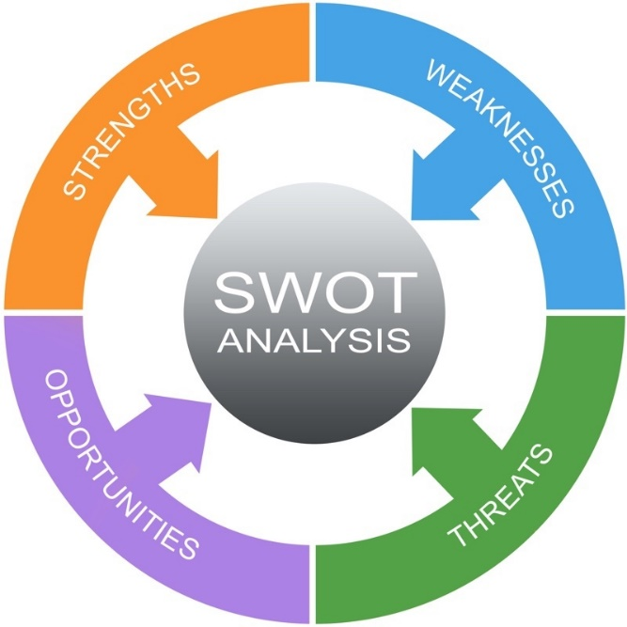
Figure 1 Swot analysis model
Source: (Benzaghta et al., 2021)
One of the major benefits La Maison Champs-Élysées offers is its central location in Paris, the appreciation of art and unique style in its interior design, and the trust factor of being part of the global Marriott brand. While there are apparent strengths, such as maintaining professional staff, the hotel also has numerous weaknesses, including unclean rooms, the inconvenience of an insufficient workforce, and problems with reservations and communication (Waaje et al., 2024). France's new immigration laws offer hotels opportunities to hire staff, modernize technology systems, and expand Marriott loyalty benefits (Bardukova, 2023). Besides the already present circumstances, La Maison Champs-Elysees will also be able to capitalize on the rise of experiential travel in which travelers want more personalized and culturally immersive experiences in their stay. The hotel has the potential to capture a small segment of the market composed of culturally oriented high-end tourists by improving its artistic persona and providing local experiences that are curated, which can then be reinforced by its brand image.
Table 1 SWOT analysis of La Maison Champs Elysées
Strengths | Weaknesses
The fantastic location in central Paris, combined with the uniquely designed and artful hotel, and the support from Marriott, are additional reasons to stay here. | The outdated rooms and lack of maintenance are the major weaknesses (Muhammad, 2022). The employees are working shorthanded and providing inconsistent service, and are having trouble with reserving and staying in touch.
Opportunities | Threats
The new laws for immigration in France upgraded technology, and membership prizes available in the Marriott network provide opportunities for the company. | The nearby high-ranking hotels pose a threat, too, as do shortages of hospitality workers and poor reviews (Wu et al., 2022).

STEEPLED Analysis
Those issues are shown by the STEEPLED factors, which are important external matters affecting La Maison Champs Elysées. If high-quality and personal service is not given, luxury guests might not feel satisfied with their stay. Using old booking systems is likely to produce errors, but introducing automation can help the business work more efficiently (Kumar, 2021). As a result of higher inflation in France, companies' expenses for wages and energy rise, causing earnings to fall. Many eco-conscious travelers may find that the lack of noticeable environmental actions dissuades them (Makoondlall-Chadee and Bokhoree, 2024). New laws in France allow for the recruitment of hospitality staff from other countries to help with labor shortages. The lack of enough staff in an organization can lead workers to burn out and risk violating labor laws (Gabriel and Aguinis, 2021). When it comes to ethics, caring for staff promotes employee retention and a good reputation among the public. Besides these, competitive environment in Paris is changing at a high rate with new boutique hotels and luxury hotels coming up. This further puts pressure on La Maison Champs Elysées to stand out by means of innovation and extraordinary experiences of the guests. The inability to change may result in loss of market share and profits.
Table 2 STEEPLED Analysis of La Maison Champs Elysées
Factor | Impact on Hotel Operations | Reference
Social | Guests are increasingly expecting personalized and high-quality service, especially in luxury hotels. Failure to meet this affects satisfaction. The luxury hotel market globally was worth USD 97.07 billion in 2024 and is anticipated to reach USD 199.55 billion by 2034, at a CAGR of 7.5%. The increase comes from a higher desire among rich travelers and foreign tourists for top-quality and customized experiences.  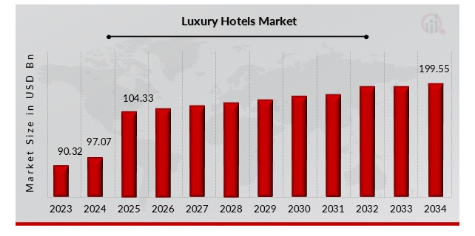  Figure 2 Global hotel market  Source: (Arjun and Yuvaraj, 2020) | (Arjun and Yuvaraj, 2025)
Technological | The outdated booking and communication systems can main to faults and guest dissatisfaction, investing in automation improves efficiency. The latest industry update suggests that increased efficiency is considered by 51% of hotel professionals as AI's major advantage for handling hotel room distribution, stock management, and scheduling staff during labor restrictions.  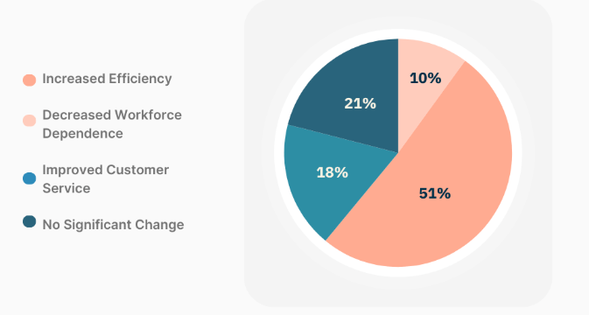  Figure 3 The hotel’s department benefits the most from AI  Source (Gulfraz Naqvi et al., 2023) | (Gulfraz Naqvi et al., 2023)
Economic | The Inflation in France has increased hospitality operating costs, including wages and energy. This strains profit margins. The CPI in France was 121.06 in April this year, which is 0.68 points higher than 120.38 in the previous month. In France, the Consumer Price Index CPI has fluctuated from 90.83 in the early 1990s to a record high of 121.06 points in August 2024.  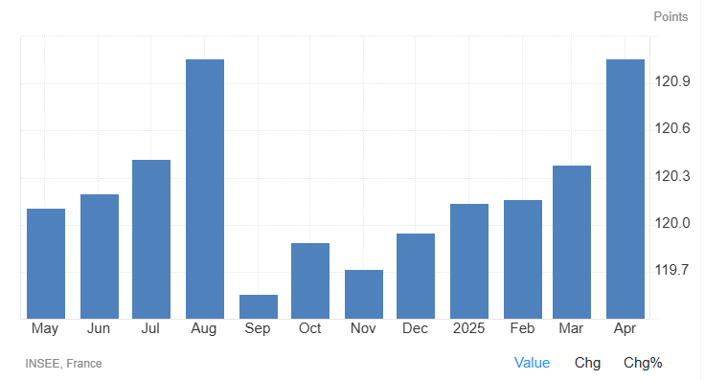  Figure 4 Consumer price index  Source: (Baghirov and Sarkhanov, 2023) | (Baghirov and Sarkhanov, 2023)
Environmental | The eco-conscious travelers prefer hotels with green practices. Europe has 31% of the world’s sustainable tourism sector, indicating many people prefer green tourism here. The hotel does not currently engage in significant environmental initiatives, so it might lose customers.  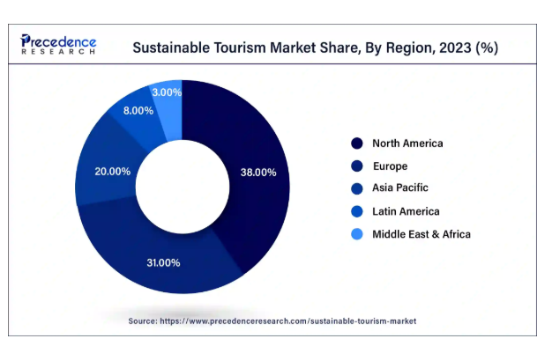  Figure 5 Sustainable tourism market  Source: (Martini and Buffa, 2020) | (Ibnou-Laaroussi et al., 2024)
Political | France's new immigration law (2023) helps hotels recruit foreign hospitality workers amid shortages. | (Sloan et al., 2022)
Legal | Compliance with labor laws is essential. A shortage of staff may lead to burnout and increase the risk of legal consequences if working hours exceed established limits.
Ethical | The ethical treatment of staff and fair working conditions affect employee retention and public image.
Demographic | Since tourists in Paris come from different countries, the staff in Paris needs to speak several languages and make services available for all cultures. The Eiffel Tower had 6.3 million visitors in 2023, and of that number, 75% were guests from other countries. This amount is up by 8% from 2022 (6.19 million), and has surpassed pre-COVID numbers (6.2 million in 2019), but remains behind the top level reached in 2014 (7.09 million). This means that multilingual and multicultural tourists keep coming to Paris, so hotels like La Maison Champs Elysées have to respond accordingly. 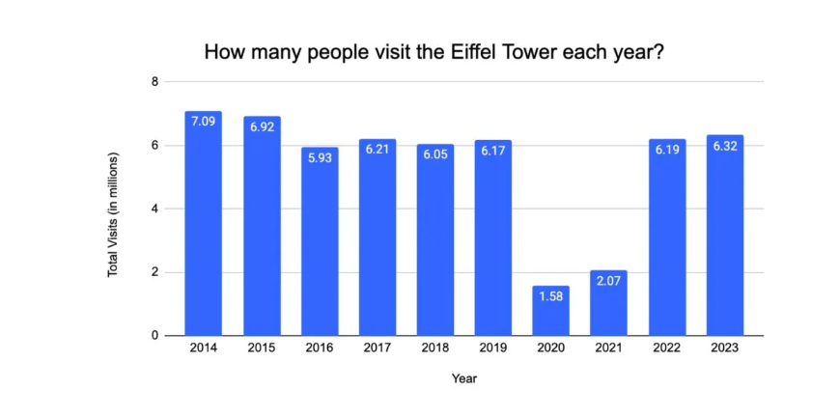  Figure 6 people visit the Eiffel Tower  Source: (George, 2021) | (George, 2021)

TOWS Analysis
The TOWS method offers workable plans for La Maison Champs Elysées. It would let the hotel profit from Marriott’s international network by promoting better technology and loyalty incentives and also benefit from new immigration laws in France to hire foreign workers (Charalampos et al., 2024). Thanks to its benefits, including location and exceptional service, the hotel may be able to compete successfully with other hotels. To help with weaknesses and opportunities (WO), the hotel should upgrade its old rooms and enhance its system for booking reservations. When addressing the last main category, weaknesses and threats (WT), it is important to improve the team to decrease complaints and prevent nearby hotels from taking customers (Boukis et al.,, 2024)
Strategy Type | Recommendations
Strengths + Opportunities (SO) | The use of Marriott support to improve technology and the offer of loyalty rewards to attract repeat guests. Hire skilled foreign staff under the new French immigration law.
Strengths + Threats (ST) | The high-maintenance service and quality are key to standing out against the competition, especially since the location is a significant advantage (Wu et al., 2023).
Weaknesses + Opportunities (WO) | Renovate the outdated rooms using the income from increased bookings. Upgrade communication and booking systems.
Weaknesses + Threats (WT) | The staff is to enhance service, minimize guest complaints, and prevent business loss to nearby hotels (Yang et al., 2020).

4 Recommendations and Change Management
Through the STEEPLED, SWOT, and TOWS frameworks, it is clear that La Maison needs to apply several related strategies to handle labor shortage, increase efficiency, and better meet the needs of guests. The recommendations rely on four main aspects: getting the right people, deploying staff efficiently, supporting staff with training and development, and integrating technology (Vrontis et al., 2023). All the recommendations fit the abilities within the hotel and the problems affecting the French tourism industry today.

Working with Recruitment Companies
Working in partnership with vocational centers and education institutions in hospitality should be one of the first solutions to deal with the labor shortage. Partnering with distinguished French schools such as Ferrandi and Vatel can help supply the food service industry with fresh talent. They should offer internships, apprenticeships, and seasonal employment programs to international students. In these partnerships, the hotel can connect with interested individuals who are keen on learning skills by working in an established hotel. The hotel could arrange career days, guest lectures, and tours for students so that more become interested in working there. The hotel might also consider recruiting people from other countries through programs and schemes that are agreed upon by governments.

4.2 Techniques for Flexible Staffing
Since the company faces fluctuating needs for workers, it should implement a core-periphery structure for its staff. The permanent staff makes sure the business's quality and brand are always consistent, while temporary staff help during the busy and eventful moments throughout the year. Without this approach, the hotel cannot manage its labor costs efficiently, react swiftly to changes in demand, and avoid service interruptions due to someone being absent without warning. Working with well-known hospitality agencies can help hotel staff get approved temporary help quickly for popular periods such as Paris Fashion Week, major exhibitions, and summer holidays (Spaargaren, 2020). For this model to work, teams should develop clear steps for handling tasks, reviewing performance, and interacting with guests, so that no mismatches between important and less important groups occur (Hong et al., 2020).

4.3 Programs for Staff Development
The talented staff stay is equally important as getting new workers to meet the labor crisis. For this reason, La Maison Champs Elysées should establish and carry out training and development plans that focus on areas such as hard skills and interpersonal skills. Hotels should use their onboarding programs to cover the service philosophy, brand values, and how the company operates. The training should include lessons on working with guests from different (cultures), using electronic devices, handling guest issues, and practicing environmentally responsible methods in hospitality. The spreading of wisdom among employees improves their job satisfaction, leads to less frequent staff changes, and enhances the regularity of service. Organisations can use incentive schemes to improve how engaged and retained their employees are, in addition to their regular training. Employees might benefit from bonuses based on results, getting support for learning another language, options for climbing the career ladder, and employee recognition. Through conducting surveys every year, management can recognise what makes their employees satisfied and what needs attention. Balancing work and life is easier for working parents or staff taking classes when part-time hired or sharing jobs are available (Evans et al., 2022).

4.4 Guest services being provided via technology
The hotel should focus on digitalising how services are delivered to reduce the demands on employees and provide a better service for guests. The implementation of advanced technology in the industry leads to more efficient work, quicker service and satisfies the demands of tech-savvy flyers. Some digital improvements may involve guests using mobile check-in and check-out, online concierge systems, and tablets in their rooms to ask for service and give responses. Besides, automation tools can help with scheduling the housekeeping team, managing inventory, and gathering maintenance updates. With these technologies, there is better cooperation, less manual effort, and service standards remain the same, even if the team gets smaller.

4.5 Handling Risks and Ways to Minimise Them
In spite of the effectiveness of the strategies, taking risks into account is always important. Having many temporary workers may lower service quality. This problem can be solved by giving them adequate training and onboarding them well. The process of releasing new technology may result in issues, so it is essential to implement it piece by piece and receive solid IT help. One should always keep an eye on changes in laws and regulations that deal with staffing and privacy online to comply.

Implementation Plan for Each Recommendation
To successfully put the planned recommendations into action, a well-structured plan must be prepared, showing when tasks should be done, which items are needed, and who will do them. Within three months, Digital Transformation is planned to help the company become more visible online and engage customers better. Important actions are refreshing the website layout, supporting a newer book system, and fine-tuning each page for use on various screens. SEO methods will also be used to boost search engine rankings. Logging regular posts to platforms like Instagram and Facebook helps grab guests' attention and promote what you have to offer. Such actions call for finding a marketing expert and setting a budget aside for paid advertisement projects. Marketing and Information Technology departments will jointly handle this new initiative (Kolobkova et al. 2021). It is best to give Sustainability Initiatives 6 months to be completed. Examples of actions are a full energy audit, using LED lighting everywhere, launching recycling initiatives, and teaming up with nearby suppliers for organic goods. These resources include buying green equipment and educating employees about environmentally friendly actions to guarantee compliance and involvement. This plan will be managed by the Operations Manager and a newly chosen Sustainability Coordinator (Rubio-Mozos et al., 2020).
Personalized profiles for guests will be created in CRM systems within 4 months so that the hotel can offer them services such as favorite room choices and meals. Teamwork with local tour operators will make the travel experience better for guests by arranging memorable activity options. Using and training staff with CRM software is necessary. The Guest Relations Manager, along with the Front Office Team, will manage this strategy (Daiva Labanauskaitė et al., 2020). The General Manager, along with the IT department and the heads of various departments, will manage this entire process (Tavitiyaman et al., 2022).

Change Management Strategy
The effectiveness of the recommendation implementation success at the La Maison Champs Elys ees will be based on a well-organized change management plan. The 8-Step Change Model developed by Kotter (1996) provides a realistic framework on how to manage this transition.
- Communication Team communication should be open to facilitate the process of uncertainty and trust-building (Darvishmotevali et al., 2020). Periodical meetings, email communication, and notifications will keep everybody informed about the necessity of every change and monitor project development. Managers will offer motivation and clear direction.
- Stakeholder Engagement Early involvement of staff through feedback forms, suggestion boxes, and conversations permits employees to have a voice, and thus they become more receptive to change (Sabian and Ispas, 2021).
- Support and Training The staff will need to feel free to adapt to the new environment and experience as little stress as possible, which will be accommodated by tailored training, workshops, and constant support by helpdesks or supervisors (Arora et al., 2024).
- Observation and Assessment KPIs will be used to track the performance and make amendments in case of necessary to enhance the outcomes (Grynko et al., 2024). With the guided framework of Kotter, the implementation will be easier, more driven, and less opposed.

Staff Engagement and Communication Plans
A manager must involve staff and keep in touch to carry out strategic changes at La Maison Champs Elysées. When workers are well-informed and feel part of the team, they tend to support the changes and add value. Meetings, newsletters, and the internal staff website will allow all team members to remain informed about the current state of the project. By being open about the details, trust improves and avoids problems when changes are made (Luo et al., 2021). Two-way communication will be promoted by including anonymous suggestion boxes, staff surveys, and scheduled Q&A sessions. This method makes it easy for employees to raise concerns or share ideas, which helps management solve issues more quickly (Donate et al., 2022). If coworkers are recognized, it lifts spirits and inspires others to contribute positively (Farrell, 2022). A crucial element of the plan is preparing and growing employees. Employing continuous learning provides staff with the skills needed and can make workers more satisfied and supported at work (‌Yoopetch et al., 2021).

Success Metrics and KPIs
La Maison Champs Elysées will use important Key Performance Indicators (KPIs) using a balanced scorecard method to gauge the success of its strategy. Using this method, you can review your financial, customer, internal process, and learning aspects in detail (‌Köseoglu et al., 2020).They play a key role in checking the results of changes in marketing and digital efforts on customer numbers and loyalty levels (Cao et al., 2024). As a result, property management systems help decrease the average time spent on check-in and check-out by 20% and reduce operational expenses by 10% by automating and effectively monitoring resources. The first year’s achievements should include energy savings of 15% and a 20% cut in waste due to recycling, all through eco-friendly plans. Such efforts help hotels perform better and also build a strong brand image, given that sustainability is a key concern in the hospitality industry nowadays (Varelas et al., 2021).
In this dimension, the improvement in guest experience will be assessed by achieving a 10% rise in survey satisfaction and a 15% boost in repeat visitors over 12 months. They highlight whether staff training and tailored services have a positive impact on guest loyalty (Waqanimaravu and Arasanmi, 2020).
Perspective | Objective | Key Performance Indicator (KPI) | Target | Timeline
Customer | To increase direct online bookings | The percentage of direct bookings via the website | +25% | Within 6 months
 | To improve brand engagement | To grow in social media interactions (likes, shares, comments) | +30% | Within 6 months
 | To enhance guest satisfaction | The post-stay guest satisfaction survey scores | +10% | Ongoing (12 months)
 | To increase guest retention | The number of repeat guest bookings | +15% | Over 12 months

Cost-Benefit Analysis
In the cost-benefit analysis, the financial (monetary) and the non-financial (human) effects of the strategic projects at La Maison Champs Élysées are analysed. Regarding the financial aspect, the overall investment of 93,000 euros in digitalisation, sustainability, and personalisation strategies is expected to yield about 105,000 euros in annual returns. Non-financial, the initiatives enhance employee competencies, customer satisfaction, and the brand image of a hotel (Cihan Cobanoglu et al., 2021). Such human-related benefits are essential to the long-term competitiveness and service quality.
Project | Cost (€) | Financial Benefit (€) | Non-Financial (Human) Benefit | Source
Digital Transformation | 30,000 | +50,000 (higher bookings) | The staff digital skills, improved guest online experience | (Busulwa et al., 2020; Cobanoglu et al. 2021)
Sustainability Measures | 23,000 | +10,000 (energy savings) | An employee awareness, green image, staff pride | Iyengar and Venkatesh (2024)
PMS & Personalised Service | 30,000 | +30,000–35,000 (efficiency, loyalty gains) | The faster service, higher guest satisfaction, less stress for staff | (Khuong and Linh, 2020 ; Milosh 2023)
Total | 93,000 | ≈105,000 annually | The stronger human capital, enhanced morale & customer relations | Patsatsia (2024)

Action Plan
No. | Problem | Solution | Desired Outcome | Time Scale | Completion Date | Planned Budget
1 | Talent shortage in the hospitality sector | To develop Strategic Recruitment Partnerships with top schools; offer internships/apprenticeships; host career fairs and lectures (Medina et al., 2020) | An improved talent pipeline and employer brand visibility (Krishnan and Rathakrishnan, 2025). | 3 months | 01/09/2025 | €0 (internal resources)
2 | Inflexible staffing during peak periods | An Implement Flexible Staffing Model: analyse workforce needs, collaborate with agencies, and use adaptive schedules (Giousmpasoglou, 2024). | The greater agility in staffing; consistent service quality (Tomy Fitrio et al., 2023) | 2 months | 01/11/2025 | €0 (process-based)
3 | Skills gap in service delivery | The Launch of a Comprehensive Training Programme focusing on soft skills via Marriott L&D and mentorships (Scerri et al., 2020). | An increased service quality and staff growth aligned with Marriott values. | 2 months | 01/12/2025 | €10,000
4 | Guest waits times and manual processes | The digitalise Guest Services: mobile check-in/out, AI for FAQs, in-room tablets (Tai et al., 2021). | An enhanced guest satisfaction and staff efficiency through automation. | 3 months | 01/02/2026 | €30,000
5 | Low digital skills among staff | To provide Digital Skills Training through demos, classes, and tech reviews (Tai et al., 2021). | The confident staff usage of hotel systems; smoother tech adoption. | 3 months | 01/03/2026 | €10,000
6 | Lack of Marriott brand consistency | The Marriott Alignment: collaborate with Marriott’s global team, use branded HR tools and analytics (Ongoing). | The stronger integration with Marriott’s global brand and operational tools. | Ongoing | Continuous | €3,000/year (ongoing)
In this action plan, there are six strategic initiatives that La Maison Champs Elysees should undertake in order to enhance its operation, service quality and brand alignment. The strategy handles the workforce and technology issues. Partnerships and flexible schedules will enhance talent recruitment and staffing flexibility. The competencies of staff will be enhanced through soft skills and digital training, and digital guest services are intended to increase efficiency and satisfaction (Mejia and Wickey-Byrd, 2023). The cooperation with Marriott guarantees the brand consistency. The majority of actions take place during 2-3 months, except brand alignment, that is continuous. The overall planned budget is 53.000e, and two of the initiatives will use internal resources without any direct cost to the hotel.

Conclusion
The central location is La Maison Champs Elysées must increase its resilience to maintain the high expectations of its clients amidst challenges from the external environment. Because many people are not immigrating due to recent changes, there is a shortage of workers in hospitality, which puts intense pressure on staff and the services provided. The consultant has used STEEPLED, SWOT, and TOWS to critically examine how forces outside the hotel and its strengths and weaknesses can affect its development. The new recommendations and plan have been set up to deal with labor issues, new technology, and how to keep employees on board, following a clear and step-by-step process (Vrontis et al., 2023). If the hotel deals with the workforce issues by having partnerships, flexible teams, effective training, and automation, it can boost its hiring, let guests enjoy their trip, and perform better. Appreciations to being well planned and professionally checked, work is done faster and kept improving. It aims to bring the hotel back to operational excellence and make sure it is seen as a leader in innovation, flexibility, and premium services in the Paris luxury hospitality market. The changes that are deliberate and strategic can maintain La Maison Champs Elysées’ reputation and help it thrive in the future.
Addressing changes properly is crucial for accomplishing these main strategic initiatives. It is now stressed that CEOs should talk with staff, involve them in key decisions, ensure they are trained for the job, and monitor progress at all times. Telling employees why these changes matter early and involving them in the decisions will increase their trust in the company. Staff engagement and recognition help to create an environment where people value inclusivity and teamwork, giving the organization stability. Still, relying on technology including automated entry and planning resources according to data reflects what people expect nowadays and is vital for the hotel's future prosperity. As technology can sometimes remove the personal touch, ensuring that staff are highly skilled in it ensures the service is as caring and attentive as always. By combining the past and present, La Maison Champs Elysées will keep its essence and become more productive.
The framework is a helpful tool for checking an organization's success. When a business pays attention to digital KPIs, environmental efforts, guest sentiments, and achievements, it shows that it is responsible and gives clarity. Thus, following these guidelines, the hotel can see where it stands and eventually make adjustments to stay on target with what it wishes to accomplish. All in all, this way of thinking allows La Maison Champs Elysées to deal with internal problems, manage employment matters, and satisfy customers. If the hotel is given proper control and regular feedback, it will be able to stay at the top amongst luxury hotels in Paris.

Reference
‌Ali, B., Ahmed, S., Gardi, B., Othman, B., Burhan, N., Hamza, A., Mahmood Aziz, H., Sabir, Y., Sorguli, S. and Anwar, G. (2021). Hotel Service Quality: The Impact of Service Quality on Customer Satisfaction in Hospitality Hotel Service Quality: The Impact of Service Quality on Customer Satisfaction in Hospitality. International journal of Engineering, Business and Management (IJEBM), [online] 5(3), pp.2456–8678. doi:https://dx.doi.org/10.22161/ijebm.5.3.2.
Arjun K and Yuvaraj KP (2025). The Impact of Globalization on Hotel Management Practices. American Journal of Psychiatric Rehabilitation, [online] 28(5), pp.31–39. doi:https://doi.org/10.69980/ajpr.v28i5.310.
Baghirov, A. and Sarkhanov, T. (2023). The Influence of Incoming Tourists and Consumer Price Index on Tourism Receipts. African Journal of Hospitality, Tourism and Leisure, [online] 12(1), pp.16–30. doi:https://doi.org/10.46222/ajhtl.19770720.351.
Benzaghta, M.A., Elwalda, A., Mousa, M., Erkan, I. and Rahman, M. (2021). SWOT Analysis applications: an Integrative Literature Review. Journal of Global Business Insights, [online] 6(1), pp.54–72. Available at: https://pdfs.semanticscholar.org/1ce6/a88073a1fedd93547b395c7b1898970736ad.pdf?_gl.
Boukis, A., Harris, L. and Koritos, C.D. (2024). ‘Give me an upgrade or I will give you a bad review!’ Investigating customer threats in the hospitality industry. Tourism Management, [online] 104, p.104927. doi:https://doi.org/10.1016/j.tourman.2024.104927.
Brochmann, G. (2020). Controlling Immigration in Europe. Mechanisms of Immigration Control: A Comparative Analysis of European Regulation Policies, [online] pp.297–334. doi:https://doi.org/10.4324/9781003086062-10.
Busulwa, R., Evans, N., Oh, A. and Kang, M. (2020). Hospitality Management and Digital Transformation. [online] Routledge eBooks. Informa. doi:https://doi.org/10.4324/9780429325205.
‌Cao, P., Sial, M.S., Álvarez-Otero, S., Talles Vianna Brugni and Ubaldo Comite (2024). Eco-engagement: Tracing CSR communication’s ripple effect on consumer hospitality loyalty. Journal of Retailing and Consumer Services, [online] 79, pp.103879–103879. doi:https://doi.org/10.1016/j.jretconser.2024.103879.
Charalampos Giousmpasoglou and Evangelia Marinakou (2024). Human Resources Management in Hotels. Springer eBooks, [online] pp.129–158. doi:https://doi.org/10.1007/978-3-031-52803-3_6.
Chela-Alvarez, X., Bulilete, O., Garcia-Illan, E., Vidal-Thomàs, Mc. and Llobera, J. (2022). Hotel housekeepers and occupational health: experiences and perceived risks. Annals of Occupational and Environmental Medicine, [online] 34(1). doi:https://doi.org/10.35371/aoem.2022.34.e29.
‌Cihan Cobanoglu, Dogan, S., Nanu, L., Fragniere, E. and Kamil Yagci (2021). Hospitality and Tourism Information Technology. [online] USF M3 Publishing, LLC eBooks. doi:https://doi.org/10.5038/9781732127593.
Daiva Labanauskaitė, Fiore, M. and Rimantas Stašys (2020). Use of E-marketing tools as communication management in the tourism industry. Tourism Management Perspectives, [online] 34, pp.100652–100652. doi:https://doi.org/10.1016/j.tmp.2020.100652.
Darvishmotevali, M., Altinay, L. and Köseoglu, M.A. (2020). The link between environmental uncertainty, organizational agility, and organizational creativity in the hotel industry. International journal of hospitality management, 87, p.102499. doi:https://doi.org/10.1016/j.ijhm.2020.102499.
Donate, M.J., González-Mohíno, M., Appio, F.P. and Bernhard, F. (2022). Dealing with knowledge hiding to improve innovation capabilities in the hotel industry: The unconventional role of knowledge-oriented leadership. Journal of Business Research, [online] 144, pp.572–586. doi:https://doi.org/10.1016/j.jbusres.2022.02.001.
Equenot, T. (2024). Change management dynamics applied to the fast-evolving luxury hotel industry. Oulu.fi. [online] doi:https://oulurepo.oulu.fi/handle/10024/50320.
‌Evans, C., Ritchie, C., Drew, H. and Ritchie, F. (2022). A marriage of convenience: How employers and students working in hospitality view the employment relationship. Hospitality & Society, [online] 12(3), pp.299–318. doi:https://doi.org/10.1386/hosp_00055_1.
‌Farrell, K. (2022). Transformational Leadership for the Hospitality and Tourism Industry. Humanism in Business Series, [online] pp.273–292. doi:https://doi.org/10.1007/978-3-030-95671-4_14.
Gabriel, K.P. and Aguinis, H. (2021). How to prevent and combat employee burnout and create healthier workplaces during crises and beyond. Business Horizons, [online] 65(2), pp.183–192. doi:https://doi.org/10.1016/j.bushor.2021.02.037.
George, R. (2021). The Tourism and Hospitality Marketing Environment. Marketing Tourism and Hospitality, [online] pp.183–219. doi:https://doi.org/10.1007/978-3-030-64111-5_6.
‌Giousmpasoglou, C. (2024). Working Conditions in the Hospitality Industry: The Case for a Fair and Decent Work Agenda. Sustainability, [online] 16(19), pp.8428–8428. doi:https://doi.org/10.3390/su16198428.
‌Grynko, T., Hviniashvili, T., Oliinyk, T., Saihak, Y., Yudina, O. and Korneyev, M. (2024). IMPROVEMENT OF THE CHANGE MANAGEMENT MODEL AT THE HOTEL INDUSTRY ENTERPRISES. Financial & Credit Activity: Problems of Theory & Practice, 3(56). doi:https://doi.org/10.55643/fcaptp.3.56.2024.4418.
Gulfraz Naqvi, Muhammad Hamza Saddique, Muhammad Sarim and Shaz Ur Riyan (2023). Application of AI in Hotel Management and its Benefits. STATISTICS, COMPUTING AND INTERDISCIPLINARY RESEARCH, [online] 5(1), pp.1–13. doi:https://doi.org/10.52700/scir.v3i2.141.
Hong, S.R., Hullman, J. and Bertini, E. (2020). Human Factors in Model Interpretability: Industry Practices, Challenges, and Needs. Proceedings of the ACM on Human-Computer Interaction, [online] 4(CSCW1), pp.1–26. doi:https://doi.org/10.1145/3392878.
Horozhankina, N., Korneyev, M. and Farzullaev, R. (2024). Marriott International’s place in international hotel chains. Umsf.dp.ua. [online] doi:https://doi.org/2706-9079.
Hossain, M.S. (2025). Sustainable Ecotourism in Bangladesh: A SWOT Analysis of Ecotourism Destinations. International Journal of Multidisciplinary Research and Growth Evaluation, 6(2), pp.1146–1163. doi:https://doi.org/10.54660/.ijmrge.2025.6.2.1146-1163.
Ibnou-Laaroussi, S., Rjoub, H. and Wong, W.-K. (2020). Sustainability of Green Tourism among International Tourists and Its Influence on the Achievement of Green Environment: Evidence from North Cyprus. Sustainability, [online] 12(14), p.5698. doi:https://doi.org/10.3390/su12145698.
‌Iyengar, M.S. and Venkatesh, R. (2024). Sustainable Luxury Stays: Investigating Eco-Friendly Practices in High-End Hotels. The Journal of the International Committee for the History of Technology, [online] 29(1), pp.125–143. doi:https://doi.org/10.11590/icon.2024.1.05.
Khuong, M.N. and Linh, U.D.T. (2020). Influence of work-related stress on employee motivation, job satisfaction and employee loyalty in hospitality industry. Management Science Letters, 10(14), pp.3279–3290. doi:https://doi.org/10.5267/j.msl.2020.6.010.
Kolobkova, V.A., Romanov, A.A. and Frolova, E.A. (2021). Digital Technologies in the Hotel Industry: New Prospects for Sustainable Development. Studies in systems, decision, and control, [online] pp.387–394. doi:https://doi.org/10.1007/978-3-030-56433-9_41.
‌Köseoglu, M.A., Altin, M., Chan, E. and Aladag, O.F. (2020). What are the key success factors for strategy formulation and implementation? Perspectives of managers in the hotel industry. International journal of hospitality management, 89, p.102574. doi:https://doi.org/10.1016/j.ijhm.2020.102574.
‌Krishnan, S. and Radhakrishnan, B. (2025). Psychosocial factors contributing to turnover intention among employees in the hospitality industry: a systematic review. Current Psychology. [online] doi:https://doi.org/10.1007/s12144-025-07550-3.
Kumar, P. (2021). Hospitality and Tourism Information Technology. USF M3 Publishing, LLC. doi:https://doi.org/10.5038/9781732127593.
Lee, S. and Kim, D.-Y. (2020). The BRAND tourism effect on loyal customer experiences in a luxury hotel: The moderating role of psychological ownership. Tourism Management Perspectives, [online] 35, p.100725. doi:https://doi.org/10.1016/j.tmp.2020.100725.
Luo, C.-Y., Tsai, C.-H.K., Chen, M.-H. and Gao, J.-L. (2021). The Effects of Psychological Capital and Internal Social Capital on Frontline Hotel Employees’ Adaptive Performance. Sustainability, [online] 13(10), pp.5430–5430. doi:https://doi.org/10.3390/su13105430.
Makoondlall-Chadee, T. and Bokhoree, C. (2024). Environmental Sustainability in Hotels: A Review of the Relevance and Contributions of Assessment Tools and Techniques. Administrative Sciences, [online] 14(12), p.320. doi:https://doi.org/10.3390/admsci14120320.
Martini, U. and Buffa, F. (2020). Marketing for Sustainable Tourism. Sustainability, [online] 12(5), pp.2014–2014. doi:https://doi.org/10.3390/su12052014.
Medina, A., Hernández, J.C., Muñoz-Cerón, E. and Rus-Casas, C. (2020). Identification of Educational Models That Encourage Business Participation in Higher Education Institutions. Sustainability, [online] 12(20), pp.8421–8421. doi:https://doi.org/10.3390/su12208421.
‌Mejia, C. and Wickey-Byrd, J. (2023). Boundary crossing, internships, and the hospitality & tourism talent pipeline. Journal of Hospitality Leisure Sport & Tourism Education, [online] 33, pp.100441–100441. doi:https://doi.org/10.1016/j.jhlste.2023.100441.
‌Milosh, P. (2023). Evolving Preferences: Understanding Contemporary Luxury Hotel Guests. Theseus.fi. [online] doi:http://www.theseus.fi/handle/10024/816941.
Morrison, A.M. (2022). Hospitality and Travel Marketing. [online] doi:https://doi.org/10.4324/9781003292616.
Muhammad, F. (2022). Hotel room preventive maintenance / Muhammad Faris Imran Fared Fahishal - UiTM Institutional Repository. Uitm.edu.my. [online] doi:https://ir.uitm.edu.my/id/eprint/85871/2/85871.PDF.
Rubio-Mozos, E., García-Muiña, F.E. and Fuentes-Moraleda, L. (2020). Sustainable Strategic Management Model for Hotel Companies: A Multi-Stakeholder Proposal to ‘Walk the Talk’ toward SDGs. Sustainability, [online] 12(20), pp.8652–8652. doi:https://doi.org/10.3390/su12208652.
Saleh, A. and Zohry, M. (2022). Towards A Sustainable Hotel Education (An Analytical Strategic Study at The Faculty of Tourism and Hotels, Mansoura University - TOWS Matrix as A Model). International Journal for Tourism, Archaeology and Hospitality, [online] 2(1), pp.45–74. doi:https://doi.org/10.21608/ijtah.2022.244444.
‌Scerri, M., Presbury, R. and Goh, E. (2020). An application of the mentoring framework to investigate the effectiveness of mentoring programs between industry mentors and student mentees in hospitality. Journal of Hospitality and Tourism Management, [online] 45, pp.143–151. doi:https://doi.org/10.1016/j.jhtm.2020.08.010.
Sibian, A.R. and Ispas, A. (2021). An approach to applying the ability-motivation-opportunity theory to identify the driving factors of green employee behavior in the hotel industry. Sustainability, 13(9), p.4659. doi:https://doi.org/10.3390/su13094659.
Sloan, P., Legrand, W. and Chen, J.S. (2022). Sustainability in the Hospitality Industry. [online] doi:https://doi.org/10.4324/9781003081128.
Spaargaren, R. (2020). Engagement of casual labor to Hotel Arts’ standards and culture. Url.edu. [online] doi:http://hdl.handle.net/20.500.14342/4188.
‌Tai, Y.-F., Wang, Y.-C. and Luo, C.-C. (2021). Technology- or human-related service innovation? Enhancing customer satisfaction, delight, and loyalty in the hospitality industry. Service Business, [online] 15(4), pp.667–694. doi:https://doi.org/10.1007/s11628-021-00461-w.
Tavitiyaman, P. et al. (2022) ‘How Task Technology Fits with Employee Engagement, Organizational Support, and Business Outcomes: Hotel Executives’ Perspective’, Journal of China Tourism Research, 18(6), pp. 1212–1238. doi: 10.1080/19388160.2022.2027834.
Thais González-Torres, Pelechano-Barahona, E. and García-Muiña, F.E. (2022). Business Innovations and Interorganizational Relationships In the Hospitality Industry: Does Partner Diversity Matter? Tourism Review International, [online] 26(2), pp.163–182. doi:https://doi.org/10.3727/154427221x16317419620255.
Tomy Fitrio, Yudha Remofa, Hardi, H. and Ismail, Y. (2023). THE ROLE OF SERVICE QUALITY AGILITY, COMPETENCE, AND ORGANIZATIONAL COMMITMENT IN IMPROVING EMPLOYEE PERFORMANCE. Jurnal Aplikasi Manajemen, [online] 21(1). doi:https://doi.org/10.21776/ub.jam.2023.021.1.17.
Tripadvisor. (2025). Tripadvisor. [online] Available at: https://www.tripadvisor.com/Hotel_Review-g187147-d197537-Reviews-La_Maison_Champs_Elysees-Paris_Ile_de_France.html [Accessed 20 May 2025].
Varelas, S., Panagiota Karvela and Georgopoulos, N. (2021). The Impact of Information Technology and Sustainable Strategies in Hotel Branding, Evidence from the Greek Environment. Sustainability, [online] 13(15), pp.8543–8543. doi:https://doi.org/10.3390/su13158543.
Vrontis, D., Christofi, M., Pereira, V., Tarba, S., Makrides, A. and Trichina, E. (2023). Artificial intelligence, robotics, advanced technologies, and human resource management: a systematic review. Artificial Intelligence and International HRM, [online] pp.172–201. doi:https://doi.org/10.4324/9781003377085-7.
Waaje, A., Karim, R., Roshid, Md.M. and Meem, T.N. (2024). Minimizing Waste in the Hospitality Industry. Advances in Hospitality, Tourism, and the Services Industry, [online] pp.125–166. doi:https://doi.org/10.4018/979-8-3693-6110-8.ch006.
Waqanimaravu, M. and Arasanmi, C. N. (2020) ‘Employee training and service quality in the hospitality industry’, Journal of Foodservice Business Research, 23(3), pp. 216–227. doi: 10.1080/15378020.2020.1724850.
Wu, J., & Zhao, N. (2022). What consumer complaints should hoteliers prioritize? Analysis of online reviews under different market segments. Journal of Hospitality Marketing & Management, 32(1), 1–28. https://doi.org/10.1080/19368623.2022.2119187
Wu, J., Yang, T., Zhou, Z. and Zhao, N. (2023). Consumers’ affective needs matter: Open innovation through mining luxury hotels’ online reviews. International Journal of Hospitality Management, [online] 114, pp.103556–103556. doi:https://doi.org/10.1016/j.ijhm.2023.103556.
Yang, C. E., Wang, Y. C., & Yang, J. (2020). Hotel Restaurant Service Employees’ Sources of Positive and Negative Emotions. Journal of Quality Assurance in Hospitality & Tourism, 21(5), 542–563. https://doi.org/10.1080/1528008X.2020.1712306
‌Yoopetch, C., Nimsai, S. and Kongarchapatara, B. (2021). The effects of employee learning, knowledge, benefits, and satisfaction on employee performance and career growth in the hospitality industry. Sustainability, 13(8), p.4101. doi:https://doi.org/10.3390/su13084101.
‌

‌
‌

