Assignment title: Kwikee-Mart Analysis
Student name: Kyle Stuart
Student number: 1811687
Word count: 1909

Content Page
Table of Contents
Introduction 3
Main Findings 4
Part 1 – Excel 4
Part 2 – Weka 10
Conclusion 16
References 17

Introduction

The company I work for has been approached by a company based in the USA, that is an office stationery retailer called Kwikee -Mart Office Supplies. As the data analyst, I have been asked to access their sales data and find areas in which they can improve. I will access where profitability is low. I will demonstrate this by using the IF function, LOOKUP, producing pivot tables and displaying the results by making use of graphs and charts. Part two will make use of Weka. I will use Kwikee-Marts data and use it to look at Regression, Classification, clustering and Association.

Main Findings

Part 1 – Excel
According to Techopida (n.d) data pre-processing is a data mining technique that involves transforming raw data into an understandable format. Real-world data can lack certain behaviours or trends and is likely to contain errors, therefore pre-processing is used to solve these issues. Pre- processing involves 5 steps, namely data cleaning which involves smoothing the noise, resolving the discrepancies in the data and filling in the missing values. The second step being data integration, which involves sorting data that has different representations that are put together. Conflicts in the data are also resolved in this step. Data transformation converts data from one format to another. The fourth step is data reduction. Data Discretization is the last step, which puts values into buckets so that there are a limited number of possible states (Sharma,2018).

The IF function allows one to make logical comparisons between a value and what you expect (Office Support, 2019). One uses the IF function to ask Excel to test a condition and to return one value if the condition is met, and another condition if it is not met (Cheusheva, 2019). The IF function will be used to tell weather Kwikee-mart’s areas of profitability are either running at a “Profit” or “Loss”. The following formula was used in order to complete this process.


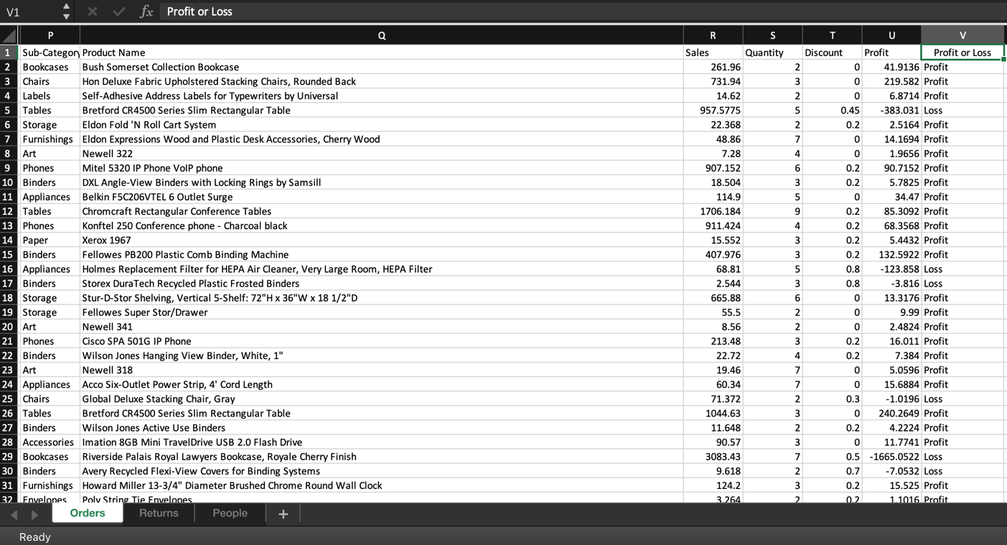

One can use VLOOKUP when one needs to find things in a table, or a range by row. An example can be looking up a price of a clothing item by searching for its code, or finding an employee name based on their employee ID. The VLOOKUP function formula is = =VLOOKUP(What you want to look up, where you want to look for it, the column number in the range containing the value to return, return an Approximate or Exact match – indicated as 1/TRUE, or 0/FALSE) (Sartin,2017).



The following formula allows one to type in the Sub- category, excel will run through the vast amount of data and give us the Profit of the sub- category. In the image below one can see that in cell Y3 it say #N/A this is due to there not being a sub- category in cell Y2. Once the sub- category is placed in cell Y2, for example “blinders” it will search through the data and calculate the over all profit for all the blinders in the data set and provide the final calculation. If the calculation has a minus sign in-front of it the sub- category is at a loss, and if the calculation is greater than 0 then the sub- category is in profit. TRUE finds partial matches, FALSE finds exact matches.

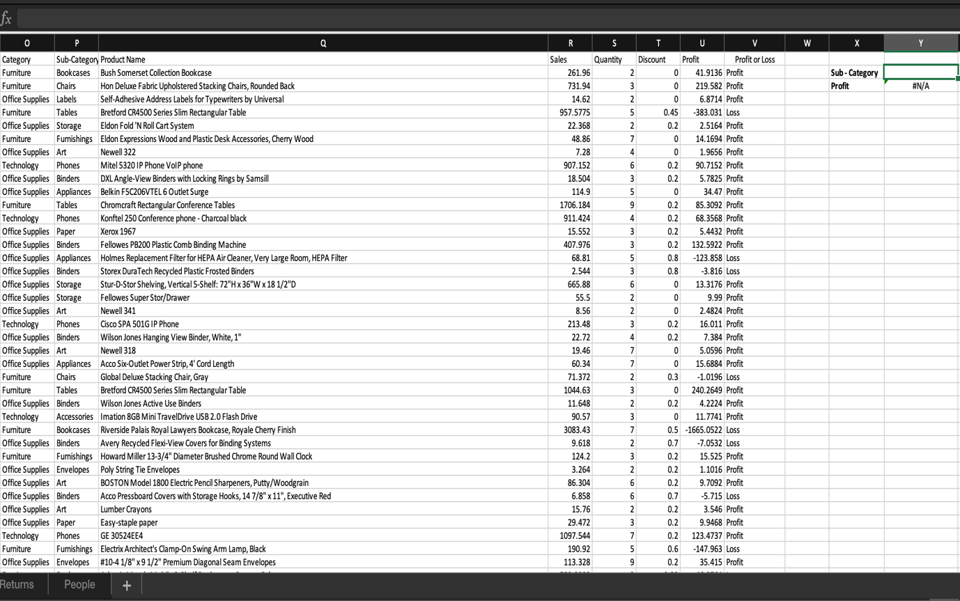

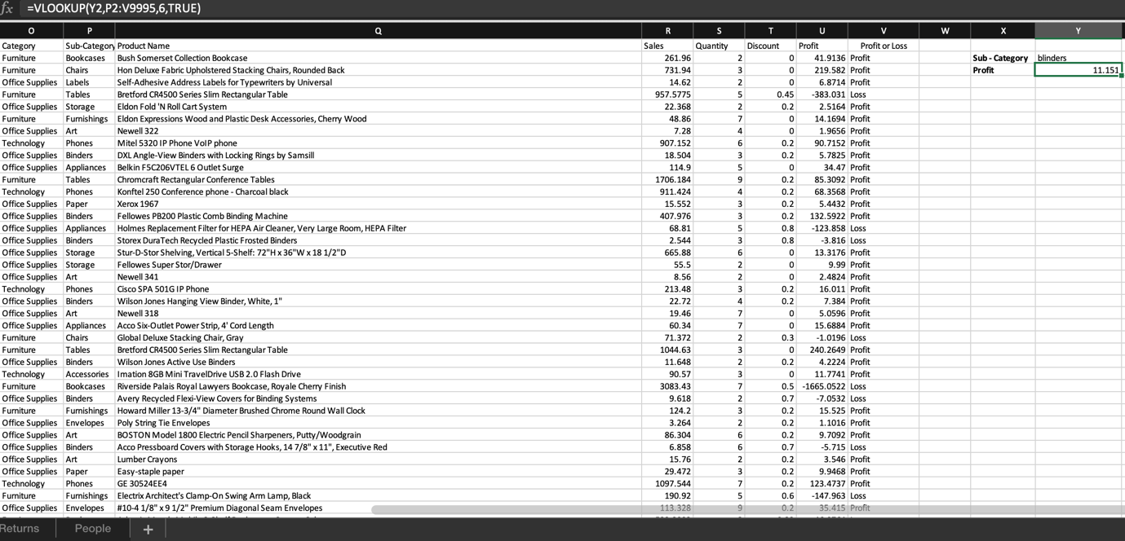

A pivot table allows one to extract the significance from a large, detailed data set. A pivot table is a data simulation tool that is used in the context of data processing. Pivot tables are used to sort, reorganize, group, summarize, count, total or average data stored in a database (Trembly, 2019).

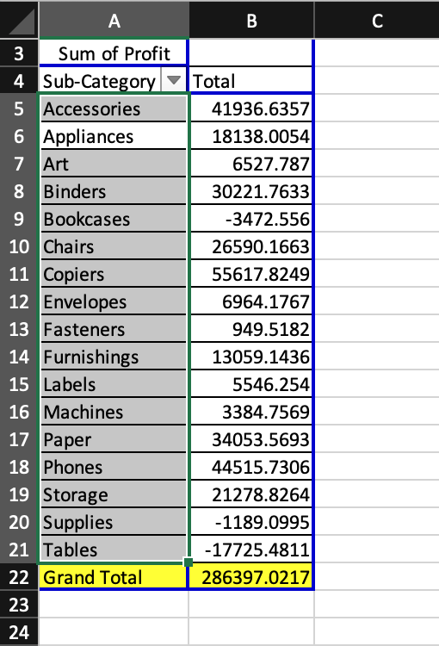

The Image above shows the pivot table I created. Kwikee-mart want me to examine areas where profitability is low, therefore filtering out data that is not needed makes it easier to focus on the fields that are important and are able to portray the information one is searching for. I selected two fields, sub- category’s and profit. By looking at the table, the management of Kwikee-mart are able to see which sub- categories are profitable and which are not, and therefore can use this information to make improvements to those areas that make them less profit.
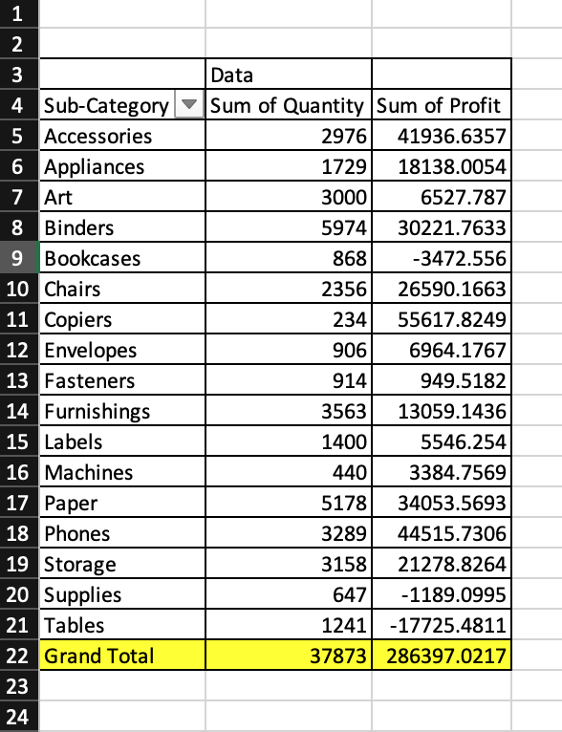

The image above displays the quantity of the sub- categories items that were sold and depicts the profit made from each sub- category. The two pivot tables I created will be visually demonstrated through the use of charts and graphs.

A Chart or graph is a visual demonstration of data from a worksheet that can bring more understanding to the data than just looking at the figures (Davidson, 2018).
A chart is a powerful tool that allows you to visually display data in a variety of different chart formats such as Bar, Column, Pie, Line, Area, Doughnut, Scatter, Surface, or Radar charts. With Excel, it is easy to create a chart.
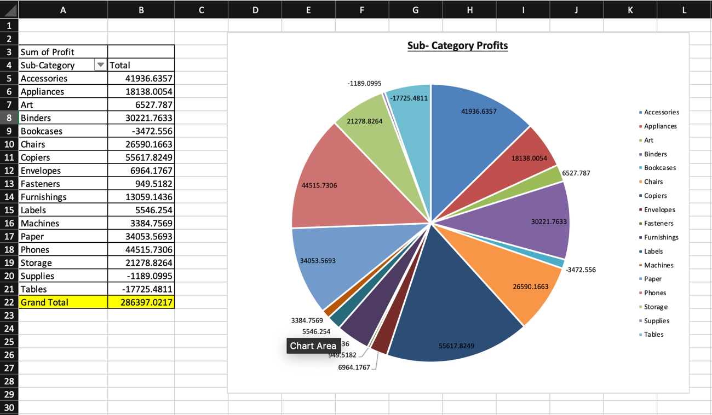

The easiest way of summarizing the following information is by using a pie chart. The advantages of using a pie chart is, it is easy to understand as it is used in business and the media, it requires minimal explanation, it can be visually simpler than other types of graphs and it can summarize large data sets in a visual form. The following pie chart shows the profits made by the various sub-categories. Kwikee-mart are trying to find out the lowest areas of profit.

Part 2 – Weka

Weka (Waikato Environment for Knowledge Analysis) is an assortment of machine learning algorithms for data mining tasks. It is also an open source software and uses flat text files to describe data. One’s own Java code can be used, or a dataset can be applied directly to the algorithm. The URL and SQL data base can also be read by Weka. Weka comprises tools for data pre-processing, classification, regression, clustering, association rules, and visualisation. New machine learning schemes can also be developed using Weka (Machine Learning Group, 2019). An example of pre-processing can be seen below.

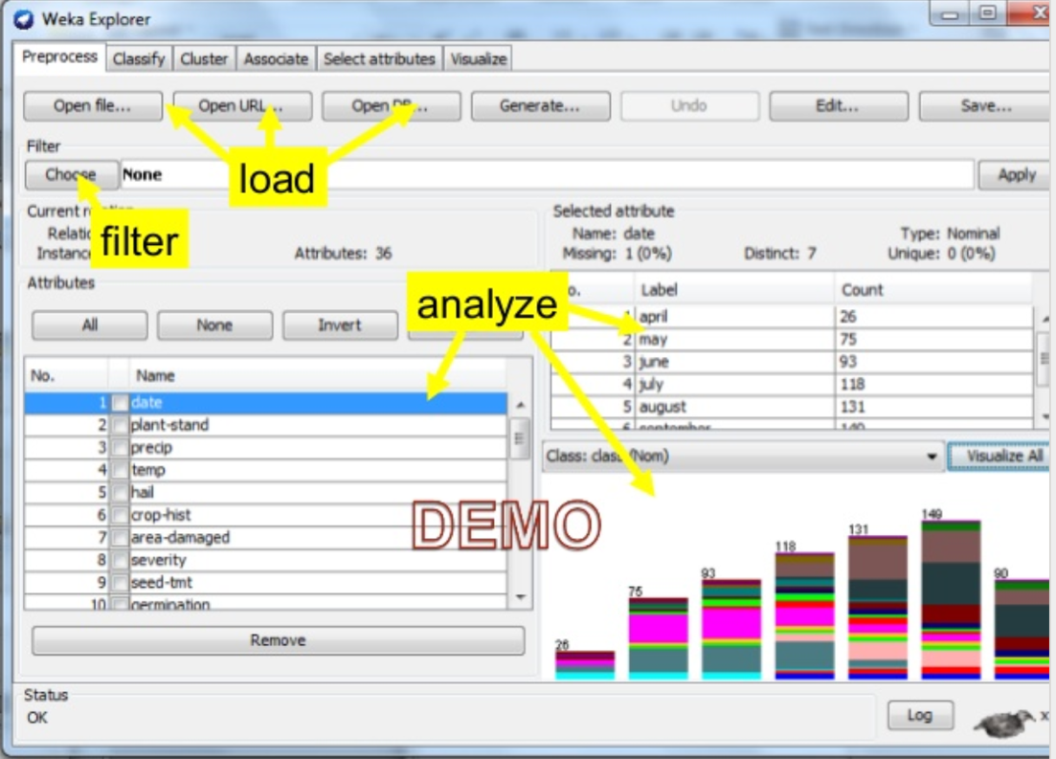

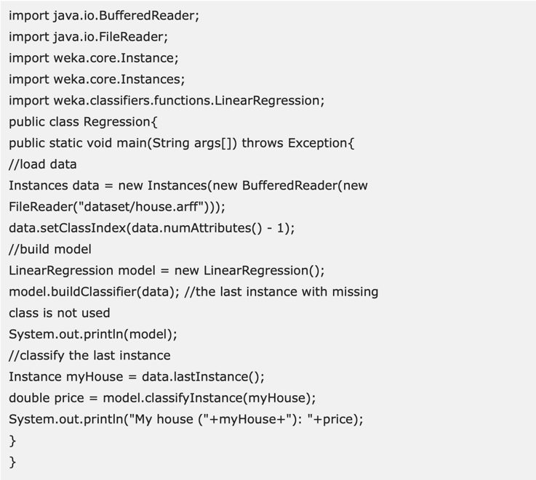
According to Foley (2018) regression analysis allows one to examine the relationship between two or more variables of interest. It is a powerful statistical method that examines the influence of one or more independent variables on a dependent variable. The steps one would follow can be seen below in an example, as well as the output one would receive.

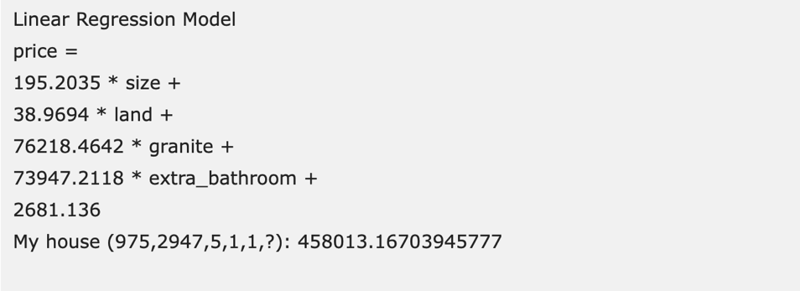

Classification is a data mining function that allocates items in a collection to target categories or classes. Classifiers in Weka are models for predicting nominal or numeric quantities. The objective of classification is to accurately predict the target class for each case in the data (Oracle Help Center, 2020). Implemented learning schemes can include decision trees and lists, support vector machines, multi-layer perceptrons, logic regressions and instant-base classifiers. The steps in which one can visualise a Weka classifier tree can be seen below.

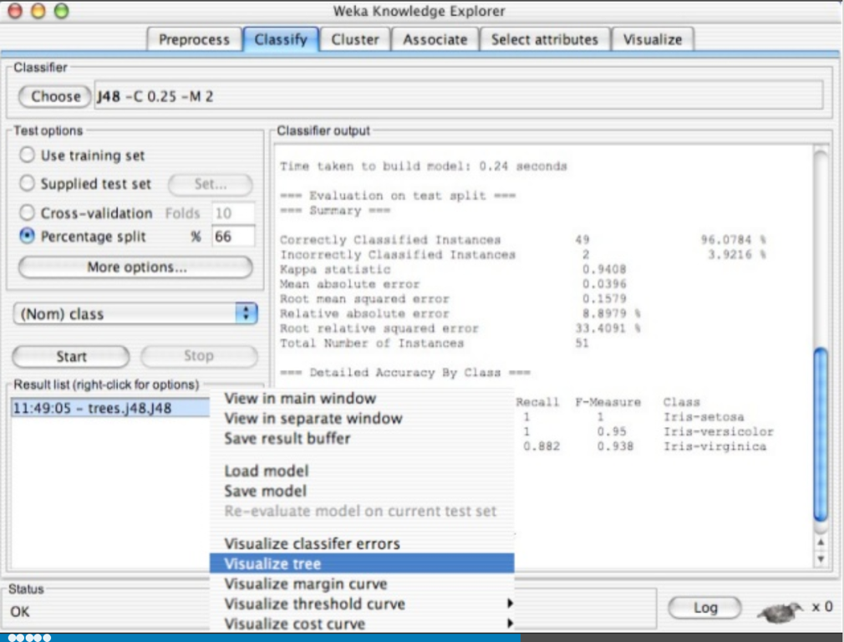

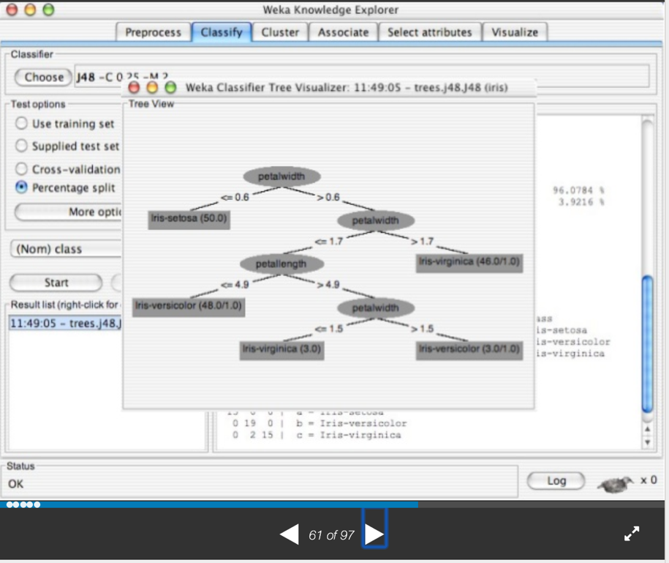

Clustering is an algorithm that finds groups of similar occurrences in the entire data set. Weka supports several clustering algorithms such as SimpleKMeans, MakeDensityBasedClusterer, HierarchicalClusterer, FilteredClusterer, FathersFirst, Cobweb, EM and Canopy. Weka allows one to create a specific number of groups depending on one’s business needs. Weka also allows one to envision the detected clusters graphically (Tutorialspoint, 2020). A defining benefit of clustering over classification is that every attribute in the data set will be used to analyse the data. An example of clustering (SimpleKMeans) can be seen below.
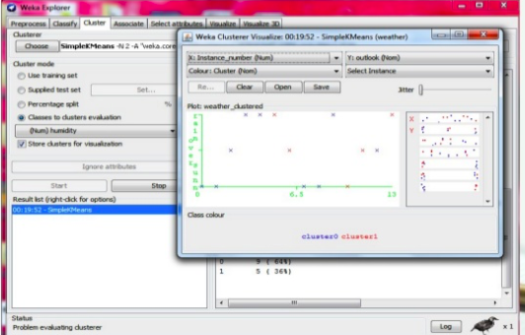

Associating rule mining finds interesting associations and relationships amongst large sets of data items. This rule shows how frequently an item set occurs in the transaction (GeeksforGeeks, (n.d.). There are few association rule algorithms implemented in Weka as it tries to find associations between different attributes instead of trying to predict the value of the class attribute. An example of association rules can be found below.
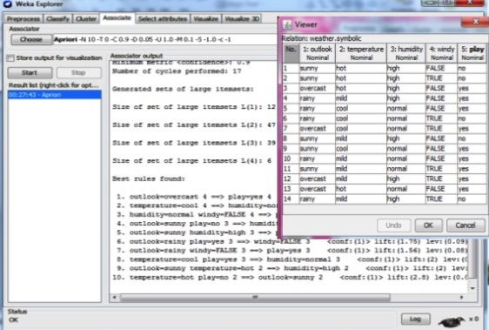

Weka has numerous advantages. Firstly, it is free and available to the general public. Is possess a comprehensive collection of data processing and modelling techniques. Weka can also be integrated into other Java packages. Some features of Weka include 49 data processing tools, 76 classification/regression algorithms, 8 clustering algorithms, 3 algorithms for finding association rules and 3 graphical user interfaces. These are “The Explorer”, which is an investigative data analysis tool, “The Experimenter”, which refers to the experimental environment, and “The Knowledge flow” which is a new process model inspired interface (Holmes, 2020).

Weka is however limited, in that it lacks correct and sufficient documentations, and that systems are updated constantly. Without the relevant training and knowledge, Weka is not user friendly and the algorithms can be complex and confusing. To work optimally, documents need to be converted to ARFF format, and the process of converting can be complex as well.

Conclusion

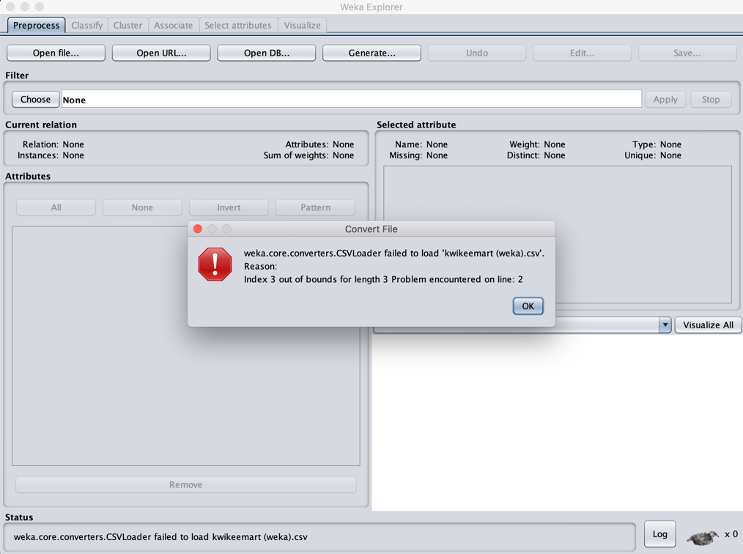
In conclusion, when analysing Kwikee-Mart Office Supplies sales data, I produced an IF statement which determined which sub-categories where at a profit or loss. I also used the VLOOKUP function to make the process of finding profit easier. The use of pivot tables enabled me to summarise the large data set by refining the categories that were relevant to determining Kwikee-Mart’s areas that needed attention. Charts and graphs allowed me to display the information from the pivot tables visually, making it easier for the management team at Kwikee-Mart to analyse and understand. Weka was another tool I could have used to analyse the sales data. Weka has different functions to that of excel and therefore could provide a more extensive analysis of the data set. Weka did however have limitations as there was problems uploading the data set, as the CSV converter was unable to convert the file to an ARFF file. This can be seen in the image below.

References

- Classification. 2020. Classification. [ONLINE] Available at: https://docs.oracle.com/cd/B28359_01/datamine.111/b28129/classify.htm#DMCON004. (Accessed 14 January 2020).

- GeeksforGeeks. 2020. Association Rule - GeeksforGeeks. [ONLINE] Available at: https://www.geeksforgeeks.org/association-rule/. (Accessed 14 January 2020).

- LaptopMag. 2020. How To Use VLOOKUP in Excel 2013 | Laptop Mag. [ONLINE] Available at: https://www.laptopmag.com/articles/excel-2013-vlookup. (Accessed 14 January 2020).

- PCWorld. 2020. Excel logical formulas: 12 simple IF statements to get started | PCWorld. [ONLINE] Available at: https://www.pcworld.com/article/2971613/excel-logical-formulas-5-simple-if-statements-to-get-started.html. (Accessed 13 January 2020).

- SurveyGizmo. 2020. What is Regression Analysis and Why Should I Use It? | SurveyGizmo Blog. [ONLINE] Available at: https://www.surveygizmo.com/resources/blog/regression-analysis/. (Accessed 12 January 2020).

- Talend Real-Time Open Source Data Integration Software. 2020. Data Transformation Defined - Talend Real-Time Open Source Data Integration Software. [ONLINE] Available at: https://www.talend.com/resources/data-transformation-defined/. (Accessed 14 January 2020).

- Techopedia.com. 2020. What is Data Preprocessing? - Definition from Techopedia. [ONLINE] Available at: https://www.techopedia.com/definition/14650/data-preprocessing. (Accessed 14 January 2020).

- Video: VLOOKUP - When and how to use it - Excel. 2020. Video: VLOOKUP - When and how to use it - Excel. [ONLINE] Available at: https://support.office.com/en-us/article/video-vlookup-when-and-how-to-use-it-9a86157a-5542-4148-a536-724823014785. (Accessed 10 January 2020).

- Weka - Clustering - Tutorialspoint. 2020. Weka - Clustering - Tutorialspoint. [ONLINE] Available at: https://www.tutorialspoint.com/weka/weka_clustering.htm. (Accessed 15 January 2020).

- Weka 3 - Data Mining with Open Source Machine Learning Software in Java . 2020. Weka 3 - Data Mining with Open Source Machine Learning Software in Java . [ONLINE] Available at: https://www.cs.waikato.ac.nz/ml/weka/. (Accessed 14 January 2020).

- Weka presentation. 2020. Weka presentation. [ONLINE] Available at: https://www.slideshare.net/Saeediqbal1/weka-presentation. (Accessed 14 January 2020).

- What is a pivot table? | Kohezion Blog. 2020. What is a pivot table? | Kohezion Blog. [ONLINE] Available at: https://www.kohezion.com/blog/what-is-a-pivot-table-examples-and-uses/. (Accessed 12 January 2020).

- www.techonthenet.com. 2020. MS Excel: How to use the IF Function (WS). [ONLINE] Available at: https://www.techonthenet.com/excel/formulas/if.php. (Accessed 12 January 2020).

- YouTube. 2020. How to load your data in weka tool ? - YouTube. [ONLINE] Available at: https://www.youtube.com/watch?v=MD_hP8NpTHE. (Accessed 13 January 2020).

