




Phil Normand
2006058
Live Music & Event Management (SBTY7005)
Portfolio 1
Natalie Smith
Table of Contents
1. Event introduction 3
1.1 Concept planning 4
1.2 Location 5
1.3 Music 6
1.4 Food and Drink 7
2. Budget 8
2.2 Income Streams 9
3. Site Map 9
4. Event Safety Management Plan 10
4.1 Purpose of an ESMP 10
4.2 Other components of the ESMP 11
5. Insurance 13
6. Premise licence 13
7. SAGs Application 14
8. Risk Assessment Form 14
9. References 15
10. Appendix 18

Event introduction

Whole Step is a two-day Festival located on Claydon Estate in Buckinghamshire. The aim of this Festival is to be entirely carbon neutral. The aim is to keep the event simple, slick and sustainable. The ‘simple’ component focuses on the artist programming by only booking artists on their music rather than a high-profile name and keeping the line-up simple. The sustainable ethos is inspired by carbon-neutral festivals such as ‘Wonderfruit Festival’ in Thailand and ‘Garden Roots’ in Singapore as well as UK Festivals that are leading the way to be greener events such as Wilderness, Glastonbury and Green Man Festival (Wootton, 2019).
Listed below are a number of green policies that will be implemented at the Festival:
- Water re-fill stations
- Campsite deposit stations – campsite waste donated to Help Refugees
- Ban on plastic straws and other single-use plastics
- Cup deposit scheme
- Plant a tree scheme with the ticket purchase
- Encourage public transport - shuttle buses from the train station to the site
- Compost toilets
- Locally sourced, sustainable food with a range of vegetarian/vegan choices
- Eco bond scheme for waste management
- Donations to sustainable charities such as WaterAid, Oxfam and Greenpeace
- No waste to landfill

Whole Step Festival will take place during the May bank holiday (29th-31st) 2021. This report will focus on the appropriate licensing and documentation that is needed for the Festival to happen legally and safely. The artefacts that will be discussed in this report are the budget, ESMP, site map, insurance, premises license, SAGs application and risk assessment.
Completing the appropriate licensing and efficient planning ensure the smooth running of an event. Moreover, if specific goals are set and executed then it is easier to reflect and self-analyse what was successful and what can be improved on in the following year.

1.1 Concept planning

5 W’s

Why?

- Endeavour to get all the music I’m passionate about heard by more people. Often music that gets overlooked or considered underground. The Festival shows no borders or pre-conceived ideas or prejudices but solely based on the quality of the music itself.
- This Festival is a musician’s music Festival. In other words, this is a Festival that is curated by the artist’s themselves. I will pick a core group of headliners and then liaise with these artists on who they want. It will be a showcase true talent.
- This idea of “quality-led music creation” stems from Gilles Peterson and Brownswood Recording’s Festival called ‘We Out Here’. This relatively new Festival places emphasis on “high quality food and drink offerings, arts and cultural offerings, crisp sound and production” (We Out Here. 2021). This type of ethos is a growing trend in Festivals that are emerging in the UK at the moment and would appeal to a specific target audience of festivalgoers.
- Idea of quality over quantity.
- Sustainable – completely green festival (minimal carbon footprint and recycled goods wherever possible)
- Would like to build my own personal network of contacts and improve my job credentials.
- Above anything else, there are a number of events and Festivals that I’ve been inspired by myself and I endeavour to combine these influences and better them to create one big party.
- No smart phone policy – this policy is enforced by a number of venues across the UK to encourage eventgoers to focus on the music and dance rather than constantly adding films to their social media stories and updates. Enforcing this policy at Whole Step would get people interacting with other Festivalgoers.
- Following the trend of raising awareness for mental health and wellness e.g. eating well and organic/well-sourced foods.
- Being a musician led Festival for mental health awareness. All money raised for the Festival will go towards Mental Health Charities and the Help Musicians Charity.

What?

- Concept: A two-day music, food/drink, festival held at Claydon Estate in Buckinghamshire (170 acres).
- Eclectic range of music – funk, soul, hip hop, house, afrobeat, electronica, jazz, DnB, techno, breakbeat, reggae, R&B, Disco, UK Funky, UK Garage, UK Rap, Dancehall, Drill, Classical.
- Location – Claydon Estate in Buckinghamshire.
- Content – Music, food and drink. Partnership with Mindful Chef and independent sustainable breweries in London and locally sourced products in Buckinghamshire.

Who?

- The target audience for the Festival is young adults aged 18 to 40 e.g. Students and young professionals
- Predominantly coming from London
- Media they consume – Instagram, Facebook, Twitter
- Stakeholders - Sponsors, council, venue, label. All requirements of the stakeholders need to be met.
- Core team – Team managers (e.g. procurement, operations, volunteers, site, infrastructure, box office, H&S), finance, operations, logistics, commercial operations, production.

When? 29th – 31st May 2021 (May Bank Holiday weekend).

Where? The Claydon Estate, Middle Claydon, Buckingham, MK18 2EX

1.2 Location

The chosen site for the Whole Step Festival is on The Claydon Estate in Buckinghamshire.

By car – Claydon Estate is 20 minutes from the M1 (Milton Keynes) and M40 (Bicester) and 10 minutes away from Buckingham.

Drivers should take the M1 to Milton Keynes or the M40 to Bicester and then head towards Claydon Estate until they pick up directions for the ‘Whole Step Festival’.

At junction 9, on the M40 (Bicester), turn off onto the A41 and then follow signs to Grendon Underwood and Calvert which are signposted from the Calvert Crossroads. The Claydon Estate is also signposted on the A413 (Buckingham) and at the Waddesdon Crossroads on the A41.

By train – Bicester North (13.5 miles) and Aylesbury Parkway (13 miles) are the nearest railway stations. Shuttle buses will be available from Bicester North to the Festival on Friday 28th and on Monday 31st. An alternative station would be Milton Keynes Central (17 miles).

By bike – Use the National Cycle Route 51. This mode of transport will be encouraged to try and reduce the carbon footprint of the event. Ticketholders will be reminded about this cycle route on social media and via email. More information is available on the Sulstrans website (see appendix B for Route 51 map).

1.3 Music

The music for this Festival will be divided into two parts – live bands and dance music. The main stage will be for the live acts and stage two (dance tent) will accommodate the DJs. After midnight, only the DJs will play in the dance tent for noise reduction. The programming of this 2-day event is inspired by a number of existing smaller festivals such as We Out Here, Maiden Voyage, Houghton and Gottwood. Figure 1 displays a mock line-up. The image for the line-up is one of my own photos and the software ‘Canva’ was used to layer the names over the top (Canva, 2021). The list of artists are a combination or established artists alongside emerging ones. There is also a mix of solo artists (rappers/singers) as well as ensembles and DJs.
Figure 1 - Provisional artist line-up for Whole-Step Festival. Design created with Canva.

1.4 Food and Drink

All food and drink vendors for the event will be from sustainable sources. All food and drinks vendors will provide their own insurance for the event that would be checked by the premise licence for the whole Festival. There will also be one primary sponsor and two secondary sponsors for the event.
The food sold will be sourced by ‘Mindful Chef’ and they will provide several food stalls that have a wide range of cuisines. The rest of the food will be locally sourced from Buckinghamshire.
The alcohol partnership for the Festival will be with Bacardi. The spirit brand has become increasingly sustainable in recent years with their global environmental initiative called ‘Good Spirited: Building a Sustainable Future’. As a result of this programme, landfill waste and carbon emissions have been significantly reduced at their warehouses. By 2022, they have pledged that 100% their sugarcane will be from sustainable sources (Green Road, 2019). Bacardi will provide a wide selection of drinks on the festival bars and they would act as a primary sponsor paying the event £10,000. In return, they would be displayed on the event tickets, flyers and posters.
Local sustainable breweries e.g. partnership with Toast Ale brewery that makes its beer with surplus bread from the catering trade. This will be the secondary sponsor for the event giving £5000 to the event (see figure 2). Their campaign endeavours to reduce food waste which is congruent with the ethos of ‘Whole Step’ Festival. Toast’s other core principles are raising awareness of the issues and solutions to food waste, reinvesting in charities fixing the food system and brewing great beers that engage drinkers (Toast, 2019). The brand advertising space will be half that of Bacardi’s.

The profits from the bar sales will be a 20/80 split i.e. 20% goes towards bar and 80% to the event.
Figure 2 - Toast Ale will act as a secondary sponsor for the event and sell its product on the bars at the Festival.

Budget

EXPENSES | ESTIMATED COST (£)
FIXED
Infrastructure  Venue hire  Estate Rental  Equipment e.g. PA/staging/rides | 15,000  5000  5000
Signage | 500
Artists  Accommodation  Fees/Programming | 3000  30,000
Licensing | 5000
Wages/rent/utilities (office) | 10,000
VARIABLE
Promotion/marketing  Paid advertising  Web development  Special offers/giveaways | 3000  1500  1000
Utilities  Power – Energy Generator Hire Ltd  Water – Energy Generator Hire Ltd  Toilets – Portable Toilet Hire Bucks  Waste Management | 40,000  10,000  35,000  10,000
Staffing  Security, Box Office, Stewards, Volunteers, Sound Engineers, Lighting Technicians, Bar Staff, Crew Catering, H&S Officer | 100,000
Miscellaneous  Name tags/badges  Printed agendas/programs  Other e.g. Pyrotechnics Front Line Fireworks | 250  500  1000
Refreshments  Food  Drink | 10,000  10,000
Total (Fixed+Variable) | 295,750

2.2 Income Streams

Revenue streams (Nielsen, 2019):

- Ticket sales – tickets will be valued at £35 for tier 1, £50 for tier 2 and £65 for tier 3. Out of the 3000 available tickets, 230 will be allocated to tier 1, 730 allocated to tier 2 and 1980 will be allocated to tier 3.
- Glamping – a small area located at the western most point of the map (marked Embers Camping on map 1) will be the glamping area. There will be 60 glamping tickets available for the Festival. A glamping ticket will cost £100.
- Sponsorships – the two main event sponsors are Bacardi and Toast Ale Brewery (see section 1.5).
- Bars – There will be two bars located near the main stage (orange zone on the general map) and one bar located near stage 2 (yellow zone). It is estimated that the bar will generate £60,000 in profit highlighting its importance as a major revenue stream.

Other types of revenue: Grants, bank loan, angel investors, crowdfunding, brand partnerships, merchandise, traders and catering.

Site Map

The site maps are located in the appendix. A general map is displayed first, followed by an emergency exit map. There were a number of important factors to consider to when designing the layout of ‘Whole Step’ festival to ensure the safety of both the public and staff as well as helping the event be as exciting and efficient as possible:
- Access to emergency services – this is made possible by having clear tracks that are accessible by vehicle and foot. The medical/welfare tent, shown as a grey cross, is therefore positioned at the bottom left-hand side of the orange area where there are yellow tracks that ambulances and fire engines can travel along (appendix A). The purple lines indicate pedestrianised paths that eventgoers can use to also access these services. The welfare tent is also positioned as close as possible both Orchard Way (the main road) and the main stage. This positioning keeps travel time to a minimum in case of an emergency.
- Width of walkways – the yellow vehicle tracks will be wide enough to accommodate all HGVs.
- Interesting layout – Claydon House overlooks the lake in the middle of the Estate. These are the two focal or feature points of the venue and thus the main stage, food and drink vendors and other entertainment is positioned here.
- Queue lines – a significant distance has been laid out between food vendors, toilets and water points to accommodate different queue lines. All water points are located near toilets.
- Minimal visibility of backs of stages/scaffolding – stage 2 backs onto a wooded area so that the artist area and stage is not visible to the attendees. The main stage that backs onto the lake will have a large banner draped behind it that covers the artist area and stage. The banner will display event sponsors, the ‘Whole Step’ logo, and also a message that relates to climate change such as “Awareness without action is worthless” or “one person’s actions CAN make a difference” - Greenpeace (Alateras, 2019). This will be accompanied with a tree symbol/graphic that is congruent with themes and colours of the festival.

- One-way systems
  - Vehicles - Queen Catherine Road (north side of the map) will be the main entrance for regular ticket holders. A one-way system for cars will be put in place whereby vehicles can only enter from the north west gate and then exit via the north east gate. These exits are shown in the emergency exit map as two purple stars at the northern most point of the site.
  - People – to stop a surge of people at the end of each night and also between sets during the day, a one-way system will be enforced that moves anti-clockwise around the orange zone. The headline acts at the end of each night will also be divided between the main stage and stage 2 to avoid congestion and overcrowding.
- Measure gradient before assembling – At the main stage, there is a slope that descends towards the front of the stage and the lake. The stage as been positioned at the point where the slope is at its shallowest to ensure crowd safety.

Event Safety Management Plan

4.1 Purpose of an ESMP

The ESMP is the planning and management of an event so that it can be carried out safely and efficiently. A full ESMP should cover all areas of the Festival so that potential risks are managed. The checklist shown in figure 3 summarises what is included in an ESMP (Bowdin, 2011, p. 615). The information for the ESMP needs to be gathered from the programming team, box office, gate manager, volunteer manager (e.g. rota and shift pattern), security company, bar managers and traders to name a few.
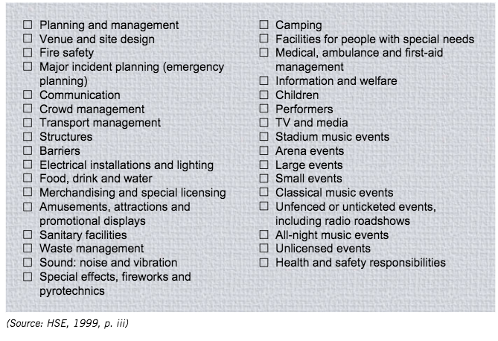
Figure 3 - Checklist for ESMP.

4.2 Other components of the ESMP

Components of an ESMP that are not referred to in this report but need to be observed and recorded for Whole Step Festival are:

- Early planning
- Timeline
- Capacity/demographic
- Management team
  - Meetings & communication
- Emergency services
- Organisational structure
- Fire Safety
  - Risk assessment
  - Fire-fighting equipment
  - Concessions
  - Smoking
- Temporary demountable structures
  - Staging
  - Marquees
  - Gazebos
  - Market trader stalls
- Performances/attractions/displays
- Bars & Alcohol
- Food concessions
- Fairground rides
- Merchandise
- Unauthorised traders
- Barriers and Fencing
  - Enclosure
  - Restricted access
  - Staging barrier
- Power
  - Electric Installations
  - General Lighting
  - Emergency lighting
  - Fuel storage
- Concessions
- Sanitary Facilities
  - Cleansing
    - Toilets
    - Water
    - Washing facilities
    - Refuse and waste management
- Medical (see appendix A for emergency site map)
  - Ambulance
  - First Aid Management
  - Medical provision
  - Contractors
- Child safety
- Catering
- Sound, Noise, Vibration
  - Safe noise limits
  - Staff
  - Attendees
  - Personal stereo systems
- Temporary supply
- Local Environment and Community
- Special Effects, Fireworks and Pyrotechnics
- Facilities for Disabled People
- Facilities for Children and welfare
- Accessibility
  - Toilets
  - Viewing platforms
  - Staff training
- Media and Publicity
- Contractor obligations and performance
- Counter Terrorism

Insurance

One-off Public liability insurance:

To cover all bases, a Hiscox special events insurance proposal form was filled out in order to receive a company quote directly. Going direct to an insurance company can be more expensive so an alternative option would be to seek out a Broker who would find a selection of companies and find different details and different permutations of the types of cover. This would ensure that the best price available is used to insure the event. The broker would gather a selection of quotes and offer different levels and types of coverage. From the options one would then select what you want. The variety of choice depends on the price and types of coverage.

The types of insurance that are required for the Festival are:
- Liability for other people (Public)
- Employers liability (e.g. volunteers and stewards)
- Property liability e.g. physical/stage/scaffolding/chairs
- Event liability – sub-section to not cover the money (maybe all contactless or just a £5k float)
- Cancellation insurance
- Severe weather insurance

The process of risk management is an attempt to mitigate or get rid of all your risk. However, eliminating all risk is impossible so that is why purchasing event insurance is crucial. Event organisers need to ensure that traders at the event such as food and drink stands provide their own Public and Employers Liability Insurance Certificates and food traders, crew caterers and bars must be registered with the Buckinghamshire Council prior to the event (Pretty Good Digital, 2019).

Premise licence

A premise licence requires communication with the Buckinghamshire Council. It also requires the site manager, licensing manager and designated premise supervisor to communicate with each other. Other licences that are required for Whole Step are:
- Alcohol licence
- PRS licence (collective licensing)
- Personal licence
- Filming licence
- Lighting and lasers licence

SAGs Application

SAGs are co-ordinated by the Buckinghamshire Council and are made up of council representatives, emergency services and event organisers. They provide “a forum for discussing and advising on public safety at an event” (HSE, 2015). The group assists the core team with the planning and management of the festival and encourages “cooperation and coordination between all relevant agencies” (HSE, 2015).
Safety Advisory Group (SAG) applications need to be accompanied with the following documents in order to be accepted (see appendix E for full application).

- Draft site route plan (see appendix A)
- Premises licence (see appendix F)
- Risk Assessment (see appendix C)
- Event Safety Management Plan (see section 4.0)
- Insurance – discussed in section 5.0 (see appendix D)
- Evidence of public liability insurance for the event (appendix D)
- Draft emergency plan
- General safety risk assessment and fire safety risk assessment

Risk Assessment Form

A risk assessment is a way of managing potential risks and can be defined “as the process of identifying these problems, assessing them and dealing with them” (Bowdin, 2011, p. 594). The main problem that arises if a risk assessment is not appropriately carried out is the event “not fulfilling its objectives” (Bowdin, 2011, p. 583). Risk management is a legal requirement under the Management of Health and Safety at Work Regulations 1992 (Bowdin, 2011, p. 594). See appendix C for the risk assessment undertaken for Whole Step.

References

Alateras, O. (2019). 5 Important Messages about Climate Change. [online] Medium. Available at: https://medium.com/@alateraso/5-important-messages-about-climate-change-4dda15846285. Accessed 31 March 2021.
Bowdin, G. A. J. (2011). Events management (3rd ed.). Elsevier Butterworth-Heinemann.

Buckinghamshire Council (2020). Buckinghamshire Council – Chiltern Area - Organising an event. [online] www.chiltern.gov.uk. Available at: https://www.chiltern.gov.uk/article/7427/Organising-an-event-. Accessed 28 February 2021.
Canva (2021). Amazingly Simple Graphic Design Software – Canva. [online] Canva.com. Available at: https://www.canva.com/. Accessed 31 March 2021.
Chalk, W. (2017). How to start your own music festival. BBC News. [online] 28 Jul. Available at: https://www.bbc.co.uk/news/newsbeat-40746555. Accessed 28 January 2021.
Ecosia Blog (2019). 10 ways to party sustainably this festival season. Ecosia Blog. Available at: https://blog.ecosia.org/we-love-green-sustainable-festival/. Accessed 1 March 2021.
Esson, R. (2018). Event Safety Management Plan. [online] pp.1–36. Available at: https://democracy.merton.gov.uk/documents/s23677/Diynamic%20Festival%20London%20-%20Event%20Safety%20Management%20Plan.pdf. Accessed 26 February 2021.
Field Day - Mighty Hoopla (2018). Event Safety Management Plan - Version 1.3. [online] pp.1–17. Available at: https://moderngov.lambeth.gov.uk/documents/s94446/3%20-%20ESMP%20V1.4.pdf. Accessed 26 February 2021.
Health and Safety Executive (2015). Event safety - Local authority Safety Advisory Group. [online] Hse.gov.uk. Available at: https://www.hse.gov.uk/event-safety/safety-advisory-groups.htm. Accessed 31 March 2021.
Nielsen, F. (2019). How Much Does a Music Festival Cost to Put On? 18 Expenses to Plan For. Billetto Blog. Available at: https://billetto.co.uk/blog/how-much-does-music-festival-cost/. Accessed 28 January 2021.
Pretty Good Digital (2019). Glastonbury Festival - Traders. [online] Glastonbury Festival - 21st-25th June, 2017. Available at: https://www.glastonburyfestivals.co.uk/information/traders/.
The Green Road (2019). Best sustainable alcohol brands 2019 - eco wines, beers and spirits you must know about. [online] Cariki. Available at: https://cariki.co.uk/blogs/the-green-road/best-sustainable-alcohol-brands. Accessed 31 March 2021.
The Purple Guide (2017). The Purple Guide. [online] Thepurpleguide.co.uk. Available at: https://www.thepurpleguide.co.uk/. Accessed 9 February 2021.
Toast Brewery Ltd. (2019). Toast Ale Impact Report. [online] Available at: https://www.toastale.com/uploads/files/1585947098ToastAle2019ImpactReport.pdf. Accessed 31 March 2021.
We Out Here (2021). Information. [online] We Out Here 2021. Available at: http://www.weoutherefestival.com/information/. Accessed 31 March 2021.
Wootton, L. (2019). The 10 Best Sustainable Festivals in the UK. [online] The Eco-Living Archive. Available at: https://eco-age.com/resources/the-best-sustainable-festivals-in-the-uk/. Accessed 1 March 2021.
Wycombe District Council (2020). A Guide For Event Organisers Event Safety Guide. [online] pp.1–31. Available at: https://www.wycombe.gov.uk/uploads/public/documents/Community/Public-safety/Event-safety-guide.pdf. Accessed 26 February 2021.

WIDER READING

Bowdin, G. et al (2006) Events Management, Oxford: Butterworth-Heinemann
[2011 version is available on E-library]

Berridge, G. (2006) Events Design and Experience, Taylor & Francis

Finch, G.G. (2016) Events Management: Meetings, Expositions, Events and Conventions: An Introduction to the Industry, Global Edition

Florida, R.L. (2014) The Rise of the Creative Class, Revisited. New York: Basic Books

Lahee, Henry Charles (2009) Annals of Music in America: A chronological record of significant musical events,The Gutenberg Project

O’Toole, W. (2010) Event Feasibility and Development, Taylor & Francis

Razaq, R. et al (2008) Events Management, Sage Publications

Tum, Julia, Philippa Norton & J. Nevan Wright (2011) Management of Event Operations, Oxford: Elsevier

Roberts, K. (2004) The Leisure Industries, Basingstoke: Palgrave Macmillan

Westerbeek, H. (2006) Managing Sports Facilities and Major Events, London: Routledge

Stancavage, Sharon (2004) A Mega Gig, Staging Rental Operations, Vol. 3 (6), pp 38- 40

Yeoman, I. (2003) Festival and Events Management, Butterworth Heinemann

Yeoman, Ian (2004) Festival and events management: an international arts and culture perspective, Oxford: Elsevier Butterworth-Heinemann

Appendix

APPENDIX A

Site Maps

General
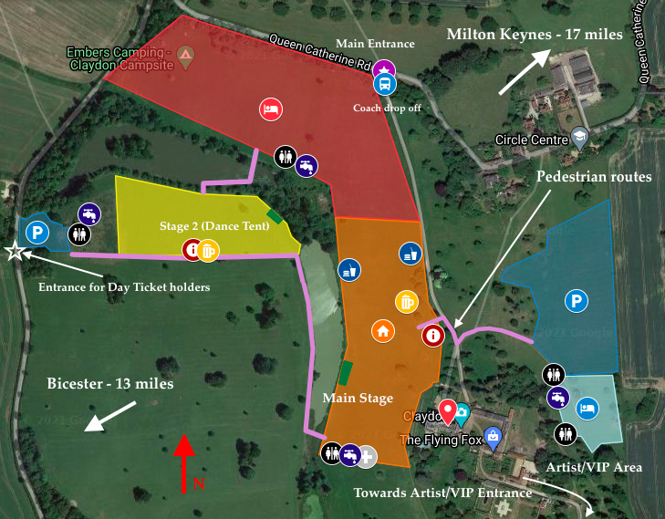

Emergency Exits and vehicle routes for transport management

The yellow lines mark the tracks available to vehicles - 2854m of track in total. This does not include the pedestrian only paths highlighted in purple.

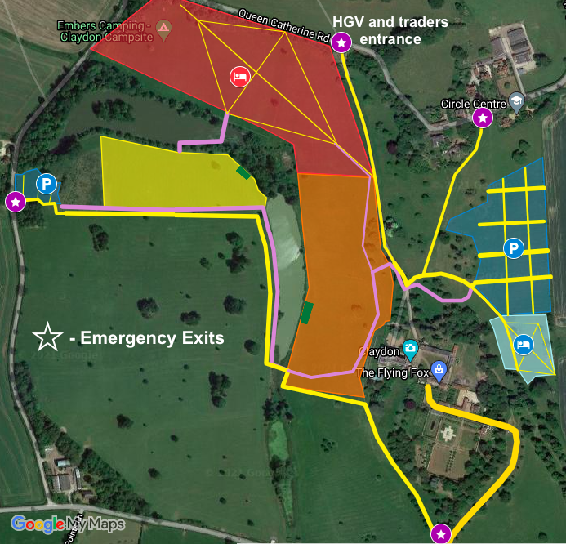

APPENDIX B

Cycle Route 51 map (Bicester to Claydon Estate)
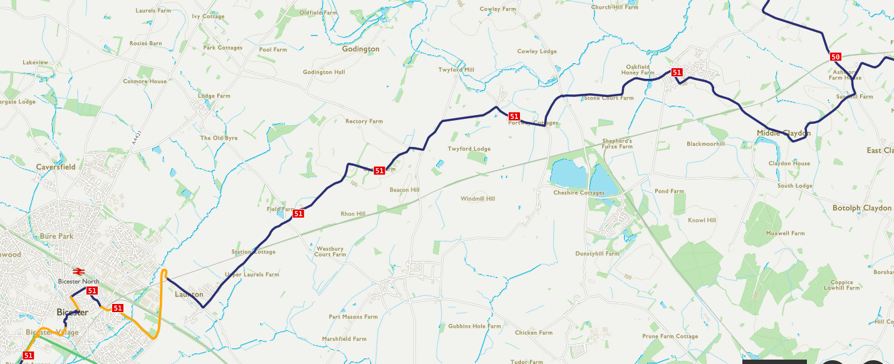
Claydon Estate

APPENDIX C

Event Safety Risk Assessment
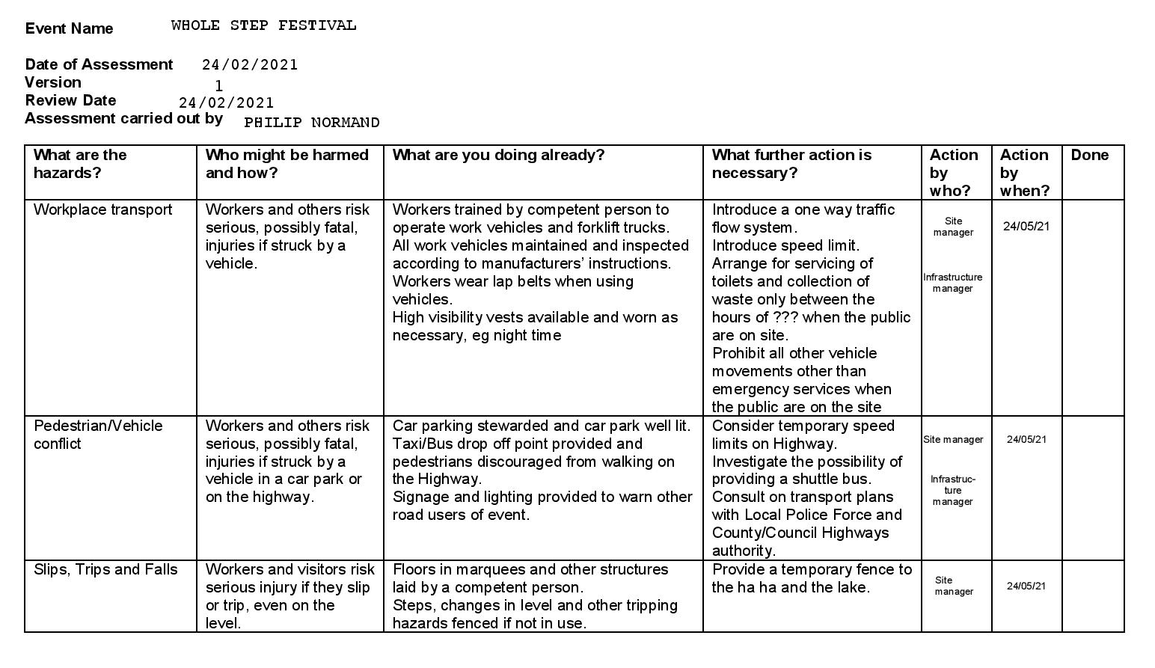

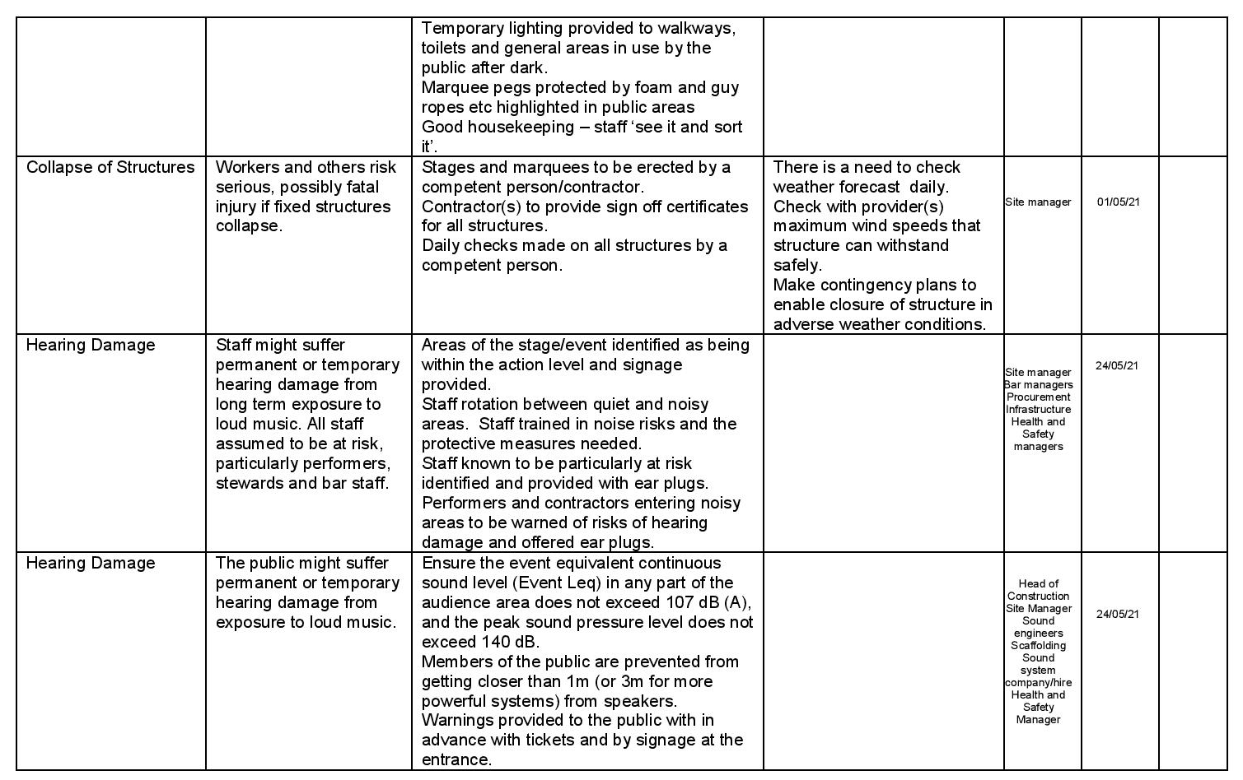

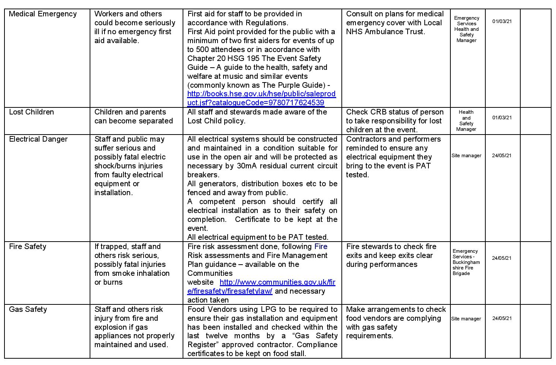

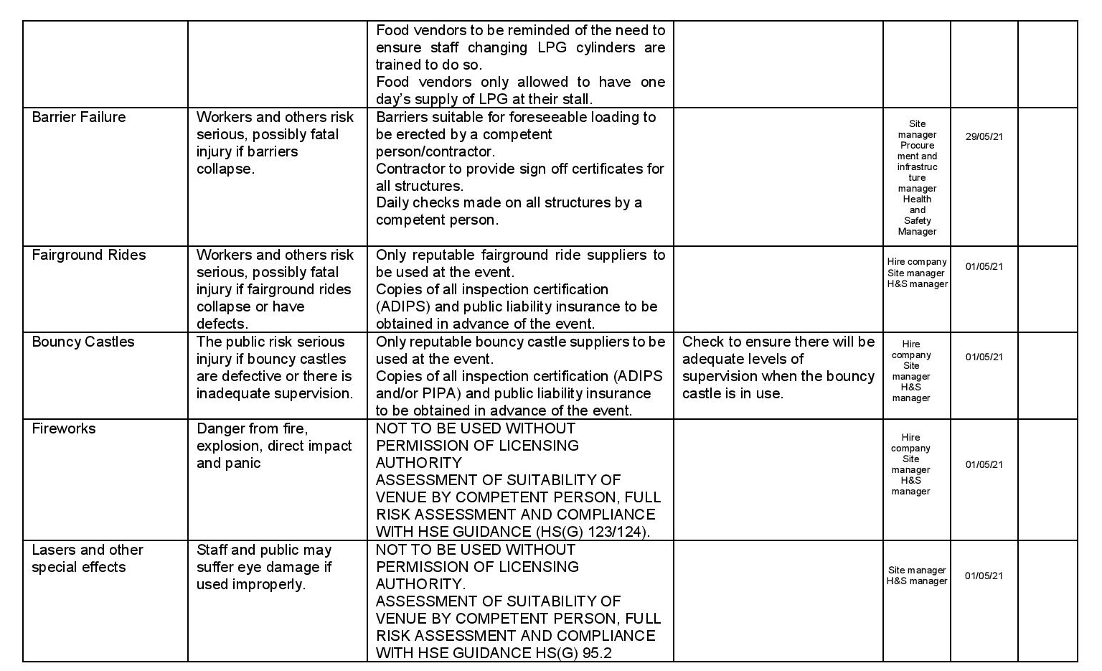

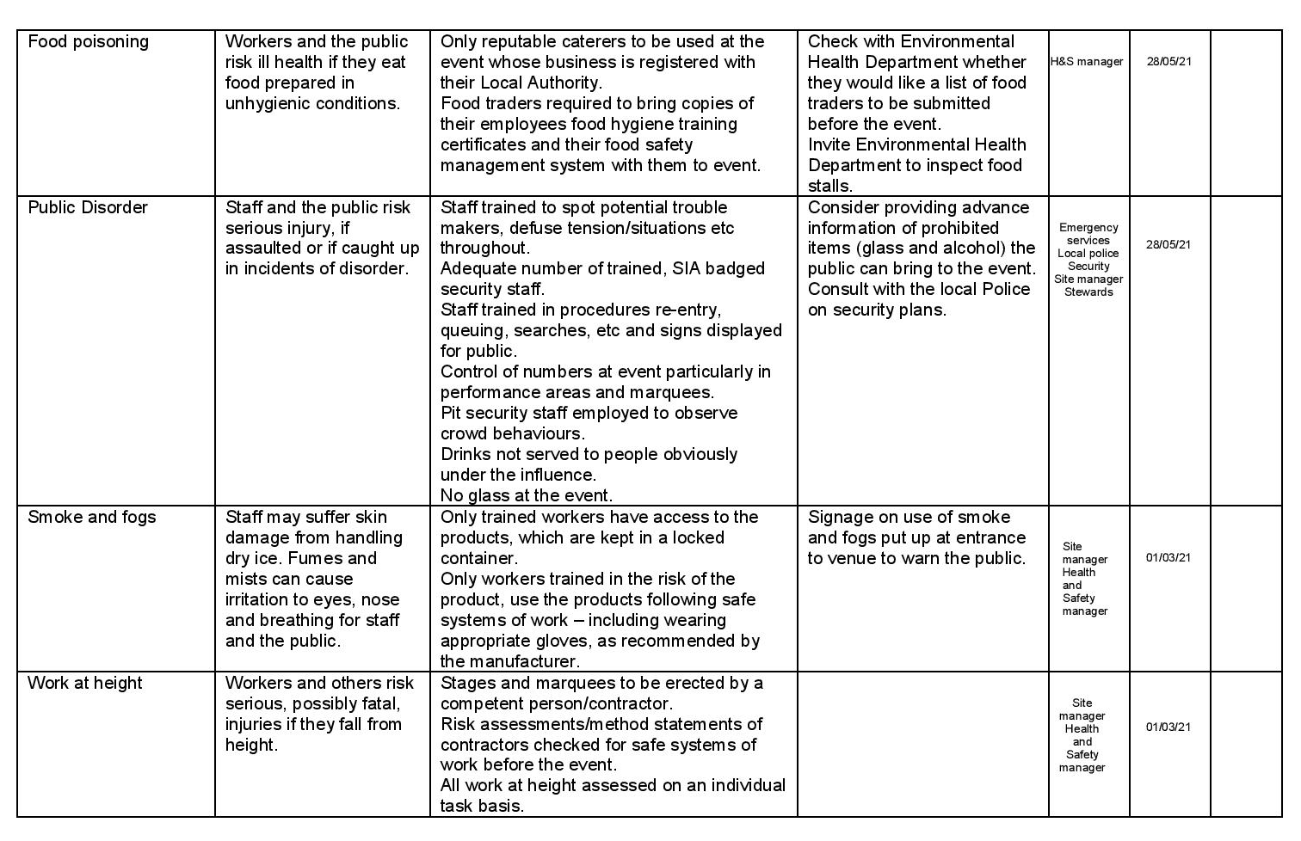

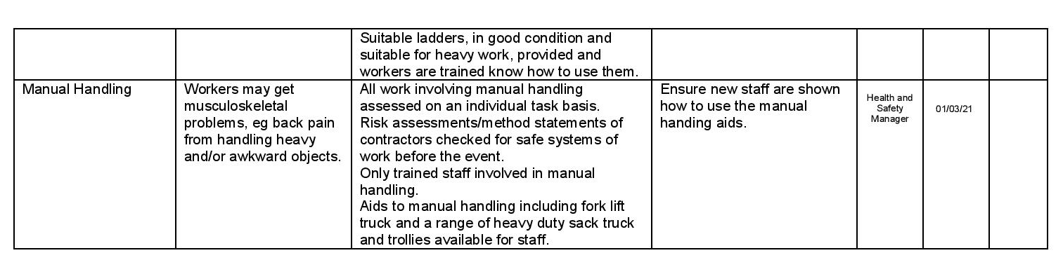

APPENDIX D

APPENDIX E

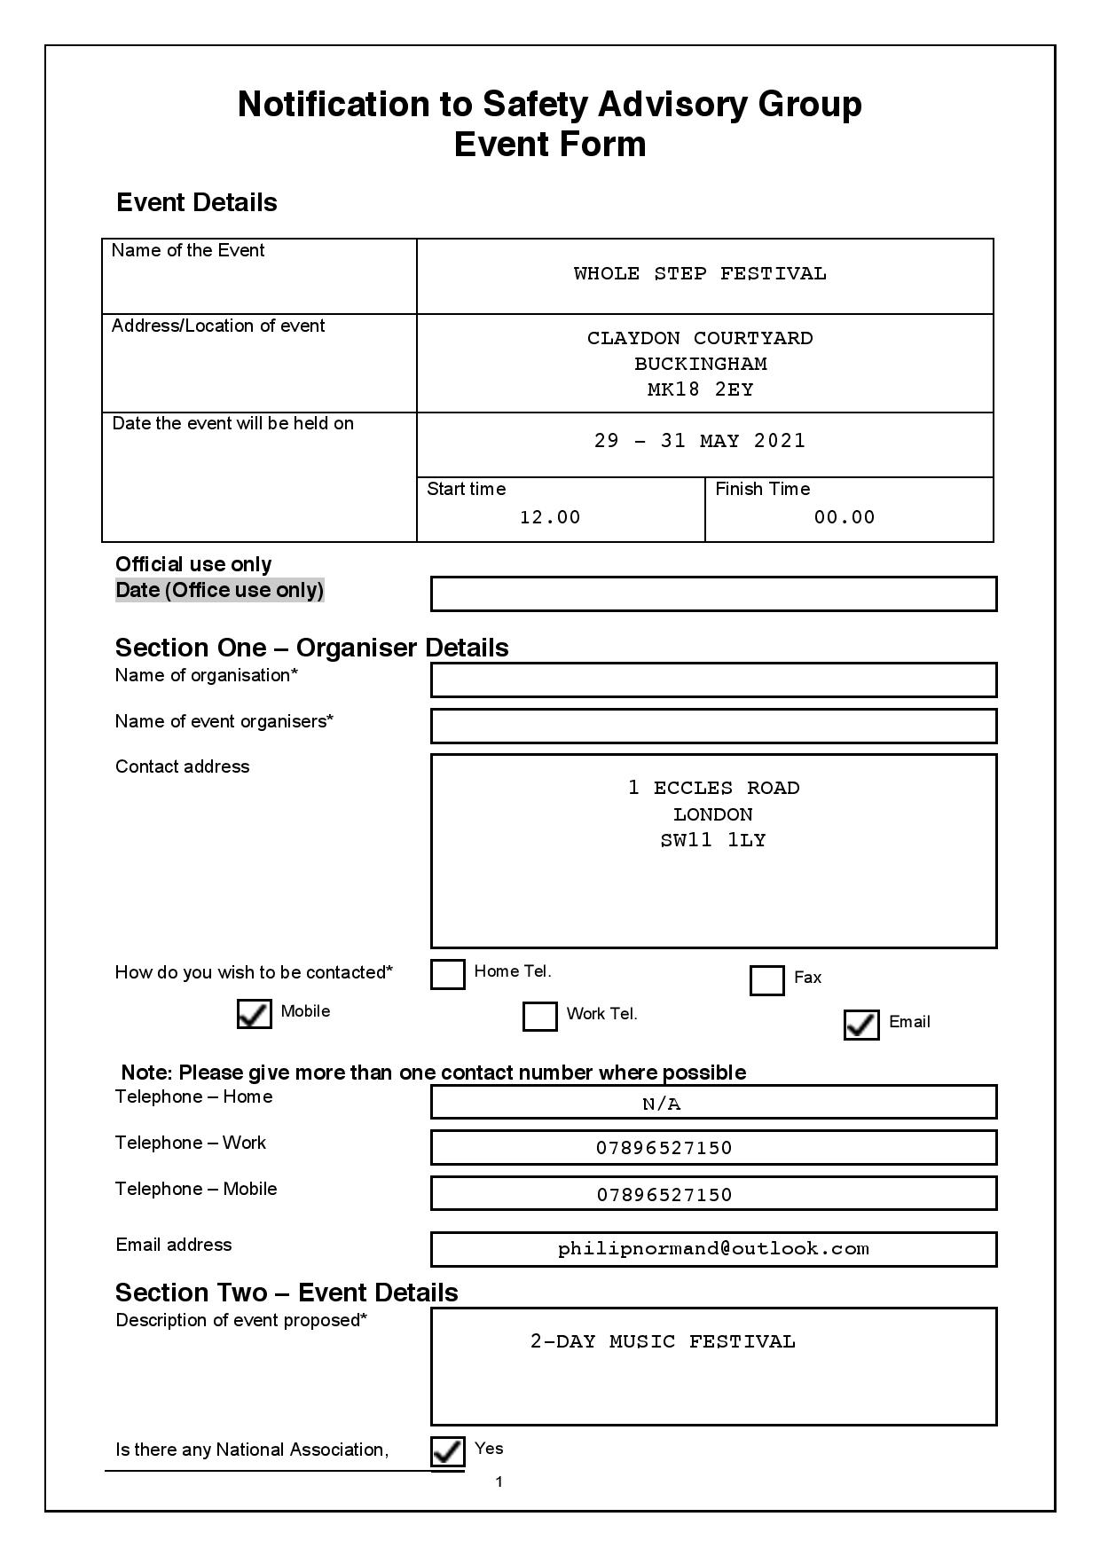
Public Event Notification/Application Form (SAGs)
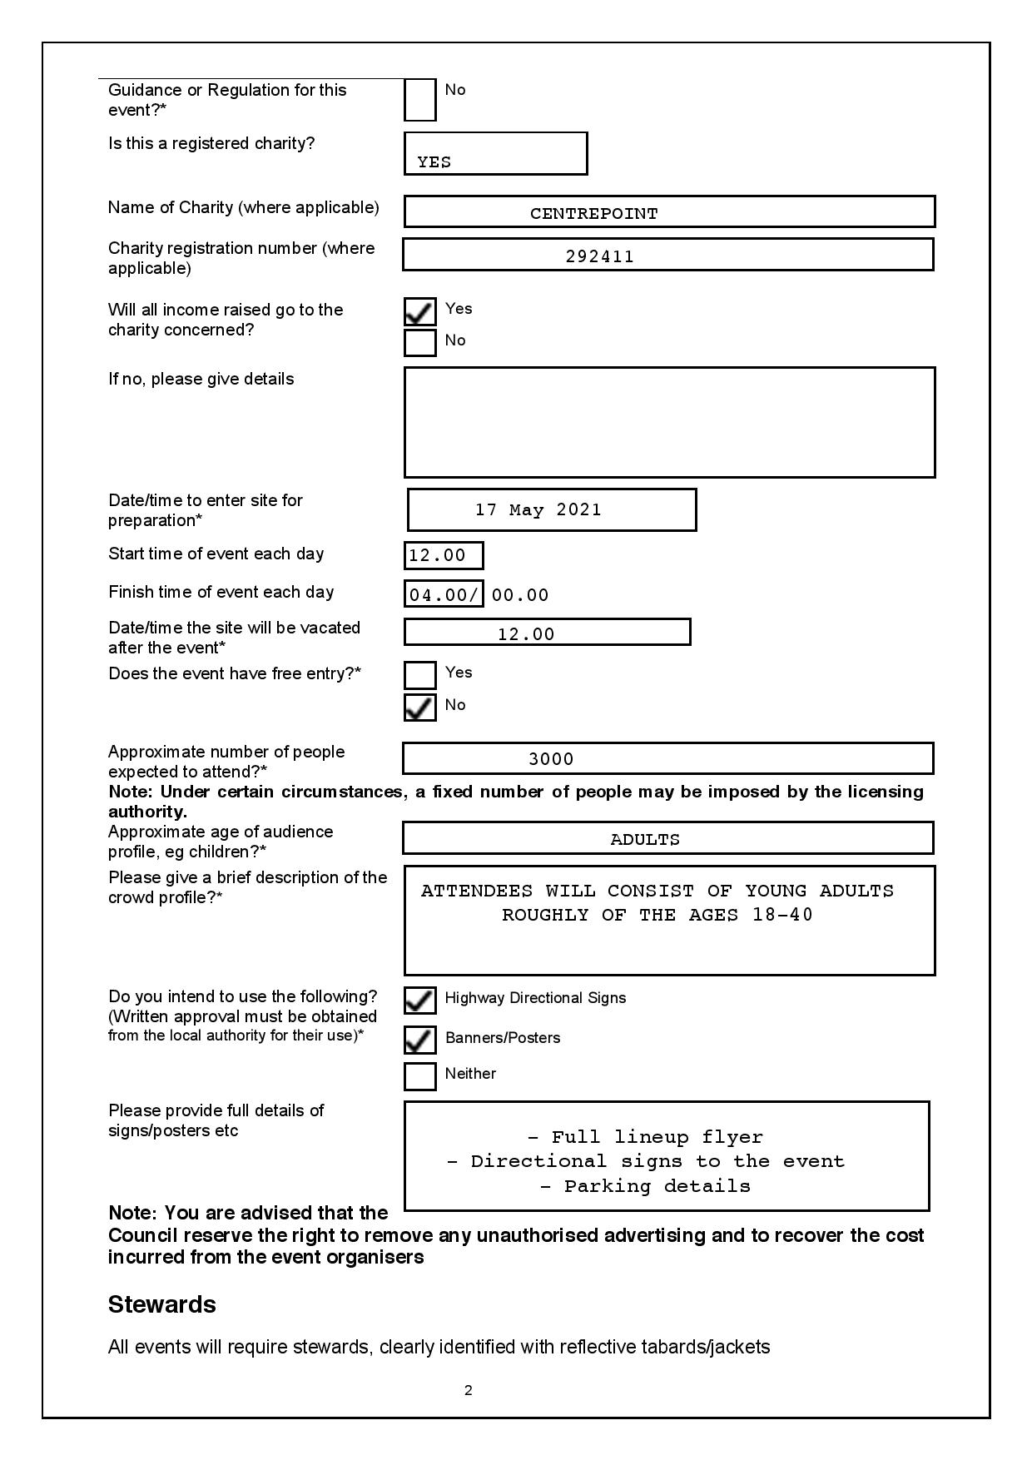
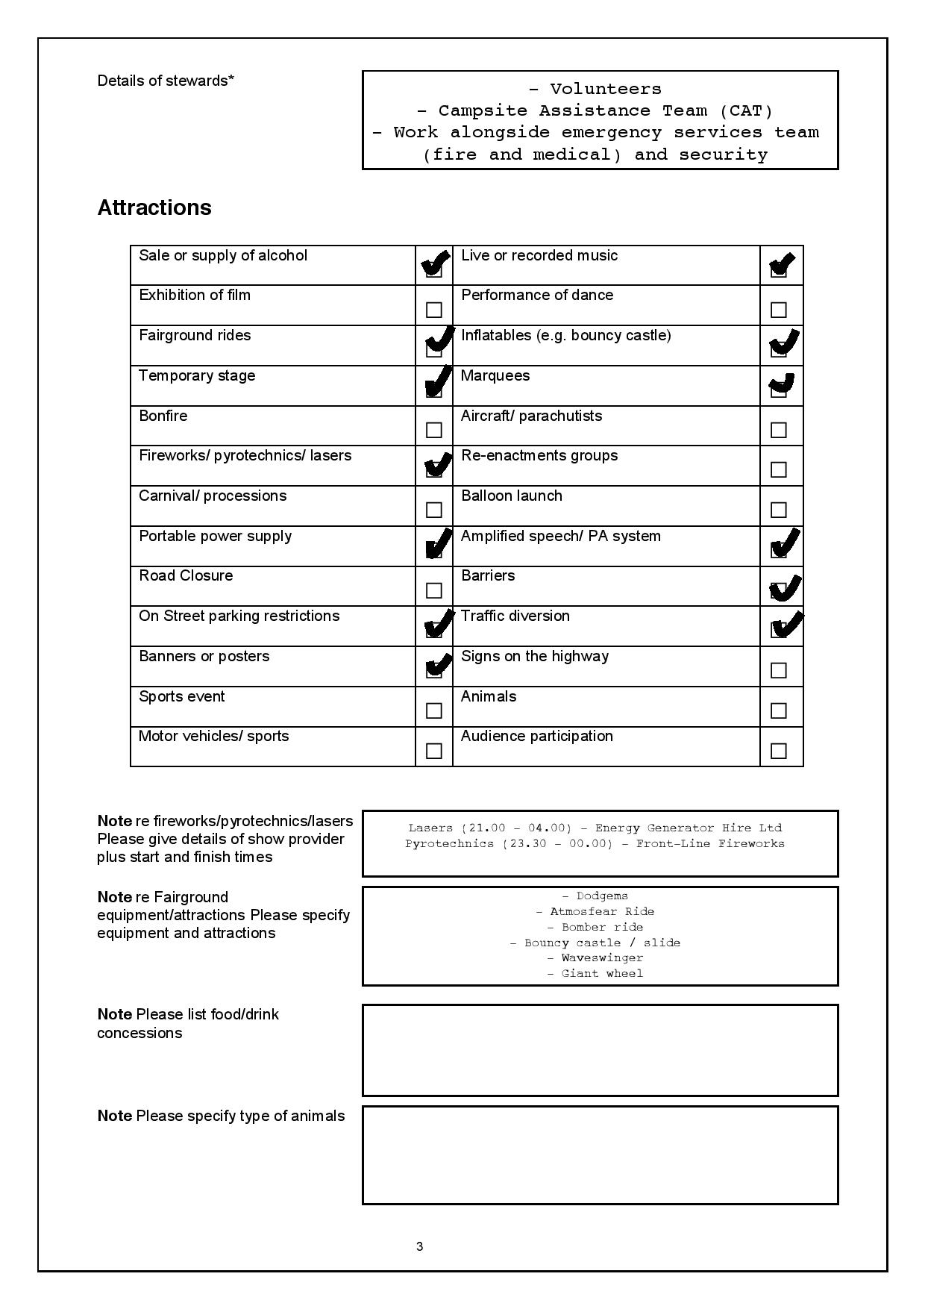
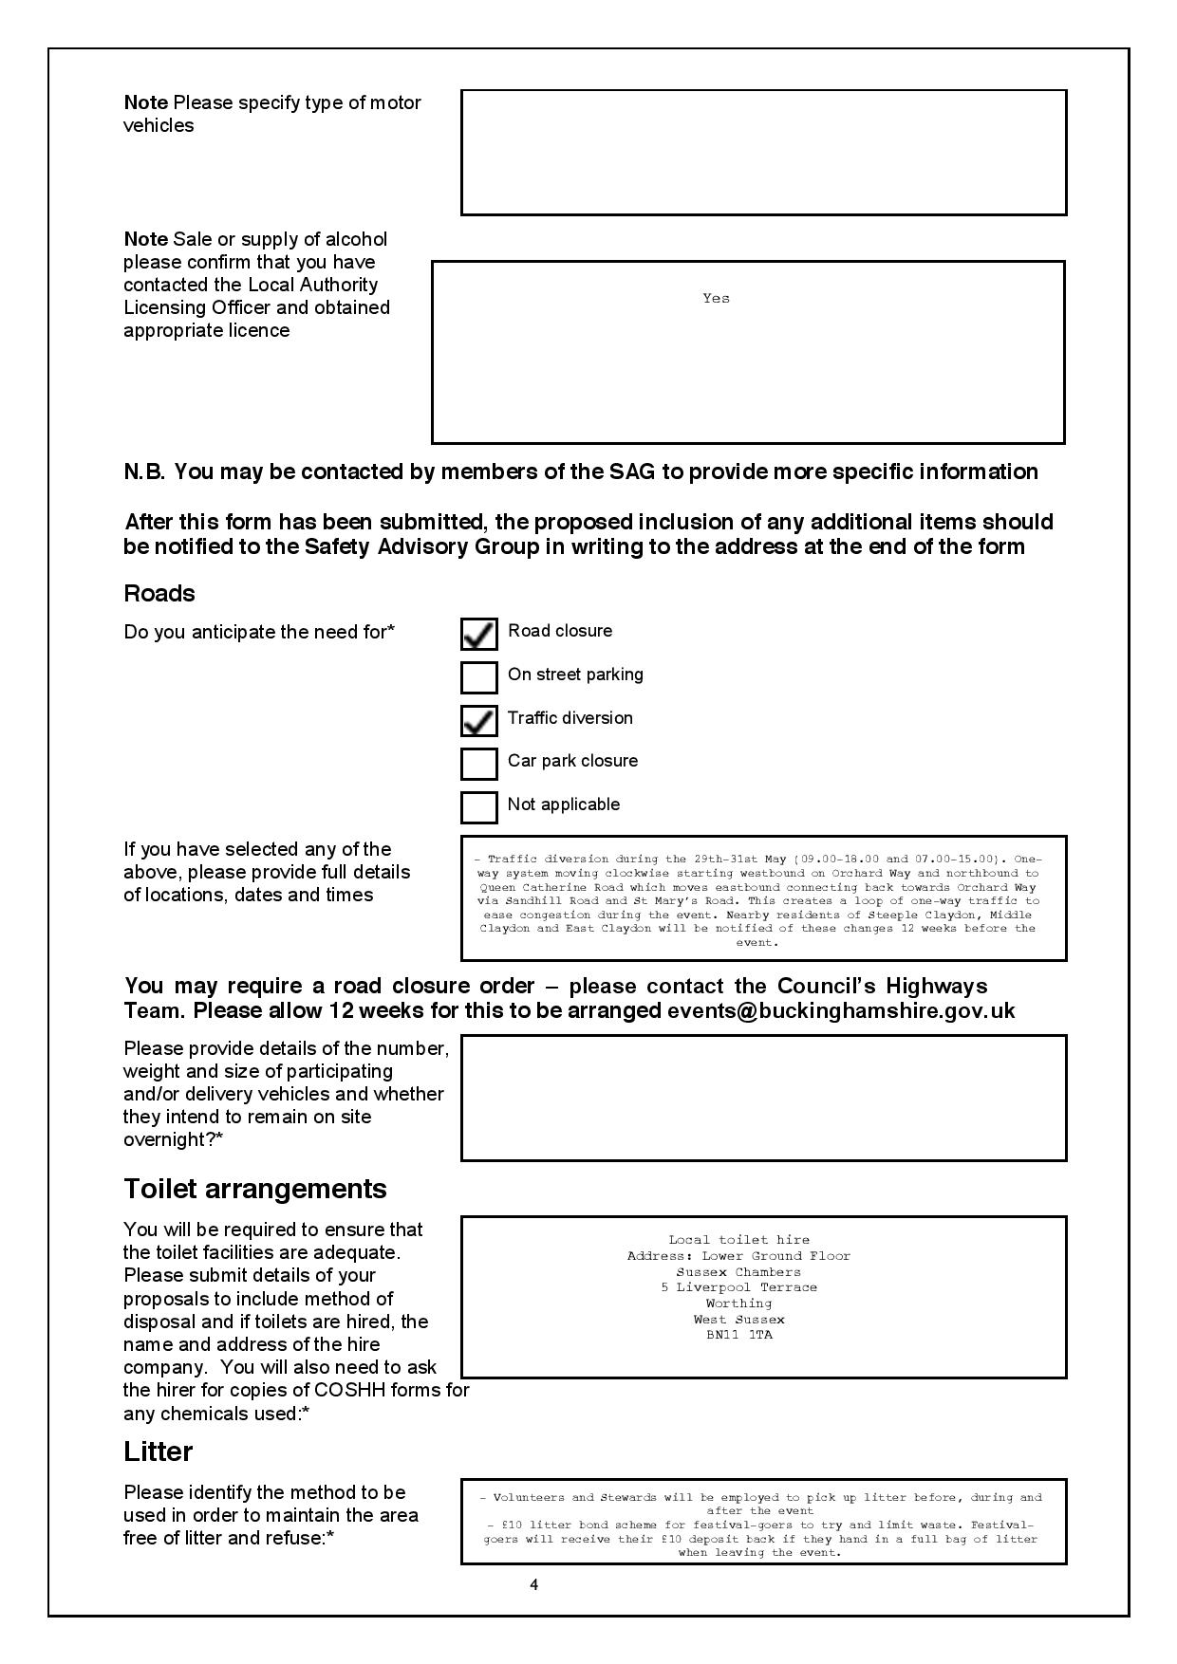
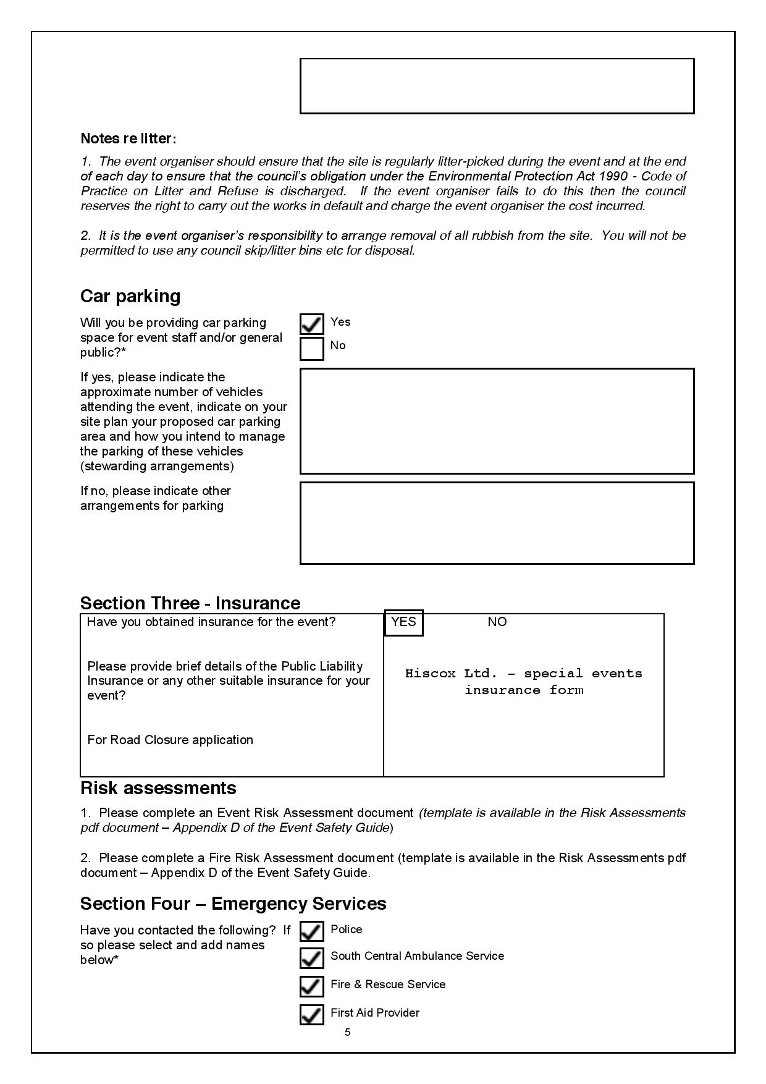
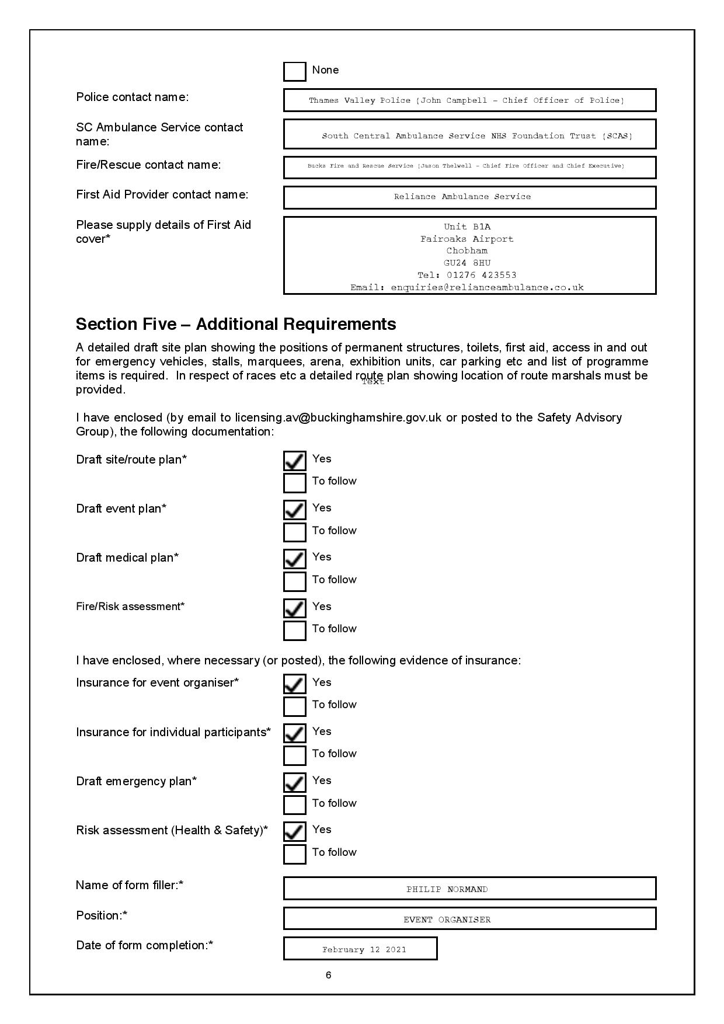


APPENDIX F

Application for a premises License to be granted under the Licensing Act 2003



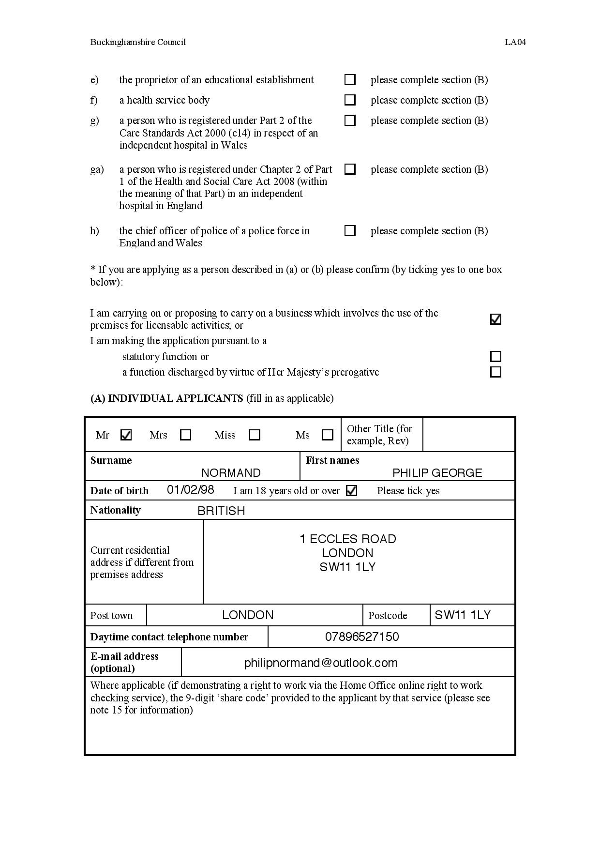
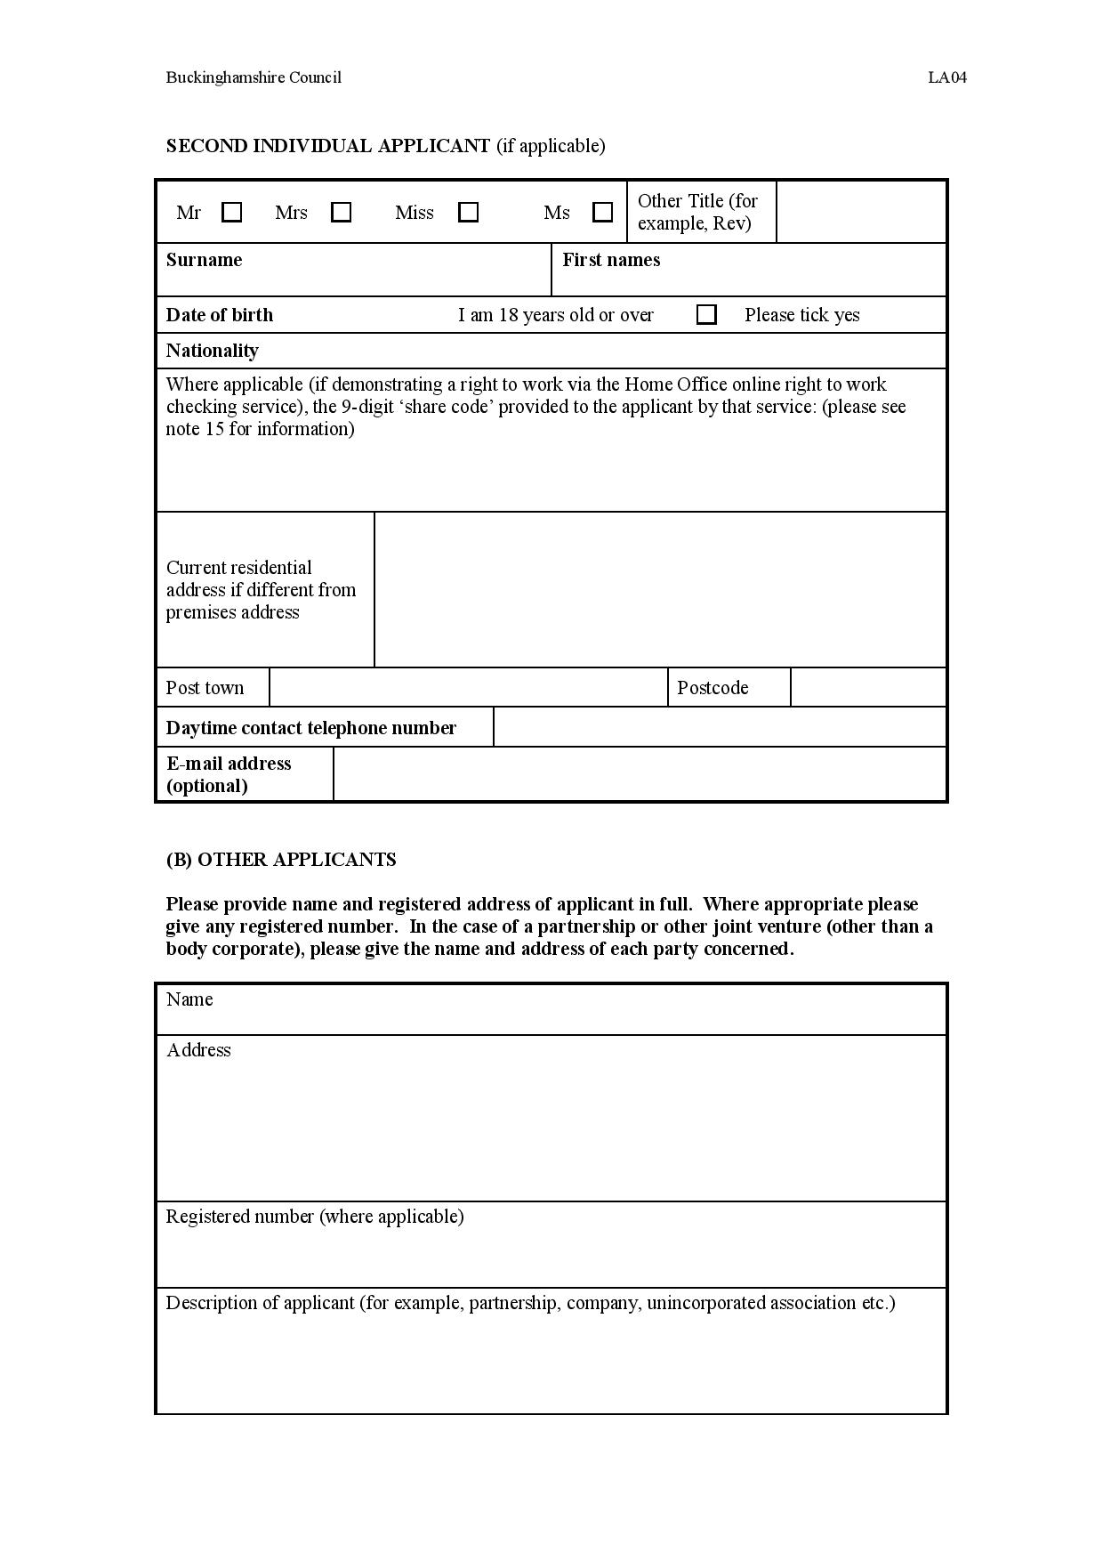
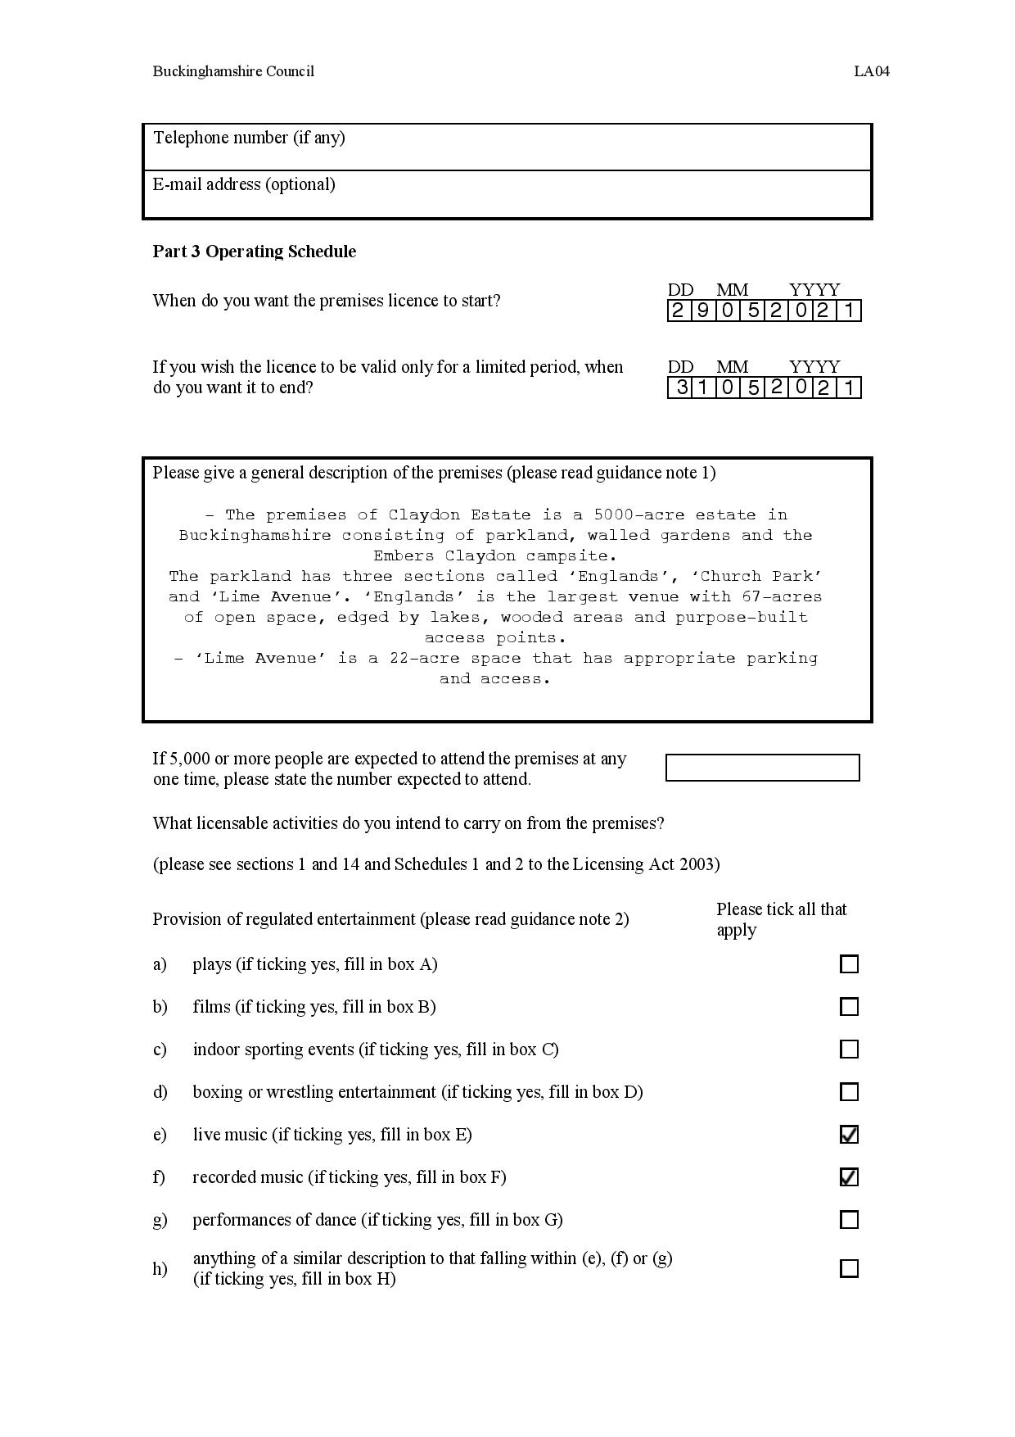

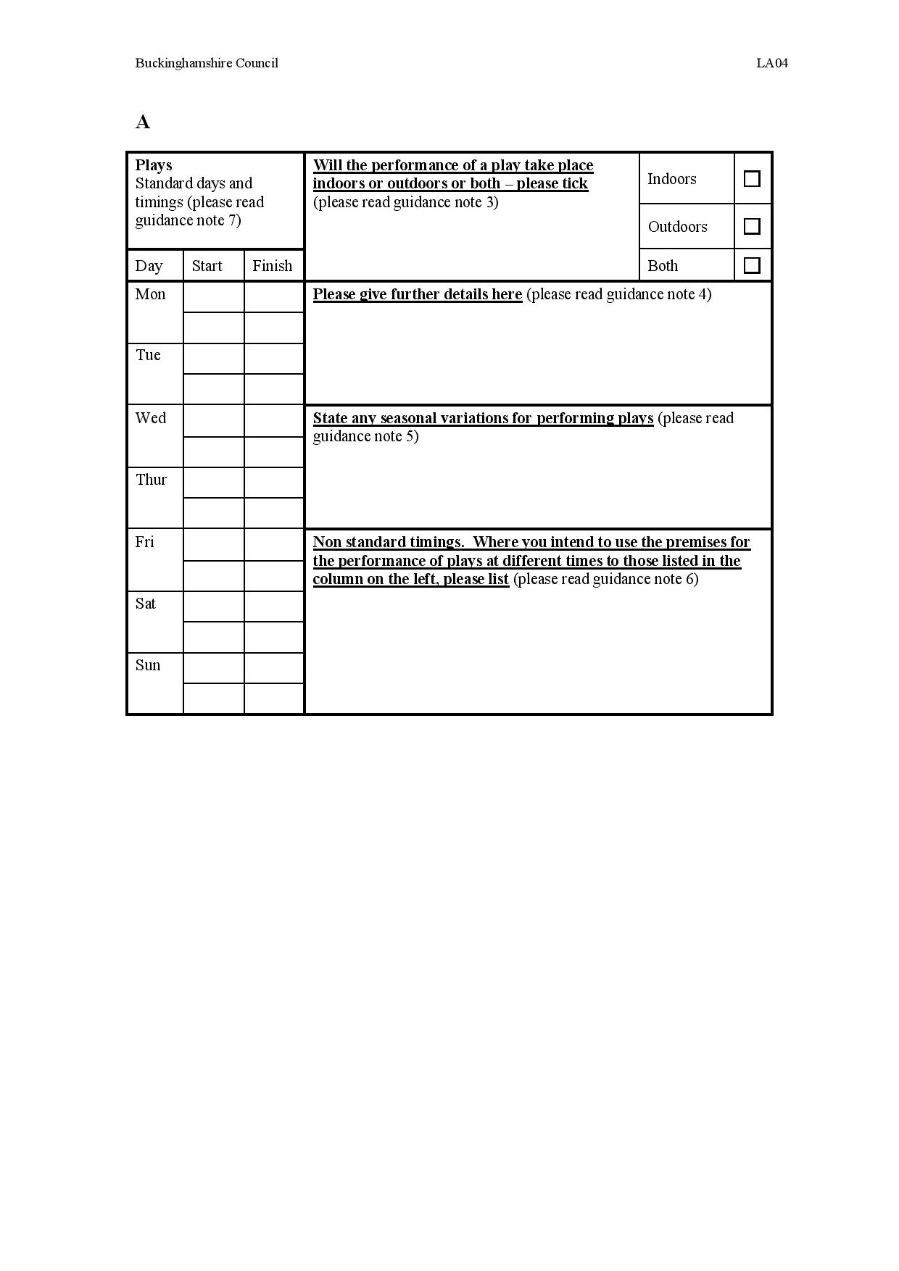
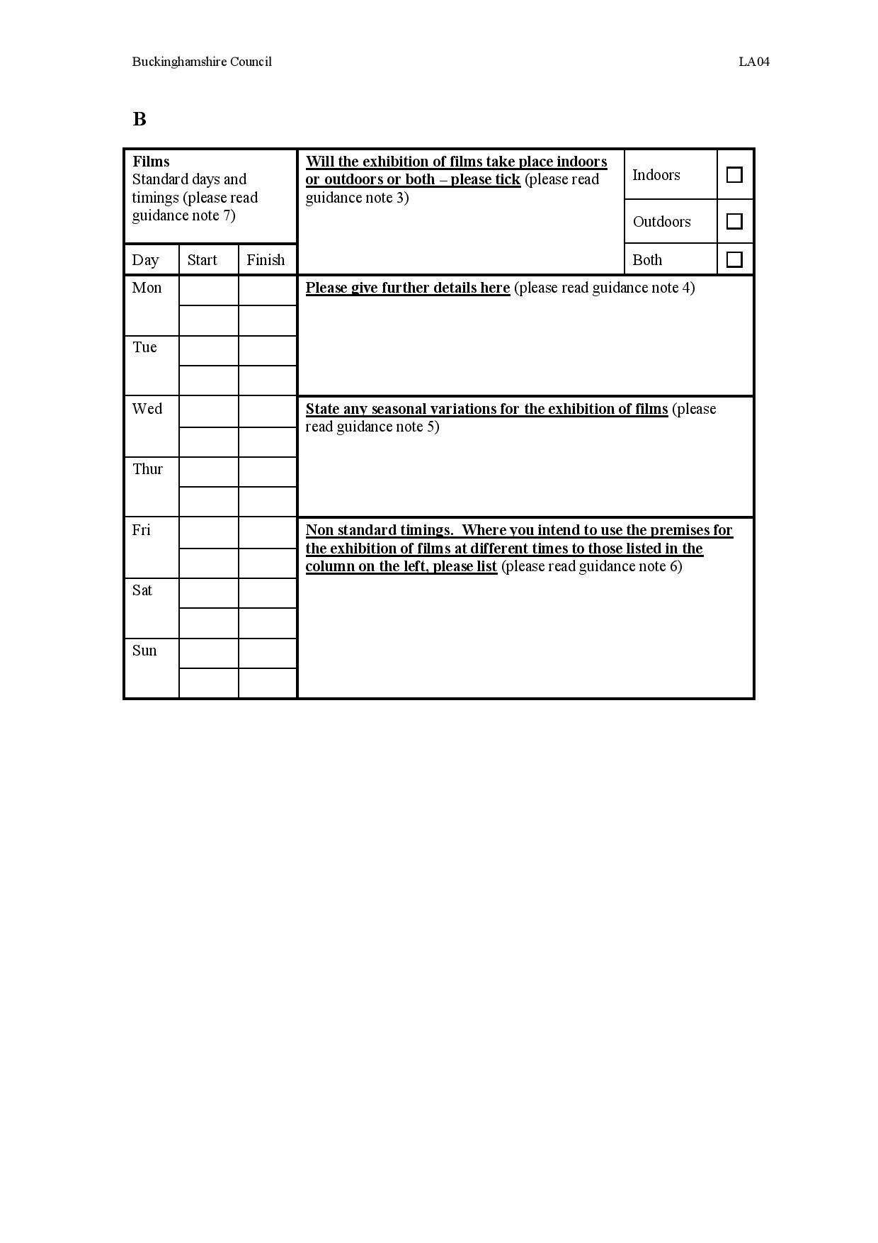
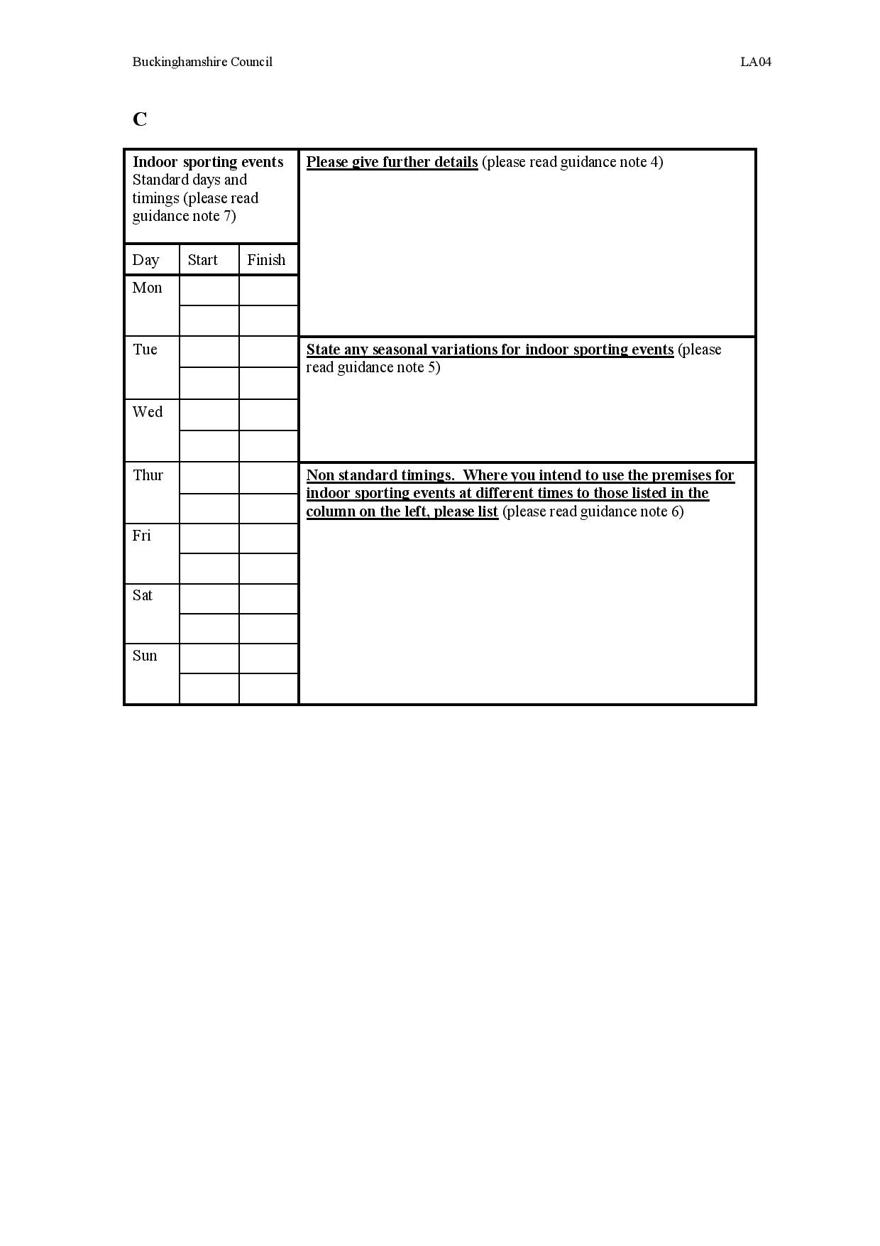
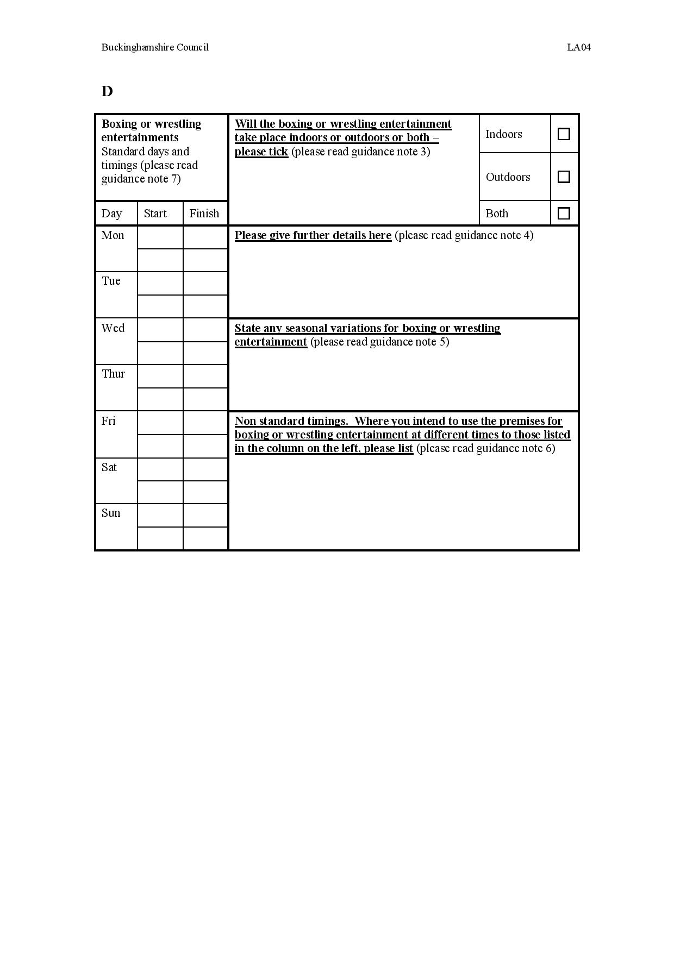
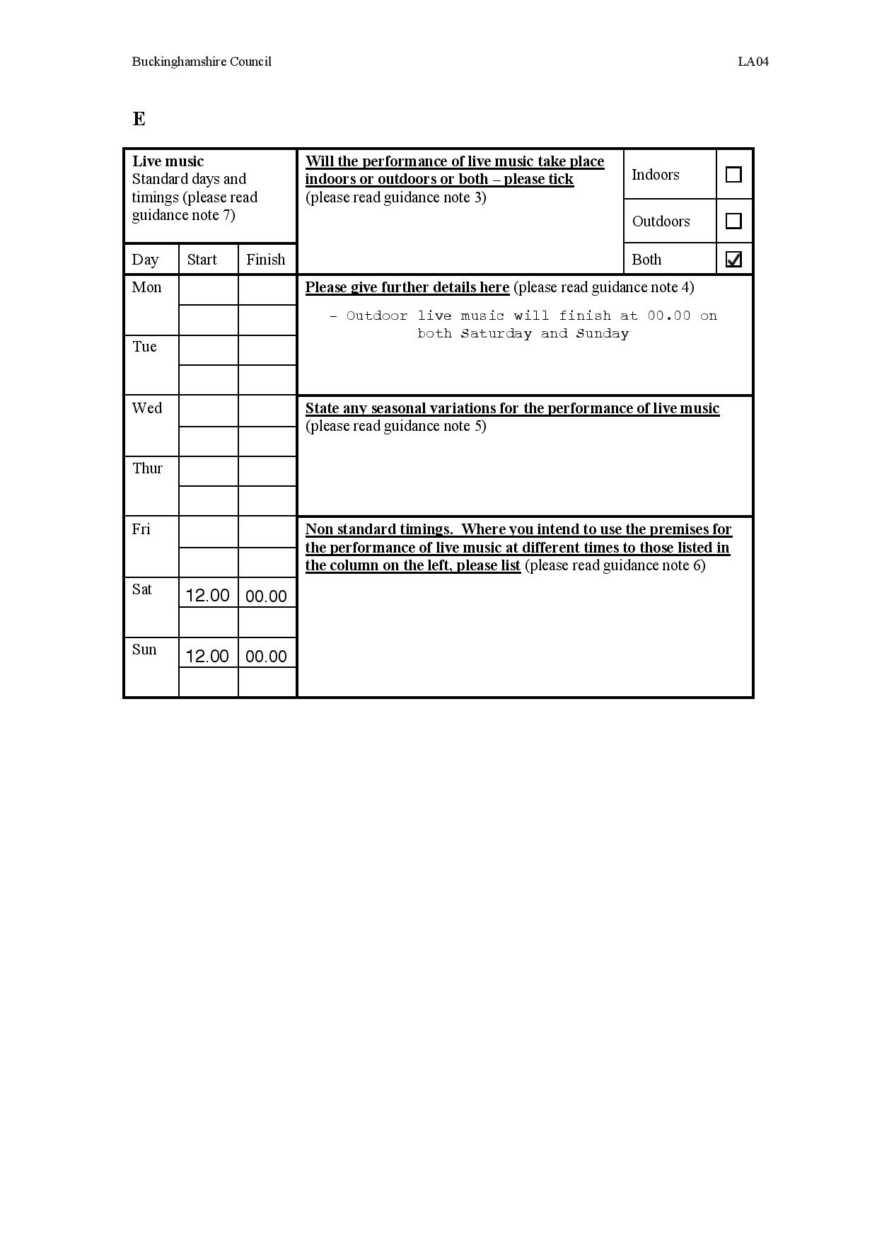
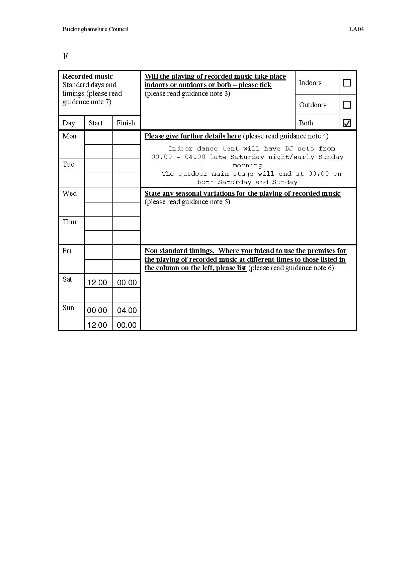
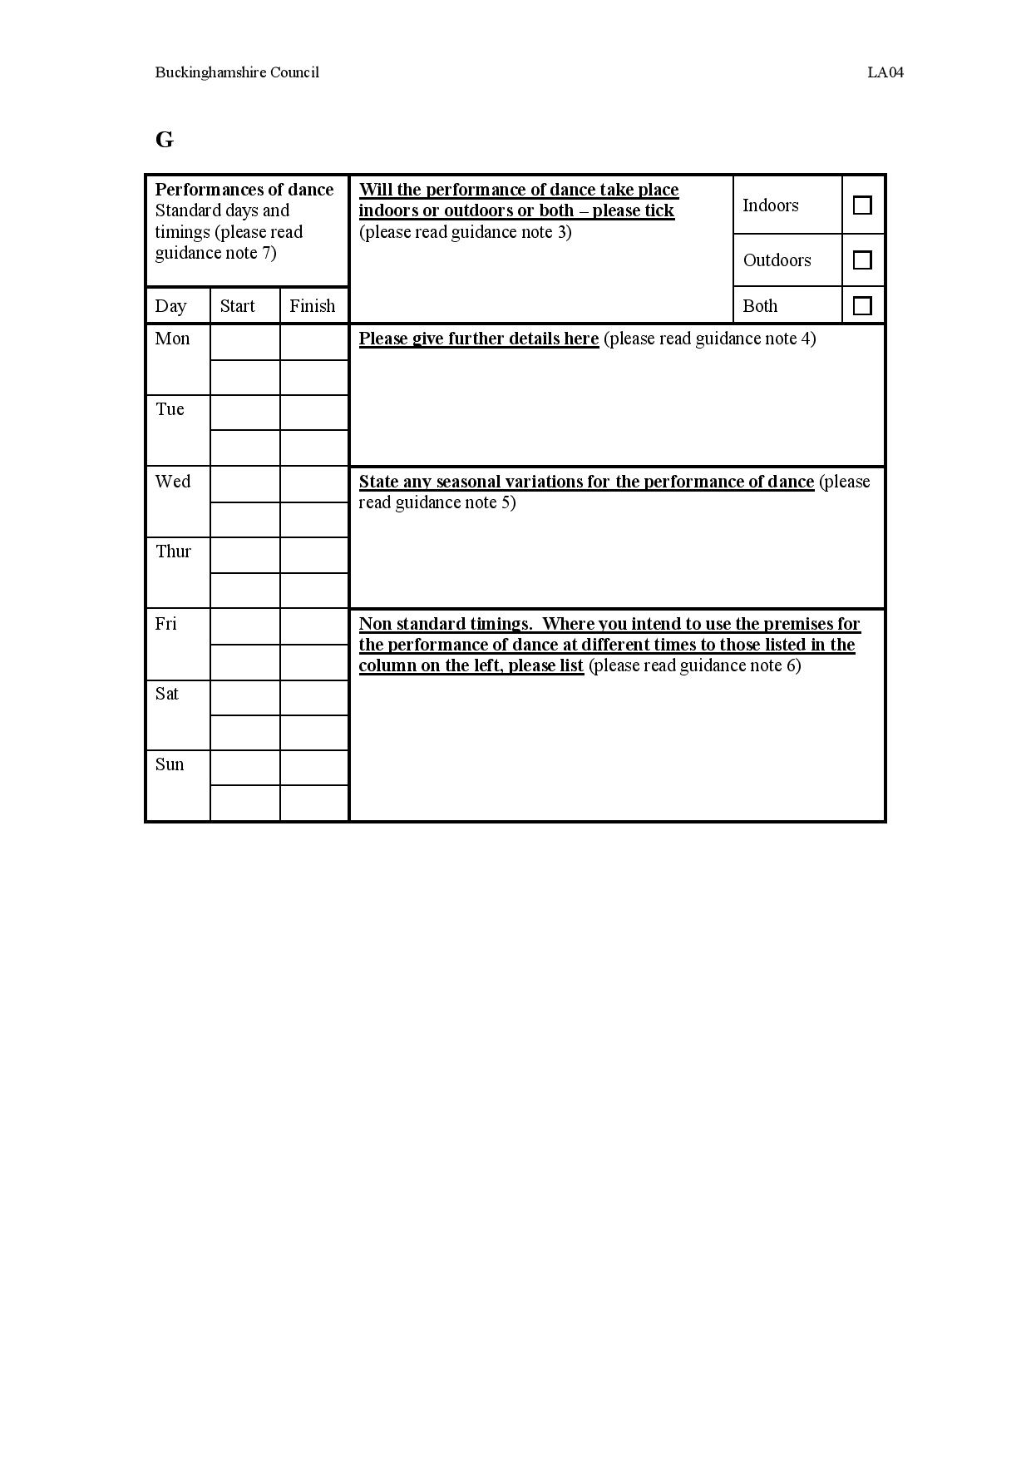
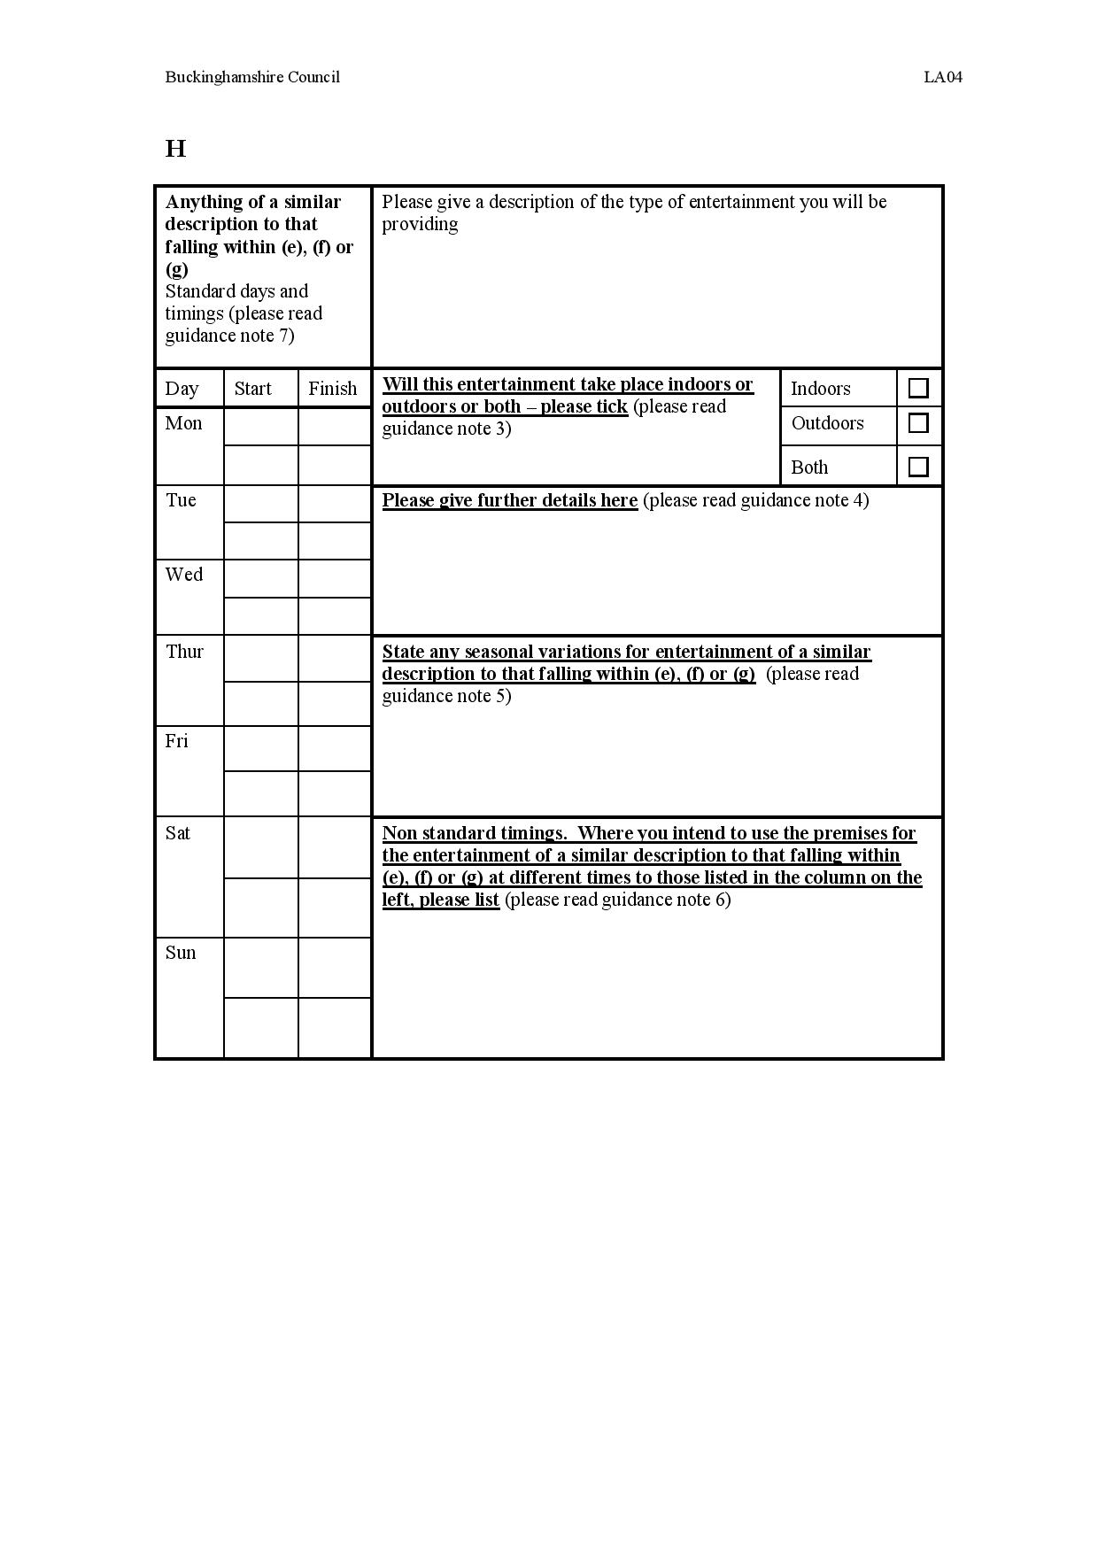
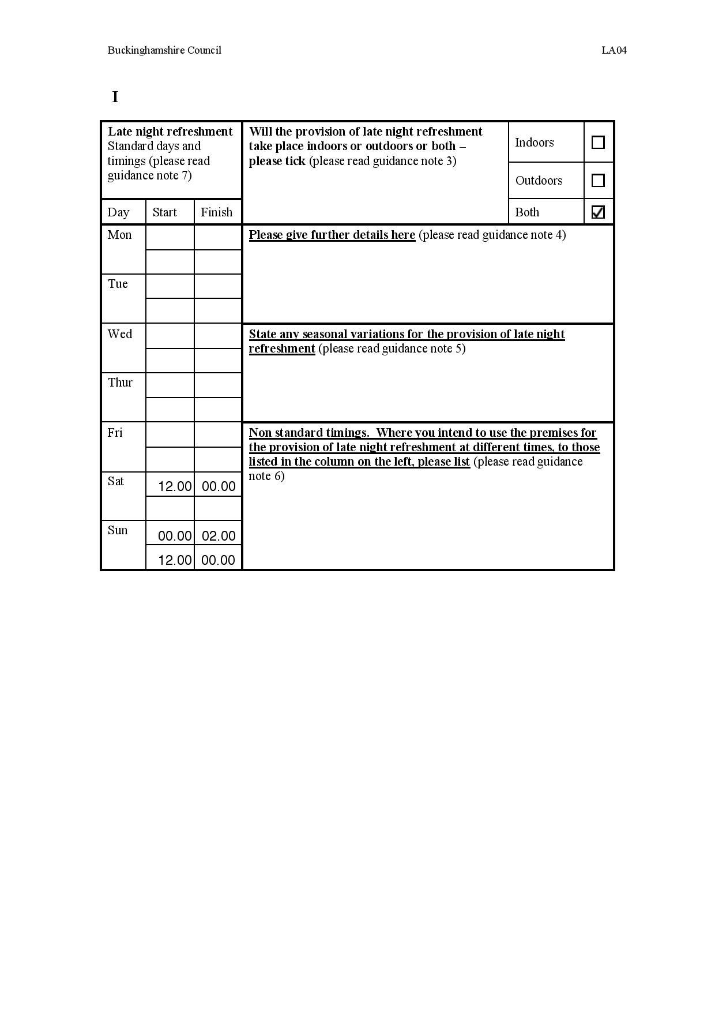
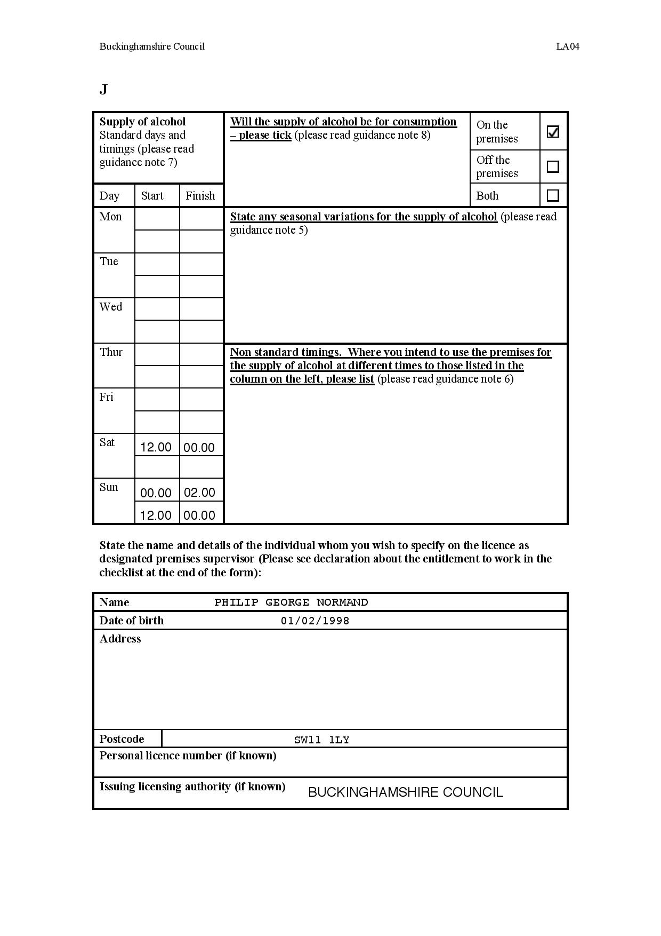
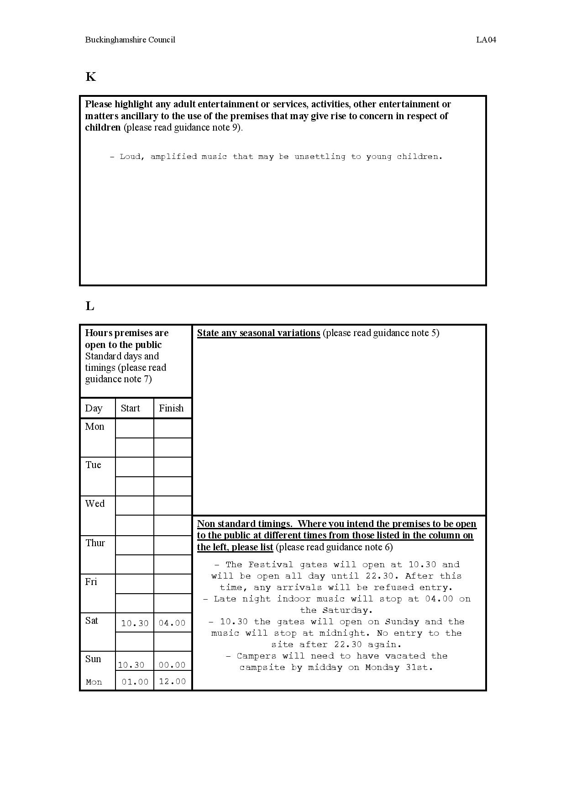
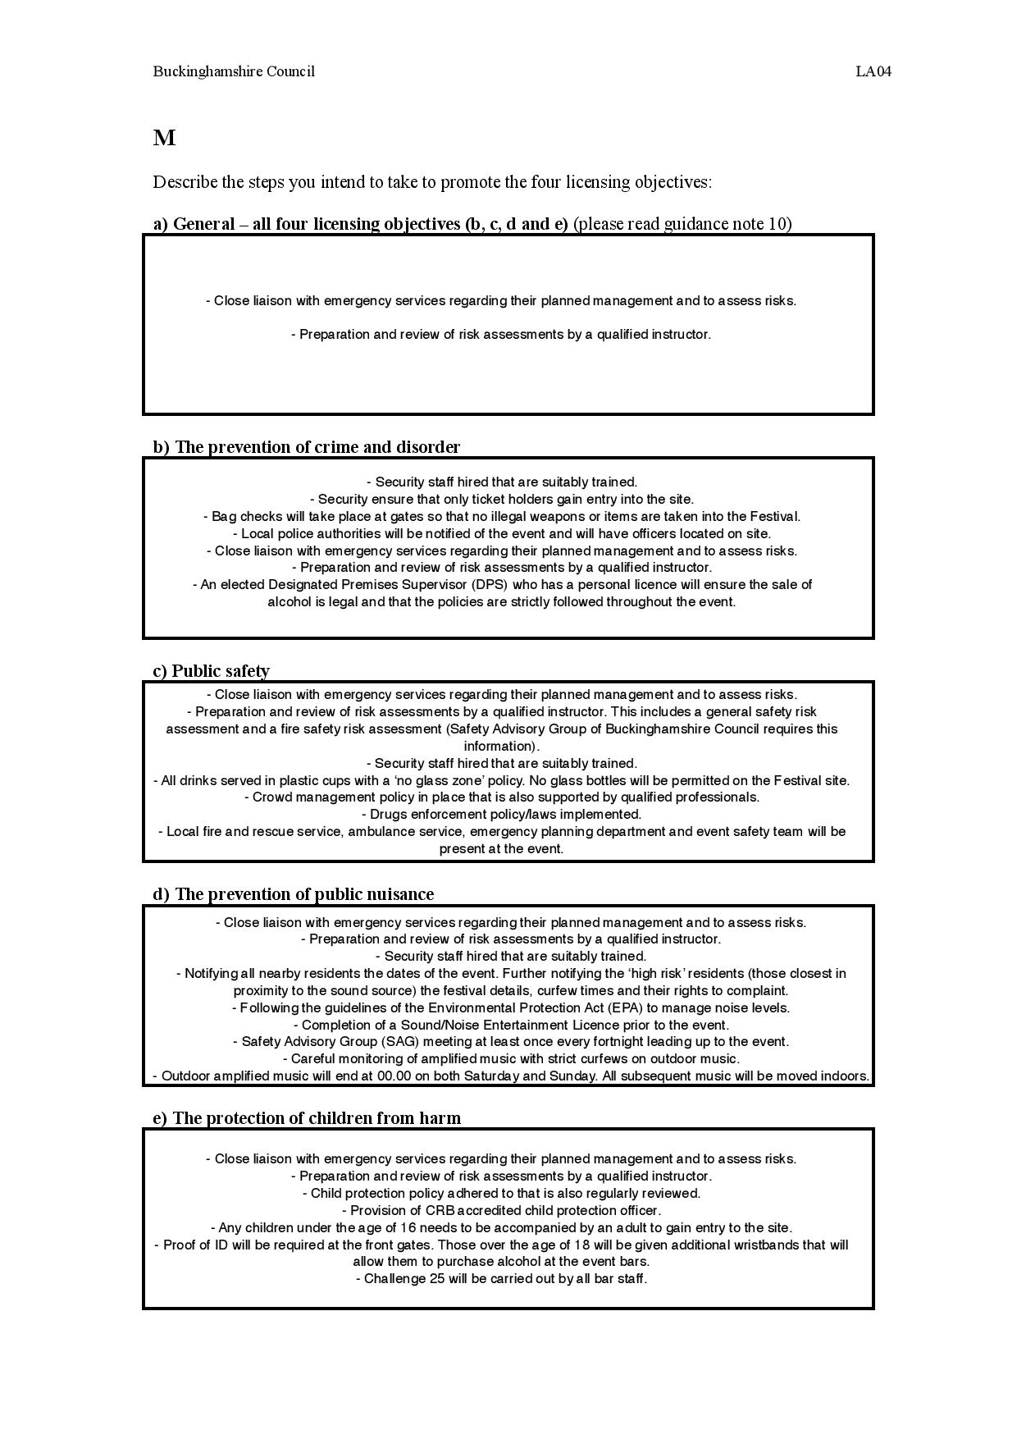
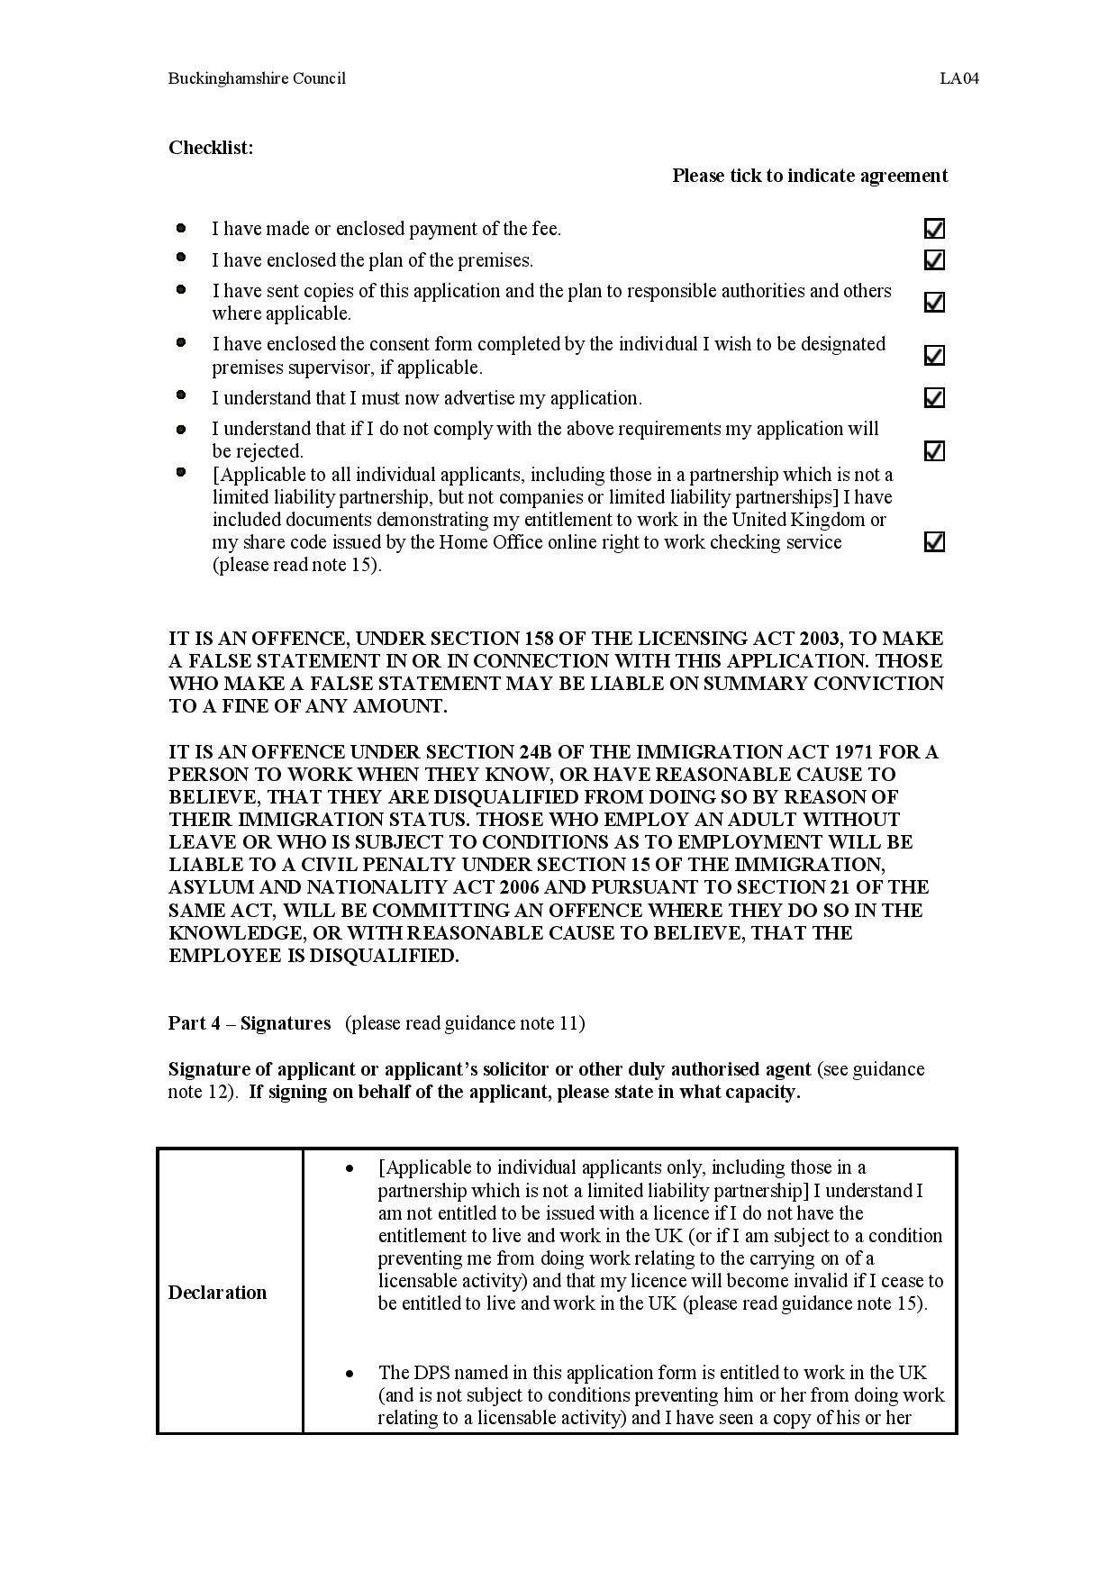
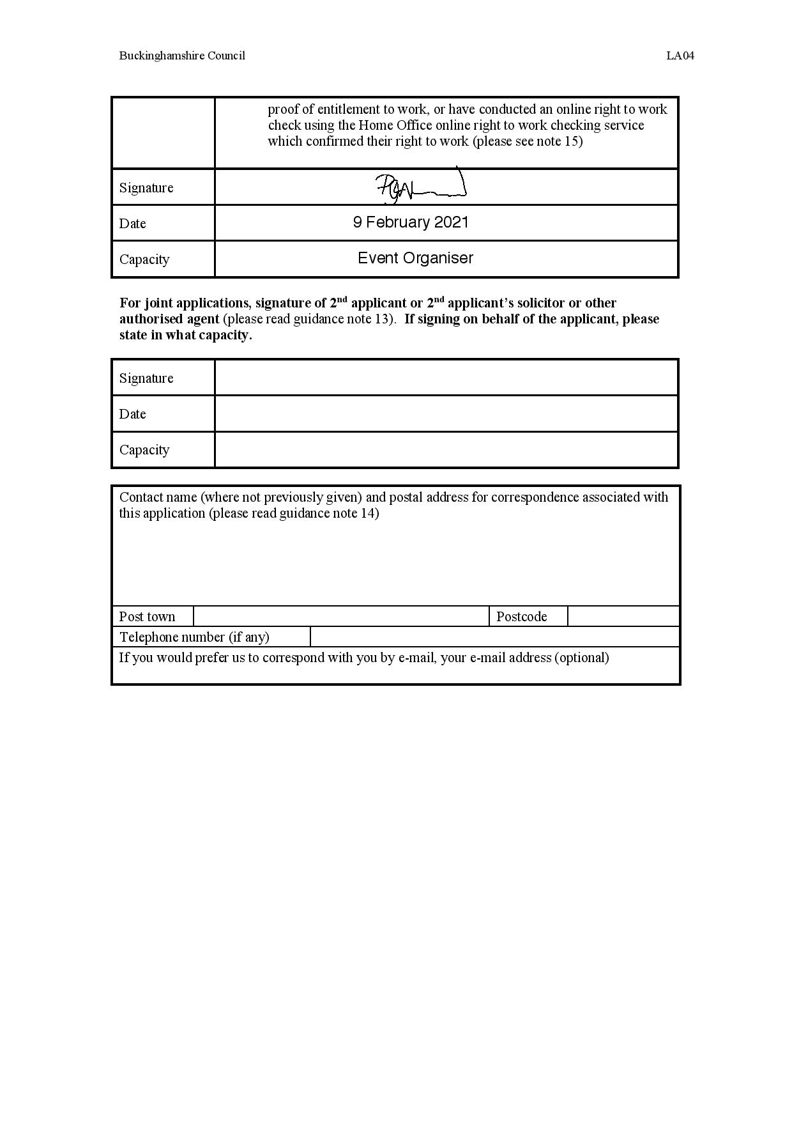
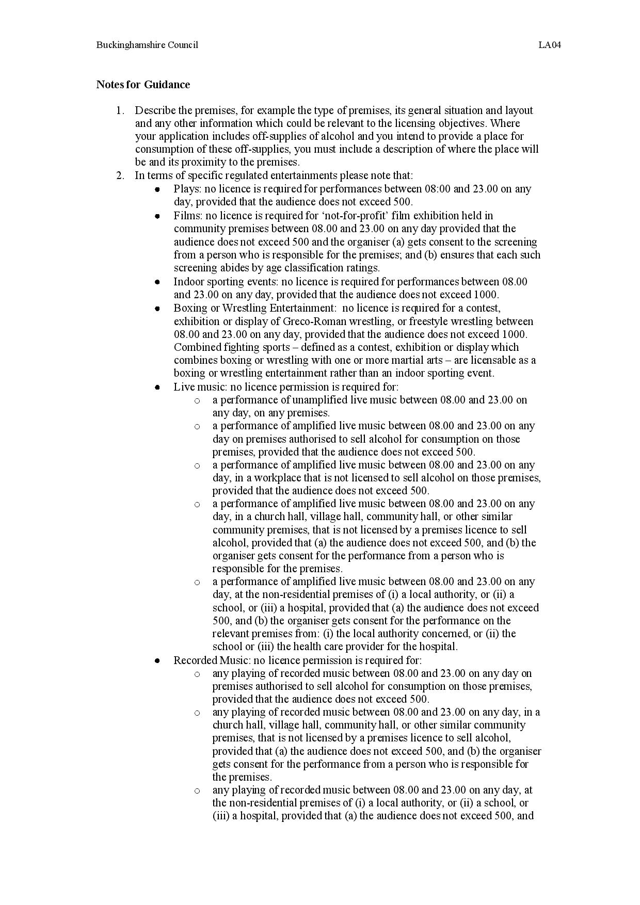
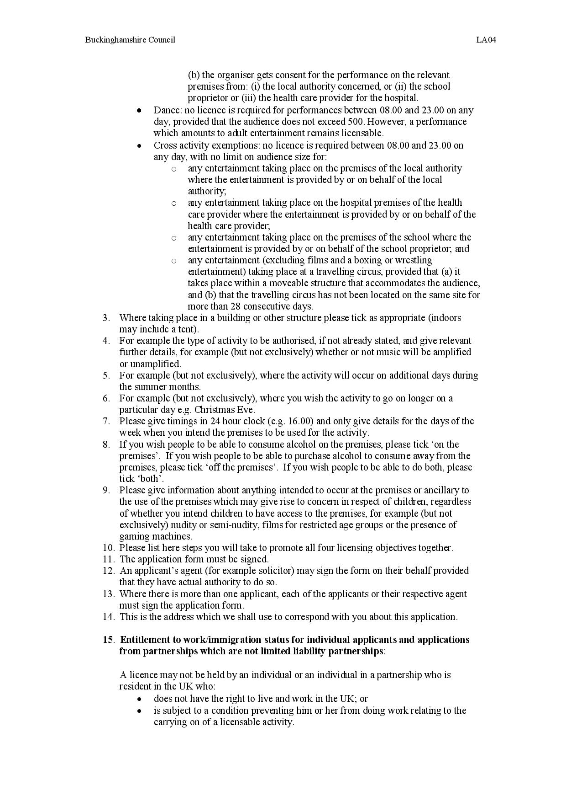
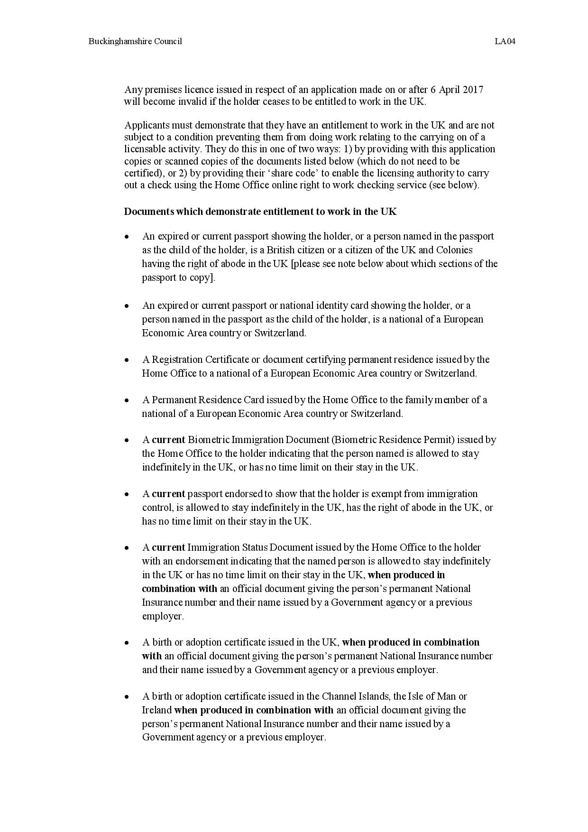
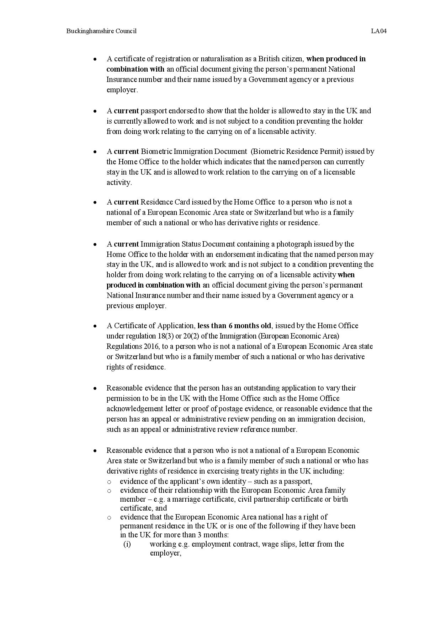
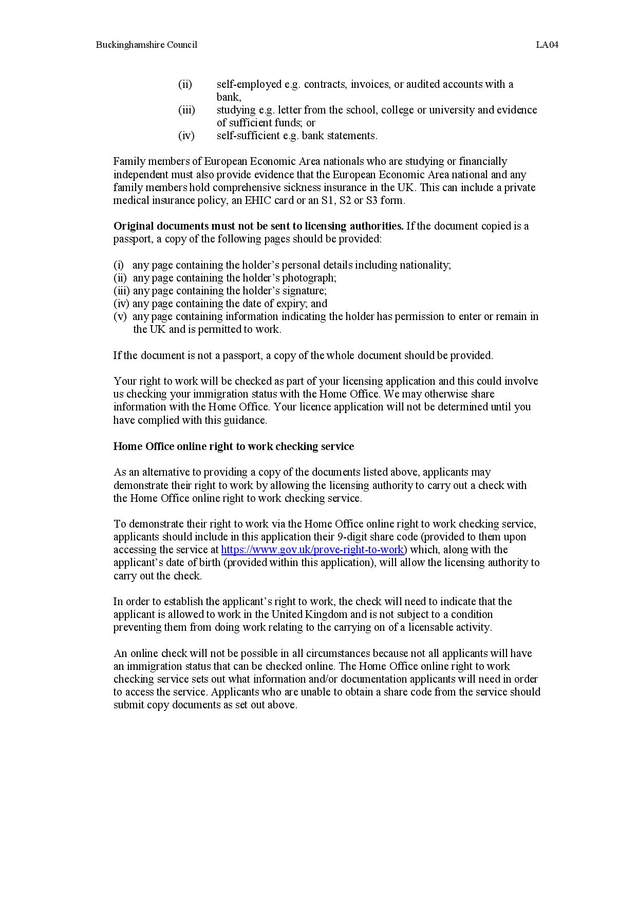

See appendix D for special events insurance proposal form/application.
See appendix F.
Workplace transport (row 1 in table) - servicing of toilet and collection of waste between 06.00 and 8.00 each day.

