

Title Page
CIVIL ENGINEERING & ARCHITECTURE ACADEMIC DISCIPLINE
CONSTRUCTION MANAGEMENT HNC

ASSIGNMENT TITLE:
Case Study

MODULE NAME & CODE:
Fundamentals Of Construction Technology ACBA4022

STUDENT NAME: Nia Alm DATE OF SUBMISSION: 8/1/26

STUDENT NUMBER: 2507084 WORD COUNT: 1869

Content Page

Title Page 1
Content Page 2
Tables Of Figures 2
Part 1- 3
1. Introduction 3
2. Background to Rhyd-y-car 3
3. Construction over time 5
3.1 Windows and Doors 5
3.2 Roof Coverings 6
3.3 Eaves Details and Rainwater Goods 7
3.4 Floor Coverings 8
3.5 Internal Joinery 9
4. Conclusion 9
References- 11
Part 2 - 12

Tables Of Figures
Figure 1 External view of Rhyd-y-car Terrace showing variation in window and door openings across different construction periods 3
Figure 2 Timber-framed, single-glazed multi-pane window typical of early nineteenth-century Rhyd-y-car dwellings 5
Figure 3 Natural slate roof coverings across Rhyd-y-car Terrace, typical of traditional Welsh domestic construction 6
Figure 4 Rainwater downpipe and shallow eaves detail demonstrating limited protection to external walls 7
Figure 5 Stone floor construction within early Rhyd-y-car dwelling, providing durability but limited thermal comfort 8
Figure 6 Exposed timber ceiling beams and internal joinery typical of early nineteenth-century workers’ housing 9

Part 1-

Introduction
This report will cover the case study of Rhyd-y-car Terrace at St Fagans National History Museum. It will examine how housing has changed between 1805 and 1985 (Museum Wales, N.d.) . Each house represents a different historical period in construction. This allows all key materials and construction methods to be compared adequately. This document will explain why these homes progressed, focusing on any improvements made for performance and considering any defects. Elements such as windows, walls, roofs, etc, are to be discussed. These developments are considered in relation to changes in building regulations and occupant requirements over time (Museum Wales, n.d. ).
Rhyd-y-car terrace presents a significant chance to contrast early workers’ dwellings with later twentieth-century residences. This enables a direct examination of how local construction developed in response to variations in material accessibility, construction expertise, financial limitations, and progressive building methods throughout the years.

Background to Rhyd-y-car
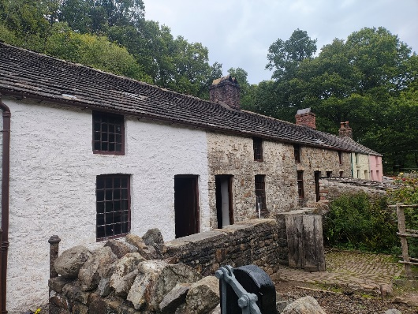
Rhyd-y-car is a row of six workers’ houses located at St Fagans, originally constructed around 1795 by Richard Crawshay to accommodate those employed in the iron industry (Museum Wales, n.d). The houses were built using traditional methods and locally sourced materials. As building standards improved and building regulations were introduced, alterations were made to the homes to fit with the expectations of occupants for safety and durability. As a result of this, Rhyd-y-car is now used to show the progress of homes over time (Museum Wales, n.d. ).
Figure 1 External view of Rhyd-y-car Terrace showing variation in window and door openings across different construction periods
The terrace is presented as six separate dwellings, each representing a different historical period: 1805, 1855, 1895, 1925, 1955, and 1985. The chronological arrangement enables direct comparison of how domestic housing evolved in response to social, economic, and industrial changes. Early homes illustrate the living conditions of labourers during the peak of the iron industry, characterised by basic living standards and a construction approach prioritising speed and cost.
As industrialisation advanced and living standards gradually improved, modifications to homes began to reflect a heightened awareness of health, sanitation, and home comfort. Subsequent modifications show the gradual incorporation of enhanced construction methods, services and materials, shaped by economic expansion and progress in building expertise. The terrace mirrors wider societal trends, encompassing population growth, urban development, and the implementation of public health initiatives.

Currently, Rhyd-y-car functions as a significant educational asset, offering knowledge about the historical evolution of housing construction. It emphasises how financial constraints, resource availability and changing norms have influenced residential architecture, providing important insights for comprehending both past and current building techniques.

Construction over time

3.1 Windows and Doors
The windows and Doors clearly exhibit the evolution of residential buildings across the various time periods. In the earlier years, windows tended to be smaller, constructed with timber framing and single-glazed, leading to poor insulation and limited natural light sources.

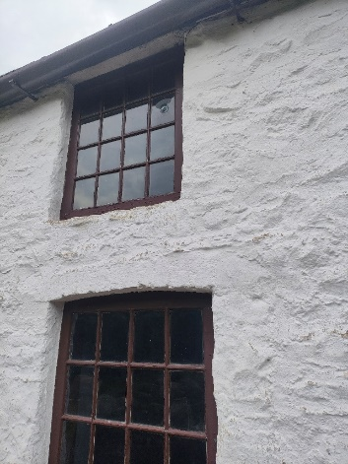
These designs illustrate the construction priorities, where cost-effectiveness and material availability take precedence over the comfort of the residents (Historic England,2021). As construction techniques advance, modifications were implemented to rectify common issues like draughts, timber deterioration and insufficient ventilation. Larger window openings and enhanced joinery were introduced to boost daylight and longevity. By the mid-to-late twentieth century, additional improvements were introduced, including enhancements to thermal efficiency, weather resistance, and security. These improvements were influenced by the introduction of building regulations and increased expectations of comfort and safety for occupants (HM Government,2021).
Figure 2 Timber-framed, single-glazed multi-pane window typical of early nineteenth-century Rhyd-y-car dwellings

The steady enlargement of window size indicates a heightened awareness of the value of natural light and airflow in home settings. Initial housing emphasised straightforward structures and lower building expenses, restricting the dimensions and quantity of window openings. With enhanced living standards, bigger openings grew more prevalent, boosting interior conditions and decreasing dependence on artificial light during the day.

Innovations in materials also enhanced the performance of windows and doors. Advancements in timber processing and joinery methods led to enhanced frame fitting, decreasing air leakage and boosting durability. Subsequent advancements brought better glazing technologies and upgraded sealing techniques, which greatly cut down on heat loss and weather infiltration.

Doors underwent a comparable transformation, developing from simple wooden structures to more durable designs that provide enhanced advancements in materials, construction expertise and regulations collectively shaped the design of openings, harmonising cost, performance and occupant comfort over time.

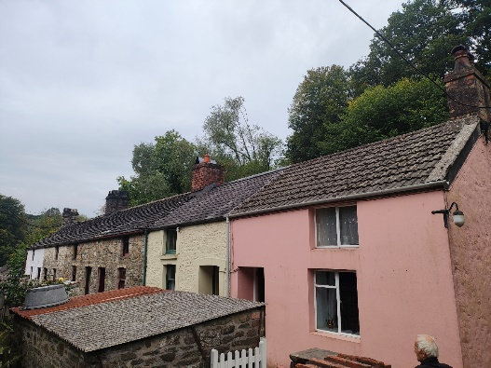
3.2 Roof Coverings
Figure 3 Natural slate roof coverings across Rhyd-y-car Terrace, typical of traditional Welsh domestic construction
Roof coverings at Rhyd-y-car Terrace clearly demonstrate the development of construction materials and techniques over time. In the earliest homes dating back to 1805, roofs were made with locally sourced natural slate secured directly to wooden battens. Slate was abundantly found in Wales and provided an economical and long-lasting roofing solution for workers’ housing. These initial roof designs lacked underlay and insulation, which meant the structures relied entirely on the slate to withstand the elements. While they performed well against rain, the lack of insulation led to a considerable amount of heat loss and diminished interior comfort.

The roofing frameworks of early homes were generally constructed using handcrafted timbers, showing craftsmanship and the limited access to standardised materials. Although this method was structurally sound, it was susceptible to drafts and moisture intrusion, especially during wind-driven rain. These drawbacks emphasise the trade-off between cost-effectiveness and performance that defined the early design of housing.

As the terrace evolved during the late nineteenth and early twentieth centuries, roofing methods advanced in tandem with industrial progress. The incorporation of roofing felt beneath slate coverings added an extra layer of protection against moisture penetration, enhancing overall weather resistance at a relatively low expense.

By the mid-to-late twentieth century, further innovations became apparent, particularly in response to heightened expectations for comfort and compliance with regulatory standards. The greater utilisation of lost insulation greatly enhanced thermal performance by minimising heat loss from the roof space. These improvements reflect both improved material availability and a growing emphasis on energy efficiency and long-term building performance, influenced by building regulations governing thermal standards (HM Government,2021).

3.3 Eaves Details and Rainwater Goods
Eaves and rainwater systems are crucial for managing surface water and protecting the building’s structure. In the original Rhyd-y-car homes, the eaves were slight, showing minimal extension beyond the wall surface. This design minimised material usage and building expenses but offered inadequate defence against rainwater runoff, heightening the chances of moisture infiltrating the masonry walls.
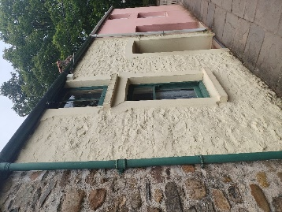
Early rainwater systems were usually made from cast iron, a material prized for its durability in the nineteenth century. Cast iron gutters and downpipes were long-lasting but needed consistent upkeep and could corrode if maintenance was not regular. Furthermore, joints were frequently inadequately sealed, resulting in leaks and ineffective water disposal.
Figure 4 Rainwater downpipe and shallow eaves detail demonstrating limited protection to external walls

With the evolution of construction practices, larger eaves projections were implemented, enhancing protection for external walls and minimising moisture-related issues. Enhancements in gutter designs and attachment techniques improved the gathering and managed release of rainwater away from the building’s structure. By the middle of the twentieth century, rainwater systems were increasingly standardised, enhancing dependability and lowering installation expenses.

Subsequent homes in the terrace showcase the utilisation of plastic rainwater systems, providing an economical option to cast iron. These systems offered enhanced corrosion resistance and notably lowered the maintenance needs. The advancements indicate a better grasp of moisture control and the lasting financial advantages of resilient, low-maintenance materials.

3.4 Floor Coverings
The flooring development in Ryd-y-car shows a distinct evolution in strength, comfort and moisture resistance, influenced by economic elements and improvements in construction techniques. In the earliest dwellings, floors were typically made of stone slabs laid directly on the ground. Stone was readily accessible and affordable, making it a sensible option for housing workers. Although these floors were very sturdy, they offered no thermal insulation and were very vulnerable to cold temperatures and moisture from the ground.
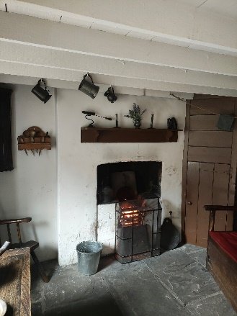

In certain homes, suspended timber floors were installed, resting on timber joists with ventilation supplied via external air bricks. This method lowered direct ground contact and enhanced comfort when compared to solid surfaces. Nevertheless, due to insufficient knowledge of ventilation needs and budget limitations, airflow frequently fell short, resulting in timber deterioration and moisture-related issues.
Figure 5 Stone flag floor construction within early Rhyd-y-car dwelling, providing durability but limited thermal comfort

As knowledge about construction advanced throughout the twentieth century, concrete ground floors grew more prevalent. When paired with damp proof membranes, concrete provided enhanced durability, lowered maintenance and improved moisture resistance. Though initially pricier, these floors offered lasting financial advantages due to enhanced performance and lower maintenance needs.
Subsequent advancements included the installation of insulation layers under concrete slabs, which enhanced thermal efficiency and comfort for occupants. The emergence of contemporary floor covering like vinyl, carpet and laminate signifies increasing demands for cleanliness, comfort and cost effectiveness in residential spaces.

3.5 Internal Joinery
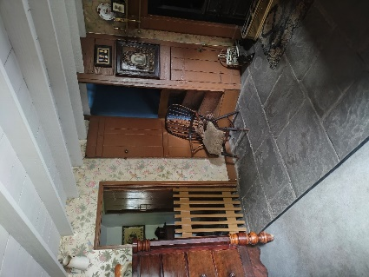
Internal joinery at Rhyd-y-car showcases notable transformations in craftsmanship, material accessibility and construction standards throughout the years. In the earliest dwellings, interior joinery was basic and practical, featuring wooden doors, skirting boards, and staircases crafted from locally obtained materials. This method reduced expenses but led to inconsistencies in quality and finish. Ornamental features were minimal, illustrating the working-class character of residences and the emphasis on functionality instead of appearance.

Early house staircases were typically steep and narrow, aimed at conserving floor space and lowering building expenses in small homes. Although efficient in optimising available space, these staircases provided reduced safety and comfort relative to subsequent designs.
Figure 6 Exposed timber ceiling beams and internal joinery typical of early nineteenth-century workers’ housing

With the growth of industrial manufacturing, joinery parts became increasingly standardised and more accessible. Timber cut by machines lowered production expenses while enhancing consistency and speed of installation. By the mid–twentieth century, internal doors and fittings exhibited greater emphasis on aesthetics, comfort, and functionality, mirroring evolving social expectations. Later dwellings also demonstrate improved fire safety considerations, with stronger door constructions and improved internal layouts influenced by building regulations (HM Government, 2019). These changes demonstrate a transition from solely functional interiors to environments created with a stronger focus on safety, comfort, durability and lasting value.

Conclusion
To conclude, the Rhyd-y-car Terrace provides a clear and valuable case study illustrating the evolution of domestic construction in Wales between 1805 and 1985. Through the examination of key building elements, including windows, roofs, floors, eaves, and internal joinery. It is clear that housing design has progressed notably due to variations in material accessibility, building expertise, financial circumstances and functionality, frequently sacrificing thermal efficiency, moisture management and comfort for residents.

With the evolution of construction methods, enhancements were steadily implemented to tackle prevalent issues like heat loss, moisture infiltration, and inadequate ventilation. Industrialisation facilitated these changes by enhancing access to standardised materials and lowering construction costs, making higher-performance solutions more feasible.

The introduction of building regulations further influenced domestic construction by setting minimum standards for safety, durability and energy efficiency, particularly during the mid-to-late twentieth century. This ensured improvements in construction quality were applied more consistently across housing.

Financial considerations have remained a key influence throughout housing development. Early dwellings prioritised affordability through the use of locally sourced materials and simple construction methods, while later housing achieved improved performance through more efficient use of materials and construction techniques. Although sustainability was not an explicit consideration in early construction, the durability and local sourcing of materials such as stone and slate align with modern sustainable principles, Subsequent enhancements in insulation and building performance indicate a growing recognition of energy efficiency.
Overall. Rhyd-y-car demonstrates that domestic construction evolves in response to technological advancements, social expectations, and economic limitations, highlighting the importance of balancing cost, performance, and occupant well-being in modern housing design.

References-
HM Government UK ‘The Building Regulations: Conservation of fuel and power, Volume 1: Dwellings’ (2010). Available at: https://assets.publishing.service.gov.uk/media/662a2e3e55e1582b6ca7e592/Approved_Document_L__Conservation_of_fuel_and_power__Volume_1_Dwellings__2021_edition_incorporating_2023_amendments.pdf (Accessed: 8 January 2026).
Historic England's ‘Energy Efficiency and Historic Buildings - Application of Part L of the Building Regulations to Historic and Traditionally Constructed Buildings’ (2011). Available at: https://historicengland.org.uk/images-books/publications/energy-efficiency-historic-buildings-ptl/heag014-energy-efficiency-partl-2025/ (Accessed: 8 January 2026).
Amgueddfa Cymru (n.d.) Museum Wales. Available at: https://museum.wales/collections/historic-buildings/29/Rhyd-y-car-Terrace/ (Accessed: 28 December 2025).
Amgueddfa Cymru (n.d.) Museum Wales. Available at: https://museum.wales/learn/activity/401/Virtual-Tour-of-Rhyd-y-car-Homes-through-Time-/ (Accessed: 8 January 2026).

Other information provided in the document has come from personal notes taken during official lectures.

Part 2 –


