

BSc (Hons) Professional Policing Practice

Adverse Childhood Experiences (ACES) and Policing: Should knowing that a person at an incident has experienced many ACES determine if an officer with specialist knowledge should be dispatched?

Student name: Rebecca KING
Student number: 1920836

First and foremost, I would like to thank my police family for inspiring me to be a better officer, and being there at all times along the way with this dissertation. I would also like to thank the staff at the university for their constant encouragement and support throughout the past three years. This thanks especially for Kelly Andrews and Jane Thomas. This help will be something that I will be eternally grateful for, and I cannot thank you enough. To Lwys and Noah…I cannot wait to start being your mother again.

Declaration
This work has not previously been accepted in substance for any degree and is not being concurrently submitted in candidature for any degree.
Signed: Rebecca KING
Date: 27/ FEB/ 2023

STATEMENT 1
This dissertation is being submitted in partial fulfilment of the requirements for the degree of BA.
Signed: Rebecca KING
Date: 03/ JAN/ 2023

STATEMENT 2
This dissertation is the result of my own independent work/investigation, except where otherwise stated.
Other sources are acknowledged by footnotes giving explicit references. A bibliography is appended.
Signed: Rebecca KING
Date: 03/ JAN/ 2023

STATEMENT 3
I hereby give consent for my dissertation, if accepted, to be available for photocopying and for interlibrary loan, and for the title and summary to be made available to outside organisations.
Signed: Rebecca KING
Date: 03/ JAN/ 2023

STATEMENT 4
I hereby give consent for my dissertation, if accepted, to be available on the university’s IT system to those who have consent to use the system.
Signed: Rebecca KING
Date: 03/ JAN/ 2023

Table of contents:
- Introduction – 5
- Literature Review - 8
- Methodology – 9
- Analysis of results - 12
- Conclusion and reflection - 23
- Bibliography - 21

- Introduction

During the time that the researcher has been employed as a police officer within Gwent Police Force (Since March 2020), their time has been spent visiting many addresses, many locations and many people, both as suspects of crime and as victims or witnesses. These incidents have ranged from -non-emergency to emergency, minor to major, and volume crime to complex and serious in nature. There have been incidents whereby there have been more than one suspect, and incidents that have involved an individual victim, and an entire community. This is the nature of response policing as noted on the website of the College of Policing (2023). As referenced by PC Azmil Shaffi of Leicestershire Police (2022) this is the bread and butter of response policing, whereby the nature of each and every call is completely different to the last call officers have been dispatched to.
Each crime needs a location, an offender, and a victim (College of Policing, 2022) to occur. By removing one of these, a crime cannot be committed. Looking into crimes was not the object of this dissertation, rather it was to explore what more could police forces do to better arm attending officers and better inform partnership agencies to make a blend of directed and trauma informed policing, for those who have been exposed to ,adverse experiences during their formative years. In particular, exploring those who have been exposed to particular traumatic experiences in their formative years
There have been studies over the years, as examined by Farrell (2005), in their book on repeat victims, and what causes such, as has there been for repeat offenders, or recidivism as noted in studies such as those by Farrell and Pease (2015), where certain characteristics have been identified as factors in such behaviour. This has also been identified in a study by Hilder, Kumar and Strang (2021) that stated that there are most certainly not a ‘felonious few’ that commit crime any longer (Sherman, 2007).
It was within the initial study conducted at the Kaiser Permanente clinics, Fellitti et Al (1998) also discovered that those who have been exposed to Adverse Childhood Experiences are more likely to engage in riskier behaviours than those who have not. This once again, suggests that police services would be impacted by these affected by Adverse Childhood Experiences, be it as a victim or a perpetrator.
The common denominator in what the studies have found is that there appeared to be a strong link between experiences that have occurred within peoples childhoods that were deemed to be traumatic, such as drug use within the family environment, physical or emotional abuse, and a parent being incarcerated, and the risk to the person being subjected to these becoming known to police for things such as drug or alcohol abuse, or violent crime, or even physical effects (Public Health Wales, 2023).
The term Adverse Childhood Experiences (ACES) has been around for over thirty years, and has been more used in the United States rather than the United Kingdom. In 1995, the Centres for Disease Control and the Kaiser Permanente health care organisation in California, worked together and undertook a study on these adverse experiences. This study concentrated on the three very specific kinds of adversity, that children and young people are potentially subjected to in their familial home environment. These adversities covered multiple damaging areas. These include multiple forms of emotional and physical abuse, dysfunction within familial set ups, and neglect. This neglect included emotional, physical and economic aspects.
The term was later coined in a study by Felitti, Adal, et al (1998) which can amount to trauma significant enough to a young person, that it can have an effect on a person’s mental, biological and sociological welfare. These centred around ten identifiable risk factors which are wide ranging. They cover abuse in the form of sexual, remembering that this is in a familial situation, but does not rule out abuse form outside of the family, physical abuse again from both inter familial and others, and over a range of severity. There was another major strand of trauma that has been shown in the aforementioned studies that have been identified as ACES and that is neglect. This appears to be based and centred around the persons home life, and that is the element of neglect. Neglect had been split into three strands by Fellitti, et (1998). The form of emotional neglect whereby the child or young person has not been engaged with emotionally, is not praised, is not encouraged to better themselves or engage with others. It can be as simple as not being smiled at, not being spoken to, or simply just ignored by someone who would ordinarily be a care giver. According to Fellitti et al (1998), other forms of neglect also contribute to ACES. These can be physical neglect whereby the young person may not be adequately fed, sheltered, clothed, or even supervised. Other traumas that were identified have been shown to be things such as witnessing familial members suffer domestic abuse, be incarcerated, family members abuse alcohol or drugs, or have significant mental health issues. Fellitti et al (1998) also identified that a split or divorce between families is an identified adverse experience.
Each one of these factors has been proven to have a negative impact upon the person Bartlett and Sacks (2019), and being subjected to them can shape the adulthood that they go on to experience later on in their lifetimes (Public Health Scotland, 2023)
1.1 Objectives
The subject area in which this research is around children and young people who have been exposed to Adverse Childhood Experiences. The aim is also to see if those working within Gwent Police Force in any capacity, have opinions to see if there is a common consensus around being given further knowledge on order to better complete the jobs in which police officers are assigned to attend, and go to on many occasions every week that they work throughout their career, as previously detailed.
The researcher would like to see how much more raw information has been collated by practitioners within relevant fields and given as part of a training module from the College of Policing.
The main objectives for this dissertation are:
• Evaluation of colleagues awareness of what Adverse Childhood Experiences are?
• Justify the Adverse Childhood Experiences input that is given in the initial 6-month training of becoming a police constable. Is this sufficient information in the eyes of the student officer, to arm them with before they get deployed onto shift?
• Explore if there are any benefits to police forces by putting a marker on someones police profile if they have been known to have been subjected to Adverse Childhood Experiences
• Outline if police and police staff think that officers attending an incident whereby it is known that someone there has suffered Adverse Childhood Experiences, should an officer with specialist knowledge be deployed.
There has seemingly been little training for student officers in the way of being informed of Adverse Childhood Experiences within Gwent Police, and the researcher has not thought that there has been a proportionate appraisal of the information that is disseminated to probationary police offices. By providing both student and existing officers an up-to-date package, based on scholarly research and on the ground findings, it would realistically give officers a deeper understanding of the types of traumas that Adverse Childhood Experiences survivors have faced, and the type of policing would be a better fit when dealing with these people. It would be of particular use when officers deal with children who have more recently come from being exposed to them. As in, should an informed or trauma-based team be sent out as a speciality, like what would be with a Taser call? Informed decision making and specialised teams are at the heart of success for police, with a positive increase in managing performance and making strategic decisions to future proof the service (Coleman, 2008).
There has previously been much review done in regard to the adverse experiences, because of how much has been published and because the information that is known about the aftereffects has been given to student police officers in training. However, during the researchers reading and research on the subject, it has become evident that whilst the cause of the ACES has been heavily studied (Finklehohr et al, 2015; Scott (2007); Trickett, Noll and Putnam (2015), as have studies into the help that is available for the aftermath, and what kind of effects dealing with this trauma has on the person and their family. And quite rightly so.
There appears to be a gap in research where police forces have encounters with ACE affected people. (Ford, 2017)There is a gap to identify what type of policing would best suit calls whereby these survivors would benefit to tailored services, or officers deployed who were armed with knowledge around further training.
One reason behind the researcher wishing to study such things, other than there being little to no data recorded on the combined topics, explicitly, is that there appears to be a gap in expertise and knowledge within the police force that they are employed in and potentially further afield, in how to deal with such people, who are without a shadow of a doubt, some of the most vulnerable persons within our communities, and going off data already gathered, definitely those who are more likely to enter the criminal justice system. (Police and Crime Commissioner of Gwent, 2022)
By more people entering the already overcrowded and underfunded judicial and penal system this creates more pressure on frontline services such as police forces, who are already seeing a substantial increase to their workloads and responsibilities (Child Protection Studies, 2017) , due to partner agencies such as Social Services and the National Health Service, publicly being on the brink of being unable to cope with the pressure that has been building up over the years with seemingly no other service to pick up the backlog, and people in need than police forces across the country. (Lord Chief Justices Office, 2020)
The information concerning Adverse Childhood Experiences and how it has been seen to affect peoples lives appears to be harrowing, as seen with the Robert Maudsley case (Leicester Mercury, 2022) With evidence showing that so many people have been exposed to so many traumatic events at young ages, with Violence Prevention Wales (2022) claiming that almost half of the population (47%) within the Principality experiencing at least one adverse childhood experience.
Having read articles from writer who have completed journals like Webster (2022), articles on the internet on sites such as from the Young Minds UK site (2022), and research papers relating to what those exposed to Adverse Childhood Experiences potentially have in store in their latter lives there naturally appears to be a direct correlation between those who have been subjected to such issues and those who are also more likely to be at an increase in adversity when they mature.
This research may identify that there is a lack of prior research in this field, there appears to be a lack of research around repeat offending committed and alleged to have been committed by those who have experienced a multitude of Adverse Childhood Experiences, along with the effect that this has upon nationwide police forces. The whole reason behind why I wished to have put some time into studying those who have experienced Adverse Childhood Experiences was purely to see if at any point of interaction with police officers, that the seemingly endless chain can be broken and the interactions with police by providing better suited problem solving, signposting, and potentially even deploying certain officers with a specific knowledge, or having someone who works within the force control room to be able to contacted and give adequate and fitting advice to frontline officers who would be able to better deal with those identified as having Adverse Childhood Experiences, at the calls (Hughes et al, 2018; Tink et al, 2018)
Unfortunately, there appears to be no prior research done to support the idea of having a holistic approach to tackling issues such as this other than Bateson, Macmanus, and Jiohnson (2019), and definitely no reading has suggested that any force in the United Kingdom has a person with a social services background in the call centre working with dispatchers who are able to call front line officers when they are at a call and dealing with people who have been exposed to Adverse Childhood Experiences. , may be in crisis, or just in need of some general advice regarding a mental health query or issue. The mental health professional also has access to records that entail the persons previous dealings with mental health services, and if they are open to accepting help or not.
It could be identified that police forces jointly fund specialists who have both police and partnership services backgrounds and work within the force control centre and be on hand to assist with any calls whereby anyone at the dispatch address is known to have experienced Adverse Childhood Experiences. A similar thing to this already exists within Gwent Police with a trained mental health worker who is on hand to give any advice to officers who are dealing with mental health related calls (Gwent police and Crime Commissioners 2016). This in turn is where the researchers other question regarding whether people who have experienced several Adverse Childhood Experiences should have a flag or a warning marker added to their police profile record, and ultimately have officers dispatched to calls including them that either have specialist knowledge, such as officers who work for roads policing, or firearms or taser carrying officers. Again, this would refer to breaking the seemingly cyclical nature of the type of offences and offence history seen in previous studies relating to those who have experienced Adverse Childhood Experiences and the frequency of and the type of offending.
To recap, for the researchers dissertation they would like to see what effect, if any, officers perceive those who have experienced Adverse Childhood Experiences has on policing. As a secondary objective, the researcher would wish to explore officers’ thoughts on how far policing should go to further safeguard those who are identified as having experienced such traumas or should this lie with protective services such as Social Services.

2 Literature review
This literature review will examine what has been written previously around the subject of Adverse Childhood Experiences (ACES) and how they can influence patterns in policing trends, and affect the every day policing of forces and their officers who serve their communities on the front line. The secondary nature to this dissertation, reflects on how those officers could be better equipped by going to calls whereby those who have been affected by Adverse Childhood Experiences.

By examining the research already done by the researchers peers, they hope to find answers to their dissertation question, whilst providing data or findings that could potentially fill a gap in knowledge and, subsequently go on to maybe aid resourcing issues that are currently being faced by police forces the country over.
Studies previously mentioned by Fellitti et al, 1998, and also by Bates, Macmahon and Johnson (2018) have identified that with an increased amount of ACES, there is significantly more risk of becoming incarcerated and living a lifestyle whereby substance misuse and poor health are more prevalent. A study conducted by Kelly-Irving, et al, 2013 corroborated previous findings and identified that there was a higher likelihood of such people committing a violent offence. Anecdotally, there have been studies conducted by Liverpool John Moores University (2020) which the researcher has read and that provides data from South Wales Police that showed 89% of their calls related to public safety concerns, welfare checks and vulnerability issues. This is clearly a huge percentage, and even more studies shown have identified that prevention for children with ACES can increase the chances of reversing such trauma and an early intervention response is proven to reduce the likelihood of a repeat offence. (College of Policing, 2018)
White and Walsh (2006) showed that there is a multitude of reasons why the maltreatment of a child is swamped with complex and difficult issues, the identification of ACES will not predict any current risk, as the ACES score is done retrospectively.
The researcher hopes that by carrying out this exploration, the evidence could end up contributing to building and supporting a trauma-based response to those who have been sadly subjected to adverse childhood experiences during their informative years and their interaction with police services. This would naturally be beneficial for both sides and could create a service whereby the people who have been subjected to adverse experiences in their childhood, could build up a better rapport with police, which is ultimately what each and every force strives to achieve.

The researcher aims to achieve this objective primarily by using relevant online articles written by police forces across the world, detailing any major identifiable trends that they, and other forces, particularly in the United Kingdom have faced. The researcher shall be using recognised and pre existing police force websites alongside government data held on such subjects, combined with child and childhood trauma specialist sites. The researcher shall also be using the online library provided to students by the University of Wales, Trinity St David, which contains many papers previously written by both undergraduate and post graduate students that may provide the researcher with some findings on which to base their own research. The researcher shall also be using other online educational databases such as Google Scholar, Research Gate, and many University websites with similar content.

Research Methodology
In order to get the answers to questions that are being set, the researcher has tested a sample of three participants with a questionnaire that held 18 questions, and had a free text box in many of the questions. This was sent out via Survey Monkey. The participants were asked afterwards what their thoughts were on the questionnaire they had completed. All three (100%) stated that there was too many questions and some of them were almost repetitive. These responses have shaped the way in which the final questionnaire that the dissertation findings are based on was. The results of the initial three have not been counted in the final count. The survey method was also changed to Google, as the findings were automatically tabulated and broken down. At no point was a physical paper questionnaire considered, due to environmental reasons. Neither was a social media style questionnaire considered due to potential issues that could arise from that, as in people may wish to report things via that way, as well as a reputational risk to any police force (Police Foundation, 2014).
There will not be an issue in regards to ethics by the way of collecting date for this dissertation as there is total anonymity to the questionnaire. Data collected will be used for 6 months post dissertation being published, and at no point will any of the information collated be available to anyone or any organisation outside of the University of South Wales, Trinity St David, without prior permission. At the point of where the link to the questions has been placed, there is a paragraph explaining what the results will be used for, and the platform it will be disseminated mainly from will have nobody under the age of 18 accessing it. There is no risk to any person, and no free text box to implement or name anyone. There is no identifiable questions as to who has answered what from the previous or following question, and there is a button at the end of the questionnaire that asks if the participant wishes to submit the information. All information will also be published with complete confidentiality. (University of Manchester, 2023)
The researcher aimed to get at least 80 questionnaires returned, and for the maximum exposure to the questionnaire, it will be posted on an internal web page. There will be a cut off to the questionnaire being closed by date, rather than by an amount of answers received. Those who agree to complete the anonymous survey will be subjected to an online link to a short and simple online survey, containing the whittled down version of the questionnaire. The opportunity to complete this survey will also be put out to the researchers current and past police colleagues. There is a one time only opportunity per person. There has been no intention of circulating this questionnaire to a broader audience outside of the researchers current force, as more training may have been given to both student and long term officers. The findings of this questionnaire and dissertation may therefore only be applicable to Gwent Police Force. Due to the questionnaire being put on an internal site, this survey shall be offered to serving and ex police officers of all rank and police staff.
The officers will have between 1 -3 years’ experience, then 3-5 years, and then 5 years plus. I want to see if there is a difference between how officers perceive their care of those who have experienced ACES as a victim and a subject. I want to know what experience has taught that maybe has not been brought into teaching as a matter of course.
The researcher has taken a critical, non objective, non biased, and in depth look at much of the existing papers and articles that were already written before the researchers dissertation had been written in order to get a better understanding of what people had already studied. This has been completed by conducting a short survey in order to see what people think, and if the people who answer the questionnaire think in a similar fashion to the researcher. With the aid of the questionnaire, it will also be possible to see if any themes develop within the answers.
Questionnaires were chosen to gather the researchers, as this dissertation will be centred around quantitative data rather than the researchers initial chosen method of a mixture of qualitative and quantitative. This has been chosen to use as not to have to rely on having to use police record systems, and the questionnaire method to gather data is the simplest way for answers to very specific questions to be answered (SurveyMonkey, 2022). The answers that are required would only be needed to be answered from a policing point of view and not as originally planned, whereby a mix of social service workers, or those within a social services background. This has been removed as the title and the objective findings will solely be beneficial to police. The aim of the research is to see what police deem to be potentially the best way in which to deal with such victims. The fact that COVID is still an issue to some sections of the community, and with the variety of people that police officers will see, and the variety of Adverse Childhood Experiences that we go,the decision has been made that it was not necessarily the best way to gather data via interview, or face to face questioning (Tripathy, 2013).
The main objectives for researcher within this dissertation are as follows:
• Is the ACES input that student officers have when they are in their initial 6-month training sufficient to arm them with before they are deployed into shift work?
• How much more could frontline officers benefit from a potential warning or advisory marker on peoples police profiles before they are sent out and deal with those who have been exposed to ACES?
• Does what officers have been taught accurately reflect what they deal with during their careers, or at least until an annual training event?
The data that the researcher requires for this dissertation to be completed will be quantitative, rather than qualitative. This option was chosen as there would have been a vast amount of replies available and within the time frame of the dissertation needing to be completed and the lasting legacy that the COVID pandemic has left behind whereby at the time of writing this, many departments within many organisations are still having their workforce work from home, and many people still do not wish to be face to face with people as a result of former restrictions.
The researcher does not think that there has been a proportionate appraisal of the information that is disseminated to new starters and probationers in relation to the topic of adverse childhood experiences, and the researcher would like to see how much more raw information has been collated by practitioners within relevant fields and given as part of a training module from the College of Policing. By providing both student and existing officers with an up-to-date package, based on scholarly research and on the ground findings, it would realistically give officers a better understanding of the types of traumas that ACES survivors have faced, and the type of policing that should be used when dealing with these people. It would be of particular use when officers are dealing with younger children and teenagers, who have more recently come from being exposed to them, and are on the brink of being criminally responsible, and there could be potential for intervention services or specialist officers sent to attend. As in, should officers be sending a trauma-based team out as a speciality, like what would happen with an authorised Taser call?
The researcher wishes to carry out this research as they have potentially discovered a gap in both research and knowledge in relation to what serving police officers need to be aware of and what dispensation officers could use when they are dealing with such people who have survived ACES. There does not appear to have been any research completed which could be analysed with this paper, but plenty of supporting data has been collated and shown,

There has previously been much research done in regards to the adverse experiences, at the lowest common denominator. Because of how much has been published and because the information that is known about the aftereffects of having such experiences, information and training has been given to trainee constables in their initial training. However, during reading and research on the subject, it has become evident that whilst the cause of the ACES has been heavily studied, as has studies into the help that is available for the aftermath, there appears to be very little recorded about what effect this has on police services. The majority of scholarly articles written around the subject of ACES seems to centre around what kind of effects dealing with this trauma has on the person and their family. And quite rightly so.
There is a definite gap in research where police forces have encounters with ACE affected people. The researcher has identified an idea to potentially investigate what type and style of policing would best suit calls whereby these survivors would benefit to tailored services, or officers deployed who were armed with knowledge around further ACES training.
In order to get the answers to questions that are being set, the researcher is aiming to get answered by way of questionnaires that will be sent to them via an online or text link to a short and simple online survey. The opportunity to complete this survey will also be published on an intranet page within the researchers current employer. Therefore, this survey shall be offered to serving and ex police officers of all rank and police staff. There is to be no intended size for a sample group.
The officers will have between 1 -3 years’ experience, then 3-5 years, and then 5 years plus. I want to see if there is a difference between how officers perceive their care of those who have experienced ACES as a victim and a subject. I want to know what experience has taught that maybe has not been brought into teaching as a matter of course.
The researcher has chosen to ask an unlimited amount of people in this way for many reasons. It is not thought at this stage that a survey whereby people can write their own paragraphs would gain me the answers that this dissertation title is after. The researcher also appreciates how busy people are and that’s something that can be likened to within any department of the police, and all other partner organisations.
The researcher has chosen to use a multiple choice questionnaire to gather their data. As previously stated, quantitative data will be collated and reflected upon rather than the initial chosen method of a mixture of qualitative and quantitative data. This has been chosen to use as not to have to rely on having to access and use police record systems, and the questionnaire method to gather data is the simplest way for answers to very specific questions to be answered. The researcher did not wish to have to deal with any data protection laws or breach any policing protocol, so the quantitative approach to collecting data was chosen.
The answers that the researcher required would only be needed to be answered from a policing point of view and not as originally planned, whereby a mix of social service workers, or those within a social services background opinions were sought. The aim of this dissertation is to see what police deem to be potentially the best way in which to deal with such victims, and of they feel that more could be done by way of informing and allocating officers. The fact that COVID is still an issue to some sections of the community, and with the variety of people that police officers will see, and the variety of places that that they go, the researcher has decided that it is not the best way to gather data via interview, or face to face questioning.
The questionnaire shall be sent out to all colleagues via Gwent Police force intranet page, whereby a link to the questionnaire shall be posted. To collate the data, there will be a set of eleven yes/ no/ maybe questions, without scope to answer freely to any question posed. The researcher will be using an application within Google to send out the questionnaire, called Google Docs, which will enable them to analyse the data more easily and tabulate the data that has been captured by the questions that have been answered by those who have completed the questions.
There is obviously going to be a gap within the data collected and this has been seen by the researcher during the gathering of the data. This hole within the data that has been collated is down to there only being a maximum of three choices for answers as there are only yes/no/ maybe answers. The researcher has not enabled the questionnaire to gather any free text thoughts or reflections regarding the question. This is purely down to the fact that the researcher is gathering quantitative data, and not qualitative data, nor a mixture of both.

Data Analysis
The overall amount of people who answered the questionnaire was eighty four separate people. These people have included serving police officers and police staff as they are the only people that would have access to the internal web page that the questionnaire was sent out on. All the data that has been captured has been formulated and out into pie charts by the software that was used to collate the results. These pie charts have collected the answers from the eighty four people who have answered the questionnaire and have automatically given the exact percentage of what answers were given by those completing it.
Out of the eighty four people who answered the questions, four replied that they were not serving police officers. This means that due to the pool of people that would have had access to the questionnaire, that the others who answered would have been police staff. These would include, but would not be limited to, force control staff, administrators, crime scene investigators, and police staff investigators.

Figure 1. Are you currently a serving police officer?
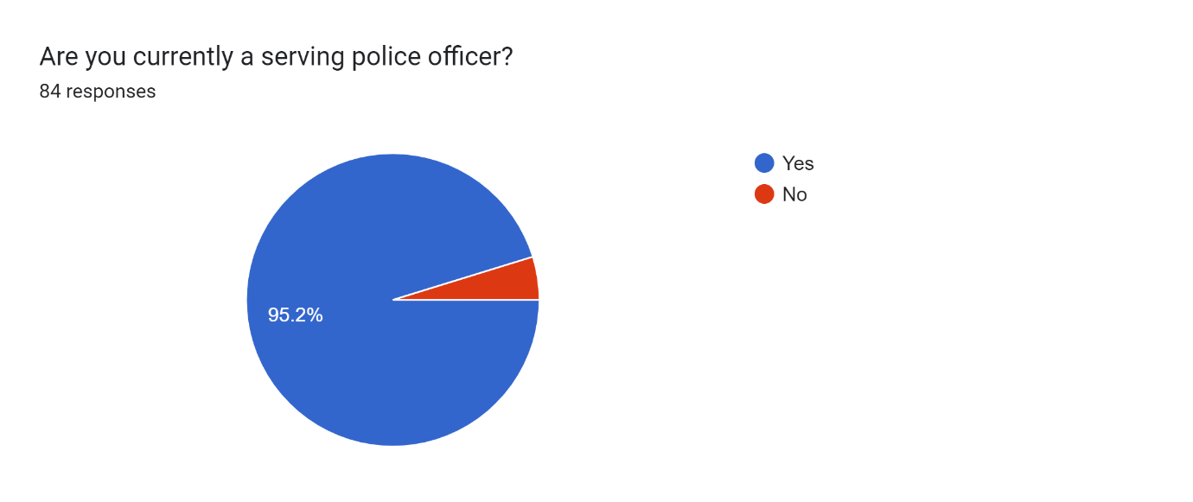

Of the police officers that have answered, the majority have had between two- and five-years’ service. This section of people made up 32.1% of those who answered. The least popular answer for this question was “between five and eight years” which measured at 17.3%. The remaining two answers had around 25% or thereabouts of the answers each, and these categories were “between six months and two years”, and “eight years plus”. This accurately represents frontline response officers within the force that the researcher is currently employed within. There is a big wave of new starters and those within their probationary period, and then those who have seen over five years as a response officer. This questionnaire, however, was not limited to response officers, and the people that answered could very well be CID officers, or those who work within specialist departments, and could be a higher rank than those on the front line,

Figure 2. Length of time as an officer
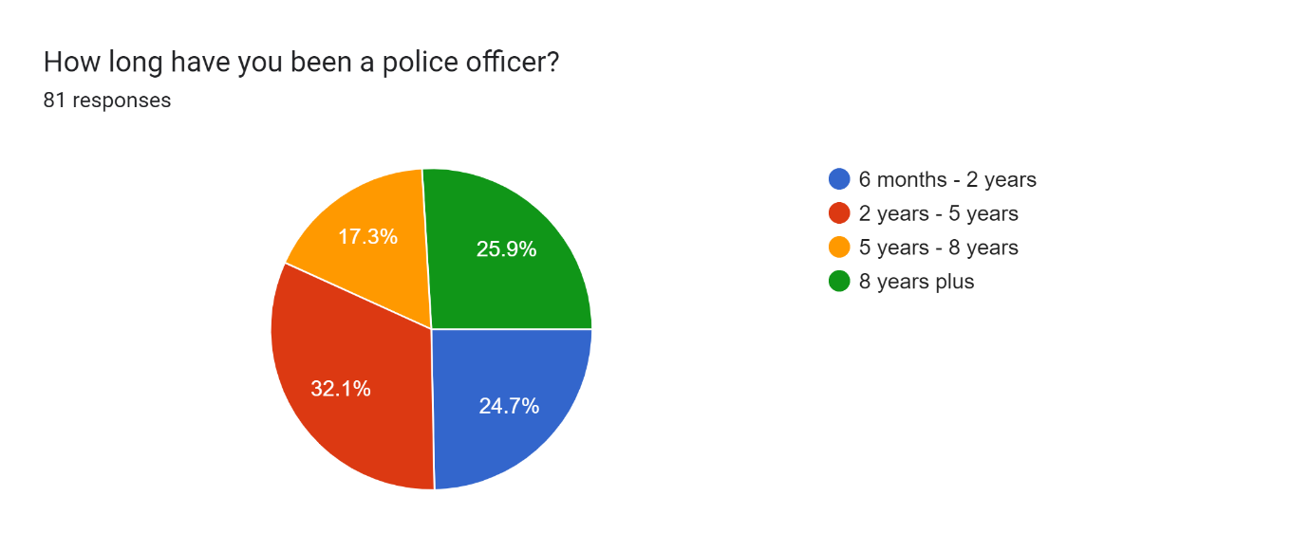

Reassuringly, there has been only two people out of the eighty four who answered had not heard of ACE’s. This could be because the people that have answered negatively has not been a front line officer or worked within a specialist department. The data also suggests that with the majority of people who completed the survey having less than 6 years service, they could potentially be more familiar with ACES rather than those who have been in the police longer. This is reinforced by the College of Policing (2023) who state that continuous staff development and regular training sessions will aid a forces services. Adverse Childhood Experiences training is mandatory for frontline officers, the researcher would have expected the results to reflect the way that they have for this question.

Figure 3. Have you heard of ACES?
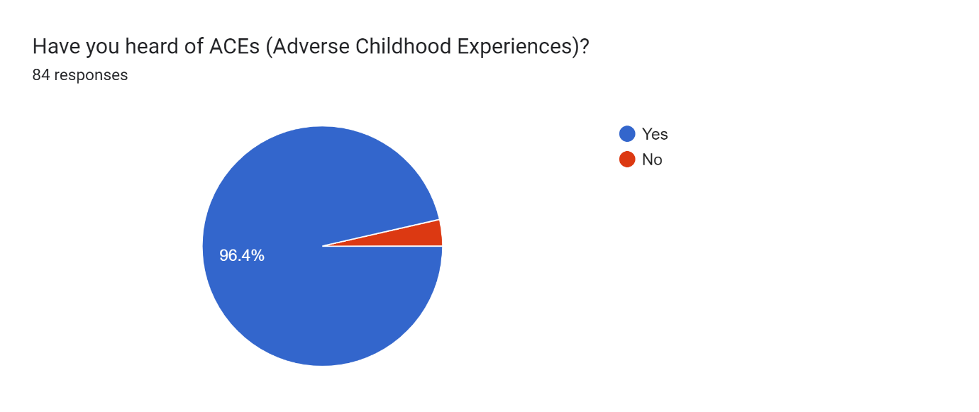
For the fourth question of the set, the researcher has asked if people could identify at least four adverse childhood experiences. This is also a reflection on what training has been available to officers. The CDC -Kaiser study (1997) has identified these to include having parental splits or divorces, parental incarceration, drug use within the immediate family, familial poverty, emotional, verbal, and physical abuse, and neglect. Again, as the questionnaire was open to the entire force on our internal website, the researcher was expecting a certain percentage of people to not be able to do so, as some may not have had the training that serving response officers would have been subjected to. It was in fact eleven out of the eighty four respondents that could not name at least four adverse childhood experiences. This is equal to 9.4% of those that answered the questionnaire. This is mirrored and almost reflected in the studies that have been looked at whereby Bellis et al (1998) has said that 9% of the general population has experienced 4 or more ACES. When previous research into adverse childhood experiences (NHS, 2022) has shown an alarming amount of the general population has been subjected to at least one of these traumatic events, this figure may go quite some way into showing why social services and partnership agencies are currently overwhelmed with supporting those who have been identified as being the most vulnerable within our communities (BASW, 2022) . The term ACES, as noted in the initial study in America in the early 1990’s by Kaiser and Permanante, alongside the American Centre for Disease Control and Prevention, was coined after this study. In 1995, the term was developed and is still used today. The term ACES would not necessarily be a household term and it would not be a surprise if the majority of the general public would struggle to know the term that has been given to such adversity, but simultaneously, would recognise that the behaviours in question, would without a shadow of a doubt, contribute to a negative effect within a family set up, and would lead to a poorer outcome in later life, for those who have been exposed to them, especially en masse.

Figure 4. Can you name at least 4 ACES?
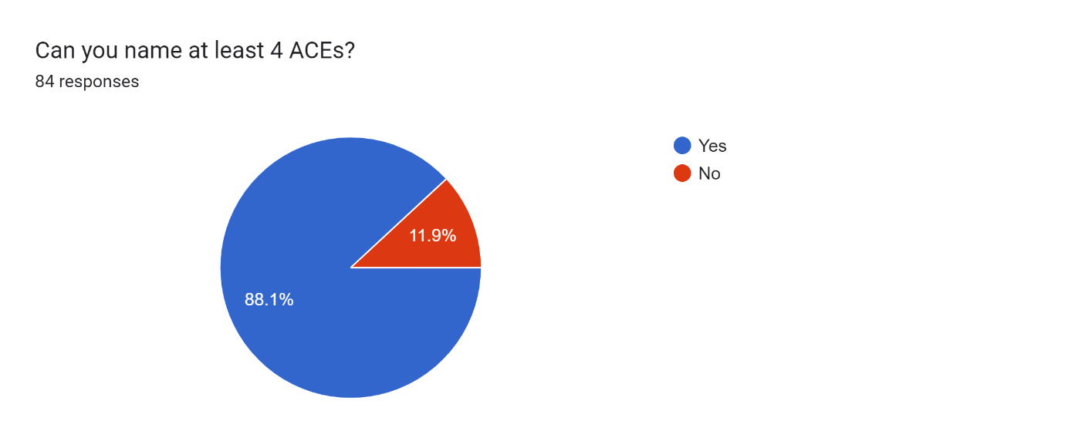

In line with the findings written out in Violence Prevention Wales’ (2022) research into adverse childhood experiences, whereby it states that around 47% of people living in Wales who responded to their survey have identified themselves as being victim to at least one adverse experience during their childhoods (Violence Prevention Wales, 2022) It may not have been a formal way in which responders to a call have been told about the people at the occurrence address being subjected to such adverse experiences, it may have been down to the officers own personal knowledge of what such experiences are, that already existed. Training that front line officers receive would enable that person to recognise certain factors that are pre-existing within familial set ups that would trigger the justification of claiming that there are adverse experiences adding to the persons behaviour/ state of mind/ reasoning behind why they are doing what they are doing or why they are feeling the way they are feeling.
It could be that once the initial adverse childhood experiences training has been implemented, the information that has been disseminated will stick in people’s minds. It can often be quite easily identifiable that certain homes, certain families and most definitely certain teenagers and young adults will embody most of the adverse implications on the way they live their lives. Such lasting effects on the individual’s behaviour have been identified once again within the Violence Prevention Wales website. These have been identified as, but not limited to eleven times more likely to have smoked cannabis than those who have not been exposed to adverse experiences in their childhood, fifteen times more likely to have committed violence towards another person, and twenty times more likely to have been incarcerated at any point. Behaviours such as these are obviously going to have a detrimental effect on policing and police resources.
The data that the questionnaire has collated in relation to this question has reflected what was initially believed. 75% of those who answered have either had prior or post incident knowledge of those within the address having been known to have experienced such experiences. This also ties in with 48% of people having been subjected to at least one ACE during their childhood (BMC Medicine, 2014) If the research had been looking at qualitative data at the same time as quantitative, maybe there would have been room to have asked for when this knowledge had been acknowledged, and if the officer that attended the incident was aware of the persons background before they have been dispatched or if they have been made aware when they have been updating the call and seen what previous experiences with police that person may have had leading up to that particular call out. Those who have answered that they had maybe known the person to have experienced such adversities but given the length of service that some of the people who have answered this questionnaire have had in, they may have just taken for granted that they had this knowledge, but it was deep in their memories.

Figure 5. Have you been at a call whereby someone at the occurrence address has been known to have experienced ACES?

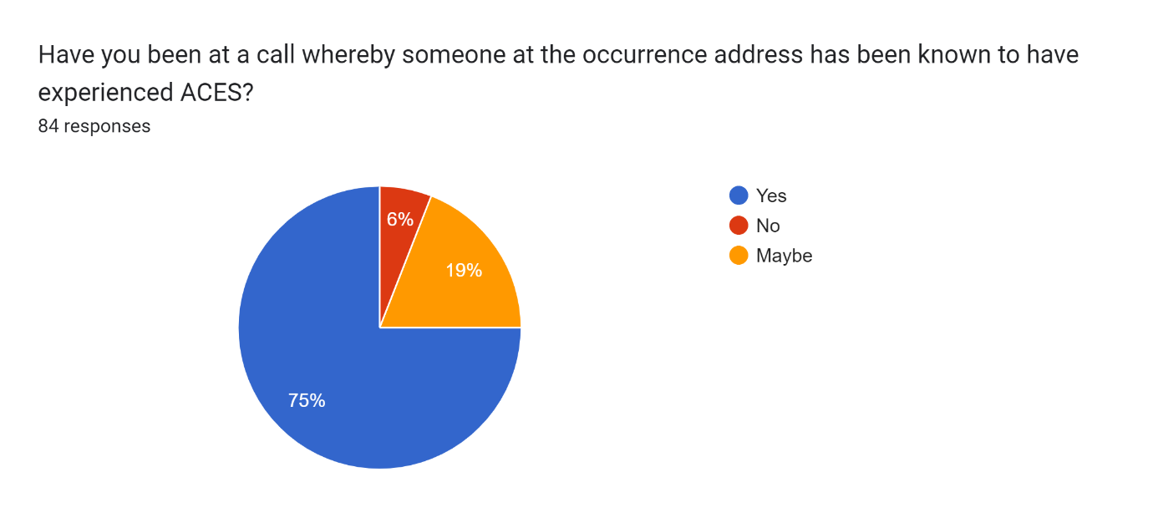

With this question, this would be specific to Gwent police forces’ training, the researcher has surmised. If the person who has answered the question had their initial training within another force, depending on the time that they have been in our force, they may or may not have had the adverse childhood experiences training that someone who has had three years or less in the force, may have had. Any such training that is delivered to serving officers that covers topics such as these, would have all been approved by the National College of Policing, so this is just a personal assumption that the researcher is making.
There are obviously many reasons as to why people would do things such as smoke cannabis, or commit a violent offence, but recognising these types of behaviours and seeing the bigger picture, as well as analysing what the familial set up has been like, would take another service other than the police, would obviously make for informed decisions following this. Police would not be able to assess the whole picture necessarily or accurately, other than what they have been involved in directly, but places like Social Services or community mental health teams, would have a much better placed input into recognising such behaviours and ultimately assisting police in better tailoring training that is given to front line and specialist officers who will be dealing with such people. The over 65% of people who have answered have clearly taken some information from the training that they have received, so more specialist training with more relevance may be of equivocal use.

Figure 6. Do you recognise an individuals behaviour to be like those in the ACES training that you have had?

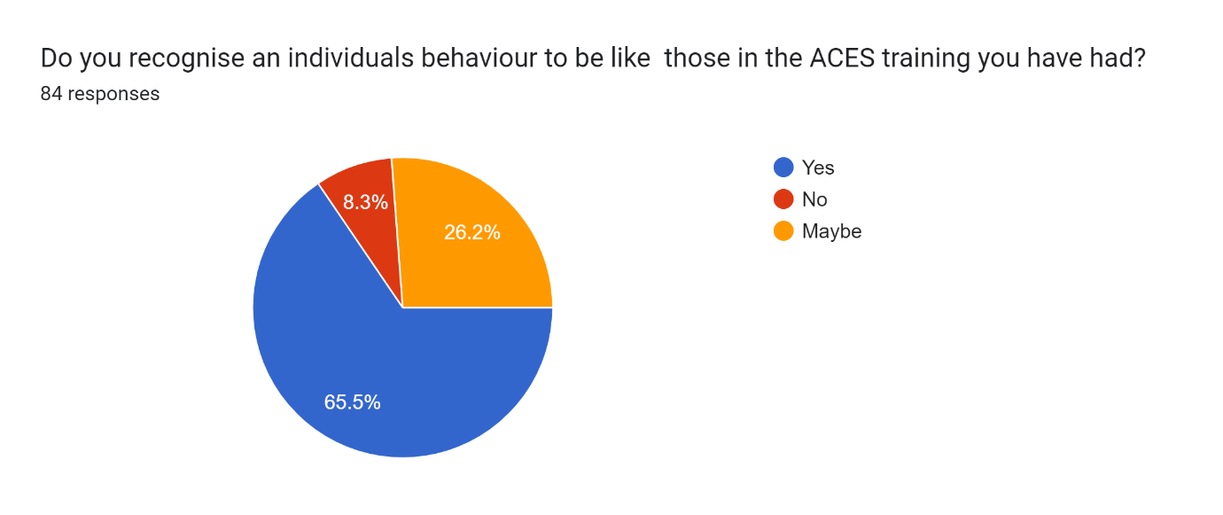

This next question also ties in with the previous and this has been asked so that the researcher has the ability to work out how much information police records should potentially be holding on people, if it is enough, or if police forces should have an extra input from the services. This is solely in relation to information The option of a warning marker on a person, may be better placed as a flag which would enable the dispatcher to better advise the attending officers that people have been exposed to such awful experiences and how to deal with what may be in store for the attending officers. The same information may be given to attending officers by colleagues who may have dealt with that person, or even have a background knowledge of what adverse childhood experiences would have for those who have gone through them.

Figure 7. If you have known someone to have experienced ACES, how did you know this?
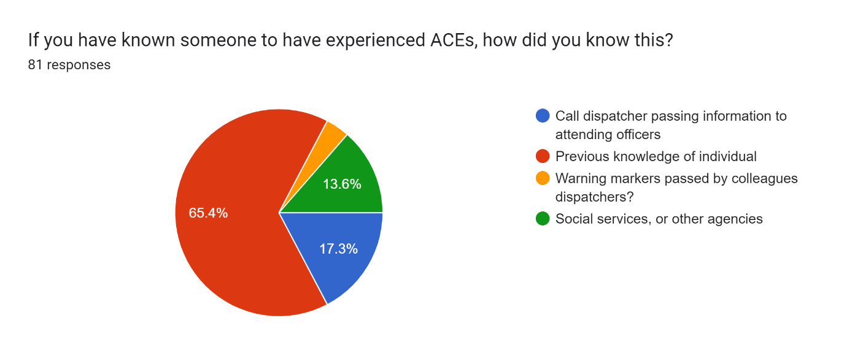

This question is the reasoning and justification behind the dissertation title; to have those who have recognised and defined adverse experiences during their childhood should have the flags/ or warning markers attached to their profiles. This would further enable both attending officers to be more aware of further issues and would be a great preventative tool for intervention services who may be able to put things in place to prevent an escalation in behaviour from the person in the future. More preventative services may be created, and this then would have the potential to relieve some of the pressure on the police forces of the land. I was surprised that of the eighty four people who responded to my survey, that only 51.8% thought it a good idea to do so. This could be because studies have shown that some adverse experiences during childhood can be reversed and mitigated with intervention and therapies as observed in a study by Harvard University (2022). This is once again out of the hands of police, but maybe this is the only thing that would have a huge cost implication by weeding out such flags or markers on peoples records and how would they ever be fully removed, is quite beyond me at this moment.

Figure 8. Do you think warning markers/ flags should be put on peoples police profiles to say that they have been exposed to ACES?
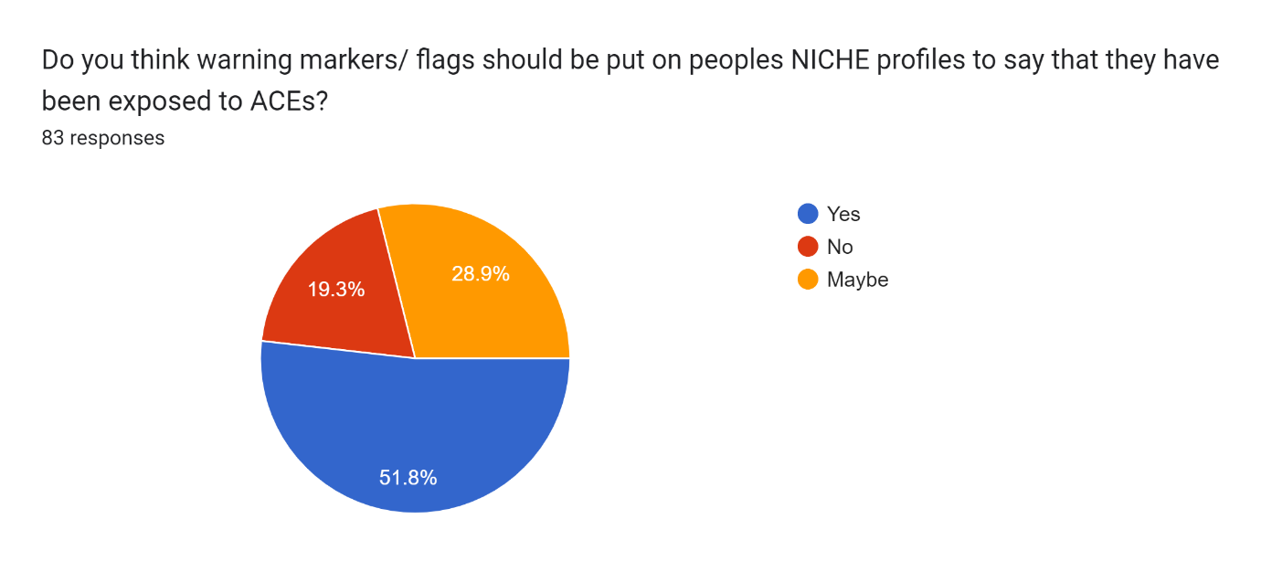

The use of specially trained officers who attend certain calls is not a new feature in policing. There are many departments within forces across the country and they will deal with incidents such as road traffic collisions, whereby the roads policing and specialist operations team are going to be taking the lead in these situations. The same with calls where there has been a firearm threat identified or another similar deadly weapon such a samurai sword, the firearms trained officers will be deployed to these. Again, where there has been an allegation of a serious sexual assault, or rape, specially trained rape and serious sexual assault officers will take the lead in these. The above are not what are classed as volume crimes, but the adverse effects on a person who has gone through adverse experiences are more likely to commit are. These again are things such as drug use, excessive alcohol use which are usually a precursor for burglaries and violent assaults, as both a perpetrator and a victim. I have the view that we should have specially trained officers who are dispatched to those who are identified as having adverse childhood experiences. This training does not have to be as elite as firearms trained officers, just an advanced knowledge of prevention techniques and services, or access to social services data that may be held (FutureLearn, 2021)
The respondents of the questionnaire did not appear to hold the same opinion as me, looking at the data, with only 28% stating they believed that officers with this bank of knowledge should be dispatched. This could be down to many factors; be it time and money, a fear of officers being taken off shift to become a specialist, or have any speciality knowledge in any field, especially given how much demand there currently is on police frontline services.

Figure 9. Do you think that specialist officers should be dispatched to calls where someone has been exposed to a high number of ACES?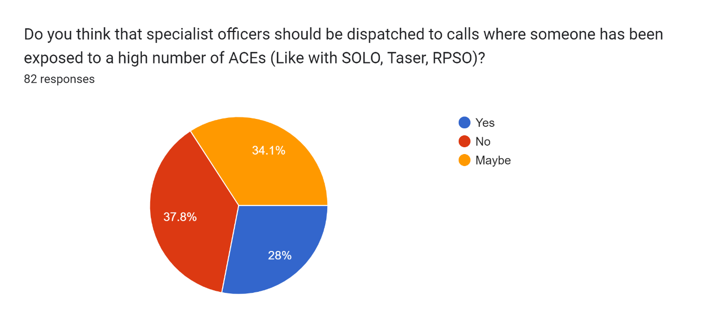
This question in particular poses many sub questions. None of these have been added and this is where qualitative data collection would have been of some use. The replies to this question in particular may be something that frontline officers may fear, the thought of even more training (Guiterriez, 2019; Jones 2021), I kept an open mind in regard to how I expected the results to turn out. I for one, am still interested by most topics that myself, as an officer, sees for training days, but I can also see where those who have much longer in service than I, roll their eyes at another topic to learn, or another way in which partner agencies will dispose of a responsibility onto police.
With just over 55% of respondents determined that they thought that they would see any further training for front line officers as being beneficial. However, there is only 19% of people that answered this question as being a negative prospect for more training. Again, the almost one in five people that said this, maybe this is where a mixture of qualitative and quantitative data collection would have been of benefit, to see why they thought this.

Figure 10. Do you think more training is needed for frontline officers to deal with calls for those with ACES?
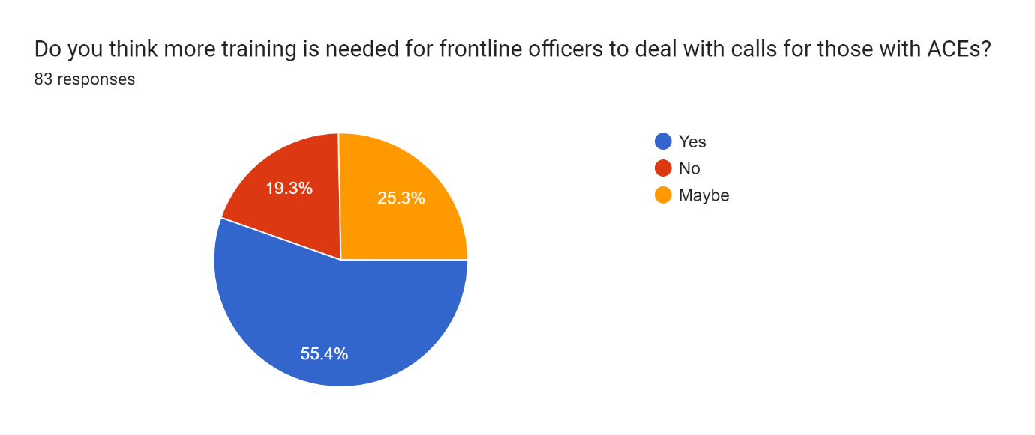

Contrary to the previous question whereby I asked if people should receive more training, this centred on partnership and protective agencies disseminating information relating to those that have been exposed to adverse childhood experiences. I have unpicked the overwhelming yes replies to infer that information should be there but may be down to individual officers to obtain and learn what would be available to them, on their own accord and time, rather than it be given to selected/ nominated or officers who wish to have the increase in knowledge.
The 83% of respondents may be of the school of thought that this is one thing that potentially relieves some of the pressure once again from police forces and makes those who would have far more prior knowledge and specialised personnel to collate and publish this data. The effects on a familial set up over time would lay solely on such protective services to determine if a person is suffering from adverse effects of such trauma at a young age. Once again, the information that would be more of a prevention for the escalation regarding further offences, or an escalation of any existing offences or potentially any substance misuse, would primarily be not within policing parameters anyway. Naturally, police have a caring element to all incidents that are dealt with, minimising risk to the people directly involved, the wider public, and identifying crime patterns that could be detected by collating incident data from similar incidents and previous incidents with the same people, displaying similar traits, and with all this data, putting it all together and identifying the correct or at least the most relevant partnership agency to be signposted to the most relevant agencies. These could be as simple as drug advisory groups, family counselling groups, early intervention agencies and similar referral pathways that may be of use and open to such clients. It is without a doubt in the minds of people who have answer this questionnaire for me, that partner agencies are much better placed to provide further information in regards to issues such as these.

Figure 11. Do you think protective agencies such as Social Services should provide police with more information in how to identify, and deal with those who have experienced a high number of ACES?
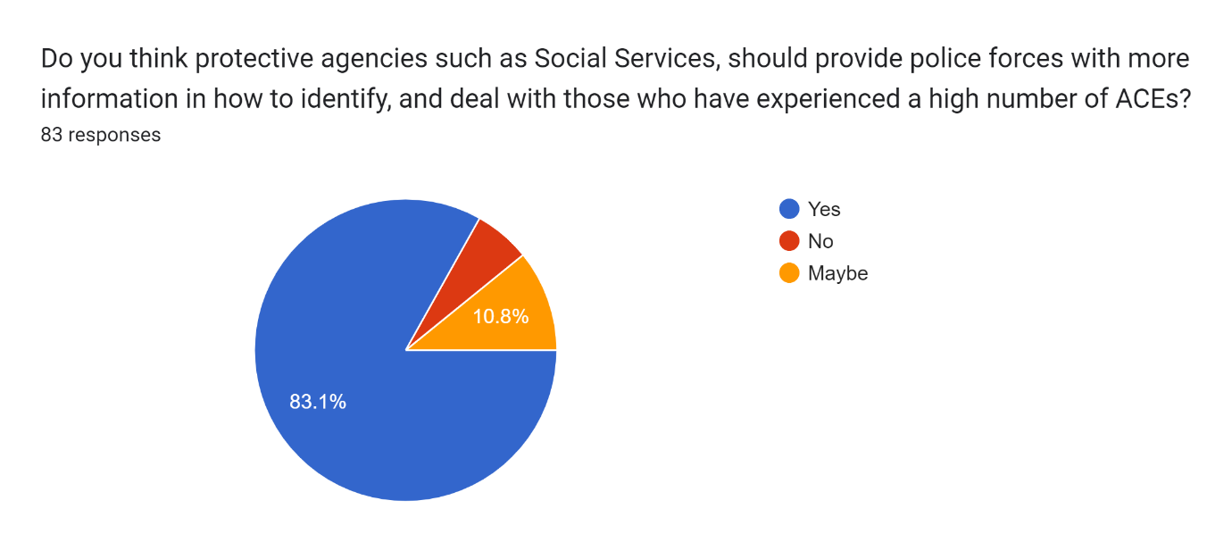
Bangor University has worked alongside Public Health Wales (2022) and have explored how those with adverse childhood experiences and those who have ended up being incarcerated, and testing out theories behind why they have offended and any links to the adversities suffered in their formative and younger years.
The research that was carried out by the university and the public health body has identified that those who were incarcerated and had demonstrated behaviours akin to those mentioned previously, such as being both the victim and the perpetrator of a violent assault, as well as reckless behaviours around drug and alcohol use, and minor crimes. This has built the picture that the life of those subjected to adverse incidents within their familial set up hugely increased the chance of becoming heavily involved with both police and courts.

Reflections
It has been noted that there is a distinct gap in the researchers data gathering process as there are only yes/no/ maybe answers. It was decided after the initial test sample was sent out that there would be too much information to analyse and when there was a mixture of quantitative and qualitative methods used. The broad scope of potential reading was huge. In the future, I would ask a more direct question so that I would anticipate on knowing how to set questions that would be more direct, but I would also like to ask peoples thoughts or opinions on ideas rather than just asking “yes or no”, incase the question posed was not clear, or the person answering it was not entirely sure what was meant by it.
Something that I would say was hugely learnt and was the main focus of my reflections was time management. I found it very hard to plan research, home commitments, my career amnd my hobby into
AS noted throughout this paper, the researcher has identified that in order to get a better understanding of what front line officers think of the questions, it would have been a better way to capture data, if the questions were qualitative as well as quantitative. This would have given scope for those answering to say why they thought things about the questions that the researcher had set out to have answered. For example, the researcher expected a higher percentage of answers to say that they thought that it was a good idea to have the aforementioned marker on peoples police record, so that they could be better armed when going to calls. The issue with the scope of the study, is that there has been no previous paper written on this topic, to compare it to.

The previous statement has also meant that the was an endless amount of scope for the researcher to begin and end the study. This, combined with work patterns and a new, and at times, overwhelming career, a family life, and all the pressures that life brings coming out of the other side if the global pandemic, that time management has been a major issue. The paperwork side of the job in policing is very much a heavy and stressful element to the job. The researcher has also undergone a divorce, and was mid house move when the dissertation was finalised. The timing of both of these elements would probably be advised against when conducting academic research in the future.
The researcher has gained skills in Microsoft Word and Google Forms by creating this dissertation, and these skills will be invaluable going forward.

Bibliography
3-ACEs-Training-Evaluation-Report.pdf (phwwhocc.co.uk)
A history of adverse childhood experiences increases parents' risks of using physical punishment towards children - Public Health Wales (nhs.wales)
AA Uses and Misuses of ACEs Police.pdf (ljmu.ac.uk)
Abductive reasoning (abductive approach) - Research-Methodology
Abused as a child, Robert Maudsley killed abusers as an adult | Crime + Investigation UK (crimeandinvestigation.co.uk)
ACEs - Adverse Childhood Experiences : Gloucestershire Healthy Living and Learning (ghll.org.uk)
ACEs Too High
Addressing trauma and adversity | Resources | YoungMinds
Adverse Childhood Experiences - Public Health Wales (nhs.wales)
Adverse Childhood Experiences (ACE) Among Prolific Young Robbery Offenders in London: Targeting Treatment for Desistance? (cam.ac.uk)
Adverse Childhood Experiences (ACEs) | VitalSigns | CDC
Adverse childhood experiences and sexual victimization in adulthood - PMC (nih.gov)
Cannibal killer Robert Maudsley imprisoned in glass box warns he'd kill again - Leicestershire Live (leicestermercury.co.uk)
Childhood Abuse, Household Dysfunction, and Indicators of Impaired Adult Worker Performance - PMC (nih.gov)
Continuing professional development (CPD) | College of Policing
Differences between deductive and inductive approaches to research - (howandwhat.net)
Ethical approval - School of Social Sciences - The University of Manchester
ETHICAL CONSIDERATION ON WRITING QUALITY DISSERTATION – PhD Assistance
Ethical Considerations in Research | Types & Examples (scribbr.co.uk)
Examining the Relationship Between Adverse Childhood Experiences and Juvenile Recidivism: A Systematic Review and Meta-Analysis - Alexis Yohros, 2022 (sagepub.com)
Have you ever wondered what it's like to be a response officer? | Leicestershire Police (leics.police.uk)
How to choose between quantitative vs. qualitative methods: Part 2 - Statistics Solutions
https://developingchild.harvard.edu/resources/aces-and-toxic-stress-frequently-asked-questions/
Key Concepts - Science of Child Development (harvard.edu)
Managing strategic knowledge in policing: do police leaders have sufficient knowledge about organisational performance to make informed strategic decisions?: Police Practice and Research: Vol 9, No 4 (tandfonline.com)
Our Journey | LAH (londonaceshub.org)
Overview of ACEs - Adverse Childhood Experiences (ACEs) - Children - Population groups - Public Health Scotland
Police Foundation Social Media Briefing.qxd (police-foundation.org.uk)
Prevalence and Characteristics of Sexual Violence, Stalking, and Intimate Partner Violence Victimization—National Intimate Partner and Sexual Violence Survey, United States, 2011 - PMC (nih.gov)
Preventing repeat and near repeat crime concentrations (whiterose.ac.uk)
Progress and prospects in the prevention of repeat victimization | 14 (taylorfrancis.com)Response policing career pathway | College of Policing
Risk and Protective Factors |Violence Prevention|Injury Center|CDC
Social media and policing: A review of recent research (e-tarjome.com)
Specialist Mental Health Support in Force Control Room | Gwent Police and Crime Commissioner (pcc.police.uk)
Specialist Police Units (futurelearn.com)
The Impact of Adverse Childhood Experiences on Health and Development in Young Children - Erica M. Webster, 2022 (sagepub.com)
The Lord Chief Justice’s Report 2020 (judiciary.uk)
The Police and Crime Commissioner for Gwent has agreed to provide funding to support the Early Action Together programme during 2022/23 | Gwent Police and Crime Commissioner (pcc.police.uk)
The relationship between adverse childhood experiences and self-sufficiency problems in early adulthood among violent offenders - PubMed (nih.gov)
The Troubling Role of Trauma in Social Work – a parent’s view. | Child Protection Resource
UCL Research Ethics Service | UCL Research Ethics - UCL – University College London
Understanding Childhood Adversity, Resilience and Crime (www.gov.scot)
understanding-the-triggers-final.pdf (pcc.police.uk)
WATCH: The pros and cons of a Yes/No question type | SurveyMonkey
What Are ACEs? And How Do They Relate to Toxic Stress? (harvard.edu)
What is Emotional Neglect? - The School Of Life

