Module: Electrical Machines
Lecturer: Steve Mosey
Stator Modelling Part 2
Name: Nathan Davies
Number: 1706135
Abstract
The premise of this report was to create varies different model related to the previous model that was created in the last report and try to make them more efficient then the original model. This task was completed with two models having less flux leakage that the original model. Other models where created as test to see how high the flux leakage could go and to generally get use to creating models and collecting data from them.
Introduction
The aim of this assignment is to create varies redesigned models of the previous model used in the last report to determine how to improve the efficiency of the model. The way that this will be done is by changing specific areas of the design then observing and recording the data that these model produce. This data will then be compared to the data from the original model to see how the efficiency of the overall model has changed.
Method
There were a lot of changes that could have been made to the model to test the efficiency of it. Some of them including changing the stator inner radius, armature dimensions, winding positions and adding fish tails on to the armatures. During the testing the design of the models was somewhat random meaning that some models might just have slight differences between them.
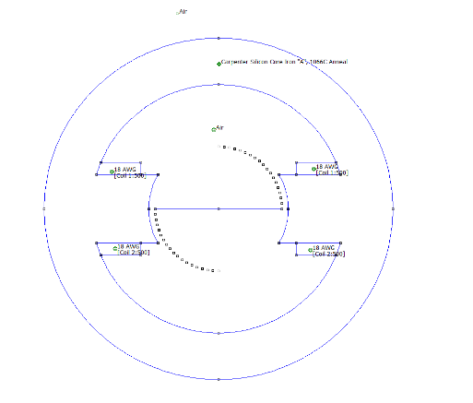
The first thing that was done at the start of this experiment was to first acquire the model from the previous model this can be seen in figure 1. After this the variety of changes listed above where introduced to the model this being changing the armature dimensions, radius etc.
As each of these new models where created data was collected from them, this was done in the same way as the previous report by first creating a mesh for the model then using the in program calculations to calculate the flux density. The countour tool was again using on the gap of the armature to get the total flux within the model and then used across the middle to simulate the rotor so that data could be acquired. A few of the new models created can be found in figures 2 – 3 bellow.
Figure 1 Original model design
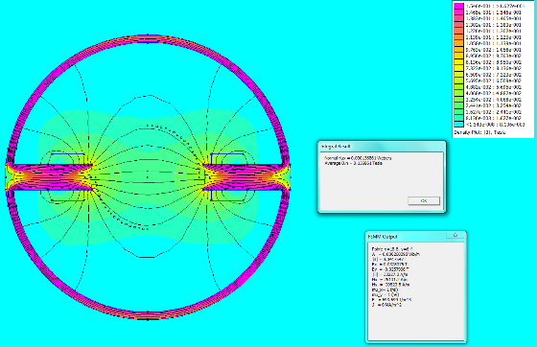
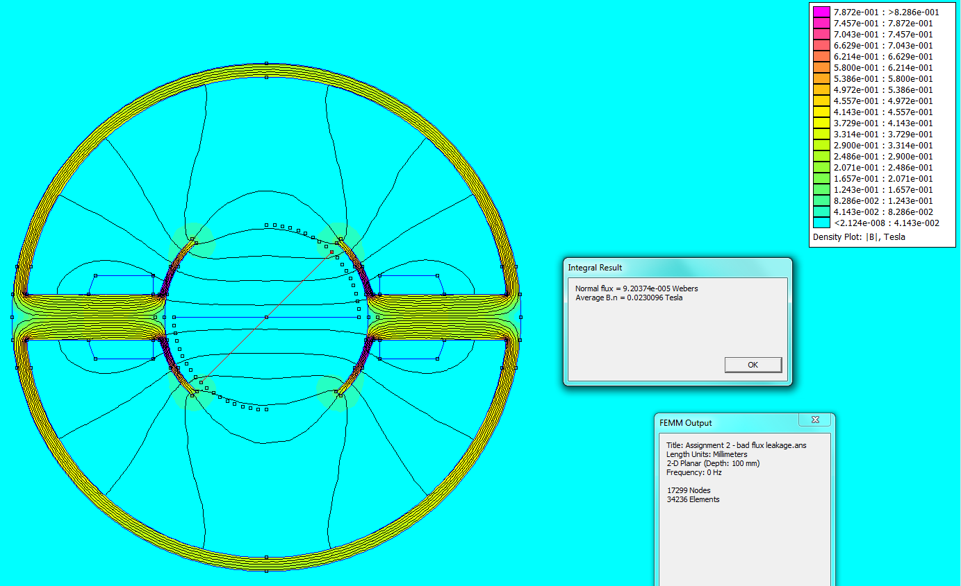
Figure 3 Another newly created model
Figure 2 One of the newly created models

Results
In this section will be a variety of tables and screenshots with the results of testing each of the newly created models a discussion of the results and comparison of them will be given in the following section.
Original Model

Flux leakage
2.950E+00
2.947E+00
2.938E+00
2.924E+00
2.905E+00
2.884E+00
2.864E+00
2.850E+00
2.845E+00
2.867E+00
2.936E+00
3.109E+00
3.557E+00
4.462E+00
5.866E+00
8.113E+00
1.247E+01
2.532E+01
-1.670E+04

Total flux
Flux being created in the stator circuit

flux across gap | average B.n
0.000255409 | 0.116095
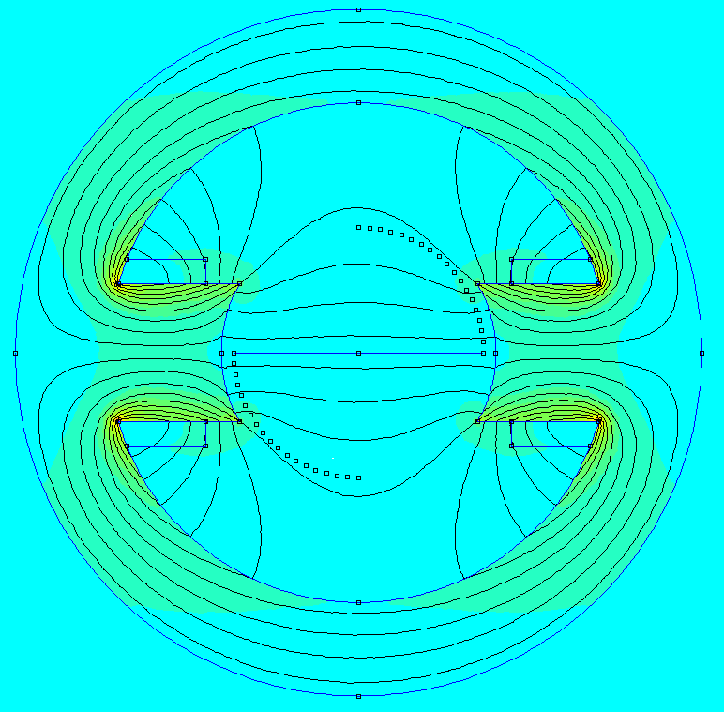
Useful flux
Flux cutting the rotor coil
Normal Flux | Average B.n
8.65771E-05 | 0.0216443
8.66787E-05 | 0.0216696
8.69308E-05 | 0.0217329
8.73573E-05 | 0.0218391
8.79309E-05 | 0.0219827
8.85461E-05 | 0.0221368
8.91642E-05 | 0.0222906
8.96325E-05 | 0.0224082
8.97591E-05 | 0.0224347
8.90727E-05 | 0.0222684
8.70025E-05 | 0.0217504
8.21566E-05 | 0.0205389
7.18051E-05 | 0.0179509
5.72388E-05 | 0.0143099
4.35416E-05 | 0.0108854
3.14804E-05 | 0.00786996
2.04825E-05 | 0.00512065
1.00879E-05 | 0.00252197
-1.52959E-08 | -3.82E-06

Model 1

Flux leakage
4.54E-01
4.55E-01
4.56E-01
4.57E-01
4.59E-01
4.61E-01
4.63E-01
4.65E-01
4.67E-01
4.68E-01
4.67E-01
4.64E-01
4.54E-01
4.36E-01
4.01E-01
3.33E-01
2.24E-01
1.09E-01
6.84E-04

Total flux
Flux being created in the stator circuit
flux across gap | average B.n
0.000136861 | 0.136861
Useful flux
Flux cutting the rotor coil
Normal Flux | Average B.n
6.22E-05 | 0.0155394
6.22E-05 | 0.015559
6.24E-05 | 0.0155909
6.26E-05 | 0.01564
6.28E-05 | 0.0156914
6.31E-05 | 0.0157769
6.34E-05 | 0.0158406
6.37E-05 | 0.0159144
6.39E-05 | 0.015975
6.41E-05 | 0.0160281
6.39E-05 | 0.0159831
6.35E-05 | 0.0158711
6.22E-05 | 0.0155416
5.97E-05 | 0.0149218
5.48E-05 | 0.0137121
4.55E-05 | 0.0113812
3.07E-05 | 0.00767687
1.49E-05 | 0.00373532
9.36E-08 | 2.34E-05
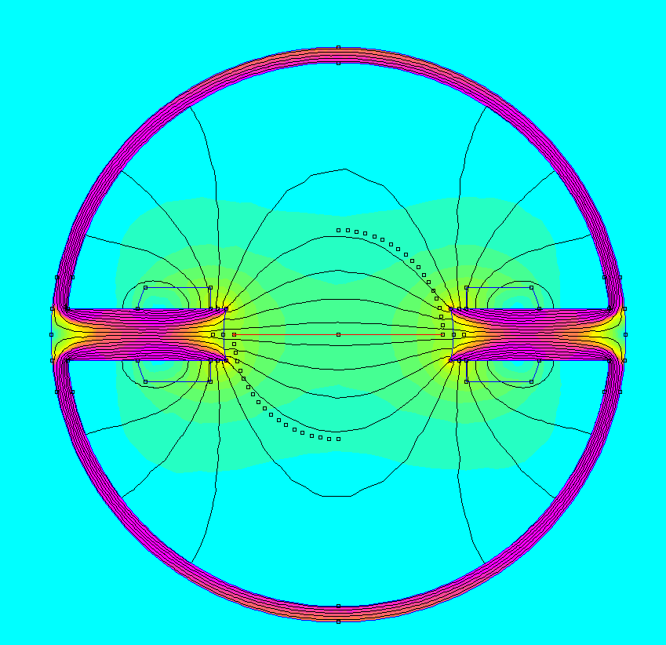
Figure 4 Model 1 – thinner armatures, larger inner radius

Model 2
Total flux
Flux being created in the stator circuit
flux across gap | average B.n
0.000251794 | 0.114452

Flux leakage
3.33E-01
3.34E-01
3.35E-01
3.36E-01
3.38E-01
3.41E-01
3.43E-01
3.44E-01
3.44E-01
3.41E-01
3.32E-01
3.11E-01
2.68E-01
2.11E-01
1.59E-01
1.14E-01
7.38E-02
3.64E-02
4.17E-05
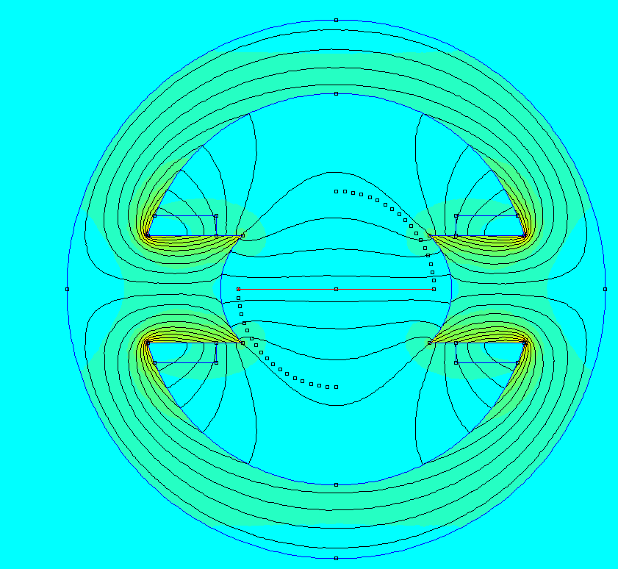
Figure 5 Model 2 – poles closer together
Useful flux
Flux cutting the rotor coil
Normal Flux | Average B.n
8.40E-05 | 0.0209883
8.40E-05 | 0.021005
8.43E-05 | 0.0210699
8.47E-05 | 0.0211715
8.52E-05 | 0.0213008
8.58E-05 | 0.0214498
8.63E-05 | 0.021577
8.67E-05 | 0.0216758
8.67E-05 | 0.0216689
8.59E-05 | 0.0214656
8.35E-05 | 0.0208861
7.83E-05 | 0.0195775
6.76E-05 | 0.0168939
5.30E-05 | 0.0132532
3.99E-05 | 0.00997838
2.87E-05 | 0.00717039
1.86E-05 | 0.00464633
9.16E-06 | 0.0022892
1.05E-08 | 2.63E-06

Model 3
Total flux
Flux being created in the stator circuit
flux across gap | average B.n
0.000199186 | 0.199186

Flux leakage
4.47E-01
4.47E-01
4.48E-01
4.49E-01
4.50E-01
4.51E-01
4.52E-01
4.52E-01
4.50E-01
4.44E-01
4.31E-01
4.05E-01
3.51E-01
3.15E-01
2.46E-01
1.54E-01
1.00E-01
4.95E-02
-2.54E-04
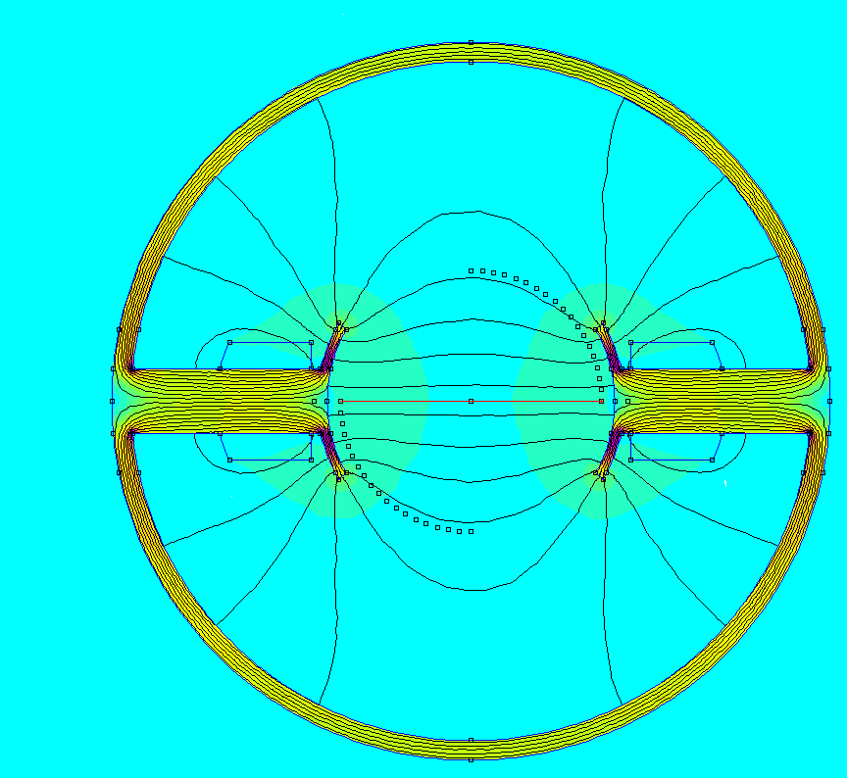
Figure 6 Model 3 armature thinner, inner radius bigger, small fish tail
Useful flux
Flux cutting the rotor coil
Normal Flux | Average B.n
8.90E-05 | 0.0222606
8.91E-05 | 0.022282
8.92E-05 | 0.0223113
8.94E-05 | 0.0223584
8.96E-05 | 0.0224015
8.99E-05 | 0.0224708
9.00E-05 | 0.0225079
9.00E-05 | 0.0224877
8.96E-05 | 0.022388
8.84E-05 | 0.0221063
8.59E-05 | 0.0214868
8.07E-05 | 0.0201671
6.99E-05 | 0.0174823
6.28E-05 | 0.0157164
4.91E-05 | 0.0122844
3.07E-05 | 0.00768428
2.00E-05 | 0.00500321
9.85E-06 | 0.00246284
-5.06E-08 | -1.27E-05

Model 4
Total flux
Flux being created in the stator circuit
flux across gap | average B.n
0.000273218 | 0.273218

Flux leakage
0.433595151
0.433763515
0.433437768
0.432961957
0.431044075
0.428240453
0.42267347
0.410540301
0.360584222
0.30993895
0.282968911
0.235590993
0.194404468
0.157212556
0.122907715
0.090644833
0.059642483
0.029598745
2.22267E-05

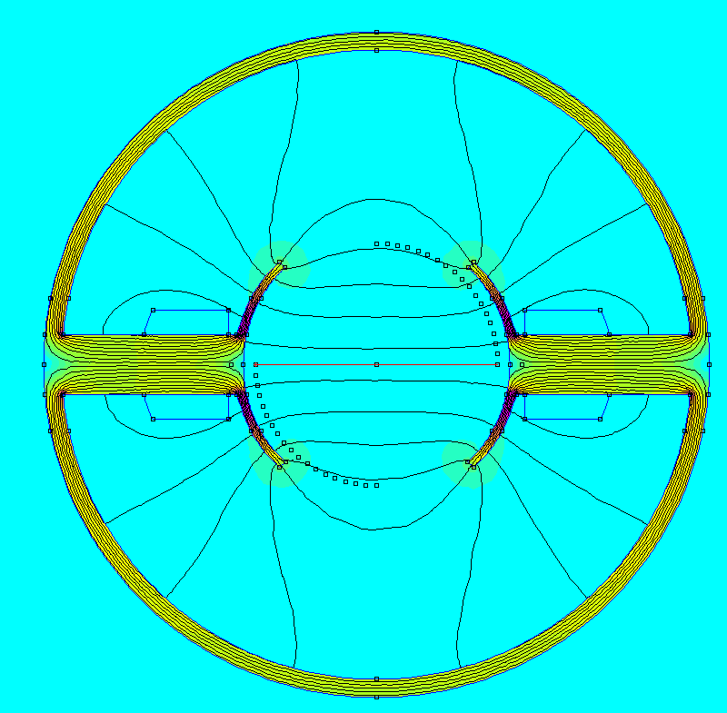
Figure 7 Model 4 - thinner armatures, inner radius bigger, big fishtail
Useful flux
Flux cutting the rotor coil
Normal Flux | Average B.n
0.000118466 | 0.0296165
0.000118512 | 0.0296279
0.000118423 | 0.0296058
0.000118293 | 0.0295728
0.000117769 | 0.0294422
0.000117003 | 0.0292512
0.000115482 | 0.0288698
0.000112167 | 0.00011217
9.85E-05 | 0.0246479
8.47E-05 | 0.0211904
7.73E-05 | 0.0193278
6.44E-05 | 0.0160917
5.31E-05 | 0.0132784
4.30E-05 | 0.0107385
3.36E-05 | 0.00839515
2.48E-05 | 0.00619133
1.63E-05 | 1.63E-05
8.09E-06 | 0.00202172
6.07E-09 | 1.52E-06

Model 5
Total flux
Flux being created in the stator circuit
flux across gap | average B.n
0.000225238 | 0.102381

Flux leakage
3.57E-01
3.58E-01
3.60E-01
3.64E-01
3.68E-01
3.74E-01
3.80E-01
3.87E-01
3.93E-01
3.96E-01
3.93E-01
3.76E-01
3.32E-01
2.64E-01
2.00E-01
1.44E-01
9.39E-02
4.63E-02
-5.37E-05
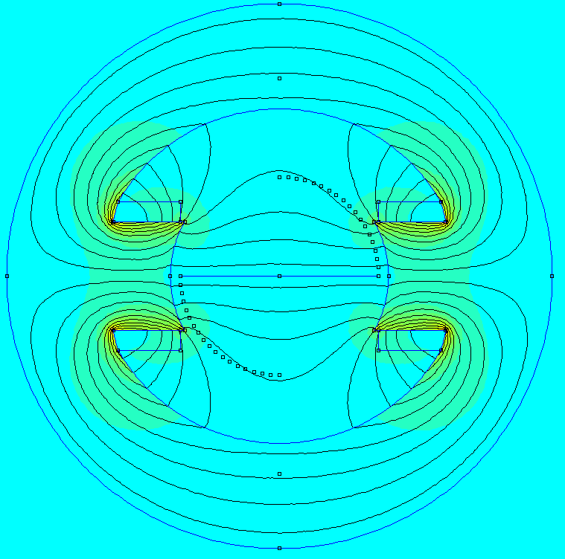
Figure 8 Model 5 – smaller inner radius
Useful flux
Flux cutting the rotor coil
Normal Flux | Average B.n
8.05E-05 | 0.0201275
8.07E-05 | 0.0201658
8.11E-05 | 0.0202845
8.19E-05 | 8.19E-05
8.29E-05 | 0.0207339
8.42E-05 | 0.0210544
8.57E-05 | 0.0214134
8.71E-05 | 0.0217827
8.85E-05 | 0.0221132
8.92E-05 | 0.0222925
8.85E-05 | 0.0221224
8.47E-05 | 0.0211836
7.47E-05 | 0.0186697
5.95E-05 | 0.0148673
4.51E-05 | 0.0112759
3.25E-05 | 0.00813635
2.12E-05 | 0.00528815
1.04E-05 | 0.00260742
-1.21E-08 | -3.02E-06

Discussion
During this section the results have been made into graph to be read easily and to show trends within the data that has been recorded. This section will first discuss the results from all the models and then show a comparison of them with the original models’ data, this will then show which model had less flux leakage meaning that that model would be the most efficient.
Figure 10 Model 2 flux leakage graph
Figure 9 Model 1 flux leakage graph
Figure 12 Model 4 flux leakage graph
Figure 11 Model 3 flux leakage graph

Figure 13 Model 5 flux leakage graph
Found above in figures 9-13 are the graphs produced from the results of each model. As can be seen most of the graphs have a similar trend in curve except Model 4 which is more of a gradual decline. Model 4 also has the most flux leakage out of all the models with a maximum value of 0.433595151 Weber. The two models with the lowest flux leakage and similar results are Models 2 and 5, model 2 had the poles moved closer and model 5 had the inner radius of the stator was shrunk.

Figure 13 Model 5 flux leakage graph
Figure 10 Model 2 Flux leakage graph

Figure 5 Original models flux leakage graph
The graphs above show the two models that had the least amount of flux leakage alongside the Original Models flux leakage graph. As can be seen by this comparison the two models created in this experiment models 2 and 5 have a more curved look rather than the immediate drop seen in the original model. Models 2 and 5 also have a much lower value of flux leakage compared to the original showing that the models are being more efficient in moving flux around the motor.

Conclusion
Overall the experiment went as planned, the whole premise of this report was to create varies magnetostatics models that when compared to the original model created in the previous report would have a lower flux leakage meaning that, that model would be more efficient. As can be seen in the results section and the discussion section this has been done with two of the created models these being Models 2 and 5 being more efficient than the original model. Some improvements that could be made if this experiment was to be done again could be to create even more models so that a wider variety of data could be collected and compared, another improvement could be to change even more variables about the stator such as the material type, winding number and winding material.

