NAME Noleen Christina Jones
STUDENT NUMBER P151033
PROGRAMME: Contextual Studies
MODULE TITLE: Dissertation
MODULE CODE: M6X01791
MODULE TUTOR: Sarah Tombs
TITLE: How do land art and socially engaged practice enable us to connect or reconnect with the natural word?

Submitted in partial fulfilment of the requirements for the degree of BA (Hons)
University of Wales Trinity Saint David, Swansea.
12th December 2018

WORD COUNT: 5671

Table of Contents
Introduction 2
Chapter 1 Understanding the need to Connect to our natural surroundings 3
Chapter 2 How connections to landscape are formed, 7
Chapter 3 Socially Engaged practice, The role of the artist in social change. 22
Conclusion 27
References 33
Bibliography 36
Illustrations 37

2
There has been much discussion over the last number of years surrounding the increasing disconnect that humans are feeling towards the environment.” As human populations continue to move to cities, there are concerns that we are becoming disconnected from nature and that this is affecting our well-being”. (Fuller
et al., 2007; Miller, 2005)
The following is a headline from a recent newspaper article,” Britain must reconnect with nature to combat 'mental health epidemic” .says Caroline Lucas Green Party co-leader. Describing the bigger picture as “abysmal”. Caroline Lucas is urging

British people to reconnect with nature to address the “mental health epidemic” facing the country. (Josh Gabbatiss,The Independent, October 2018).
This research seeks to establish how land art and the use of community projects involving the direct engagement of the wider public, can bring about both sustainable change and health and well-being benefits and can be a tool in bridging the relationship between humans and the natural world, and how socially engaged practices can be used to challenge the distinction between the arts and its audience, and the role of the gallery and Museum in modern times.
In its broadest sense ‘connection to nature’ describes the mix of feelings and attitudes that people have towards the landscape we inhabit. (RSPB, 2013).
Connection to nature may therefore also be described as ‘loving nature’, having a
‘sense of awe and wonder’ or simply ‘caring for the environment’ (RSPB, 2013).

3
How can we expect people to care about things they have no little or no experience with knowledge of? There have been several articles in newspapers and documents recently highlighting the decline in the amount of time our children are spending in the outside environment, favouring to spend their free time indoors, with a heavy increase noted in their use of technology. According to Robert Macfarlane author of “the lost words” British children now spend on average less time outdoors each day than prisoners, around an hour of their day is spent outside outside per day, screen time has dramatically incr, and screen time is mostly inside time. Poverty, postcode, ethnicity, risk, perception, these all affect children's experience of nature. (BBC Newsnight, 2017.) Although children are not exclusively the concern of this research, I feel it is an important factor worthy of examination, as they will be the guardians of whatever these projects leave behind, and how the youngest members of our society currently view their links with the natural world will be a deciding factor in how much they are willing to contribute to their future upkeep. Perhaps one way of addressing this would be to utilise outdoor based community art projects as a mechanism to support learning in an informal setting, such as is being offered by Swansea based project Graft, I have included details of this project further along in this document. An independent report for the Welsh Government
into Arts in Education in the Schools of Wales, Written by Professor Dai Smith (2003) (Research Chair in the Cultural History of Wales, Swansea University) states,

4
we must, if we are to succeed
economically and thrive socially, we must ground a quality education in both creativity as practice and culture as knowledge. At the heart of this unity are the arts
– arts which inspire and then create our desired end of the creative society. Otherwise, at best, we will be imitative and therefore second rate.

If the alignment of early education with the arts can be achieved and Socially engaged practices that involve the use of the land can become the conduit, it could be a combination that may in turn help to heal the much reported disconnect we are experiencing.
“Connectedness to natural surroundings can be defined as the extent to which an individual’s view of nature is incorporated into their perception of their own sense of self”. (Schultz, 2002).
This investigation therefore will look at the differing styles of earthworks and the psychology of this type of activity to examine the ways in which art can create opportunities to connect us to our environment. The goal of founding land artists was to disrupt and challenge the integrity of the commercialised world of the traditional gallery (The art story: earth art) and furthermore attempts to establish if this still relevant today.
It will be an attempt to gain an understanding of how relationships form for the individual and how this may influence the work they undertake.
Ways in which artists differ in their approach to land art will be explored to consider ideas around the meaning of place and the phenomenon of place and place
5
attachment and environmental identity. (Clayton, 2003). A consideration of socially engaged practice, and the benefits of audience participation.

The investigation firstly examines natural art in public spaces, drawing on both personal experience and analysis of the work of fellow ‘Land’ artists, taking into consideration both historical and contemporary works. The emergence of the land art movement can be traced to the 1960’s and 1970’s, having at the forefront of its communication a reminder of the passing of time, nearing a half century old, now may be a significant period to reflect upon its value to society as a whole. An important aspect of the movement is the language being utilised, founders of the movement were disgruntled by the plasticity and artificiality of art. They wanted to get people out of museums and back into nature. They were intrigued by both the fragility and strength of nature, and the challenge of manipulating it.(ecobrooklyn livingwalls, Malone Matson, 2012) worth observing are the similarities to the principles of Art Povera The term 'Arte Povera' was introduced by the Italian art critic and curator, Germano Celant, in 1967.(Zero to infinity: Arte Povera 1962-1972) being one of the movements which came immediately before, urban cultural activity would

6
appear to be the springboard from where the movement emerged, it welcomed experimentation. The ephemeral nature of some of the earth works almost makes
photography and film the only means of delivery to the audience, bar the live experience of course. Land art as a movement takes many different forms and this investigation aims to document its progression and popularity in modern times.
When looking at historical research it should be noted that the work of male artists tends to be given priority over that of the female, this is one of the reasons I Have chosen to assess the work made by female artists such as Nancy Holt, Ana Mendieta, and Agnes Denes, all were prominent figures in the movement, through the lens of available knowledge this research will seek to discover why their practice was important to land art. To bring balance and contrast to the document the work of Owen Griffiths is also presented and scrutinised.

In male-dominated Western culture, women’s knowledge and creativity has been linked with their bodies and sexual reproductive organs, symbolically making them closer to nature. Whilst men, who are free from such bodily restraints, are closer to culture” (Ortner and Whitehead 1981: 7).

7
Recent scholarship made available to women, as well as pivotal exhibitions at New York’s Sculpture centre and Brooklyn Museum, appear to be redressing the balance and have helped to correct this bias, highlighting the women artists who were instrumental in the development of this art form (Sarah Gottesman 2017).
Four examples of natural art in public spaces are looked at next, exploring the media used, the intention, chosen site and outcome and effectiveness as a mechanism for uniting human being and landscape.
Mendieta is one of the few well known and exhibited. Latin American women artists of her era. Her work distributed across fifty-seven public collections, in the United States, Latin America, Europe and Australia, including those of the Guggenheim and Tate, previously these institutions have been sites for protests highlighting her absence. When Mendieta died, she was yet to have a single museum show. (Rosanna Mclaughlin, 2.)
Mendieta was a prominent figure in the body art movement, working with the concepts of place, home, belonging and identity, I see echoes of this in my own practice, and can understand that aching need to feel close to the earth.

“I decided that for the images to have magic qualities I had to work directly with nature. I had to go to the source of life, to mother earth."
Ana Mendieta (1973).

8
Mendieta’s intent is transparent from the outset, in the reading of the above statement, using a process of organic matter and commitment of her own body to the earth to create the desired conclusion. Her work consisted of flowers, rocks, feathers, blood and earth. Film photography and performance were her method of delivery to the audience. She embraced her femininity but was equally comfortable with gender fluidity and was known to manipulate her own body to assume a different role, and play with the boundaries between the sexes. She dealt with both the physical and spiritual connections we hold with the land, carrying out a deep exploration concerning presence and absence, both being key ideas within the ethereal. She carried out a detailed study of the body's relationship to nature and its place within the world. Looking particularly at Mendieta's untitled silueta series (México 1973, 74 and 76) (Tate: Ana Mendieta) the achingly personal connection between the artist and the land is profound and deeply moving, compared with the work of another land artist such as Holt, there appears to be something of a much more raw engagement present here, when we examine the possible reasoning for this intimate collaboration between body and earth.

9
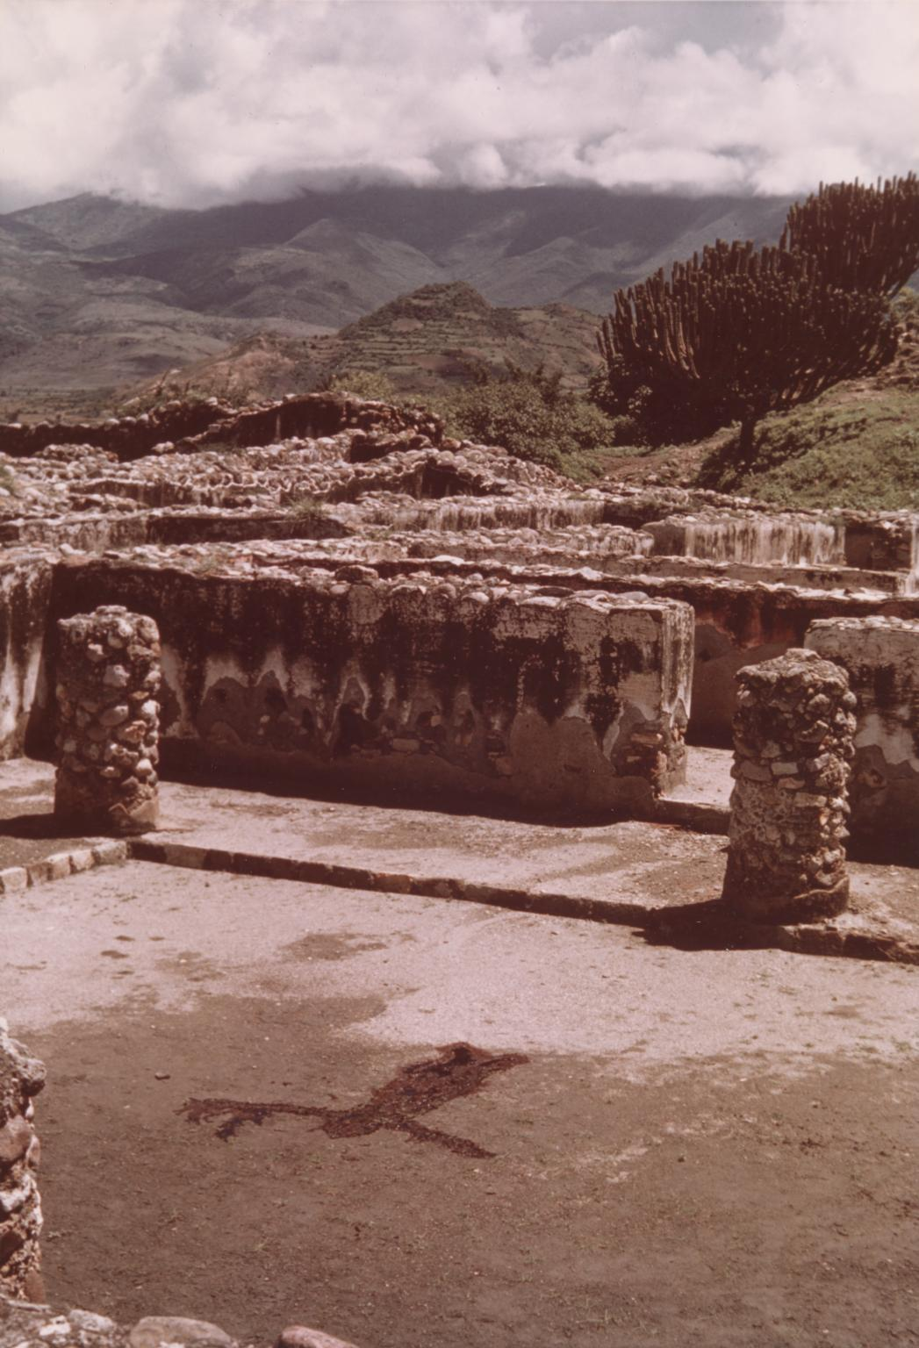Fig1 (Silueta Series, Mexico,1974.) © (The estate of Ana Mendieta, courtesy Galerie Lelong, New York) Licence this image.

10
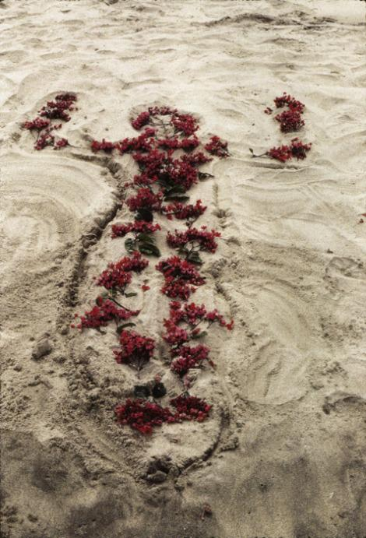
Fig2(earth-bodywork and earth-body sculptures.) (1972-1977)
innovative Intermedia art programme run by Hans Breder.

11
In one piece Mendieta purchased blood from a butcher at a market in the city of Oaxaca and poured it onto the earth within the outlines of her body, Assisted by Artist Hans Breder who was her teacher at that time. Breder made a tracing of her outline before she gathered the earth around it creating a rim capable of holding the blood. This the being the second of her series of Siluetas or silhouettes that Mendieta created in Mexico and the first in which she used the outline of her body, rather than her body itself. (Tate: Ana Mendieta)

I have been carrying out a dialogue between the landscape and the female body (based on my own silhouette). I believe this has been a direct result of my having been torn from my homeland (Cuba) during my adolescence. I am overwhelmed by the feeling of having been cast from the womb (nature). My art is the way I re-establish the bonds that unite me to the universe. It is a return to the maternal source. Through my earth/body sculptures I become one with the earth ... I become an extension of nature and nature becomes an extension of my body. This obsessive act of reasserting my ties with the earth is really the reactivation of primaeval beliefs ... [in] an omnipresent female force, the after-image of being encompassed within the womb. (The New Museum of Contemporary Art Annual Report, 1988, P. 10.)

As Humans the natural environment has been widely reported to be fundamental to our wellbeing. Throughout her practice Mendieta may have followed her primal
12
instinct to be in touch with the earth. It could be said Mendieta was in tune with and was obeying her biophilic tendencies in order to produce work.
The term Biophilia was used in The Anatomy of human destructiveness 1973 by Psychoanalyst Erich Fromm and spoke of the idea that “humans have an innate capacity to seek out connections with nature and other forms of life”. (Karen Rogers,Britannica.com)

It becomes clear from reading Mendieta's own words that in her longing for connection, she was attempting to utilise the land for its therapeutic benefits and as a means to deal with the deep-seated feelings of isolation she undoubtedly experienced due to the circumstances she found herself in during her formative years.

Nancy Holt (1938-2014) was a key member of the Earth, Land and Conceptual art movements and a pioneer of both site-specific installation and film and video work. (parafin,artists:Nancy Holt. Available online.)
Akin to Mendieta, Holt employed the earth as both medium and subject, key themes to be found within her works were perception, time and space and memory, she successfully altered perception of the landscape, a prime example of this being her

13
iconic work Sun Tunnels, although on this occasion placed upon rather than made from the earth, the deeply embedded connection to time, space and perception
becomes quickly apparent and emanates from the sculpture. Holt, who resided and based her practice for many years in Galisteo, New Mexico. The American West, was where she chose to pursue her desire to create sculpture on a grand scale. Abundant with wide-open spaces, artists like Michael Heizer, Walter De Maria, James Turrell and Robert Smithson, whom Ms. Holt married in 1963 were also inspired to use this as the base for many great works. (Randy Kennedy, The New York Times,Feb,12,2014).

Internationally recognised for her works, Agnes Denes a primary figure among the concept-based artists who emerged in the 1960s and 1970s, she has produced works in a wide range of mediums. As a pioneer of environmental art, she created Rice/Tree/Burial in 1968 in Sullivan County, New York which, according to the renowned art historian and curator Peter Selz, was “probably the first large scale site-specific piece anywhere with ecological concerns.” (www.agnesdenesstudio.com).
One of her best-known works of particular interest in terms of its socio-political ideas and does more to show the links between art and nature and collective project outcomes is Wheatfield-A confrontation. Supported by the public art fund, the work was realised during spring/summer of 1982. The piece consisted of a field of corn
14
being planted, sited on a former landfill in downtown Manhattan. two blocks from Wall Street and the World Trade Center facing the Statue of Liberty.
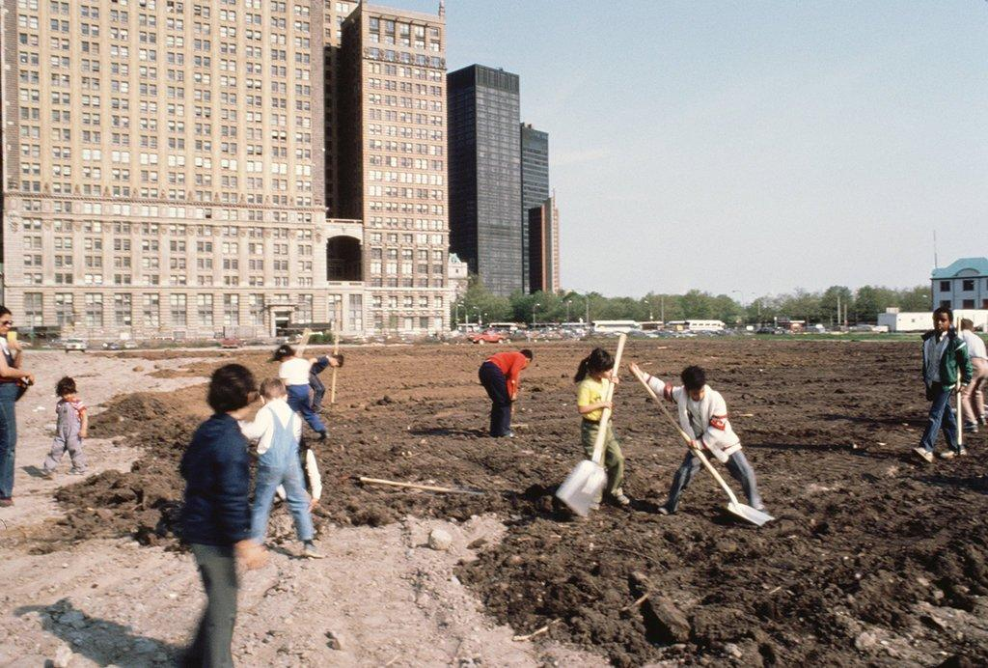fig3(Wheatfield – A Confrontation)
Battery Park Landfill, Downtown Manhattan – Volunteers Spreading the Soil,” 1982.Credit© Agnes Denes, courtesy Leslie Tonkonow Artworks + Projects
Two hundred truckloads of soil were brought onto a land worth $4.5 billion, participants were tasked with digging two hundred and eighty-five furrows by hand and the area cleared of rocks and rubbish. The seeds were sown by hand and the furrows covered with soil. For four months the field was maintained, cleared, weeded, fertilized, and sprayed, irrigation systems installed, the crop was harvested on August 16, over 1000 pounds of wheat was produced. Wheatfield was described
15
by Denes as a” symbol, a universal concept; it represented food, energy, commerce, world trade, and economics”. It referred to mismanagement, waste, world hunger and ecological concerns. It called attention to our misplaced priorities, seeing it as a confrontation of High civilization. (www.agnesdenesstudio.com/works7)

The harvested grain was distributed to twenty-eight cities across the world in an exhibition called "The International Art Show for the End of World Hunger", organized by the Minnesota Museum of Art (1987-90). The recipients of the seeds planted them in many parts of the globe.(www.agnesdenesstudio.com/works7)

When asked recently why she created a wheat field she replied as follows,” That was the beginning of wanting to re-evaluate knowledge.” further stating a desire to want to know “the clean language of art”. Denes also clearly expressed her need to do something meaningful, alluding to a type of art that is “transparent and unselfish”. An analysis of her words suggests, delivering an art with a truth to it was of importance to Denes, Wheatfield could be considered a unique and successful vehicle which allowed the viewer to cross the line from observer to participant, harnessing the power of the land to bring about this absorbing and transformative experience. (Karrie Jacobs, The New York Times, 2018).
The approach to site and the process of working of the aforementioned artists are in complete contrast with one another, whilst sharing the same founding medium, and
16
highlights the potential of the land as a flexible and useful tool, particularly where we recognise the evolvement of the land art movement through Dene’s iconic achievement. Mendieta showed us it was possible to engage with the land on a deep and personal level, Holt gave us a stark reminder of our age-old Human instinct to be connected to and guided by both the seasons and the universe It appears that these artists’ contribution was invaluable to the movement, and created developments that use the body and community. However, it could be said that Denes creation gave us an entirely new direction in which to take land art and undoubtedly helped propel us onward to seek out art works which could indeed engage and benefit communities on many levels.

In this next section the phenomenon of place and place attachment will be considered, with particular reference to the natural world: looking at the choosing and use of site:
As Nancy Holt undertook her first exploration of the West, around Las Vegas in 1968 with Smithson and Mr. Heizer, she described it as transformative in her life as an artist; during the visit, she said, she did not sleep for four days.
“It seemed to me that I had this Western space that had been within me,” she said many years later. “That was my inner reality. I was experiencing it on the outside, simultaneously with my spaciousness within. I felt at one.” (The New York Times, Randy Kennedy, February 12th,2014.)
17
Both physical appearance and symbolic/emotional meaning are very
important to human perceptions of landscapes, and other attempts should be made to understand how the two constructs contribute to visual preference in future research. (Chia-kuen Cheng, 2007)
A complex set of ideas and feelings appear to be present in the forming of attachment to place, this may somewhat hinder the research as it could be quite difficult to reach a clear understanding of these intricate human actions and behaviours. Examination of recent research into the relationship between landscape and emotional bonding suggests adding familiar landscape elements to unknown places can significantly enhance bonds. Although the landscape was new to Holt, could it be through the process of making her mark that she was able to experience a near immediate familiarity, as she brought with her and projected her own ideas upon it? Was this what lead to the feeling of oneness she reports to having felt? What causes us to strive to develop such strong bonds with a certain place? What grants us an authority to refer to a space as “our own”? When we find ourselves in an urban setting could gentrification be a contributing factor in our predetermined feelings of familiarity? Nature offers us uniqueness in contrast and in order to maintain a healthy balance green spaces should be an accessible feature of our modern towns and cities.

"Space "and "place" are familiar words denoting common experiences. We live in space, there is no space for another building on the lot. The Great Plains look spacious.
Place is security, space is freedom: we are attached to the one
18
and long for the other. Geographers study places. Planners would like to evoke "a sense of place."(YF Tuan 1977:3)

Holt’s interest in physical space and the geographical specificity was a key concern throughout her work. (Parafin artists, Nancy Holt. Available online.)

Mendieta's practice was regarding presence, absence, and the inevitable cycles within nature and life. (The Art Story: modern art insight: Ana Mendieta)

How can we understand the complexity of the way in which humans respond to their surroundings? The Land artist would appear to have a great desire to escape these spatial laws when it came to the site of their works, and although the previous artworks mentioned did have audience participation, attention will be drawn to another branch of earthworks which operates under the umbrella of Socially engaged art, the purpose of which is to engage people in the community who would not normally engage with the arts.(Tate, art-terms, Community Art). This will be elaborated further on this topic later. The next section will focus on the interactions between artist and environment and participatory practices, if we look at the way Mendieta approached this ongoing dialogue between her own body and the landscape, we could assume that she felt that only a physical combining of the two would be sufficient to bring about her vision, the audience participation was restricted to the role of the viewer, where in comparison , Sun Tunnels offered a much more interactive experience. Nancy Holt is reported to have felt a deep sense of “oneness with her chosen site, she chose to place something on rather than use the landscape
19
in a physically intimate manner, it could be argued that, it is a contemporary work of art with a very ancient feel to it, comparable to Neolithic monuments, such as Stonehenge, as they both share Celestial alignment, were both designed to accommodate a gathering of people. As humans, we have been noting and celebrating this ‘sun-stillness’, or ‘solstice’, for thousands of years.(Ashwanden, C, 2017.)The moon and the sun have always played an important role in our human experience, the cycle of both, was in the past, and is now, both celebrated and observed.
 Fig4 Nancy Holt "Sun Tunnels" (1973-1976) Location: Utah Desert.
The average person spends 90% of their time indoors, but when we die, we insist on being buried outside in a tranquil natural setting, we are returned to the earth, we are not separate to, but a part of the landscapes we find ourselves in. We share an ancient elemental history with all life on Earth, humans share genetic material with
21
plants.

Early caregiving relationships establish an attachment system which optimally provides a secure base from which the developing child explores her or his environment. (Shemmings, David (2008).

Socially engaged practices

Socially engaged practice describes art that is collaborative, often participatory and involves people as the medium or material of the work. Socially engaged practice, also referred to as social practice or socially engaged art, can include any artform which involves people and communities in debate, collaboration or social interaction.(Tate, Art-terms, Socially engaged practice.)
What is place attachment and what are its effects?
Developing place attachment to one's home and local area is beneficial. It has been linked with many positive health and community participation outcomes.
“People with higher place attachment report greater social and political involvement in their communities” (Mesch & Manor, 1998), (Journal of Environmental Psychology, 2014.)
“Communities comprised of highly attached people are more likely to work together to achieve a desired outcome, such as protecting the environment”. (G. Brown, Reed, & Harris, 2002)
“Protecting the social and physical features that characterise their neighbourhoods”. (Mesch & Manor, 1998).
A project by Swansea-based artist and curator Owen Griffiths, tries to demonstrates the power and effectiveness of Social Practice is Graft, based at the National
22
Waterfront Museum in Swansea, a new socially engaged art project, which was commissioned by Nawr Yr Arwr/Now the Hero (NYA/NTH) and 1418Now.
This is a community garden, arts & educational project led by artist Owen Griffiths in partnership with The National Waterfront Museum, NTH/NYA & Cae Tan CSA.

Graft: A soil-based syllabus:

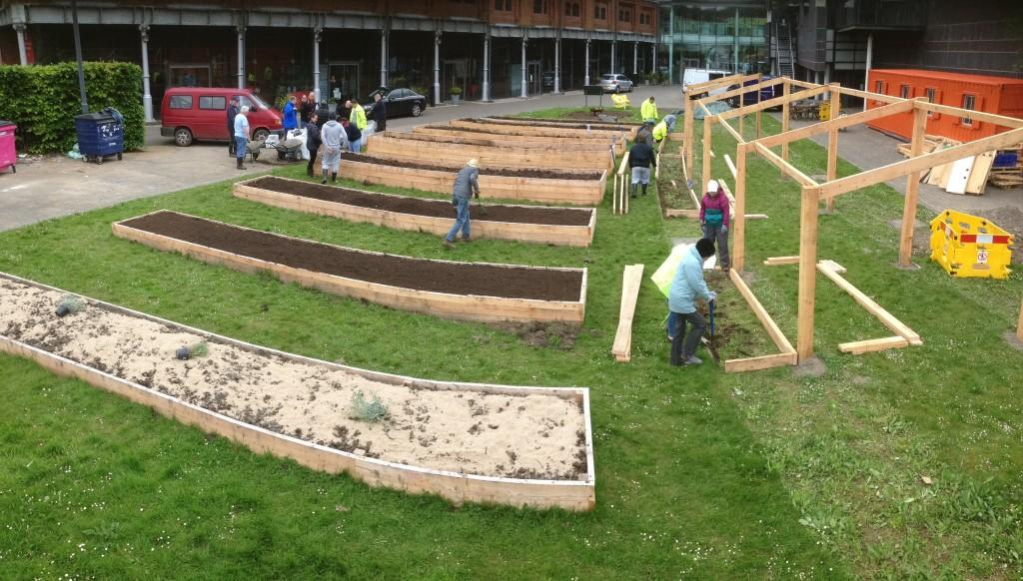 Fig 5 Graft a soil-based syllabus

Tom O'Kane, http://caetancsa.org

I am a social practice artist working with sites and communities, responding to architecture, people and place. I am interested in the critical and dominant roles that capital, the architect and the (urban) planner play in our experience of the everyday
23
and how we address the disconnection between community, place, our environments and the forces and ideals that maintain this in-balance. (Owen Griffiths, Taliesin)

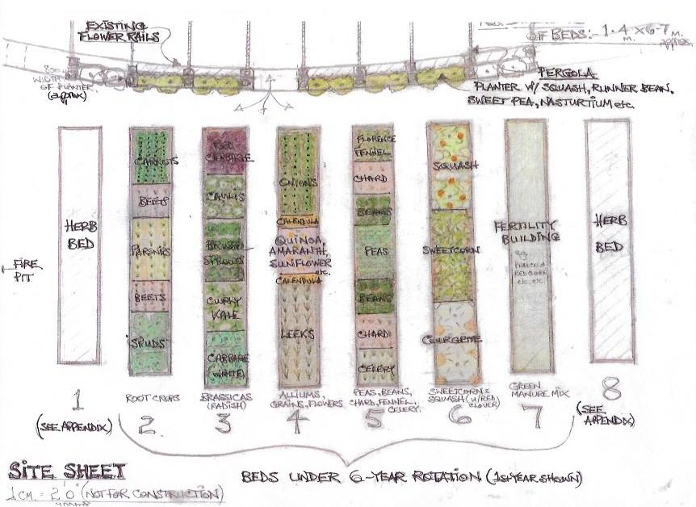
Fig6 Site sheet,Tom O'Kane, http://caetancsa.org

Works have included gardens, workshops, community green spaces, research-based projects, exhibitions and film work. Research is centered on architectural critique, alternative community models, community / political struggle and ‘edible land’, as spaces of resistance against a normative dominance in our urban and civic landscapes. Exploring participatory and workshop models to enable community design or collaboration is an ongoing and expanding interest.
I’m interested in the role of the artist as a utopian existence; working as different characters in a shifting territory. (Owen Griffiths, Taliesin)

24
The role of the artist in social change and their ability to influence the thought and behaviour of society is demonstrated well in the work of Owen and all involved, this is now a permanent piece of green infrastructure in Swansea City Centre, alongside previous project Vetch Veg (2011), The work involved transforming a derelict, city centre football stadium into a vegetable garden, an interdisciplinary project, part sculpture, part centre, part ecosystem and resource. This Visionary project yielded results from unused land, the artwork became the catalyst with the artist as curator, inviting dialogue with the community, engaging them as active participants rather than witnesses of the changing landscape of their city. Vetch Veg, (In association with Adain Avion, project managed by Taliesin Arts Centre in partnership with Glynn Vivian Art Gallery, Swansea Environmental Forum and the City and County of Swansea) ran for one year until September 2012, after which the community began running the project. Its activities include filmmaking, lectures, gigs, sculptures, discussion, and events. (Owen Griffiths, Vetch Veg).

Community groups from a wide range of backgrounds across the city built every part of the garden with the creative team, including the 12 raised beds, a pergola and benches from local timber. The work makes connections between plate and soil and explores the power of making and sharing a meal together.(National Waterfront Museum)All produce grown in the garden was donated to projects who make food for
25
those in need across the city and was to make a soup for the 2500 people who attended the Now The Hero performances in September, which included a site-specific theatre production commemorating the end of the First World War.

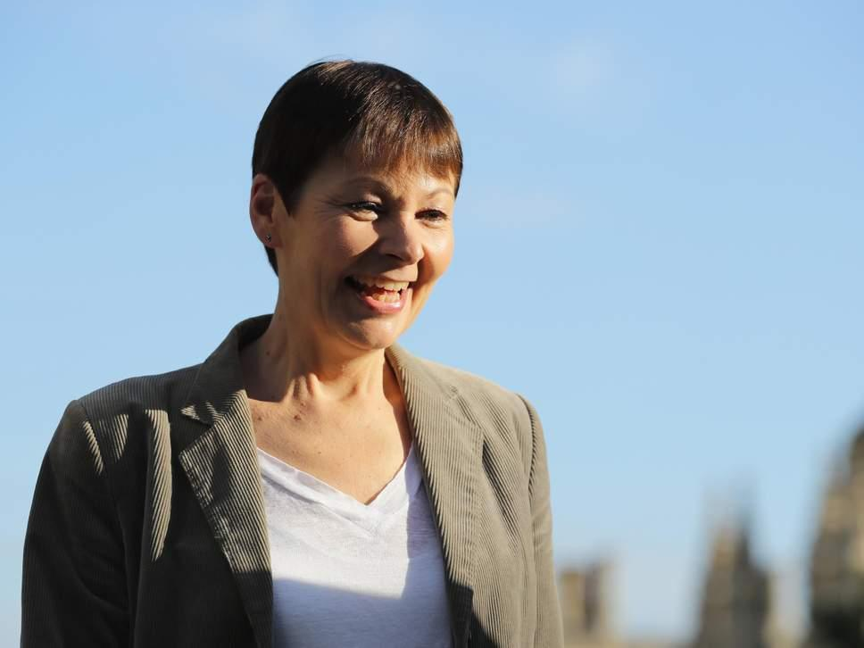
Fig 7 Caroline Lucas (Getty, 2018)
The Green Party co-leader says the government should “change planning rules to ensure everyone in the UK has access to green space” (2018)

26
According to Caroline Lucas co-leader of the Green party “Research shows moving to greener areas improves people’s mental wellbeing for the long term – but with those living in
the most deprived areas having the highest rates of mental health problems and the least access to green spaces, we should be taking nature to the people.
(Josh Gabbatiss,The Independent, October, 2018).

27

Conclusion

The move away from the traditional studio-based practice, has taken many forms and has evolved to encompass a great variety of styles since the movement began, Land art as a whole offers us the opportunity to both strengthen bonds with, and express oneself within the natural environment, however It would appear that Socially engaged practice would be at the forefront as a potential solution to help regain an element of balance when attempting to address the initial questions laid out at the beginning of this document. When a work of art, such as Owen Griffiths Graft, can be both participatory and then allowed to become ingrained within the fabric of a community, an opportunity of study may present itself allowing us to understand on a deeper level the potential of such projects to bridge the ever-widening gap between ourselves and our natural surroundings. The creation of these unique projects often in the heart of an urban setting may in some part offer an avenue in which to explore a fresh set of ideas in dealing with the societal issues which intrude upon both our daily lives and indeed feature in media sources on a regular basis. Caroline Lucas urges us to look at the bigger picture, citing a reconnection to nature as a necessary step. The Green party Co-leader so adamant that this is the way forward to improve the health of the nation, states, Our Government should alter planning rules to allow everyone in the United Kingdom access to green space. With the gentrification of our towns and cities and the
28
removal of much of our public parks and woodland, delivering nature to people in this way, otherwise cut off from these natural resources could perhaps be offered as a partial solution. The shared experience which occurs for the participants of such activities may in some part alleviate the feelings of isolation that is purported to be felt across today's society. As Humans we need to interact with each other and it would appear modern forms of communication has left some at risk of marginalisation. The coming together of people and organisations in this way opens new dialogue with many dimensions and presents new ideas. A common ground on which to gather, a reminder of how communities once interacted with one another and how this could be once more brought about through the use of participatory practices. Through my involvement in a community-based project, Eco Dysgu-Eco Learn (2002-2012) situated on a forty-two-acre woodland site on the outskirts of Bridgend South Wales, I saw evidence of how creative process offered in a natural setting, brought about a significant change in those who participated. Some examples of the Workshops on offer taught willow weaving, wood carving, ceramics and gardening. With a kitchen on site, the cooking and sharing of fruits and vegetables which they had contributed to their planting and growth, became a work of art in its own right. The client base consisted of people who had found themselves on the margins of society, the workshops facilitated there were designed to promote education through creativity, and instil a sense of connectedness, both to the environment and each other, as previous work had identified that the group felt a

29
distinct lack of belonging. It offered a real opportunity to rethink relations between, artist, audience and environment. It could be said that it led to many social and

environmental changes within that location, which may have had a more far-reaching impact had it not closed due to lack of funding. In March 2002 Eco Dysgu was approached by a local school and asked to facilitate a project involving nine children (aged 15-16 years) the site was a disused piece of land. The activities with the guidance of two tutors, consisted of building a hut and making a picnic table, benches, stools, bird boxes and various sculptures. A channel was dug to carry rainwater into a stream and a
wooden bridge placed over the stream to give access to the land from the car park. (Patrick Duncumb 2010).

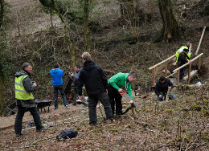Fig 8 Volunteering (Eco-Dysgu,Bridgend South Wales.)
Further social research is needed to gather the necessary information to help gain an understanding of the benefits and implications to community, participants and environment of a communal collaborative setting which offers a chance for interaction and communication which without artist intervention may not otherwise take place. What will be the long-term consequence of enabling a curating of your own environment? as well as having an immersive and shared experience within your own community and the landscape? When art is used as the language in a Social context and outdoor setting. In this technological age a rise of sociocultural activities that include land art may offer opportunities to interact with organic materials and could lead to possible solutions which encourage less indoor time. In
31
an interview about his book Landmarks, when referring to the removal of nature related words from the Oxford junior dictionary Author Robert Macfarlane states
This displacement of the outdoor and the natural by the indoor and the virtual is “a small but significant symptom of the simulated life we increasingly lead, A basic literacy of landscape is falling away up and down the ages. And what is lost along with this literacy is something precious: a kind of word magic, the power that certain terms possess to enchant our relations with nature and place. (Michael Kerr, The Telegraph, 2015).
The removal of trees and the desolation of our green spaces, a rapidly growing digital culture combined with urban and social change have been factors repeatedly mentioned when examining evidence of our disappearing links with nature. Findings from a paper written by Public health England on the natural environment, found that “access to and use of green space are lower amongst people who are elderly, have a disability, are from
a BAME background and/or live in a deprived area”. (HM Government, 2014).
While the rise in people living in urban areas without access to green space
contributes to disconnecting from nature, there is growing evidence of how this distance impacts negatively on our health and wellbeing, the natural world is a not benign and has much to offer us. It would seem, socially engaged practices have much to offer in terms of their potential to reach the groups mentioned especially if they can be based in the heart of urban communities. It could be argued our
32
language has changed, and our social behaviour has changed, possibly contributing factors in our decreasing relationship with the land around us. Our ways of seeing in modern times appear to have altered our dialogue with nature, a more inclusive type of art practice presents interesting alternatives to the alienation and lack of belonging being experienced by many people at present. Socially engaged practice which concerns itself with the landscape gives a platform for actions of individuals and groups, a sharing of ideas may instil a sense of connectedness and assist in departing knowledge and language pertaining to nature, and could be of use in the strengthening of overall relations, whilst also addressing aspects of modern social disintegration, social and environmental identity and estrangement from the natural world.

33

References

Books

Title | Space and Place: The Perspective of Experience  Tales and Travels of a School Inspector Series
Author | Yi-Fu Tuan
Edition | illustrated, reprint
Publisher | University of Minnesota Press, 1977
ISBN | 0816638772, 9780816638772
Length | 235 pages
Subjects | Science  ›  Environmental Science  Science / Environmental Science  Social Science / Human Geography

34
Online sources including Journals
https://core.ac.uk/download/pdf/4277610.pdf
https://kar.kent.ac.uk/10867/

http://parafin.co.uk/phone/artists--nancy-holt.html

http://www.agnesdenesstudio.com
http://www.agnesdenesstudio.com/works7.html
https://www.alisonjacquesgallery.com/usr/documents/press/download_url/670/04-2018-ame-artreview.pdf
https://www.britannica.com/science/biophilia-hypothesis
http://www.cell.com/trends/ecology-evolution/fulltext/S0169-5347(05)00164-3
https://www.childrenandnature.org/2007/07/01/the-powerful-link-between-conserving-land-and-preserving-health/
http://www.ecodysgu.org.uk/wordpress/wp-content/uploads/Thesis-1-PDF-file.pdf
https://www.fullerlab.org/psychological-benefits-of-greenspace-increase-with-biodiversity/
http://www.galerielelong.com/artists/estate-of-ana-mendieta
http://www.vetchveg.co.uk/wp/owen-griffiths/
https://abundancedancegarden.wordpress.com/2017/06/20/down-the-rabbit-hole/
https://archive.newmuseum.org/exhibitions/157
https://ecobrooklyn.com/earth-art-movement/
https://journals.sagepub.com/doi/abs/10.1177/05333160122077587

https://museum.wales/swansea/whatson/10176/Garden-Gathering/

https://www.artsy.net/article/artsy-editorial-10-female-land-artists
35
https://www.independent.co.uk/environment/caroline-lucas-green-party-conference-nature-mental-health-wildlife-a8570986.html

https://www.m.theartstory.org/artist-mendieta-ana.htm
https://www.m.theartstory.org/movement-earth-art.htm
http://www.nhm.ac.uk/content/dam/nhmwww/about-us/visitor-research/Disconnect%20with%20nature%20Lit%20review.pdf
https://www.nowthehero.wales/graft-a-soil-based-syllabus
https://www.nytimes.com/2014/02/12/arts/design/nancy-holt-outdoor-artist-dies-at-75.html
https://www.nytimes.com/2018/06/14/t-magazine/agnes-denes-art.html
https://www.researchgate.net/publication/228091197_Theory_of_Attachment_and_Place_Attachment
https://www.rspb.org.uk/Images/connecting-with-nature
https://www.sciencedirect.com/science/article/pii/S0272494414000954
https://www.taliesinartscentre.co.uk/en/owen-griffiths---associate-artist

https://www.tate.org.uk/art/art-terms/c/community-art
https://www.tate.org.uk/art/art-terms/s/socially-engaged-practice
https://www.tate.org.uk/whats-on/tate-modern/exhibition/zero-infinity-arte-povera-1962-1972
http://ww2.rspb.org.uk/Images/connecting-with-nature_tcm9-354603.pdf
http://www.worldcat.org/title/sexual-meanings-the-cultural-construction-of-gender-and-sexuality/oclc/6942585
36

Bibliography

Overlay
Lippard Lucy R
Paperback, 272 pages
Published April 1st 1995 by The New Press (first published 1983
ISBN 1565842383 (ISBN 13: 9781565842380)

Webliography
http://blog.worldagroforestry.org/index.php/2012/06/19/closing-the-gap-between-man-and-nature/
http://www.ecodysgu.org.uk/
https://journals.sagepub.com/doi/abs/10.1177/05333160122077587
https://link.springer.com/chapter/10.1007/978-1-4684-8753-4_12
https://museum.wales/swansea/whatson/10176/Garden-Gathering/
https://permaculturenews.org/2017/06/29/permaculture-art-part-1-using-art-ecosystem-restoration/
https://www.artsy.net/article/artsy-editorial-10-female-land-artists
https://www.edp24.co.uk/news/education/norfolk-campaign-for-the-lost-words-primary-schools-1-5792327
https://www.groundwork.org.uk/sites/wales
https://www.tate.org.uk/research/publications/tate-papers/13/psychosis-and-the-sublime-in-american-art-rothko-and-smithson

37
Illustrations
Fig 1:(Silueta Series, Mexico,1974.)
https://www.tate.org.uk/art/artworks/mendieta-untitled-silueta-series-mexico-t13357

Fig 2:(earth-bodywork and earth-body sculptures.) (1972-1977)
innovative Intermedia art programme run by Hans Breder.
https://www.tate.org.uk/Journal of Environmental Management
journal homepage: www.elsevier.com/locate/jenvman
Article history:
Received 31 July 2014
Received in revised form
22 April 2015
Accepted 17 May 2015
Available online
https://www.artsy.net/article/artsy-editorial-10-female-land-artists

https://museum.waart/artworks/mendieta-untitled-silueta-series-mexico-t13357

fig3(Wheatfield – A Confrontation)
Battery Park Landfill, Downtown Manhattan – Volunteers Spreading the Soil,” 1982.Credit© Agnes Denes, courtesy Leslie Tonkonow Artworks + Projects
https://www.nytimes.com/2018/06/14/t-magazine/agnes-denes-art.html

Fig 4: Nancy Holt "Sun Tunnels" (1973-1976) Location: Utah Desert.
https://medium.com/@milenaolesinska77/sun-tunnels-nancy-holt-4c90655b1ca4

Fig 5: Graft a soil-based syllabus
Tom O'Kane, http://caetancsa.org
https://www.google.co.uk/search?q=owen+griffiths+graft&rlz=1C1DVJR_enGB742GB742&source=lnms&tbm=isch&sa=X&ved=0ahUKEwi8lY6pnJbfAhVIyqQKHYiFCsYQ_AUIDigB
38
Fig 6: Site sheet Tom O'Kane, http://caetancsa.org
https://www.google.co.uk/search?q=owen+griffiths+graft&rlz=1C1DVJR_enGB742GB742&source=lnms&tbm=isch&sa=X&ved=0ahUKEwi8lY6pnJbfAhVIyqQKHYiFCsYQ_AUIDigB
Fig 7: Caroline Lucas, Co-leader of the Green party. (Getty,2018)
https://www.independent.co.uk/environment/caroline-lucas-green-party-conference-nature-mental-health-wildlife-a8570986.html

Fig 8: Volunteering
https://www.google.co.uk/url?sa=i&source=images&cd=&cad=rja&uact=8&ved=2ahUKEwiLwc6ao5bfAhUKKywKHc7LD20QjB16BAgBEAQ&url=http%3A%2F%2Fwww.ecodysgu.org.uk%2F&psig=AOvVaw2pOcDyTZaUkVHokMbLu7m-&ust=1544566082979105

