
DIGITAL SKILLS & RESEARCH METHODS : ASSIGNMENT 2 – RESEARCH REPORT
IMPACT OF VIRTUAL LEARNING ENVIRONMENT

MODULE CODE: BMWS4003
STUDENT NAME: JANINA-EVELINE OROS
STUDENT ID: 2128948

Table of Contents

Introduction………………………………………….. 3
The Rationale of the Research ……………………... 4
Research Objectives……………………...................... 4
Literature Review……………………….... ……….... 5
The Research Methodology……………… ………… 7
Research Methods…………………………………… 7
Statistics about the populace and sample size……… 7
Required data and data collection process…………. 7
Data Collection……………………………………….. 8
Ethical considerations in data collection…………… 14
Learnings from the Research……………………….. 15
Conclusion……………………………………………. 16
References……………………………………………. 16
Appendix……………………………………………... 18
Collected data………………………………………… 18
Questionnaire………………………………………… 18

INTRODUCTION

The VLE also known as the virtual learning environment is the most frequently used technology in educational institutions in the UK. It is an online learning and teaching platform that is used by academic institutions. Most of the universities and colleges in the UK are using VLE to facilitate online education and make education more available and affordable to students. VLE includes several tools for teaching and learning that are designed by academic institutions and technology experts for improving the academic experience of students. The term (VLE) was introduced back in 1986 by Starr Roxanne Hiltz. The main components of VLE are curriculum mapping, providing online support to the teachers and students, racking the students, ranking their performance, links outside resources, discussion threads, web publishing, etc. The positive effects of VLE include a collaborative platform that encourage students to self-learning and encourages resource sharing. It also increases the enthusiasm and interest of the students in learning. But there are negative sides to it too. There is a lack of supervision and guidance from the teachers, which might reduce their efficiency. This research report is titled “The Impact of Virtual Learning Environment (VLE)”. While conducting the research, both primary and secondary data were collected and used. The primary data was collected by using an online questionnaire.

The Rationale of the Research

The Rationale of the research describe the reason why it was conducted. Here the rationale was to figure out the impact of VLE on the student learning experience of the UK, in their academics. The research also determines the influence of VLE on the development of a learning program and style is independent and how VLE motivates the students. It is also expected to increase the research knowledge of the author.

Research Objectives

The research is expected to achieve the following objectives:

- To figure out the effect of VLE on the overall learning and teaching condition of the UK.
- Finding out the strategies to improve the Virtual Learning Experience of the students.
- Graining deeper and more detailed knowledge about how the Virtual Learning Experience works.
- Understanding the usage of VLE in learning, teaching, and increasing student experience.
- Investigating how VLE affects the communications between teachers and students.

Literature Review

The VLE or the Virtual Learning Experience was introduced and developed to provide the students with a better and more learning experience on online platforms. Students and teachers from all around the UK use the VLE for digital education. A study conducted in West Virginia, USA started that VLE is a very efficient tool that helps the educational institution to design its curriculum, map the learning progress of the students, add additional resources for the students, track the learning process of the students, share resources, and establish an easier and quicker communication between the teachers and the students, control access of the huge resources and database and enhance the learning experience and effectiveness of the students as a whole ( Scardamalia and Bereiter, 2012).
The findings of Wernet et al. were back by a study by Diochon and Cameron (2011). Together they developed a research project that focused on how the learning content of the undergraduate business students is accessible through VLE only.
They also found out that the necessity for the learners to be active while utilizing a VLE increased their interest, attention, self-assurance, and aptitude toward learning. Students devised their very own acquiring expertise through joint efforts with peers in different regions offering the chance to build the employability of graduates, their skills, and competencies ( Diochon an Cameron, 2011).
Early in twenty-first century, the virtual learning environment was put into place in the United Kingdom’s schools. Blackboard (2020) says that in 2010, VLE was used by more than 3.700 institutions in 60 countries. Now, schools are focussing on VLE to improve students learning experiences (Blackboard, 2020). Underwood (2009) investigated how the Virtual Learning Environment affects student learning by taking a sample of 34 schools.
There are several disadvantages and challenges related to the VLE. Internet-based learning disrupts the required emotional and societal communication found in actual classrooms.
Robertson and Klotz (2013) found from their studies that online platforms in learning do not have the same helpfulness as formal and routine conversation and the feeling of society and community that is fostered in conventional classrooms. It also sometimes reduces the attention of students due to the lack of direct or physical supervision of the teachers. The challenge is to retain the same quality of classroom education on VLE platforms. Also maintaining the legal requirements and ensuring proper supervision of the learning process can be tough to maintain.
According to several studies, the need for maintaining legal requirements is must in authorizing VLE. The authority must be aware of FERPA and state laws like Illinois’ School Student Records Act. There, under Section 504, the usage of recording device has been independent of others’ permission.

The Research Methodology
Research Methods
Research Methodology is one of the most important parts of the research that gives the user an enhanced idea of how the research was conducted. Research can be qualitative or quantitative. This research project regarding the Virtual Learning Experience uses both qualitative and quantitative approaches and information to help the researchers draw a better conclusion (Bell, Bryman and Harley, 2018).

Statistics about the populace and sample size
The populations refer to all the data that is in a dataset. And the sample refers to a selective part of the whole population. The population numbers for this study include 1000K students. Due to COVID-19 pandemic, it was impossible to collect data from the entire population. Consequently, the data used here were collected using a random sampling method (Groebner et al., 2013). The size of the sample is fifteen.

Required data and collection process
This research was done using primary information, as well as secondary information. Secondary data is information collected from articles, journals, and previous studies (Windle, 2010), while the primary ones were collected directly. We have gathered secondary data for this research from journals, blogs, and previously published research paper based on a comparable issue. And the primary data has been gathered using the questionnaire. Using Google Form, a survey questionnaire has been created and sent to the respondent’s consideration (Pienta, Alter, and Lyle, 2010).

Data Collection

The answers of the respondents
Statistics of the population for the research:

The chart indicates the gender of the population on which the research has been conducted. The population is comprised of students from University of Wales Trinity Saint David from UK.
Question 1: Do you have an experience in relation to the usage
of Virtual Learning Environment?
It can be seen here that most of most of the students (83,3%) agreed that using VLE has a positive and beneficial impact on their overall learning experience, while 16,7 % disagreed. So, the overall result can be said positively.
18 responses

Question 2: Do you prefer to use Virtual Learning Environment for your higher Studies?
18 responses
Here it can be that 83.3% respondents stated that VLE facilitates the development of an independent platform for students. So, the majority is agreeing here. According to them, by accessing a variety of learning materials via the VLE, they can generate their ideas and expand their horizon of knowledge.

Questions 3: Did you have proper training to use University VLE for your studies?
18 responses
Even here the respondents stated that using VLE boosts the interest and willingness to learn. Nowadays students all around the world have access to technology and technological devices. So, using a technological platform will increase their motivation to learn new topics.

Question 4: Would you like to see that the university continue to use VLE Platform after pandemic as well?
18 responses

Here, majority of respondents felt that the VLE of the institution fosters communication between students and teachers, which is essential; for the enhancement of students learning experiences.

Question 5: Do you prefer to communicate with your lecturers and your friends via VLE?
18 responses
It can be seen

Just a part of respondents are agree to communicate with their lecturer and friends by VLE, almost the same part are disagree to use VLE for communication.

Question 6: Please rate the act of the online learning platform on your academic studies during pandemic.
18 responses
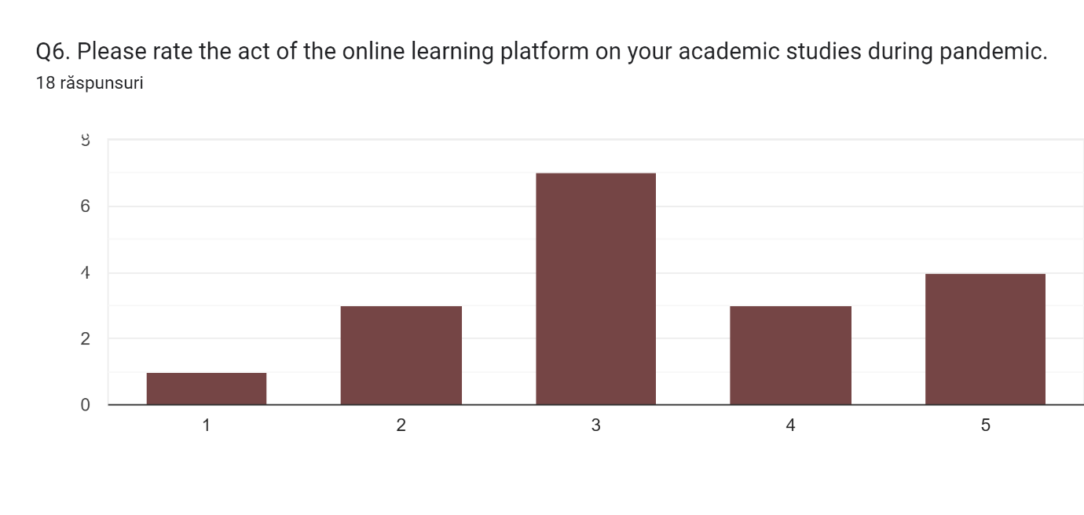
Some of the students stated that they have a lot of technical problems while learning from internet tools, some of them was excited because the online platform help them achieved a lot of knowledge by studying online, and another said that the online platform has decreased their productivity.

Question 7: Please rate your preference to do your studies in VLE.
18 responses
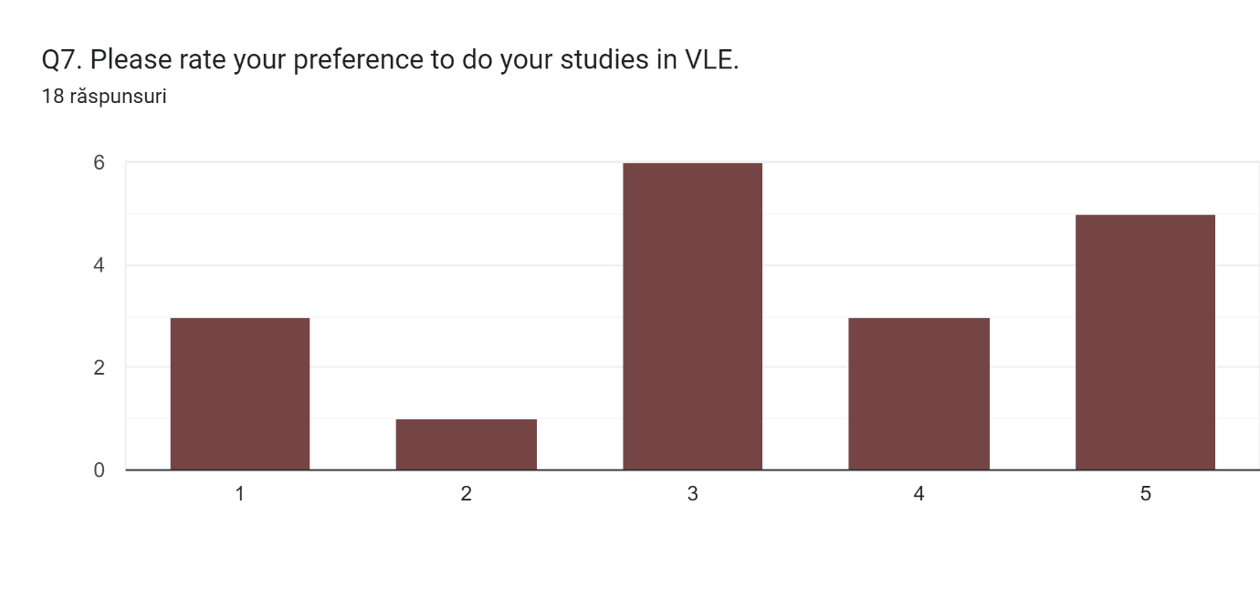
Many of those who answered said that the Internet helped them a lot in completing assignments, believing that the online platform is very suitable for the assignment, among which we also have opinions against online learning.
Question 8: Does university e-learning platform provide appropriate
support to complete your assignments?
18 responses
Most of those who answered this question said that the online platform is helpful for online education, some of those who answered said that online education is not useful.

Question 9: Do you find required and appropriate resources in VLE for each module which you study?
18 responses
More than 70% of those who answered said that they find many resources to study on the online platform, and they can study in class with their colleagues.

Question 10: Since lockdown, how satisfied are you in relation to support which you received from lecturers, university admin and management through VLE towards your studies?
18 responses
Most of them had a good opinion about the support received from the lecturer during the pandemic, they were very helpful, we also have negative opinions in which they were not satisfied with the materials received during the pandemic.

Ethical considerations in data collection
All the relevant ethical codes of conduct have been maintained and respondents to the data collection process for this research. The privacy of the respondents has been maintained, and the responses were made anonymously. The respondents were briefed about the aim of the research and the academic purpose of the research. Also, the consent of the respondents was taken before providing them with the questionnaire.
Learnings from the Research
· From the research findings, VLE positively impacts the learning experience of the students.
· VLE improves the motivation to learn and increases attention to studies.
· VLE also builds strong student-teacher communication.
· VLE is easier to use for students.
· VLE increases the enthusiasm of the students.
· Usage of VLE has many advantages for both the students and teachers in the case of direct consultation, communication, resource sharing, and study planning.

Conclusion
Moreover, the VLE is easily accessible through technological devices, and it increases the efficiency of the students to a great extent. It creates a platform for resource sharing and interactive communication and unlimited resource sharing. However, the tone needs to keep in mind that the actual effectiveness of VLE must be tested continuously, by ensuring personal guidelines by the teachers and the platform should be updated when needed. Also, the educational institutions using VLE must ensure strong data and security of the personal information of the users. Finally, it can be said that the research has greatly improved my critical analysis ability, critical thinking ability, and reading skills.

References
Barker, J. and Gossman, P., 2013. The learning impact of a virtual learning environment: students’ views. Teacher education advancement Network Journal (TEAN), 5(2), pp.19-38. Bell, B., Harley. (2018). Business research methods.
Diochon, M.C. and Cameron, A.F., 2001. Technology-based interactive learning: Designing an international student research project. Active Learning in Higher Education, 2(2), pp.114-127.
Groebner, R.J., Chang, C.S., Hughes, J.W., Maingi, R., Snyder, P.B., Xu, X.Q., Boedo, J.A., Boyle, D.P., Callen, J.D., Canik, J.M. and Ziegler, I., 2013. Improved understanding of physical processes in pedestal structure, leading to improved predictive capability for ITER. Nuclear Fusion, 53(9), p.093024.
Moore, C.M., Robertson, N.L., Arsanious, N., Middleton, T., Villers, A., Klotz, L., Taneja, S.S. and Emberton, M., 2013. Image-guided prostate biopsy using magnetic resonance imaging–derived targets: a systematic review. European urology, 63(1), pp.125-140.
Pienta, A.M., Alter, G.C. and Lyle, J.A., 2010. The enduring value of social science research: the use and reuse of primary research data.
Scardamalia, M. and Bereiter, C., 1994. Computer support for knowledge-building communities. The journal of the learning sciences, 3(3), pp.265-283.
Talbert-Johnson, C., 2013. Preparing highly qualified teacher candidates for urban schools: The importance of dispositions. Education and urban society, 39(1), pp.147-160.
Windle, P.E., 2010. Secondary data analysis: is it useful and valid? Journal of PeriAnesthesia Nursing, 25(5), pp.322-324.

Appendix


