Managing Professional Practice in Advocacy
Assignment 1: Eced7004

This assignment will critically explore the implications of professionalising independent advocacy services and will reflect on the impact of these services if they became controlled by government agencies. The research will discuss any potential change in legislation and restrictions on professional advocacy practice that may influence the work that aims to empower individuals. This assignment will also identify types of advocacy to build a greater understanding of any impact on advocacy services, such as any negative effects on the freedom to empower people and to take control of their own lives, if the service was controlled by government agencies. Furthermore, if advocacy services are to become regulated, will the empowerment of individuals become more difficult if restricted by regulations? The terminology of professionalising the advocacy service will be discussed, and the impact of this will also be addressed.
John Wilkes 18th century MP and Journalist was credited for advocacy after his attacks on the government in his publication ‘The North Briton’, a satirical pamphlet which led to his arrest but when later released his defiance led to the end of slavery in England (UK Parliament, 2023), further on in history both socialist and labour movements were the model of contemporary advocacy (Rywak, 2014). When considering modern advocacy, however, empowerment theory is a fundamental part of any advocacy practice. It aims to help vulnerable individuals overcome challenges and barriers, in other words giving power to those who do not have it (Irvie, no date). Senker (2022) reflected on the position of advocacy and recognised that over the last forty years, advocacy has developed into a creditable service, but this may now be under threat. According to Social Care Institute for Excellence (2022, c), there is a risk of the Human Rights Act 1998 (Legislation.gov.1998) being weakened; with budgets being tightened for local authorities due to care priorities, and an increase in demand for advocacy services, all indicate potential challenges in the future. On the other hand, it is further argued by Social Care Institute for Excellence (2022, c) that commissioning independent advocacy services offer benefits such as easy access to Multi-Skilled Advocates, maximising the effectiveness of the service, assured compliance with laws, review and analysis of data to understand future demand and clearer expectations. Therefore, change can be viewed as a positive, as in the case of independent advocacy services. When advocacy was first developed it could be argued that in history advocacy services were less accountable, therefore any future developments in terms of services being controlled by government agencies are debated as a positive outcome.
Mercer (2016) presents research, set in a historical context, which illustrates how over time, we have developed a better understanding of illnesses, such as mental health, and consequently better strategies for managing these have been developed. Previously patients suffering from mental health may have been incarcerated, and not given a voice, now seen as being inhumane, but in the 1950’s it did lead to advocacy development becoming more evident (Mercer, 2016). Advocacy services have continued to be developed, mainly as a result of statutory guidance and legislation, for example, the Social Care and Well-being Act (Wales) 2014, the Human Rights Act 1998 and Mental Capacity Act 2005. Other matters when considering the implications of potential changes, such as being controlled by government services, are argued by Wood, et al., (2013) as having a lack of transparency of service entitlement, constant change of budget and implications of services making applications for funding due to the current competitive nature of this process.
In addition to this, when exploring the implications of professionalising a service, Wilensky (1964) demonstrates there has been an increase in being licenced and certified as a skilled practitioner, however, when critically exploring this the evidence found does not suggest that becoming an advocate is any more difficult or restricted. On the other hand, by professionalizing advocacy services it could be argued that research recognises the importance of the service, however, there may also be a concern the term professionalisation may prevent some people from becoming independent advocates as the terminology creates pressure (Hayes, et al., 2019). Joseph (2023) further argues that when hiring advocates, qualifications do not always carry importance when choosing an advocate, personal qualities are more significant. This further argues the point that fewer people with personal experiences who may be deemed more able to help due to their understanding, may not consider advocate roles when a more professionalised approach is enforced.
In order to explore the implication of professionalising advocacy services it is important to have an understanding of where the different types of advocacy currently stand, therefore types of advocacy will be discussed briefly. Diagram 1: Models of Advocacy produced by Gwent Regional Partnership Board (2019), below illustrates the different types of advocacy which Mind (2018) and Stewart, et al. (2013) have also identified in their research as different types of advocacy.

Diagram 1: Models of Advocacy
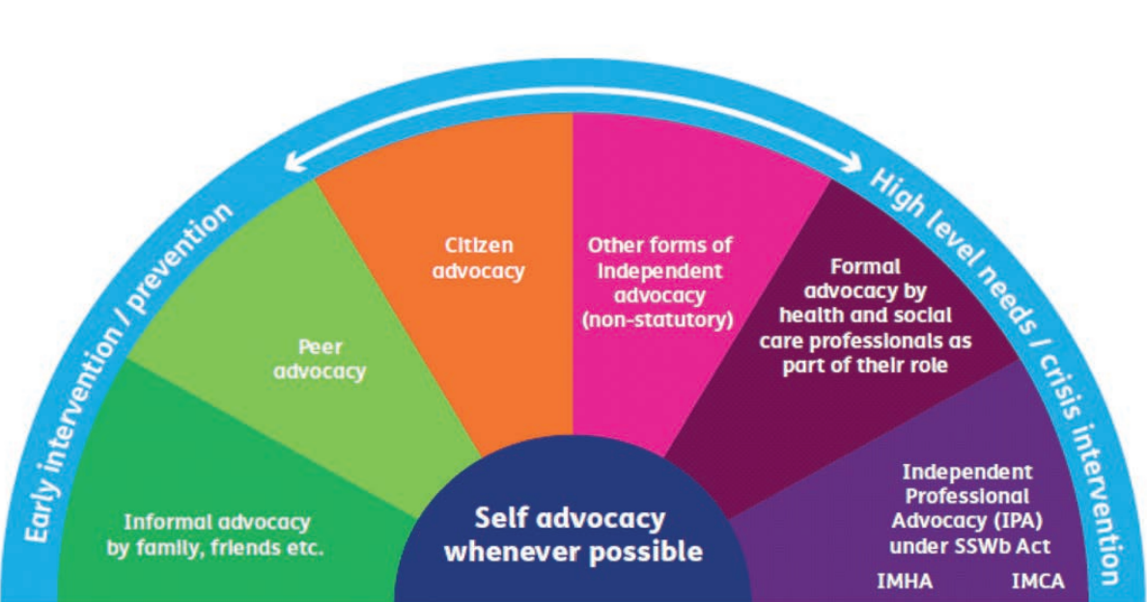
(Gwent Regional Partnership Board, 2019)
Batman (2000) discusses the meaning of self-advocacy, as mentioned in the diagram above, as the ability to identify and express and assert one’s personal needs, for example, to speak up for one’s self. Formal advocacy as described by Thurrock. Gov (no date) implies that this type of advocacy is not linked to any other services, on the other hand, Rethink Mental Illness (No Date) argues this is provided by non-profit government agencies or organisations for example health and social care professionals, that pay advocates to support vulnerable people or groups. Hartman (2019) describes peer advocacy as individuals who have shared life experiences are in the same position which enables them to represent each other with no conflict of interest. Peer advocates are chosen to advocate for others in either a group or an individual setting to help each other (Scottish Independent Advocacy Alliance, 2021). It is argued that a peer advocate could be in exactly the same situation or position as his peer, therefore he/she has a better chance of meeting the needs of someone else (The National Survivor, 2023).
Independent advocacy is an advocate that an individual has consented to and communicated their views to, in order for the advocate to represent them and can be anyone from a paid advocate to a friend, neighbour or organisation (Independent Age, 2016). It is stated by Social Care Institute for Excellence (2014, a) that ‘Independent means the service is not controlled by the council and only think about what the people they are helping want’. They are there to empower a vulnerable person to have their rights considered and supported, help provide them with any information and facilitate and interact with organisations and authorities in any developmental processes (Mencap, 2017). As explained by Quality Performance Mark (QPM) (2023), in diagram 2 below, within independent advocacy there is either instructed advocacy which means acting on another’s behalf and under their instructions, this can be either statutory or non-statutory, which will be explained further, and non-instructed advocacy (QPM, 2023). This can also be statutory or non-statutory, where individuals cannot talk for themselves and cannot give instructions to the advocate supporting them (QPM, 2023). According to The Challenging Behaviour Foundation
Non-instructed independent advocacy is essential for vulnerable individuals, for example, those who lack the capacity to make decisions about their own lives or who are unable to communicate their needs (Challenging Behaviour Foundation, 2021, p.3).
Independent advocacy is a person-centred approach founded in the 1940s by Carl Roger who believed ‘given the right conditions, a person can reach their full potential and become their true self, which he termed 'self-actualisation' (British Association for Counselling and psychotherapy (BACP) 2023). This view is shared by Care Quality Commissioner (2022) who argues that person-centred care is the key to professional practice in advocacy in order to ensure people are listened to, individuals are involved in planning their support and care and uphold equality as outlined in the Equalities Act 2010 (Gov.uk, 2010, a).
Having illustrated the many different types of advocacy it could be difficult therefore to appreciate the difficulties there would be if attempts were made to professionalise and control all advocacy services by government agencies. For example, what would be the impact on the person-centred approach? It is with this question in mind this paper debates the future of advocacy. If, for example, a tick-box approach was introduced by government agencies, in order to make a service more efficient and quicker, would the patient feel more or less empowered by this approach? This approach is defined by (Cambridge Dictionary, 2023) as given instructions where the individual loses the ability to make decisions and is unable to use their own knowledge. When viewing the Welsh Government’s statutory guidance for Advocacy Services, a series of boxes are filled with rules and restrictions and could be argued that this complies with a tick box method of do’s and don’ts (Welsh Government, 2019, c).

Diagram 2: Independent Advocacy
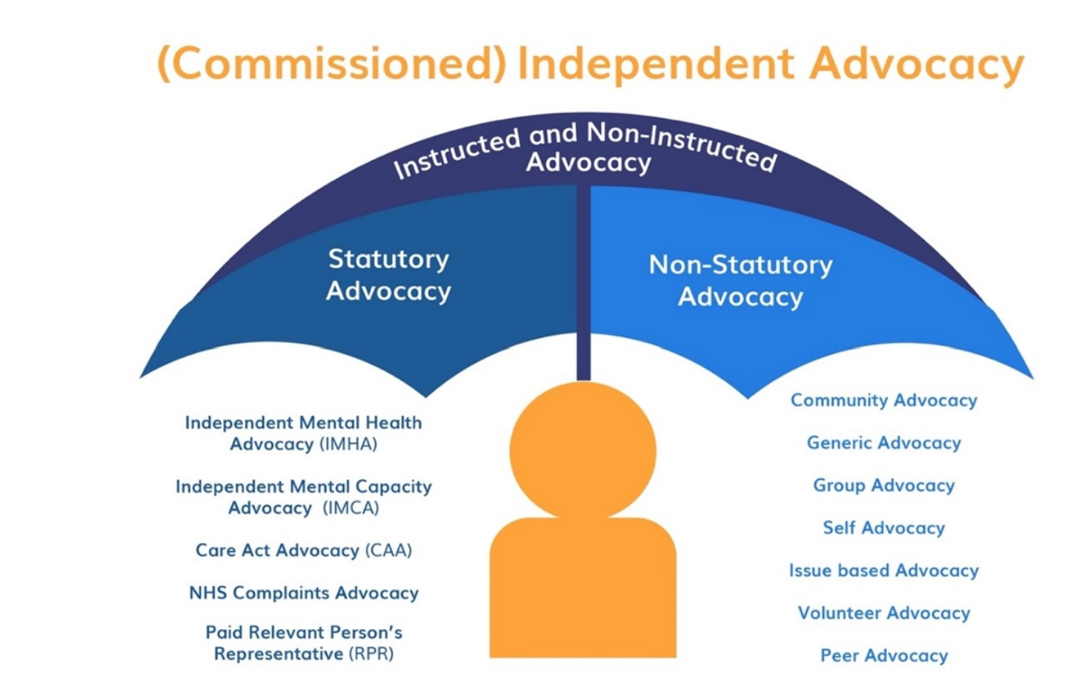
(QPM, 2023)
When considering the meaning of independent advocacy, it is further argued how advocacy can maintain its personal-centred approach when regulated under the same legal framework as social workers, for example. Furthermore, from the perspective of the social worker, best practice considers the interest of the vulnerable bounded by rules and regulations (Social Care Wales, 2017), but an advocate that currently sits independently gets to know the venerable person’s wishes and fights for their rights. This is further explained by Dalton and Carlin (2002), in a historical context, that the position of an independent advocate is that the client’s voice must be heard which is different to a professional advocate who has to follow the position that the service user and medical opinions know what is best for the client.
With this in mind, the current position of independent advocacy services as demonstrated by Independent Age (no date) argues these services are currently separate from both NHS and Social Services. Under the Social Care and Well-being (Wales) Act 2014, it is statutory for vulnerable children in need of care or support to have an entitlement under section 21(7) to have an independent advocate (Welsh Government, 2019, a). Also under the Mental Capacity Act 2005, it is statutory for an Independent Mental Capacity Advocate (IMCA) to be provided for the purpose where individuals lack the capacity to talk for themselves, this, for example, includes: exploring different options for medical treatment, support in meetings, supports views, upheld their rights (Social Care Institute for Excellence, 2010, b). The Liberty Protection Safeguard which is part of the Mental Capacity (Amendment) Act 2019, addresses the issues of the appropriate person and the independent mental capacity advocates (Department of Health and Social Care, 2021) The appropriate person’s key role is to support the person’s views wishes and feelings about their care and support, arguably this is what could be considered the role of an advocate, so it should be questioned, are we looking at a name change but the roles stay the same? However, it is noted that both of these key roles are referred to separately in the Mental Capacity (Amendment) Act 2019 (Department of Health and Social Care, 2021).
As briefly mentioned earlier an understanding of statutory and non-statutory advocacy, as shown above in diagram 2, in simple terms means if it is statutory there is a legal obligation under certain legislation, for example, the Health and Social Care Act 2014 (Welsh Government, 2019) or the Mental Health Act, that an individual has to be provided with an advocate (The Advocacy Project, 2023). On the other hand, non-statutory means that their need for an advocate does not fall under legal obligations and would have to be paid for or alternatively made available through volunteers or charities (Advocacy Matters, 2023). With this in mind, it is a question of whether government involvement may or may not be effective. It is stated by Abolhassani, et al. (2019) that the government may be supportive in addressing problems but on the other hand, government officials will have self-political goals which will mean decisions may not always be in the interest of the public. To further understand what an advocacy service would face when having to comply with government regulations, a critical evaluation of a research paper called ‘Challenges Businesses Face when Complying with Regulation’ by Gov. uk (2020, b) argues the costs out ways the benefits to the public, it’s time-consuming when complying with the requirements, wasn’t adaptable to different sectors and challenging to translate. The research does positively argue government intervention promotes more jobs, innovation and promotes competitive fairness for businesses when everybody is complying with the same rules (Gov. uk, 2020, b).
When considering professionalising advocacy services current standards of the practice for example the Charter argues they are already deemed assessed and regulated in some areas of advocacy as previously discussed. A guided idea of what is good practice looks at if there needs to be regulated services to make improvements in this area. At present, the Advocacy Charter (Appendix 1) outlines what is expected in order to meet high standards and an assessment is carried out to see if these standards are met (National Development Team for Inclusion, 2022). In the event that they have reached the standards of the charter, a Quality Performance Mark (QPM) is given (National Development Team for Inclusion, 2022). There is already an expectation from the Advocacy Charter to professionalise standards of practice which argues the question, is there a need for control by government agencies? Or on the other hand, does research suggest it’s already regulated independently?
It is stated in the Social Services and Well-being (Wales) 2014 Act, Part 10 of the Code of Practice, there is much importance to keeping advocacy services independent of commissioning organisations to enable the advocates to better support vulnerable people (Welsh Government, 2019). National Development Team for Inclusion, (2022) argues there is significance to opposing powerful professionals and further to this, is it viable to keep independence while professionalising advocacy services? The National Development Team for Inclusion (2022) further states ‘If we are working as a Relevant persons representative and we feel a situation should go to the Court of Protection, we shouldn’t be afraid of “upsetting” the local authority or social workers’. This relates back to the debate on the meaning of advocacy and the freedom for vulnerable people to have their needs met and their voices to be heard. furthermore, this questions if the role of an advocate will be made harder whilst restricted by regulations and even harder to fight for the right of vulnerable people if they are having to fight opposing opposition such as social workers. The Welsh Government, (2018, b) issued a consultation-Summary Response in which views were considered from both government professionals and service providers in being able to regulate advocacy services. The report initially expresses government concerns about the quality and quantity of advocacy services (Welsh Government, 2018, b). It is demonstrated by the Welsh Government, (2018, b) the views of service providers, suggesting when regulating services there needs to be a consideration for the affordability aspect as it is concerning that small advocate services will not be able to afford to comply with the requirements of regulations as mentioned earlier. There is a further debate from service professionals that regulating advocacy services will participate in losing the definition of independent advocacy services (Welsh Government, 2018, b).
Green (2014) discuss the need for more innovative advocacy arguing that currently there is a cycle of policy papers, recommendation, consultations and talks about how to innovate the composite advocacy system but this is mainly people at the top like government bodies. Green (2014) continues by demonstrating there is a need for good practice as an alternative to regulated services such as staff annual performance reviews, a recognition for opportunities that involve people who care about the issues within organisations giving positive influences, and better use of funds that work towards innovation as it is argued some subsidize funds unrelated to this.
Article 12 of the United Nations Convention on the Rights of the Child states:
Article 12 1. States Parties shall assure to the child who is capable of forming his or her own views the right to express those views freely in all matters affecting the child, the views of the child being given due weight in accordance with the age and maturity of the child (UNICEF, 2016, p4).
With this in mind, it is argued that an independent advocate is mindful that they cannot remain neutral and need to be biased to empower their client as previously mentioned in the role of an advocate and therefore there may be a conflict of interest. This in other terms is what the person wants conflicting with what the government is saying is right for that individual which goes against each other, this in term may result in enabling the advocate to do their job (The Family Rights Group, 2023). Consequently, this argues further concern about the implications of the advocacy becoming controlled by government agencies.
The intention of this research was to explore the implications of professionalising advocacy services. It has proved to be challenging when examining research in this area to identify whether this is something that is currently being undertaken or not, however, under legislation such as the Social Care and Well-Being (Wales) Act 2014 and the Mental Capacity Act 2019 some advocacy services are already government controlled. In terms of professionalising advocacy services, it is questionable as to the specific meaning of this because it would appear there are different types of advocates that could either be family members, peer advocates for example people with similar experiences, or independent advocates which are separate to controlled government agencies, therefore how could all advocacy services be controlled by government agencies. However, it could be argued the professionalisation of advocacy services would be ensured by being in line with the expectations of the Advocacy Charter (2018) and the Advocacy Quality Performance Mark as part of the Code of Practice (2014), ensuring standardisation of advocacy services in the UK.

References
Abolhassani, M., Wang, Z. and Haan, de J. (2019) Kyklos: International Review for Social Science, How Does Government Control Affect Firm Value? New Evidence for China. (1)73, pp.3-21, Available at: https://onlinelibrary.wiley.com/doi/full/10.1111 /kykl.12216 (Accessed: 11 May 2023).
Advocacy Matters (2023) What is Advocacy? Available at: https://advocacymatters. org.uk/about-us/what-is-advocacy/#:~:text=Non%2DStatutory%20or%20 Community %20Advocacy&text=Non%20statutory%20advocacy%20supports%20individuals,to %20speak%20up%20for%20yourself. (Accessed: 26 April 2023).
British Association for Counselling and psychotherapy BACP (2023) What is Person-Centred Counselling: Therapy Types. Available at: https://www.bacp.co.uk/about-therapy/types-of-therapy/person-centred-counselling/#:~:text=Person%2Dcentred %20counselling%20is%20one,termed%20'self%2Dactualisation'. (Accessed: 5 May 2023).
Batman, N. (2000) Advocacy Skills for Health and Social Care Professionals. Jessica Kingsley Publishers: London and Philadelphia.
Care Quality Commission (2022) People’s Experience of Person-Centred Care. Available at: https://www.cqc.org.uk/publications/themes-care/rss22_02_person-centred (Accessed: 5 May 2023.
Cambridge Dictionary (2023) Tick Box: adjective. Available at: https://dictionary.cambridge. org/dictionary/english/tick-box (Accessed: 10 May 2023).
Challenging Behaviour Foundation (2021) Commissioning Advocacy Services for Individuals with Severe Learning Disabilities: A Pamphlet for Commissioners. Available at: https://www.challengingbehaviour.org.uk/wp-content/uploads/2021/03/Advocacy-guide-for-commissioners.pdf (Accessed: 20 April 2023).
Dalton, S. and Carlin, P. (2002) Journal of Mental Health Law, Independent Advocacy: A Brief Look at its Past and Present. Is its Future Under Threat? pp.21-33, Available at: https://core.ac.uk/download/pdf/266994369.pdf (Accessed: 5 May 2023).
Department of Health and Social Care (2021) Guidance: Liberty Protection Safeguards: the appropriate person and independent Mental Capacity Advocates. Available at: https://www.gov.uk/government/publications/liberty-protection-safeguards-factsheets/liberty-protection-safeguards-the-appropriate-person-and-independent-mental-capacity-advocates (Accessed: 12 May 2023).
Family Rights Group (2023) Advice and Advocacy Conflict of Interest Policy. Available at: https://frg.org.uk/get-help-and-advice/advice-and-advocacy-standards-and-policies/advice-and-advocacy-conflict-of-interest-policy/ (Accessed: 11 May 2023).
Gov.uk (2010, a) Legislation.gov.uk: Equalities Act 2010. Available at: https://www.legislation. gov.uk/ukpga/20 10/15/contents (Accessed: 5 May 2023).
Gov.uk (2020, b) Challenges businesses face when complying with regulation: Research Report. Available at: https://assets.publishing.service.gov.uk/government/uploads /system/uploads/attachment_data/file/944520/challenges-businesses-face-when-complying-with-regulations.pdf (Accessed: 11 May 2023).
Green, D. (2014) Oxfam. How can Advocacy NGOs become more Innovative yout Thought Please. Available at: https://frompoverty.oxfam.org.uk/how-can-ngos-get-more-innov ative-in-their-advocacy-work-your-thoughts-please/ (Accessed: 04 May 2023
Gwent Regional Partnership Board (2019) Our Vision and Interventions for Adult Advocacy. Available at: https://gata.cymru/wp-content/uploads/2019/10/Gwent-Advocacy-Strate gy.pdf (Accessed 26 April 2023).
Hartman, A. (2019) Peer Advocacy. Available at: https://www.nsun.org.uk/peer-advocacy/ (Accessed: 12 May 2023).
Hayes, L., Johnson, E. and Tarrant, A. (2019) Professionalization at Work in Adult Social Care. Available at: https://www.gmb.org.uk/sites/default/files/Professionalisation_at_Work _0309.pdf (Accessed: 12 May 2023).
Independent Age (2016) Factsheet: Independent Advocacy. Available at: https://www. independentage.org/sites/default/files/2016-12/Factsheet-Independent-advocacy-larger-text-version.pdf (Accessed: 26 April 2023).
Irvine, P. (no date) Empowerment in Independent Advocacy by Peter Irvine. Available at: https://www.ndti.org.uk/news/empowerment-in-independent-advocacy-by-peter-irvine (Accessed: 11 May 2023).
Joseph, W. (2023) An Advocate Comes from Within: What makes a good advocate. Available at: https://www.voiceability.org/news/an-advocate-comes-from-within-what-makes-a-good-professional-advocate (Accessed: 14 May 2023).
Legislation.gov (1998) Human Right Act 1998. Available at: https://www.legislation .gov.uk/ukpga/1998/42/contents (Accessed: 12 May 2023).
Mencap (2017) What is Independent Advocacy? Available at: https://www.mencap.org.uk/ sites/default/files/2018-03/What%20is%20advocacy.pdf (Accessed: 26 April 2023).
Mercer, K. (2016) The History of Advocacy. Available at: https://www.speakeasyadvocacy.org .uk/wp-content/uploads/2016/11/History-of-Advocacy-Oct16-Kate-Mercer.pdf (Accessed:12 May 2023).
Mind (2018) Advocacy in Mental Health. Available at: https://www.mind.org.uk/media-a/2901/advocacy-2018.pdf (Accessed: 21 April 2023).
National Development Team for Inclusion (2022) Advocacy Quality Performance Mark (QPM). Available at: https://www.ndti.org.uk/projects/advocacy-quality-performance-mark (Accessed: 28 April 2023).
Parliament UK (2023) John Wilkes- Liberty & Parliament. Available at: https://www.parliament.uk/about/living-heritage/evolutionofparliament/houseofcom mons/reformacts/overview/wilkeslib1/ (Accessed: 11 May 2023).
Rethink Mental Illness (no date) Peer and Group Advocacy. Available at: https://www. rethinkessexadvocacy.org/get-help/peer-group-advocacy/ (Accessed: 26 April 2023).
Quality Performance Mark (QPM) (2023, a) The Advocacy Charter. Available at: https://qua lityadvocacy.org.uk/resources/advocacy-charter/ (Accessed: 24 April 2023).
Quality Performance Mark (QPM) (2023, b) Code of Practice. Available at: https://qu alityadvocacy.org.uk/wp-content/uploads/2018/05/Code-of-Practice-1.pdf (Accessed: 24 April 2023).
Quality Performance Mark (QPM) (2021, c) Regulation. What Could it Mean for Independent Advocacy? Available at: https://qualityadvocacy.org.uk/wp-content/uploads/2021/03/ Regulation-sessions-14.pdf (Accessed: 24 April 2023).
Quality Performance Mark (QPM) (2023) What you can do if you are unhappy about your advocacy service. Available at: https://qualityadvocacy.org.uk/what-you-can-do-if-you-are-unhappy-about-your-advocacy-service/ (Accessed: 24 April 2023). Scottish Independent Advocacy Alliance (2021) Peer Advocacy: How Independent Advocacy has Made a Difference in People’s Lives. Available at: https://www.siaa.org.uk/wp-content/uploads/2021/02/SIAA_Guide_to_Peer_Advocacy_Leaflet.pdf (Accessed: 26 April 2023).
Rywak, A. History of Advocacy 101. Available at: https://borgenproject.org/history-advocacy-2/ (Accessed: 14 May 2023).
Senker, J. (2022) VoiceAbility, Springboard and Safety Net: What Lies Ahead for Advocacy in 2022. Available at: https://www.voiceability.org/news/springboard-and-safety-net-what-lies-ahead-for-advocacy-in-2022 (Accessed: 10 May 2023).
Social Care Institute for Excellence (2014, a) Care Act 2014: Commissioning Independent advocacy-easy Read Summary. Available at: https://www.scie.org.uk/files/advocacy /commissioning-independent-advocacy/commissioning-independent-advocacy-easy-read.pdf (Accessed: 26 April 2023).
Social Care Institute for Excellence (2010, b) Mental Capacity Act (MCA): Independent Mental Capacity Advocate (IMCA). Available at: https://www.scie.org.uk/mca/imca (Accessed: 28 April 2023).
Social Care Institute for Excellence (2022, c) Commissioning Independent Advocacy under the Care Act. Available at: https://www.scie.org.uk/advocacy/commissioning (Accessed: 10 May 2023).
Social Care Wales (2017) The Social Worker: Practise Guidance for Social Care Wales. Available at: https://socialcare.wales/cms-assets/documents/The-social-worker-April-2017.pdf (Accessed: 5 May 2023).
Stewart, A. and MacIntyre, G. (2013) Insights, Advocacy: Models and Effectiveness. Available at: https://www.iriss. org.uk/sites/default/files/iriss-insight-20.pdf (Accessed: 26 April 2023).
The Advocacy Project (2023) Types of Advocacy. Available at: https://www.advocacyproject .org.uk/home/advocacy/how-we-work/types-of-advocacy/#:~:text=Statutory%20 advocacy%20means%20a%20person,to%20make%20their%20own%20decisions. (Accessed: 26 April 2023).
The National Survivor User Network (2023) Peer Advocacy. Available at: https://www.nsun.org.uk/peer-advocacy/ (Accessed: 26 April 2023).
Thurrock.Gov (no date) Someone to Speak on your behalf: Types of Advocacy. Available at: https://www.thurrock.gov.uk/someone-to-speak-on-your-behalf/types-of-advocacy#:~:text=Description,people%20who%20support%20the%20person. (Accessed: 12 May 2023).
UNICEF (2016) The United Nations Convention on the Rights of the Child. Available at: https://www.unicef.org.uk/wp-content/uploads/2016/08/unicef-convention-rights-child-uncrc.pdf (Accessed: 5 May 2023).
Welsh Government (2019, a) Social Services and Well-being (Wales) Act 2014: Part 10 Code of Practice (Advocacy). Available at: https://www.gov.wales/sites/default/files/ publications/2019-12/social-services-and--well-being-wales-act-2014-part-10-code-of-practice-advocacy.pdf (Accessed: 28 April 2023).
Welsh Government (2018, b) Welsh Government Consultation-Summary of response: Advocacy Services Regulations, Implementing a new regulatory framework. Available at: https://www.gov.wales/sites/default/files/consultations/2019-02/summa ry-of-responses.pdf (Accessed: 03 May 2023).
Welsh Government (2019, c) Statutory Guidance: Advocacy Services, This statutory guidance relates to Parts 2 to 15 of The Regulated Advocacy Services (Service Providers and Responsible Individuals) (Wales) Regulations 2019. Available at: https://www.gov.wales/sites/default/files/publications/2019-04/guidance-for-providers-and-responsible-individuals-of-regulated-advocacy-services.pdf (Accessed: 10 May 2023).
Wilensky, H. (1964) The American Journal of Sociology. The Professionalization of Everyone. (2)lxx, pp. 137, Available at: https://www.jstor.org/stable/2775206 (Accessed: 12 May 2023).
Wood, M. and Selwyn, J. (2013) The characteristics of Young People using Independent Advocacy Services. Available at: https://www.education.ox.ac.uk/wp-content/uploads/ 2019/06/Independent-Advocacy-Services.pdf (Accessed: 12 May 2023).

Appendix
Appendix One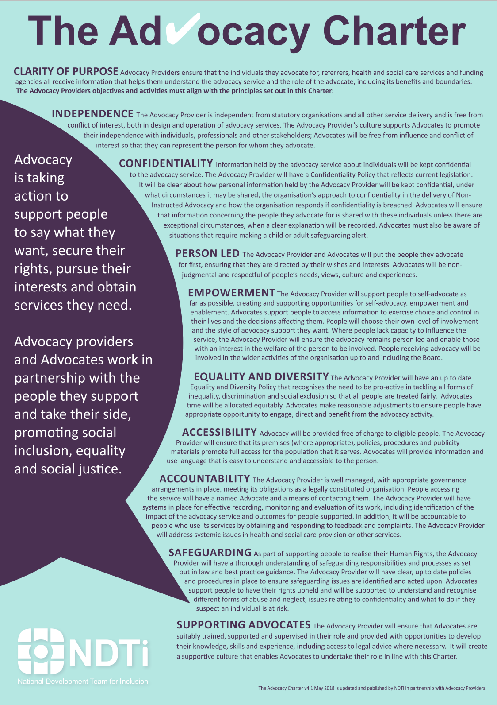
(Quality Performance Mark (QPM), 2023,a)

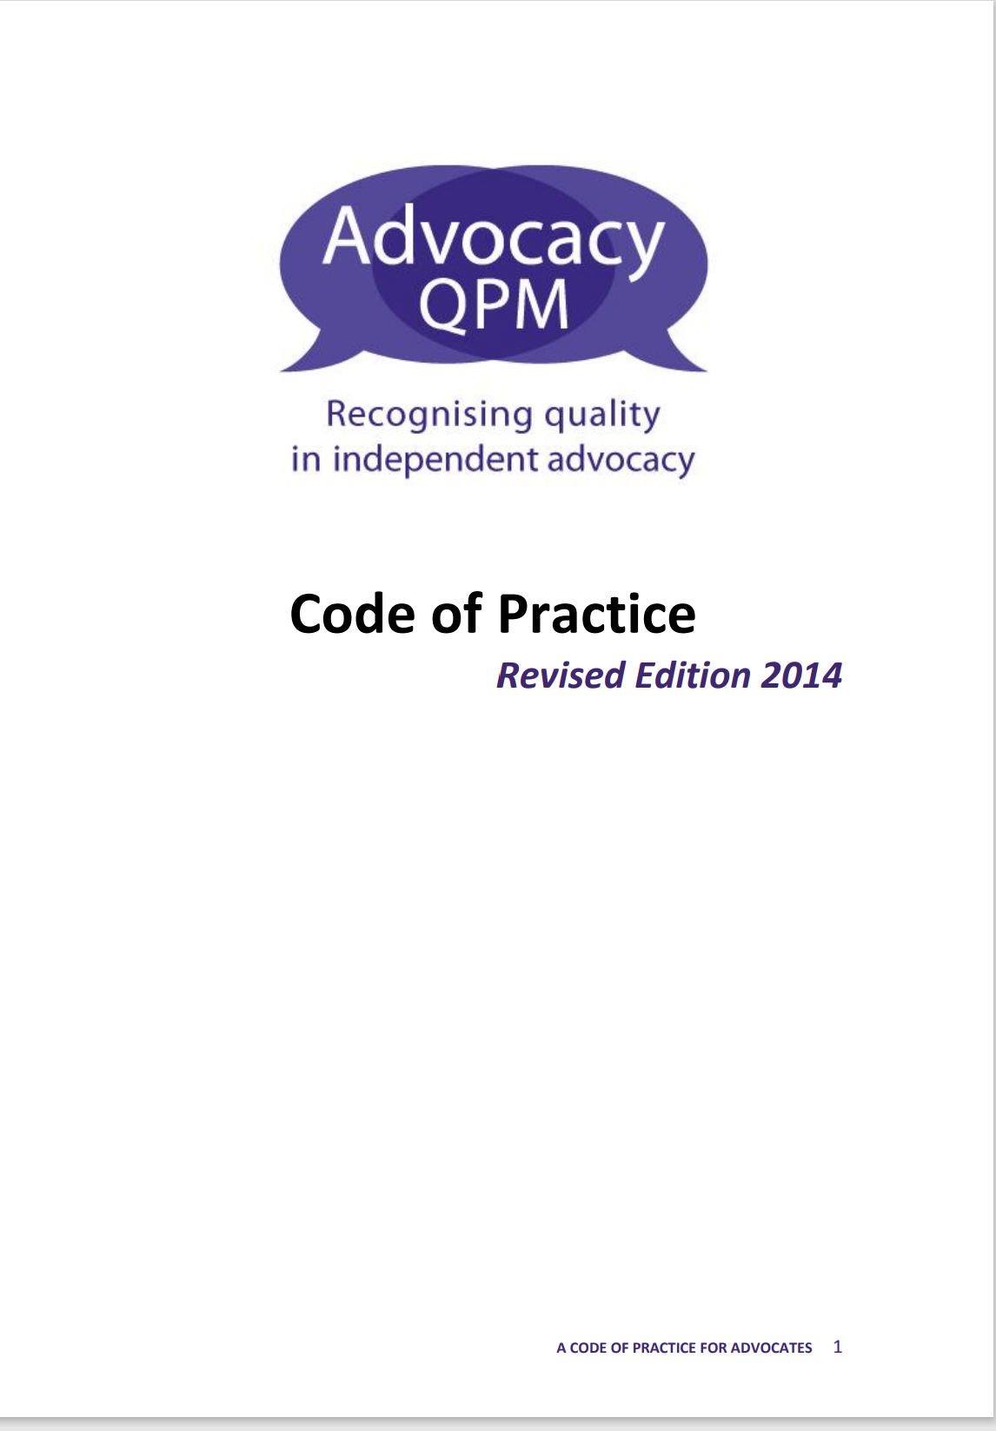
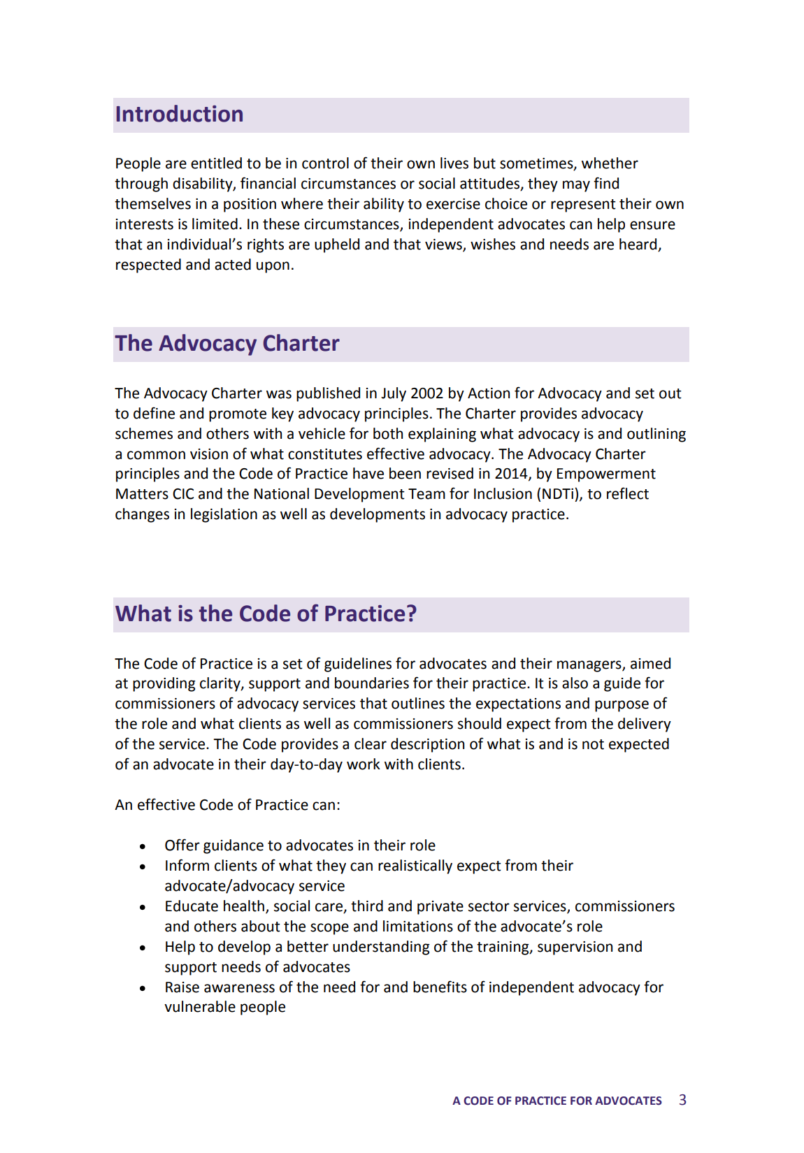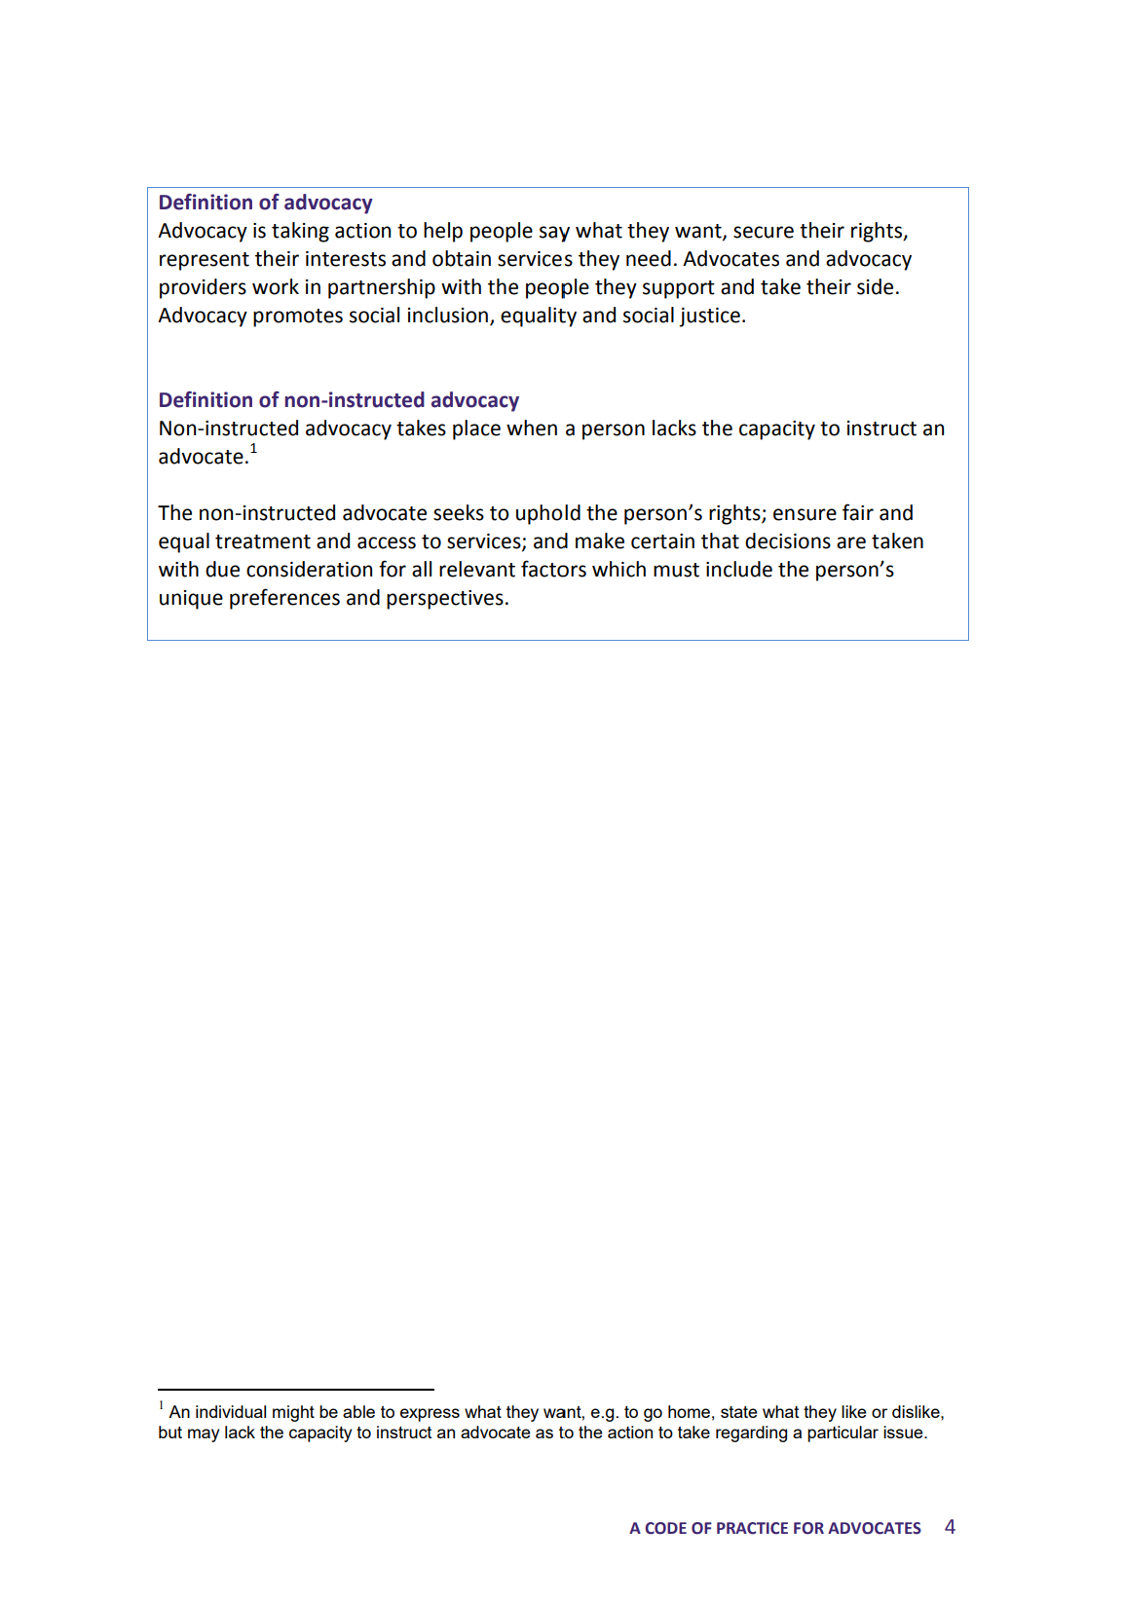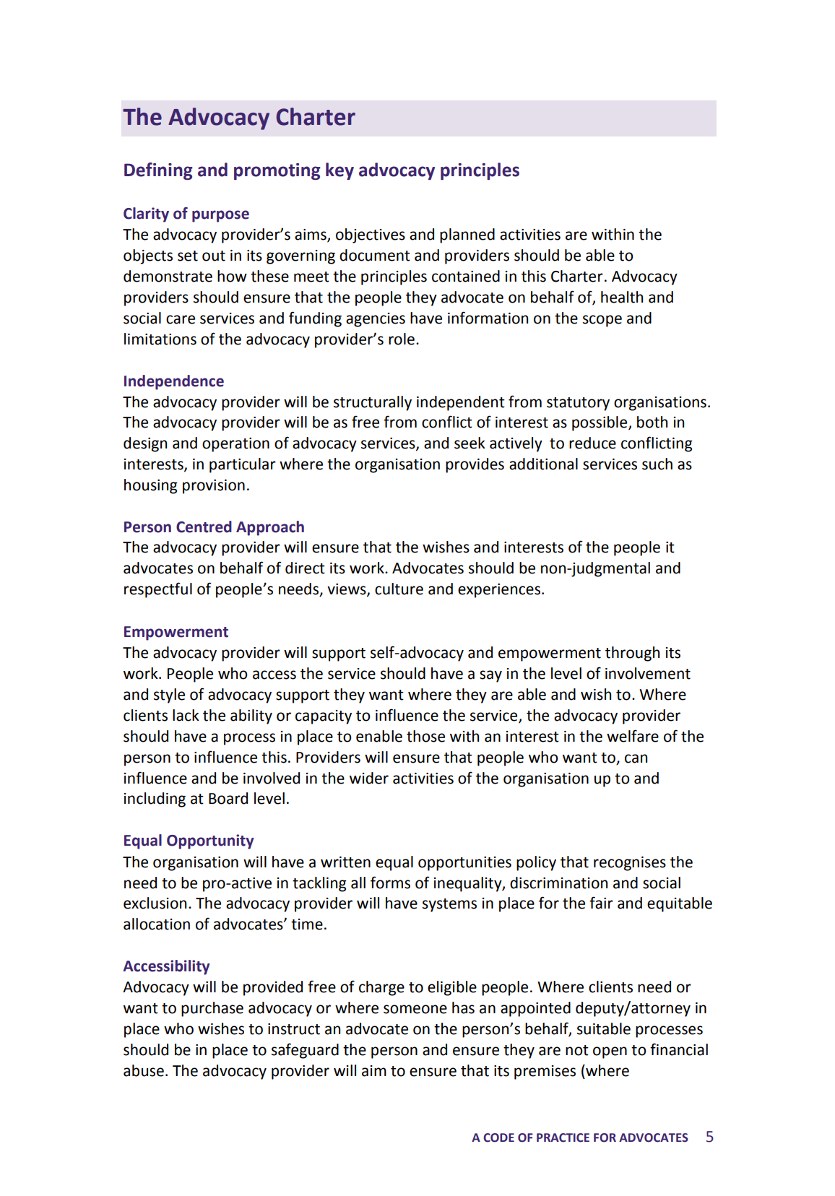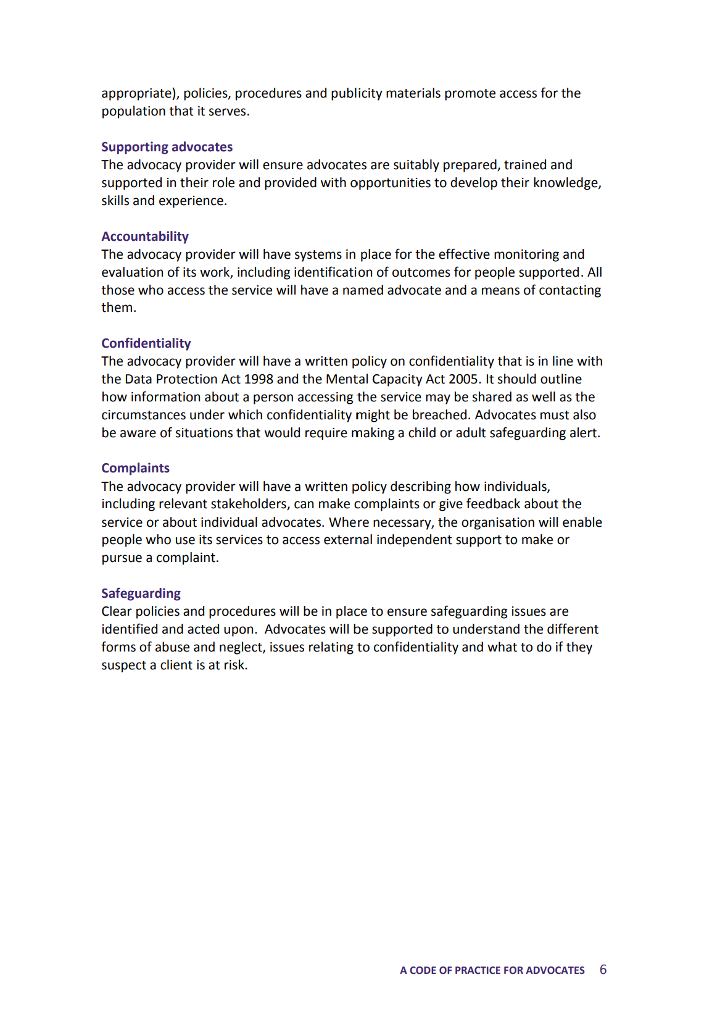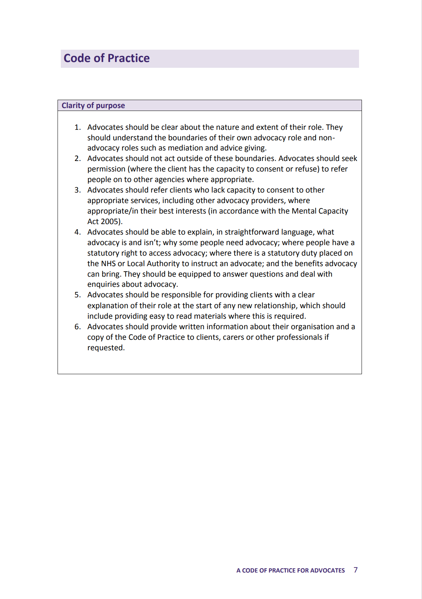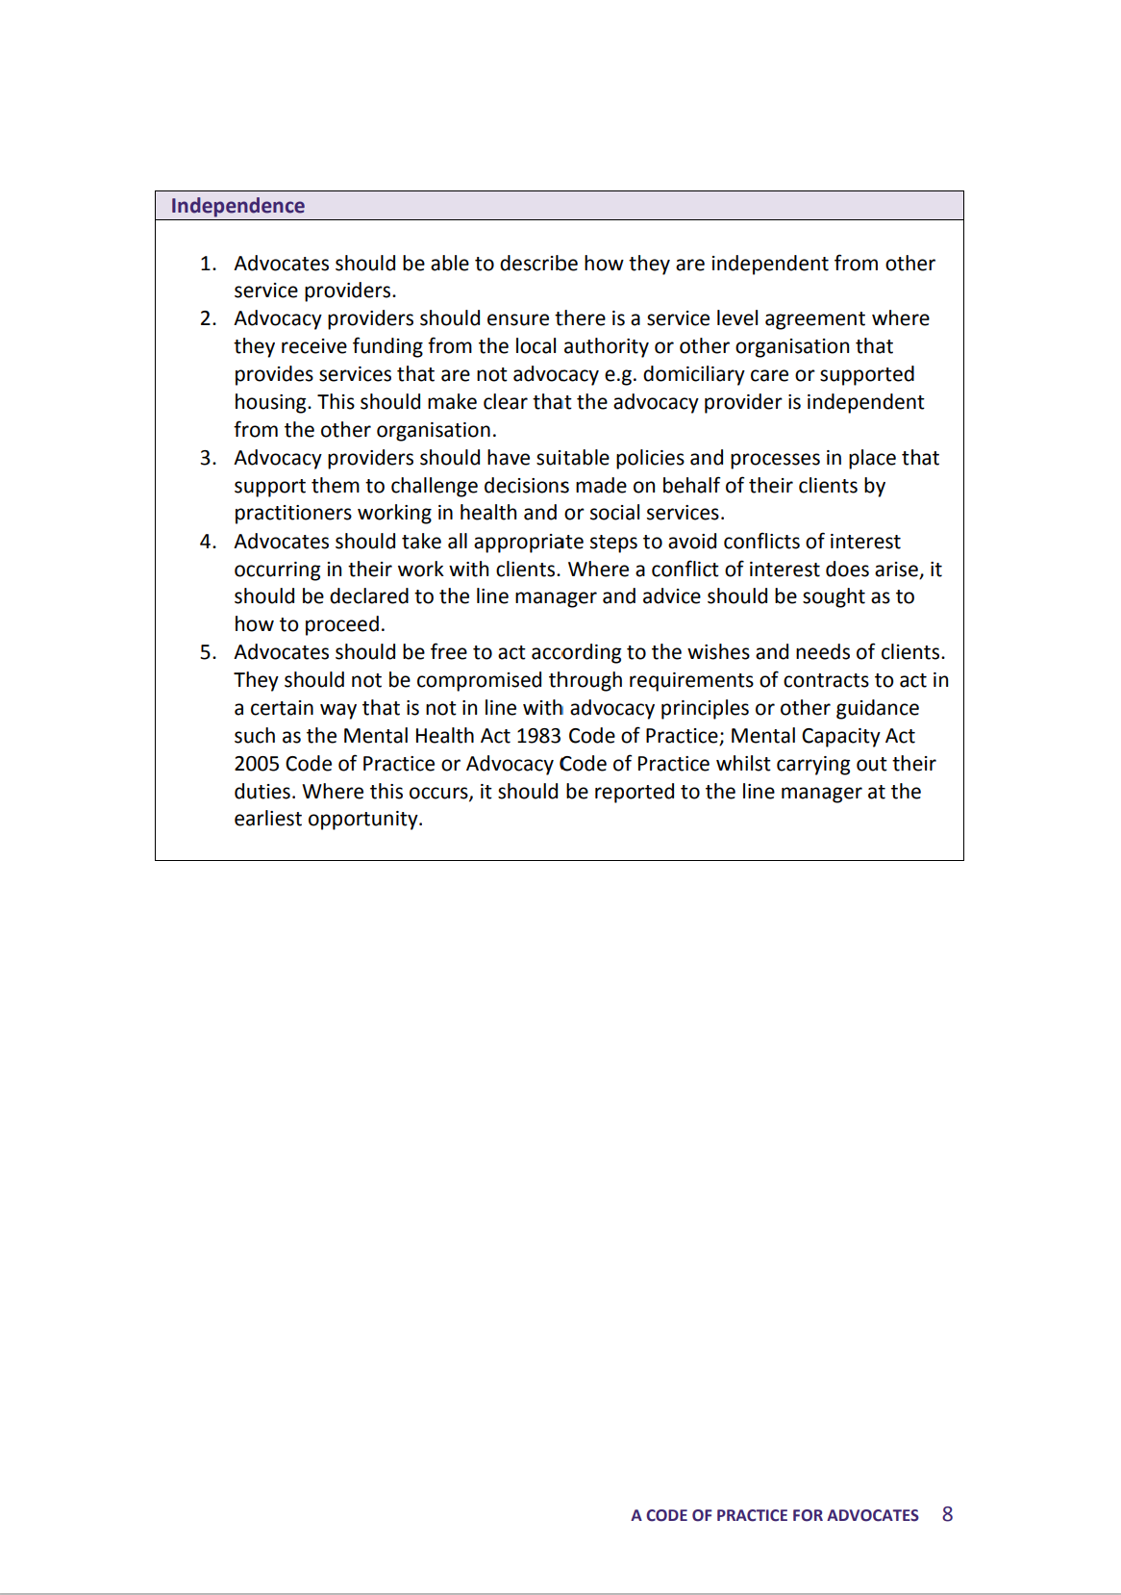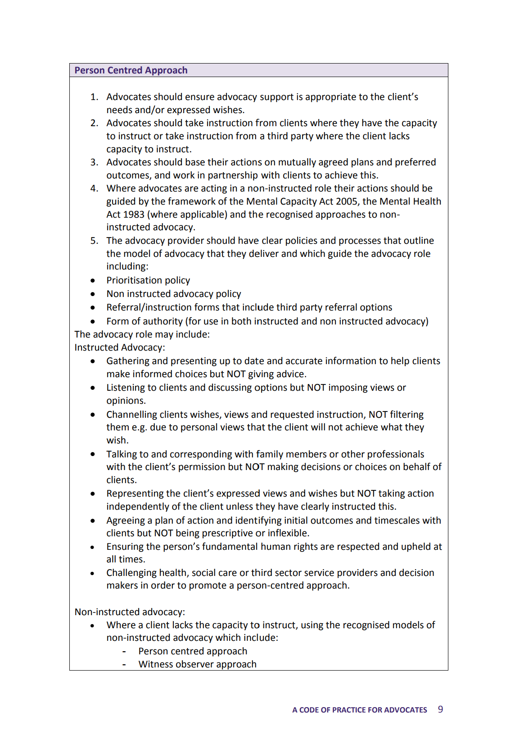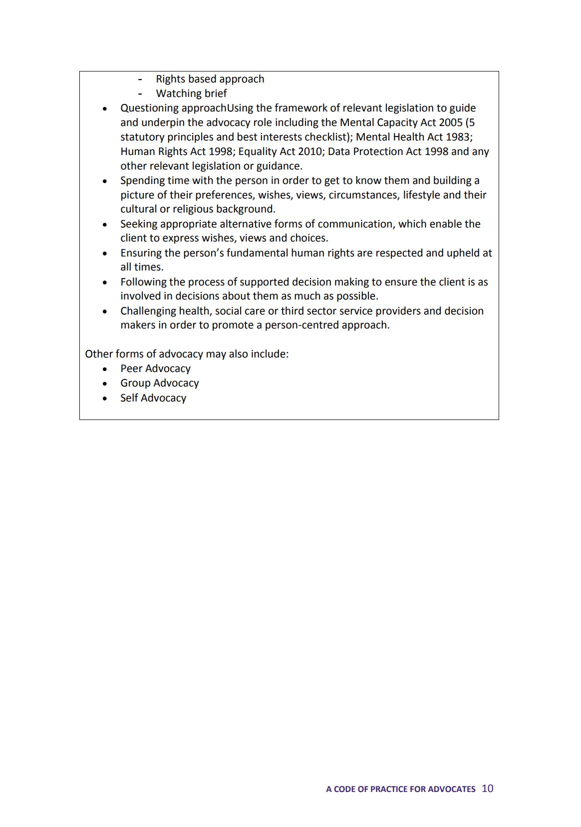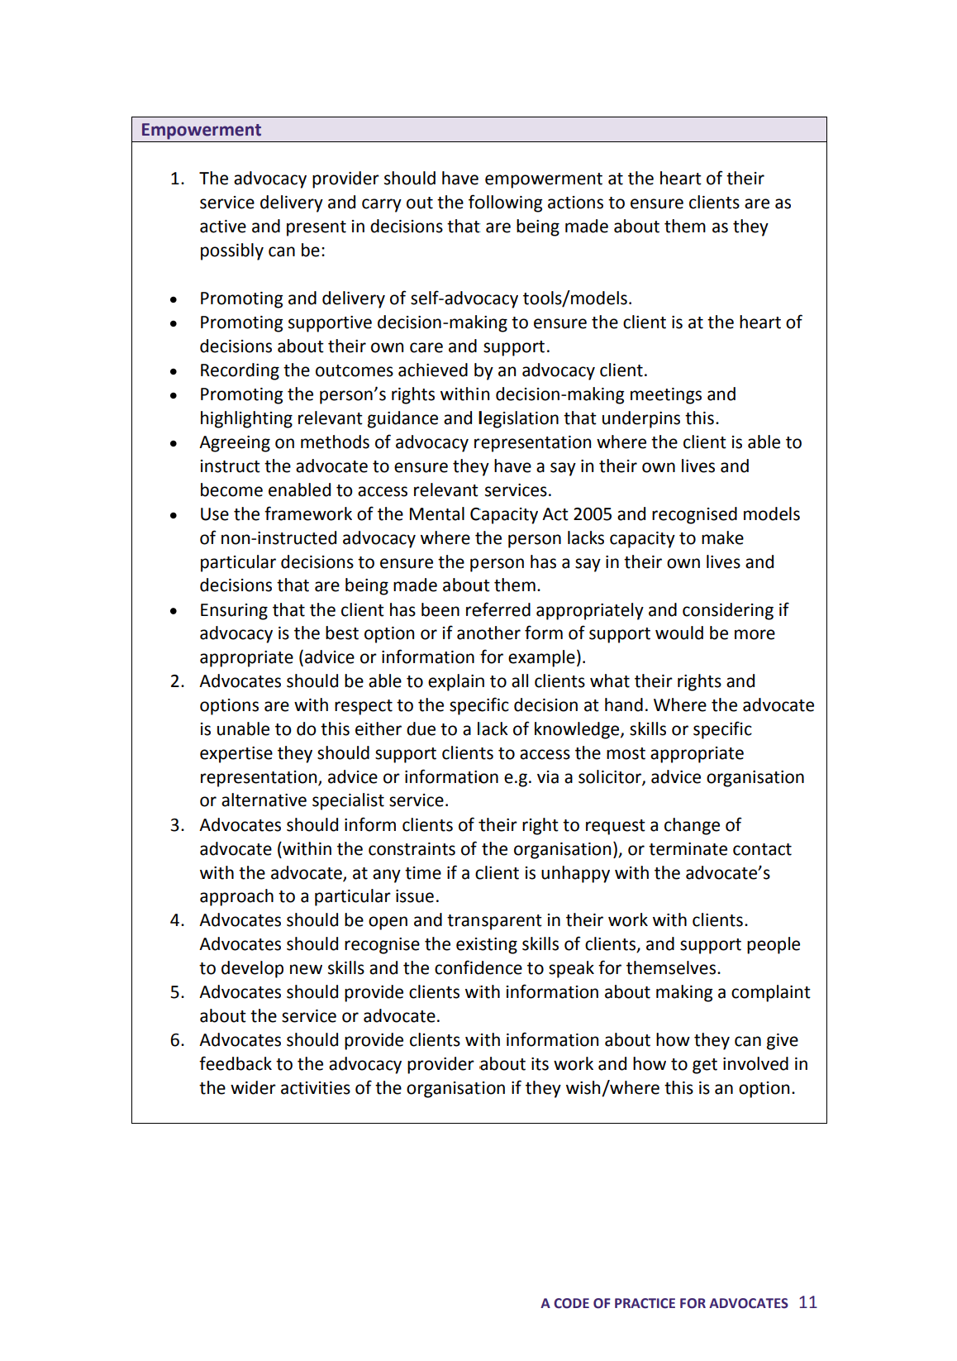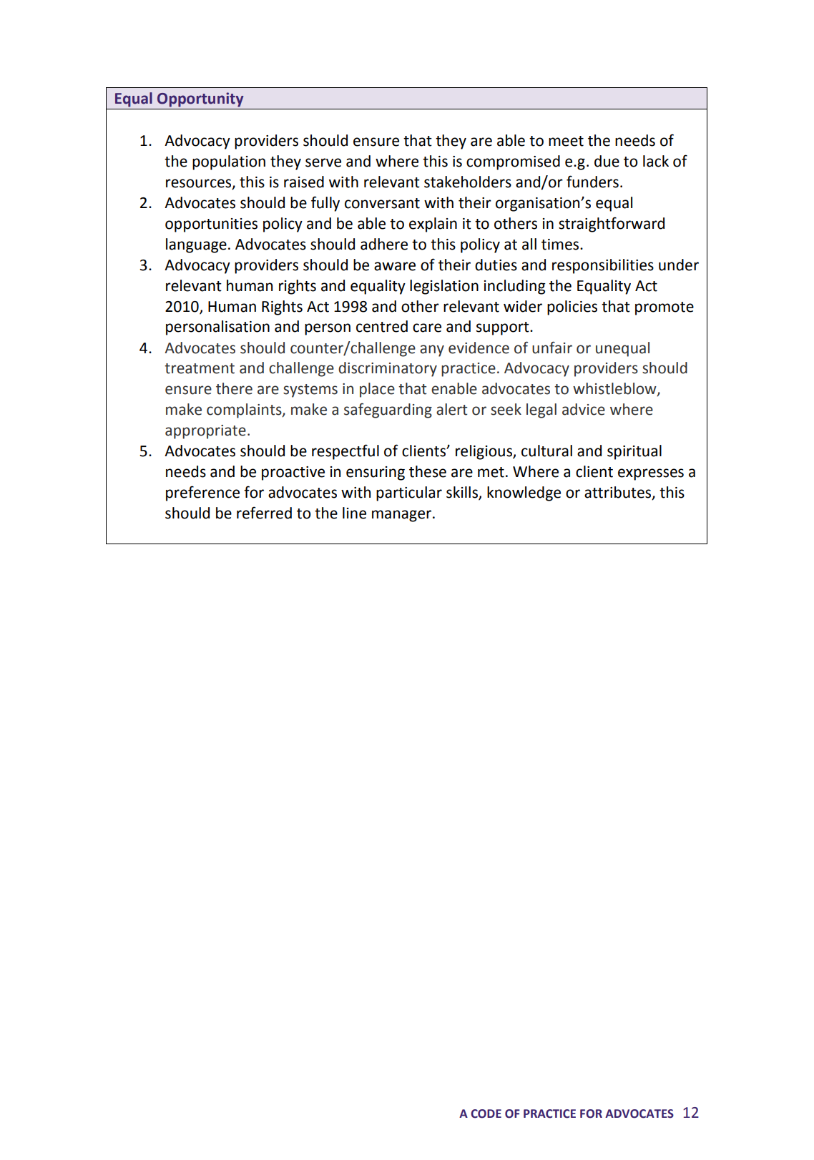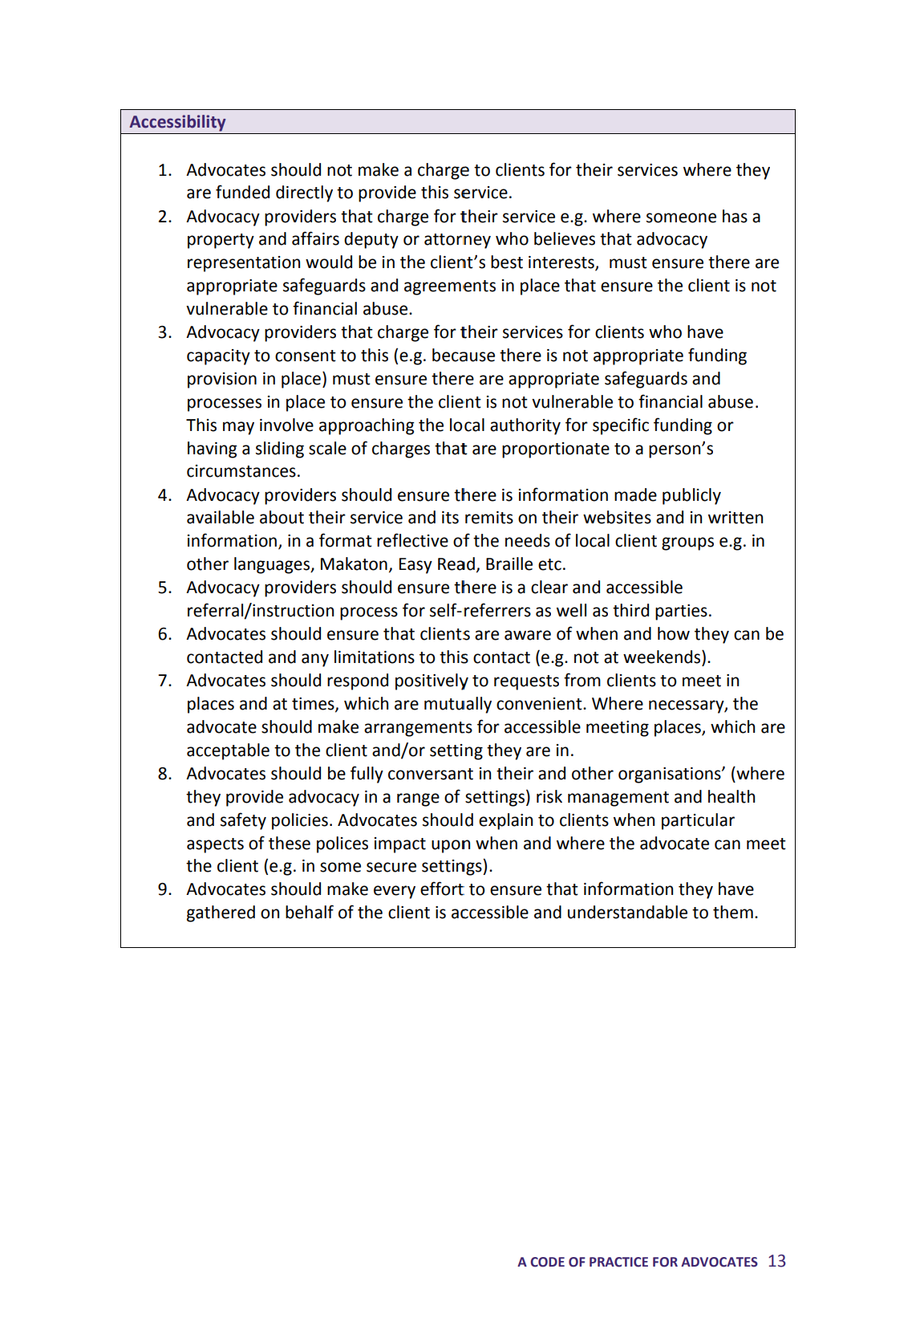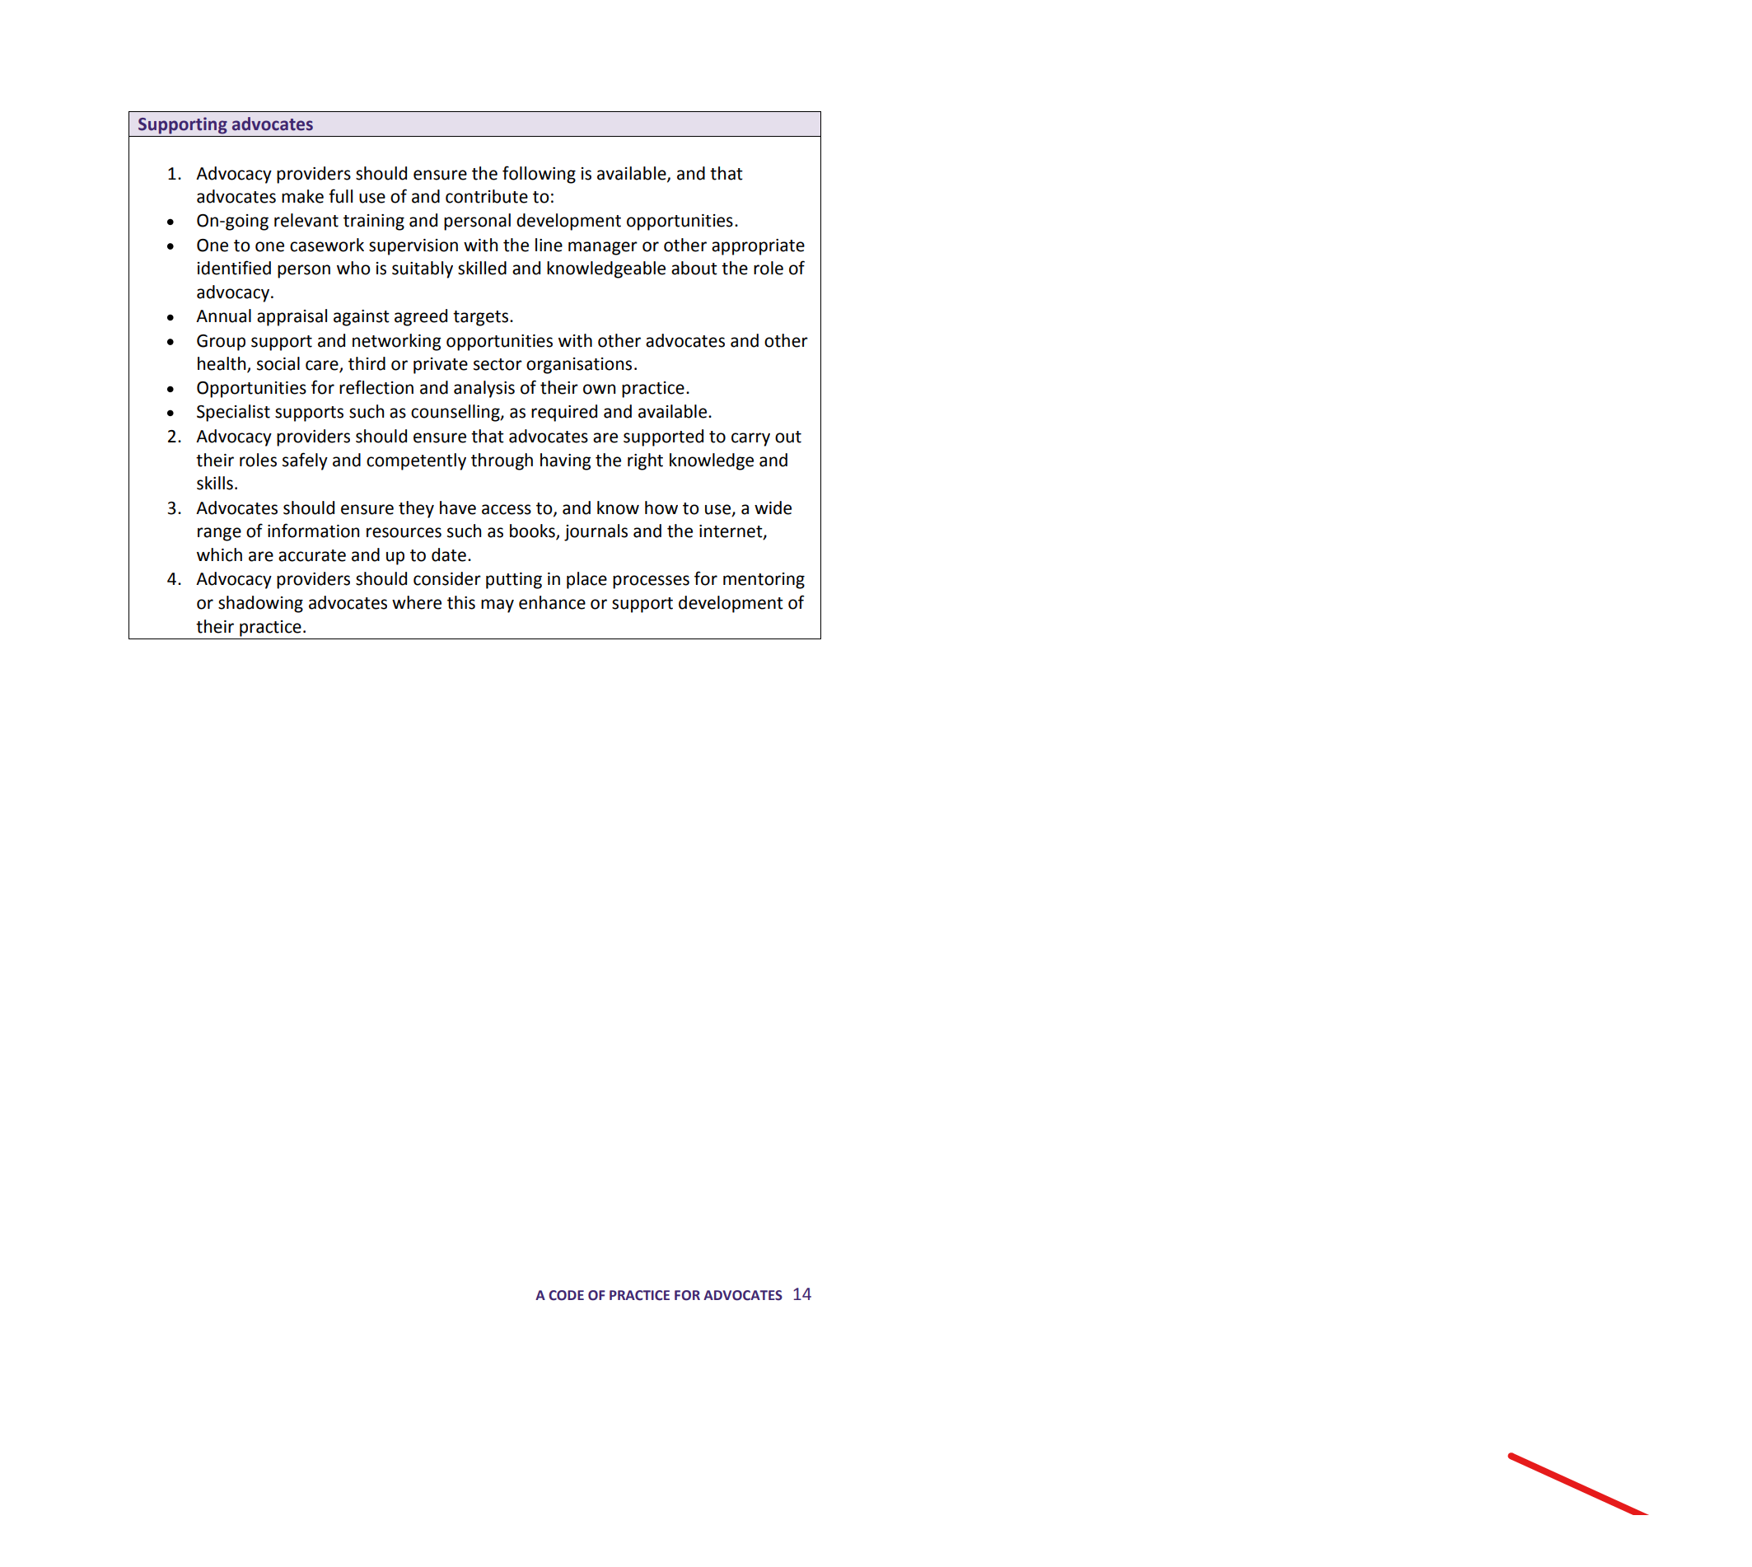
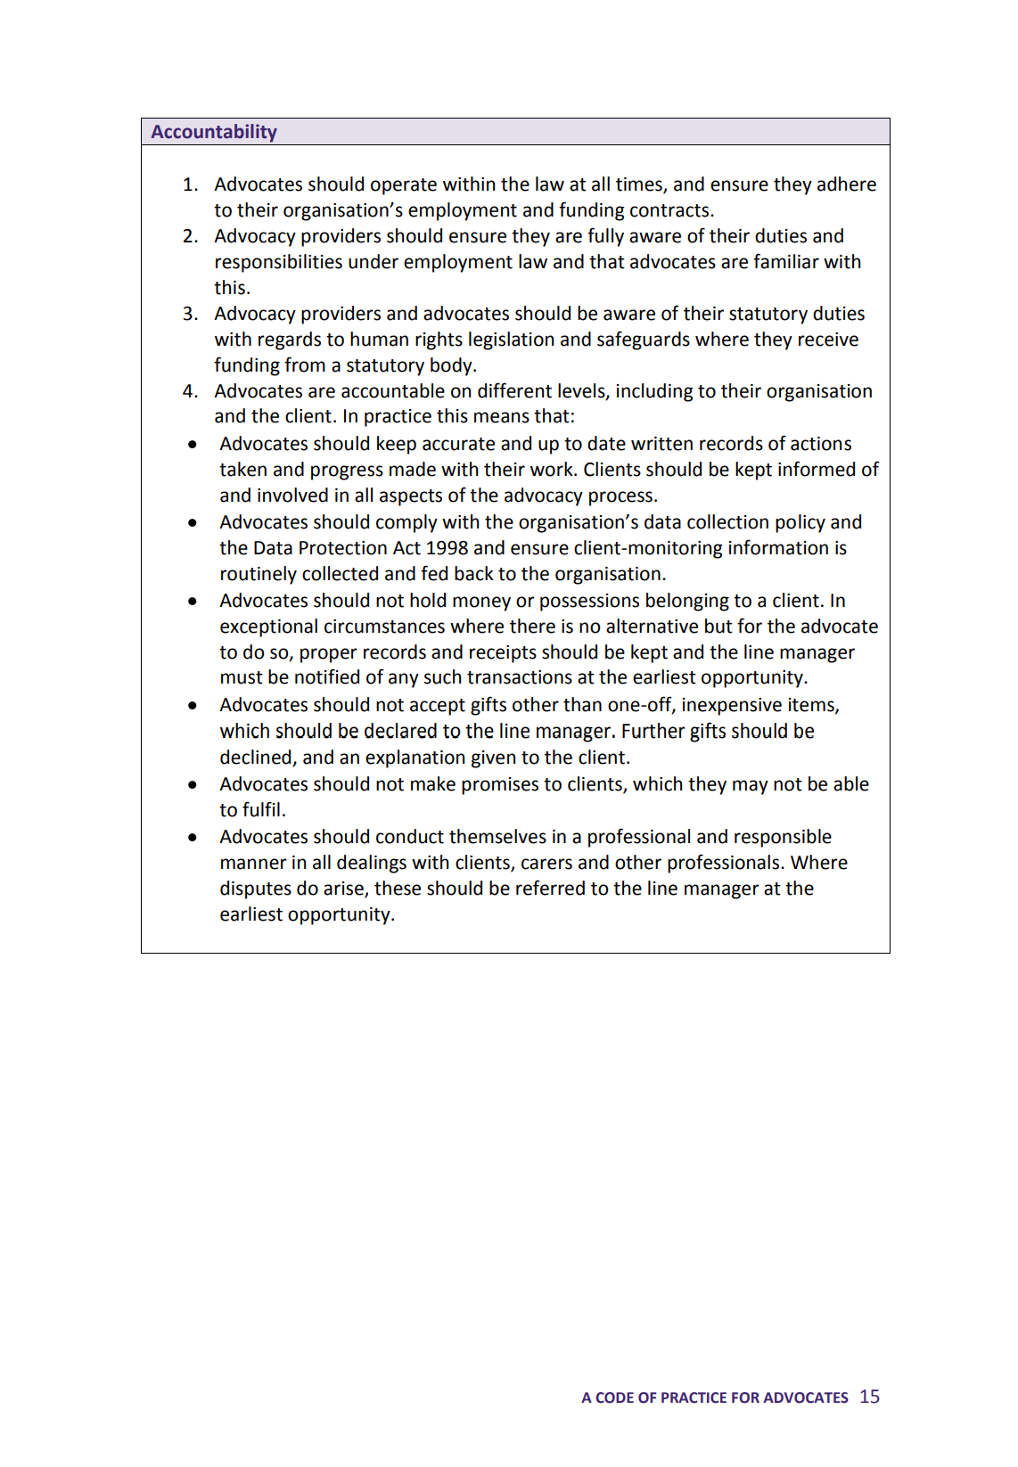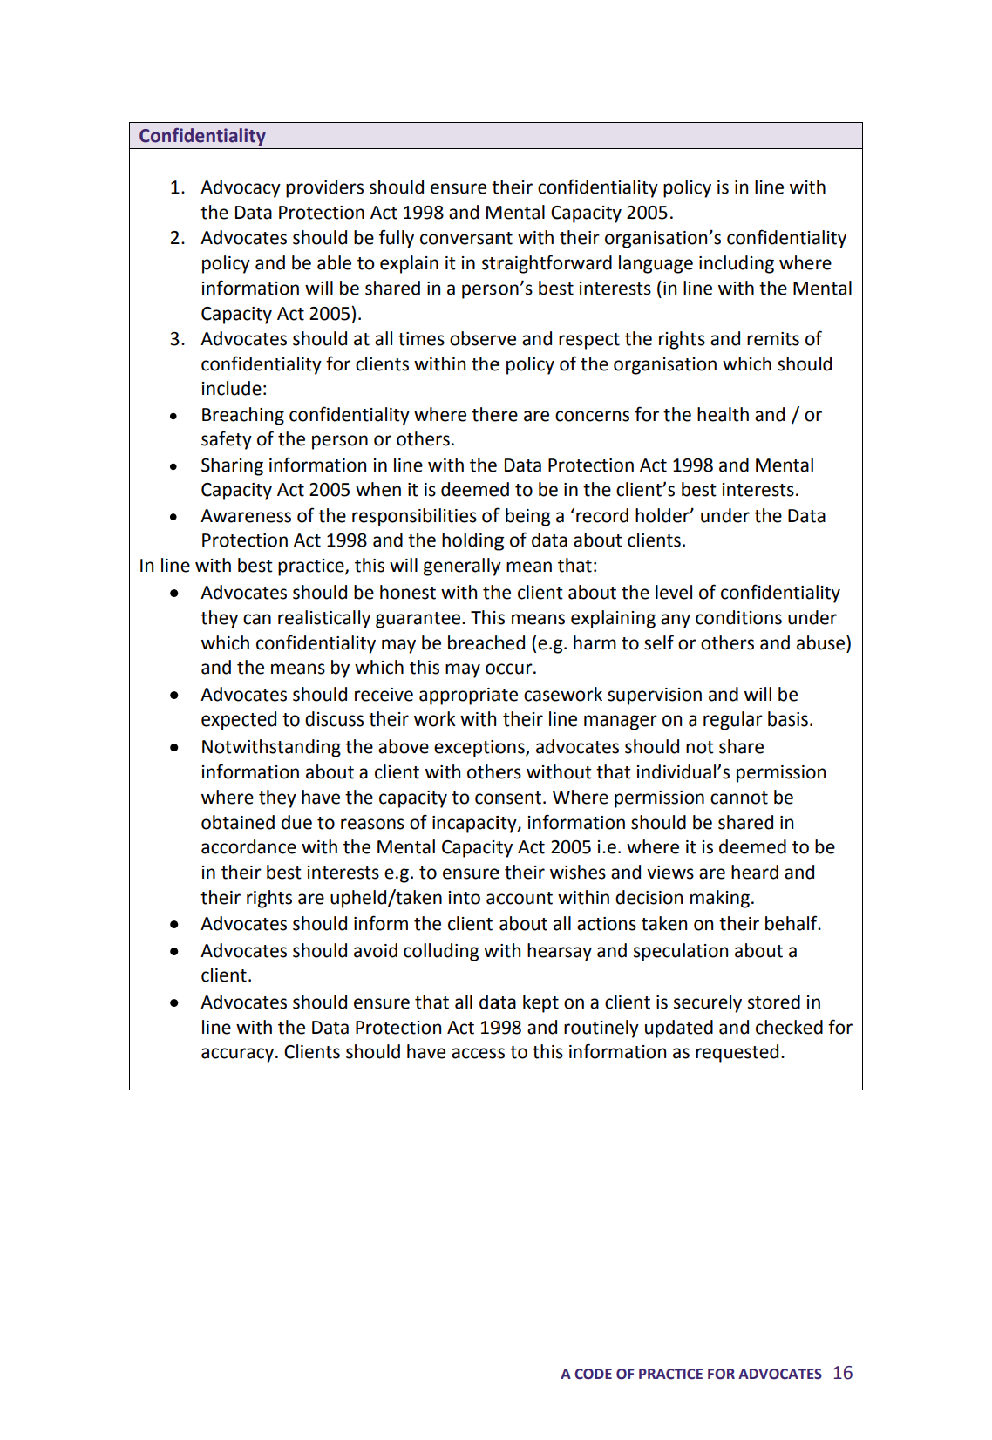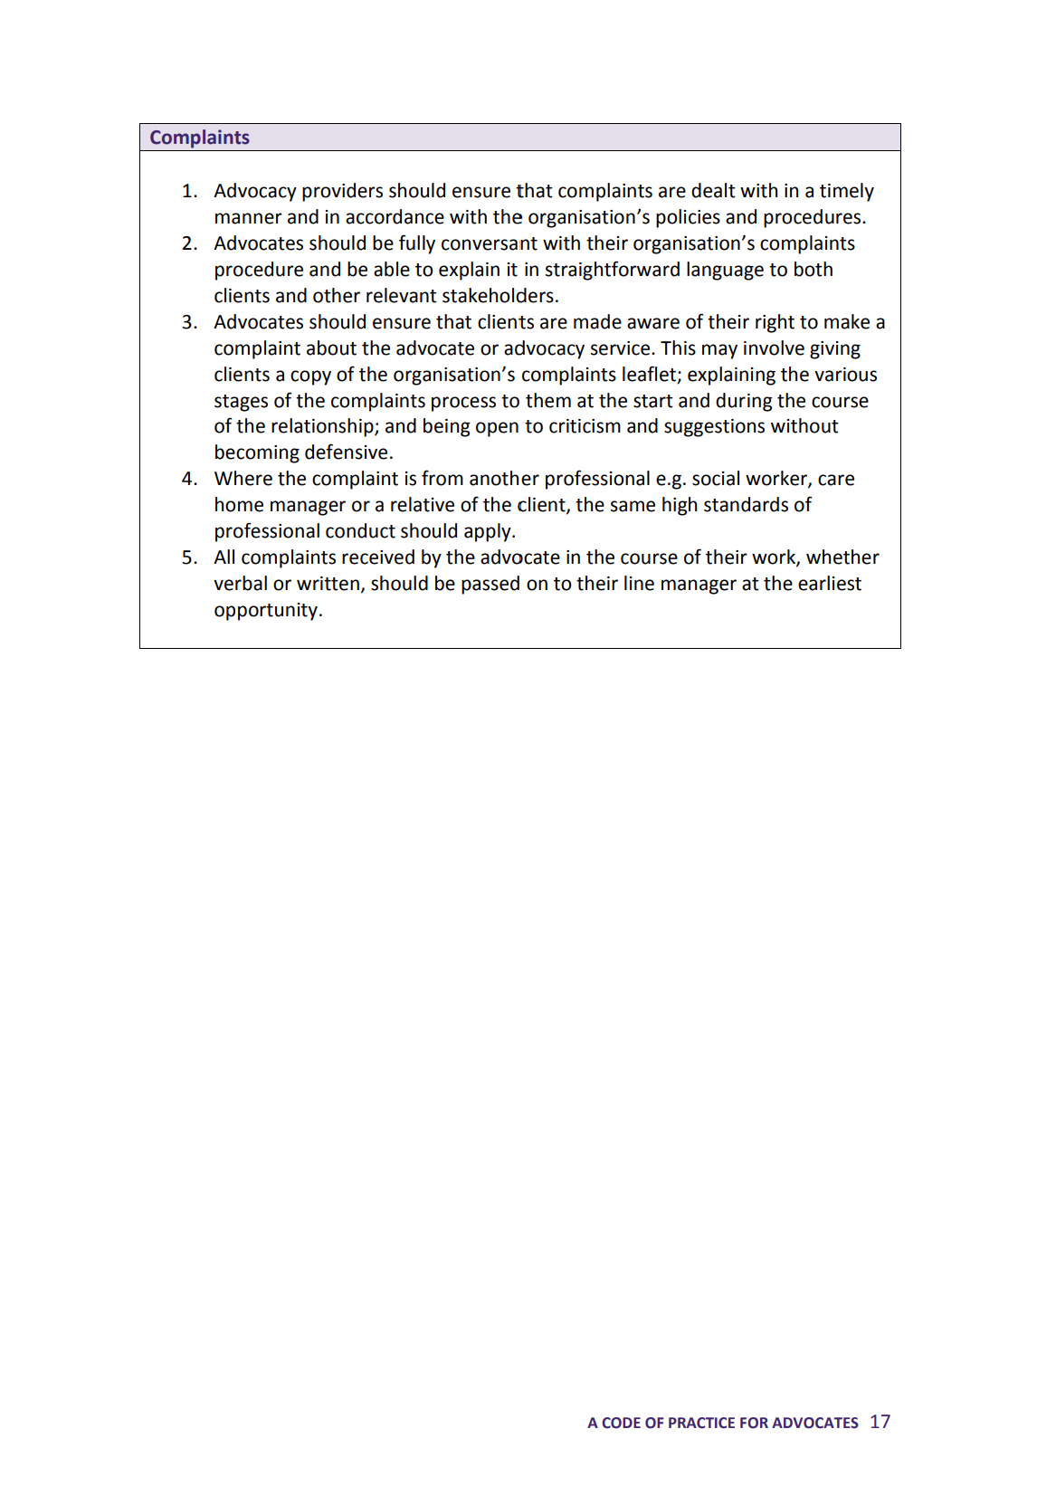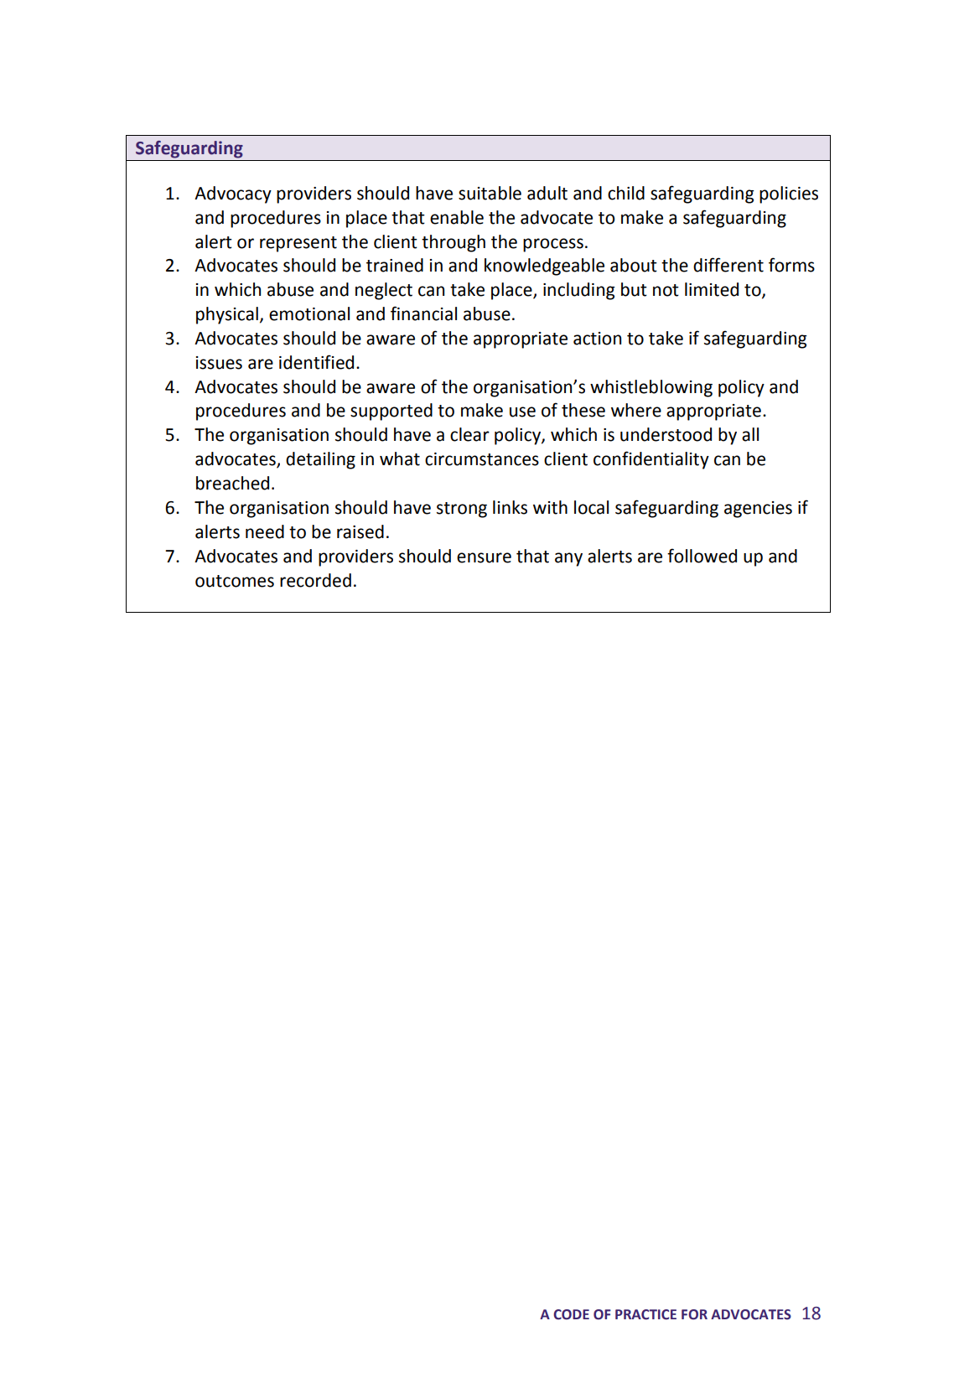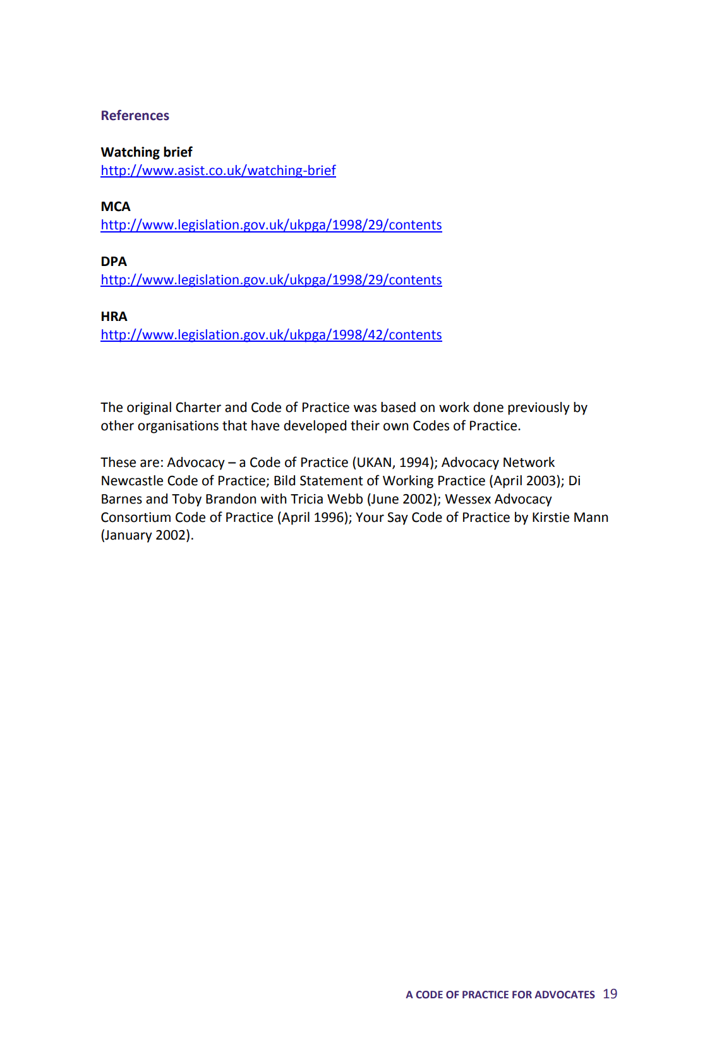
(Quality Performance Mark (QPM), 2023,b)

Appendix Three
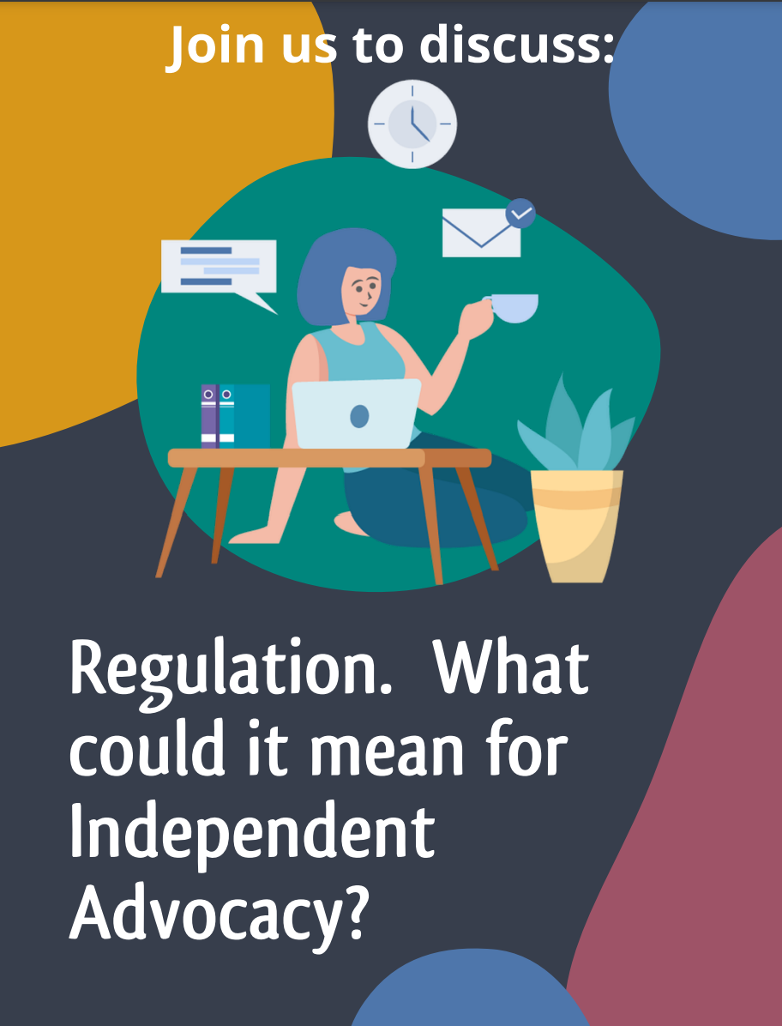

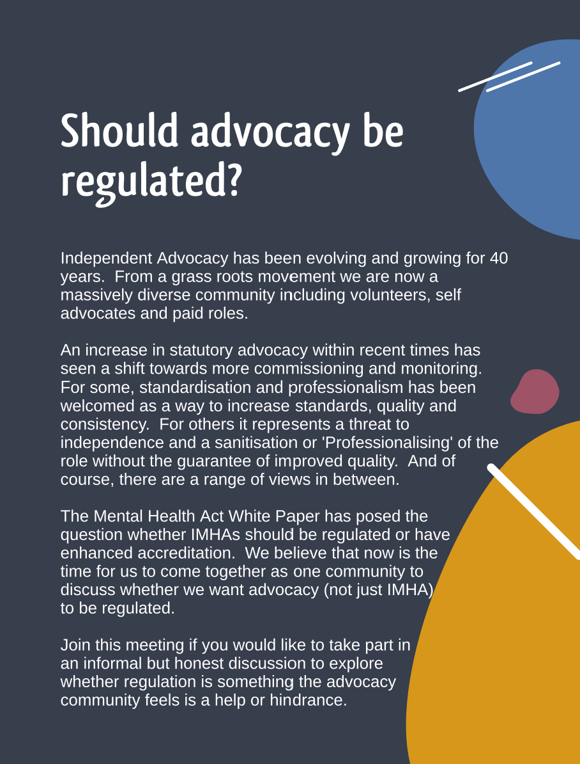
(QPM, 2021, C)

