

Student name: | Md. Rakibul Hasan | Student ID number: | 2438287
Programme: | MBA
Module: | Managing Marketing Change
Module code: | BMMB7026 | Contribution to Overall Module Assessment (%): | 75%
Lecturer: | Gwyneth Jones | Internal Verifier: | Marie Pitson
Assignment Title: | Future Developments in the Field of Marketing  (Individual Report) | Word count (or equivalent): | 3986
Assessment Title | A Critical Evaluation of Marketing Change and Future Marketing Strategy at Tesla
Submission deadline: | Wednesday 7th January 2026

Executive Summary
The electric vehicle (EV) market can be described as a shift in paradigm in a time of acceleration to a stable, competitive and highly regulated business environment through innovation. This report critically examines the functions and performance of the marketing activity of Tesla within this dynamic environment and provides further developments of marketing activity towards addressing the new strategic issues.
As it has been discussed, Tesla has been successful in history with a technology-based and innovative-oriented marketing approach combined with a favourable policy environment, first-mover and strong brand symbolism. However, in an EV market with maturity, there has been more competition, stronger buyer bargaining, and heightened regulatory control, which has reduced the applicability of this emergent and informal model of marketing.
The report identifies acute flaws in the existing Tesla marketing approach by subjecting it to the famous marketing and change management frameworks, including PESTLE, Porter's Five Forces, Ansoff Matrix, SWOT, STP and SOSTAC. These include a bad segmentation discipline, bad brand positioning versus mainstream customer expectations, bad marketing governing systems and bad performance measurement systems.
According to the report, Tesla must rebrand marketing as a customer-centric organisational capability that is strategically controlled and not the extension of product innovation. The SOSTAC-based recommendations propose the shift to positioning based on the experience, the improved target market segmentation, the integrated communications, and the elaborated customer-oriented performance metrics to assist the company in attaining the long-term competitive advantage in a developed EV market.

Table of Contents
Executive Summary 2
1. Introduction 4
2. Change and Evolution of the Marketing Market 6
2.1 Maturity and Shifting Customer Behaviour in the market 6
2.2 Implication of Change and Strategy in Marketing 6
3. Marketing Change Drivers: PESTLE Analysis 8
4. The Structure of an Industry: Porter's Five Forces 10
5. Ansoff Matrix Strategic Direction 12
6. SWOT Analysis 14
7. Segmentation, Targeting and Positioning (STP) 17
8. Evaluation of Marketing Activities 19
8.1 Governance and Communications of the brand 19
8.2 Marketing Control and Measurement 19
9. Conclusions 20
10. Action plan: SOSTAC Framework 21
Reference list 23

1. Introduction
Marketing is a very significant factor in the provision of organisations' response to environmental change by the creation of customer value and the preservation of competitive advantage. In dynamic and technology-driven industries, marketing extends beyond the promotion exercise and includes the organisational aspect of strategic coordination, the generation of customer insight and performance governance (Cameron and Green, 2024). As markets become mature, marketing transitions to trust, consistency and management of customer long-term value rather than creating awareness (Ali and Shabn, 2024).
One example of such a transition is the electric vehicle (EV) market across the globe. The factors that fueled the initial growth of the market included technological novelty, environmental discourses and strong policy enticements that reduce the risk of adoption and boost perceived value (Zaino et al., 2024; U.S. Department of Energy, 2023). However, the industry is now characterised by the growing level of competition, growing sensitivity to prices, tricky regulatory context, and shifting consumer demands (BCG, 2024). Tesla has also played a major role in changing the mindset of customers towards EVs and has been in a position to enjoy good brand equity and primacy. Nevertheless, as the pace of technological convergence and the evenness of competition increase, the factors that have led to the early success of Tesla are rapidly changing (Buchholz, 2024).
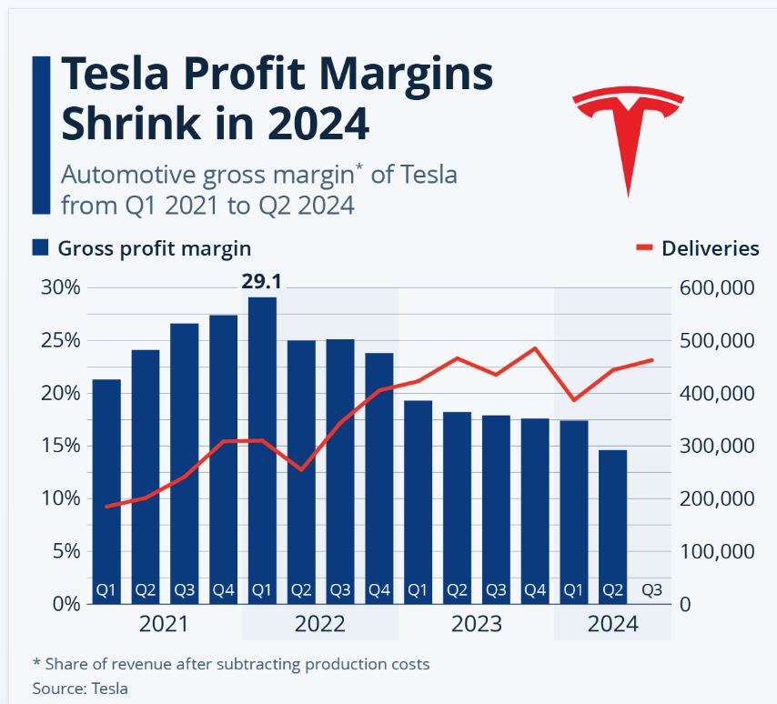
Figure 1: Margin Compression as an Indicator of Market Maturity and Competitive Parity in the EV Market (Buchholz, 2024)
The fact that Tesla automotive gross margins have been slowly declining in 2021-24 is empirical evidence of the maturation of the automotive industry and the increased level of price competition, which, per the shift to value-based and experience-based and relationship-based marketing, is required.
The present report is a critical evaluation of the marketing operations of Tesla in the context of the marketing change and market maturity. It assesses the efficiency of the current marketing strategy used by Tesla, demonstrates the key weaknesses of the strategy, and recommends the marketing evolutions in the future, relying on the familiar models of marketing and change management.

2. Change and Evolution of the Marketing Market

2.1 Maturity and Shifting Customer Behaviour in the market
The diffusion of innovation theory can be applied in the interpretation of the development of the EV market. Tesla's innovation-based positioning and earned media utilisation were hugely effective since the first movers were technologically oriented, environmentally oriented and symbolic product users (Hashem, Ruiz and Curras-Perez, 2024). The prices were accepted as being high, and the failures of the services were accepted instead of the supposed innovation and status in this segment.
As the market is shifting to the early and late majority adoptive status, the criteria of the consumer decision-making will shift dynamically. The mainstream consumers are risk-averse and pay attention to the cost of the product, its reliability, and services, in general, and the overall cost of ownership (Pamidimukkala et al., 2024; Yildiz, 2024). Then, technological innovation becomes a hygienic factor and not a differentiator. The additional overlap of EV technologies among the companies eliminates the historical reliance on the marketing benefit of Tesla based on innovation (Zaino et al., 2024).
The Tesla marketing logic has had its share of accommodating this behaviour change. The unspoken assumption that the early-adopter incentives may be easily handed over to the mass-market consumers has turned out to be unclear, and this has become a distortion in the positioning of the brand and the ever-evolving customer demands (Quaglieri and Mercuri, 2024).

2.2 Implication of Change and Strategy in Marketing
The marketing change theory distinguishes between emergent and planned change. Tesla marketing development has been primarily emergent, i.e. reactive pricing, unplanned communication shift and unorganised brand management (Dawson and Andriopoulos, 2021). Even though emergent change is flexible in the short run, it cannot be sufficient in situations when strategic realignment is required in the mature markets (Cameron and Green, 2024).
These environments require that the organisations must possess systematic customer insight practices, strict segmentation, coherent communications and effective performance control systems. It is imperative that the lack of an officially integrated marketing ability of Tesla restricts its aptitude to manage brand consistency, relationship and value development with clients in the long run since the outside influences become increasingly harsh (Ali and Shabn, 2024).

3. Marketing Change Drivers: PESTLE Analysis
External environmental factors have a tremendous influence on the Tesla marketing strategy because the electric vehicle (EV) market is entering the stage of maturity. The most significant drivers of marketing change to be laid emphasis on by a PESTLE analysis are those that are of a macro-environmental nature.
Table 1: PESTLE Analysis of External Drivers of Marketing Change at Tesla (Self-Made)
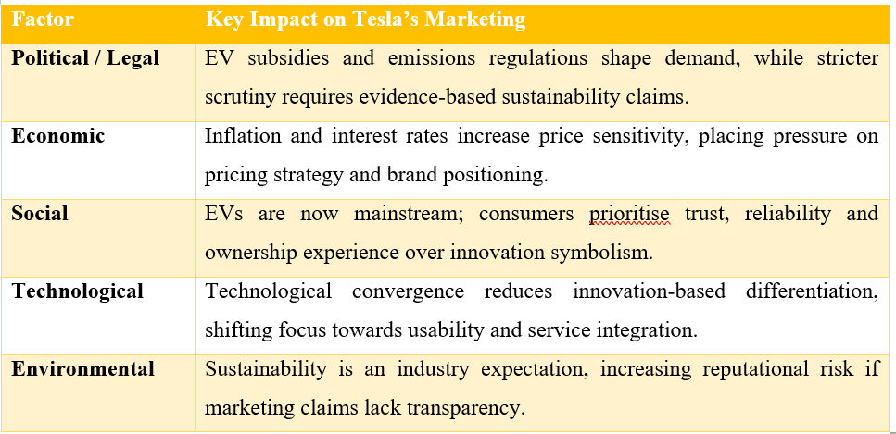
Political and Legal:
The government historically ensures the use of EVs with the help of subsidies and emissions limits and localisation, as it is more affordable and develops faster on the market (U.S. Department of Energy, 2023). However, the increased regulation of marketing flexibility is curbed now on the environmental and sustainability claims. Tesla also needs to ensure that advertisement messages are plain, backed by facts, and not against regulatory provisions, as exaggerated messages can cause reputational and legal harm to the brand (Tesla, 2024; Khalid and Anwar, 2024).
Economic:
The market of EVs has been more sensitive to consumer prices as a result of increasing inflation, an increase in the rates of interest, and cost-of-living pressures. Tesla, in turn, reacted by playing the price-cutting game that it had to do multiple times to restore the demand and maintain the sales volume (Buchholz, 2024). Though such a strategy works in the short term, it may result in losing a premium brand position, and it is introduced as an illustration of a strategic dilemma between the growth strategy that is founded on volume and sustainable brand equity (BCG, 2024).
Social:
As EVs become a product of the mass market, their customers are losing their fascination with symbolic innovation and are more concerned about trust, reliability and ownership experience. The shift of the decision-making processes and orientation towards the quality of services and reassurance is proven by empirical research (Pamidimukkala et al., 2024; Yildiz, 2024).
Technological:
The divergence in technology within the manufacturer of the EVs has brought about convergence, thereby eradicating the differentiation that is premised only on innovation. The marketing plans will then have to shift to the usability, service integration and experience management in the retention of competitive advantage (Zaino et al., 2024).
Environmental:
The industry has now become a demand for sustainability, and no longer a source of competitive advantage. This substantiates the claim that there is a necessity to have plausible, open and verifiable environmental marketing communications to maintain consumer confidence (Quaglieri and Mercuri, 2024).

4. The Structure of an Industry: Porter's Five Forces
The competitive environment of the electric vehicle (EV) market is analysed with the help of the Five Forces model developed by Porter, and the external forces that impact the marketing approach of Tesla as the market turned into a mature one (BCG, 2024).
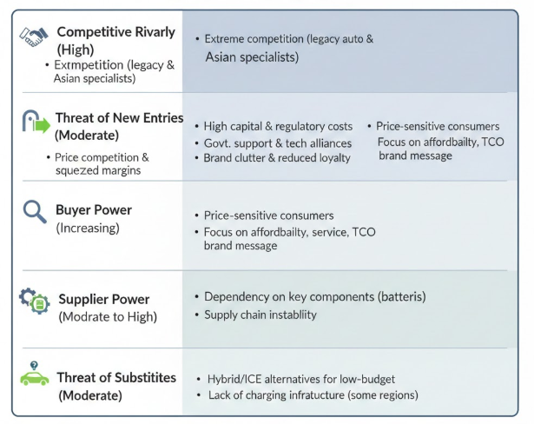
Figure 2: Porter’s Five Forces Analysis of the Electric Vehicle Industry (Self-Made)
Competitive Rivalry (High):
The competitive situation in the EV market is also extreme, and it continues to increase. Tesla competes intensely with the established car manufacturers and emerging EV specialists, particularly those in the Asian market. The influence of convergence in technologies has reduced differentiation in the essential EV features such as battery range, performance and digital interfaces and limited the ability of Tesla to position itself on the basis of innovation (Zaino et al., 2024). This has contributed to the long-term price competition and squeeze of margins that have been exhibited by the regular price reductions and the declining automotive margins (Buchholz, 2024). The high intensity of competition in marketing will mean a shift in focus, communication of value, trust and ownership experience.
Threat of substitute products (Low):
The threat of new entries is medium due to the capital amounts needed, the expense of meeting the regulations and economies of scale. However, the government support in some of the regions, notably the emerging markets, continues to be sustained by technological alliances and modular vehicle platforms (U.S. Department of Energy, 2023; Borden and Kuchler, 2025). This increases the clutter of the brand and competition among brands in the consumer's attention, culminating in reduced brand loyalty.
Buyer Power (Increasing):
The supplier's strength has been increasing tremendously with the growth of EV substitutes. As has been discovered, mainstream consumers are becoming price sensitive and risk averse and comparison motivated and becoming more focused on affordability, the quality of service and the total cost of ownership (He and Hu, 2024; Pamidimukkala et al., 2024). Growing buyer power puts Tesla's pricing policy under pressure and reduces the effectiveness of aspirational brand messages.
Power of Supplier (Moderate to High):
The supplier power is moderate to high since Tesla is dependent on such materials as batteries, which are key and specific elements. The supply chain instability and geopolitical insecurity increase the cost instability that indirectly restricts the marketing promise on the cost stability and dependability in supply deliveries (McKinsey, 2026).
Threat of substitutes (Moderate):
The threat of substitution is moderate. Low-budget consumers will be interested in hybrid engines and other mobility solutions (internal combustion engine), in particular in regions with low density of the charging infrastructure (Quaglieri and Mercuri, 2024).
Even though the Five Forces framework as presented by Porter is an apt description of the structural forces in the context of Tesla marketing change, the framework is lagging behind in terms of the role that the ecosystem forces, such as the integration of software and energy solutions, which remain the fundamental element of the Tesla value proposition, play (Roy et al., 2025).

5. Ansoff Matrix Strategic Direction
The Ansoff Matrix is employed to identify the strategic growth opportunities of Tesla and the alterations that would be introduced to the marketing sphere. The framework categorises the growth strategies based on the products and markets, giving a perspective on the risk exposure and the direction of the strategy.
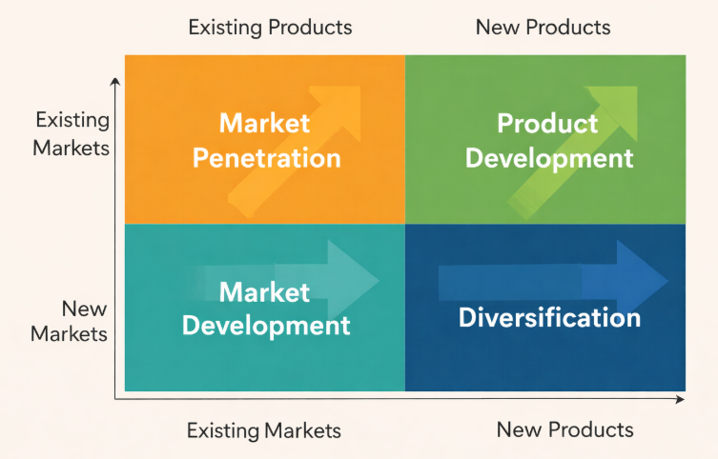
Figure 3: Strategic Growth Directions for Tesla Using the Ansoff Matrix (Self-Made)
Market Penetration:
Tesla's recent price reductions can be considered a type of market penetration strategy that is destined to stimulate the sales volume in the current markets. Such a strategy has been capable of creating a short-term demand in a setting where the uptake of EVs is slowing down (Buchholz, 2024). Market penetration is another marketing tool that is also helpful, as it makes use of the existing brand recognition and distribution channels, which reduces the feedback
Still, the limitations are rather significant. It is a threat of continued price reduction since it will erode brand equity, and brand Tesla as a producer of value rather than a producer of high-end innovations. The research indicates that the aggressive penetration pricing of the developed markets tends to result in price wars and compressions that reduce the long-run profitability (BCG, 2024). In this respect, market penetration provides tactical reprieve but a bad strategy position when misused.
Product Development:
Tesla has no strategy change, and the product development is founded on the new models of vehicles, software upgrades, and self-driving. These activities enhance the innovativeness of Tesla and the media attention (Borden and Kuchler, 2025). Ongoing narration of technological leadership is also an advantage to marketing.
The marginal differentiation of new features, however, is reduced by convergence in technology. Analysis of the EV market shows that innovation is turning into a hygienic factor and not a significant factor in purchases (Zaino et al., 2024). As competitors roll out similar technologies, experience-based marketing approaches will come in handy, and therefore, the product development will not suffice to sustain the competitive advantage.
Market Development:
The development can be marketed by means of geographic expansion; Tesla will be able to access the emerging markets. The competitiveness in the new spheres will enable the possibility of expanding the volume and diversifying the sources of revenue (Jain and Singh, 2024). The strengths associated with marketing include the need to use the international brand recognition to accelerate the entry.
Diversification:
Diversifying and entering the business into the energy storage sector, solar and artificial intelligence solutions is a high-reward strategy, yet risky, as taken by Tesla. The division will reduce dependence on automotive collections and contribute to the development of the ecosystem (Roy et al., 2025). Diversification will enhance Tesla's sustainability narrative and image of innovativeness in terms of marketing.
Ansoff Matrix is a useful strategic tool that categorises the growth opportunities of Tesla and its risks. But it is inherently fixed and is not responsive to the feedback loops between markets, products, and customer experience, which are iterative. The effectiveness of Tesla's marketing is based on the interdependencies within the ecosystem, i.e. software updates, which affect the value of the vehicle but do not lie within the scope of Ansoff. Consequently, the strategic direction is based on the matrix, which should be justified by flexible and customer-oriented frameworks, such as SOSTAC.

6. SWOT Analysis
It is a SWOT analysis to bring together the internal strengths and the external forces in Tesla to establish the viability of the Tesla marketing strategy in an electric car (EV) market that is maturing. This framework assists in strategic decision-making processes because it aids in aligning the organisational resources with the market-based opportunities and threats (BCG, 2024).
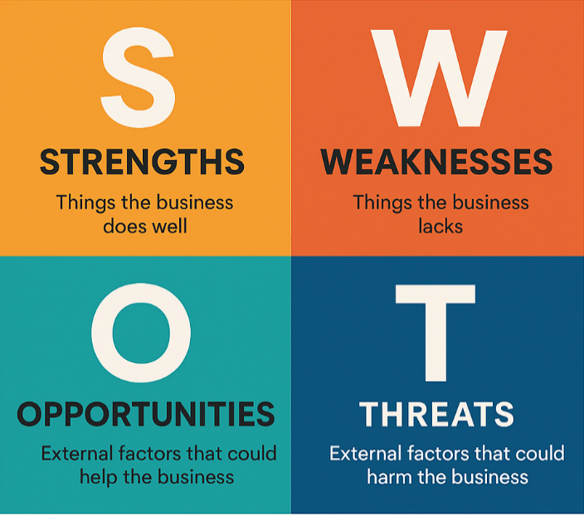
Figure 4: SWOT Analysis of Tesla’s Marketing Environment (Self-Made)
Strengths:
The biggest marketing advantage that Tesla has is its huge brand equity that has been built through consistent leadership in the sector of innovation and being the first mover within the EV market. Tesla was one of the first to arrive and could shape customer attitudes regarding the EVs as transformational and highly innovative technology, with a great earned media presence and brand promotion (BCG, 2024). Innovation in battery systems, software integration and autonomous driving also contributed to this differentiated positioning (Borden and Kuchler, 2025). However, it has been discovered that when EV technologies come together, innovation leadership becomes less effective as a long-term marketing differentiator (Zaino et al., 2024).
Weaknesses:
Tesla also has poor marketing governance and strategic control despite having a good brand equity. Marketing decisions remain casual, lacking a lot of discipline and division, and a lack of willingness to incorporate customer insight into strategic planning (Cameron and Green, 2024). Poor targeting has resulted in the establishment of confusion between the luxury and the mass-market positioning that supplements the chances of erroneous value propositions (Hashem, Ruiz and Curras-Perez, 2024). Besides, Tesla lacks a range of customer-oriented performance metrics, such as customer lifetime value and retention, which restrict organisational learning and accountability (Ali and Shabn, 2024; Kvíčala, Králová and Suchánek, 2024).
Opportunities:
The additional expansion of the mass acceptance of EVs is a massive advertising opportunity for Tesla. Empirical evidence suggests that mass consumers of EVs slowly become more aware of the reliability of services, ownership experience and long-term value over technological innovation (Pamidimukkala et al., 2024; Yildiz, 2024). This creates openings in the service differentiation and lifecycle marketing strategies, which can be used to increase retention and customer lifetime value (Ali and Shabn, 2024). By increasing the perception and experience-based positioning of customers, Tesla will be able to leverage the growing number of install base to build a long-term customer relationship in the first sale.
Threats:
The external threats that Tesla must address are growing competition on price, regulatory and reputational instability. One of the reasons that the industry statistics show has led to the narrowing of the margins is the increase in competition, which puts more pressure on prices and brand positioning (Buchholz, 2024). At the same time, the fact that the environmental claims would be under stricter regulatory control would increase the risk of reputational damage when the marketing messages exceed the abilities of the operation (Khalid and Anwar, 2024; Tesla, 2024). In addition, Tesla is prone to image uncertainty; the application of the type of communication that also depends on a leader predisposes Tesla to the image uncertainty, which undermines the trust of the risk-averse mass customer base (Quaglieri and Mercuri, 2024).
Table 2: Summary of Internal and External Strategic Factors Affecting Tesla’s Marketing Strategy (Self-Made)
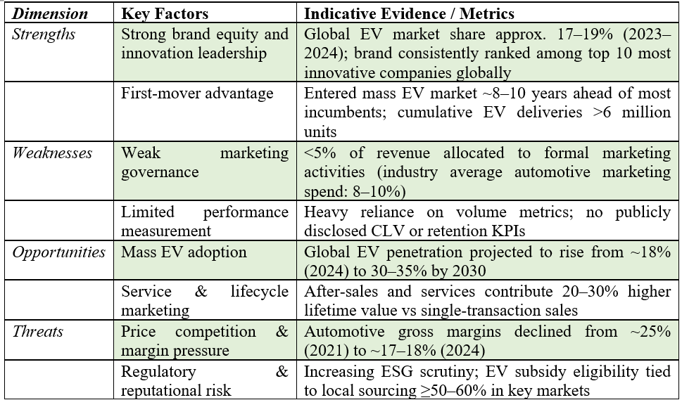

7. Segmentation, Targeting and Positioning (STP)
Segmentation, targeting and positioning (STP) offer a strategic framework for identifying separate customer groups and fitting the value propositions to their expectations. In a maturing electric vehicle market, effective STP is critical to ensuring coherence between Tesla's target segments, brand positioning and long-term competitive advantage.
Segmentation Theory:
The markets, according to the segmentation theory, comprise heterogeneous consumer groups that have various needs, motivations and risk perceptions. It was a strategically sound choice, as Tesla, as a company, has had a rich history of vehicles targeted at the early adopters who are rich, have been keen on technological innovation, green symbolism, and being a first-mover. These consumers were quite tolerant of the high price and the inability to provide uniformity in service, which enabled Tesla to concentrate on innovation rather than experience management. This similarity in the attributes that the segments were characterised with, as well as the value proposition, was a key factor in the early success of Tesla in the market.
Targeting Theory:
The targeting theory is concerned with targeting segments that the organisation can serve effectively and profitably. Tesla has responded to market maturity and competitiveness with a volume-based reaction to the current trend of targeting the mass market with aggressive price cuts. However, mainstream consumers are completely the opposite of early adopters because they have more to do with reliability, post-sales and reduction of risks. The act of pursuing expansion without suitable adjustment of the organisation, therefore, strains the strategies and risks of failing to meet the expectations.
Positioning and Strategic Fit:
Positioning theory focuses on consistency between the promise of the brand, expectation and actual delivery by the customer. This is a pragmatic decision criterion of mass-market consumers, and Tesla's remains aspirational and technology-oriented positioning, which are mutually incompatible. This perplexity poses a threat to blur the premier brand equity and equally to fail to meet the mainstream consumption end-customers, lacking segmentation rigour and positioning policy.
Table 3: STP Analysis Highlighting Strategic Alignment and Tension at Tesla (Self-Made)
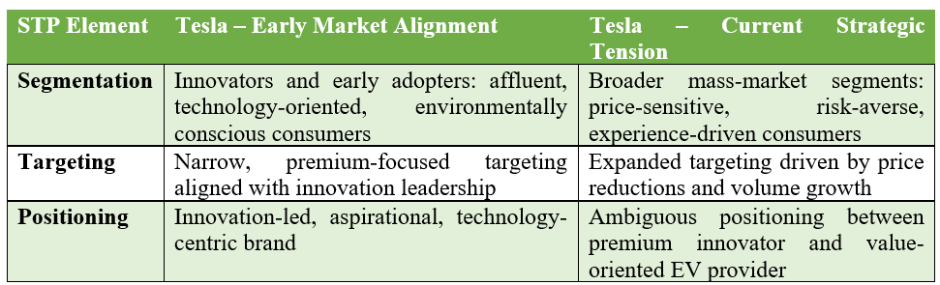

8. Evaluation of Marketing Activities

8.1 Governance and Communications of the brand
The earned media and communication, which is dependent on the leadership figure, was a strategic efficiency of Tesla in the early growth phase of the EV market, when the demand exceeded the supply, and the narratives of the innovation created an appeal towards their own. However, as the market matures and the competition increases, this approach proves a significant governance limitation (Quaglieri and Mercuri, 2024). The Integrated Marketing Communication (IMC) theory emphasises the consistency of the message, the credibility and control by the managers as the determinant of the development of trust among risk-averse consumers who form the majority audience. That Tesla continues to use informal and, in most respects, uncontrollable communicational channels exposes the Tesla brand to reputational turbulence, particularly when the Tesla leadership discourse takes the centre stage in brand narratives. This volatility in controlled and competitive marketplaces places the brand's dependability and customer trust at a disadvantage (BCG, 2024).

8.2 Marketing Control and Measurement
Effective marketing transformation would involve the presence of effective control systems, which would be able to tie the strategic objectives and measurable outcomes. The current state of the performance measurement at Tesla is on aggregate financial measurements involving vehicle delivery, revenue growth and market share. Even though these measures enable one to have a high-level understanding of organisational performance, they provide little visibility as regards the understanding of the marketing effectiveness or value creation to the customer (Kvíčala, Králová and Suchánek, 2024). Absence of customer-sensitive key performance indicators such as customer lifetime value, customer retention, costs of acquisition and campaign return on investment constrains organisational learning and strategic enhancement (Ali and Shabn, 2024). When marketing decisions are arrived at without the use of a systematic feedback system, the motive behind them is likely to be the immediate volume performance as compared to the long-term relationships-based value. This analytical control weakness compromises accountability on a more mature EV market, and Tesla would not maximise marketing expenditure and brand equity in the long run (Cameron and Green, 2024).

9. Conclusions
The Tesla marketing plan has been quite effective in the electric vehicle (EV) market in a phase of expansion, at an innovation-driven and policy-enhanced level. The firm had a high brand equity, first-mover advantage and technological leadership, hence it could create demand with very minimal formal marketing governance. However, as the EV industry moves to the maturity stage, the structural loopholes of the segmentation discipline, control and measurement of performance in the communications have started to be more accentuated. The ever-increasing competition, the convergence of technologies, and the rise in buyer power also predetermine the ineffectiveness of an informal, innovation-led marketing approach. The additional reliance of these practices may result in loss of brand equity, loss of confidence among the customers and failure in the long-term competitiveness. This implies that the strong will require a product strategic shift so as to rebrand marketing as a professional customer-based organisational capacity, a management of experience, analytical control and sustainable value creation along the customer lifecycle.

10. Action plan: SOSTAC Framework
The SSTAC framework is applied to provide a systematic and realistic approach to the marketing recommendations that Tesla can implement on the basis of the challenges identified in the analysis above. This model is fairly suitable as it relates strategic intention and action, and performance management in vibrant markets.

Figure 5: SOSTAC Framework for Marketing Strategy Development (Self-Made)
Situation:
Tesla has entered a mature and highly competitive EV market, which is featured by the convergence of technologies, price wars, a more regulatory world and evolving consumer needs. The inefficiency of the marketing governance, the discipline of the segmentation and performance measurement are the obstacles to the long-term efficiency, even though the good brand equity and innovation leadership remain to be regarded as its primary resources (BCG, 2024; Zaino et al., 2024).
Objectives:
Marketing objectives of Tesla should extend beyond short-term sales volume to the long-term value creation. The key objectives should be better brand consistency and trust, better customer retention, and customer lifetime value. More accountability on the functionality of the marketing is essential, particularly in the present market in which the cost of acquisition is rising (Ali and Shabn, 2024).
Strategy:
The recommendation is to implement a market-driven strategy that is geared towards experience-based refined segmentation and positioning. Tesla should differentiate its high-end and low-end segments, and value propositions must match the expectations of the segment. Its strategic focus would have to change to reliability, service quality and ownership experience as the priorities of the consumers of the mass-market (Pamidimukkala et al., 2024; Yildiz, 2024).
Tactics:
Tesla should consider using an integrated marketing communications (IMC) plan, which would align paid, owned and earned media, in order to reinforce this strategy. Lifecycle-based communication programmes should be formulated to mobilise the customers even after the purchase in order to enhance the trust, satisfaction and advocacy. To reduce the perceived risk, the mainstream buyers should be targeted in terms of reassurance communication and presence of the service (Hashem, Ruiz and Curras-Perez, 2024).
Action:
At the operational level, Tesla should invest in the marketing analytics, customer insight and the inter and cross-functional coordination between the marketing, sales and service staff. The execution of and strategic learning will be consistent in the market through the formalisation of the marketing government structures (Cameron and Green, 2024).
Control:
Finally, there must be good customer-based KPIs control systems, i.e. customer lifetime value, customer retention, the cost of customer acquisition and the returns on investment associated with customer campaigns. The steps will enable the consideration and optimisation of marketing strategy on a continuous basis, which will maintain competitive advantage (Ali and Shabn, 2024; Kvičala, Kralova and Suchanek, 2024).

Reference list
Ali, N. and Shabn, O.S. (2024). Customer lifetime value (CLV) insights for strategic marketing success and its impact on organizational financial performance. Cogent business & management, 11(1). doi:https://doi.org/10.1080/23311975.2024.2361321.
BCG (2024). BCG’s Most Innovative Companies Report: The Collection. [online] BCG Global. Available at: https://www.bcg.com/publications/most-innovative-companies-the-collection [Accessed 2 Jan. 2026].
Borden, K. and Küchler, S. (2025). Automotive product development: Accelerating to new horizons. [online] McKinsey & Company. Available at: https://www.mckinsey.com/capabilities/operations/our-insights/automotive-product-development-accelerating-to-new-horizons [Accessed 2 Jan. 2026].
Buchanan, D. and Badham, R. (2008). Power, Politics, and Organizational Change: Winning the Turf Game. doi:https://doi.org/10.4135/9781446280300.
Buchholz, K. (2024). Infographic: Tesla Profit Margins Shrink in 2024. [online] Statista Daily Data. Available at: https://www.statista.com/chart/29774/tesla-gross-margin-and-deliveries/?srsltid=AfmBOoqqoeDpL2om4rXjuQHqPISmAwAMWnm2RGdWYWYJSyVCgfmf1TKq [Accessed 2 Jan. 2026].
Cameron, E. and Green, M. (2024). Making Sense of Change Management. 6th ed. London: Kogan Page Publishers.
Dawson, P. and Andriopoulos, C. (2021). Managing Change, Creativity and Innovation. SAGE.
Hashem, M., Ruiz, C. and Curras-Perez, R. (2024). Understanding the Dynamics of Brand Love in the Automobile Industry. Journal of Theoretical and Applied Electronic Commerce Research, [online] 19(2), pp.1142–1163. doi:https://doi.org/10.3390/jtaer19020059.
He, X. and Hu, Y. (2024). The Decision-Making Processes for Consumer Electric Vehicle Adoption Based on a Goal-Directed Behavior Model. World Electric Vehicle Journal, 15(9). doi:https://doi.org/10.3390/wevj15090386.
Jain, M. and Singh, A. (2024). An Empirical Study on Electric Vehicle Adoption in India: A Step Towards a Greener Environment. Transport Policy. doi:https://doi.org/10.1016/j.tranpol.2024.07.018.
Khalid, A. and Anwar, A. (2024). Pro-environment consumer behaviour and electric vehicle adoptions: a comparative regional meta-analysis. Applied Economics, pp.1–25. doi:https://doi.org/10.1080/00036846.2024.2303407.
Kvíčala, D., Králová, M. and Suchánek, P. (2024). The impact of online purchase behaviour on customer lifetime value. Journal of marketing analytics. doi:https://doi.org/10.1057/s41270-024-00328-9.
Mckinsey (2026). What a teardown of the latest electric vehicles reveals about the future of mass-market EVs | McKinsey. [online] www.mckinsey.com. Available at: https://www.mckinsey.com/industries/automotive-and-assembly/our-insights/what-a-teardown-of-the-latest-electric-vehicles-reveals-about-the-future-of-mass-market-evs [Accessed 2 Jan. 2026].
Pamidimukkala, A., Kermanshachi, S., Rosenberger, J.M. and Hladik, G. (2024). Adoption of electric vehicles: An empirical study of consumers’ intentions. Transport Economics and Management, [online] 2, pp.359–366. doi:https://doi.org/10.1016/j.team.2024.11.001.
Quaglieri, L. and Mercuri, F. (2024). Investigating Consumer Behaviour Towards Electric Vehicles: A Systematic Literature Review. Circular Economy and Sustainability. doi:https://doi.org/10.1007/s43615-024-00461-8.
Roy, S.K., Dey, B.L., Brown, D.M., Abid, A., Apostolidis, C. and Christofi, M. (2025). Business Model Innovation through AI Adaptation: The Role of Strategic Human Resources Management. British Journal of Management, 36(2). doi:https://doi.org/10.1111/1467-8551.12894.
Spiteri, J. (2025). Driving Successful Transformations.
Tesla (2024). Corporate Governance | Tesla Investor Relations. [online] ir.tesla.com. Available at: https://ir.tesla.com/corporate [Accessed 2 Jan. 2026].
U.S. Department of Energy (2023). Department of Energy. [online] Energy.gov. Available at: https://www.energy.gov/ [Accessed 2 Jan. 2026].
Yildiz, B. (2024). Sustainable mobility and electric vehicle adoption: a study on the impact of perceived benefits and risks. Transport, 39(2), pp.129–145. doi:https://doi.org/10.3846/transport.2024.22413.
Zaino, R., Ahmed, V., Alhammadi, A.M. and Alghoush, M. (2024). Electric Vehicle Adoption: A Comprehensive Systematic Review of Technological, Environmental, Organizational and Policy Impacts. World Electric Vehicle Journal, [online] 15(8), p.375. doi:https://doi.org/10.3390/wevj15080375.

