

Human Resource Management

Assignment Title :- HRM Assignment-1
Module Name :- Human Resource Management
Module Code :- LCMB7000
Student Name :- Krupaben Hasmukhbhai Dhameliya
Student ID :- 2207957
Name of Lecturer :- Dr Mushfiqur Rahman / Dr Gladius Kulothungan
Submission Date :- 4th January 2023

Executive summary
This report analyses the current state of the labour market in the UK along with the emerging changes in the human resource strategies post covid post Brexit. For further analysis, the labour market is analysed using labour force, employment, unemployment rates, and claims through various graphs, figures, and data. For analysing the emerging changes in the strategies, Tesco company was selected. For analysing the changes due to post covid, remote and hybrid working, resilience, and flexibility were analysed and changes due to post-Brexit, communication, data and technology, leadership factors, and many more are analysed. To conclude, there has been a significant change in the strategies post covid and post Brexit which are necessary to understand as it directly or indirectly affects the resources of the company.

TABLE OF CONTENT
- Executive summary ……………………………………………………. 1
- Introduction ……………………………………………………………. 3
- The current state of the labor market in the UK ………………………. 4
- Emerging changes in human resources strategies post covid, post-Brexit external environment …………………………………………………. 10
- Emerging changes in HR strategies post covid ………………………. 10
- Remote working
- Higher flexibility
- Resilience is a challenge
- Emerging changes in HR strategies Post-Brexit external environment 12
- Conclusion ……………………………………………………………. 14
- References …………………………………………………………...... 15

Introduction
The labor market is also referred to as the job market which signifies the demand and supply of labor, wherein, the employers signify the demand, and employees signify the supply. The labor market is associated with the markets of goods, services, as well as capital. Employers demand labor as they are a key part of the manufacturing process because they are responsible for converting input into output (Doeringer and Piore, 2020). However, the employees or the individuals work as laborers and complete the production or the manufacturing process. On the other hand, human resources are a department that is responsible for screening, vetting, hiring, selecting, onboarding, promoting, training, firing, and paying, as well as giving benefits to the employees. The human resource strategy works as a roadmap in solving the challenges faced by the organizations along with considering the solutions which are beneficial to society as well (Hrebiniak, 2013). The input of the human resource manager is required for creating policies, talent management deciding compensation, elevating the significance of corporate culture, succession planning, along with recruitment. This paper analyzes the current status of the labor market in the United Kingdom along with the changes in the human resource strategies after covid and after Brexit.
The current state of the labor market in the UK

The workforce and the population of the UK are ageing hence it is significant to understand the importance of the economic labor market. Everyone above the age of 16 is either economically active, employed, unemployed, or economically inactive. Employment signifies the people who are working, including part-time workers as well. However, if people are searching for some works for more than 4 weeks are classified as unemployed (Moodysanalytics, 2022). People who are not working and are not considering working for the next few weeks are known as economically inactive which includes students, disabled people, and people looking after their families.
The participation rate of the labor force in the UK increased in October 2022 to 63% which is more than 62.9% as compared with the previous month (CEIC, 2022). The labor force of the UK, in the year 2021, amounted to 34,653,319 which shows a decrease from the year 2020, where the labor force amounted to 34,679,986 whereas the population in the year 2021 was 67,326,569 which is more than the population of the year 2022. In the graph, the thin line denotes the population and the other line denoted the labor force in the UK (Theworldbank, 2022).
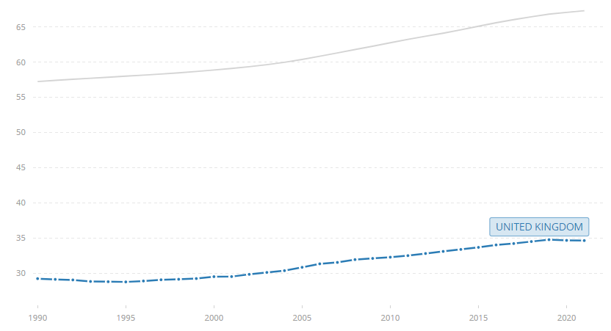
Figure 1 Labor force, total - United Kingdom
(Source: Theworldbank, 2022)
The labor force in the UK has increased over the past year. As of October 2021, it amounted to approximately 53,775 NSAAR, while as of October 2022, it amounted to 53,966 NSAAR. In September 2022, it amounted to 53,956 which shows an increase of 0.02%. However, a major change arose from June to July 2022, in June it amounted to 53,826 NSAAR, and in July the amount was 53,900 which shows an increase of 0.14% (Moodysanalytics, 2022).
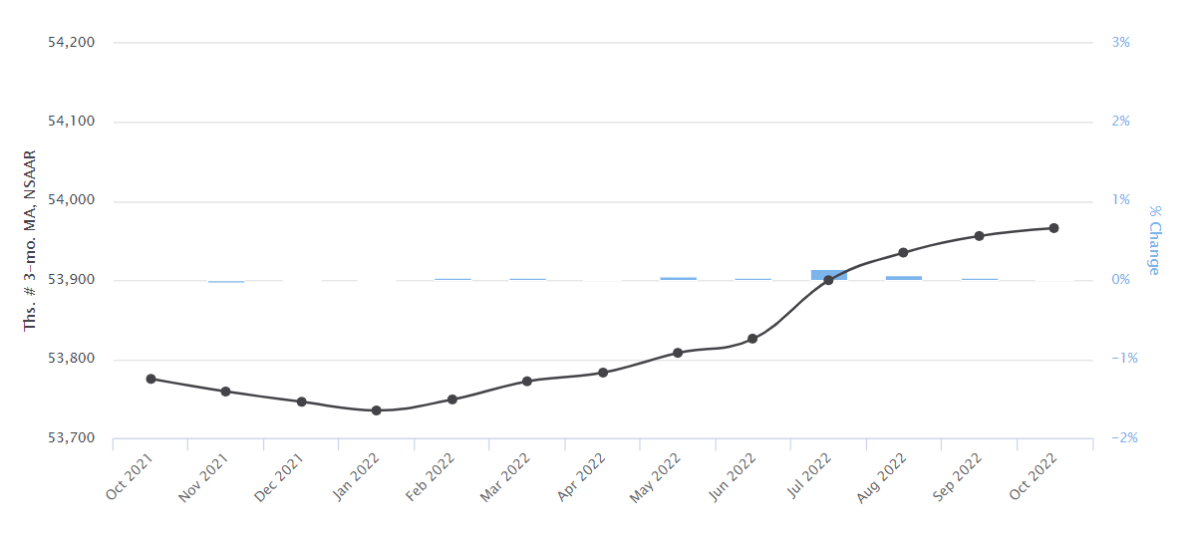
Figure 2 United Kingdom - Labor Force
(Source: Moodysanalytics, 2022)
This table shows the labor force in October 2022 amounted to 53,966 which is slightly greater than the last month which amounted to 53,956. The labor force employment in October 2022 amounted to 32,773 which is better than the previous month which amounted to 32,739, however, the unemployment in October 2022 amounted to 1,247 which is 0.1% more than the previous month which amounted to 3.6% (Moodysanalytics, 2022). The wages and salaries are measured quarterly which is Mil. GBP, SA 11 reflecting a great increase in comparison to the previous quarter which was Mil. GBP, SA -13. However, agriculture employment is measured annually and as of 2017, it amounted to 376,298 which shows a decrease from the previous year as it amounted to 378,714 (Moody analytics, 2022).

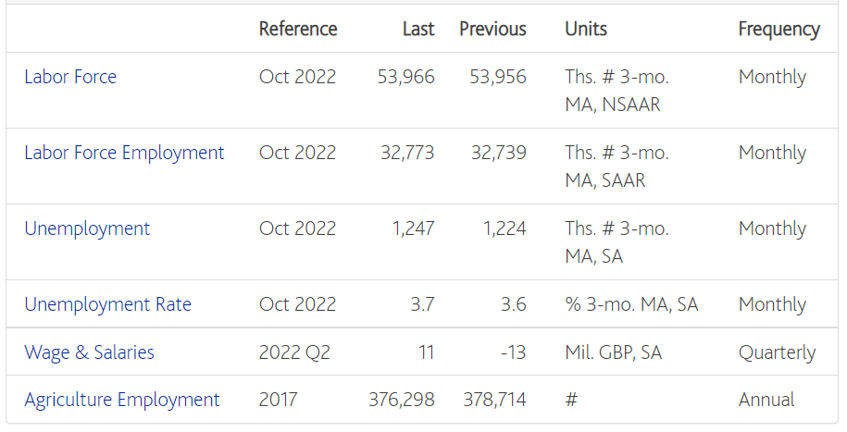
(Source: Moodysanalytics, 2022)
Currently, the UK is facing one of the tightest markets of labor over the years. Due to the shortages in the labor market, the businesses are unable to serve their existing customers, attracting new customers which eventually hampers their growth. Covid 19 has impacted the economy of the UK which resulted in a 21.5% decline in the GDP, on the contrary, unemployment has risen, increase in short-time work, numerous drop vacancies, and numerous falls in the number of hours worked by laborers. In the year 2020, from March to September, there has been a 673,000 decline in jobs (Costa and Machin, 2020).

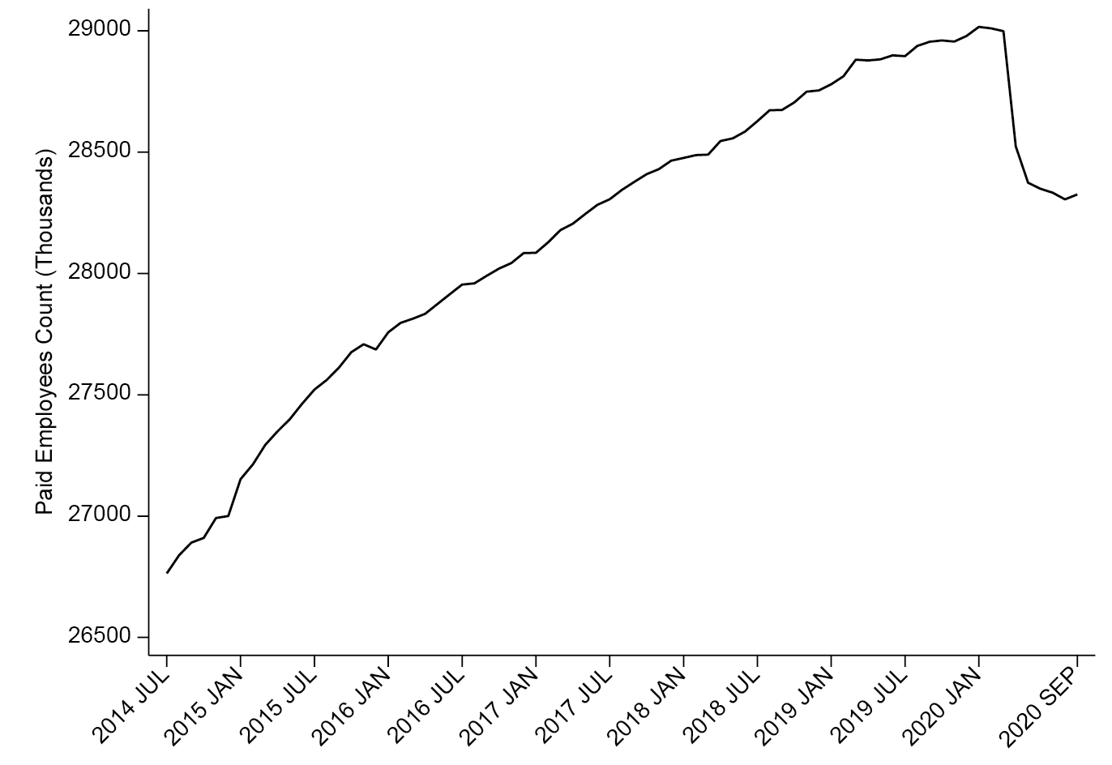
Figure 3 UK Employment Count of Paid Employees
(Source: Costa and Machin, 2020)
However, a rise of 1.5 million unemployment claims which represents an increase of 115% between March to July (Costa and Machin, 2020). The unemployment rates as well as the employment counts are misleading in association with the actual impact of Covid 19 crisis within the labor market of the UK. Throughout the initial year of the pandemic, the employment rate was declining however, the unemployment rates and economic inactivity were rising for women and men.
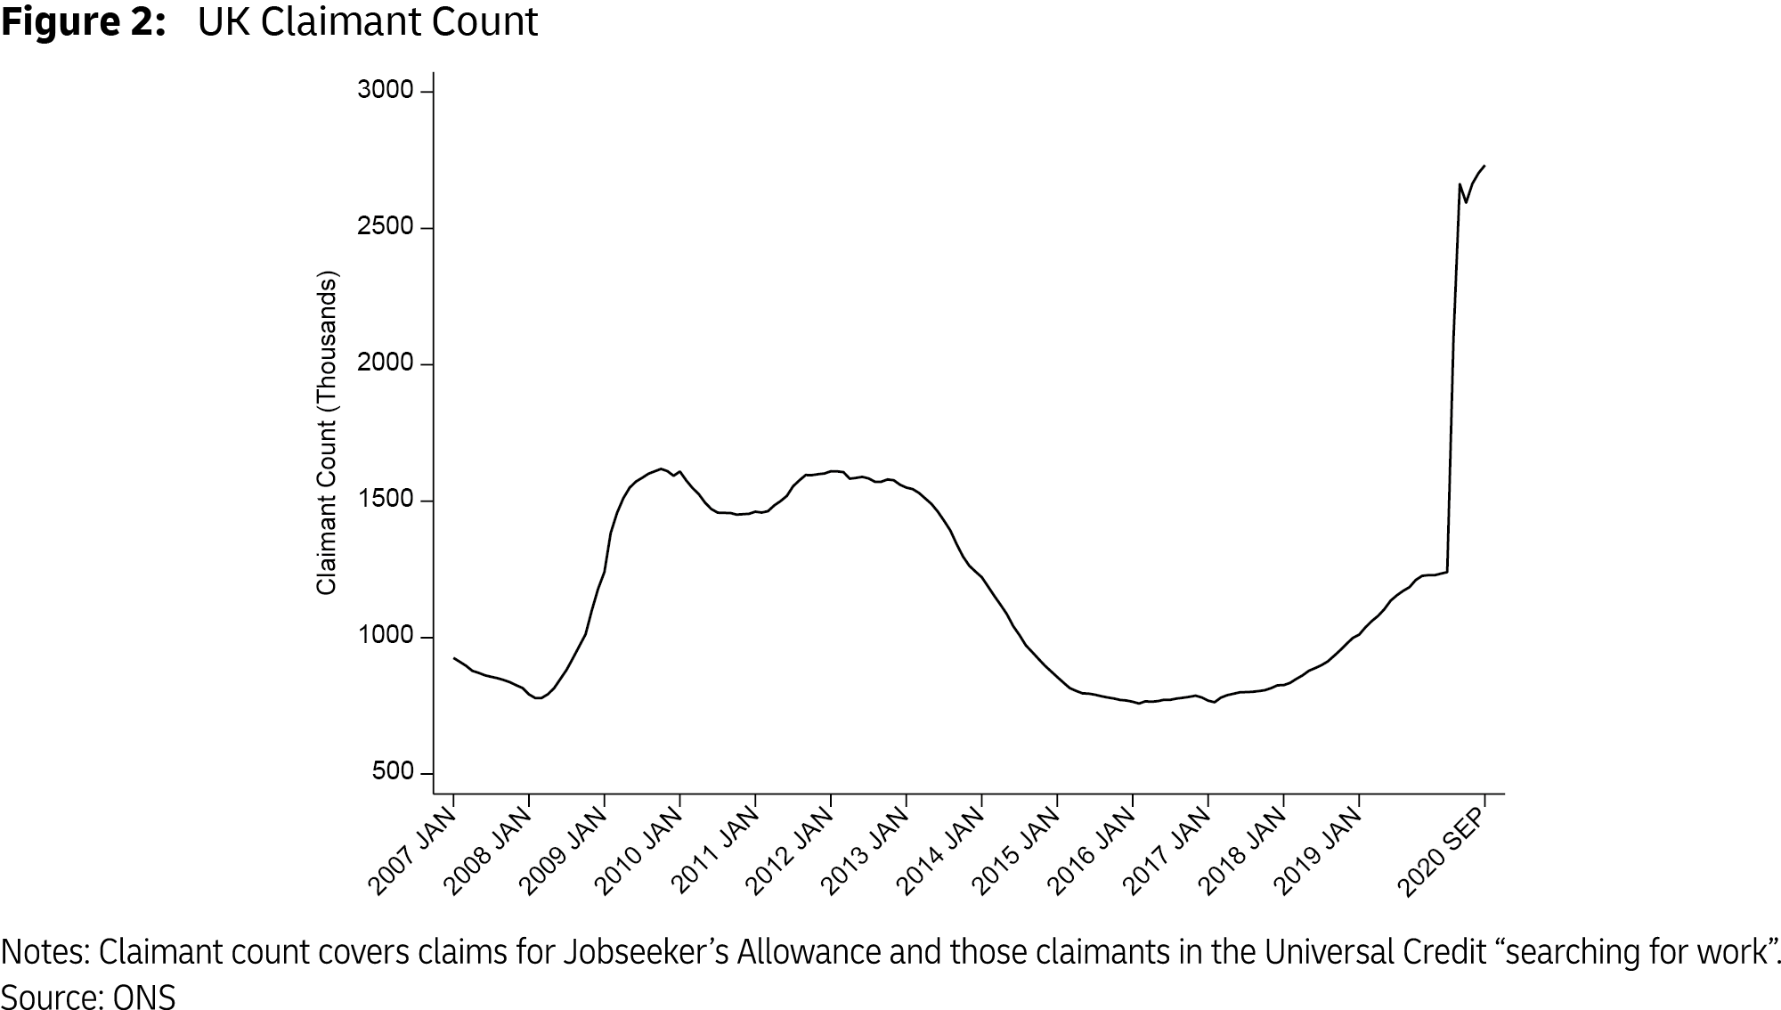
Figure 4 UK Claimant Count
(Source: Costa and Machin, 2020)
On the other hand, the employment rate in the UK in the year 2022, between June to August amounted to 75.5% which is 0.3% less than the previous quarter from March to May. The employment rate in the year 2022 from March to May amounted to 75.8% which is 0.3% more than 75.5% (ONS, 2022b).

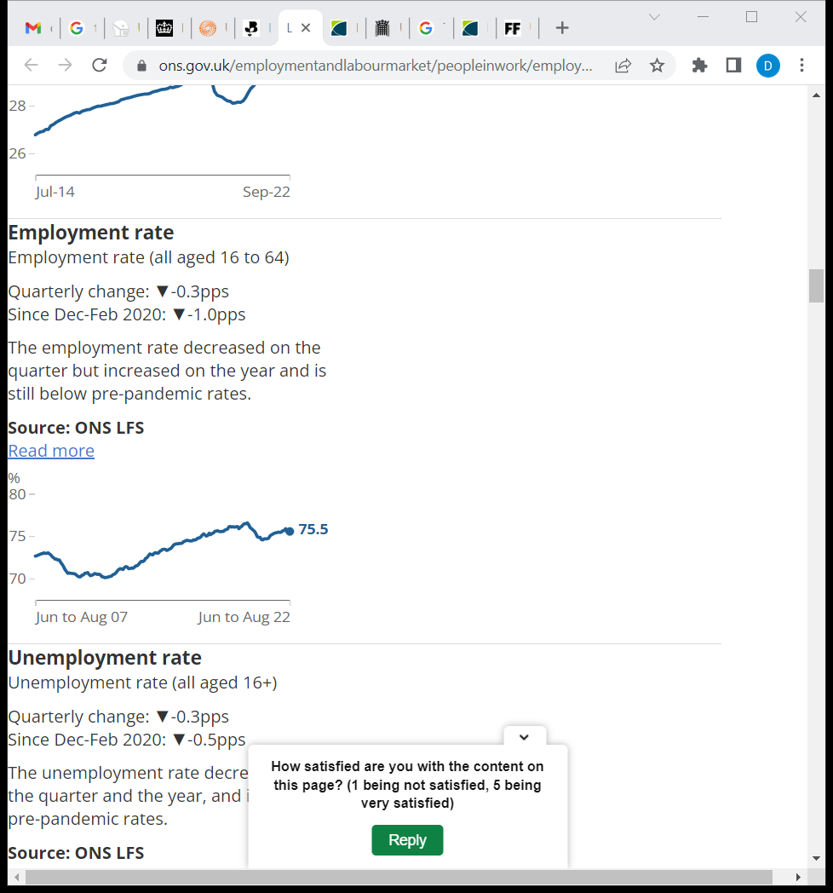
Figure 5 Employment Rate (all aged 16 to 64)
(Source: ONS, 2022b)
On the contrary, before the covid 19 pandemic, there was a record-breaking rise which amounted to 73.1% which signifies 929,000 employments. The schemes of the government helped in creating numerous jobs due to which there was a rise in the employment rate. The number of female workers has also reached 68.1% and set a record by amounting to 14.2 million (Department for work and pensions and The rt hon Esther mc vey mp, 2014).
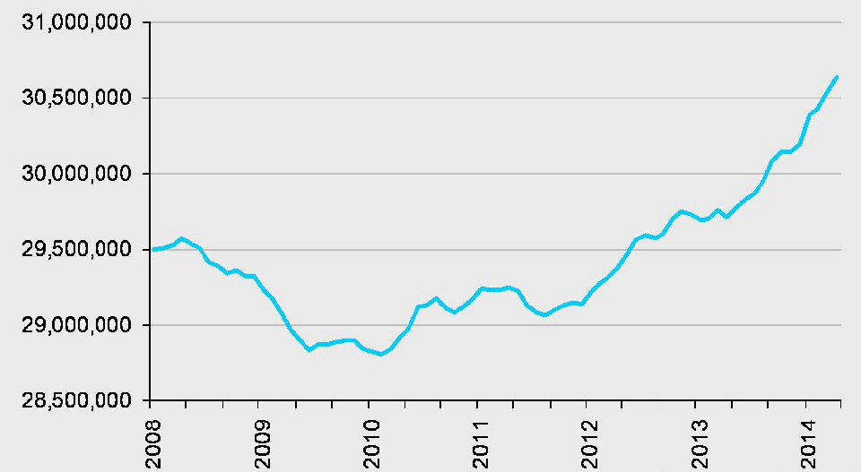
Figure 6 UK Employment Level
(Source: Department for work and pensions and The rt hon Esther Mc vey mp, 2014)
On the other hand, the number of unemployed people within 6 and 12 months rose in the long quarters, however, in the short and long term there was a decrease. Between June to August, the number of unemployed people in single vacancies decreased by 0.9% (ONS, 2022b). The unemployment rate lowered by 0.3% in the year 2022, from June to August on quarter to 3.5% which signifies the lowest rate from the year 1974 (Schomberg, 2022).

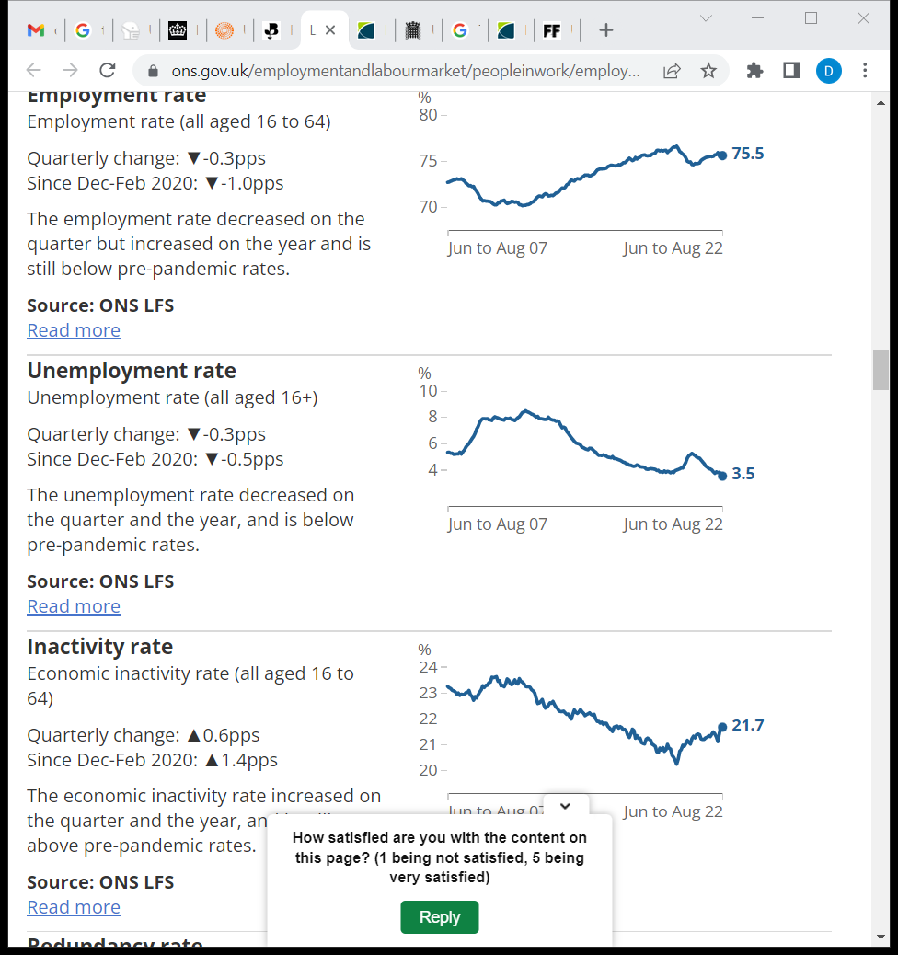
Figure 7 Unemployment rate (all aged 16+)
(Source: ONS, 2022b).

In the year 2022, the UK experienced a 3.7% unemployment rate in October in three months as compared with the previous period which amounted to 3.6% in July three months. However, in January 2022, the unemployment rate amounted to 3.9% which slightly decreased in February and came down to 3.8%, and further decreased in March and came to 3.7%. On the contrary, from April to June 2022, the unemployment rate was constant and was 3.8%, which decreased in July by 0.2% and further increased in October and amounted to 3.7%.
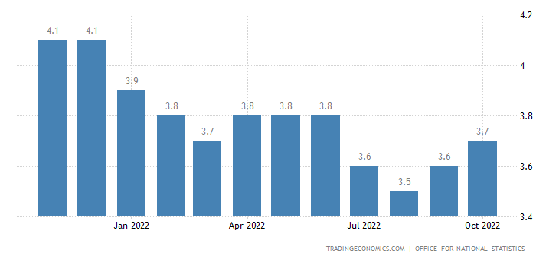
Figure 8 Unemployment rate in October 2022
(Source: Tradingeconomics, 2022)
The number of employees working full time has increased within the last three months which is from March to May, the part-time employees have also raised within the three months, thereby reflecting the recovery since the heavy falls within the initial stages of the pandemic. The count of self-employed workers decreased in the initial year of covid nineteen and since the count is low, however, the count has raised during the year 2022 from March to May (ONS, 2022a).
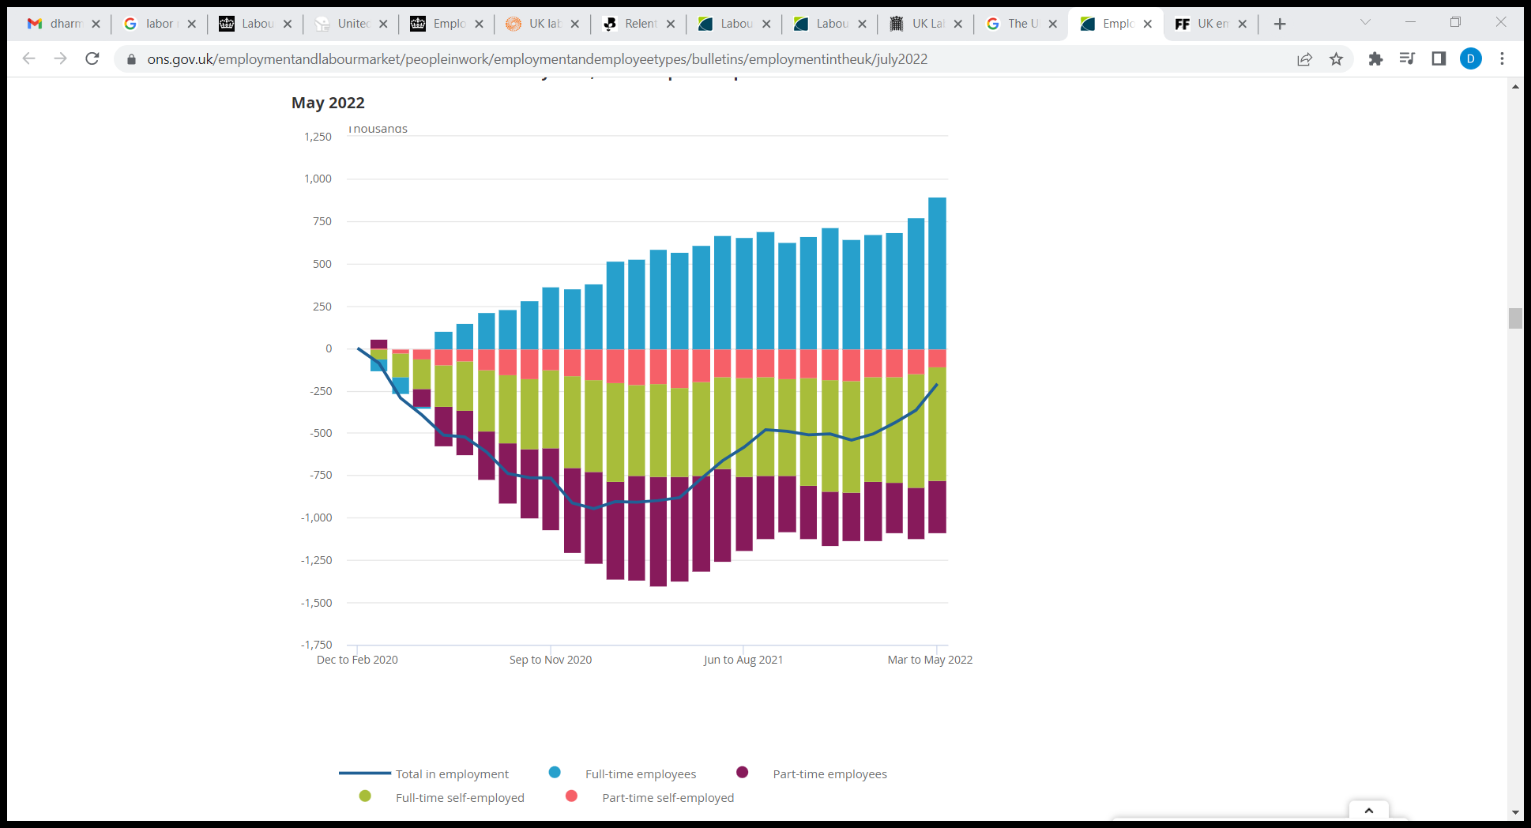
Figure 9: Employees and part-time self-employed workers increased over the latest three-month period, while the number of full-time self-employed decreased
(Source: ONS, 2022a)
On the other hand, 92% of the human resource managers believe that the job market in the UK is experiencing a shortage in labour out of which 42% of the companies are losing around 11% to 15% of their revenue due to the unavailability of the skilled workers, and the 24% of the companies are losing around 16% to 20% of their revenues (Cumming, 2022). Around 55% of the population believe that the shortage of labour is due to the pandemic however, 20% believe that it was pre-pandemic (Cumming, 2022).
Emerging changes in human resources strategies post covid-19, post-Brexit external environment

Emerging changes in HR strategies post covid-19
Along with expanding the corporate persuasion of HR, the covid-19 pandemic has also resulted in emphasizing to the employees. Post the pandemic, there has been a significant uncertainty regarding the minds of people, the external environment, as well as regarding the growth of businesses. It became difficult to run the businesses smoothly as everything changed, massive transformation took place in the ways of working, career opportunities, and many more. Due to the uncertainty, employees are concerned regarding their future, as well as the HR teams are facing difficulties in aligning back everything in the manner things were pre-pandemic (Giurge and Bohns,2020). Therefore, it becomes significant in changing the strategies for the smooth functioning of the business post-pandemic.
Remote working
During the pandemic, everything shifted from offline to online modes, such as education, and offices, the meetings conducted online, and students used to give their exams online which made everyone habitual regarding the situation. This graph shows the number of employees working from home in the year 2020 amounted to 5641 as compared with the year 2019 which amounted to 4607 (Clark, 2022).
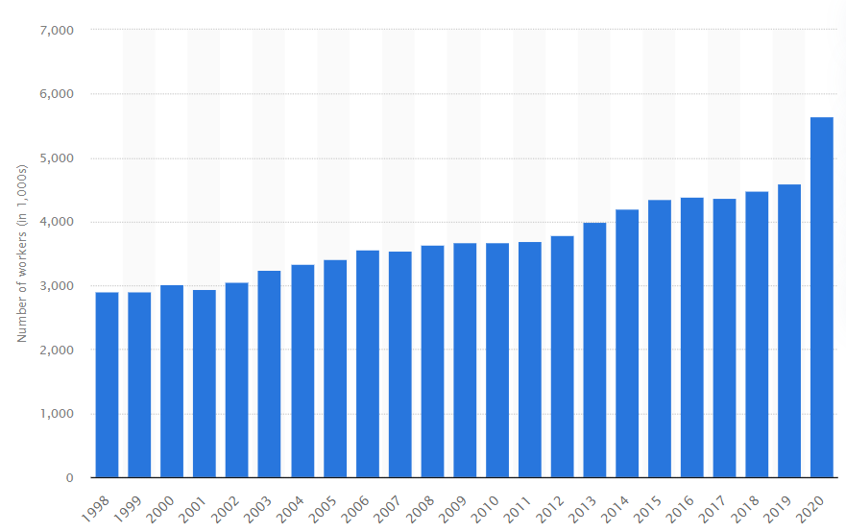
Figure 10 Number of employees that work from home in the UK 1998-2020
(Source: Clark, 2022)

On the other hand, before the pandemic, working from home was a luxury, however, post-pandemic, digitalization has enabled the options of hybrid and remote work for both employers and employees. Working from home has become a significant part of employment decisions as companies are experiencing reductions in their fixed cost and on the other hand, the top-level management has developed confidence in the performance of their employees while they are working from home (Sava Alexandra, 2022).
Higher flexibility
However, the changes due to the pandemic have resulted in more flexibility as various organizations laid off their employees and reduced their staff for covering their costs which have also affected their policies, and payrolls. On the contrary, in solving the issues of remote work, companies had to coordinate the payments and schedules accordingly hence, the companies need to design an open and flexible organizational structure which is a key challenge for HR professionals (Anjum, Rahman and Rahman, 2022).

Resilience is a challenge
Earlier, companies used to emphasize the efficiency of the employees however, post covid, resilience has come into the picture. Due to restructuring, furlough, as well as redundancies the companies were facing a shortage of skilled workers hence, it is the responsibility of the HR to manage the existing workforce efficiently and effectively to bring balance. HR professionals play a major role in sustaining and recovering the careers of the employee's post covid along with this, building resilience is also a major function for recovering the employees from the shock of the pandemic (Hite and McDonald, 2020).

Emerging changes in HR strategies post-Brexit external environment
In the year 2019, between May and July, the average employment rate was 76.1% pre-pandemic (ONS, 2019b). However, due to Brexit, various companies left the country or went bankrupt along with taking their prospects with them. On the other hand, the covid 19, restrictions, as well as the lockdown throughout the world coupled with an end in the transition period of Brexit signifies that various companies went bankrupt due to the shock of the pandemic.
Brexit is having an impact on the talent pool of the UK which eventually impacts the organizational strategies associated with workforce planning. Following Brexit, the UK has now become the least attractive destination for talent as it will not offer easy access through the European Union for talented people due to which the UK might experience a decrease in the number of citizens of the EU who come for work (MHR, 2019). Therefore, HR needs to have a supporting plan which covers certain strategies to cope with the same. Along with this, HR needs to have a keen eye on the new migration rules after Brexit as it might be possible that the current workers of the EU will get cover by the immigration rules of the UK (MHR, 2019). Since the time of the Brexit decision, leaders are looking for a better future. HR plays a key role in getting a strong and large workforce who are talented, energized, knowledgeable, as well as skilled.
Communication is a significant aspect of business and the heart of Brexit. HR is responsible for initiating communication with the stakeholders as well as ensuring that communication is effective and updated (Stone, 2020). Similarly, the leadership ensures that everything goes as per the plan. HR plays a vital role in consulting with the leaders for reviewing the priorities of HR services, processes, policies, procedures, systems, as well as technologies. On the other hand, motivation is significant for an organization to succeed, and maintaining motivation amongst the employees irrespective of the situation requires a lot of effort (Chadwick and Raver, 2015). HR ensures that the policies and procedures are reviewed to ensure flexibility within the system to avoid any chaos in the future. HR also ensures that the organization maintains the emotional, financial, mental, and physical wellness of the employees.
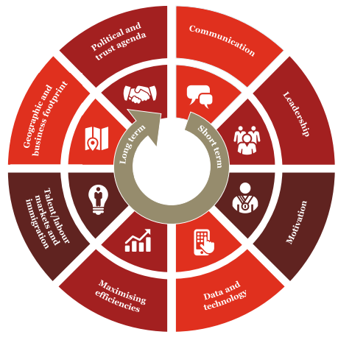
Figure 11 HR priorities
(Source: PWC, 2016)
On the other hand, data and technology are also essential to protect the business against fraud, to easily access the data, as well as to make amendments to the policies, and procedures. HR ensures that all the employee data are stored properly with the help of the technologies and are easily accessible by everyone working within the organization so that it becomes easy to understand the position of the organization and what needs to be improved (Katal, Wazid and Goudar, 2013). On the contrary, another HR emerging change is the maximization of efficiencies as post-Brexit, every organization focuses on efficiency. To ensure that employees are efficient, HR considers the terms and conditions of employment, retirement benefits, risk management, policies, procedures, as well as other benefits.
On the contrary, labor markets and immigration, the impact on it refers to an area wherein modeling and analytics are used. HR strategies help in identifying the people affected by the changes made in the immigration status, the potential labor and talent market scenarios, and specialists required for getting Brexit done, in addition to, review of the succession plan to identify alternative talents (Simionescu, Strielkowski and Kalyugina, 2017).

Conclusion
To conclude, the labor market and human resource strategies have seen significant changes post covid and post-Brexit. In 2022, there has been an increase in the participation rate of the labor force. The covid and Brexit have also impacted the human resource strategies of Tesco along with its resources. Tesco offered employment to utilize the resources optimally, along with offered remote and hybrid working, as well as resilience to cope with the resources.

References
Anjum, N., Rahman, M. and Rahman, S., 2022. Challenges for HR Professionals in the Post-COVID-19 ERA. Journal of Business Strategy Finance and Management, 4(1), 5-11.
CEIC., 2022. United Kingdom Labor Force Participation Rate. Available at: https://www.ceicdata.com/en/indicator/united-kingdom/labour-force-participation-rate. (Accessed: 22/12/2022).
Chadwick, I.C. and Raver, J.L., 2015. Motivating organizations to learn: Goal orientation and its influence on organizational learning. Journal of management, 41(3), pp.957-986.
Clark, D., 2022. Number of those in employment who work mainly from home in the UK from 1998 to 2020. Available at: https://www.statista.com/statistics/312345/working-from-home-in-the-united-kingdom-levels-employed-uk-y-on-y/. (Accessed: 22/12/2022).
Costa, R and Machin, S., 2020. Crisis Response Monitoring. Available at: https://covid-19.iza.org/crisis-monitor/uk/. (Accessed: 22/12/2022).
Cumming, A., 2022. 92% HR professionals think UK job market experiencing labor shortage, research finds. Available at: https://www.businessleader.co.uk/92-hr-professionals-think-uk-job-market-experiencing-labour-shortage-research-finds/. (Accessed: 22/12/2022).
Department for Work and Pensions and The Rt Hon Esther McVey MP., 2014. Employment rate matches record high. Available at: https://www.gov.uk/government/news/employment-rate-matches-record-high. (Accessed: 22/12/2022).
Doeringer, P.B. and Piore, M.J., 2020. Internal labor markets and manpower analysis: with a new introduction. Routledge.
Giurge, L. M. and Bohns, V. K., 2020. 3 Tips to Avoid WFH Burnout. Available at: https://hbr.org/2020/04/3-tips-to-avoid-wfh-burnout. (Accessed: 22/12/2022).
Hite, L. M., and McDonald, K. S., 2020. Careers after COVID-19: Challenges and changes. Human Resource Development International, 23(4), 427-437.
Hrebiniak, L.G., 2013. Making strategy work: Leading effective execution and change. FT Press.
Katal, A., Wazid, M. and Goudar, R.H., 2013, August. Big data: issues, challenges, tools and good practices. In 2013 Sixth international conference on contemporary computing (IC3) (pp. 404-409). IEEE.
MHR., 2019. How Brexit will change the game for HR. Available at: https://mhrglobal.com/uk/en/blog/how-brexit-will-affect-hr. (Accessed: 22/12/2022).
Moody’s Analytics., 2022. United Kingdom – Labor Force. Available at: https://www.economy.com/united-kingdom/labor-force. (Accessed: 22/12/2022).
ONS., 2022a. Employment in the UK: July 2022. Available at: https://www.ons.gov.uk/employmentandlabourmarket/peopleinwork/employmentandemployeetypes/bulletins/employmentintheuk/july2022. (Accessed: 22/12/2022).
ONS., 2022b. Employment in the UK: September 2019. Available at: https://www.ons.gov.uk/employmentandlabourmarket/peopleinwork/employmentandemployeetypes/bulletins/employmentintheuk/september2019. (Accessed: 22/12/2022).
ONS., 2022c. Labor market overview, UK: October 2022. Available at: https://www.ons.gov.uk/employmentandlabourmarket/peopleinwork/employmentandemployeetypes/bulletins/uklabourmarket/october2022#:~:text=Main%20points,employment%20rate%20than%20other%20periods. (Accessed: 22/12/2022).
PWC., 2016. Brexit – A key role for HR. Available at: https://www.pwc.co.uk/eu-referendum/po-summary-of-brexit-and-hr-related-issues-september-2016.pdf. (Accessed: 22/12/2022).
Sava Alexandra, J., 2022. Work from home & remote work – Statistics & Facts. Available at: https://www.statista.com/topics/6565/work-from-home-and-remote-work/#topicHeader__wrapper. (Accessed; 22/12/2022).
Schomberg, W., 2022. UK labor market exodus drives jobless rate down to 3.5%. Available at: https://www.reuters.com/markets/europe/uk-jobless-rate-falls-slightly-35-2022-10-11/. (Accessed: 22/12/2022).
Simionescu, M., Strielkowski, W. and Kalyugina, S., 2017. The impact of Brexit on labour migration and labour markets in the United Kingdom and the EU. Terra Economicus, 15(1), pp.148-156.
Stone, R.J., Cox, A. and Gavin, M., 2020. Human resource management. John Wiley & Sons.
The World Bank., 2022. Labor force, total – United Kingdom. Available at: https://data.worldbank.org/indicator/SL.TLF.TOTL.IN?contextual=population-and-labor&locations=GB. (Accessed: 22/12/2022).
Trading Economics., 2022. United Kingdom Unemployment Rate. Available at: https://tradingeconomics.com/united-kingdom/unemployment-rate. (Accessed: 22/12/2022).

