

LCBB4003- Introducing the Modern Workplace

Aleksandar Kirilov Lolov
Student ID: 2218455
Lecturer: Dr. Hoang Dang Nguyen

Individual report

Table of contents

- Purpose of the report………………..3
- Introduction………………….4
- Organization of Pret a Manager………………..5
- Organization Performance……………..7
- Pret Organization-Structure Performance………………9
- Organization Culture Performance Relationship………………..11
- Conclusion of Organization, Structure and Culture Relationship…………..13
- Conclusion of Employee Motivation………………..15
- Reference list…………….17
Purpose of the report

Overall, the purpose of doing a report for Pret a Manger's organization, structure, and performance would be to provide them with a comprehensive assessment of their current operations and strategies for improvement. The report would help Pret a Manger identify areas where they could optimize their structure or processes to increase efficiency, improve customer satisfaction, and boost overall performance. The employee might also provide recommendations for training or professional development programs that could help improve employee engagement and retention rates.

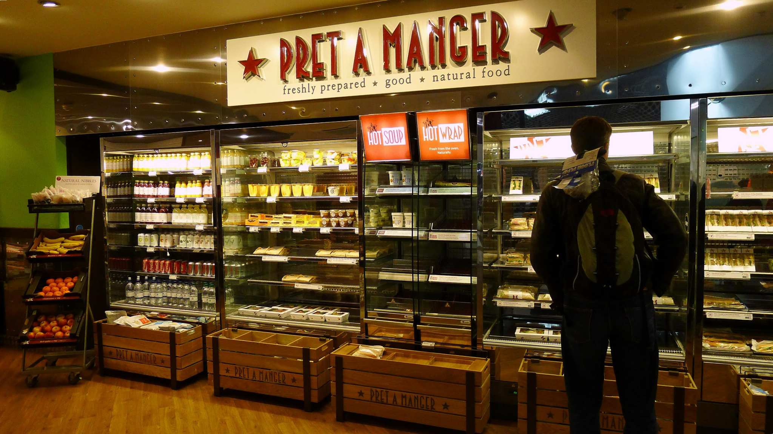 Introduction
Pret a Manager is a popular fast-casual restaurant chain that offers fresh, handmade sandwiches, salads, and other delicious food options. The company was founded in 1986 in London and has since expanded to over 500 locations worldwide. What sets Pret a Manager apart is their commitment to using high-quality ingredients and sustainable practices, which has earned them a loyal following among health- conscious and environmentally conscious consumers. If you are looking for a quick, healthy and tasty meal on-the-go, I highly recommend checking out Pret a Manager.

Organization of Pret a Manager
Pret a Manger is a British multinational sandwich shop chain that was founded in London in 1983. The company's organizational structure is designed to support its core values of quality, service and team spirit. Pret A Manger operates under a decentralized organizational structure with each spirit. The shop has a team of employees who are responsible for the day-to-day operations running of the shop. Each shop is led managed by a Shop Manager who is responsible for ensuring that the shop achieves its sales targets goals and provides excellent customer service. At the regional level, Pret A Manger is organized into clusters of shops that are overseen by Regional Managers. Regional Managers are responsible for ensuring that the shops stores in their region achieve their sales targets goals and deliver high-quality customer service. At the corporate level, Pret A Manger has an executive team that sets the overall strategy and direction for the company. The leadership team is led by the CEO, who is responsible for overseeing the company's operations and ensuring that it meets its financial and strategic objective goals. Pret A Manger also has a strong places great emphasis on employee development and training. The company has a dedicated training team that provides training and development opportunities for it’s to employees at all levels.

Organization performance
Pret a Manger is a multinational sandwich shop, with over 500 locations worldwide. In 2020, the company faced a significant decline drop in sales due to the COVID-19 pandemic, which resulted in led to widespread lockdowns and reduced foot traffic in urban areas where many of the company's stores are located. According to a report by Statista, Pret a Mangers revenue sales in 2020 was were 299 million, a significant decrease from its revenue sales of 710 million in 2019. The company also reported a pre-tax loss of 204 million in 2020, compared to a profit of 58 million in 2019.However, despite the challenges faced by the company in 2020, it has shown resilience in its efforts to adapt to the changing business landscape. Pret a Manger has introduced new initiatives such as expanding its delivery options and launching a new online ordering platform to reach customers in different ways. In 2021, Pret a Manger announced plans to open 200 new stores in the United Kingdom which will create 5,000 jobs over the next five years. The company has also been focusing on sustainability with a goal to become carbon neutral by 2025 and to reduce its use of single-use plastic. According to its 2020 annual report, the company's revenue decreased company's sales fell by 52% compared to the previous year.

Pret Organization-Structure Performance

Pret a Manger is known for its flat organizational structure, which emphasizes a collaborative work environment and encourages employee input and feedback. The company's "managers" are referred to as "team leaders," and they work alongside their teams to ensure that operations run smoothly. This structure is designed to promote communication and foster a sense of ownership among employees.

Research suggests that a flat organizational structure can be beneficial for employee motivation, job satisfaction, and ultimately, performance. Studies have found that when employees have more autonomy and input in decision-making processes, they feel more valued and are more likely to be engaged and productive.

However, it is important to note that organizational structure is just one factor that can impact performance, and there are many other variables that can play a role. Other factors that may impact Pret a Manger's performance include market conditions, competition, consumer preferences, and the impact of COVID-19.

Organization culture-performance relationship

Pret a Trough places a solid accentuation on its culture, which is characterized by a center on client benefit, development, and supportability. The company's culture is outlined to advance collaboration among workers and to make a positive involvement for clients.

Investigate has appeared that a solid organizational culture can have a positive effect on representative inspiration, engagement, and execution. When representatives feel that their company's culture adjusts with their individual values and objectives, they are more likely to be committed to their work and to go over and past to assist their organization succeed.

Pret a Manger's culture is additionally closely tied to its trade technique. For case, the company's center on supportability is reflected in its utilize of characteristic fixings and endeavors to diminish squander, which may request to environmentally-conscious buyers.

Conclusion of Organization, Structure and Culture Relationship

Generally, Pret a Manger's organizational structure, culture, and values have played a noteworthy part within the company's victory. The level of organizational structure and accentuation on collaboration have made a difference to advance worker engagement and propriety, which can contribute to made strides execution. So also, the company's culture, which emphasizes client benefit, development, and sustainability, has made a difference to form a positive work environment and a solid sense of reason among representatives. In any case, it is vital to note that organizational structure and culture are fair two of numerous components that can affect execution, and it is vital to consider other factors such as advertise conditions and competition. In general, Pret a Manger's approach to organizational plan and culture might serve as a valuable case for other companies looking to advance representative engagement and cultivate a sense of reason and meaning within the working environment.

Conclusion of employee motivation

In conclusion, worker inspiration could be a basic viewpoint of Pret a Manager's victory. Through its one of a kind representative culture, Pret a Manager has made an exceedingly persuaded workforce that's committed to the company's values and mission. By giving its representatives with openings for career improvement, acknowledgment and a positive work environment, Pret a Chief has been able to decrease representative turnover and increment representative fulfillment. The company's center on representative inspiration has too brought about in higher levels of client fulfillment and budgetary execution. Generally, Pret a Manager's employee motivation techniques give important bits of knowledge for other companies looking to form a positive and persuaded workforce.

Reference list
Pret a Manger. (2020). Annual report and accounts 2019. https://www.pret.co.uk/~/media/files/pret-a-manger/investors/annual-report-accounts-2019.pdf

Pret a Manger. (2021). Pret A Manger Announces Plans To Open 200 New Stores In The UK, Creating 5,000 Jobs Over The Next Five Years. https://www.pret.co.uk/en-GB/newsroom/pret-a-manger-announces-plans-to-open-200-new-stores-in-the-uk-creating-5000-jobs-over-the-next-five-years
Behrman, J. N. (2017). Pret a Manger: A Case Study. Journal of Business Case Studies, 13(1), 1-6.

Pret a Manger. (2022). Pret a Manger delivers a profit in 2022 as it continues to invest in its business and people. https://www.pret.co.uk/en-GB/newsroom/pret-a-manger-delivers-a-profit-in-2022-as-it-continues-to-invest-in-its-business-and-people

