

Programme: Master of Business Administration Module: International Business Concepts
Module code: LCMB7034

Student Name: Kuldip KIshorbhai Bhuva
Student ID: 2517333
Module Name: International Business Concepts (LCMB7034)
Lecturer Name: Charles Oham
Word Count: 5120
Submission Deadline: 14th August 2026
Table of content
Section 1: International Market Entry Analysis 2
1. Organisational Classification and Global Strategy 2
1.1 Background of the Company 2
1.2 Application of Bartlett and Ghoshal's Model for Strategic Categorisation 2
1.3 Discussion on Global Configuration and Competitive Advantage 3
2. Macro-Environmental Appraisal and Market Attractiveness 5
2.1 Evaluation of India as a Target Market 5
2.2 Political Environment 5
2.3 Economic Environment 7
2.4 Legal Environment 9
2.5 Cultural Environment 12
2.6 Application of (OLI) Paradigm for Market Entry Analysis 14
3. Entry Mode Strategy and Strategic Synthesis 17
3.1 Discussion on the Historical Entry Mode adopted by Aldi 17
3.2 Analysing Aldi Entry Strategy 17
3.3 Recommended Entry Mode for India 18
3.3.1 Identification of Alternative Entry Modes 18
3.3.2 Justification of the Recommended Entry Mode 18
3.4 Conclusion and Strategic Recommendations 20
3.4.1 Overall Conclusion 20
3.4.2 Strategic Recommendations 20
Section 2: Reflective Account Through Gibbs Model 21
References 25

Section 1: International Market Entry Analysis

1. Organisational Classification and Global Strategy

1.1 Background of the Company
Aldi is a popular supermarket chain that provides grocery and other retail products to customers headquarter in Germany. In addition, the company also manufactures bakery commodities such as “Specially Selected Jalapeno Cheddar Sourdough Bread” to meet the changes in consumer preferences in 2026 (Wilt, 2026). The diversification of the product line has also improved the operational stability of the organisation in 18 countries across the globe. Aldi has increased its market share growth to 11.0% in 2025 (Stainton, 2025). Thus, the availability of diversified products and higher revenue has increased the competitive advantage of Aldi on other organisations.

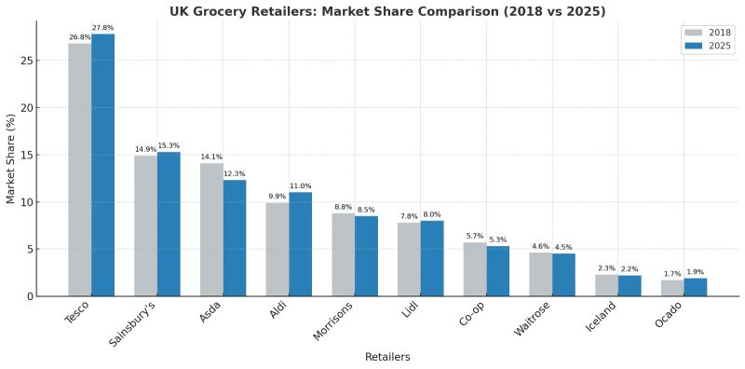
Figure 1: Market Growth of the Retail Companies
(Source: Stainton, 2025).

1.2 Application of Bartlett and Ghoshal's Model for Strategic Categorisation
As stated by Brock and Hydle (2018) use of the “Bartlett and Ghoshal's” model highlights strategic options for reliable expansion of the business to respond with economic changes. This helps businesses to enhance international operations through local and global integration. In local aspects, Aldi's revenue rises 5.9% by strengthening its position due to reliable demand from consumers and consumer transaction rates increase by 7% (Das, 2026). As, 61% of consumers purchase retail products from the German market by accessing discounts gathered from the various retail products (Statista, 2025)
Aldi while expanding in India will follow a transnational strategy by being more reliable in achieving efficiency to respond with market conditions. The company will be able to serve the “low cost model” by the ability to modify its products to meet Indian consumer needs. The Indian retail market will reach about $1,124 billion in 2025 with a growth rate of 12.80% from 2026-2034, addressing digitized adoption, income growth and enhanced improvement in consumer spending (IMARC, 2026). Aldi will introduce "traditional snacks”, Indian species and “Ready-to eat food” in the Indian market by collaborating with suppliers, enhancing the sustainable performance of the business. Indian consumers rely on “region-specific food,” which reflects their dynamic taste at convenient budgets. The Indian retail sector follows “FSSAI - Food Safety and Standards Authority of India” by describing food safety and the ability to manage public health through safe consumption. Thus, Aldi in the Indian market will follow “FSSAI” regulations to respond with consumer preferences which leads to a rise in “high consumer satisfaction" by strengthening its competitive position in the market.
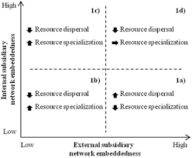
Figure 2: Bartlett and Ghoshal's Model
(Source: Djodat and Knyphausen-Aufseß, 2017)

1.3 Discussion on Global Configuration and Competitive Advantage
Aldi has focused on internationalising its business operations to increase its products to a larger consumer base. In addition, the organisation has utilised partnership techniques for enhancing its operational efficiency. As an example, Aldi has collaborated with Arla for developing the “Polytag Project” for recycling milk bottles in Denmark (Yuto, 2026). The initiative has also helped the organisation in improving sustainability in its business operations. Aldi has reduced the volume of its greenhouse gas emissions by 26% in 2025 (Informa, 2025). Aldi has also acquired business tie-ups with Chinese companies such as Golden Eagle International Group for developing 4 retail stores in Nanjing (Food Talk, 2026). Thus, the availability of international collaborations has assisted Aldi in improving the brand acceptance of its commodities.
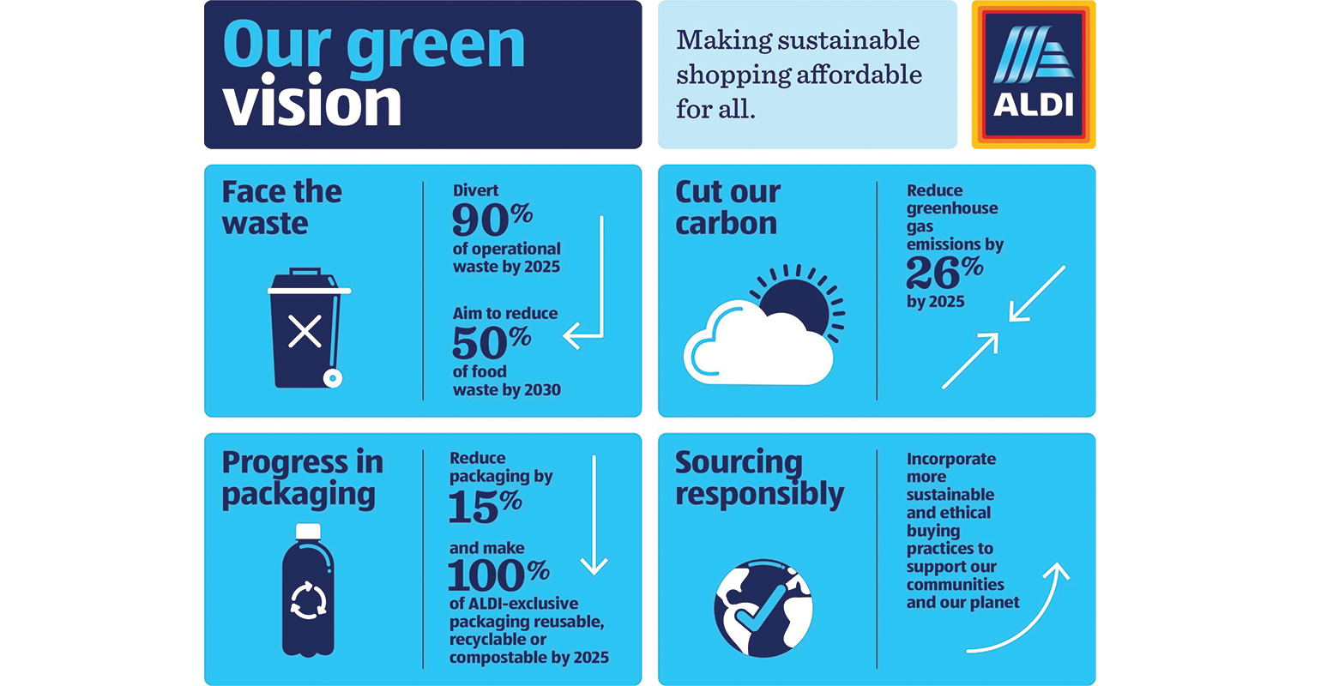
Figure 3: Green Vision of Aldi
(Source: Informa, 2025)

2. Macro-Environmental Appraisal and Market Attractiveness

2.1 Evaluation of India as a Target Market
India has been a popular retail market for foreign organisations due to the higher product demand among customers. For instance, the revenue of Indian grocery services has increased to $10bn in 2025 (Grand View Research, 2025). The income growth has strengthened the market stability of the industry. On the other hand, the sector has also achieved a CAGR growth rate of 44.9% from 2025-2030 (Grand View Research, 2025). Thus, the financial enhancement of the Indian grocery industry has provided opportunities for organisations in establishing business units effectively.
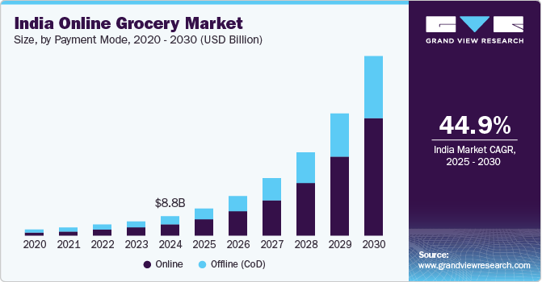
Figure 4: CAGR Growth Rate of Indian Grocery Services
(Source: Grand View Research, 2025)

2.2 Political Environment
Political Stability
Indians have a stable democratic system with a 0.0 score due to favorable investment in managing climate and infrastructural investment in enhancing the supply chain of retail (The Global Economy, 2025). The Indian government has followed GST reforms by following “two slab structures" that leads to enhanced overall transparency (5% to 18%) (PIB, 2025). In India, the GST of grocery rate is about 18% based on high rises of household expenses and boosts its consumption which slows down overall demand of product purchases. Thus, enhancing household demand of Indian consumers by investing on cheaper product leads enhances operational efficiency of business.
Foreign Investment Policy
The Indian government has encouraged the entry of foreign investments with its economy for achieving operational stability. For example, the local authorities have adopted the guidelines of the “Foreign Direct Investment Review Act 2025” with an intent to enhance the transparency of the financial transactions in 2025 (White Case, 2025). The existence of a flexible legal structure has also provided opportunities for international companies to expand their business portfolio in the country. In India, the value of FDI has increased to $19.4bn in 2025 (Government of India, 2025). Hence, the enhancement in business investments will provide opportunities for Aldi in carrying out expansion strategies in the country.
Trade restrictions
India has the ability to expand its access by “Free trade agreement protocols" for reliable management of supply chain leads to reduce logistic hurdles. 96.8% of the tariff lines is addressed with preferential market access by ability to convert 99.5% in maintaining Indian exports (Anon, 2025). These free trade choices have been accessed by analyzing market competition, managing product prices and enhancing improvement in the supply chain. The retail sector lowers its tax rate by ability to cut logistic costs by posing hurdles in the uniform market.
Implication on the Company
Opportunity
The availability of a flexible investment policy has assisted the Indian government in strengthening international trade relations and improving the local economy. In addition, the initiative has also strengthened the competitiveness of the industries that has also improved the product quality of indigenous organisations. Overall, the internationalisation of the Indian economy will strengthen the brand reputation of organisations such as Aldi.
Threat
The enhancement in the investment value of overseas organisations has reduced the demand for local products among customers. In addition, the globalisation strategy has also reduced the growth of the SME companies in India. Overall, the decline in the growth of the Indian firms have hampered the economic development of the country.

2.3 Economic Environment
Economic Growth
India is a rapidly developing economy that has strengthened in political and financial relations across the globe. As an example, the value of the “Gross Domestic Product” for India has increased to $4.18 tn in 2025 (Government of India, 2026). The enhancement in the GDP growth has also reduced the occurrence of monetary crises within the country. India has also increased its inflation rate to 3.93%, signifying the enhancement in the prices of essential items in 2026 (Mo, 2026). India has also reduced its debt value to $706bn due to diversification of market investments in 2026 (IKEA, 2026). Thus, the strengthening of the economic status has assisted India in becoming a strong market for foreign companies.
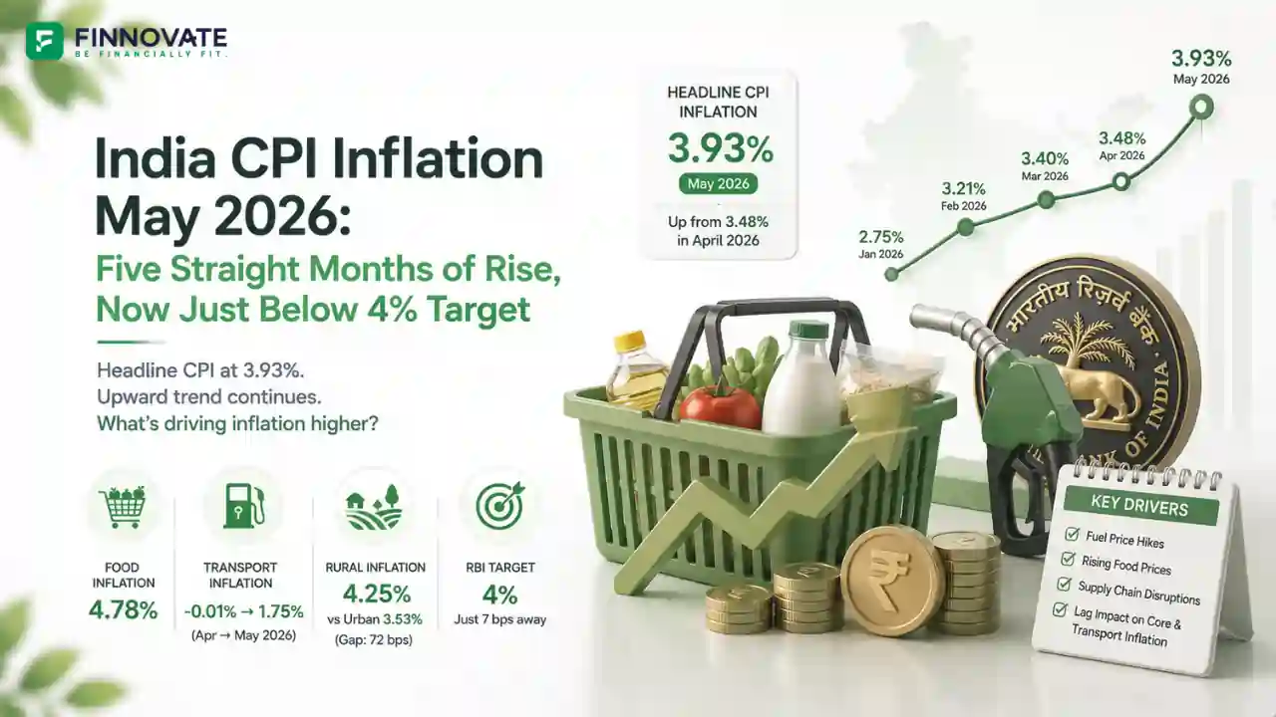
Figure 5: Indian Inflation Rate
(Source: Mo, 2026)
Consumer Purchasing Power
The retail sector in India by 2030 has the ability to raise about US$ 2361.11 billion with its growth rate 35% due to growth of apparel, beverage and food items (IBEF, 2026). Contributions to 10% of GDP growth and has an employment rate of about 8%, holding the third retail position in the market. The retail market in India is expected to be about US$1 trillion by 2030 due to the expansion of digital payments, the self-kiosk option and the development of e-commerce infrastructure that will enhance retail opportunities in the market (IBEF, 2026). Although, in India, quick e-commerce has a wider operation in 80 countries by aligning with tariffs.
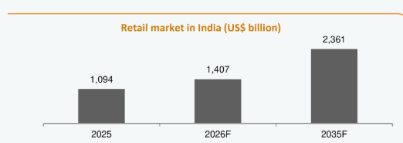
Figure 6: Indian retail market
(Source: IBEF, 2026)
Growth of the Grocery Industry
The Indian grocery sector has stressed upon enhancing its business investments for ensuring the provision of quality products to the customers. For instance, the government has provided financial grants worth ₹5cr to the small retail business in meeting the expenses incurred for its operational activities in 2025 (StartupFlora, 2025). In addition, the investment has also provided opportunities for MSMe groceries in digitalising its business operations. Overall, the improvement in the availability of the statutory funds has assisted the retail companies such as Aldi in meeting the growing expenditure of its business operations.
Implication on the Company
Opportunity
The economic environment in India will provide Aldi to expand in the market by accessing disposal income of consumers, accessing consumer purchasing power. The Indian government provides financial grants for enhancing operational activities of the retail sector by addressing improvement in supply chain and enhancing improvement in manufacturing hubs by presence of a large consumer base in the market.
Threats
The rise of inflation rate in India signifies the product price which leads to shift in consumer needs. Regional income of Indian consumers varies based on purchasing of Aldi’s products to meet regional needs by highlighting its affordability in the market. The monetary crisis occurs due to increases in borrowing cost leads to reduced overall spending of the consumer.

2.4 Legal Environment
Labour Laws
India has emphasised on strengthening the protection of its labour force for improving harmony and achieving economic growth. The government has developed the “Code of Wages Act 2026” that stresses upon the provision of accurate wages to workers involved in public and private organisations (Indian Parliament, 2026). In addition, the law has also involved the timely enhancement of the income for the employees in the country. For example, the average income of Indian workers will increase to ₹28000 in 2026 (Sutariya, 2025). Hence, the provision of flexible labour laws will help Aldi in improving the engagement level of its workforce.
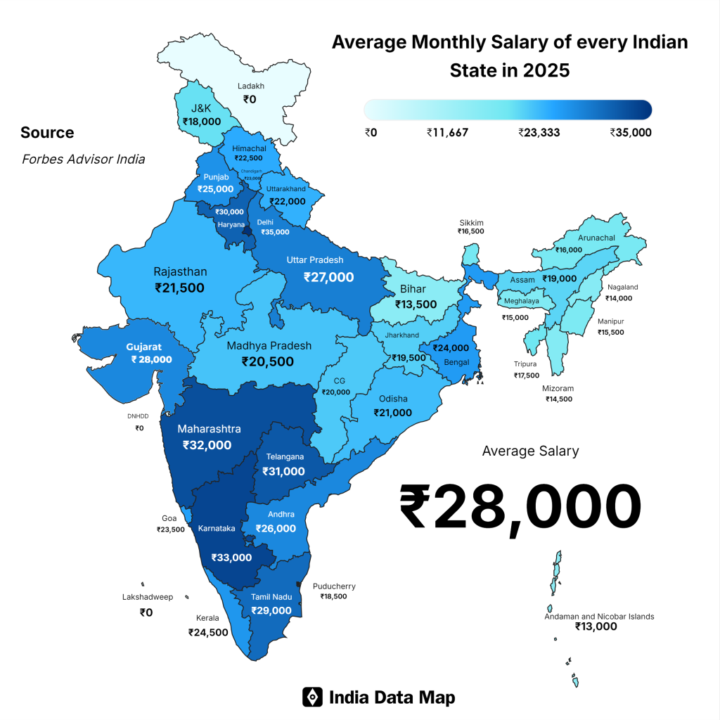
Figure 7: Average Salary in India
(Source: Sutariya, 2025)

FDI Regulations
The adoption of FDI policy has its reliable impact in addressing trends in the modern landscape with capital investment, instructional development beneficial for the local market. The Indian government provided permission for "Multi-branded trading” which is about 51% for serving fresh foods. 50% invested is for development of the “back-end infrastructure” for enhancing improvement in transportation. Total of 30% of the processed food is sourced through MSMEs (Government of India, 2025). Aldi will follow “Multi-Brand Retail Trading” vehicle expansion in the Indian market by serving government approval for manufacturing goods and infrastructure. FSSAI rules followed by the Indian government for reliable selling of goods by following “Food Safety and Standards Act of 2006” for validate licensing, product mislabelling and hygiene practices (Government of India, 2025). Thus, adoption of this Act is more reliable for product safety and leads to enhanced overall operational cost.
Environmental Regulations
The availability of environmental laws has helped India in strengthening the protection of its natural surroundings. For instance, the country has developed the “Environmental Revolution Policy 2025” that has aimed at monitoring the emission growth and fossil fuel consumption of the organisation (Malla, 2025). This has also helped India in strengthening its environmental sustainability. India has also reduced its carbon emission growth by 2% due to high environmental awareness among the residents in 2025 (Carbon Brief , 2026). Hence, the growth of sustainability across the country will assist Aldi in improving its goodwill among local communities.
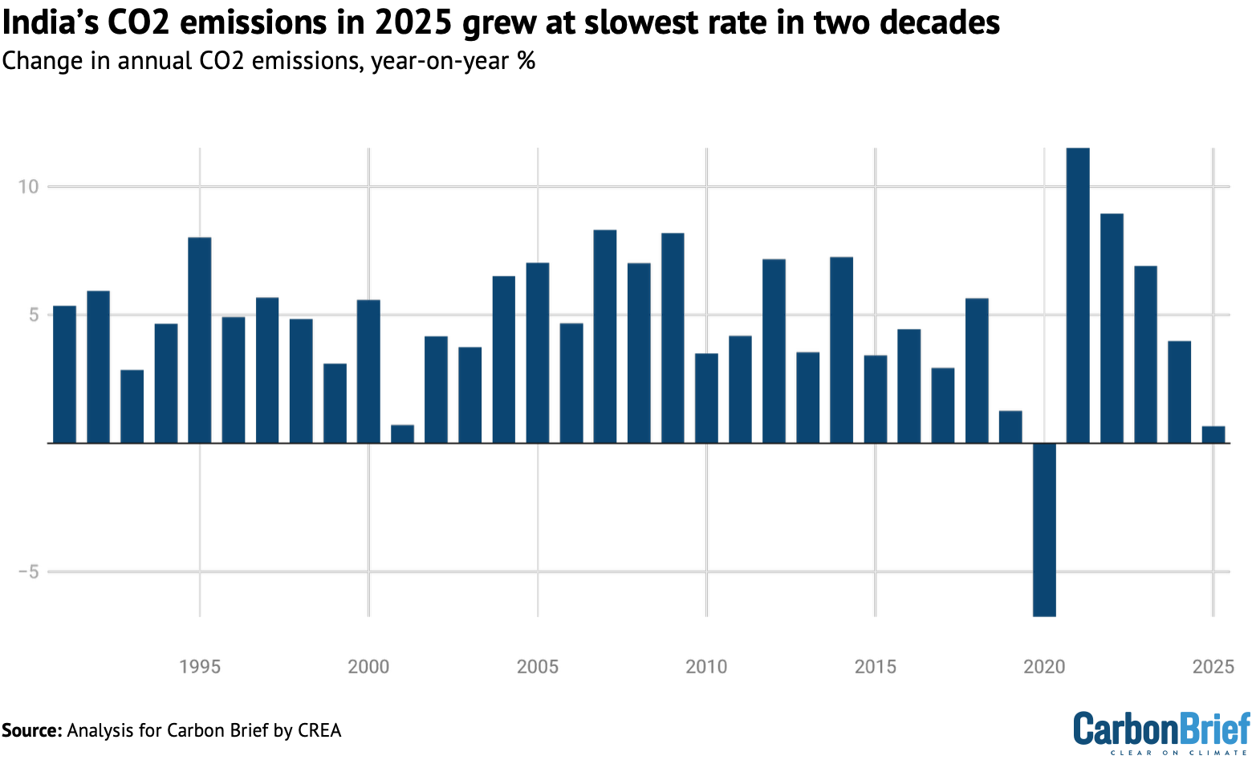
Figure 8: Carbon Emission Growth in India
(Source: Carbon Brief, 2026)
Intellectual Property
India followed the intellectual property regime by following the “WTO Agreement” for geographic indication, trademark and product patents. The “Trade Marks Act, 1999” is to protect brand name, logo and authorized uses of products by other companies (Government of India, 2025). Aldi while entertaining in the Indian market follows “Trade Marks Act, 1999” by protecting products from unauthorised use to showcase its strong competition in the market. This leads to enhanced consumer purchasing by highlighting the brand value of the Indian retail sector in showcasing stiff competition in the market. “Copyright Act 1957” is used by the retailers to promote products by collecting data from websites, product catalogs and marketing campaigns highlighting its originality in the market (Government of India, 2025). Indian retailers follow this act by ability to carry out criminal offenses in the market, addressed by continuous monitoring.

Implication on the Company
Opportunity
The availability of skilled and unskilled labour will assist Aldi in meeting the workforce requirements of its business units and ensuring smooth completion of its project. In addition, the enhancement in the wage structure will also improve the engagement level of the workforce within the operational activities of the organisation.
Threat
The existence of higher emphasis on environmental sustainability and complex FDI regulations will increase the operational cost for Aldi and hamper its product demand among customers. Overall, the decline in the consumption of commodities will reduce the market growth of the company and lower its competitive advantage over local competitors.

2.5 Cultural Environment
Hofstede's Cultural Dimensions

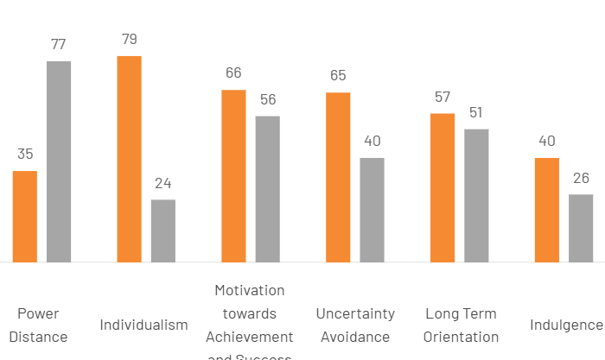
Figure 9: Hofstede country comparison tool
(Source: The Culture Factor, 2020)
“Hofstede’s cultural dimensions” highlights the consumer habits towards retail shopping, and demand for the product leads to enhanced overall sales of the grocery supermarket. Germany has a 35 score (low power), with rising high operating expenses and labour costs, which squeeze the purchasing power of the customers. Whereas India has a 77 score (High Power), driving growth in supermarkets, leading d to demand from customers for organic food, branded goods and premium packaging. This in turn leads to better shopping by reducing disposable income of the consumers.
Germany has high individualism (79), driving demand for customized food choices, personalized recommendations, and self-expression of the brand to enhance retail shopping. India has low individualism (24), as shoppers serve customers with personalized goods and rely on a “quick-ecommerce platform,” which enhances overall brand value. Germany has high motivation (66) due to the presence of cost-conscious customers that reshape the retail sector by prioritising discounts, which is hard to capture large market share. India has low motivation (56) due to local consumer loyalty and perception towards the freshness of products and digitalised shopping experiences.
Consumer attitude towards supermarket
In India, customers have developed preference for carrying out purchasing activities from large supermarkets due to the provision of diversified products. As an example, the Indian grocery sector has increased its Incremental revenue growth to $268.22bn due to high service quality in 2025 (Technavio, 2025). The market growth also signifies improvement in the demand for retail products among customers in the country. In addition, the industry has also reduced the tariff value on its commodities to 10.66% in 2025 (Ambey, 2026). Hence, the growing commodity demand and low operational cost will assist Aldi in strengthening its market position in India.
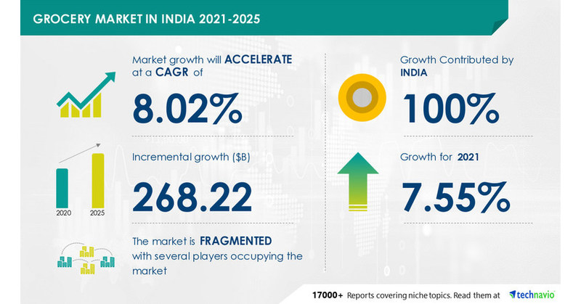
Figure 10: Incremental Revenue Growth
(Source: Technavio, 2025)
Implications on the Company
Opportunity
The growth in the grocery market will help Aldi in establishing business units through collaboration and catering to the needs of Indian customers. Hence, the adoption of indigenous partnership will also provide opportunities for the organisation in understanding industrial trends.
Threat
The enhancement in the sectoral income will also increase competition level for Aldi from local organizations that will adversely influence its market growth in India. In addition, the availability of higher business taxes will increase the product cost of the company.

2.6 Application of (OLI) Paradigm for Market Entry Analysis
Ownership Advantage
Brand reputation has been a viable aspect that has improved the product acceptance level of the organisation among local and international customers. In addition, the method has also influenced the market growth of the company. For instance, the brand index score of Aldi has increased to 48 in 2025 (Retail World Editor, 2026). The improvement in the customer popularity has assisted the organisation in strengthening its presence in the international market. Overall, the availability of the strong brand reputation has helped the retail company in overcoming market competition.
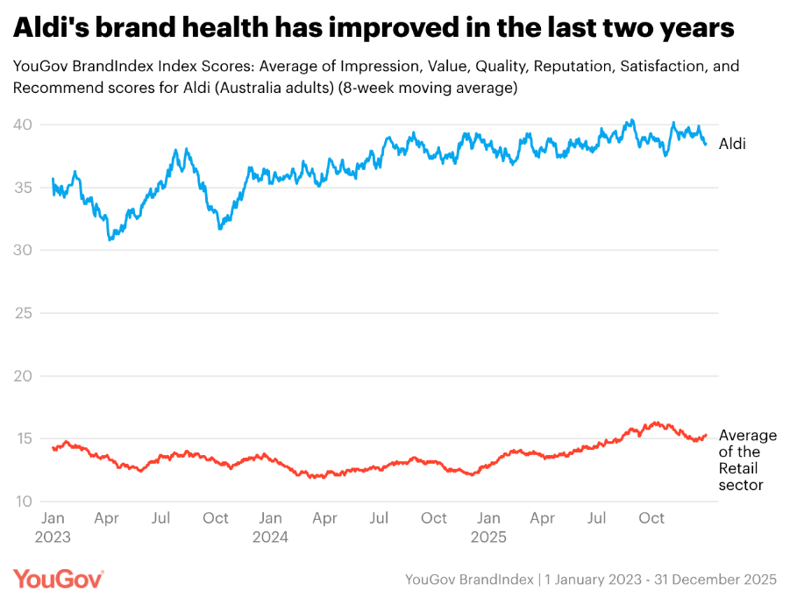 Figure 11: Brand Index Score of Aldi
(Source: Retail World Editor, 2026)
Location Advantages (L)
While expanding in India, Aldi will face certain challenges in the adoption of policy, the right talent, and a conscious customer base. India surges with rapid urbanization, which is powerful for domestic consumption. The purchasing habits of Indian consumers relies on a better variety of products, maintaining proper hygiene, and quick e-commerce services, which have a wider demand in the market, with growth of about US$ 1.5 billion in 2026 (IBEF, 2026). Price sensitivity among consumers in the Indian retail market has its massive alignment with the core values of Aldi. However, changes in FDI norms in India reshape supermarket chains, with vendor pressure and investing infrastructure growth affecting Aldi.
Internalization Advantages (I)
Internationalisation is an important aspect that has provided global recognition to the products of an organisation. Aldi has focused on adopting business tie-ups for carrying out expansion of its business operations. As an instance, the organisation has collaborated with Wilberforce for developing a risk assessment plan and strengthening its supply chain network in 2025 (Aldi, 2025). The partnership has also played an important role in strengthening the brand position of the company in the Irish retail sector. Aldi has also collaborated with Guy White for acquiring 2.8 acres of property for developing retail stores and storage units in the UK (Griffiths, 2026). Overall, the availability of diversified partnerships has improved the global trend of Aldi brands.
Aldi's entry in the Indian market using the OLI Framework
Factors of the OLI framework help Aldi enter the Indian market by highlighting stiff competition, accessing consumer preferences, improving the supply chain, and navigating regulatory shifts in the business. Aldi in the Indian market will collaborate with Reliance Fresh to serve fresh grocery products to Indian consumers by understanding their preferences. Aldi will enhance its operational efficiency by following FDI norms and state approvals, leading to massive growth of the retail sector. Aldi follows the “Trade Marks Act, 1999” which prevents competitors from safeguarding brand identity with unauthorised selling of products. Thus, Aldi develops a competitive position in the retail market based on proper trademarks and preferences of local customers.

3. Entry Mode Strategy and Strategic Synthesis

3.1 Discussion on the Historical Entry Mode adopted by Aldi
Merger and Acquisition
Aldi has acquired companies such as Southeastern Grocers to enhance its market presence by 400 stores in 2025 (Redman and Adam, 2025). In addition, the takeover has also assisted the organisation in strengthening its brand extension activities.
Direct Selling
The direct selling activities is also a viable strategy that has demonstrated the physical presence of the organisations. Aldi has focused on executing interactions with the customers by the development of 2567 offline stores in 2025 (Caraceni, 2025). In addition, the expansion of the business units has also provided opportunities for the supermarket company in improving its brand loyalty among consumers.
Strategic Partner
The inclusion of strategic partnerships has helped companies in understanding the consumer trends in foreign markets. Aldi has collaborated with C&S Wholesale Grocers for developing 225 retail stores with an intent to meet the product demand in the USA (The Packer , 2025). The commercial tie-up has also provided opportunities for the supermarket company in enhancing the brand recognition for its products. Thus, the improvement in the popularity of the commodities and lowering of market risk will improve the operational quality of Aldi in India.

3.2 Analysing Aldi Entry Strategy
Strength
The inclusion of the direct selling option will improve the customer relationship of Aldi and increase in loyalty levels significantly. In addition, the strategy will also improve the supplier volume of the company and provide strength to its inventory management operations. Thus, the adoption of the techniques mentioned above will help Aldi in improving its brand health.
Weakness
The adoption of the acquisition technique will limit the scope for Aldi in strengthening its local knowledge regarding the Indian market. This will increase the business competition level for the company and hamper its productivity. For example, DeMart has developed 500 retail supermarket chains to strengthen its product expansion strategy in 2026 (Roy, 2026). Hence, the growing popularity of Indian grocery companies will reduce consumer growth of Aldi significantly.

3.3 Recommended Entry Mode for India

3.3.1 Identification of Alternative Entry Modes
Exporting
Aldi has its sourcing hub in India by following FDI norms and reliable product sourcing enhance improvement in business operations. The company develops partnerships with Genpact to transform its business operations in India (Genpact, 2025).
Licensing
While entering the Indian market, Aldi follows the “FSSAI License”, which is more reliable for e-commerce by strict labeling and maintaining food safety (FSSAI, 2026).
Joint Venture
Aldi will develop a joint venture with Reliance retail with the ability to develop domestic retail systems by following proper “Copyright” and "Trademark act”. The company develops a supplier network by collaborating with logistics in accessing the preferences of the Indian consumers.
Strategic Alliance
Aldi will collaborate with D-mart by the ability to expand its reach in the Indian market with demand of e-commerce shopping, digitalisation and strong push towards "phygital".
Wholly Owned Subsidiary
Aldi will be fully owned by the “Shoppers Stop” who have its full control in managing business operations across reliable pricing, and managing supply chain. Thus, high investment is required for enhancing political and financial risk which slow down market entry.

3.3.2 Justification of the Recommended Entry Mode
Financial Risk
The occurrence of stagnant growth in revenue is a viable risk that has adversely influenced the financial improvement of the Indian retail sector. As an example, the industry has improved its market value by 6 % due to the high standard of living cost for the customers in 2025 (Indian Retailer, 2026). Thus, the adoption of JV techniques will help Aldi in strengthening its position in the Indian retail sector.
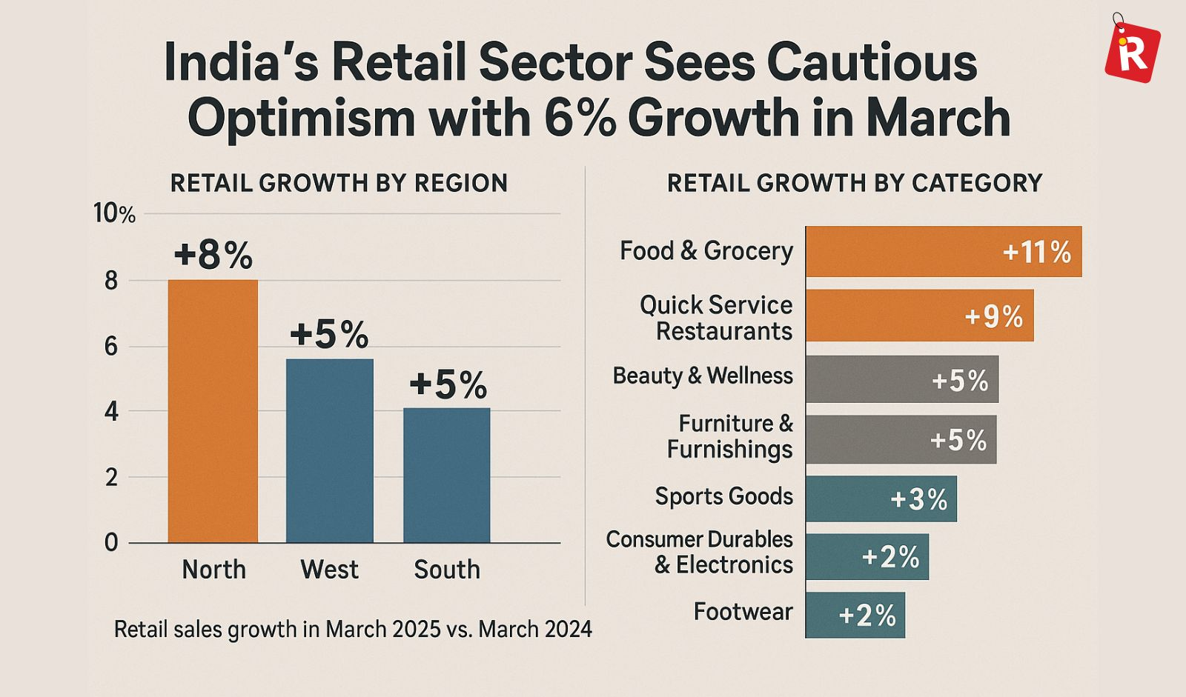
Figure 12: Market Growth of the Indian Grocery Sector
(Source: Indian Retailer, 2026)
Political Risk
The Indian government has collaborated with the FCI to provide food products at subsidized rates that has also caused variations in the earning capacity of the rural and urban companies (FCI, 2025). Overall, the adoption of the JV techniques will help Aldi in understanding the local legal requirements of the Indian grocery sector.
Strategic Fit
The adoption of strategic partnerships through JV have provided assistance to organisations in overcoming market risk and ensuring smooth completion of its business operations. Aldi has collaborated with Digital Wave Technology in strengthening the utility of AI in improving its supply chain operations (Supermarket News, 2025). Thus, the adoption of JV techniques will improve the digital strength of the supermarket company and enhance its operational productivity.
Operational Risk
Aldi reduces its operational risk through joint ventures by ability to respond with uncertainties, investment and disagreement to respond with strategic priorities. The Indian partners such as Reliance Retail collaborate with Aldi by following GST norms with digital filing and mandatory pre-packaged labeling highlighting durability of products in the market.
Resource Commitment
Retail investment capital in India will grow about $30 trillion by 2047 due to significant growth of the economy (Trehan, Pozhath and Pratap, 2025). Aldi will transform the business by collaborating with a “quick e-commerce " platform following GST norms. Thus, Aldi entered the Indian market through a JV to manage resources through the "Trade Market Act” leading to increased purchasing power for customers.
Control vs Flexibility
Aldi, adopted joint ventures, has its high control by following quality standards which leads to improved business reputation. The Indian retail sector follows “BIS Certification” in manufacturing products by importing and exporting raw materials (BIS, 2022). The company enhances its flexibility in “local market” adoption based on accessing regional preferences to enhance operational exposure in the market.

3.4 Conclusion and Strategic Recommendations

3.4.1 Overall Conclusion
Based on overall analysis, inclusion of the direct selling techniques will improve the brand presence of Aldi in India. The Joint venture techniques helped Aldi in enhancing its consumer base and acquiring a competitive advantage by collaborating with Reliance Retail, Swiggy and Digital Wave Technology for enhancing improvement in business operation. Thus, this collaboration helped Aldi to expand in the Indian market with local sourcing and improve local product knowledge of the company.

3.4.2 Strategic Recommendations
Aldi has its low risk by following FSSAI licenses in the Indian market, as it has strict control in managing supply and chain and day-to-day operations. However, Aldi has its direct suppliers in India which follow sustainability by carrying out raw products by proper certification. This company collaborates with D-mart and Shopper stop is more reliable for expansion of the retail network from its scratch following strict cost controls.

Section 2: Reflective Account Through Gibbs Model
The application of the Gibbs Reflective Model provides opportunities in developing a proper understanding regarding the skills acquired from personal experiences gained through the completion of a project. Overall, the framework is a viable parameter in evaluating professional success and failure of individuals.
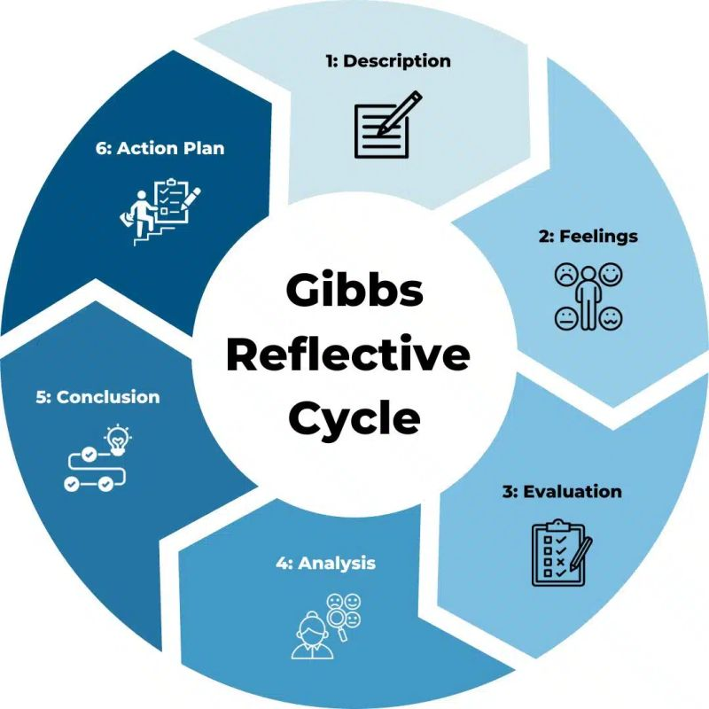
Figure 13: Gibbs Reflective Cycle
(Source: Dubey, 2025)
Description
The report has provided me with opportunities of improving my knowledge regarding the expansion strategies that will be adopted by Aldi for carrying out business operations in India. I also developed an understanding regarding the operational and financial performance of the Indian retail sector that strengthened my analytical skills effectively. In addition, I have utilized diversified methods such as the OLI framework that evaluated the international competitive advantage and brand growth of the supermarket company. The use of the models mentioned above also improved my research capacity and enhanced the quality of my investigation process. According to Fried, (2020), the inclusion of theories and frameworks in reports has helped in increasing the database of the evaluation program and strengthening its quality. Overall, I have provided a detailed analysis regarding the business ventures of Aldi in India within my research work.
Feeling
While doing the assignment, I think that the information collected for this research helps me to enhance my critical thinking skills. I have the ability to collect information by breaking down learning outcomes, which is more reliable for gathering desired outputs. I encountered several challenges due to the use of biased sources and outdated information that affected the overall quality of the research. I gathered knowledge related to market changes and stiff competition in the retail sector which strengthened demand for foreign products, and reached products in new markets by highlighting its export competition in the market. Shift in Aldi's product has its ability to meet the affordability of products by seeking urban consumer needs. I spent too much time gathering information from the lecture notes, which slowed down my analytical skills. The successful knowledge associated with the learning outcomes that have been carried out from the peer-reviewed journals (Alnajjar and Aly, 2024). The different viewpoint of the author associated with the research topic helped me to improve my confidence skills by ability to learn concepts from the module. This evidence has a massive linkage in developing assignments by applying a theoretical framework and core concepts for successful execution of assignments.
Evaluation
During the completion of the report, I have strengthened my cultural model through the inclusion of the Hofstede model. The framework has helped me in understanding the working pattern adopted in countries such as Germany and India and its impact on the global economy. In addition, I also observed issues in communicating my requirements to the local retailers for understanding the market trends in the industry that caused delays in the completion of the data collection activities. As stated by Leslie (2024), the occurrence of communication breakdown has reduced the smooth transmission of information required in the completion of a project. The communication issue will also lower the growth of my professional career significantly. I also had problems in understanding the legal regulations adopted within the Indian grocery industry due to an absence of proper statutory knowledge. Thus, the investigation had a significant impact on my professional career.
Analysis
The structured information gathered for the research helps me to enhance my research skills by accessing academic viewpoints. Knowledge gained from the courses help me to enhance my ability by recommending reading in accessing deeper academic perspectives. Uses of Hofstede application of cultural dimension Aldi while expanding in India. Application of “Bartlett and Ghoshal” for reliable expansion of Aldi in the Indian market through critical evaluation. This knowledge helps me to gather information by breaking learning outcomes into smaller parts that help me to filter out irrelevant and unauthentic information. I am able to refine my searching process with keywords which are more reliable for professional development of my career. This knowledge helps me to address reliable improvement by linking with theories in real time and carrying out research from academic databases, which enhances my personal career development (Gopalan, Shum and Boud, 2025). I think that I will improve my research ability by increasing the competitive advantage of Aldi over other organisations. I am able to carry out information regarding political, economic, cultural and legal factors that are more effective for Aldi’s expansion in the Indian market. Thus, this information enhances my critical thinking ability to respond with the business ideas by strategic planning.
Conclusion
Based on my personal experience, I feel that I was able to utilize multiple frameworks such as Hofstede and OLI models for understanding the cultural difference between the countries and the brand reputation of Aldi. In addition, the techniques have also provided opportunities for me in understanding the operational strength of the organisation. On the other hand, I also noticed issues in my communication and statutory skills that have lowered my research quality and narrowed the scope of my professional growth aspect. The challenges mentioned above have also hampered my time management skills and caused delays in the completion of my investigation process. I also acquired information about the political, economic and legal scenarios in India that will influence the business operations of Aldi within the country. Overall, learning experience from the completion of the report has helped me in improving my professional skills and achieving significant career growth.

Action Plan
Improvement plan | Action taken | Time plan
Biased sources and outdated information | - Adoption of SIFT techniques is more reliable to carry out information and enhance reliable accuracy.  - Tracking reliable sources is addressed by breaking learning outcomes into different parts. | 5 month
Complexity in gathering information due to limited time | - Use of Pomodoro Technique is more effective to collect information by setting strict boundaries in achieving business goals. | 6 month
Ability to improve my researching skills | - Enhance my researching skill search operator by ability to narrow down question through checking the quality of sources. | 6 months
Table 1: Action plan

References
Aldi (2025). Our partnerships - Aldi UK. [online] Aldi.co.uk. Available at: https://www.aldi.co.uk/corporate/partnerships/supply-chain.
Alnajjar, H.A. and Aly, E. (2024). Exploring the effectiveness of the Career Guidance and Counseling Program on the perceived readiness for the job market: A lived experience among nursing students. Frontiers in Public Health, [online] 12. doi:10.3389/fpubh.2024.1403730.
Ambey (2026). Tariff on most items to be in single digits in FY28 budget: FM sitharaman. [online] bseindia. Available at: https://www.business-standard.com/economy/news/govt-to-cut-tariff-on-most-items-to-single-digit-in-fy28-budget-fm-126080602140_1.html.
Anon, (2025). India’s Free Trade Agreements (2025-26)- Key Highlights1. [online] Available at: https://www.commerce.gov.in/files/2026-03/FTAs%20achievement%20v6%205%20pm.pdf.
BIS (2022). Products under compulsory certification | bureau of Indian standards. [online] Bis.gov.in. Available at: https://www.bis.gov.in/product-certification/products-under-compulsory-certification/?lang=en .
Brock, D.M. and Hydle, K.M. (2018). Transnationality – sharpening the integration-responsiveness vision in global professional firms. European Management Journal, 36(1), pp.117–124. doi:10.1016/j.emj.2017.01.003.
Caraceni, A. (2025). Here’s the total number of Aldi Stores in America in 2025. [online] Food Republic. Available at: https://www.foodrepublic.com/1969477/number-aldi-stores-america-2025/.
Carbon Brief (2026). Analysis: India’s CO2 emissions in 2025 grew at the slowest rate in two decades. [online] Carbon Brief. Available at: https://www.carbonbrief.org/analysis-indias-co2-emissions-in-2025-grew-at-slowest-rate-in-two-decades.
Das, D. (2026). Aldi Nord sees revenue, market share and customer growth in FY 2025. [online] ESM Magazine. Available at: https://www.esmmagazine.com/retail/aldi-nord-sees-revenue-market-share-and-customer-growth-in-fy-2025-311108
Djodat, N. and zu Knyphausen-Aufseß, D. (2017). Revisiting Ghoshal and Bartlett’s theory of the multinational Corporation as an Interorganizational Network. Management International Review, [online] 57(3), pp.349–378. doi:10.1007/s11575-016-0298-3.
Dubey, A. (2025). Gibbs’ reflective cycle in a nutshell ✨. [online] Linkedin.com. Available at: https://www.linkedin.com/posts/anubha-dubey-0579a32b6_gibbs-reflective-cycle-in-a-nutshell-gibbs-activity-7368641387170398208-AJ9P.
FCCI (2025). Indian economy buffer stocks and food security public distribution system. [online] Available at: https://cdn.visionias.in/value_added_material/6711f-public-distribution-system-buffer-stocks-and-food-security.pd.
Food Talk (2026). FoodTalks [online] Foodtalks.cn. Available at: https://www.foodtalks.cn/en/news/59702.
Fried, E.I. (2020). Theories and models: What they are, what they are for, and what they are about. Psychological Inquiry, [online] 31(4), pp.336–344. doi:10.1080/1047840x.2020.1854011.
FSSAI (2026). FSSAI. [online] Fssai.gov.in. Available at: https://www.fssai.gov.in/
Genpact (2025). Genpact and ALDI SÜD Enter Multi-Year Partnership to ... . [online] Available at: https://media.genpact.com/2024-07-09-Genpact-and-ALDI-SUD-Enter-Multi-Year-Partnership-to-Reimagine-ALDIs-Business-Services,-Leveraging-Data,-Technology,-and-AI-Solutions.
Gopalan, Y., Shum, S.B. and Boud, D. (2025). The professional learning of academic researchers through their career. Studies in Higher Education, pp.1–18. doi:10.1080/03075079.2025.2505932.
Government of India (2025). Copyright act, 1957. [online] Indiacode.nic.in. doi:195714.
Government of India (2025). FSSAI. [online] fssai.gov.in. Available at: https://fssai.gov.in/cms/food-safety-and-standards-regulations.php
Government of India (2025). India records USD 81.04 billion FDI inflow in FY 2024–25. [online] Pib.gov.in. Available at: https://www.pib.gov.in/PressReleasePage.aspx?PRID=2131716&reg=48&lang=2.
Government of India (2025). Review of the policy on foreign direct investment-allowing FDI in multi-brand retail trading. [online] Government of India Ministry of Commerce & Industry . Available at: https://www.dpiit.gov.in/static/uploads/2025/07/384fbc020758137b3622fd8dd7bbf016.pdf .
Government of India (2025). Trade Marks Act, 1999. [online] Available at: https://www.indiacode.nic.in/bitstream/123456789/15427/1/the_trade_marks_act%2C_1999.pdf.
Government of India (2026). India becomes world’s 4th largest economy, surpasses Japan: NITI aayog | akashvani news. [online] Newsonair.gov.in. Available at: https://newsonair.gov.in/india-becomes-worlds-4th-largest-economy-surpasses-japan-niti-aayog/.
Grand View Research (2025). India online grocery market size report, 2021-2028. [online] www.grandviewresearch.com. Available at: https://www.grandviewresearch.com/industry-analysis/india-online-grocery-market.
Griffiths, H. (2026). Success for Guy White’s Aldi partnership as four-year planning battle ends. [online] Forecourt Trader. Available at: https://forecourttrader.co.uk/news/success-for-guy-whites-aldi-partnership-as-four-year-planning-battle-ends/721960.article.
IBEF (2026). Retail industry in India: Overview of retail sector, market size, growth...IBEF. [online] www.ibef.org. Available at: https://www.ibef.org/industry/retail-india
IKEA (2026). [online] Available at: https://dea.gov.in/files/external_debt_documents/Quarterly%20ED%20Report%20Sept25.pdf.
IMARC (2026). India retail market size, share, growth and industry report. [online] Imarcgroup.com. Available at: https://www.imarcgroup.com/india-retail-market
Indian Parliament (2026). Rules and regulations review code on wages (central) rules, 2026. [online] Available at: https://prsindia.org/files/bills_acts/bills_parliament/2026/Wages_Rules_2026.pdf.
Indian Retailer (2026). IndianRetailer.Com. [online] Indian Retailer. Available at: https://www.indianretailer.com/article/retail-business/retail/indias-retail-sector-sees-cautious-optimism-6-growth-march.
Informa (2025). ALDI takes steps to reduce waste, increase recycling. [online] Waste360.com. Available at: https://www.waste360.com/waste-reduction/aldi-takes-steps-to-reduce-waste-increase-recycling.
Leslie, M. (2024). Communication breakdown. Science, 384(6698), pp.839–841. doi:10.1126/science.adq5716.
Malla (2025). India’s environmental revolution 2025 policies you need to know!.Pptx. [online] Slideshare. Available at: https://www.slideshare.net/slideshow/india-s-environmental-revolution-2025-policies-you-need-to-know-pptx/281954167.
Mo (2026). India CPI inflation may 2026: 3.93%, Fifth straight monthly rise. [online] Finovate Blog. Available at: https://www.finnovate.in/learn/blog/india-cpi-inflation-may-2026-analysis.
PIB (2025). GST reforms 2025: Relief for common man, boost for businesses relief, simplification, and growth for all. [online] GST Reforms 2025: Relief for Common Man, Boost for ... Available at: https://static.pib.gov.in/WriteReadData/specificdocs/documents/2025/sep/doc202594628401.pdf
Redman, R. and Adam, D. (2025). Aldi to acquire southeastern grocers’ winn-dixie, Harveys supermarkets. [online] Supermarketnews.com. Available at: https://www.supermarketnews.com/foodservice-retail/aldi-to-acquire-southeastern-grocers-winn-dixie-harveys-supermarkets.
Retail World Editor (2026). ALDI breaks into YouGov Australia’s top 10 as value-driven trust pays off | RW. [online] Retailworld Magazine.com.au. Available at: https://retailworldmagazine.com.au/aldi-breaks-into-yougov-australias-top-10-as-value-driven-trust-pays-off/.
Roy (2026). DMart’s 500-Store milestone: Built on value, not velocity. [online] d__indiaRetail. Available at: https://www.indiaretailing.com/dmarts-500store-milestone-built-on-value-not-velocity.
Stainton, P. (2025). #Aldi achieving their highest ever share, and #ASDA continuing to struggle , are the key take-outs from worldpanel by Kantar’s UK market data for 12 weeks ending 23rd march 2025 released this morning. [online] LinkedIn. Available at: https://www.linkedin.com/posts/paul-stainton-005447134_aldi-asda-lidl-activity-7312752592076300289-OoHg/.
StartupFlora (2025). Government grants up to ₹5 crore for food business - MOFPI scheme 2025. [online] Startupflora.com. Available at: https://startupflora.com/post/government-grant-up-to-inr5-crore-for-food-business-mofpi-scheme-2025.
Statista (2025). Topic: Aldi customers in Germany. [online] Statista. Available at: https://www.statista.com/topics/7459/aldi-customers-in-germany/?srsltid=AfmBOoqJgAQQ7Gmh-IX5IEpDmdvBc9NZAMuXTGcNE4m1wzFA4i8Jp9O2
Supermarket News (2025). Aldi leans into AI with Digital Wave partnership. [online] Supermarketnews.com. Available at: https://www.supermarketnews.com/grocery-technology/aldi-boosts-automation-with-digital-wave-partnership.
Sutariya (2025). 2025 Average salary in India: Regional differences explained. [online] India Data Map. Available at: https://indiadatamap.com/2025/08/31/2025-average-salary-in-india/.
Technavio (2025). Grocery market in India to grow at a CAGR of 8.02% By 2025 | growing urbanization & rise in personal products to boost growth | 17000+ technavio reports. [online] www.prnewswire.com. Available at: https://www.prnewswire.com/news-releases/grocery-market-in-india-to-grow-at-a-cagr-of-8-02-by-2025--growing-urbanization--rise-in-personal-products-to-boost-growth--17000-technavio-reports-301412754.html.
The Culture Factor (2020). Country comparison tool. [online] Theculturefactor.com. Available at: https://www.theculturefactor.com/country-comparison-tool?countries=germany%2Cindia
The Global Economy (2025). India political stability - data, chart | TheGlobalEconomy.Com. [online] TheGlobalEconomy.com. www.theglobaleconomy.com. Available at: https://www.theglobaleconomy.com/India/wb_political_stability/
The Packer (2025). Aldi to open record-breaking 225-plus stores in 2025. [online] The Packer. Available at: https://www.thepacker.com/news/retail/aldi-open-record-breaking-225-plus-stores-2025.
Trehan, S., Pozhath, R. and Pratap, M. (2025). How India invests 2025. [online] Bain. Bain & Company. Available at: https://www.bain.com/insights/how-india-invests-2025/
White Case (2025). Foreign direct investment reviews 2025: India | white & case LLP. [online] Whitecase.com. Available at: https://www.whitecase.com/insight-our-thinking/foreign-direct-investment-reviews-2025-india.
Wilt, A. (2026). These are Aldi’s best new products of 2026 (so far). [online] Southern Living. Available at: https://www.southernliving.com/aldi-best-new-products-2026-11975086.
Yuto (2026). Aldi and Arla aim to boost milk bottle recycling with new collaboration. [online] Packaging Europe. Available at: https://packagingeurope.com/news/aldi-and-arla-aim-to-boost-milk-bottle-recycling-rated-with-new-collaboration/14563.article.

