Programme: BSc Applied Computing
Alexandru Carp

Module code: ACCB6017
Lecturer: Fahad Ahmed
Student ID : 2317094

Full Interface & Testing
Module: Usability Engineering

Contents
1. Introduction 3
2. Full-colour storyboard design 3
2.1 Design goals and continuity from Assignment 1 3
Figure 1. Original low-fidelity wireframe flow used as the structural baseline. 4
2.2 Complete navigation flow 4
Figure 2. Full-colour storyboard flow. The complete, larger screens appear in Appendix A 5
2.3 Graphics and colour scheme 5
2.4 Changes made after wireframe feedback 6
2.5 Significant screens 6
3. Final prototype feedback 8
3.1 Evaluation method 8
3.2 Coverage of personas 9
3.3 Results and evidence 9
4. Data to collect from a released game 10
4.1 Purpose and data minimisation 10
4.2 Automatically collected usage data 10
4.3 Directly collected emotional-response data 11
4.4 Ethics, privacy and interpretation 11
5. Usability and user-experience trade-offs 12
5.1 How a purely usability-led version would differ 12
5.2 Conflicts resolved in the prototype 12
6. Reflective summary 12
7. Conclusion 13
References 14
Bibliography 14
Appendix A - Complete full-colour storyboards 15
Appendix B - Final usability-test pack 22
B1. Participant message 22
B2. Scenario and task questions 22
B3. Ratings and open feedback 22
B4. Anonymised participant response record 22
B5. Evidence handling 23
Appendix C - Design traceability 23

1. Introduction
In the cooperative strategy game Pandemic, players pool their specialised skills to manage threats and accomplish a common goal. In this project, the cooperative structure is modified for a mobile game that takes place on the campus of UWTSD London. In order to handle a fictional campus emergency and finish a cure before the outbreak track hits its limit, up to six players—representing various university roles—work together.
These wireframes are developed into full-colour storyboards in the current report. It describes the visual design, records modifications made in response to previous input, offers a brief assessment of the finished prototype, talks about gathering data for a workable release, and considers striking a balance between usability and emotional experience.
The prototype concentrates on the main mobile interactions that the brief calls for: starting or joining a private team, choosing a role, going thru an optional tutorial, viewing the campus map, debating and voting, confirming an action, getting feedback, starting an autosaved game again, and seeing the outcome. [1]

2. Full-colour storyboard design

2.1 Design goals and continuity from Assignment 1
Morgan is a time-constrained working student; Sam is a frequent social player; Jordan is an infrequent strategic player; and Daniel is an independent commuter who enjoys sessions with friends only. Short sessions, unambiguous controls, private teams, text-based collaboration, an optional tutorial, and automated saving were among their shared needs. As a result, the full-colour design preserves Morgan's previous scenario while giving it a more robust visual hierarchy and more lucid feedback.

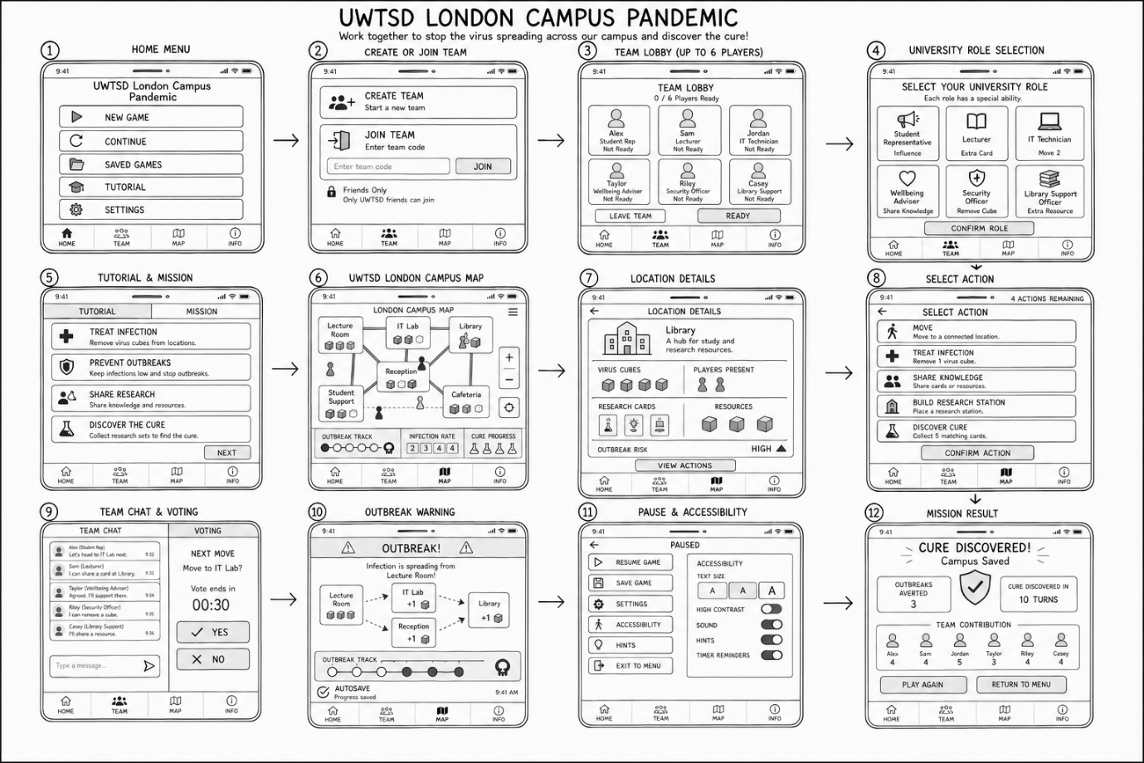

Figure 1. Original low-fidelity wireframe flow used as the structural baseline.

2.2 Complete navigation flow
The primary path thru twelve displays is depicted in Figure 2. Players may navigate between important locations while playing thanks to the persistent Map, Team, Chat, and Help controls, while the numbered screens follow a linear sequence throughout the scenario. This blends versatility for seasoned users with a clear path for beginners. By maintaining the visibility of valid destinations and current state, the design prioritises identification over recall. [2] [3]

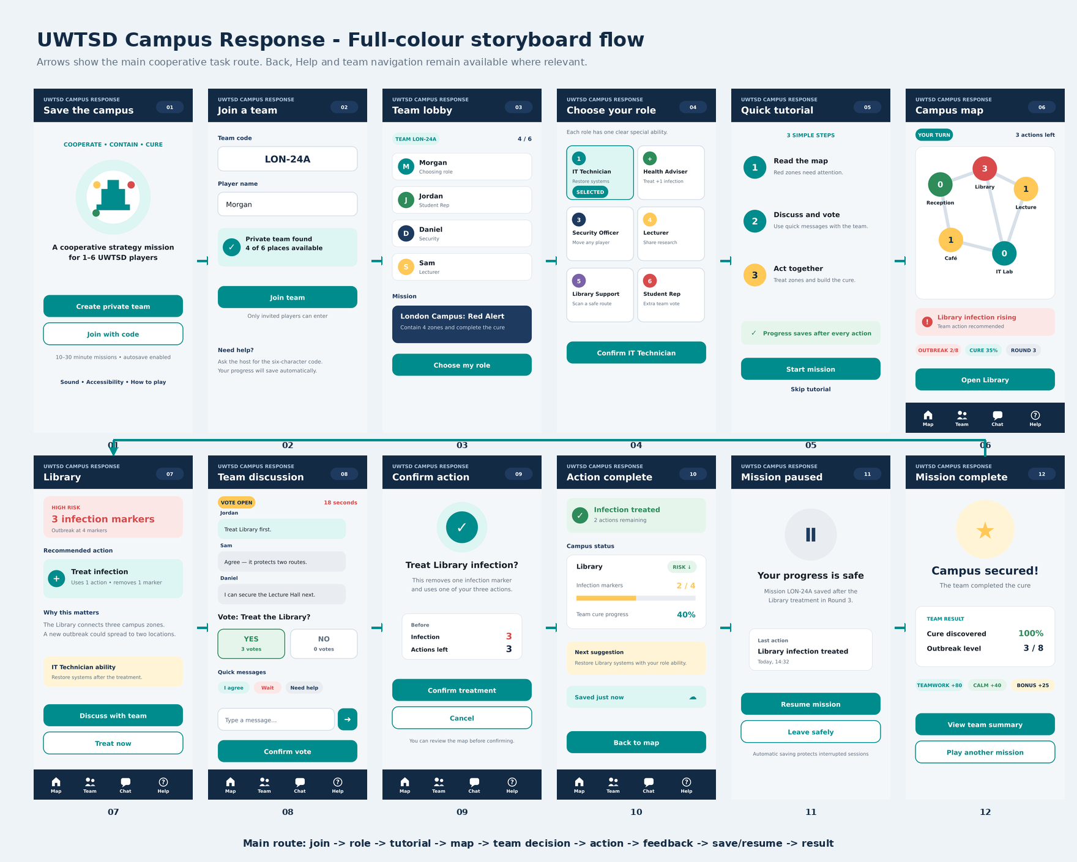

Figure 2. Full-colour storyboard flow. The complete, larger screens appear in Appendix A

2.3 Graphics and colour scheme
The interface uses flat vector graphics, rounded cards and simple icons because these remain legible on a mobile screen and can later be reproduced consistently in a working prototype. The graphics avoid detailed decoration that could compete with the map, voting and threat information. University roles are represented by coloured circular badges and short ability descriptions rather than realistic portraits, keeping the design neutral and reducing unnecessary visual load.
Dark navy (#132A44), teal (#008C8C), off-white (#F4F7FA), amber (#FFC857), crimson (#D94B4B), and green (#2D8C5A) make up the fundamental colour scheme. Navy offers a consistent campus identity; amber indicates warning; red indicates an urgent infection; green indicates a successful action; and teal indicates primary actions and collaboration. Text labels, numbers, images, and position all repeat the meaning, so red and green are never the only ways to communicate. The WCAG principle of at least 4.5:1 contrast for standard text is followed when placing normal text on high-contrast light or dark backgrounds. [4]
Colour | Interface use | Reason
Navy | Header, navigation and result values | Stable hierarchy and strong contrast
Teal | Primary buttons, selected role and teamwork | Consistent signifier for safe action
Amber | Warnings, medium infection and bonus | Attention without implying immediate failure
Red | High risk and outbreak warnings | Reserved for urgent states
Green | Success messages and reduced risk | Clear positive feedback

2.4 Changes made after wireframe feedback
The previous wireframes were examined by two peer assessors and three participants. Although they cited limited writing, cluttered map/location panels, and inadequate explanation of outbreak, infection, and cure signs, they did comprehend the general pattern. Instead of altering the productive cooperative flow, the final storyboard immediately addresses those problems.
Earlier feedback | Change in final design | Storyboard evidence
Text and icons appeared too small | Larger headings, short labels and large full-width action buttons | Screens 1, 6, 7 and 10
Map and location screens were crowded | Secondary details removed; one recommended action shown at a time | Screens 6 and 7
Indicators needed explanation | Plain-language labels, numbers, progress bars and optional Help | Screens 5, 6 and 10
Important actions were not prominent | Teal primary button and separate confirmation screen | Screens 7 and 9
Feedback after an action was weak | Success banner, changed risk value, actions remaining and save status | Screen 10
Interrupted sessions required protection | Visible autosave confirmation and resume summary | Screens 10 and 11

2.5 Significant screens
The campus map is the main decision screen. It shows only the data necessary for the current turn: zone connections, infection values, outbreak level, cure progress, round and remaining actions. The Library uses red, a numeric value of 3 and a warning card, so the player is not expected to interpret colour alone. The full-width Open Library button provides an obvious next step.
The Team Discussion screen supports cooperation without voice chat. Named messages, quick responses and a two-option vote reduce typing during short sessions. The Action Complete screen closes the feedback loop by confirming the treatment and showing its immediate effect. These choices apply visible system status, clear signifiers and prompt feedback, all central to understandable interaction
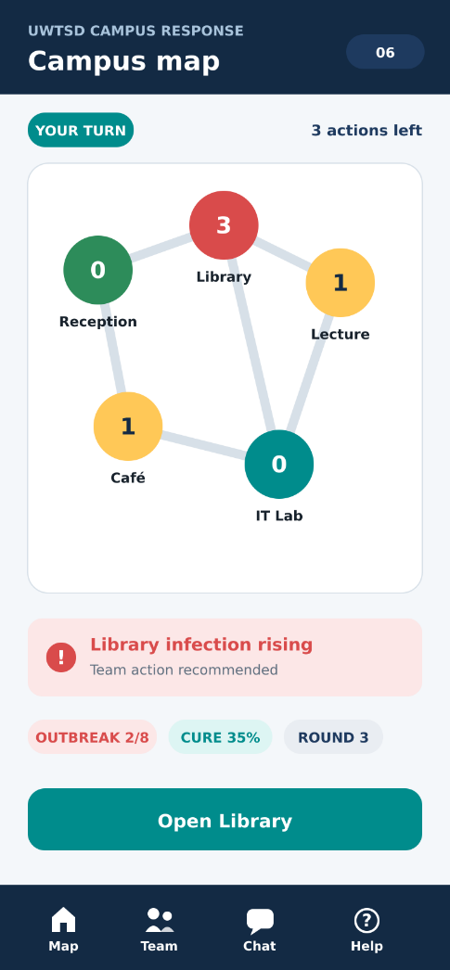
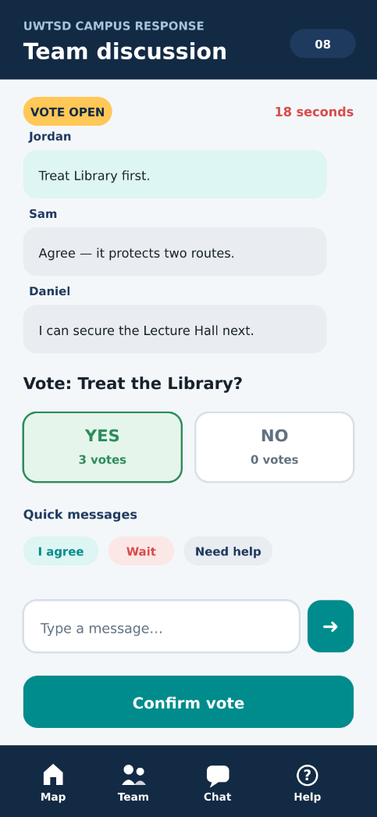

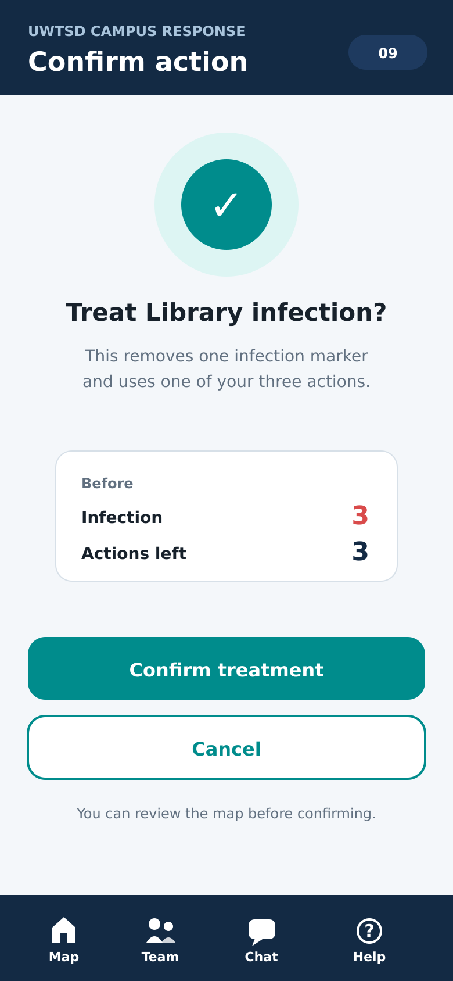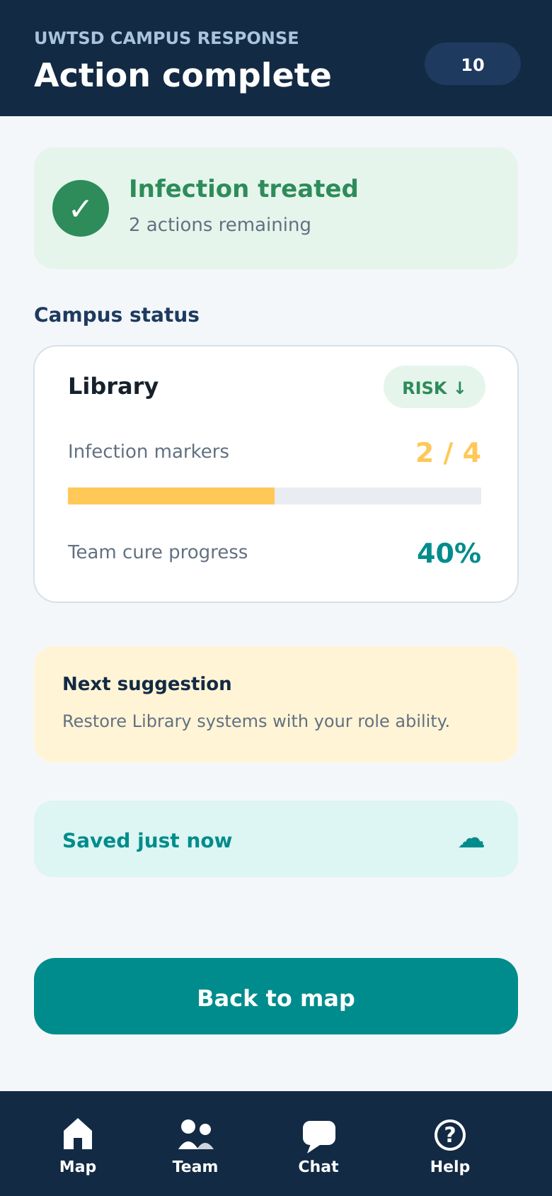

3. Final prototype feedback

3.1 Evaluation method
Three individuals, identified only as P1, P2, and P3, performed a brief scenario-based assessment. After reviewing the larger versions of the primary choice screens and the whole storyboard flow, each participant verified an anonymous response summary. The assessment considered the behaviours exemplified by the previous personas: infrequent strategy use, short-session or commuting requirements, low gaming confidence, and interest in cooperative play. Although a small convenience sample cannot accurately reflect all students, it can be used to detect significant issues with a static prototype.
The larger versions of Screens 6–10 and the full storyboard flow are given to participants. They are asked to describe how they would do five jobs if they were Morgan, the IT technician. The evaluation assesses comprehension and anticipated involvement rather than actual touch accuracy or system response time because the storyboard is static.
1. Join team LON-24A and choose the IT Technician role.
2. Identify the campus zone that needs the most urgent attention.
3. Discuss the problem, vote and choose the treatment action.
4. Explain what changed after the treatment and how many actions remain.
5. Pause and explain how the mission would be resumed later.
Was offered 1–5 rating questions about clarity, readability, confidence, visual appeal, and teamwork, and marks task comprehension as success, half success, or failure. The best feature, the most perplexing aspect, and one suggested improvement are gathered in three open-ended questions. Instead of treating satisfaction as the same as task achievement, this integrates behavioural evidence with emotional reaction. Effectiveness, efficiency, and contextual satisfaction are used to understand usability. [5] [6]

3.2 Coverage of personas
Participant profile to recruit | Persona represented | Reason for inclusion
Occasional mobile strategy player | Jordan | Tests clarity without expert game knowledge
Student who works or commutes | Daniel / Morgan | Tests short-session design and autosave
Regular social or multiplayer player | Sam | Tests teamwork, voting and expected game feedback

3.3 Results and evidence
Measure | P1 | P2 | P3 | Summary
Tasks understood (out of 5) | 5 | 5 | 5 | 5.0
Clarity rating (1–5) | 5 | 4 | 5 | 4.7
Readability rating (1–5) | 4 | 4 | 5 | 4.3
Confidence rating (1–5) | 5 | 4 | 4 | 4.3
Visual appeal rating (1–5) | 4 | 5 | 5 | 4.7
Teamwork rating (1–5) | 5 | 4 | 5 | 4.7

Each of the three participants acknowledged that the mission had been salvaged, explained the impact of the treatment, knew how to vote and discuss, and correctly identified the library as the highest-risk area. The voting page, big buttons, clear map colours, and instant action feedback received the most positive responses. The design was characterised by participants as simple, dependable, and aesthetically pleasing.
The criticism was straightforward but helpful. P1 believed that parts of the secondary text might be longer. P2 asked for a brief explanation since she wasn't immediately sure what the cure percentage indicated. P3 recommended making the back control more noticeable. Regarding readability and guidance, the first two remarks aligned with the previous wireframe findings. A novel idea was the back control. Therefore, a later interactive version would have a consistent back arrow in the header, add a brief explanation to the cure indicator, and significantly increase supplementary content.

4. Data to collect from a released game

4.1 Purpose and data minimisation
Only data that clearly addresses a design or dependability question should be gathered by a functional game. The mere fact that data collection is feasible does not make it worthwhile. Finding out where players lose interest, where screens make mistakes, if sessions last the full 10 to 30 minutes, and whether the cooperative dynamics are still fun after repeated play are the major goals. Consent should be required for optional research questions, and players should be given a clear privacy notice.

4.2 Automatically collected usage data
Data item | Why it is needed | How it could influence version 2
Anonymous session and mission ID | Connect events from one play session without using a real name | Measure completion and return rate
Screen views and navigation path | Find loops, abandoned screens and hidden functions | Simplify navigation or reposition controls
Task and mission completion | Measure whether players can achieve the shared goal | Rebalance mission difficulty
Time per screen and session | Detect hesitation and test the 10–30-minute target | Shorten tutorials or complex decisions
Action, cancel and confirmation events | Find accidental choices and uncertainty | Improve labels, mapping and confirmation rules
Help and tutorial use | Identify instructions that are missing or excessive | Add contextual help only where needed
Vote participation and response time | Evaluate whether cooperative decisions include the team | Adjust timers and quick messages
Autosave, resume and technical errors | Measure interruption recovery and reliability | Priorities crash, network and save fixes
Device, operating system and app version | Diagnose platform-specific problems | Target testing and performance work

4.3 Directly collected emotional-response data
Event logs can indicate that a player paused at the map, but they are unable to reveal whether the player was bored, puzzled, under pressure, or just got a call. Therefore, direct user involvement is necessary for emotional response. A brief post-mission evaluation can enquire about the player's level of composure, team value, social inclusion, and desire to participate again. Explanations would be given throughout a recurring interview and optional open remark. To avoid interfering with the experience and possibly lowering the quality of responses, these prompts should be brief and should not come after every mission.
Large-scale research has demonstrated the System Usability Scale's value across many products, and it can offer a condensed overall usability measure . However, neither the level of cooperation nor emotional engagement could be explained by SUS alone. Thus, behavioural measurements would be supplemented by brief bespoke experience items and sporadic interviews. Qualitative remarks aid in elucidating the reasons behind the patterns revealed by quantitative statistics. [5] [7] [8] [9]

4.4 Ethics, privacy and interpretation
- Use an anonymous player ID and avoid collecting names, exact location or message content unless essential.
- Separate optional research consent from the basic ability to play.
- Give players access to privacy information and a way to withdraw optional data.
- Limit retention and restrict access to raw research data.
- Analyze team messages as counts or categories where possible rather than storing private text.
- Do not treat correlation as proof: long time on a screen may mean confusion or careful strategy.

5. Usability and user-experience trade-offs

5.1 How a purely usability-led version would differ
Steps, visual ornamentation, and uncertainty would be reduced with a design that is only focused on usability. It might eliminate the timed vote, replace the campus map with a straightforward list of locations, choose the highest-risk option automatically, and display all of the rules in plain print. Although such a version might be effective, it would diminish the sense of being a specialised team handling a crisis on campus. As a result, usability is considered essential but insufficient in the existing design. Hassenzahl contends that perceived product quality encompasses both pragmatic and hedonistic elements, whereas Norman describes how emotional attributes impact experience in addition to appearance. [10] [11]

5.2 Conflicts resolved in the prototype
Conflict | Usability pressure | Experience pressure | Resolution
Campus map | A list would be faster to scan | A spatial map supports strategy and campus identity | Keep a simplified five-node map with numeric risk
Warning colours | Strong red improves urgency | Too much red can feel stressful | Reserve red for high risk and use calm navy/teal elsewhere
Action confirmation | An extra step slows play | Accidental team actions are frustrating | Confirm only consequential actions and explain the cost
Timed voting | A timer may pressure inexperienced players | Time pressure creates cooperative tension | Show the remaining time clearly and provide quick messages
Tutorial | More instruction improves first-time understanding | Long instruction delays play | Use a skippable three-step tutorial and contextual Help
Game status | Many indicators improve awareness | Dense displays reduce immersion and readability | Show only outbreak, cure, round and actions on the map

Progressive disclosure is used in these resolutions; while comprehensive explanation is accessible via Help or the location screen, crucial information is immediately displayed. This eliminates the need for the player to commit rules to memory while maintaining a strategic experience. It also considers the prior participants' request for both direction and a clear display.

6. Reflective summary
Understanding users was the first step in the process, followed by requirements definition, wireframe creation, feedback gathering, and full-colour storyboard development. The most helpful lesson was to avoid applying visual refinement before the interaction structure is clear. While the final colour stage made it simpler to assess hierarchy, urgency, and emotional tone, the greyscale wireframes allowed participants to concentrate on flow.
The design was significantly altered by user engagement. Since cooperative strategy games frequently contain complex information, I might have incorporated additional data, smaller map labels, and longer missions in the absence of the questionnaire and interviews. Instead, short play, interruptions, big controllers, and little information were highlighted by the target consumers. Autosave, a resume summary, full-width buttons, brief notifications, and a smaller map were the results of this. The clarity had improved, according to the later wireframe evaluation, but the map and indication explanations still required improvement.
The interpretation of those remarks was aided by usability theory. The turn, threat, and save indicators were directed by status visibility. Buttons, chosen roles, and location nodes were all directed by signifiers. The likelihood of inadvertently spending an action was decreased via constraints and confirmation. Rather than recollection, recognition preserved role skills and appropriate behaviour. While emotional-design literature kept the interface from becoming merely a functional checklist, ISO's emphasis on effectiveness, efficiency, and satisfaction offered a helpful evaluation framework.
Limitations were also disclosed by the project. Accessible UWTSD students made up the small sample. Since the storyboards were static, they were unable to assess true touch accuracy, latency, learning over multiple sessions, or collaboration among six players at once. Therefore, task completion, errors, time, observations, and post-task ratings should be included in a future interactive prototype. This should be followed by a brief field test during commutes or breaks from school. Nevertheless, compared to depending solely on personal choice, the iterative process resulted in a design that was clearer and more convincing. [6]

7. Conclusion
This report developed the UWTSD London Campus cooperative game from low-fidelity wireframes into a complete twelve-screen, full-colour mobile storyboard. The navy and teal interface creates a calm campus identity, while amber, red and green communicate warning, danger and success with supporting text and icons. Earlier feedback was addressed through larger controls, simpler screens, contextual help, confirmation and visible autosave feedback.
All three participants understood the scenario and rated the main qualities positively, while still identifying improvements to secondary text, the cure explanation and Back navigation. A working release would combine anonymous usage events with occasional ratings and interviews, applying data minimisation and clear consent. Overall, the final design balances efficiency with a sense of teamwork and urgency.

References

Bibliography

[1] | Z.-M. Games, “Pandemic,” Z-Man Games, 1 2 2026. [Online]. Available: https://www.zmangames.com/game/pandemic/. [Accessed 16 08 2026].
[2] | Y. Rogers, H. Sharp and J. Preece, Interaction Design: Beyond Human-Computer Interaction, Hoboken, NJ: Wiley, 2023.
[3] | D. A. Norman, The Design of Everyday Things, New York: Basic Books, 2013.
[4] | W. W. W. Consortium, “Web Content Accessibility Guidelines,” Basic Books2, 1 1 2024. [Online]. Available: https://www.w3.org/TR/WCAG22/. [Accessed 15 8 2026].
[5] | J. Lazar, J. H. Feng and H. Hochheiser, Research Methods in Human-Computer Interaction, Cambridge, MA: Morgan Kaufmann, 2017.
[6] | I. O. f. Standardization, “Ergonomics of Human-System Interaction – Part 11: Usability: Definitions and Concepts,” ISO 9241-11:2018, Geneva, 2018.
[7] | J. Brooke, “Usability Evaluation in Industry,” in Usability Evaluation in Industry, Unknow, Taylor & Francis, 1996, pp. 186- 194.
[8] | A. Bangor, P. T. Kortum and J. T. Miller, “An Empirical Evaluation of the System Usability Scale,” International Journal of Human-Computer Interaction, vol. 24, no. 6, p. 574–594, 2008.
[9] | T. Tullis and W. Albert, Measuring the User Experience, Waltham, MA: Morgan Kaufmann, 2013.
[10] | M. Hassenzahl, “The Interplay of Beauty, Goodness, and Usability in Interactive Products,” Human–Computer Interaction, vol. 19, no. 4, p. 319–349, 2004.
[11] | D. A. Norman, Emotional Design: Why We Love (or Hate) Everyday Things, New York: Basic Book, 2004.

Appendix A - Complete full-colour storyboards
Every important screen is displayed in the appendix at a mobile-phone scale. Figure 2 corresponds to the sequence numbers. The overview's arrows indicate the primary screen transitions; throughout the operation, the permanent bottom navigation offers access to the Map, Team, Chat, and Help.
Figure A1. Complete navigation overview.

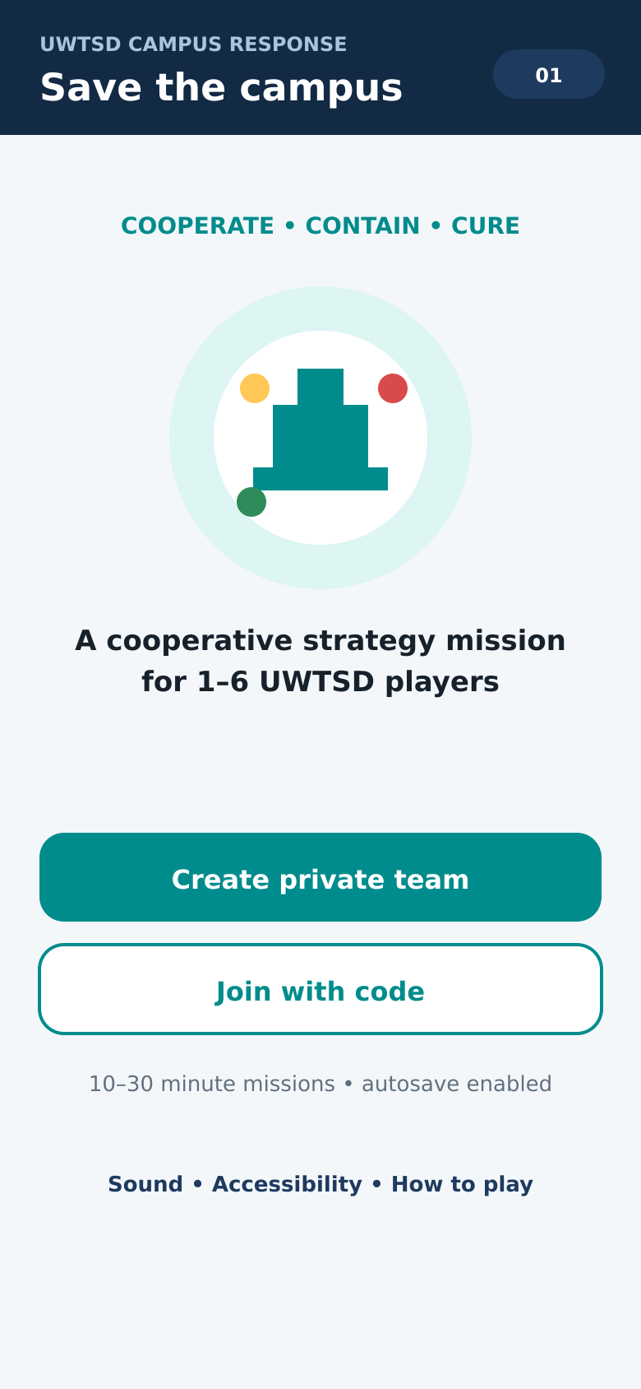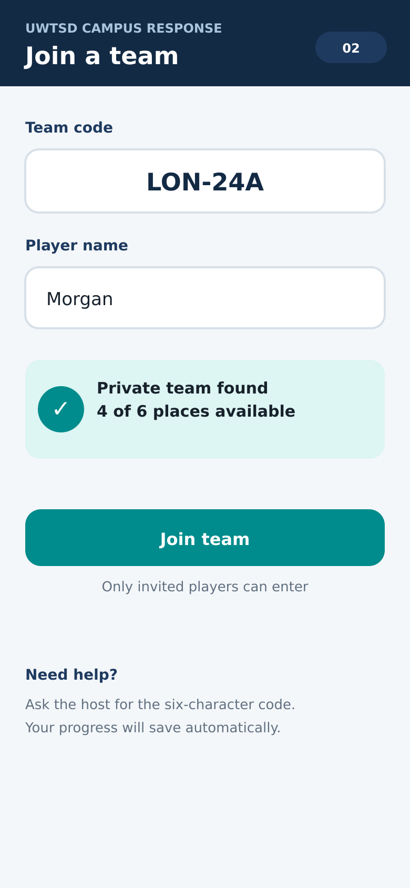
Figure A2. Welcome: create or join a private team | Figure A3. Join: enter team code and player name
Navigation: continue using the main teal button. Where shown, the bottom bar also opens Map, Team, Chat or Help. Secondary outlined buttons support cancelling, leaving safely or repeating a mission.

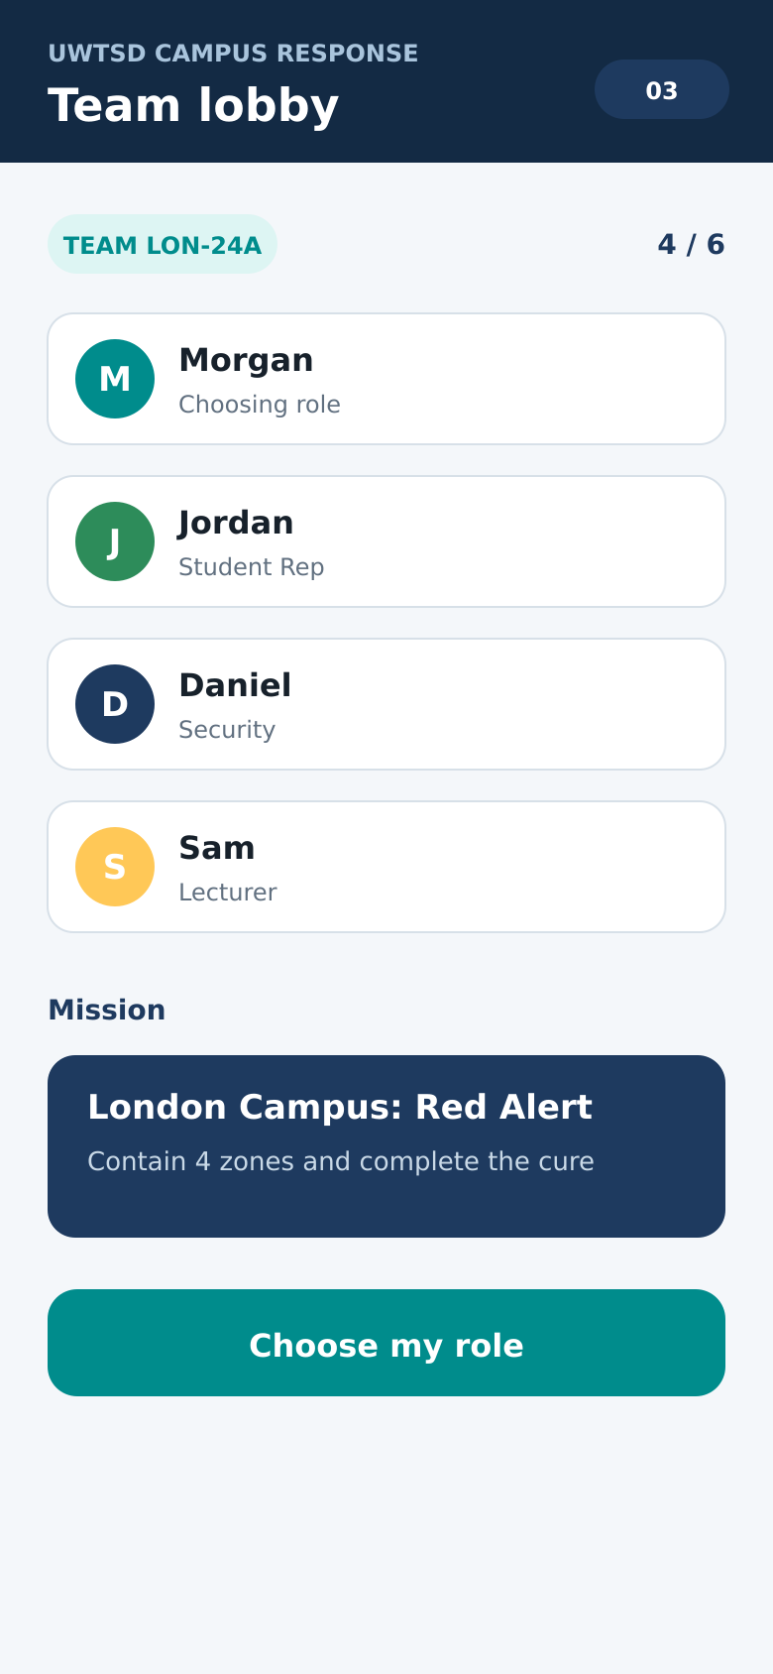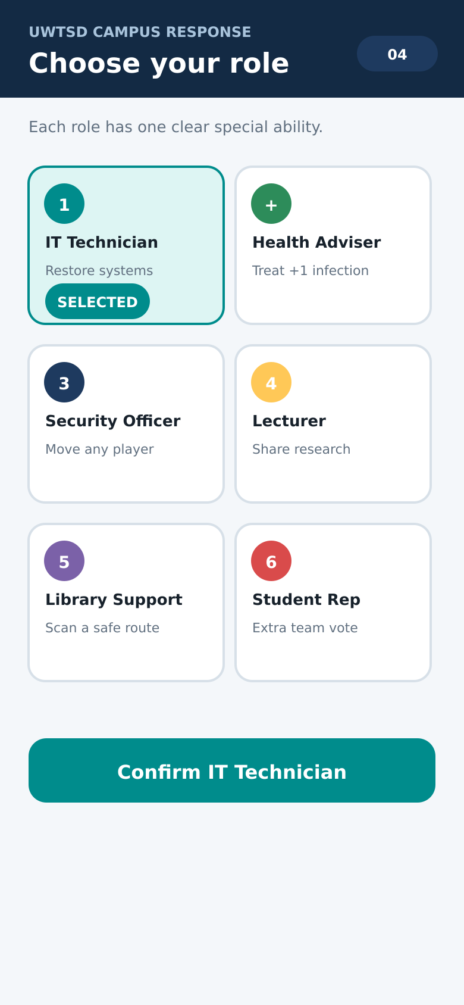
Figure A4. Lobby: see players and mission | Figure A5. Roles: choose a university specialist
Navigation: continue using the main teal button. Where shown, the bottom bar also opens Map, Team, Chat or Help. Secondary outlined buttons support cancelling, leaving safely or repeating a mission.

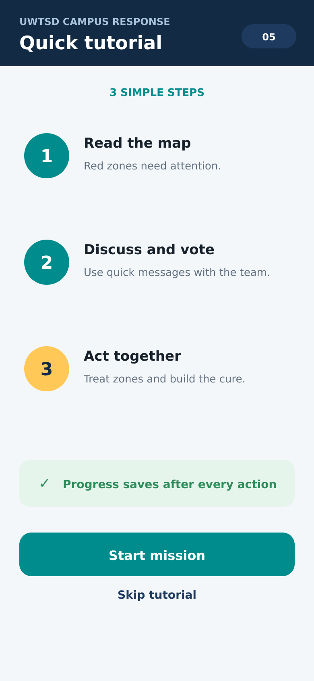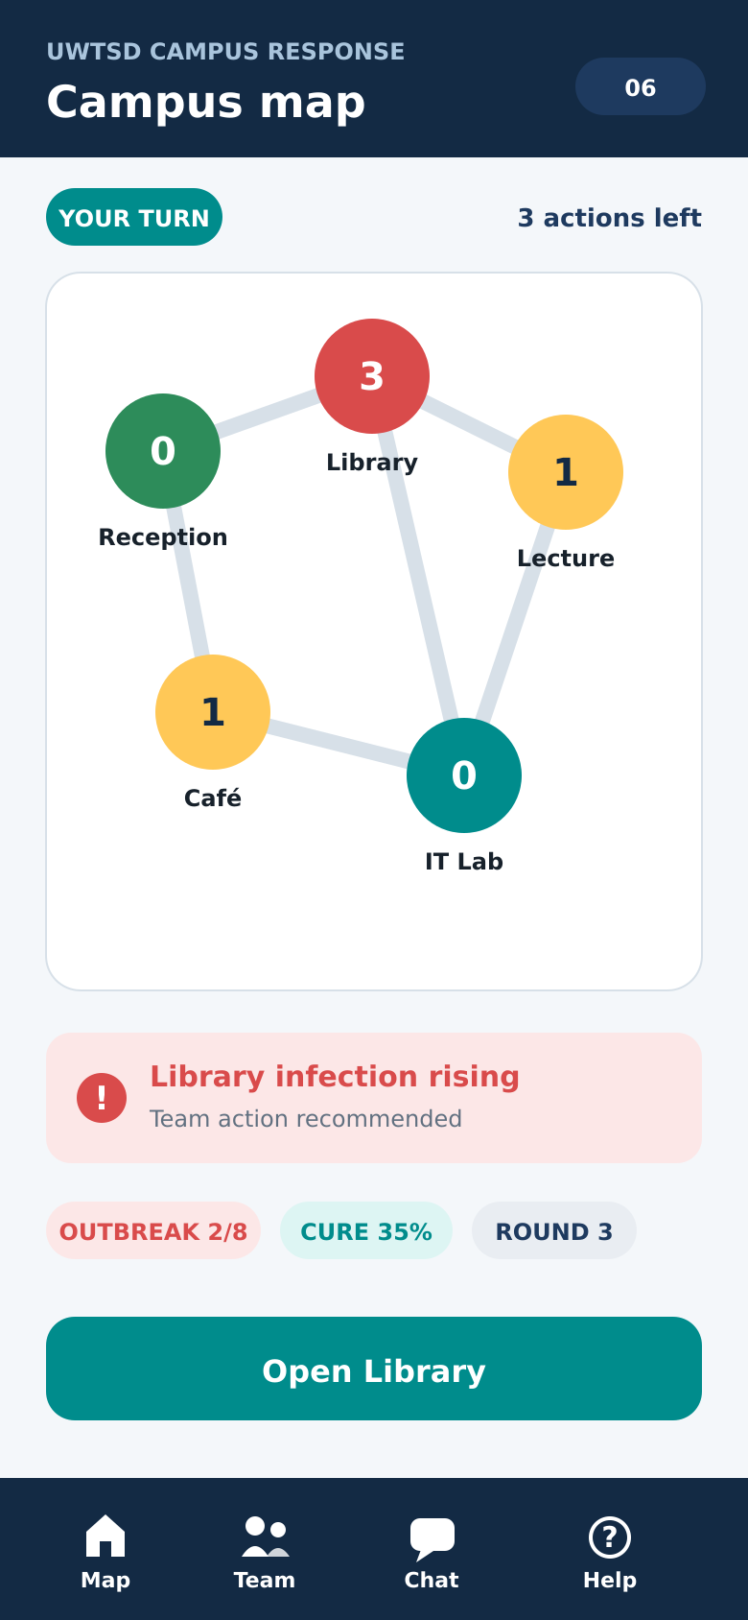

Figure A6. Tutorial: three skippable steps | Figure A7. Map: read risk and choose a location
Navigation: continue using the main teal button. Where shown, the bottom bar also opens Map, Team, Chat or Help. Secondary outlined buttons support cancelling, leaving safely or repeating a mission.

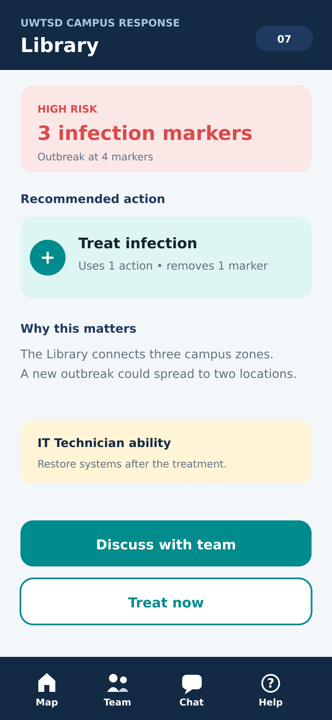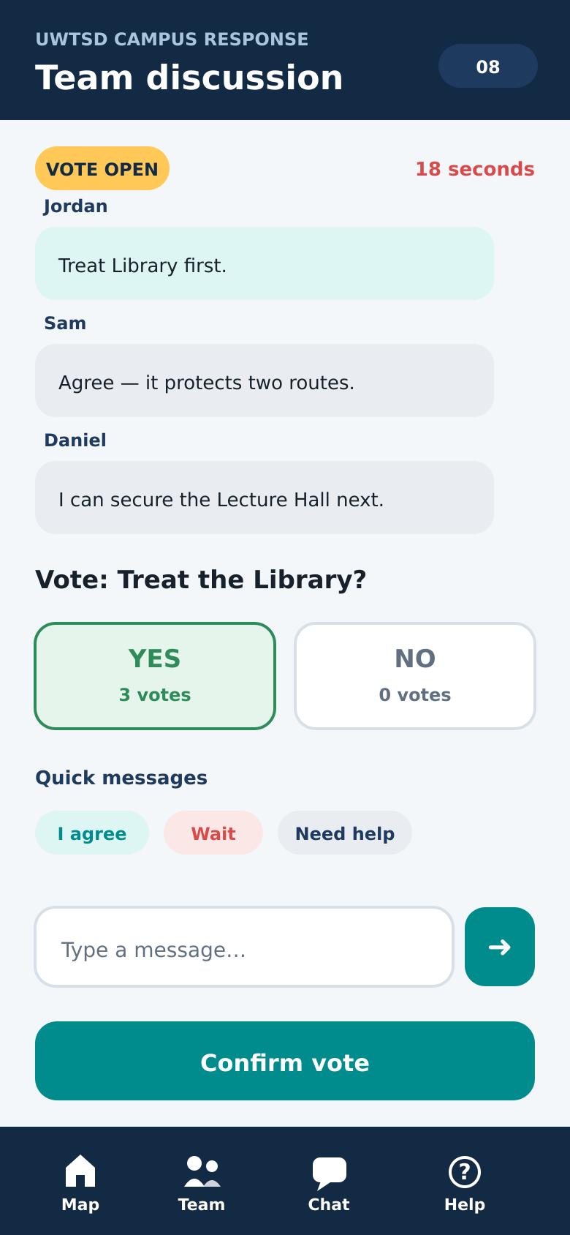
Figure A8. Library: review risk and recommended action | Figure A9. Team: discuss and vote
Navigation: continue using the main teal button. Where shown, the bottom bar also opens Map, Team, Chat or Help. Secondary outlined buttons support cancelling, leaving safely or repeating a mission.

Figure A10. Confirmation: prevent accidental action | Figure A11. Feedback: show result and autosave
Navigation: continue using the main teal button. Where shown, the bottom bar also opens Map, Team, Chat or Help. Secondary outlined buttons support cancelling, leaving safely or repeating a mission.

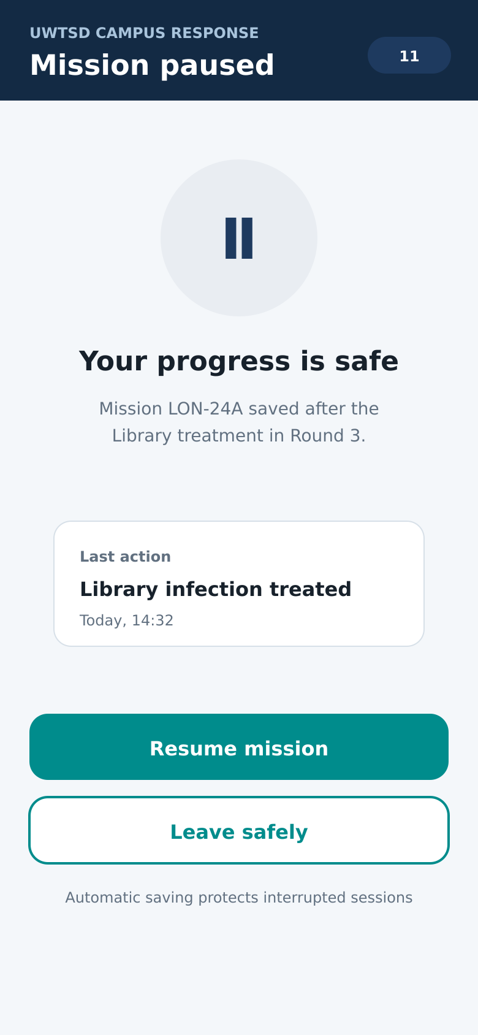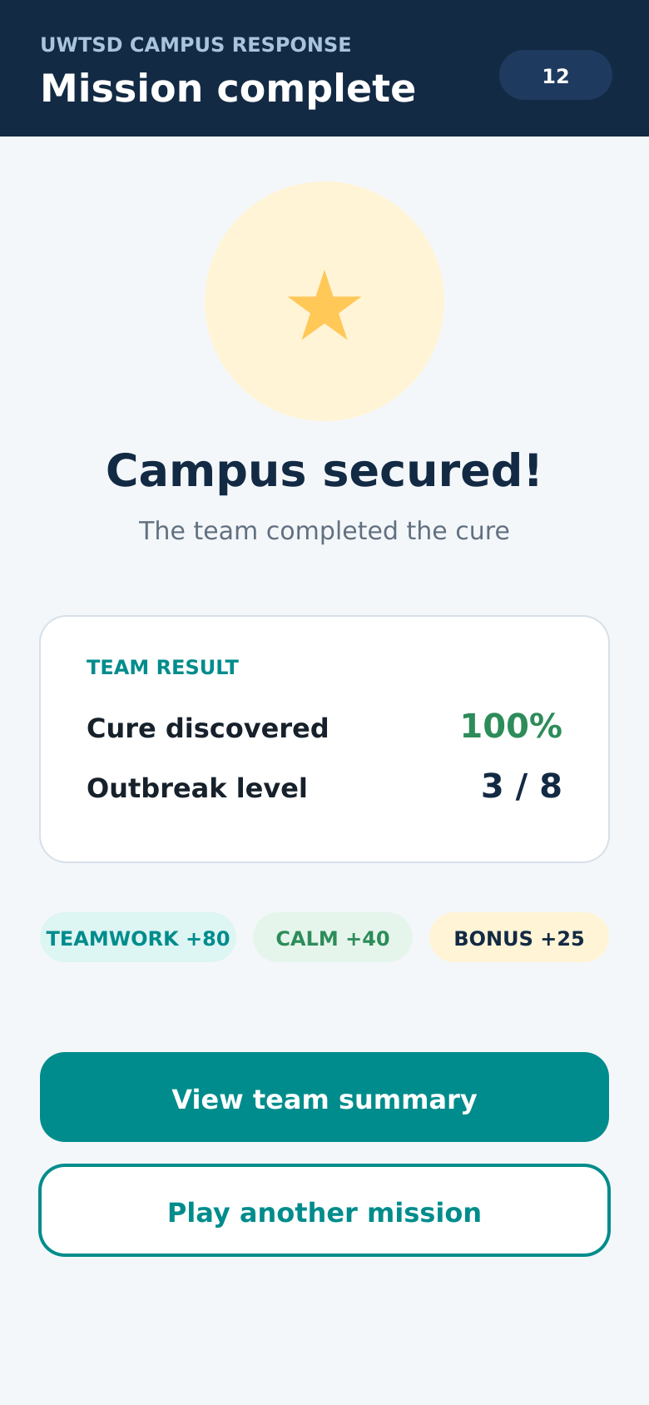
Figure A12. Resume: continue an interrupted mission | Figure A13. Result: cure progress and team outcome
Navigation: continue using the main teal button. Where shown, the bottom bar also opens Map, Team, Chat or Help. Secondary outlined buttons support cancelling, leaving safely or repeating a mission.

Appendix B - Final usability-test pack

B1. Participant message
Hello. I am evaluating a static mobile-game storyboard for a university assignment. The test takes about five minutes. Your participation is voluntary and your answers will be recorded anonymously as P1, P2 or P3. Please look at the storyboard and answer the questions below. You may stop at any time. Do you agree to take part?

B2. Scenario and task questions
Scenario: You are Morgan, a UWTSD student with limited time. You join a private campus-response team and choose the IT Technician role. The Library infection is increasing and the team must agree on an action.
- Which button would you use to join the team, and where would you choose your role?
- On the campus map, which location is most urgent and what information tells you this?
- How would you ask the team and vote before treating the location?
- After the action, what changed and how many actions remain?
- If you close the game, how do you know that your progress is safe?

B3. Ratings and open feedback
- How clear is the navigation? (1 = very unclear, 5 = very clear)
- How readable are the text, icons and buttons? (1–5)
- How confident would you feel choosing an action? (1–5)
- How visually appealing is the colour design? (1–5)
- How well does the interface support teamwork? (1–5)
- What is the strongest part of the prototype?
- What is unclear, missing or difficult to use?
- What one improvement should be made before development?

B4. Anonymised participant response record
The following concise records were confirmed after P1-P3 reviewed the full-colour storyboards. Identifying details were not retained.
Participant | Confirmed task interpretation | Ratings: C/R/Co/V/T | Positive and negative feedback
P1 | Join by code; select IT Technician; treat the red Library; vote Yes; recognise the save message. | 5 / 4 / 5 / 4 / 5 | Map and colours were clear. Some smaller text could be larger.
P2 | Library has the highest warning; use quick messages and vote; infection falls and cure rises; resume from pause. | 4 / 4 / 4 / 5 / 4 | Consistent colours and large buttons. Cure percentage needed a short explanation.
P3 | Joining and role selection were straightforward; confirm the team decision; action and save feedback were clear. | 5 / 5 / 4 / 5 / 5 | Voting and feedback were strongest. A more visible Back control was suggested.
Key: C = clarity, R = readability, Co = confidence, V = visual appeal, T = teamwork. All ratings used a five-point scale.

B5. Evidence handling
The report uses anonymised participant codes and concise response summaries. Names, phone numbers and profile images are excluded. The summaries are presented in Appendix B and analysed in Section 3.3 so that feedback remains traceable without exposing personal information.

Appendix C - Design traceability
User/persona need | Requirement | Implemented screen(s) | Evaluation question
Morgan: limited time | Short route and autosave | 5, 10 and 11 | Can progress be resumed?
Daniel: private play | Code-based private team | 1-3 | Can the user join the team?
Sam: social teamwork | Chat, quick messages and vote | 8 | Is team discussion clear?
Jordan: occasional player | Optional tutorial and visible ability | 4-5 | Can a non-expert choose a role?
All personas: readable controls | Large labels and full-width actions | All | Are text and buttons readable?
All personas: avoid mistakes | Action cost and confirmation | 7 and 9 | Does the user feel confident?
All personas: understand status | Numeric risk, progress and feedback | 6 and 10 | Can the user explain the result?

