A Quantitative Analysis of Performance Reporting in AI-Driven Google Advertising


UNIVERSITY OF WALES TRINITY SAINT DAVID

Lecturer: Dr. Alfred Mensah
Student name: Mihai Tilea
Student ID: 2124071
Module code: LCBB6000
Date: 22/12/2025
Table of Contents
Abstract 4
Chapter 1: Introduction 5
1.1 Background & Context: AI Automation in Google Ads 5
1.2 Problem Statement and Research Gap 6
1.3 Research Aim and Objectives 6
1.4 Research Questions 7
1.5 Structure of the Dissertation 7
Chapter 2: Literature Review 8
2.1 AI and Automation in Digital Marketing 8
2.2 Algorithmic Bidding and Smart Bidding Systems 9
2.3 Performance Max and Cross-Channel Automation 10
2.4 Performance Measurement in Digital Advertising 11
2.5 Vendor Case Studies and Promotional Evidence 12
2.6 The Black-Box AI 13
2.7 Academic Case Studies 14
Chapter 3: Methodology 14
3.1 Research Philosophy 14
3.2 Research Design: Quantitative Content Analysis 15
3.3 Dataset Selection and Criteria 16
3.4 Data Extraction and Analysis 17
3.5 Methodological and Ethical Considerations 18
Chapter 4: Findings and Analysis 19
4.1 Overview of the Case Study Dataset 19
4.2 Range Analysis and Skew 20
4.3 Detailed Efficiency Outcomes 21
4.4 Smart Bidding vs Performance Max 21
4.5 Summary of Reported Claims 22
4.6 Critical Interpretation 23
Chapter 5: Conclusion 24
5.1 Summary of Findings 24
5.2 Theoretical Interpretation 25
5.3 Strategic Implications 26
5.4 Limitations of the Study 27
5.5 Future Research and Conclusion 27
References 29
Appendices 34
Terms of Glossary 42

Abstract
The transition from manual bidding to AI-driven automation in Google Ads represents a fundamental shift in digital marketing practice. As decision-making authority is delegated to "black-box" algorithmic systems such as Smart Bidding and Performance Max, independent verification of advertising effectiveness has become increasingly difficult. Consequently, practitioners are often forced to rely on vendor- and agency-produced case studies as primary evidence of performance. This dissertation critically evaluates the validity and interpretability of these performance claims.
Adopting a positivist and deductive research approach, the study employs quantitative content analysis to examine eight publicly available Google Ads case studies published between 2020 and 2025. Rather than treating these documents as evidence of causal effectiveness, the analysis examines reported numeric outcomes as manifestations of industry discourse, focusing on patterns of disclosure, aggregation, and omission.
The analysis reveals that reported performance outcomes are characterized by extreme variance and strategic omission rather than consistent efficiency gains. While reported Return on Ad Spend (ROAS) uplifts ranged from 28% to an outlier of 204%, the distribution is heavily skewed, rendering standard averages misleading. Furthermore, the study identifies a clear divergence in narrative framing: Smart Bidding is consistently presented through efficiency metrics (ROAS/CPA), whereas Performance Max is framed almost exclusively through growth metrics like revenue, effectively limiting visibility to more metrics.

Chapter 1: Introduction

1.1 Background & Context: AI Automation in Google Ads
Digital advertising evolved significantly over the past decade, driven by advances in technology like machine learning and automation. The growing use of analytics has shifted marketing practice away from intuition-led campaign management towards systematic, data-driven optimisation, where competitive advantage is increasingly derived from the effective use of organisational data assets (Davenport and Harris, 2007). This transition reflects more complex developments within digital marketing, as firms respond to increasing volume of data across online channels that require reliance on automated decision-making systems (Chaffey and Ellis-Chadwick, 2022).
Within paid search advertising, Google Ads has progressively transferred optimisation responsibility from advertisers to algorithmic systems capable of processing large volumes of real-time information (Carah, 2024). The systems evaluate contextual signals such as user query characteristics, device type, geographic location, and temporal factors at the point of auction, enabling bid adjustments that are impractical to perform manually at scale. The manual keyword bidding becomes increasingly inefficient under budget and exposure constraints, providing a theoretical foundation for the adoption of algorithmic bidding mechanisms (Selçuk and Özlük, 2013).
According to Google’s platform documentation, Smart Bidding integrates historical performance data with live auction-time signals to optimise outcomes such as conversion value and return on ad spend (Google Ads Help, 2025a). More recently, Google has consolidated several automated campaign features into a unified AI-driven framework, branded as Performance Max, which represents its latest goal-based, fully automated campaign solution extending automation beyond bidding to include targeting and creative delivery (Google Ads Help, 2025b). These developments exemplify the broader application of machine learning in marketing, where automated models increasingly perform tasks traditionally managed by human decision-makers (Brei, 2020). However, the proliferation of these proprietary, 'black-box' systems has created a significant challenge: evaluating their true efficacy relies heavily on performance evidence generated and disseminated by the platform itself.

1.2 Problem Statement and Research Gap
As bidding, targeting, and creative decisions are increasingly delegated to automated systems, advertisers have limited visibility into how budget constraints, optimisation objectives, and real-time signals are translated into individual bidding decisions. Recent economic research demonstrates that data-driven bidding algorithms operate through opaque intermediary processes that are not directly observable to advertisers, making independent assessment of performance outcomes inherently difficult (Bergemann, 2025). Research on AI governance and evaluation has highlighted that performance reporting in commercial AI systems is often selective, favouring positive outcomes while omitting failures (Mittelstadt, 2025).
Concerns regarding transparency are further reflected in industry analyses of highly automated campaign formats. Independent industry assessments have argued that campaign types such as Performance Max limit advertiser insight into optimisation logic and performance drivers, effectively functioning as black-box marketing technologies with constrained accountability (TrafficGuard, 2023). The most accessible evidence for performance comes from the platform vendors and their partner agencies themselves. As a result, while these sources provide accessible numeric performance indicators, they offer limited transparency regarding the conditions under which the outcomes were achieved.
From an academic perspective, this situation reveals a clear research gap. Although human-centred and responsible AI research increasingly examines transparency, accountability, and user trust in algorithmic systems, it has paid limited attention to systematically analysing the performance outcomes that are publicly reported within digital advertising industry evolution (Tahaei et al., 2023). This study addresses that gap by treating the produced case studies as an object of analysis, seeking to clarify what can reasonably be inferred from reported performance outcomes and to define the boundaries within which such claims should be interpreted.

1.3 Research Aim and Objectives
The aim of this study pursues three specific objectives. First, it seeks to collect, and record disclosed quantitative performance metrics, including Return on Ad Spend (ROAS), Cost Per Acquisition (CPA), conversions, and revenue, from a defined set of publicly available case studies published between 2020 and 2025. Second, the study aims to quantify and analyse these reported metrics to identify recurring patterns and trends in claimed performance improvements across different cases and automation tools. Third, the research critically evaluates the strategic implications of these reported outcomes, while also examining the methodological limitations inherent in relying on promotional, secondary data sources.
Together, these objectives position the study to assess not the causal effectiveness of AI automation tools, and instead analysing the nature, consistency, and interpretability of the performance outcomes that are publicly reported.

1.4 Research Questions
There are four primary questions:
RQ1: What quantitative performance outcomes are reported in publicly available vendor and agency published case studies for AI automation tools in Google Ads between 2020 and 2025?
RQ2: What patterns and consistencies can be identified in the reported performance metrics across the case study corpus?
RQ3: How do reported performance outcomes differ between case studies focused on search-based AI bidding implementations and those focused on cross-channel AI-driven Performance Max campaigns?
RQ4: What methodological limitations and strategic implications arise from relying on this promotional, secondary evidence base to evaluate AI tool performance?
Together, these questions frame the study’s analytical focus on the nature, consistency, and interpretability of reported performance claims within the digital advertising industry.

1.5 Structure of the Dissertation
This dissertation is structured into five chapters. Chapter 1 introduces the research context, outlines the problem addressed, and defines the study’s aims and research questions. Chapter 2 reviews the relevant academic literature on AI automation in digital advertising, Google Ads bidding systems, performance measurement, and the limitations of promotional materials evidence. Chapter 3 presents the research methodology, detailing the study’s philosophical stance, research design, data collection process, and analytical approach. Chapter 4 reports and analyses the findings from the case study dataset, presenting aggregated performance outcomes and critical interpretation. Finally, Chapter 5 concludes the study by summarising key findings, discussing strategic implications, acknowledging limitations, adding suggested directions for future research.

Chapter 2: Literature Review

2.1 AI and Automation in Digital Marketing
Guercini (2020) mentions that digital marketing decision-making has become increasingly complex as the volume, velocity, and variety of data available to firms have expanded. Historically, marketing decisions were largely guided by heuristics, experience, and managerial intuition, with human actors selecting strategies based on limited information and relatively stable environment. As digital channels multiplied and consumer behaviour fragmented across devices and contexts, these intuition-led approaches became progressively less effective.
The rise of big data fundamentally altered this decision-making landscape. Advances in data collection and analytics enabled firms to observe consumer behaviour at unprecedented granularity that also introduced levels of complexity that exceeded human cognitive capacity (Erevelles, Fukawa and Swayne, 2016). In response, organisations increasingly turned to automated and algorithmic systems capable of processing large datasets and identifying probabilistic patterns beyond the reach of manual analysis (Davenport et al., 2020).
Artificial intelligence in digital marketing is best understood as an optimisation mechanism rather than a substitute for human creativity or strategic reasoning. While Google defines AI as a tool for 'continuous adjustment,' for the advertiser, this practically means handing over the keys to the budget. It turns active management into passive monitoring (Huang and Rust, 2018). This capability makes automation particularly well suited to environments characterised by uncertainty, rapid change, and large numbers of interacting variables (Syam and Sharma, 2018).
The adoption of AI-driven automation also reshapes organisational roles and responsibilities. Jarrahi (2018) argues that rather than directly executing individual decisions, human actors increasingly configure objectives, constraints, and evaluation criteria, while algorithms perform operational decision-making within those boundaries. This reconfiguration offers potential efficiency gains but simultaneously raises questions concerning accountability, oversight, and ethical responsibility when decision authority is delegated to automated systems (Martin, 2019). These issues form an important foundation for understanding how automated performance outcomes are later reported, interpreted, and evaluated within digital advertising contexts.

2.2 Algorithmic Bidding and Smart Bidding Systems
Bidding in paid search advertising determines the price an advertiser is willing to pay to participate in an auction for a given user query. Early models of search advertising relied on manual keyword bidding, where advertisers set fixed bids based on historical averages and periodically adjusted them in response to observed performance. This approach was feasible in relatively simple environments but assumed that a single bid could represent a wide range of user contexts and competitive conditions (Edelman, Ostrovsky and Schwarz, 2007).
As auction environments increased in complexity, manual bidding revealed a fundamental limitation. Human decision-makers are unable to process the large number of variables that influence each individual auction, such as user intent, device type, location, time, and competitive dynamics. This limitation has been described as a human bottleneck, where decision quality deteriorates as complexity increases (Jiang, 2023).
Algorithmic bidding reframes the problem by treating bid selection as a real-time optimisation task rather than a static pricing decision. Instead of assigning a single bid to a keyword, algorithmic systems estimate the expected value of participating in each auction and adjust bids accordingly. Research on data-driven bidding demonstrates that such systems optimise under budget constraints by dynamically balancing spend allocation across opportunities with varying predicted returns (Bergemann, 2025).
Smart Bidding represents a platform-level implementation of algorithmic bidding within search advertising. Rather than setting bids manually, advertisers define performance objectives such as Target Cost Per Acquisition or Target Return on Ad Spend. Under a Target ROAS strategy, the system aims to maximise conversion value while maintaining an average ratio between revenue and advertising spend over time (Google, 2024). Bid adjustments are made at auction time based on predicted conversion value and cost.
This approach relies on probabilistic models that continuously update predictions using historical and real-time data. Techniques such as reinforcement learning and real-time optimisation enable systems to adapt bids dynamically as conditions change (Thomas, 2025). While this allows for greater responsiveness and scale, it also reduces transparency, as individual bid decisions are generated by models whose internal logic is not directly observable.
Understanding this shift from manual to algorithmic bidding is essential for interpreting reported performance outcomes. Metrics such as ROAS under Smart Bidding reflect aggregated results from thousands of probabilistic auction-level decisions, rather than the effectiveness of discrete keyword-level adjustments. This distinction forms the technical foundation for evaluating how performance improvements are later reported and framed in industry case studies.

2.3 Performance Max and Cross-Channel Automation
The evolution from algorithmic bidding to fully automated campaign management represents a fundamental structural change in digital advertising decision-making. Earlier forms of automation focused primarily on bid optimisation, while advertisers retained control over campaign structure, targeting logic, and channel allocation. As artificial intelligence capabilities advanced, automation expanded beyond individual decision points toward integrated architectures designed to manage multiple campaign components simultaneously (Davenport et al., 2020).
Performance Max is a goal-based campaign format that consolidates bidding, targeting, creative delivery, and inventory allocation into a single automated architecture. Rather than relying on keyword-based segmentation alone, the campaign uses advertiser-provided assets and high-level objectives to guide optimisation across multiple Google-owned channels, including search, display, video, and discovery environments (Google, 2024).
The automation embedded within Performance Max relies on machine learning models that continuously evaluate performance signals across channels and user contexts. These models determine how budget is distributed, which creative assets are served, and where ads appear, based on predicted outcome probabilities rather than predefined rules (Joshi et al., 2025). Unlike keyword-based campaigns, where performance changes can often be traced to specific bid or targeting adjustments, Performance Max outcomes emerge from interactions across channels, audiences, budgets, and creative inputs. This opacity limits the ability to attribute results to any single optimisation mechanism and complicates independent evaluation of effectiveness (Mittelstadt et al., 2016).
When Performance Max is credited with performance improvements in vendor or agency case studies, those claims inherently represent the output of a consolidated and opaque optimisation system. Disentangling the influence of the tool itself from contextual factors such as creative quality, budget allocation, account history, or selective reporting practices becomes a central challenge for critical evaluation. Addressing this challenge forms a core motivation for the analytical approach adopted in this study, which examines reported outcomes as industry discourse rather than as isolated measures of causal effectiveness (Kannan and Li, 2017).

2.4 Performance Measurement in Digital Advertising
Performance measurement in digital advertising relies on a set of standardised quantitative metrics used to evaluate efficiency, scale, and commercial impact. Common indicators include Return on Ad Spend (ROAS), Cost Per Acquisition (CPA), conversion volume, and revenue. ROAS measures the ratio of revenue generated relative to advertising spend, while CPA represents the average cost required to generate a single conversion. Conversion volume and revenue are frequently used as indicators of campaign scale and overall commercial contribution (Chaffey and Ellis-Chadwick, 2022).
Digital advertising outcomes emerge from complex customer journeys involving multiple interactions across channels and time periods. Attribution models attempt to assign credit for conversions to specific touchpoints, but empirical research demonstrates that non-direct and indirect channels are frequently misattributed, resulting in distorted performance estimates (Anderl et al., 2016).
Establishing incrementality requires counterfactual analysis, typically through controlled experiments or randomised conversion lift studies. While such approaches can provide robust causal evidence, large-scale experimental research shows that different measurement models can yield substantially different estimates of advertising effectiveness, even when applied to identical campaigns (Gordon et al., 2017). These methods are complex and resource-intensive, and they are rarely disclosed.
These systems operate as black-box measurement frameworks in which the platform controls both the optimisation logic and the reporting of its success, creating an inherent conflict of interest (Neumann, 2018). Privacy constraints and restricted data access further shape what can be measured and reported, influencing both metric construction and interpretation (Bleier, Goldfarb and Tucker, 2020). This limitation is central to evaluating the produced case studies, which typically report selective performance outcomes, often extreme uplifts, without the methodological context required to assess their representativeness or causal validity.

2.5 Vendor Case Studies and Promotional Evidence
The case studies occupy a central position within contemporary digital marketing discourse, functioning as key mechanisms through which platforms disseminate best practice and legitimise new technologies. Rather than serving as neutral evaluations, these case studies are structured as narrative artefacts designed to demonstrate success, influence practitioner adoption, and reinforce preferred interpretations of performance outcomes (Hackley, 2003). Within the context of AI-driven advertising, they play a particularly influential role in shaping expectations around automation effectiveness.
A fundamental limitation of this evidence base is its susceptibility to selective reporting and survivorship bias. Research on organisational learning demonstrates that unsuccessful or neutral outcomes are systematically underreported, resulting in a distorted representation of effectiveness that privileges exceptional successes over typical performance (Denrell, 2003). As a result, reported metrics such as large percentage uplifts in return on ad spend or conversions tend to reflect best-case scenarios rather than representative outcomes. When such claims are aggregated or generalised, they risk overstating the reliability of AI-driven optimisation tools.
In digital marketing practice, case studies also function as strategic content marketing assets. Platforms and agencies deploy success narratives to support product positioning, establish authority, and generate demand within competitive markets (Holliman and Rowley, 2014). In doing so, AI automation tools are frequently foregrounded as the primary drivers of performance improvement, even when outcomes may be influenced by multiple concurrent factors, such as budget increases, creative changes, or broader market conditions.
From an analytical perspective, vendor case studies should therefore be understood as elements of industry discourse rather than objective measurements of effectiveness. They contribute to the social construction of meaning around AI-driven advertising success, shaping practitioner understanding through repeated narratives rather than systematic evaluation (Phillips and Hardy, 2002).

2.6 The Black-Box AI
The increasing use of algorithmic decision-making in digital advertising has intensified concerns regarding transparency and accountability. Many AI-driven systems operate as black boxes, where the internal logic governing optimisation decisions is not directly observable by users (Pasquale, 2015). While this opacity limits independent auditing, proponents argue it is a necessary trade-off to enable real-time decision-making at a scale that exceeds human cognitive capacity (Davenport et al., 2020). Once optimisation and reporting are controlled by the same platform, accountability becomes further diffused, as users must rely on system outputs without access to underlying decision processes. Research on responsible and human-centred AI highlights that such opacity creates challenges for interpretability, oversight, and informed decision-making, particularly in commercial environments where incentives are not neutral (Mittelstadt et al., 2016).

2.7 Academic Case Studies
Academic research examining AI automation in digital advertising remains limited, particularly in applied, real-world contexts. Existing studies often focus on controlled experiments, simulations, or single-case analyses, which provide valuable technical insight but lack broad generalisability (Bergemann, 2025). Applied academic case studies that audit platform-reported performance outcomes are rare, in part due to restricted data access and the proprietary nature of advertising systems. Where such studies do exist, they frequently highlight methodological constraints and reliance on secondary data (Metsänheimo, 2023).

Chapter 3: Methodology

3.1 Research Philosophy
This study adopts a positivist research philosophy, which emphasises the systematic analysis of observable and measurable phenomena through structured methods. Within business and marketing research, positivism is commonly associated with quantitative approaches that aim to identify empirical patterns while minimising researcher bias through standardised measurement and transparent analytical procedures (Bell, Bryman and Harley, 2022). This stance is particularly suitable for analysing the manifest content of promotional case studies, specifically the numeric performance claims they report, to identify patterns, regularities, and deviations in reported outcomes.
The research follows a deductive approach, whereby existing theory informs the research design, data extraction framework, and analytical focus. This approach is guided by theoretical expectations established in the literature review, specifically concerning the opacity of algorithmic advertising systems, the limitations of platform-mediated performance measurement, and the publication bias inherent in the case studies produced evidence. These theoretical insights shape both the selection of variables and the interpretation of reported performance outcomes, ensuring coherence between the conceptual framework and empirical analysis.
Methodologically, the study employs quantitative content analysis of publicly available secondary data. Quantitative content analysis enables the systematic extraction, categorisation, and aggregation of numeric information from textual sources, supporting structured comparison across cases (Krippendorff, 2018). As the research relies on secondary data, it does not seek to establish causal relationships. Instead, it aims to systematically evaluate how performance outcomes are reported within industry discourse, thereby directly addressing the research questions, consistent with established principles of secondary data analysis in social research (Vartanian, 2010). “While adopting a positivist stance toward manifest numeric claims, the study remains critically aware of the constructed and promotional nature of its data sources.

3.2 Research Design: Quantitative Content Analysis
A quantitative content analysis research design is employed to systematically examine reported performance outcomes in vendor- and agency-produced Google Ads case studies. This design is appropriate where the objective is to extract, standardise, and compare numeric information embedded within textual sources (Neuendorf, 2017). Rather than interpreting meaning, intent, or narrative framing, the analysis focuses on identifying measurable variables that can be aggregated and examined consistently across multiple reporting instances (Riffe et al., 2019).
The unit of analysis is the individual case study. Each case study is treated as a discrete instance in which one or more performance outcomes are reported in relation to a specific Google Ads automation tool. The analysis is restricted to manifest content only, meaning that only explicitly stated numeric performance claims are recorded. No inference is made regarding unstated results, implied causality, or underlying optimisation mechanisms. This restriction to manifest content enhances reliability and replicability by minimising subjective interpretation within the coding process (Berelson, 1952).
A structured data extraction framework is applied to ensure consistency across cases. Performance metrics such as Return on Ad Spend, Cost Per Acquisition, conversion volume, revenue change, and related indicators are recorded only when they are explicitly disclosed. Metrics presented qualitatively or without numeric values are excluded from quantitative aggregation. Where multiple metrics are reported within a single case study, each metric is captured independently to preserve analytical granularity and enable comparison across reporting dimensions (Krippendorff, 2018).
The analytical focus does not aim to compare advertisers, industries, or campaign contexts directly. Instead, it concentrates on identifying patterns, central tendencies, and variability within the reported performance outcomes themselves. This includes examining the distribution of reported improvements, the resulting skew in measures of the range analysis, and the presence of extreme values within the dataset. By analysing how outcomes are reported rather than attempting to establish causal effectiveness, the research design aligns directly with the study’s objective of critically evaluating industry performance claims within their reporting context (White and Marsh, 2006).

3.3 Dataset Selection and Criteria
The dataset for this study consists of publicly available reporting performance outcomes for Google Ads AI automation. Case studies were identified through targeted searches of Google’s official marketing publications, including Think with Google and Google Ads Help resources, as well as the websites of established digital marketing agencies and Google Partner organisations that publish client success narratives. This approach reflects how performance claims about marketing AI are communicated within contemporary practice (Davenport et al., 2020).
The temporal scope of the dataset was limited to the period between 2020 and 2025. This timeframe aligns with the widespread adoption and maturation of advanced Smart Bidding strategies and the expansion of Performance Max campaigns, ensuring the analysis reflects contemporary implementations of AI-driven automation.
Case selection was guided by a purposive sampling strategy, which involved intentionally targeting information-rich cases that were directly relevant to the research objectives rather than aiming for representativeness (Patton, 2015). Documents were included only if they were presented as case studies describing a specific advertiser or campaign, referenced a named Google Ads AI automation tool or explicitly described algorithmic or automated bidding strategies, and reported at least one quantitative performance outcome, such as Return on Ad Spend, Cost Per Acquisition, conversions, or revenue change.
Documents were excluded if they discussed AI or automation in general terms without a client case, relied solely on qualitative claims without numeric performance data, or focused on advertising platforms other than Google Ads. The resulting sample reflects the selective nature of publicly available evidence, which often leads to the undersampling of failure (Denrell, 2003). The use of documentary secondary data necessitated explicit boundary-setting and transparent selection rules to ensure the analysis remained focused on its specific objective (Bell, Bryman and Harley, 2022).

3.4 Data Extraction and Analysis
A structured coding framework was developed to extract and standardise data from each case study into quantifiable variables. The framework was designed deductively to capture both contextual information (e.g., brand, industry, tool type) and core performance metrics under investigation (e.g., ROAS, CPA). Each case study was treated as a single unit of analysis.
The coding process adhered strictly to the principle of manifest content analysis, whereby only explicitly stated numeric performance values were recorded as data, excluding inferred meanings or qualitative descriptions (Krippendorff, 2018). Claims such as “significant improvement” or visual representations without a stated percentage were excluded to ensure that all included data were directly comparable and transparently reported. To maintain analytical validity, a key rule was applied: each numeric value was recorded exclusively under the variable it explicitly described, preventing the conflation of different performance dimensions (Neuendorf, 2017). Where a metric was not reported, it was coded as ‘NA’ (Not Available), and no data imputation was performed, preserving the integrity of the secondary dataset (Vartanian, 2010).
Following extraction, the dataset was analysed using descriptive statistical techniques. Measures of mean and median, were calculated to summarise reported performance outcomes and assess the influence of extreme values. While the mean provides an indication of overall reported uplift, the median offers a more robust measure that is less sensitive to outliers (Anderson et al., 2020). This distinction supports the identification of publication bias, where exceptionally high-performance claims are more prevalent than typical outcomes (Denrell, 2003). Reporting both measures enables a cautious interpretation of aggregated performance claims.

3.5 Methodological and Ethical Considerations
This study is subject to several methodological and ethical considerations arising from its design and data sources. Methodologically, the dataset consists exclusively of industry reports produced case studies, introducing a high likelihood of promotional bias and selective reporting of positive outcomes (Pfeffer and Sutton, 2006). The analysis is non-causal in nature and cannot establish whether reported performance changes were directly attributable to AI automation tools rather than external contextual factors, an inherent limitation of descriptive secondary data analysis (Bell, Bryman and Harley, 2022). In addition, the small sample size (n=8) reflects the curated nature of public success narratives and limits statistical generalisability, though it remains appropriate for exploratory analysis of this evidence base (Patton, 2015).
Ethically, the study relies solely on publicly available secondary data and does not involve human participants, personal data, or experimental intervention. As such, formal ethical approval was not required under standard institutional frameworks for documentary analysis (Saunders, 2023). Care was taken to accurately represent reported performance claims without misinterpretation, and the analysis avoids evaluative judgement of individual organisations, focusing instead on aggregated patterns within industry discourse.

Chapter 4: Findings and Analysis

4.1 Overview of the Case Study Dataset
The analysis is based on eight publicly available case studies (n = 8) published between 2020 and 2025. The dataset comprises cases produced by vendors and agencies operating within three sectors: Retail (n = 4), Travel (n = 3), and Healthcare/Services (n = 1).
The automation mechanisms featured across the cases include Google Smart Bidding (n = 5), Google Performance Max (n = 2), and one tool-agnostic, profit-first strategy. The key characteristics of each case, including sector, automation context, and stated campaign objective, are summarised in Table 4.1.
Table 4.1
Case ID | Brand | Industry | Tool / AI Mechanism | Primary Goal | Source Type
1 | FishingBooker | Travel | Smart Bidding (Target ROAS) | Profit Maximization | Vendor
2 | Economy Bookings | Travel | Performance Max | Scaled Revenue Growth | Vendor
3 | KEH Camera | Retail (Photography) | Performance Max | Scaled Revenue Growth | Agency
4 | Royal Design | Retail (Home Design) | Smart Bidding (Target ROAS) | Profitable Top-Line Growth | Agency
5 | Skyscanner | Travel / Service | Smart Bidding (SA360) | Efficient Traffic Acquisition | Agency
6 | Vine Apparel | Retail (Fashion) | Smart Bidding (via AdAi) | Efficiency & Revenue Scaling | Vendor
7 | Jayne Boutique | Retail (Fashion) | Smart Bidding (Target ROAS) | Profit-Focused Growth | Agency
8 | Medical Services Group | Healthcare/Services | Automated Bidding (Unspecified) | Lower Cost, Boost Appointments | Agency

Quantitative performance reporting was inconsistent across the dataset. Revenue change was the most frequently disclosed metric (n = 5). Return on Ad Spend (ROAS) was reported in three cases, while conversion volume was reported in four cases. Metrics such as Cost Per Acquisition (CPA) and profit appeared in two cases each. No single performance metric was reported universally across all case studies.
This variability in metric disclosure reflects the selective and non-standardised nature of vendor and agency produced case studies and establishes the context for the descriptive analysis that follows.

4.2 Range Analysis and Skew
Analysis of the three case studies reporting Return on Ad Spend (ROAS) reveals a pronounced discrepancy between measures. The mean reported ROAS uplift across these cases is 93.67%, while the median reported uplift is substantially lower at 49%. Reported outcomes varied drastically, ranging from a modest 28% efficiency gain to an extreme 204% outlier (n = 7). This variance demonstrates the limitations of interpreting ‘average’ performance figures within this evidence base.
This divergence reflects a positively skewed distribution driven by a single extreme outlier. The reported ROAS values are 28%, 49%, and 204%. The value of 204% disproportionately inflates the arithmetic mean. In contrast, the median, representing the middle value in the ordered dataset, provides a more resistant measure of the range of values for this distribution.
Table 4.2
Metric | Cases (n) | Mean Uplift (%) | Median Uplift (%)
ROAS | 3 | 93.67 | 49.00
Conversions | 4 | 77.50 | 50.50
Revenue | 5 | 47.60 | 40.00
Profit | 2 | 44.00 | 44.00
CPA (Reduction) | 2 | -36.00 | -36.00
Conv. Rate (CVR) | 2 | 68.00 | 68.00

4.3 Detailed Efficiency Outcomes
Efficiency outcomes varied considerably across the case study dataset. As shown in Table 4.3, where Return on Ad Spend (ROAS) improvements ranged from 28% to 204% across the three cases disclosing this metric. Two of the three ROAS values (28% and 49%) clustered below 50%, while a single case reported an extreme outlier of 204%, directly contributing to the skew discussed in Chapter 4.2.
Table 4.3
Cost efficiency outcomes were reported less frequently. Cost Per Acquisition (CPA) reductions were disclosed in only two cases, with decreases of 13% and 59%. Both reductions indicate improved cost efficiency, though the limited sample (n = 2) precludes broader comparison. Conversion rate (CVR) improvements were also reported in two cases, with uplifts of 44% and 92%.
Overall, efficiency metrics were selectively reported and unevenly distributed. This is evident in the patchwork of data in Table 1, where metrics such as ROAS, CPA, and CVR are frequently absent (coded as ‘NA’). No efficiency metric was disclosed universally, reinforcing the non-standardised and curated nature of the performance evidence base.

4.4 Smart Bidding vs Performance Max
Reported performance outcomes differed by automation context, reflecting variation in how Smart Bidding and Performance Max are presented within the presented case studies. Of the eight cases analysed, five focused on Google Smart Bidding implementations, two on Performance Max campaigns, and one employed a tool-agnostic, profit-first strategy.
Smart Bidding case studies predominantly emphasised efficiency-oriented outcomes. ROAS improvements were reported in three Smart Bidding cases (Cases 1, 6, and 7), with values ranging from 28% to 204%. Two of these values clustered below 50%, while a single case reported an extreme uplift of 204%. Cost efficiency outcomes were also more commonly associated with Smart Bidding. Both reported CPA reductions occurred in Smart Bidding cases (Cases 5 and 8), with decreases of 13% and 59%, respectively. Similarly, both reported CVR improvements (44% and 92%) were disclosed within Smart Bidding cases (Cases 1 and 8). These patterns indicate that Smart Bidding narratives tend to foreground metrics related to efficiency, cost control, and profitability.
In contrast, Performance Max case studies focused primarily on scale-oriented growth outcomes. Both Performance Max cases (Cases 2 and 3) reported substantial revenue increases (40% and 76.3%) alongside conversion growth. However, neither disclosed ROAS, CPA, profit, or CVR metrics. The reported outcomes emphasised volume expansion and cross-channel reach rather than efficiency or cost containment.
This systematic variation in metric disclosure illustrates the curated and non-standardised nature of the evidence base. The choice of which performance metrics to report appears aligned with the preferred narrative associated with each automation tool, reinforcing that reported outcomes reflect selective presentation rather than comprehensive performance measurement.

4.5 Summary of Reported Claims
Across the eight case studies analysed, reported performance claims consistently present AI-driven automation as delivering substantial improvements in advertising outcomes. These claims span both efficiency-oriented metrics, such as Return on Ad Spend (ROAS), Cost Per Acquisition (CPA), and conversion rate (CVR), and growth-oriented metrics, including revenue, conversions, and traffic volume. However, the distribution and availability of these metrics vary considerably across cases.
Efficiency outcomes were reported selectively and unevenly. ROAS was disclosed in three cases, CPA reductions in two cases, and CVR improvements in two cases. Where reported, these metrics frequently indicated sizeable uplifts, though their occurrence was concentrated within a small subset of the dataset. Growth outcomes were more commonly reported. Revenue change appeared in five cases, while conversion volume was disclosed in four cases, often presented as headline indicators of success.
No case study reported a complete set of performance metrics, and no single metric was disclosed universally across all cases. Instead, each case presented a limited selection of outcomes, often aligned with a specific strategic emphasis, such as profitability, cost efficiency, or revenue growth. As a result, the aggregate evidence base consists of a patchwork of reported improvements rather than a standardised or comprehensive performance record.
Taken together, the reported claims portray AI automation as highly effective across multiple dimensions of performance. However, this portrayal is constructed through selective disclosure of metrics, producing an evidence base that reflects reported success rather than full performance transparency.

4.6 Critical Interpretation
The findings presented in this chapter must be interpreted within the clear boundaries imposed by the nature of the evidence base. The reported performance outcomes reflect curated, best-case scenarios drawn from the evidence in the case studies rather than systematically collected or independently verified data. As demonstrated by the recurring discrepancy between mean and median values, aggregated performance figures are sensitive to extreme outliers, which substantially influence perceptions of “average” effectiveness.
The selective disclosure of metrics limits comparability across cases. The absence of consistent baseline definitions, incomplete reporting of efficiency metrics, and variation in strategic objectives prevent holistic evaluation of AI automation performance. The analysis therefore does not support generalisation about typical outcomes, nor does it allow attribution of reported improvements solely to the automation tools themselves.
Instead, the evidence illustrates how performance is presented within industry discourse. The findings should be understood as indicative of reporting practices and narrative construction rather than as conclusive measures of causal effectiveness or expected advertiser results. These boundaries are central to interpreting the findings presented in this chapter and inform the practical guidance developed in the concluding discussion.

Chapter 5: Conclusion

5.1 Summary of Findings
This study finds that quantitative performance outcomes reported in the case studies are highly skewed and inconsistently disclosed. The discrepancy between the mean reported Return on Ad Spend (ROAS) uplift of 93.67% and the median uplift of 49% (Table 4.2) demonstrates that reported average performance is disproportionately influenced by extreme positive outliers. As a result, the arithmetic mean functions as a poor indicator of typical performance within this evidence base, reflecting best-case scenarios rather than representative outcomes.
With respect to reporting practices, the findings indicate that metric disclosure is selective and non-standardised. No single performance metric was reported consistently across all cases (Table 4.3). Growth-oriented metrics, particularly revenue change, were disclosed most frequently (n = 5), whereas efficiency metrics such as Cost Per Acquisition (CPA) and ROAS were reported less often and typically in isolation. Notably, efficiency gains were never reported alongside negative trade-offs or countervailing performance effects, indicating a systematic bias toward exclusively positive framing.
Finally, the analysis identifies a clear divergence in how performance outcomes are framed according to automation context. Case studies employing Google Smart Bidding predominantly emphasised efficiency and profitability outcomes, accounting for all reported instances of CPA reduction and ROAS improvement. In contrast, Performance Max case studies focused exclusively on scale-oriented metrics, specifically revenue growth and conversion volume, without disclosing efficiency performance. This pattern suggests that reported outcomes differ not only in magnitude, but also in the strategic selection of metrics used to construct narratives of success.
Table 5.3

5.2 Theoretical Interpretation
The empirical findings of this study align closely with theoretical expectations of survivorship bias in the management and organisational learning literature. As demonstrated in Chapter 5.1, the substantial disparity between the mean reported Return on Ad Spend (ROAS) uplift of 93.67% and the median uplift of 49% reflects a positively skewed distribution driven by extreme positive outliers. Denrell (2003) predicted that organizations systematically undersample failure. This dataset proves that theory: we see 100% success rates in the documents, which confirms we are looking at a 'survivor' population, not a general one.
Within vendor and agency case studies, the undersampling of failure is effectively absolute. The dataset analysed contains no instances of negative performance outcomes, efficiency losses, or unsuccessful implementations. This indicates that the publication process operates as a filtering mechanism that removes not only failures but also average or inconclusive results, leaving only exceptional cases for dissemination. As a result, the evidence base constitutes a censored sample that reflects the upper bound of algorithmic performance rather than its expected or typical value.
This distortion has important implications for evidence-based decision-making. By presenting best-case outcomes as representative performance signals, the industry produces what Pfeffer and Sutton (2006) describe as “dangerous half-truths”: claims that are factually correct in isolation but misleading when interpreted collectively. The skew identified in this study demonstrates that while substantial performance gains are possible with AI-driven tools such as Smart Bidding, these outcomes are reported without the probabilistic context required to assess their likelihood, frequency, or associated risk.
This analysis confirms that promotional case studies function primarily as narrative constructions rather than evaluative evidence, serving to amplify success while systematically obscuring variability and downside risk in AI-driven advertising performance. This theoretical understanding underscores the need for a critical framework through which practitioners can interpret reported performance claims, which is developed in the following section.

5.3 Strategic Implications
The findings of this study indicate that the case studies should not be read as neutral evaluations of AI automation performance, but as curated narratives shaped by selective disclosure and survivorship bias. Given that such materials remain a primary source of information for practitioners, a critical framework for interpreting reported performance outcomes is required.
First, practitioners should interrogate reported averages rather than accepting headline figures at face value. As demonstrated by the discrepancy between mean and median ROAS outcomes (Chapter 4.2), reported “average” performance may be disproportionately influenced by extreme outliers. Evaluating whether a figure represents a mean, median, or single best-case instance is essential for assessing how representative the reported outcome is likely to be.
Second, attention should be paid to which performance metrics are disclosed and which are omitted. This study shows that growth-oriented metrics such as revenue and conversions are frequently reported in isolation, while efficiency metrics such as ROAS and CPA are often absent (Table 5.3). Silence on efficiency performance should therefore be interpreted as analytically meaningful—potentially signaling a trade-off that has been excluded from the narrative—rather than as a neutral omission.
Third, reported outcomes should be interpreted in light of the narrative framing associated with different automation contexts. Smart Bidding case studies predominantly frame success in terms of efficiency and profitability, whereas Performance Max cases emphasise scale and volume (Chapter 4.5). Recognising this distinction allows practitioners to decode the persuasive intent underlying metric selection rather than assuming comprehensive performance reporting.
Finally, percentage uplifts should always be contextualised. Without information on baseline performance, budget changes, time horizons, and attribution assumptions, reported improvements cannot be meaningfully evaluated. The absence of such context represents a significant limitation of promotional evidence.
Collectively, this framework enables practitioners to engage with industry case studies more critically, treating them as indicative signals rather than definitive proof of expected performance.

5.4 Limitations of the Study
This study is subject to several limitations arising from its design, data sources, and analytical scope. First, the dataset consists exclusively of vendor and agency produced case studies, which introduces an inherent risk of promotional bias and selective reporting. As a result, the findings reflect reported performance outcomes rather than independently verified effectiveness.
Second, the analysis is non-causal in nature. The study does not establish whether reported performance changes were directly attributable to AI automation tools, as contextual factors such as budget variation, creative changes, or market conditions cannot be isolated using secondary promotional data.Despite these constraints, the study provides a structured and transparent examination of an evidence base widely relied upon by practitioners.

5.5 Future Research and Conclusion
Given the limitations, future research should move beyond vendor supplied secondary data to examine independent performance evidence. A primary opportunity lies in conducting longitudinal studies using anonymised, direct-access campaign data to verify whether the efficiency gains reported in case studies are sustained over time or represent short-term variances. Additionally, qualitative research involving interviews with digital marketing practitioners could investigate how industry professionals interpret and utilise these promotional materials in their decision-making processes, verifying whether the "framework for critical consumption" proposed in this study aligns with current practice.
In conclusion, this study set out to critically evaluate the performance claims of AI automation tools in Google Ads. Through a quantitative content analysis of eight vendor- and agency-produced case studies, the research has demonstrated that reported outcomes are highly skewed, selectively disclosed, and heavily influenced by survivorship bias. While tools such as Smart Bidding and Performance Max are undeniably capable of delivering significant efficiency and growth, the evidence used to promote them functions less as an objective record of capability and more as a curated narrative of success. For practitioners, in an era of automated decision-making, the most valuable human skill remains the ability to critically question the data presented to us.

References
Anderl, E., Becker, I., Von Wangenheim, F., & Schumann, J. H. (2016). Mapping the customer journey: Lessons learned from graph-based online attribution modeling. International Journal of Research in Marketing, 33(3), 457–474. DOI: https://doi.org/10.1016/j.ijresmar.2016.03.001.
Anderson, D.R., Sweeney, D.J. and Williams, T.A. (2020) Statistics for Business and Economics. 14th edn. Boston, MA: Cengage Learning.
Bell, E., Bryman, A. and Harley, B. (2022) Business Research Methods. 6th edn. Oxford: Oxford University Press.
Berelson, B. (1952) Content Analysis in Communication Research. Glencoe: Free Press.
Bergemann, D., Bonatti, A. and Wu, N. (2025) ‘Bidding with budgets: Data-driven bid algorithms in digital advertising’, International Journal of Industrial Organization, p. 103172. DOI: https://doi.org/10.1016/j.ijindorg.2025.103172.
Bleier, A., Goldfarb, A. and Tucker, C. (2020) ‘Consumer privacy and the future of data-based innovation and marketing’, International Journal of Research in Marketing, 37(3), pp. 466–480.
Brei, V.A. (2020) ‘Machine learning in marketing: Overview, learning strategies, applications and future developments’, Foundations and Trends® in Marketing, 14(3), pp. 173–236. DOI:10.1561/1700000065.
Carah, Nicholas (2024). Observing “tuned” advertising on digital platforms. Internet Policy Review, 13(2). Available at: https://policyreview.info/articles/analysis/observing-tuned-advertising-digital-platforms (Accessed: 09.11.2025)
Chaffey, D. and Ellis-Chadwick, F. (2022) Digital Marketing: Strategy, Implementation and Practice. 8th edn. Harlow: Pearson.
Davenport, T., Guha, A., Grewal, D. and Bressgott, T. (2020) ‘How artificial intelligence will change the future of marketing’, Journal of the Academy of Marketing Science, 48(1), pp. 24–42.
Davenport, T.H. and Harris, J.G. (2007) Competing on Analytics: The New Science of Winning. Boston, MA: Harvard Business School Press.
Denrell, J. (2003) ‘Vicarious learning, undersampling of failure, and the myths of management’, Organization Science, 14(3), pp. 227–243.
Edelman, B., Ostrovsky, M. and Schwarz, M. (2007) ‘Internet advertising and the generalized second-price auction’, American Economic Review, 97(1), pp. 242–259.
Erevelles, S., Fukawa, N. and Swayne, L. (2016) ‘Big data consumer analytics and the transformation of marketing’, Journal of Business Research, 69(2), pp. 897–904.
Google (2024) About Performance Max campaigns. Available at: https://support.google.com/google-ads/answer/10724817 (Accessed: 18 December 2025).
Google Ads Help (2025) ‘About Smart Bidding’, Google Ads Help Center. Available at: https://support.google.com/google-ads/answer/7065882 (Accessed: 12.11.2025).
Google Ads Help (2025) ‘Your guide to Smart Bidding’, Google Ads Help Center. Available at: https://support.google.com/google-ads/answer/11095984 (Accessed: 12.11.2025).
Gordon, B.R., Zettelmeyer, F., Bhargava, N. and Chapsky, D. (2017) ‘A comparison of approaches to advertising measurement: Evidence from big field experiments at Facebook’, SSRN Electronic Journal [Preprint]. DOI: https://doi.org/10.2139/ssrn.3033144.
Guercini, S. (2020) ‘Marketing automation and the change in decision making: The role of heuristics’, in Marketing Automation and Decision Making. Cham: Springer.
Hackley, C. (2003) Doing Research Projects in Marketing, Management and Consumer Research. London: Routledge.
Holliman, G. and Rowley, J. (2014) ‘Business to business digital content marketing: marketers’ perceptions of best practice’, Journal of Research in Interactive Marketing, 8(4), pp. 269–293.
Huang, M.H. and Rust, R.T. (2018) ‘Artificial intelligence in service’, Journal of Service Research, 21(2), pp. 155–172. DOI: https://doi.org/10.1177/1094670517752459
Jarrahi, M.H. (2018) ‘Artificial intelligence and the future of work: Human–AI symbiosis in organizational decision making’, Business Horizons, 61(4), pp. 577–586. DOI: 10.1016/j.bushor.2018.03.007
Järvinen, J. and Taiminen, H. (2016) ‘Harnessing marketing automation for B2B content marketing’, Industrial Marketing Management, 54, pp. 164–175. DOI: https://doi.org/10.1016/j.indmarman.2015.07.002
Jiang, P. (2023) ‘Automated bidding vs manual bidding strategies in search engine marketing: A keyword efficiency perspective’, Journal of Marketing Analytics, 11(4), pp. 1–14. DOI: 10.1057/s41270-023-00260-4
Joshi, T., Lahorkar, A., Tikhe, G. and Valadi, J. (2025) ‘Machine learning-powered agents for optimized product management in Performance Max campaigns’, Engineering Proceedings, 100(1), p. 36. DOI: https://doi.org/10.3390/engproc2025100036
Kannan, P.K. and Li, H.A. (2017) ‘Digital marketing: A framework, review and research agenda’, International Journal of Research in Marketing, 34(1), pp. 22–45. DOI: https://doi.org/10.1016/j.ijresmar.2016.11.006
Krippendorff, K. (2018) Content Analysis: An Introduction to Its Methodology. 4th edn. Thousand Oaks: Sage Publications.
March, J.G. (2010) The Ambiguities of Experience. Ithaca: Cornell University Press.
Pfeffer, J. and Sutton, R.I. (2006) Hard Facts, Dangerous Half-Truths, and Total Nonsense. Boston: Harvard Business School Press.
Martin, K. (2019) ‘Ethical implications and accountability of algorithms’, Journal of Business Ethics, 160(4), pp. 835–850. DOI: https://doi.org/10.1007/s10551-018-3921-3
Metsänheimo, S.-M. (2023) The Impact of Automation on Paid Search Advertising Performance. Master’s thesis. University of Helsinki.
Mittelstadt, B. (2025) ‘More research needs to be done on the long-term impact of AI’, Eurac Research. (published 19 June 2025) Available at: https://www.eurac.edu/en/blogs/imagining-futures/research-long-term-impact-of-ai-brent-mittelstadt (Accessed: 13 November 2025).
Mittelstadt, B., Allo, P., Taddeo, M., Wachter, S. and Floridi, L. (2016) ‘The ethics of algorithms: Mapping the debate’, Big Data & Society, 3(2), pp. 1–21. DOI: https://doi.org/10.1177/2053951716679679.
Neuendorf, K.A. (2017) The Content Analysis Guidebook. 2nd edn. Thousand Oaks: Sage Publications.
Neumann, N., Tucker, C.E. and Whitfield, T. (2018) ‘How effective is black-box digital consumer profiling and audience delivery? Evidence from field studies’, SSRN Electronic Journal [Preprint]. DOI: https://doi.org/10.2139/ssrn.3203131.
O’Gorman, K. (2015) Research methods for business & management: a guide to writing your dissertation. 2nd ed. Oxford, England: Goodfellow Publishers Ltd
Pasquale, F. (2015) The Black Box Society: The Secret Algorithms That Control Money and Information. Cambridge, MA: Harvard University Press.
Patton, M.Q. (2015) Qualitative Research & Evaluation Methods. 4th edn. Thousand Oaks: Sage Publications.
Pfeffer, J. and Sutton, R.I. (2006) Hard Facts, Dangerous Half-Truths, and Total Nonsense: Profiting from Evidence-Based Management. Boston, MA: Harvard Business School Press.
Phillips, N. and Hardy, C. (2002) Discourse Analysis. Thousand Oaks: Sage Publications.
Riffe, D., Lacy, S., Fico, F. and Watson, B. (2019) Analyzing Media Messages: Using Quantitative Content Analysis in Research. 4th edn. New York: Routledge.
Saunders, M.N.K. (2019) Research methods for business students. 8th ed. Harlow: Pearson
Saunders, M.N.K., Lewis, P. and Thornhill, A. (2023) Research Methods for Business Students. 9th edn. Harlow: Pearson Education.
Selçuk, B. and Özlük, Ö. (2013) ‘Optimal keyword bidding in search-based advertising with target exposure levels’, European Journal of Operational Research, 226(1), pp. 163–172. DOI: https://doi.org/10.1016/j.ejor.2012.10.032
Syam, N. and Sharma, A. (2018) ‘Waiting for a sales renaissance in the fourth industrial revolution: Machine learning and artificial intelligence in sales research and practice’, Industrial Marketing Management, 69, pp. 135–146. DOI: https://doi.org/10.1016/j.indmarman.2017.12.019
Tahaei, M., Constantinides, M., Quercia, D., Kennedy, S., Muller, M., Stumpf, S., Liao, Q.V., Baeza-Yates, R., Aroyo, L., Holbrook, J., Luger, E., Madaio, M., Blumenfeld, I.G., De-Arteaga, M., Vitak, J. and Olteanu, A. (2023) ‘Human-centered responsible artificial intelligence: Current and future trends’, in Extended Abstracts of the 2023 CHI Conference on Human Factors in Computing Systems (CHI EA ’23). New York: Association for Computing Machinery, Article 515, pp. 1–4. https://doi.org/10.1145/3544549.3583178.
Think with Google (2019) Smart Bidding boosts FishingBooker’s ROAS by 49%. Available at: https://www.thinkwithgoogle.com/intl/en-emea/marketing-strategies/search/smart-bidding-boosts-fishingbookers-roas-49/ (Accessed: 20.11.2025).
Thomas, A. (2025) ‘Reinforcement learning for budget and bid optimization in online ad auctions: Methods and applications’, European Journal of Computer Science and Information Technology, 13(4), pp. 24–36. https://doi.org/10.37745/ejcsit.2013/vol13n442436
TrafficGuard (2023) Two Years of Performance Max: Fraud Detect & Black Box Marketing Technology. Available at: https://www.trafficguard.ai/blog/two-years-of-performance-max-how-black-box-marketing-technology-is-holding-the-industry-back (Accessed: 12 November 2025).
Vartanian, T.P. (2010) Secondary Data Analysis. Oxford: Oxford University Press.
White, M.D. and Marsh, E.E. (2006) ‘Content analysis: A flexible methodology’, Library Trends, 55(1), pp. 22–45. DOI:10.1353/lib.2006.0053

Appendices
Given the interdisciplinary nature of this study and the extensive use of platform-specific terminology and performance metrics, a comprehensive glossary of terms and acronyms is provided in the Appendix to support clarity and reader accessibility.

Web links source with screenshots for the case studies including the last day accessed:
Case Study 1: FishingBooker (29.11.2025) https://www.thinkwithgoogle.com/intl/en-emea/marketing-strategies/search/smart-bidding-boosts-fishingbookers-roas-49/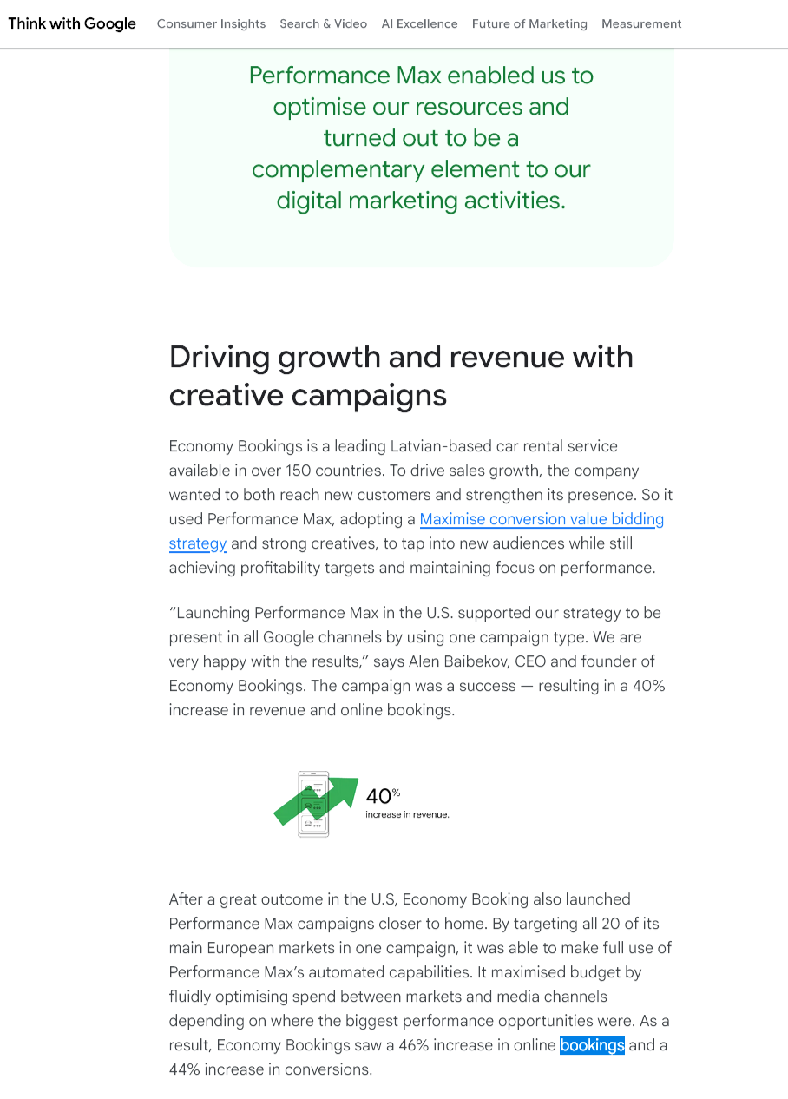

Case Study 2: Economy Bookings (29.11.2025) https://business.google.com/uk/think/ai-excellence/performance-max-marketing-consumer/

Case Study 3: KEH Camera https://www.goinflow.com/blog/performance-max-case-study/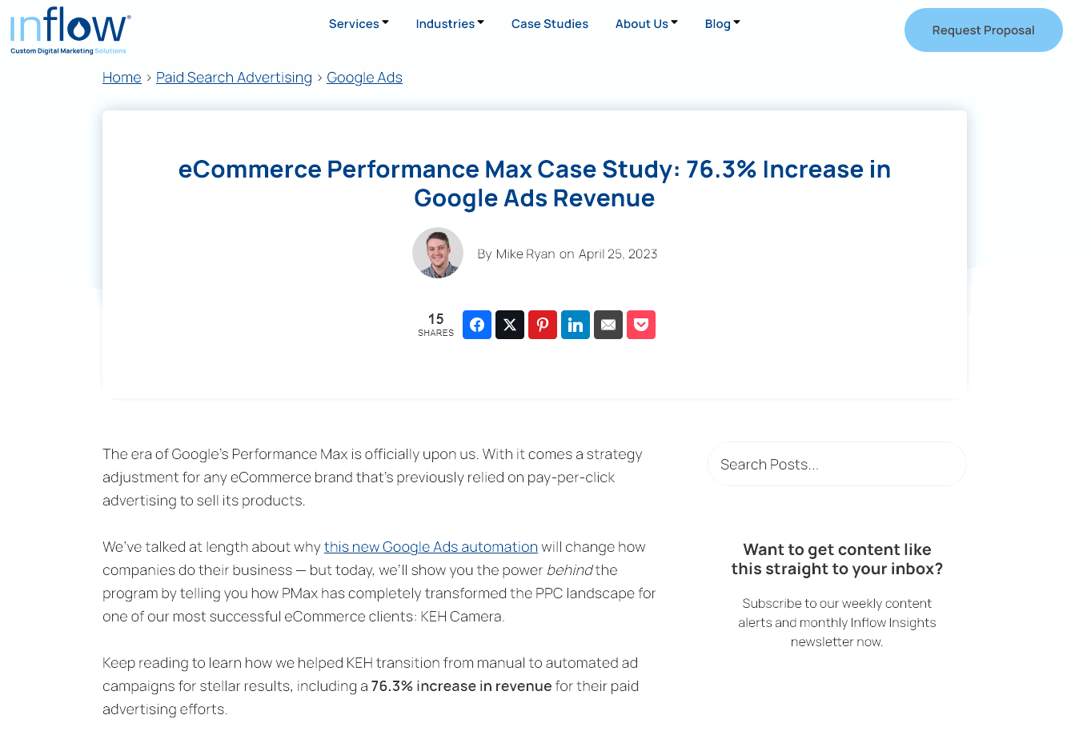
Case Study 4: Royal Design (29.11.2025) https://www.precis.com/work/royal-design-a-profitable-growth-story
Case Study 5: Skyscanner (29.11.2025) https://gmp.brainlabsdigital.com/case-studies/skyscanner-activates-bidding-in-search-ads-360-with-stratospheric-results/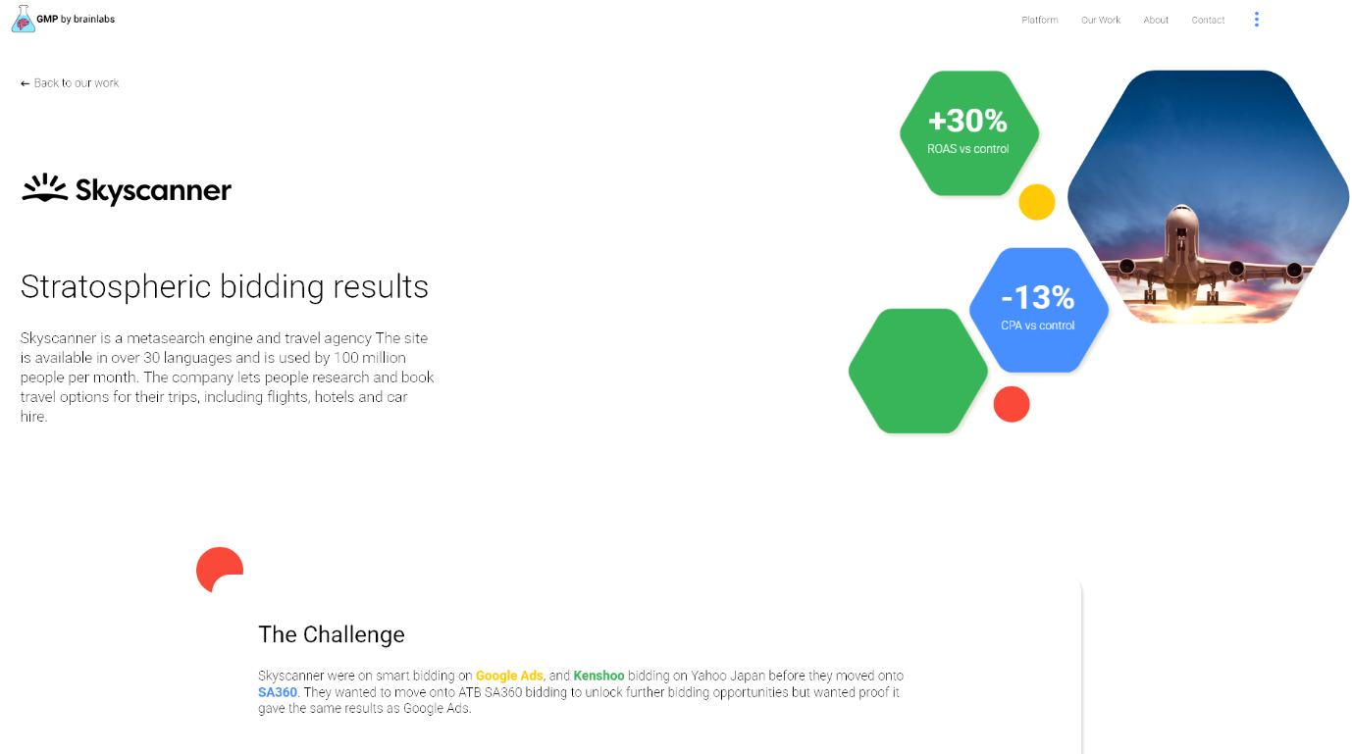
Case Study 6: Vine Apparel (29.11.2025) https://www.revvim.com/case-studies/vine-apparel/
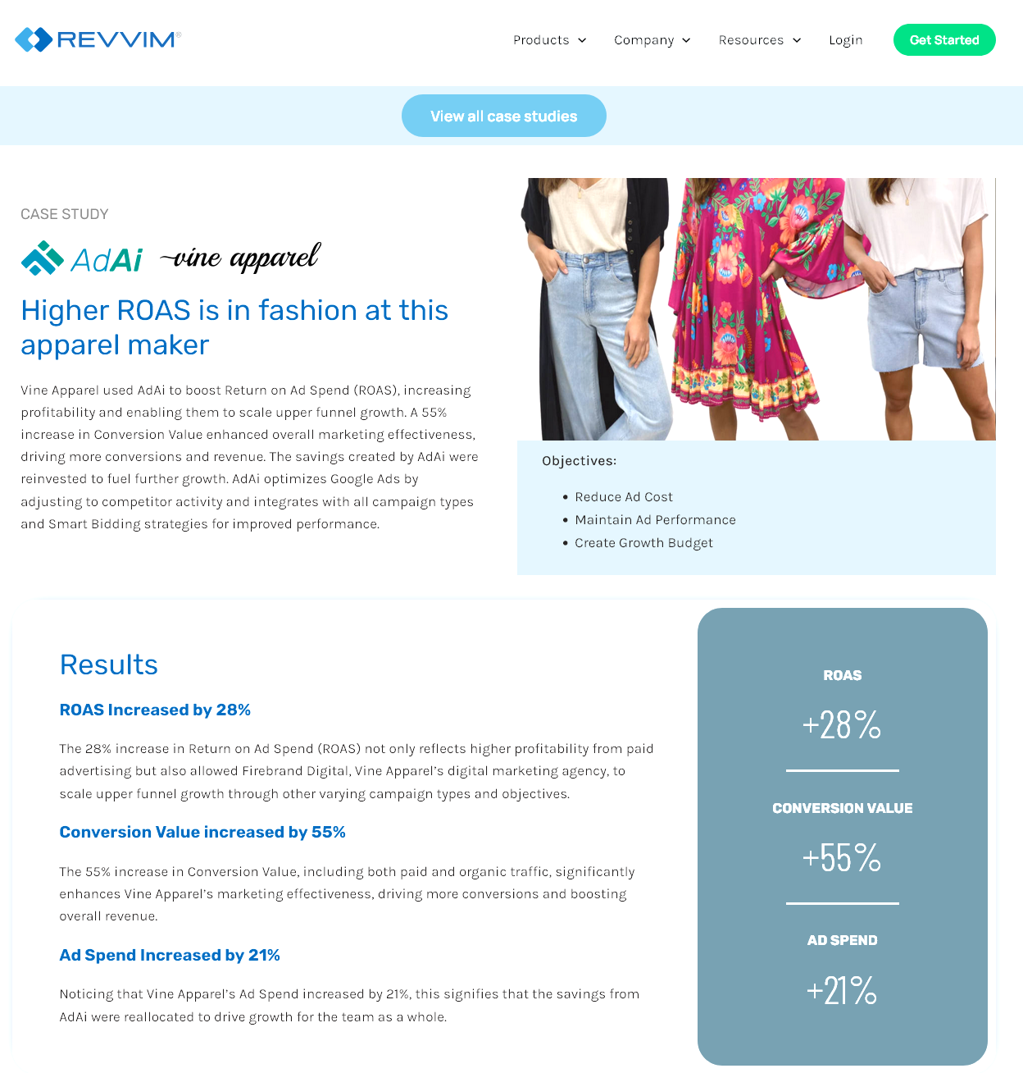
Case Study 7: Jayne Boutique (29.11.2025) https://www.acornstrategy.ca/blogs/case-study/jayne-boutique-google-ads-roas-triples-in-12-months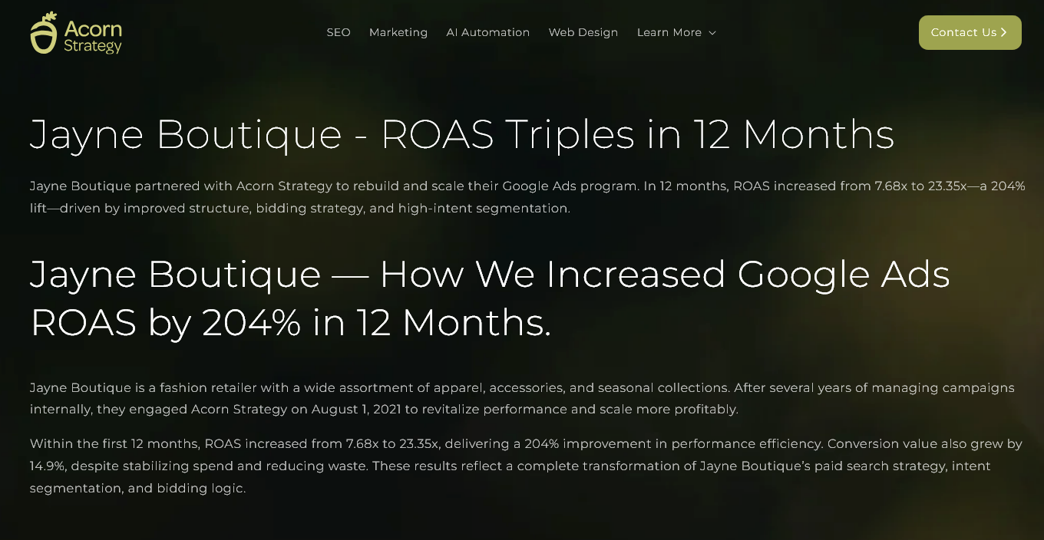Case Study 8: Medical Services Group (29.11.2025) https://realtop.com/google-ads-medical-services-group/
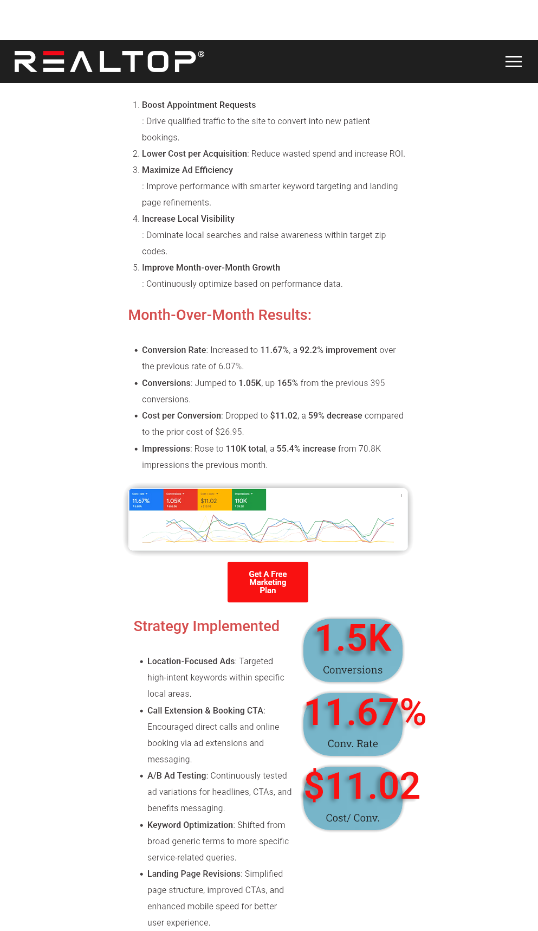

Terms of Glossary
AI (Artificial Intelligence)
Computer-based systems capable of performing tasks that normally require human intelligence, such as learning from data, prediction, and decision-making.
Conv. / Conversions
The number of times a desired action (e.g. purchase, lead, booking) is completed.
CPA (Cost Per Acquisition)
The average cost required to generate one conversion. A negative percentage change indicates improved cost efficiency.
CVR (Conversion Rate)
The percentage of users who complete a conversion after clicking an ad, calculated as conversions divided by clicks.
Cross-Channel Automation
Automation that operates across multiple advertising channels (e.g. Search, Display, Video, Discovery) rather than a single channel.
KP (Key Performance)
A shorthand label used in some case study materials to refer to a key performance outcome or metric, such as revenue growth, conversions, or efficiency.
NA (Not Available)
Indicates that a specific performance metric was not reported or disclosed in the source case study.
ROAS (Return on Ad Spend)
A performance efficiency metric calculated as revenue divided by advertising spend. Higher ROAS indicates greater efficiency.
SA360 (Search Ads 360)
Google’s enterprise-level search campaign management platform, which includes advanced Smart Bidding capabilities.
SKU (Stock Keeping Unit)
A unique identifier used to distinguish individual products within a retailer’s inventory.
Target CPA (Target Cost Per Acquisition)
A Smart Bidding strategy that aims to generate as many conversions as possible at or below a specified average cost.
Target ROAS (Target Return on Ad Spend)
A Smart Bidding strategy that aims to maximise conversion value while maintaining a specified average ROAS.
Tool-Agnostic Strategy
An optimisation approach not tied to a specific advertising tool

