Yan Zhang

Team Selection, Formation and Leadership

Table of content
Executive summary 1
Introduction 2
1. Staff selection 2
1.1. Staff selection methods and evaluation 2
1.2. Public Sector Equality Duty 4
1.3. Summary 5
2. Team Development 6
2.1. Build an efficient team 6
2.2. Establish high performance working practices 7
2.3. Summary 8
3. Leadership approaches 9
3.1. Analyze of the leadership approaches 9
3.2. Summary 11
4. Team development assessment indicator 12
4.1. key performance indicators 12
4.2. Summary 14
Conclusion 15
Reference 16
Bibliography 17

Table of Figures
Figure 1: Steps for staff selection 2
Figure 2: Nine Roles 7
Figure 3: Pyramid of management and leadership development 9

Table of Tables
Table 1: KPIs of the NHS Wales Informatics Service Project 13

Executive summary
This report will elaborate on how to deal with the prospect of team development from the perspective of employee selection, building an efficient team, leadership methods and key performance indicators in the data analysis project of the NHS Wales Informatics Service organization. Besides, this article will also propose some suggestions from these four aspects.

The first part critically evaluates the method of selecting employees and suggests that staff should be comprehensively examined and selected based on their abilities, ability to learn, ability to withstand stress, and the ability to live in harmony with team members. Besides, when hiring staff, the company should actively implement various aspects of the PSED in practice, such as combating gender discrimination, racial discrimination and so on.

The second part assesses how to accelerate the development of an effective team and establish an efficient working environment. An effective team should have excellent leadership and team members have a clear team role. In order to establish an efficient working environment, the team must develop a comprehensive management mechanism and reward and punishment mechanism, and assign project tasks according to the characteristics of each team member.

The third section analyzes the leadership methods that may be employed with staff and attempts to understand their suitability and possible outcomes in this environment. A good leader needs to set a good example for team members, create a pleasant team atmosphere and team culture for the team, and encourage staff to express their opinions boldly so that the leader can better lead a team.

The fourth chapter develops the key performance indicators for the team to monitor the development of the team based on the SMART principles. Through these indicators, the project manager can examine the work of staff and master the progress of the project, which is conducive to the development of the project.

Through the above chapters, some suggestions are made on how to form a team and how to manage the team. These methods can be applied to the data analysis project of the NHS Wales Informatics Service organization to ensure that the project can be completed on time and in quality.

Introduction
The Welsh NHS information service has set up a project team on national health data to tackle the problem of analyzing health data. The project team as part of the public sector agencies, according to the standard, the project should implement the conditions of the Public Sector Equal Responsibility (PSED) in the contract terms. In this context, this report will analyze how to promote team development from staff selection, building an effective team, leadership methods, and key performance indicators.

Staff selection
This chapter will critically evaluate the various methods of staff selection, and make some suggestions on staff selection for the Welsh NHS information service project. In addition, suggestions on how to deal with various aspects of PSED in practice will also be proposed.

Staff selection methods and evaluation
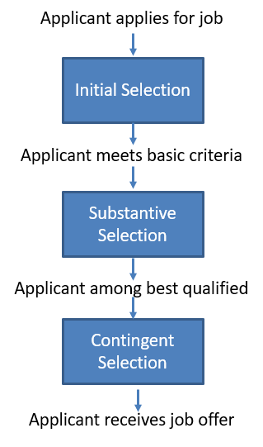
Choosing the right staff is an essential factor in business success. As we all know, the team is the organization, and the staff of the team is a precious and vital asset. Generally, a large part of management ability is to choose the right person and the right combination. If the company has a suitable team from the start, then the company will be more successful. Therefore, a good staff selection process is indispensable and it can help the company reduce the chances of employing inappropriate staff. The basic steps for staff selection are shown in figure 1.
Figure 1 Steps for staff selection

The initial selection is to check basic information such as the applicant's application form and relevant background. After the initial selection, it will enter into the substantive selection, which pays more attention to the ability of the applicant, including personal ability, communication ability, and collaboration ability. After this process, those who can meet the basic requirements but are not as competent as others will be rejected. The last part is contingent selection, and those who do not meet the requirements (such as drug use or physical illness and so on) will be rejected. After passing all the options, the applicant can receive a job offer.

An example of selecting staff [1]. When a project manager of a company chooses staff for the team, he first chooses two newly graduated college students. Then, when selecting a senior programmer, the manager has two choices, one is because he has a child and the work is suspended, but he is familiar with the project area, and the other has a wealth of programming experience. Finally, the project manager chose the former. We can get some experience from this case:
- Graduates may not have the skills needed for this project, but they are enthusiastic and willing to receive training.
- Skilled people are not necessarily the most appropriate, and sometimes familiar with the project area is more important.

In choosing staff, the most critical factors depend on other staff' skills, project types and application areas. For a development system project, here are some factors that may affect the manager's choice of employees [1].
- Developers must have an understanding of this area and have some experience.
- Developers must master the appropriate programming language.
- Have the ability to solve problems.
- Have a good learning ability so that he can learn more quickly.
- Have a good personality and live in harmony with team members.
- Have excellent communication skills to communicate with his team members.
- It is critical to adapt to the working environment of the project and to have a positive attitude.

As can be seen from the above factors, as a project manager, finding staff with skills and experience is not an easy task. If the manager chooses an inexperienced employee, he may be unfamiliar with the field and have a negative impact on the project. In the absence of relevant programming skills, it can lead to a variety of problems in the project. However, in a long-term project, learning a language is easy, but the ability to solve complex problems is relatively difficult, so in a development team, people with problem solving skills and domain experience are more important.

In addition to the previous method, there are also two popular staff selection methods. The first is Rodger's Seven Point Plan [2]:
- Physical make-up. Including health condition, physical condition, behavior and appearance.
- Attainments. Education background and work experience.
- General intelligence. Ability to learn and understand things.
- Special attributes. Such as sports, communicative, literary.
- Interests. For example, have a strong interest in literature, numbers and so on.
- Disposition. Such as steady type, lively type, optimistic type, pessimistic type
- Circumstances. Personal circumstances

Another is the Pattern of Personality proposed by Munro Fraser [3]:
- Influence on others and charism.
- Acquired knowledge and qualifications. Relevant education and work experience.
- Innate ability. Strong ability to learn and understand.
- Motivation. Strong motivation with clear goals.
- Flexibility ability to adjust. Ability to get along well with others, optimistic working attitude and strong ability to work under pressure.

The above two methods are not perfect, but it can be seen that in selecting employees, in addition to the need for solid professional knowledge and personal abilities, one's ability to learn, life and work attitude, and ability to get along with others are essential.

Public Sector Equality Duty
When recruiting new staff, more and more attention has been paid to the protection of staff's rights and interests. On October 1, 2010, the government enacted ‘The Equality Act 2010’, which replaced the previous anti-discrimination act, eliminated inconsistencies, simplified and strengthened the law, , and made it easier for people to understand and abide by it. The bill contains a new public sector equality obligation (PSED) that replaces separate obligations on gender, disability and race [4]. The new bill contains the following features:
- Age
- Sexual orientation
- Gender reassignment
- Sex
- Religion or belief – including lack of belief
- Race – including ethnic or national origin, color or nationality
- Disability
- Pregnancy and maternity

Tessa Russell and Tom Levesley [5] pointed out in the article that women play a critical role in business and encourage women to become business leaders and provide appropriate advice for future leaders – both men and women. Natasha Davies [6] also pointed out in the article that women have made tremendous contributions to economic growth. Therefore, when recruiting employees, companies must face up to the status of women in business, oppose all gender discrimination, and strictly abide by the provisions of the PSED.

Summary
This chapter evaluates several staff selection methods and discusses how to address aspects of PSED in practice. In a word, companies should thoroughly review candidates when recruiting and actively implement the rules of PSED.

Here are some suggestions for recruiting staff:
- New staff should have some experience in the field of health data analysis. Because the team members are between 25 and 35 years old, so some older and experienced staff can be recruited into the team.
- New staff should have certain programming skills and interested in programming. In this project, staff must master Java, python, MYSQL and data mining algorithm.
- New staff should have a positive learning attitude and strong learning ability.
- New staff should have a healthy body and a positive work enthusiasm.
- New staff should have excellent communication skills and get along with other staff.
- New staff should have a strong resistance to stress and responsibility.

In order to achieve equality in this project, we should actively take corresponding measures to solve all aspects of PSED:
- Do not limit gender and age when recruiting staff.
- Rethink leadership roles and team composition. Because all team members are male, so it is necessary to consider recruiting some women staff.
- Use standard and transparent hiring processes.
- Encourage women to apply for leadership positions and increase the training of female leaders.
- Provide staff with flexible working patterns.
- Give staff the power of choice, such as refusing to travel or freely scheduling holidays.
- Give employees enough time to rest and reduce unnecessary overtime.
- Fulfill all the rules of PSED.

Team Development
This chapter will discuss the methods used to build an effective team and makes specific recommendations for how to build an effective team.

Build an efficient team
With the rapid development of science and technology, the demand for talents of companies is increasingly diversified, which makes company management face various complicated problems.

In general, it is difficult to deal with various complex problems only based on personal ability. The team is built to solve all kinds of complicated problems and take appropriate actions. The contribution of a team is usually higher than the sum of the contributions of the various parts of the team. However, efficient teams do not suddenly appear at some point, and they are usually built on a careful and professional basis. So, what makes an effective team? Here are some key factors:
- Everyone contributes to the team in different ways and help each other.
- Everyone has a clear goal and is willing to work for it.
- Everyone is focused on tasks and processes.
- The team has a good leader.

Leaders play a significant role in the team. As Eisenhower said, ‘a lion-led flock can defeat a lion led by a sheep.’ Good team leaders can often speed up the project process, manage the inevitable conflicts, and push the team forward. Graeff, Claude L. [7] has pointed out that situational leadership theory plays a vital role in a team. The report of CCL [8] pointed out the new trend of transformational leadership, including kicking glass, change endurance, embracing disruption, digital fluency, reimagined reviews, accidental leaders, culture reboot. Therefore, leadership plays a vital role in building an effective team.

Dr. Meredith Belbin [9] once said, ‘A team is not a group of titled people, but a group of individuals, each with a role that other members can understand.’ Dr. Meredith Belbin and his team found that there were nine clusters of behaviors (as is shown in figure 2), including resource plant, shaper, teamworker, implementer co-ordinatorand, investigator, completer finisher, specialist and monitor evaluator. They believe that in order to be an effective team, each team needs to have one of the nine team role behaviors. However, this does not mean that every team needs nine team roles. Typically, team members need to have at least one familiar team role, but this can change over time.

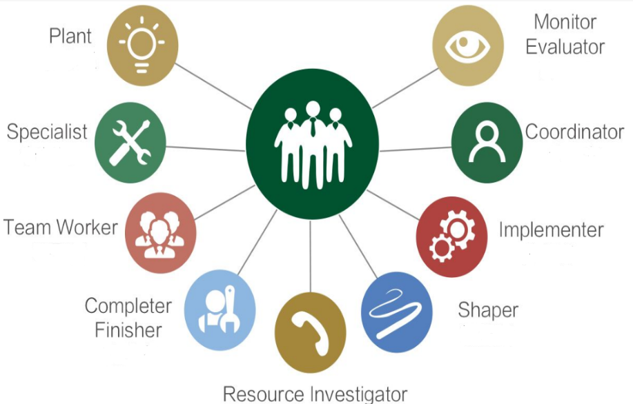
Figure 2 Nine Roles

Through the above analysis, the following methods are summarized to accelerate the construction of an effective team:
- Having a good leader is the key to building a good team. The leadership of a team leader will determine the combat effectiveness of that team. The relationship between the leader and the team is one and zero, the leader is one, and the team is zero. Team leaders do not have enough leadership, no matter how many zeros there are, the result is zero. That is to say, if the team leader is strong, the team will be strong. Team leader's ability is weak, the whole team is weak.

- Team members need to be clear about their team roles. Whether the team can operate efficiently and create an excellent performance for the company, the first requirement is that every staff in the team can clear understand their role in the team and correctly position their actual working ability and responsibility. If the wrong definition of the role in the team, it will affect the progress of the team.

- Everyone should have a clear goal and focus on the task. If team members have clear goals and have a hard work direction, they can focus on their work and help drive the development of the project.

The above approaches emphasize the importance of leadership, team roles and clear goals in building an effective team. Although these methods may not be comprehensive enough, through these important factors, it can not only accelerate the establishment of an efficient team but also promote the progress of the project.

Establish high performance working practices
After building a team, how can the team work effectively? First, we need to know what is a high-performance work environment:
- Ability to speak up and provide ideas
- Effectively manage conflicts and disagreements
- Everyone participates in the discussion and is willing to listen to each other
- Constructive criticism is expected
- Excellent team culture and team atmosphere

High performance work practices can drive the project forward. The following suggestions help to establish an efficient working atmosphere in the team:
- Firstly, encourage team members to speak up. At present, the age distribution of our team members is between 25 and 35 years old, and youth means that the project team will have strong creativity, for example, they can consider from the perspective of young people how to use the health data to provide some suggestions for young people. Therefore, encouraging team members to express their opinions can not only help the team build a pleasant team atmosphere, but also offer some constructive suggestions to the team.

- Secondly, a set of reasonable management mechanism, which includes salary mechanism, promotion mechanism, incentive mechanism and so on. An excellent team must have a fair, just and open effective mechanism to motivate team members to work harder and be more willing to pay. Moreover, the establishment of the mechanism must be an insight into human nature, to meet human desire, to win the hearts of the people. This is the core key to attracting, motivating and retaining talent.

- Thirdly, strengthen team learning to build a team culture. Team learning is a learning process that promotes teamwork and realizes common objectives. Team learning requires all team members to be open and honest, to share their assumptions and to express their personal views. In addition, participants must treat each other as partners to eliminate communication barriers, understand other people’s perspectives, and reduce discomfort.

The above methods can help the project to create a high-performance work practice. Only in this way can a team develop healthily and help the whole project move forward.

Summary
This chapter focused on how to build an effective team and build high-performance work practices. In order to build a team with high performance, there must be a good team leader, and the team members must have a clear role orientation. In the health data analysis project for NHS Wales Informatics Service, if anyone is sensitive to the data, and with excellent programming skills, he can be responsible for analyzing the data. If someone is good at writing, he can be responsible for writing the report. Besides, some other factors such as encourage team members to express their opinions, a pleasant team atmosphere, considerable rewards, and team culture are also essential factors in building an effective team and building high-performance work practices.

Leadership approaches
This chapter will discuss leadership approaches and propose suggestions on leadership approaches to understand the applicability and possible effectiveness of staff in this environment.

Analyze of the leadership approaches
In modern management, more and more companies put team building in the first place. In a team, the team's sense of cooperation is particularly important. However, when there is a problem in the project or a conflict between members, the leader will play a critical role in the team. The leader can improve the team's cohesion, and help the team members get along with each other. In leadership work, leaders use many approaches to solve problems. However, some leadership approaches are useful, some are not good, some are scientific, and some are unscientific. Different leadership approaches have different effects. In a sense, whether or not the correct and effective leadership can be achieved depends on whether the leader has a scientific leadership approach, which is crucial to the quality of the work.

Management systems [10] defines leadership effectiveness as 'successful ability to influence team members to achieve results in the most effective and effective way.' Management systems developed a three-factor framework to explain leadership effectiveness, including role concepts, management/leadership roles, and management of intrinsic games. Besides, Management systems have developed a pyramid of management and leadership development that identifies the critical skills required for each management and leadership. When one moves from one management/leader to another, he needs to gradually develop a higher level of skills (as shown in Figure 3).
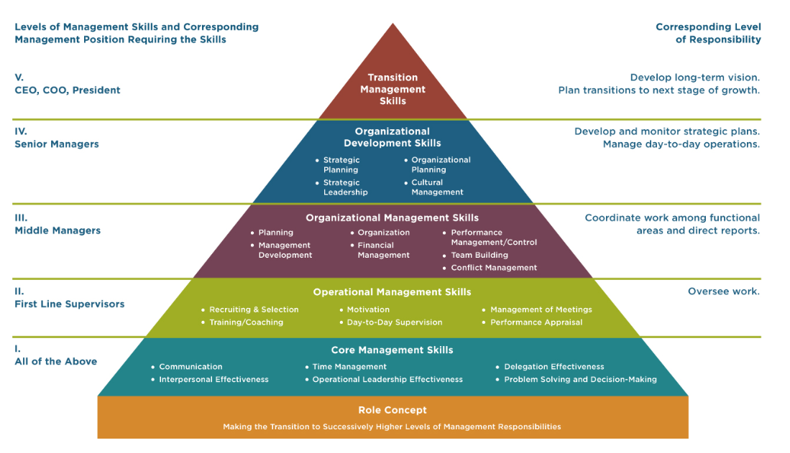
Figure 3 Pyramid of management and leadership development

Amir Sadeghi and Zaidatol Akmaliah Lope Pihie [11]studied the relationship between academic Leaders'styles and leadership effectiveness of research universities in Malaysia. The result shows that motivation, accidental reward, laissez-faire, idealistic influence, personalized consideration, abnormal management, and intellectual stimulation are all important predictors of leadership effectiveness.

To be a good leader, leader must understand self-management and gradually establish your own dignity. It should also focus on situational leadership and adopt different leadership styles for different employees and different situations. In order to understand leadership from the perspective of leaders, the Penny Tamkin team [12] interviewed 262 business leaders. The interviews mainly include the following aspects: vision, relationships, environment, self-awareness, power/control, Performance, Contextual factors and Communication. Based on the respondents' answers, they summed up three important ideas as the core of leadership and regarded them as the essence of leadership [12]:
- Representing the central position of the organization's systematic thinking and action.
- Outstanding leaders believe that talent is the way to performance
- Leader role plays a crucial role

Through the above analysis, the following leadership methods can be adopted:
- Find a suitable leadership approach and stick with it. Frequently changing management strategies can make team members feel frustrated and uncomfortable, so leaders should find the right management strategy and stick with it.
- Set objectives and monitor the achievement of objectives. Setting a clear and proper goal is critical to the team's direction. Besides, setting and meeting milestones also helps leaders understand team daily progress and productivity.
- Try to create a pleasant working environment. A study shows that a well-designed office environment can increase the overall performance of the team by 20%.
- Set a good example for team members. Team members will observe the behavior of the old leader directly or indirectly. This means that staff will use leadership as a reference and often imitate the attitude of the leader to work. No one wants to work for a leader who does not go all out and does not motivate employees.
- Use only constructive criticism. Constructive criticism refers to making useful suggestions to others. This includes not only positive evaluations, but also areas for improvement. The person making the suggestion should express constructive criticism in the right way, not in a critical way.
- Develop a team culture. Team culture is a kind of subconscious culture formed by team members in the process of mutual cooperation, in order to achieve their own life value and achieve the common goal of the team. Team culture is a concept that defines the relationship between team members and represents the vitality of the team.

Summary
This chapter have focused on the role of the leadership approach in the team and found that the right leadership approach can make a significant contribution to the team. Moreover, some leadership methods were put forward for the NHS Wales Informatics Service project. These leadership methods not only can enhance the cohesion of the team and avoid problems arising from some inappropriate leadership methods, but also can help understand the suitability and possible outcomes of team members in this environment.

Team development assessment indicator
This chapter will discuss key performance indicators and develop an assessment indicator that will be used to monitor the development of NHS Wales Informatics Service project team.

key performance indicators
Key performance indicators (also known as kPIs) are used by project managers to measure the project performance of team members. In a team, kPIs can not only help the project manager to clarify the primary responsibilities, but also help team members to understand the indicators of their work assessment. Therefore, it is important to for team management to establish a simple and useful KPI system. The development of KPI has the following advantages
- Set appropriate performance indicators according to the actual development of the team.
- Supervise project progress of the team.
- Identify existing or potential problems, and find appropriate solutions.
- The output of KPI is the basis for evaluating the work of team members.

However, it is not easy to design a KPI that is suitable for your team. When designing a KPI system, the following mistakes often occur:
- Over-elaboration of indicators caused by a misunderstanding of specific principles. Specific principles refer to specific work indicators that should be targeted in performance appraisal, rather than general ones. However, many designers understand that indicators should not be general, should be as detailed as possible. However, overly detailed indicators may prevent the index from becoming a key driver of enterprise value creation

- Omission of key indicators caused by a misunderstanding of measurable principles. In the actual design of the KPI system, some people are too rigorous in quantification and strive to quantify all indicators.

- The "mean" problem of indicators caused by the misunderstanding of achievable principles. Achievable principles refer to that performance indicators can be realized by working hard, and it is necessary to avoid setting up inappropriate objectives. High targets may cause staff and companies to fail to achieve goals, so the indicators will become meaningless. As a result, designers of KPI systems tend to be "average" in order to avoid the polarization of target setting, and usually prefer the mean value as the indicator. But not all "middle" goals are appropriate.

In the company, the process of determining KPIs generally follows [13]. Firstly, the establishment of an evaluation index system. The index system of each level can be established in order from macro to micro. First of all, define the strategic objectives of the team, identify the focus of the team, and identify the key performance indicators involved in these key areas. Next, the project manager needs to establish kPIs that are appropriate for the team. Then, the KPI staff of each project team will decompose the KPI in more detail.

Secondly, establish evaluation criteria. Generally speaking, indicators refer to the aspects from which work is measured or evaluated. And the standard is to point to what level should achieve respectively on each index. Indicators solve the problem of "what" we need to evaluate, while standards solve the problem of "how" and "how much" are required to be evaluated.

Thirdly, review of KPIs. The purpose of reviewing KPIs is to ensure that these kPIs can effectively reflect the work performance of project team members.

George T.Dolan [14] the SMART principle, which can be used to determine key performance indicators:
- S means Specific. Performance indicators should be specific indicators, with specific evaluation criteria rather than broad, general indicators.
- M means Measurable. This means that performance indicators should ensure that the data or information they use is measurable.
- A represents Attainable. Performance indicators should be set according to the actual situation, and it should be an achievable goal.
- R represents Relevant. Relevant refers to the performance indicator that has a clear correlation with the superior goal and is finally integrated with the company goal.
- T is for Time bound. A specific time period within which you are bound to focus on achieving your performance goals.

In order to better complete the project of NHS Wales Informatics Service, we can adopt the following methods to develop KPI indicators suitable for this team (as is shown in table 1).

KPI | Description | Weight | Purpose | Assessment cycle
Work quality | Whether there are too many bugs in the code | 15 | Ensure project quality | One month
Work efficiency | Whether to complete the task within the specified time | 15 | Ensure that projects are completed on time | One month
Work attitude | Whether to be passionate about their work | 10 | Ensure that employees are motivated to work | One month
Professional knowledge | Whether they have enough knowledge and applied to the project | 10 | Ensure that employees are able to complete tasks | One month
Responsibility | Whether to be responsible for the task | 10 | Ensure that employees are responsible for their work | One month
Coordination and cooperation | Whether they can actively coordinate and cooperate with others | 10 | Ensure team harmony | One month
Compliance | Whether to follow the procedure strictly and follow the rules | 10 | Ensure discipline within the team | One month
Development potential | Whether they can take the initiative to learn and have the development potential | 10 | Investigate the development prospects of employees | One month
Cost | Whether they can reduce project costs | 10 | Save project costs | One month
Table1 KPIs of the NHS Wales Informatics Service Project

It is worth noting that the project manager will judge the scores of these KPIs. However, KPIs are not fixed. Different KPIs may be required in different project phases. Therefore, KPIs should be continuously changed according to specific projects and specific needs.

Summary
This chapter have discussed the role of key performance indicators in team development and related development processes. Besides, this chapter combined the current popular SMART principle to develop KPIs for NHS Wales Informatics Service project. Teams can review these indicators and monitor project progress to ensure that projects are completed on time and with quality.

Conclusion
This article discussed the establishment of data analysis project team of the NHS Wales Informatics Service organization. In terms of staff selection, we need to consider not only the individual abilities of the staff, but also the professional experience, work attitude and ability to get along with others. In building an effective team, a good leader is the first step in building a good team. In addition, staff must have clear goals and the team must have a positive culture. In terms of leadership, it is important to find a leadership method that suits this team, encourage staff to express their ideas, and create a harmonious team atmosphere for the team. Finally, in order to supervise the completion of the project and examine the work efficiency of the staff, this article has developed key performance indicators which is suitable for the NHS Wales Informatics Service project team.

These methods can help the data analysis project quickly recruit the right staff and build an effective project team. And through the appropriate leadership methods and KPIs to move forward to the project, to ensure that the project can be completed on time and quality.

Reference
[1] | I. Sommerville, Software Engineering, 9th Edition, Addison-Wesley, 2008.
[2] | Rodger, The seven-point plan, London: National Institute of Industrial Psychology, 1968.
[3] | T. F.-F. G. SYSTEM, "THE FIVE-FOLD GRADING SYSTEM," [Online]. Available: http://www-users.york.ac.uk/~aew6/Courses/People%20and%20Quality/Munro.pdf. [Accessed 12 4 2019].
[4] | Equality and Human Rights Commission, The Essential Guide to the Public Sector Equality Duty, Equality and Human Rights Commission, 2014.
[5] | T. L. Tessa Russell, "Breaking Glass: Strategies for Tomorrow's Leaders," Chartered Institute of Management Accountants, 2010.
[6] | :. N. Davies, "Women and the economy," Chwarae Teg, 2015.
[7] | C. L. Graeff, "Evolution of Situational Leadership Theory: A Critical Review’," Leadership Quarterly, vol. 8(2), pp. 153-170, 1997.
[8] | N. Petrie, "Future Trends in Leadership Development," Center for Creative Leadership, 2014. [Online]. Available: https://www.ccl.org/articles/white-papers/trends-report-talent-reimagined/. [Accessed 13 4 2019].
[9] | Belbin, "Belbin Team Roles," Belbin, [Online]. Available: https://www.belbin.com/about/belbin-team-roles/. [Accessed 13 4 2019].
[10] | Management Systems, "Management and Leadership Development," 2010. [Online]. Available: https://www.mgtsystems.com/management-and-leadership-development. [Accessed 14 4 2019].
[11] | Z. A. L. P. Amir Sadeghi, "Transformational Leadership and Its Predictive Effects on Leadership Effectiveness," International Journal of Business and Social Science , vol. 3, pp. 186-197, 4 2012.
[12] | G. P. W. H. C. Penny Tamkin, "Exceeding Expectation: the principles," The work foundation, 2010.
[13] | Klipfolio, "KPI Examples and Templates," [Online]. Available: https://www.klipfolio.com/resources/kpi-examples. [Accessed 14 4 2019].
[14] | G. T.Doran, "There’s a S.M.A.R.T way to write management goals and objectives," AMA FORUM, pp. 35-16, 11 1981.

Bibliography
[1] | K. M. B. a. E. A. L. Abhishek Srivastava, “Empowering Leadership in Management Teams: Effects on Knowledge Sharing, Efficacy, And Performance,” Academy of Management Journal, 30 11 2017.
[2] | F. C. Lunenburg, “Leadership versus Management:A Key Distinction—At Least in Theory,” INTERNATIONAL JOURNAL OF MANAGEMENT, BUSINESS, AND ADMINISTRATION, 1 2011.
[3] | J. Kotterman, “Leadership Versus Management: What's the Difference?,” The Journal for Quality and Participation, pp. 13-17, 2006.
[4] | W. H. V. D. Gmelch, Leadership Skills for Department Chairs, Bolton: Anker Publishing Company, 1993.
[5] | R. Stacey, Tools and Techniques of Leadership and Management, London: Business & Economics, 2012.
[6] | G. B. Weathersby, “Leadership vs. management,” Management Review, 3 1999.
[7] | Parvesh K. Chopra, “Emotional intelligence: A catalyst for inspirational leadership and management excellence,” Gopal K. Kanji, pp. 997-1004, 3 8 2010.
[8] | K. Borgelt, “The leadership/management conundrum: innovation or risk management?,” LEADERSHIP & ORGANIZATION DEVELOPMENT JOURNAL, pp. 122-136, 2007.
[9] | M. S. Wood, “Determinants of Shared Leadership in Management Teams,” INTERNATION JOUNAL OF LEADERSHIPSTUDIES, pp. 64-85, 2005.
[10] | S. Kim, “Participative Management and Job Satisfaction: Lessons for Management Leadership,” PABLIC ADMINSTRATION REVIEW, pp. 231-241, 3 2002.

