Marcos Gonzalez Norris
1802722 UWTSD school of engineering
An investigation into additive manufacturing for the production of specialised sunglasses

Contents
Introduction 2
Additive manufacturing 2
Current manufacturing process of sunglasses 2
Justification for using additive manufacturing to manufacture sunglasses 3
Tools used for redesign 3
Final design 4
Conclusion 7
References 8

Introduction

Additive manufacturing
Over recent years additive manufacturing has been an emerging technology at the forefront of innovation. However, there are still many areas in industry where additive manufacturing can be implemented to improve design, cost and manufacturing time. This report investigates how additive manufacturing can be used to improve the quality of production of sunglasses. By using additive manufacturing, sunglasses can be designed to improve customer satisfaction in a cost-effective way.
Additive manufacturing is more commonly known as 3D printing. The process takes a digital rendering of a design and splits the component into multiple thin layers. A printer then ejects a molten material which is commonly a plastic, however, it can also be a metallic material. The molten material is ejected in the pattern of the first layer, once one layer is complete the printer then begins to print out the next layer on top of the previous one. This process is repeated until all the layers are printed leaving the finished part ready to be used.
A benefit of using additive manufacturing is that it produces less waste material than other processes. This is because only the exact amount of material required to make the part is used unlike other methods which either require further finishing or even parts of material to be cut off and disposed of. Additive manufacturing also allows for more complex designs than for other manufacturing processes. This means that the design can be more efficient and tailored for its purpose. The versatility of this process means that it can be applied to many different industries.

Current manufacturing process of sunglasses
The initial purpose of sunglasses was to protect a person’s eyes from incurring permanent damage caused by the suns UV rays. Studies show that over 20% of cataracts cases are likely to have been caused by UV rays (Oxfordonlinepharmacy.co.uk, 2016). Thus, showing the importance of wearing sunglasses when exposed to sunlight. Over the last few decades sunglasses have also become a fashion accessory which in turn is causing the eyewear market to grow even further. In the united states alone the sunglass industry generated 4.66 billion USD in revenue in 2018 (O’Connell, 2019). It is a market that is projected to keep growing as people are made more aware of the health benefits as well as more fashionable options being offered.
Die-cutting is a commonly used manufacturing process for a generic plastic sunglass frame. During this process a steel die in the shape of the frames is used to cut out a frame from sheets of cellulose-acetate. These sheets must be heated to a temperature of around 68°C so that they are soft enough to be cut. The frames are then machined and finished to remove sharp edges as well as to add grooves for the lenses and hinge mechanisms (Madehow.com, n.d.). Other processes such as injection moulding are also used as well as hand crafted frames to be fitted for an individual’s face.
There are many drawbacks in using a manufacturing process like Die-cutting. Firstly, the cost of making the die is very high. This makes it very complicated for a new design to implemented as it will require a significant financial investment each time the design changes. This in turn means that the design of the sunglasses must essentially accommodate all face shapes and sizes as making designs for individuals would be too expensive and time consuming. Another issue with these manufacturing processes is that the machines required have a high initial cost as well as high running costs. This is due to the heavy moving machinery and the heating required for the cellulose-acetate requiring a significant amount of energy. The large machinery also requires a lot of space and staff to maintain it. This means that the company must either rent or buy a larger warehouse/factory to produce the frames. Another drawback is that the manufacturing process can only produce relatively simple solid shapes. This means that the design of the frames is very limited with more efficient designs not being able to be implemented. This in turn means that the design must be compromised and therefore be less comfortable, weaker and heavier than is necessary.

Justification for using additive manufacturing to manufacture sunglasses
Although additive manufacturing would improve the design of sunglasses used in many different situations, this investigation will focus specifically on how additive manufacturing can be used to produce rock-climbing sunglasses.
When thinking about the safety equipment required for rock-climbing items such as: ropes, harness, helmets and even crash matts come to mind. However, sunglasses are also an essential part of safe outdoor rock-climbing. When the sun is shinning brightly against the rock surface it can be quite difficult to see where the foot and hand holds are. In some cases, the light reflected can be so bright that it is almost impossible to climb without sunglasses. Not only do sunglasses protect the user’s eyes from UV rays but if designed appropriately they can also provide protection from falling rocks or dust coming off the wall and potentially getting in the user’s eyes.
When rock-climbing, it is important that the climber stays fully focused throughout the whole climb. If the climber makes one mistake it could lead to a life-threatening situation. Because of this it is very important that a climber is very comfortable with all the equipment they use. If a climber is wearing sunglasses that are either uncomfortable or that must be adjusted every now and then, they could endanger themselves by losing focus. By using additive manufacturing an individual’s sunglasses can be designed to fit perfectly to that persons face so that they are comfortable and so that they don’t slip off.
Another reason why additive manufacturing should be used to produce sunglasses is that it allows the design to be as efficient as possible. By doing topology optimisation on the initial design of the frames it is possible to find an organic shape that provides strength to the design while also reducing the amount of material required. This therefore means that the frames will be very durable and light weight. The reduction in weight would make the sunglasses more comfortable and cheaper to manufacture. When climbing, every gram of weight saved is essential and by using additive manufacturing the organic design can be printed as it is without any changes unlike other manufacturing processes where adaptations would be required. The optimised design will also allow the sunglasses to be breathable, allowing for sweat to evaporate and add to the comfort of the user.
By using additive manufacturing, it is possible to make a frame that as stated above will be robust, lightweight, comfortable and breathable. All of this can be achieved in just a few hours at a fraction of the cost that it would be with any other manufacturing process, making it very profitable for a company to implement.

Tools used for redesign
The first tool used for the design process was a decision gate using the Lucas methodology. By using this tool, it was concluded that the hinge mechanism found in sunglasses is non-essential. Specifically, when looking at glasses for climbing, a hinge mechanism is not needed as the user will always be wearing the glasses. By removing the hinge, the design for the sunglasses will be stronger and simpler as well as removing possible faults from occurring. For example, sand could enter the hinge mechanism and stop it from working. This kind of fault would be very common in a climbing environment. By removing the hinge mechanism, we are also able to make the arms and frame into one piece. This further simplifies the design and manufacture time.
The tool that will be used to make the initial frame design and basic template will be solidworks. This CAD software allows the user to combine 3D scans with already made parts. Once the design is finished it can then be saved as an STL file which can then be used directly into the printer for the part to be made.
Within solidworks the topology study tool will be used for the optimisation of the part. This tool allows the user to input all kinds of loads and scenarios to be simulated to conclude the most efficient design based on those simulations. This is a vital tool to ensure that the design is strong and lightweight.
Another tool that will be used for the redesign will be 3D facial scanning. By using a device such as the 3D Scanner 1.0 A (Xyzprinting.com, n.d.) it will be possible to produce a 3D model of an individual’s face. This 3D scan can then be imported into solidworks and used to mould the sunglass frame around the scan to produce perfectly fitting sunglasses. When trying to fit glasses onto a face it is important take into consideration 5 measurements. These measurements are frame width, pupil placement, arm length, bridge height and bridge width (Anon, 2020). Although the design of the frames will be based mainly on these measurements it will also take into consideration any protruding features and the curvature of the persons face.

Final design
The final design has been made to follow five main criteria’s, they are: comfort, lightweight, breathability, robustness and eye protection. However, in fulfilling these criteria the final design has also become cheaper and faster to manufacture. This is mainly down to the reduction in material required to make the sunglasses as a result of the topology optimisation.
The lenses within the final design will be made out polycarbonate. Polycarbonate has the advantage of being lightweight as well as being very strong compared to glass or plastic lenses. The lenses will be polarized to prevent UV rays from passing through the lens and causing damage to the users’ eyes. A polarized lens also means that the user will not experience any lens glare which ensures that the user will always have clear vision when climbing (Zigler, 2017). The sunglasses have been designed so that although the overall dimensions change according to each customer the frame surrounding the lenses never changes. This means that only one set of lens design needs to be manufactured and therefore it is not necessary nor wise to use additive manufacturing for this part of the glasses. The lenses will be attached to the glass by placing them within grooves in the inner part of the frame. The natural flexibility of the material should allow of the lenses to just click on but will be rigid enough to stop them from coming out once placed inside.
As can be seen from figure 1 the topology optimisation has reduced the amount of material required in the central area of the arms. This reduction in material has allowed a 50% reduction in mass while still maintaining its structural strength and rigidity. The reduction in material also means that the glasses allow air to flow freely between the users’ head and the glasses meaning that when doing I high intensity activity like climbing the user does not have build-up of sweat and therefore improving the comfort of the user.
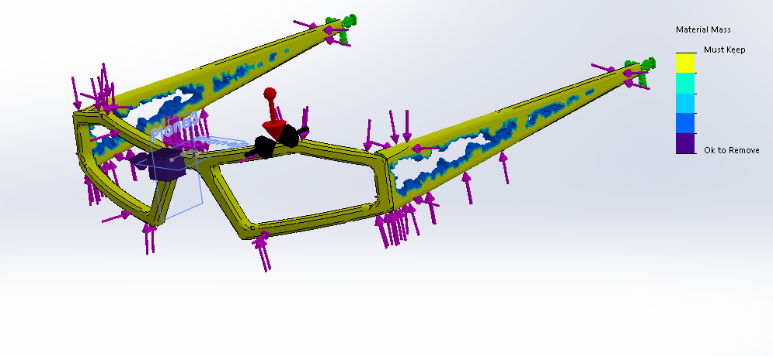
(Figure 1- Topology optimisation)

Another feature of the final design is that the inner face of the frame is dimensioned by the 3D scan of an individual’s face. By having the inner surface shaped around the face of the user the glasses will be as comfortable as is possible for the user will still staying firmly onto the users’ face. This means that even if the user is upside down while climbing the glasses should be able to stay on their face without any interaction with them. This feature on the final design can only be achieved by using additive manufacturing because any other manufacturing process would either take too long or be far too expensive to justify making a unique design for every user. Figure 2 shows an engineering drawing of the basic template of the sunglasses. The drawing shows the main dimensions that will be affecting the fit and comfort of the user. Dimension x is the arm length, this dimension is determined by the distance between the temples and the back of the users’ ears. Dimension Y1 and Y2 are bridge width and bridge height respectively. These dimensions are determined by the shape and size of the user’s nose. The bridge height and width are crucial for the alignment of the glasses and if these dimensions are not accurate then the comfort of the glasses will reduce significantly. Dimension Z is the frame width which is determined by the width of the users’ face. Dimension R is angle of curvature of the glasses. This is determined by the curvature of the users’ face and is vital to ensure that the glasses stay flush against the user to avoid dust or other particles from getting into the climbers’ eyes.
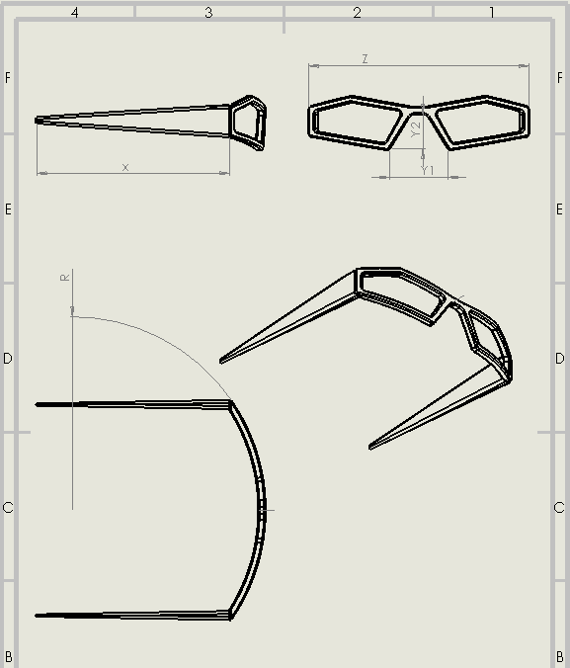
(Figure 2 – Engineering Drawing)

The final feature of the glasses is the actual look/style that they have. As a result of the glasses being moulded around an individual’s face it means that every pair of sunglasses is unique. This defining feature allows the sunglasses to be unlike any other in the market with buyers being drawn to them not just for the practical benefits but to have an accessory that is uniquely personalised to them. Figure 3 and 4 shows an example of what the final design might look like for an individual (without the lenses). The images show how the unique pattern formed within the arms can be aesthetically pleasing while still fulfilling a practical purpose.
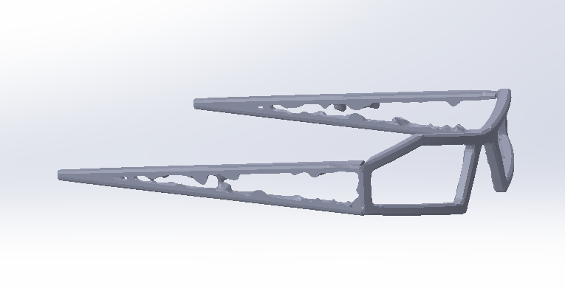
(Figure 3 – Final design view 1)

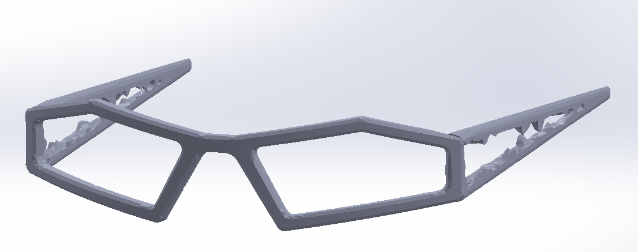
(Figure 4 – Final design view 2)

Conclusion
By using additive manufacturing to produce specialised sunglasses we can design a product that is light weight, strong, affordable and personalised. It has allowed the design to be constrained by its specification rather than its manufacturing process. The downside to using additive manufacturing is that you cannot produce thousands of products a day. However, for this case, when you are designing a product that is unique to everyone, it is by far the fastest reliable production method.
Large batch manufacturing processes still have a large impact in industry. However, additive manufacturing techniques are constantly changing and improving at an incredible rate. For the right product/part additive manufacturing can vastly improve the economy of its manufacturing. This investigation has proven that additive manufacturing can change the way we view the products that we use on a day to day basis. In a world where resources are finite, it is becoming more important for companies to be less wasteful with the manufacturing of products. Additive manufacturing can be a significant step forward in helping companies to be more sustainable while still improving their own products.

References
O’Connell, L. (2019). U.S. Sunglasses Market - Statistics & Facts. [online] www.statista.com. Available at: https://www.statista.com/topics/5071/sunglasses-in-the-us/ [Accessed 28 Jan. 2020].
Oxfordonlinepharmacy.co.uk. (2016). Why do we need to wear sunglasses? | Oxford Online Pharmacy. [online] Available at: https://www.oxfordonlinepharmacy.co.uk/blog/why-do-we-need-to-wear-sunglasses [Accessed 28 Jan. 2020].
Madehow.com. (n.d.). How eyeglass frame is made. [online] Available at: http://www.madehow.com/Volume-5/Eyeglass-Frame.html [Accessed 28 Jan. 2020].
Xyzprinting.com. (n.d.). [online] Available at: https://www.xyzprinting.com/en-GB/product/3d-scanner-pro [Accessed 1 Feb. 2020].
Anon, (2020). How Should Glasses Fit? Glasses Measuring Guide & Finding Your Size. [online] Available at: https://bespokeunit.com/glasses/fit/ [Accessed 2 Feb. 2020].
Zigler, J. (2017). 13 Best Indestructible, Unbreakable Polarized Sunglasses. [online] Eye Love. Available at: https://eyelovethesun.com/blogs/news/top-5-unbreakable-sunglasses [Accessed 3 Feb. 2020].

