Written Business Plan

MODULE:BMSW 4006

Managing Enterprise in the 21st Century

Hristina Birova - Kokkini 2120089
Iunsiya Hussain 2024760
Frida Izabella Tac 2118358
Claudia Ilie 1816378
Sana Arif 2116663

Lecturer: Olu Adegbite



Table of Contents

Executive Summary 3
Company Overview…………………………………………………………………………………………………………………………… 3
Product and Services 4
Market audit 4
Competitors Analysis 5
SWOT Analysis 6
PESTLE Analysis 6
Target Market 7
Marketing Plan 7
Financial Plan 8
References 10

Executive Summary
Beauty On The Way is a mobile beauty salon covering Birmingham and the surrounding areas owned by Iunsiya Hussain, Hristina Birova-Kokkini, Frida Izabella Tac, Claudia Ilie, Sana Arif.
In the busy everyday life, not everyone can spend the precious time to visit a beautician saloon, but everyone needs to. That is why Beauty On The Way offers to visit you at suitable for you time and at the convenience of your home or office. Since the company is mobile and will travel throughout the Birmingham region, consumers won't have to worry about making the trip from home or work for beautician themselves.
Beauty On The Way offers make-up, eyecare, nails and haircuts aiming not only to the working-class clients but the once in care homes, customers with disabled and mental health problems. The team of Beauty On The Way has extensive experience in working in the butty industry such as hairdressing, make up, threading and waxing, nail & eye lash, health and social care, and business administration.
The £60000 investment from the owners in making the saloon mobile will give the company unique advantage over its competitors Primark Beauty Studio, Tandis Hair and Beauty Salon, Tandis Hair and Beauty Salon.
To ensure all the needed resources to start the owners of the company have ensured a £20 000 grant from the local council. This grant will be spent on stock and materials, tools, equipment and van.

Company Overview
The mission and vision statement for Beauty on The Way is ‘our goal as a company is to make our customers feel beautiful by providing them with top quality service and with our professionalism building ever long-lasting relationships.’ The reason why this mission and vision statement has been chosen for the company is because Beauty on The Way want their customers to know that their number one priority is them, they want to give their customers the best service as well as beautifying them as they desire. Building a relationship with them so that they are comfortable with employees at Beauty on The Way which will encourage them to become returning and regular customers using the services provided by the business.
The history of the company is that all employees, Iunsiya, Frida, Sana, Claudia and Hristina met at the University of Wales Trinity St David’s. Studying the same course, with the passion of opening beauty businesses, however individually it would have financially been impossible. The only option to open a business was to go into a partnership and invest £60,000 as well as the £20,000 grant given by the local council. Each investing £12,000 of savings towards the opening of Beauty on The Way.
Beauty on The Way is a mobile beauty company. Travelling to customers within the Birmingham area. With extensive research and development having a mobile beauty van that would travel to provide clients with beauty services instead of clients travelling to Beauty on The Way, this idea came across intriguing and rare.
Partnership legal structure was chosen to ensure all owners had the power to make decisions for the company. The company’s assets, liabilities, profit, and losses are shared amongst all within the partnership providing partners with the feeling of equalness in the business.

Product and Services
We engaged to offer the best prices and promotions, and we ensure our customers that we are using best products, cruelty free products ensuring high quality results from our team which are fully trained in beauty services, health & safety.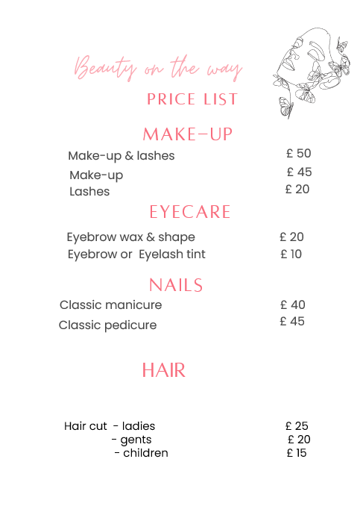

Market audit
For a new business, market audit is a valuable strategic and tactical planning tool. (Denisa & Jaroslav, 2013), It is a method for determining the worth, risk, and efficacy of marketing. One of the most important aspects of a planning process is appraising a company's existing position and potential. (Radulescu, 2012).

Competitors Analysis
According to Myk Pono (2018), A competitor analysis is a method that assists us in identifying our competitors, their strengths, and flaws, and comparing them to our business.
Because all businesses face competition, it is critical for a new firm to investigate the market leaders nearest to you in your sector to compete. In terms of competitors analysis, the goal is to assess the strengths of other competitors in our market and to establish strategies barriers that may be adopted to prevent other competitors from entering our market.
When we researched about the best 4 beauty salon from Birmingham, we find out that we all use the same advertising methods Facebook Instagram Google. Our advantage over the competition is that we will advertise on Twitter and posters as well, and our customers can be any age and gender another advantage is that we are the only beauty salon which will travel to customer's home.

Top 4 best beauty businesses in Birmingham, based on 5* Google review given by customers:
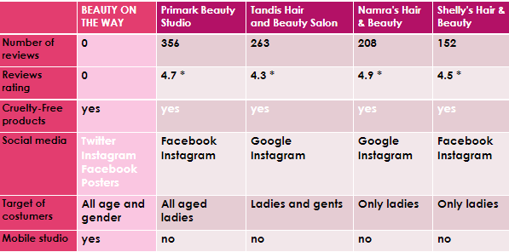

SWOT Analysis
“Swot analysis is a very useful technique that organizations use for making informed decisions“(Ajmera, 2017).
Strengths | Weaknesses
- Large range of services  - Excellent customer services  - Extended opening hours  - We are in an excellent location | - Lack of capacity  - Not having enough marketing experience  - No online appointment facility
Opportunities | Threats
- Good Internet opportunities  - Strong market growth  - More people booking online  - Stock organic products | - New salon opening in area  - Costs of having the best stylists and technicians  - Discounting by competitors

PESTLE Analysis
Beauty on the way can use PESTLE in many ways. Using political issues such as inflation which is prices increasing. This means customers may find it hard to spend on luxuries such as self-care therefore beauty on the way can decrease prices. Health and safety regulations can help Beauty on the way keep on top of the safety aspects therefore not breaking any rules. Economic factors such as tax increases and cost of living increasing can mean that individuals have less money to spend on self-care as disposable income decreases. Social trends can have a massive impact on beaty on the way such as the trend of doing everything at home (convivence) can mean beaty on the way could have a massive influx of customers therefore increasing profit for beauty on the way. Innovative technology such as new straighteners and other tools can be expensive for the firm but will bring in a lot of customers as consumers like when businesses have the latest technology. Health and safety laws such as making sure there is always a first aid box in the van and that all staff being trained in first aid will ensure customer satisfaction and employee well-being, Data protection laws such as protecting consumer information will make customers feel safer therefore will want to come to them. Some environmental issues that will affect this business is as beaty on the way is mobile if there is traffic customer wait time will increase therefore the business will have a bad reputation and customer satisfaction will decrease therefore the likelihood of repeat customers decreases.

Target Market
Jeff Bullas, who is one of the 10 Digital Marketing Influencers to Follow in 2021, says "Start by defining your ideal target audience and identify them."
Our goal is to serve customers of all ages and genders from the working class to people living in care homes, student, ones with disabilities and mental health problems and the ones living in the rural areas of Birmingham.
Care homes
The people there need our services on a regular basis, having two days set aside specifically for them on schedule, this is done after meeting with the nursing home managers and determining a suitable room and days.
Student campuses
Students of different ages and with different family status receive our services at a certain place and at the time they want, convenient for them, at acceptable prices.
Disabled and with mental health problems
These are clients who gain self-confidence by using our services, offered in an appropriately respectful and discreet manner in a familiar environment.
Rural areas of Birmingham
Clients consisting of families living in the rural areas of Birmingham where there is no beauty salons or beauticians and the access to this service is connected with high cost of traveling and high consumption of time, whole families can use our services at a time convenient for them at reasonable prices and excellent quality.

Marketing Plan
Management Team - a management team is different people in the organization that oversee various aspects of the business. For beauty on the way they have 5 different people on their team the MUA who carries out distinctive styles of makeup, oversees the inventory such as stock taking each make up item and is also in charge of the Maintenace of each makeup tool. The accountant manager oversees the firm's accounts, deals with any booking including cancellations and movement of times, manages all admin this includes new stock and ensuring payments are made. The hair stylist oversees all things concerning hair such as cuts, coloring and Maintenace. The threading and waxing stylist oversees all things waxing e.g., threading, and waxing everywhere e.g., legs and arms. The nail and eyelash specialists are concerned with nail extensions pedicures eye lash lift and extinctions.

Financial Plan
Beauty on the way has created cash flow forecasts also profit and loss forecasts for the period of 31 January 2023 to 31 December 2023. The business ensured financial planning for the company is a top priority. The reason is because ‘poor financial planning can always be a disaster. This can create economic problems in your business.’ (F1 Radical, 2022) to avoid this, it is essential to financially plan for the company.

In this cash flow forecast a clear observation can be made that in the month February the business had a negative balance after the outgoings for the month were taken from the incoming from sales this resulted for the opening balance for February of £74,235 being reduced to £72,671 for the closing balance.
It is usual for new businesses to incur negative balances at the beginning of opening as they are investing a large amount into the company and as seen in this forecast with less sales also as a business, they are not yet known to the community which results in few sales. It can be seen as the month’s progress the business’s opening balance is increasing every month. A glimpse of this cash flow forecast shows that the company is thriving.

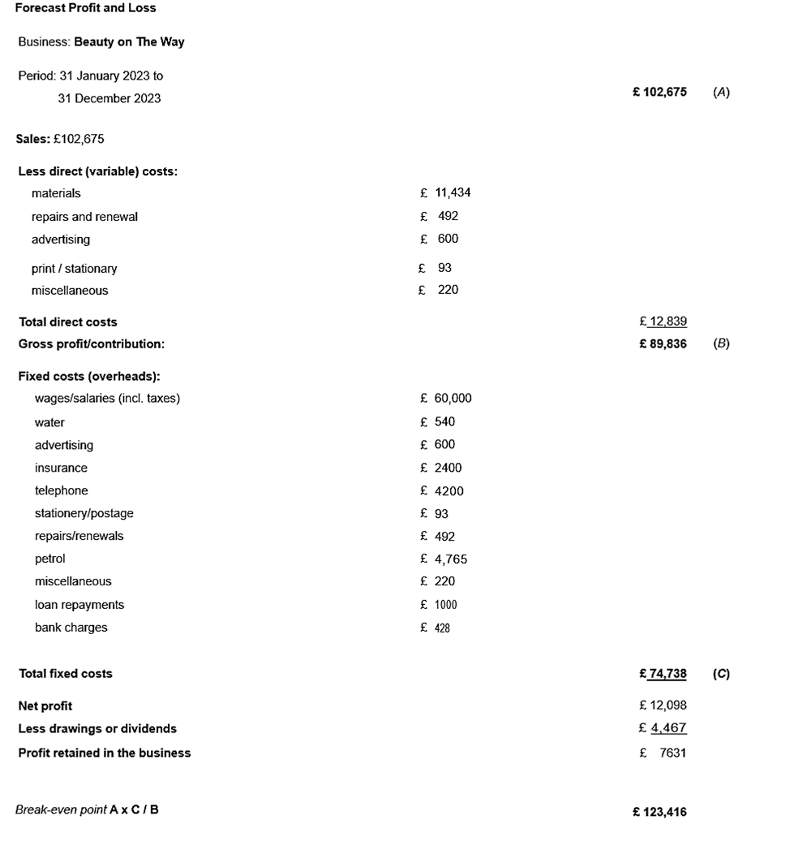This is the profit and loss forecast for Beauty on The Way, this is an income statement. An income statement shows the profit and loss of a company over time, in this statement a 12-month period.

References
- Myk Pono (2018). Competitive Analysis: How to Conduct a Competitive Analysis. [online] Myk Pono. Available at: https://www.mykpono.com/how-to-conduct-competitive-analysis/ [Accessed 08 Nov. 2022].

- Violeta, R; (2012), International journal of Academic research in Economics and Management sciences; 1(5) pp.222.

- Burns, P. (2007) Entrepreneurship and small business . 2nd ed. Basingstoke :, Palgrave Macmillan.

- Tinkler, Schriek, M., & Maund, A. (Eds.). (2017). Certificate in higher education : skills for the workplace student yearbook . Sage.

- Journal of small business and entrepreneurship. (1985). In International Council for Small Business-Canada. (Ed.), Journal of small business and entrepreneurship. (p. 1 online resource). Routledge Taylor & Francis; International Council for Small Business-Canada.

- Reuvid. (2011). Start up and run your own business [electronic resource] : the essential guide to planning, funding and growing your new enterprise (8th ed., p. 1 online resource (336 p.)). Kogan Page Ltd.

- Young, P. (no date) Business Plan. Place of publication not identified: Global Media Publications.

- Blackwell, E. (2011) How to prepare a business plan. 5th ed. London ;: Kogan Page.

- Lane, M. (1998) The effective business plan. London: Straightforward.

- Hazelgren, B.J. and Hazelgren, B.J. (2005) Your First Business Plan A Simple Question and Answer Format Designed to Help You Write Your Own Plan. 5th ed. Naperville: Sourcebooks, Inc.

- Jeff Bullas , Traffic the ultimate guide to website traffic for small business, The Edition 2021, Conclusion

