Title: Research report
Student name: Nasreen Akhtar
Student no: 2132945
Module: Digital skills and research methods
Module code: LCHS4002
Lectures name: Munodzinesa Zuwirai

Contents
Introduction 2
Research design 2
Research question 3
Research method 3
Ethical consideration 5
Results 5
Discussion 10
Conclusion 11
References 12
Appendix 13

List of figures
Figure 1 Voluntarily participation 7
Figure 2 Usage of more than one digital tool to collaborate with peers 8
Figure 3 Use of other digital tools instead of MS office 8
Figure 4 Use of Microsoft word for collaboration with peers 9
Figure 5 Usage of different tools for collaboration 9
Figure 6 Do not use any digital tools to collaborate with peers 10
Figure 7 Frequently using Microsoft office for collaboration with peers 10
Figure 8 Use of one driver and Microsoft office teams 11
Figure 9 Usage of PowerPoint over Microsoft teams for collaboration 11
Figure 10 Frequently used applications for collaboration 12

Introduction
Technology is advancing rapidly, and many useful tools have been introduced. The world is moving to develop better technologies to help people with work. There would be no technology usage if it did not aid in reducing the load of people. The introduction of the internet has solved many problems and unlocked various possibilities. According to Abbas (2020), effective communication is essential for business because it is a key tool for growth. If communication is not effective, then the growth of business comes to risk, and the internet has solved this problem. Multiple digital tools have been developed, which are helping in different ways.
Mahalil et al. (2020) defines digital tools as "the programs, websites or online resources that can make tasks easier to complete." Many tasks can be easily done on web browsers without downloading the software. Some famous digital tools are zoom software, google classroom, Microsoft office, and google meet. Students and professionals use these platforms to perform important tasks. This report is about the students of USTSD and is different digital tools they use to collaborate with peers. Interviews are conducted, and responses are collected through a questionnaire. Their report will also cover the result and analyze them in the discussion. All the findings will be examined in the conclusion section.

Research design
There are various types of research design, but it is vital to choose the efficient and cost-effective design. Data can be collected in various ways, but some research methods are expensive and do not give the required results. Some research design methods are explanatory, observational, descriptive, action, experimental, and causal. The explanatory research design aims to find insights and ideas to understand the topic better. The data can be collected through literature, experience, focus group, and case study analysis (Mohajan, 2018). Descriptive research design is mostly used in business because it studies people and societies. Business uses this method to get awareness about market trends and consumer behaviors. Various objectives can be achieved by this design, and it also aids in solving multiple problems. It is also useful for marketing the product when it is developed. When data is collected, then the hypothesis is developed. Experimental research design is used when there is more than one variable involved. The collected data is checked against mean, mode, median, standard deviation, etc., to check the reliability. Data verification is important to develop because variables can be altered. If data passes, the hypothesis is developed and better than descriptive techniques.

Research question
Following is the research question for this report.
- Which digital tool is most used by students at UWTSD to collaborate?

Research method
Various data collection methods are used, but qualitative and quantitative methods. However, based on data, methods are divided into primary and secondary collections. Qualitative research collects and analyzes non-numerical data because it does not involve numbers. This method analyzes the experience and opinions to develop insights into the problem. The qualitative method benefits humanities, social sciences, education, history, and sociology research. Some qualitative research methods are grounded theory, ethnography, action research, phenomenological research, and narrative research (Peterson, 2019). Moreover, the methods used are observation, interviews, surveys, research groups, and secondary research. In interviews, people or participants are asked different questions, and one-to-one conversations are made.
People's responses are recorded during observations, and detailed field notes are taken. Surveys are also a common method, including distributing questionnaires with open-ended questions. The collected data can be an image, video, audio, or text. Qualitative data involves organizing and exploring data before developing the hypothesis (Pandey and Pandey, 2021). Sometimes, a coding system is used, and codes are assigned to collected data. Later, these codes are linked together into cohesive overarching themes.
In contrast, the quantitative method involves numerical analysis and according to Van Hoof et al. (2022), "quantitative methods emphasize objective measurements and the statistical, mathematical, or numerical analysis of data collected through polls, questionnaires, surveys, etc.". There are various quantitative methods types: descriptive, correlational, comparative, and experimental research. Experiments, surveys, polls, telephone interviews, and face-to-face interviews are different ways to collect data.
Three types of interviews, i.e., structured, semi-structured, and unstructured. In this report, data is collected through semi-structured interviews, and a questionnaire is developed. All participants participate voluntarily, and their responses are recorded with consent. Quantitative approaches are taken, and the collected data is put in pictorial form. The pie chart and graphs are made to get a better picture. The results are analyzed in the below section, and the important thing is that ethical considerations will be taken into account.

Ethical consideration
Ethical considerations are important in research work and should not be violated. Arifin (2018) defines ethical considerations as "a set of principles that guide your research design and practices." Data should not be collected with force because every person has the right to deny participation in data collection. Ethics says that voluntary participation is necessary because personal information can be asked for. If research demands personal information, it should be kept confidential and must not be leaked. Participants have the right to know what will be used of this information, and it is ethically important to use the data only for research purposes. It should also be ensured that research is understood and what is expected from participants.
Violation of ethical policies is a criminal offense, and the researcher must take permission from concerned parties before data collection. Ethics also demands that the researcher must be polite and he should have the information on the topic (Bloomfield and Fisher, 2019). In this research, the data collected is only used for academic purposes, and all the responses will be kept confidential. Leakage of such information can bring bad norms, and people's trust also breaks. All the participants in this research participate voluntarily, and their data is kept safe.

Results
Nine people voluntarily participated in this research, and ten questions were asked. The first question was asked about participation, and the below graph shows that all participants took part of their own will, and no one was forced to interview or participate.
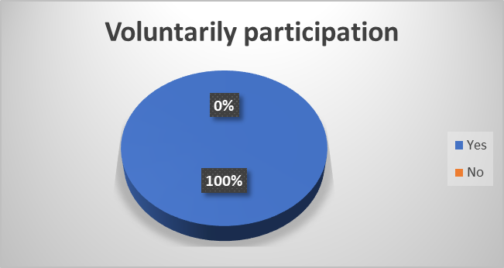
Figure 1 Voluntarily participation
When it was asked from participants what did they use more than one digital tool when they collaborated with a peer? Most people responded in yes, and one person responded no. It means that most participants use different tools and do not rely on a single digital tool to collaborate.
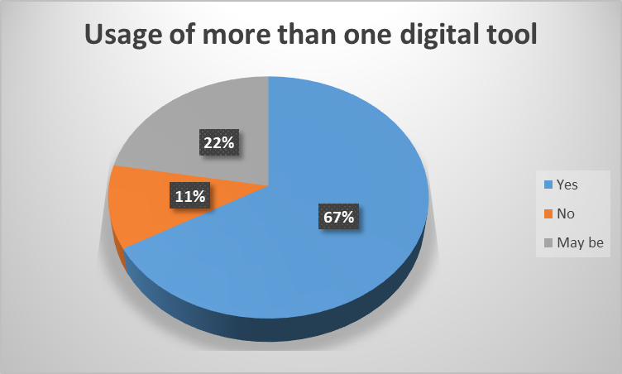
Figure 2 Usage of more than one digital tool to collaborate with peers
The graph below shows that Microsoft word is not the only digital tool used by participants. There are other tools present as well that help for collaborating. Three people gave an affirmative response, while the majority responded no.
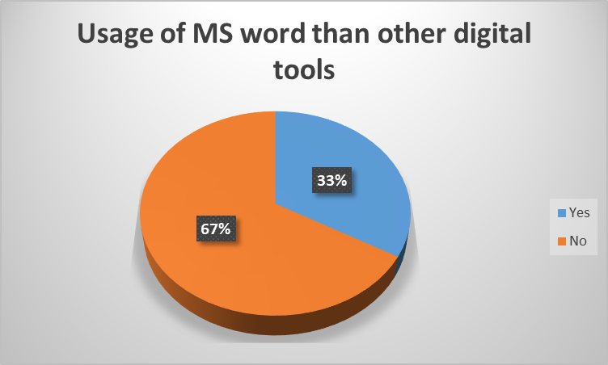
Figure 3 Use of other digital tools instead of MS office
When participants were asked whether they use Microsoft office to collaborate with peers, four people said yes, while three answered no. However, two people responded "maybe" because they were unsure of their answer.

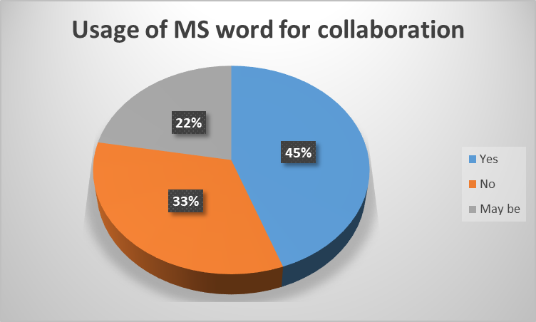
Figure 4 Use of Microsoft word for collaboration with peers
The next question was whether they used "different types of digital tools to collaborate with others"? Most people agree that they use different tools, but two strongly agree. However, none of the respondents give a no in response.
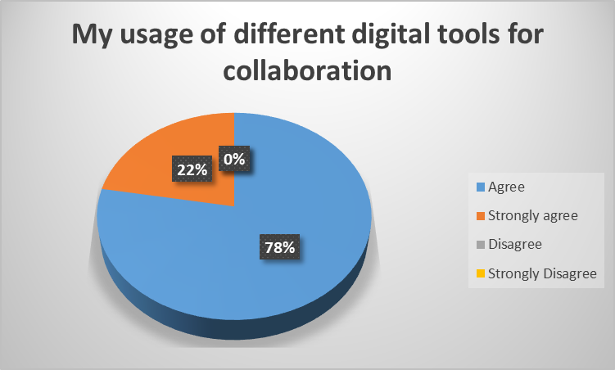
Figure 5 Usage of different tools for collaboration
Seven participants disagree that they do not use any digital tool to collaborate. However, two people agree with it. It means that most people use one or more digital tools for collaborating with peers.

Figure 6 Do not use any digital tools to collaborate with peers
The next question was asked about the frequent use of Microsoft office teams for collaborating with peers and eight people responded yes, but one disagreed. The below graph shows that eight-nine percent of people use Microsoft team for collaboration.
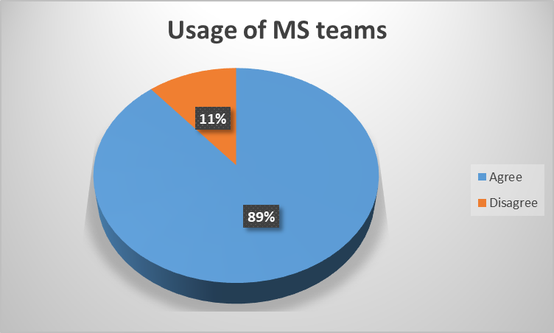
Figure 7 Frequently using Microsoft office for collaboration with peers
When asked, "did they use a Microsoft office team and one driver to collaborate with peers"? Then almost every participant agree with it, but one participant gives a negative response.

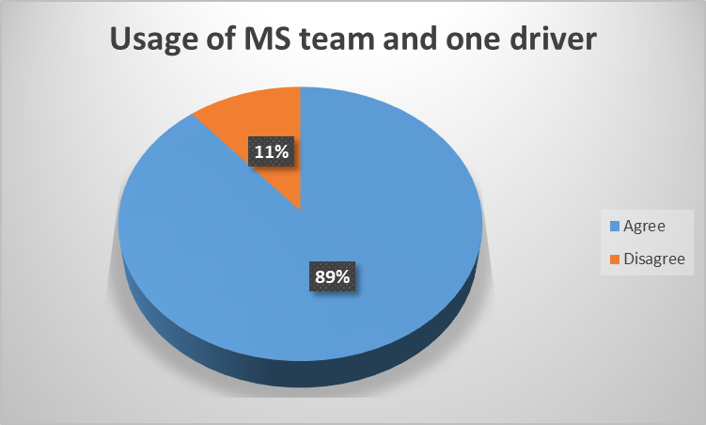
Figure 8 Use of one driver and Microsoft office teams
Four participants agreed, and the same number disagreed when asked, "did they use PowerPoint more than Microsoft teams to collaborate with others?" However, one person strongly disagrees with it. Therefore, it can be concluded that students frequently use PowerPoint.
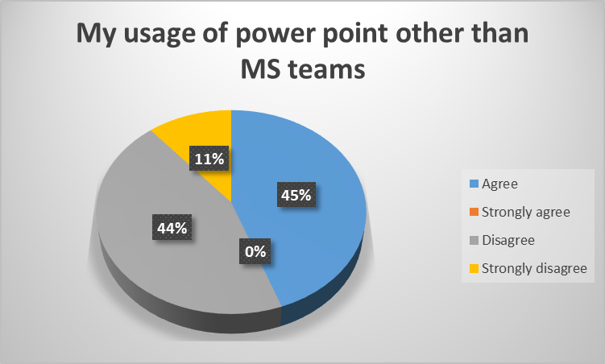
Figure 9 Usage of PowerPoint over Microsoft teams for collaboration
Participants were asked to rank Microsoft word, Moodle, Microsoft power point, Microsoft teams, one drive, and excel based on their usage. It can be observed that students frequently use Microsoft word to collaborate with peers.
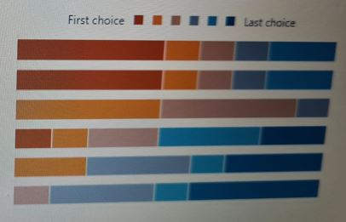
Figure 10 Frequently used applications for collaboration

Discussion
The above graphs show that students use various digital tools to collaborate with peers and get work assistance. The crucial thing was people's participation; nine people took this survey. All people took part voluntarily and had the right to leave the interview. The session consisted of simple yes, no, agree, disagree, and may be options. Students' responses show that they prefer to work with more than one digital tool. Many digital tools are available, but they like to work with Microsoft word. It is simple and effective software that professionals use. However, some students prefer to work with other software such as moodle, zoom, one drive, etc. There are various advantages of every platform over another, but most students rank Microsoft word as their priority. Most students responded that it is better to work with different digital tools, but it is preferred to use that tool that fits their working style. Therefore, seven people responded they agreed when it was asked that they use different digital tools for collaboration? It is essential to mention that many students use Microsoft team but prefer to work with zoom, google meet, and classroom. Some students feel comfortable working with teams, but others like to use zoom.
However, both are simple and effective platforms for students. Universities prefer to use professional software; therefore, Microsoft team is mostly used in contrast to one drive for collaboration. Due to Covid-19, the trend of online classes has increased, and many online meeting platforms have gained popularity (Saileela et al., 2020). Software like zoom and google meet were present for many years, but their usage increased when the lockdown was imposed two years back. Physical classes have resumed, but educational institutes now work with both ways. If a situation like Covid-19 increases, education institutes are ready for online teaching. When respondents were asked about using digital tools for collaboration with peers, some students were also present and said that they do not use any digital tools, i.e., Microsoft office, zoom, meet, moodle, etc., for collaboration.

Conclusion
In brief, a survey was conducted, and quantitative approaches were taken for data collection. The importance of digital tools cannot be denied in students' lives because they increased after Covid-19. Most students have responded that they prefer to work with Microsoft Office and use the Microsoft team for collaboration with peers. Many useful digital tools have been developed, and students use more than one tool to get aid in their assignments. Every student has different thinking because some prefer to work with one drive, and some use google meet. But they cannot eliminate the digital tools from their teaching life. These platforms are simple and effective and therefore used by professionals.

References
Arifin, S.R.M., 2018. Ethical considerations in qualitative study. International Journal of Care Scholars, 1(2), pp.30-33.
ABBAS, E.W., 2020. Managing information systems by integrating information systems success model and the unified theory of acceptance and usage of technology. Polish Journal of Management Studies.
Bloomfield, J. and Fisher, M.J., 2019. Quantitative research design. Journal of the Australasian Rehabilitation Nurses Association, 22(2), pp.27-30.
Mahalil, I., Yusof, A.M. and Ibrahim, N., 2020, August. A literature review on the usage of Technology Acceptance Model for analysing a virtual reality's cycling sport applications with enhanced realism fidelity. In 2020 8th International Conference on Information Technology and Multimedia (ICIMU) (pp. 237-242). IEEE.
Mohajan, H.K., 2018. Qualitative research methodology in social sciences and related subjects. Journal of Economic Development, Environment and People, 7(1), pp.23-48.
Peterson, J.S., 2019. Presenting a qualitative study: A reviewer’s perspective. Gifted Child Quarterly, 63(3), pp.147-158.
Pandey, P. and Pandey, M.M., 2021. Research methodology tools and techniques. Bridge Center.
Saileela, K., Lawrence, A.A. and Kalaivani, S., 2020. Technology Usage and Technology Addiction of Higher Secondary Students. Journal of Xi'an University of Architecture & Technology, 12(4), pp.2588-2602.
van Hoof, J., van den Hoven, R.F., Hess, M., van Staalduinen, W.H., Hulsebosch-Janssen, L.M. and Dikken, J., 2022. How older people experience the age-friendliness of The Hague: A quantitative study. Cities, 124, p.103568.

Appendix
1. I consent to participate in this research and take part voluntarily
- Yes
- No
2. When you are collaborating with peers do you use more than one digital tool?
- Yes
- No
- May be
3. Do you use MS word more than other digital tools when you are working with peers?
- Yes
- No
4. Do you use MS office to collaborate with peers?
- Yes
- No
- May be
5. Rank these applications in order to how frequently you use them to collaborate with others?
- MS word
- Moodle
- MS power point
- MS teams
- One Drive
- MS excel
6. I use different types of digital tools to collaborate with other.
- Agree
- Strongly agree
- Disagree
- Strongly Disagree
7. I use MS teams frequently to collaborate with others
- Agree
- Disagree
8. I use power point more than I use MS teams to collaborate with others.
- Agree
- Strongly agree
- Disagree
- Strongly disagree
9. I use MS teams and one driver to collaborate with others
- Agree
- Disagree
10. I do no use any digital tools to collaborate with peers
- Agree
- Disagree

