

DIGITAL SKILLS AND RESEARCH METHODS
Name | Al Amin Mia
Student ID | 2009718
Programme | CertHE Skills for the Workplace
Module | Digital skills And Research Methods
Module code | BMSW4003
Module Leader | Koushik Modak
Lecturer Name | Koushik Modak
Assignment Title | DSR Assessment 2 Individual Report
Task | Produce a research report on the impact of VLE in the UWTSD London Campus (2000 words)
Submission deadline | 29 April 2021 before the time 23:59
The impact of virtual learning Environment (VLE)
ABSTRACT
This report is produced to demonstrate how the present generation interact with virtual learning environment (VLE) in the University of Wales Trinity Saint David London Campus as per the requirement of Digital Skills and Research Methods Module where we must explain the impact of VLE on the organisation, admin staff, lecturers and the most import, the student.

Table of Contents
1.0 INTRODUCTION 2
2.0 Research Objectives 2
3.0 Literature Review of existing literature 2
4.0 Research Methodology 3
4.1 Research method and the methodology 3
4.2 Qualitative, Quantitative, and combined approach 3
4.3 Primary data and Secondary data 3
4.4 Population, Sample and Sample size 3
4.5 Ethics in data collection 3
5.0 Result/findings, analysis, and discussion 4
5.1 Primary and secondary data analysis 4
5.2 online survey rusult 5
5.3 Summary of the finding 8
6.0 Conclusion and Recommendation 9
Bibliography 10

INTRODUCTION
Virtual learning environment or in short VLE is the traditional learning environment which indicate a virtual space where can teach and learn from distance in a peculiar and innovative way and in some turn, it can take on new forms and meaning thanks to the digital technology and the use of an internet connection. (Dillenbourg,2002) VLE has recently came visible in many sectors but the most important one which this report will focus on is how education theory and practice are being affected using VLE platform provided by the institutes. (Weller, 2007) In less word if there is a well organised VLE system will allow different types of student and lecturers to get the best style of education possible because there are peoples who are more capable to learn by listening and those who need a visual practice to understand some concept. This report is produced to examine and understand different aspect and the implication of VLE into the University of Wales Trinity Saint David London Campus considering and examining some ideas of existing literatures and research.

Research Objectives
The aim and objective of this research is to understand how virtual learning environment (VLE) will affect student and how will support them to optimise their study in and virtual platforms. To achieve the right information’s to support this report, it was necessary conduct a deep research of some existing literatures reviews on:
- HAL archives-ouvertes, Virtual Learning Environments by Pierre Dillenbourg.
- The use of virtual learning environment and their impact on academic performance
- VLE based analysis and design.

Literature Review of existing literature
A research from Gatherer and Manning founded that virtual learning environment helps to establish a good connection between lecturers and students as they can have a communication from distance even if not attending classes, and online environment is vast of information and anything can be founded, on the other hand a research from Gunn KP argued that having a face-to-face communication, and making more real-life experience rather that doing their own study and research online as a lone person and attending physical classes is much more important if considering grow as an individual. This review show that the development of VLE support learning and teaching in sense of a positive or negative impact and that the independent learning can some time motivate peoples to learn more but at the same time can have a negative effect as the student will became lazier in a long term. To support their research both studies have interviewed student from different sectors and subject and they confirmed that the VLE is a great source for additional information rather having class teaching and that most of the times those student tended to use online sources for their exams and study more that using books and primary sources on the other hand there were some interviewers that mentioned that having physical and face to face classes is much preferred as its help them to concentrate and motivate by receiving information from teachers. Another study from Pierre Dillenbourg, Daniel Schneider, Paraskevi Synteta reported that VLE are not restricted to distance education and it can be considered as a successful way of study for the new generation if distance and web-based education are combined will make learning environment much more robust and will allow student and lectures to gather more information by staying in one place instead of going different places to collect information. To support this study peoples from different age and ethnic were interviewed and asked if virtual learning environment does improve education. Majority of the interviewers admitted that this method has a potential effect on the systems and improve the quality of education by reducing it cost. The conclusion of the research it that there were not any proof of the superiority on the learning outcomes ether way between virtual learning environment and real-life environment in term of study, but the fact is that the evolution it will not stop any time soon, and the main issue it is not to prove and demonstrate the effect that virtual learning environment can have which can come from different prospective view, but it is more import how to understand it and how to use it to improve the effective of life.

Research Methodology

Research method and the methodology
To support this report, it was necessary to create a web survey on google form were student at the University of Wales Trinity Saint David London Campus were askes some simple question related to the virtual learning environment used from the institute. The university is currently using some online platform such Moodle and office 365 service to communicate with their student, staff and the lectures.

Qualitative, Quantitative, and combined approach
Is important to understand how students thinks on approaching VLE into their daily life. The quantitative data has been collected based on the qualitative data where a scholar research was conducted with and online survey.

Primary data and Secondary data
Primary data was collected from the university web page where they shared information about their questionaries, investigations and survey prepared for the campus student and the secondary data it was collected from the online survey created for the purpose of this research report.

Population, Sample and Sample size
In the University of Wales Trinity Saint David London Campus there is a population of around 2500 between students, stuff and professors. Unfortunately, was not possible to get a feedback from all those students so just 16 volunteers’ student was chosen to complete the online survey.

Ethics in data collection
There is an ethical obligation to protect all the data that was collected from the volunteers which can contain personal information therefore it was necessary to make them as anonymous which will not make any data collected as confidential and can be shared for further studies and research.

Result/findings, analysis, and discussion
As many of us know virtual learning environment (VLE) is used worldwide in many kinds of sectors and is it typically perform to deliver virtual materials, instruction and facilitate telecommunication or communication between peoples or companies. (Barker, 2013) In this report is included an online survey into virtual learning environment to the student at the University of Wales Trinity Saint David (UWTSD) London Campus where was exanimated and reported the effects of using university VLE system called Moodle on the university learning. This online survey was based on an investigation research which investigate whether has been a positive effect to the peoples that use VLE on their learning or whether the use of virtual learning helps to develop their independent learning skills by increasing teachers and student motivation to learn more and have a totally different kind of way to learn.

Primary and secondary data analysis
In this instance a survey has been conducted at the University of Wales Trinity Saint David London Campus where 16 volunteer participants who participate in this program to answer the questions. In this survey around 10 questions were asked to those participants and all the questions were successfully answered. At this moment because of the current covid-19 situation it was not possible to gather data from student by doing face to face interview on their perception of virtual learning platform provided from the university. Apart from this, some information has been obtained from a secondary data research conducted by the University of Wales Trinity Saint David, the main point of those data is to understand if the online and distance learning, teaching and study is great way to learn efficiently without commuting regularly to physically attend lessons and having face to face contact or conversation with lecturers and others student. Also, they came out with same great advantages after conducting this research where the main advantage of online and distance learning allows most peoples to manage their daily lifestyle efficiently helping them to achieve their full potential.

online survey rusult
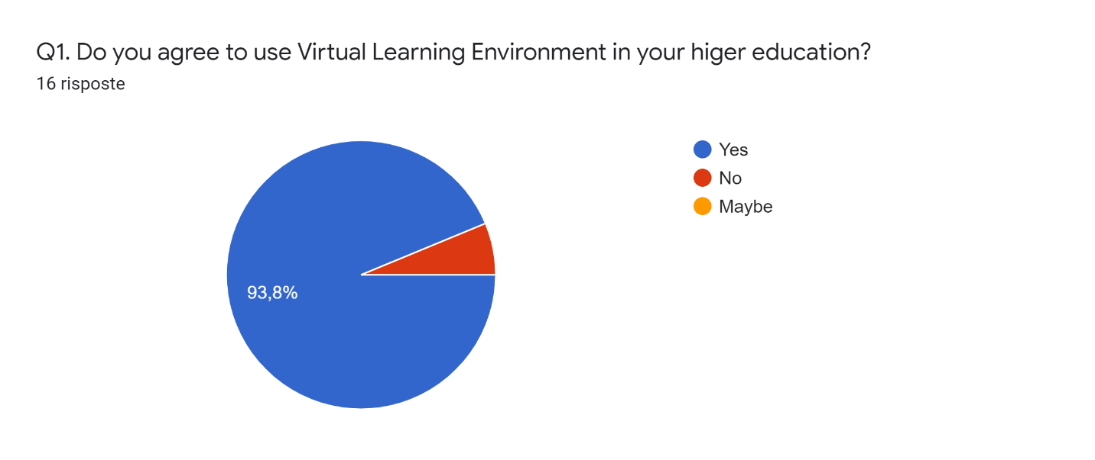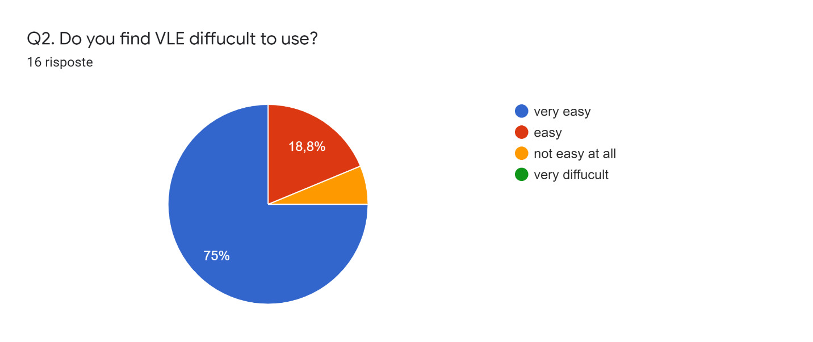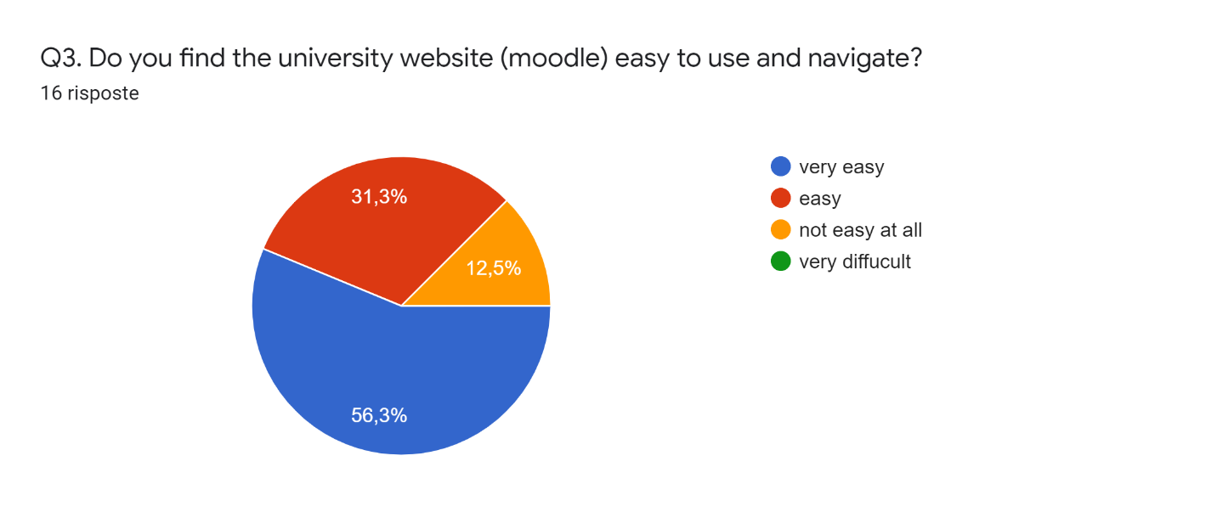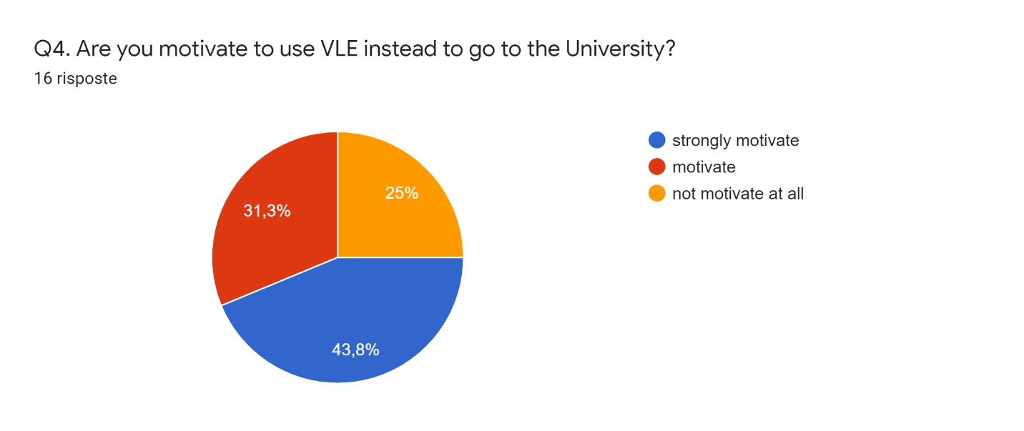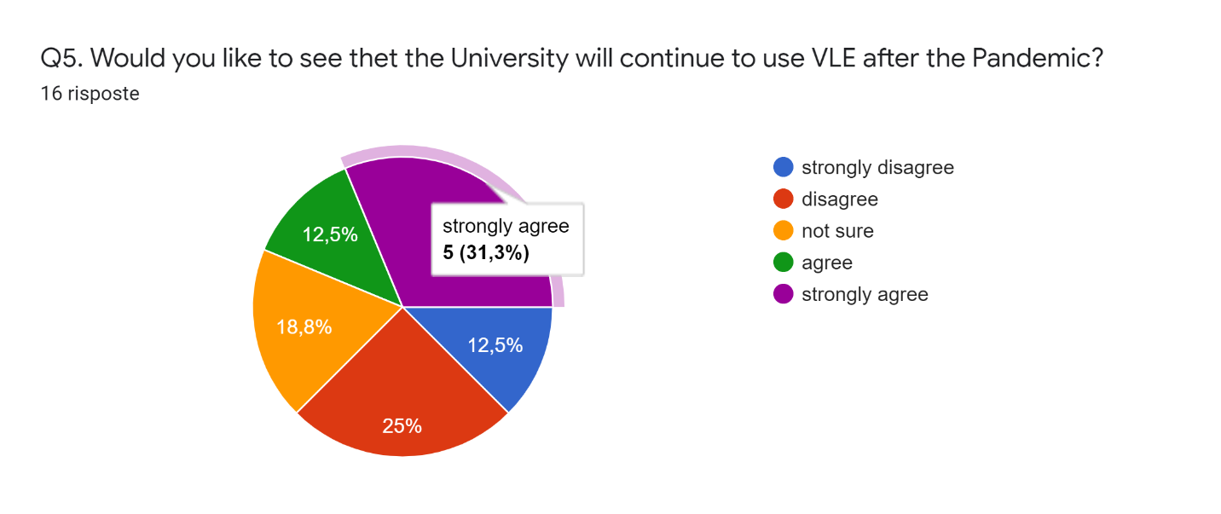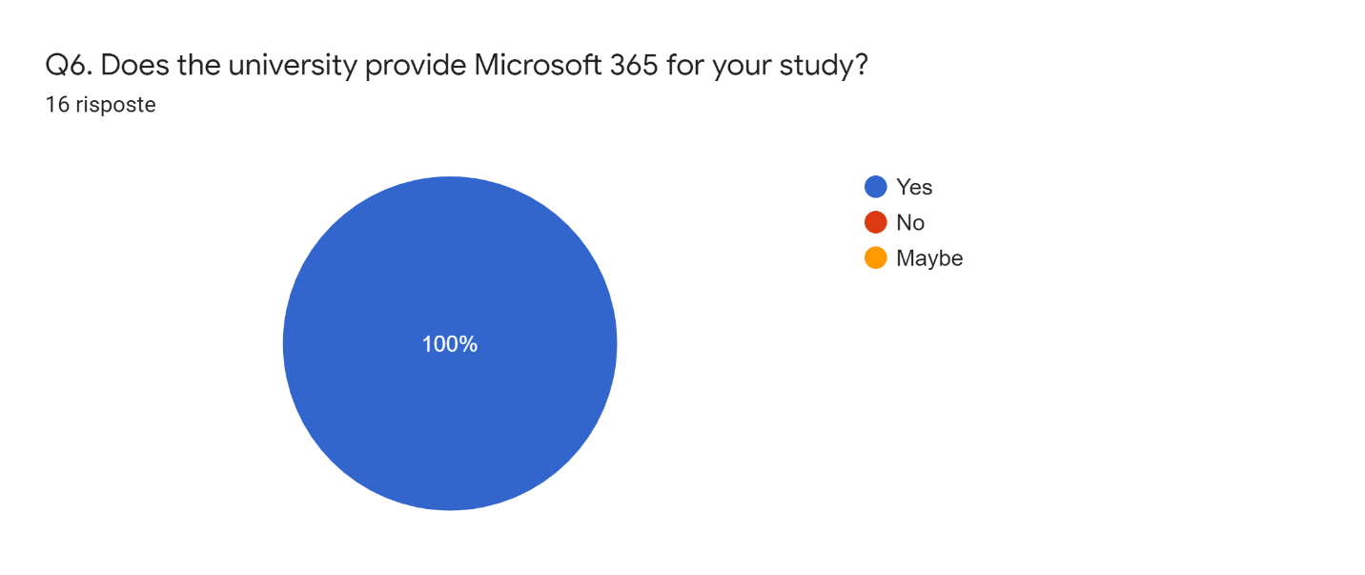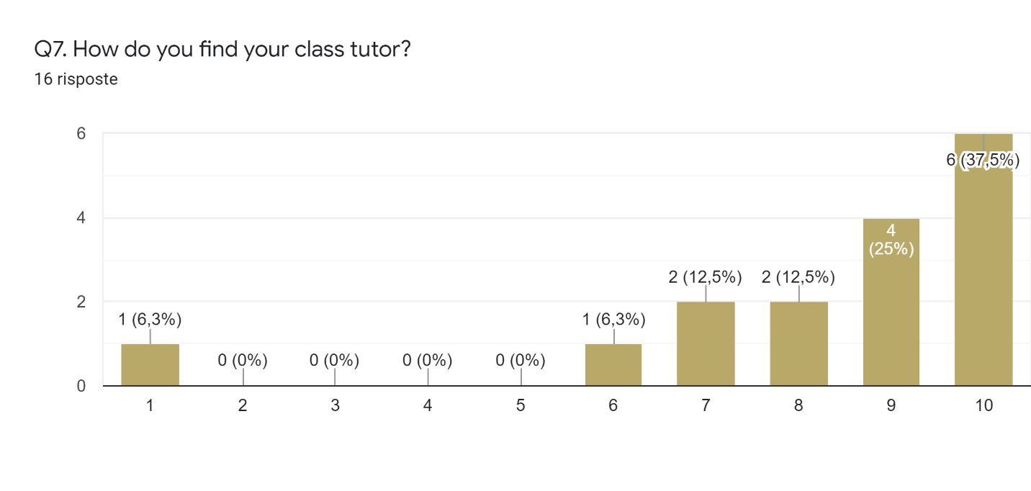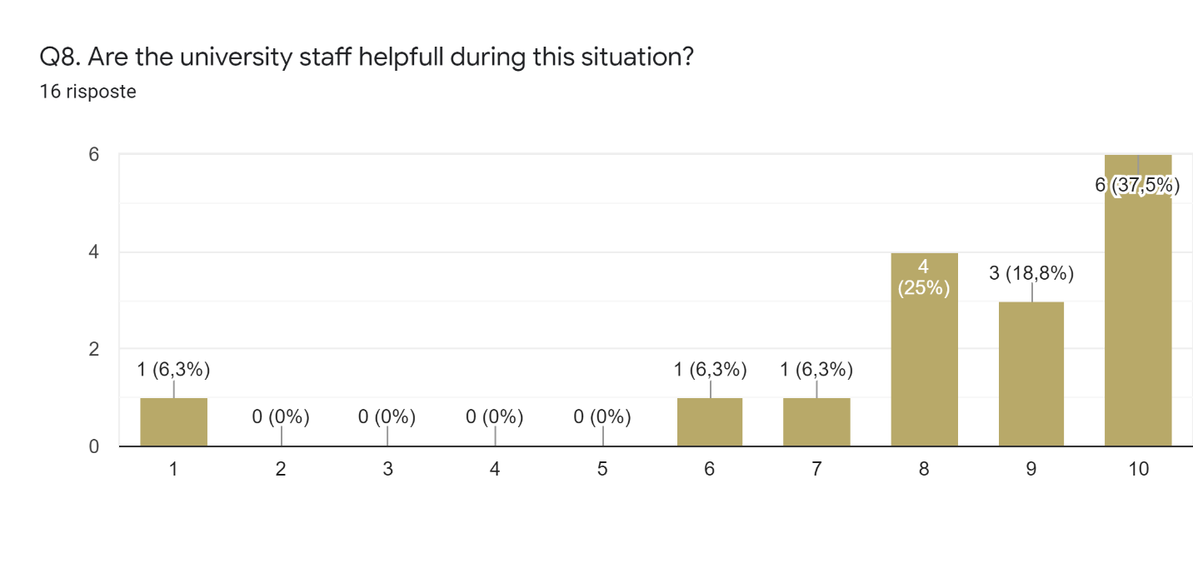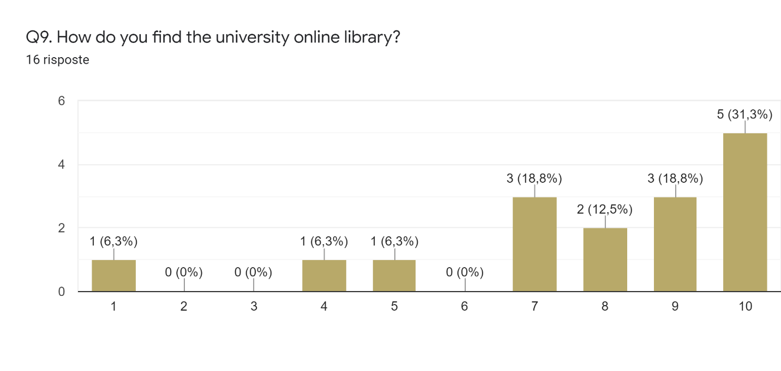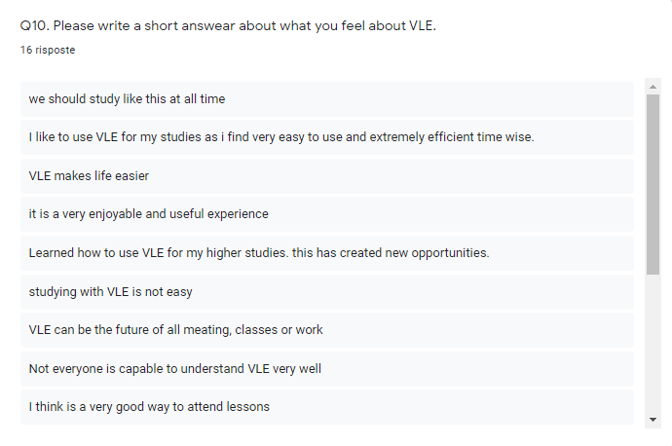

Summary of the finding
- At the beginning of the academic year student were asked if they agree to use virtual learning environment platform such as Moodle which is the university platform used to communicate with their student and lecturers, Microsoft Office ecosystem and Teams. As we can see on question and figure number one 93.8% of the answer were YES, this led us to understand that people are happier to attend classes online rather than physically.
- On the questions number 2, 3, 4 and 5 peoples are asked how they find those virtual learning environment platforms if they are easy to navigate and how motivated and confident and if they like to continue study in this way or going back to the class. As we can see on most of the peoples are strongly agreed and positive about keeping their class and study on the online platform instead of returning to the university.
- The last questions 6, 7, 8, 9 and 10 is it to understand how satisfy peoples are at the UWTSD whether they are happy or not about the facility, tutors and staff provided by the institute.

Conclusion and Recommendation
After gathered all the data in this research related to the virtual learning environment at the University of Wales Trinity Saint David London Campus this conclusion can include several points of view. As we know not all the peoples are same, everyone thinks differently and have different way to learn that’s way for some VLE is the best option for who want to combine private life and study but the other hand there are also peoples that love study by going to a physical place because its help them to learn much better and understand thinks easily. In this part of the report, it will be very important to include the advantages and the disadvantage of the online platform reported above, in this way peoples will be able to choose freely which type is better for them. The main point to cover on the advantages of VLE is that peoples are freer to addend the classes from any kind of devices no matter of where they are which give them flexibility to not be in a place in a specific time, it is also convenience and affordable for those who want to focus on some others think, with full time jobs and have different kind of responsibility.(Blanson.2020) But we also need to consider that is very important to interact with people which will not lead to feel isolated and lonely. Most peoples who attend on those type of lesson tends to be distracted on something else instead of focusing on what they need to do. The last but not the least is that online platform is really helping a lot on humans’ generation by facilitating a lot of work and communication, but we also need to consider that this technology for how great it is can and will have issue. At the end everyone is free have their own opinion, the suggest is always reflect deeply before making any decisions. (McCue,2018)

Bibliography
Dillenbourg, P., Schneider, D. and Synteta, P., 2002, September. Virtual learning environments. In Proceedings of the 3rd Hellenic conference information & communication technologies in education (pp. 3-18).
Peter Demian (Lecturer in Construction Management) & James Morrice (Graduate) (2012) The use of virtual learning environments and their impact on academic performance, Engineering Education, 7:1, 11-19, DOI: 10.11120/ened.2012.07010011
GathererD. and ManningF.C.R. (1998) Correlation of examination performance with lecture attendance: a comparative study of first-year biological sciences undergraduates. Biochemical Education, 26 (2), 121-123.
Pierre Dillenbourg, Daniel Schneider, Paraskevi Synteta. Virtual Learning Environments. 3rd Hellenic Conference ”Information & Communication Technologies in Education”, 2002, Rhodes, Greece. pp.3- 18. ffhal-00190701f
Gunn, K. P. (1993). A correlation between attendance and grades in a first-year psychology class. Canadian Psychology/Psychologie canadienne, 34(2), 201–202. https://doi.org/10.1037/h0078770
Chetwynd, A., 2017. VLE based analysis and design. The Plymouth Student Scientist - Volume 10, No. 1 - 2017 [online] Pearl.plymouth.ac.uk. Available at: <https://pearl.plymouth.ac.uk/bitstream/handle/10026.1/14141/TPSS-2017-Vol10n1_102-142Chetwynd.pdf?sequence=1&isAllowed=y> [Accessed 15 April 2021].
Weller, M., 2007. Virtual learning environments: Using, choosing and developing your VLE. Routledge.
Barker, J. and Gossman, P., 2013. The learning impact of a virtual learning environment: students’ views. Teacher education advancement network journal (TEAN), 5(2), pp.19-38.
UWTSD, W. (2018). Online and distance learning. Retrieved April 21, 2021, from https://www.uwtsd.ac.uk/online/
McCue, T.J. (2018) E-learning climbing to $325 Billion by 2025 UF Canvas Absorb Schoology Moodle, Forbes.31July 2018.
Blanson, K.L., Ntuli, E., Blankson, J. (2020) Handbook of research on creating meaningful experiences in online courses. Hershey, PA, USA: IGI Global.

