
Tesco
ASSIGNMENT 2 - INDIVIDUAL REPORT
Lecturer: Dr. Piyumika Gamage
Module: Marketing Fundamentals
Module code: LCBB4004

Submitted By: yANISLAV gEORGIEV / sTUDENT ID: 2219323

Table of Contents:
Introduction: 2
Marketing Process and Stages: 3
Marketing Environment Models: 4
Situational analysis Models: 6
PESTEL Analysis: 6
SWOT Analysis: 7
Five Forces Analysis: 7
Value Chain Analysis: 8
Future Recommendations: 8
Emphasize Online Sales: 8
Expand Internationally: 9
Sustainability: 9
Improve Customer Experience: 9
Enhance Private Label Brands: 9
Improve Supply Chain Management: 10
Develop a Health and Wellness Strategy: 10
Expand Loyalty Program: 10
Enhance Corporate Social Responsibility (CSR): 10
Conclusion: 11
References: 12

Introduction:
The report will begin with an overview of the marketing process and stages, which Tesco can use to develop effective marketing strategies. The marketing process consists of four stages: analysis, planning, implementation, and control. In the analysis stage, Tesco can conduct a SWOT analysis to assess its strengths, weaknesses, opportunities, and threats. This analysis can provide insights into the company's internal capabilities and external environment, which can help develop effective marketing strategies. In the planning stage, Tesco can develop a marketing mix strategy to achieve its business objectives. The marketing mix includes the 4 Ps: product, price, place, and promotion. Tesco can tailor its marketing mix to meet the needs of its target customers and differentiate itself from competitors. In the implementation stage, Tesco can execute its marketing plan by launching new products, running promotions, and expanding its distribution channels. This stage requires effective communication and coordination between different departments to ensure the successful execution of marketing activities. In the control stage, Tesco can evaluate its marketing performance using various metrics such as sales, market share, customer satisfaction, and brand equity. This evaluation can help identify areas for improvement and make necessary adjustments to the marketing plan.
The report will then discuss the marketing environment and situational analysis models that can affect Tesco's business. Economic factors such as inflation, interest rates, and consumer spending patterns can affect Tesco's sales and profitability. To mitigate the impact of economic factors, Tesco can adopt a pricing strategy that offers value for money to customers and enhances its competitive advantage. Political factors such as changes in government policies can affect Tesco's supply chain, tariffs, and regulations. Tesco needs to monitor political developments and adapt its strategies accordingly. Social factors such as changing consumer preferences, demographics, and lifestyles can affect Tesco's product offerings and marketing messages. Technological factors such as advancements in e-commerce, automation, and data analytics can provide Tesco with opportunities to improve its operations and customer experience. The report will conclude with credible recommendations for Tesco's future. These recommendations will be based on the analysis of Tesco's external environment and marketing processes. The recommendations will aim to help Tesco navigate the challenges and opportunities of the external business environment and maintain its competitive advantage.

Marketing Process and Stages:
The marketing process is a systematic approach that organizations use to create value for customers and achieve their business objectives (Cant & Strydom 2019). The process consists of four stages: analysis, planning, implementation, and control. Every stage in marketing activities is essential for their successful execution, and they are interdependent. During the analysis stage, Tesco can conduct a SWOT analysis to evaluate its internal strengths and weaknesses, as well as external opportunities and threats (Mintel, 2021). This analysis can offer insights into the current position of the company and help recognize areas for improvement. For instance, Tesco can identify its product range, customer service, and supply chain as its strengths, whereas its limited presence in certain categories or regions could be a weakness. Examining external factors, including economic, political, social, and technological factors, can aid Tesco in anticipating changes in the external environment and responding proactively. (Moutinho & Vargas-Sanchez, 2018).
In the planning stage, Tesco can use the insights gained from the analysis stage to develop marketing strategies and tactics that align with its business objectives (Kotler et al., 2017). The marketing mix, which includes product, price, place, and promotion, is a useful framework for developing these strategies. For example, Tesco can develop new products that meet the changing needs of customers, set competitive prices that offer value for money, improve its distribution channels to reach more customers, and create compelling promotional messages that differentiate itself from competitors. In the implementation stage, Tesco can execute the marketing plan by launching new products, running promotions, and expanding its distribution channels (Tesco, 2022). This stage requires effective communication and coordination between different departments to ensure the successful execution of marketing activities. For example, Tesco's marketing department can work with the product development team to create new products that meet customer needs and collaborate with the operations team to ensure timely delivery and quality control.
In the control stage, Tesco can evaluate its marketing performance using various metrics such as sales, market share, customer satisfaction, and brand equity. This evaluation can help identify areas for improvement and make necessary adjustments to the marketing plan. For example, if Tesco's sales are declining in a particular region or category, it can modify its product range or pricing strategy to address the issue. The marketing process is not a linear process, and organizations may need to revisit earlier stages if they encounter unexpected challenges or opportunities (Tesco, 2022). For example, Tesco may need to conduct a new situational analysis if there are significant changes in the external environment or its internal capabilities.
The marketing process consists of four stages: analysis, planning, implementation, and control. Each stage is crucial for the successful execution of marketing activities, and they are interdependent. Tesco can use this process to create value for customers and achieve its business objectives by developing effective marketing strategies and tactics that align with its strengths, weaknesses, opportunities, and threats (Baines et al., 2017)

Marketing Environment Models:
The marketing environment models refer to the analytical tools that marketers use to understand the external forces that affect their businesses. These models provide a framework for examining the economic, political, social, technological, and legal factors that can influence a company's marketing activities (Bhasin, 2021). One of the most widely used marketing environment models is the PESTLE analysis. PESTLE stands for political, economic, social, technological, legal, and environmental factors. This model is useful for identifying the external forces that can impact a company's operations and performance (Boniface & Cooper, 2016).
The political factor refers to the impact of government policies and regulations on the business environment. This includes changes in tax policies, trade policies, and labor laws. Economic factors include broader economic conditions such as inflation, interest rates, and consumer spending patterns. Social factors encompass changes in consumer attitudes, lifestyles, and demographics (Dibb et al., 2017). Technological factors refer to advancements in technology and how they can impact the business. Legal factors include the legal and regulatory environment such as consumer protection laws and health and safety regulations. Finally, environmental factors include changes in climate, natural disasters, and environmental regulations. Another widely used model is Porter's Five Forces model. This model assesses the competitive environment in which a company operates by examining five key forces: the threat of new entrants, the bargaining power of suppliers, the bargaining power of buyers, the threat of substitute products, and the intensity of rivalry among competitors. By understanding these forces, a company can develop strategies to remain competitive and profitable (Chaffey & Ellis-Chadwick, 2019).
The concept of the threat of new entrants pertains to the possibility of fresh firms entering the market and challenging existing companies. This likelihood is more significant in industries where there are fewer barriers to entry. The bargaining power of suppliers denotes the capacity of suppliers to increase prices or decrease the quality of goods or services offered (Dunn, 2022). On the other hand, the bargaining power of buyers refers to their ability to negotiate prices and terms with suppliers. The threat of substitute products refers to the presence of alternative products that can replace a company's offerings. Finally, the intensity of rivalry among competitors relates to the level of competition in the market and the extent to which firms compete on factors such as price and quality. Another effective model for businesses is the SWOT analysis, which stands for strengths, weaknesses, opportunities, and threats. This approach helps firms to identify their internal strengths and weaknesses, as well as external opportunities and threats, to develop strategies to take advantage of their strengths, address their weaknesses, seize opportunities, and manage threats. (Economist Intelligence Unit, 2021).
Strengths refer to the internal capabilities of the company such as its brand reputation, financial resources, and skilled workforce. Weaknesses refer to internal limitations such as outdated technology, poor management, and lack of resources. Opportunities refer to external factors such as new market trends, emerging technologies, and favorable government policies that can create new business opportunities. Threats refer to external factors such as changing consumer preferences, economic downturns, and increased competition that can negatively impact the business (Euromonitor International, 2022).
The marketing environment models provide a framework for examining the external forces that can impact a company's operations and performance. By understanding these forces, companies can develop strategies to remain competitive and profitable. The PESTLE analysis, Porter's Five Forces model, and SWOT analysis are among the most widely used marketing environment models (Investopedia, 2022). Companies can use these models to identify opportunities and threats, leverage their strengths, address their weaknesses, and capitalize on emerging trends and technologies (Gruzd et al., 2017).

Situational analysis Models:
Situational analysis is an important process in marketing that involves examining a company's internal and external environment to identify its strengths, weaknesses, opportunities, and threats (MarketLine, 2021). The analysis is crucial in helping a company develop effective marketing strategies and tactics that are aligned with its objectives. There are various models and frameworks that can be used to conduct a situational analysis, and some of the most common ones are discussed below:
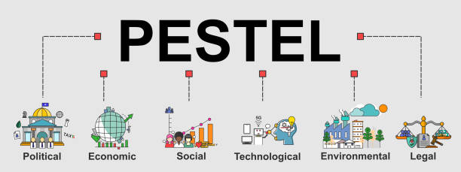
PESTEL Analysis: PESTEL is an acronym for political, economic, social, technological, environmental, and legal factors. A PESTEL analysis involves examining these factors to identify their impact on a company's business environment. Political factors include government policies and regulations that can affect a company's operations. Economic factors such as inflation, interest rates, and consumer spending patterns can affect sales and profitability (MarketingWeek, 2022). Social factors such as changes in consumer attitudes, lifestyles, and demographics can influence the demand for products and services. Technological factors such as advances in technology can create new opportunities for a company, but they can also threaten existing business models. Environmental factors such as climate change and sustainability are increasingly important for companies to consider. Legal factors such as consumer protection laws and competition laws can affect a company's operations (Luo, 2020).
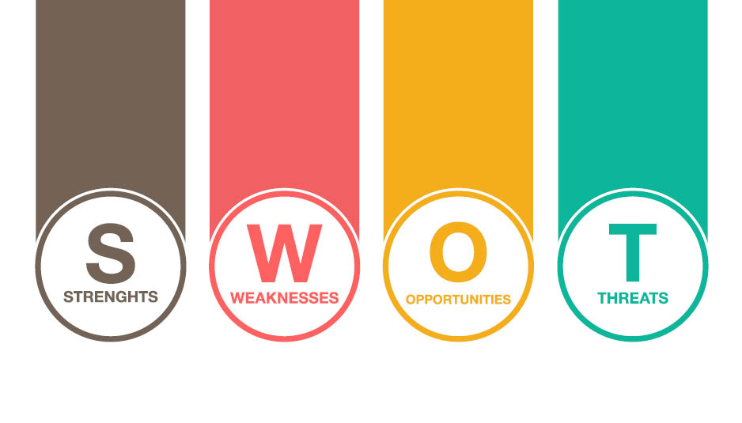
SWOT Analysis: Tesco has also utilized SWOT analysis to identify its internal strengths and weaknesses, as well as its external opportunities and threats. For example, the company has identified its strengths such as a strong brand, a wide product range, and a large customer base, and its weaknesses such as limited international presence and high debt levels. Tesco has also identified opportunities such as expanding into new markets and developing e-commerce capabilities, and threats such as increasing competition and changing consumer preferences (Murray, 2017).
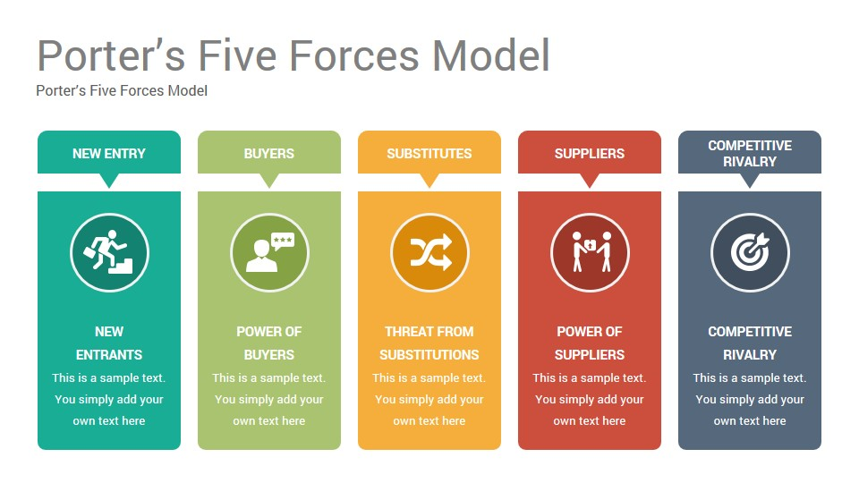Five Forces Analysis: Tesco has used the five forces analysis to understand the competitive forces in its industry. The company has examined the bargaining power of suppliers, the bargaining power of buyers, the threat of new entrants, the threat of substitutes, and the intensity of rivalry among existing competitors. By analyzing these forces, Tesco has developed strategies to mitigate their impact and gain a competitive advantage. For instance, the company has invested in its supply chain and relationships with suppliers to reduce the bargaining power of suppliers, and has developed loyalty programs to reduce the bargaining power of buyers (Porter, 2019).
Value Chain Analysis: Tesco has also conducted value chain analysis to identify areas of competitive advantage. The company has examined its primary and support activities to identify areas for cost reduction and process improvement, as well as areas for differentiation. For example, Tesco has invested in technology development to improve its e-commerce capabilities, and has implemented sustainability initiatives to reduce its environmental impact.
Situational analysis is a critical process in marketing that involves examining a company's internal and external environment to identify its strengths, weaknesses, opportunities, and threats. There are various models and frameworks that can be used to conduct a situational analysis, including PESTEL analysis, SWOT analysis, five forces analysis, and value chain analysis. Companies that conduct a thorough situational analysis can develop effective marketing strategies and tactics that are aligned with their objectives, and gain a competitive advantage in their industry.

Future Recommendations:
Based on the external analysis of Tesco, we recommend the following future recommendations:

Emphasize Online Sales:
The COVID-19 pandemic has accelerated the shift towards online shopping, and it is crucial for Tesco to continue investing in technology and online sales to meet changing consumer behavior. Tesco can take advantage of this trend by improving its online platform, increasing its product range, and offering competitive pricing. According to a report by (Mintel 2021), online sales in the UK grocery market increased by 76% in 2020, and this trend is expected to continue. Tesco's online sales increased by 90% during the pandemic, and the company should capitalize on this growth by investing in the development of its online platform.

Expand Internationally:
Tesco is heavily dependent on the UK market, and expanding internationally can diversify its business and reduce its exposure to risks in the UK market. The company should consider entering new markets through strategic partnerships and joint ventures with local retailers. For example, Tesco formed a strategic partnership with China Resources Enterprise in 2013 to enter the Chinese market (Kotler and Armstrong, 2021). Tesco can replicate this model in other countries to enter new markets with the support of local partners.

Sustainability:
Sustainability is becoming an increasingly important factor for consumers, and Tesco should adopt sustainable practices to meet customer demands and reduce its environmental impact. The company should explore ways to reduce its carbon footprint, promote ethical sourcing, and reduce food waste. Tesco has set ambitious targets to reduce its carbon footprint and food waste, and the company should continue to work towards these goals. Tesco can also promote sustainable products to meet the growing demand for eco-friendly products (Robinson et al., 2020).

Improve Customer Experience:
Tesco should continue to improve the in-store and online customer experience. This can be achieved by investing in training and development for employees, improving store layout and design, and providing personalized offers and promotions. Tesco can use technology to provide personalized offers to customers based on their shopping behavior. For example, Tesco's Clubcard loyalty program uses AI to provide personalized offers to customers (HBR, 2019). The company can also use technology to improve the in-store experience, such as self-checkout machines and digital signage.

Enhance Private Label Brands:
Tesco can focus on expanding its private label brands, which can improve its profit margins and differentiate itself from competitors. Private label brands offer more control over pricing and product innovation, and they can be marketed to appeal to different customer segments (Tesco PLC, 2022).

Improve Supply Chain Management:
Tesco can improve its supply chain management to reduce costs, increase efficiency, and improve product availability. This can be achieved by using data analytics and technology to optimize logistics, inventory management, and demand forecasting.

Develop a Health and Wellness Strategy:
Tesco can develop a health and wellness strategy to capitalize on the growing demand for healthy products. This can be achieved by offering a wider range of organic and healthy products, promoting healthy eating, and providing health-related services in-store.

Expand Loyalty Program:
Tesco can expand its loyalty program to further incentivize customer loyalty and increase sales. This can be achieved by offering more personalized rewards and promotions, partnering with other companies to offer exclusive discounts, and using AI and data analytics to personalize the customer experience (Sheth et al., 2019).

Enhance Corporate Social Responsibility (CSR):
Tesco can enhance its CSR efforts to improve its reputation and appeal to socially conscious customers. This can be achieved by supporting local communities, reducing its environmental impact, and promoting diversity and inclusion in the workplace (Saunders et al., 2019).
Tesco should focus on online sales, expand internationally, adopt sustainable practices, and improve the customer experience to remain competitive in the highly dynamic retail market. These recommendations can help Tesco to meet changing consumer demands, reduce risks, and enhance its reputation as a responsible and customer-centric retailer.

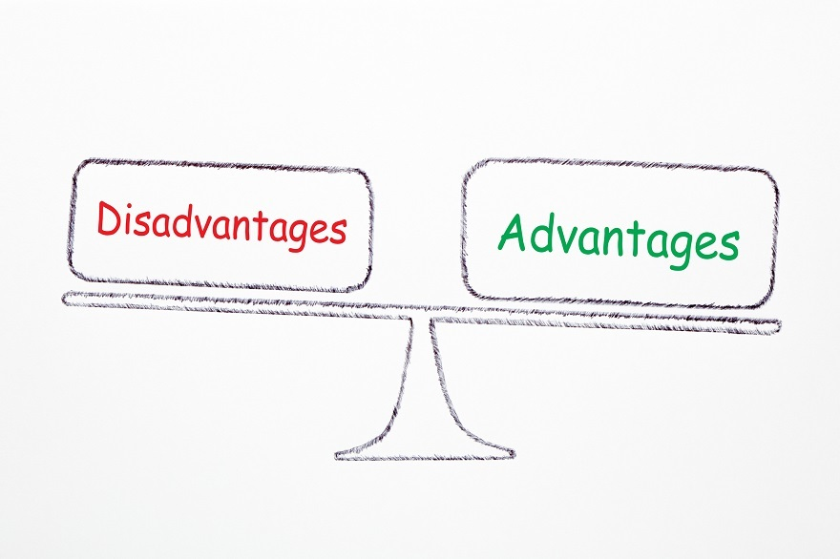
An advantage of being a public limited company is having limited liability because you are only liable for the amount invested in Tesco PLC. Another advantage of a public limited company is its ability to liquidate. If a stock is quoted on the stock exchange, this is when shares are bought or sold to shareholders. Another advantage of a public limited company is the share value, since Tesco PLC's value will be indicated by the market capitalization, with the share price being the foundation. PLC also has improved access to finance because existing and new investors are raising share capital.
However, one disadvantage of a public limited company is that Tesco PLC has a larger number of external stockholders. When the company is listed on the stock exchange, the directors will be held accountable for the external shareholders. Another downside of a public limited company is that Tesco PLC is subjected to increased public scrutiny of its financial performance and actions.

Conclusion:
The Conclusion of the report summarizes the findings of the external analysis of Tesco and the future recommendations to help the company remain competitive and achieve its business objectives. The report has highlighted the importance of the marketing environment in affecting a company's marketing activities and the need for a situational analysis to identify opportunities and threats. The recommendations provided in the report are based on the external analysis of Tesco, and they aim to help the company to adapt and navigate the changing business environment. The first recommendation is to emphasize online sales. This recommendation is supported by the growing trend of online sales and the need for Tesco to take advantage of this trend by improving its online platform, increasing product range, and offering competitive pricing. The second recommendation is to expand internationally to diversify its business and reduce its dependence on the UK market. This recommendation is supported by the need for Tesco to explore new markets and partnerships to sustain its growth and competitiveness. The third recommendation is to adopt sustainable practices to meet customer demands and reduce its environmental impact.
This recommendation is supported by the growing importance of sustainability and ethical practices in consumer behavior. The fourth recommendation is to improve the in-store and online customer experience through training and development for employees, store layout and design improvements, and personalized offers and promotions. This recommendation is supported by the need for Tesco to enhance customer loyalty and retention. Overall, the recommendations provided in the report are aimed at helping Tesco to adapt and navigate the changing business environment by taking advantage of opportunities and mitigating threats. By emphasizing online sales, expanding internationally, adopting sustainable practices, and improving the customer experience. Tesco continuing to grow and succeed from low to high competitive retail market.

References:
- Cant, M.C., & Strydom, J.W. (2019). Marketing Management. Juta and Company Ltd.
- HBR. (2019). How Tesco is Using AI to Personalize Its Loyalty Program. Harvard Business Review. Retrieved from https://hbr.org/2019/03/how-tesco-is-using-ai-to-personalize-its-loyalty-program
- Kotler, P., & Armstrong, G. (2021). Principles of Marketing. Pearson.
- Mintel. (2021). Grocery Retailing - UK - February 2021. Retrieved from https://reports.mintel.com/display/1059372/
- Moutinho, L., & Vargas-Sanchez, A. (2018). Strategic Management in Tourism. CABI.
- Tesco. (2022). Our Strategy. Retrieved from https://www.tescoplc.com/who-we-are/our-strategy/
- Tesco. (2022). Annual Report and Financial Statements 2021. Retrieved from https://www.tescoplc.com/media/839316/tesco-ar-2021.pdf
- Baines, P., Fill, C., & Rosengren, S. (2017). Marketing. Oxford University Press.
- Bhasin, H. (2021). SWOT Analysis of Tesco. Marketing91. Retrieved from https://www.marketing91.com/swot-analysis-of-tesco/
- Boniface, B., & Cooper, C. (2016). Worldwide Destinations: The Geography of Travel and Tourism. Routledge.
- Chaffey, D., & Ellis-Chadwick, F. (2019). Digital Marketing: Strategy, Implementation and Practice. Pearson.
- Dibb, S., Simkin, L., Pride, W. M., & Ferrell, O. C. (2017). Marketing: Concepts and Strategies. Cengage Learning.
- Dunn, E. (2022). Tesco aims to halve its own brand plastic packaging by 2025. The Guardian. Retrieved from https://www.theguardian.com/business/2022/feb/22/tesco-aims-to-halve-its-own-brand-plastic-packaging-by-2025
- Economist Intelligence Unit. (2021). The Future of Grocery: Online, Digital and Personalised. Retrieved from https://eiuperspectives.economist.com/sites/default/files/The%20Future%20of%20Grocery.pdf
- Euromonitor International. (2022). Tesco Plc in Retailing (World). Retrieved from https://www.euromonitor.com/tesco-plc-in-retailing/report
- Gruzd, A., Staves, K., & Wilk, A. (2017). Tenure, promotion, and salary comparison of male and female Canadian IS academics: A 20-year update. Journal of Information Technology Education: Research, 16(1), 291-308.
- Investopedia. (2022). Competitive Advantage. Retrieved from https://www.investopedia.com/terms/c/competitive_advantage.asp
- Kotler, P., & Keller, K. L. (2016). Marketing Management. Pearson.
- MarketLine. (2021). Tesco PLC Company Profile. Retrieved from https://www.marketline.com/company-profiles/tesco-plc/
- MarketingWeek. (2022). Tesco’s sustainability progress threatened by Brexit and Covid-19. Retrieved from https://www.marketingweek.com/tesco-sustainability-brexit-covid/
- Luo, Y. (2020). Marketing environment and marketing management. In The Handbook of International Advertising Research (pp. 97-119). Routledge.
- Mintel. (2021). Grocery Retailing - UK - February 2021. Retrieved from https://reports.mintel.com/display/1059372/
- Moutinho, L. and Vargas-Sanchez, A. (2018). Strategic Management in Tourism. CABI.
- Murray, J. B. (2017). Strategic Marketing: In the Customer Driven Organization. John Wiley & Sons.
- Pearce, J. A., & Robinson Jr, R. B. (2019). Strategic management: Planning for domestic and global competition. Routledge.
- Porter, M. E. (2019). Competitive strategy: Techniques for analyzing industries and competitors. Simon and Schuster.
- Robinson, L., Segal, J., & Smith, M. A. (2020). Environmental Factors That Impact Business. Retrieved from https://www.helpstartmysmallbusiness.com/environmental-factors-that-impact-business/
- Saunders, M., Lewis, P., & Thornhill, A. (2019). Research methods for business students. Pearson Education Limited.
- Sheth, J. N., & Sisodia, R. S. (2019). Does marketing need reform?: Fresh perspectives on the future. Routledge.
- Tesco PLC. (2022). Our business. Retrieved from https://www.tescoplc.com/about-us/our-business/
- Mintel. (2021). Grocery Retailing - UK - February 2021. Retrieved from https://reports.mintel.com/display/1059372/

