Analyse the demographic factors which are most likely to influence public perception of SOuth Wales Police.
By Caitlin Carter
University of Wales Trinity Saint David – Criminology and Policing BSc.
Dissertation Paper – May 2023 | (2003634)
Declaration
This work has not previously been accepted in substance for any degree and is not being concurrently submitted in candidature for any degree.
Statement 1
This dissertation is being submitted in partial fulfilment of the requirements for the degree of BSc.
Statement 2
This dissertation is the result of my own independent work/investigation, except where otherwise stated.
Other sources are acknowledged in the Reference section.
Statement 3
I hereby give consent for my dissertation, if accepted, to be available for photocopying and for interlibrary loan, and for the title and summary to be made available to outside organisations.
Statement 4
I hereby give consent for my dissertation, if accepted, to be available on the university’s IT system to those who have consent to use the system.
Acknowledgements
I would like to show my appreciation to all who motivated me to completing this dissertation. An extra special thank you to my dissertation supervisor, Laura Knight. She provided me with continued support and advice throughout, encouraging me to work with optimum effort.
Abstract
The purpose of the research is to identify the main demographics influencing public perception of South Wales Police. This research is of importance as it was requested by South Wales Police staff and provides recommendations to improve policing by consent which is fundamental to effective policing. The main research results show that social demographics are the most influential, including gender, age, and ethnicity. Therefore, allowing the researcher to offer recommendations aimed at improving public perception of South Wales Police.
Table of Contents
Chapter One: Introduction………………………………………………………………………………………………. 5
1.3 Aims and Objectives………………………………………………………………………………………………….. 6
Chapter Two: Literature Review……………………………………………………………………………………… 7
2.1 Objective One…………………………………………………………………………………………………………… 7
2.2 Objective Two…………………………………………………………………………………………………………. 10
2.3 Objective Three……………………………………………………………………………………………………… 12
Chapter Three: Methodology………………………………………………………………………………………. 15
3.2 Research Onion……………………………………………………………………………………………………… 15
3.2.1 Philosophy………………………………………………………………………………………………………….. 16
3.2.2 Research Approach……………………………………………………………………………………………… 17
3.2.3 Strategies……………………………………………………………………………………………………………. 18
3.2.4 Choice of Methods ……………………………………………………………………………………………… 19
    - Time Horizon…………………………………………………………………………………………………….. 19
  - Techniques for Data Collection, Processes and Analysis………………………………………… 19
  - Sampling………………………………………………………………………………………………………………. 22
  - Survey Design………………………………………………………………………………………………………. 22
  - Reliability and Validity…………………………………………………………………………………………. 23
  - Limitations and potential hurdles………………………………………………………………………… 23
  - Ethical Considerations………………………………………………………………………………………….. 24
Chapter Four: Analysis of Data…………………………………………………………………………………….. 25
4.1 Introduction…………………………………………………………………………………………………………… 25
4.2 Findings: Description……………………………………………………………………………………………… 25
4.1.2 Analysis………………………………………………………………………………………………………………. 26
Chapter Five: Conclusion……………………………………………………………………………………………… 40
5.1 Introduction……………………………………………………………………………………………………………. 40
5.2 Summary of findings and conclusions…………………………………………………………………….. 40
5.2.1 Objective one……………………………………………………………………………………………………… 40
5.2.2 Objective two……………………………………………………………………………………………………… 41
5.2.3 Objective three…………………………………………………………………………………………………… 41
5.3 Limitations………..…………………………………………………………………………………………………… 42
5.4 Recommendations……………………………….……………………………………………………………….. 42
List of Tables
Table 1: Participants by age and gender
Table 2: Participants by gender and ethnicity
Table 3: Question seven analysis
List of Figures
Figure 1: Presents pictorially the research onion and displays the six stages to complete a research methodology.
Figure 2: Data collected from question seven
Figure 3: Data insight from question 9, regarding the perception on South Wales Police from genders.
Figure 4: Data evidence from question 9, concerning the impact of age.
Figure 5: Data from question 9, with regard to the impact ethnicity has on an participants view of South Wales Police.
Figure 6: Data findings from question 9, revealing the effect of sexual orientation on perception of South Wales Police.
Figure 7: Data collected from question 13
Figure 8: Data collected from questions 14, 15, 16 and 17
Figure 9: Sir Robert Peel’s nine principles of policing
Figure 10: Policing Code of Ethics
Chapter One: Introduction
  - Research background and focus
The central discussion of this dissertation will focus on identifying the demographic factors that have an influence on the public perception of the police, specifically focusing on South Wales Police Force. According to Hayes (2022) demographic factors include personal characteristics that represent a population, including gender, age and ethnicity, which can be collected from the use of surveys. South Wales Police force was chosen to be at focal point of the research due to the participants main residency being within the South Wales Police catchment area. Stephens (2022) brought this area of concern to attention throughout the Policing Vision 2025 report, which announced the connection between the police and the public will consistently be the core of policing in Britain. This piece of information is fundamental to the research, without the public there would not be policing by consent, which is crucial within the nine Peelian principles of policing (Kumar et al, 2022). The motivation to analyse and evaluate this area of concern became clear from stop and search statistics published by the Home Office (2022). Between April 2020 and March 2021, for every 1,000 white individuals there were 7.5 stop and searches, compared to 52.6 searches for every 1,000 black individuals. These figures suggest that an abuse of power could have been performed by officers, victimising ethnic minorities.
The relevance and importance of this research question was highlighted by Goldsmith (2005), as during the 20th century this area of concern received a small scale of attention by researchers. Therefore, demonstrating a need for in depth research to be carried out concerning the influence demographics have on the public perception of South Wales Police. The public perception of the police determines the general relationship between the public and the police (UNODC, 2011). Proposing that a good relationship between the public and the police can effectively deter and prevent crime, support their surrounding communities, and maintain public order. This field of study is important and beneficial to the police, providing them with a further understanding of what can be done to improve their relationship with the public. In addition, this is a practical problem as it has resulted due to genuine interactions and events involving police services and members of the public.
  - Aims and Objectives
    - Aim
The main aim of this research is to analyse the demographic factors which are most likely to influence public perception of South Wales Police. To address the overall research aim there will be three objectives.
    - Objectives
- Explore existing literature concerning whether the public hold mistrust towards the police.
- Identify the main demographics that have an impact on the relationship between South Wales Police and the public.
- Evaluate previous efforts by the police to build a relationship with the public and any future recommendations.
These objectives will be discussed in depth and detail throughout the research, to ensure they are met effectively and successfully, supporting the researcher to accomplish the main research aim (Barber and Taylor, 1990).
Chapter Two: Literature Review
2.1 “Explore existing literature concerning whether the public hold mistrust towards the police.”
Firstly, this chapter will aim to explore prior literature relevant to public trust within the police. The need to complete this is to identify any absent gaps of research which may be important for the subject area. According to Community Relations Service (2016), a secure relationship between the police and the public is crucial when providing effective policing and ‘policing by consent’. This relationship can be maintained through the ‘Policing Code of Ethics’ (See appendix 2), as they demonstrate the standards the public hold of policing (College of Policing, 2014). Reinforcing this, Jackson and Bradford (2010) implied honesty and integrity alongside a sense of trust is of extreme importance to the public. Schafer et al (2003) suggest that in order for the police service to provide efficient and effective policing they must first secure the support of the public, by again referring to the importance of ‘policing by consent’. This is included in Sir Robert Peel’s Principles (See appendix 1). Prior literature to this is cited by Worrall (1999) expressing that the support of the public is ‘complicated’ which could be a result of historical institutional incidents, such as the English Riots during the late 1900s. Additionally Schafer et al (2003) implied that in order to research this area of concern, attitudes towards the police, views of police efficiency, and perceptions of officer characteristics need to be examined.
Whilst South Wales Police are focal point of this research, according to Mahon (2020), a way to measure the public perception of the service involves the use of the public consultation survey. On behalf of the South Wales Police and Crime Commissioner, Mahon (2020) released the survey results for 2020-2021, as the service has a responsibility to collect and analyse the opinions of the public. The responsibility comes from the Police Reform and Social Responsibility Act [2011], the main aim of this act was to increase accountability across policing (House of Commons, 2010). The survey was completed by communities such as Cardiff, Barry, Neath Abbey, and Swansea, which are all areas served by South Wales Police. Concerning the survey, approximately 1073 South Wales citizens participated. However, results revealed that only one sixth of participants (15.6%) felt that South Wales Police responds effectively to reports of crime. This information is of importance as it reveals a substantial amount of the public do not have trust in regard to South Wales Police. It was recognised that participants felt local policing requires improvement, with increased visibility and patrols. In response, the South Wales Police and Crime Commissioner (2023) announced the need to improve their percept, focusing on neighbourhood policing and community safety arrangements.
In order to achieve the first objective, a range of community opinions will need to be collected and evaluated to gain a representative conclusion of public opinion and trust in the police. Girardi (2022) explored the criminalisation, victimisation, and relationship of the LGBTQ+ community within policing. Purpose for this study stemmed from previous research showing that only one fifth of the sample size would report cases of hate-motivated incidents to their police force. The most common reason for not reporting was the feeling and belief that nothing would get done by the police, therefore the respondents showed no trust or confidence in policing. Following on from this, Girardi’s study showed that the LGBTQ+ community is seen as ‘visibly invisible’ implying that once sufficient support and welfare is not at hand, there is a decreasing number of individuals willing to come forward and purse legal action following hate crime incidents. Looking at the issue of reporting to the police throughout this study, it was found that many participants had a negative experience with the police. This literature illustrates that the LGBTQ+ community do not have trust and confidence in the police, but also presenting sexual orientation to be a demographic factor influencing the relationship between the public and the police.
Additionally, the Metropolitan Police (2023) released an online article stating that the legitimacy of their force was dangerously damaged, with members of the public questioning their trust and confidence in the police. This was the consequence policing had to face as a result of Wayne Couzens, who at the time was an active police officer. Wayne Couzens was found guilty of the kidnap, sexual assault, and murder of Sarah Everard during 2021. According to Topping (2021) this raised public concern for protection of women, the public felt that the police service does not do enough when preventing violence against women and girls. Furthermore, Topping (2021) states that the sense of distress and anxiety the city felt spread across the United Kingdom. This implies that all police forces across England and Wales were experiencing the same mistrust and loss in confidence as a consequence of the abuse of power.
The consequences did not stop there, as according to End Violence Against Women (2021) this abuse of power violation resulted in 47% of women and 40% of men experiencing a sense of broken trust in police forces. Although prior research indicates that the public did not have confidence in the police preventing violence against women foregoing this offence. As Alexander-Scott et al (2016) voiced their concern for women’s’ safety during 2016, they stated that violence against women and girls affect one third of women in their lifetime. Alongside this, their research established that 1 in 10 women would be less likely to report cases of violence. This information indicates that gender is a demographic factor influencing the public perception of the police service. This literature suggests that a significant portion of both the younger and older generation do not have trust in the police.
To conclude this objective, by analysing the prior literature it indicates that overall, the public do not hold trust and confidence in the police service. There are many communities within the public that have reported experiencing mistrust in the police due to previous experiences or have dissatisfaction with the service they provide.
2.2 “Identify the main demographics that have an impact on the relationship between South Wales Police and the public.”
With regards to the second objective, it will work to identify literature showing evidence of the demographics that have an impact on the relationship between South Wales Police and the public. That being the case, focusing on South Wales Police and providing an overview, they supply a public service to precisely 1.3 million individuals, exactly 42% of the United Kingdom (South Wales Police, 2023). It was found that South Wales Police provide a service to 63 of the most deprived communities in Wales, which later may be a contributing factor to the research.
Relating previous literature by Girardi (2022) that suggested sexual orientation is a main demographic factor influencing the perception of the police to South Wales Police, would include the 2020 public consultation survey results. According to Mahon (2020) the findings show that the public felt hate crime should be a priority for police. Implying that during previous years hate crime surrounding individuals’ sexual orientation did not receive enough recognition. Additionally, to support this the South Wales Police and Crime Commissioner (2021) expressed that from all participants in the most recent survey, 80.6% that responded claimed to be heterosexual. Which could potentially be a reason hate crime was not felt to be a priority this year, as they are not the individuals or communities experiencing it.
Concerning the demographic race, the South Wales Police and Crime Commissioner (2021) saw that the public felt ‘working to reduce any racial inequality within policing’ should be a priority. Evidence to show that race is a demographic factor influencing the public perception of South Wales Police was presented by Hayward (2022). Shown through statistics, collected by Cardiff University’s Wales Governance Centre (WGC), that one in every 1,000 white individuals were victim to a stop and search, compared to 56 in every 1,000 black individuals and 16 in every 1,000 Asian individuals. This research implies that the force was abusing their stop and search powers by showing racial disproportionality. This would have a seriously negative impact on the relationship between the public and South Wales Police. In agreeance, the Home Office (2021) released statistics collected across forces in England and Wales, uncovering that individuals with an ethnic minority background were more than seven times likely to be victim of a stop and search when compared to individuals with a white background. This information suggests that ethnicity is a demographic factor influencing the relationship and perception between the police and the public. Moreover, Dodd (2021) stated that stop and search powers were introduced to create effective policing, however the misuse of the power has caused harm to the relationship between the police and the public.
Overall, there is a need for improvement concerning the relationship between South Wales Police and the public. The National Police Chiefs’ Council (2023) published a report, uncovering that between October 2021 and March 2022, approximately 653 conduct cases and 672 officers and staff were flagged in relation to violence against women and girls. Also, revealing that South Wales Police Force had the highest number of officers involved in these allegations of violence against women. All this considered, it shows that social demographics are extremely influential in regard to the public perception of South Wales Police.
2.3 “Evaluate previous efforts by the police to build a relationship with the public and any future recommendations.”
This chapter will aim to achieve the third research objective, by uncovering and evaluating foregoing and previous recommendations made to the police across the United Kingdom to build their relationship with the public. The need for recommendations within policing was highlighted by End Violence Against Women (2021), as their nationwide research found 70% of the participants believe the police service is required to change and reform. This resulted in the Association of Police and Crime Commissioners (APCC) working in collaboration with the National Police Chiefs’ Council (NPCC). Creating approaches and schemes with the aim of improving public trust and confidence, including a APCC & NPCC Partnership Summit 2022. The 2023 Partnership Summit is still being finalised (Association of Police and Crime Commissioners, 2023).
According to The Police Foundation (2022), the police across the United Kingdom were faced with the demand of reform and improvement if they were to overcome issues surrounding public confidence. The foundation believed that if effort was not made to amend the relationship between the public and the police, then ‘policing by consent’ would suffer. In agreeance, South Wales police (2022) expressed their concern for building a positive and strong relationship with the public. As the police across the UK were faced with this ultimatum, they followed recommendations made by the Landmark Report (Policing Foundation, 2022). The first recommendations included, building a diverse workforce, which was aimed to improve the influence of the ethnicity demographic. Relating to this ethnicity, Dodd (2021) found that males aged between 15-19 that came from an ethnic minority background were targeted by police for stop and searches. Therefore, indicating that there is a clear need to improve ethnicity within the police. As a result of this recommendation, South Wales Police (2022) revealed they had introduced a National Inclusion Week. They stated the scheme aimed to recognize and celebrate inclusivity in every form. This demonstrates that South Wales Police are actively dealing with specific demographics with the main aim of improving their relationship with the public, which is essential to improve the public perception of their force.
Following the recommendations made in the Landmark Report they proposed all officers undergo additional training and support. This recommendation had the aim of addressing and preventing poor conduct and unprofessional behaviour. The guidance has links to improving the gender demographic. As, The Police Foundation (2022) expressed the need for reform shortly after the high-profile case of Sarah Everard and an active police officer, Wayne Couzens. According to His Majesty’s Inspectorate of Constabulary and Fire & Rescue Services (2022) following this case, police forces across the UK faced damaging repercussions. Which led to the Home Secretary authorising that all vetting and anti-corruption capacity was to be evaluated under Section 54(2B) of the Police Act [1996]. Topping (2021) suggested that this case put violence against women at a focal point everywhere. In an attempt for the police to build their relationship and trust with the public, the executive for the End Violence Against Women Coalition recommended a need for additional funding and fundamental change. In addition, Foulkes (2021) who is the policing lead for the ‘HeForShe’ scheme cited in the third ‘Annual gender equality in UK policing report’, that the aim of the scheme is to bring police responses to violence against women and girls to attention. These recommendations relate to the demand to improve gender equality within the police, indicating the recommendations came following the after-effects the Sarah Everard case had on women and girls’ perception of police in particular (Foulkes, 2021).
To conclude the literature review, importance should be given to the evidence collected throughout which achieve all research objectives. The current state of literature shows that demographics influencing the public perception, trust and confidence in the police has been somewhat researched throughout previous years. However, acknowledging current affairs within policing there is a research gap concerning the modernized public perception of South Wales Police. Outlining areas for future research, individuals’ perception of South Wales Police should be analysed, alongside their demographical profile, to establish a correlation between the variables. Therefore, as a result of the literature review the following research question is constructed;
“Analyse the demographic factors which are most likely to influence public perception of South Wales Police.”

Chapter Three: Research Methodology
  - Introduction
According to McCombes (2019), a methodology is utilised to explain and justify data collection and analysis methods, which are to be used within the research. This chapter is essential and crucial as part of a dissertation, it clarifies how the research was carried out, permitting researchers to assess the reliability and validity of the research.
A review of the prior literature during chapter two evaluated and analysed an extensive range of research, focusing on the main demographic factors that have an influence on public perception of South Wales Police. Throughout the second chapter it was recognised that social demographics were the most likely to influence the public perception negatively, despite South Wales Police efforts to re-establish a positive relationship with the public. An identified research gap includes the geographical area and time period of the research. Therefore, highlighting the relevance of this study, concerning the contemporary public perception of South Wales Police.
Therefore, the third chapter aims to examine the most appropriate methods that should be used for data collection in order to achieve the second objective:
“Identify the main demographics that have an impact on the relationship between South Wales Police and that public.”
  - Research Onion
The ‘Research Onion’ created by Saunders et al during 2007, is a framework which includes all that must be considered through the process of designing a robust research methodology (Phair and Warren, 2021). Therefore, throughout this chapter the Research Onion is the decision-making model that will be followed to complete an effective research methodology.
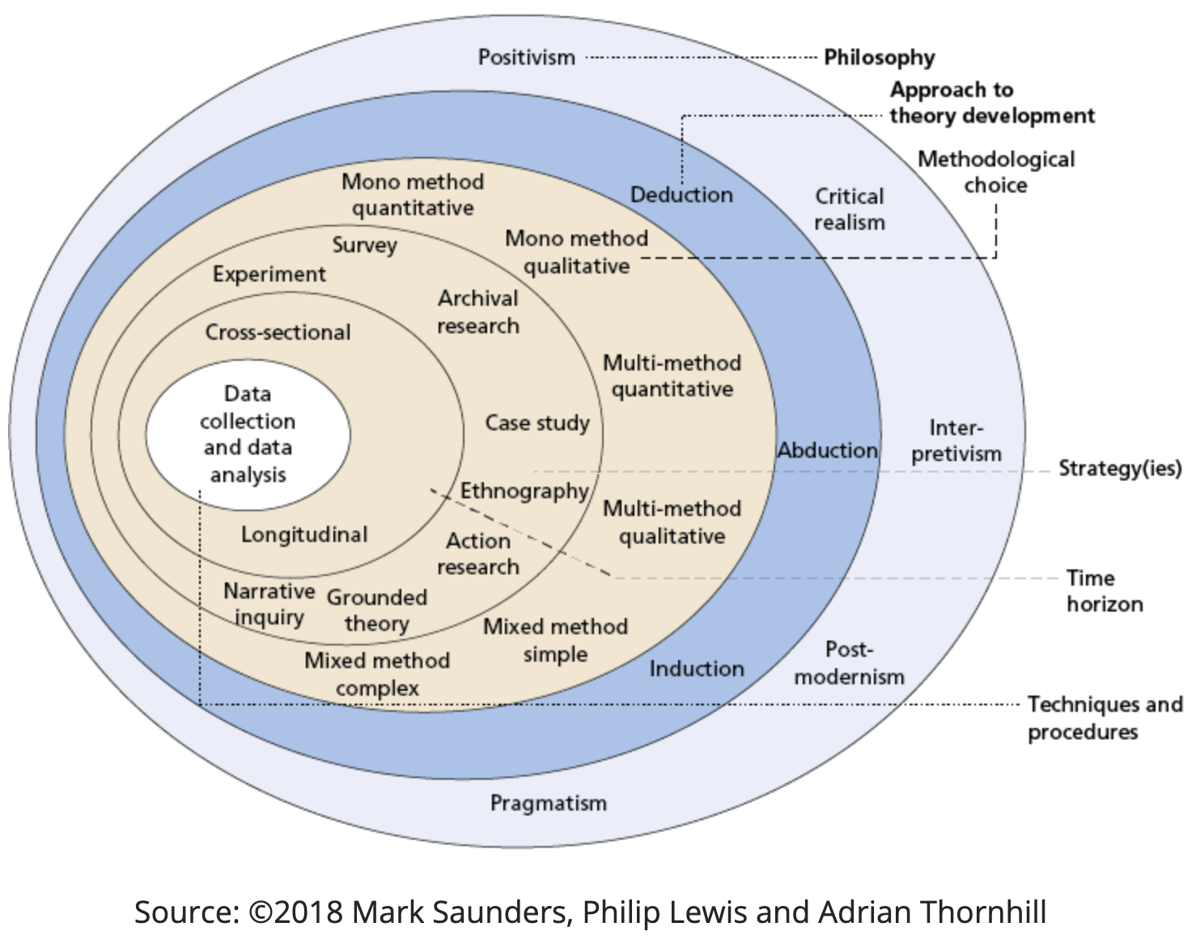
Figure 1: presents pictorially the research onion and displays the six stages to complete a research methodology.
    - Philosophy
Saunders et al (2019, pp. 130) introduces the research philosophy as an assumption that will structure the research questions, methods used and the interpretations of the findings. Thus, the philosophy is concerned with the techniques in which data will be collected, analysed, and used Dudovskiy (2022). As seen in the research onion, the philosophy includes three data collection methods: positivism, pragmatism and interpretivism. Nickerson (2022) suggested that an interpretivist approach focuses on questioning the motivation and reasoning, with the aim to uncover an extensive understanding of the field of study being analysed. Moreover, Putnam and Banghart (2017) indicate that the interpretivist approach considers social sciences, including social theories and perspectives which supports a view of society being socially constructed. Accordingly, as this research will be focusing for the most part on collecting qualitative data, an interpretivist philosophy has been identified as the most appropriate approach (Dudovskiy. 2019). This qualitative focused philosophy will have a “humanistic focus” meaning it will interpret, analyse, and study the findings that determine the main demographic factors influencing public perception of South Wales Police from experiences (Theophilus, 2018).
Suitably, a survey to establish a collective body of community knowledge, understanding, and opinion concerning the field of study was produced on the basis of this research philosophy. Despite, the survey collecting qualitative and quantitative data, it appeared that the qualitative data will be of the most importance to reach the research question. Therefore, it seemed suitable to uphold an interpretivist philosophy combined with a mixed method research approach.
    - Research Approach
Having identified ‘interpretivism’ as the philosophy theory, it became apparent that the inductive approach would be the most effective to providing reasoning for the findings. As Thomas (2016) suggested that this research approach can identify direct connections between the research objectives and the primary data findings. In agreeance, according to Soiferman (2010), when embracing an interpretivist approach, the inductive approach will work to uncover patterns and concerns in the data measured. This research is justified as it will aim to detect a pattern within the relationship South Wales Police force have with members of different demographic groups. Ultimately drawing a general conclusion by obtaining findings in a context of focused evaluation questions.
    - Strategies
Research strategy is the process utilised in the collection of primary data ready for analysis to identify up to date knowledge of a research question, it sets out the general direction, involving the process of conducting the research (Mcleod, 2020). Survey research is described to include “the collection of information from a sample of individuals through their responses to the questions” (Check and Schutt, 2011, pp.160). Therefore, surveys have been identified as the chosen strategy as they appeared to be the most suitable method. This is due to their ability to retrieve a broad amount of information from a large sample size, their efficiency, and generalisability (Bradburn, Sudman and Wansink, 2004).
In addition, survey research is commonly the strategy used to develop a representative image of attitudes and characteristics of a large sample size (Check and Schutt, 2011, pp.160). This allows for open and closed questions to be included to evaluate participants opinions and experiences. This justifies the choice of a survey as the research strategy, as a representative image of the public perception of South Wales Police is required. In agreeance, Young (2019) indicated that data collected by the means of survey strategy can be utilised to analyse the variables in the finding and generate data that is representative of a specific population or area.
Therefore, in justification survey strategies will be used due to its compatibility with the previous layers of the research onion. It supports an interpretivist inductive approach to the research at hand, therefore favourable for the research.
    - Choice of methods
Tengli (2020) reports methodological choice to concern the selection and use of either quantitative, qualitative, or mixed method research designs. During this research a mixed method approach will be applied, meaning qualitative and quantitative data collection and analysis techniques will be used. According to the Office for Health Improvement and Disparities (2020), incorporating the two will supply more in-depth findings, the quantitative data will measure the numeric data, allowing for a generalisation of each demographic group across the concerned area. Whereas the qualitative findings will explain how and why those results transpired, providing an analysis for the participants opinions and experiences. In agreeance Zefeiti and Mohamad (2015) indicated that a mixed-method approach will result in a more extensive understanding of the research collected. Hence, a mixed method approach will be the most appropriate and fitting for this research.
    - Time Horizon
Melnikovas (2018, pp.34) describes the time horizon as the identification of a suitable time frame to organise and gather the data. Two types of time horizons are identified by the research onion (figure 1); cross-sectional and longitudinal. The cross-sectional time horizon involves the collection of data at a particular time, ultimately becoming a short-term study. Longitudinal consists of the collection of data over multiple points in time. Considering the time restrictions placed upon academic research projects and the application of a survey strategy, cross-sectional time horizon appeared to be the compatible method to conduct this research (Thomas, 2022).

  - Techniques for Data Collection, Processes and Analysis
Tengli (2020) suggests that the final layer of the research onion relates to the finer details of data collection and analysis, which acts as a contributing element to the studies validity and reliability. Ott and Longnecker (2015) suggested that the design of the data collection is the significant stage in knowledgeable data gathering. A systematic data collection will be applied, by conducting a mixed method questionnaire.
Data collection consisting of primary and secondary approaches is the method of collecting, analysing, and evaluating data from connected sources (Dudovskiy, 2008). Produced and conducted first hand by the researcher, primary research is directed towards a particular field which leads the direction of the study (Persaud, 2010). In order to complete the primary research for this field of study, a survey was chosen as the most suitable means to collect first hand data on the public perception of South Wales Police. Concerning the collection of survey responses, Regmi et al (2017) implied that data collection through internet technology, such as online websites, is cost effective and time efficient. Therefore, the survey will be completed through ‘Google Forms’, a well-known online platform.
Whereas, according to Dudovskiy (2008) secondary data contains data that has already been collected by another researcher and published through the means of books, articles, or online portals. This type of data was carried out throughout the literature review, where all research objectives were researched thoroughly.
Bringing attention to the research objectives, the survey will consist of nine closed questions and eight open questions, with questions being reflective of the research goal and objectives. Focusing on objective two;
“Identify the main demographics that have an impact on the relationship between South Wales Police and the public.”
By the survey providing quantitative and qualitative data, it allows for the researcher to discover a connection between the influence of demographic groups on the experiences and relationship between a participant and South Wales Police, achieving all research objectives. As throughout the literature review Girardi (2022) found sexual orientation was a key demographic, followed by statistics indicating that race was carrying an impact on the relationship between the public and the police (Home Office, 2021). Therefore, the literature review suggested that social demographics hold the most control over the public perception of the police.
To ensure all participants are within residency of South Wales Police, this highlighted a need for question two. It ensures all the data collected can be used to draw a general connection and conclusion.
“Evaluate previous efforts by the police to build a relationship with the public and any future recommendations.”
Question eleven specifically links the third objective, as it is solely focusing on South Wales Police improving their relationship with the public. Due to it being an open-ended question, this means the participants can give reasoning behind their response instead of answering from a pre-established set of answers (Allen, 2017). The question was designed to actively engage the participants with the proposal of improving their relationship with their serving force and interpret their attitude towards it. The benefit of including this question is it will allow for a comprehensive approach to recognise the reasons previous efforts found in the literature review failed.
  - Sampling
Throughout the collection of primary data, random probability sampling will be used, to prompt this sample every individual will have an equal chance of being selected (Nikolopoulou, 2022a). Sample strategy in survey research refers to the selection of an adequate sample in order to be able to draw a conclusion representative of a society (Zefeiti and Mohamad, 2015). With this in mind, the survey will include a question confirming participants main residency is within South Wales Police Catchment area.
In addition, the sample should be considerable large so that is it possible to produce a meaningful conclusion, that represents the entire area of South Wales Police force. Faber and Fonseca (2014) expressed that a sample should not be of a limited small-scale as it risks creating a false premise. Therefore, for these reasons a systematic sample will be applied to this research, consisting of a large sample size.
In justification, according to Mcleod (2020) this method of sampling is the most effective for the research as it attempts to access hard-to-reach social groups that are not always detectable. In addition, due to this research question specifically focusing on South Wales Police, this method is practical as it collects the perspectives of a target group established from a location.
3.5 Survey Design
According to Kelley et al (2003) a vital step to producing a questionnaire is to identify what it should aim to uncover and achieve, again implying that the questions should be focused on the research objectives. In order to accomplish this both open and closed questions will be included, this will be the optimal technique to gather participants personal opinions and experiences. Open questions will allow the participants to provide in depth detail, deliver new insights and give a better understanding of their perception (Cleave, 2017). Knowing this, to produce an advantageous research survey, the design will collect both quantitative and qualitative data. Therefore, this will allow participants demographics to be measured alongside their perception, allowing for a connection and identification of the demographics that influence the public perception of South Wales Police, answering the research question.
  - Reliability and Validity
Reliability and validity are both used to evaluate the standard of the research. Reliability referring to the extent that the study can be replicated with all the same circumstances by following the same data collection method and analysis technique (Heale and Twycross, 2015, pp.66-67). Moreover, validity is best described as the accuracy and precision of a measurement (Middleton, 2022), this indicates that ensuring reliability and validity will produce consistency and accuracy throughout the research.
A way to reduce or prevent any threats to the reliability and validity of this study would be to ensure participants with anonymity. This reduces the risk of participation deception, where no information concerning the research question will be withheld and the findings will remain reliable (Coffelt, 2017).
  - Limitations and potential hurdles
Limitations are features or weaknesses of a research design or methodology that risk influencing the analysis of the findings (Ross and Bibler Zaidi, 2019). The timing of this study could be a limitation or potential hurdle, as responses could be influenced as a result of recent events from neighbouring police forces. This could cause the consequence of a bias response, as surveys are prone to response bias (Nikolopoulou, 2022b). Moreover, social desirability bias may play a role, occurring consciously or unconsciously, it is where participants answer in a way, they believe to be socially acceptable (Nikolopoulou, 2022c).
Additionally, it is possible that the sample may be a limitation as it is impractical to collect an even split of demographics in participants. Therefore, a means to overcome this would include using a large sample in attempt to reach all demographic categories in question, even the hard-to-reach categories.
  - Ethical Considerations
Ethical considerations refer to a set of essential principles that direct the research to ensure the rights of an individual who became the subject of study. The principles can include voluntary participation, informed consent, anonymity, confidentiality, potential for harm and results communication (Bhandari, 2022).
Concerning the ethical considerations of this research, it is to be carried out in obedience to the University of Wales Trinity Saint David’s ethical standards. This conveys that the participants consent was attained, and their participation was voluntary with the option to withdraw at any time. Moreover, the survey (See appendix 3) was confined to individuals of the age eighteen and above, with their confidentiality a priority. Additionally, to ensure ethical approval was gained both the co-ordinator and the dissertation supervisor approved the ethics approval form to continue with this research.

Chapter Four: Analysis of Data
4.1 Introduction
Throughout Chapter three, the researcher established the research methods used to accomplish the research objectives. Chapter four will focus on the analysis of the data collected through the survey, especially demographic analysis. According to Hayes (2022), this involves the analysis of multiple variables regarding a group of individuals. To be completed by presenting and analysing the primary data collected, identifying useful information, patterns, and trends. Allowing the researcher to draw an informed conclusion. Identifying the relationship between demographics and the public perception of South Wales Police, accomplishing all research objectives.
Data analysis is the key element to any research project, it is the process of depositing facts or statistics to answer the research question (Calzon, 2023). The researcher will be focusing on identifying patterns, relationships, or trends by interpreting the data collected to uncover any discrepancies between demographical groups.
The data collected from the survey is to be analysed via Google Forms, as this software was used to gather participant responses. Microsoft Excel will be used to present results in graphs and contingency tables to determine trends.
4.2 Findings: Description
The qualitative data will bring focus to the participants’ perception and attitude, supplying the researcher with insight. Throughout data analysis the grounded theory will be applied, by evaluating the responses individually to detect and display conceptual patterns through generalisability (Chun Tie, Birks and Francis, 2019).
The survey included 17 questions, with a total of 54 responses collected, questions three to six were concerned with the demographics of participants. Providing a brief summary of the main findings, a contingency table was created to measure each the perception of a demographic group when discussing South Wales Police (See appendix 5). Findings corresponded with expectations from the literature review research, becoming apparent that demographics do influence the public perception of South Wales Police.
4.2.1 Analysis
Chapter three highlighted the importance of ethical consideration throughout research. Question one ensured that participants were willing to participate in the survey and allowed the data to be collected for research purposes, results (See appendix 4) confirmed that all 54 participants consented to this.
With the research question in mind, all research collected is to be generalised to South Wales Police, question two was included to guarantee participants main residency is within South Wales Police force catchment area. The results reveal that 52 (98.1%) participants are within the catchment area, meaning the research is representative of South Wales Police force.
Amongst the 54 participants, 31 (57.4%) identified themselves as female, 20 (37%) identified as male and three (5.6%) identified as non-binary, no participants selected prefer not to say. This question is of importance to answering the research question as throughout chapter two, it became apparent gender roles often impact how an individual interacts with society, influencing the participants perspective on the subject matter (Carli, 2015).
Analysing the results, the most frequent age group to complete the survey was 18-24, totalling 53.7% of all responses. This may support claims that a particular age demographic can shape an individual’s values, attitudes, and beliefs (Weiss and Zhang, 2020).
Synthesising this, The Police Foundation (2018) revealed in chapter two that a third of those sentenced to prison within the United Kingdom were ages 18-25, linking to involvement with 40% of cases using police time. This knowledge will be important to consider whilst analysing the qualitative data.
Age Group | Gender
 | Female (%) | Male (%) | Non-binary (%)
18-24 | 15 (27.7) | 11 (20.3) | 3 (5.5)
25-25 | 5 (9.2) | 1 (1.8) | 0
35-44 | 4 (7.4) | 2 (3.7) | 0
45-54 | 3 (5.5) | 2 (3.7) | 0
55-64 | 2 (3.7) | 2 (3.7) | 0
65+ | 2 (3.7) | 2 (3.7) | 0
Total | 31 | 20 | 3

Table 1: Participants by age and gender
Ethnicity was the third demographic-based question, included to uncover a potential relationship or pattern between the public perception of South Wales Police and ethnicity. According to (Allmark, 2004) the representation of diverse culture is crucial when carrying out research to reflect population diversity. Majority of participants (87%) selected having a ‘White British’ ethnicity, implying that the sample is not as representative of ethnicity as desired.

Gender | Ethnicity
 | White British (%) | Black or African American (%) | Asian (%) | Chinese (%) | Other (%)
Male | 18 (33.3) | 0 | 1 (1.9) | 0 | 1 (1.9)
Female | 27 (50) | 1 (1.9) | 1 (1.9) | 1 (1.8) | 0
Non-binary | 2 (3.7) | 1 (1.9) | 0 | 0 | 0
Total | 47 (87) | 2 (3.7) | 2 (3.7) | 1 (1.9) | 1 (1.9)

Table 2: Participants by gender and ethnicity

Figure 2: Data collected from question seven
Results from question seven appear to show nearly an equal divide when asked if South Wales Police is representative of local communities. Analysing the qualitative data provided, many responses from the ‘no’ section included:
“Rarely see any officers.”
“I don’t think my local community trust them”.
“I can’t say I’ve seen police involved in community activities.”
Whilst responses from the ‘yes’ section included:
“Yes, because they are mostly white and straight.”
“They look like everyone from a majority white village.”
Patterns from this data show that the ethnicity of the sample could have influenced these figures. South Wales Police are seen to be predominately white and the sample consisted of 87% of White British individuals, whilst majority of the ‘yes’ answers included their local officers having the same ethnicity.
Question nine was included with the aim of answering objective two, by providing insight to the participants demographic profile and their view of South Wales Police officers. To analyse the quantitative responses a contingency table was produced (See appendix 5). The table includes all demographical information collected and their individual view of SWP officers, ranging from very positive to very negative. This aims to establish a correlation between the two variables: demographics and perception.

Figure 3: Data insight from question 9, regarding the perception on South Wales Police from genders.
Results appeared to be fairly balanced when analysing the gender demographic, as there was almost an even split between the female and male participants. However, non-binary results show that they view South Wales Police officers positively. As 5.6% of the overall sample identified as non-binary, 66.6% of the non-binary participants selected ‘very positive’ when asked how they view the officers.

Figure 4: Data evidence from question 9, concerning the impact of age.
Data shows that the age group 18-24 have a relatively positive view of SWP officers. 41% of participants in this age group selected the two positive options, with only 22% favouring the negative side of the scale. Comparing this to older generational groups, it suggests that the younger generation have a greater view of officers. Figures reveal that 50% of 55-64 year olds hold a very negative view of the officers, compared to only 25% claiming a very positive view. 75% of the age group 65+ did not select any options that indicate them having a positive perception. Suggesting the age demographic shapes an individual’s values, attitudes, and beliefs (Weiss and Zhang, 2020).

Figure 5: Data from question 9, with regard to the impact ethnicity has on an participants view of South Wales Police.
Ethnicity statistics did not show a direct connection between participants perception of SWP officers and their ethnicity. The ‘Black or African American’ participants were equally divided between ‘very positive’ and ‘very negative’ whereas ‘White British’ participants had an overall positive view of officers.

Figure 6: Data findings from question 9, revealing the effect of sexual orientation on perception of South Wales Police.
Figures from the graph above suggest sexual orientation does influence perception of South Wales Police officers. 37% of heterosexual participants selected they view the officers positively, although 50% of bisexual participants do not hold the same perception.
Question 13 focuses solely on objective three, querying if the relationship between South Wales Police and the public could be improved by means of improving diversity in the force, increasing community engagement or additional vetting, the option for other was included.

Figure 7: Data collected from question 13.
Results from the graph show that all participants felt something could be done to improve their relationship with South Wales Police. 19 participants believe increase in community engagement and additional vetting would be the most effective strategy to improve their relationship. Although, six participants suggested alternative routes to improve relations, some responses collected were; all of the above, additional funding for the service, complete reformation of the force, the officers “turning up and doing what they are paid to do” and sharing good news. These figures imply South Wales Police have multiple avenues to explore whilst building their relationship with the public.

Figure 8: Data collected from questions 14, 15, 16 and 17.
Figure eight reveals question 14, 15 and 16 had almost equally split opinions regarding whether gender, age, and ethnicity impacts SWP interaction with the public. Yet, when presented with question 17, participants felt strongly that sexual orientation does not impact their relationship with SWP.
The quantitative data from question 14 shows that participants responses were balanced, 51% stated no, whilst 47% implied that gender does have an impact. The qualitative data included responses such as;
Female participant, 18-24: “Women are completely dismissed by police officers, I would rather talk to a female officer than a man.”
Female participant, 18-24: “Female officers are taken less seriously than male officers.”
Non-binary participant, 18-24: “Being a female presenting person, when seeing a male officer my first thoughts aren’t ‘I’m safe’ they are how can I avoid that person.”
Female participant, 45-54: “Personal preference would be a female.”
Male participant, 18-24: “I feel many people would feel a lot more comfortable around women police officers, especially if they are women makes people feel safer.”
Male participant, 55-64: “certain people my age have preconceptions and would prefer a male officer.”
Despite 51% of the sample not believing gender impacts South Wales Police interaction with the public. Whilst interpreting the justifications, patterns and trends were identified. It appeared a great deal of participants, from all genders, brought attention to the fact that female officers assist members of the public, mainly women and girls, in feeling safer and less vulnerable. With reference to chapter two, the End Violence Against Women (2021) foundation uncovered that 47% of women reduced their trust in the police. followed by the National Police Chiefs’ Council (2023) expressing that trust between females and the police has been seriously damaged due to the current events, such as the Sarah Everard case. Suggesting that personal experiences or an individual’s sense of identify may have influenced responses to this question. Nevertheless, the primary and secondary data collected align, providing evidence that gender does have an impact on the public perception of South Wales Police.
Data from question 15 reveals that from 51 responses, 25 (49%) selected ‘Yes’, 24 (47%) selected ‘No’ and 2 (4%) selected ‘Not sure’. Several justifications attached to this question were:
18-24: “From experience, younger officers tend to have better understanding in certain situations in areas largely populated by students.”
35-44: “Too young.”
18-24: “Young people perceive officers as the enemy due to how they are characterised in pop culture and from social media. Whereas the older generation perceive them as protectors and enforcers, and more willing to may randomly interact with them positively.”
18-24: “The older generations still believe if an officer has committed an offence against a person, for example the misuse of force then it must be the victims fault straight away.”
18-24: “I believe it depends on where the public get their information from, not age.”
35-44: “Too many old school corrupt people in high roles.”
55-64: “You want something you feel can get the job done and more experienced.”
45-55: “Maturity, experience and communication skills of the officer matter.”
45-55: “Younger I feel they do not have enough life experience.”
Throughout interpreting this data, it was recognised that the older age groups, particularly 45-55 and 55-64, believe that an officers’ level of experience is important, and the younger officers do not have enough in their opinion. Although, comparing this with the younger age groups, they believe that the younger officers have more understanding of situations than older officers, especially when dealing with the younger generation. This suggests that perception of an age group can impact South Wales Police interaction with the public.
Question 16 had similar results, 51% of participants selecting ‘yes’ when asked if ethnicity impacts South Wales Police interaction with the public. Taking into consideration, the sample was 87% White British, results for this question could have been influenced due to the minority ethnicities not being fully represented. Nevertheless, responses for the participants justifications were:
White British: “Maybe a person who isn’t white wouldn’t report their crime to an all-white police force out of fear of not being believed.”
White British: “Generally in South Wales it is heavily a white ethnicity job.”
White British: “Officers predominately white”
Black or African American: “POC are stopped and searched more, they are always racially profiled more. Many wrong arrests have been made because they can’t differentiate one another. POC women are not taken seriously or even cared for and there always seems to be victim blaming involved.”
Welsh: “Yes. I don’t know where to begin.”
Chinese: “No because ethnicity doesn’t seem to impact police interaction in our community but perhaps in larger cities where there are certain stereotypes unfortunately.”
Asian: “Having a diverse force could help interactions with other ethnic groups.”
Asian: “The black community are overpoliced so it would impact the interaction with the public.”
Patterns discovered through this data show that South Wales Police is perceived as a predominantly white ethnic force. Participants justifications suggest that to a large extent, ethnicity does impact South Wales Police interaction with the public. One participant in particular stated they would want to be represented by an officer of their own ethnicity, suggesting their interaction would be contrasting if dealing with an officer of another ethnicity.
Drawing attention to chapter two, the College of Policing (2014) maintain the importance of the Policing Code of Ethics (See appendix 1). However, both the primary and secondary data clearly shows that officers are able to abuse their position and power by abusing their power, contradicting ‘honesty and integrity’ and ‘equality and diversity’ within the Code of Ethics.
Question 17, the final survey question, asked ‘Do you believe sexual orientation impacts South Wales Police interaction with the public? Why?”. With reference to figure eight, results appear to show 62% of participants selected that it does not, compared to only 30% believing that it does. The participants explanations were:
Heterosexual: “The public think the police are judging them.”
Heterosexual: “People from the LGBTQ+ community are less likely to interact with police through fear of prejudice.”
Homosexual: “The older generation of police believe in the old-fashioned way so it would impact the interaction with the public.”
Bisexual: “Makes no difference to me.”
Homosexual: “In my opinion straight white men aren’t to be trusted. When I know a person is queer or identifies in the LGBTQ+ community I instantly feel safer in that situation.”
Heterosexual: “Particularly with the LGBTQ+ being more at risk of assault, sexual orientation needs to be taken into consideration as officers deal with scenarios in a respectful manner. Not everyone believes in equality and their actions or words might display this when interacting with someone of a different orientation.”
Analysing this qualitative data, it is clear that having an 81.5% heterosexual sample has influenced the figures in the quantitative data. Data from figure eight shows overall participants did not believe sexual orientation impacted the interaction between South Wales Police and the public. However, Mahon (2020) found that hate crime is a priority the police should be tackling. Whilst analysing it became apparent that heterosexual participants counted as majority of the ‘no’ sector. However, qualitative data revealed the general public are concerned about members of the LGBTQ+ community when interacting with South Wales Police. Both, heterosexual and homosexual participants stated there is a fear of prejudice towards the LGBTQ+ community and they are automatically at higher risk of victimisation, however they are unlikely to interact with the police.

Chapter Five: Conclusion
5.1 Introduction
The overall aim of this research was to advance an understanding of the main demographics that influence public perception of South Wales Police. The leading research objectives included were:
- Explore existing literature concerning whether the public hold mistrust towards the police.
- Identify the main demographics that have an impact on the relationship between South Wales Police and the public.
- Evaluate previous efforts by the police to build a relationship with the public and any future recommendations.
On the basis of the qualitative and quantitative analysis, it can be concluded that social demographics are important variables to consider when South Wales Police develop their relationship with the public. Throughout this chapter, it will be shown how the gap in the research was addressed, confirmation of the existing theory of demographics, and provide an explanation of how the research will help solve the issue.
5.2 Summary of findings and conclusions
5.2.1 Objective one
From research of prior literature, it was evident that the public do hold mistrust towards the police. Official sources such as the National Police Chiefs’ Council (2023), stated that trust between females and policing is absent. Furthermore, the results of the public consultation survey 2020-21 revealed that the publics’ trust for policing is diminishing (Mahon, 2020). The literature made it apparent that demographics were causing this decline in trust, setting an expectation for the survey results.
5.2.2 Objective two
As expected, empirical results did match expectations. Through the use of primary data, it was found that social demographics, including age, gender, ethnicity and sexual orientation do influence the public perception of South Wales Police. While 87% of participants were ‘White British’ limits the generalisability of results, the qualitative data uncovered through chapter two and four demonstrates that over policing of ethnic minorities is a matter of concern. Additionally, whilst synthesising results, the conclusion was reached that the gender, age, sexual orientation, and ethnicity all influenced the participants perception of South Wales Police.
5.2.3 Objective three
The research clearly illustrates that South Wales Police are aware of the need to improve relations with the public, shown with the introduction of National inclusion Week (South Wales Police, 2022). Although, research throughout has raised the question, do all forces need to improve their public perception, for South Wales Police to see their efforts make an impact. As it is clear from evidence within chapter two and four that neighbouring forces disgrace, causes damage to the public perception of South Wales Police. As the findings from both chapters acknowledge females’ safety concerns. His Majesty’s Inspectorate of Constabulary and Fire & Rescue Services (2022) recognised this, warranting for all officer vetting to be assessed. However, empirical results show that this was not effective, with 38% of participants expressing additional vetting is vital to improving their perception of the force. Overall, objective three was answered, by evaluating the previous efforts of South Wales Police previous it was apparent they have not been effective in improving the public perception.
Therefore, addressing the gap in the research and confirming existing theories, an individuals’ social demographic profile does influence their perception of South Wales Police. This research can be beneficial to South Wales Police, providing them with the information to create effective efforts when improving their relationship with the public.
5.3 Limitations
A significant limitation was that the sample happened to be predominantly 18-24 year olds with a White British ethnicity, because the survey was circulated through social media. In the future, to target a more diverse sample, the surveys will be handed out in person. This will allow the sample and results to become more generalisable and representative, overcoming the limitation.
5.4 Recommendations
A secure relationship between the public and the police is crucial when providing effective policing (Community Relations Service, 2016), illustrated through the Peelian Principles (See appendix 1) and Policing Code of Ethics (See appendix 2). The findings are of relevance to South Wales Police, allowing them to identify demographic groups that require improvement. Despite previous efforts, the force is seen to be predominantly white by participants, recommending a more diverse workforce. Moreover, additional vetting should be implemented to focus on improving their relationship with public, specifically gender. If the force is to tackle the fundamental issues concerning the reasoning behind these demographics influencing the public perception, they will see an improvement.
Reference List
Alexander-Scott, M., Bell, E. and Holden, J. (2016). SHIFTING SOCIAL NORMS TO TACKLE VIOLENCE AGAINST WOMEN AND GIRLS (VAWG). [online] pp.4–49. Available at: https://assets.publishing.service.gov.uk/government/uploads/system/uploads/attachment_data/file/507845/Shifting-Social-Norms-tackle-Violence-against-Women-Girls3.pdf [Accessed 14 Nov. 2022].
Allen, M. (2017). Survey: Open-Ended Questions - SAGE Research Methods. [online] methods.sagepub.com. Available at: https://methods.sagepub.com/reference/the-sage-encyclopedia-of-communication-research-methods/i14345.xml [Accessed 14 Feb. 2023].
Allmark, P. (2004). Should research samples reflect the diversity of the population? J Med Ethics, [online] 30(2), pp.185–189. doi:https://doi.org/10.1136/jme.2003.004374.
Association of Police and Crime Commissioners (2023). Event programme - APCC & NPCC Partnership Summit 2023. [online] www.npcc-apcc.com. Available at: https://www.npcc-apcc.com/programme2022.asp [Accessed 28 Apr. 2023].
Barber, W.E. and Taylor, J.N. (1990). The Importance of Goals, Objectives, and Values in the Fisheries Management Process and Organization: A Review. North American Journal of Fisheries Management, [online] 10(4), pp.365–373. doi:https://doi.org/10.1577/1548-8675(1990)010%3C0365:tiogoa%3E2.3.co;2.
Bhandari, P. (2022b). Ethical Considerations in Research | Types & Examples. [online] Scribbr. Available at: https://www.scribbr.co.uk/research-methods/ethical-considerations/ [Accessed 9 Feb. 2023].
Bradburn, N.M., Sudman, S. and Wansink, B. (2004). Asking Questions: The Definitive Guide to Questionnaire Design -- For Market Research, Political Polls, and Social and Health Questionnaires. [online] Google Books. John Wiley & Sons. Available at: https://books.google.co.uk/books?hl=en&lr=&id=YXKbTx2j9i4C&oi=fnd&pg=PR7&dq=Bradburn+NM [Accessed 8 Feb. 2023].
Calzon, B. (2023). Learn Here Different Ways of Data Analysis Methods & Techniques. [online] BI Blog | Data Visualization & Analytics Blog | Datapine. Available at: https://www.datapine.com/blog/data-analysis-methods-and-techniques/ [Accessed 30 Apr. 2023].
Carli, L.L. (2015). Social Influence and Gender. Oxford Handbooks Online, [online] 57(4), pp.725–741. doi:https://doi.org/10.1093/oxfordhb/9780199859870.013.16.
Check, J. and Schutt, R.K. (2011). Research Methods in Education. [online] Google Books, SAGE Publications, pp.160–161. Available at: https://books.google.co.uk/books?hl=en&lr=&id=nSWYAAAAQBAJ&oi=fnd&pg=PP1&ots=U9ltS_-Pfg&sig=ircZdNh5-vvVBwNHCDmJ0Xi1Ahc&redir_esc=y#v=onepage&q&f=false [Accessed 8 Feb. 2023].
Chun Tie, Y., Birks, M. and Francis, K. (2019). Grounded theory research: A design framework for novice researchers. SAGE Open Medicine, [online] 7(1), p.205031211882292. doi:https://doi.org/10.1177/2050312118822927.
Cleave, P. (2017). The Pros And Cons Of Using Open Ended Questions. [online] SmartSurvey. Available at: https://www.smartsurvey.co.uk/blog/the-pros-and-cons-of-using-open-ended-questions [Accessed 12 Feb. 2023].
Coffelt , T. (2017). Confidentiality and Anonymity of Participants. [online] Sagepub.com. Available at: https://methods.sagepub.com/reference/the-sage-encyclopedia-of-communication-research-methods/i3126.xml [Accessed 29 Apr. 2023].
College of Policing (2014). Code of Ethics: A Code of Practice for the Principles and Standards of Professional Behaviour for the Policing Profession of England and Wales. [online] Assests Publishing Service, pp.1–23. Available at: https://assets.publishing.service.gov.uk/government/uploads/system/uploads/attachment_data/file/341650/Code_of_Ethics_2014_FINAL_July14.pdf.
Community Relations Service (2016). Importance of Police-Community Relationships and Resources for Further Reading. [online] pp.2–4. Available at: https://www.justice.gov/file/1437336/download [Accessed 27 Apr. 2023].
Dodd, V. (2021). Use of stop and search rises 24% in England and Wales in a year. [online] the Guardian. Available at: https://www.theguardian.com/law/2021/nov/18/stop-and-search-rose-by-24-in-england-and-wales-during-lockdowns [Accessed 15 Nov. 2022].
Dudovskiy, J. (2008). Data Collection Methods - Research-Methodology. [online] Research-Methodology. Available at: https://research-methodology.net/research-methods/data-collection/ [Accessed 10 Feb. 2023].
Dudovskiy, J. (2019). Interpretivism (interpretivist) Research Philosophy. [online] Research-Methodology. Available at: https://research-methodology.net/research-philosophy/interpretivism/ [Accessed 22 Jan. 2023].
Dudovskiy, J. (2022). Research Philosophy - Research Methodology. [online] Business Research Methodology. Available at: https://research-methodology.net/research-philosophy/ [Accessed 21 Jan. 2023].
End Violence Against Women (2021). Almost half of women have less trust in police following Sarah Everard murder. [online] www.endviolenceagainstwomen.org.uk. Available at: https://www.endviolenceagainstwomen.org.uk/almost-half-of-women-have-less-trust-in-police-following-sarah-everard-murder/ [Accessed 14 Nov. 2022].
Faber, J. and Fonseca, L.M. (2014). How Sample Size Influences Research Outcomes. Dental Press Journal of Orthodontics, [online] 19(4), pp.27–29. Available at: https://www.ncbi.nlm.nih.gov/pmc/articles/PMC4296634/#:~:text=The%20use%20of%20sample%20size,when%20they%20are%20clinically%20insignificant..
Foulkes, C. (2021). Gender Equality in UK Policing. [online] Available at: https://www.heforshe.org/sites/default/files/2021-12/HeForShe%20Gender%20Equality%20Report%20v4%20%28LR%29.pdf [Accessed Nov. 16AD].
Girardi, R. (2021). ‘It’s easy to mistrust police when they keep on killing us’: A queer exploration of police violence and LGBTQ+ Victimization. Journal of Gender Studies, [online] pp.1–11. doi:https://doi.org/10.1080/09589236.2021.1979481.
Goldmsith , A. (2005). Police reform and the problem of trust. www.sagepublications.com, [online] 9(4), pp.443–470. Available at: http://www.slcdocs.com/ODHR/Website/Right%20to%20Safety/Literature/PoliceReformAndTheProblemOfTrust.pdf [Accessed 7 Oct. 2022].
Hayes, A. (2022). Demographics: How to Collect, Analyze, and Use Demographic Data. [online] Investopedia. Available at: https://www.investopedia.com/terms/d/demographics.asp#:~:text=Demographics%20are%20statistics%20that%20describe [Accessed 24 Apr. 2023].
Hayward, W. (2022). ‘Disgraceful’ stop and search statistics for Welsh police forces released. [online] WalesOnline. Available at: https://www.walesonline.co.uk/news/wales-news/police-stop-search-powers-wales-23315799 [Accessed 15 Nov. 2022].
Heale, R. and Twycross, A. (2015). Validity and Reliability in Quantitative Studies. Evidence Based Nursing, [online] 18(3), pp.66–67. doi:https://doi.org/10.1136/eb-2015-102129.
His Majesty’s Inspectorate of Constabulary and Fire & Rescue Services (2022). An inspection of vetting, misconduct, and misogyny in the police service. [online] HMICFRS. Available at: https://www.justiceinspectorates.gov.uk/hmicfrs/publications/an-inspection-of-vetting-misconduct-and-misogyny-in-the-police-service/.
Home Office (2021). Police powers and procedures: Stop and search and arrests, England and Wales, year ending 31 March 2021. [online] GOV.UK. Available at: https://www.gov.uk/government/statistics/police-powers-and-procedures-stop-and-search-and-arrests-england-and-wales-year-ending-31-march-2021/police-powers-and-procedures-stop-and-search-and-arrests-england-and-wales-year-ending-31-march-2021 [Accessed 15 Nov. 2022].
Home Office (2022). Stop and Search. [online] Gov.uk. Available at: https://www.ethnicity-facts-figures.service.gov.uk/crime-justice-and-the-law/policing/stop-and-search/latest [Accessed 25 Apr. 2023].
House of Commons (2010). Police Reform and Social Responsibility Bill. [online] pp.1–46. Available at: https://researchbriefings.files.parliament.uk/documents/RP10-81/RP10-81.pdf [Accessed Nov. 21AD].
Jackson, J. and Bradford, B. (2010). What is Trust and Confidence in the Police? Policing, [online] 4(3), pp.241–248. doi:https://doi.org/10.1093/police/paq020.
Kelley, K., Clark, B., Brown, V. and Sitzia, J. (2003). Good Practice in the Conduct and Reporting of Survey Research. International Journal for Quality in Health Care, [online] 15(3), pp.261–266. Available at: https://academic.oup.com/intqhc/article/15/3/261/1856193 [Accessed 12 Feb. 2023].
Kumar, S., Sherman, L.W. and Strang, H. (2022). The Fall and Rise of Racial Inequality in London Homicides: a Challenge for Policing by Consent. Cambridge Journal of Evidence-Based Policing, [online] 6, pp.202–225. doi:https://doi.org/10.1007/s41887-022-00084-9.
Mahon , S. (2020). Public Survey Results. [online] South Wales : Police and Crime Commissioner , pp.1–16. Available at: https://www.southwalescommissioner.org.uk/media/2162/2019-12-05-analysis-of-the-precept-survey-final.pdf [Accessed Nov. 21AD].
McCombes, S. (2019). How to Write Methodology | A Step-by-Step Guide. [online] Scribbr. Available at: https://www.scribbr.co.uk/thesis-dissertation/methodology/ [Accessed 17 Jan. 2023].
Mcleod, S. (2020). Research Methods | Simply Psychology. [online] Simplypsychology.org. Available at: https://www.simplypsychology.org/research-methods.html [Accessed 3 Dec. 2022].
Melnikovas, A. (2018). Towards an Explicit Research Methodology: Adapting Research Onion Model for Futures Studies. [online] p.34. doi:https://doi.org/10.6531/JFS.201812_23(2).0003.
Metropolitan Police (2023). Wayne Couzens sentenced for exposure crimes. [online] Mynewsdesk. Available at: https://news.met.police.uk/news/wayne-couzens-sentenced-for-exposure-crimes-463116 [Accessed 28 Apr. 2023].
Middleton, F. (2022). Reliability vs Validity in Research | Differences, Types & Examples. [online] Scribbr. Available at: https://www.scribbr.co.uk/research-methods/reliability-or-validity/ [Accessed 12 Feb. 2023].
National Police Chiefs' Council (2023). First violence against women and girls benchmark published. [online] National Police Chiefs’ Council (NPCC). Available at: https://news.npcc.police.uk/releases/first-benchmark-of-police-performance-on-tackling-violence-against-women-and-girls-published [Accessed 29 Apr. 2023].
Nickerson, C. (2022). Interpretivism Paradigm & Research Philosophy. [online] simplysociology.com. Available at: https://simplysociology.com/interpretivism-paradigm.html [Accessed 6 Feb. 2023].
Nikolopoulou, K. (2022a). What Is Probability Sampling? | Types & Examples. [online] Scribbr. Available at: https://www.scribbr.co.uk/research-methods/probability-sampling-methods/#:~:text=Published%20on%207%20July%202022 [Accessed 30 Apr. 2023].
Nikolopoulou, K. (2022b). What Is Response Bias? | Definition & Examples. [online] Scribbr. Available at: https://www.scribbr.co.uk/bias-in-research/response-bias-explained/ [Accessed 13 Feb. 2023].
Nikolopoulou, K. (2022c). What Is Social Desirability Bias? | Definition & Examples. [online] Scribbr. Available at: https://www.scribbr.co.uk/bias-in-research/what-is-social-desirability-bias/ [Accessed 13 Feb. 2023].
Office for Health Improvement and Disparities (2020). Mixed Methods Study. [online] GOV.UK. Available at: https://www.gov.uk/guidance/mixed-methods-study [Accessed 8 Feb. 2023].
Ott, R.L. and Longnecker, M.T. (2015). An Introduction to Statistical Methods and Data Analysis. [online] Google Books. Cengage Learning. Available at: https://books.google.co.uk/books?hl=en&lr=&id=VAuyBQAAQBAJ&oi=fnd&pg=PP1&dq=methods+of+data+analysis&ots=9fAKEpeRJj&sig=2mUbInxQzROuIEry0ZRK0WsqPus#v=onepage&q&f=false [Accessed 20 Apr. 2023].
Persaud, N. (2010). Primary Data Source. [online] Sagepub.com. Available at: https://methods.sagepub.com/Reference/encyc-of-research-design/n333.xml [Accessed 10 Feb. 2023].
Phair, D. and Warren, K. (2021). Saunders’ Research Onion: Explained Simply. [online] Grad Coach. Available at: https://gradcoach.com/saunders-research-onion/ [Accessed 17 Jan. 2023].
Police Federation (2018). The Office of Constable. [online] Surrey : Police Federation. Available at: https://www.polfed.org/media/14239/the-office-of-constable-with-links-2018.pdf [Accessed 30 Apr. 2023].
Putnam, L.L. and Banghart, S. (2017). Interpretive Approaches. The International Encyclopedia of Organizational Communication, [online] pp.1–17. doi:https://doi.org/10.1002/9781118955567.wbieoc118.
Regmi, P.R., Waithaka, E., Paudyal, A., Simkhada, P. and Van Teijlingen, E. (2017). Guide to the design and application of online questionnaire surveys. Nepal Journal of Epidemiology, [online] 6(4), pp.640–644. doi:https://doi.org/10.3126/nje.v6i4.17258.
Ross, P.T. and Bibler Zaidi, N.L. (2019). Limited by Our Limitations. Perspectives on Medical Education, [online] 8(4), pp.261–264. doi:https://doi.org/10.1007/s40037-019-00530-x.
Saunders , M.N.K., Lewis , P. and Thornhill, A. (2019). Research Methods for Business Students . 8th ed. [online] pp.128–170. Available at: https://www.researchgate.net/profile/Mark-Saunders-10/publication/330760964_Research_Methods_for_Business_Students_Chapter_4_Understanding_research_philosophy_and_approaches_to_theory_development/links/5c53056f299bf12be3f0e2cf/Research-Methods-for-Business-Students-Chapter-4-Understanding-research-philosophy-and-approaches-to-theory-development.pdf [Accessed 17 Jan. 2023].
Schafer, J.A., Huebner, B.M. and Bynum, T.S. (2003). Citizen Perceptions of Police Services: Race, Neighborhood Context, and Community Policing. Police Quarterly, [online] 6(4), pp.440–468. doi:https://doi.org/10.1177/1098611102250459.
Soiferman, K. (2010). Compare and Contrast Inductive and Deductive Research Approaches. [online] Available at: https://files.eric.ed.gov/fulltext/ED542066.pdf [Accessed 8 Feb. 2023].
South Wales Police (2022). National Inclusivity Week. [online] Available at: https://www.south-wales.police.uk/news/south-wales/news/2022/med-sep/national-inclusion-week/ [Accessed Nov. 14AD].
South Wales Police (2023). Overview . [online] South Wales Police Heddlu De Cymru. Available at: https://www.south-wales.police.uk/police-forces/south-wales-police/areas/about-us/about-us/overview/#.
South Wales Police and Crime Commissioner (2021). Public Consultation Results 2021-2022. [online] Available at: https://www.southwalescommissioner.org.uk/media/2400/2021-01-06-our-police-our-community-final.pdf [Accessed Nov. 21AD].
South Wales Police and Crime Commissioner (2023). South Wales precept rise of 7.4% approved by Police and Crime Panel. [online] commissioner.south-wales.police.uk. Available at: https://commissioner.south-wales.police.uk/en/news/precept-2324/#:~:text=South%20Wales%20precept%20rise%20of%207.4%25%20approved%20by%20Police%20and%20Crime%20Panel [Accessed 29 Apr. 2023].
Stephens, G. (2022). Neighbourhood Policing. [online] College of Policing. Available at: https://www.college.police.uk/guidance/neighbourhood-policing/foreword [Accessed 25 Apr. 2023].
Tengli, M.B. (2020). Blog 132-Research Onion: A Systematic Approach to Designing Research Methodology | | Welcome to AESA. [online] Aesa. Available at: https://www.aesanetwork.org/research-onion-a-systematic-approach-to-designing-research-methodology/ [Accessed 8 Feb. 2023].
The Police Foundation (2018). POLICING AND YOUNG ADULTS Developing a tailored approach. [online] Kennington. Available at: https://www.police-foundation.org.uk/2017/wp-content/uploads/2018/07/policing_and_young_adults_final_report_2018.pdf [Accessed 20 Apr. 2023].
The Police Foundation (2022). New landmark report into future of policing proposes most fundamental reform for a generation. [online] The Police Foundation. Available at: https://www.police-foundation.org.uk/news/19573-2/ [Accessed 21 Nov. 2022].
Theophilus, A. (2018). Qualitative research: deductive and inductive - ProQuest. ProQuest, [online] 18(4). Available at: https://www.proquest.com/docview/2133411195?parentSessionId=hA252E1JAJY4c98aqVELjNQqnfILnKtTN8yR7GZ%2BB24%3D&pq-origsite=primo&accountid=130472 [Accessed 6 Feb. 2023].
Thomas, D.R. (2016). A General Inductive Approach for Analyzing Qualitative Evaluation Data. American Journal of Evaluation, 27(2), pp.237–246. doi:https://doi.org/10.1177/1098214005283748.
Topping, A. (2021). ‘A crossroads’: the impact of the Sarah Everard case on women’s safety. [online] the Guardian. Available at: https://www.theguardian.com/uk-news/2021/jul/09/a-crossroads-the-impact-of-the-sarah-everard-case-on-womens-safety.
UNODC (2011). Handbook on Police accountability, Oversight and Integrity CRIMINAL JUSTICE HANDBOOK SERIES. [online] Available at: https://www.unodc.org/pdf/criminal_justice/Handbook_on_police_Accountability_Oversight_and_Integrity.pdf [Accessed 7 Oct. 2022].
Weiss, D. and Zhang, X. (2020). Multiple Sources of Aging Attitudes: Perceptions of Age Groups and Generations From Adolescence to Old Age Across China, Germany, and the United States. Journal of Cross-Cultural Psychology, [online] 51(6), p.002202212092590. doi:https://doi.org/10.1177/0022022120925904.
Worrall, J. L. (1999). Public perceptions of police efficacy and image: The “fuzziness” ofsupport for the police.American Journal of Criminal Justice,24, 47-66.
Young, J. (2019). Representative Sample is often used to extrapolate broader sentiment. [online] Investopedia. Available at: https://www.investopedia.com/terms/r/representative-sample.asp [Accessed 9 Feb. 2022].
Zefeiti, S.M.B.A. and Mohamad, N.A. (2015). Methodological Considerations in Studying Transformational Leadership and its Outcomes. International Journal of Engineering Business Management, [online] 7(10), p.10. doi:https://doi.org/10.5772/60429.

‌‌Case Law reference List
Police Act [1996].
Police Reform and Social Responsibility Act [2011].

Appendices
Appendix 1: Sir Robert Peel’s nine principles of policing
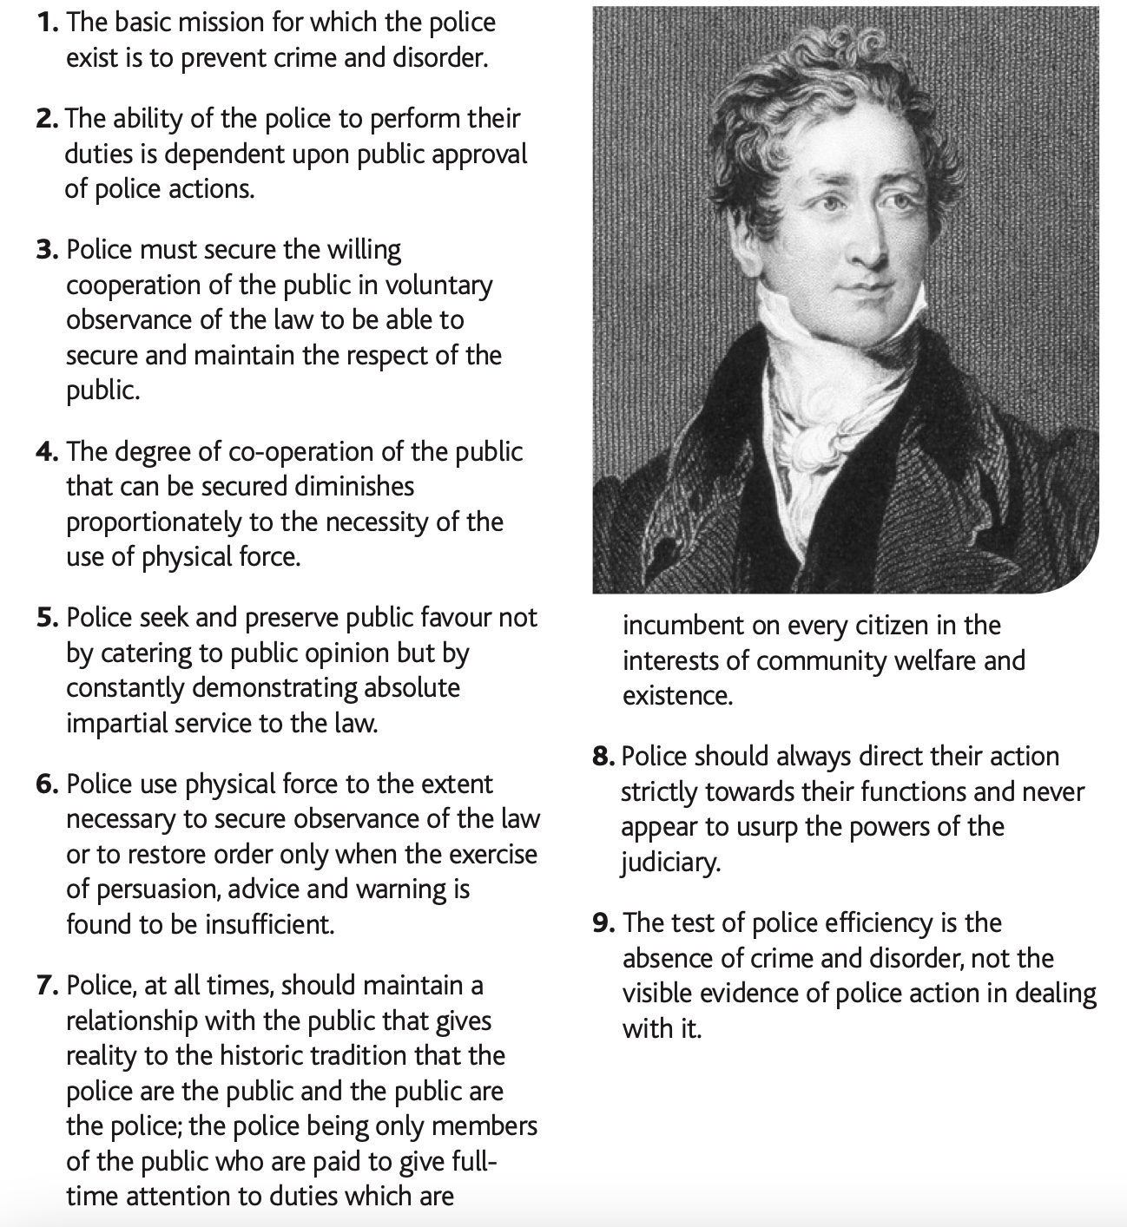
Figure 9: (Police Federation, 2018)

Appendix 2: Policing Code of Ethics
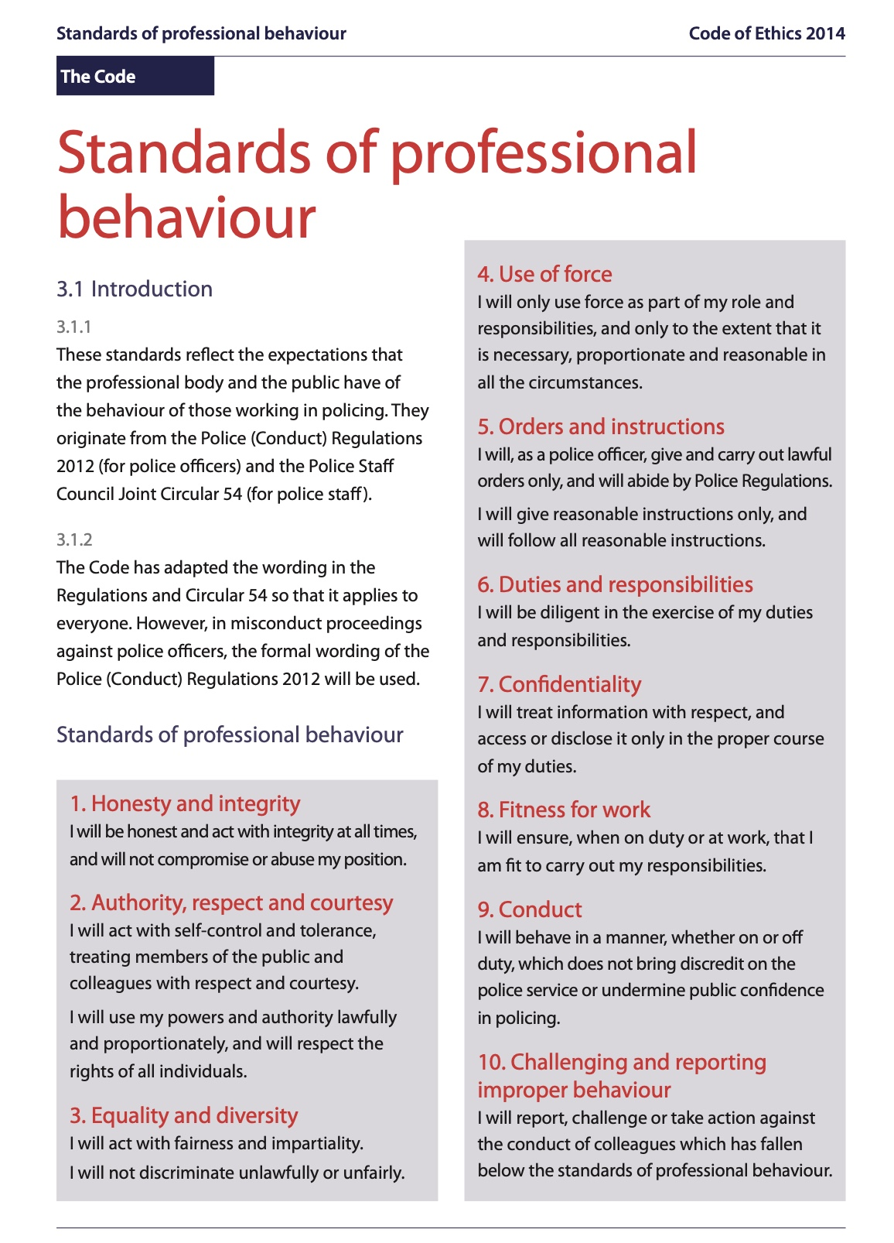
Figure 10: (College of Policing, 2014)

Appendix 3: Copy of Survey
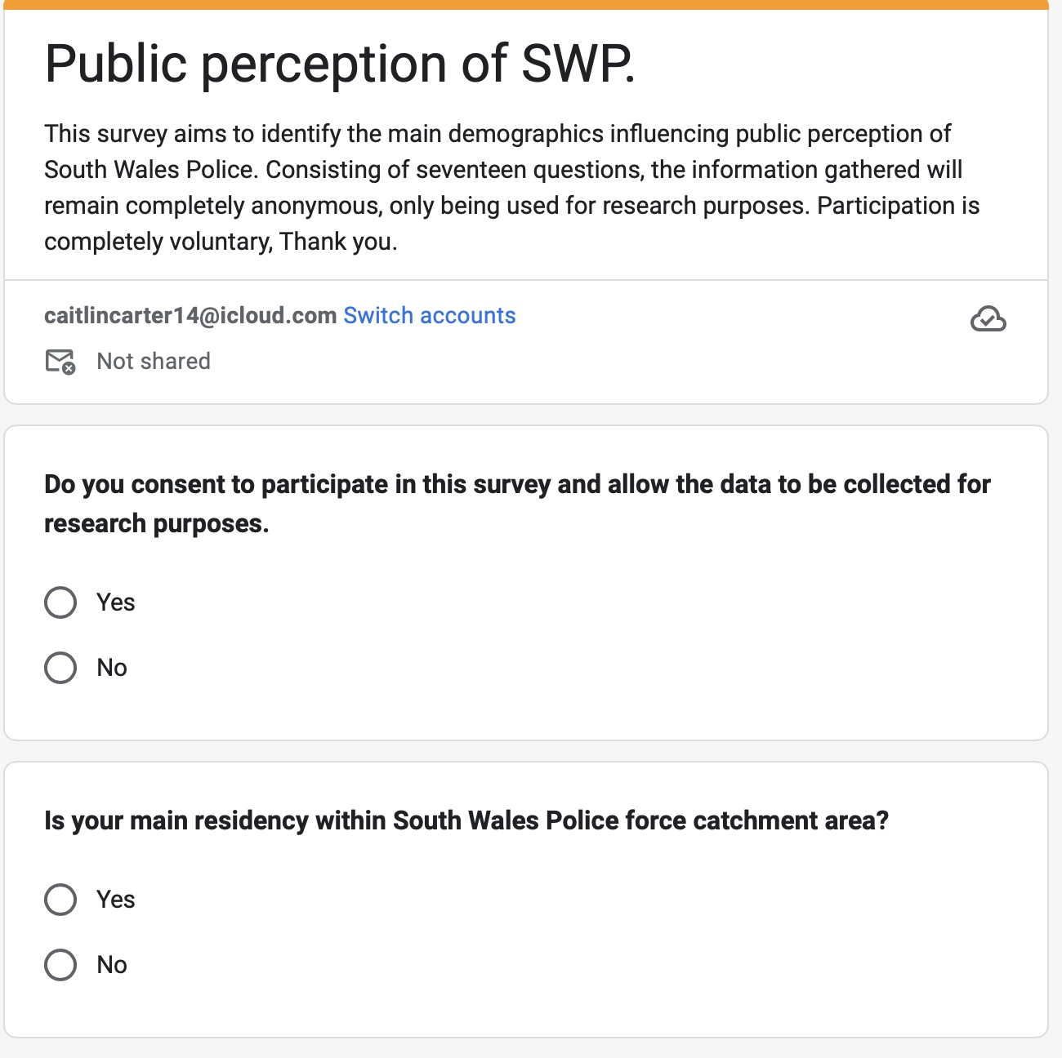
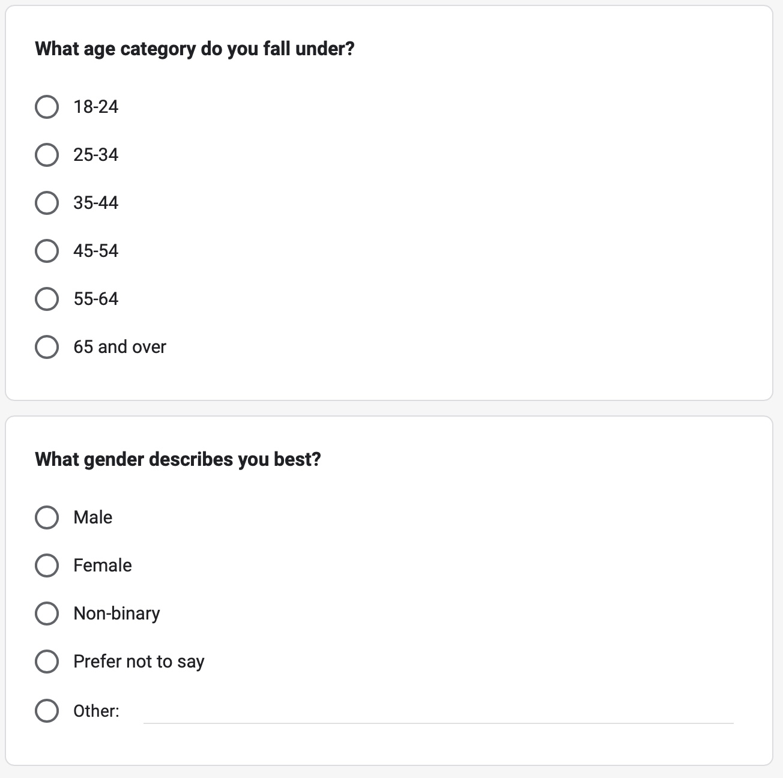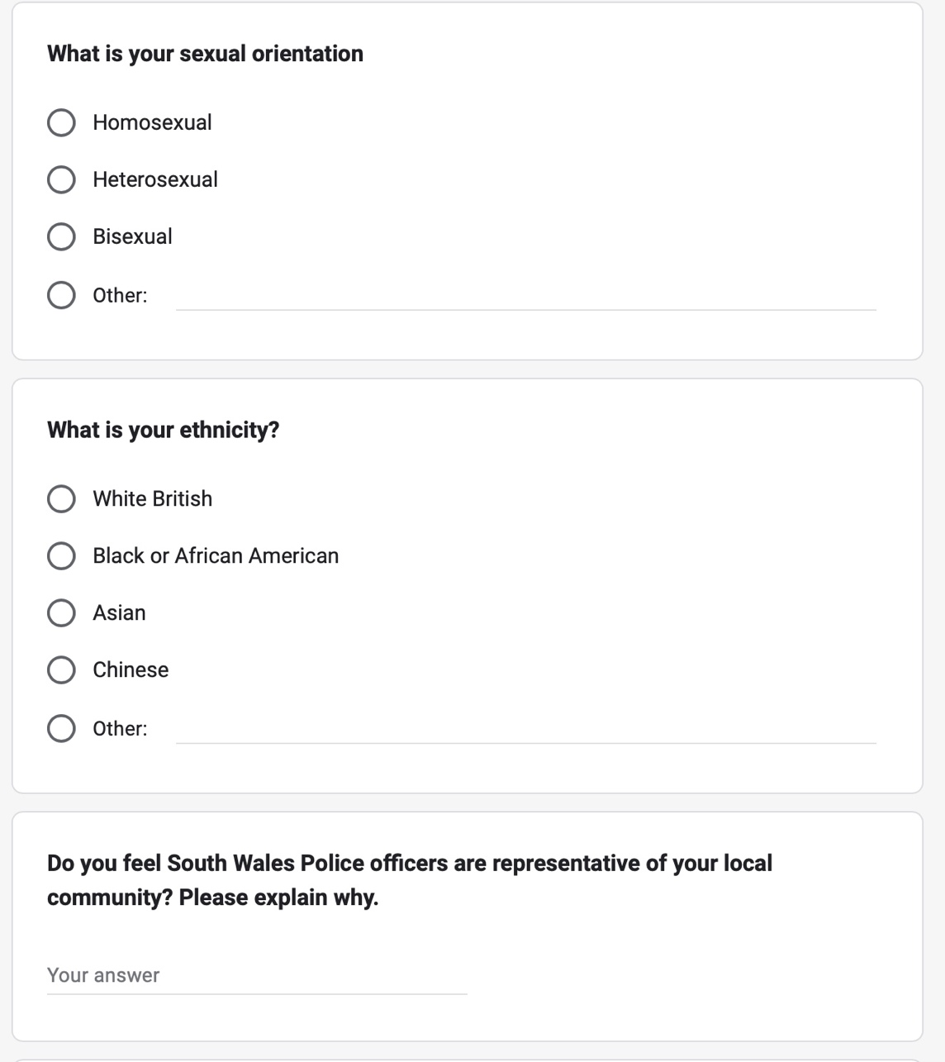
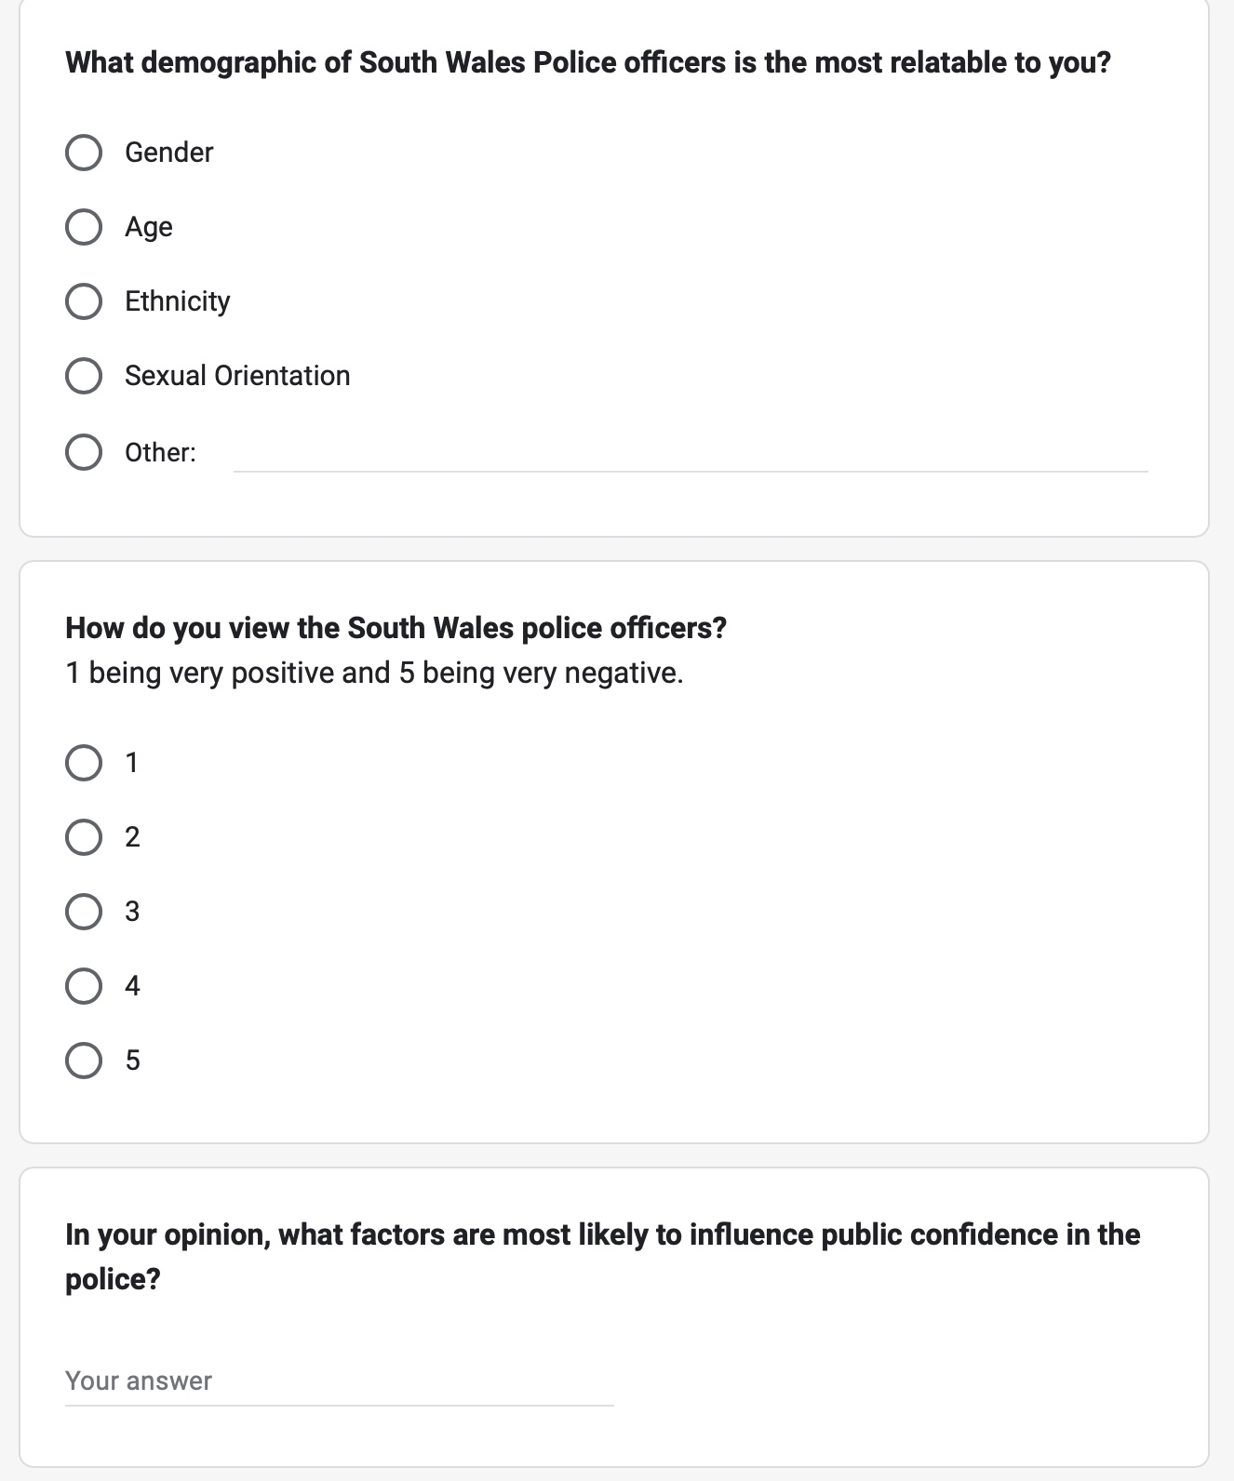

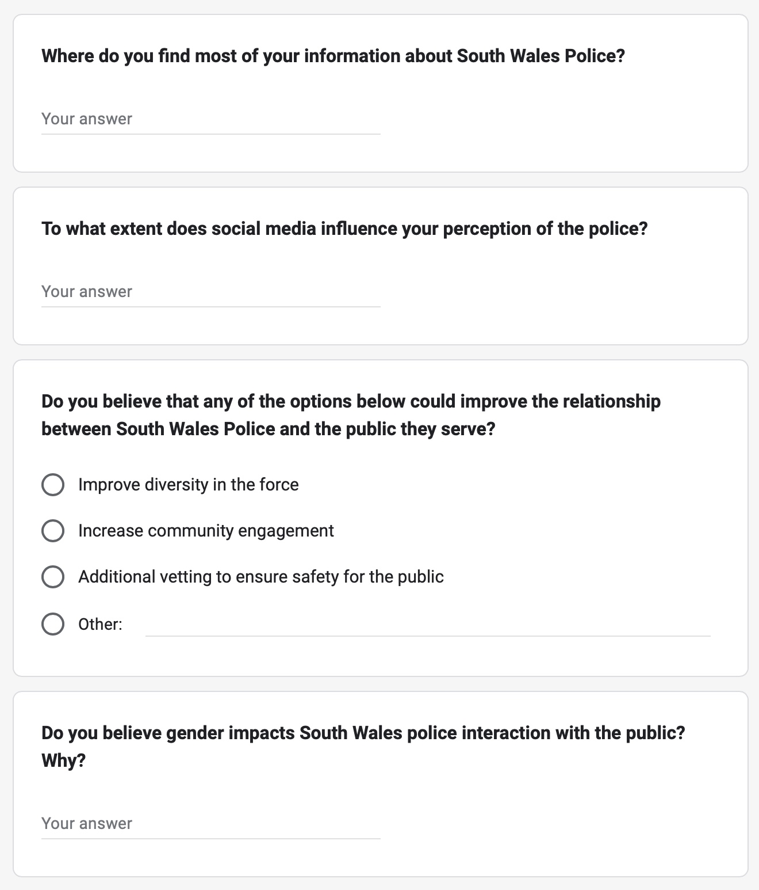
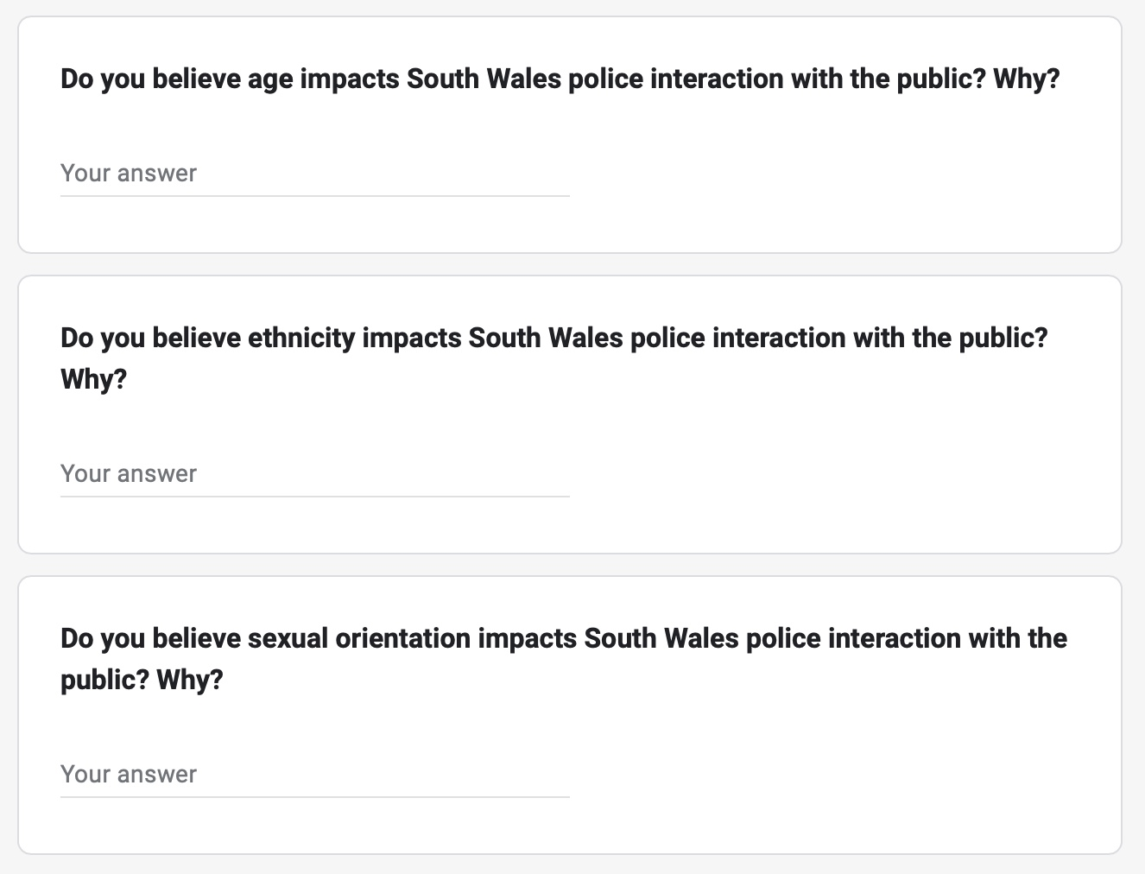
Appendix 4: Survey Results
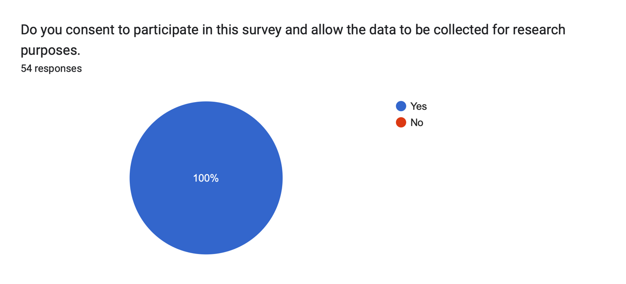
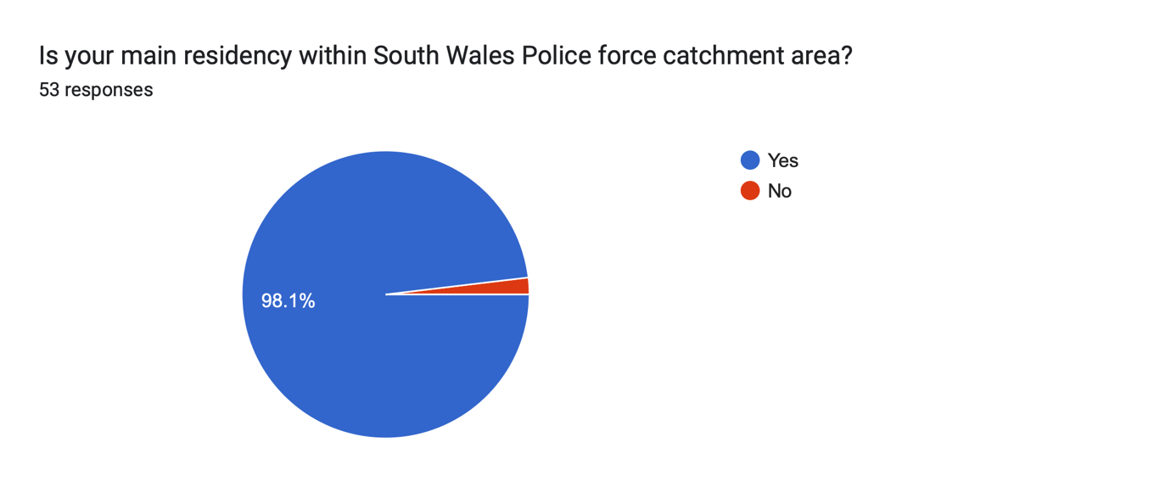
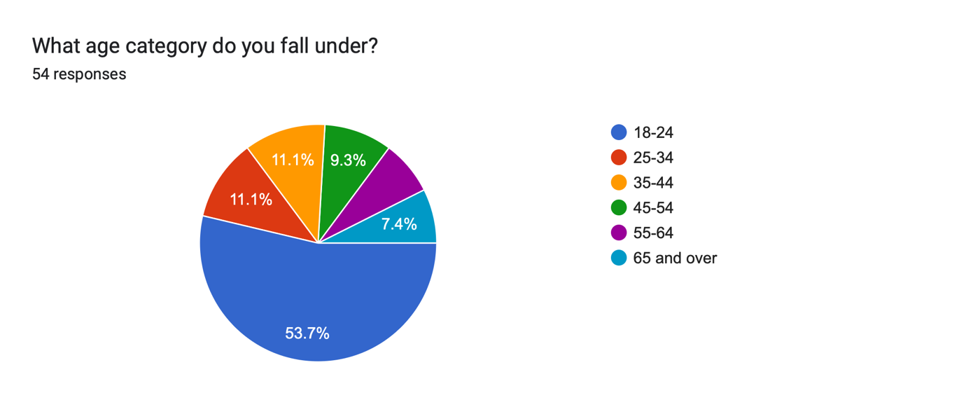
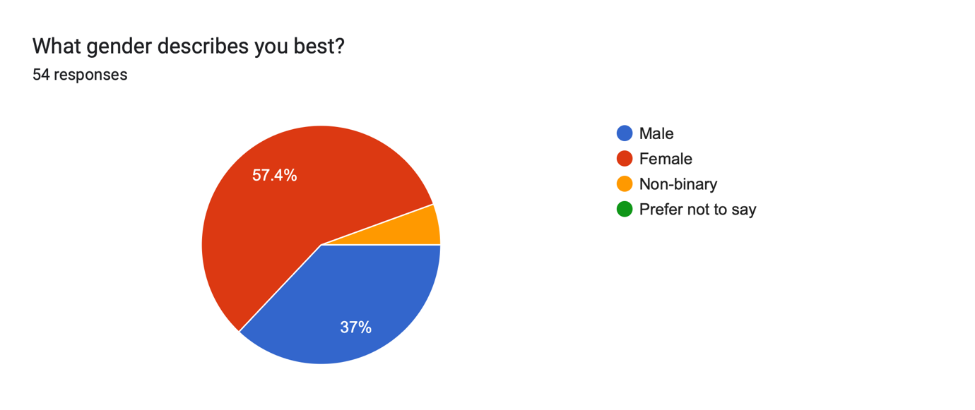
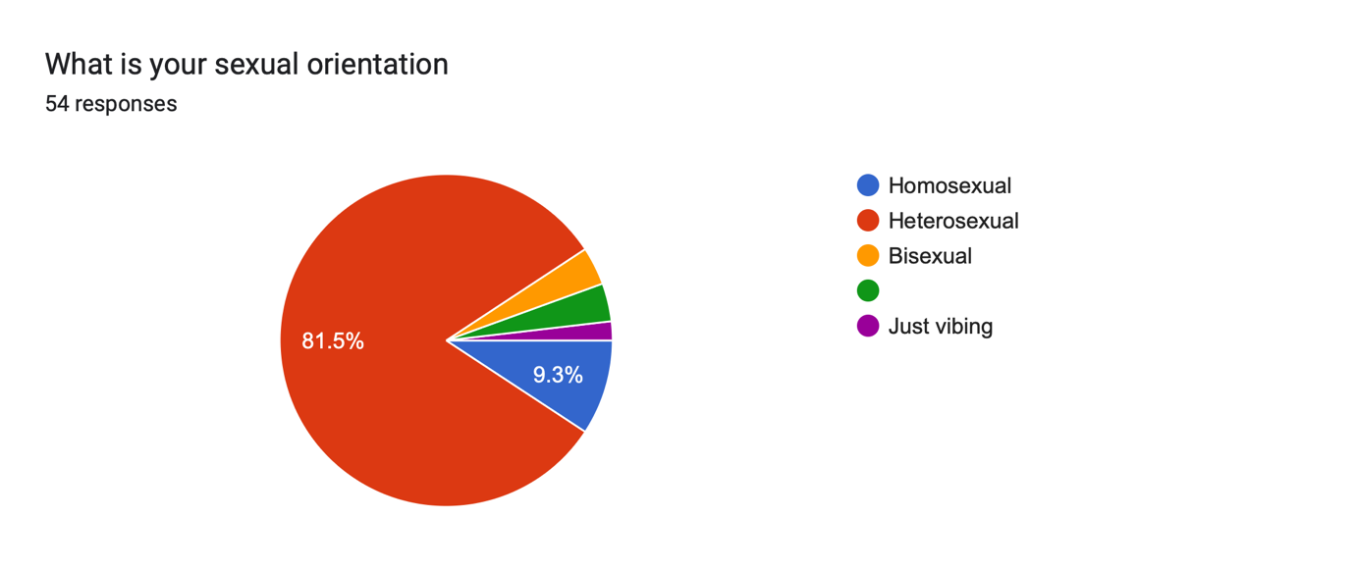
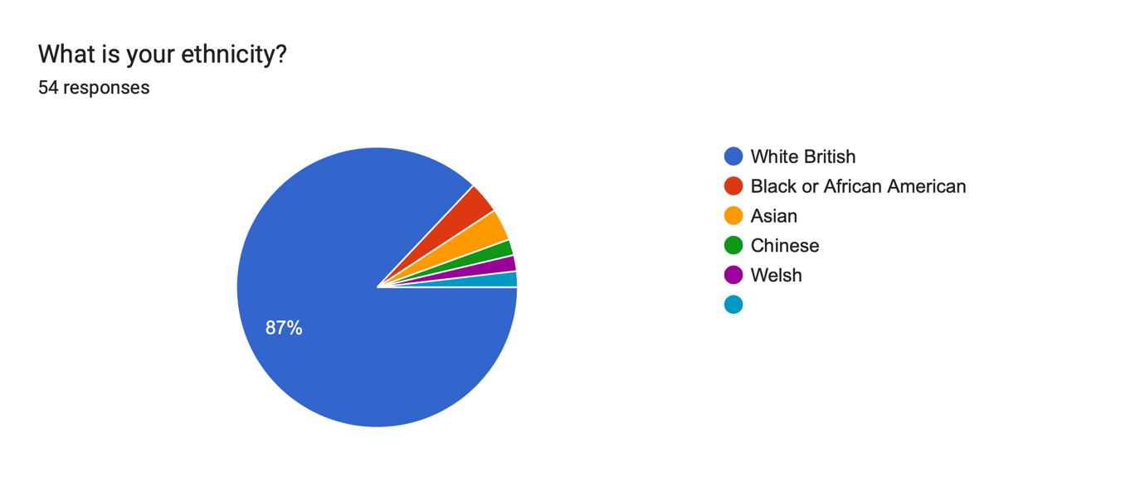
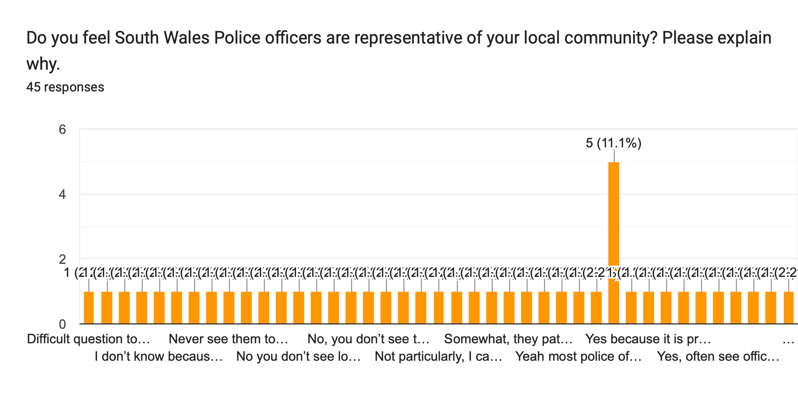
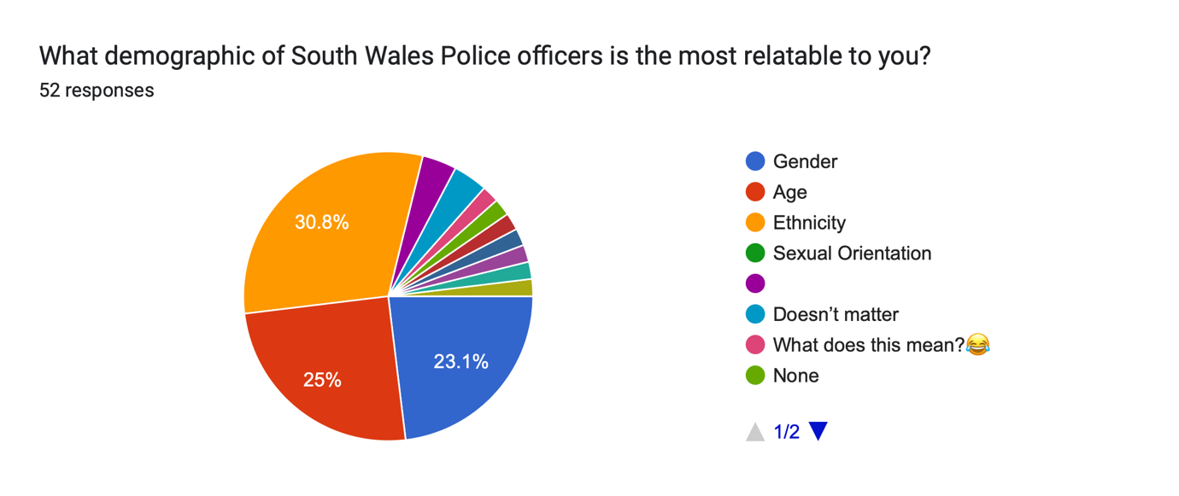
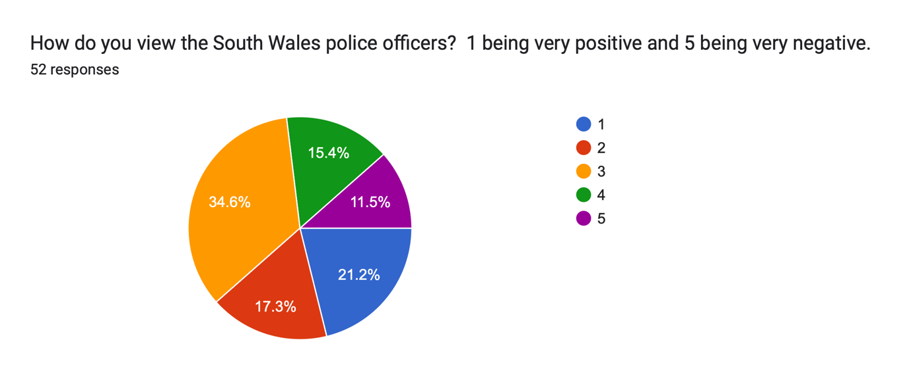
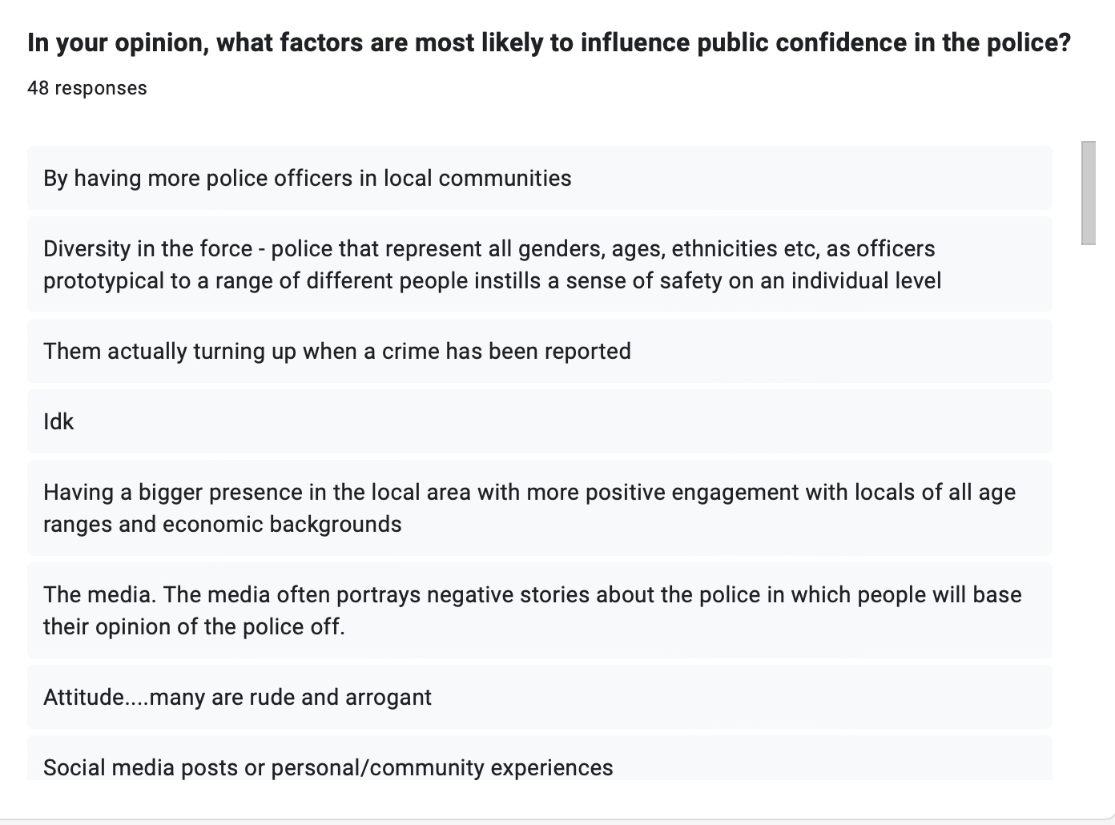
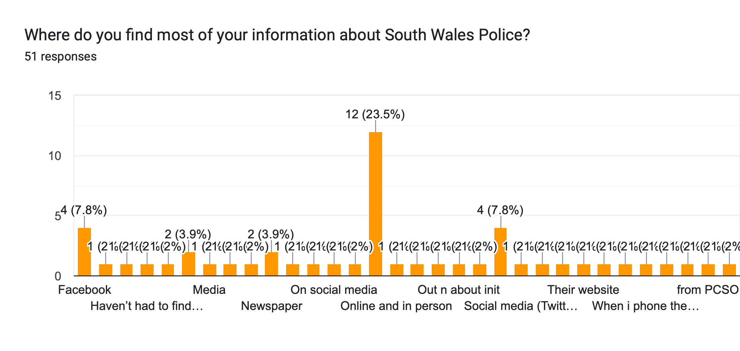
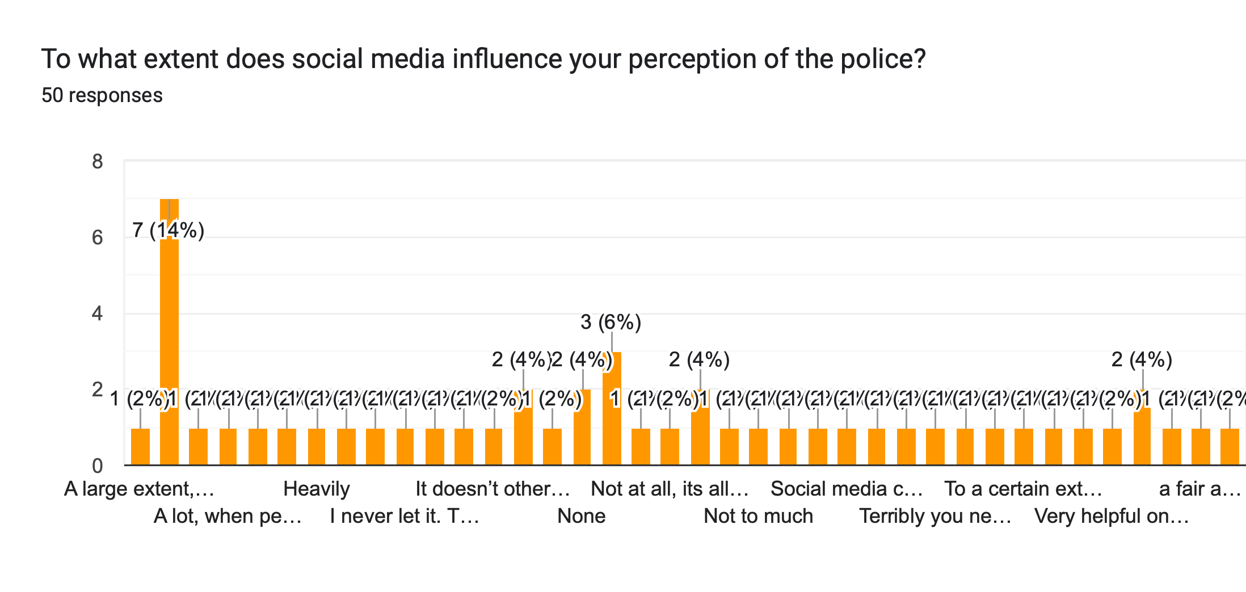
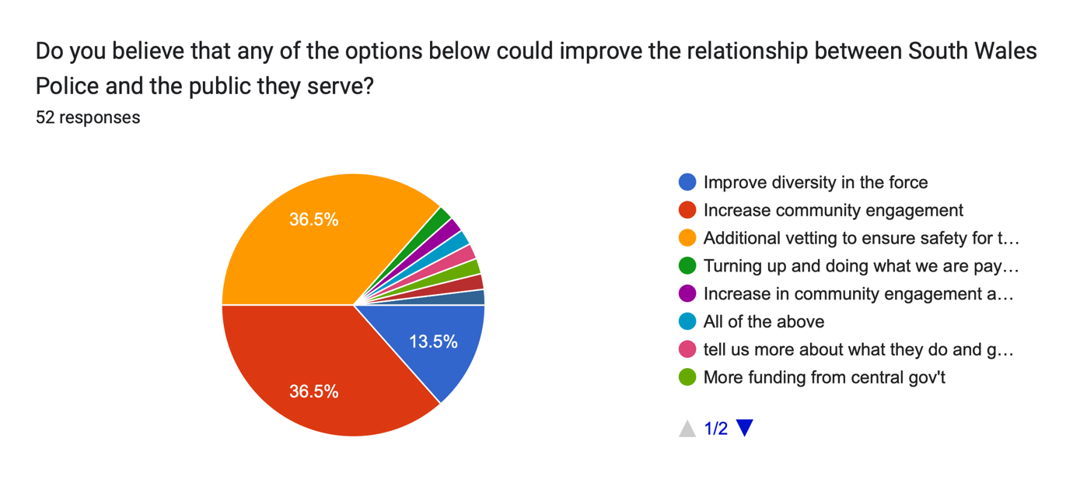
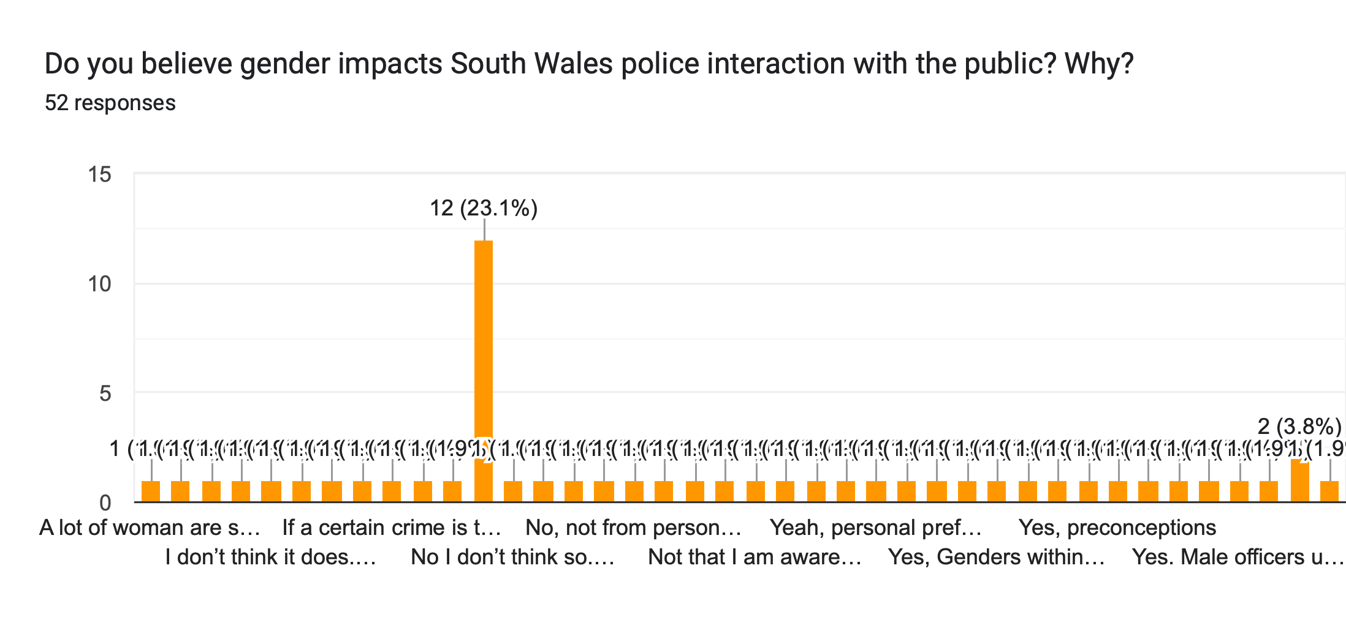
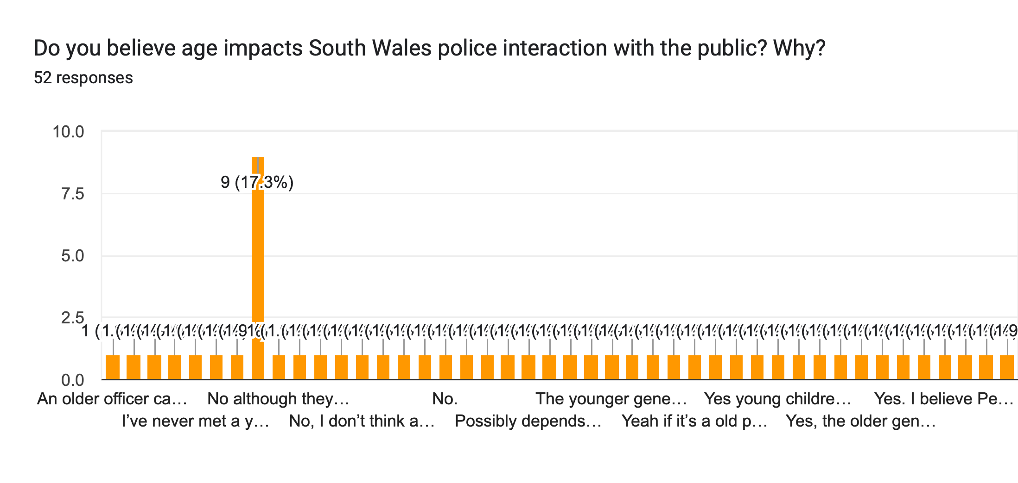
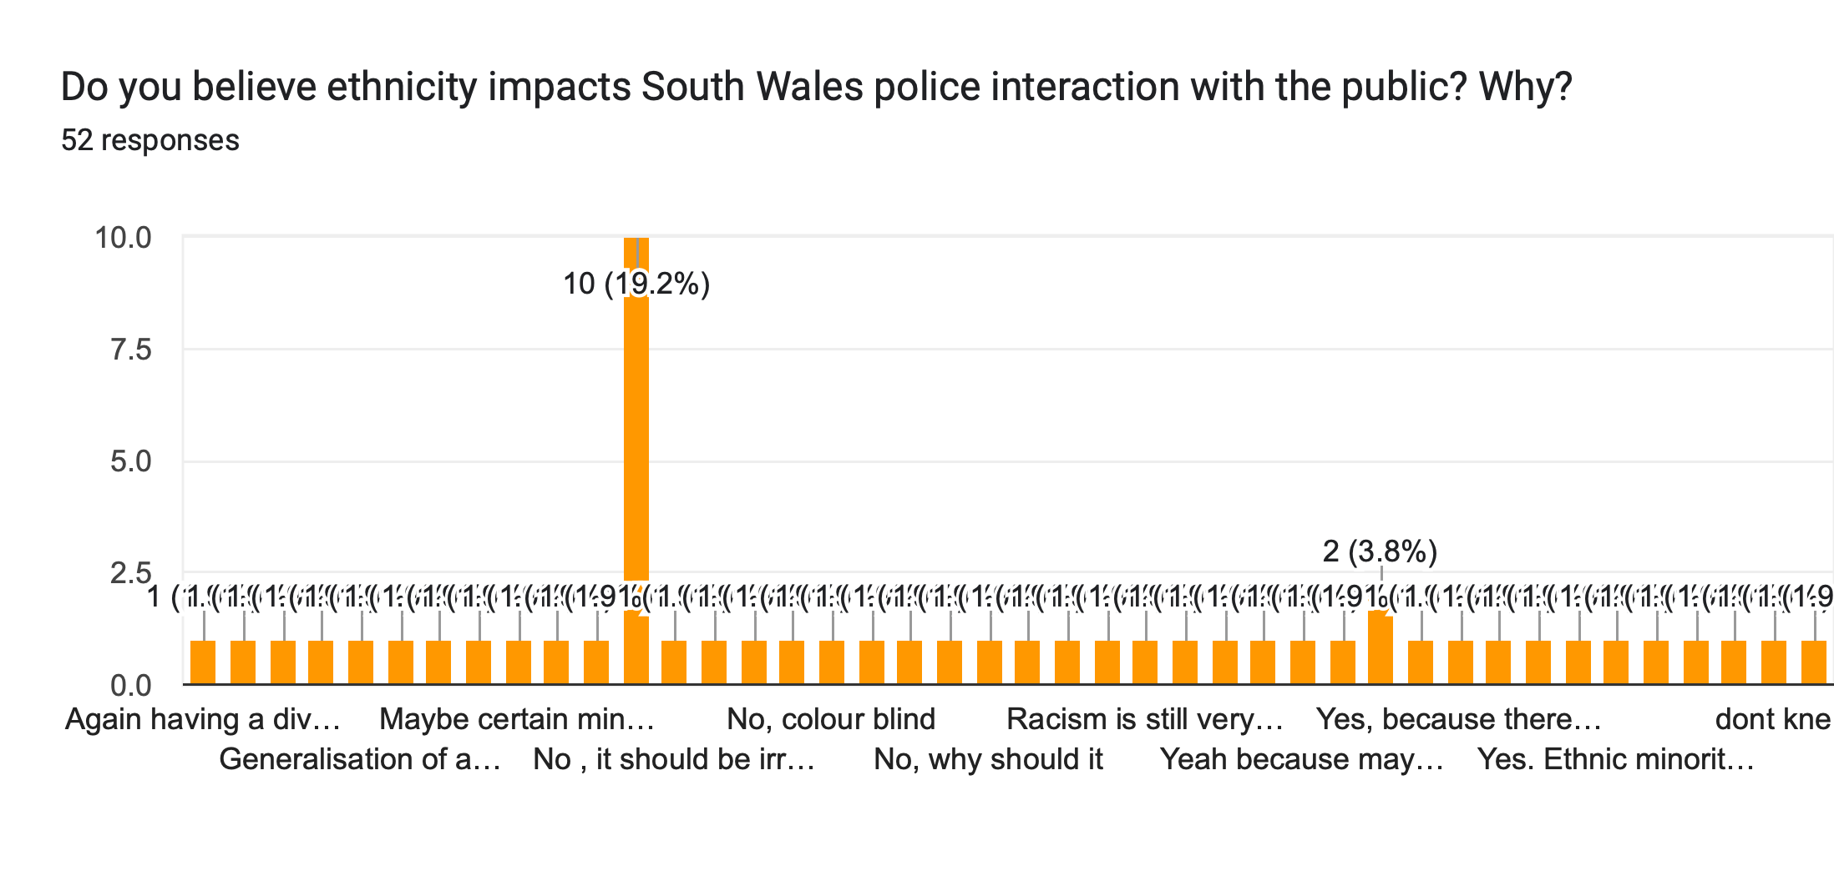
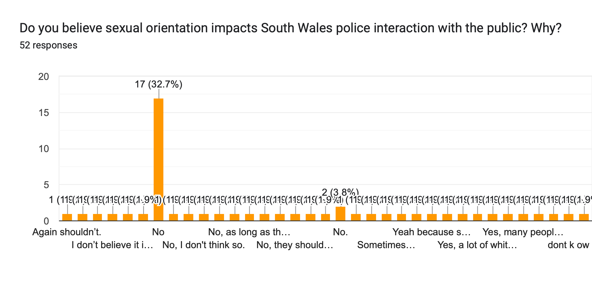
Appendix 5: Analysis of Survey responses
Table 1: Participants by gender and age
Age Group | Gender
 | Female (%) | Male (%) | Non-binary (%)
18-24 | 15 (27.7) | 11 (20.3) | 3 (5.5)
25-25 | 5 (9.2) | 1 (1.8) | 0
35-44 | 4 (7.4) | 2 (3.7) | 0
45-54 | 3 (5.5) | 2 (3.7) | 0
55-64 | 2 (3.7) | 2 (3.7) | 0
65+ | 2 (3.7) | 2 (3.7) | 0
Total | 31 | 20 | 3

Table 2: Participants by gender and ethnicity
Gender | Ethnicity
 | White British (%) | Black or African American (%) | Asian (%) | Chinese (%) | Other (%)
Male | 18 (33.3) | 0 | 1 (1.9) | 0 | 1 (1.9)
Female | 27 (50) | 1 (1.9) | 1 (1.9) | 1 (1.8) | 0
Non-binary | 2 (3.7) | 1 (1.9) | 0 | 0 | 0
Total | 47 (87) | 2 (3.7) | 2 (3.7) | 1 (1.9) | 1 (1.9)

Table 3: Question seven analysis
Q.7 Analysis Demographics | Very Positive |  |  |  | Very Negative
 | 1 | 2 | 3 | 4 | 5
Age Group
18-24 | 7 | 6 | 7 | 7 | 0
25-34 | 1 | 0 | 3 | 1 | 1
35-44 | 1 | 1 | 2 | 0 | 2
45-54 | 1 | 1 | 3 | 0 | 0
55-64 | 1 | 0 | 1 | 0 | 2
65+ | 0 | 1 | 2 | 0 | 1
Gender
Male | 3 | 4 | 6 | 4 | 2
Female | 6 | 5 | 11 | 4 | 4
Non-binary | 2 | 0 | 1 | 0 | 0
Ethnicity
White British | 8 | 9 | 17 | 7 | 4
Black or African American | 1 | 0 | 0 | 0 | 1
Asian | 1 | 0 | 0 | 1 | 0
Chinese | 1 | 0 | 0 | 0 | 0
Other | 0 | 0 | 1 | 0 | 1
Sexual Orientation
Homosexual | 2 | 1 | 1 | 1 | 0
Heterosexual | 8 | 8 | 15 | 7 | 5
Bisexual | 1 | 0 | 0 | 0 | 1
Other | 0 | 0 | 2 | 0 | 0

