

M6X01090
Critical and Real-Time Application Programming Part 2

Mike Dacey

By: Eyad Ahmed N. Algmesh-P142639
23-07-18

RESULT

School of Applied Computing ASSIGNMENT SPECIFICATION

Student name: | Eyad Ahmed N Algmesh | Student P number: | P142639
Programme: | SE
Lecturer: | Mike Dacey | Internal Verifier:
Assignment Title: | Critical and Real-Time Application Programming Part 2
Hand Out Date: |  | Submission deadline: | 20/7/18
Referencing: | In the main body of your submission you must give credit to authors on whose research your work is based. Append to your submission a reference list that indicates the books, articles, etc. that you have read or quoted in order to complete this assignment (e.g. for books: surname of author and initials, year of publication, title of book, edition, publisher: place of publication).
Disclosure: | I declare that this assignment is all my own work and that I have acknowledged all materials used from the published or unpublished works of other people. All references have been duly cited.
Student’s Signature: | Hardcopy assignments will not be accepted without a signature here  Eyad | Date: | 23/07/18
Late submission will result in a late penalty mark, as follows:
Up to one week late, maximum mark of 40% for first attempts. No late submission for resit work.
(Academic Quality Handbook 2017/18 7.5 (5))
Only the Extenuating Circumstances Committee may grant an extension.

Learning Outcomes tested
(from module syllabus)
Develop a systematic understanding of the syntax, semantics, concepts and principles of web programming for complex web applications
Deploy web programming techniques, design patterns, frameworks and/or application platforms
Critically evaluate the techniques and technology used in the development of web applications

Real Time Operating Systems (RTOS)

Introduction:

A system which provides the user of a computer to control and utilize the hardware devices attached to the computer is called operating system. It provides the user every function to effectively use all the devices attached to the computer. Operating system’s front end is user friendly to utilize the resources efficiently without any errors. Some basic and most important task performed by an operating system is managing different resources attached to the computer. Operating system has functions of resource management, conflict management and memory and resource allocation. (Tanenbaum, 2009)

Today with the advancement in every field computers are the core of every institution. Therefore, many operating systems are launched every year with some new improvements in every aspect. Two main and common operating systems are Linux and Microsoft Windows. Linux is an open source operating system. The difference is in the functioning of kernels from both operating systems. Both operating systems have different GUI. Operating systems are improving their systems with time to meet the market demands. With the advancement of technology super computers which are much quicker than old computers require some good, fast and efficient operating system to run. A good operating system with much performance can handle such computers. The parallel processing hardware also creates new challenges for operating systems to effectively use these devices. (Shapiro et al, 2004).
Most popular operating systems are Microsoft Windows and Linux. Yet there is another operating system which is called real-time operating system. It is just like other operating systems effectively allowing user to use devices connected to a computer. There are some protocols which only exist for real-time operating systems only. The real-time operating system also performs operations like simpler operating systems which are resource management, memory management and memory and task allocations, handling files and information. The only difference between these operating systems is the execution of these tasks. The real time operating system has its own protocols and algorithms for performing tasks. (Casavent et al, 1988).

The Real Time Operating Systems:

In real time operating systems, the tasks are performed according to the time allocated to each task. The hardware components also give access to the task for some specific time in which they can use different hardware demanded by the task. So for the time involving systems require a précised operating system to effectively carry out tasks. A real time operating system must have the capability to do all this accurately and in time.

There are 2 types of Real Time Operating Systems:
- Soft Real-Time Operating System.
- Hard Real-Time Operating System.

The Hard-Real-Time Systems:
In a hard RTOS, there is time dead line for each process to finalize its results. It is a précised system which involves time effectively. Systems having operating systems failing to complete processes in deadline time are failed operating systems. It is not the factor that task should be completed in given time, but the factor is operating system should match the time deadline allocated.
Example:
A hard-real-time operating system is supposed to generate output in time of 1 minute. The operating system should be able to do all the calculations of input and output in the given period of 1 minute. It doesn’t mean that any calculation or input or output is not acceptable. This tells the system the exact time to have output ready and when it is requested. All calculations and task sections should be meaningful in 1 minute to deliver results. A fired missile is an example of real time operating system. If the missile is supposed to hit the target at 7 AM than at means at 7 AM the missile should hit the target at 7 AM. It is considered good if it hits the target (Tanenbaum, 2009).

The Soft Real Time System:
Tasks in soft real time system are executed within the time allotted to each task individually. The deadlines in such algorithms can be missed. Results should be ready in the given time in such systems which should be useful in given time. In soft real time operating systems there are priorities of different tasks. The tasks with higher priority are completed first as compared to tasks with lower priorities. Three main tasks of these systems are memory management, process management and joint kill. In soft real time operating systems there are priorities of different tasks. The tasks with higher priorities are performed first than task having lower priorities (Tanenbaum, 2009).
The Process Management:
Threads are created in process management. The management of those threads is called process management. Different threads have different operations. The process management has to carry out the process and then allocating the memory to each process.
In process management there are two types of systems running. One is the system task which is required for the successful operation of a system. The other part or system is the application task which is necessary for the successful operation of an application with some hardware related task. The hard-real-time system and the soft real-time system runs successfully if the processes progress in one after another order. Algorithms used, and the scheduling used decides the success of these process. If good algorithm is used than processes are executed efficiently. If the bad algorithms with poor logics are used than the process fails. These different algorithms are also used to avoid any deadlocks. Deadlocks are the negative impression on the running of an operating system (Li et al, 1997).

Memory Management:
Hard and soft real-time systems handle the RAM (random access memory) and ROM (read only memory). Storage size is limited in hard real-time systems and in soft real-time systems there are huge memories to be handled.
For better memory management the priorities are allocated to each process. Memory management is efficient if the task of memory access is divided into segmentation and paging. Segmentation is the process of dividing the primary memory of system into different segments/ sections. Paging is the process in which storage is further sub-divided. These sub-divided parts are than used to store some information in them and also information can be read from them very quickly and efficiently (Meghanattan, 2005).
File Management:
Managing of files is also an important task for an operating system to perform. Data is organized and stored in form of files in memory. File management is important task at both levels i.e user level and system level also. Different files are stored in the memory of system which is primary and secondary memory of the system and these files are then stored or retrieved as per user or system process (Silberschatz, 2014).
Device Management:
The devices connected to computer are used to provide input and output to and from the system. A good operating system should have such algorithm to utilize the devices connected in an efficient way to save time. Light weight and embedded systems are usually operated by real time operating systems. Limitation is compulsory to achieve the deadline allocated with systems (Silberschatz, 2014).
The common difference between general purpose systems and real time systems is the hardware, the kernel design, the algorithm scheduling. Kernel design used in real time operating systems is pre-emptive kernel algorithm. This kernel design is compulsory for priority handling and scheduling of tasks. To meet the deadlines scheduling in RTOS is developed.

Case Study: A driver is guided by car satnav. The waypoints are updated on the screen and driver is reminded with a latency of 1.5s.

A soft time real system will manage the specific satnav. The specified hardware will be having a geo-graphical positioning system to determine the correct location of the car. Memory will store the map or the meta data for the traced location of car, a central processing unit (CPU) will be used to process different things like route calculation and a display for displaying input and output information from the user. Latency of displaying the updates to the user is 1.5 seconds. This is an ideal time for remaining the user of the upcoming changes in the route, but the deadline can be slightly missed. A few seconds added or deduced in updating will not be a reason for failure of system. The time performance will define how accurate is the satnav working and in cases of consistent and major delays in the information.

Section B: (Implementation)

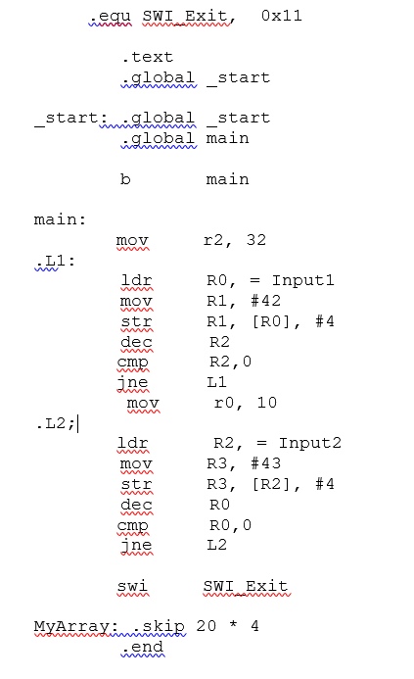
Bit masking will use the code given below:

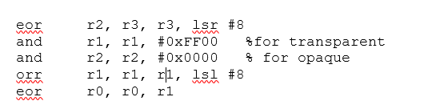
The following calculation related to buffer will be utilized to address the multiple paths of the given arrays.
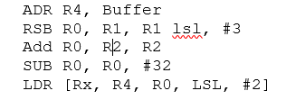

Section C: (Analysis)

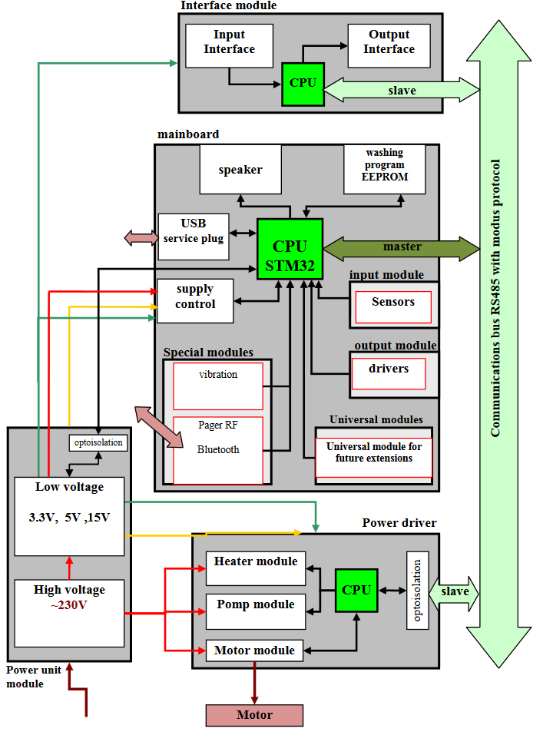
Figure 1. Embedded System of Washing Machine
A soft real-time operating system is used for given task. Deadlines are allotted to tasks to be completed in given time interval. Two different central processing units will be monitored by the operating system. First CPU will main board and the second will be the memory interface and will control all other features of the second CPU.
Design requirements for the system are as following.
The Device Management:
Operating system must control all the sensors attached to the device. The motor and the processing unit will be also controlled by operating system. Data from sensors will be read and stored in specific given timeline. Device management routine will also allocate hardware resources for different tasks. The management used will be the priority-based device management (Meghanattan, 2005).
The Memory Management:
Using serial communication link an EEPROM module will be used for memory and interfacing. As different data operations are to be processed so the operating system must segment the memory and should schedule algorithms for writing data in memory. For proper operation of machine correct commands should be read by the CPU (Meghanattan, 2005).
The Interrupt Handling:
Sensors control the dry and wash cycles of machine which are the major operations of machine. The interrupt generated will be tackled by the operating system. From different interrupts some interrupts will be given higher priority than other interrupts. The priority will be allocated by the person operating the system.
In the normal wash cycle which goes on until the round is completed. An operator needs to stop the machine at his own will. For this there will be a button for this which will trigger the interrupt once the button is pressed. That button will have a higher priority than other buttons. Once the button is triggered the machine will stop. Values of stopped machine will be fed to the sensors. Hence sensors will be giving results accordingly (Barbanov, 1997).
The Interface Handling:
Message passes through devices with operating system. Operating systems transmit messages from device to device via control communication. The messages pass between devices and sensors used for successful operations of machine. Operating systems handles all the deadlocks and interrupts. It is handled by operating system.
Real-time operating system shall compute results accordingly and will provide results to the user. This information includes all the types of cloths and fabric and the type of wash cycle. It also handles the sensors and motor. Checks like the closed door of machine, level of water in machine are checked by different algorithms implemented (Barbanov, 1997).

References:
Barabanov, M., 1997. A linux-based real-time operating system.
Casavant, T.L. and Kuhl, J.G., 1988. A taxonomy of scheduling in general-purpose distributed computing systems. IEEE Transactions on software engineering, 14(2), pp.141-154.
Li, Y., Potkonjak, M. and Wolf, W., 1997, October. Real-time operating systems for embedded computing. In Computer Design: VLSI in Computers and Processors, 1997. ICCD'97. Proceedings., 1997 IEEE International Conference on (pp. 388-392). IEEE.
Meghanathan, S.B.N., 2005. A survey of contemporary real-time operating systems. Informatica, 29(2).
Shapiro, J., Doerrie, M.S., Northup, E., Sridhar, S. and Miller, M., 2004. Towards a verified, general-purpose operating system kernel. Klein [10], pp.1-19.
Silberschatz, A., Galvin, P.B. and Gagne, G., 2014. Operating system concepts essentials. John Wiley & Sons, Inc.
Tanenbaum, A.S., 2009. Modern operating system. Pearson Education, Inc.

