
Name: Mit Ahir
Student Id: 2513323
Programme:
MSc Public Health and Social Care in Practice
Module Code:
LCHS7003
Module Title:
Community Care and Management of Longer-term Conditions
Assessment Title:
Component 1 – Information Booklet of Long-Term Condition Management
Lecturer:
Raheela shaikh
Submission Date:
27 February 2026

INFORMATION BOOKLET ON CATARACT AMONG UK PATIENTS


Table of Contents
1. Introduction 3
2. Background 3
2.1 Definition 3
2.2 Prevalence 3
2.3 Burden 5
2.4 Risk factors 6
3. Main body 6
3.1 Implication 6
3.2 Theoretical implication of Cataract 8
3.3 Policy analysis 9
Local political health and social care agendas 9
National political health and social care agendas 9
Promotion of developmental initiatives by these policies 9
3.4 Recommendations or cataract treatment outcome in UK 10
4. Conclusion 11
References 13

1. Introduction
The information booklet aims to present relevant information on Cataracts and their management within the NHS. Cataract, being a long-term health condition, has been considered in this booklet and information on its prevalence and burden of disease on the UK population has been illustrated. The implication followed by a theoretical explanation of the long-term condition has also been elucidated in this booklet. This information booklet provides a brief evaluation of healthcare policies on cataract treatment in the UK and identifies recommended solutions to implement person-centred care.

2. Background

2.1 Definition
As defined by NHS UK, a cataract is the blurring of vision of the eyes due to clouding of the lens. If left untreated, it can cause permanent blindness. It is mostly seen in the case of older adults and may take a long time to reach maturity when surgical intervention is needed. Symptoms of cataract include blurred vision, reduced visibility at night, light sensitivity, double vision, and seeing a halo around lights (nhs.uk, 2025). Reasons for the development of cataract are mainly old age, along with co-morbidities like diabetes, which aggravate the cataract-forming process. Additional injury or eye conditions can also lead to cataract formation in the early years. Smoking and long-term exposure to harsh sunlight are also reasons for cataract formation.

2.2 Prevalence
As of 2025, 90 million people have been affected by cataracts. 70% adults over the age of 65 years in the UK have been affected by cataract. 30-35% among them have cataract in both eyes, and there have been 680,000 cataract operations each year in England alone. However, WHO claimed that cataract cannot be accepted as an easily treatable long-term condition, rater 51% of blindness globally is caused by cataract. In low and middle-income countries, lack of accessibility to surgery and an increase in the number of the ageing population are some of the major reasons for the development of cataract (Chen et al. 2025). Jiang et al. (2021) claimed that from 2022 to 2050, there is an expected increase in cataract prevalence due to a rapidly ageing population globally.
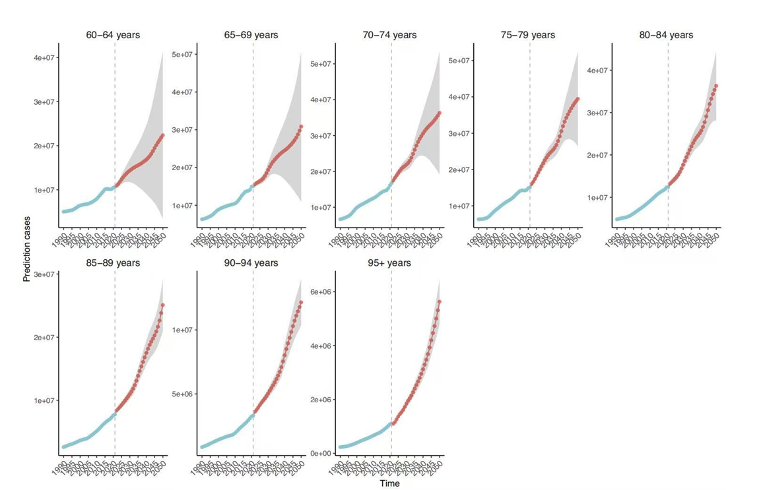
Figure 1: Projected cataract prevalence for 20250 globally
(Source: Jiang et al. 2021)
Similarly, in the UK, there is an expected 50% increase in cataract surgery cases by 2035. This is evident from the recent 2024 data of an increase in the number of people undergoing cataract surgery. In 2023, 4679 per 1,00,000of population were admitted for cataract surgery, but in 202,4 ending 5160 per 1,00,000 of the population admitted for cataract surgery in the UK. The north west part of the UK recorded the highest rate of cataract surgery in 2024 (gov.uk, 2024). Apart from the elderly population, cataract is also seen among babies, but it is very rare. Only 3 to 4 babies among 10,000 are seen to be brown with cataract, mainly due to a genetic defect or any genetic disease, which can even harm their vision development (nhs.uk, 2025).
a)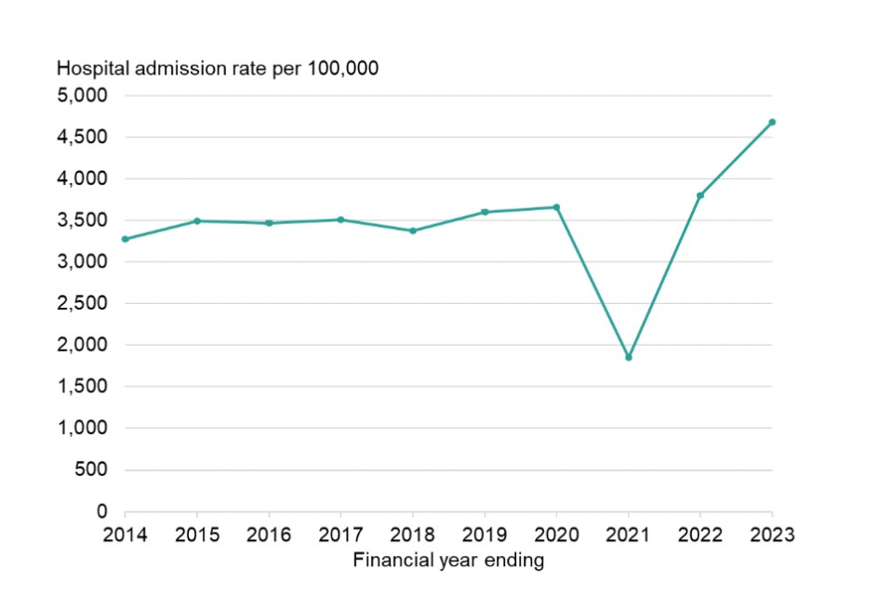
b)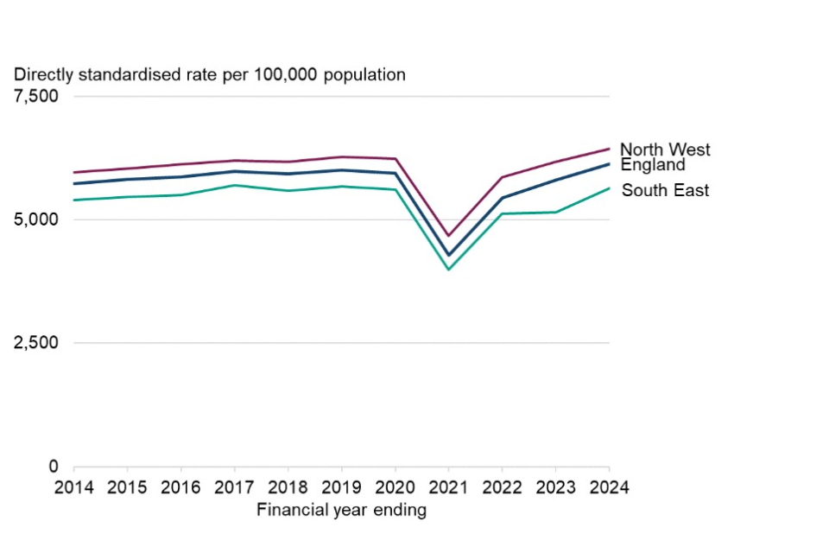
Figure 2. a) Hospital admissions in the NHS for cataract surgery from 2014 to 2023. b) Regions in the UK with the highest cataract surgery admissions
(Source: gov.uk, 2024)

2.3 Burden
The global burden of disease of cataract is a high DALY of the disease, with 91.2% increase in DALY in recent years. Wang et al. (2024) have claimed that an increase in particulate matter and smoking habits is raising the burden of disease. Apart from the overall prevalence burden, there is an increase in the financial burden of the disease as well. The financial burden of cataract in the UK, comprising both private and public expenses, is a huge amount, amounting to £25 billion annually. The NHS has a burden of £4.1 billion, including eye care and cataract surgery services. However, the waiting time is 18 weeks in the NHS for getting a cataract surgery. But in some non-urgent cases, patients have been waiting up to 4 years even for getting cataract surgery. Due to this reason, many patients opt for private cataract surgery services, which cost them from £2000 to up to £4000, which can be a significant financial burden for cataract surgery of only one eye (Ginel et al. 2023; Malcolm et al. 2025).

2.4 Risk factors
The major risk factors associated with the development of long-term condition like diabetes are mainly old age. People above the age of 60 tend to start developing cataract symptoms. But apart from these co-morbidities like diabetes increase the risk of cataract development by 5 times. Smoking subjects the lens of the eyes to oxidative stress, which also increases the tendency for cataract development 3 times. UV exposure and long-term consumption of steroids are also some of the reasons which lead to the development of cataract (Wigley, 2025).

3. Main body

3.1 Implication
Physical
Duman et al. (2019) identified that the visual problems caused by cataract increase the risk of falls among the elderly and restrict daily mobility due to loss of balance. Mencucci et al. (2023) claimed that this visual impairment and mobility restriction lead to the future development of physical frailty among the elderly. The motor impairment due to cataract slows the gait time in the elderly. Tsang et al. (2024) added that the risk of falls among the elderly associated with cataract can cause a high risk of fracture. This is supported by a hazard ratio of 1.28. This claim is supported by Dinarvand et al. (2024) as well, and the research added that cataract can cause muscle atrophy and loss of independent movement among the elderly, which leads to frailty and lack of confidence in independent mobility. Azevedo et al. (2025) found that even body movement are affected by character due to restricted mobility as a result of visual impairment. This body movement reduction is measured to identify that elderly people lack static balance control when diagnosed with cataract due to poor vision. Thus, on a physical evaluation, cataract reduces the QALY by 30-50%. This is attributed to the risk of falls and the associated fractures caused by unavoidable falls, causing a lower quality of life and higher healthcare expenses.
Social
In research by Blachnio et al. (2024), it has been noted that cataract pre- and post-surgery does not affect the social functioning of the affected individuals. Rather, post-surgery, there is better emotional well-being and social engagement. But pre-surgery waiting time also does not affect the social life of the individuals. Patients, especially from urban areas, have stable social relationships despite having long term cataract condition. But Du et al. (2025) stated that cataract among individuals below 60 years can affect their social life because people below 60 years suffering from cataract tend to social and professional life and experience a higher financial burden due to personal financial costs. A similar idea has been presented by Abu Bakr et al. (2023) who have claimed that visual impairment due to cataract leads to affects social life due to restricted mobility and inability to contribute economically. Harsi et al. (2023) added that individuals affected by cataract experience limited social interaction and activities, which takes a toll on their psychological well-being as well. However, this restriction of social life is dependent on the age, sex, education level and socioeconomic condition of the individuals.
Psychological
Wang et al. (2024) claimed that preoperative anxiety and stress can affect the success outcome of cataract surgeries, which can eventually lead to lifelong depression. Further Pellegrini et al. (2020) added that in the case of senile cataract, that leads to lifelong blindness, depression can be associated symptom due to loss of vision. Surgery in such cases have strong association with improvement in depressive symptoms. Binder et al. (2020) mentioned that cataract in young age can lead to the development of anxiety disorders in children. Dhawale et al. (20204) have stated that in all the cases of depression and anxiety associated with cataract due to visual impairment and mobility restriction, mental well-being has been restored after successful surgery. Xiaong et al. (2023) claimed that cognitive impairment due to depression and functional disabilities is a common side effect of cataract among elderly individuals.
Wider implication for family
Pur et al. (2023) mentioned that loss of employment in addition to the financial burden, can strain relationships with family and can even provide a financial burden on the family. Du et al. (2025) in this regard claimed that the financial burden of the individual treatment puts the whole family under economic strain, creating inter family conflicts and straining relations. Lima et al. (2020) mentioned that in case of cataract in children, parents go through turbulent feeling as they are unable to manage treatment and care time with their professional duties to manage the financial expenses of treatment. This even downgrades the emotional well-being of the individuals.

3.2 Theoretical implication of Cataract
UK-based model
In case of UK the House of Care model is the most suitable model that is used to explain the impact and chances for improvement of long-term health issues among patients. The main principle of this model lies in collaborative care and patient empowerment as well as integrated care services. In accordance to the House of Care Model the NHS present services for cataract can be explained. Patients are provided with detailed information on their eye condition which enables patient empowerment. Empowerment entails patients to make informed decisions which is integral to cataract care. The integrated services in this regard comprises of a close collaboration and information exchange between the healthcare professionals, nurses as well as local healthcare professionals to promote timely interventions (Coulter et al. 2016). The integrated system includes surgery based on priority and severity of the cataract condition of the patients the appointment of the patients is given to reduce waiting time. The services for cataract treatment are also made equitable for proper access to services. The cataract treatment-based services are designed to improve the long-term quality of life of the affected patients. This model is applied by the NHS for cataract treatment and the major benefits imparted by application of the model are short waiting times and shared decision making as well as improved long term life quality of the affected patients. However, there is lack of proper collaboration at many levels which is the foundation of this model. For improve patient outcome in case of cataract as per this model the NHS needs to provide a holistic treatment by addressing pre surgery risks of falls through a more coordinated healthcare service and social and economic empowerment (Sridharan et al. 2025).
International model
The chronic care models which are an international healthcare model clearly identifies and describes patient’s needs for cataract. The chronic care model defines the self-management and transparency in the overall information regarding disease. The model explains that long term improvement in patient outcome is only achieved when patients are engaged in self-management. Informing patients about cataract condition and progression as well as the need of surgery provides them engagement and independence on cataract management (Torres-Enamorado and Casado-Mejía, 2026). The model defines the importance of technology in ensuring improvement in health outcome of patients. Electronic Health Records are the most effective technological interventions that allows monitoring of surgical success in case of cataract patient thus allowing scope for improvement in health outcome of the patients. the model also defines the usage of referral pathways such as a sequential checkup by optometrist and them ophthalmologist to reduce delay in treatment and ensuring effective health outcome for long term disease like cataract. The model clarifies the need or a systematic checkup system and continued checkup after surgery to reduce the hospital burden thus paving the way for improved quality of life after cataract surgery (Sassen, 2023).

3.3 Policy analysis

Local political health and social care agendas
In UK for cataract care there are local integrated care boards (ICBs). They are entitled to take care of the overall budget for the cataract surgery which are done under the NHS. However, on proper evaluation it has been noted that the ICB’s do not function uniformly all through the UK. rather in some places the ICB provide early surgery and in some places, there is long wait time. This in fact depends on the availability of the local funds (Nikita et al. 2023).
Along with the ICBs there are community-based care services who provide pre- and post-surgery care to the patients but it reduces hospital visit and reduces pressure on the hospital as well. these community-based care services improve long term health outcome of the cataract patients and implements integrated community-based care (Alsusa et al. 2025).

National political health and social care agendas
The NICE guidelines are the primary set of guidelines which are followed by all healthcare professionals in UK while dealing with cataract patients. The NICE cataract guidelines promote equitable services for all patients suffering from cataract and allows patient centered decision making. the guideline clearly outlines the importance of maintaining transparency in the overall treatment process (Zhang et al. 2022). National Ophthalmology Database (NOD) Audit is another benchmark standard that is maintained in case of cataract treatment. The main aim of the audit is to collect information on surgery outcome of cataract patients to identify pain points and improve the overall quality of lie of the patient’s post-surgery. Based on assessment of the outcomes benchmarks re set for cataract surgery in UK (Teo, 2023).

Promotion of developmental initiatives by these policies
The main focus of these policies and national and political health and social care agendas is towards capacity expansion to accommodate the rising cataract cases. There is a growing trend in NHS related to referral of many cataract patients to private clinics. This is supported by the NHS policy of independent sector treatment and is being done to reduce pressure on the NHS but this is putting the quality of care under questions and even prevents NHS staffs to be trained on proper ophthalmology care. In order to address this issue, the policies and agendas are aimed at providing access to equitable care services related to cataract (Burke, 2025). The policies promote evidence-based treatment practice and providing integrated care. In terms of integrated care pre- and post-surgery care integrated with social care initiatives are provided to patient to prevent falls and provide support in managing daily activities in case of elderly patients with cataract in both eyes who have limited mobility (rcophth.ac.uk, 2022).

3.4 Recommendations or cataract treatment outcome in UK
Improvement towards person centered care approach
- Practicing shared decision making
The NHS as well as the outsourced private organisation engaged in cataract surgery in UK need to inform the patients fully about the cataract condition and progression as well as risk and the chances of recovery (Dai et al. 2024). Patients should have the autonomy to make their own decision regarding surgery based on the knowledge of the condition of their vision. additionally primary care givers of the patients also need to be included in the shared decision process as they are directly associated with the care process. thus, maintaining proper transparency and sharing relevant information is needed to promote person centered care approach in cataract management (Bouaziz et al. 2022).
- Integrated collaborative networks
Proper collaborative network between the optometrists, the ophthalmologist, the nurse, healthcare and social care need to be established to reduce hospital burden and enhance accessibility of services. The integrated collaborative network also comprises of the pharmacists who should be aware of all the co-morbidities and the condition of vision of the patient to provide relevant medicines and remind the patient about the restocking when needed to ensure continuous treatment and follow up (Loke et al. 2025).
Self-management
- Patient education
Patient education is needed to promote self-awareness and management of cataract. Leaflets or digital books or guidelines are needed to make patients aware of the symptoms, risks, surgery and post-surgery recovery of cataract (Lin et al. 2024).
- Falls prevention through integrated care
Social care workers need to work in close collaboration with primary healthcare workers to provide patients in critical condition of cataract with support in mobility. Such care regime prevents falls in elderly patients. social care workers need to educate the primary care givers regarding the severity of cataract and its potential hazards to promote self-management (Leung et al. 2024).
- Digital tools
Digital tools like online appointment booking or asking or urgent care can make patients independent in managing cataract. In addition, post-surgery recovery guidance can also promote self-management. Platforms can be directly connected to the NHS portal for booking appointments (Moghaddasi et al. 2025).
End-of-life care
For patients in end-of-life surgery is not a suitable choice for such patient’s holistic care services are needed. Health and social workers and primary care givers need to provide assistance to promote independence in case of such patients. Treating such patients with dignity is needed to instill self-respect and provide comfort. For improving quality of life in end-of-life care patients can be assisted with low vision aids rather than surgical intervention of cataract (Shloush et al. 2025).

4. Conclusion
Thus, it can be concluded that cataract being a long-term disease proper self-awareness and management is needed to improve quality of life. Cataract treatment is easily available in UK but in countries with poor economic conditions lack of access to treatment due to cataract leads to permanent blindness. Cataract in UK is mostly seen among elderly patients but the long wait time is the major drawback of the NHS in case of cataract treatment. There are difference physical and social barriers that patients experience in case of suffering from cataract among which falls risk is the most fatal and is most common among elderly. In this regard integrated care approach with proper social care needs for cataract patients in needed which the NHS is yet to provide. The theoretical model-based explanation of the NHS shows its alignment to the house of care model but there is lack of adherence to chronic care models due to the lack of proper collaboration and integrated treatment. This is also evident from the variations in surgery wait times of the different ICBs which occurs due to the availability variation in funds for the surgery. All these factors all together indicate that cataract treatment is available in UK but there are certain accessibility issues which creates barriers in equitable distribution of the treatment facilities. Proper care network and effective policies specific to cataract treatment is needed for improving the quality-of-life pre- and post-surgery.

References
Abu Bakr, H.A.E.R., Shafik, S.A., El-Zayat, O.S. and Abd El Fatah, S.H., 2023. Quality Of Life for Elderly Patients with Cataract. Sohag Journal of Nursing Science, 2(2), pp.10-21.
Alsusa, M., Ahmad, S., Smith, Z., Evans, S., Wilkinson, E. and Roberts, H., 2025. High patient acceptance of immediately sequential bilateral cataract surgery (ISBCS) as part of a one-stop see-and-treat pathway within an innovative NHS cataract unit. Eye, 39(6), pp.1165-1169.
Azevedo, L.D.S., Feitosa Jr, N.Q., Santos, E.G.R., Alvarez, M.A.M., Norat, L.A.X., Botelho, G.I.S., Belgamo, A., Pinto, G.H.L., Santana Castro, K.J., Callegari, B. and Costa e Silva, A.D.A., 2025. Assessing static balance control improvement following cataract surgery using a smartphone. Digital Health, 11, p.20552076241277468.
Binder, K.W., Wrzesińska, M.A. and Kocur, J., 2020. Anxiety in persons with visual impairment. Psychiatr Pol, 54(2), pp.279-288.
Błachnio, K., Dusińska, A., Szymonik, J., Juzwiszyn, J., Bestecka, M. and Chabowski, M., 2024. Quality of life after cataract surgery. Journal of clinical medicine, 13(17), p.5209.
Bouaziz, M., Cheng, T., Minuti, A., Denisova, K. and Barmettler, A., 2022. Shared decision making in ophthalmology: a scoping review. American Journal of Ophthalmology, 237, pp.146-153.
Burke, N., 2025. Unveiling the future of cataract assessment: Examining the Evolving Role of Optometric Care Pathways in the UK.
Chen, S.P., Woreta, F. and Chang, D.F., 2025. Cataracts: a review. Jama, 333(23), pp.2093-2103.
Coulter, .A., Kramer, G., Warren, T. and Salisbury, S. (2016). Building the House of Care for people with long-term conditions: the foundation of the House of Care framework. Available at: https://bjgp.org/content/bjgp/66/645/e288.full.pdf [Accessed on 24th February, 2026]
Dai, J., Hua, Y., Chen, Y., Huang, J., Zhang, X., Sun, Y., Chen, C., Chen, Y. and Zhou, K., 2024. Current status of shared decision-making in intraocular lens selection for cataract surgery: a cross-sectional study. Patient preference and adherence, pp.1311-1321.
De Lima, S., Kugelberg, M. and Jirwe, M., 2020. Congenital cataract in newborns: A qualitative study on parents’ experiences of the surgery and subsequent care. Acta Ophthalmologica, 98(6), pp.585-591.
Dhawale, K.K., Tidake, P. and DHAWALE, K.K., 2024. Cataract surgery and mental health: a comprehensive review on outcomes in the elderly. Cureus, 16(7).
Dinarvand, D., Panthakey, J., Hassan, A. and Ahmed, M.H., 2024. Frailty and visual impairment in elderly individuals: improving outcomes and modulating cognitive decline through collaborative care between geriatricians and ophthalmologists. Diseases, 12(11), p.273.
Du, Y., Wang, A., Wang, C., Chen, Y. and Lin, Y., 2025. A qualitative study of the family caregiver burden for caregivers of children with congenital cataracts from a social ecosystem theory perspective. BMC nursing, 24(1), p.833.
Duman, F., Kılıç, Z. and Özcan-Ekşi, E.E., 2019. Impact of cataract surgery on functional balance skills of adults. Turkish journal of ophthalmology, 49(5), p.243.
Duman, F., Kılıç, Z. and Özcan-Ekşi, E.E., 2019. Impact of cataract surgery on functional balance skills of adults. Turkish journal of ophthalmology, 49(5), p.243.
Ginel, J., Burguera, N., Rocha-de-Lossada, C., Pinero, D., Saez-Martin, A. and Fernandez, J., 2023. Economic evaluation of cataract: a systematic mapping review. Ophthalmology and Therapy, 12(2), pp.789-807.
gov.uk. (2024). Vision profile statistical commentary: May 2024. https://www.gov.uk/government/statistics/vision-profile-may-2024-update/vision-profile-statistical-commentary-may-2024 [Accessed on 18th February, 2026]
Harsi, E.E., Benksim, A., Kasmaoui, F.E. and Cherkaoui, M., 2023. Factors associated with quality of life among older adults with cataract. NPG Neurologie-Psychiatrie-Gériatrie, 23(137), pp.306-314.
Jiang, X., Xu, B., Zhai, J., Huang, S., Cheng, H., Ma, L. and Zhao, Y.E., 2026. Global trends in cataract burden: a 30-year epidemiological analysis and prediction of 2050 from the Global Burden of Disease 2021 study. British Journal of Ophthalmology, 110(2), pp.139-147.
Leung, P.W.S., Leung, A.C.H., Chan, D.S.L. and Tsang, C.S.O., 2024. Vision care as a strategy to prevent falls among people with moderate or severe intellectual disability in the hostel setting in Hong Kong. Asia Pacific Journal of Health Management, 19(2), pp.4-10.
Lin, M.X., Li, G., Cui, D., Mathews, P.M. and Akpek, E.K., 2024. Usability of patient education–oriented cataract surgery websites. Ophthalmology, 131(4), pp.499-506.
Loke, W.T., Yew, S.M.E., Lim, Z.W., Lim, B.X., Chai, C., Koh, V.T.C., Chen, D.Z. and Tham, Y.C., 2025. Co-Management of Post-Cataract Surgery Patients Between Ophthalmologists and Optometrists: A Scoping Review. Ophthalmic Epidemiology, pp.1-12.
Malcolm, J., Donachie, P.H., Hernández, R. and Buchan, J.C., 2025. The Royal College of Ophthalmologists’ National Ophthalmology Database study of cataract surgery: report 20, the hidden cost of intraocular lens choices for National Health Service funded cataract surgery in England. Eye, 39(17), pp.3142-3147.
Mencucci, R., Stefanini, S., Favuzza, E., Cennamo, M., De Vitto, C. and Mossello, E., 2023. Beyond vision: Cataract and health status in old age, a narrative review. Frontiers in medicine, 10, p.1110383.
Moghaddasi, H., Rabiei, R. and Valizadeh Laktarashi, H., 2025. Mobile health and postoperative self-care following glaucoma, cataract, or corneal transplant surgeries. BMC ophthalmology, 25(1), p.644.
nhs.uk. (2025). Cataracts in adults,. Available at: https://www.nhs.uk/conditions/cataracts/ [Accessed on 18th February, 2026]
Nikita, E., Allen, R., Khambati, H., Tsounis, C., Tucker, W., Malcolmson, K., Hingorani, M. and Marjoram, Z., 2023. Implementing integrated care in ophthalmology: a community case study. Frontiers in Medicine, 10, p.1150525.
Pellegrini, M., Bernabei, F., Schiavi, C. and Giannaccare, G., 2020. Impact of Cataract surgery on depression and cognitive function: systematic review and Meta‐Analysis. Clinical & experimental ophthalmology, 48(5), pp.593-601.
Pur, D.R., Cirone, K.D., Iordanous, Y., Sharan, S. and Malvankar-Mehta, M.S., 2023. Psychological impact of caregiving for children with eye diseases: a systematic review and meta-analysis. Journal of Pediatric Ophthalmology & Strabismus, 60(4), pp.238-247.
rcophth.ac.uk. (2022). Integrated care systems and the commissioning of eyecare services in England. Available at: https://www.rcophth.ac.uk/news-views/integrated-care-systems-and-the-commissioning-of-eyecare-services-in-england/ [Accessed on 24th February, 2026]
Sassen, B., 2023. Mapping Health. In Nursing: Health Education and Improving Patient Self-Management: Intervention Mapping for Healthy Lifestyles (pp. 9-38). Cham: Springer International Publishing.
Shloush, M., Eleff, A. and Eleff, E., 2025. Ophthalmology Considerations in End-of-Life Care. Cureus, 17(10).
Sridharan, S., Whynot, J., Antflick, J., Shah, N., Macdougall, I. and Nakaima, A., 2025. Building a House of Care: Movements Toward an Integration of Neuroscience and Community Solutions. In A New Blueprint for Brain Health: How Community-Led Evaluations will Construct a Healthier Future (pp. 213-233). Cham: Springer Nature Switzerland.
Teo, K.Y.C., 2023. The NOD audit: Insights into the current state of management for neovascular age-related macular degeneration. Eye, 37(17), pp.3521-3522.
Torres-Enamorado, D. and Casado-Mejía, R., 2026, January. Care as a Central Concept: Dimensions, Inequalities and Challenges in Chronic Care in Contemporary Societies: A Narrative Review. In Healthcare (Vol. 14, No. 3, p. 359).
Tsang, J.Y., Wright, A., Carr, M.J., Dickinson, C., Harper, R.A., Kontopantelis, E., Van Staa, T., Munford, L., Blakeman, T. and Ashcroft, D.M., 2024. Risk of falls and fractures in individuals with cataract, age-related macular degeneration, or glaucoma. JAMA ophthalmology, 142(2), pp.96-106.
Wang, D., Tang, T., Li, P., Zhao, J., Shen, B. and Zhang, M., 2024. The global burden of cataracts and its attributable risk factors in 204 countries and territories: a systematic analysis of the global burden of disease study. Frontiers in public health, 12, p.1366677.
Wang, S., Du, Z., Lai, C., Seth, I., Wang, Y., Huang, Y., Fang, Y., Liao, H., Hu, Y., Yu, H. and Zhang, X., 2024. The association between cataract surgery and mental health in older adults: a review. International Journal of Surgery, 110(4), pp.2300-2312.
Wigley, S. (2025). What Are Risk Factors for Cataracts?. Available at: https://www.healthline.com/health/what-causes-cataracts [Accessed on 18th February, 2026]
Xiong, Z., Li, X., Yang, D., Xiong, C., Xu, Q. and Zhou, Q., 2023. The association between cataract and incidence of cognitive impairment in older adults: A systematic review and meta-analysis. Behavioural Brain Research, 450, p.114455.
Zhang, J.H., Ramke, J., Lee, C.N., Gordon, I., Safi, S., Lingham, G., Evans, J.R. and Keel, S., 2022. A systematic review of clinical practice guidelines for cataract: evidence to support the development of the WHO package of eye care interventions. Vision, 6(2), p.36.

