Structured Agentic-Style versus Direct LLM Generation for Multilingual Travel Planning: A Comparative Study with an Exploratory Multi-Agent Extension


Rabeya Begum (2209407)

Supervisor: Dr Aliyu Sambo

Second Marker: Dr Vijeyananthan Thayananthan

Project submitted as part of the requirements for the award of MSc Data and Artificial Intelligence

August 2026

Acknowledgements
First and foremost, I wish to express my deepest gratitude to my supervisor Dr Aliyu Sambo, for his guidance, patience, and encouragement throughout this project, and for believing in my research. I also thank Dr Nouh Elmitwally for his helpful insights and support, and Dr Vijeyananthan Thayananthan for his academic advice and expertise whenever it was needed.
My heartfelt thanks go to my beloved family, who have been my greatest strength. To my mother, thank you for your endless love, prayers, and constant belief in me. To my siblings, nephews, nieces, my husband and my wonderful children Sahara, Mikael and Issa, thank you for your understanding, your patience, and your motivation as I balanced study alongside all our other responsibilities. Your love kept me going through every busy day and late at night.
I am also grateful to my dear friends for their kindness, comfort, and encouragement along the way.
Most tenderly, I dedicate this work to my late father. Though you were not here to witness this journey or see its completion, your wisdom, your values and your belief in hard work and education have guided every step of this journey. This achievement is as much yours as it is mine, and I hope it makes you proud.

Contents
Abstract 6
Chapter 1: Introduction 7
1.1 Background 7
1.2 Research Problem 8
1.3 Aim and Objectives 9
1.4 Research Questions 10
1.5 Scope of the Study 11
1.6 Dissertation Structure 11
Chapter 2: Literature Review 12
2.1 Large Language Models and Planning 12
2.2 Limitations of Non-Agentic LLMs 13
2.3 Agentic AI and Tool-Augmented Planning 14
2.4 LangChain and Agentic Pipelines 16
2.5 TravelPlanner and Benchmark-Based Evaluation 17
2.6 Multilingual LLM Performance 17
2.7 Hallucination and Constraint Satisfaction 18
2.8 Research Gap 19
Chapter 3: Research Design and Methodology 20
3.1 Research Design 20
3.2 Dataset and Sampling Strategy 22
3.3 Multilingual Dataset Preparation 23
3.4 System Conditions 24
3.5 Prompt Design 26
3.6 Experimental Procedure 27
3.7 Evaluation Metrics 27
3.8 Statistical Analysis 31
3.9 Pilot Study 33
3.10 Supplementary Multi-Agent Evaluation 33
3.11 Reliability of Manual Evaluation 34
3.12 Ethical Considerations and Data Management 34
Chapter 4: Implementation and Results 35
4.1 Implementation Overview 35
4.2 Implementation Environment 36
4.3 Final Dataset and Output Structure 37
4.4 Pilot Results 37
4.5 Full Evaluation Results 40
4.6 Algorithmic Rule Validation 45
4.7 Results by Language 49
4.8 Supplementary Three-System Evaluation 50
4.9 Repair Stage 50
Chapter 5: Discussion 51
5.1 Interpreting the Findings 51
5.2 RQ1: Does the Structured Pipeline Produce Fewer Groundedness Errors? 52
5.3 RQ2: Does the Structured Pipeline Improve Constraint Adherence? 52
5.4 RQ3: How Does Performance Differ Between English and Bengali? 53
5.5 RQ4: What Error Patterns Were Most Common? 53
5.6 RQ5: What Does the Multi-Agent Extension Add? 54
5.7 Statistical Robustness and Uncertainty 54
5.8 Relationship to Literature 55
5.9 The Grounding-Completeness Trade-off in Context 55
5.10 Practical Implications 56
Chapter 6: Conclusion and Future Work 56
6.1 Conclusion 56
6.2 Contribution of the Study 57
6.3 Limitations 58
6.4 Future Work 59
6.5 Final Reflection 59
References 60
Appendix A: Complete Scoring Rubric and Examples 64
A.1 Full Rubric with Behavioural Anchors 64
A.2 Worked Scoring Example 66
A.3 Borderline Example 66
Appendix B: Reproducibility Details 67
B.1 Model and Parameters 67
B.2 Prompts 67
B.3 Data Dictionary 68
B.4 Analysis and Archive 69

Table 1 - Literature gap to design mapping 20
Table 2 - System conditions compared. 25
Table 3 - Evaluation of rubric with behavioural scoring anchors 28
Table 4 - Tools and libraries 36
Table 5 - Primary experiment scope 37
Table 6 - Pilot study summary 39
Table 7 - Primary experiment, manual rubric scores, n = 40 matched pairs 41
Table 8 - Primary Inferential Results 44
Table 9 - Deterministic rule failures, main experiment by system 47
Table 10 - Rule validation summary scores 48
Table 11 - Overall validity by language 49
Table 12 - Supplementary deterministic validation summary, n = 6 scenario-language cases per system 50
Table 13 - Targeted repair results 51

Figure 1 - Preview of the first 10 English input scenarios from the evaluated TravelPlanner subset. 23
Figure 2 - Example English TravelPlanner prompts and corresponding template-generated Bengali prompts used for bilingual evaluation. 24
Figure 3 - Summary of prompt design differences between the non-agentic baseline and structured agentic-style pipeline. 26
Figure 4 - Experimental procedure for comparing baseline and structured-pipeline travel-planning outputs. 27
Figure 5 - Pilot unsupported details: baseline in all three scenarios, structured pipeline in two. 38
Figure 6 - Pilot average overall validity score for baseline and structured-pipeline outputs. 38
Figure 7 - Pilot TravelPlanner format match for baseline and structured-pipeline outputs. 38
Figure 8 - Mean evaluation scores for the eight technical criteria and separate overall validity, n = 40. 40
Figure 9 - Difference between structured-pipeline and baseline average scores. 43
Figure 10 - Win, tie and loss comparison between the baseline and structured agentic-style pipeline for the two primary outcomes 45
Figure 11 - Mean structured-pipeline-minus-baseline differences across the eight technical criteria and separate overall validity. 46
Figure 12 - Overall validity by language and system. 49

Abstract
Large language models (LLMs) can produce fluent travel itineraries, but fluency does not guarantee factual grounding, constraint adherence, or practical usefulness. This study compares direct LLM generation with a structured agentic-style prompting pipeline for bilingual travel planning. The primary experiment used 20 underlying easy-level TravelPlanner scenarios, each represented in English and Bengali to produce 40 matched scenario-language cases and 80 system outputs. Eight technical criteria plus a separate holistic overall-validity judgement were scored manually. The structured pipeline achieved higher mean hallucination-control and overall-validity scores than the baseline (1.825 versus 1.625 and 1.625 versus 1.550, respectively), but the baseline was higher on five of the eight technical criteria. For hallucination control, the mean paired difference was +0.200 (95% paired bootstrap CI [-0.025, 0.400]); the Wilcoxon test gave W = 63.0, raw p = .0736 and Holm-adjusted p = .5155. For overall validity, the mean paired difference was +0.075 (95% CI [-0.125, 0.300]); W = 80.0, raw p = .4913 and Holm-adjusted p = 1.000. Neither primary outcome was statistically significant after correction. Deterministic rule checks broadly supported a grounding-completeness trade-off. A supplementary planner-checker-revision-validator workflow was completed on six scenario-language cases; archived deterministic validation showed no clear advantage for the multi-agent condition. A two-case repair exercise provided only preliminary evidence that targeted repair can resolve flagged failures. Overall, structured prompting improved grounding descriptively without guaranteeing better completeness or overall planning performance. Conclusions are limited to the evaluated easy-level Gemini 2.5 Flash prompt-based implementation, without live tools, retrieval, persistent memory or autonomous action.

Chapter 1: Introduction

1.1 Background
Large language models (LLMs) have demonstrated strong capabilities across a wide range of natural language and reasoning tasks [1], [2], [3]. These models, typically based on the transformer architecture first proposed by Vaswani et al. [4], are trained on vast text corpora and learn to predict the next token in a sequence, enabling them to produce coherent, contextually appropriate text across diverse domains and styles. As their capabilities have advanced through scaling laws [5], instruction tuning [6], and alignment techniques, LLMs have increasingly been applied to practical planning tasks, including travel itinerary generation, where users seek personalised, accurate, and actionable plans that respect multiple constraints simultaneously [7], [8]. The practical relevance of these applications is substantial, yet the reliability of LLM-based planning remains an open research question.
Travel planning is a particularly demanding and relevant domain for LLM evaluation. A useful itinerary must satisfy multiple constraints at once. It must respect specified origin and destination locations, travel dates, trip duration, number of travellers, and budget limits, while also proposing realistic transport connections, viable accommodation options, and appropriate activities. Each of these elements must furthermore be factually grounded in real-world information rather than invented. Yet LLMs are known to suffer from a critical limitation that threatens precisely this requirement. They frequently generate plausible sounding but factually incorrect information, a phenomenon widely described in the research literature as hallucination [9], [10]. In the travel context, a hallucination could take the form of an invented hotel name, a non-existent flight number, an incorrect price, or an impossible transport connection. Such errors are not merely stylistic imperfections. They can render an itinerary unusable, financially costly, or misleading for the traveller who relies upon it. The stakes are therefore higher than in many other LLM application domains where factual inaccuracy may be less consequential.
The problem becomes more complex still in multilingual settings. Most LLM evaluation research has historically focused on English, and performance can degrade in languages with fewer training resources or less comprehensive benchmark coverage [11], [12]. Bengali is a major world language that nevertheless remains comparatively under-represented in many LLM evaluations. A system that performs well for English travel planning may not necessarily transfer reliably to Bengali, yet this multilingual dimension has been under-explored in the existing planning literature. Given the global nature of travel and the growing demand for LLM services in non-English languages, this gap is both academically significant and important.
Against this background, structured prompting and agentic-style workflows have emerged as candidate strategies for improving the reliability of LLM outputs. By decomposing a complex task into smaller stages, for example by first extracting constraints and then generating an itinerary conditioned on those extracted constraints, a system may reduce the cognitive load on the model at each step and produce outputs that are more closely grounded in the available evidence [13], [14]. Proponents of agentic AI argue that such decomposition, when combined with tools, memory, and reflection, can overcome many of the inherent limitations of direct single-step generation [15], [16]. However, the empirical evidence for such benefits remains mixed, and few studies have examined these approaches systematically in controlled multilingual travel-planning contexts. Furthermore, the term agentic itself is used inconsistently across the literature, sometimes describing simple prompt-structuring techniques and at other times implying full autonomy with tool use and persistent memory. This conceptual imprecision hampers academic progress and makes it difficult to compare findings across studies or to assess the practical significance of reported improvements. A clearer, more bounded account of what structured prompting can and cannot achieve is therefore both timely and necessary.

1.2 Research Problem
Travel planning with LLMs involves a fundamental and under-documented tension between fluency and fidelity. Direct single-step generation often produces natural, readable itineraries that flow well linguistically, but it may include unsupported entities, incorrect dates, or budget overruns. Structured approaches can improve grounding and caution, but they risk becoming overly cautious, omitting legitimate details, or producing less complete plans. There is limited empirical evidence about how this trade-off manifests across different evaluation criteria, how it interacts with language, and whether adding a separate validator stage in a multi-agent configuration can resolve it.
Furthermore, much existing research uses the term agentic broadly, applying it to any structured workflow and at times implying capabilities that the evaluated system does not actually possess, such as live tool use, autonomous action, or persistent memory. A clearer, more bounded account of what structured prompting can and cannot achieve, and a more precise use of terminology throughout, are needed to advance the field and to ensure that academic claims are defensible and reproducible. This study addresses both the empirical question of comparative performance and the methodological question of how to evaluate and describe such systems rigorously.

1.3 Aim and Objectives
Aim. To evaluate whether structured constraint-aware prompting improves the reliability of multilingual travel planning compared with direct grounded LLM generation, and to explore the descriptive contribution of an extended multi-agent planner-checker-revision-validator workflow on a smaller supplementary sample.
Objectives.
1. To design and implement two primary system conditions for travel itinerary production: a direct grounded baseline and a structured constraint-aware prompt containing an ordered checking/decomposition sequence, both using Gemini 2.5 Flash through Google Gemini API.
2. To construct a bilingual evaluation dataset from 20 underlying travel scenarios, with each represented in English and Bengali to produce 40 scenario-language cases, grounded in the TravelPlanner benchmark framework and accompanied by structured reference information describing attractions, restaurants, accommodation, and transport options.
3. To develop a replicable eight-criterion technical rubric, with overall validity assessed separately with explicit behavioural scoring anchors for each score level of 0, 1, and 2, supported by worked examples and rules for combining multiple errors within a single criterion.
4. To compare the two primary systems across hallucination control, constraint adherence, feasibility, completeness, and holistic validity, using both manual rubric scoring and complementary algorithmic rule validation.
5. To examine whether performance differences are consistent across English and Bengali, and whether the relative effect of the structured pipeline varies by language.
6. To identify common error patterns across systems, and to assess the convergence between manual rubric judgements and automated rule-based detection.
7. To explore descriptively the behaviour of an extended planner-checker-revision-validator workflow on a smaller supplementary sample comprising scenario IDs 1-3 in both English and Bengali.

1.4 Research Questions
The study addresses five research questions. RQ5 is framed explicitly as exploratory given the smaller sample size of the multi-agent arm.
- RQ1. To what extent does the structured agentic-style pipeline produce itineraries with fewer groundedness errors, that is, fewer unsupported flights, hotels, restaurants, attractions, prices, or transport options, compared with direct single-step generation?
- RQ2. Does the structured pipeline improve constraint adherence, assessed both as an overall dimension and across its component criteria of budget adherence, date consistency, transport feasibility, accommodation support, and itinerary completeness?
- RQ3. How does performance differ between English and Bengali, and does the relative effect of the structured pipeline change by language?
- RQ4. What types of error are most common across systems, and how do error patterns identified by manual rubric scoring correspond to those detected by complementary algorithmic rule checks?
- RQ5. (Exploratory.) What additional descriptive performance, if any, does a multi-agent planner-checker-revision-validator workflow show compared with the two primary systems?

1.5 Scope of the Study
This study evaluates a specific prompt-based implementation. The structured primary condition embeds constraint identification, reference checking and final itinerary generation within one Gemini API call. It does not use live tools, persistent memory, autonomous action, dynamic retrieval or external execution. The term agentic-style is therefore used descriptively to refer to the ordered decomposition and constraint-awareness of the prompt, not as a claim that the primary condition is a fully autonomous agent.
The primary evaluation covers 20 underlying TravelPlanner scenarios, each represented in English and Bengali to produce 40 matched scenario-language cases. The primary model was Gemini 2.5 Flash, accessed through the Google Gemini API during the experiment period [17]. A supplementary workflow study used three of the same underlying scenario IDs in both languages (six scenario-language cases) to examine a planner-checker-revision-validator configuration. The study does not test other models, benchmark families or domains, and the primary sample is restricted to easy-level TravelPlanner cases; generalisability beyond these boundaries should therefore not be assumed.

1.6 Dissertation Structure
This dissertation is organised into six chapters followed by references and appendices. Chapter 2 reviews the relevant literature on LLMs and planning, limitations of non-agentic approaches, agentic and tool-augmented systems, multilingual performance, and hallucination, concluding with an explicit gap-to-design mapping table. Chapter 3 describes the research design, dataset preparation, system conditions, prompt design, experimental procedure, evaluation metrics and full rubric, statistical approach, pilot study, supplementary multi-agent evaluation, reliability safeguards, and ethical considerations. Chapter 4 presents the implementation and results, including pilot findings, primary manual evaluation results, algorithmic rule validation as a complementary cross-check, results by language, supplementary three-system evaluation, and repair stage outcomes. Chapter 5 discusses the findings in relation to each research question, considers statistical robustness and uncertainty, relates the results to the existing literature, and draws out practical implications. Chapter 6 concludes, summarises the contributions of the study, acknowledges limitations, and suggests directions for future work. The references follow IEEE numbered format, and two appendices provide the complete scoring rubric with examples and detailed reproducibility information, respectively.

Chapter 2: Literature Review

2.1 Large Language Models and Planning
LLMs have demonstrated strong few-shot learning and general language capabilities [1], [18]. These capabilities have contributed to their application across increasingly complex tasks, including planning and decision-making [7], [8]. OpenAI's GPT-4 Technical Report, for example, demonstrated capabilities across a wide range of professional and academic domains, including simulated bar examinations, mathematics, and coding tasks [2], while survey work by Zhao et al. [18] documented the rapid progress of LLMs across reasoning, generation, alignment, and safety. The transformer architecture itself, with its self-attention mechanism enabling parallel processing and long-range dependency modelling, has proven remarkably adaptable across tasks, and subsequent innovations such as instruction tuning [6] and reinforcement learning from human feedback have further improved alignment with user intentions. The LLaMA family of models [19] and related open-source developments have also expanded access to large model capabilities, enabling broader research experimentation and fostering a vibrant ecosystem of model variants and fine-tuning approaches.
However, fluency does not guarantee reliability. Valmeekam et al. [7] demonstrated that LLMs frequently fail on planning benchmarks, producing plans that are syntactically plausible but semantically incorrect, incomplete, or logically inconsistent. The authors argued that LLMs should not be treated as reliable planners without additional safeguards. Travel-planning performance also depends on how task constraints and supporting reference information are represented [8]. The gap between linguistic competence and planning reliability is therefore a central motivation for the present study, which investigates whether structured prompting can narrow this gap. The question is not merely academic, as commercial deployments of LLM-based planners could expose users to real financial and practical risks if reliability is not properly addressed. Furthermore, the cognitive mechanisms by which LLMs produce plans remain incompletely understood, making it difficult to predict when or why a given plan might fail.

2.2 Limitations of Non-Agentic LLMs
Direct single-step generation, in which the model is given a single prompt and produces a complete output in a single generation call, suffers from several well-documented limitations that are particularly relevant to planning tasks.
First, models tend to hallucinate plausible sounding but unsupported facts [9]. Because they generate from parametric knowledge rather than consulting external evidence at generation time, they may confidently present invented details as facts. This tendency is exacerbated when the model encounters information gaps or ambiguous constraints, as it often prefers to produce a fluent, complete-sounding response rather than acknowledge uncertainty or omit details. Second, direct generation can struggle with arithmetic, multi-step constraint satisfaction, and logical consistency, particularly when several requirements must be satisfied simultaneously. They are overconfident, presenting uncertain or incorrect claims with high linguistic certainty, which can mislead users into trusting outputs that should be verified [20].
A travel plan that must respect a budget, date range, and set of transport constraints simultaneously requires multi-step reasoning that direct generation does not always perform reliably. The model may correctly identify each constraint individually but fail to ensure that all constraints are satisfied simultaneously in the final plan. Third, their knowledge is parametric and static, so they cannot reliably access real-time or domain-specific evidence without augmentation such as retrieval [21]. Fourth, they may also present incorrect claims with unwarranted confidence, which can make outputs appear more reliable than they are [20]. This overconfidence is particularly problematic in planning contexts where users may lack the domain knowledge to identify errors themselves.
Chain-of-thought prompting, in which the model is asked to generate intermediate reasoning steps before producing a final answer, can improve performance on some reasoning tasks [22]. However, it does not eliminate hallucination, nor does it guarantee adherence to external constraints. Other prompting strategies such as self-consistency, which samples multiple reasoning paths and selects the most frequent answer, and least-to-most prompting, which decomposes problems into sub-problems, have shown benefits on specific benchmarks but do not fully resolve the grounding problem for open-domain planning tasks. The limitations of direct generation motivate the search for more structured approaches, which are reviewed in the following section.

2.3 Agentic AI and Tool-Augmented Planning
The term agentic AI encompasses a broad spectrum of approaches, from simple structured prompting workflows to fully autonomous systems equipped with tools, memory, and action capabilities [15]. Several intermediate strategies have shown promise in the literature.
The ReAct framework interleaves reasoning traces with task-specific actions, allowing a model to decide when to consult external tools and when to rely on internal knowledge [13]. Toolformer teaches models to decide for themselves when to call external application programming interfaces (APIs), learning to use tools from a small number of demonstrations [23]. Reflexion uses verbal self-reflection across multiple attempts, enabling a model to criticise its own previous output and generate an improved version on the next trial [16]. Plan-and-Solve prompting decomposes a problem into an explicit plan first, then executes each step of that plan sequentially [14]. Generative agents extend this idea further, creating interactive simulacra of human behaviour with long-term memory and reflection capabilities [24].
Mialon et al. [25] provided a useful taxonomy of augmented language models, distinguishing between reasoning strategies, tool use, and memory systems. Importantly, many of the reported gains in this literature involve systems that use external tools, iterative refinement, or both [25]. The evidence for purely prompt-based decomposition without external feedback or iteration is more mixed, leaving the conditions under which simple structuring helps or hinders insufficiently understood.
The distinction between various levels of agency is also conceptually important for this study. Some researchers use the term "agentic" broadly to describe any system that decomposes tasks into steps, while others reserve the term for systems that exhibit autonomy, goal-directed behaviour, tool use, and adaptation to feedback. This conceptual ambiguity can lead to confusion when comparing results across studies. A system that uses an ordered decomposition/checking prompt, as in the present primary study, is qualitatively different from a system that can autonomously decide when to call tools, reflect on its own outputs, and iteratively refine its approach. Both may be described as "agentic" in literature, but their capabilities and limitations differ substantially. This study addresses this ambiguity by explicitly defining what is meant by "agentic style" in the context of this specific implementation and by maintaining consistent terminology throughout. The findings should therefore be interpreted as applying to prompt-structured decomposition approaches rather than to fully autonomous agentic systems in a broader sense.
Another important consideration is the relationship between agentic-style prompting and chain-of-thought reasoning [22]. Both approaches involve structuring the model's reasoning process, but they differ in important ways. Chain-of-thought prompting asks the model to generate intermediate reasoning steps within a single generation, typically to improve logical reasoning on tasks such as arithmetic or logic puzzles. Structured or agentic-style decomposition can be implemented in different ways. In some systems, generation is separated into multiple model calls, with the output of one stage feeding into the next. In other implementations, including the primary condition evaluated in this study, decomposition is embedded within a single prompt as an ordered sequence of constraint identification, checking and generation instructions. Multi-call workflows allow greater inspection of intermediate outputs, whereas single-call structured prompting retains the entire reasoning process within one generation.
The findings of this study suggest that a trade-off between grounding control and completeness is plausible: the structured prompt achieved better hallucination-control scores but lower scores on several completeness and feasibility dimensions than direct generation. Understanding how ordered prompting changes these error patterns is important for developing a more precise account of structured LLM planning.
This is an important methodological choice, as it allows the research to identify what, if anything, structure alone contributes before considering more complex architecture. The findings may also help to explain why some agentic-style implementations succeed while others fail: the benefits often attributed to agency may in fact stem primarily from tool use or iteration rather than from decomposition per se.

2.4 LangChain and Agentic Pipelines
LangChain provides a popular framework for composing LLM workflows, including chains, agents and tool integrations [26]. Related research has explored structured agent workflows and tool-use configurations [27], [28]. The evidence for purely prompt-based decomposition without external feedback or iteration is more mixed, leaving the conditions under which simple structuring helps or hinders insufficiently understood. However, framework flexibility can also mask important conceptual distinctions. A LangChain agent might range from a simple prompt sequence with no tools to a complex system with multiple APIs, memory, and decision loops.
AgentBench [28] offers a standardised evaluation framework for LLM agents across multiple environments, revealing that current agentic systems still struggle with reliability and reproducibility in complex settings. The need for clear terminology and careful characterisation of what a given agentic system does is therefore pressing. Without such precision, the literature risks accumulating findings that are difficult to compare or replicate, slowing rather than accelerating progress. The present study addresses this need by explicitly defining what is meant by agentic style in the context of this specific implementation and by maintaining consistent terminology throughout.

2.5 TravelPlanner and Benchmark-Based Evaluation
Xie et al. [8] introduced TravelPlanner, a benchmark for real-world travel planning with language agents. The benchmark provides structured scenarios with accompanying reference information describing available attractions, restaurants, accommodation, and transport options. Evaluators can then check whether generated itineraries remain grounded in that reference information and whether they satisfy the specified constraints. Oh et al. [29] extended this work with Flex-TravelPlanner, examining more flexible planning settings and the trade-off between adherence and adaptation.
A key insight from this line of research is that evaluation must go beyond linguistic fluency and measure grounding, constraint adherence, and feasibility explicitly. The TravelPlanner framework therefore forms the methodological foundation of the present study, which adopts its scenario structure and reference-information format while extending evaluation to a bilingual setting and adding a complementary algorithmic validation layer.
The benchmark also highlights the importance of reproducible evaluation, which is addressed in this study through the rubric, the reproducibility appendix, and the retention of all outputs and scores in the research archive. By building on an established benchmark, this study ensures a degree of comparability with existing work while extending it in new directions. The choice of benchmark also reflects a deliberate commitment to evaluating LLM planning capabilities in a setting where the ground truth is known, enabling systematic assessment of both errors and successes.

2.6 Multilingual LLM Performance
Most LLM benchmarks are English-centric. Multilingual evaluations such as MEGA by Ahuja et al. [11], XTREME [30], and XTREME-R [31] reveal that performance typically declines in non-English languages, especially those with less training data or fewer benchmark resources. Models such as PaLM [3], BLOOM [32], and the NLLB translation system [12] have advanced multilingual capabilities, although meaningful performance gaps remain across many non-English languages, particularly in lower-resource settings [11], [30], [31].
Conneau et al. [33] and Artetxe and Schwenk [34] demonstrated that cross-lingual transfer is possible but uneven, and that zero-shot performance in a target language rarely matches English performance. In the context of travel planning, this raises the question of whether any benefits of structured prompting are preserved across languages, or whether they are attenuated in lower-resource settings. The bilingual design of the present study, with matched English and Bengali scenarios, allows this question to be addressed empirically.
The inclusion of Bengali is particularly valuable given its status as a major world language that is nevertheless under-represented in many LLM evaluations. By comparing performance across the two languages, this study contributes evidence on whether structured prompting strategies transfer effectively across linguistic contexts, an issue of both theoretical and practical importance for global LLM deployments.

2.7 Hallucination and Constraint Satisfaction
Hallucination in natural language generation has been studied extensively across summarisation, dialogue, and open-domain generation tasks. Ji et al. [9] provided a comprehensive survey, distinguishing between factuality and faithfulness, and cataloguing detection and mitigation strategies. Detection benchmarks such as HaluEval [10] and TruthfulQA [20] have been developed to measure different facets of the problem. Mitigation strategies include retrieval-augmented generation [21], self-checking approaches such as SelfCheckGPT [35], fine-grained evaluation with FActScore [36], and research-and-revise methods such as RARR [37]. Maynez et al. [38] studied faithfulness in abstractive summarisation, while Rashkin et al. [39] developed measures of attribution in natural language generation. Automatic evaluation metrics such as BLEU [40], ROUGE [41], METEOR [42], BERTScore [43], and BLEURT [44] have also been developed, though these primarily measure fluency and similarity to reference texts rather than factual grounding per se.
In travel planning specifically, hallucination takes concrete and verifiable forms: invented hotels, unsupported flight numbers, incorrect prices, or impossible transport connections. Constraint satisfaction overlaps with grounding but is analytically distinct. A plan might use only supported entities yet still violate budget limits, date ranges, or traveller requirements. Both dimensions must be evaluated for a plan to be considered dependable. The eight-criterion technical rubric developed in this study therefore separates grounding criteria such as hallucination control from constraint criteria such as budget adherence and date consistency, enabling each to be assessed independently. This multi-dimensional evaluation approach is a methodological contribution of the study, moving beyond single-score evaluations that can mask important trade-offs. By measuring multiple dimensions simultaneously, the study provides a more nuanced account of system performance than would be possible with a single aggregate metric.

2.8 Research Gap
Three principal gaps in existing literature are addressed by this study.
First, there is limited multilingual planning evaluation. Existing travel-planning benchmarks and studies have evaluated systems in English, leaving the transfer of findings to other languages less well established [8], [11], [30], [31]. The bilingual design of this study responds directly to this gap.
Second, the benefit of structured generation without tools remains unclear. Many reported successes in the agentic literature involve external tool use, iterative refinement, or both. The independent contribution of prompt-structure decomposition alone, without tools or iteration, is less well established. By comparing a prompt-only structured pipeline against a direct baseline under controlled conditions, this study isolates the effect of structuring itself.
Third, there is limited evidence on validator roles within a planning pipeline. Few studies compare direct generation, structured prompting, and a separate validator stage within the same controlled experimental framework, leaving open the question of what each stage contributes and whether validation alone is sufficient without repair. The supplementary multi-agent arm of this study provides initial exploratory evidence on this question.

Table 1 - Literature gap to design mapping
Literature gap | Design response | Evidence produced
Limited multilingual planning evaluation | Matched English and Bengali scenarios | System-by-language comparisons across 40 cases
Unclear benefit of structured generation without tools | Matched direct and structured constraint-aware prompting conditions | Paired metric differences across eight technical criteria plus separate overall validity
Limited evidence for validator roles | Exploratory planner-checker-revision-validator condition | Three-system descriptive comparison on supplementary sample
Overreliance on fluency as a proxy for  quality | Grounding and constraint rubric with algorithmic cross-check | Eight technical scores plus holistic validity and rule-failure analysis

Table 1 summarises how the study responds to the main gaps identified in literature, linking each limitation to the corresponding research design choice and the evidence generated by the study.

Chapter 3: Research Design and Methodology

3.1 Research Design
A matched-pair experimental design was employed to enable controlled comparison between the two primary system conditions. Each of the 40 scenario-language cases was processed under both conditions: a direct baseline using single-step generation and a structured agentic-style prompt containing explicit constraint identification and checking before the final itinerary. The same Gemini 2.5 Flash model was used for both conditions, ensuring that the comparison isolates prompt/workflow structure rather than model identity. A supplementary workflow comparison reused scenario IDs 1-3 in both languages and added a planner-checker-revision-validator condition.
All outputs were evaluated manually against an eight-criterion technical rubric, and algorithmic rule-based validation was applied as a complementary, reproducible cross-check. This approach was used to strengthen methodological rigour while acknowledging the limitations associated with single-evaluator scoring. The manual evaluation captured nuanced judgement across the planning criteria, while the deterministic checker assessed structural consistency using predefined rules. Agreement between the two forms of evaluation increased confidence in patterns that appeared in both, although the rule checker was not treated as an independent human rating or as a substitute for inter-rater reliability.
The matched-pair design was chosen over a between-subjects design for several methodological reasons. First, it controls scenario difficulty and characteristics: each scenario is evaluated under both conditions, so differences between conditions cannot be attributed to differences in scenario difficulty. This is particularly important because the matched design ensures that both systems are evaluated on the same scenario-language inputs, controlling differences in origin, destination, budget and reference information across cases. Second, the matched design increases statistical power by reducing variability due to scenario differences. Each scenario serves as its own control, making it easier to detect systematic differences between the two system conditions. Third, the design aligns naturally with the practical question of interest: for any given travel scenario, which system produces the better itinerary? The matched design answers this question directly by comparing the two systems with the same inputs.
The addition of algorithmic rule validation strengthens the research design by providing a reproducible cross-check on selected structural properties. In this study, convergence between manual scoring and automated structural checking on the key trade-off pattern, with the structured pipeline showing better grounding but worse completeness, supports the interpretation that the pattern is not solely an artefact of the manual scoring procedure. The two methods also capture complementary aspects of performance: the manual rubric captures nuanced judgements of quality and usability, while the rule checker provides objective, reproducible measurements of specific structural properties. Together, they provide a more comprehensive evaluation than either method could provide alone.

3.2 Dataset and Sampling Strategy
The primary evaluation used 20 underlying scenarios drawn from the prepared TravelPlanner-derived dataset [8]. Each scenario was represented in English and Bengali, producing 40 matched scenario-language cases. The final evaluated sample consisted of scenario IDs 1-20 in each language. All 20 underlying scenarios in this primary sample were labelled easy in the source data and had no additional local constraints recorded. The sample therefore provides a controlled comparison of the two workflows on matched bilingual inputs, but it should not be described as covering the full range of TravelPlanner difficulty levels or constraint profiles. Each case retained structured reference information on available attractions, restaurants, accommodation and transport.
The wider prepared input file contained 200 language-specific rows (100 English and 100 Bengali) spanning easy and medium cases, but only the first 20 underlying scenario IDs were carried forward into the completed primary evaluation. This was a pragmatic final-sample choice rather than a stratified or random sample. Consequently, the results should be interpreted as evidence for this evaluated subset rather than as an estimate of performance across the full TravelPlanner benchmark.

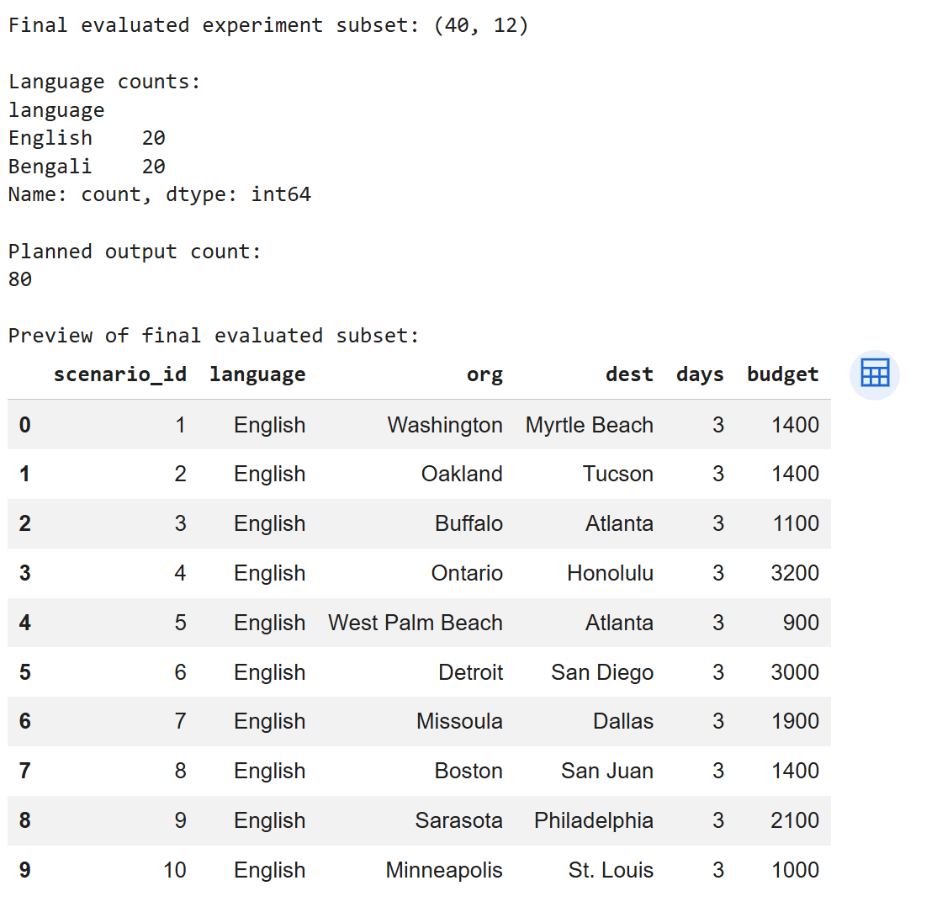
Figure 1 - Preview of the first 10 English input scenarios from the evaluated TravelPlanner subset.
Figure 1 shows the first 10 English input cases from the final evaluated subset, illustrating the origins, destinations, three-day duration and budget values present in the selected cases. The corresponding Bengali cases use the same underlying structured scenario values.

3.3 Multilingual Dataset Preparation
The bilingual primary dataset consisted of 20 underlying TravelPlanner scenarios, each represented once in English and once in Bengali, resulting in 40 matched scenario-language cases. The final Bengali query text was generated from the structured scenario fields using a fixed Bengali template. Origin and destination names, dates, traveller counts, budgets and any available local-constraint fields were inserted directly from the corresponding source row. This approach was chosen after earlier translation experiments because it preserved the key constraints deterministically.


Figure 2 - Example English TravelPlanner prompts and corresponding template-generated Bengali prompts used for bilingual evaluation.
Figure 2 illustrates the paired English and Bengali query construction. The Bengali prompts were template-generated from the same structured scenario fields rather than being free-form translations of the English text. This preserved origin, destination, trip duration, dates, number of travellers and budget across the two language versions.
The final input file was checked by comparing the paired structured fields used to construct each query. Because the Bengali prompt was generated from those fields, numerical values and named locations were preserved directly. This controls an important source of cross-lingual variation, although it does not constitute an independent linguistic validation of Bengali naturalness.

3.4 System Conditions
Three system conditions were implemented, with the third reserved for the supplementary smaller-sample evaluation.

Table 2 - System conditions compared.
Feature | Non-agentic baseline | Structured agentic-style pipeline | Multi-agent extension, supplementary only
Response style | Direct single-step generation | Single API call with ordered constraint checking before final generation | Separate Planner, Checker, Revision and Final Validator calls
Constraint extraction | Implicit, within a single prompt | Explicitly prompted within the same generation call | Explicitly checked across separate workflow stages
Validation behaviour | Not explicitly prompted | Prompted to remain aligned with constraints during generation | Checker and Final Validator review grounding, costs and feasibility
Workflow complexity | Lower | Higher | Highest
External tools used | None | None | None

The structured condition is consistently described in this document as a structured agentic-style pipeline or, where brevity is needed, an agentic-style pipeline. It does not use live tools, persistent memory, or autonomous action, and no broader claim about agentic systems in general is intended. This bounded terminology is used to avoid overclaiming and to ensure that the title and narrative accurately reflect the capabilities that were implemented. The distinction between agentic-style prompting and full agentic capability is maintained throughout the document to ensure conceptual clarity and to prevent readers from assuming capabilities that were not part of the experimental design.

3.5 Prompt Design
The baseline prompt instructed the model to create a travel plan using only the reference information provided. The prompt was designed to be clear and direct, mirroring how a user might naturally request a travel plan from an LLM.
The structured primary condition used a single Gemini API call with an explicitly ordered set of instructions inside the prompt. Before producing the final itinerary, the model was instructed to identify the origin, destination, dates, trip duration, traveller count and budget; inspect the available reference information; check support for transport, accommodation, restaurants and attractions; construct the day-by-day plan; re-check dates, budget and constraints; and state when information was missing rather than guessing. The baseline used the same model and reference information but did not contain this ordered decomposition/checking sequence. The contrast is therefore between direct grounded generation and structured grounded prompting, not between one API call and a genuinely autonomous multi-step agent.
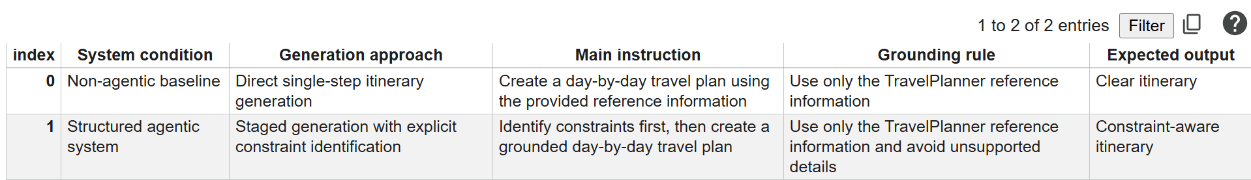
Figure 3 - Summary of prompt design differences between the non-agentic baseline and structured agentic-style pipeline.
This diagram should be read as a conceptual contrast between direct generation and the ordered reasoning/checking stages embedded within the structured prompt. In the archived implementation, the structured primary condition was executed as one API call rather than as two separately persisted model calls.
The supplementary condition implemented a separate multi-call workflow consisting of Planner, Checker, Revision and Final Validator stages. This is operationally different from the primary structured prompt and is therefore reported only as an exploratory extension. The final primary prompts and a description of the supplementary stages are provided in Appendix B.

3.6 Experimental Procedure
All experiments were run in Google Colab using Python. For each scenario-language case, baseline and structured outputs were generated with Gemini 2.5 Flash and saved to CSV. The same reference information was supplied to both conditions. The generation code saved intermediate backups and used retry handling for API errors. The completed primary file contains 40 successful Baseline outputs and 40 successful Agentic-labelled structured-pipeline outputs; the notebook records that a missing Bengali Agentic output for scenario 11 was rerun and then written back to the completed file. Evaluation was performed on the saved outputs so that later API changes could not alter the scored material.
The experimental procedure was designed to minimise sources of variation other than the system condition itself, ensuring that observed differences could be attributed to the workflow structure rather than to confounding factors such as model version changes or different experimental environments.
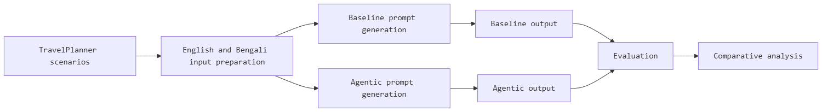
Figure 4 - Experimental procedure for comparing baseline and structured-pipeline travel-planning outputs.
This flowchart depicts the experimental workflow: each scenario is processed by both systems, outputs are saved to CSV, then evaluated using manual rubric scoring and algorithmic rule validation.

3.7 Evaluation Metrics
Each output was evaluated against eight technical criteria, each scored 0, 1, or 2, plus a separate holistic overall-validity judgement scored on the same 0–2 scale. The rubric was refined from an initial version through a pilot study on three scenarios and is presented below with full behavioural anchors for each score level.

Table 3 - Evaluation of rubric with behavioural scoring anchors
Metric | 0: Failed | 1: Partial | 2: Full
Hallucination control | Output includes one or more material unsupported entities such as flights, hotels, restaurants, attractions, prices, or transport options not present in the reference data | Output is largely grounded but includes minor ambiguous phrasing or one borderline unsupported detail that does not materially affect the plan | All named entities, prices, and transport options are traceable to the reference information
Constraint satisfaction | Plan violates one or more hard constraints such as wrong origin, wrong destination, wrong trip length, or wrong number of travellers | Plan respects core constraints but contains one ambiguity or minor omission in how constraints are expressed | All explicit constraints from the scenario are respected throughout the plan
Budget adherence | Plan demonstrably exceeds the stated budget or uses materially unsupported cost estimates | Costing is incomplete or contains minor uncertainty but no confirmed major overrun; budget is at least acknowledged | All included costs are supported, and the calculated total remains within budget
Date consistency | Wrong dates, wrong duration, or impossible day and date sequence | Mostly correct but contains one ambiguity or minor inconsistency | All dates, days, and travel sequences are internally consistent
Transport feasibility | Transport connections are impossible, unsupported, or materially misrepresented | Transport is largely supported but one leg is ambiguous or suboptimally described | All transport legs are supported and feasible given the reference data
Accommodation support | Accommodation is invented or contradicted by the reference data | Some accommodation details are supported but important fields are missing or uncertain | Accommodation and its material attributes are fully supported by the reference data
Itinerary completeness | Major days or trip components are missing | Plan covers the trip but is thin on one day or component | Each day of the trip is meaningfully covered with activities and logistics
Language consistency | Output is in the wrong language or mixes languages unintentionally | Output is mostly in the target language but contains isolated foreign terms or awkward phrasing | Output is consistently in the target language and reads naturally
Overall validity | Plan is materially unusable due to errors | Plan is usable in principle but has notable weaknesses that would require correction | Plan is coherent, grounded, and usable as a travel itinerary

Multiple errors within a metric are combined by taking the score that best reflects the overall severity of the failures. For hallucination control, a higher score indicates better performance, that is, fewer or no hallucinations. Missing information is treated as not provided and scored according to whether the omission renders the criterion failed, partial, or acceptable. A clear distinction is maintained between unsupported, meaning not present in the reference data, incorrect, meaning contradicting the reference data, and not provided, meaning simply absent from the output. One worked scoring example and one borderline example are provided in Appendix A to illustrate the application of these rules. The rubric was designed to balance specificity with practical applicability, providing enough guidance to ensure consistent scoring while remaining flexible enough to capture the nuances of real model outputs.
The development of the rubric followed an iterative process. An initial version with broader, less specific criteria was drafted based on the TravelPlanner benchmark evaluation guidelines [8]. This initial rubric was then applied to the three pilot scenarios, and ambiguities or inconsistencies in scoring were identified. For example, the initial version did not clearly distinguish between a plan that omits accommodation entirely and one that mentions accommodation but provides unsupported details. This distinction was clarified in the revised rubric through the behavioural anchors for each score level. The iterative refinement process helped to ensure that the rubric criteria are both comprehensive and discriminable, meaning that they cover the important dimensions of itinerary quality while also enabling consistent scoring across different outputs.
The decision to use a three-point scale (0, 1, 2) rather than a finer-grained scale was motivated by several considerations. First, a three-point scale was selected to provide a clear distinction between failed, partial, and fully satisfactory performance while keeping the manual evaluation process practical and consistent. Second, the distinctions between adjacent score levels on a finer-grained scale, such as a five-point scale, would be difficult to define clearly and apply consistently, particularly for a single evaluator. Third, the three-point scale maps naturally onto the conceptual distinction between failed, partial, and full performance on each criterion, which is both intuitive to apply and easy to interpret in the results. The trade-off, of course, is reduced sensitivity: slight differences in quality within each score band are not captured. This limitation is partially mitigated by the eight technical criteria, which together provide a multi-dimensional profile of each itinerary's strengths and weaknesses; overall validity is retained as a separate holistic judgement.
The directionality of each scale was also carefully considered. For all criteria, a higher score indicates better performance. This is straightforward for most criteria but requires careful definition for hallucination control, where "better" means fewer hallucinations. The rubric explicitly defines the score levels so that a score of 2 indicates no material unsupported entities, a score of 1 indicates largely grounded output with minor issues, and a score of 0 indicates material unsupported entities. This consistent directionality simplifies the interpretation of results and the calculation of composite scores, as all metrics are oriented in the same direction.

3.8 Statistical Analysis
$$\bar{x}= \left(\frac{1}{n}\right)\sum_{i=1}^{n}{x_{i}}$$
The arithmetic mean was used to summarise performance for each system and criterion, where $x_{i}$denotes an individual score and $n$is the number of observations.
$$s = \sqrt{\left[\frac{\sum_{i=1}^{n}{{\left(x_{i}- \bar{x}\right)}^{2}}}{n - 1}\right]}$$
where $x_{i}$denotes an individual score, $\bar{x}$ is the sample mean, and $n$ is the number of observations.
$$CI_{95}\% = \left[Q_{0.025} (\overline{d*}), Q_{0.975} (\overline{d*})\right]$$
where $Q_{0.025}$and $Q_{0.975}$denote the 2.5th and 97.5th percentiles of the bootstrap distribution of the mean paired difference, respectively.
For the primary outcomes, 95% paired bootstrap confidence intervals were calculated for the mean structured-minus-baseline difference using 10,000 paired resamples and the percentile method [45]. The scenario-language pair was the matching unit, and a fixed random seed (42) was used.
$$d_{i}=S_{i}-B_{i}$$
where $d_{i}$ is the paired difference for scenario-language case $i$, $S_{i}$ is the structured-pipeline score, and $B_{i}$ is the baseline score.
$$r_{rb}=\frac{\left(R^{+}- R^{-}\right)}{\left(R^{+}+ R^{-}\right)}$$
where $R^{+}$ and $R^{-}$ denote the sums of the positive and negative signed ranks, respectively.
The Wilcoxon signed-rank test was used for paired comparisons because each scenario-language case was evaluated under both system conditions [46]. Rank-biserial correlation was used as the paired effect-size measure, with positive values favouring the structured pipeline and negative values favouring the baseline.
For the primary experiment, the eight technical criteria and the separate holistic overall-validity judgement were analysed at the criterion level using paired Wilcoxon signed-rank tests. Hallucination control and overall validity were treated as the two primary outcomes, while the remaining seven technical criteria were treated as secondary. Holm correction was applied across the full set of nine criterion-level p-values, providing a conservative family-wise error control [47].
The primary analysis reports the mean paired difference, median paired difference, 95% paired bootstrap confidence interval for the mean difference, win/tie/loss counts, Wilcoxon statistic, raw p-value, Holm-adjusted p-value, and rank-biserial effect size for the two primary outcomes. No primary claim of statistical significance is made unless the corrected p-value is below .05.
The technical composite is calculated descriptively as the mean of the eight specific technical criteria, excluding holistic overall validity to avoid double-counting. Holistic overall validity is reported separately because it represents a summary judgement that partly reflects the underlying technical dimensions.
The supplementary workflow was analysed descriptively because the archived work contains six scenario-language cases and a completed deterministic rule-validation output but does not contain a persisted final nine-criterion scored table from which the previously drafted Friedman and pairwise Wilcoxon results could be independently reproduced. The final report therefore does not make inferential claims for the supplementary three-system comparison.
For the supplementary comparison, the deterministic validator provides the reproducible evidence retained in the project archive. Baseline, structured and multi-agent outputs were checked using the same rule-based validation framework. The six language-specific cases correspond to three underlying scenarios represented in English and Bengali, so they are treated as a small exploratory sample rather than six fully independent real-world scenarios.

3.9 Pilot Study
A pilot study was conducted on three scenarios to refine the rubric and prompts. The pilot suggested that both systems could produce usable plans and that the evaluation criteria were discriminable. It also revealed ambiguities in the initial rubric wording that were resolved before the main experiment. In particular, the distinction between score levels 1 and 2 for accommodation support was clarified, and the generation prompts were slightly rephrased for clarity. The pilot also exposed practical issues with API call formatting and output saving, which were resolved before the main data collection.

3.10 Supplementary Multi-Agent Evaluation
On a supplementary sample comprising scenario IDs 1-3 in English and Bengali (six scenario-language cases), the notebook implemented a planner, checker, revision and final-validator workflow. The workflow generated one multi-agent output for each case and retained the corresponding baseline and structured outputs for comparison. All six multi-agent cases reached an 'approved with limitations' status in the notebook's final validation stage. Because this status was itself produced by a model-based validator, it is treated as workflow evidence rather than independent ground truth. The final quantitative supplementary comparison therefore relies on the archived deterministic rule-validation files.

3.11 Reliability of Manual Evaluation
All primary rubric scores were recorded by one researcher using the 0-1-2 rubric. Formal inter-rater reliability was not available because no independent second scorer was used. The deterministic validator was therefore used only as a complementary structural cross-check and not as a substitute for independent human agreement.
First, algorithmic rule validation. A deterministic rule-based checker separately verified structural properties such as date coverage, budget mention, and supported entity use. This provides a reproducible cross-check on the manual judgements. The agreement between the two methods is reported in Chapter 4 as converging evidence; it is not treated as independent inter-rater validation.
Second, no blinded second scoring pass was conducted. Formal intra-rater reliability therefore cannot be reported. This is acknowledged as a limitation rather than being presented as a completed validation step.

3.12 Ethical Considerations and Data Management
All data used in this study are from the publicly available TravelPlanner benchmark or generated via Google Gemini API under its terms of service. No personal or sensitive data were collected. Generated outputs, raw scores, and analysis code are retained in a secure research archive as described in the reproducibility appendix.
The broader ethical risks of large language models are acknowledged. These include the potential for biased outputs, the generation and amplification of misinformation, environmental impact from training and inference, and issues of fairness and access across different user groups and languages [48], [49], [50]. Model reporting and dataset documentation practices follow the principles of model cards [51] and datasheets for datasets [52] as far as they apply to this student project. The study also considers the ethical implications of its findings: if LLM-based travel planners are deployed commercially without adequate reliability safeguards, users could suffer financial loss or practical inconvenience, highlighting the importance of rigorous evaluation methodologies such as the one developed here.
The principal methodological limitations are the single-evaluator primary scoring, the absence of formal inter-rater or intra-rater reliability, and the restricted difficulty profile of the primary sample. Although a 200-row bilingual input file was prepared, the completed primary evaluation used the first 20 underlying scenario IDs in both languages; these were all easy-level cases without additional local constraints. The study therefore cannot establish whether the observed workflow trade-off would also occur in medium or hard TravelPlanner scenarios. In addition, the supplementary multi-agent evaluation contains only three underlying scenarios represented in two languages. Finally, the archived notebooks do not explicitly set Gemini generation parameters such as temperature, top-p or maximum output tokens; therefore, fixed values for these settings cannot be reported. These limitations are considered further in Chapter 6.

Chapter 4: Implementation and Results

4.1 Implementation Overview
The experiment was implemented in Python using Google Colab as the primary coding environment. Scenario data and reference information were loaded from structured CSV files. The Gemini 2.5 API was called for each system condition using the appropriate prompt or prompt sequence, and outputs were saved for later evaluation. Manual scoring was conducted against the rubric described in Chapter 3, and algorithmic rule validation was applied programmatically as a complementary cross-check. Graphs and statistical analyses were generated using standard Python libraries. The implementation was designed with reproducibility in mind, with the primary prompts, dataset structure, scoring rubric, analysis procedures and archived outputs documented in Appendix B.

Table 4 - Tools and libraries
Tool or library | Purpose in the study
Google Colab | Main coding and experiment environment
Python | Data processing, evaluation, and visualisation
Pandas | Loading, cleaning, and analysing CSV files
Matplotlib | Creating comparison graphs
Google Gemini API | Generating travel itineraries
NumPy and SciPy | Statistical calculations

4.2 Implementation Environment
The experiments were implemented with Gemini 2.5 Flash through Google Colab and the Google Gemini API. The archived generation notebook explicitly records the model name as gemini-2.5-flash. API calls were made through SDK’s generate_content interface. The notebook does not set explicit temperature, top-p, maximum-output-token or generation seed values; those settings therefore remained at the API/SDK defaults in the archived implementation and are not reported as controlled experimental parameters. Both primary conditions used the same model and calling code, which preserves the within-case workflow comparison even though exact decoding parameters were not explicitly fixed.

4.3 Final Dataset and Output Structure

Table 5 - Primary experiment scope
Language condition | Number of scenario-language cases | System outputs per case | Total generated outputs
English | 20 | 2 | 40
Bengali | 20 | 2 | 40
Total | 40 | 2 | 80

Table 5 summarises the scope of the primary experiment. The evaluation comprised 40 scenario-language cases across two language conditions: English and Bengali, with 20 cases for each language. For every scenario-language case, both systems generated one output, resulting in 40 outputs per language condition and 80 generated outputs in total. This structure ensured that the two systems were evaluated on matched scenario content across both language conditions, enabling a consistent comparison of their performance.

4.4 Pilot Results
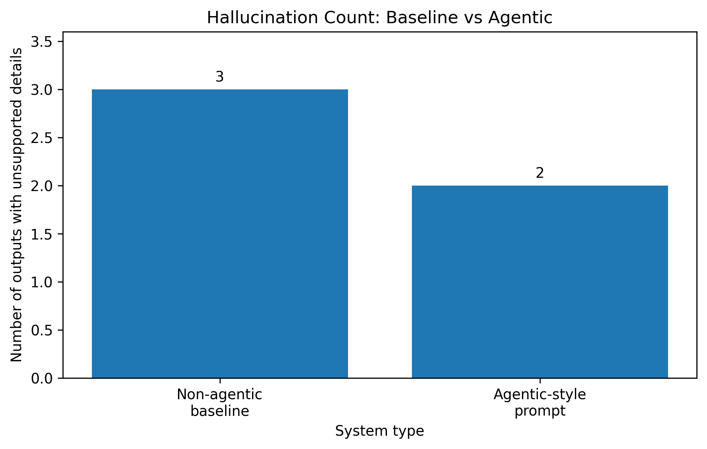
Figure 5 - Pilot unsupported details: baseline in all three scenarios, structured pipeline in two.
The pilot revealed that unsupported details appeared in all three baseline outputs and two of the three structured outputs, providing preliminary evidence of a grounding advantage.
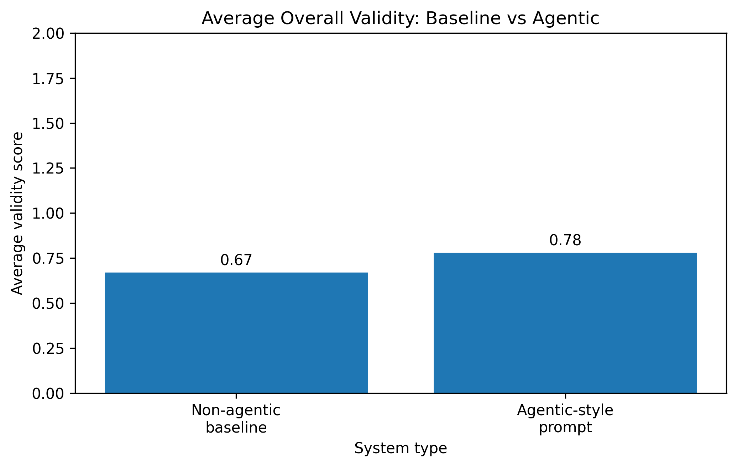
Figure 6 - Pilot average overall validity score for baseline and structured-pipeline outputs.
Pilot average overall validity scores showed a small descriptive advantage for the structured agentic-style system (0.78 versus 0.67).
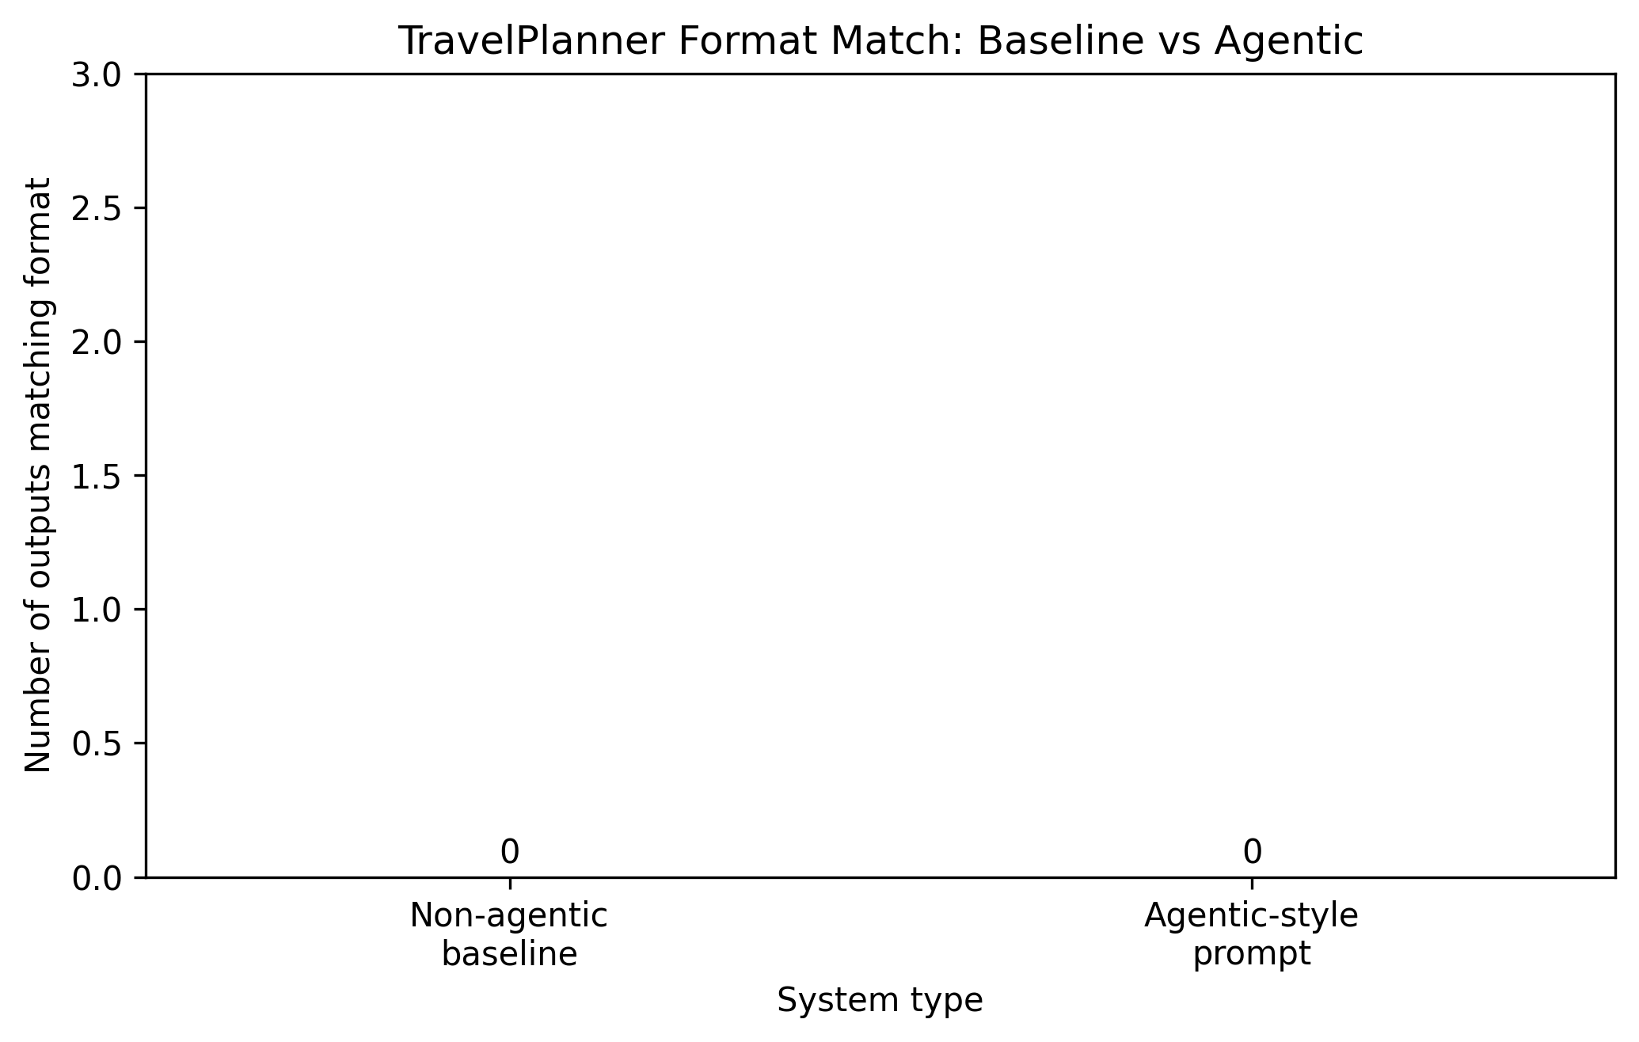
Figure 7 - Pilot TravelPlanner format match for baseline and structured-pipeline outputs.
Neither system produced outputs that formally matched the TravelPlanner evaluation format in the pilot, indicating format adherence requires more explicit instruction.
Table 6 - Pilot study summary
Pilot measure | Non-agentic baseline | Structured agentic-style pipeline
Outputs with unsupported details | 3 out of 3 | 2 out of 3
Outputs matching TravelPlanner format | 0 out of 3 | 0 out of 3
Average overall validity score | 0.67 | 0.78

The pilot indicated that both systems could produce usable plans and that the structured approach showed a small descriptive advantage on grounding. It also led to minor refinements in the rubric wording and prompt phrasing before the main experiment. In particular, the distinction between score levels 1 and 2 for accommodation support was clarified following pilot ambiguities.

4.5 Full Evaluation Results
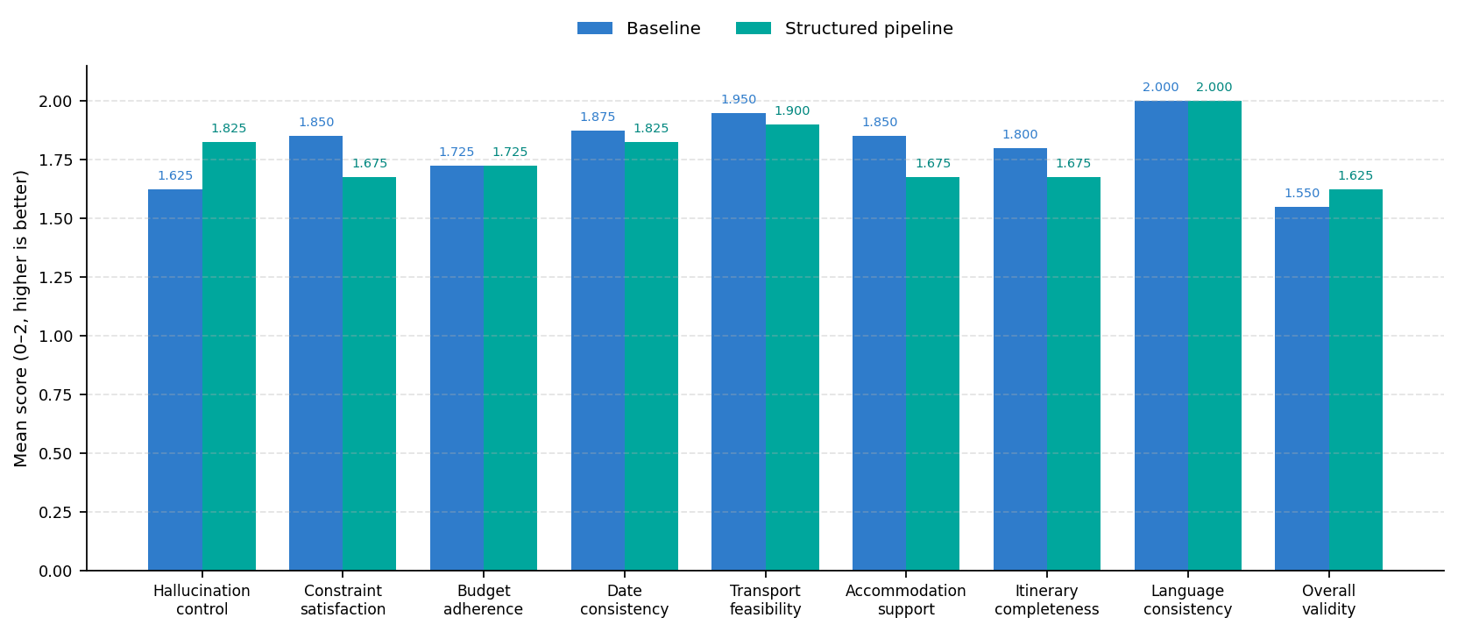
Figure 8 - Mean evaluation scores for the eight technical criteria and separate overall validity, n = 40.
Figure 8 summarises the eight technical criterion means and the separate holistic overall-validity mean for the 40 matched scenario-language pairs. The pattern is mixed: the structured pipeline is higher on hallucination control and holistic overall validity, whereas the baseline is higher on most constraints, feasibility, and completeness criteria.

Table 7 - Primary experiment, manual rubric scores, n = 40 matched pairs
Evaluation metric | Baseline mean | Structured pipeline mean | Mean paired difference, pipeline minus baseline | Direction
Hallucination control | 1.625 | 1.825 | +0.200 | Structured pipeline higher
Constraint satisfaction | 1.850 | 1.675 | -0.175 | Baseline higher
Budget adherence | 1.725 | 1.725 | 0.000 | Tied
Date consistency | 1.875 | 1.825 | -0.050 | Baseline higher
Transport feasibility | 1.950 | 1.900 | -0.050 | Baseline higher
Accommodation support | 1.850 | 1.675 | -0.175 | Baseline higher
Itinerary completeness | 1.800 | 1.675 | -0.125 | Baseline higher
Language consistency | 2.000 | 2.000 | 0.000 | Tied
Technical composite, 8 metrics only | 1.834 | 1.788 | -0.046 | Baseline slightly higher
Overall validity, holistic and separate | 1.550 | 1.625 | +0.075 | Structured pipeline slightly higher

Across the eight technical criteria, the baseline is higher on five, the systems are tied on two, and the structured pipeline is higher on one. The largest baseline advantages occur in constraint satisfaction and accommodation support (both -0.175), followed by itinerary completeness (-0.125). The structured pipeline's largest advantage is hallucination control (+0.200). Overall validity is also higher for the structured pipeline by +0.075.
The primary criterion-level Wilcoxon results do not establish statistically significant differences after Holm correction. For hallucination control, the structured pipeline had a mean of 1.825 versus 1.625 for the baseline (mean paired difference = +0.200). The median paired difference was 0.000, and the 95% paired percentile-bootstrap CI for the mean difference was [-0.025, 0.400]. The Wilcoxon test gave W = 63.0, raw p = .0736 and Holm-adjusted p = .5155, with a rank-biserial effect of 0.4000; there were 14 Structured pipeline wins, 6 Baseline wins and 20 ties. For overall validity, the structured pipeline had a mean of 1.625 versus 1.550 for the baseline (mean paired difference = +0.075). The median paired difference was 0.000, with a 95% paired percentile-bootstrap CI of [-0.125, 0.300]. The Wilcoxon test gave W = 80.0, raw p = .4913 and Holm-adjusted p = 1.000, with a rank-biserial effect of 0.1579; there were 11 Structured pipeline wins, 8 Baseline wins and 21 ties. The results therefore support a descriptive trade-off rather than a claim of statistically significant superiority.
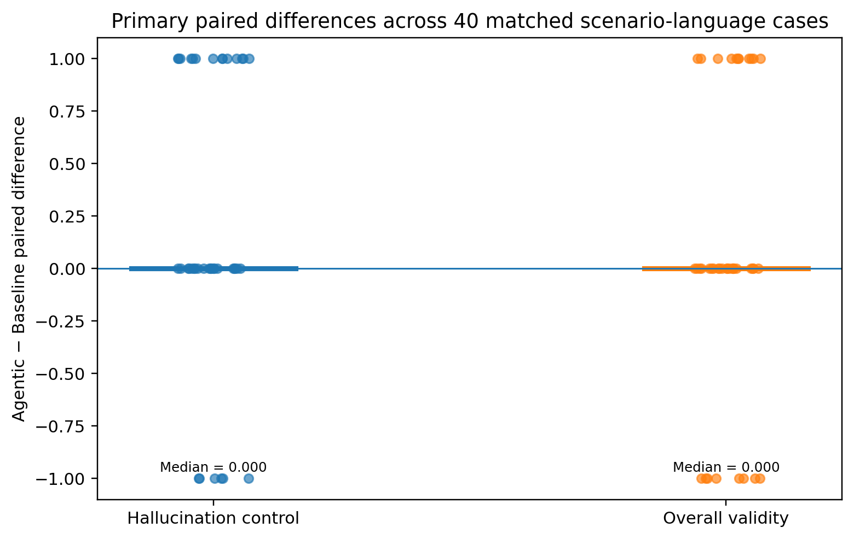
Figure 9 - Difference between structured-pipeline and baseline average scores.
Figure 9 shows the 40 matched Structured pipeline-minus-Baseline differences for the two primary outcomes. The horizontal zero line denotes no paired change; the short horizontal marker within each outcome shows the median paired difference (0.000 for both outcomes).

Table 8 - Primary Inferential Results
Primary outcome | Baseline | Structured pipeline | Mean Δ | Median Δ | 95% paired bootstrap CI | Wilcoxon / effect
Hallucination control | 1.625 | 1.825 | +0.200 | 0.000 | [-0.025, 0.400] | W = 63.0; p = .0736; Holm p = .5155; r_rb = .4000; 14/20/6 wins/ties/losses
Overall validity | 1.550 | 1.625 | +0.075 | 0.000 | [-0.125, 0.300] | W = 80.0; p = .4913; Holm p = 1.000; r_rb = .1579; 11/21/8 wins/ties/losses

Note: Δ denotes Structured pipeline minus Baseline. Confidence intervals are 95% percentile intervals for the mean paired difference, based on 10,000 paired bootstrap resamples of the 40 scenario-language differences (random seed = 42). Holm-adjusted p-values shown here use the conservative nine-test family reported in the criterion-level analysis.

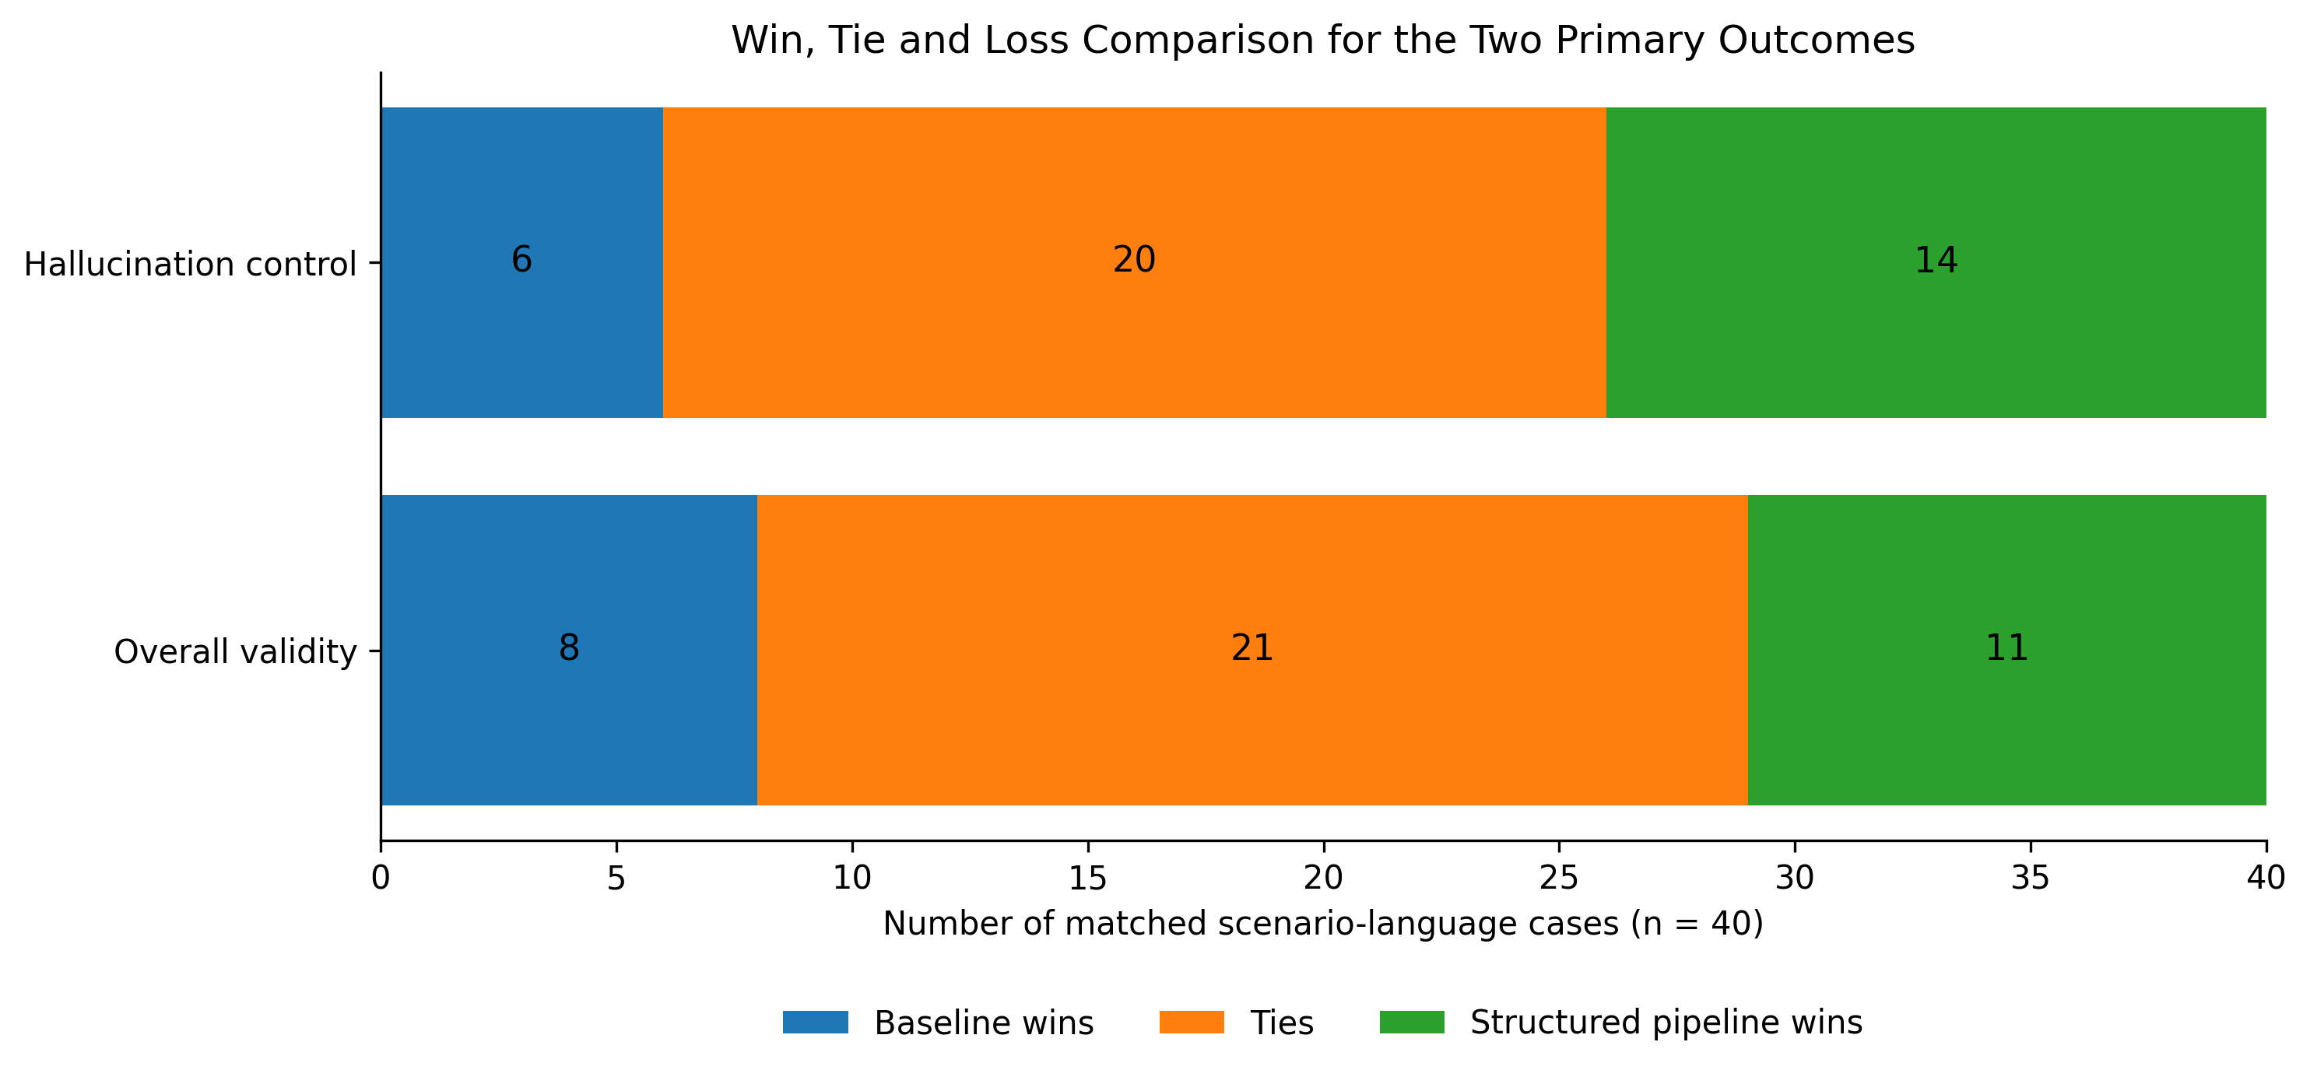
Figure 10 - Win, tie and loss comparison between the baseline and structured agentic-style pipeline for the two primary outcomes
Figure 10 provides a case-level view of the two primary outcomes. For hallucination control, the structured pipeline performed better in 14 of the 40 matched cases, compared with 6 wins for the baseline, while 20 cases were tied. For overall validity, the structured pipeline recorded 11 wins and the baseline recorded 8, with 21 ties. Although the structured pipeline achieved more wins than the baseline on both outcomes, the high proportion of tied cases shows that differences between the systems were not consistent across the full sample. This supports the inferential results, which indicate a descriptive advantage for the structured pipeline but do not establish statistically significant superiority.

4.6 Algorithmic Rule Validation
A deterministic rule-based checker was applied to all 98 generated outputs, comprising 80 primary outputs and 18 supplementary outputs. The checker assessed structural properties such as date coverage, required-day coverage, accommodation support, origin and destination mention, supported food or attraction references, budget statements, transport support, and language consistency.
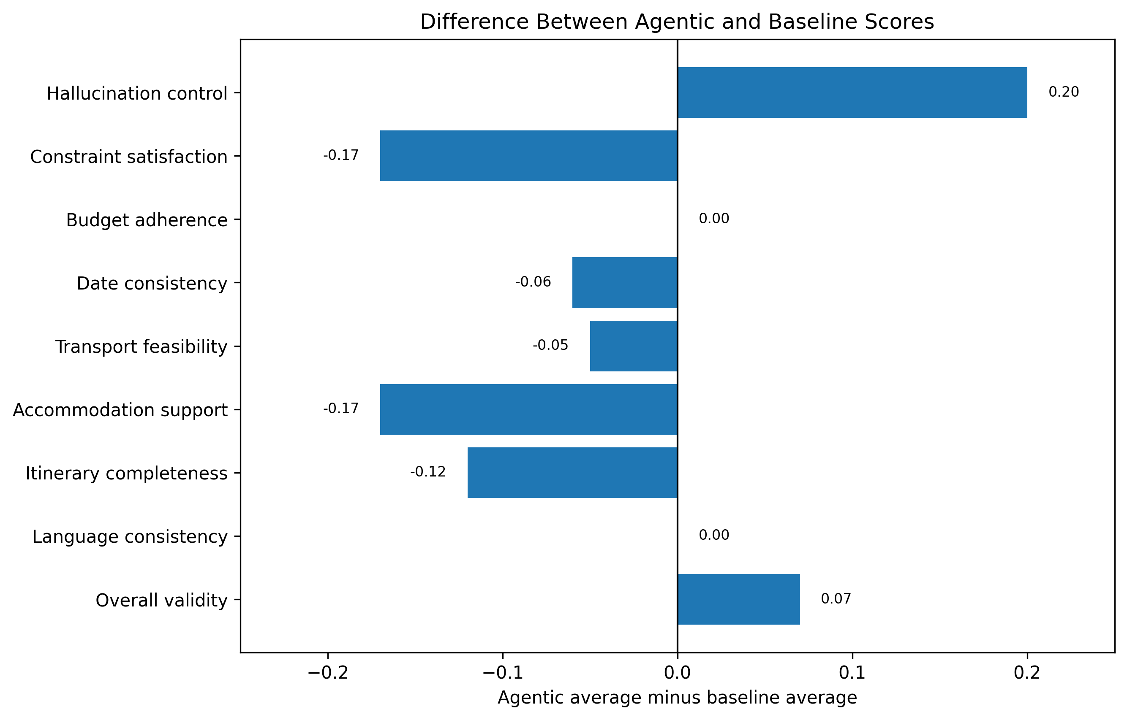
Figure 11 - Mean structured-pipeline-minus-baseline differences across the eight technical criteria and separate overall validity.
The difference plot makes the trade-off visually clear: positive values favour the structured pipeline on hallucination control and overall validity, while negative values favour the baseline on most completeness and feasibility criteria.

Table 9 - Deterministic rule failures, main experiment by system
Rule | Structured pipeline failure rate, per cent | Baseline failure rate, per cent
Requested dates covered | 40.0 | 37.5
Required days covered | 27.5 | 17.5
Supported accommodation or limitation noted | 22.5 | 15.0
Origin mentioned | 17.5 | 15.0
Supported food or attraction detected | 7.5 | 5.0
Stated total within budget | 5.0 | 3.7
Budget acknowledged | 2.5 | 0.0
Destination mentioned | 2.5 | 2.5
Supported transport detected | 0.0 | 2.5
Language consistent | 0.0 | 0.0
Output available | 0.0 | 0.0

The rule-based results broadly converge with the manual pattern, particularly for accommodation and date-related omissions. In the main experiment, the structured pipeline had higher failure rates for requested-date coverage (40.0% versus 37.5%), required-day coverage (27.5% versus 17.5%), and supported accommodation or an explicit limitation note (22.5% versus 15.0%). These checks provide reproducible supporting evidence for the observed completeness trade-off, but they should not be described as independent human validation.
Note: Failure rates are calculated using the number of outputs for which each rule was applicable. Denominators therefore vary across rules. For example, the “stated total within budget” rule was applicable to 27 baseline outputs and 20 structured-pipeline outputs.
Table 10 - Rule validation summary scores
System | Mean validation score, per cent | Pass rate, per cent
Baseline | 94.11 | 100.0
Structured agentic-style pipeline | 93.68 | 97.5

Table 10 summarises the overall rule-based validation performance for the two systems, showing similar mean validation scores and a slightly higher pass rate for the baseline.

4.7 Results by Language
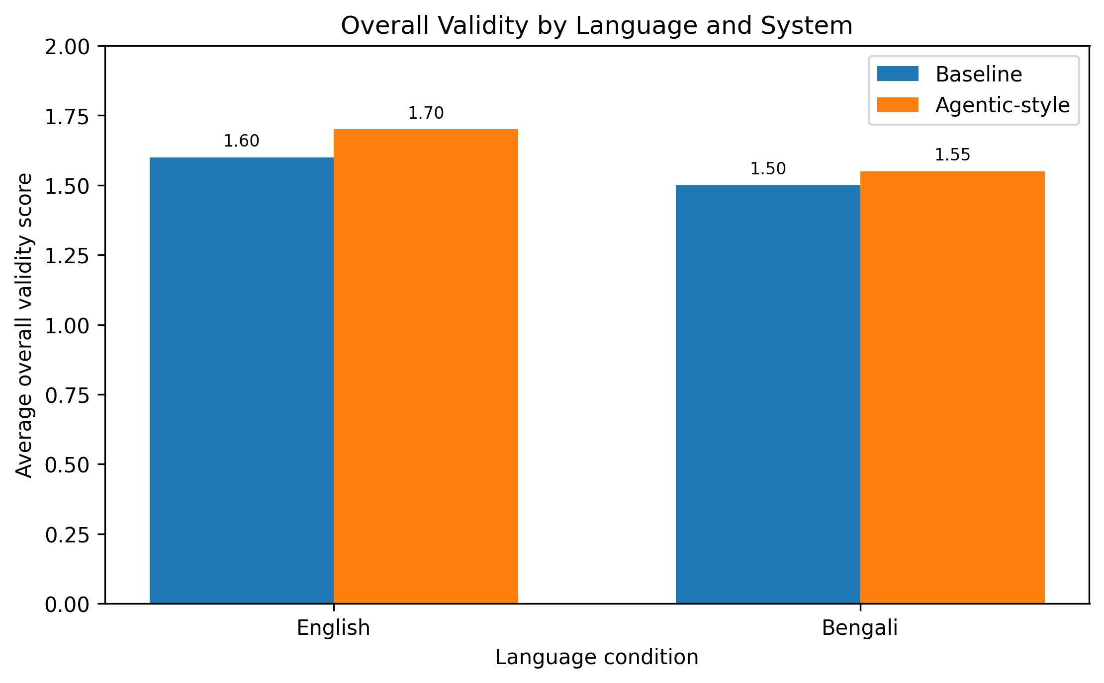
Figure 12 - Overall validity by language and system.
Both languages show the same descriptive direction for holistic overall validity: the structured pipeline is higher in English (1.70 versus 1.60) and Bengali (1.55 versus 1.50). The difference is larger in English (+0.10) than in Bengali (+0.05). These are descriptive language-level comparisons; the study does not claim a statistically significant language interaction.
Table 11 - Overall validity by language
Language | Baseline overall validity | Structured pipeline overall validity
English | 1.60 | 1.70
Bengali | 1.50 | 1.55

The bilingual results suggest that the structured pipeline's modest holistic advantage was present in both languages, but the gain was smaller in Bengali. One possible explanation is that multi-stage instruction following or constraint extraction may be less reliable in Bengali, although this mechanism was not directly tested. The finding is therefore best treated as a descriptive indication that language may moderate the practical value of structured prompting.

4.8 Supplementary Three-System Evaluation
The supplementary evaluation examines a planner-checker-revision-validator workflow on three underlying scenarios represented in English and Bengali (six scenario-language cases). The archived notebook confirms completion of all six multi-agent workflows. For a reproducible quantitative comparison, this section reports the deterministic validator outputs retained in the project archive rather than the unsaved model-based nine-criterion evaluation.
Table 12 - Supplementary deterministic validation summary, n = 6 scenario-language cases per system
System | Outputs | Mean validation score (%) | Median validation score (%)
Baseline | 6 | 93.64 | 90.91
Structured pipeline | 6 | 93.64 | 90.91
Multi-agent | 6 | 93.64 | 95.45

Table 12 reports the deterministic validation archived results. The mean validation score was identical across the three systems at 93.64%. The multi-agent condition had a higher median score (95.45% versus 90.91%), but its strict pass rate was lower because one of six outputs was classified as Pass with limitations. With only three underlying scenarios, these values are descriptive and do not demonstrate superiority of any system.

4.9 Repair Stage
Two outputs that failed initial rule validation were subjected to a targeted repair stage in which identified issues were addressed.

Table 13 - Targeted repair results
Measure | Value
Number of repair candidates | 2
Mean score before repair, per cent | 75
Mean score after repair, per cent | 95
Mean score improvement, percentage points | +20
Outputs reaching Pass after repair | 2 out of 2
Repair success rate, per cent | 100

In the two cases examined, the repair stage resolved the identified validation failures: the mean validation score increased from 75% before repair to 95% after repair, and both candidates passed after repair. Because only two candidates were repaired, this should be treated as preliminary evidence rather than an estimate of a general repair success rate.

Chapter 5: Discussion

5.1 Interpreting the Findings
The primary results do not support a general claim that the structured agentic-style pipeline is better than direct generation. Instead, the 40 matched cases show a consistent trade-off: the structured pipeline is more successful at avoiding unsupported details, while the baseline performs better on several aspects of completeness and feasibility. The inferential tests strengthen the interpretation by showing that neither of the two primary outcomes reached statistical significance after Holm correction.

5.2 RQ1: Does the Structured Pipeline Produce Fewer Groundedness Errors?
RQ1 is supported descriptively but not inferentially. Hallucination control was higher for the structured pipeline (1.825 versus 1.625), a mean difference of +0.200. The paired Wilcoxon test gave W = 63.0 and a raw p-value of .0736; after Holm correction across the nine criterion-level tests, the adjusted p-value was .5155. The rank-biserial effect was 0.4000, and the paired results contained 14 Structured pipeline wins, 6 Baseline wins, and 20 ties. The result therefore suggests a meaningful descriptive tendency towards better grounding, but it is not statistically significant under the study's multiple-testing correction.
The absolute scores are also informative. The baseline mean of 1.625 indicates that most outputs were already reasonably well grounded, leaving limited room for improvement. The structured pipeline moved the mean closer to the maximum score of 2.0, but the uncertainty around the paired comparison means that this improvement should be treated as a pattern to investigate rather than a demonstrated effect.
A plausible explanation is that the ordered constraint-identification instructions focus the model on information explicitly represented in the scenario and reference data. It may also encourage a more cautious generation style, reducing the tendency to assert details that are not clearly supported. These are possible mechanisms rather than mechanisms established by the experiment; testing them would require targeted ablation studies.

5.3 RQ2: Does the Structured Pipeline Improve Constraint Adherence?
RQ2 is not supported as a general improvement claim. The baseline scored higher on constraint satisfaction (1.850 versus 1.675), date consistency (1.875 versus 1.825), transport feasibility (1.950 versus 1.900), accommodation support (1.850 versus 1.675), and itinerary completeness (1.800 versus 1.675). Budget adherence was identical at 1.725, while language consistency was 2.000 for both systems. None of the nine criterion-level Wilcoxon comparisons was statistically significant after Holm correction, so these differences should be interpreted as descriptive.
The pattern is consistent with a caution-completeness trade-off. The structured pipeline appears less willing to assert unsupported details, but that caution can also lead to omissions. The rule checker supports this interpretation: structured outputs had higher failure rates for date coverage, required-day coverage, and accommodation support. The evidence therefore points to a change in error type rather than a simple reduction in all errors.
This result demonstrates why a single aggregate score would have been insufficient. A grounding-only evaluation would favour the structured pipeline, while a completeness-oriented evaluation would favour the baseline. Separating the criteria makes the trade-off visible and avoids turning a mixed result into an overly broad claim of superiority.
The largest descriptive disadvantages for the structured pipeline were accommodation support and constraint satisfaction (-0.175 each), followed by itinerary completeness (-0.125). Smaller differences occurred regarding date consistency (-0.050) and transport feasibility (-0.050). These differences suggest that omission is concentrated in particular parts of the itinerary rather than being uniformly distributed across the task.

5.4 RQ3: How Does Performance Differ Between English and Bengali?
RQ3 shows the same descriptive direction in both languages. Overall validity was 1.70 for the structured pipeline versus 1.60 for the baseline in English, and 1.55 versus 1.50 in Bengali. The smaller Bengali gap should not be over-interpreted because no formal interaction test was conducted. One possible explanation, which was not directly tested, is that the model may follow complex multi-stage instructions less consistently in Bengali, reducing the benefit of the structured workflow.

5.5 RQ4: What Error Patterns Were Most Common?
The most prominent rule-based failures in the main experiment concerned requested-date coverage (40.0% for the structured pipeline versus 37.5% for the baseline), required-day coverage (27.5% versus 17.5%), and supported accommodation or an explicit limitation note (22.5% versus 15.0%). These are primarily omission-type failures. The manual scores show the same broad pattern, particularly for accommodation support and itinerary completeness.
The agreement between manual scoring and deterministic checking provides converging evidence that the pattern is not solely a product of the manual scoring procedure. However, the rule checker is not an independent human evaluator and does not establish inter-rater reliability. Its value is instead that it provides a reproducible structural cross-check of selected properties.

5.6 RQ5: What Does the Multi-Agent Extension Add?
RQ5 remains exploratory. The archived multi-agent notebook confirms completion of the planner-checker-revision-validator workflow for six scenario-language cases, while the deterministic validator gives the reproducible quantitative comparison. Mean deterministic validation scores were 93.64% for the baseline, 93.64% for the structured pipeline and 93.64% for the multi-agent condition. Median scores were 90.91%, 90.91% and 95.45%, respectively. Pass rates were 100% for baseline and structured outputs; the multi-agent outputs had an 83.33% pass rate and 16.67% pass-with-limitations rate. These results do not show a clear quantitative advantage for the more complex workflow. The separate repair exercise is more informative about the value of acting on detected errors: both of the two targeted repair candidates passed after repair, although n = 2 is far too small for a general effectiveness claim.
The supplementary results therefore do not demonstrate that adding a validator improves performance. They do, however, motivate a useful engineering question: whether validation becomes more valuable when it is followed by targeted repair. In the separate repair exercise, both of the two candidates passed after repair, but n = 2 is far too small to estimate a general success rate. The appropriate conclusion is that repair is promising enough to justify a larger controlled experiment.

5.7 Statistical Robustness and Uncertainty
Statistical analysis of the primary experiment provides a more cautious picture than the descriptive means alone. For hallucination control, the mean paired difference was +0.200, the median paired difference was 0.000, and the 95% paired bootstrap CI for the mean difference was [-0.025, 0.400]. The Wilcoxon test produced W = 63.0, raw p = .0736, Holm-adjusted p = .5155, and a rank-biserial effect of 0.4000. Overall validity showed a mean paired difference of +0.075, a median difference of 0.000, and a 95% paired bootstrap CI of [-0.125, 0.300], with W = 80.0, raw p = .4913, Holm-adjusted p = 1.000, and a rank-biserial effect of 0.1579. None of the nine criterion-level comparisons was significant after Holm correction. No inferential significance test is reported for the supplementary arm because the archived work does not contain a persisted final supplementary scoring table sufficient to reproduce the previously drafted inferential statistics.

5.8 Relationship to Literature
The findings add a more balanced perspective to the literature on structured and agentic-style prompting. Prior work has shown that decomposition, planning prompts, and tool-augmented workflows can improve performance on selected tasks [13], [14], but the present results show that prompt-based decomposition alone does not guarantee an across-the-board improvement. In this implementation, the main benefit was better grounding, while several completeness and feasibility measures moved in the opposite direction. The result is consistent with the TravelPlanner emphasis on evaluating grounding and constraint satisfaction rather than relying on fluent output alone [8].

5.9 The Grounding-Completeness Trade-off in Context
The central trade-off can be understood as a difference between cautious and expansive generation. The structured pipeline explicitly identifies constraints before generation, which may reduce commission errors such as unsupported claims. At the same time, the model may become more reluctant to supply details that are not directly foregrounded, increasing omission errors. The direct baseline is freer to produce a fuller itinerary, but that freedom can also increase the opportunity for unsupported details.
Conceptually, this pattern resembles a precision-recall trade-off, although precision and recall were not calculated directly in this study. The analogy is useful because it captures the tension between asserting fewer unsupported details and providing a complete set of useful details. It should be treated only as an interpretive analogy, not as a claim that the study measured precision or recall.
The findings also show why agentic-style systems should be evaluated across multiple dimensions. A system can improve factual grounding while becoming less complete, and a single aggregate score can hide that change. For real travel planning, users need both reliable facts and sufficient itinerary detail. Evaluation frameworks should therefore report the component dimensions as well as any composite or holistic judgement.
The smaller Bengali improvement adds another layer of uncertainty. The structured pipeline's holistic advantage was +0.10 in English but only +0.05 in Bengali. This may indicate that the effectiveness of multi-stage prompting depends partly on language, but the present design does not isolate the cause. Future work should evaluate language-specific prompt formulations and measure the quality of constraint extraction directly.

5.10 Practical Implications
Four practical implications follow. First, structure alone is not enough: the ordered constraint-aware prompt improved grounding descriptively but did not improve the broader set of planning criteria. Second, deterministic validation is useful as a post-generation quality check, particularly for dates, accommodation and required itinerary components. Third, validation may be more useful when paired with repair. The two repaired cases both passed after intervention, providing preliminary evidence that a repair stage deserves a larger controlled evaluation. Finally, multilingual systems should be evaluated separately by language rather than assuming that a strategy that works in English will transfer unchanged.

Chapter 6: Conclusion and Future Work

6.1 Conclusion
In the 40-case bilingual primary experiment, the structured agentic-style pipeline achieved higher mean scores for hallucination control (1.825 versus 1.625) and holistic overall validity (1.625 versus 1.550). However, the baseline was higher on five of the eight technical criteria, the systems were tied on two, and the structured pipeline was higher on one. The eight-criterion technical composite was 1.834 for the baseline and 1.788 for the structured pipeline. The two primary Wilcoxon tests did not identify statistically significant differences after the conservative Holm correction across all nine criterion-level tests.
The supplementary planner-checker-revision-validator workflow was completed for six scenario-language cases. Archived deterministic validation produced the same mean score (93.64%) for all three systems, with a slightly higher median for the multi-agent outputs but a lower strict pass rate. The supplementary evidence therefore does not establish an advantage for the more complex workflow. The targeted repair exercise resolved both of the two selected validation failures, but that sample is too small to support a general claim about repair effectiveness.
The main conclusion is therefore deliberately narrow. Within this implementation, explicit constraint extraction improved grounding descriptively but did not produce a statistically significant improvement in the two primary outcomes and did not improve the broader set of itinerary-quality criteria. The structured workflow changes the balance of errors rather than removing them: it appears to reduce some unsupported details while increasing omissions in areas such as accommodation and completeness.
The study also demonstrates the value of combining manual rubric scoring with deterministic structural checks. The two approaches point to the same broad trade-off, while serving different purposes. The manual rubric captures overall usefulness and nuanced judgement; the rule checker provides reproducible checks of selected structural properties. Together they provide converging evidence without being treated as equivalent forms of validation.
These conclusions apply only to the Gemini 2.5 prompt-based implementation evaluated here. They should not be generalised to fully autonomous agentic systems, tool-using agents, retrieval-augmented systems, or other models without further evidence.

6.2 Contribution of the Study
This study makes three main contributions. First, it provides matched bilingual evidence of a descriptive grounding-completeness trade-off, in which structured constraint-aware prompting produced higher grounding scores but lower scores on several completeness-related criteria. Second, it provides an eight-criterion technical evaluation framework with explicit behavioural anchors, a separate holistic validity judgement, deterministic rule checks, and paired statistical analysis. Third, it provides exploratory evidence on planner-checker-revision-validator and repair stages, showing why validation and repair deserve separate evaluation rather than being assumed to improve planning automatically.

6.3 Limitations
First, all primary manual rubric scoring was completed by a single researcher. No independent second evaluator or blinded second scoring pass was conducted, so formal inter-rater and intra-rater reliability could not be calculated. The deterministic rule-based checker provides a reproducible complementary cross-check on selected structural properties, but it does not replace independent human agreement.
Second, the primary sample was not stratified across TravelPlanner difficulty. The completed experiment used scenario IDs 1-20 in both languages, and all 20 underlying cases were labelled easy with no additional local constraints. The findings therefore apply most directly to this easier subset and should not be generalised to more constrained or difficult planning cases without further testing.
Third, only Gemini 2.5 Flash and TravelPlanner-derived scenarios were tested, so generalisability to other models, datasets, domains and languages is limited. The archived generation notebook also does not explicitly set temperature, top-p, maximum output tokens or a generation seed. Although both primary systems used the same model and API pathway, exact decoding settings were not controlled in the saved implementation.
Fourth, the structured pipeline used no live tools, dynamic retrieval, persistent memory or autonomous action. Results may therefore differ substantially for systems with external evidence or iterative tool use.
Fifth, the supplementary comparison contains only three underlying scenarios represented in two languages. Its archived deterministic results are descriptive, and the absence of a persisted final supplementary rubric-score table prevents independent reproduction of the previously drafted inferential analysis.
Sixth, the repair exercise involved only two candidates. The 100% post-repair pass rate describes those two cases and is not an estimate of general repair effectiveness.

6.4 Future Work
Several directions would strengthen the study. First, a fourth experimental condition should assess generation plus validation plus repair on a larger sample. Second, deterministic checks could be integrated into the generation loop so that the model receives explicit feedback before the final answer is produced. Third, retrieval-augmented generation could be tested to determine whether external evidence reduces hallucination without increasing omission. Fourth, future evaluations should use multiple blinded raters and report an appropriate inter-rater reliability statistic. Fifth, the experiment should be repeated across models, languages, and benchmark families. Sixth, scenario-level moderators such as budget tightness and constraint density should be analysed to identify where structured prompting helps or harms most.
Further work should also examine prompt design directly. Variations in the constraint-extraction instructions, generation prompt, and validator criteria may change the balance between grounding and completeness. A useful test would be to add an explicit instruction to include all relevant supported details after the constraints have been extracted, then compare whether this reduces omission without reintroducing unsupported content.
Finally, future work should consider user preferences and practical utility. A controlled user study could examine whether travellers prefer a shorter, more cautious plan or a fuller plan containing a small number of uncertain details. Hybrid systems combining structured prompting, retrieval, deterministic checks, and repair may provide a more reliable route to practical travel planning than increasing workflow complexity alone.

6.5 Final Reflection
This project began with the expectation that a more structured workflow would generally outperform direct generation. The results were more nuanced. Structure helped with grounding, but it did not solve completeness and feasibility problems, and the primary statistical tests did not show significant differences after correction. The most useful lesson is therefore not that one architecture is universally better, but that reliable planning depends on how different safeguards work together. A practical system is likely to need structure to identify constraints, evidence to support factual claims, deterministic checks to catch omissions, and repair to correct the problems that remain.

References
[1] T. B. Brown et al., "Language Models are Few-Shot Learners," in Advances in Neural Information Processing Systems, vol. 33, pp. 1877-1901, 2020.
[2] OpenAI, "GPT-4 Technical Report," arXiv preprint arXiv:2303.08774, 2023.
[3] A. Chowdhery et al., "PaLM: Scaling Language Modeling with Pathways," Journal of Machine Learning Research, vol. 24, no. 240, pp. 1-113, 2023.
[4] A. Vaswani et al., "Attention Is All You Need," in Advances in Neural Information Processing Systems, vol. 30, 2017.
[5] J. Hoffmann et al., "Training Compute-Optimal Large Language Models," in Advances in Neural Information Processing Systems, vol. 35, pp. 30016-30032, 2022.
[6] L. Ouyang et al., "Training Language Models to Follow Instructions with Human Feedback," in Advances in Neural Information Processing Systems, vol. 35, 2022.
[7] K. Valmeekam, A. Olmo, S. Sreedharan, and S. Kambhampati, "Large Language Models Still Cannot Plan: A Benchmark for LLMs on Planning and Reasoning about Change," arXiv preprint arXiv:2206.10498, 2022.
[8] J. Xie et al., "TravelPlanner: A Benchmark for Real-World Planning with Language Agents," in Proceedings of the 41st International Conference on Machine Learning (ICML), PMLR, vol. 235, pp. 54590-54613, 2024.
[9] Z. Ji et al., "Survey of Hallucination in Natural Language Generation," ACM Computing Surveys, vol. 55, no. 12, pp. 1-38, 2023.
[10] J. Li et al., "HaluEval: A Large-Scale Hallucination Evaluation Benchmark for Large Language Models," in Proc. EMNLP, pp. 6449-6464, 2023.
[11] K. Ahuja et al., "MEGA: Multilingual Evaluation of Generative AI," in Proc. EMNLP, pp. 4232-4267, 2023.
[12] NLLB Team et al., "No Language Left Behind: Scaling Human-Centred Machine Translation," arXiv preprint arXiv:2207.04672, 2022.
[13] S. Yao et al., "ReAct: Synergizing Reasoning and Acting in Language Models," in Proc. International Conference on Learning Representations, 2023.
[14] L. Wang et al., "Plan-and-Solve Prompting: Improving Zero-Shot Chain-of-Thought Reasoning by Large Language Models," arXiv preprint arXiv:2305.04091, 2023.
[15] Z. Xi et al., "The Rise and Potential of Large Language Model Based Agents: A Survey," arXiv preprint arXiv:2309.07864, 2023.
[16] N. Shinn, F. Cassano, E. Berman, A. Gopinath, K. Narasimhan, and S. Yao, "Reflexion: Language Agents with Verbal Reinforcement Learning," in Advances in Neural Information Processing Systems, vol. 36, 2023.
[17] Google, "Gemini API Documentation," Google AI for Developers. [Online]. Available: https://ai.google.dev/gemini-api/docs. [Accessed: Jun. 18, 2026].
[18] W. X. Zhao et al., "A Survey of Large Language Models," arXiv preprint arXiv:2303.18223, 2023.
[19] H. Touvron et al., "LLaMA: Open and Efficient Foundation Language Models," arXiv preprint arXiv:2302.13971, 2023.
[20] S. Lin, J. Hilton, and O. Evans, "TruthfulQA: Measuring How Models Mimic Human Falsehoods," in Proc. ACL, pp. 3214-3252, 2022.
[21] P. Lewis et al., "Retrieval-Augmented Generation for Knowledge-Intensive NLP Tasks," in Advances in Neural Information Processing Systems, vol. 33, 2020.
[22] J. Wei et al., "Chain-of-Thought Prompting Elicits Reasoning in Large Language Models," in Advances in Neural Information Processing Systems, vol. 35, 2022.
[23] T. Schick et al., "Toolformer: Language Models Can Teach Themselves to Use Tools," arXiv preprint arXiv:2302.04761, 2023.
[24] J. S. Park et al., "Generative Agents: Interactive Simulacra of Human Behavior," in Proc. UIST, 2023.
[25] G. Mialon et al., "Augmented Language Models: A Survey," arXiv preprint arXiv:2302.07842, 2023.
[26] LangChain, "Agents," LangChain Documentation. [Online]. Available: https://python.langchain.com. [Accessed: Jun. 18, 2026].
[27] Y. Qin et al., "ToolLLM: Facilitating Large Language Models to Master 16000+ Real-world APIs," in Proc. International Conference on Learning Representations, 2024.
[28] X. Liu et al., "AgentBench: Evaluating LLMs as Agents," in Proc. International Conference on Learning Representations, 2024.
[29] J. Oh, E. Kim, and A. Oh, "Flex-TravelPlanner: A Benchmark for Flexible Planning with Language Agents," arXiv preprint arXiv:2506.04649, 2025.
[30] J. Hu et al., "XTREME: A Massively Multilingual Multi-Task Benchmark for Evaluating Cross-lingual Generalisation," in Proc. International Conference on Machine Learning, 2020.
[31] S. Ruder et al., "XTREME-R: Towards More Challenging and Nuanced Multilingual Evaluation," in Proc. EMNLP, pp. 10215-10245, 2021.
[32] T. L. Scao et al., "BLOOM: A 176B-Parameter Open-Access Multilingual Language Model," arXiv preprint arXiv:2211.05100, 2022.
[33] A. Conneau et al., "Unsupervised Cross-lingual Representation Learning at Scale," in Proc. ACL, pp. 8440-8451, 2020.
[34] M. Artetxe and H. Schwenk, "Massively Multilingual Sentence Embeddings for Zero-Shot Cross-Lingual Transfer and Beyond," Transactions of the Association for Computational Linguistics, vol. 7, pp. 597-610, 2019.
[35] P. Manakul, A. Liusie, and M. J. F. Gales, "SelfCheckGPT: Zero-Resource Black-Box Hallucination Detection for Generative Large Language Models," in Proc. EMNLP, 2023.
[36] S. Min et al., "FActScore: Fine-Grained Atomic Evaluation of Factual Precision in Long Form Text Generation," in Proc. EMNLP, pp. 12076-12100, 2023.
[37] T. Gao et al., "RARR: Researching and Revising What Language Models Say, Using Language Models," in Proc. ACL, pp. 16477-16508, 2023.
[38] J. Maynez, S. Narayan, B. Bohnet, and R. McDonald, "On Faithfulness and Factuality in Abstractive Summarisation," in Proc. ACL, pp. 1906-1919, 2020.
[39] H. Rashkin, V. Nikolaev, M. Lamm, and D. Reitter, "Measuring Attribution in Natural Language Generation Models," Computational Linguistics, vol. 47, no. 4, pp. 779-820, 2021.
[40] K. Papineni, S. Roukos, T. Ward, and W. J. Zhu, "BLEU: A Method for Automatic Evaluation of Machine Translation," in Proc. ACL, pp. 311-318, 2002.
[41] C. Y. Lin, "ROUGE: A Package for Automatic Evaluation of Summaries," in Proc. Workshop on Text Summarization Branches Out, pp. 74-81, 2004.
[42] S. Banerjee and A. Lavie, "METEOR: An Automatic Metric for MT Evaluation with Improved Correlation with Human Judgments," in Proc. ACL Workshop on Intrinsic and Extrinsic Evaluation Measures for Machine Translation and Summarisation, 2005.
[43] T. Zhang, V. Kishore, F. Wu, K. Q. Weinberger, and Y. Artzi, "BERTScore: Evaluating Text Generation with BERT," in Proc. International Conference on Learning Representations, 2020.
[44] T. Sellam, D. Das, and A. P. Parikh, "BLEURT: Learning Robust Metrics for Text Generation," in Proc. ACL, pp. 7881-7892, 2020.
[45] B. Efron and R. J. Tibshirani, An Introduction to the Bootstrap. New York, NY, USA: Chapman and Hall, 1993.
[46] F. Wilcoxon, "Individual Comparisons by Ranking Methods," Biometrics Bulletin, vol. 1, no. 6, pp. 80-83, 1945.
[47] S. Holm, "A Simple Sequentially Rejective Multiple Test Procedure," Scandinavian Journal of Statistics, vol. 6, no. 2, pp. 65-70, 1979.
[48] E. M. Bender, T. Gebru, A. McMillan-Major, and S. Shmitchell, "On the Dangers of Stochastic Parrots: Can Language Models Be Too Big?" in Proc. ACM Conference on Fairness, Accountability, and Transparency, 2021.
[49] R. Bommasani et al., "On the Opportunities and Risks of Foundation Models," arXiv preprint arXiv:2108.07258, 2021.
[50] L. Weidinger et al., "Ethical and Social Risks of Harm from Language Models," arXiv preprint arXiv:2112.04359, 2021.
[51] M. Mitchell et al., "Model Cards for Model Reporting," in Proc. ACM Conference on Fairness, Accountability, and Transparency, pp. 220-229, 2019.
[52] T. Gebru et al., "Datasheets for Datasets," Communications of the ACM, vol. 64, no. 12, pp. 86-92, 2021.

Appendix A: Complete Scoring Rubric and Examples

A.1 Full Rubric with Behavioural Anchors
The full rubric, repeated from Chapter 3 for convenience, is shown in Table A.1.

Table A.1 Complete evaluation rubric
Metric | 0: Failed | 1: Partial | 2: Full
Hallucination control | Material unsupported entities present | Largely grounded with one minor ambiguity | All entities traceable to reference
Constraint satisfaction | Hard constraint violated | Core constraints respected, one ambiguity | All constraints respected
Budget adherence | Exceeds budget or unsupported costs | Incomplete cost but no confirmed overrun | All costs supported, total within budget
Date consistency | Wrong dates, duration, or impossible sequence | Mostly correct, one ambiguity | All dates and sequences consistent
Transport feasibility | Impossible or unsupported connections | Largely supported, one ambiguous leg | All transport supported and feasible
Accommodation support | Invented or contradicted | Some details supported, important fields missing | Fully supported by reference data
Itinerary completeness | Major components missing | Covers trip but thin on one day | Each day meaningfully covered
Language consistency | Wrong language or mixing | Mostly target language, isolated issues | Consistently natural target language
Overall validity | Materially unusable | Usable in principle, notable weaknesses | Coherent, grounded, and usable

A.2 Worked Scoring Example
Scenario: three-day Washington to Myrtle Beach, budget 1,400 US dollars, self-driving option available.
Baseline output excerpt. Day one, self-driving to Myrtle Beach for 34 dollars. Stay at Yellow submarine for 179 dollars per night. Dinner at First Eat for 21 dollars. Day two, visit WonderWorks, lunch at Nagai for 19 dollars, afternoon at Broadway at the Beach, dinner at d Curry House for 33 dollars. Day three, morning at Myrtle Beach State Park, return self-driving for 34 dollars.
Scoring rationale. Hallucination control: all entities, including yellow submarine, First Eat, WonderWorks, Nagai, Broadway at the Beach, d Curry House, and Myrtle Beach State Park, appear in the reference data. Score 2. Budget adherence: transport 68 dollars, accommodation 358 dollars, food approximately 101 dollars, total approximately 527 dollars, well within 1,400 dollars. Score 2. Accommodation support: Yellow submarine is listed with price, room type, house rules, and minimum nights. Score 2.

A.3 Borderline Example
Same scenario. Structured pipeline output correctly avoids inventing entities but does not explicitly name an accommodation, stating only "check into your accommodation" without identifying a supported option.
Scoring rationale. Hallucination control: no invented entities. Score 2. Accommodation support: no specific accommodation from the reference is named, and important fields are missing. Score 1.
This illustrates the core trade-off observed in the study. The cautious structured output avoids hallucination but omits a concrete accommodation reference, lowering its completeness score.

Appendix B: Reproducibility Details
Primary evaluation data source. The 40-case primary analysis was reconstructed from the supplied evaluation archive containing 80 evaluated rows: 40 Baseline and 40 structured pipeline outputs, with 20 English and 20 Bengali scenario-language cases. The file used for the final statistical check was travelplanner_evaluation_working.csv.

B.1 Model and Parameters
- Model: Gemini 2.5 Flash (gemini-2.5-flash)
- API access date and experiment run dates: May to August 2026
- Temperature: not explicitly set in the archived generation notebook (API/SDK default used)
- Top-p: not explicitly set in the archived generation notebook (API/SDK default used)
- Maximum output tokens: not explicitly set in the archived generation notebook (API/SDK default used)
- Platform: Google Colab
- Python version: 3.12
- Key libraries: Pandas, NumPy, SciPy, Matplotlib (exact package versions not captured in the archive).
- Generation seed: not explicitly set in the archived generation notebook. The statistical bootstrap analysis used random seed 42.

B.2 Prompts
Baseline prompt (final generation function): "You are a travel planning assistant. Target response language: {language}. Use ONLY the provided reference information. Do not invent hotels, restaurants, flights, attractions, transport options, prices, or activities. If something is not available in the provided reference information, clearly state that it is not available. Travel request: {query_text}. Provided reference information: {reference_information}. Task: Create a clear day-by-day travel plan directly from the travel request and the provided reference information. Important rules: respond ONLY in {language}; do not switch language; do not use outside knowledge; do not invent unsupported details."
Structured agentic-style prompt (final generation function): "You are an expert travel planning agent. Target response language: {language}. Use ONLY the provided reference information and do not invent unsupported details. Before writing the final itinerary: (1) identify origin, destination, dates, duration, travellers and budget; (2) identify available reference information; (3) check whether transport, accommodation, restaurants and attractions are supported; (4) create a day-by-day itinerary using only supported information; (5) check dates, budget and user constraints; and (6) state when information is missing rather than guessing. Travel request: {query_text}. Provided reference information: {reference_information}. Respond ONLY in {language}, do not use outside knowledge, and return a clear day-by-day plan."
Implementation note: the archived primary generation notebook implements the structured condition as one prompt containing an explicit ordered checking/decomposition sequence before the final answer. It does not make a separate API call for a persisted stage-one constraint list. The term "two-stage" therefore describes the prompted reasoning structure, not two independently executed model calls.
Supplementary workflow: the archived notebook implements separate Planner, Checker, Revision and Final Validator calls. The final validator checks origin/destination/dates/travellers, outward and return journeys, support for named entities, unsupported details, known-cost arithmetic, labelling of unavailable costs, budget certainty, schedule completeness and output language, returning APPROVED, APPROVED WITH LIMITATIONS or REVISION REQUIRED.

B.3 Data Dictionary
Primary evaluation CSV columns: scenario_id, underlying scenario identifier (1-20, repeated across English and Bengali); language; system_type (Baseline or Agentic); query_text; reference_information; generated_output; generation_status; nine rubric score columns from hallucination_score through overall_validity_score; and evaluation_notes. The primary evaluation file contains 80 rows because each of the 40 scenario-language cases has one Baseline and one Agentic output.

B.4 Analysis and Archive
The supplied research archive contains the generation notebooks, the completed 40-case primary output CSV, the 80-row primary evaluation CSV, the 200-row prepared bilingual input/results files, the supplementary multi-agent notebook, and deterministic validation/repair CSVs. Generation code includes retry logic and intermediate backups. One missing Bengali Agentic output (scenario 11) was explicitly rerun and then saved into the completed primary file. The archive does not contain a persisted final supplementary nine-criterion scored table, so supplementary inferential statistics are not reported in the final dissertation.

DECLARATION
I, Rabeya Begum, declare that I am the sole author of this Project; that all references cited have been consulted; that I have conducted all work of which this submission is a record.
This work has not previously been accepted as part of any other degree submission.
Signed:

Date: 28.08.2026

FORM OF CONSENT
I, Rabeya Begum, hereby consent that my Project, submitted in candidature for the MSc Data and Artificial Intelligence degree, if successful, may be made available for consultation and photocopying within the University Library and may also be made available through online repositories for educational and research purposes, in accordance with the University regulations.
Signed:
Date: 28.08.2026

