Ricci Hibbertgreaves
1902124
Submission date: 10th December 2021
Submission ID: 1902124
File name: Therapeutic Photography and Phototherapy: reflections on mental health effects of treatments inside and outside a clinical setting revised.
Word count: 4641
Character count:24,524

Therapeutic Photography and Phototherapy: reflections on mental health effects of treatments inside and outside a clinical setting.
by ericci hibbertgreaves
Title: Therapeutic Photography and Phototherapy: reflections on mental health effects of treatments inside and outside a clinical setting.
Ericcia Hibbertgreaves
1902124
BA Photography in the Arts
Word count: 4641
Hamish Gane

INTRODUCTION
Art is not an actual organism but presents only the appearance of life, growth, a functional unity. (Langer, 1953, pp373)
This thesis explores two different concepts of therapy associated with photography, it examines their beneficial or detrimental influence on a subject’s mental wellbeing. The focus is that photography is a beneficial tool in the treatment of mental health illnesses, but more pertinently, this study's hypothesis suggests that using photography to help the human psyche outside of a professional and clinical setting, has more of a positive impact than a negative impact. As a photographer, the discipline within my practice has properties that can both overlap in both photography and art. So consequently, I would like to investigate quite broadly in terms of photography and art, but with a focus on photography. The research will reference those who use these practices of therapeutic photography and phototherapy, and also examine several artists who create work related to their mental health.
An increase in awareness of the importance of mental health, greater debates about wellbeing, and more public conversation about feelings and emotions are evolving, meaning a myriad of new therapies are growing alongside this. One of these is the family of Art Therapies, which includes Therapeutic Photography and Phototherapy as two of those outlets. Creating photography could be perceived as a benefit to our mental health and wellbeing, and because cameras are always on us, through our smartphones, there has been a significant rise in accessibility to photographic therapies. Many people do not have the time or money to access certain therapies, but Phototherapy and Therapeutic Photography are more accessible, as people can engage with it in their own time and fit it around their daily commitments. The use of photography through a therapeutic eye is being widely marketed to the public as a way to enhance and improve your mental health and wellbeing but looking at case studies of multiple celebrated photographers with mental health issues, suggests that it is questionable whether creating photographs related to your mental health is beneficial or can cause more harm than good. The thesis will analyse several significant photographers, such as Diane Arbus, Francesca Woodman, and Jo Spence, who used photography in very different ways to address some of these issues.
CHAPTER ONE: Phototherapy and Therapeutic Photography
“How someone responds to a particular image at a particular time might provide clues to their unconscious”. (Loewenthal, 2013, pp.69-70)
There are multiple reasons for the existence of a photograph; why it is taken, talked about, shared with others, kept for ourselves, posed for, and remembered. (Weisner. 2007, p.8) There is always something embedded into an image that we relate to and that is why neither Phototherapy nor Therapeutic Photography is all about the technology of taking a photograph or the art itself, it is about the meanings, the stories, and secrets that those images hold. The experience arisen by a photograph is caused by a “series of bisociative process”, (Koestler, 1964, pp391) which is the Unconscious working in the background (Koestler, 1964, pp391) and this is part of a phase that lets person discover their own rooted creativity and once this happens “the flash of spontaneous illumination is followed by emotional catharsis: ‘truth’ and ‘beauty’ appear as complementary aspects of the indivisible experience.” (Koestler, 1964, pp.344)

Phototherapy
Phototherapy was created in the 19th century but did not come properly into practice or recognition until the 21st century and this is when the practice became more accepted in medical and psychotherapeutic circles, with it then being classed as part of the Art therapy family of treatments. The man responsible for Phototherapy and gaining its recognition and current status was Hugh Welch Diamond. He was the pioneer for the creation of medical photography, Diamond would document facial expressions of patients who suffered from mental health illnesses and used those images to help identify the illness. Diamond adapted the technique of photography from William Fox Talbot. Fox Talbot himself was not a professional photographer but a scientist and inventor and his studies into light and optics led to the creation of calotype photographic negatives, “he decided to try and impregnate paper with chemicals”. (Linguapress, 2020) This was a big step towards photography today as it meant that an image could automatically be transferred onto paper, from this a positive image could be produced, using a contact sheet from the negative image. After this discovery, the art of photography developed and became a common thing to do. Fox Talbot left the lasting legacy “the application of photography to the physiognomic and mental phenomena of insanity.” (Loewenthal. 2013, pp.3) Medical professionals started to use facial expressions and features as a way to help diagnose mental illnesses after this which helped in the establishment of photography in a therapeutic eye.
It is a therapeutic process, which is a powerful way to unlock certain repressed emotions and memories and can break down one’s personal walls or barriers, giving the participant a deeper understanding of why they have made the decisions and choices they have made. This helps the participant become aware of what this has done to their lives and the impacts it is having, without having to actually speak about their struggles. (Gauthier, 2010)
The way photography and art have been combined creates a set of stalwart tools that facilitates and enables the participant in the process to cope with the inevitable challenge of living a more fulfilled life which they could and will live. With these sets of different tools, Phototherapy allows patients to acknowledge the hidden parts of themselves and the grey areas in their lives that require more attention. This allows the images themselves, created by the participants, to speak for them and bring a remarkable ability to symbolically show and ease one’s emotions, which successfully contributes to the therapy process.
There are diverse ways that Phototherapy can help unlock codes (Weiser,1923, pp.345) stored up and boxed away, which are the participants’ emotions. The participants’ family albums, personal snapshots, pictures that have been taken by others and self-portraits, all become tools that are used by the therapists of Phototherapy to help the participant. Stemming from this, feelings, thoughts, and memories can be evoked, and these photos can help the professional have a deepened insight into what the participant is struggling with. This helps encourage a conversation between the therapist and participant which is initiated by the photograph, and this leaves the participant having more time to find the right words and be able to express themselves in more than just words. (Weisner. 1923, pp345)

Therapeutic photography
In 2018 some researchers at Lancaster University found out that the act of taking a photo daily improved people’s wellbeing through community interaction, self-care, and the potential for reminiscence. (The one project, 2021)
The two practices should not be seen as complete opposites when it comes to practice, they should be celebrated and acknowledged as being a final destination in a long line of healing practices, so alongside Phototherapy, Therapeutic Photography developed into its own process but the main difference between them is, that the Therapeutic Photography process can be accomplished by anyone, it does not need the skill of a trained therapist (Gibson, 2018, p20). With this in mind, not having a professional involvement could technically class Therapeutic Photography as an activity or a pastime, but because Therapeutic Photography is used as a process, it leads ultimately to an outcome. It can then be classed as therapeutic. Through the application of taking an image to enhance ‘self-knowledge, awareness, well-being, and relationship.’ (Weiser, 2010, pp.3) It helps aid the participant’s experiences and perceptions of Therapeutic Photography because it is based on the understanding that anyone “whether trained or untrained...(can) project their inner conflicts into visual form,” (Naumberg, 1966, pp.1) lets it become unrestricted and accessible to everyone “adults, adolescents, children and…. persons with behaviour disorders as well as neurotic and psychotic patients.” (Naumberg,1966, pp.2)
When a person’s brain is fully focused on a task or activity such as taking a photo, it lets the brain slow down and allows the subconscious to create the required vision for a photographic image. The participant then becomes unaware of the ever-rotating world that’s surrounding them and engrossed in the task of creating an image, this then provides a therapeutic outcome that does not necessarily always come from observed therapeutic practices. This helps encourage the verbalising side of therapy but because the speaking part of the process is not an essential requirement it lets the human psyche come to where it needs to be because it is being brought just from the images and creation of those images.
“Our brain is mainly an image processor... not a word processor.” (Bushman,2012). Part of growing up and evolving as a person includes visualising before using spoken words, “seeing comes before words. The child looks and recognises before it can speak.” (Berger, 2008, pp7). People absorb a lot more through imagery, our lives are constantly being influenced through seeing things, and not so much from hearing things. The viewer then will create their own “inner language” (Weiser, 1993, pp6) which helps categorise the world and issues around them and makes their thoughts and feelings more accessible to themselves. A person’s experiences are very important and when that experience had been affected by raw and deeply emotional experiences, it becomes hard to verbalise, (Weiser, 2007, pp6) so using photography as a way to help the human psyche is a beneficial way to understand oneself and have an understanding of why the world around them is causing dis-pleasure to the patient, it isn’t a promised fix to all their problems, because what really is? “Photography will never contain more detail than the ever-larger picture of life in space and time”. (Weiser, 2007, pp5) Photography is a great way to gently remind us that imagery is still a way to safely be able to confront those feelings and emotions. As part of human nature, people will never fully be able to come to terms or fully understand their emotions and feelings as we can never actually achieve this due to only having fractions of life and emotions in our span of consciousness.
The positive feelings that you get from using photography as a therapeutic tool are great when achieved and a good outcome offers a great sense of achievement and satisfaction, but sometimes these positive feelings may not be intended and are only discovered because the person who is using therapeutic therapy practices have a talent for the particular activity. (Gibson, 2018, pp14) When coming across the benefits accidentally, it does not become a therapeutic practice, it just becomes a hobby. Is this helpful in the long run or will it create more negative feelings and outcomes?
Accessibility is one of the benefits of this practice, anyone can pick up a camera or use their mobile phone to capture an image and because these courses in Therapeutic Photography are either free or at a low price, it allows the therapy to become accessible to people who may not normally have any interest in taking part in a creative activity. With this in mind, it is interesting to think about how it affects those who create photography as a profession and professionals who use their photography practice to release their feelings. Even when it helps reduce and relieve internal and physical symptoms caused by the human psyche, it cannot solve everything, bringing up pushed away feelings, memories, and emotions may sometimes create more of a negative impact.

CHAPTER TWO: Therapeutic Photography Case Studies
There are many photographers who use their practice to project their emotions and feelings into their work, sometimes with this being the only purpose of their work. Some artists have the aim for their work to help them as individuals and for no one else, but some artists use photography to help others by showing them their own mental or emotional struggles so that when the public view the artist’s work they can relate to it and relate to the psychological problems, this can then lead to the help of opening up about different struggles. This normally causes more of a positive impact than a harmful one.
Whether it is intentional or not, professional photographers are starting to use Therapeutic Photography practices. They have created their own outcomes from practicing photography because they are either expressing their emotions or they are helping others, and this is why it falls into the Therapeutic Photography practices. The release of built-up emotions and un-said feelings can turn into a sense of happiness and relief, this is what Malchiodi calls "catharsis" which in simpler terms means ‘purging’ and ‘cleansing.’ (Malchiodi, 2007, p.14.)
“I would rather die young, leaving various accomplishments, some work, my friendships with you, and some more artifacts intact, instead of pell-mell erasing all of these delicate things” Francesca Woodman (Wang, Hazitt, 2016)
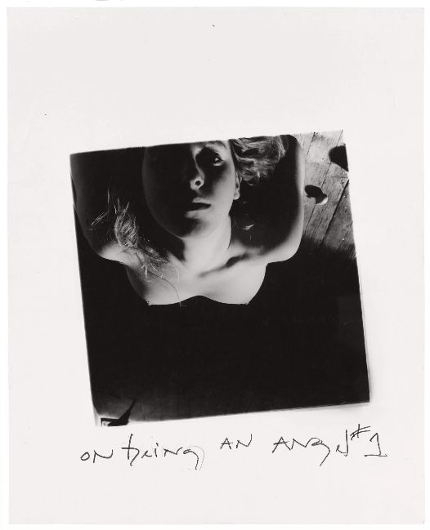
Figure 1.
Francesca Woodman is one of the most esteemed American photographers who has become a very criticised and remarkable prodigy. (Gumport, 2011, pp.2) At the age of twenty-two, Woodman tragically committed suicide, leaving the only work she had created, this was a big portfolio of eight hundred photos that were created during her university life. These eight hundred images are the only ones that have been published and viewed by the public, meaning there could be many more out there. Woodman has been a photographer, who since the mid-1980s, when she was re-discovered, about 5 years after her suicide, (Gumport,2011, pp.3) has received a lot of attention from audiences and critics for the work that she created. When the world looks at Woodman’s work, the receiving thoughts of the people who have viewed her work, is often that her work is very modernistic solely due to the beauty within the imagery and how she portrays being alone so graciously, but as with most artists, the inquiry and outlook of her work will always be revolving and the reception for these images will forever change.
When an artist creates either a piece of art or a photograph, it is often a very spontaneous process, which can then take more time to develop. The piece of art/photography normally reflects on what that artist is going through. The process of putting feelings and emotions into their work normally shows that ‘it is a symptom of the creator’s state of mind’. (Langer, 1953, pp25) The process of adding symbolism into their creation is a way for them to articulate the ideas they have had and until these are ‘adequately achieved’ (Langer,1953, pp28) it is something which they cannot necessarily think about.
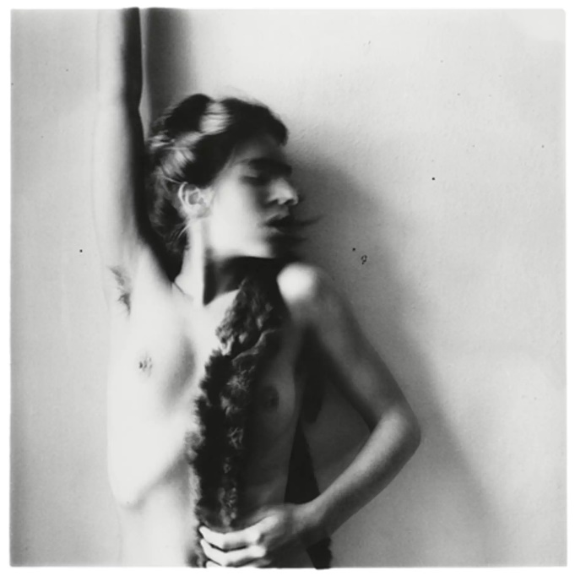
Figure.2.
This image above is from one of Woodman’s books called “the angels” (created in 1978), she created this book to show her exploration of existing but doing this on a subliminal level. The book had around 100 gelatine silver prints of Woodman’s work in it, which were created during her experience of being a student. Woodman’s work is heavily inspired by surrealism and photographers like Hans Bellmer and Man Ray, whilst having a basis of feminism, avant-garde, sexuality, gender, identity, and emotions. Woodman used her work to express herself, as a young human being she had a lot of emotions that she was dealing with, which she directed into her work, leaving her imagery to be an insight into her potency.
Woodman is using her naked body, not as a sexual symbol but to show the emptiness around her, making the viewer not just consider the figure but also the performance that went into taking the image, the positioning of her body, and the process. These photographs were made to provoke emotions and not to be viewed as provocative. (Hanif, 2016) When looking at Woodman’s work, such as the one above, a sense of Roland Barthes’s Camera Lucida comes into play.
“Photography may correspond to the intrusion, in our modern society, of a symbolic Death, outside of religion, outside of ritual, a kind of abrupt dive into literal Death. Life/Death: the paradigm is reduced to a simple click, the one separating the initial pose from the final print” (Barthes,1993, pp92) Woodman’s work suggests she has different identities which gives it extra intensity, extra venerability too.
In Therapeutic Photography the emotions that are connected to a snapshot sometimes comes from the unconscious and gives the participant an understanding of the relationship they have with themselves, and by creating a self-portrait it allows them to confront those unconscious thoughts whilst also confronting the fearful possibilities of life directly whilst also being able to face death, divorce, suicide, disabilities, and loss of identity headfirst. (Weiser, 1923, pp134)
Woodman created her work to show herself the realisation of her pain and whilst her craved catharsis is just for her seeing, it did not turn out that way, due to her work being published after her death, but unconsciously Woodman had been using Therapeutic Photography all along. Her inner language was to display her feelings in a performance which she then captured in her photography, and even though her outcome from her work was tragic; ultimately it became the outcome, which then places her practices into the Therapeutic Photography practice.
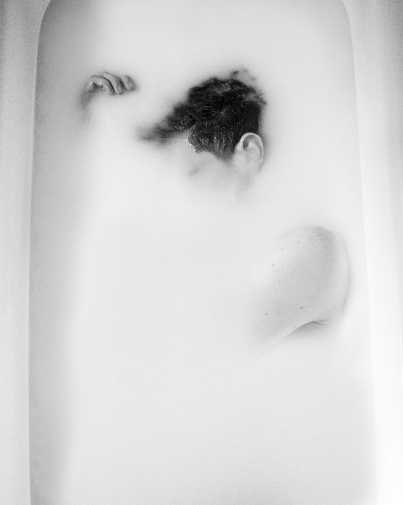
Figure.3
Often self-portraits are the most expressive work, and a lot of artists use this to search for their true selves through this process. Diagnosed with depression and anxiety at the age of 19, in 2013, Edward Honaker was experiencing a persistent feeling of sadness, and this was creating an overwhelming obstacle in his day-to-day life. "All I knew is that I became bad at the things I used to be good at, and I didn't know why,". (Holmes, Huffington Post, 2015) Your mind is who you actually are and when your brain doesn’t work properly or the way you want it to, becomes scary, this is how Honaker felt and it was only after his diagnosis that Honaker began to understand what was going on in his mind., because of this Honaker then reached out for his camera and turned his emotions into something tangible. This resulted in a series of impactful self-portraits that capture his personal experience and help combat his depression and anxiety.
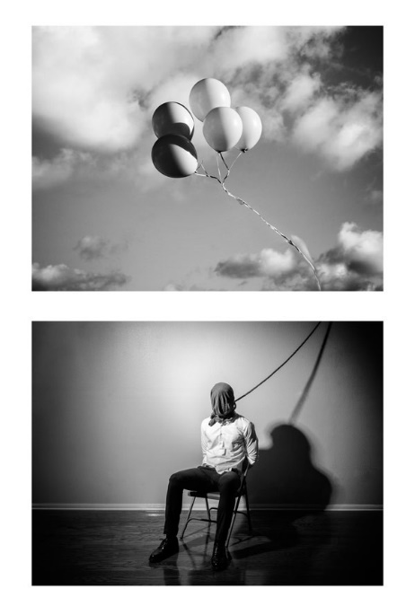
Honaker’s depression is marked by obscurity, a visual disruption of the face which refers to the mental distortion that is brought about by depression (Uys, Design Indaba, 2017). Mental health disorders have become such a taboo topic and if people ever try to bring it up in a normal conversation, people tend to go silent or try to say that the issues are not as big as that person thinks and that it is not a real problem. “I’m hoping that these images will help open up a conversation about mental health issues. Everyone is or will be affected by them one way or another and ignoring them doesn’t make things better.” (Jangbauer, Ignant, 2015) He adds “It’s kind of hard to feel any kind of emotion when you’re depressed, and good art can definitely move people”. (Holmes, Huffington Post, 2015)
Figure. 4
Photography has become a way to capture symptoms in a more realistic way. With psychoanalysis and using photography in a therapeutic eye, it has changed the way the viewer sees a photograph, it’s not just a view into emotions but it is also a view or even a mirror into the unconscious and into the reality of the world around us. A photographer makes every choice when it comes to capturing a photograph, the smoothness or the boldness, the colour, and the subject. Honaker’s depiction of his experience becomes particularly poignant when considering the perceived shame of men to speak out about emotional turmoil for fear that such exposure would be a strike against their own masculinity: “The photographer vocalises his anguish in honesty through these images, which could help others to identify and acknowledge the emotional disrepair in themselves,”. (Uys, Design Indaba,2017) For Honaker to take part in capturing himself in self-portraits to document his struggles is a way for his unconscious to become less censored and this helps his cognitive health stay sharp and led him to become of the right mind because he is confronting his thoughts and emotions.
“Black and white pictures appear more real than the coloured image” (Evans,1978, pp13) Honaker’s work creates an impact with the black and white colouring, but people have learned to see black and white photography with their own-coloured lens, people put their own colour information into a monochrome image, which makes Honaker’s work even more impactful because it provides each viewer a sense of their own understanding of the image and their own understanding of what they want from that image.
With Therapeutic Photography, being a process that is something a participant can do in their own time; the aesthetic satisfaction and the emotional potential growth is what Honaker shows within his work. Without Honaker knowing, there will be a side to his thought process when creating photos that will help himself, meaning his work slots into Therapeutic Photography nicely.

CHAPTER THREE: Phototherapy Case Studies
There will be parts of Phototherapy that could be difficult or in some cases, probably ineffective for a photographer, their ability to differentiate between their artistic views and production of work and the practice of using Phototherapy may be more difficult than they think and it may actually turn out to more stressful for the professional photographer than what it is meant to be, which is relaxing, helpful and a way to express their negative emotions, which then can bring everything up, thus creating more negative emotions, which ultimately then slows down the process of the therapy. Professional artists are for the majority of their time looking for verification when the involvement of their work is at play, and this is normally from the viewer, but they also look for verification within themselves which come “post factum”, (Koestler, 1964, pp330) when an image is complete. This in itself is not always a good thing either, it can be “a leap into the dark, a dive into the deeps”, like a diver who “is more likely to come up with mud, then a coral” (Koestler,1964, pp330) The looking for verification can get in the way of the Phototherapy process because they are not truly putting in the work for themselves, but for others.
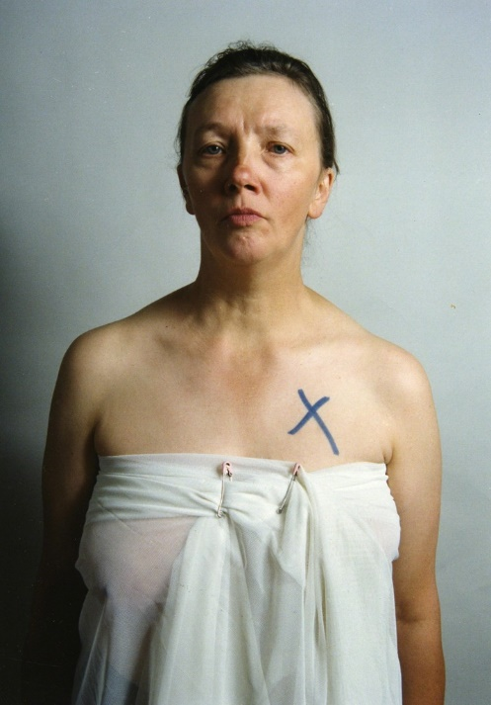
“By virtue of our thoughts and imagination, we have not only feelings but a life feeling”. (Langer, 1953, pp372)
Figure.5.
Photography has made it possible for people to transform a living moment into a piece of paper or a digital image that they can keep forever and it represents something that has happened in their life but it has drained all the things that make it feel real, like smell and sound (Dennet, 2011, pp235) so it becomes a fragment, but a fragment that can be passed around and shared with others unlike a memory that slowly disappears and changes.
Jo Spence has been a photographic creator who had a massive impact on the photography world but also in the psychological world. She started off her journey into photography through commercials and then moved into creating work for herself, this then moved on to her inputting her own practices into Photo- therapy. Spence wanted to do this because of her struggles with what she went through when she had breast cancer and found that it was the most helpful way to show her journey and for her to share it with other people. Spence believed that an image, like an identity, is never-ending and never finished. (Bell, 2002, pp7)
Spence's collaboration on phototherapy with Rosie Martin was something she was deeply committed to, after her breast cancer was cured, she tragically developed leukaemia and then ended up passing away from this. Spence spent her dying moment trying to communicate to people that a therapy like Phototherapy was accessible and that it’s a process that helps people speak the unspeakable (Bell, 2002, pp7)because the moments when we look into in an image, looking between those borders, shows us that that’s the now and they are there within that time and space as if we are physically back there and with the emotions within those images makes it feel as if it’s electronically charged. (Weiser,1985, pp4)
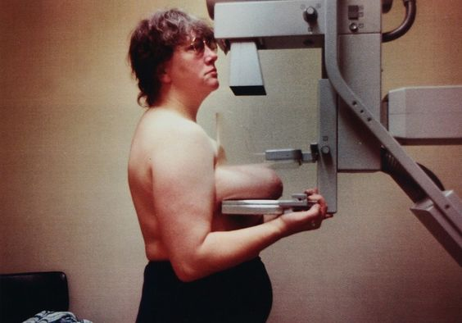
Figure 6.
This image above is part of Spence's work documenting her illness and struggle with breast cancer, called “mammogram”, They are raw and real. Spence wanted to compel her viewers who are mainly the female audience, to react in a visceral way so that they could imagine and put themselves into the image alongside with putting their breasts in that situation. (Bell, 2002, p19) Spence wanted to make the audience aware that breast cancer is such a real and daunting thing, so having the image of her breasts squashed between two plates makes Spence's struggles justified but also lets others know the intimate details of her struggles too.
Spence's breast squashed between these two plates is expressing violence and showing conventional coercion that comes from orthodox medicine and how it is so violent and aggressive to take part in, not like taking photos, that is completely different. Taking a photo should be a way for people to relax, absorb life around them, so when Spence created this photo, this was a different take on what you expect Phototherapy to be, she was angry at professionals and angry at being ill and wanted to use her camera as a weapon, to show the symbolic side to her internal emotions and physical feelings about the medical treatment that’s she has been put through and the impacts coming from the experience itself. (Bell, 2002, pp12)
A photograph is a way to tell a narrative without having to speak it, Spence wanted to narrate different social sciences and the understandings of how hard the experience can be. Sometimes photography can become a way for people to illustrate what their lives could be, and what they could become, instead of what their true selves are like, Spence challenged this and tried to point out what was wrong with this with her work.
Spence said that “Two elements make up Photo Therapy—photography and therapy— and each word has come to have a number of meanings for me, both as a former professional photographer and a cancer person. I arrived at these formulations mostly through actual practice, so my ideas may not be the same as those of an academic or professional therapist. Any theory I have now acquired came to me slowly from a variety of sources...” (Rutanen,2015, pp5)

CONCLUSION
Producing photography can be a compelling and powerful experience, as it allows the creator to change their world. This brings satisfaction and a sense of accomplishment, this then leads to a positive cycle of producing positive thoughts and emotions, while facing hard and raw events. Photography has got an unlimited potential which allows anyone to be their true selves and express themselves more freely. It is no different to Artists who use painting as their own type of therapy to express their emotions and to find a better understanding of their inner self, Artists like Frida Kahlo, Vincent Van Gogh are just two who represent this.
With the success and satisfaction of creating an image, it lets the creator continue to grow and this is positive for the human psyche. It is clear that creating a photograph can help with the uplift of positive psychology which may then lead to more understanding of mindfulness. However, whilst there are positives about creating photographs there are parts of creating images that could be detrimental to the participant’s mental health it could create situations, such as imposter syndrome, low self-esteem, or thoughts that the work they are creating is not good enough, alongside the possibility of burning out after creating images. When looking into using photography as a coping mechanism or a therapeutic process, the creator will be looking into deep-rooted emotions with is both a negative and a positive.
Although I have not been able to come to a critical verdict on whether creating photos in or outside a clinical setting has more or less impact on the human psyche, it is evident that photography has a massive impact on the person participating and that both practices have a significant role in the upcoming therapy practices which helps makes it less of a surprise that photography has entered the psychological practices.
Photography may not be seen as a part of survival, but it is definitely an established part of human life and using phototherapy and therapeutic photography, is definitely a process that continues to grow and become more mainstream.
List of Illustrations
Figure 1. Francesca Woodman, On Being an Angel # 1, Providence, Rhode Island, 1977. © George and Betty Woodman
Figure 2. Francesca Woodman, Untitled, MacDowell Colony, Peterborough, New Hampshire, 1980 © George and Betty Woodman
Figure3. Edward Honaker, Taking a bath on sunday.,2015
Figure4. Edward Honaker, what a heavenly way to die? 2015
Figure 5. Jo Spence, A Picture of Health: How Do I Begin? 1982-1983
Figure 6. Jo Spence, Mammogram, 1988
Bibliography
- Aspland.L (2020). Mindfulness photography for troubled times. South Wales: https://leeaspland.com/books/. p1-46
- Barthes, R (1993). Camera Lucida. UK: Penguin Random House. p92.
- Bell, S.E. (2002). Photo images: Jo Spence’s narrative of living with illness. 6 (1), p1-26.
- Berger, J. (2008) ways of seeing. London: penguin books
- Berman, L. (1993) Beyond the Smile: The Therapeutic Use of the Photograph. London: Routledge.
- Bunyan, M. (2015). exhibition: ‘Francesca Woodman. on being an angel’ at Moderna museet, Stockholm. Available: https://artblart.com/tag/some-disordered-interior-geometries/. Last accessed 7th November 2021.
- Bushman. B (2012) learning through visuals: visual imagery in the classroom. Available at: https://www.psychologytoday.com/gb/blog/get-psyched/201207/learning-through-visuals (accessed on 30th November 2021)
- Dennett, T. (2009) “Jo Spence’s camera therapy: Personal therapeutic photography as a response to adversity.” European Journal of Psychotherapy and Counselling
- Dennett, T. (2011). jo spences auto therapeutic survival strategies. 15 (3), p224-235.
- Dunhill, A. (2012). The Flight from Touch: Woodman’s Portrait of a Reputation. 2 (1), p1-12.
- Dunhill, A. (2012). Woodman and Woodman: Chains of Signifiers.1 (1), p1-19.
- Dunhill, A. (2012). The Flight from Touch: Woodman’s Portrait of a Reputation. 1 (1), p1-12.
- Dunhill, A. (2012). Dialogue with Disappearance, Dialogue with Days. 1 (1), p140.
- Evans, B. (2019). Therapeutic Photography. Available: https://phototherapy-centre.com/therapeutic-photography/. Last accessed 12th September 2021.
- Evans, H. Taylor, E (1978). Pictures on a paper: Photojournalism, Graphics, and picture editing. USA: Wadsworth Pub, Co. p1-33.
- Franco.J. (2013). The Meanings of the Selfie. Available: https://www.nytimes.com/2013/12/29/arts/the-meanings-of-the-selfie.html. Last accessed 29th September 2021.
- Fiore, J. (2018). Revaluating Francesca Woodman, Whose Early Death Haunts Her Ground-breaking Images. Available: https://www.artsy.net/article/artsy-editorial-reevaluating-francesca-woodman-early-death-haunts-groundbreaking-images. Last accessed 15th Nov 2021.
- Gabriel.M. (2012). Can Photography Be Used as a Form of Therapy? Available: https://contrastly.com/can-photography-be-used-as-a-form-of-therapy/. Last accessed 9th October 2021.
- Gauthier, K. (2010). ​Art and Photo Therapies: Creating Opportunities for Change and Healing. Available: https://www.pictureyourselfwell.com/. Last accessed 7th November 2021.
- Gibson. N (2018). Therapeutic photography: enhancing self-esteem, self-efficiency, and resilience. London: Jessica Kingsley publication. p1-120.
- Grant. A Leigh-Phippard.H, Short N P, (2015). Re-storying narrative identity: a dialogical study of mental health recovery and survival. New York: John Wiley & Sons Ltd... p1-170.
- Gumport, E. (2011). The Long Exposure of Francesca Woodman. MARIAN GOOD MANGALLERY. 1 (1), p1-9.
- Hanif, N. (2016). On Being an Angel: finding Francesca Woodman in the otherness of her self-portraits. Available: http://latitudebrasil.org/media/uploads/clipping/clipping/2016_01_13-brit.pdf. Last accessed 15th Nov 2021.
- Hannavy J, Encyclopaedia of Nineteenth-Century Photography, Routledge, London/New York, 2007
- Holmes, L. (2015). These Photos Capture the Anguish of Living with Depression. Available: https://www.huffingtonpost.co.uk/entry/edward-honaker-photography-mental-illness_n_55f0759ce4b03784e2777fbb. Last accessed 24th November 2021.
- Institute of Mental Health. (2010). Using Photography as Therapy. Available: https://www.imh.com.sg/wellness/page.aspx?id=1243. Last accessed 12th September 2021.
- Jenelle, K. (2021). What is Therapeutic Photography? Is Photography Good for Mental Health? Available: https://digitalworldbeauty.com/what-is-therapeutic-photography-is-photography-good-for-mental-health. Last accessed 24th October 2021.
- Jensen, K. (2015). Healing Through Photos: Therapeutic Photography. Available: https://odyssey.antiochsb.edu/media/slideshows/healing-through-photos-therapeutic-photography/. Last accessed 16th October 2021.
- Jangbauer, J. (2015). Photographer Edward Honaker Documents His Own Depression. Available: https://www.ignant.com/2015/09/24/photographer-edward-honaker-documents-his-own-depression/. Last accessed 15th Nov 2021.
- Killick.J. (2019). Therapeutic Photography and Healing Childhood Trauma (Considerations). Available: https://findingmypsych.com/therapeutic-photography-and-healing-childhood-trauma-considerations/. Last accessed 8 Nov 2021.
- Koestler, A (1964). The art of creation. London: Hutchinsons and co LTD. p121, p322-391.
- Langer, S.K (1953). Feelings and form. Routledge: Kegan Paul limited. p25-39, p369- 373.
- Linguapress. (2020). William Fox Talbot and the origins of photography. Available: https://linguapress.com/advanced/fox-talbot-photography.htm. Last accessed 30th November 2021.
- Loewenthal.D (2013). Photography and Therapeutic photography in a digital age. London: Routledge. p1-208.
- MacDonald, I. Photography saved my life. Available: http://therapeutic-photography.co.uk/. Last accessed 21st September 2021.
- Malchiodi, C.A. (2007) The art therapy sourcebook. 2nd Ed. New York: McGraw-Hill.
- Martin, R. Spence, J. (1985). new portraits for old: the use of the camera in therapy.19 (1), p66-92.
- Naumberg, M. (1966) dynamically oriented art therapy: its principles and practice. New York: Grune & Stratton.
- The One Project Education Inc. (2021). Therapeutic Photography. Available: https://theoneproject.co/therapeutic-photography/. Last accessed 12th October 2021.
- Pearce, M. (2021). Notes on The Act of Creation by Arthur Koestler. Available: http://webprojects.eecs.qmul.ac.uk/marcusp/notes/koestler.pdf. Last accessed 3rd December 2021.
- Prequel. (2021). Photography And Mental Health — In Front of And Behind the Camera. Available: https://medium.com/@prequelapp/photography-and-mental-health-in-front-of-and-behind-the-camera-76d89b999625. Last accessed 16th September 2021.
- Ronning.D. (2017). The Selfie: Using Photography as a Form of Self Reflection. Available: http://www.psychedinsanfrancisco.com/selfie-self-reflection/. Last accessed 2nd October 2021.
- Rutanen, J. (2015). Phototherapy and Therapeutic Photography: The Healing Power of Photographs. 1 (1), p3-45.
- Sanmiguel, C. The Artist: Just Francesca. Available: https://www.thecollector.com/francesca-woodman-photographer-facts/. Last accessed 7th November 2021.
- Some Theory. (2014). What is Phototherapy. Available: https://theartoftherapy1.blogspot.com/2014/03/what-is-photo-therapy-all-about.html. Last accessed 30th October 2021.
- Tempesta, E. (2015). Photographer suffering from depression captures his mental illness in haunting series of self-portraits to raise awareness for the disorder. Available: https://www.dailymail.co.uk/femail/article-3240571/Photographer-suffering-depression-captures-mental-illness-haunting-series-self-portraits-raise-awareness-disorder.html. Last accessed 24th November 2021.
- Uys, E. (2017). How can photography help us understand depression? Available: https://www.designindaba.com/articles/creative-work/how-can-photography-help-us-understand-depression. Last accessed 24th November 2021.
- Wang, E.W. (2016). Dialogue with Francesca Woodman. Available: https://hazlitt.net/feature/dialogue-francesca-woodman. Last accessed 12th September 2021.
- Weisner, J. (2010). Using self-Portrait Photographs During Therapy Sessions to Help People Improve Their Lives. Fabio Piccini, P.1-43
- Weiser, J (1923). Phototherapy techniques: exploring the secrets of personal snapshots and family albums. Vancouver: Jossey-bass publisher. p4- 10, p127- 134, p343-246.
- Weiser, J. (2007). Using Phototherapy techniques in art therapy and other counselling practices. Canadian Art Therapy Association Newsletter, 6:4, p 4-7.
- What is Phototherapy? (2018) Available: https://photography-traumahealing.weebly.com/what-is-phototherapy.html. Last accessed 20th October 2021.

