
PORTFOLIO
Mark Chivers




Athena Counselling Services Ltd
107 Walter Road, Swansea. SA1 5QQ
Tel: 07722 288244
www.athenacounsellingservices.com

Table of Contents
Reflective Commentary 2
References for commentary 5
Portfolio of evidence 6
Evidence 1: Background information 6
Section A Information Form 6
Section B: Mission Statement 7
Section C: Values and Strategic Aims 8
Evidence 2: Reflective Logs 14
Section A: Hours log. 14
Section B: Reflective Log 15
Evidence 3: Volunteering Process 17
Section A: Required skills 17
Section B: Volunteering opportunities 20
Section C: Initial Application Form and Interview Process 24
Section D: Training 27
Evidence 4: Reports 31
Appendix
- References 32

Reflective Commentary/narrative essay 1, 000 Words
Reflective piece using the Gibbs Reflective Cycle (Gibbs, 1988)

During my placement I am to receive emails from potential clients and to assign them to the most appropriate counsellor, I was also given the go ahead to gather research on ADHD that Athena could then use as information to help the general public through their website. Athena is currently exploring ways that they can assess and diagnose people for both ADHD and ASD which are two conditions that apply to myself, one of the directors of Athena is currently completing an MSc in Psychiatry to allow for these assessments. I have developed a much greater understanding of ADHD as a condition than I had prior to the placement such as ADHD being an executive function disorder rather than an attention disorder and as such is named inappropriately but renaming it would result in loss of legal protections (Barkley, 2009).

I have never researched a special interest before now for the specific purpose of an information panel, due to ADHD being of a personal nature to myself has been very good for me. It has helped improve my self-esteem and has offered me a greater understanding of myself than I have ever had. As an example Dr Barkley has helped me understand that I am not an unintelligent person, I know what I need to do and how to do it but as ADHD is an executive function disorder which prevents me from doing that task, his explanation of how people with ADHD often do not have an appropriate concept of time and how this relates to them being chronically early or late was very helpful (Barkley, 2009). Another psychiatrist who has helped with this is Dr Tracey Marks who described this inability as inertia in the brain that prevents the action from taking place (Marks, 2021).

I have used my teamworking skills whilst having discussions about the ADHD research and I have had meetings to go through what I have found and what would be helpful to include on the website, we decided upon using YouTube playlists of short segments of Dr Barkley and links to Dr Tracey’s videos. During the research I also found someone who uses peer-reviewed research and puts it into more simple terms whilst having videos showcasing strategies that she uses to help live with the disorder (McCabe, 2017), after viewing her content with the team this was also considered to be appropriate to place on the website (McCabe, 2015).

I was very surprised that my initial contact with the client did not need to be as in depth as I had originally considered, due to the privacy policies and the sensitive nature of the needs of potential clients I only needed to enquire for a very simple description of the issue. As a very inquisitive person initially I did need to set aside my own curiosity as I recognised any enquiries could become inappropriate and as an unqualified staff member it was not my place.

The most challenging part of this placement so far has been the access to the website, I was very motivated in finding out more about ADHD and to share this information on the site however the website appeared to be non-existent for a majority of the beginning of my placement and it made updating the site impossible. I held out hope that the site access issues would be fixed swiftly and I would be able to put the information I had gathered on there.

Finding out more about ADHD has been the most satisfying experience so far, I was assessed for it in the recent years and the information I have found has helped explain so many difficulties I have had over my life, it has helped me develop methods and tools to improve myself and to not demonise my short-comings. Sharing this new found passion with other members on the team and with close relationships has been wonderful seeing their own interest and understanding of the disorder expand.
There have been a few problems with my placement, the service manager has an illness which impacts her working schedule and has meant that we have needed to cancel some meetings and it is one of the reasons my placement started later than initially planned. The meetings were rescheduled when it was possible but it has been difficult to fit them in as Athena closed over the Christmas period. The other major issue was with the website, I offered my helped to attempt to discover the cause of the issue and I discovered that the website was hidden from the public due to it being locked behind a username and password. After informing the service manager the issue is being looked into and will hopefully be fixed soon. The only aspect I would change would have been to start the placement sooner as it would have given more time for client interaction and research.
I experienced a lot of anxiety over the placement so far, it is something I deal with regularly and having the extra pressure has made that very challenging. The team at Athena is very supportive and have been extremely accommodating to my needs for which I am incredibly thankful as I had a period if incredibly poor mental health that was swiftly followed up by a physical illness which stopped me being able to perform my placement. I did experience a lot of frustration with website issues, but I am very pleased that I was able to discover the problem and to kickstart the process of fixing it.
All in all the placement has been a good experience and I have enjoyed it. I look forward to continuing it and getting the information I have researched onto the website.
953 words

Reference list for reflective commentary
Barkley, R. A. (2009). 30 essential ideas about ADHD - Dr. Russell a Barkley. 30 Essential Ideas about ADHD - Dr. Russell A Barkley. Retrieved November 4, 2022, from https://www.youtube.com/playlist?list=PLzBixSjmbc8eFl6UX5_wWGP8i0mAs-cvY
Gibbs G (1988). Learning by Doing: A guide to teaching and learning methods. Further Education Unit. Oxford Polytechnic: Oxford
Marks, T. (n.d.). Home. markspsychiatry.com. Retrieved November 11, 2022, from https://markspsychiatry.com/all-things-adhd/
McCabe, J. (2015, October 19). How to ADHD. YouTube. Retrieved November 11, 2022, from https://www.youtube.com/@HowtoADHD
McCabe, J. (2017). This is what it's really like to live with ADHD. Jessica McCabe: This is what it's really like to live with ADHD | TED Talk. Retrieved November 11, 2022, from https://www.ted.com/talks/jessica_mccabe_this_is_what_it_s_really_like_to_live_with_adhd_jan_2017

Portfolio of Evidence
Evidence 1: Background Information
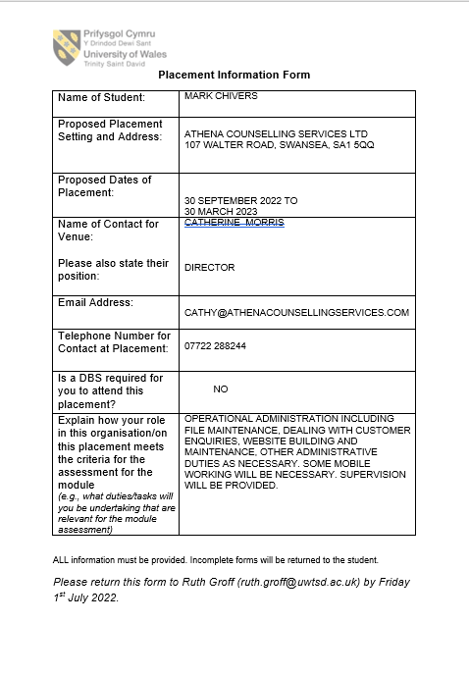
Section A: Information Form
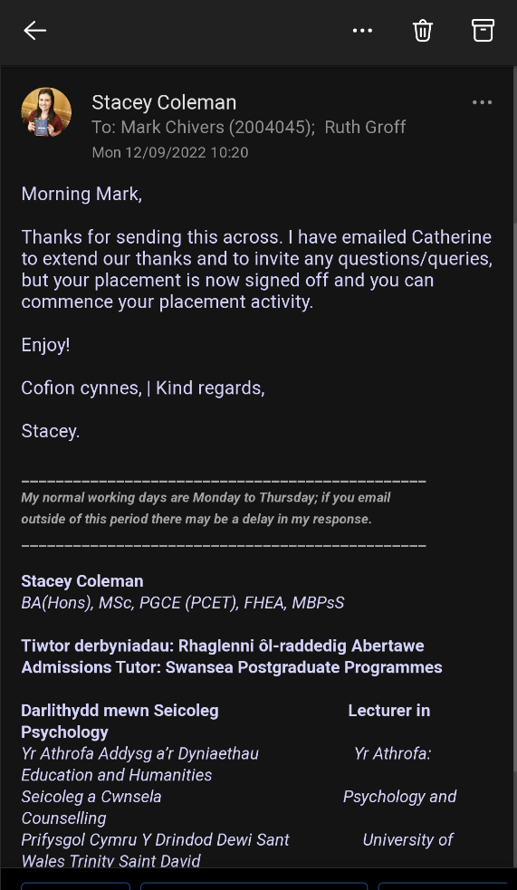

Section B: Mission Statement
Mission Statement and information taken from Athena Counselling Services website (www.athenacounsellingservices.com)
‘As integrative counsellors and psychotherapists, our approach is to provide support and practical feedback to help clients resolve current issues. With sensitivity and understanding we help our clients to find solutions to a wide range of life challenges and psychological issues. Counselling and psychotherapy are tools to help you manage your life better. We specialise in trauma.
We have been working in the counselling sector for many years and have a wealth of education and experience to offer our clients.’
About Us
Our company is built on the principles of providing reliable, accessible and professional services. We have been working for many years in Swansea. By combining our specialisations, we can help our clients from many different perspectives and increase the chances of therapeutic success. (www.athenacounsellingservices.com/about us)
Athena Counselling Services Ltd
Tel: 07722 288244
www.athenacounsellingservices.com
info@athenacounsellingservices.com
Company Directors:
Cathy Morris MA. BA (Hons). PGCE. PGDip Psychological Trauma. HED Couns. Prac. Cert. Focusing Oriented Trauma Practitioner. Accelerated Resolution for Trauma (ART) Therapist. Cert. Supervision
Reg. MBACP
Tim Morris

Section C: Values and Strategic Aims
- Policy documents:

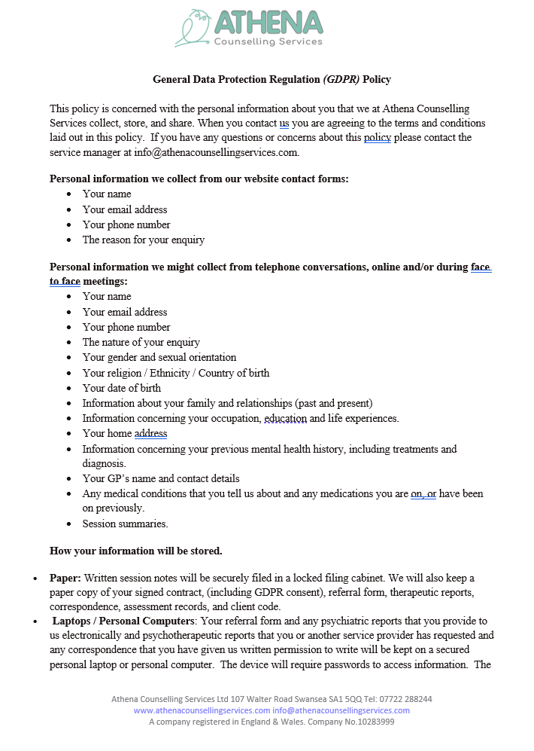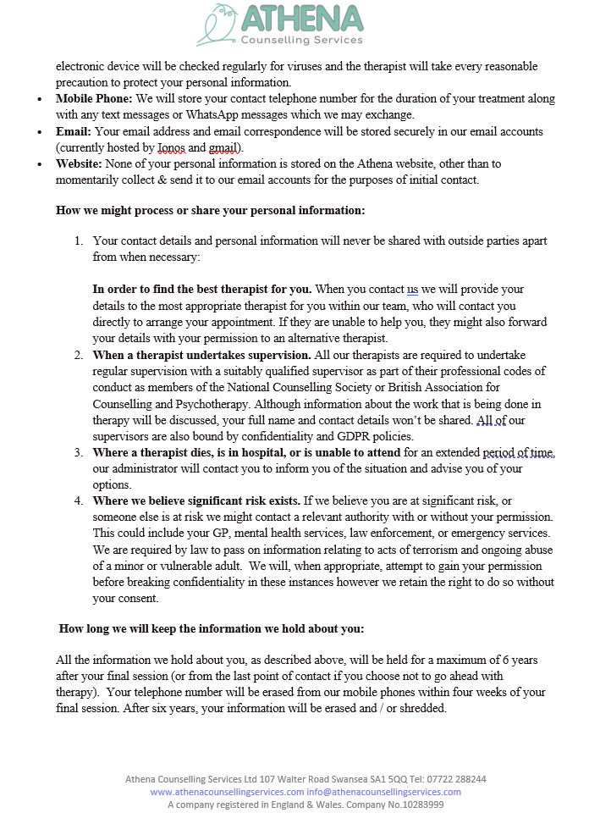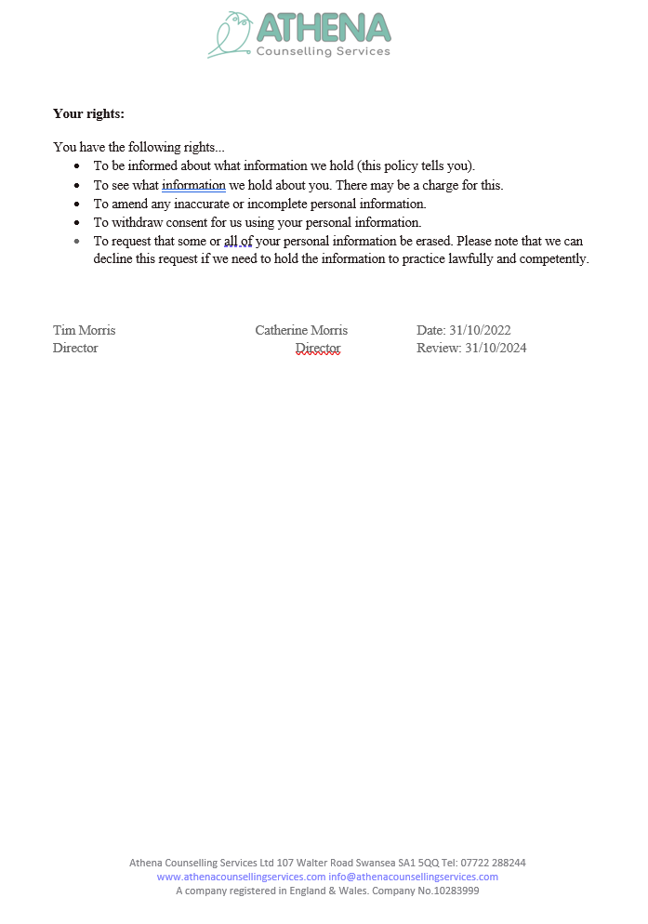
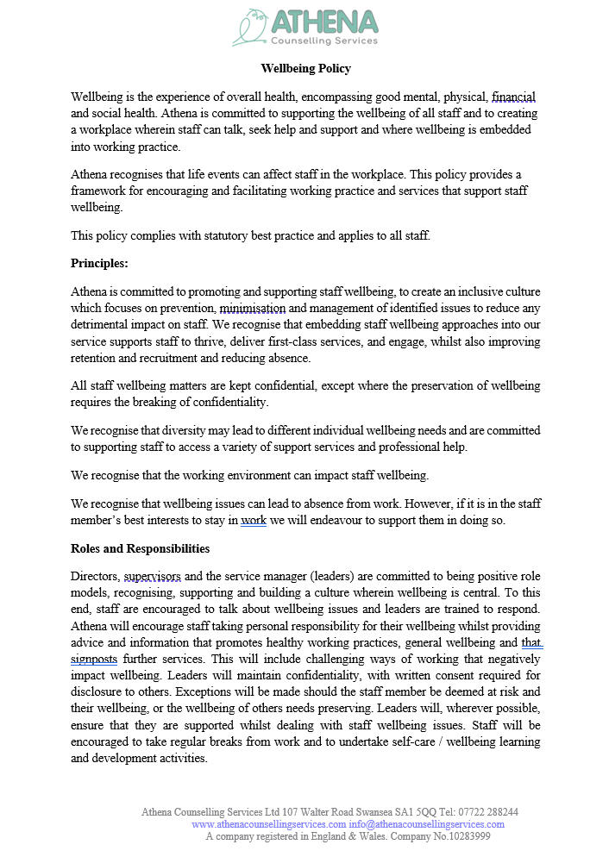
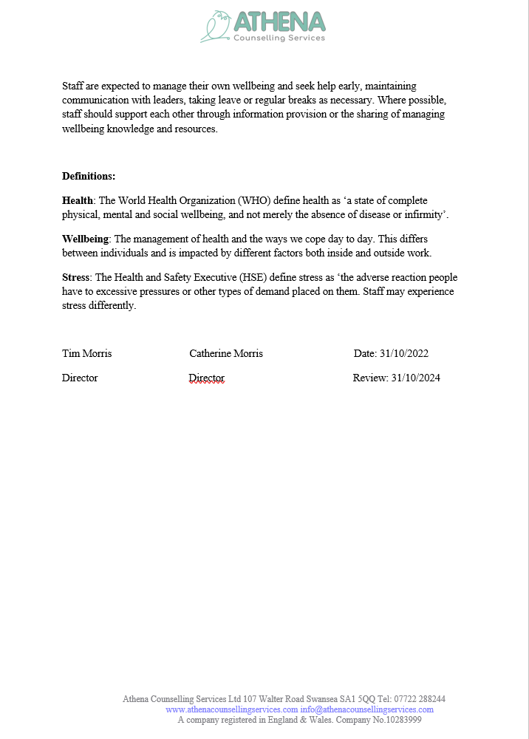
Evidence 2: Reflective Logs
Section A: Hours log.
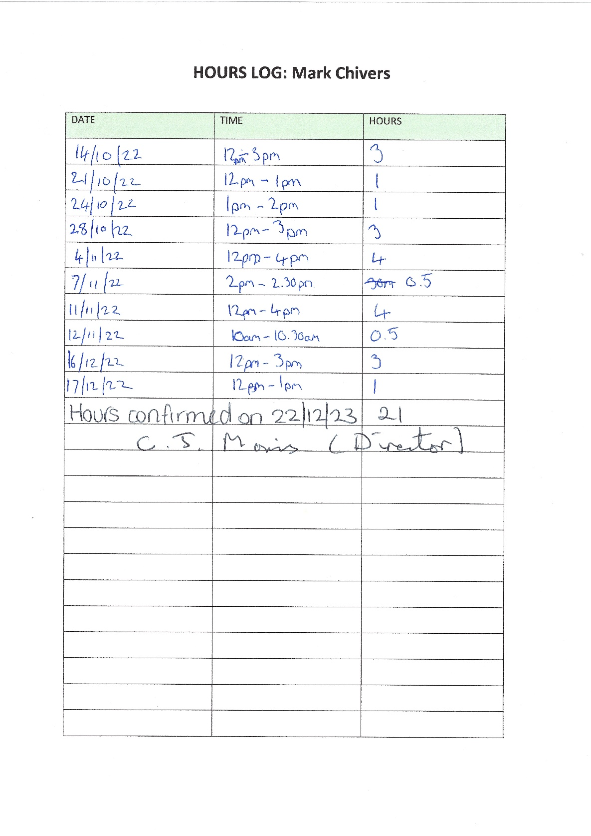

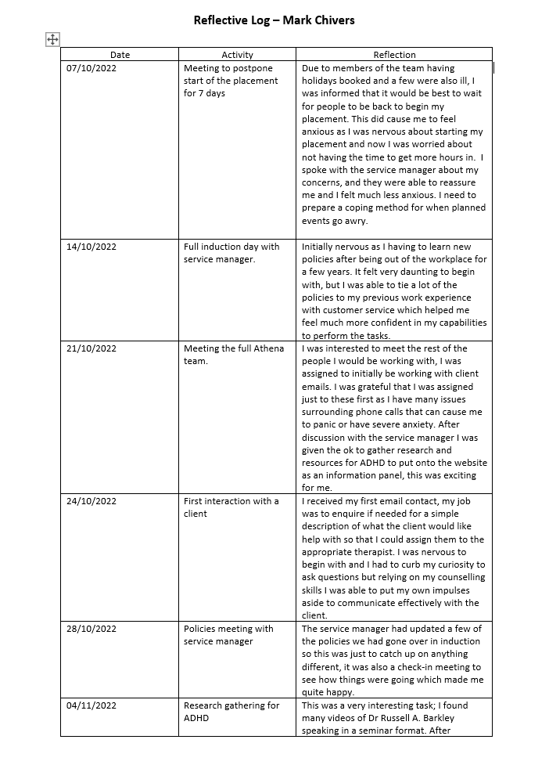
Section B: Reflective Log
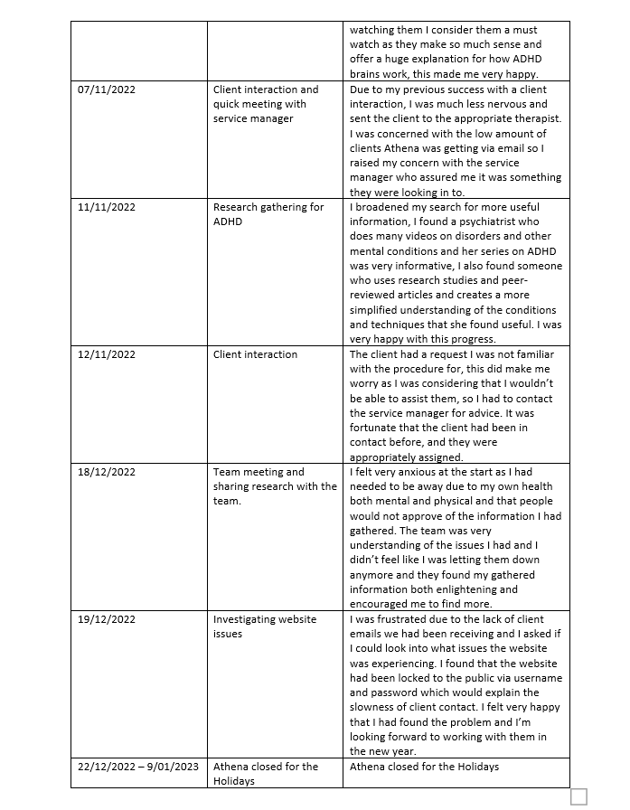

Evidence 3: Volunteering Process
Section A: Required skills
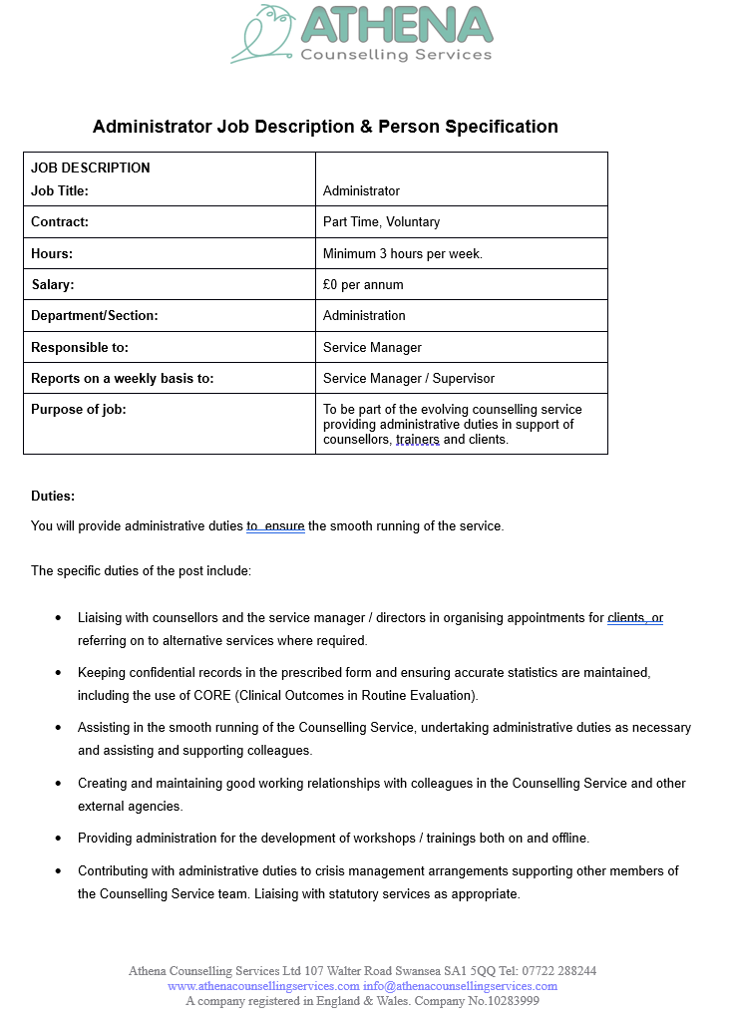

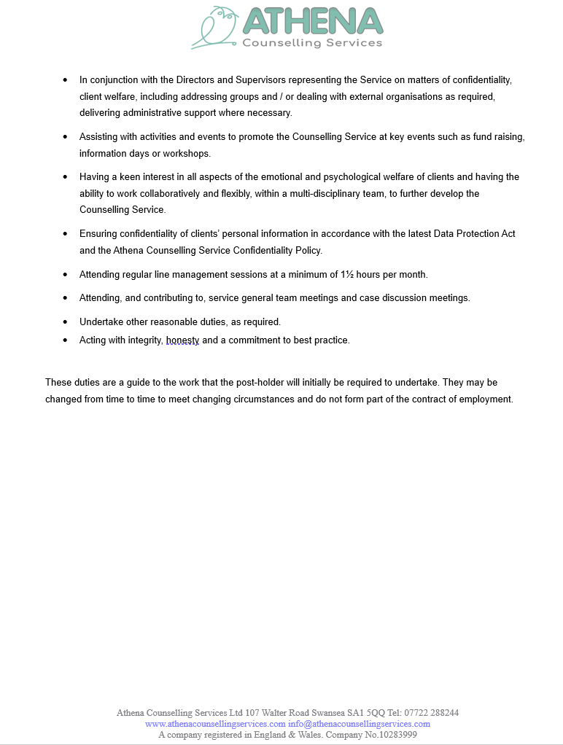
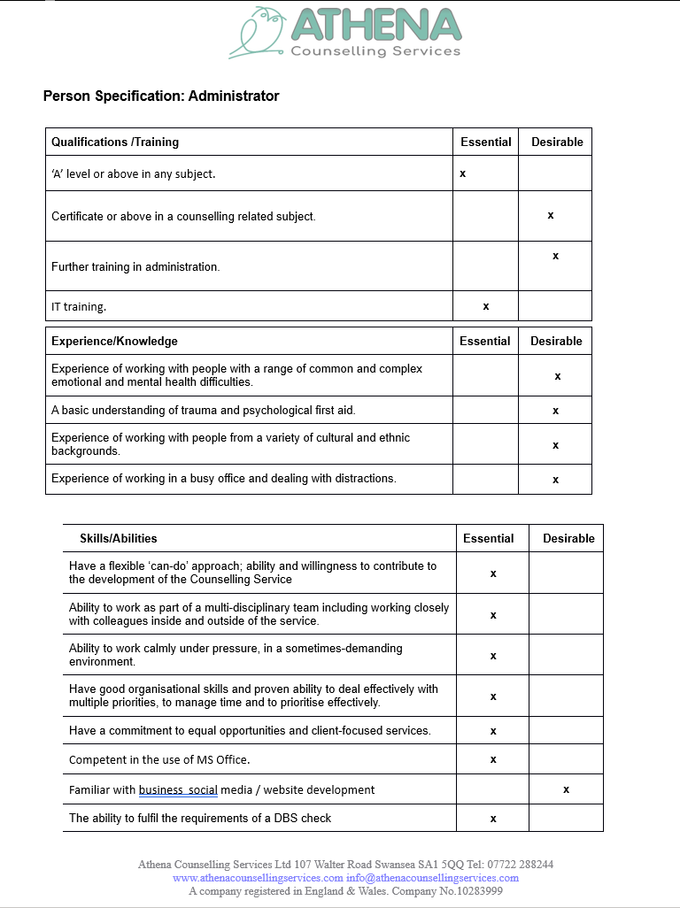
Section B: Volunteering opportunities
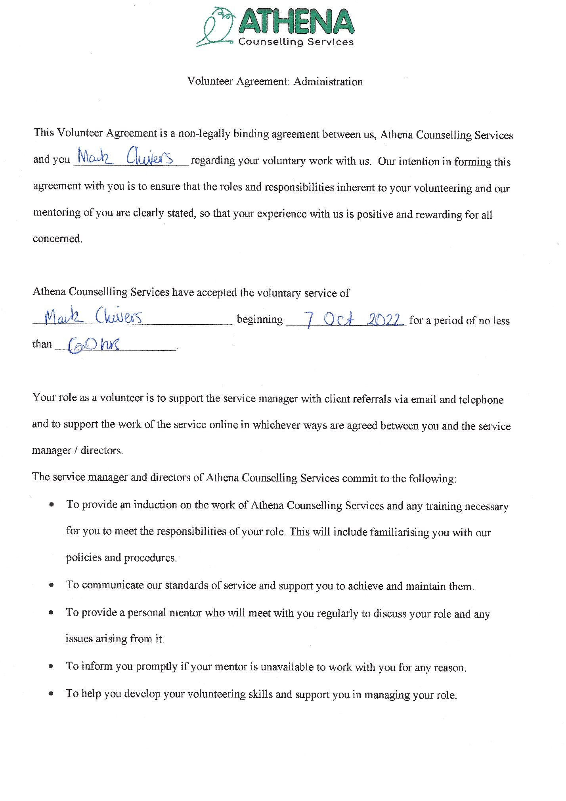
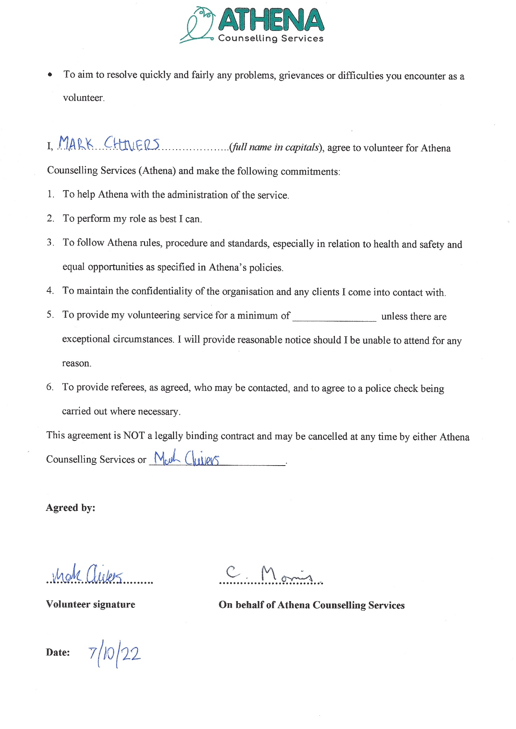
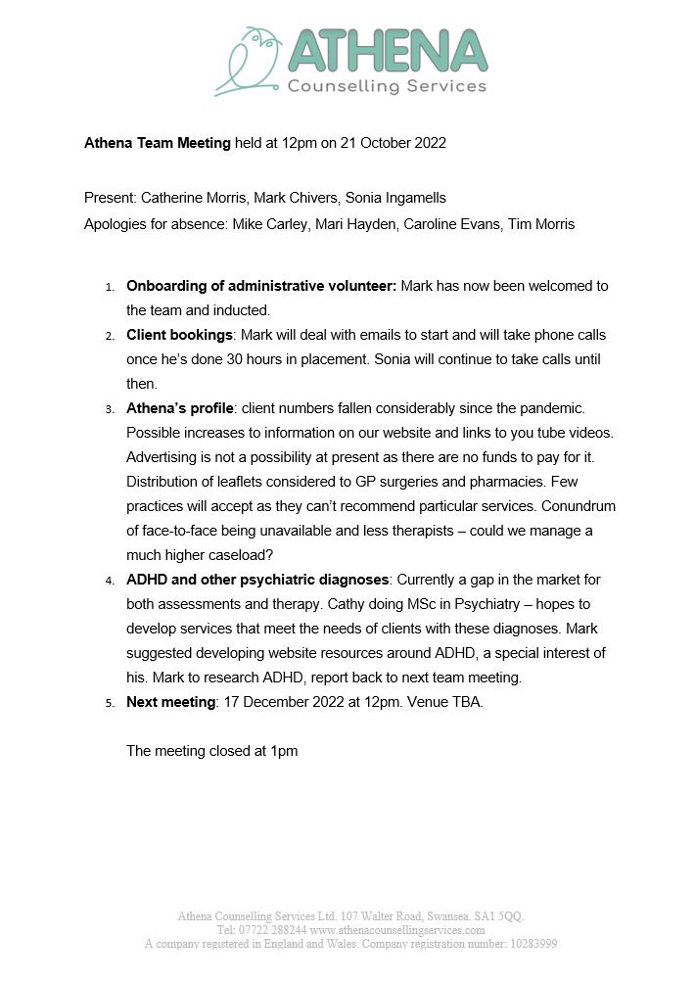
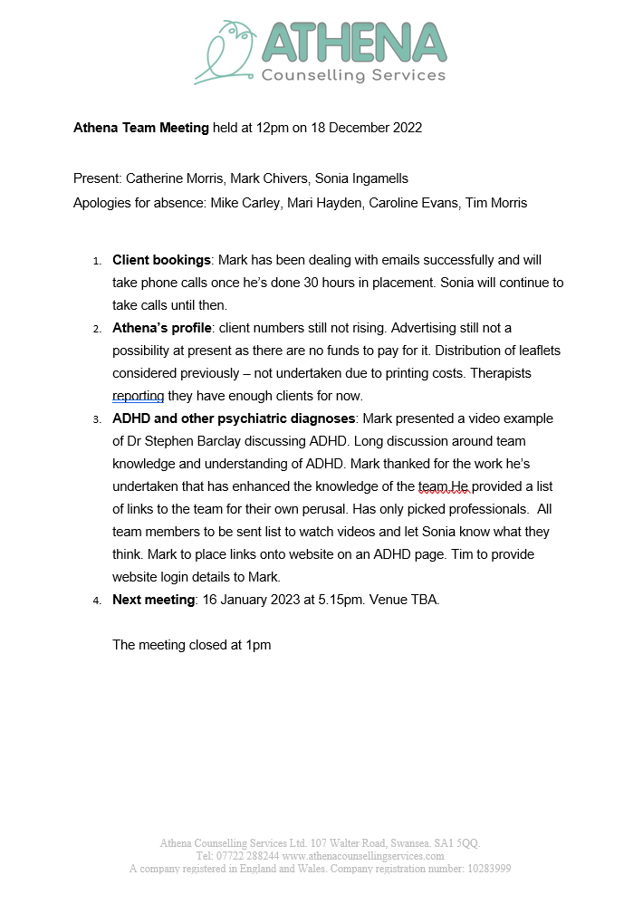
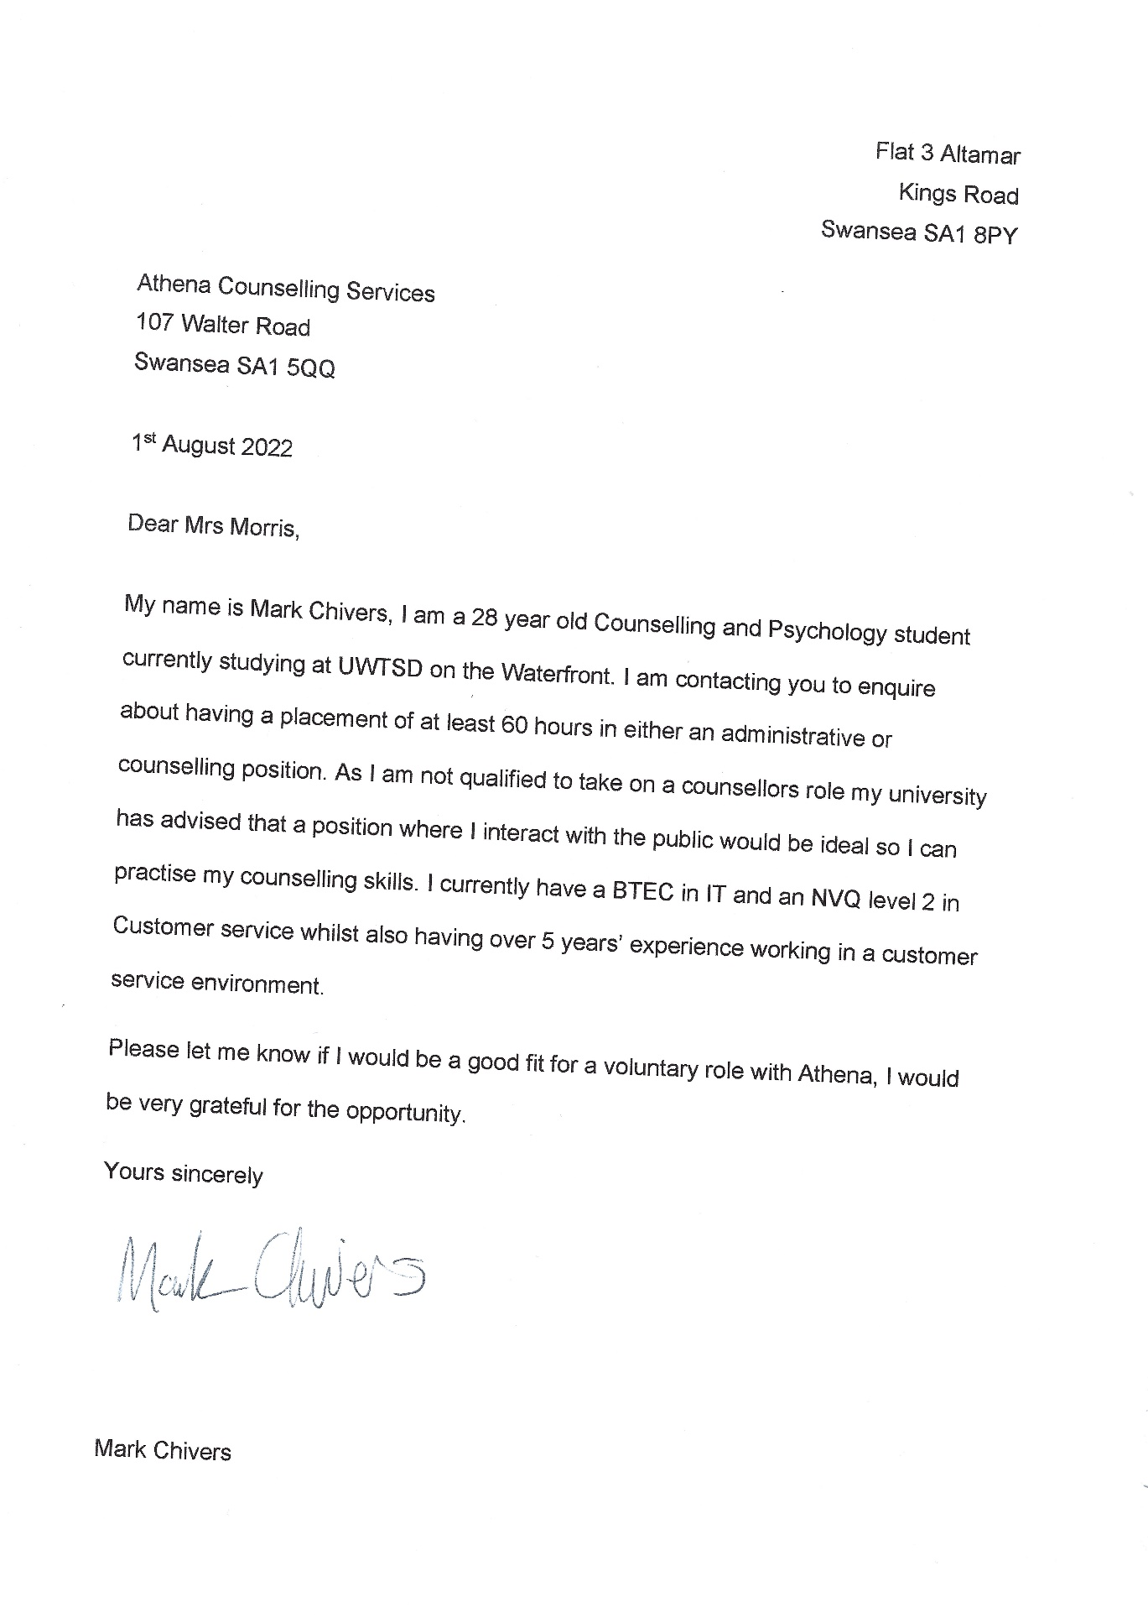
Section C: Initial Application Form and Interview Process

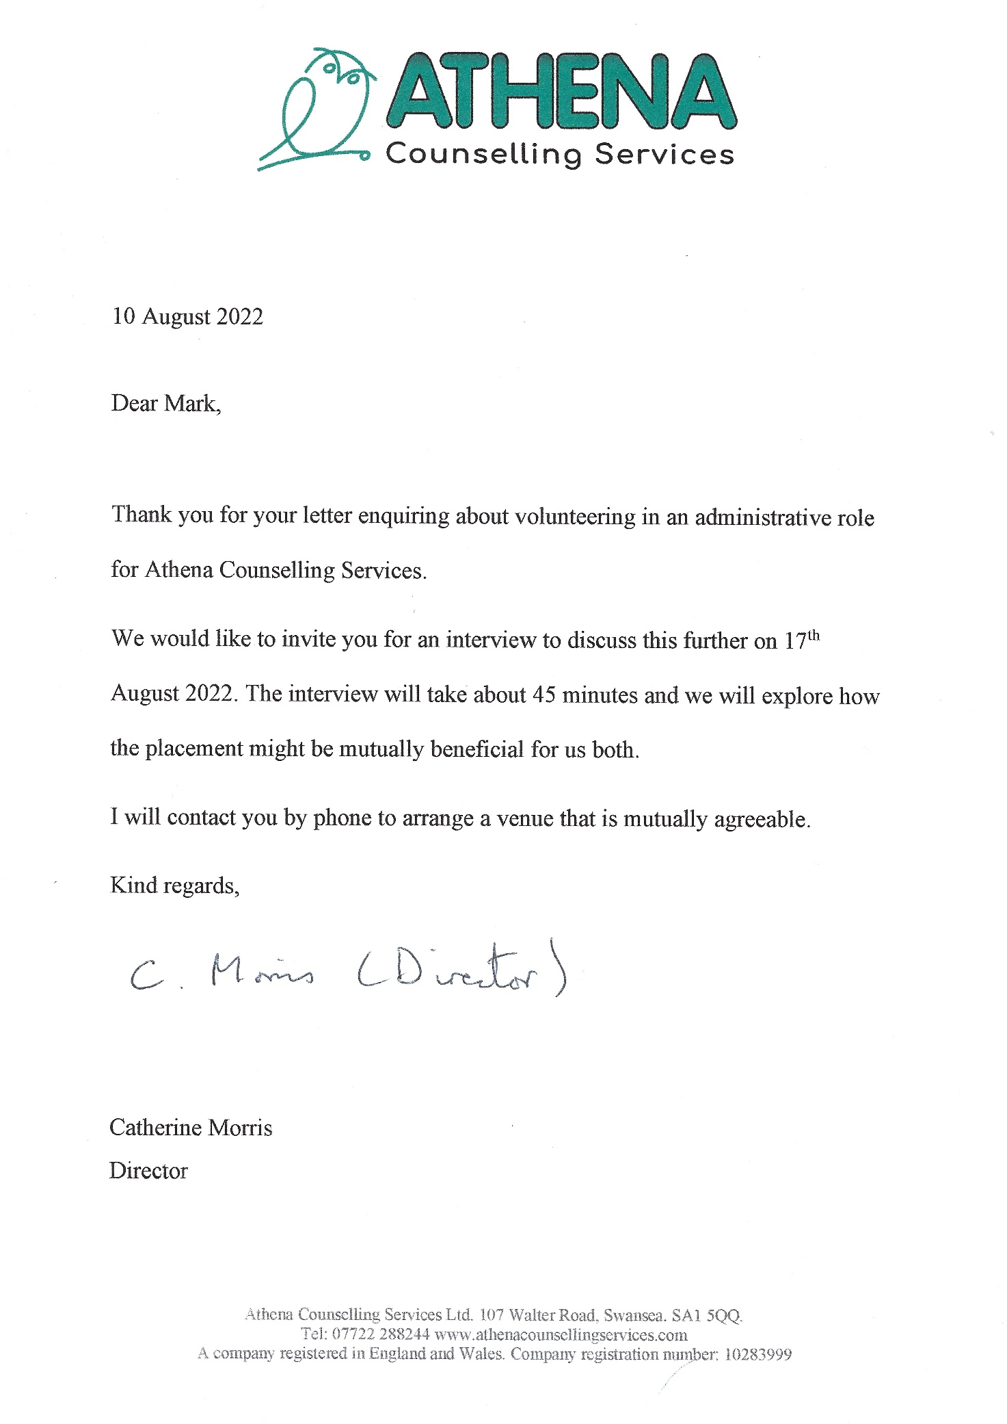
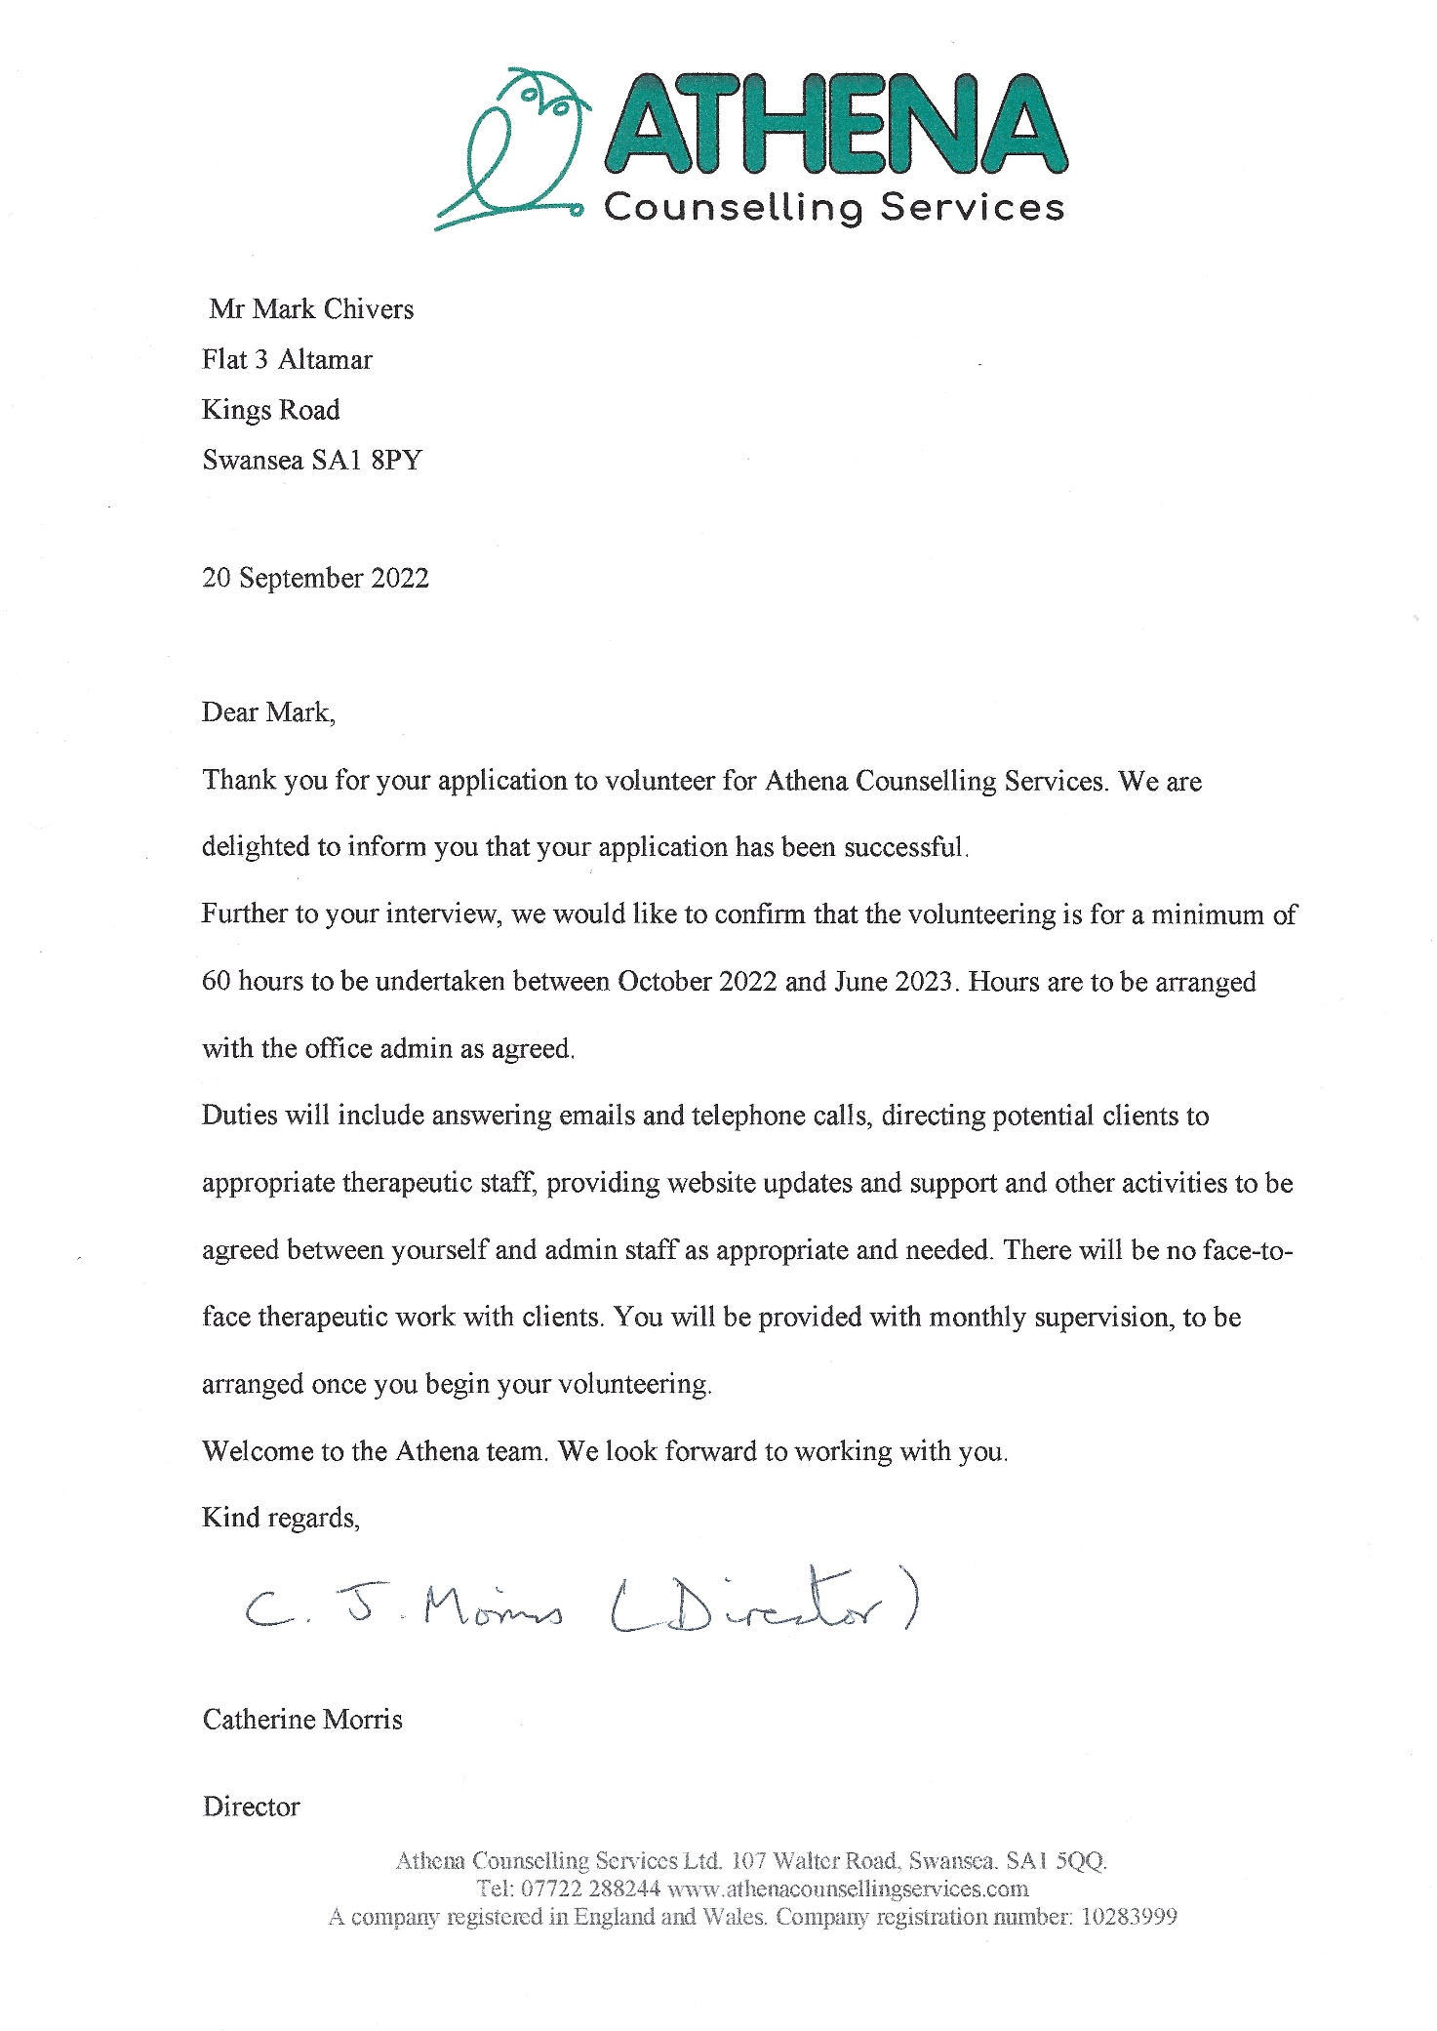
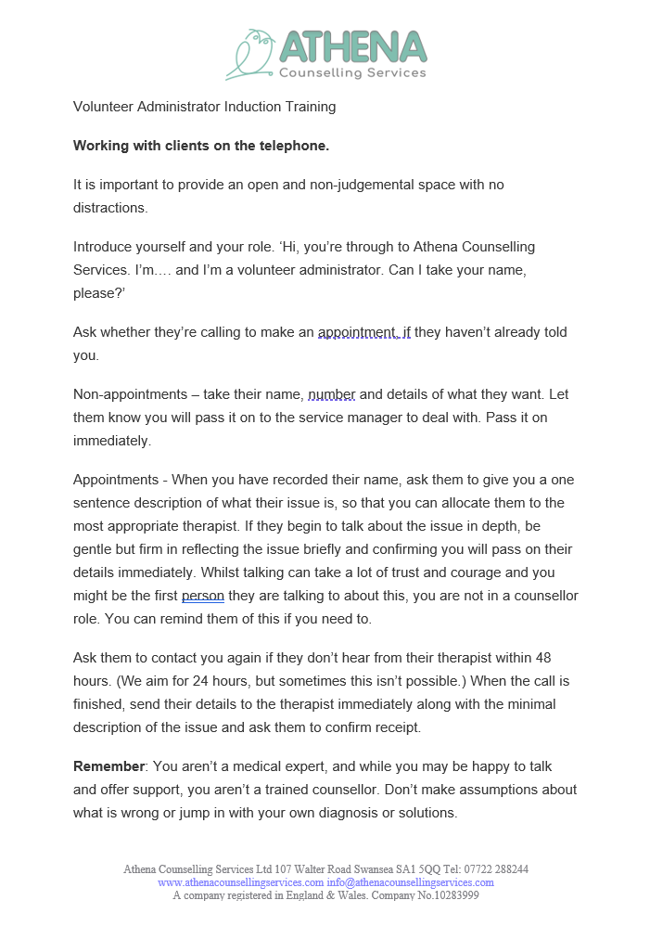
Section D: Training
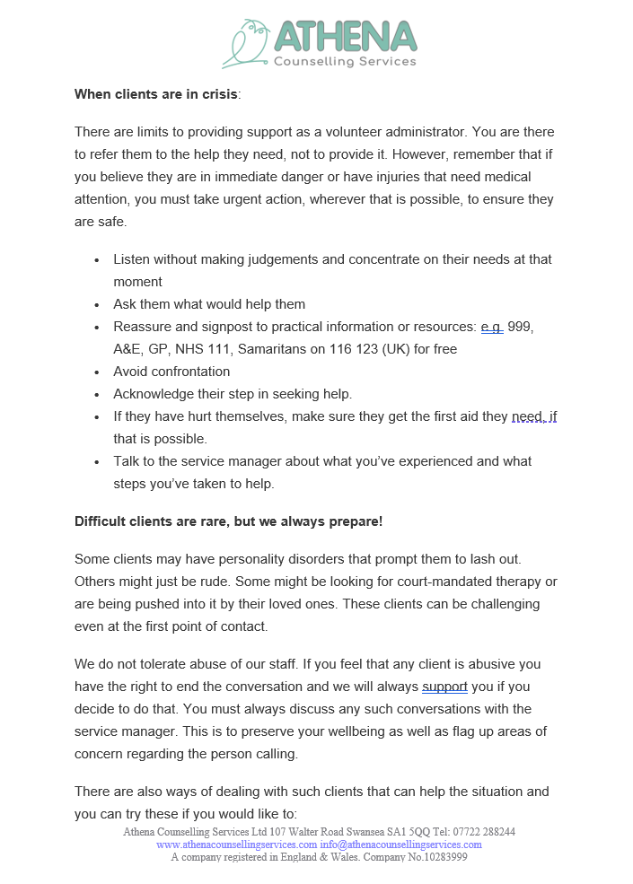
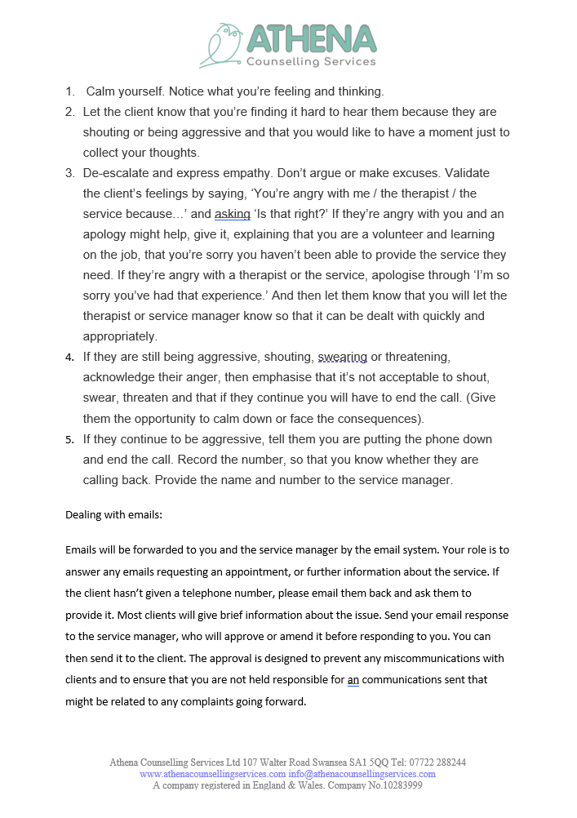
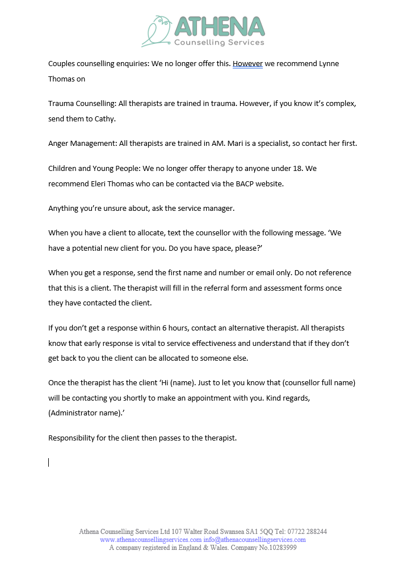
Evidence 4: Reports
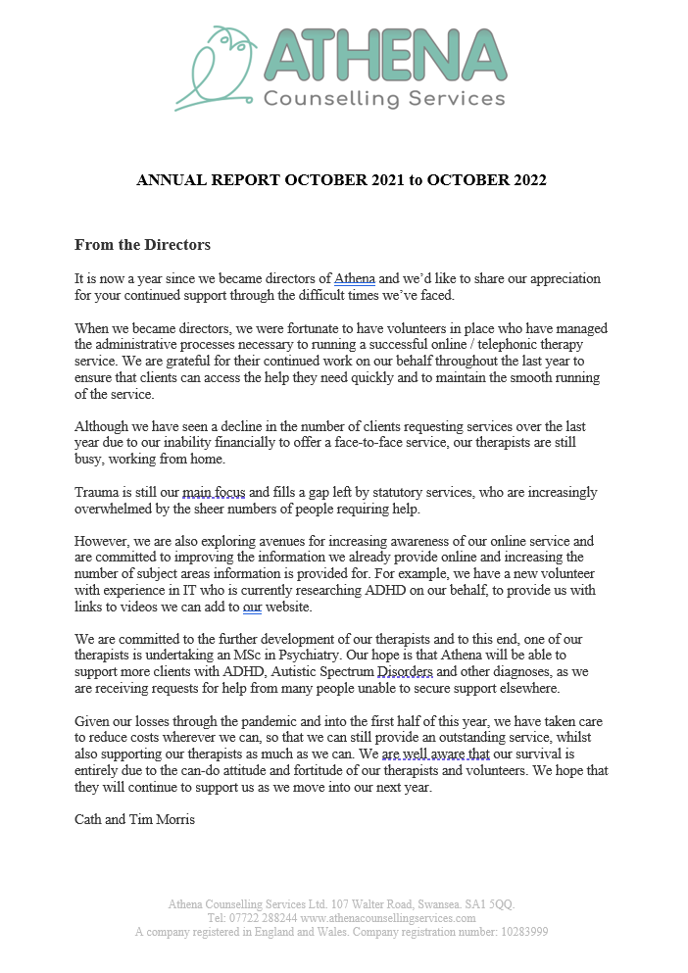
- Annual Report 2022
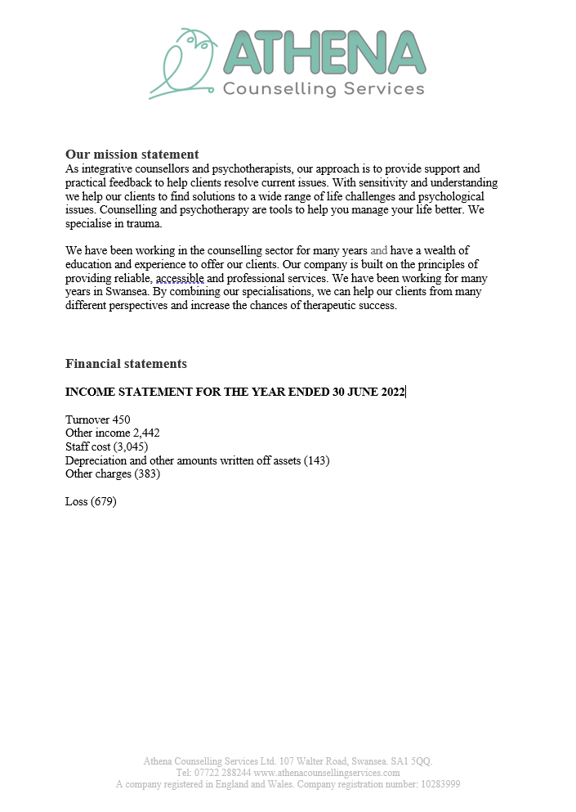
Appendix
- References
www.athenacounsellingservices.com accessed on 14/10/2022
www.athenacounsellingservices.com/about us accessed on 14/10/2022

