UWTSD
Name - Judith Churcher
Course – Business and Management (BA)
Module – Contemporary Challenges: Making a Difference (BMSP4008)
Three blogs - Approximately 500-600 words each.
Blog 1 - Based on your learning from Unit 1, what do you consider to be the biggest threat to humankind and why?
Blog 2 - Based on your learning from Unit 2, evaluate the skills you will need to be successful in your chosen field. Identify those you think are the most significant and justify your selection.
Blog 3 - Based on your learning from Unit 3, discuss the merits or shortcomings of design thinking to your chosen areas of study.

Is Artificial Intelligence a threat to humanity?
Whether we like it or not AI filtering into our life more and more. According to ‘IDC, 2021 data generating is increasing at an extraordinary rate by organisations, but it can’t come quick enough!’
What is Artificial Intelligence?
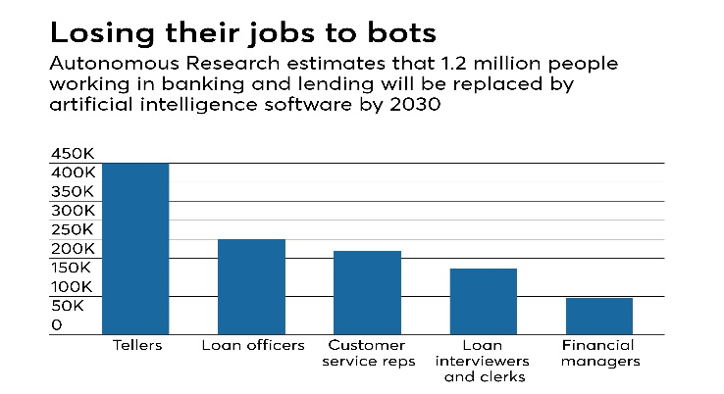
AI is known as a human-like behaviour, but it comes from a machine (robot!). It can come in many from starting at the more basic form of mimicking human behaviour by using data from the past. To the more extensive kind that can identify the difference between small things or those that are in manufacturing companies performing difficult actions at a high pace.
(Crosman,2018)
What is it good for?
There is no denying that AI does hold some benefits. If you are a large corporation, it can be very powerful. ‘Pedamkar (2020) says that amazon use AI based robots in its warehouses as this can reduce human intensive labour, but also improves the safety in the workplace.’ Using AI robots will improve efficiency, reduce human error, and will work indefinitely, or will it?
Many would tell us that AI is the way forward, in which it could be. It has helped us get to places that humans could not. Without AI would we have been able to visit inhospitable planets? Or go to the deepest part of the ocean? It gives us opportunities to explore and discover new things more than ever before.
Can we say that working along side AI is a good thing? “Some believe that computers and humanity are not separate, but instead a single, cognitive unit that already works together for the betterment of all.” (Gaille, 2018)
Why should we feel threatened?
Let’s look further down the line…think about when AI starts to take over, all be it there will be more job opportunities for people who will programme and control them but think of the job loss for those who’s jobs have been reduced or removed as they have been taken over by robots.
This graph shows the amount of people that are likely to lose their jobs due to AI. This raises questions to what will happen when robots take over. Will there be enough jobs for everyone when according to ‘Roser (2013) the world population is growing 1.0% per year’?
AI is not easy on the wallet. If you are a smaller business, you may find yourself struggling to take advantage of the benefit that AI has to offer. But if you own your own business would you want to remove the independence of it and use AI that lacks creativity? In years to come I see there to be a world where we live side by side with AI robots but will we be a commodity to THEM?
Although AI has shown and will have immense potential, do we know enough about them to know the true power they have or the power that they can be given.
What do you need to be successful in your role as a HR Manager?
Human resources managers are crucial in any larger business, and they are relied on more and more.
What is a HR Manager?
Human resources managers are found in many industries. They are responsible for managing the people workplace culture and environment. ‘Heathfield, 2021, tells us that if the role is done well the productivity and contributions from staff and overall company will be full of drive and they are more likely to accomplish goals and reach targets.’
They are responsible for employee’s moral. To gain trust and to make sure that they are working productively. To help do this, HR Mangers need to look at the company’s mission and targets and share them with staff to made them feel included with a sense of belonging.

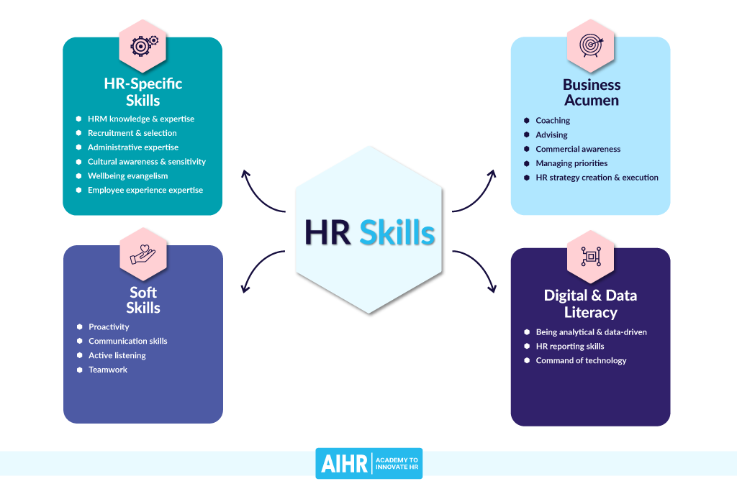
What Qualities do you need to be a HR Manger?

As a HR Manager there are many skills that you will need to be successful. These will include but are not limited to:
- Communication skills
- Administrative skills
- Managing priorities
- Coaching
- Recruiting and selection
- Active listening
- Teamwork (Vulpen, 2021)
I find that the most important skills to have as a HR manager active listening. This is important as a HR manager as you will be faced with many situations where issues will need to be discusses are resolved. ‘Robinson, 2022, tells us that it is an important skill to have as people will seek you to speak about personal and professional problems that may arise.’
Confidentially is another crucial skill. When people are coming to you with problems it is your responsibly to make sure that sensitive information is not spread and are to stay private. You will be faced with not only personal problems, but you will have to hand personal information like personal records and payroll details.
What could be the most important skill for a HR manager to have? As it is working with HUMANS you need to be able to interact with employees. Although you are in a professional environment you need to make sure that you can also be approachable.
After gathering as much skills as you can academically, the best way to be more confident, to grow and to adapt is to gain experience on the job. To further your experience there are plenty of HR courses.
Design thinking in HR Management
Design thinking is an important part or working in HR. ‘Symonds, 2022, tells us that as employers you would be under pressure to adapt to evolving employee expectations.’ To be able to make a difference to your organisation you need to be able to design new management strategies.
What is design thinking in HR all about?
What is design thinking? It is human centred... and HR is all about interactions with humans! “It’s a form of analysis that puts the stakeholder at the centre of the process in order to solve complex problems” (Symonds, 2022) The first stage of design thinking is empathy. As a HR manager you need to be able to observe empathically on how people react to certain situations. You need to be able to see things from other people’s perspectives and listening to people’s feedback. This is an important part to play to ensure the employee has a good experience and support which in turn will increase performance and productivity.
The second stage of design thinking
The second stage of design thinking is define. In HR management you are listening to your employees, therefore you are collecting information from them but making the feedback relatable and simple for them to understand. From this you can learn about your employees and find out what they need from you.
The third stage of design thinking
The third stage is ideate. After observation the employees and their feedback to you, you can understand what problems need your attention. Teamwork will come into this stage as you will have many brainstorming sessions you can use your active listening skills to help encourage other to share their ideas.
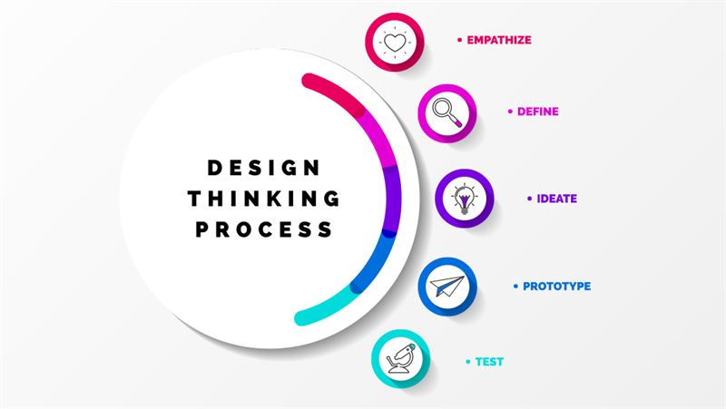
(Knowledge Lab, 2020)
The fourth stage
The fourth stage is prototype. After the brainstorming and coming up with various ideas together, then you can bring them to life. To be able to get the best outcome you need to build on your best ideas. Don’t forget that you need to keep your employees experience as your main focus at all times. This stage is all about having something to present to your employees and is ready to test.
The final stage
If you haven’t guessed it, the last stage is to test. That’s right, you will be putting them to the test. By doing this you will be able to evaluate whether it worked well or whether there is still room for improvement. Its important not to give up at this point. Any test that get done you should be collecting feedback so people can share their opinions so you can change any issues that need addressing to make the final solution the right solution.

References.
IDC. (2021) HPE Artificial Intelligence (AI) Solutions. Artificial Intelligence (AI) Solutions & Technologies | HPE United Kingdom
Pedamkar, P. (2020) Benefits of Artificial Intelligence. Benefits of Artificial Intelligence | Top 6 Key Benefits of Artificial Intelligence (educba.com)
Gaille, L. (2018) 16 Artificial Intelligence Pros and Cons. 16 Artificial Intelligence Pros and Cons – Vittana.org
Crosman, P. (2018) How Artificial Intelligence is Reshaping Jobs in Banking. How artificial intelligence is reshaping jobs in banking | American Banker
Roser, M. Ritchie, H. Ortiz-Ospina, E. (2013) World population growth. World Population Growth - Our World in Data
2
Heathfield, S.M. (2021) What is human resource management? Definition and examples of human resource management. Human Resource Management: What Is It? (thebalancecareers.com)
Vulpen, E. (2021) 18 HR skills every HR generalist needs. 18 HR Skills Every HR Generalist Needs [with Infographic] - AIHR
Teamwork.com (2022) 14 Crucial HR skills & competencies. 14 Crucial HR Skills & Competencies (teambuilding.com)
3
Symonds, C. (2022) What is design thinking in HR? 5 key principles. What is Design Thinking in HR? 5 Key Principles (factorialhr.com)

Knowledge Lab. (2020) Design thinking process. [Image] Design Thinking Process - Knowledge Lab Newsroom (cision.com) Accessed: 14.03.22
Business 901. (2013) The use of design thinking at Toyota. The Use of Design Thinking at Toyota (business901.com)

