

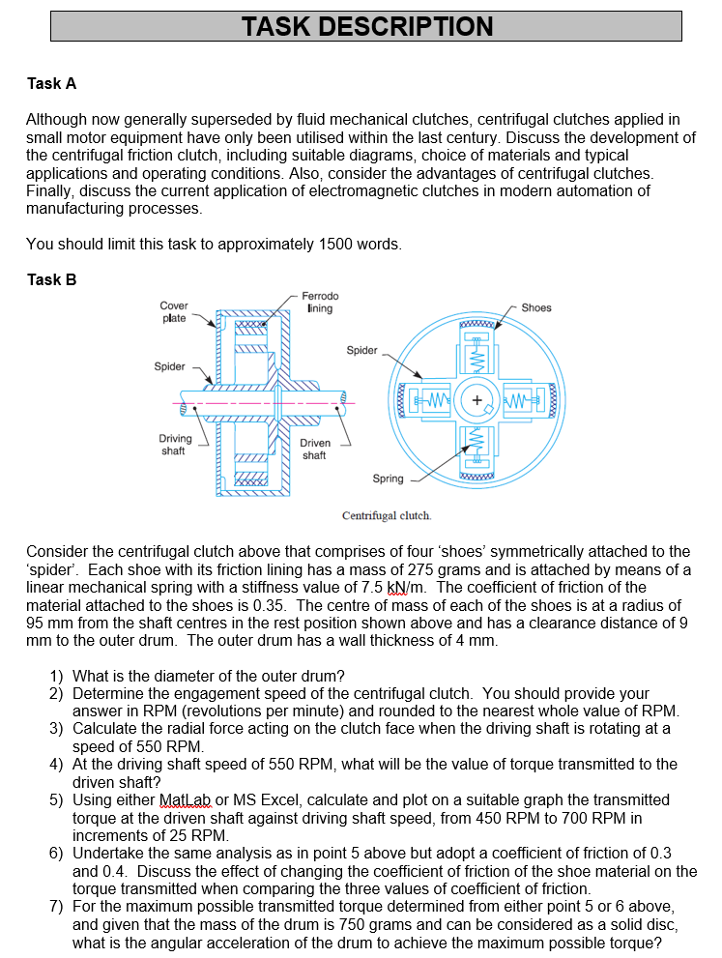



Task A
A clutch is an engineering device used for transferring motion from an engine to a gearbox or other machinery. The centrifugal clutch (or sometimes referred to as the friction clutch) is a mechanical device used on driven rotary equipment. This clutch can be found to be used in mopeds, lawn mowers, go-karts, and chainsaws, these are combustion engines, the clutch automatically transmits the torque from the drive to the driven equipment ensuring a gentle initiation with no load engagement. Engineer’s guide (2019). This application prevents the devices engine from stalling when the output shaft comes to an abrupt halt. Figure 1 below is a diagram of a centrifugal clutch:
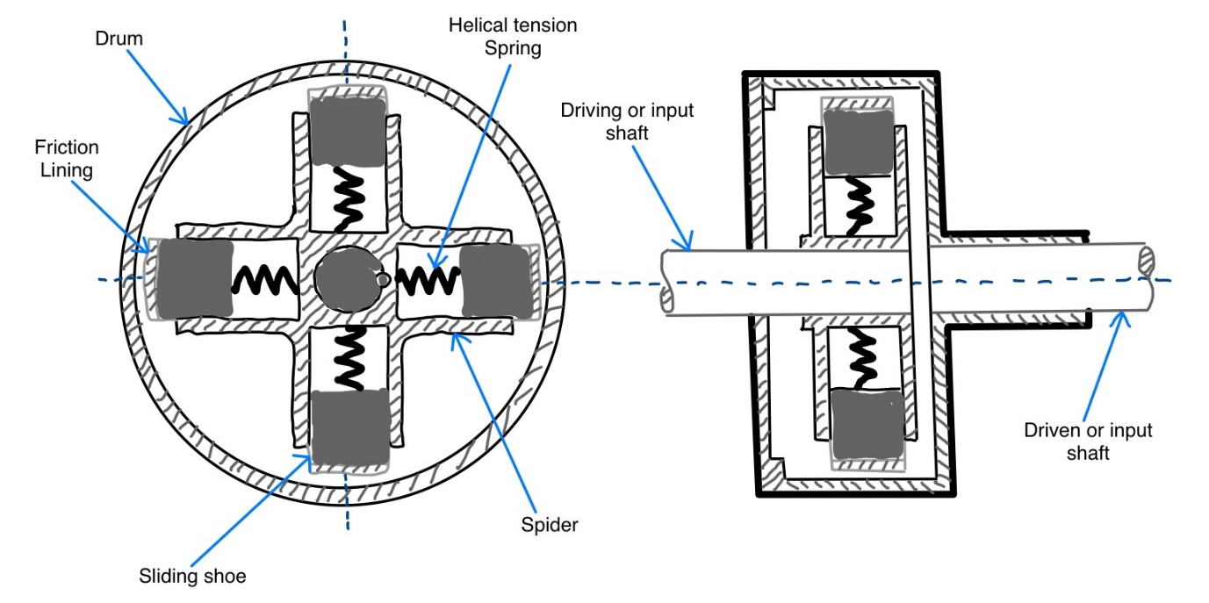
(Figure 1: Centrifugal clutch line diagram) Source: Rhys Brannan, testoTips.com (2019)
When discussing centrifugal clutches, it is important to understand what a centrifugal & centripetal force is. ByJus’s (2019) states Centrifugal force is a pseudo force in a circular motion which acts along the radius and is directed away from the centre of a circle, whilst centripetal force is the component of force acting on an object in curvilinear motion, directed towards the axis of rotation. This can be shown in figure 2 below:
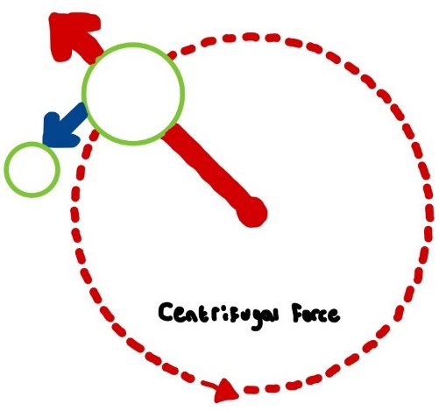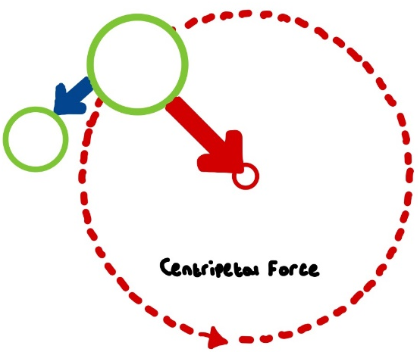
(Figure 2: Centrifugal & Centripetal force diagram) Source: Rhys Brannan, Biggs & Lucas (2022)
Centripetal force is the name given to any force that keeps an object moving in a circle, the force always points perpendicular to the direction of an objects motion, for example, if a subject was riding in a car and the road banks and turns to the left the normal force from the banked road will push the car to the left, if the centripetal force were to suddenly disappear, the car would continue moving in a straight line. The apparent outward force is described by Newtons laws of motion, consider a mass ‘m’ rotated at constant angular speed ‘ω’ at a radius ‘r’. There will be a force equal to the product of the mass and centripetal acceleration of the body and will act in the direction toward the centre of rotation. Hence:
Centripetal force, Fc $=mω^{2}r$
But due to Newtons 3rd law of motion “for every action, there is an equal and opposite reaction”, there is a reaction to the inwards centripetal force which is equal in magnitude but opposite in direction. This force is the centrifugal force, this is significant when determining the force acting on devices such as centrifugal clutches. Centrifugal force can be calculated by:
Centrifugal force = $m×\frac{v^{2}}{r}$
University of Wales Trinity Saint David class notes (2023).
Construction of a centrifugal clutch
The centrifugal clutch is made up of five key components:
Part | Description
Drum | The drum is the housing of the clutch, it surrounds all of the clutch components, including the sliding shoes, guides and springs. The drum will be connected to the driven shaft of the transmission system.
Spider | These are equally spaced guides, usually separated by 90 degrees if there are four of them, that hold the shoes and respective springs. They are mounted on the driver shaft.
Helical tension spring | The springs disengage the clutch when the engine functions at low speeds.
Shoes | The are sliding components that move within the guideways and are equipped with friction linings at their ends, these initiate contact with the drum during engagement
Friction lining | Ensure a solid grip with the inner surface of the drum.
Source: Testbook (2023)
Bird & Ross (2012) state the clutch works on the principle that the rotating driving shaft will cause the centrifugal weights to move radially outwards with increasing speed of rotation of the driving shaft. The figure 3 below shows this.

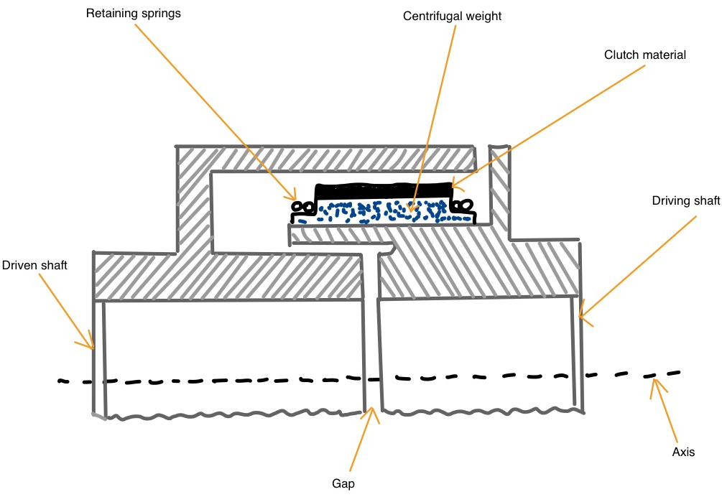
(Figure 3: Centrifugal clutch) Source: Rhys Brannan (2023), Bird & Ross (2012)
The centrifugal weights are retained by the helical tension springs, but when the speed of the driving shaft reaches its maximum the clutch material engages with the driven shaft, through the friction lining, this causes the driven shaft to rotate. They go on to state it causes the driven shaft to reach a high speed of rotation in a smooth manner in the required time. Figure 4 shows the centrifugal clutch at Idle speed and at operating speed.
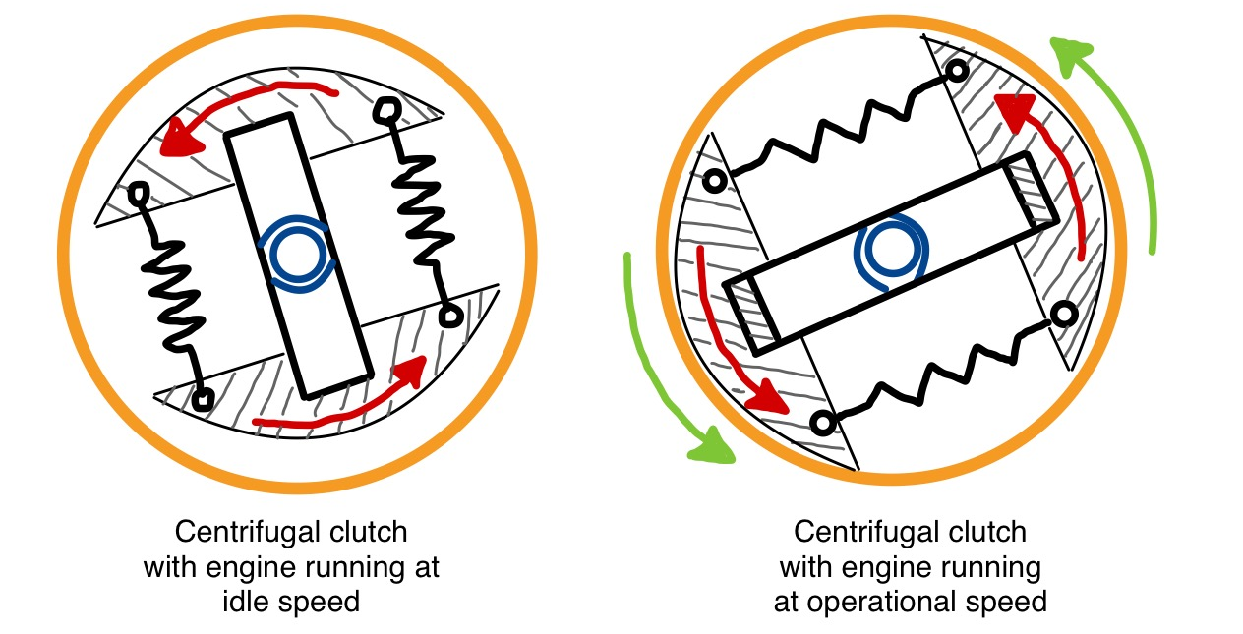
(Figure 4: Centrifugal clutch disengaged & engaged) Source: Rhys Brannan (2023), Engineering expert (2013)
Development of the centrifugal clutch
Since the introduction of internal combustion engine as the driving force in motor vehicles, engineers have been tasked with the difficulty of separating the driveline from the engine from stalling when the speed drops below a self-sustaining point of the engine and reconnecting it gradually to accelerate the motor vehicle to device from rest. C.W. Tridgell (1969) states in their paper that it was desirable for engineers to find a solution that was automatic and not dependent on the capability of the driver. Centrifugal governors were focused on by designers, most widely used in steam engines during the 19th century steam age, they control engine speed by adjusting the flow of fuel to maintain a nearly constant speed, academic accelerator (2016). Tridgell (1969) goes on to discuss that centrifugal force, being directly connected to speed, can become useful when applied to clutches as it can be exploited to understand the speed of rotation and support the force to transfer torque. Patents for the centrifugal clutch have been filed since the 1890s. Siddeley (2013) articulates that the Armstrong Siddeley 17hp was one of the first cars to feature an automatic centrifugal clutch beginning in 1936.
Material selection of centrifugal clutch friction lining
What-when-how (2011) discusses how the friction linings of a centrifugal clutch can be subjected to strict rubbing, therefore the ling material should have a grouping of the following properties to be suitable for the operating conditions:
- High coefficient of friction under entire operating conditions.
- High energy absorption over short periods.
- Be able to resist high pressure plate compressive loads.
- Can withstand high impact centrifugal loads during gear changing.
- Adequate shear strength to transmit engine torque.
- Ability to be bonded to the backplates of centrifugal clutch.
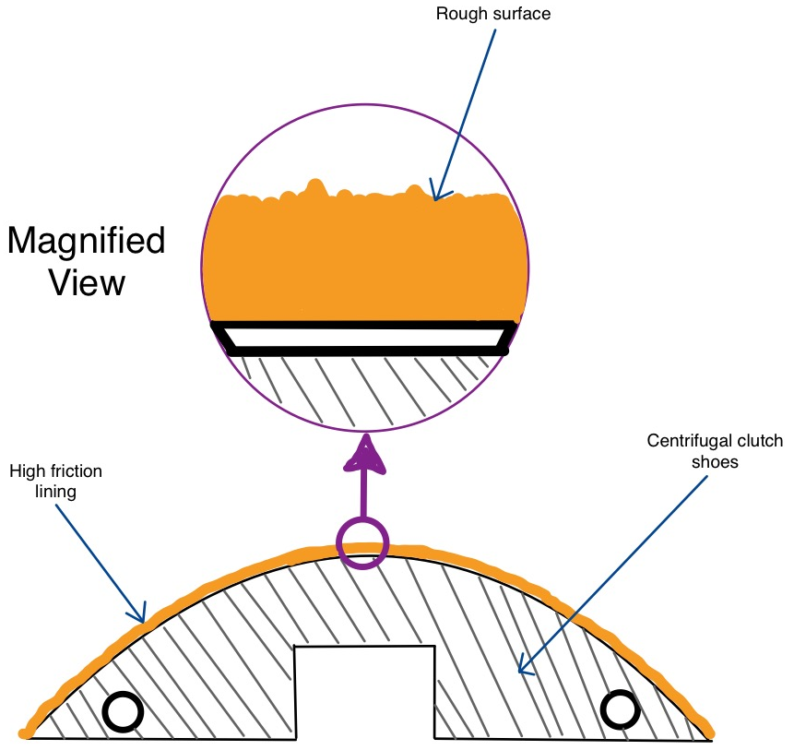
(Figure 5: Friction lining of centrifugal clutch) Source: Rhys Brannan (2023), Engineering expert witness blog (2012)
There are four main types of clutch lining material used today, organic, Ceramic, Kevlar or carbon-carbon, Phoenix friction (2022). The below table show the fade temperature and a description of the materials. The fade temperature is when part of the resin material starts to vaporise which can decrease the coefficient of friction, Dixcel (2023).
Source: Kor- Pak (2018), HPM (2013), Autoworks (2023).

How a centrifugal clutch operates.
BLM (2019) indicates that the centrifugal clutch uses centrifugal force to turn the driveshaft and acts as a transmission activated by the increasing rpm of an engine. Sirajeddine (2023) goes on to state that the centrifugal clutch is commonly deemed to be one of the smoothest types of clutches (compared to a dog clutch, cone clutch or dry clutch) as it engages the load to the engine progressively, this allows the engine to reach its optimal torque before it’s carrying any load. The writer goes on to discuss that a centrifugal clutch can have up to six shoes that follow a symmetrical positioning on the drive shaft. Expansion springs are used in the clutch to allow the shoes to expand in a controlled manner in relation to the engines RPM.
Advantages of centrifugal clutches
Engineering designer (2023) cites that a key advantage of the centrifugal clutch is its cost effectiveness when compared to other methods of driving the drive shaft, such as belt drives or chain transmissions. The centrifugal clutch requires fewer parts and also far less maintenance since it operates automatically by responding directly to changes in engine revolutions per minute. They go on to state, unlike other drive systems which must be lubricated periodically this clutch has self-lubricating components that do not require regular maintenance.
Another advantage BLM (2023) discusses is that centrifugal clutches have less chance of stalling and causing damage to a vehicle or device. Heavy loads and sudden starts can put a burden on engines. This clutch has a progressive engagement with load which is safer. These clutches specialise in smooth and shockless acceleration.
Finally, Kumar (2019) argues that main advantage of the clutch is the increased efficiency compared to other methods of driving the drive shaft. By engaging and disengaging at specific engine speeds, this type of clutch allows the engine to operate within its optimal speed range. This means the power is transmitted when it is most effective, improving fuel economy and reducing energy wastage. This result is a more cost-effective and sustainable operation.
Electromagnetic clutch
Testbook (2023) says an electromagnetic clutch is a highly efficient device that utilises the principles of electromagnetism, the technology enables seamless transmission between two rotating shafts. They go to discuss how the electromagnetic operates using these steps:
- At the start the clutch remains disengaged, with clearance between the rotor and the hub.
- When the engine activates this prompts the rotation of the rotor which is connected to the engine shaft. A DC battery supplies a direct current to the clutch winding.
- The application of high voltage DC current creates an electromagnet, creating an attractive force on the armature.
- The armature exerts a pressure to the friction plate, causing it to move towards the rotor and initiating the rotation of the hub.
- When the hub rotates this allows the rotor to transmit 100% torque when engaged.
- When the operator presses the clutch switch the battery discontinues the supply to the winding, eliminating the electromagnetic force and causes the clutch to revert to the disengaged phase.
Figure 6 below shows the construction of an electromagnetic clutch.

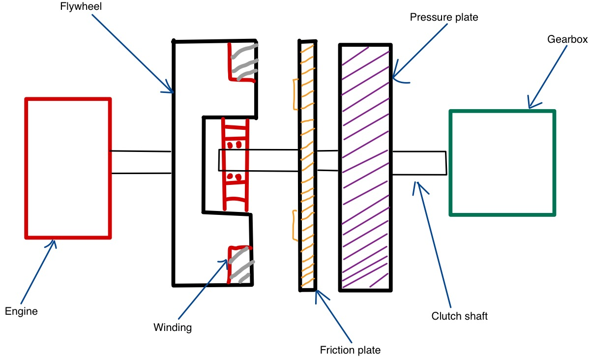
(Figure 6: Construction of electromagnetic clutch) Source: Rhys Brannan (2023) Mechcontent (2017).
Mecholic (2016) expresses that electromagnetic clutches are used for remote applications as they do not require a linkage to set in motion the clutch, they can be found to be used in printing machinery, factory automation, conveyor drives and copier machines. They go on to state in the automotive industry they replace clutch pedals by a simple switch button. A small electromagnetic clutch is used to drive the compressor of air conditioning units.

Part B
1)
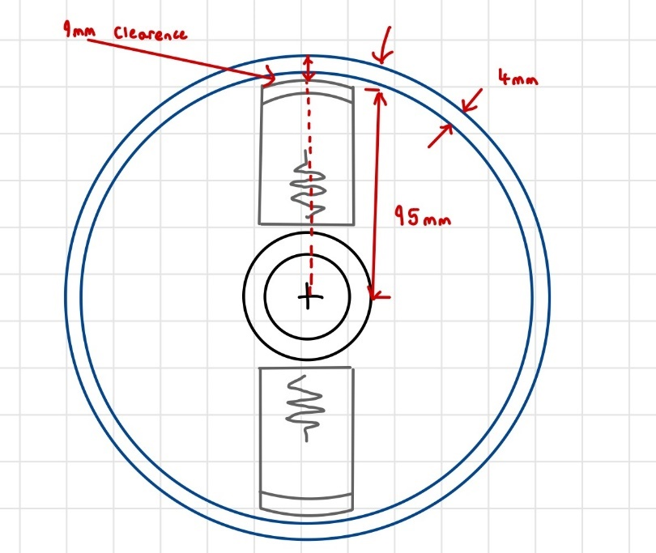
Centre if mass of each of the shoes is at a radius of 95mm from the shaft and the centres in the rest position. There is a clearance distance of 9mm to the outer drum and the drum has a wall thickness of 4mm.
Shoe to opposite shoe = 95+95= 190mm
Outer drum diameter= 190 + 18 = 208mm

2)
The engagement speed = Lockup speed
This is the speed at which the shoes are just making contact with the inner drum.
Using Hooke’s law $f=kx$
K=7.5 KN/M = 7500 N/M
X= 9 mm clearance = 0.009 M
F= 7500 x 0.009 = 67.5 N
For four shoes = 67.5 x 4 = 270 N
Using $f_{c}=mω^{2}r$ , this can be rearranged to find angular velocity $ω=\sqrt{\frac{f_{C}}{mr}}$
270 = (0.275x4) x $ω^{2}$ x (104x${10}^{-3}$)
$$ω=\sqrt{\frac{270}{\left(0.275*4\right)×(104× {10}^{-3})}}$$
$$ω=48.58 rev/s$$
The answer now needs to be converted to revolutions per minute (RPM), the equation $\frac{60}{2π}$ is used.
$$ω=48.58× \frac{60}{2π}=463.92 RPM$$
Rounded to the nearest whole number the engagement speed of the centrifugal clutch is 464 RPM.

3)
Given that:
$$k=7.5\frac{KN}{M}=7.5 × {10}^{3}\frac{N}{M}$$
$$m=275 g=0.275 kg$$
$$d=190mm=0.19 M$$
$$r1=\frac{d}{2}=\frac{0.19}{2}=0.095 M$$
$$fr=9mm=0.009 M$$
Need to convert 550 RPM into radians per second.
$$\frac{rad}{s}=\frac{550}{60}×2 π=\frac{55}{3}π$$
When the mass engages $r2=r1+fr$
$$r2=0.095+0.009=0.104 M$$
Centrifugal force $=m ω^{2}r$
$$=0.275 ×\left(\frac{55}{3}π\right)×0.104=94.874 N$$
Now the spring force needs to be considered.
Spring force = $k ×fr$
$$=\left(7.5 ×{10}^{3}\right) ×0.009=67.5 N$$
The force on the clutch face from one shoe $=Centrifugal force-Spring force$
= 94.874 – 67.5 = 27.374 N
The force caused by four shoes = 27.374 x 4 = 109.496 N

4)
$$Torque=F ×R (Force ×Radial Force)$$
From the previous question it is found that the force of one shoe = 27.374 N
To work out the torque the coefficient of friction of the material attached to the shoes needs to be considered, this is given as 0.35 .
$Frictional force=fs= μ ×f$
$$=0.35 ×27.374=9.555$$
The torque applied can now be worked out using $T=F ×R$
$$T=9.555 ×0.095=0.907735 N/M$$
The torque of four shoes = 0.907735 x 4 = 3.6309 N/M

5)
Microsoft Excel was used to find the transmitted torque at the driven shaft against driving shaft speed, from 450 RPM to 700 RPM in increments of 25 RPM.
In the appendix the full data can be found that was inputted to excel.
For a coefficient of friction 0.35 the torque values of the four shoes are as shown in the table below.
RPM | Torque of four shoes (N/M)
450 | 0.265274862
475 | 0.434071139
500 | 1.450833672
525 | 2.519737874
550 | 3.640783744
575 | 4.813971282
600 | 6.039300488
625 | 7.316771363
650 | 8.646383906
675 | 10.02813812
700 | 11.462034

From the data it can be seen as the RPM increases the torque transmitted at the driven shaft increases. This can be expressed by the following graph.

6) Changing the coefficient of friction of the material on the shoes will change the torque transmitted at the driven shaft.
0.3 coefficient of friction
RPM | Torque of four shoes (N/M)
450 | 0.227378454
475 | 0.372060977
500 | 1.243571719
525 | 2.15977532
550 | 3.12067178
575 | 4.126261099
600 | 5.176543276
625 | 6.271518311
650 | 7.411186206
675 | 8.595546958
700 | 9.82460057

0.4 Coefficient of friction
RPM | Torque of four shoes (N/M)
450 | 0.303171272
475 | 0.496081302
500 | 1.658095626
525 | 2.879700427
550 | 4.160895707
575 | 5.501681465
600 | 6.902057701
625 | 8.362024415
650 | 9.881581607
675 | 11.46072928
700 | 13.09946743

Comparing the three coefficients of friction

As can be seen from the graph the torque transmitted at 450-475 RPM is very similar and in the same range for the 0.3, 0.35 and 0.4 coefficients of friction. But as the RPM increase the range of torque increase between the three coefficients.

Bibliography
Academic accelerator (2016), ‘Centrifugal governor’, [Online]. Available: https://academic-accelerator.com/encyclopedia/centrifugal-governor [2023, October, 30].
AutoProTips (2019), ‘Centrifugal clutch’, [Online]. Available: https://www.autoprotips.com/centrifugal-clutch/ $,[$2023, October, 19$]$.
Biggs B. and Lucas J. (2022), ‘What are centrifugal and centripetal forces?’, [Online]. Available: https://www.livescience.com/52488-centrifugal-centripetal-forces.html , $[$2023, October, 26$]$.
Bird J. and Ross C. (2012), ‘Mechanical Engineering principles’ (2nd Ed), Oxfordshire: Routledge.
BLM (2019), ‘Advantages and disadvantages of centrifugal clutch’, [Online]. Available: https://www.blm-cm.com/blog/advantages-disadvantages-centrifugal-clutches/, [2023, October, 31].
Byju’s (2019), ‘Centripetal and centrifugal force’, [Online]. Available: https://byjus.com/physics/centripetal-and-centrifugal-force/ , $[$2023, October, 26$]$.
Dixcel (2023), ‘What is fade resistance?’ [Online]. Available: https://www.dixcel.co.jp/en/literature/lid-2240/ [2023, October, 24].
Engineer’s Guide (2019), ‘Centrifugal clutch explained – an engineers guide to a centrifugal clutch’, [Online]. Available: https://www.lancereal.com/centrifugal-clutch-explained/ , $[$2023, October, 17$]$.
Engineering Designer (2023), ‘How does a centrifugal clutch work? What are the pros and cons?’, [Online]. Available: https://www.engineeringdesigner.co.uk/how-does-a-centrifugal-clutch-work-what-are-the-pros-and-cons/ [2023, October, 20].
Engineering expert (2013), ‘how a centrifugal clutch works with animation’, [Online]. Available: http://www.engineeringexpert.net/Engineering-Expert-Witness-Blog/tag/centrifugal-clutch [2023, October, 27].
Engineering expert (2013), ‘Mechanical power transmission – centrifugal clutch shoe wear’, [Online]. Available: http://www.engineeringexpert.net/Engineering-Expert-Witness-Blog/mechanical-power-transmission-%e2%80%93-centrifugal-clutch-shoe-wear [2023, October, 24].
European Patent Specification (2013), ‘method of making a centrifugal clutch’, [Online]. Available: https://patentimages.storage.googleapis.com/36/12/e9/d51a3dcc09856b/EP2350485B1.pdf , [2023, October, 26].
HPM (2013), ‘Clutch Materials’, [Online]. Available: https://www.highpowermedia.com/Archive/clutch-materials, [2023, October, 24].
Kor-Pak (2018), ‘What is the best clutch material for friction?’, [Online]. Available: https://kor-pak.com/best-clutch-material-friction/ , [2023, October, 24].
Kumar S. (2019), ‘What is centrifugal clutch? – Working principle, Applications, advantages, disadvantages’, [Online]. Available: https://marinerspointpro.com/centrifugal-clutch/, [2023, October, 30].
Mech Content (2017), ‘Electromagnetic clutch’, [Online]. Available: https://mechcontent.com/electromagnetic-clutch/, [2023, October, 31].
Mecholic (2016), ‘Electromagnetic clutch working applications’ [Online]. Available: https://www.mecholic.com/2016/01/electromagnetic-clutch-working-application-advantages.html , [2023, October, 31].
Phoenix friction (2022), ‘Clutch friction materials explained’, [Online]. Available: https://www.phoenixfriction.com/t-clutch-materials-explained.aspx [2023, October, 24].
Siddeley (2013), ‘Armstrong Siddeley 17hp’ [Online]. Available: https://web.archive.org/web/20130619055632/http://www.siddeley.com/info_17hp.html [2023, October, 30].
Sirajeddine Y. (2023), ‘Centrifugal clutch- how it works’, [Online]. Available: https://www.linkedin.com/pulse/centrifugal-clutch-how-works-youness-sirajeddine, [2023, October, 30].
Testbook (2023), ‘Centrifugal Clutch: Know Diagram, Construction, Advantages and Applications’ , [Online]. Available: https://testbook.com/mechanical-engineering/centrifugal-clutch, [2023, October, 22].
Tridgwell C.W. (1969) ‘Centrifugal clutches for automotive use’, [Online]. Available: https://journals.sagepub.com/doi/epdf/10.1243/PIME_CONF_1969_184_280_02 [2023, October, 30].
What-when-how (2011), ‘Clutch frictional material’, [Online]. Available: https://what-when-how.com/automobile/clutch-frictional-material-automobile , [2023, October, 26].

Appendix


