Ground Investigation

A ground investigation by Quantum Geotechnical Ltd was conducted on a site 602.45m from the site of Theatr Triawd in 2017 (site shown in Figure 1).
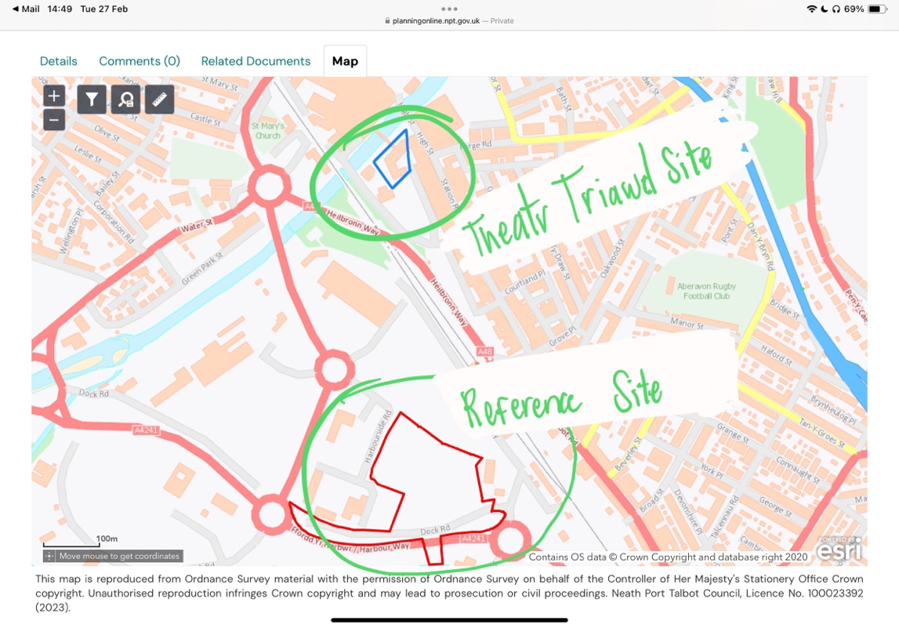
Figure 1 Image Showing the Reference Site.

A borehole Log from the reference Site is shown in Figure 2 below.
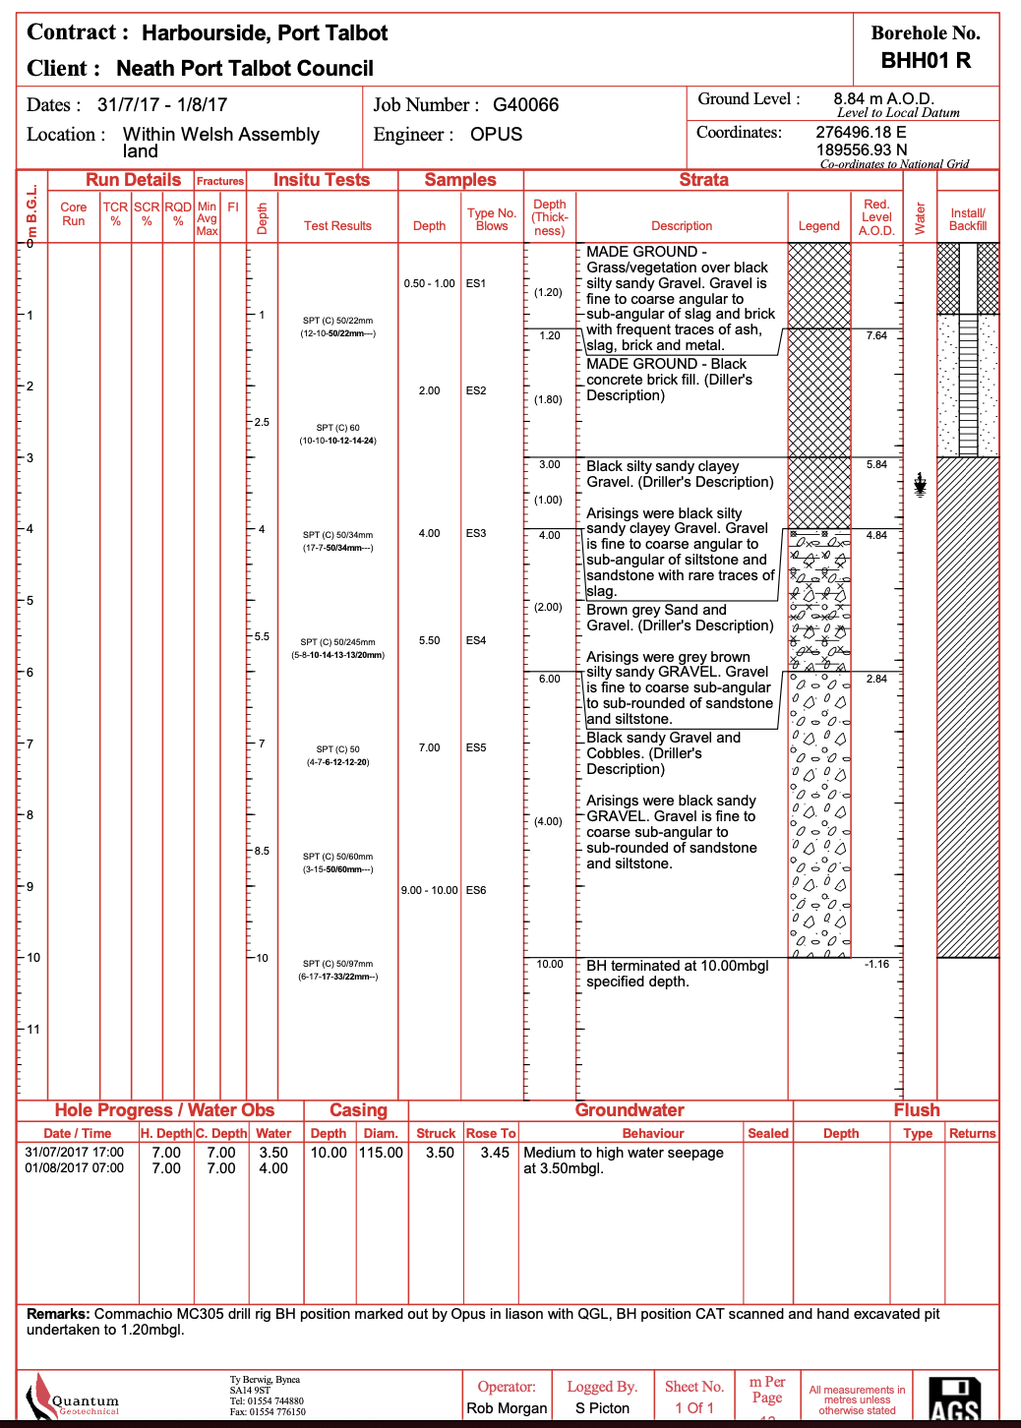
Figure 2 Image Showing a Borehole Log from the Reference Site (Quantum Geotechnical Ltd).

Summary of the ground investigation/ borehole logs:

The near-surface stratum is mostly comprised of made ground. It is generally black silty sandy gravel in texture and its contents are ash, slag, brick, concrete, and stone with some coal fragments, and the thickness ranges from 1.00m – 3.40m. Beneath the mase ground is coarse alluvial sand and gravel. And under that, there is a layer of mudstone and sandstone from 6.50m – 8.00m depth. These ground conditions were ‘fairly consistent’ throughout the entire site area. (Summary is shown in Figure 3)

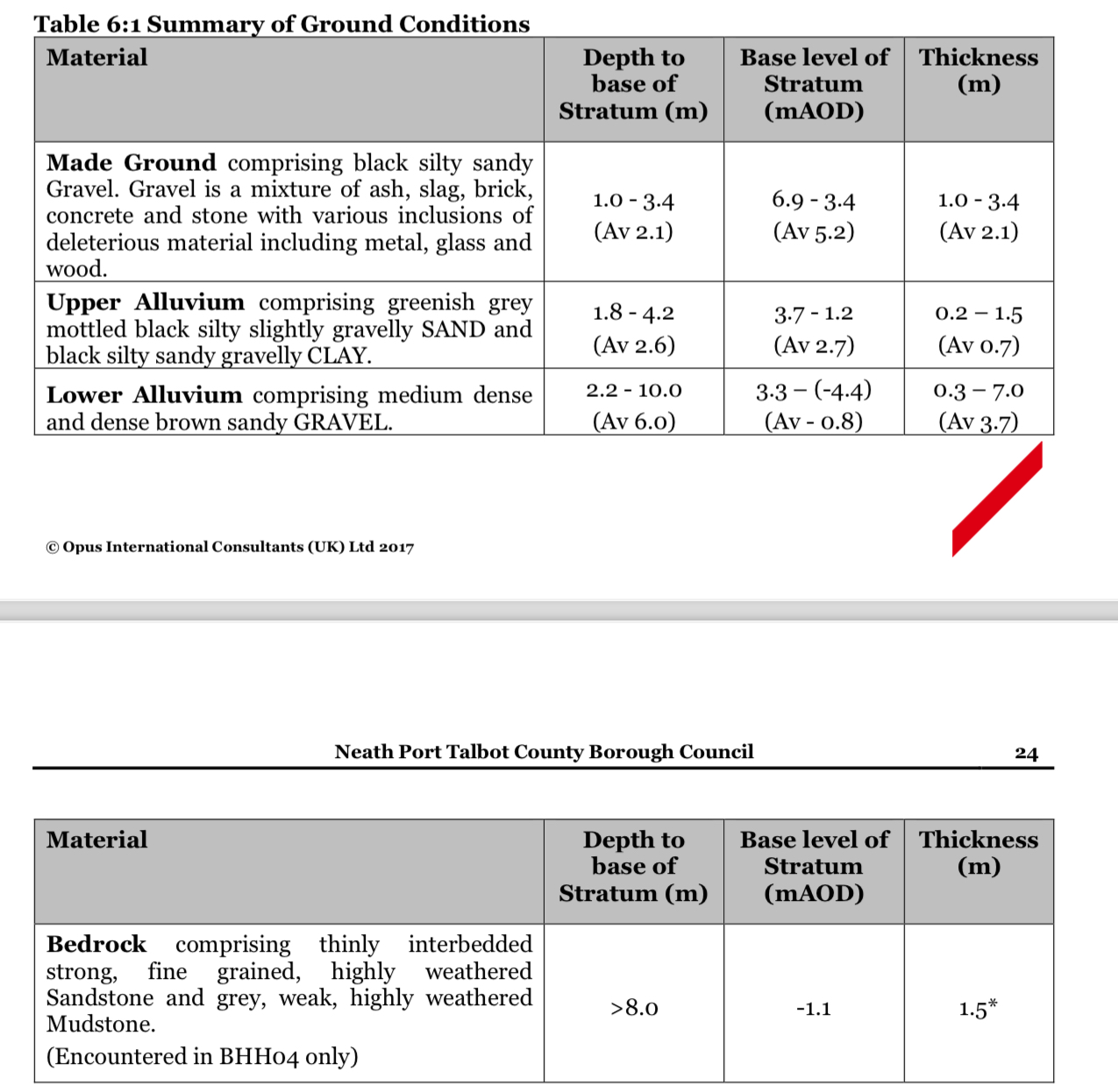
Figure 3 Image Showing a Summary of the Ground Conditions from the Reference Site (Quantum Geotechnical Ltd).

Given that summary of the site’s ground condition/ makeup. The following preliminary foundations were suggested which are subject to revision after the precise loading of the building is known:
- Shallow Pad or Trench Fill Foundation
- Piles (for any raised areas)
- Ground Improvement- vibro-stone columns to transfer the loads directly to the underlying dense gravels. This application allows the use of shallow foundations.
- Reinforced Raft Foundation- can be used to reduce potential differential settlement.

For Theatr Triawd:
Pile Foundations are suggested as the site makeup up is similar and piles will transfer the loads to the layer of gravel to support the structure.

A further investigation into the properties and characteristics of the different strata at the reference site reinforced the decision to use pile foundations for the Theatr Triawd. The characteristics are shown in Figure 4 below.
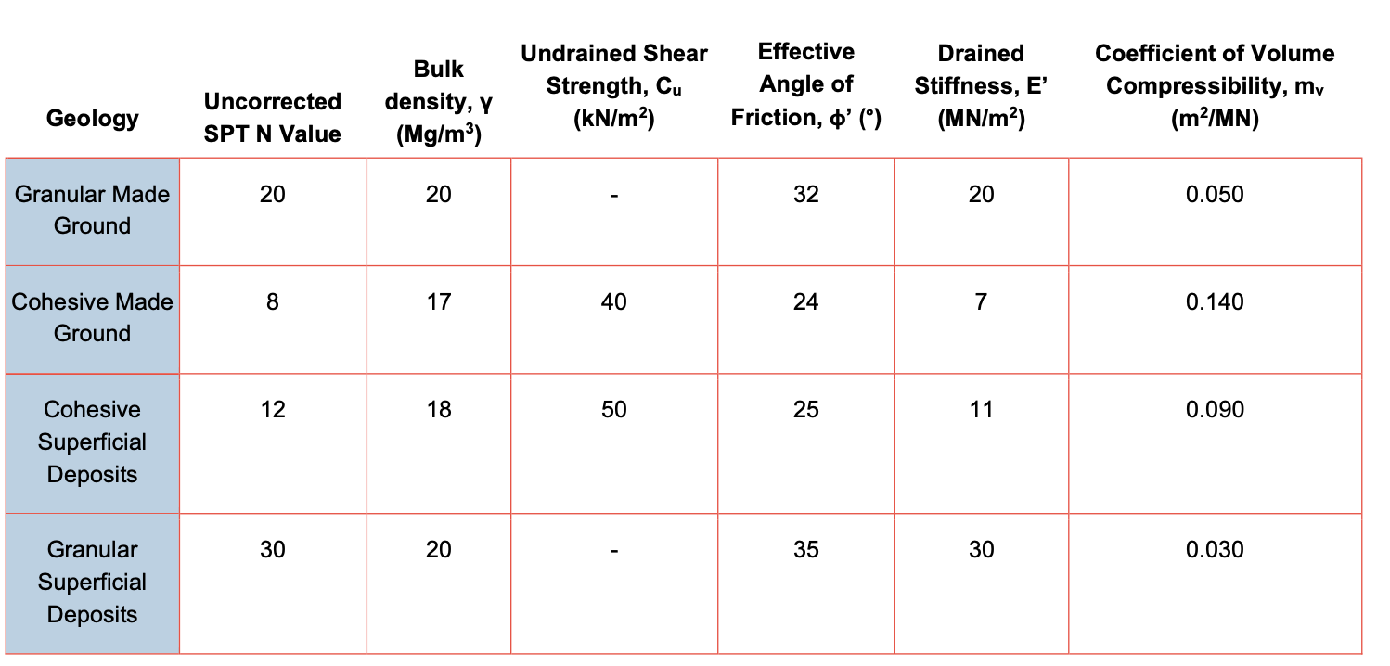
Figure 4 Image Showing the Properties of the Strata of the Reference Site (Quantum Geotechnical Ltd).

The design of the pile foundations is in the foundation substantiation section.

