Name:____________Bethan Woolley_____________________

Student Number: ______2523031__________________
__________________________________________________________

WORKSHEET 4 – TESTING

- Original code:
[Copy and paste your original code from Moodle into this box. Do not change it.]
import random

locations = [1,2,3,4,5,6,7,8,9,10,11,12,13,14,15,16,17,18,19,20,21,22,23,24,25,26,27,28,29,30,31,32,33,34,35,36,37,38,39,40,41,42,43,44,45,46,47,48,49,50]

treasures = []

for i in range(5):
treasures.append(random.choice(locations))

print("Welcome to Treasure Island!")
print("There are 5 treasure chests hidden across the island (locations 1-50)")

myGuess = int(input("Where would you like to search?: "))

while myGuess < 1 or myGuess > 50:
print("Please enter a number between 1 and 50.")
myGuess = int(input("Try again: "))

while myGuess not in treasures:

print("No treasure found at location", myGuess)
print("Your metal detector remains silent...")

for treasure in treasures:

if myGuess >= treasure - 5 and myGuess <= treasure + 5:
print("Hot")

elif myGuess >= treasure - 10 and myGuess <= treasure + 10:
print("Warm")

elif myGuess >= treasure - 20 and myGuess <= treasure + 20:
print("Cool")

else:
print("Cold")

myGuess = int(input("Try again: "))

while myGuess < 1 or myGuess > 50:
print("Please enter a number between 1 and 50.")
myGuess = int(input("Try again: "))

print("INCREDIBLE! You've found a treasure chest!")
print("You've discovered 1000 gold coins!")

Code Testing

First, create a test rig, so that you can see the generated numbers before testing the programme - so that you can see what you’re doing!

For each test below, run your code and enter the values provided. Provide a screenshot of what happened when the programme ran. Did the programme behave correctly or did it do something unexpected? Fill in a box for each test below. You should present 11 separate boxes, 1 for each test. (Note: the first box is provided as a template)

Test the following:

- Guess is an exact match on the first number in the set
- Guess is an exact match on the last number in the set
- User enters their guess as -4
- User enters their guess as 55
- Within 2 of a number (below)
- Within 2 of a number (above)
- Within 5 of a number (below)
- Within 5 of a number (above)
- Within 2 of two numbers
- Within 2 or 5 of three numbers (you may need to run your program a few times to generate a suitable number set, or you can hard code the values into the test rig)
- What happens if a duplicate number is generated within the random number set?

Test:
- Guess is an exact match on first number in the set

Screenshot(s) of output:
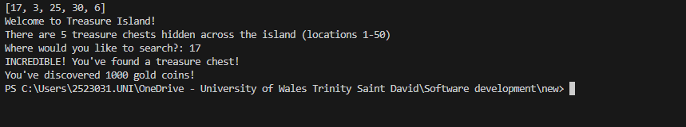

Result: Did the program behave as expected ie syntactically and logically correct?
YES
If NO, what problems were encountered and why? Suggest how things could be improved.

(Copy and paste box above for each of the rest of the tests)
Test:
2. Guess is an exact match on the last number in the set

Screenshot(s) of output:

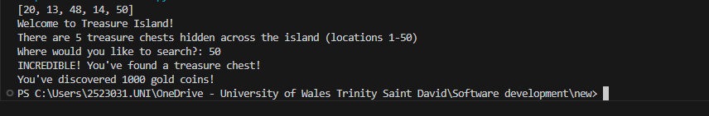
Result: Did the program behave as expected ie syntactically and logically correct?
YES
If NO, what problems were encountered and why? Suggest how things could be improved.

Test:
3. User enters their guess as -4

Screenshot(s) of output: 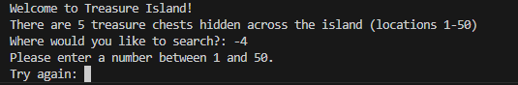

Result: Did the program behave as expected ie syntactically and logically correct?
YES
If NO, what problems were encountered and why? Suggest how things could be improved.

Test:
4. User enters their guess as 55

Screenshot(s) of output: 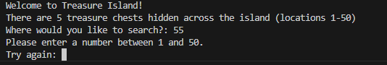

Result: Did the program behave as expected ie syntactically and logically correct?
YES
If NO, what problems were encountered and why? Suggest how things could be improved.

Test:
5. Within 2 of a number (below)

Screenshot(s) of output:
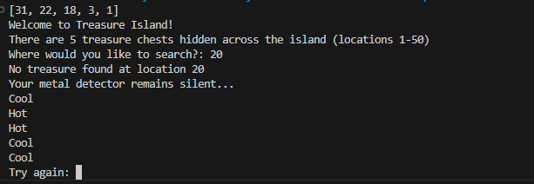

Result: Did the program behave as expected ie syntactically and logically correct?
YES
Test:
6. Within 2 of a number (above)

Screenshot(s) of output:
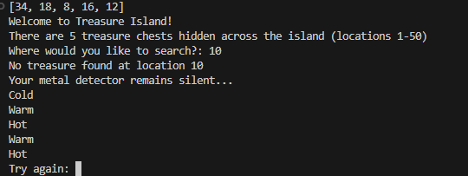

Result: Did the program behave as expected ie syntactically and logically correct?
YES
If NO, what problems were encountered and why? Suggest how things could be improved.

Test:
7. Within 5 of a number (below)

Screenshot(s) of output:

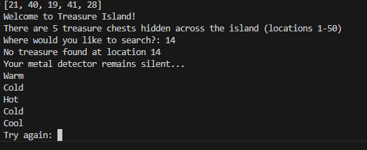
Result: Did the program behave as expected ie syntactically and logically correct?
YES
If NO, what problems were encountered and why? Suggest how things could be improved.

Test:
8. Within 5 of a number (above)

Screenshot(s) of output:
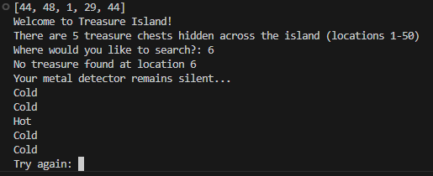

Result: Did the program behave as expected ie syntactically and logically correct?
YES
If NO, what problems were encountered and why? Suggest how things could be improved.

Test:
9. Within 2 of two numbers

Screenshot(s) of output:
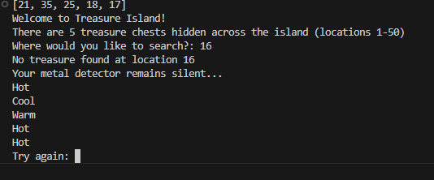

Result: Did the program behave as expected ie syntactically and logically correct?
YES
If NO, what problems were encountered and why? Suggest how things could be improved.

Test:
10. Within 2 or 5 of three numbers (you may need to run your program a few times to generate a suitable number set, or you can hard code the values into the test rig)

Screenshot(s) of output:
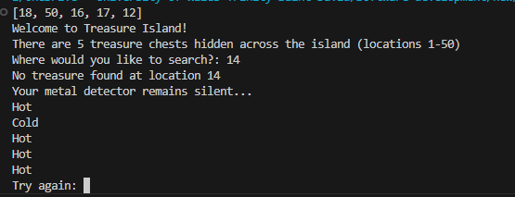

Result: Did the program behave as expected ie syntactically and logically correct?
YES
If NO, what problems were encountered and why? Suggest how things could be improved.

Test:
11.What happens if a duplicate number is generated within the random number set?

Screenshot(s) of output:

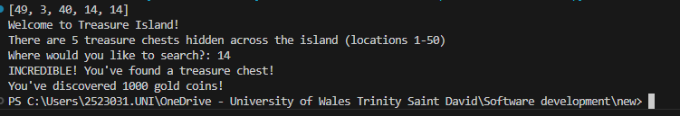
Result: Did the program behave as expected ie syntactically and logically correct?
No shouldn’t be duplicates

- Consider the results of the above tests and revisit your original code in order to address the tests that failed. (Note: you may not be able to solve all of the problems that were originally encountered, but solve as many as you can.)

Paste your full revised code here :

[Copy and paste your full revised code here – note, do not use a screenshot]
import random

locations = [1,2,3,4,5,6,7,8,9,10,11,12,13,14,15,16,17,18,19,20,21,22,23,24,25,26,27,28,29,30,31,32,33,34,35,36,37,38,39,40,41,42,43,44,45,46,47,48,49,50]

treasures = []

for i in range(5):
treasures.append(random.choice(locations))
print(treasures)

print("Welcome to Treasure Island!")
print("There are 5 treasure chests hidden across the island (locations 1-50)")

myGuess = int(input("Where would you like to search?: "))

while myGuess < 1 or myGuess > 50:
print("Please enter a number between 1 and 50.")
myGuess = int(input("Try again: "))

while myGuess not in treasures:

print("No treasure found at location", myGuess)
print("Your metal detector remains silent...")

for treasure in treasures:

if myGuess >= treasure - 5 and myGuess <= treasure + 5:
print("Hot")

elif myGuess >= treasure - 10 and myGuess <= treasure + 10:
print("Warm")

elif myGuess >= treasure - 20 and myGuess <= treasure + 20:
print("Cool")

else:
print("Cold")

myGuess = int(input("Try again: "))

while myGuess < 1 or myGuess > 50:
print("Please enter a number between 1 and 50.")
myGuess = int(input("Try again: "))

print("INCREDIBLE! You've found a treasure chest!")
print("You've discovered 1000 gold coins!")

